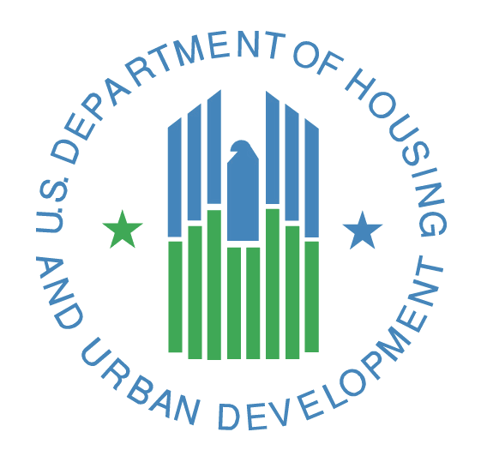

Project Management Plan

PPM Version 2.0

*<Project or Solution Name>*

**U.S. Department of Housing and Urban Development**

*<Month, Year>*

**Solution Information**

|  |  |
| --- | --- |
|  | Information |
| Solution Name | <Solution Name> |
| Solution Acronym | <Solution Acronym> |
| Project Cost Accounting System (PCAS) Identifier | <PCAS Identifier> |
| Document Owner | <Owner Name> |
| Primary Segment Sponsor | <Primary Segment Sponsor Name> |
| Version/Release Number | <Version/Release Number> |

**Document History**

<Provide information on how the development and distribution of the Project Management Plan is controlled and tracked. Use the table below to provide the version number, date, author, and a brief description of the reason for creating the revised version.>

|  |  |  |  |
| --- | --- | --- | --- |
| Version No. | Date | Author | Revision Description |
|  |  |  |  |
|  |  |  |  |
|  |  |  |  |
|  |  |  |  |

**Contents**

Solution Information………………………………………………………………………………………………………………………….…….i

Document History .i

Contents ii

1. Schedule Management 1

1.1 Project Schedule Baseline (Planning Phase) 1

2. Cost/Project Budget Management 2

2.1 Cost Baseline (Planning Phase) 2

3. Scope and Change Management 3

4. Quality Assurance 4

5. Human Resources Management 5

6. Communications and Stakeholder Management 6

7. Risk Management 7

8. Procurement Management 8

9. Process Improvement 9

10. Configuration Management 10

11. Requirements Management 11

Appendix A: References 12

Appendix B: Key Terms 13

# Schedule Management

<Describe the approach for establishing, managing, and controlling the Project Schedule. This includes the approach for defining tasks, estimating level of effort, establishing schedule baselines and allocating resources. Address schedule management, obtaining agreement on schedule changes, managing schedule changes, and measuring and reporting schedule performance. The project’s work breakdown structure is in the WBS/Project Schedule Artifact.

Example Approach: The project will establish a baseline within the first four weeks of the project and monitor progress against the baseline on a weekly basis. The IT Project Manager will be responsible for ensuring updates to the project schedule with the latest information and never more than four business days out of date. For variances on major milestones greater than 10%, the project may choose to use guidance specified by HUD’s capital planning and investment control (CPIC) processes within the Investment Management organization.>

## Project Schedule Baseline (Planning Phase)

<Provide milestone dates for each phase of the PPM life cycle as included in the project schedule. Describe the maintenance of the project schedule baseline (Planning Phase). How often will it be updated?>

# Cost/Project Budget Management

<The focus of cost management is on the cost of resources needed to complete project activities. Describe the approach for planning, estimating, budgeting, and controlling costs in order to complete the project within the approved budget. Specify the variance thresholds for monitoring cost performance indicating the allowable amount of variation before corrective action is required.

Along with the cost of the resources needed to complete the project, consider the effect of project decisions on the subsequent recurring cost of using, maintaining, and supporting the delivered solution/service through to its decommissioning or retirement.

## Cost Baseline (Planning Phase)

<Provide cost information for each phase of the PPM life cycle as included in the life cycle cost estimate (and also in the Project Charter). Describe the steps involved in the cost baseline (Planning Phase) maintenance.>

# Scope and Change Management

<Describe scope management throughout the project. Scope management involves developing processes on:

* How to prepare a detailed scope statement
* How to create the WBS from the detailed scope statement
* How the WBS will be maintained and approved
* How formal acceptance of completed project deliverables will be obtained
* How requests for changes to the detailed project scope statement will be processed

Include the processes for how you will manage change on the project and use the Change Management Log template to document changes. The change log documents the comprehensive list of changes made during the project. An effective change management process will cover approving changes and managing changes to:

* Deliverables
* Organizational process assets
* Project documents
* Baselines>

# Quality Assurance

<Define the project’s quality policies, procedures, areas of application, and associated criteria. Document the quality management approach including the quality objectives and standards, methods and tools, and roles and responsibilities. Describe operational techniques and activities that the team will use to provide quality assurance, including identification of assessments, reviews, and audits, the process for quality analysis, how quality will be determined and measured, and the steps for corrective actions.

Note: The PPM V2.0 Project Type Guides may offer a project the opportunity to tailor the PPM life cycle and incorporate the quality assurance content into the Project Management Plan. If your project can tailor out a separate document, the description of this decision should be within the Project Tailoring Agreement (PTA). Complete this section at a high-level if you are preparing a separate subsidiary document on quality assurance.>

# Human Resources Management

<Human Resource Planning identifies and determines the right resources with the necessary skills required for project success. Describe the roles and responsibilities, reporting relationships, and staffing management within the project. Within staffing management, if applicable, include timetables for staff acquisition and release, identification of training needs, team-building strategies, plans for rewards and recognition, compliance considerations, and the impact of the staffing management plan on the organization.>

# Communications and Stakeholder Management

<Communications management is how a project provides guidance and information on managing stakeholder expectations. Discuss administration of how, when, and by whom information about the project will be disseminated. In this section, also describe:

* Stakeholder communications requirements
* Information to be communicated
* Reason for distribution of information
* Person or groups who will receive information
* Escalation processes

Include in this section and define the processes and techniques the project will utilize to engage stakeholders in project decisions and execution based on the analysis of their needs, interests, and potential impacts.

Note: The PPM V2.0 Project Type Guides may offer a project the opportunity to tailor the PPM life cycle and incorporate the communications management content into the Project Management Plan. The Project Tailoring Agreement (PTA) should include any separate documents. Complete this section at a high-level if you are preparing a separate subsidiary document on communications management.>

# Risk Management

<Project risk management includes the processes of conducting risk management planning, identification, analysis, response planning, and controlling risk on a project. Describe at a high-level the following on how the project will:

* Conduct risk management activities
* Determine which risks may affect the project
* Prioritize risks for further analysis or action by assessing and combining their probability of occurrence and impact
* Analyze the effect of identified risks on overall project objectives
* Develop options to reduce threats to project objectives
* Control risks (risk response plans, risk tracking, identification of new risks)

Note: The PPM V2.0 Project Type Guides may offer a project the opportunity to tailor the PPM life cycle and incorporate the risk management content into the Project Management Plan. If your project can tailor out a separate document, the description of this decision should be within the Project Tailoring Agreement (PTA). Complete this section at a high-level if you are preparing a separate subsidiary document on risk management.>

# Procurement Management

<Effective IT project management involves creating plans or strategies for managing acquisitions. The plans or strategies change based on the needs of each individual project and can be informal or formal based on project characteristics. Procurement management within PPM describes how a project team will acquire goods and services from outside of HUD. Describe the overall design of the procurements throughout the project. Be specific and depict where contracts will be in place as it pertains to the project scope and high-level requirements at this point. Describe the management of the procurement processes from developing procurement documents through contract closure.

Note: The PPM V2.0 Project Type Guides may offer a project the opportunity to tailor the PPM life cycle and incorporate the procurement management content into the Project Management Plan if the project will only be utilizing one contract. If your project can tailor out a separate document, the description of this decision should be within the Project Tailoring Agreement (PTA). Complete this section at a high-level if you are preparing a separate subsidiary document on procurement management (if the project will be utilizing more than one contract.>

# Process Improvement

<Describe the steps for analyzing project management and product development processes to identify activities that enhance their value. Be sure to include problems experienced, constraints experienced, and non-value added activities identified during process operation.>

# Configuration Management

*<Note: This section is required to be completed if the Project Type Guide offers a project the opportunity to tailor the PPM life cycle and incorporate the configuration management content into the Project Management Plan. The Project Tailoring Agreement (PTA) should include this section as well. If you are not completing this section, it means a subsidiary document on configuration management exists. Document configuration management performance on the project.>*

# Requirements Management

*<Note: This section is required to be completed if the Project Type Guide offers a project the opportunity to tailor the PPM life cycle and incorporate the requirements management content into the Project Management Plan. The Project Tailoring Agreement (PTA) should include this section as well. If you are not completing this section, it means a subsidiary document on requirements management exists. Document requirements management performance on the project including how requirements will be analyzed, documented, and managed.>*

Appendix A: References

<Insert the name, version number, description, and physical location of any documents referenced in this document. Add rows to the table as necessary.>

Table 1 below summarizes the documents referenced in this document.

|  |  |  |
| --- | --- | --- |
| Document Name | Description | Location |
| <Document Name and Version Number> | <Document description> | <URL to where document is located> |
|  |  |  |
|  |  |  |

Table 1 - Appendix A: References

Appendix B: Key Terms

Table 2 below provides definitions and explanations for terms and acronyms relevant to the content presented within this document.

|  |  |
| --- | --- |
| Term | Definition |
| <Insert Term> | <Provide definition of term and acronyms used in this document> |
|  |  |
|  |  |

Table 2 - Appendix B: Key Terms