Capital Fund Data Certification
Step by Step Instruction Guide
January 22, 2009 version

Table of Contents

Basic Navigation: 2
General Information – Capital Fund Data Certification pages: 5
Step 1: Is the List of developments Complete and Accurate? 6
Step 2: Is the Data for each Development Accurate? 9
Step 3: Correcting Inaccurate Data: 17
Step 4: Validating 1999 Information: 22
Step 5A: Certifying the Accuracy of a Development’s Data: 23
Step 5B: Rejecting Certification of a Development’s Data: 26
Changing Certification Status of a Development: 30
Step 6: Submitting the PHA’s certification: 31
Assigning Capital Fund Data Certification Roles to PHA Staff 32
Common and Potential Errors 33

Basic Navigation:
In order to access the Capital Fund Data Certification pages in the Public and Indian Housing Information Center Inventory Management System (PIC/IMS) system, follow the usual procedure to log into the PIC/IMS system. On the main menu page for PIC/IMS, select the “Development” link under “Housing Inventory” (see screen shot below).

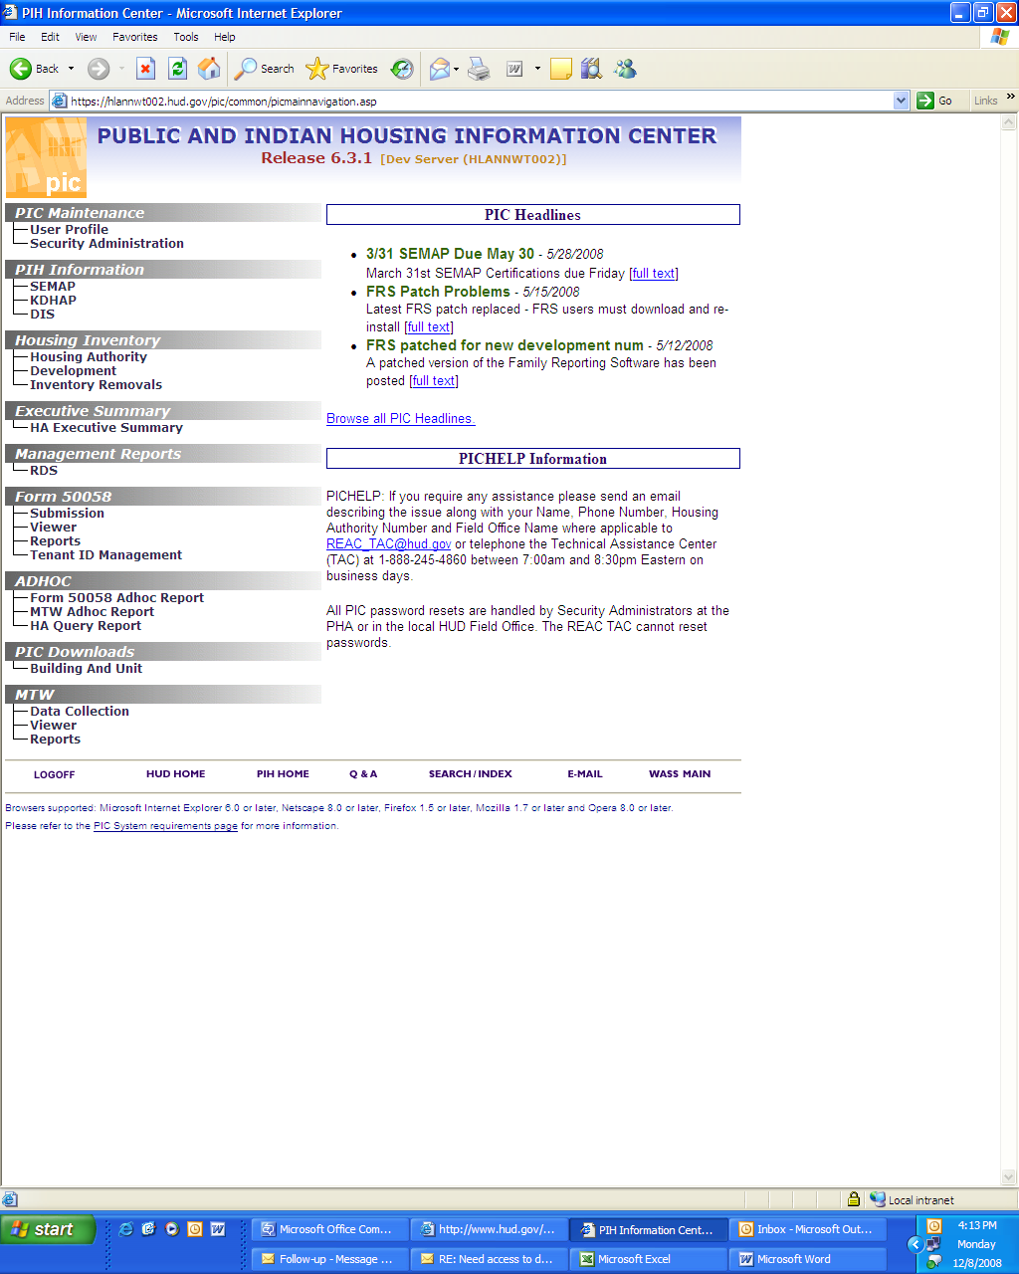
Once you have navigated to the Development sub-module within the Housing Inventory module you will see the following page displayed. Click on the CAPFUND B&U Certification tab on the right hand side at the top of the page (see screen shot below).

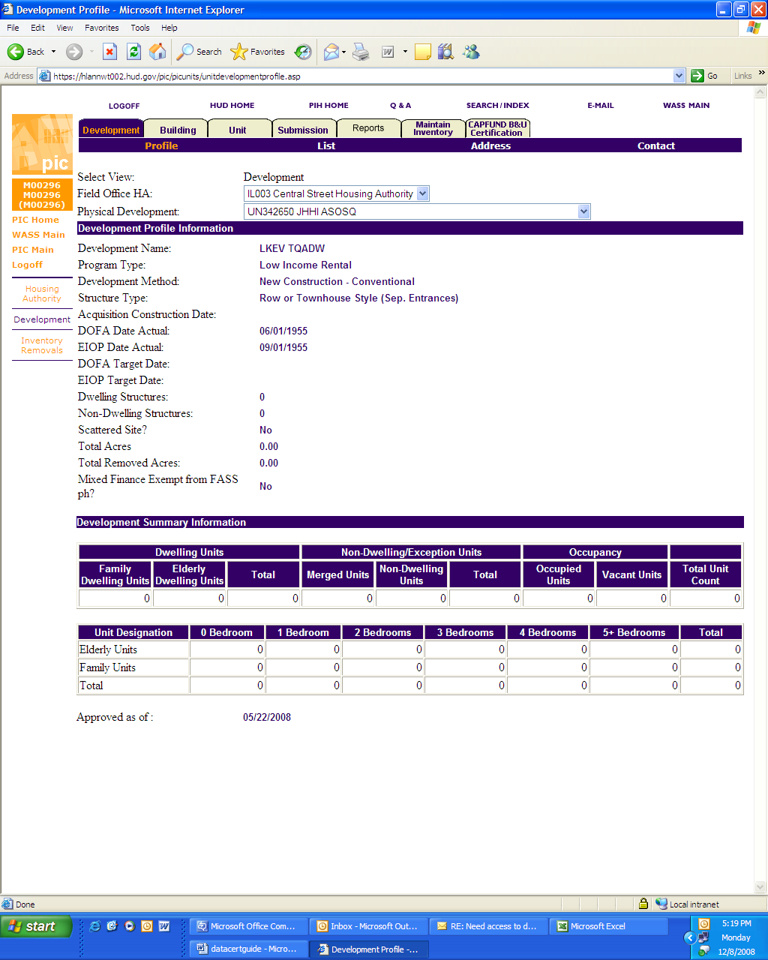

Once you have clicked on the tab, the system will display the Capital Fund Building and Unit Data Certification tab page (see screen shot below):

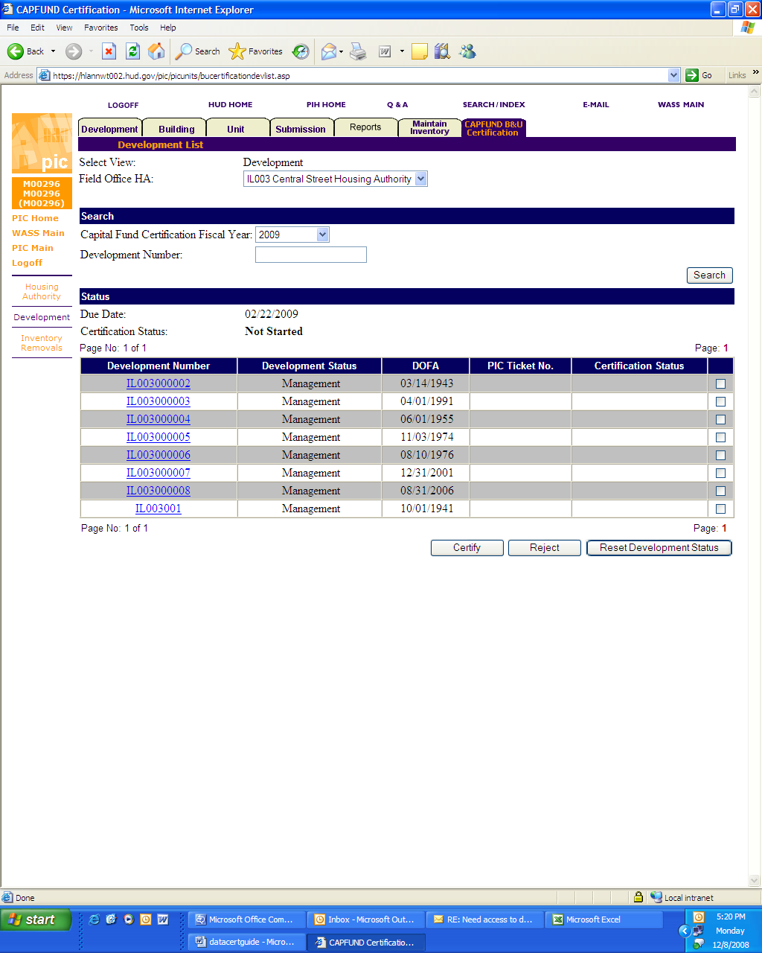

General Information – Capital Fund Data Certification pages:

The data certification process proceeds as follows:
- PHA reviews the data for inaccuracies.
- PHA corrects any data inaccuracies which it is able to correct.
- PHA certifies all of the developments that have accurate data.
- If the data is inaccurate and the PHA cannot correct the data, PHA provides a Help Ticket number which reports the data inaccuracy for correction by HUD and marks the developments in which it cannot correct inaccurate PIC/IMS data as “rejected.” Note: The help ticket must include all of the information and justification needed to correct the data inaccuracies. Failure to include all of the required information may jeopardize the funding for the development in question.
- Once the Data Certification tab page accurately displays all of the PHA’s developments and they have been either marked “certified” or “rejected,” the PHA submits the certification.

Please note that the Capital Fund Data Certification pages (the Capital Fund Building and Unit Data Certification tab page and the hyperlinked Development Details page) in PIC/IMS display the state of a PHA’s inventory as of the “reporting date” established by the Office of Public and Indian Housing (PIH). PIH normally sets the “reporting date” at September 30 of the previous Federal Fiscal Year (e.g. 9/30/2008).

The Data Certification pages display data that is stored elsewhere in PIC/IMS, usually under either the “Development” and “Inventory Removals” sub modules of the “Housing Inventory” module. PHAs cannot correct erroneous information on the Capital Fund Data Certification pages themselves. PHAs must navigate to the location where PIC/IMS stores the source information that the Data Certification pages display in order to make corrections to erroneous data. Note also, that HUD Field Office staff may have to review and approve changes for them to take effect. Also note that once data is changed or corrected in PIC/IMS outside of the Data Certification pages, there will be a one day lag from the time the correction is finalized before the Capital Fund Data Certification pages are updated and display the corrected data.

Users have to be assigned the appropriate access rights to access the Capital Fund Data Certification pages. If pages do not properly display (similar to the screen shots presented in this step by step guide) or you are not given the ability to enter data, it may be that your security administrator has not assigned you the proper roles to access the system. See the Assigning Capital Fund Data Certification Roles section below for information on assigning roles for the Capital Fund Data Certification pages.

Step 1: Is the List of developments Complete and Accurate?
Toward the bottom of Capital Fund Building and Unit Data Certification tab page, the system will list all of the developments in the PHA’s inventory that will be included in the Capital Fund formula. Depending on the number of developments in a PHAs inventory, the list of developments may not fit on a single screen, in which case scroll down to the bottom of the screen to see more developments (see screen shot below).

The first thing that a PHA should check is whether the list of developments is complete and accurate. If a PHA has added a new development that has reached Date of Full Availability (DOFA) prior to the “reporting date,” and the development is not displayed in the list, navigate to the Development Profile page for the missing development and validate that the DOFA Date Actual data element has the correct DOFA date listed. If it does not, work with your local PIH Field Office staff to correct or approve the DOFA date (DOFA dates are not effective until approved by appropriate Field Office staff). If a development reaches DOFA after the reporting date, it will not be displayed in the list of developments (if it does, then the DOFA date is wrong because the system will filter out DOFA dates after the reporting date). If the list includes a development that reached DOFA after the reporting date, follow the same course of action to correct the DOFA date. The PIC/IMS system lists DOFA dates in the Development sub module under the Housing Inventory module on the “Development” tab.

PHAs should also double check that the PIC system has properly calculated changes in DOFA dates whenever a PHA reassigns buildings from one development to another. The PIC/IMS system recalculates a development’s DOFA date whenever it reassigns a building from one development to another based on a PHA’s request. In such instances the PIC/IMS system generates a weighted average DOFA date based on the DOFA dates associated with each building assigned to the development. This guide provides an example of a weighted average DOFA date calculation on the next page.
Example of a weighted average DOFA calculation

- Assume a PHA has developments A, B and C (developments NY005074, NY005103 and NY005189 in table below) that are being merged into a new development D (development NY005011630P in the table below). Also assume all of the buildings within A, B and C have always been assigned to A, B and C respectively since they first became public housing.
- The system has assigned a DOFA date to each of the buildings within each development based on when the development was first available for occupancy as public housing.
- Establish a base date in the past (Jan 1, 1900 usually works) to calculate the number of days between the base date and each DOFA date for each building within each development.
- For each building, multiply the number of units in that building with the difference in days calculated in Step 3 above.
- Add the results of calculations from Step 4. (This will give you total “unit-days”).
- Sum the total number of units that are being merged into the new development D.
- Divide the result of Step 5 (total unit-days) with result of Step 5 (total units). The resultant number of days needs to be added to Jan 1, 1900 to get the new weighted average DOFA date for new development D.

New Development Number | Old Development Number | DOFA Date | DOFA Days from 1/1/1900 | Building | # Units | Unit-Days
NY005011630P | NY005074 | 12/31/1966 | 24470 | 163001 | 175 | 4,282,250
 |  |  |  | 163002 | 174 | 4,257,780
 |  |  |  | 163003 | 180 | 4,404,600
NY005011630P | NY005103 | 8/31/1972 | 26540 | 196001 | 87 | 2,308,980
 |  |  |  | 196001 | 113 | 2,999,020
NY005011630P | NY005189 | 4/30/1976 | 27878 | 256001 | 300 | 8,363,400
 |  |  |  | Total | 1029 | 26,616,030
 |  | Weighted Average DOFA | DOFA Days from 1/1/1900
NY005011630P | N/A | 10/27/1970 | 25865.9184

Step 2: Is the Data for each Development Accurate?

Each development number listed on the Capital Fund Building and Unit Data Certification tab page is a hyperlink. Click on the desired development number link to bring up the Development Details page for that development (see screen shot below).

Below is a screen shot of the Development Details page that will appear after you click on the development number link (see screen shot below):

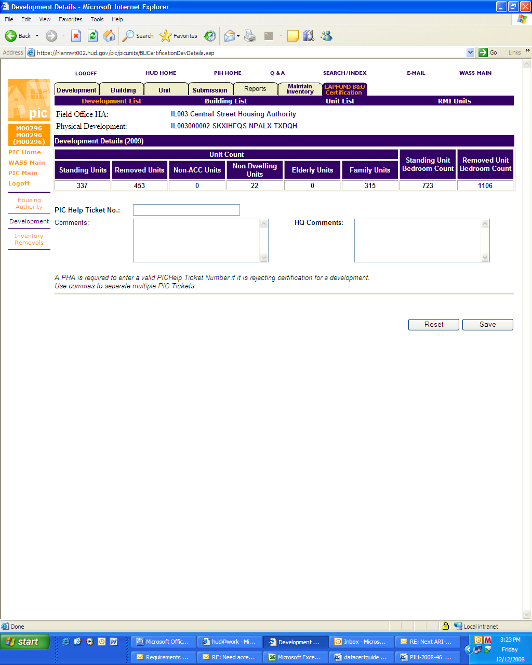

The Development Details page contains the essential data related to the development that the Department uses to calculate the Capital Fund formula:

Standing units – standing units are the number of ACC units in the development as of the “reporting date” that have not been removed from the inventory of the development. The standing unit count excludes non-ACC units.
Removed units – removed units are units in the development that have been removed from the inventory with an approved action date/closing date for the removal that is on or before the “reporting date.”
Non ACC Units – non-ACC units are units that are not included under the public housing annual contributions contract between HUD and the PHA. Usually these units are market rate or non public housing units in mixed finance developments. (Note that demolished/disposed units are still ACC units even though they are no longer in the inventory – they retain the status that they had when they were removed from the inventory.) Units that are marked as non-ACC units, will not be included in the Capital Fund formula.
Non-Dwelling Units – non-dwelling units include dwelling units that are marked as “exception” units. Non-dwelling units do not include non-dwelling buildings in the development.
Elderly Units – the number of units designated with the unit designation of elderly unit in the Development sub module.
Family Units – the number of units designated with the unit designation of family unit in the Development sub module.
Standing Unit Bedroom Count – the total number of bedrooms in the standing units.
Removed Unit Bedroom Count – the total number of bedrooms that were in the removed units prior to their removal.
An error in any of the above data elements will affect the calculation of the Capital Fund formula.

Please note that PHAs must not only check that the number of units removed is correct, but also that the effective date for units removed is accurate. The Capital Fund formula calculates Replacement Housing Factor funding based on the removal dates.
There are three navigation links that take the user to different PIC/IMS pages for the development. They display the source data used to display the data on the Development Details page to facilitate further investigation of the source data. The navigation links are located on the dark blue navigation bar underneath the tabs at the top of the page (see items circled in red in the screen shot below).

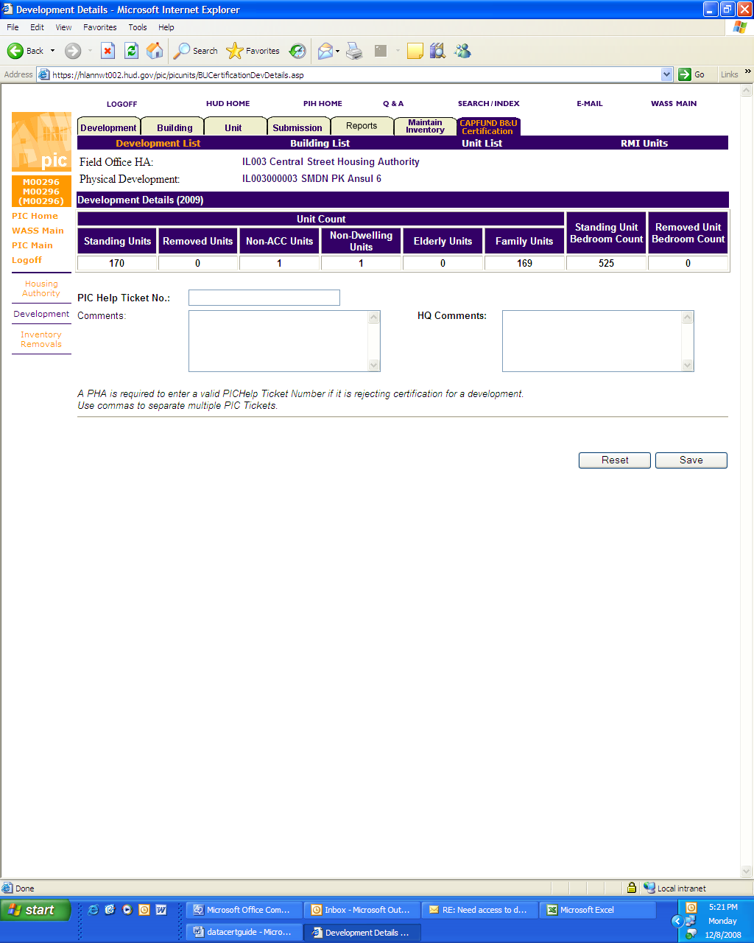

The “building list” link will take the user to a list of the buildings within the development (similar to the list available by clicking on the “Building” tab on the main navigation page of the Development sub module - see screen shot below).

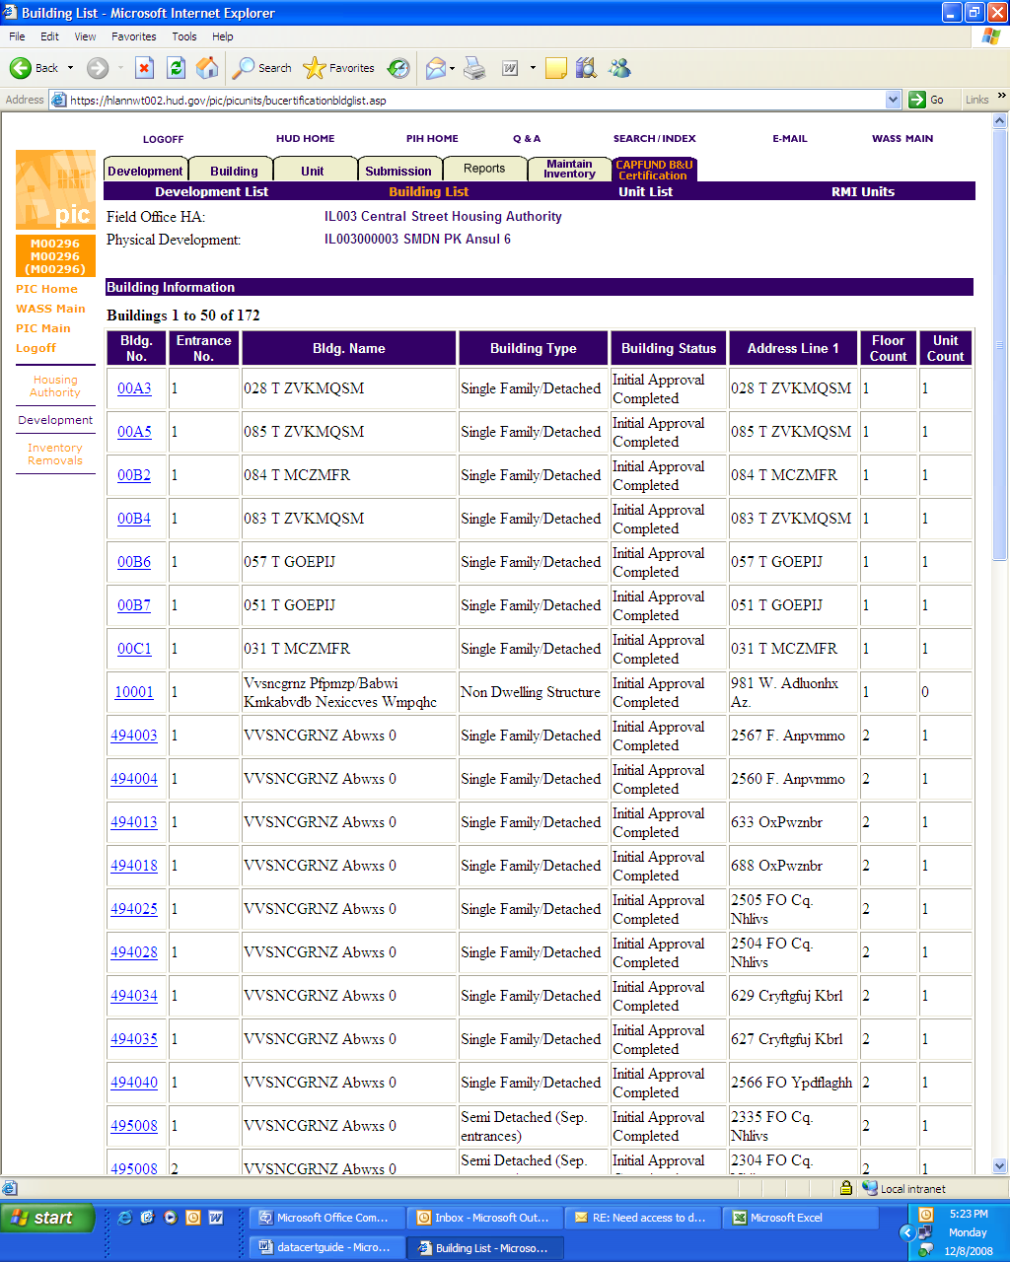

The “unit list” link will take the user to a list of the units within the development (similar to the list available by clicking on the “Unit” tab on the main navigation page of the Development sub module - see screen shot below).

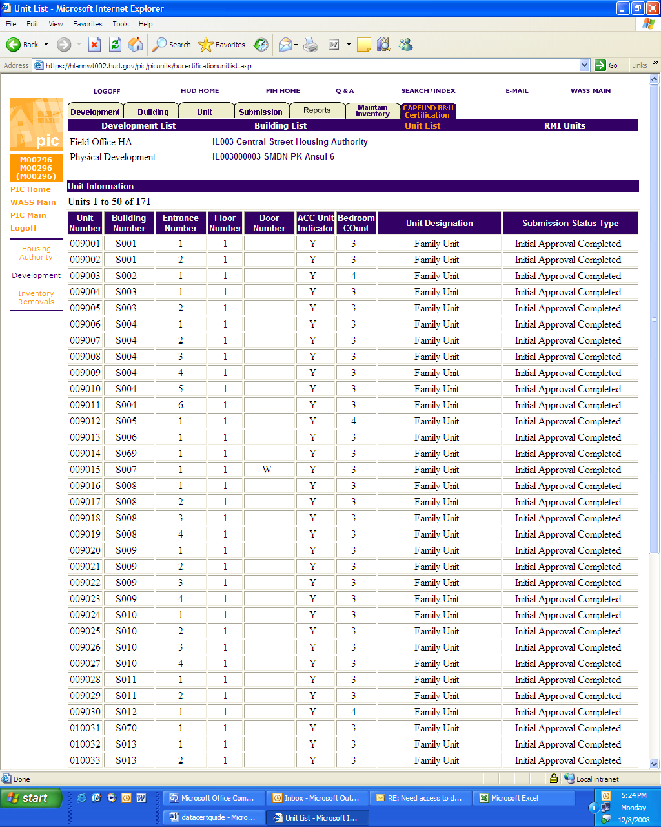

The “RMI Units” link will take the user to a list of approved demolition/disposition applications for the development (similar to the list available by clicking on the “Removed from Inventory” tab on the main navigation page of the “Inventory Removals” sub module - see screen shot below).

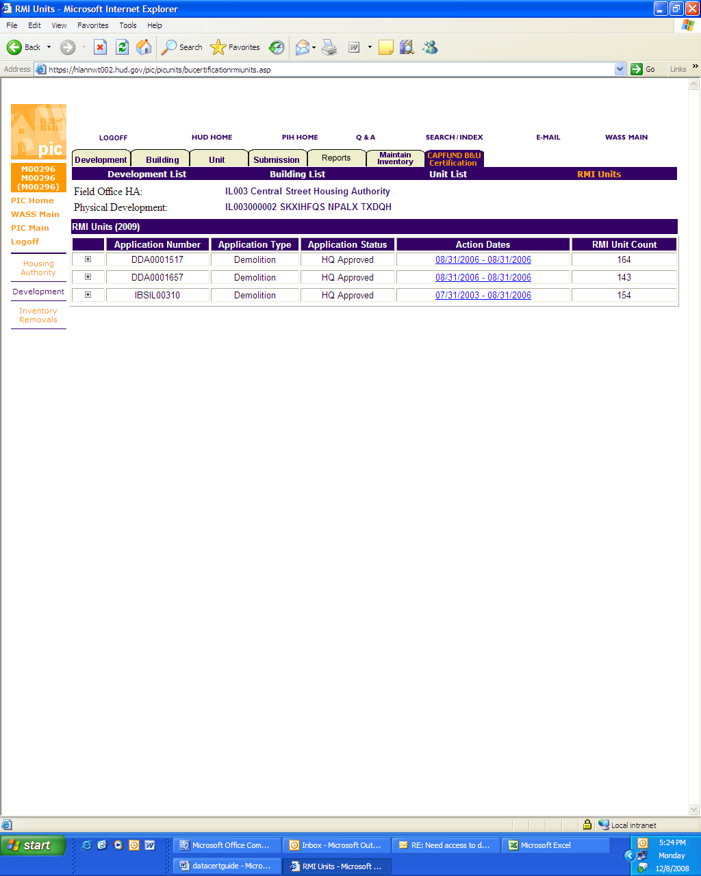

Notice that there is a + sign in the left hand box of the table. Clicking on the + sign will provide more detail (see screen shot below). In this instance you can see that units were removed on different dates.

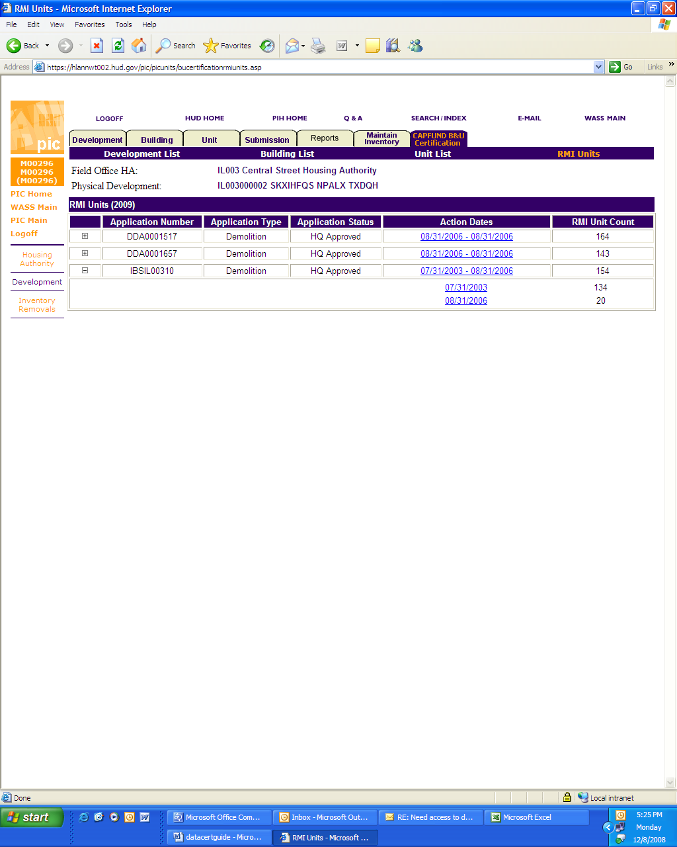

Step 3: Correcting Inaccurate Data:

If the data displayed on the Development Details page for a development is incorrect, a PHA must take steps to correct the inaccurate data prior to certifying to the accuracy of the data for that development on the Capital Fund Building and Unit Data Certification tab page. In this situation a PHA would follow the normal procedures for changing the source data in PIC/IMS. Some corrections will require coordination with Field Office staff to ensure that any corrections that require Field Office approval prior to taking effect are approved prior to certifying to the accuracy of the data. Some corrections require Field Office staff to make the corrections on a PHA’s behalf (particularly corrections relating to development level data such as DOFA dates). Any changes in source data will be reflected in the PIC/IMS Data Certification pages the day after they are finalized. Once the data is correct, a PHA can then mark the development as “certified” on the Capital Fund Building and Unit Data Certification tab page (see Step 5A Certifying the Accuracy of a Development’s Data section below).

In rare instances, PHAs may encounter errors that cannot be corrected by either the PHA or Field Office staff because of the way the PIC/IMS system operates. In those instances, PHAs are to submit a request to the Real Estate Assessment Center Technical Assistance Center (TAC) help desk. In such instances PHA staff can either:
- send an email describing the issue (include staff member name, phone number, housing authority number and field office name where applicable) to REAC_TAC@hud.gov or
- telephone the TAC at 1-888-245-4860 between 7:00am and 8:30pm Eastern time on business days.
The TAC will assign a ticket number to track the issue to resolution. (The ticket number will be a five digit number preceded by “IM.”) If the issue is resolved sufficiently before the deadline for certifying, the PHA should take the necessary steps to correct the remaining inaccurate data and certify that the data for the development is accurate.

If the issue is not resolved prior to the deadline for certification or there is insufficient time to make the correction after the issue is resolved but before the certification deadline, the affected PHA is to “reject” certification for the development (see Step 5B Rejecting Certification of a Development’s Data section below). In order to “reject” a certification for a development, a PHA must provide certain data on the Development Details page for the development.

As mentioned earlier, in this situation the TAC will assign a Help Ticket number to the PHA. The PHA must enter the Help Ticket number into the space provided on the Development Details web page. The PHA must also provide a comment in the space provided that indicates what data element(s) is/are wrong, what the correct data is and why it cannot correct the data through the normal procedure (see screen shot below).

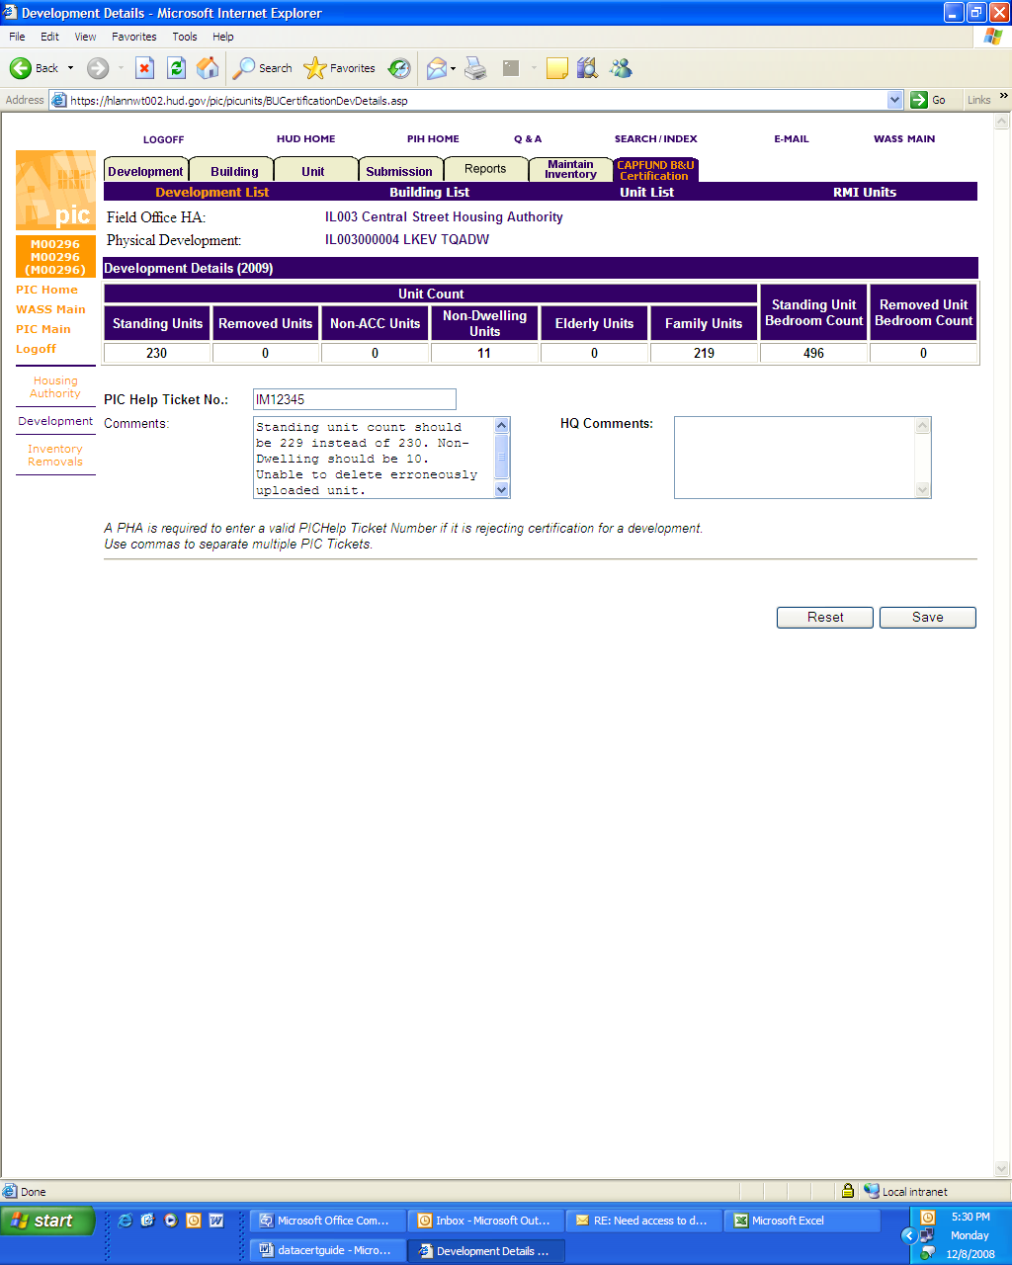

Once the PHA has entered the Help ticket number and comment, it must click the “save” button in lower right hand corner of the page (see screen shot below). (Note that a PHA can enter multiple PICHelp ticket numbers if applicable as long as they are separated by commas.)

Notice that the page indicates that it has been saved (see screen shot below):

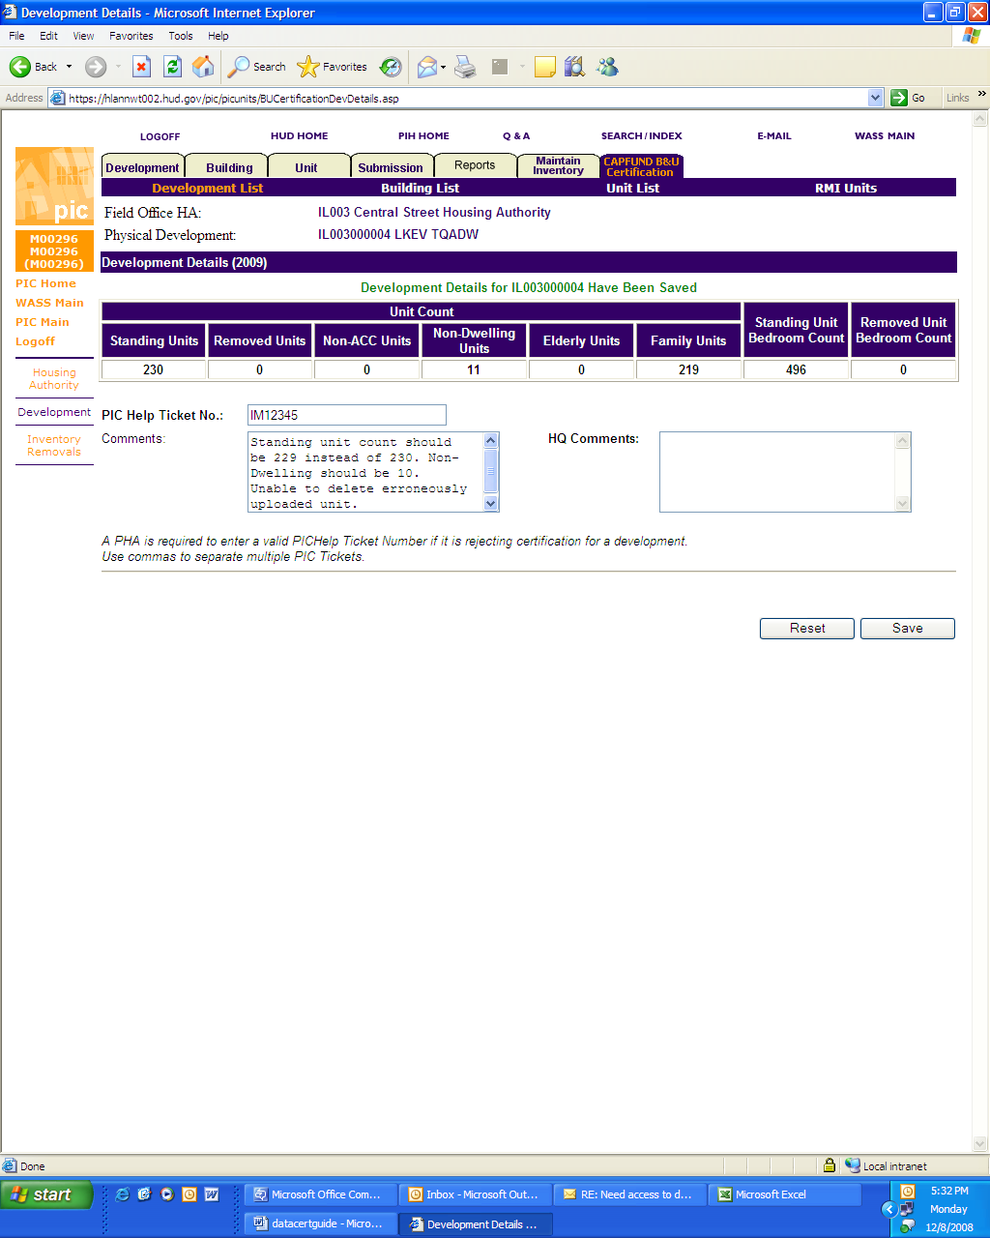

The Capital Fund Building and Unit Data Certification tab page now displays a PIC Help ticket number for the corresponding development (see screen shot below):

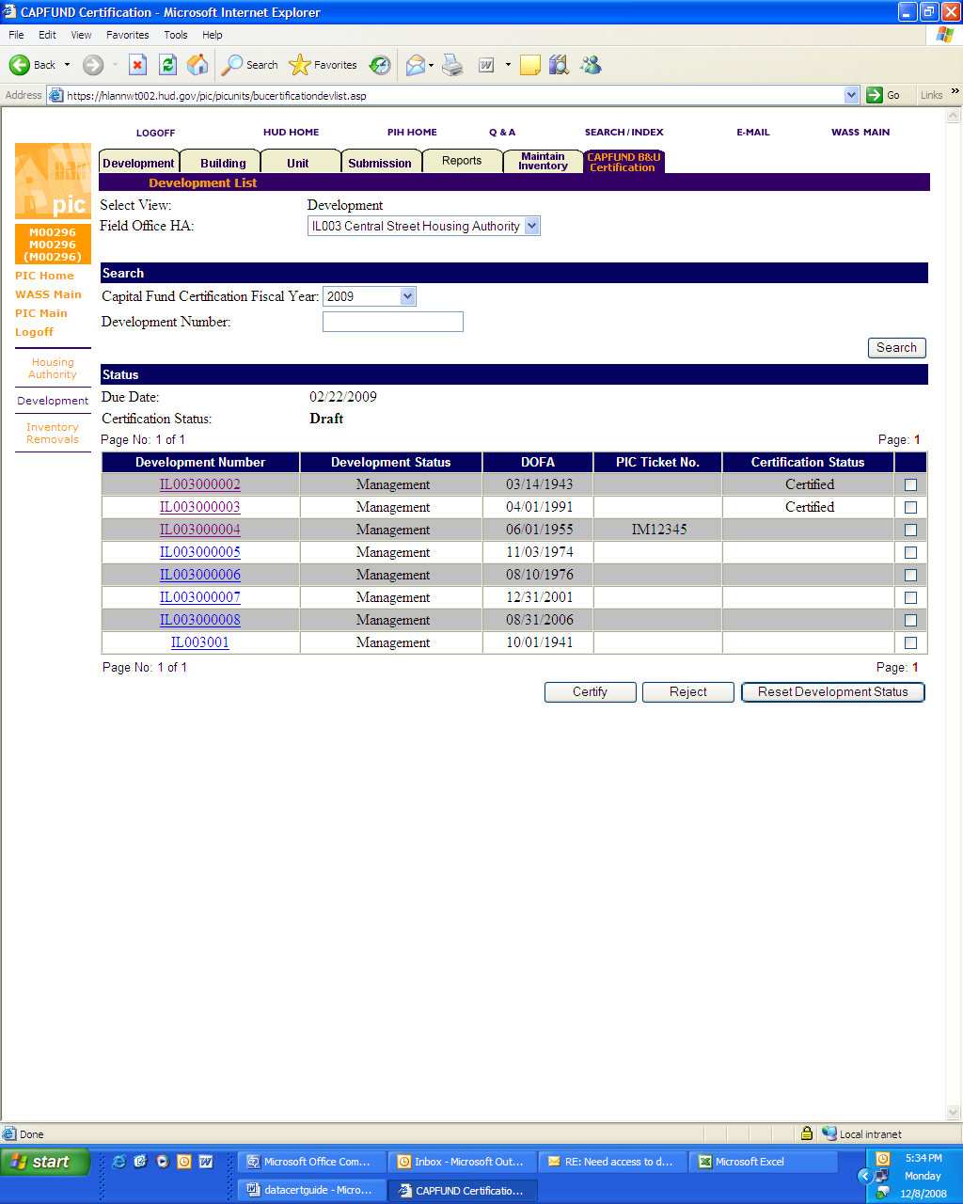

Step 4: Validating 1999 Information:

In 2007 and 2008, the Department required PHAs to review 1999 data used to calculate the Capital Fund formula. PHAs are no longer required to review 1999 data (see screen shot below).

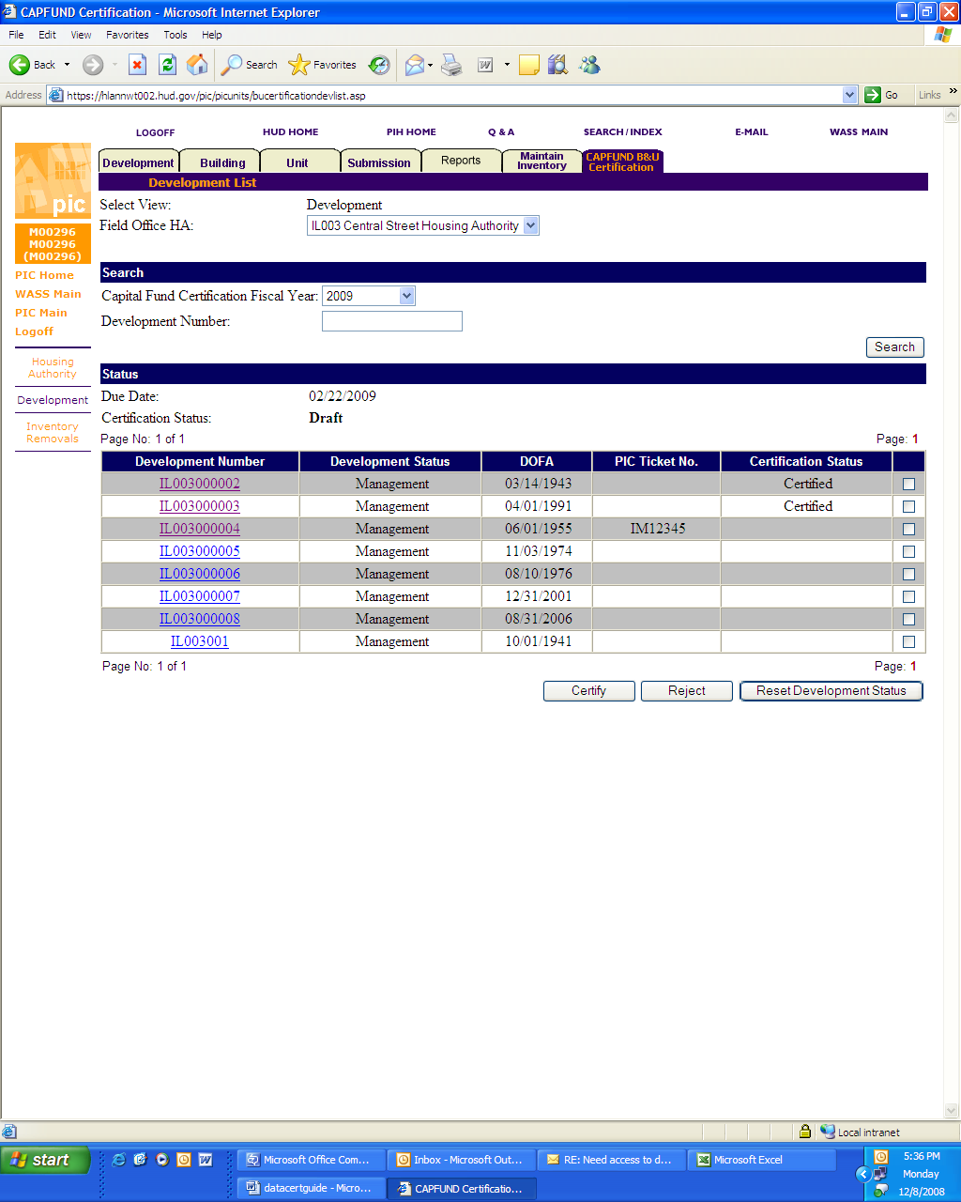

Step 5A: Certifying the Accuracy of a Development’s Data:

Once a PHA has established that the data for a development is accurate, it will then navigate to the Capital Fund Building and Unit Data Certification tab page and scroll to the point where the system displays the development number for the validated development.

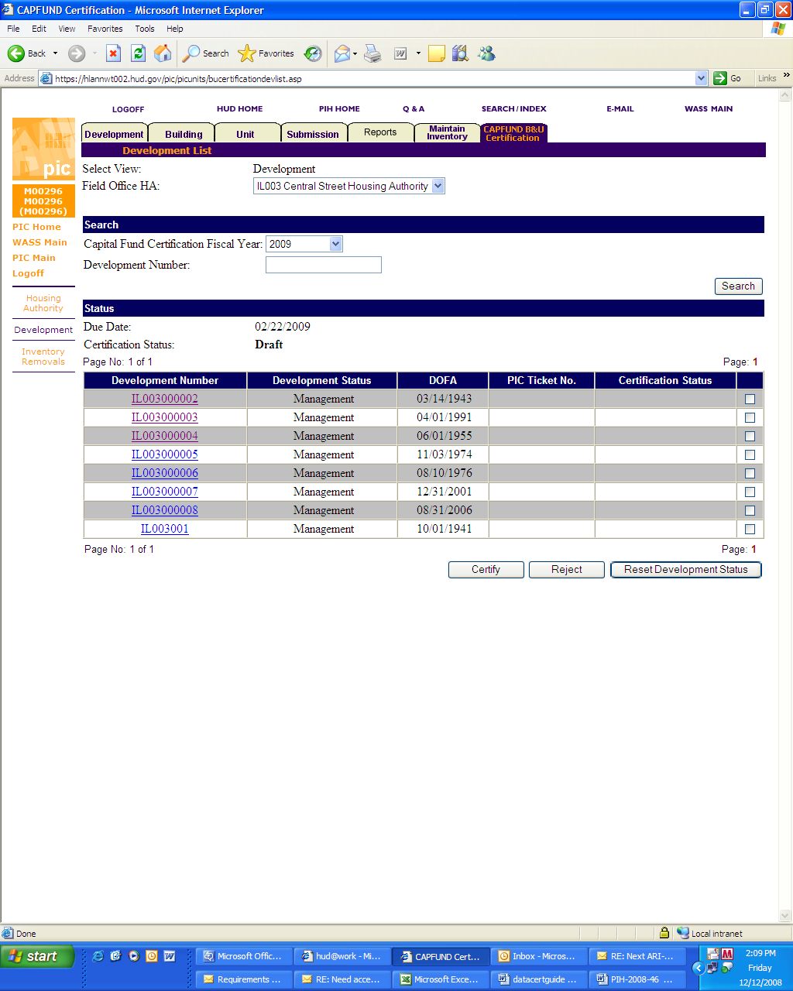
The user will then 1) click the check box for the development to the right of the certification status column, and then 2) click the “certify” button at the bottom right of the page (see screen shot below).

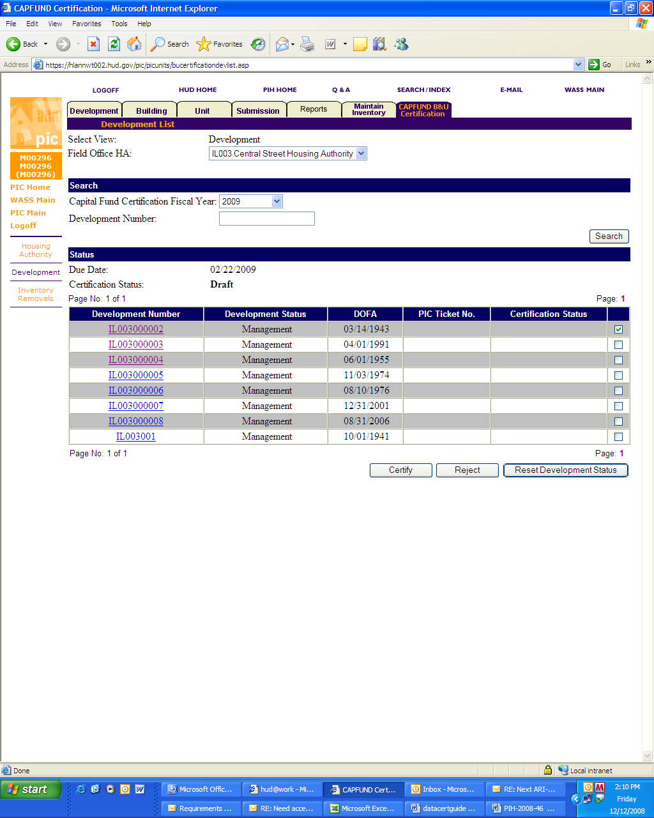
1
2

The Capital Fund Building and Unit Data Certification tab page will then mark the development as “certified” (see screen shot below).

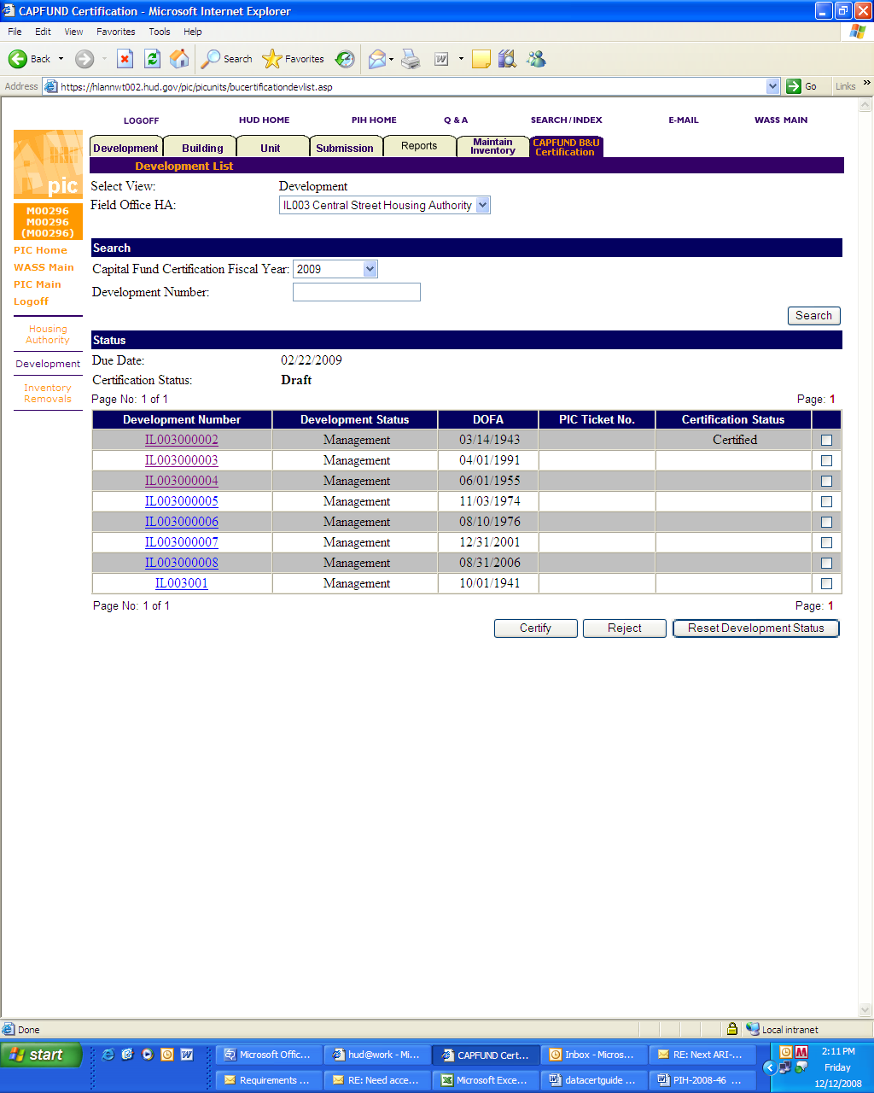

Step 5B: Rejecting Certification of a Development’s Data:

Once a PHA has established that the data for a development is not accurate and that it cannot be made accurate because of a problem with the PIC/IMS system, it will follow a procedure for marking the development “rejected” that is similar to the procedure for marking a development “certified.” It will navigate to the Capital Fund Building and Unit Data Certification tab page and scroll to the point where the system displays the development number for the development that contains data that cannot be made accurate due to a system problem (see screen shot below).

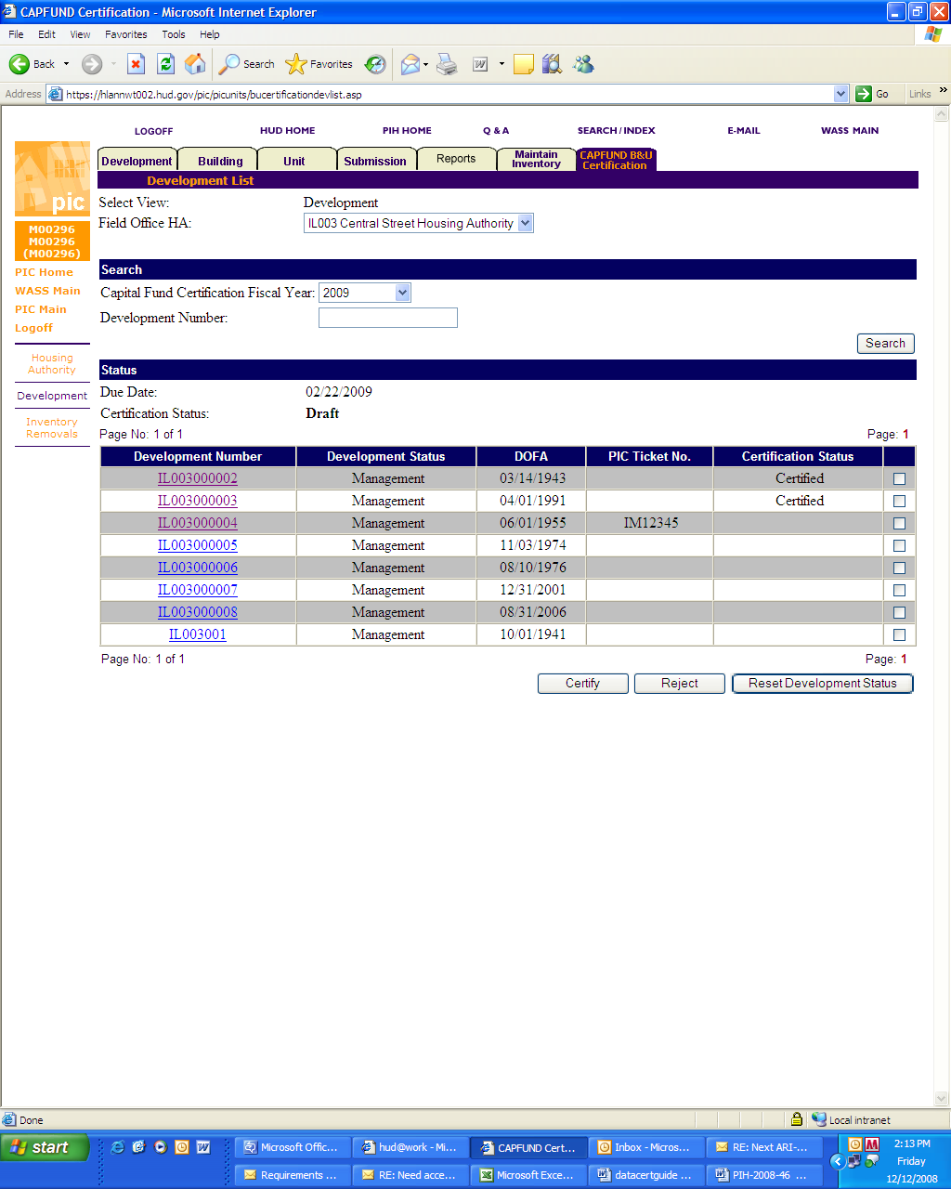

Note that the system displays a PIC/IMS Ticket number on the Capital Fund Building and Unit Data Certification tab page for any developments where the user has entered and saved a ticket number and comment on the Development Details page for the development.

The user will then 1) click the check box for the development to the right of the certification status column, and then 2) click the “reject” button at the bottom right of the page (see screen shot below).

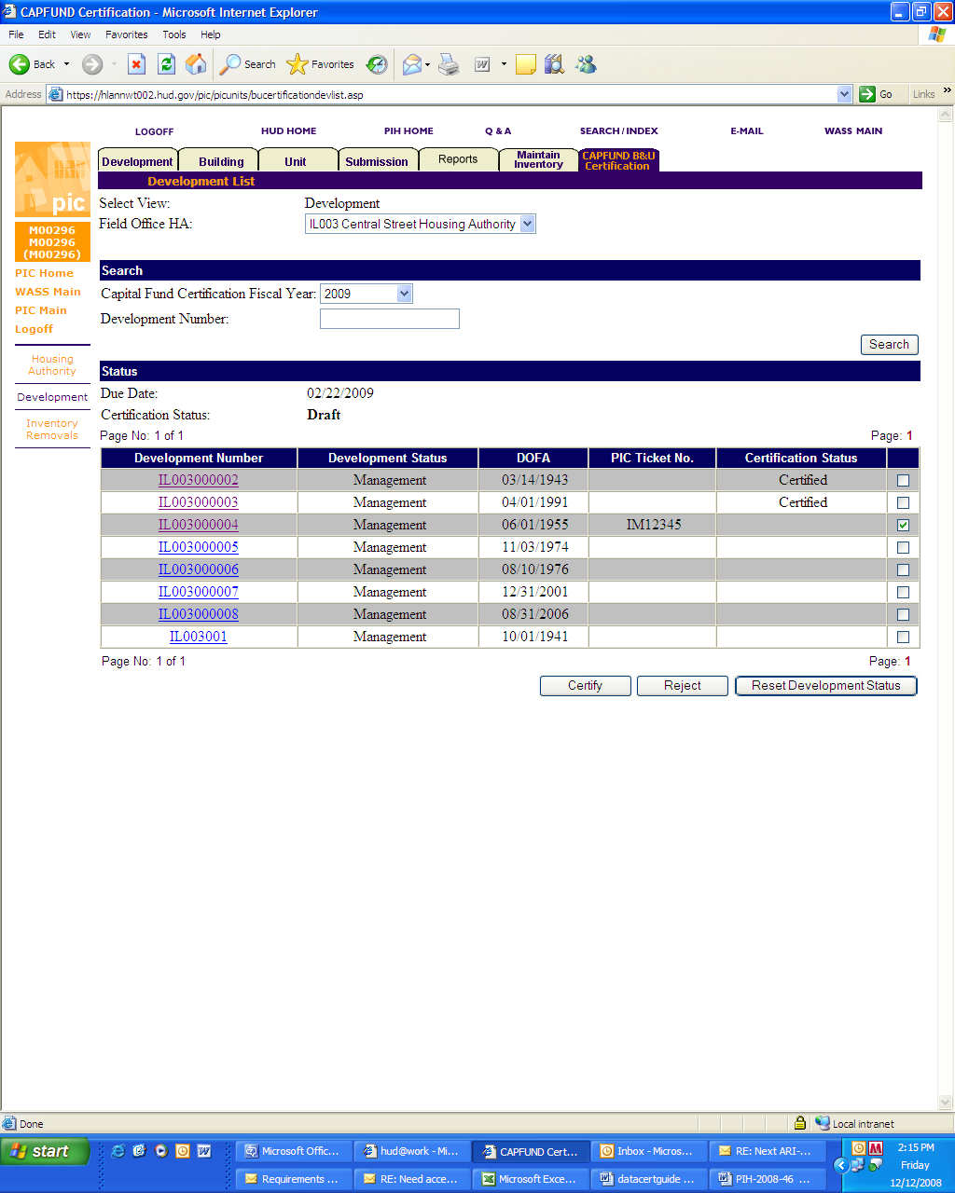
1
2
The Capital Fund Building and Unit Data Certification tab page will then mark the development as “rejected” (see screen shot below).

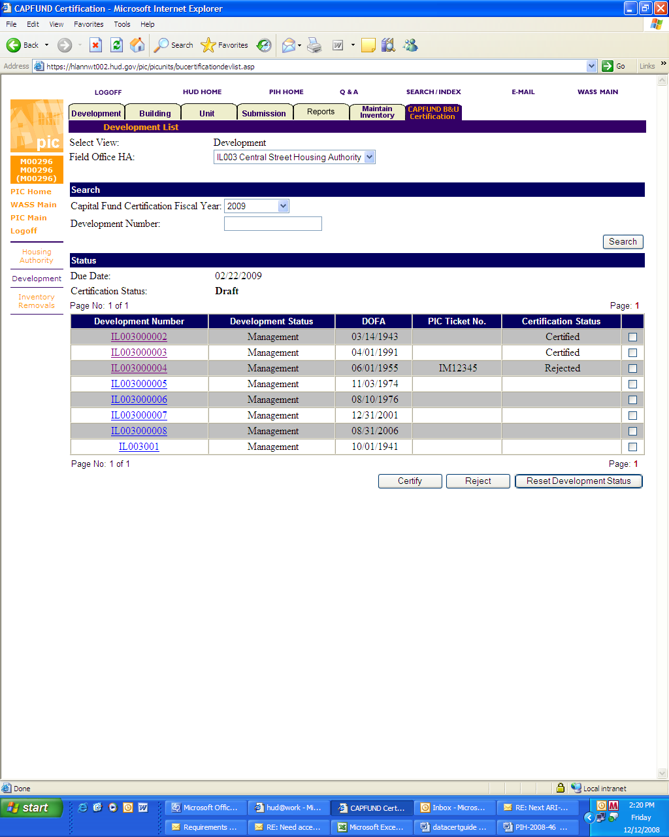

Changing Certification Status of a Development:

Prior to submitting a Capital Fund data certification, a user can change the status of a development from “certified” to “rejected” or vice versa if he/she either set the wrong status or circumstances have changed and the status is no longer valid. To change the status, the user should follow the instructions for the status that should be applied to the development (either “certified” or “rejected”). The new status will override the old status. Note, if changing status from “rejected” to “certified,” the help ticket number and comment remain in the system; however, the Department will disregard them because the development’s status will be “certified.” A user can also reset the status to blank by checking the box next to the development and then clicking the “Reset Development Status” button next to the “certify” and “reject” buttons at the bottom of the screen (see screen shot below).

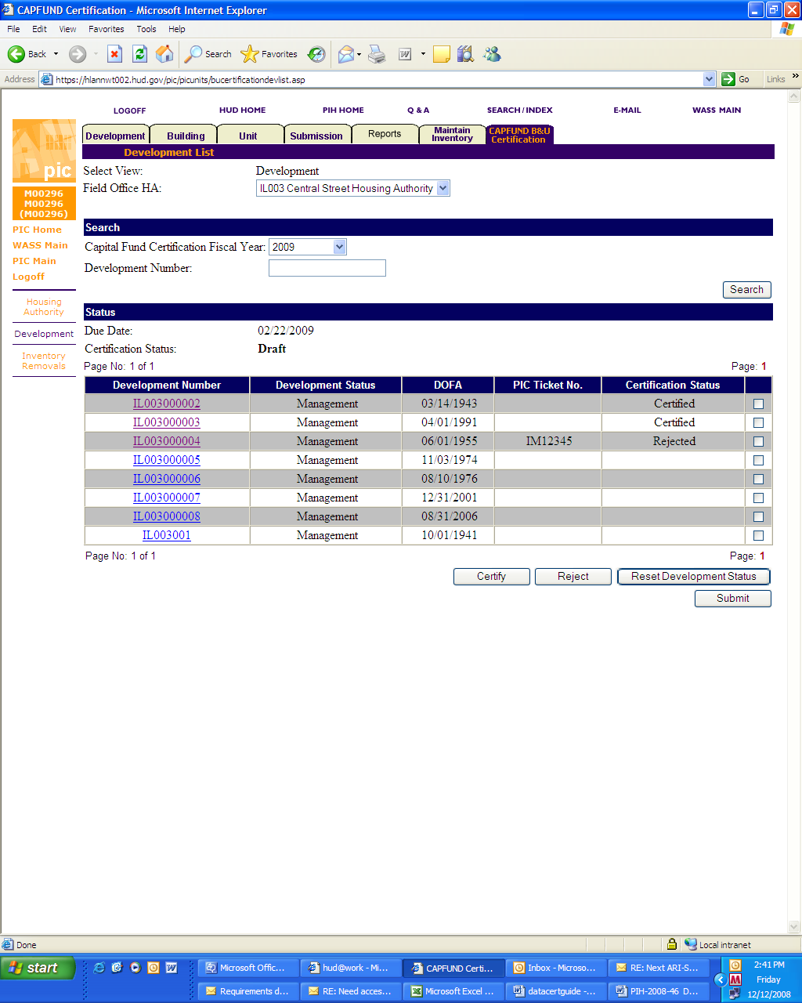

Step 6: Submitting the PHA’s certification:

Once users have set the status of every development in the PHA’s inventory (either “certified” or “rejected”) the PHA is ready to submit the certification to the Department. It submits the certification by clicking on the “submit” button in the lower right hand corner of the Capital Fund Building and Unit Data Certification tab page (see screen shot below). Once the “Submit” button has been clicked, the PHA can make no more changes to the submission.

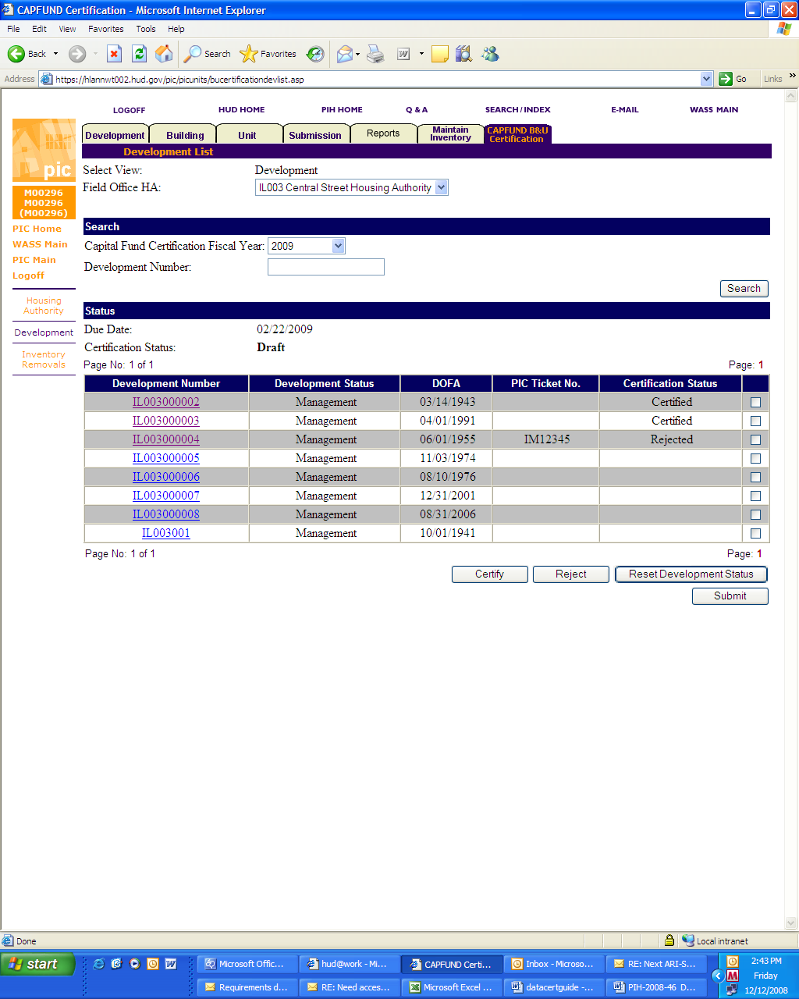

Assigning Capital Fund Data Certification Roles to PHA Staff

If there is a problem accessing the Capital Fund Data Certification pages, PHA staff responsible for carrying out the certification process need to contact their PHA’s PIC/IMS security administrator and request the assignment of the proper roles. Security Administrators assign roles in the Security tab of the Security Administration sub module of the PIC/IMS Maintenance module. Security administrators need to assign the ”Edit Development” role to users that are entering data on the Capital Fund Data Certification pages. Security administrators need to assign the “Submit Development” role to users that are submitting the certification data to HUD. Only Executive Directors are intended to receive the “Submit Development” role.

Executive Directors can delegate the responsibility for submitting Capital Fund Data Certifications to subordinate staff by assigning them the “Submit Development” role. PHA PIC/IMS Security Administrators can assign the Submit role to other users if the PHA Executive Director delegates to a subordinate staff member (in writing) the responsibility to submit Capital Fund data certifications on behalf of the PHA. The Security Administrator selects the user, then clicks “Assign Role.” The Security Administrator selects the role name in the drop-down box, then clicks “Save” to complete the assignment. (See screen shot below).

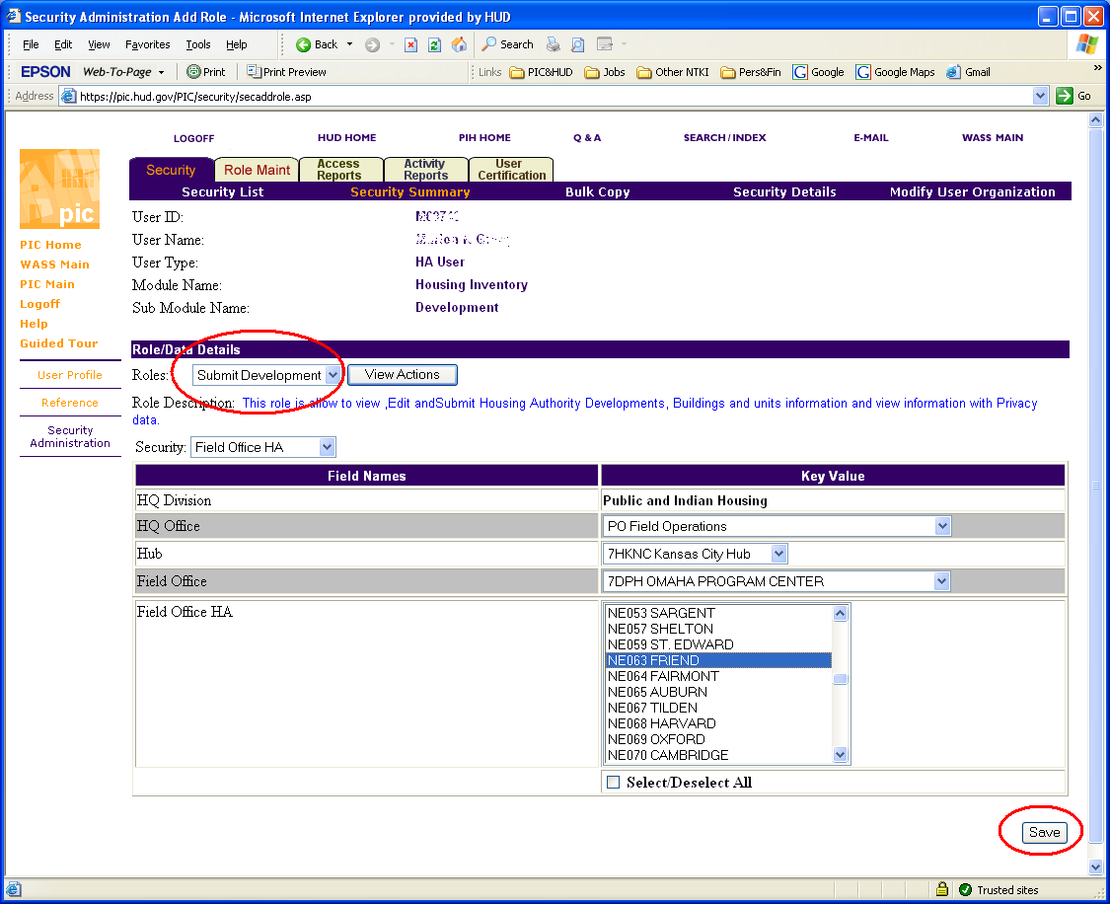

Common and Potential Errors

In reviewing their data, PHAs should consider the following:
- Has the Field Office approved all of the data that the PHA has submitted for approval in PIC? (Note that data entered in PIC but not yet approved will not be displayed on the Data Certification page or its subsidiary Development Details page.) In calculating the Capital Fund formula, the Department will only use finalized data; therefore, data that is submitted by a PHA but not finalized in the system because it is awaiting Field Office action will be disregarded in the calculation.
Data Certification Page
- Does the Data Certification page list all of the developments that it should? PHAs should validate that new developments that achieved DOFA on or before the “reporting date” (e.g. 9/30/2008) are included in the list displayed on the Capital Fund Building and Unit Data Certification tab page. Likewise PHAs should validate that any developments that left the inventory (e.g., through demolition, disposition) in prior years (before 2006) but still had standing units in 1997 are also on the list. The Department will not factor developments omitted from the Data Certification page list in the Capital Fund formula calculation.
Development Details Page
- Not only does the Development Details page display the proper number of units removed from the inventory (RMI) as of the “reporting date,” but also, does PIC reflect accurately when the units were removed? If the RMI date is inaccurate, the Department will start Replacement Housing Factor grant funding either sooner or later than it should in calculating the formula.
- Is the correct number of units displayed as non-ACC (non-Annual Contributions Contract) units? Units that are not subject to the Department’s public housing ACC with the PHA should be listed as non-ACC units. (An example of this situation would be non-public housing units in a mixed finance development.) Units that are deprogrammed or are in the process of being removed from the inventory (e.g., through demolition or disposition) continue to be ACC units. The Department does not include non-ACC units in the Capital Fund formula calculation because they are ineligible to be included in the formula.

From a computer with access to the Internet type the following address into an Internet Browser program (such as Internet Explorer) http://hudatwork.hud.gov/po/reac/home/accessreac.cfm. Click on the “Log in” link. Type in your User ID and Password. Click “OK” to log in to a secure website. Indicate that you agree to follow the rules for system access by clicking “accept” on the following page that displays. The next page will display a list of computer systems that support the Office of Public and Indian Housing, click on the PIH Information Center (PIC) link.
Note: if a PHA has a large number of developments, it may have to navigate to multiple pages to see the complete list of developments. It can see other pages by clicking on the page number hyperlink in the lower right hand corner of the page.
In April of 2008, the Department implemented a new development numbering system within the PIC/IMS system in order to mirror the same building to development assignments that PHAs had implemented for Asset Management Projects (AMPs). In certain circumstances PHAs can continue to request reassignment of buildings from one development to another subject to HUD approval.
DOFA Days (24, 470) = Number of days between 12/31/1966 and 01/01/1900 Unit-Days (4,282,250) = Number of Units(175) X DOFA Days (24,470)
DOFA Days (25865.9) = Total Number of Unit-Days (26,616,030)/ Total Number of Units (1029) DOFA Date (10/26/1970) = 25865 days after 01/01/1900
The 1999 data is historical and therefore does not change from year to year. At this point, the Department believes that it has made all of the corrections to the 1999 data that should be required based on the information PHAs provided during the 2007 and 2008 certification processes and therefore is no longer requesting validation. PHAs can see how the Department handled requested changes to 1999 data by viewing the HQ comments section of the Developments Details web pages for the 2007 and 2008 certification.
Units removed from the inventory in 1997 and prior years are not eligible for funding under the formula.

