**RAD**

**PHA Instructions**

**Converting Units from Multiple AMPs into One RAD Financing Transaction**

When combining two or more AMPs into one RAD project, PHAs must submit an application for each AMP. One AMP is considered the “core” AMP. All the financial information must be included in the application for the core AMP and that application must cover all AMPs in the RAD transaction.  Any other AMPs in the transaction are referred to as “supplemental” AMPs, and applications must be submitted for each supplemental AMP in order to remove that AMP from the ACC. It is crucial that PHAs provide explanations cross-referencing the core and supplemental applications as appropriate in each separate application in the transaction.

**Step 1**

* Open up applications for all AMPs in this RAD transaction
* Read the instructions tab

**Step 2**

Complete separate applications for each **supplemental AMP**, per the instructions below:

Complete Section 1 of the supplemental AMP

Complete Section 2

* In the application for the supplemental AMP, enter the units that will be converted under RAD in Line 47 (Units Converting). If there is more than one supplemental AMP, the application for each supplemental AMP will only reflect the units converting under RAD from that particular AMP in Line 47. In the example below, the supplemental AMP has 90 units.

Complete Section 3

* In Line 72 include the following explanation: “The units are being converted and are from supplemental AMP [name, PIC Dev #: XX#########]. {Provide a detailed breakdown of the number of units per bedroom type}. The units will be combined with the core AMP [name, PIC Dev #: XX#########] in a single financing transaction.”
  + Cross-reference any additional supplemental AMPs in your explanation of this RAD transaction in Line 72. Line 72 should also include a detailed breakdown of the number of units per bedroom type for the additional supplemental AMP.

Section 4

* Leave blank

Complete Section 5

* The AMP’s three year historical average vacancy and bad debt rates will auto-populate The RAD program minimums for vacancy rate (3%) and bad debt rate (2%) will also auto-populate, though the PHA can change the fields because they are highlighted grey (see instructions tab). If the red flag “explain reduction from historical” shows on Line 106 and/or Line 109, such as the example below, provide a detailed explanation as to why the proposed vacancy and / or bad debt rate is lower than the historical rate in Line 107 and / or 110. It is also helpful if the PHA explains high vacancy and bad debt rates, even if the PHA enters a higher proposed rate.

Sections 6-15

* Leave these sections blank

Section 16

* Submit a separate Board Approval Form for each AMP (supplemental and core)
* The PHA may submit separate resident comments for each supplemental AMP as well as the core AMP; the PHA should clearly identify the date of the resident meetings on each set of resident comments.
* The PHA also has the option to submit one set of resident comments that incorporates every AMP in the RAD transaction (core AMP and supplemental AMP). Please note: if the PHA elects to submit resident comments that incorporate the core and supplemental AMPs, that document must clearly list each AMP. The PHA may submit one set of comments per resident meeting, or combine the comments from both meetings as long as the PHA clearly identifies the document represents comments from both resident meetings and provides the dates and lists the AMPs.
* See Step 4 for example

**Step 3**

Complete the application for the **core AMP**. The application for the core AMP will reflect the entire financing transaction, and will cover every AMP in the RAD transaction.

Complete Section 1 of the core AMP

Complete Section 2

* In Line 47 (Units Converting), enter the units that will be converting from the core AMP
* In Line 49 (Other Affordable) enter the units from the supplemental AMP that will be converted under RAD
  + In the example below, the units are various bedroom sizes from one AMP. However, PHAs have the option to add another supplemental AMP, and those units would also be added to the Other Affordable line (Line 49). In this instance, it is very important that the PHA utilize Line 72 in the applications for the supplemental AMPs to provide a detailed breakdown of the number of units per bedroom type for each AMP (see Step 2, Section 3 of the supplemental AMP application).

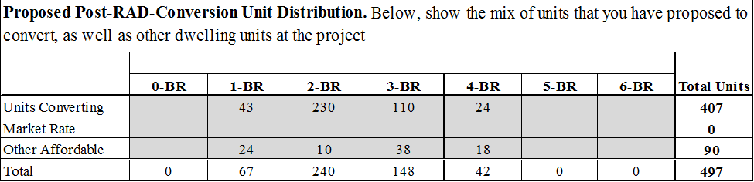

Complete Section 3

* Provide a detailed explanation of the RAD transaction, including a breakdown of the core and supplemental AMP(s) in Line 72

Complete Sections 4 and 5

* For these sections, fill out information for the entire RAD transaction
* This includes all units from the core AMP and the supplemental AMP included in the conversion, as well as any other units in the transaction

Go to Section 6 of the core AMP

* Enter the Gross Potential Rents for the units that will be converted from the supplemental AMP
  + To find the Gross Potential Rents, go to the application for the supplemental AMP – Section 9, Cell R187
  + The Gross Potential Rents can be found under Apartment Gross Potential Rent, RAD Units (Cell R187)
  + PHAs with more than one supplemental AMP in their RAD transaction will need to add together the Gross Potential Rent amount in Cell R187 for each supplemental AMP and enter the total in Line S117
* Enter the RAD program minimums for Vacancy Loss (3%) and Bad Debt Loss (2%) for the units that will be converted from the supplemental AMP
* The PHA may choose to enter vacancy or bad debt rates other than the program minimums, however, the PHA will need to provide a detailed explanation in Line 122
* If the red flag indicating vacancy loss or bad debt is low appears in Line 117, provide a detailed explanation in Line 122 along with the information outlined below
* In Line 122 include the following explanation: “The Other affordable apartments are also RAD units connected with the conversion of the supplemental AMP [name, PIC Dev #: XX#########], which has been submitted as a separate application and is attached. The units in the core AMP [name, PIC Dev #: XX#########] and the supplemental AMP [name] will be combined in a single financing transaction and will be included under a single HAP contract”
  + Provide an explanation of the conversion
  + Cross-reference any additional supplemental AMPs in your explanation of the conversion in Line 122

Sections 7, 8, 9, 10, 11, 12, 13, and 15

* For these sections, fill out information for the entire RAD transaction
* This includes all units from the core AMP and the supplemental AMP included in the conversion, as well as any other units in the transaction
* Section 14 is not applicable

Section 16

* Submit a separate Board Approval Form for each AMP (supplemental and core)
* Submit any applicable attachments (e.g. Financing Letter of Interest)
* Submit resident comments (see Step 2, Section 16 for details)

**Step 4**

Submit all applications for this RAD transaction –the application for the core AMP and any supplemental applications– to [RADapplications@hud.gov](mailto:RADapplications@hud.gov) at the same time

* 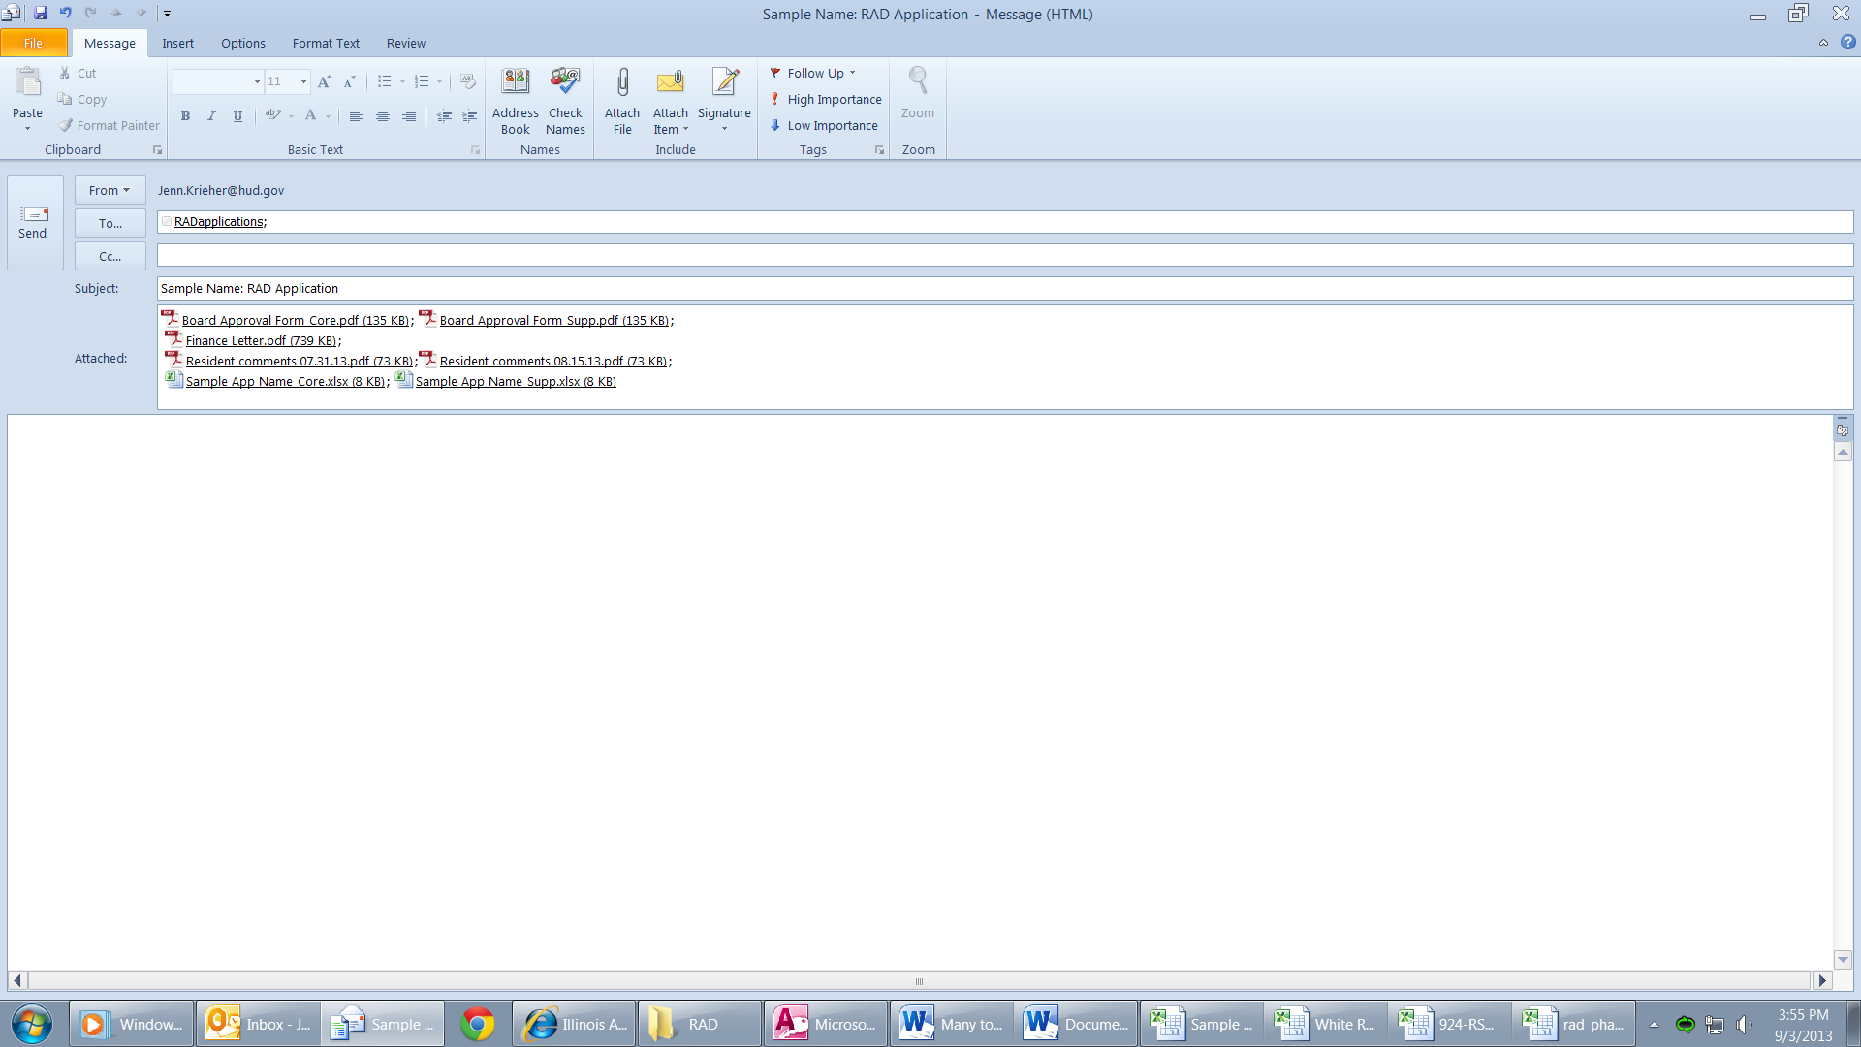Include Core and Supp (for supplemental) in the file names for the appropriate electronic applications and Board Approval Forms