Lender adminsitrative functions
For Lender Account Managers and Backup Account Managers

Table of Contents
How does the Lender Account Manager Give Backup Account Managers Access to the Portal: 2
How does the Lender Account Manager or Backup Account Manager Give Lender Account Representatives Access to the Portal: 6
How does the Lender Account Manager Give an Operator Access: 10

ACCESSING THE PORTAL

- To access the portal, go to the “232 Healthcare Portal” website under the “General Information” section:
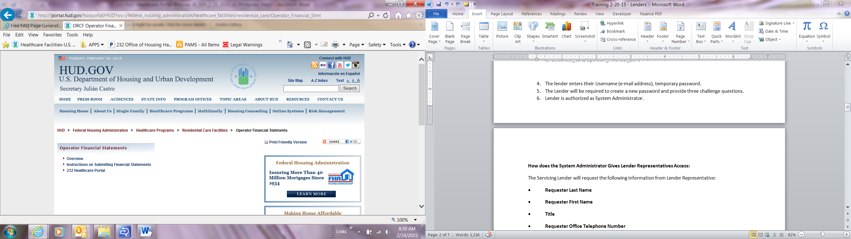

- Select Okay.
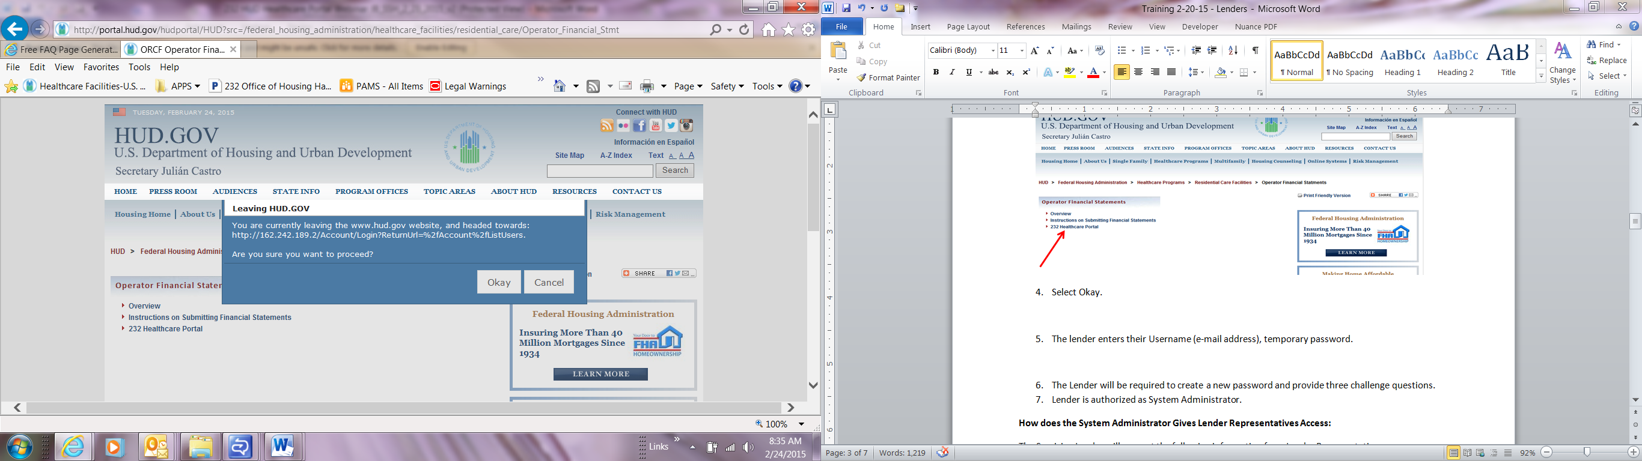

- You will be re-directed to the 232 Healthcare Portal.

HOW TO LOG INTO THE PORTAL

- Enter your Username (e-mail address) and password.

2. Click the “Log In” button.
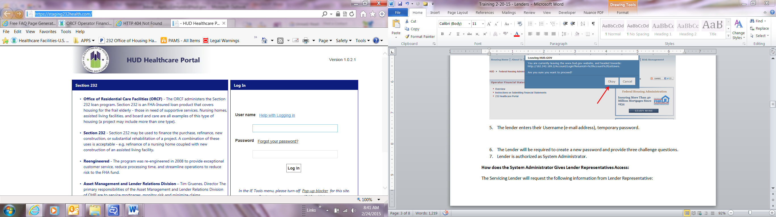

How does the Lender Account Manager Give Backup Account Managers Access to the Portal?
The Lender Account Manager will request the following information from Backup Account Manager:
• Requester Last Name
• Requester First Name
• Title
• Requester Office Telephone Number
• Requester Office Address
• City
• State
• Zip code
• E-mail Address
• Time Zone
• FHA number of the Facility or Facilities associated with
When the Lender Account Manager receives this information, he or she will create a new user account and assign roles and permissions to the new user. The Lender Account Manager will:
- Sign into the Portal

- Go to the Administration tab and select “Register”.
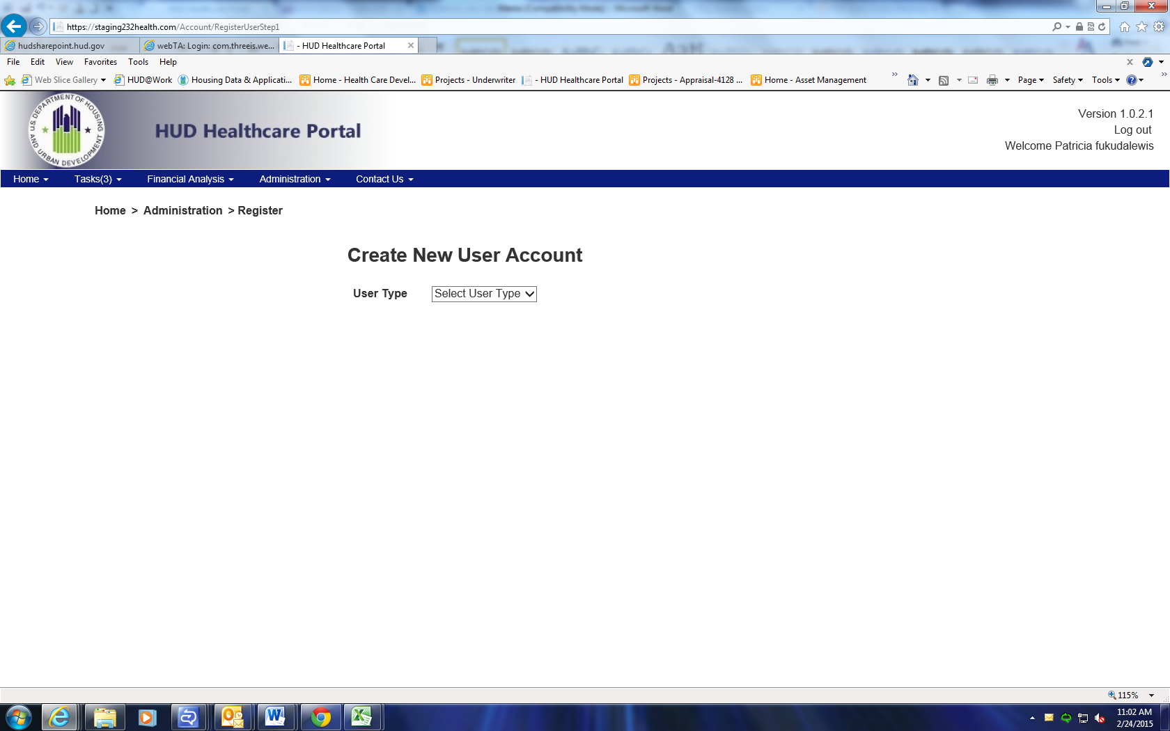

- Select “External user” for User Type.
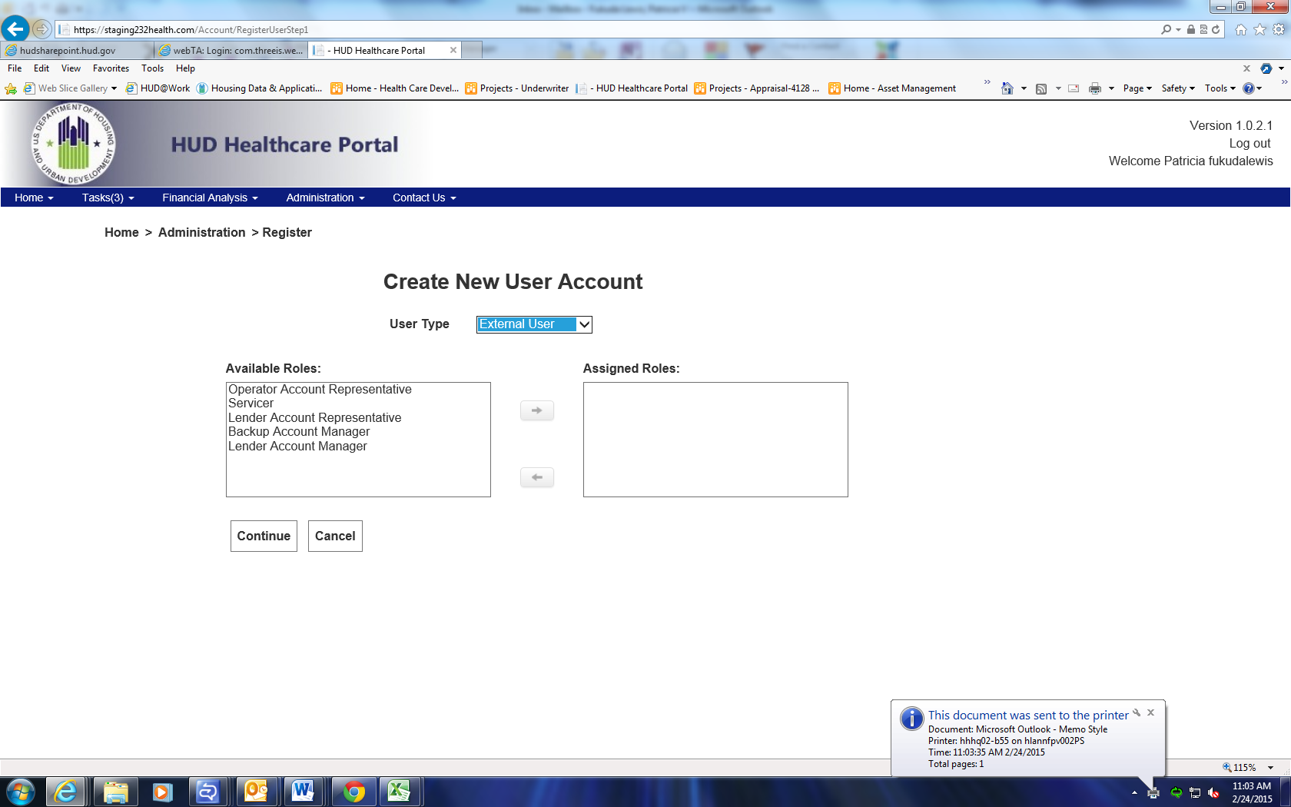

- Under Available Roles, select Backup Account Manager, to assign the Lender to the new role.
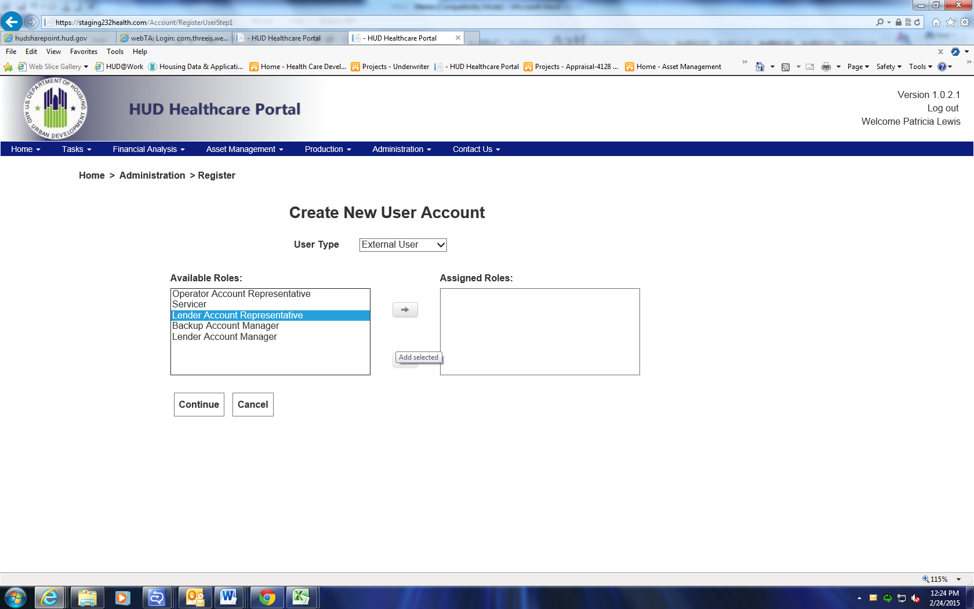
- Click the arrow to move the assigned role to the “Assigned Roles” box to the right.
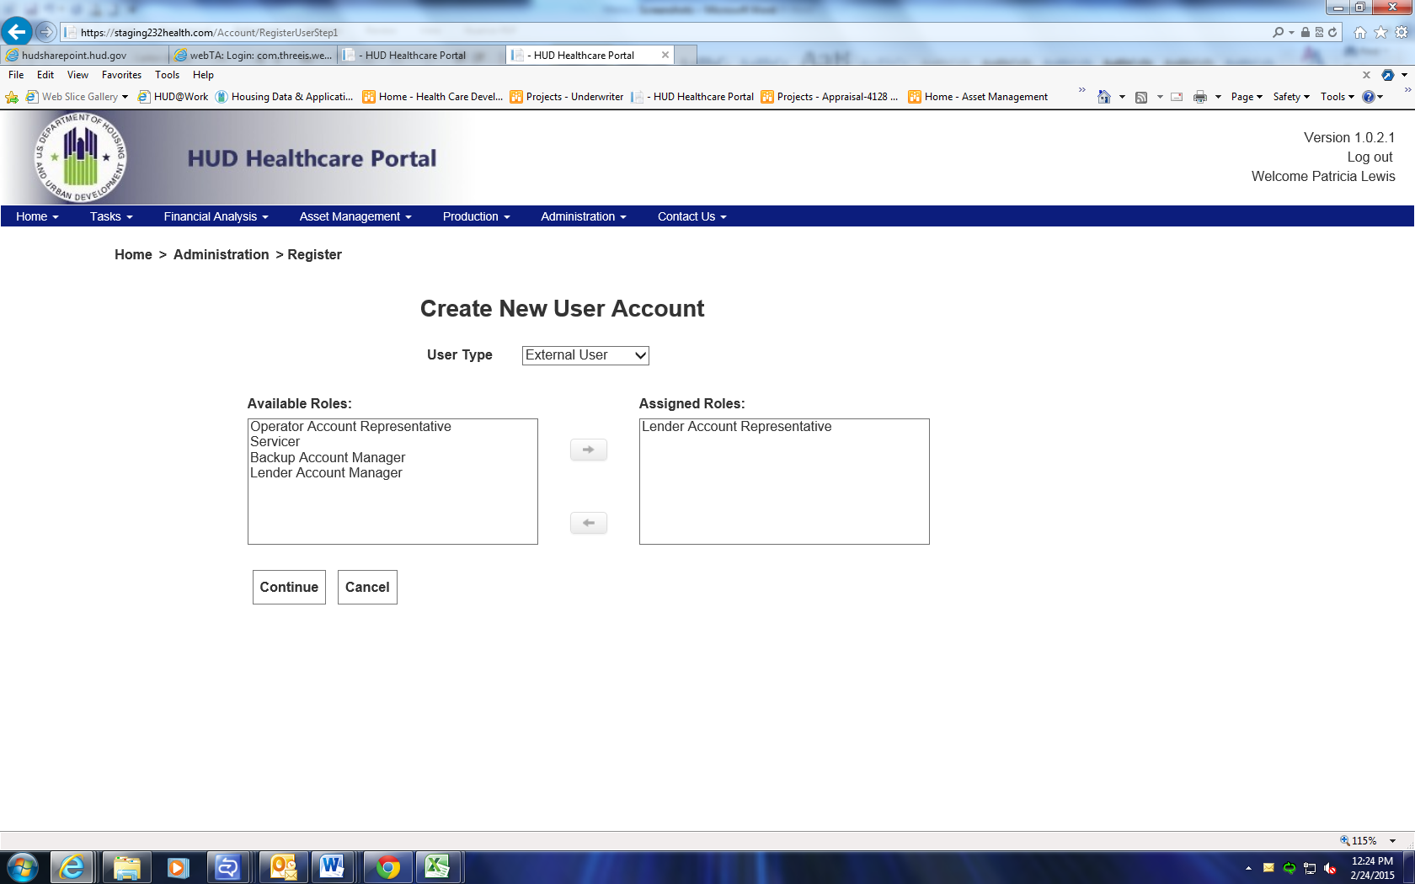
- Select the “Continue” button.
- Enter the required information.
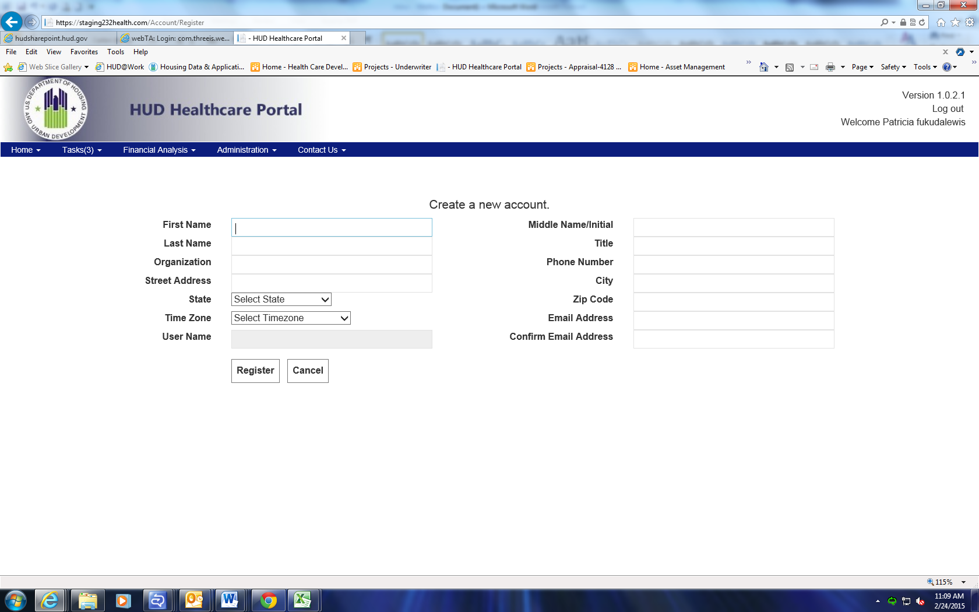
- Select “Register”.
- You will be taken back to the “Manage user” section of the Portal.

How does the Lender Account Manager or Backup Account Manager Give Lender Account Representatives Access to the Portal?
The Lender Account Manager will request the following information from Lender Account Representative:
• Requester Last Name
• Requester First Name
• Title
• Requester Office Telephone Number
• Requester Office Address
• City
• State
• Zip code
• E-mail Address
• Time Zone
• FHA number of the Facility or Facilities associated with
When the Lender Account Manager receives this information, he or she will create a new user account and assign roles and permissions to the new user. The Lender Account Manager will:
- Sign into the Portal

- Go to the Administration tab and select “Register”.

- Select “External user” for User Type.

- Under Available Roles, select Lender Account Representative, to assign the Servicer Lender to the new role.

- Click the arrow to move the assigned role to the “Assigned Roles” box to the right.
- Select the “Continue” button.

- Enter the required information.
- Select “Register”.
- You will be taken back to the “Manage user” section of the Portal.

How does the Lender Account Manager Give an Operator Access?
The Servicer will request the following information from the Operator:
• Requester Last Name
• Requester First Name
• Title
• Requester Office Telephone Number
• Requester Office Address
• City
• State
• Zip code
• E-mail Address
• Time Zone
• FHA number of the Facility or Facilities associated with

When the Lender Account Manager receives this information, he or she will create a new user account and assign roles and permissions to the HHcP. The Lender Account Manager will sign into the Portal and:
- Go to the Administration tab and select “Register”.

- Select “External user” for User Type.

- Under Available Roles, select Operator Account Representative to assign the Operator to the new role.
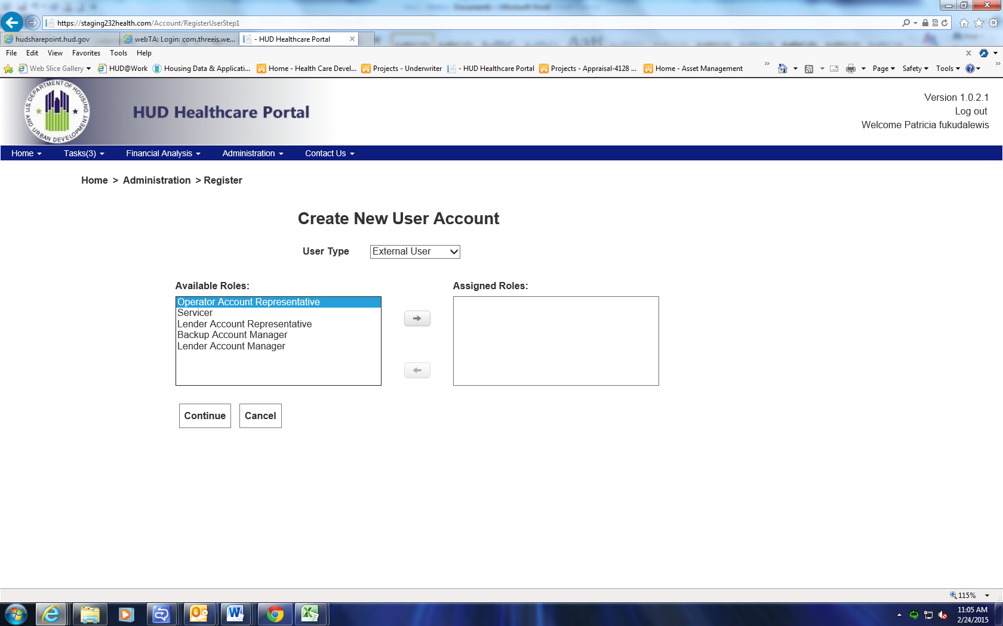

- Click the arrow to move the assigned role to the “Assigned Roles” box to the right.
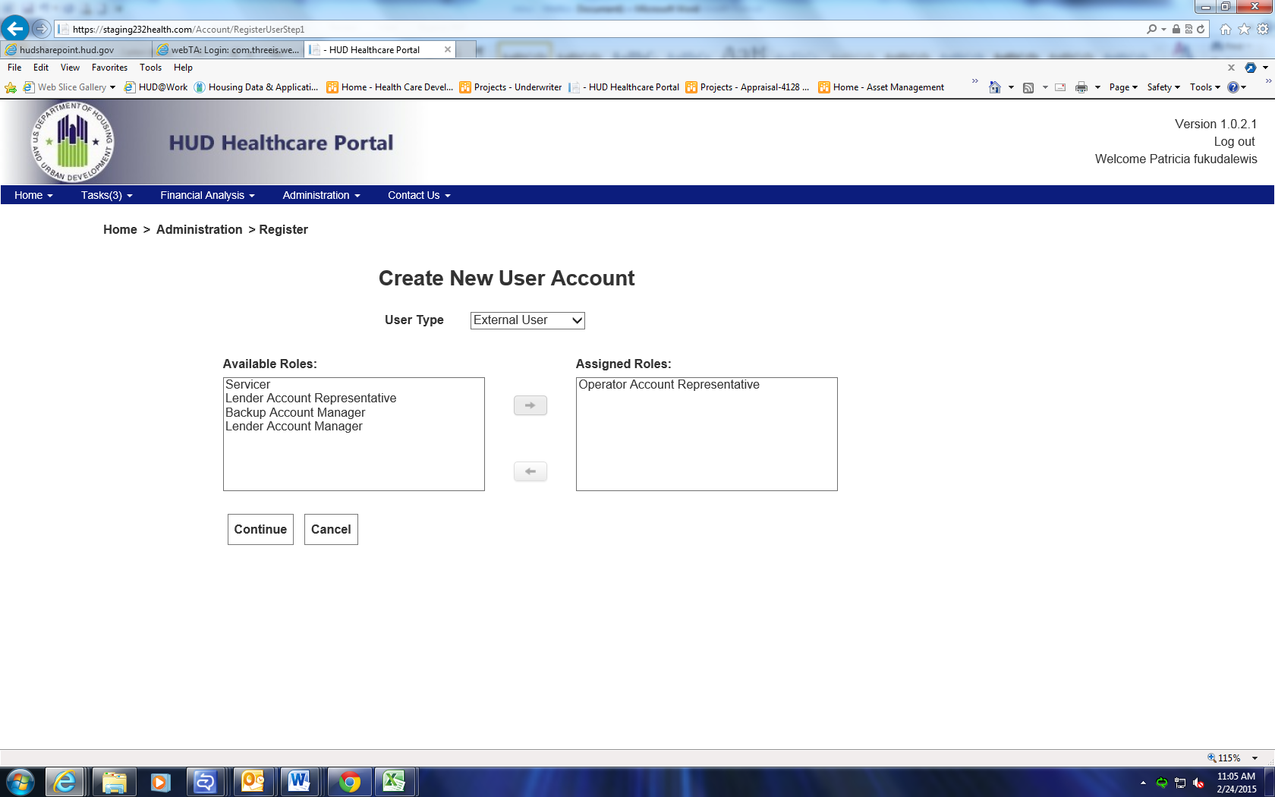

- Select the “Continue” button.

- Select the Servicer’s name in the “Available Lenders” box.
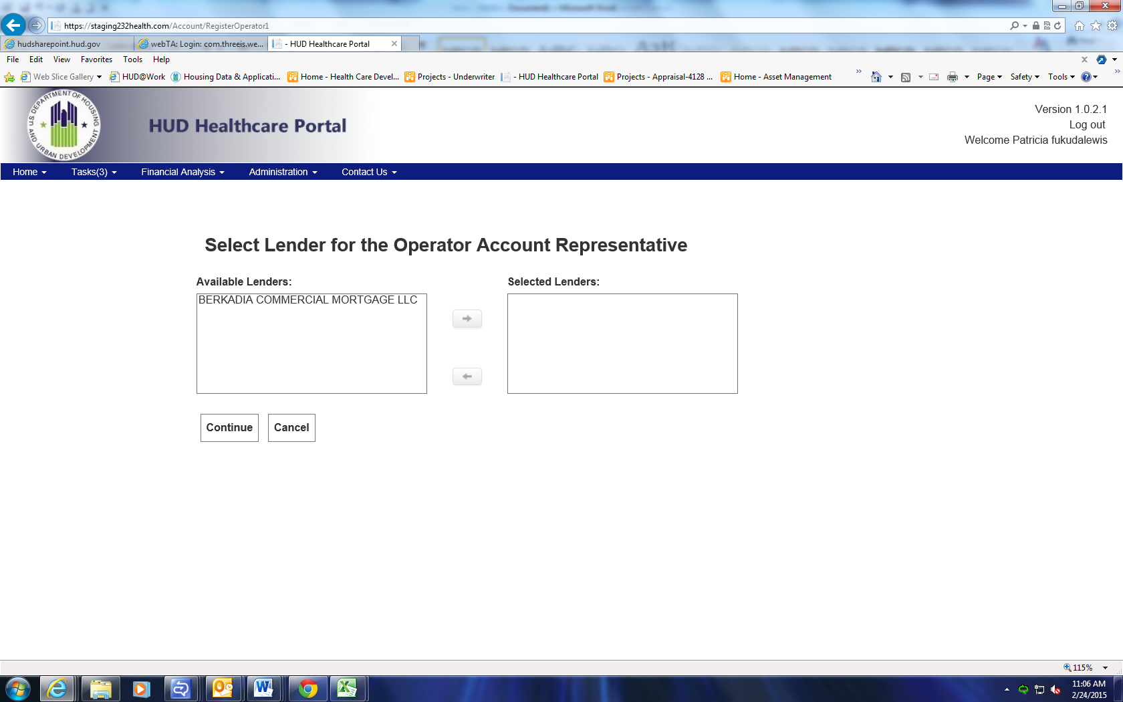

- Click the top arrow to move the “Available Lenders” name to the “Selected Lenders” box.
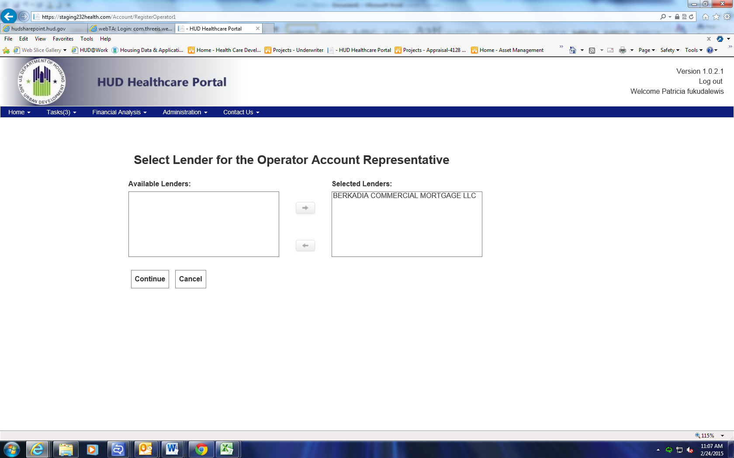
- Click “Continue”.

- Select the “Available FHA Number(s) to assign to the Operator.
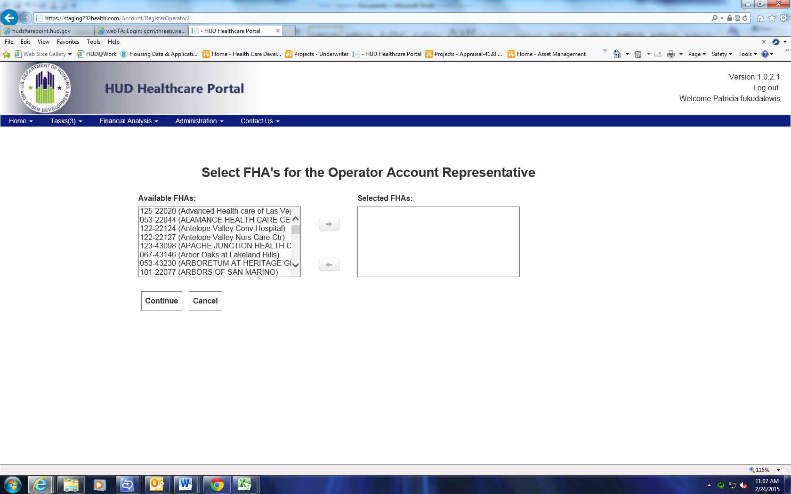

- Click the top arrow to move the “Available FHA” properties to the “Selected FHA” box.
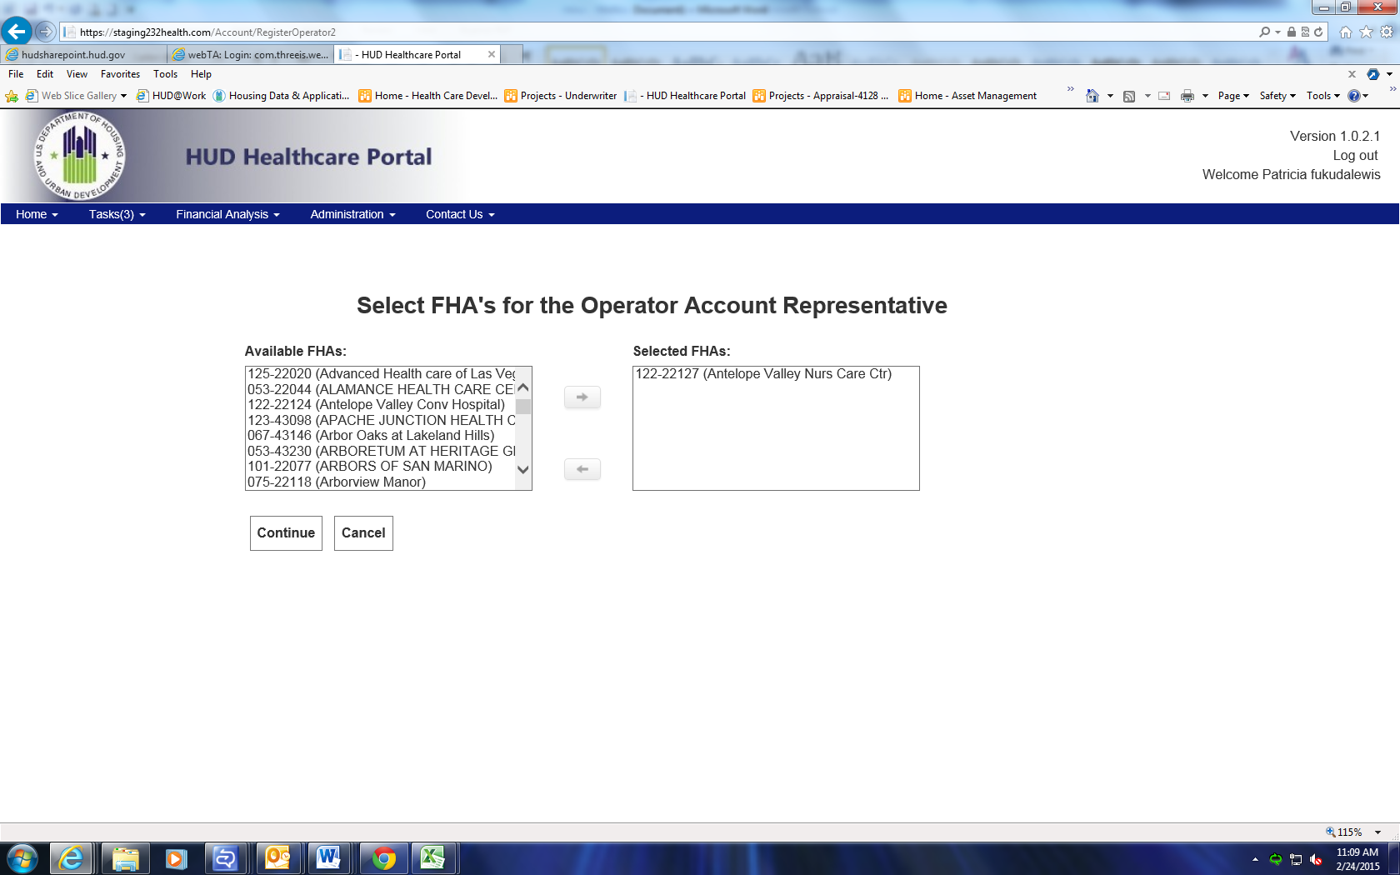
- Click “Continue”.
- Enter the required information obtained from the Operator.
- Select “Register”.

- You will be taken back to the “Manage user” section of the Portal.
