FAIR HOUSING DISCRIMINATION AND
MOBILE HOME PARKS

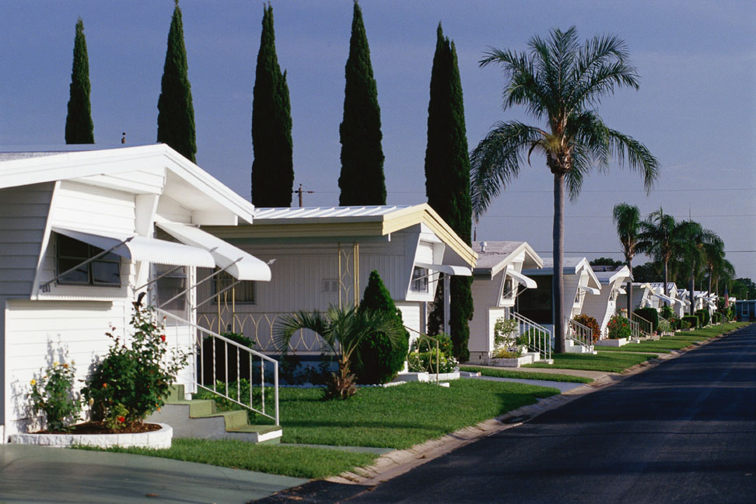

Legal Aid Society of

Palm Beach County
Fair Housing Project
TABLE OF CONTENTS

Introduction to Fair Housing Act 3

Discrimination Against Families
with Children 7

Discrimination Against Individuals
with Disabilities 10

Contacting a Mobile Home Park Owner
and Lease Agreements 13

Evictions 14

Guests 19

Duties of Residents and Park Owner 20
Remedies of Residents 21

Retaliation 22

Conclusion 23

INTRODUCTION TO FAIR HOUSING

Q: WHAT IS THE FAIR HOUSING ACT?

A: This law was passed by Congress in 1968 and prohibits discrimination based on race, color, sex, age, religion, disability, national origin or familial status for transactions involving real property.

Q: WHY IS THIS IMPORTANT TO ME?

A: Anyone who has been denied the opportunity to enter into a lease because of discrimination may be entitled to relief under the Fair Housing Act. This includes activities by mobile home park owners and landlords.

Q: WHAT CAN I DO IF I HAVE BEEN DENIED HOUSING BECAUSE OF DISCRIMINATION?

A: This booklet will explain your rights under the Fair Housing Act and how you may obtain relief (which may include money damages) from discrimination.

Q: How will I know that I have been discriminated against by the landlord or mobile home park owner?

A: Mobile home park owners and landlords are prohibited from discrimination under the Fair Housing Act. They are not allowed to do certain things, some of which are listed below:

Under the Federal Fair Housing Act, a landlord or mobile park owner may not…

- Refuse to rent or sell a mobile home to an individual based on race, color, religion, sex, familial status, national origin or disability.

- Refuse to negotiate for housing in a mobile home park.

- Make housing unavailable to an individual or family based on race, color, religion, sex, familial status, national origin, or disability.

- Establish different terms, conditions policies, and procedures for an individual or family based on race, color, religion, sex, familial status, national origin or disability.

- Provide different or separate housing facilities or services based on race, color, religion, sex, familial status, national origin or disability.

- Deny that housing is available for inspection or move in when in actuality the housing is ready and available for inspection.

- Persuade an owner to sell or rent their property for profit based on race, color, religion, sex, familial status, national origin or disability.

- Deny access to or membership in service or facility ordinarily provided to residents in the mobile home park community based on race, color, religion, sex, familial status, national origin or disability.

- Make, print, or distribute any statements, advertisements, or other printed material that discriminates on the basis of race, color, religion, sex, familial status, national origin or disability.

* In addition to the protections available under federal law, Palm Beach County also has an ordinance that prohibits discrimination against race, color, religion, sex, familial status, national origin, disability, sexual orientation, age, and marital status.

EXAMPLES OF CASES WHERE DISCRIMINATION WAS FOUND TO BE COMMITTED BY MOBILE HOME PARK OWNERS:

- Prohibition against prospective mobile home buyers with children from buying in a mobile home park. Mobile home park owner told prospective buyers that the park was an adult only community. Under Florida law, a 55+ or adult only mobile home park must register with the Florida Commission on Human Relations and establish specific guidelines for accepting new home buyers under the Fair Housing Act.

- Segregating individuals or families within the mobile home park on the basis of national origin or familial status.

FAMILIES WITH CHILDREN

Q: CAN A MOBILE HOME PARK PROHIBIT FAMILIES WITH CHILDREN FROM RENTING OR BUYING A MOBILE HOME OR LOT?

A: Generally, a Mobile Home Park may not prevent a family from residing in a Mobile Home Park. However, if the Mobile Home Park is registered with the Florida Commission on Human Relations as a 55+ community and follows specific guidelines established by HUD, then the Park may prohibit families with children.

Q: CAN A MOBILE HOME PARK FORCE MY FAMILY TO AN AREA OF THE PARK ASSIGNED FOR CHILDREN ONLY?

A: No! A Mobile Home Park may not limit families to certain areas of the Mobile Home Park.

Q: CAN A MOBILE HOME PARK CHARGE MY FAMILY A HIGHER RENTAL RATE BECAUSE I HAVE CHILDREN?

A: No! A Mobile Home Park may not charge families with children higher rental rates. Additionally, a Mobile Home Park may not charge families with children a higher security deposit than individuals without children. A Mobile Home Park must treat all owners or renters the same.

Q: WHAT ARE SOME EXAMPLES OF DISCRIMINATORY BEHAVIOR?

A: Here’s a couple:
- Beware of comments like, “Kids are nothing but trouble,” or, “Children can visit but can not live here.”
2. Restriction on the age of residents. A Mobile Home Park cannot prefer that residents be in a certain age range. For example, a Mobile Home Park cannot require that residents be in their late 20’s.
Q: ARE THERE ANY EXCEPTIONS?

A: Yes. If a Mobile Home Park is designated as a 55 and older only community then the Park may refuse to rent to families with children. However, a 55+ designation does not relieve the Mobile Home Park of its duty not to discriminate against other protected classes (sex, race, ethnicity, disability, etc.).

Q: HOW WILL I KNOW THAT A PARTICULAR MOBILE HOME PARK IS A 55+ COMMUNITY?

A: Mobile Home Parks that wish to operate as 55+ Communities must register with the Florida Commission on Human Rights. A list of communities that are designated as 55+ can be found on FCHR’s website. The FCHR’s website is: http://fchr.state.fl.us/

DISABILITY ACCOMMODATIONS

Q: WHO IS A DISABLED PERSON?
A: Anyone with a physical or mental impairment which substantially limits one or more of such person’s major life activities. You must also have a record of your disability.

Q: WHAT CONSTITUTES A MAJOR LIFE ACTIVITY?
A: A major life activity consists of caring for oneself, performing manual tasks, walking, seeing, hearing, speaking, breathing, learning, working, sitting, standing, lifting, reaching, sleeping and mental/emotional processes such as thinking, concentrating and interacting with others.

Q: WHAT IS A MODIFICATION?
A: A modification is a change to an existing structure which is necessary in order for someone with a disability to have enjoyment of the premises.

Q: WHAT IS AN ACCOMODATION OF DISABILITY?
A: An accommodation is a change to a policy or procedure that will help a disabled person enjoy the premises.

Q: How will I know that I have been discriminated against because of my disability?
A: The landlord should not refuse a
reasonable request for an
accommodation or modification.

Landlord may not refuse a disabled person’s reasonable request for an accommodation or modification to be completed at the tenant’s expense (where reasonable, the landlord may permit changes only if you agree to restore the property to its original condition when you move out).

- A disabled tenant may request approval to build a ramp at the entrance of his or her front door at his or her expense to ensure that easy access with his or her wheelchair.

- Landlord or Mobile Home Park may not refuse to allow a tenant’s medically necessary pet. For example, if your landlord or mobile home park has a no pet policy, you may request a reasonable accommodation of your disability in writing if the pet is medically necessary for the treatment of your physical or mental condition. An example of a medically necessary pet would be a dog that is trained to help individuals who are blind or otherwise visually impaired.

- Landlord or mobile home park may not prohibit the use of scooters or other mobility devices in the common areas of the mobile home park.

- It is not necessary to get the Mobile Home Park’s permission to make modification to the inside of the home, such as grab bars, when the tenant owns the home. When the tenant does not own the home, it will be necessary to request the accommodation from the owner of the mobile home.

- Changes to the outside of the Mobile Home must also be approved by Mobile Home Park, even if the Park does not own the home in some cases.

- The Mobile Home Park may also make exceptions to the parking rules to accommodate a disabled tenant and waive any fee for overnight guests.
CONTACTING THE MOBILE
HOME PARK OWNER

Q: I HAVE AN ISSUE OR PROBLEM AND WOULD LIKE TO ADDRESS IT WITH THE MOBILE HOME PARK OWNER, WHAT IS THE BEST WAY TO DO THIS?

A: The best way to communicate with the Mobile Home Park is by certified mail. Remember to keep copies of all letters sent to the Park Owner.

LEASES

Q: WHAT ARE SOME THINGS I SHOULD DO WHEN ENTERING INTO A LEASE AT A MOBILE HOME PARK?

A: Here is a checklist that should help you when entering into a lease:
- Always make sure that you have been given a copy of the lease before you agree to live in the Mobile Home Park.
- Read the lease carefully so that you understand all the terms. The terms must be fair and reasonable. If you are uncertain as to the meaning of any of terms in the lease, it is always a good idea to ask an attorney to explain them to you.
- Both the Park Owner and the Tenant must sign the lease.
- Any provision in a lease that attempts to waive or preclude the rights or remedies of the tenant will be unenforceable.

EVICTION

Q: I’M BEING EVICTED, WHAT DO I DO?

A: You should read all documents that you receive from the Courthouse, mobile home park, and the park’s attorney. If you do not feel that you will be able to represent yourself in the court process, you may need to consult with an attorney.
Q: WHAT REASONS CAN A PARK OWNER EVICT A RESIDENT?

A: There are only certain circumstances under which you could be evicted. They include failure to comply with a valid provision of the lease agreement, failure to pay rent, violation of a federal or state law that was harmful to the health, safety, or welfare of your neighbors, or violation of park rules and regulations.

Q: WHAT HAPPENS IF I HAVE BEEN SERVED NOTICE OF A VIOLATION OF A PARK RULE?

A: If you have been served a valid notice of violation of a Park Rule, you will have SEVEN (7) days to correct the problem.

In order for a notice of violation to be valid, it must be must be 1) made within 30 days of the alleged violation, 2) must be written, 3) clearly state what rule or regulation that you violated, and 4) must be posted on the premises and sent to you by certified or registered mail.
Florida Law states that delivery of the mailed notice shall be deemed given five (5) days after the date of the postmark.

Q: WHAT HAPPENS IF I HAVE MORE THAN ONE VIOLATION?

A: If you have violated the same valid rule or regulation twice within 12 months you may be evicted.

Q: CAN I BE EVICTED FOR A SINGLE VIOLATION OF A PARK RULE?

A: You can be evicted for a single violation of a Park Rule if a court finds that the violation endangered the life, health, safety, property, or peaceful enjoyment of the Park or your neighbors.

Q: HOW MUCH TIME SHOULD I BE GIVEN TO VACATE FOLLOWING A NOTICE OF EVICTION?

A: After the Court awards possession to the park owner, the clerk’s office will issue a Writ of Possession for the Sheriff’s Office to execute. However, the Writ of Possession may not be issued until ten (10) days after the Court issues a judgment against you. During this ten (10) day period, you should use this time to remove your personal belongings and trailer from the site.

Q: I HAVE BEEN SERVED NOTICE OF A VIOLATION, BUT EVERYONE ELSE VIOLATES THE SAME RULE, AND I AM THE ONLY ONE WHO HAS BEEN SERVED WITH A NOTICE, WHAT CAN I DO?

A: You cannot be evicted for violating a rule if the Park does not require everyone to comply with it. The Park cannot use a rule or regulation to single someone out.

If you feel that you are being singled out by the Park Owner because of your race, color, religion, sex, familial status, national origin or disability (also sexual orientation, age, marital status in Palm Beach County), you may be a victim of discrimination under the federal Fair Housing Act, Florida Fair Housing Act, or local ordinance prohibiting discrimination in housing.

Q: CAN I BE EVICTED IF PART OR THE ENTIRE PARK IN WHICH MY LOT IS LOCATED IS GOING TO BE USED FOR A PURPOSE OTHER THAN A MOBILE HOME LOT?

A: Yes. If this is the case, the Park Owner must give you at least six (6) months notice of the change in the use of the land. Under certain circumstances you may be entitled to payment from the Mobile Home Relocation Corporation.

Q: WHAT HAPPENS IF THE PARK OWNER APPLIES FOR REZONING OF THE PARK?

A: The rezoning request will not be approved by the government until an investigation into the adequacy of other Mobile Home Parks has taken place or has been completed. Within 5 days of filing a request to change the Park’s zoning, the Park has to give written notice of the proposed change to the tenants.

GUESTS

Q: WHO IS A GUEST?

A: Anyone who does not stay for more than 15 consecutive days or 30 days out of the year. The lease may also contain information regarding the number of persons living with you. The Park Owner may also require registration with the Park and/or a fee if you have visitors who stay longer than the allowed time.

Q: DO I HAVE TO RIGHT TO HAVE GUESTS?

A: Yes! The Park cannot prohibit you from having guests, or charge a fee for guests as long as they do not stay for a longer time that is allowed by the rules and regulations of the Park.

The Park can not treat residents unfairly because of the guest’s race, color, religion, sex, familial status, national origin or disability (sexual orientation, age, or marital status in Palm Beach County).

DUTIES OF RRESIDENTS

Q: WHAT ARE MY DUTIES AS A TENANT IN A MOBILE HOME PARK?

A: Tenants must pay the rent on time, comply with the Park Rules, keep their home within the applicable building and health codes, keep the lot clean, and conduct himself\herself in a manner that does not unreasonably disturb other residents.

DUTIES OF THE PARK OWNER

Q: WHAT ARE THE DUTIES OF THE PARK OWNER?

A: Some of the things that the Park Owner has to do include: complying with applicable building and health codes, maintaining and repairing common areas, providing access to the common areas at all reasonable times, and maintaining utility connection.
REMEDIES FOR RESIDENTS

Q: IF MY RIGHTS ARE VIOLATED OR THE PARK OWNER FAILS TO PERFORM A DUTY, WHAT MAY I DO?

A: You may hire an attorney, file a complaint with the Florida Department of Business and Professional Regulation’s Division of Mobile Homes or you may sue the Park Owner.

Q: IF MY RIGHTS ARE BEING VIOLATED OR THE PARK OWNER IS NOT PERFORMING THEIR DUTIES, DO I STILL HAVE TO PAY RENT?

A: Maybe. However, there must be a major noncompliance by the Park Owner that triggers the nonpayment of rent.

Q: IF I DECIDE TO WITHOLD RENT, DO I HAVE TO NOTIFY THE PARK OWNER OF MY INTENTION?

A: Yes. You must give the Park Owner written notice of your intention to withhold rent and allow the Park Owner 7 days (after the notice) to correct the problem. The best way to communicate with the Mobile Home Park is by certified mail. Remember to keep copies of all letters sent to the Park Owner. You should also give notice at least 7 days before the rent is due. This way the Park Owner has time to comply before the rent is due, otherwise, you may be liable for nonpayment of rent.

RETALIATION

Q: CAN THE PARK OWNER RETALIATE AGAINST ME BY RAISING THE RENT OR BY THREATENING TO EVICT ME FOR ASSERTING MY RIGHTS?

A: No! This type of conduct is illegal. You cannot be retaliated against for anything you have the legal right to do as long as you have acted in good faith and for proper reasons.

CONCLUSION

Q: I HAVE READ THIS BOOKLET AND HAVE DETERMINED THAT I MIGHT HAVE A FAIR HOUSING CLAIM, WHAT SHOULD I DO?

A: After reading this booklet you should have a basic idea of what your rights are under the Fair Housing Act. If you feel that you have a valid claim, please contact:

The Fair Housing Project at the Legal Aid Society of Palm Beach County
423 Fern Street, Suite 200
West Palm Beach, FL 33401
Phone: (561) 655-8944

U.S. Department of Housing and Urban Development (HUD)
909 SE First Ave, Room 500
Miami, FL 33131
Phone: (305) 536-4456

Palm Beach County Office of
Equal Opportunity
215 N. Olive Avenue, Suite 130
West Palm Beach, Florida 33401
Telephone: (561) 355-4883
This book was made possible with the support of the U.S. Department of Housing and Urban Development.

