This Word document contains an interactive form you can complete and e-mail for submission of form HUD-50075.1, Annual Statement/Performance and Evaluation Report.

This form has been constructed to calculate the totals on Line 20 of Page 1. Enter the requested amounts for lines 1 through 19. When you have finished entering these amounts, highlight line 20 then press the F9 key. The totals will automatically be reflected in line 20.

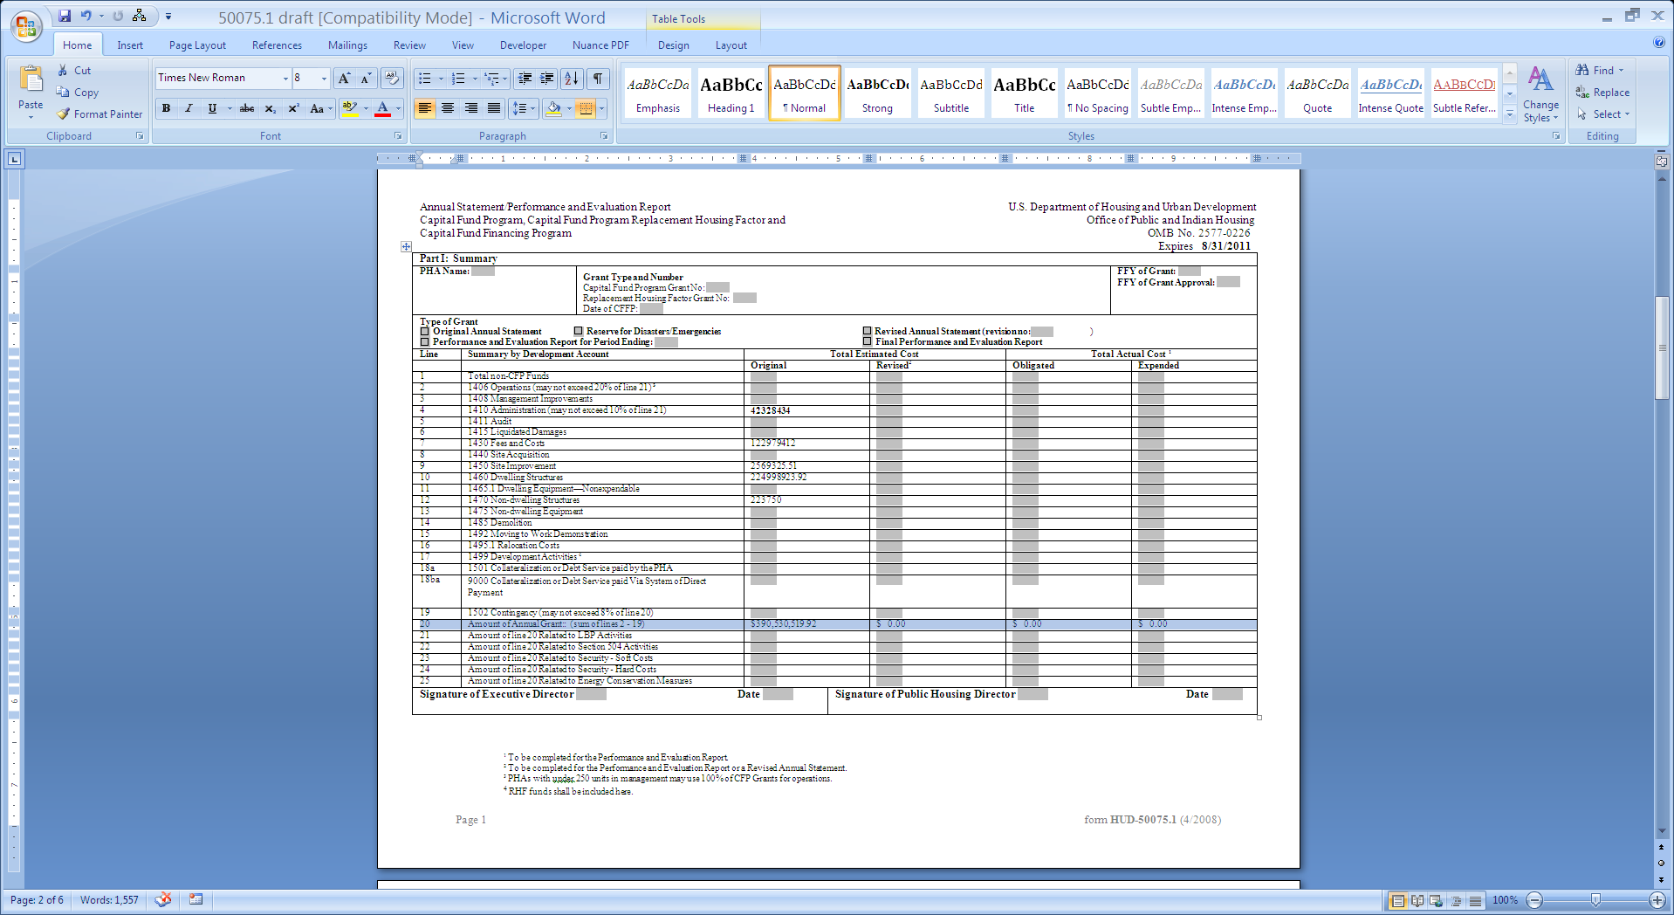

Annual Statement/Performance and Evaluation Report U.S. Department of Housing and Urban Development
Capital Fund Program, Capital Fund Program Replacement Housing Factor and Office of Public and Indian Housing
Capital Fund Financing Program OMB No. 2577-0226
Expires 8/31/2011
Part I: Summary
PHA Name: |  | Grant Type and Number  Capital Fund Program Grant No:  Replacement Housing Factor Grant No:  Date of CFFP: |  |  |  |  | FFY of Grant:  FFY of Grant Approval:
Type of Grant
Original Annual Statement Reserve for Disasters/Emergencies Revised Annual Statement (revision no: )
Performance and Evaluation Report for Period Ending: Final Performance and Evaluation Report
Line | Summary by Development Account |  | Total Estimated Cost |  |  | Total Actual Cost ¹
 |  |  | Original |  | Revised² | Obligated |  | Expended
1 | Total non-CFP Funds
2 | 1406 Operations (may not exceed 20% of line 21) ³
3 | 1408 Management Improvements
4 | 1410 Administration (may not exceed 10% of line 21)
5 | 1411 Audit
6 | 1415 Liquidated Damages
7 | 1430 Fees and Costs
8 | 1440 Site Acquisition
9 | 1450 Site Improvement
10 | 1460 Dwelling Structures
11 | 1465.1 Dwelling Equipment—Nonexpendable
12 | 1470 Non-dwelling Structures
13 | 1475 Non-dwelling Equipment
14 | 1485 Demolition
15 | 1492 Moving to Work Demonstration
16 | 1495.1 Relocation Costs
17 | 1499 Development Activities ⁴
18a | 1501 Collateralization or Debt Service paid by the PHA
18ba | 9000 Collateralization or Debt Service paid Via System of Direct Payment
19 | 1502 Contingency (may not exceed 8% of line 20)
20 | Amount of Annual Grant:: (sum of lines 2 - 19) |  | $ 0.00 |  | $ 0.00 | $ 0.00 |  | $ 0.00
21 | Amount of line 20 Related to LBP Activities
22 | Amount of line 20 Related to Section 504 Activities
23 | Amount of line 20 Related to Security - Soft Costs
24 | Amount of line 20 Related to Security - Hard Costs
25 | Amount of line 20 Related to Energy Conservation Measures
Signature of Executive Director Date |  |  |  | Signature of Public Housing Director Date

¹ To be completed for the Performance and Evaluation Report.
² To be completed for the Performance and Evaluation Report or a Revised Annual Statement.
³ PHAs with under 250 units in management may use 100% of CFP Grants for operations.
⁴ RHF funds shall be included here.

Annual Statement/Performance and Evaluation Report U.S. Department of Housing and Urban Development
Capital Fund Program, Capital Fund Program Replacement Housing Factor and Office of Public and Indian Housing
Capital Fund Financing Program OMB No. 2577-0226
Expires 8/31/2011

Part II: Supporting Pages
PHA Name: |  | Grant Type and Number  Capital Fund Program Grant No:  CFFP (Yes/ No):  Replacement Housing Factor Grant No: |  |  |  |  | Federal FFY of Grant:
Development Number Name/PHA-Wide Activities | General Description of Major Work Categories |  | Development Account No. | Quantity | Total Estimated Cost |  |  | Total Actual Cost |  | Status of Work
 |  |  |  |  | Original | Revised ¹ |  | Funds Obligated² | Funds Expended²
¹ To be completed for the Performance and Evaluation Report or a Revised Annual Statement.
² To be completed for the Performance and Evaluation Report.

Annual Statement/Performance and Evaluation Report U.S. Department of Housing and Urban Development
Capital Fund Program, Capital Fund Program Replacement Housing Factor and Office of Public and Indian Housing
Capital Fund Financing Program OMB No. 2577-0226
Expires 8/31/2011

Part II: Supporting Pages
PHA Name: |  | Grant Type and Number  Capital Fund Program Grant No:  CFFP (Yes/ No):  Replacement Housing Factor Grant No: |  |  |  |  | Federal FFY of Grant:
Development Number Name/PHA-Wide Activities | General Description of Major Work Categories |  | Development Account No. | Quantity | Total Estimated Cost |  |  | Total Actual Cost |  | Status of Work
 |  |  |  |  | Original | Revised ¹ |  | Funds Obligated² | Funds Expended²
¹ To be completed for the Performance and Evaluation Report or a Revised Annual Statement.
² To be completed for the Performance and Evaluation Report.

Annual Statement/Performance and Evaluation Report U.S. Department of Housing and Urban Development
Capital Fund Program, Capital Fund Program Replacement Housing Factor and Office of Public and Indian Housing
Capital Fund Financing Program OMB No. 2577-0226
Expires 8/31/2011

Part III: Implementation Schedule for Capital Fund Financing Program
PHA Name: |  |  |  |  | Federal FFY of Grant:
Development Number Name/PHA-Wide Activities | All Fund Obligated  (Quarter Ending Date) |  | All Funds Expended  (Quarter Ending Date) |  | Reasons for Revised Target Dates ¹
 | Original Obligation End Date | Actual Obligation End Date | Original Expenditure End Date | Actual Expenditure End Date

¹ Obligation and expenditure end dated can only be revised with HUD approval pursuant to Section 9j of the U.S. Housing Act of 1937, as amended.

Annual Statement/Performance and Evaluation Report U.S. Department of Housing and Urban Development
Capital Fund Program, Capital Fund Program Replacement Housing Factor and Office of Public and Indian Housing
Capital Fund Financing Program OMB No. 2577-0226
Expires 8/31/2011

Part III: Implementation Schedule for Capital Fund Financing Program
PHA Name: |  |  |  |  | Federal FFY of Grant:
Development Number Name/PHA-Wide Activities | All Fund Obligated  (Quarter Ending Date) |  | All Funds Expended  (Quarter Ending Date) |  | Reasons for Revised Target Dates ¹
 | Original Obligation End Date | Actual Obligation End Date | Original Expenditure End Date | Actual Expenditure End Date

¹ Obligation and expenditure end dated can only be revised with HUD approval pursuant to Section 9j of the U.S. Housing Act of 1937, as amended.

