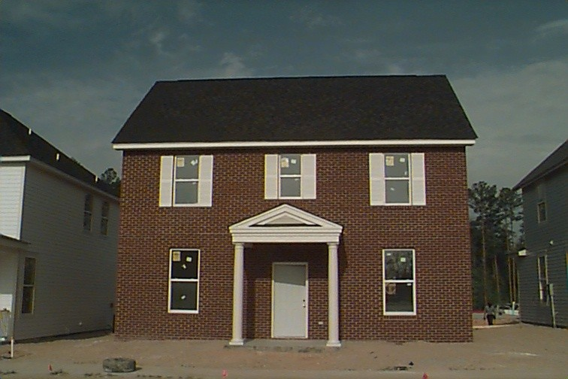

How community and faith-based organizations can help?
Faith-based and community-based organizations are the new partners in community development, holding promises and hope for the revitalization of America’s communities. Faith-based organizations are tackling difficult community issues, such as creating affordable housing for families and generating wealth through economic development.
How can communities and faith-based organizations be linked?
Section 3 is a successful integration of governmental and community resources working together to maximize economic opportunities for the targeted populations. The key to successful implementation of Section 3 lies in

- Partnering with community and faith- based organizations and advocacy groups
- Sharing information
- Obtaining community input
- Creating employment, training and support service programs that are dedicated to assisting low and very-low income persons achieving self-sufficiency and ultimately homeownership.

How can businesses and residents pursue an alleged violation of Section 3?
You can file a written complaint with your local HUD Field Office or mail it to:
The Assistant Secretary
for Fair Housing and Equal Opportunity
Attn: Office of Economic Opportunity
U.S Department of Housing
and Urban Development
451 7th Street, SW
Washington, DC 20410

A written complaint should include the name and address of the person filing the complaint and the name and address of the individual or group who allegedly violated Section 3 statues, a description of the acts or omission of acts, and the corrective action sought i.e. training, employment and contracting opportunities.

U.S. Department of Housing and Urban Development
Office of Fair Housing and Equal Opportunity
Office of Economic Opportunity
451 7th Street SW
Washington, DC 20410
202-708-3633
TTY/TDD 1-800-877-8339
http://www.hud.gov/offices/fheo/section3/section3.cfm
U.S. Department of Housing and Urban development

Section 3

Putting the Pieces Together
towards Homeownership

Employment
Opportunities
Job Training
Opportunities

Entrepreneur
Opportunities
Contracting
Opportunities

Bridging Communities Together Through Self Sufficiency & Homeownership

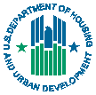
U.S. Department of Housing Fair Housing and Equal
and Urban Development Opportunity
DRAFT

What is Section 3?
Section 3 is a provision of the Housing and Urban Development (HUD) Act of 1968 that requires recipients of certain HUD financial assistance to help low-income residents gain the skills and jobs needed to become self-sufficient. The program also requires that qualified, low-income business owners be awarded work on HUD-funded contracts.
Who are Section 3 residents?
- Public housing residents
- Low and very-low income persons who live in the area where a HUD-assisted project is located
What is a Section 3 business?
A business that:
- Is owned primarily by Section 3 residents (51% or more); or
- Employs Section 3 residents; or
- Subcontracts with businesses which provide economic opportunities to low and very low income persons

What types of economic opportunities are available?
- Jobs
- Life-skills and vocational training
- Contracts
What programs are covered?
Section 3 applies to HUD-funded Public and Indian Housing projects for:
- Development,
- Operating, and
- Modernization expenditures.
Section 3 also applies to certain HUD-funded Housing and Community Development projects that complete:
- Housing rehabilitation,
- Housing construction, and
- Other public construction.
Any employment resulting from these expenditures is subject to compliance with Section 3. This includes jobs in:
- Administration
- Clerical support
- Construction
- Management

How does Section 3 promote self- sufficiency?
Section 3 lays the groundwork for obtaining training, employment, and contracting opportunities. This integral starting point coupled with other resources
- Federal, state, and local programs
- Community and faith-based organizations
- Advocacy groups
provides the opportunity for economic advancement and self-sufficiency.
How does Section 3 promote homeownership?
Section 3 is the starting point to self -sufficiency. Once a Section 3 resident has obtained employment or contracting opportunities they have completed a first step to self-sufficiency.
Remember, “It doesn’t have to be fields of dreams.” Homeownership is achievable. For more information visit our website at:
http://www.hud.gov.

