U.S. Department of Housing and Urban Development
Office of Public and Indian Housing

______________________________________________________________________________

Special Attention of: | Notice: PIH 2012-4 (HA)
Public Housing and Section 8 Program Administrators, Public Housing Hub Office Directors; Public Housing Field Office Directors; Program Center Coordinators;  Resident Management Corporations; Resident Councils; Participants of Public Housing, Housing Choice Voucher, Project-Based Certificate, and Project-Based Voucher Programs; Section 8 Property Owners and  Landlords | Issued: January 1, 2012  Expires: Effective until amended, superseded, or rescinded  Cross References: 24 CFR 5.233, HUD OIG Audit Report Number 2010-FW-0001

SUBJECT: Effective Use of the Enterprise Income Verification (EIV) System’s Deceased Tenants Report to Reduce Subsidy Payment & Administrative Errors

- Purpose. This notice explains the procedures Public Housing Agencies (PHAs) are required to implement to deal with families with deceased household members. The implementation of the procedures outlined in this notice will ensure that PHAs successfully submit accurate data to HUD via the Public and Indian Housing Information Center (PIC) and that PHAs do not make subsidy overpayments on behalf of deceased single member households. Where overpayments have been made, the PHA will recoup the overpayment from the landlord/owner of the rental property under the programs noted in Section 2 of this notice, with the exception of the Public Housing program. This notice supersedes PIH Notices
2010-50 and 2010-09.

- Applicability. This Notice applies to the following HUD-PIH rental assistance programs: Public Housing, Section 8 Moderate Rehabilitation, Project-Based Voucher, Project-Based Certificate; and Housing Choice Voucher programs.

- Background. In January and September, 2008, the Department encouraged PHAs to utilize the Deceased Tenants Report available in the Enterprise Income Verification (EIV) system. In a letter sent to all PHA Executive Directors, the Department urged PHAs to use the report on a monthly basis to assist in identifying families with deceased household members, and reduce the occurrence of paying housing assistance on behalf of deceased single member households. The Department also urged all PHAs to take appropriate corrective actions to address families with deceased household members and update the form HUD-50058 (Family Report) to reflect accurate household composition and transmit the updated form HUD-50058 in a timely manner.

HUD continues to provide formal and informal guidance and training via PIH notices, email and webcast, related to effective use of the EIV system, including the Deceased Tenants Report.

Many PHAs have taken corrective actions to transmit more accurate data to HUD via PIC, and have reduced the number of deceased single member households continuing to receive improper rental assistance. PHAs with zero deceased household members reported on the Deceased Tenants Report are to be commended for their efforts.

However, there are some PHAs that have not followed HUD’s informal guidance. According to HUD’s Office of Inspector General (OIG) audit report number 2010-FW-0001, issued on November 29, 2009, PHAs paid approximately $7 million in questionable housing assistance payments for deceased tenants in single member households. The OIG also determined that PHAs did not update family composition on the form HUD-50058 in a timely manner, which resulted in incorrect information in PIC.

In accordance with the new regulatory requirement at 24 CFR 5.233(a)(2)(ii), which became effective on January 31, 2010, under the Final Rule: Refinement of Income and Rent Determination Requirements in Public and Assisted Housing Programs: Implementation of the Enterprise Income Verification System-Amendments, published at 74 FR 68924 on December 29, 2009, all PHAs are required to use the EIV system to reduce administrative and subsidy payment errors in accordance with HUD administrative guidance. Accordingly, HUD is issuing this formal guidance to ensure that PHAs:

- Use EIV’s deceased tenant information for effective decision making, corrective action implementation, and reporting activities;
- Implement policies and procedures to minimize erroneous subsidy payments on behalf of deceased single member households; and
- Provide accurate and reliable information to HUD via PIC in a timely manner.

- Effective Date. This notice is effective upon issuance and remains in effect until amended, superseded, or rescinded.

- Monitoring Deceased Tenants. PHAs must generate the Deceased Tenants Report at least once a month. The purpose of generating the Deceased Tenants Report monthly is to prevent, eliminate and/or recover improper payments being made on behalf of deceased Section 8 tenants and ensure PHAs are aware of unoccupied public housing units which must be prepared for occupancy and made available for occupancy by the next eligible family. PHAs who administer Section 8 programs are required to generate the report prior to disbursing the upcoming monthly housing assistance payment (HAP) to owners. PHAs who administer the public housing program are required to generate the report when generating the new monthly rent roll to flag deceased tenants. PHAs must review the report and follow up with the listed families immediately and take the necessary corrective actions outlined in section 8 of this notice.

- How to Access the Deceased Tenants Report: The Deceased Tenants Report identifies deceased household members (whose identity has been confirmed by the Social Security Administration (SSA))* who are included in the family’s composition (including single member deceased households) as reported on Section 3 (Family Composition) of the form HUD-50058. The death information is provided by the SSA. Single member deceased households are denoted with a red asterisk (*) after the member’s deceased date (see example one below). If the deceased date is listed as N/A, this means the date of death is not available (see example two below).

*The individual’s social security number (SSN), date of birth, and surname reported on the form HUD-50058 must match SSA’s database. Deceased information is not displayed for any individual whose EIV identity verification status is failed (including individuals with a PIC-generated alternate identification number).

Example 1:



Example 2:



Single Member Households. Effective April 19, 2010, EIV’s Deceased Tenants Report was modified to isolate deceased single member households in addition to the previous consolidated report which contained deceased single and multiple member households. This implemented system modification reduces PHA administrative burden in identifying deceased single member households.

Follow the following steps to access the Deceased Tenants Report:

1: To access the Deceased Tenant Report, log onto the EIV system at: https://hudapps.hud.gov/HUD_Systems. If you do not have access to the EIV system, complete and submit the EIV Access Authorization Form and Rules of Behavior and User Agreement (form HUD-52676) to the EIV Coordinator in your local HUD office. For more information, go to: http://portal.hud.gov/hudportal/HUD?src=/program_offices/public_indian_housing/programs/ph/rhiip/uivsystem.

2: Once logged into the system, scroll down the left side of the screen and double click on the Deceased Tenants Report link (located under the Verification Reports header). Select the program for which you desire to generate the report for (Public Housing, Section 8 or all PIH programs). You may also select a specific reexamination month; however, the system automatically defaults to All (which HUD recommends that you use). If you are responsible for more than one PHA, be sure to select the appropriate PHA code in the PHA drop down menu.
3: Double click the Get Report button. The report will then display on the screen and can easily be downloaded into Excel or printed for your convenience.

Note: WARNING: This report contains full social security numbers of tenants. You must ensure that this report is adequately safeguarded to prevent improper disclosure of personally identifiable information (PII) as provided in PIH Notice 2010-15, U.S. Department of Housing and Urban Development (HUD) Privacy Protection
Guidance for Third Parties.

Report Selection Criteria for Deceased Tenants Report

Program Type: The default selection is All PIH Program. However, the user may select: All PIH Programs, Section 8, or Public Housing

Household Type: The default selection is All Households. However, the user may select: All Households, Single Member Households, or Multiple Member Households.

Reexamination Month: The default selection is All. However, the user may select a specific month.

PHA: The default selection is your PHA. If you have multiple PHAs assigned to your user ID, be certain to select the applicable PHA for which you wish to generate the report.

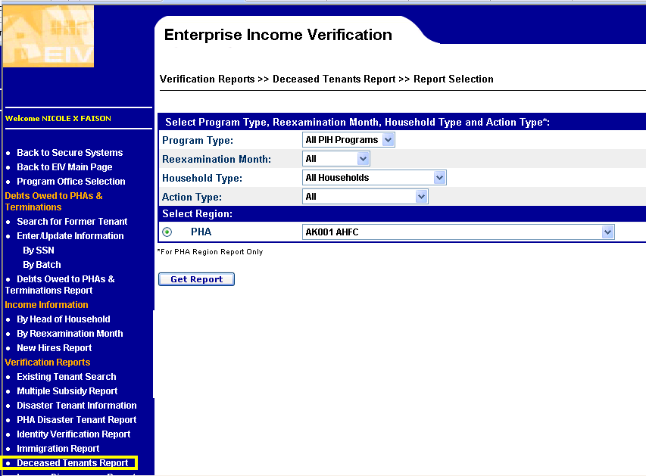

Sample Deceased Tenants Report

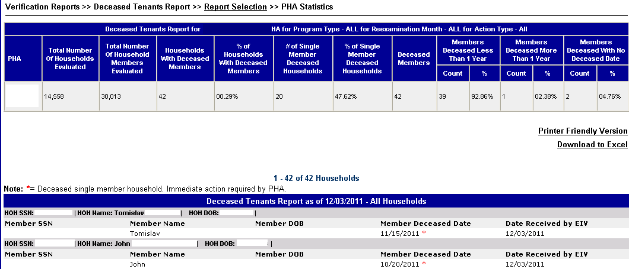

- Administrative Actions Required by PHAs: When the Deceased Tenants Report identifies an individual as being deceased, PHAs are required to take the following actions:

- Immediately send a letter to the head of household (HOH) or emergency contact person (if the HOH is deceased and there is no other adult household member) to confirm the death of the listed household member.

- Section 8 Programs only – Notify the owner in writing of the deceased HOH.

- Corrective Actions Required by PHAs for Single Member Households:

- Public Housing Program only: Conduct a home visit to determine if anyone is residing in the unit. (Optional for Section 8 program)

If there are unauthorized persons (including a live-in aide) in the unit of a deceased single member household you must pursue judicial intervention to have them lawfully removed from the unit. You may be found liable for a wrongful eviction if you change the locks on the unit to prevent the unauthorized occupants from entering the unit. Follow your local Tenant and Landlord laws to regain possession of the unit.

- Section 8 Programs only: For deceased single member households or a household where the remaining household member is a live-in aide, PHAs are required to discontinue HAP to the owner no later than the first of the following month after the month in which the death occurred. See Section 15 of this notice for determining amount of owner housing assistance overpayments.

Note: PHAs are required to immediately terminate program assistance for deceased single member households which will result in termination of the HAP contract and HAP to the owner in accordance with the aforementioned provisions. The owner is entitled to receive the full HAP amount for the month in which the death occurred.
The owner is not entitled to HAP for any month following the month in which the death occurred, with the exception of the Project-Based Voucher (PBV) program in accordance with 24 CFR 983.352(b).

- Project-Based Voucher (PBV) Vacancy Payments in Accordance with 24 CFR 983.352: For deceased single member households or a household where the remaining household member is a live-in aide, in accordance with the aforementioned regulatory provision, the owner of a unit subsidized under the PBV program is eligible to receive vacancy payments as outlined below:

- Payment for move-out month: if an assisted family moves out of the unit, the owner may keep the HAP payable for the calendar month in which the death of the HOH occurred.

- At the discretion of the PHA and in accordance with the PHA’s written policy, the HAP contract may provide for vacancy payments to the owner for a PHA-determined period of vacancy extending from the beginning of the first calendar month after the death of the HOH for a period not to exceed two (2) full months following the month in which the death occurred.

- The vacancy payment to the owner for each month of the maximum two-month period is determined by the PHA, and cannot exceed the monthly rent to owner under the assisted lease, minus any portion of the rental payments received by the owner (including amounts available from the tenant’s security deposit). Any vacancy payment may cover only the period the unit remains vacant.

- The PHA may make vacancy payments to the owner only if:

  - The owner submits a request for vacancy payments in the form and manner required by the PHA;
  - The owners gives the PHA prompt written notice certifying that to the best of the owner’s knowledge and belief, the HOH is deceased and the date of death;
  - The owner certifies that the vacancy is not the fault of the owner and that the unit was vacant during the period for which payment is claimed;
  - The owner certifies that it has taken every reasonable action to minimize the likelihood and length of vacancy; and
  - The owner provides any additional information required and requested by the PHA to verify that the owner is entitled to the vacancy payment and to determine the amount of any vacancy payment.

- What to do when the remaining household member is a live-in aide: When the HOH dies and the only remaining household member is the live-in aide, the live-in aide is not entitled or eligible for any rental assistance or continued occupancy in a subsidized unit. By definition, the live-in aide would not be living in the subsidized unit except to provide the necessary supportive services on behalf of the elderly or disabled HOH.

The PHA may not designate the live-in aide as the new HOH or change the relation code (line item 3h on the form HUD-50058) of the live-in aide to make him or her an eligible household member (eligible for assistance) nor pay HAP on behalf of the live-in aide for any month after the month in which the HOH died.

- What to do if the HOH is deceased and the remaining household members are minors: PHAs should have an established policy for dealing with situations when the HOH dies during tenancy and the remaining household members are minors. A common practice of PHAs includes (but is not limited to) allowing a temporary adult guardian to reside in the unit until a court-appointed guardian is established.

In accordance with its screening policies, the PHA may add the new guardian as the new HOH. PHAs are encouraged to work with the local Department of Social Services to ensure that the best interests of the children are addressed.

- What to do if an identified household member is incorrectly reported to be deceased: There are very few instances when an error has been made in the SSA’s Death Match File (DMF), where an individual is reported as deceased, but actually living. In the event that a household member is misidentified as deceased on the Deceased Tenants Report, PHAs should immediately notify the individual in writing and advise the individual to contact SSA so that SSA may correct its records. The individual may contact SSA at (800) 772-1213, or visit his/her local SSA office for assistance. Speech and/or hearing impaired individuals may call SSA’s toll-free telephone typewriter (TTY) number (800) 325-0778.

The PHA should also provide the individual with his/her section of the EIV Income Report, which shows the death information. PHAs are authorized to provide EIV information only to the individual the information pertains to. The PHA may provide the minor’s information to the minor’s adult parent or guardian.

Last, PHAs are required to make a note in the tenant file that the individual has been identified as deceased; however, the PHA has confirmed that the individual is actually alive.

Note: Only SSA can correct erroneous death information.

- Time frame for removal of individual from the Deceased Tenants Report: The individuals that appear on the Deceased Tenants Report are based on current information reported on the form HUD-50058. The Deceased Tenants Report is updated every weekend. A deceased individual will be removed from the report when:

  - The PHA transmits an updated form HUD-50058, that does not contain the previously identified deceased household member in Section 3 (Family Composition) of the form HUD-50058; or

  - HUD obtains the updated and corrected information from SSA’s DMF.

Example 1: Mr. Jones was listed on the Deceased Tenants Report dated December 3, 2011, with a deceased date of November 20, 2010.
On December 12, 2011, the PHA confirmed that Mr. Jones was actually alive and advised Mr. Jones to visit his local SSA office to have the error corrected. SSA corrected the DMF on December 29, 2011. When HUD conducted computer matching with SSA on January 10, 2012, HUD obtained new SSA data which indicated that Mr. Jones was not deceased. The Deceased Tenants Report was updated on the weekend of January 14, 2012. When the PHA accessed the Deceased Tenants Report on January 16, 2012, Mr. Jones was no longer on the report.

Example 2: Mr. Williams was listed on the Deceased Tenants Report dated December 17, 2011, with a deceased date of June 10, 2009. On January 6, 2012, the PHA confirmed that Mr. Williams was deceased. The PHA then completed and submitted an end of participation (EOP) form HUD-50058 on January 9, 2012. The Deceased Tenants Report was updated on the weekend of January 14, 2012. When the PHA accessed the Deceased Tenants Report on January 16, 2012, Mr. Williams was no longer on the report.

Type of Action and Effective Date to Record on Form HUD-50058: Below prescribes the applicable type of action and effective date the PHA is required to record on form HUD-50058 to report changes of family composition and income. PHAs are required to successfully submit an updated form HUD-50058 to PIC no later than 60 calendar days from the effective date of the action recorded on line 2b of the form HUD-50058 or no later than 60 days from the date EIV received the death information, whichever is sooner.

- Deceased Single Member Households. Once the PHA has confirmed the death of the HOH of a single member household or a household where the surviving household member is the live-in aide, the PHA is required to complete and successfully submit a form HUD-50058 with the following:

Line 2a – Type of Action = 6 (End of Participation)

Line 2b – Effective Date of Action = Date of Death from Deceased Tenants Report,
or as noted below. (If date is listed as “N/A”, enter the date of death as confirmed by
Obituary, Death Record, or other information obtained or as noted below.)

Section 8 programs: PHAs may list the EOP date as the last day of the
month in which the death occurred. The landlord is entitled to receive the full HAP amount for the month in which the tenant death occurred.

Public Housing program: PHAs are required to list the EOP date as of the date on
which the family or designee of the deceased tenant’s estate returned the keys and
signed a vacate notice; or the date the public housing lease was terminated; or the
date the PHA legally regained possession of the unit, whichever occurs first.

- Public Housing Deceased Single Member Households with Unauthorized Occupants in Possession of the Public Housing Unit. In instances in which there are unauthorized occupants in the public housing unit after the death of the HOH, the PHA must initiate litigation to regain possession of the public housing unit.

To remove the deceased HOH from the Deceased Tenants report in which there is pending litigation to regain possession of the public housing unit, the PHA is required to compete and successfully submit an updated form HUD-50058 to PIC as outlined in below authorized workaround and provide HUD with the below noted documentation

Authorized Workaround:

- The PHA will submit the following information to HUD Headquarters (HHQ) and a copy to the local HUD field office:

  - PHA Certification signed and dated by the Executive Director or designated official on the PHAs letterhead, which states the following:

    - I certify under the penalties of perjury that the attached list of head of household names are deceased, however, the Housing Authority has initiated litigation, which is currently pending, and has prevented the PHA from regaining possession of the public housing unit. I agree to submit an updated form HUD-50058 to PIC, in accordance with HUD guidance, once the PHA has regained possession of the public housing unit or the court has issued a final order.

    - I understand that HUD may request copies of court proceedings filed with the court and agree to furnish such documents and any other documents associated with the pending litigation upon written request of a HUD official.

  - A listing of the deceased HOHs in which there is pending litigation, the type of pending litigation (i.e. breach of lease, tenant holding over action, etc.) the date the litigation began and court –assigned case number.

    - PHAs must download the current EIV Deceased Tenants report into Excel (prior to implementing action item 3 below) to create the listing of deceased HOHs, however, the PHA must delete all tenant social security numbers before sending the file to HUD.

    - Add the following columns to the report and provide the applicable information:
      - Date Litigation Initiated
      - Court-Assigned Case Number
      - Type of Litigation

- Submissions must be emailed to PIH.RHIIP.TA@HUD.GOV, with a copy to the local HUD office within 60 calendar days of the date the PHA initiated litigation.
- The PHA will successfully submit an action type 3 (interim reexamination) form HUD-50058 to PIC in which the deceased HOH is removed from family composition and the current HOH information is listed as:

  - 3b, last name: Litigation
  - 3c, first name: Pending
  - 3d, middle initial: leave blank
  - 3e, date of birth: list same as initial HOH
  - 3g, Sex:, list same as initial HOH
  - 3i, citizenship: list same as initial HOH
  - 3j, disability: list same as initial HOH
  - 3k, race: list same as initial HOH
  - 3m, ethnicity: list same as initial HOH
  - 3n, social security number: create alternate ID using PIC Tenant ID Management tool
  - 3p, Alien registration Number: leave blank
  - 3w, former HOH SSN: list SSN of deceased HOH

- Multiple Household Members with Deceased Head of Household – Surviving Adult Household Member. Once the PHA has confirmed the death of the HOH, the PHA is required to complete and submit a form HUD-50058 with the following:

Line 2a – Type of Action = 3 (Interim Reexamination)

Line 2b – Effective Date of Action = Date of Death from Deceased Tenants Report (if date is listed as “N/A”, enter the date of death as confirmed by Obituary, Death Record, or other information obtained.) or other date in accordance with PHA interim reexam policy.

Line 3a (Member 01) - delete the deceased HOH’s information and enter the information of the adult household member who has been designated HOH.

Line 3a – delete the information of the other adult household member, whose information you entered on Line 3a (Member 01)

Line 3w – enter the Social Security Number (SSN) of the former (deceased) HOH.

- Multiple Household Members with Deceased Head of Household – with Surviving Minor Household Members. Once the PHA has confirmed the death of the HOH, the PHA is required to complete and submit a form HUD-50058 with the following:

Line 2a – Type of Action = 3 (Interim Reexamination)

Line 2b – Effective Date of Action = Date of Death from Deceased Tenants Report (if date is listed as “N/A”, enter the date of death as confirmed by Obituary, Death Record, or other information obtained.) or other date in accordance with PHA interim reexam policy.

Line 3a (Member 01) - delete the deceased HOH’s information and enter the adult household member’s information of the temporary or permanent guardian.

Line 3w – enter the Social Security Number (SSN) of the former (deceased) HOH.

- Other Household Changes. If, in scenario B or C above, there is also a change in family income and composition resulting in a change in the family’s total family share and/or unit size, the effective date on line 2b should be the effective date of the new total family share in accordance with PHA-established policies.

- Removal of Personal Belongings from Public Housing Unit (Applicable to the Public Housing program only): Upon notification of the death, either by HUD’s EIV system or a third party, the family or designee of the deceased tenant’s estate should be allotted a minimum of fourteen (14) consecutive days to remove personal belongings from the unit in accordance with the guidance below. This guidance is designed to afford families a reasonable time frame to remove personal belongings from the public housing unit and enable the PHA to prepare the unit, as quickly as possible, for occupancy by the next eligible family in need of affordable housing.

While there is no HUD requirement for the time frame allotted to the family or designee of the deceased tenant’s estate, HUD recommends an allotted time frame of fourteen (14) consecutive days, beginning the day after the date of notification, for the family or designee of the descendant’s estate to remove personal belongings from the public housing unit unless:

- There is a state or local law which requires a shorter or longer time frame to remove personal belongings. In those instances, the PHA must comply with local and/or state law; or

- The rent has been paid for the month in which the death occurs, in advance of the date of death. In those instances, the family or designee of the deceased tenant’s estate should be allotted time through the end of the month in which the rent has been paid, or fourteen consecutive days from the date the PHA is notified of the death, whichever is greater.

  - Example 1: As of August 1, 2011, Joe Jones has paid rent through August 31, 2011. Mr. Jones died on August 22, 2011, and the PHA is notified of the death by Mr. Jones’ sister on August 23, 2011. The family or designee of the deceased tenant’s estate has until
September 6, 2011, to remove personal belongings from the unit, unless state or local landlord laws authorize a shorter or longer time period.

  - Example 2: As of August 1, 2011, Mary Smith has paid rent through September 30, 2011. Ms. Smith died on August 22, 2011, and the PHA is notified of the death by a 3rd party on August 24, 2011. The family or designee of the deceased tenant’s estate has until September 30, 2011, to remove personal belongings from the unit, unless state or local landlord laws authorize a shorter or longer time period.

  - Example 3: As of August 1, 2011, John Doe has not paid rent for August 2011. Mr. Doe died on August 10, 2011, and the PHA is notified of the death by Mr. Doe’s friend on August 12, 2011. The family or designee of the deceased tenant’s estate has until August 26, 2011, to remove personal belongings from the unit, unless state or local landlord laws authorize a shorter or longer time period.

PHAs are reminded to comply with local and state established tenant-landlord laws with respect to lease termination, possession of premises upon death and removal of personal belongings from the public housing unit.

- Retroactive Repayment of HAP by Owners: If an owner receives HAP for any month in which the owner is ineligible to receive HAP because of a deceased tenant, the PHA must immediately notify the owner in writing of the ineligible HAP and require the owner to repay the overpayment to the PHA within 30 days. If the owner does not comply, the PHA may deduct the amount due to the PHA from any amounts due to the owner under any other HAP contract. If there is no other HAP contract with the owner, the PHA may seek and obtain additional relief by judicial order or action in accordance with state and local laws.

Example: The Deceased Tenants Report dated December 17, 2011, indicates that Mr. Robert died on March 9, 2011. The landlord/owner is not eligible for HAP in any month following March 2011. The PHA erroneously paid the landlord/owner HAP of $500 each month during the period of April 2011 through December 2011. The landlord/owner must repay the PHA $4,500 ($500 X 9 months).

In instances where a deceased single member household has been deceased for a period greater than one (1) month and the owner received HAP, the PHA may determine that the owner has breached the HAP contract. As such, the PHA may exercise any of its rights and remedies under the HAP contract, or any other available rights and remedies for such breach.

The PHA must notify the owner of such determination, including a brief statement of the reasons for the determination. The notice by the PHA to the owner may require the owner to take corrective action, as verified or determined by the PHA, by a deadline prescribed in the notice.
The PHA’s rights and remedies for owner breach of the HAP contract may include recovery of overpayments, suspension of HAP, abatement or other reduction of HAP, termination of HAP, and termination of all HAP contracts. The PHA may seek and obtain additional relief by judicial order or action, including specific performance, other injunctive relief or order for damages.

- HUD Recognition of PHAs’ Compliance with Effective Use of EIV’s Deceased Tenants Report: HUD may publicly recognize all PHAs with zero deceased tenants on the report as of December 31st, March 31st, June 30th, and September 30th by publishing the HUD-Designated EIV Stars online at: http://portal.hud.gov/hudportal/HUD?src=/program_offices/public_indian_housing/programs/ph/rhiip/uivsystem#stars, and distributing this list to the subscribers of the PIH.RHIIP.TA mailing list.

- Penalties for Non-Compliance with Use of EIV’s Deceased Tenants Report:

Section 8 Programs: If the PHA overpaid HAP on behalf of a single member deceased household and fails to collect the overpayment from the owner, the PHA is required to reimburse 100 percent of the overpayment to the HCV HAP account from the Administrative Fee Equity account, Central Office Cost Center (COCC) account, or other non-Federal funds. In addition, if such errors impacted any funding baseline determinations, funding for the affected renewal periods may be adjusted.

Note: A PHA cannot reimburse prior year HAP costs with current year HAP funding because the funding carries forward but does not carry back.

HUD will monitor each PHA’s Deceased Tenants Report on a quarterly basis and notify affected PHAs of the need to correct deficiencies and provide HUD with documentation of such corrections. PHAs may be subject to monetary sanctions for failure to 1) recover or attempt to recover improper subsidy payments made in error; 2) reimburse the Housing Choice Voucher (HCV) housing assistance payment (HAP) account for any unrecovered HAP overpayment; 3) correct noted deficiencies identified on the Deceased Tenants report in accordance with HUD regulations and/or administrative guidance; or 4) provide HUD-requested documents in response to a HUD notice.

If at any time HUD determines that the PHA has not taken the necessary corrective action(s) within 60 days of the date EIV received the death information, the PHA may be subject to a withholding of its monthly administrative fee each month that the number of single deceased household members is greater than zero.

Public Housing Program: HUD will monitor each PHA’s Deceased Tenants Report on a quarterly basis. If at any time HUD determines that the PHA has not taken the necessary corrective action(s) within 60 days of the date EIV received the information, the PHA may be subject to a monetary penalty, as determined by the Assistant Secretary, each month that the number of single deceased household members is greater than zero. HUD may offset the PHA’s monthly operating subsidy by the amount of the imposed penalty or require the PHA to pay the amount of the penalty from non-Federal funds, directly to HUD.

For any imposed penalty, HUD will notify the PHA in writing of such penalty and afford the PHA a 30-day period to appeal HUD’s decision. Appeals must be postmarked no later than 30 days from the date of the penalty notice and sent by certified mail or carrier service (UPS, FEDEX, DHL, etc.) to:

U.S. Department of Housing and Urban Development
Office of Public and Indian Housing
Real Estate Assessment Center
Attention: Nicole Faison
451 7th Street, SW, Room PCFL1
Washington, DC 20410

Appeals by fax or email will not be processed. HUD will provide a written response to your appeal request within 30 days of receiving the appeal request.

- EIV System Training: HUD offers free EIV system training via webcast and You Tube videos which can be viewed by staff at any time at: http://portal.hud.gov/hudportal/HUD?src=/program_offices/public_indian_housing/programs/ph/rhiip/piheivwebcasts. Past and future training opportunities, including training materials are available at: http://portal.hud.gov/hudportal/HUD?src=/program_offices/public_indian_housing/programs/ph/rhiip/training#3. As a condition of initial and continued EIV system access, all system users are required to view HUD Headquarters-provided EIV system training and complete annual Federal Information Systems Security (ISS) Awareness training offered online at: http://iase.disa.mil/eta/index.html#onlinetraining. Click on the Federal ISS Awareness (for non-DOD Personnel) icon to begin and complete the training. This training is not owned by HUD, therefore all inquiries or assistance with this training, must be obtained by visiting: http://iase.disa.mil/eta/iaetafaq.html#answer6. Once the individual has completed the online Federal ISS Awareness training, s/he must print and retain the certificate of completion, which may be subject to inspection and/or audit.

EIV system users must self-certify within the EIV system at the log-in page that the training has been completed. Staff is not required to possess a Certificate of Completion for EIV training in order to gain or continue accessing the EIV system, or be certified by the User Administrator on a semi-annual basis.

- For inquiries about this notice contact: your local HUD field office or Nicole Faison of HUD Headquarters’ Office of Public and Indian Housing: Real Estate Assessment Center at (202) 475-7963, or via email at PIH.RHIIP.TA@HUD.GOV. Persons with hearing or speech impairments may access the aforementioned number via TTY by calling the Federal Information Relay Service at (800) 877-8339.

- Paperwork Reduction Act: The information collection requirements contained in this Notice have been approved by the Office of Management and Budget (OMB under the Paperwork Reduction Act of 1995 (44 U.S.C. 3520) and assigned OMB control number(s) 2577-0083. In accordance with the Paperwork Reduction Act, HUD may not conduct or sponsor, and a person is not required to respond to, a collection of information unless the collection displays a currently valid OMB control number.

/s/
Sandra B. Henriquez, Assistant Secretary for
Public and Indian Housing

