HECM Delinquent Loan DATA Reporting PROCEDURES

The HECM Insurance Accounting Collection System (IACS) is being modified to support the reporting of HECM loans involving delinquent property charges and information related to corporate advances made by mortgagees for taxes, insurance or other delinquent property charges. The implementation of the modifications will be accomplished in two phases. This document addresses Phase I, for which the initial reporting must be completed by February 7, 2011. Information about Phase II will be provided after Phase I has been implemented.

Mortgagees must provide HUD with an MS-Excel file listing:
(1) 10-digit FHA mortgagee number
(2) Corporate advance payment type (i.e., tax, insurance or other)
(3) FHA case number
(4) Corporate advance amount and repayment amount
(5) Corporate advance and repayment transaction date
(6) First missed payment date
(7) Housing Counseling Referral – Yes or No

Mortgagees have the option of providing HUD with the “Name” of a HCA, insurance carrier, homeowners association, or taxing authority etc., in the initial reporting Excel file. However, mortgagees that do not provide a “Name” may update IACS at a later time.

The MS-Excel file should be submitted via email to: HECMAdmin@hud.gov. The HUD contractor will be responsible for processing the MS-Excel file on behalf of HUD. Once the file has been processed, the mortgagee will be notified and advised of any errors encountered.

Phase I

Phase I will involve modifications to four screens. The total corporate advance amount for each loan will be reflected in IACS upon completion and implementation of Phase II.

A description of each screen modification included in Phase I is presented below:
(1) The MU02 “Loan Maintenance Screen” will be modified to display a corporate advance flag (Y/N) which will indicate the existence of corporate advance(s) for this case. The corporate advance flag will be set to ‘N’ when the loan’s Corporate Advance balance is zero.
(2) The MI01 “Loan Balance Information Screen” will include a new field to display the corporate advance total.
(3) The MI14 “Loan Transaction History Screen” will include a new field to display the corporate advance total.
(4) The MI07” Loan Balance Advance Detail” will include a new field to display the corporate advance total.

Samples of the modified screens are provided in Attachment I, Screen Samples.

The file format presented below must be used by the mortgagee to send HUD the corporate advance information.

MS-Excel File Format for Corporate Advances
Column Number | Field Name | Description | Field Length | Format - Value
1 | Mortgagee ID | Servicer number of the loan. This field is required. Please ensure that there is no truncation of the field for data beginning with zero. | 10 | Numeric  XXXXXXXXXX
2 | Payment Type | Corporate advance payment type; Used to indicate whether the transaction amount is an advance or a repayment, and whether it is for taxes, insurance, or “other” amounts. This field is required.  The valid payment type values are described below:  1. ADV-TAX is a Corporate Advance payment for taxes.  2. ADV-INS is a Corporate Advance for insurance.  3. ADV-OTH is a Corporate Advance for other payment types.  4. RPY-TAX is a repayment of an amount advanced for taxes.  5. RPY-INS is a repayment of an amount advanced for insurance.  6. RPY-OTH is a repayment of an amount advanced for “other” purposes. | 7 | Alpha  ADV-TAX  ADV-INS  ADV-OTH  RPY-TAX  RPY-INS  RPY-OTH
3 | Case Number | FHA case number. This is a required field. The hyphen must be included with the case number. Please ensure that there is no truncation of the field for data beginning with zero. | 11 | Numeric and Hyphen  NNN-NNNNNN
4 | Amount | Corporate advance amount, which has six digits to the left of the decimal and the two digits to right of the decimal point. Entry of a (+) or (-) sign is required. Enter a (+) sign for a corporate advance transaction. Enter a (-) sign for a repayment transaction.  (The ‘$’ sign should not be entered.) | 9 | Numeric  000000.00+  000000.00-
5 | Transaction  Date | Date that the corporate advance payment was issued or repaid. This is a required field. Please ensure that there is no truncation of field for data beginning with zero. | 6 | Date  MMDDYY
6 | First Missed Payment Date | The date of the first missed payment for taxes, insurance, or other amount. This is a required field. Enter the date in MMDDYY format. If the first missed payment date is unknown, enter 000000.  Please ensure that there is no truncation of field for the data beginning with zero. | 6 | Date  MMDDYY  000000
7 | HCA Referral  ( Y / N) | Enter “Y” if the case was referred to a HCA (Housing Counseling Agency) The “Y” or “N” is required.  Enter an “N” if the case was not referred to an HCA. | 1 | Alpha  Y or N
8 | Name | The Name field allows 22 characters. The Name is optional. Enter the name of HCA, insurance carrier or homeowners association, taxing authority etc. | 22 | Alpha  XXXXXXXXX

Example of MS-Excel File

Column 1 | Column 2 | Column 3 | Column 4 | Column 5 | Column 6 | Col. 7 | Column 8
0123456789 | ADV-TAX | 123-456789 | 002500.00+ | 112309 | 070109 | Y | Housing Agency
0123456789 | ADV-INS | 123-456789 | 000400.00+ | 111909 | 070109 | Y | Housing Agency
0123456789 | ADV-OTH | 123-456789 | 000025.00+ | 013110 | 070109 | Y | Housing Agency
1111188888 | ADV-TAX | 101-554444 | 000500.00+ | 061509 | 041509 | N
2225521308 | RPY-TAX | 987-654321 | 001500.00- | 071510 | MMDDYY | Y | Home Ownership Assoc.
2225521308 | RPY-INS | 987-654321 | 000400.00- | 072810 | MMDDYY | Y | Home Ownership Assoc.
2225521308 | RPY-OTH | 987-654321 | 000025.00- | 073110 | MMDDYY | Y | Home Ownership Assoc.
0333344444 | RPY-TAX | 431-222222 | 000100.00- | 080710 | 000000 | Y | Housing Agency

Phase II
As noted, Phase II will display the total corporate advance amount for each loan and allow mortgagees to enter information about corporate advances and repayments as they occur. Additional information about Phase II will be communicated at a later time.

Attachment I - Screen Samples

Exhibit 1 - MU02 “Loan Maintenance Screen”
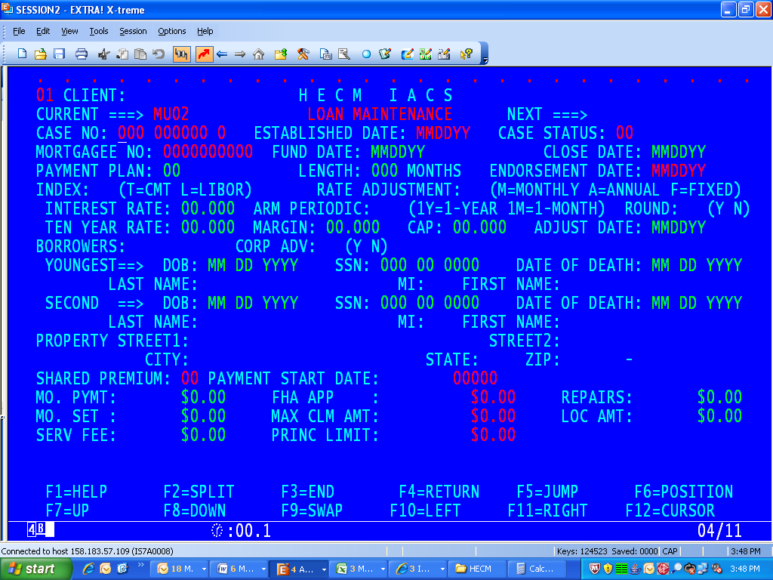
The MU02 screen will include a corporate advance flag (Y/N) which will indicate the existence of corporate advance(s) for this case. The corporate advance flag will be set to ‘N’ when the loan Corporate Advances balance is zero.

Exhibit 2 - MI01 “Loan Balance Information Screen”
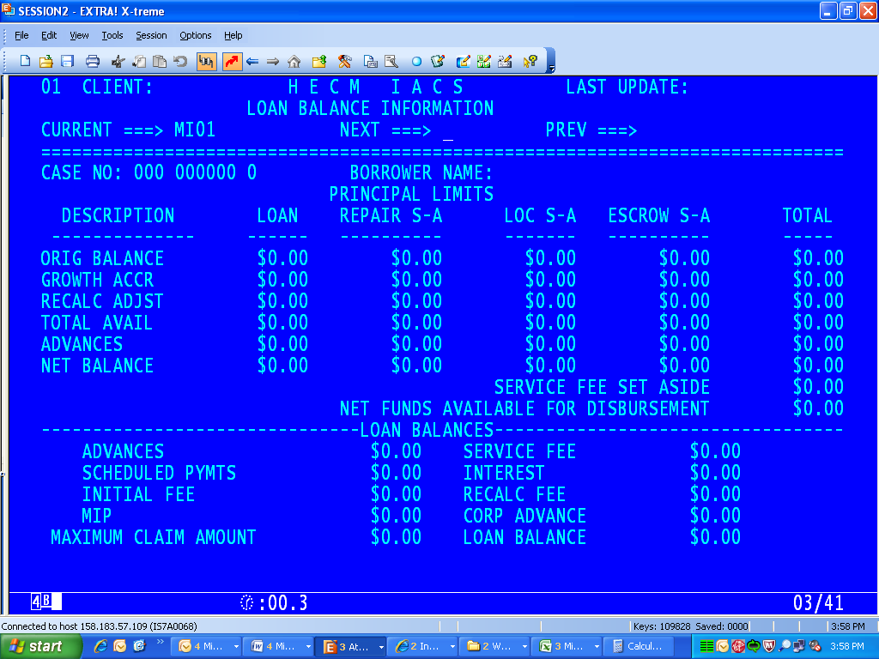
The MI01 screen will include the total corporate advance amount field.
Exhibit 3 - MI14 “Loan Transaction History Screen”
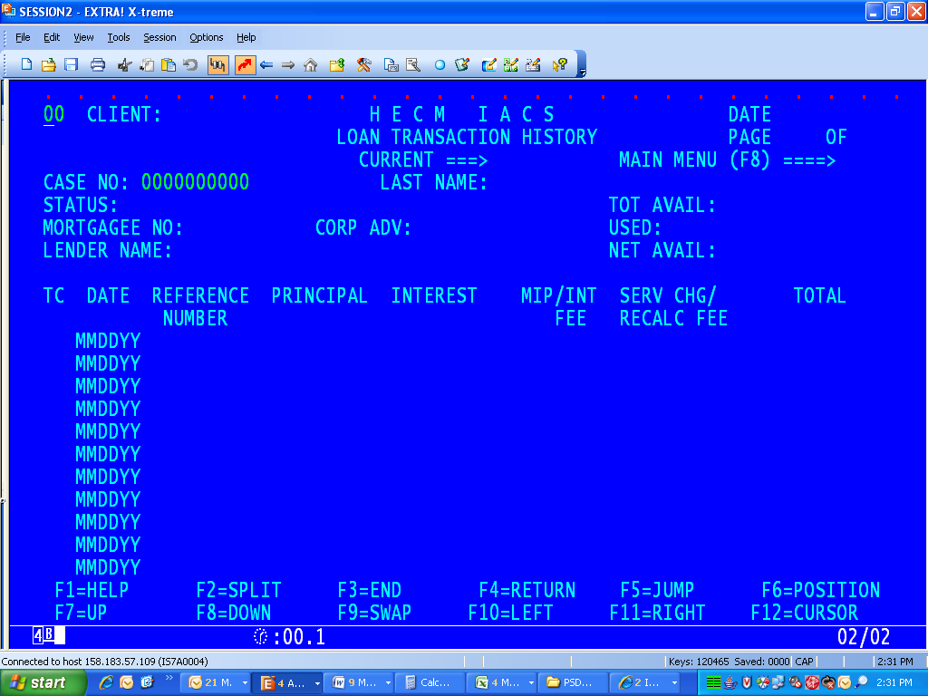
The MI14 will include the total corporate advance amount.

Exhibit 4 - MI07 – “Loan Balance Advance Detail Screen”
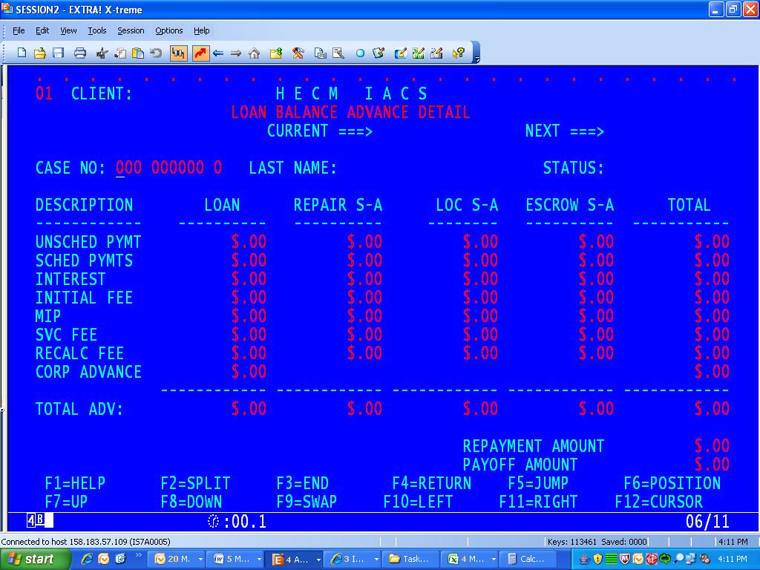
The MI07 screen will include the total corporate advance amount.

