U.S. Department of Housing and Urban Development
Office of Public and Indian Housing

______________________________________________________________________________

Special Attention of: Notice PIH 2010-9 (HA)
Public Housing and Section 8 Program Administrators,
Public Housing Hub Office Directors; Public Housing Issued: March 30, 2010
Field Office Directors; Program Center Coordinators;
Resident Management Corporations; Resident Councils; Expires: March 31, 2011
Participants of Public Housing, Housing Choice Voucher
Voucher, Project-Based Certificate, and Project-Based
Voucher Programs; Section 8 Property Owners and
Landlords
_____________________________
Cross References: 24 CFR 5.233,
HUD OIG Audit Report Number 2010-FW-0001

SUBJECT: Effective Use of the Enterprise Income Verification (EIV) System’s Deceased Tenants Report to Reduce Subsidy Payment & Administrative Errors

- Purpose: This Notice explains the procedures Public Housing Agencies (PHAs) are required to implement to deal with families with deceased household members. The implementation of the procedures outlined in this Notice will ensure that PHAs submit accurate data to HUD via the Public and Indian Housing Information Center (PIC) and that PHAs do not make subsidy overpayments on behalf of deceased single member households. Where overpayments have been made, the PHA will recoup the overpayment from the landlord/owner of the rental property under the programs noted in Section 2 of this Notice, with the exception of the Public Housing program.

- Applicability: This Notice applies to the following HUD-PIH rental assistance programs: Public Housing, Section 8 Moderate Rehabilitation, Project-Based Voucher, Project-Based Certificate; and Housing Choice Voucher programs.

- Background: In January and September, 2008, the Department encouraged PHAs to utilize the Deceased Tenants Report available in the Enterprise Income Verification (EIV) system. In a letter sent to all PHA Executive Directors, the Department urged PHAs to use the report on a monthly basis to assist in identifying families with deceased household members, and reduce the occurrence of paying housing assistance on behalf of deceased single member households. The Department also urged all PHAs to take appropriate corrective actions to address families with deceased household members and update the form HUD-50058 (Family Report) to reflect accurate household composition and transmit the updated form HUD-50058 in a timely manner.

HUD has continued to provide informal guidance and training via satellite and webcast, related to effective use of the EIV system, including the Deceased Tenants Report.

Many PHAs have taken corrective actions to transmit more accurate data to HUD via PIC, and have reduced the number of deceased single member households continuing to receive ineligible rental assistance. PHAs with zero deceased household members reported on the Deceased Tenants Report are to be commended for their efforts.

However, there are some PHAs that have not followed HUD’s informal guidance. According to HUD’s Office of Inspector General (OIG), audit report number 2010-FW-0001, PHAs have paid approximately $7 million in questionable payments for deceased tenants in single member households. The OIG also determined that PHAs did not update family composition on the form HUD-50058 in a timely manner, which resulted in incorrect information in PIC.

In accordance with the new regulatory requirement at 24 CFR 5.233(a)(2)(ii), which became effective on January 31, 2010, under the Final Rule: Refinement of Income and Rent Determination Requirements in Public and Assisted Housing Programs: Implementation of the Enterprise Income Verification System-Amendments, published at 74 FR 68924 on December 29, 2009, all PHAs are required to use the EIV system to reduce administrative and subsidy payment errors in accordance with HUD administrative guidance. Accordingly, HUD is issuing this formal guidance to ensure that PHAs:

- Use EIV’s deceased tenant information for effective decision making, corrective action implementation, and reporting activities;
- Implement policies and procedures to minimize erroneous subsidy payments on behalf of deceased single member households; and
- Provide accurate and reliable information to HUD via PIC.

- Effective Date: This Notice is effective upon issuance.

- Monitoring Deceased Tenants. PHAs must generate the Deceased Tenants Report at least once a month. PHAs who administer Section 8 programs should generate the report prior to disbursing the upcoming monthly housing assistance payments (HAP) to owners. PHAs who administer the public housing program should generate the report when generating the new monthly rent roll to flag deceased tenants. PHAs must review the report and follow up with the listed families immediately and take the necessary corrective actions outlined in Section 7 of this Notice.

- How to Access the Deceased Tenants Report. The Deceased Tenants Report identifies deceased household members (whose identity has been confirmed by the Social Security Administration (SSA))* who are included in the family’s composition (including single member deceased households) as reported on Section 3 (Family Composition) of the form HUD-50058. The death information is provided by the SSA. Single member deceased households are denoted with a red asterisk (*) after the member’s deceased date (see example one below). If the deceased date is listed as N/A, this means the date of death is not available (see example two below).

*The individual’s social security number (SSN), date of birth, and surname reported on the form HUD-50058 must match SSA’s database. Deceased information is not displayed for any individual whose EIV identity verification status is failed (including individuals with a PIC-generated alternate identification number).

Example 1:



Example 2:



Effective April 19, 2010, EIV’s Deceased Tenants Report will be modified to isolate deceased single member households in addition to the current consolidated report which contains deceased single and multiple member households. This planned system modification will reduce PHA administrative burden in identifying deceased single member households.

Follow the following steps to access the Deceased Tenants Report:

1: To access the Deceased Tenant Report, log onto the EIV system at: https://hudapps.hud.gov/HUD_Systems. If you do not have access to the EIV system, complete and submit the EIV Access Authorization Form and Rules of Behavior and User Agreement to the EIV Coordinator in your local HUD office. For more information, go to: http://www.hud.gov/offices/pih/programs/ph/rhiip/uivsystem.cfm.

2: Once logged into the system, scroll down the left side of the screen and double click on the Deceased Tenants Report link (located under the Verification Reports header). Select the program for which you desire to generate the report for (Public Housing, Section 8 or all PIH programs). You may also select a specific reexamination month; however, the system automatically defaults to All (which HUD recommends that you use). If you are responsible for more than one PHA, be sure to select the appropriate PHA code in the PHA drop down menu.

3: Double click the Get Report button. The report will then display on the screen and can easily be downloaded into Excel or printed for your convenience.

Note: WARNING: This report contains full social security numbers of tenants. You must ensure that this report is adequately safeguarded to prevent improper disclosure of private information.

Report Selection Criteria for Deceased Tenants Report

Program Type: Select either All PIH Programs, Section 8, or Public Housing

Reexamination Month: The default selection is All. However, the user may select a specific month.

PHA: The default selection is your PHA. If you have multiple PHAs assigned to your user ID, be certain to select the applicable PHA you wish to generate the report.

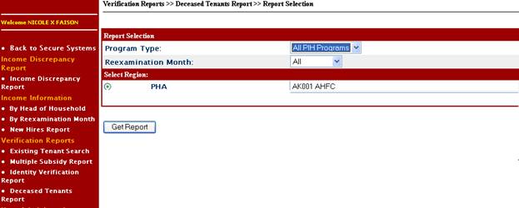

Sample Deceased Tenants Report

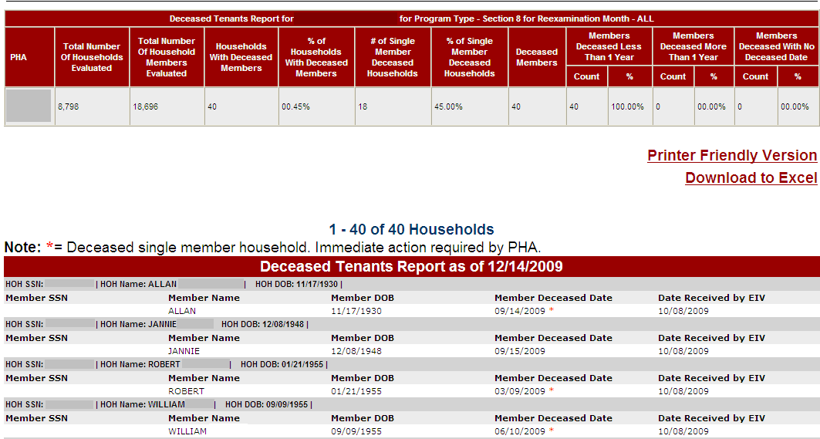

- Corrective Actions Required by PHAs. When the Deceased Tenants Report identifies an individual as being deceased, PHAs are required to take the following actions:

- Immediately contact the head of household (HOH) or emergency contact person (if the HOH is deceased and there is no other adult household member) to confirm the death of the listed household member. A letter should be sent to the HOH, followed by a telephone call.

- Public Housing only - Conduct a home visit to determine if anyone is residing in the unit. (Optional for Section 8 program)

If there are unauthorized persons in the unit of a deceased single member household you must pursue judicial intervention to have them lawfully removed from the unit. You may be found liable for a wrongful eviction if you change the locks on the unit to prevent the unauthorized occupants from entering the unit. Follow your local Tenant and Landlord laws to regain possession of the unit.

- Section 8 Programs only – Notify the owner in writing of the deceased HOH.

For deceased single member households or a household where the remaining household member is a live-in aide, PHAs are required to discontinue HAP to the owner no later than the first of the following month after the death occurred. See Section 13 of this Notice for determining amount of owner housing assistance overpayments.

Note: PHAs are required to immediately terminate program assistance for deceased single member households which will result in termination of the HAP contract and HAP to the owner in accordance with the aforementioned provisions. The owner is not entitled to HAP for any month following the month in which the death occurred. There are no exceptions to this policy and procedures.

- When the remaining household member is a live-in aide. When the HOH dies and the only remaining household member is the live-in aide, the live-in aide is not entitled or eligible for any rental assistance or continued occupancy in a subsidized unit. By definition, the live-in aide would not be living in the subsidized unit except to provide the necessary supportive services on behalf of the elderly or disabled HOH. The PHA may not designate the live-in aide as the new HOH or change the relation code (line item 3h on the form HUD-50058) of the live-in aide to make him or her an eligible household member (eligible for assistance) nor pay HAP on behalf of the live-in aide for any month after the month in which the HOH died.

The PHA must notify the live-in aide s/he is required to vacate the unit at the end of month. If the live-in aide does not vacate the unit, the PHA (or owner/landlord) must follow local Tenant and Landlord laws to regain possession of the unit.

- What to do if the HOH is deceased and the remaining household members are minors. PHAs should have an established policy for dealing with situations when the HOH dies during tenancy and the remaining household members are minors. A common practice of PHAs includes (but is not limited to) allowing a temporary adult guardian to reside in the unit until a court-appointed guardian is established. In accordance with its screening policies, the PHA may add the new guardian as the new HOH. PHAs are encouraged to work with the local Department of Social Services to ensure that the best interests of the children are addressed.

- What to do if an identified household member is reported to be deceased and is actually alive. There are a very few instances when an error has been made in the SSA’s Death Match File (DMF), wherean individual is reported as deceased, but actually living. In the event that a household member is misidentified as deceased on the Deceased Tenants Report, PHAs should immediately notify the individual in writing and advise the individual to contact SSA so that SSA may correct its records. The individual may contact SSA at (800) 772-1213, or visit his/her local SSA office for assistance.

The PHA should also provide the individual with his/her section of the EIV Income Report, which shows the death information. PHAs are authorized to provide EIV information only to the individual the information pertains to. The PHA may provide the minor’s information to the minor’s adult parent or guardian.

Last, PHAs are required to make a note in the tenant file that the individual has been identified as deceased; however, the PHA has confirmed that the individual is actually alive.

Note: Only SSA can correct erroneous death information.

- Time frame for removal of individual from the Deceased Tenants Report. The families that appear on the Deceased Tenants Report are based on current information reported on the form HUD-50058. The Deceased Tenants Report is updated every weekend. A deceased individual will be removed from the report when:

  - The PHA transmits an updated form HUD-50058, that does not contain the previously identified deceased household member in Section 3 of the form HUD-50058 (Family Composition); or

  - HUD obtains the updated and corrected information from SSA’s DMF.

Example 1: Mr. Jones was listed on the Deceased Tenants Report dated December 14, 2009, with a deceased date of November 20, 2009. On December 1, 2009, the PHA confirmed that Mr. Jones was actually alive and advised Mr. Jones to visit his local SSA office to have the error corrected. SSA corrected the DMF on December 20, 2009. When HUD conducted computer matching with SSA on January 6, 2010, HUD obtained new SSA data which indicated that Mr. Jones was not deceased. The Deceased Tenants Report was updated on the weekend of January 8, 2010. When the PHA accessed the Deceased Tenants Report on January 11, 2010, Mr. Jones was no longer on the report.

Example 2: Mr. Williams was listed on the Deceased Tenants Report dated December 14, 2009, with a deceased date of June 10, 2009. On January 6, 2010, the PHA confirmed that Mr. Williams was deceased. The PHA then completed and submitted an EOP form HUD-50058 on January 7, 2010. The Deceased Tenants Report was updated on the weekend of January 8, 2010. When the PHA accessed the Deceased Tenants Report on January 11, 2010, Mr. Williams was no longer on the report.

- Type of Action and Effective Date to Record on Form HUD-50058. Below prescribes the applicable type of action and effective date the PHA is required to record on form HUD-50058 to report changes of family composition and income.

- Deceased Single Member Households. Once the PHA has confirmed the death of the HOH of a single member household or a household where the surviving household member is the live-in aide, the PHA is required to complete and submit a form HUD-50058 with the following:

Line 2a – Type of Action = 6 (End of Participation)

Line 2b – Effective Date of Action = Date of Death from Deceased Tenants Report,
or as noted below. (If date is listed as “N/A”, enter the date of death as confirmed by
Obituary, Death Record, or other information obtained.)

Section 8 programs: PHAs may list the date of death as the last day of the
month in which the death occurred.

Public Housing program: For deceased single member households (where there are
no unauthorized unit occupants), PHAs may list the date of death as the last day of
the month, in which the death occurred. PHAs are required to then classify the unit as
vacant in PIC. The PHA may not use a later date based on the date that all personal
belongings were removed from the unit by the family. The PHA may coordinate the
removal of personal belongings within a reasonable time frame (not to exceed 14
days).

In situations where the PHA seeks judicial intervention to regain possession of the
Public housing unit, the PHA must list eviction date (the day in which the PHA has
regained possession of the unit) as the effective date of action.

- Deceased Household Member of a Multiple Member Household – Surviving Adult Household Member. Once the PHA has confirmed the death of the HOH, the PHA is required to complete and submit a form HUD-50058 with the following:

Line 2a – Type of Action = 3 (Interim Reexamination)

Line 2b – Effective Date of Action = Date of Death from Deceased Tenants Report (if date is listed as “N/A”, enter the date of death as confirmed by Obituary, Death Record, or other information obtained.)

Line 3a (Member 01) - delete the deceased HOH’s information and enter the information of the adult household member who has been designated HOH.

Line 3a – delete the information of the other adult household member, whose information you entered on Line 3a (Member 01).

Line 3w – enter the Social Security Number (SSN) of the former (deceased) HOH.

- Deceased Household Member of a Multiple Member Household – No Surviving Adult Household Member. Once the PHA has confirmed the death of the HOH, the PHA is required to complete and submit a form HUD-50058 with the following:

Line 2a – Type of Action = 3 (Interim Reexamination)

Line 2b – Effective Date of Action = Date of Death from Deceased Tenants Report (if date is listed as “N/A”, enter the date of death as confirmed by Obituary, Death Record, or other information obtained.)

Line 3a (Member 01) - delete the deceased HOH’s information and enter the adult household member’s information of the temporary or permanent guardian.

Line 3w – enter the Social Security Number (SSN) of the former (deceased) HOH.

- Other Household Changes. If, in scenario B or C above, there is also a change in family income resulting in a change in the family’s total family share, the effective date on line 2b should be the effective date of the new total family share in accordance with PHA-established policies.

- Retroactive Repayment of HAP by Owners. If an owner receives HAP for any month in which the owner is ineligible to receive HAP because of a deceased tenant, the PHA must immediately notify the owner in writing of the ineligible HAP and require the owner to repay the overpayment to the PHA within 30 days. If the owner does not comply, the PHA may deduct the amount due to the PHA from any amounts due to the owner under any other HAP contract. If there is no other HAP contract with the owner, the PHA may seek and obtain additional relief by judicial order or action in accordance with state and local laws.

Example: The Deceased Tenants Report dated December 14, 2009, indicates that Mr. Robert died on March 9, 2009. The landlord/owner is not eligible for HAP in any month following March 2009. The PHA erroneously paid the landlord/owner HAP of $500 each month during the period of April 2009 through December 2009. The landlord/owner must repay the PHA $4,500 ($500 X 9 months).

In instances where a deceased single member household has been deceased for a period greater than 6 months and the owner received HAP, the PHA may determine that the owner has breached the HAP contract. As such, the PHA may exercise any of its rights and remedies under the HAP contract, or any other available rights and remedies for such breach.
The PHA must notify the owner of such determination, including a brief statement of the reasons for the determination. The notice by the PHA to the owner may require the owner to take corrective action, as verified or determined by the PHA, by a deadline prescribed in the notice.

The PHA’s rights and remedies for owner breach of the HAP contract may include recovery of overpayments, suspension of HAP, abatement or other reduction of HAP, termination of HAP, and termination of all HAP contracts. The PHA may seek and obtain additional relief by judicial order or action, including specific performance, other injunctive relief or order for damages.

- Penalties for Non-Compliance with Use of EIV’s Deceased Tenants Report

Section 8 Programs: If the PHA overpaid HAP on behalf of a single member deceased household and fails to collect the overpayment from the owner, the PHA is required to reimburse 100 percent of the overpayment to HAP Equity from the Administrative Fee Equity or other non-Federal funds. In addition, if such errors impacted any funding baseline determinations, funding for the affected renewal periods may be adjusted.

Note: A PHA cannot reimburse prior year HAP costs with current year HAP funding because the funding carries forward but does not carry back.

HUD will monitor each PHA’s Deceased Tenants Report on a quarterly basis. If at any time the report identifies deceased single member households who have been deceased for a period exceeding six months, and HUD determines that the PHA has not taken the necessary corrective action, the PHA may be subject to a withholding of its monthly administrative fee each month that the number of single deceased household members is greater than zero.

Public Housing Program: HUD will monitor each PHA’s Deceased Tenants Report on a quarterly basis. If at any time, the report identifies deceased single member households who have been deceased for a period exceeding six months, and HUD determines that the PHA has not taken the necessary corrective action, the PHA may be subject to a monetary penalty, as determined by the Assistant Secretary, each month that the number of single deceased household members deceased for a period of one year or longer is greater than zero. HUD may offset the PHA’s monthly operating subsidy by the amount of the imposed penalty or require the PHA to pay the amount of the penalty from non-Federal funds, directly to HUD.

For any imposed penalty, HUD will notify the PHA in writing of such penalty and afford the PHA a 30-day period to appeal HUD’s decision. Appeals must be postmarked no later than 30 days from the date of the penalty Notice and sent by certified mail or carrier service (UPS, FEDEX, DHL, etc.) to:

U.S. Department of Housing and Urban Development
Office of Public and Indian Housing
Assistant Secretary Sandra B. Henriquez
Attention: EIV Appeals
451 7th Street, SW, Room 4100
Washington, DC 20410

Appeals by fax or email will not be processed. HUD will provide a written response to your appeal request within 60 days of receiving the appeal request.

- EIV System Training. HUD offers free EIV system training via webcast and can be viewed by staff at any time at: http://www.hud.gov/webcasts/archives/iv.cfm. Past and future training opportunities, including training materials are available at: http://www.hud.gov/offices/pih/programs/ph/rhiip/training.cfm. As a condition of initial and continued EIV system access, all system users are required to view HUD Headquarters-provided EIV system training and annual Security Awareness training.

EIV system users must self-certify within the EIV system at the log-in page that the training has been completed. Staff is not required to possess a Certificate of Completion for EIV training in order to gain or continue accessing the EIV system, or be certified by the User Administrator on a quarterly basis (or semi-annual basis after April 2010).

- For inquiries about this Notice contact: your local HUD field office or Nicole Faison of HUD Headquarters’ Office of Public Housing and Voucher Programs at (202) 402-4267, or via email at PIH.RHIIP.TA@HUD.GOV.

- Paperwork Reduction: The information collection requirements contained in this Notice have been approved by the Office of Management and Budget (OMB under the Paperwork Reduction Act of 1995 (44 U.S.C. 3520) and assigned OMB control number(s) 2577-0083. In accordance with the Paperwork Reduction Act, HUD may not conduct or sponsor, and a person is not required to respond to, a collection of information unless the collection displays a currently valid OMB control number.

/s/
Sandra B. Henriquez, Assistant Secretary for
Public and Indian Housing

