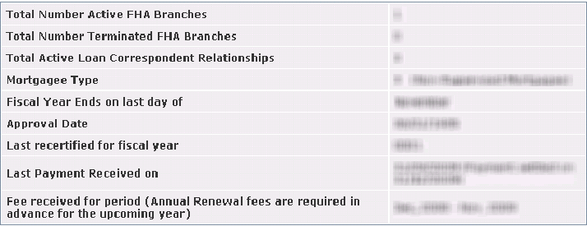
Annual Certification is due and the user is a corporate office with annual certification rights.

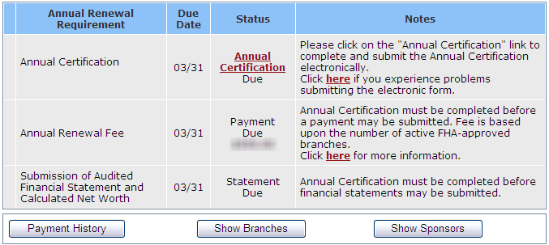
The Annual Certification screen – ready for data entry.
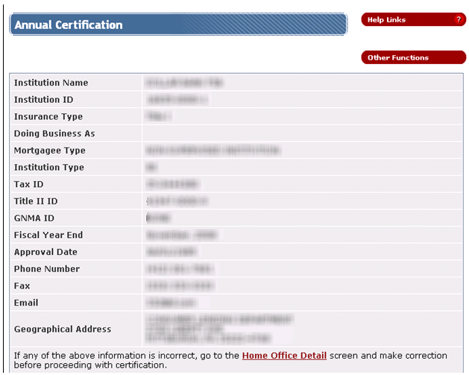
Screen continues on next page………
….continuation of the screen from the previous page:
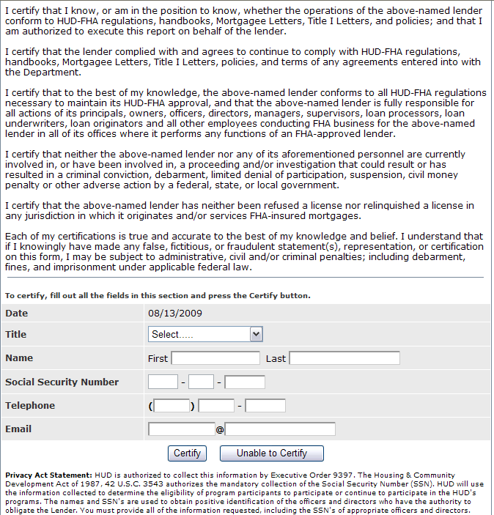

The same screen showing the content of the Title drop-down selection box.

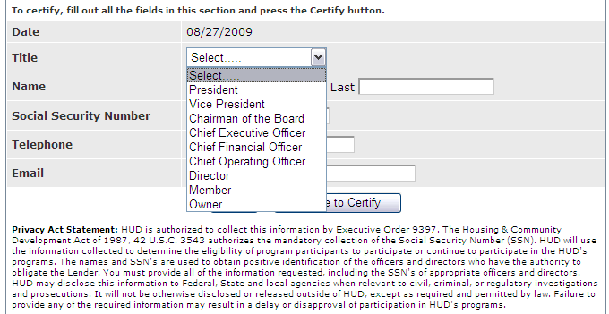

No errors detected through the first round of checking (without database access). User is asked to review and confirm entries before it is send to the server for further error checking and processing.
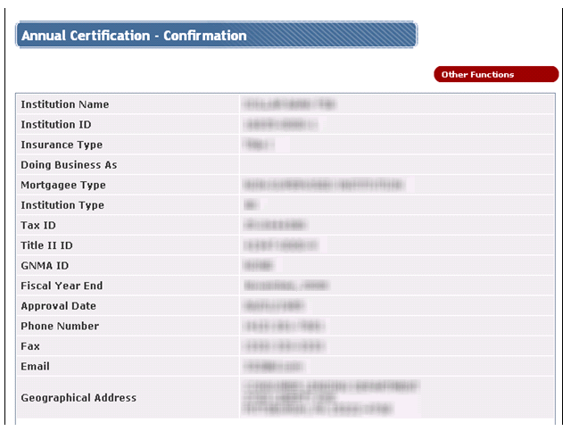

Screen continues on the next page …

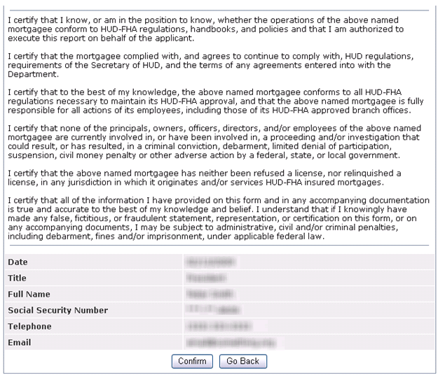
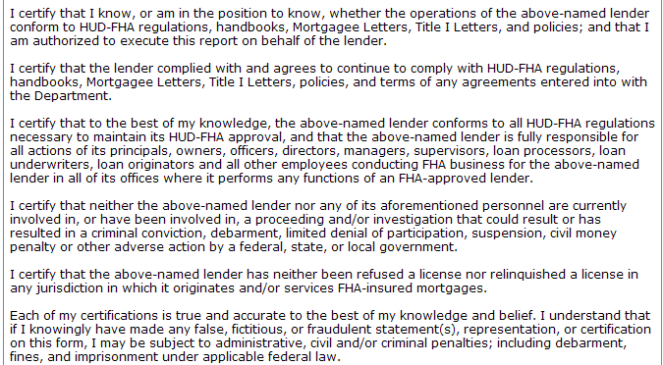
… continuation from the previous page

The Annual Certification Update Results - showing a successful update.

Successful Update:
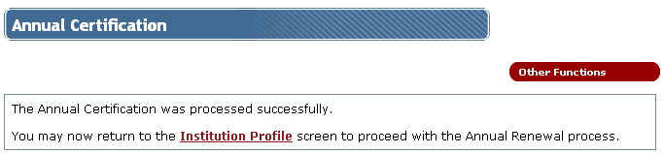

The bottom part of the Institution Profile screen after the successful processing of the Annual Certification.
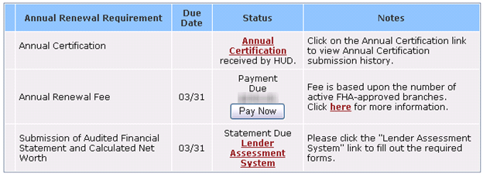

Annual Renewal History screen.
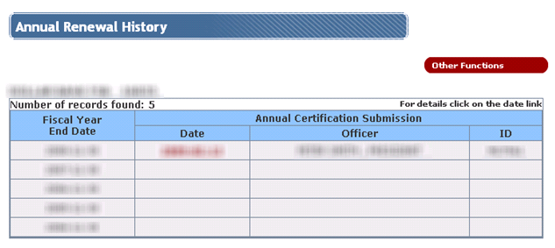

History record of the submitted and accepted Annual Certification
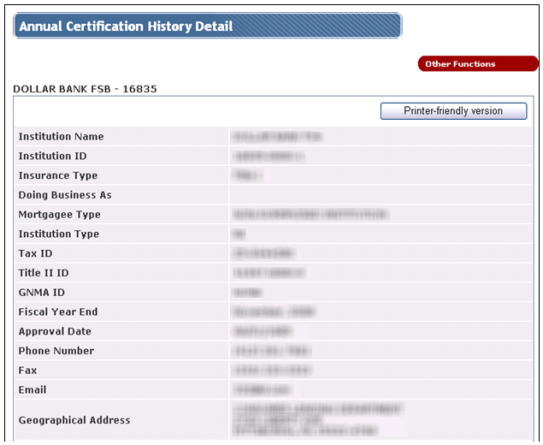
Screen continues on the next page …..
… continuation from the previous page
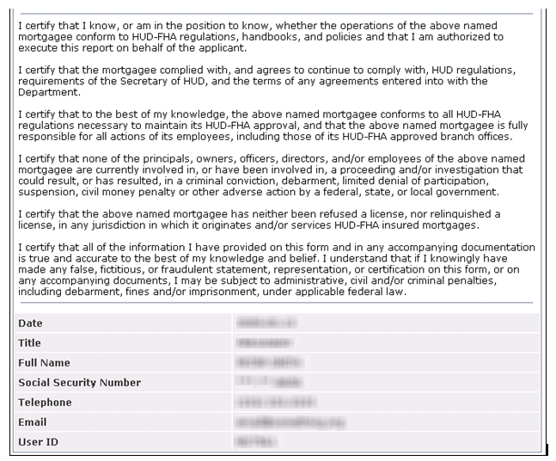

User who is unable to certify will be asked to fill out a form shown on the screen below.

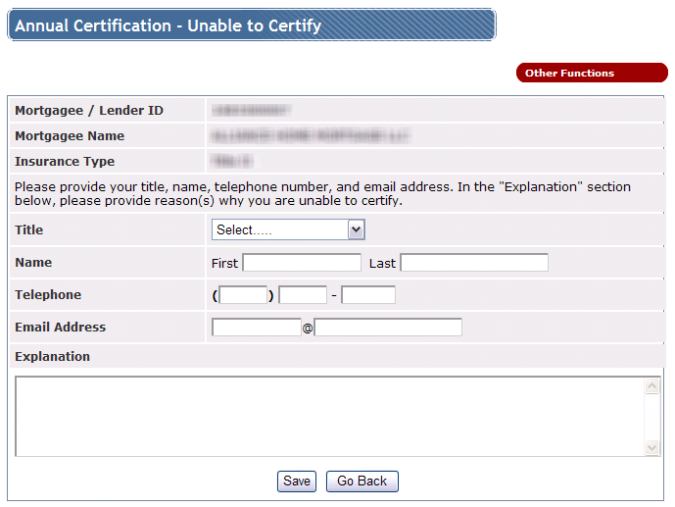

The Annual Certification Update Results – showing a successful email submission.
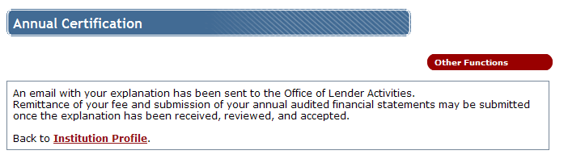

The bottom part of the Institution Profile screen after the user returns from sending explanation why they were unable to certify.
