U.S. Department of Housing and Urban Development
Office of Public and Indian Housing

Special Attention of: Notice PIH 2005-4 (HA)
Public Housing Agencies
Public Housing Hub Office Directors Issued: January 18, 2005
Public Housing Program Center Directors
Regional Directors Expires: January 31, 2006
Field Office Directors
Cross Reference:

Subject: Exigent Health and Safety Deficiency Correction Certification – New Reporting Procedures

- Purpose. This notice describes the new electronic exigent health and safety (EHS) system for public housing agencies (PHAs) and Public Housing Field Office staff. This notice explains how PHAs are to certify to the correction or abatement of the life-threatening (i.e., EHS) deficiencies observed during Uniform Physical Condition Standards (UPCS) inspections. It also outlines the procedures for Field Office staff to enter and record any follow-up activities that they have completed to ensure that EHS deficiencies have been corrected or abated.

- Applicability. This notice is applicable to all PHAs and Public Housing Field Office staff. It describes procedures related to the EHS deficiencies observed in the UPCS inspections conducted in accordance with the Public Housing Assessment System (PHAS) regulation (24 CFR Part 902) and the UPCS regulation (24 CFR Part 5, Subpart G).

- Definition.

EHS Deficiency. An EHS deficiency is a deficiency that threatens the life, health and/or safety of the residents. An EHS deficiency is observed in any one of the five inspectable areas of a property during a UPCS inspection. The EHS deficiencies by inspectable area are:

Site
Air Quality – Propane/Natural Gas/Methane Gas Detected
Electrical Hazards – Exposed Wires/Open Panels
Electrical Hazards – Water Leaks on/near Electrical Equipment

Building Exterior
Electrical Hazards – Exposed Wires/Open Panels
Electrical Hazards – Water Leaks on/near Electrical Equipment
Emergency Fire Exits – Emergency/Fire Exits Blocked/Unusable
Fire Escapes – Blocked Egress/Ladders
Fire Escapes – Visibly Missing Components

Building Systems
Air Quality – Propane/Natural Gas/Methane Gas Detected
Domestic Water – Misaligned Chimney/Ventilation System
Electrical System – Missing Breakers/Fuses
Electrical System – Missing Covers
Electrical Hazards – Exposed Wires/Open Panels
Electrical Hazards – Water Leaks on/near Electrical Equipment
Emergency Fire Exits – Emergency/Fire Exits Blocked/Unusable
Fire Protection – Missing/Damaged/Expired Extinguishers
HVAC – Misaligned Chimney/Ventilation System

Common Areas
Air Quality – Propane/Natural Gas/Methane Gas Detected
Electrical – Missing Breakers
Electrical – Missing Covers
Electrical Hazards – Exposed Wires/Open Panels
Electrical Hazards – Water Leaks on/near Electrical Equipment
Emergency Fire Exits – Emergency/Fire Exits Blocked/Unusable
HVAC – Misaligned Chimney/Ventilation System
Outlets/Switches/Cover Plates – Missing/Broken
Smoke Detector – Missing/Inoperable
Windows – Security Bars Prevent Egress

Unit
Air Quality – Propane/Natural Gas/Methane Gas Detected
Electrical Hazards – Exposed Wires/Open Panels
Electrical Hazards – Water Leaks on/near Electrical Equipment
Electrical System – Missing Breakers/Fuses
Electrical System – Missing Covers
Emergency Fire Exits – Emergency/Fire Exits Blocked/Unusable
Hot Water Heater – Misaligned Chimney/Ventilation System
HVAC – Misaligned Chimney/Ventilation System
Outlets/Switches – Missing
Outlets/Switches – Missing/Broken Cover Plates
Smoke Detector – Missing/Inoperable
Window – Security Bars Prevent Egress

- Current Policy. The inspector includes all observed health and safety deficiencies in the inspection report. In addition, the inspector notifies the PHA of the observed EHS deficiencies at the end of each inspection or at the end of each day in a multi-day inspection. The inspector completes an “Exigent Health and Safety Notification Form” (the notification form) at the end of an inspection or at the end of each day, and delivers it to the PHA or property representative for signature.

After the inspection is reviewed and scored, the PHA is notified electronically that it may access the inspection summary report listing the score and deficiencies observed during the inspection. The inspection report is in a portable document format (PDF). The last page of the inspection summary report is the “PHA Certification of Repairs for Exigent Health and Fire Safety Hazards” (the certification form). On this form, PHAs list the EHS deficiencies and describe the corrective action that has been taken (e.g., replacing a broken cover plate on an electrical outlet). Each PHA then faxes the completed form to the appropriate Field Office.

- New Policy. Effective immediately, PHAs are to begin using the new online application to report EHS deficiency correction/abatement activities to HUD. The online application will allow the PHA to enter correction and abatement activities for each EHS deficiency. As part of its review process, the Field Office staff will view the properties in their jurisdiction, conduct applicable follow-up activities with PHAs, and use the online system to report whether the EHS deficiencies have, in fact, been corrected or abated. All PHAs are to correct or abate EHS deficiencies within 24 hours after the inspection, and certify to the correction or abatement activity through the online application within three business days of the inspection.

- Appendix 1, PHA User Instructions, explains how PHAs are to certify to the correction or abatement of EHS deficiencies observed during UPCS inspections. Appendix 1 includes instructions for PHA users to access the EHS certification system and helpful screen reproductions for the navigation of the system.

- Appendix 2, Field Office User Instructions, outlines the procedures for Field Office staff to enter and record any follow-up activities that they have completed to ensure that EHS deficiencies have been corrected or abated.

- Paperwork Reduction Act. The information collection requirements contained in this guidance have been approved by the Office of Management and Budget (OMB) under the Paperwork Reduction Act of 1995 (44 U.S.C. 3520) and assigned OMB Approval Number 2577-0241. In accordance with the Paperwork Reduction Act, HUD may not conduct or sponsor, and a person is not required to respond to, a collection of information unless the collection displays a currently valid OMB Approval Number 2577-0241.

- Questions. If you have any questions regarding this notice, contact PIH-REAC’s Technical Assistance Center at (888) 245-4860 (this is a toll free number).

_______________________________
Michael Liu, Assistant Secretary for
Public and Indian Housing

Each PHA user will log into the EHS Report system through Secure Systems. Secure Systems is accessible through the “Online Systems” link on the PIH-REAC web page (on left-hand menu), as shown on the screen reproduction below.

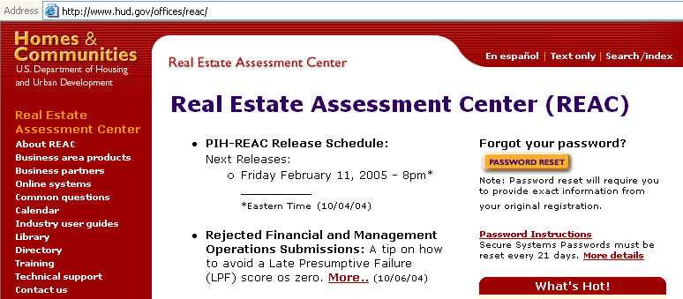

- Clicking on the “Online Systems” link will take the user to the page that allows for Secure Systems access. The user will select the “Log In” link, as shown on the screen reproduction below, to display the screen that requires the user name and password.

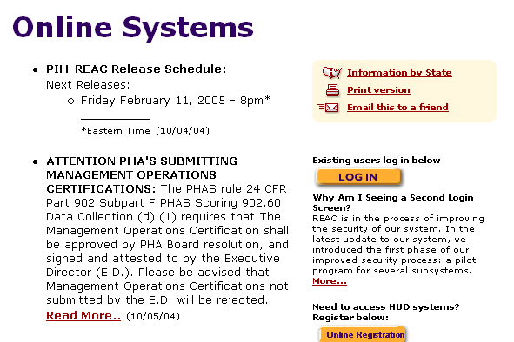

- The user will enter a user name and password and click “OK,” as shown on the screen reproduction below. Note: Each PHA user will enter the user name and password that is used for all of the other Secure Systems applications that support PHAS.

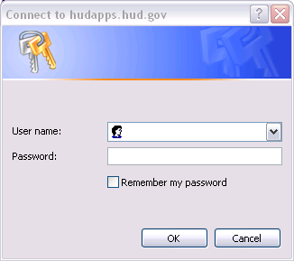

- When a login is successful, the warning and notice screen comes up, as shown on the screen reproduction below. After reviewing the messages on the screen, the user will select “Continue” to access the Secure Systems menu. Note: If the log in attempt is unsuccessful, the user should contact the PIH-REAC Technical Assistance Center at 1-888-245-4860.

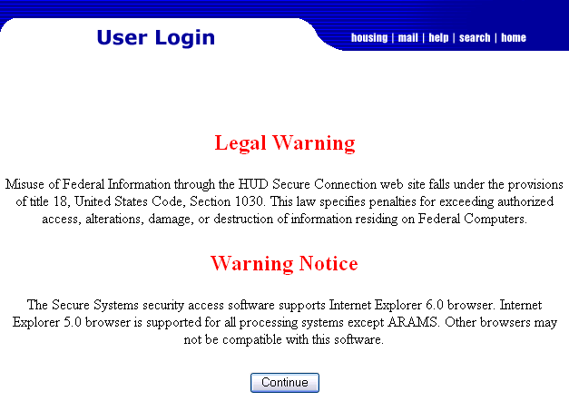
- The user will select the “Physical Assessment Subsystem (PASS)” link, as shown on the screen reproduction below. Note: Each system on the Main Menu is connected to the user’s login ID, therefore, the available menu options may vary from the links shown in the screen reproduction below. All PHA users will be able to view the link titled “Physical Assessment Subsystem (PASS).”

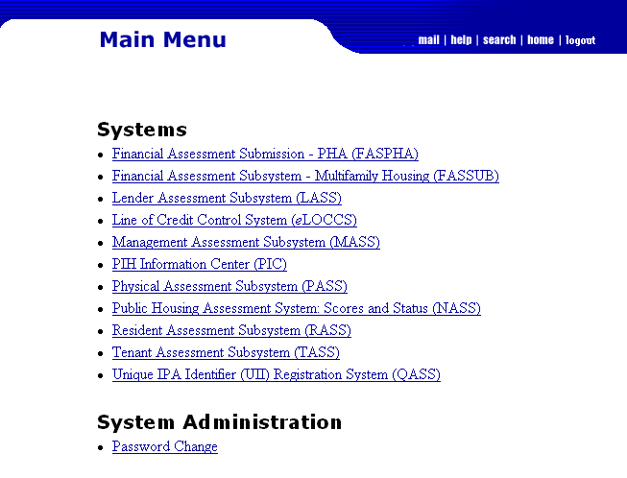

- From the Physical Inspection Main Menu, under the header “Reporting,” the user will select “EH&S Reports,” as shown in the screen reproduction below. Note: Each activity on the Physical Inspection Main Menu is linked to the user’s ID, therefore, the available menu options may vary from the links shown in the screen reproduction below.

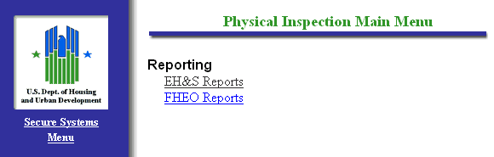

- To search for a specific property with EHS deficiencies, the user may search by the PIH Project Number or by the Inspection ID, as shown on the screen reproduction below. After entering one of the numbers, the user will select “Search” using the search button shown at the bottom of the “Exigent Health and Safety Reports” screen.

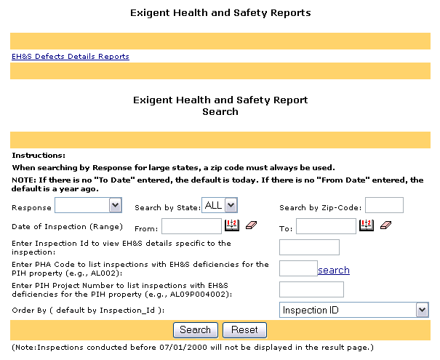

- The search will return the following information for each property: the Inspection Id; the PHA Code; PIH Project ID; Property Id; Property Name; Inspection Date; if applicable, the last date that HUD visited the property to verify certification of the repair or mitigation of EHS deficiencies; and the EH&S report, as shown on the screen reproduction below. The user will select the “EH&S Details” link to see all of the EHS deficiencies that were recorded during the inspection. Note: For purposes of this notice, all PHA and inspection identifiers have been removed from the screens shown.

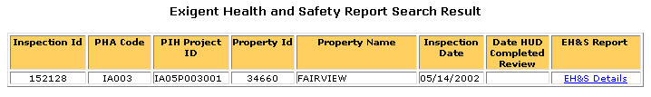

- A PHA user may also view all of the PHA’s properties with EHS deficiencies by entering the “PHA Code” on the “Exigent Health and Safety Reports” screen, as shown on the screen reproduction below.

- If a user is unsure of the PHA Code, the user will select the “search” link to search for the PHA Code, as shown on the screen reproduction below.

- This link displays the PHA Search page that allows the user to search by state and full or partial city name (optional).

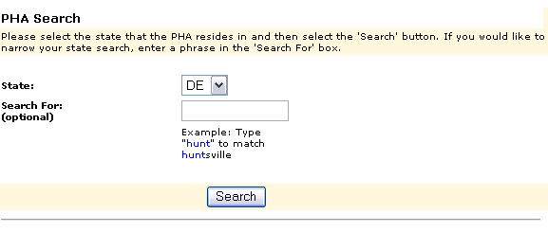
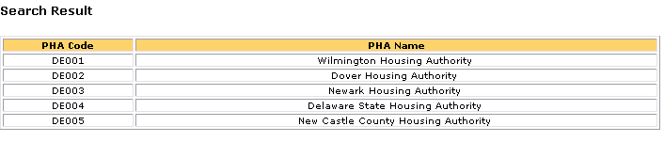

- After finding the correct PHA Code, the user will type that code into the PHA Code text box to complete the search for properties with EH&S deficiencies.

- The results of searching by a PHA Code will be a list of inspections for a specific PHA. Again, the user will select the “EH&S Details” link to view the details of the EHS deficiencies and enter or view the correction or abatement information. Note: Within the example shown in the screen reproduction below, the PHA has only one property for which the inspector observed an EHS deficiency, however several properties may appear for other PHAs.

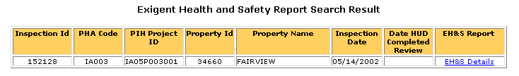

- The screen will display each EHS deficiency that the inspector recorded during the inspection of that property, as shown on the screen reproduction below. It will also display the comment(s) the inspector entered during the inspection which support the classification of the deficiency as an EHS deficiency.

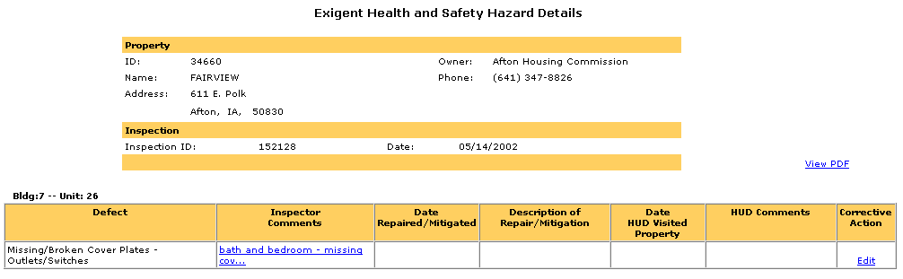

- Selecting the link under the header “Inspector Comments,” allows the user to view the inspector’s comments in their entirety, as shown on the screen reproduction below. To close the pop-up box with the inspector’s comments, the user will select the “Close” button.

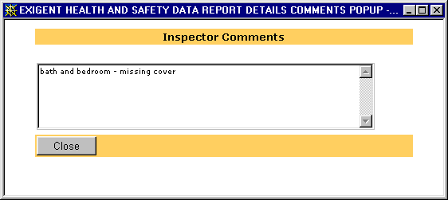

- To enter the correction or abatement action taken for an EHS deficiency, the user will select the “Edit” link in the “Corrective Action” column on the screen titled “Exigent Health and Safety Hazard Details,” as shown on the screen reproduction below.

The terminology used in the system to indicate “corrected,” is the term “repaired,” and for abated” is the term “mitigated.”

Repaired = Corrected

Mitigated = Abated

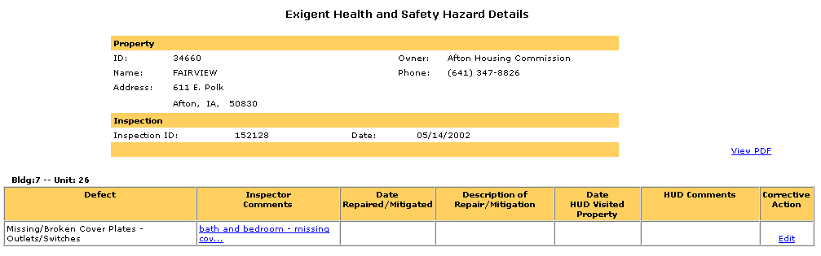

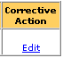

- On the Exigent Health and Safety Hazard Corrective Action screen, the user will complete the “Date Repaired/Mitigated” and the “Description of Repair/Mitigation” fields, as shown on the screen reproduction below. After the information has been entered, the user will select “Update.” Leaving the screen without selecting “Update” will cause the user to lose all information entered. Note: If a user enters any information in error, the user can select “Reset.” This will delete all of the information that was entered and permit the user to re-enter the correct information.

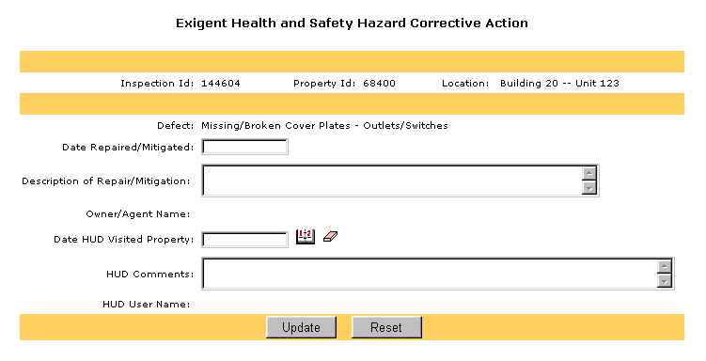

- The certification page will then be displayed. This page explains that by entering the deficiency correction or abatement information, the user is certifying that those corrective actions were taken.

After reading the agreement, the user will select the “Agree” choice, then click the “Continue” button in order to certify to the correction or abatement of the EHS deficiencies, as shown on the screen reproduction below.

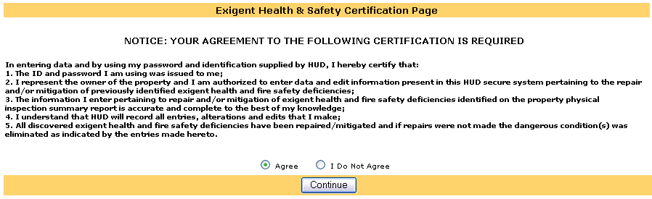

- From the “Exigent Health and Safety Hazard Details” screen, selecting the “View PDF” link will provide the user with the Inspection Summary Report for the property. The Inspection Summary Report contains each EHS deficiency recorded during the inspection and its impact on the inspection score.

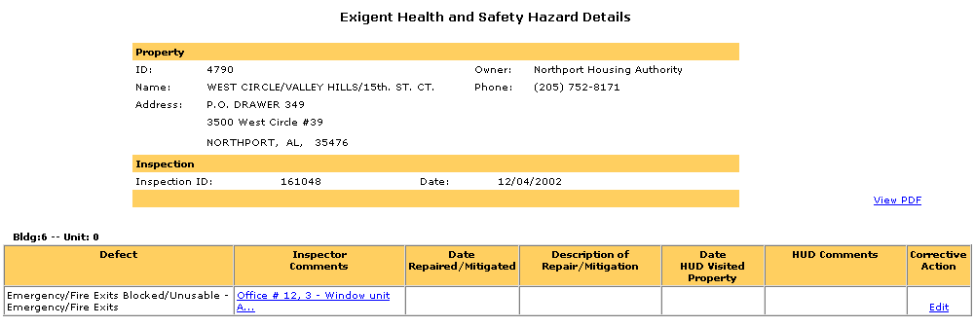

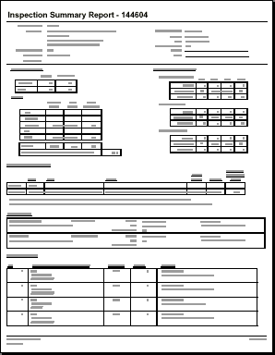

- The “EH&S Defects Details Reports” link provides comprehensive information for all properties within a specified state and for all inspections during a specified period of time. To view this information, the user will select the “EH&S Defects Details Reports” link, as shown on the screen reproduction below.

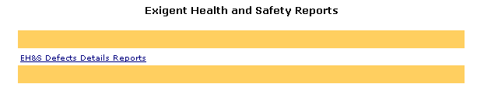

- The user will select a date range for the report by using the calendars next to the “From:” and “To:” fields, and then select a state from the drop down menu, as shown on the screen reproduction below. Note: Selecting a date range of more than three months may slow the response time considerably or cause the request to “time out,” indicating that the system cannot complete the search.

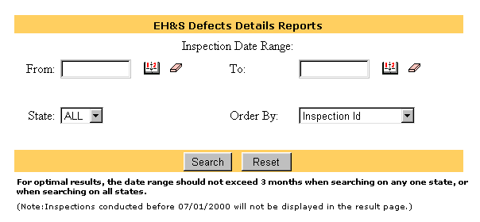

- After entering the date range and state, the user can choose to have the inspection results sorted by any of the following fields: Inspection Id, Inspection Date, Property Id, Property Name, PHA Code, or PIH Project Number. To sort, the user will select one of the choices from the “Order By” drop-down box. Then, the user will select “Search,” as shown on the screen reproduction below. Note: If the user does not select an “Order By” field, the results will automatically be sorted by “Inspection Id.”

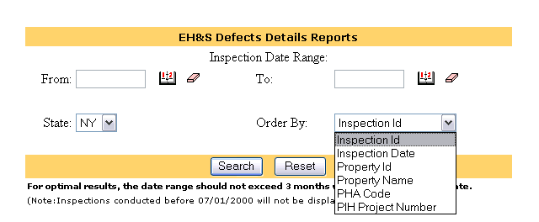

- The EH&S Defects Details Report will be displayed as shown on the screen reproduction below. This report provides the details and status for each property inspection as well as the assigned Field Office. Note: The “HUD Reviewed (Yes/No)” field is only populated with a “Yes” answer when HUD has completed the review of the property and a comment has been entered.

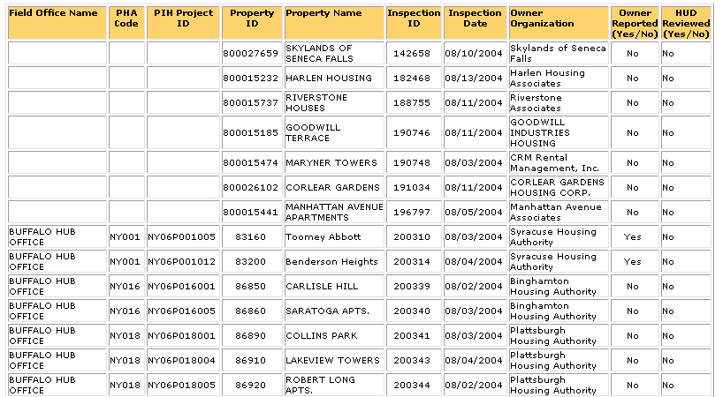

- The user may then download the “EH&S Defects Details Reports” to a Microsoft Excel file by selecting the “Download to Spreadsheet” button as shown in the reproduction, below. The user may then save the spreadsheet to the desired file location on his/her computer.

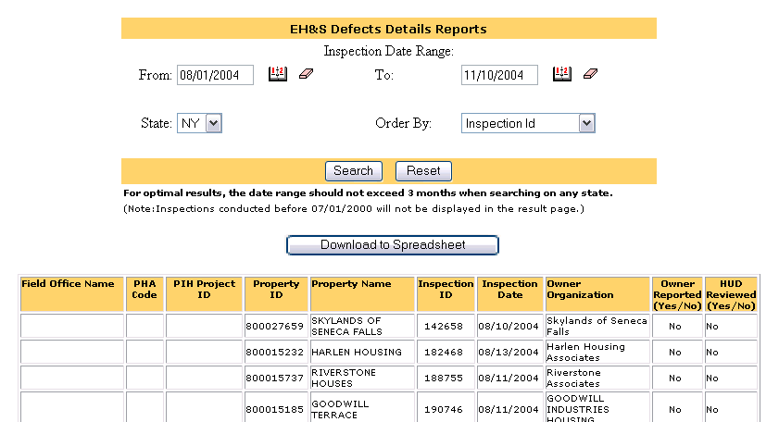

- At the bottom of each screen in the system is a “REAC Technical Assistance Center” link. If the user encounters any problems during use of the system, the user should select this link.

This link will take the user to the technical assistance web page. Holding the cursor over the link will display the Technical Assistance Center toll-free telephone number (1-888-245-4860). Users may contact the Center between the hours of 7:00 a.m. and 8:00 p.m. Eastern Standard Time for assistance with the use of the system, questions regarding the UPCS protocol, and user name and password issues.

- Field Office users will log into Secure Systems to access the EHS report system using the following uniform resource locator (URL):

https://hudapps.hud.gov:80/ssmaster

- The Field Office user will enter a user ID and password and then select the “Login” button, as shown on the screen reproduction below. Note: Each Field Office user will enter his/her existing Secure Systems user ID and password. A Field Office user that does not have a valid Secure Systems user ID should e-mail PIH-REAC ADP Security at REAC_ADP_Security@hud.gov to apply for a user ID. All Field Office users will have a user ID that begins with an “H” and a password of six to eight characters in length.

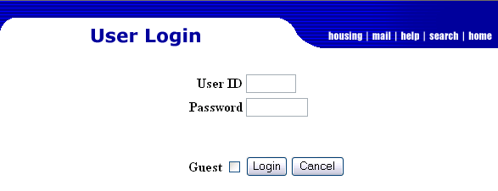

- When a login is successful, the warning and notice screen comes up, as shown on the screen reproduction below. After reviewing the messages on the screen, the user will select “Continue” to access the Secure Systems menu. Note: If the log in attempt is unsuccessful, the user should contact the PIH-REAC Technical Assistance Center at 1-888-245-4860.

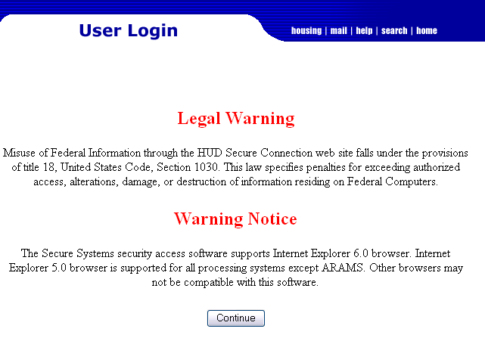
- The user will select “Physical Assessment Subsystem (PASS)” from the Secure Systems Main Menu, as shown in the screen reproduction below. Note: Each activity on the Main Menu is linked to the user’s ID; therefore, the available menu options may vary from the links shown in the screen reproduction below.

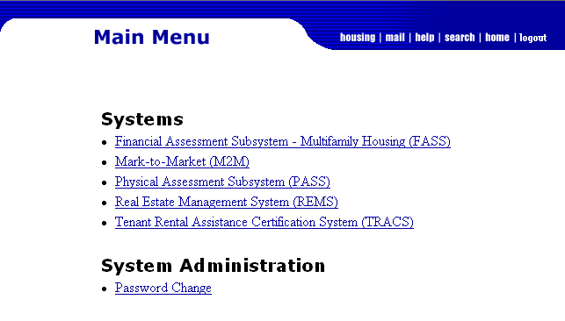

- A second login screen titled “Secure Systems Single Sign On Pilot” will appear, as shown in the screen reproduction below. The user will enter the H-ID in the User ID field, then the network password (the password used to login to their Windows desktop computer) into the Password field.

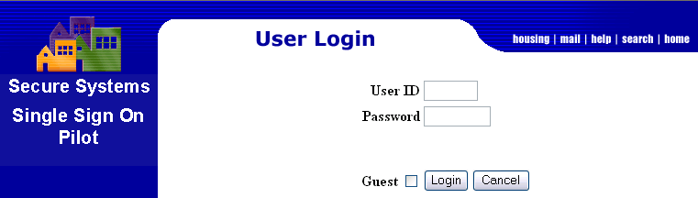

- From the Physical Inspection Main Menu, under the header “Reporting,” the user will select “EH&S Reports,” as shown in the screen reproduction below. Note: Each activity on the Physical Inspection Main Menu is linked to the user’s ID, therefore the available menu options may vary from the links shown in the screen reproduction below.

- A page titled “Exigent Health and Safety Reports” will be displayed, as shown on the screen reproduction below. A Field Office user may use the search section to search by individual inspection or PIH Project Number as well as by state or zip code for properties in the Field Office’s jurisdiction. After entering the selection criteria, the user will select the “Search” button. Note: Because the “Search by State” functionality for some states is a very large database, the search may “time out,” indicating that the system cannot complete the search. In these cases, a search by Inspection ID or PIH Project Number is recommended.

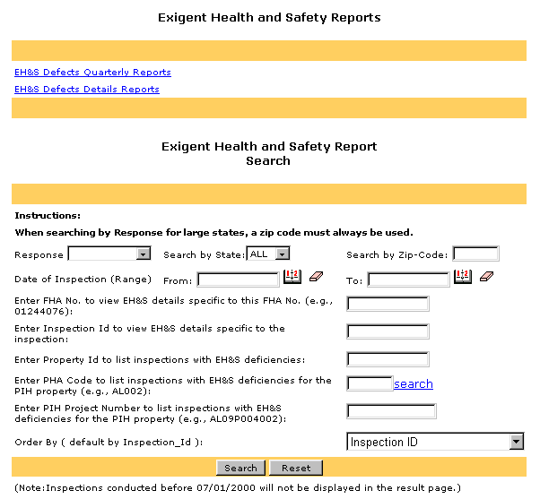

- Field Office users may also view all properties with EHS deficiencies for a particular PHA by entering the “PHA Code,” as shown on the screen reproduction below.

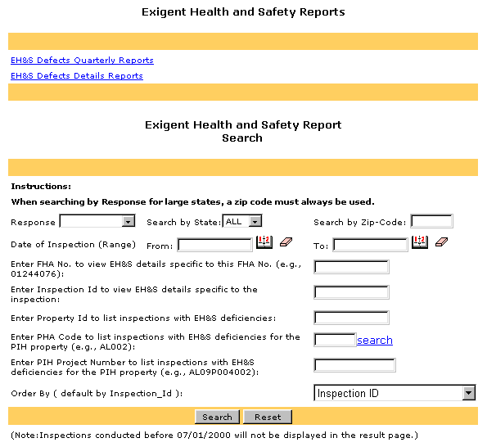

- If a user is unsure of the PHA Code, the user may select the “search” link to search for the PHA Code, as shown on the screen reproduction below.

- This link displays the PHA Search page that allows the user to search by state and by full or partial city name (optional), as shown on the screen reproduction below.

- After finding the correct PHA Code, the user will type that code into the PHA Code text box to complete the search for properties with EH&S deficiencies.

- The results of searching by a PHA Code will be a list of the inspections for a specific PHA. The user will select the “EH&S Details” link, as shown on the screen reproduction below, to view the details of the EHS deficiencies and enter or view the correction or abatement information. Note: For purposes of this notice, all property and inspection identifiers have been removed from the screens shown.

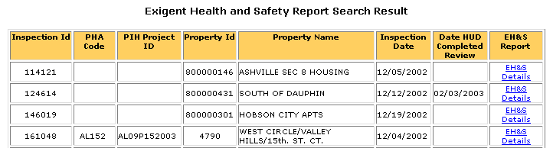

- After clicking the link “EH&S Details,” the Exigent Health and Safety Hazard Details screen will display. All EHS deficiencies that the inspector observed and recorded are listed by building and unit number. To display the comments the inspector entered about a deficiency during the inspection, the user will select the link under “Inspector Comments.” The link under “Inspection Comments” will state the location and type of deficiency, as shown in the screen reproduction below.

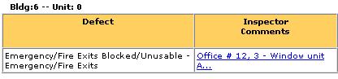

- To close the pop-up box, the user will select the “Close” button, as shown in the screen reproduction below.

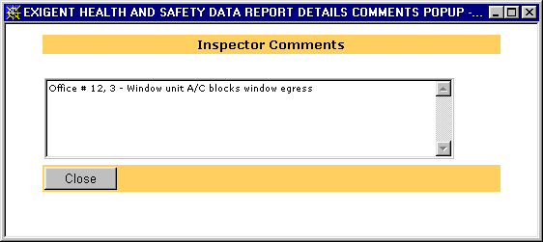

- Selecting the “View PDF” link on the “Exigent Health and Safety Hazard Details” page will provide the user with the Inspection Summary Report for the property. The Inspection Summary Report displays each EHS deficiency observed and recorded during the inspection and its impact on the inspection score, as shown in the screen reproductions below.

- To view any Corrective Action taken by the PHA or to enter any Field Office follow-up activity comments, the Field Office user will select the “Edit” link, as shown in the screen reproduction below.

- After clicking the “Edit” link under the heading Corrective Action, the “Exigent Health and Safety Hazard Corrective Action” screen will be displayed. To complete the “Date HUD Visited Property” field, the user will select the calendar icon, as shown in the screen reproduction below. Comments can then be entered into the “HUD Comments” field by simply typing in the box provided. After entering the date and comments, the user will select “Update.” Note: Both the date and comment(s) must be entered. The “Update” selection will prompt the user to complete the entry if one of these two fields is incomplete. Any comments recorded in error may be deleted by selecting the “Reset” button.

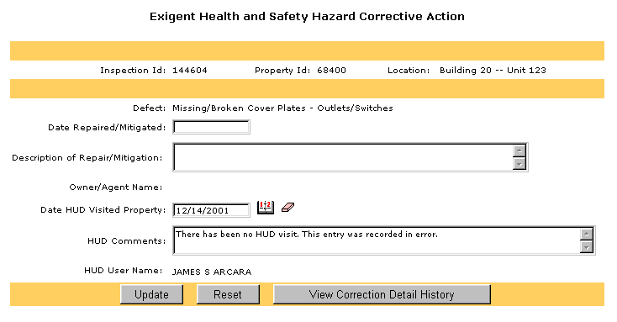

Note: As part of their fieldwork, PIH-REAC PASS Quality Assurance (QA) staff conduct follow-up activities on properties with EHS deficiencies. Both Field Office and QA staff may enter comments in the “HUD Comments” field and the “Date HUD Visited Property” field. To view all of the comments entered, select the “View Correction Detail History” button. This will display all of the comments that have been entered and the name of the individual who entered each comment. The most recent comment is displayed first.

The terminology used in the system to indicate “corrected,” is the term “repaired,” and for abated” is the term “mitigated.”

Repaired = Corrected

Mitigated = Abated

- The “EH&S Defects Details Report” link provides comprehensive information for all properties within a specified state and for all inspections during a specified period of time. The user will select the “EH&S Defects Details Reports” link to select the report data criteria, as shown in the screen reproduction below.

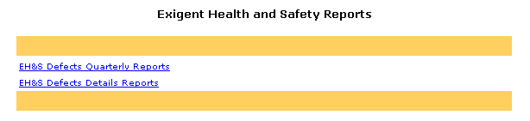

- The EH&S Defects Details Reports search screen will be displayed, as shown in the screen reproduction below. The user will select a date range for the report by using the calendars for the “From:” and “To:” fields, and then select a state from the drop down menu. Note: Selecting a date range of greater than three months may slow response time considerably, or cause the request to “time out.”

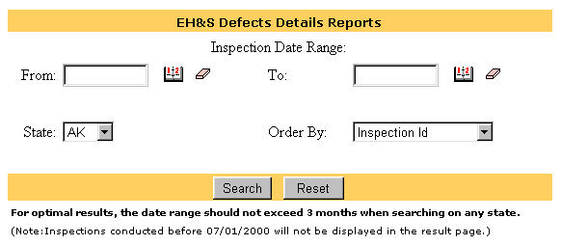

- After entering the date range and state, the user can choose to sort the inspection results by any of the following fields: Inspection Id, Inspection Date, Property Id, Property Name, PHA Code, or PIH Project Number. To sort, the user will select one of the choices from the “Order By” drop-down box. Then, the user will select “Search,” as shown on the screen reproduction below. Note: If the user does not select an “Order By” field, the results of the search will automatically be sorted by “Inspection Id.”

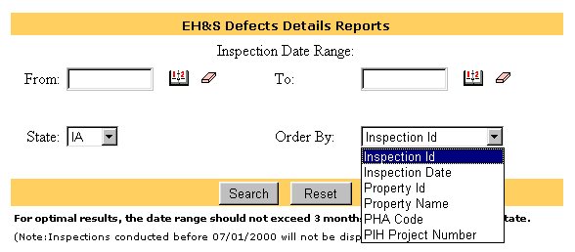

- The screen will display the EH&S Defects Details Report as shown in the screen reproduction below. This report provides the details and status for each property inspection and includes the assigned Field Office. Note: The “HUD Reviewed (Yes/No)” field is only populated with a Yes answer when the review of the property is complete and a comment has been entered.

- The user may then download the “EH&S Defects Details Reports” to a Microsoft Excel file by selecting the “Download to Spreadsheet” button as shown in the reproduction below. The user may then save the spreadsheet to the desired file location on his/her computer.

- The “EH&S Defects Quarterly Reports” link provides a quarterly report containing a list of all PHAs with properties inspected that have EHS deficiencies, their assigned Field Office, and how many deficiencies were observed and recorded. Note: This report is created on the first Saturday after the close of the quarter. For example, if the quarter ends on a Monday, the report is available after the following Saturday.

- The user may then select the link to the particular calendar quarter.

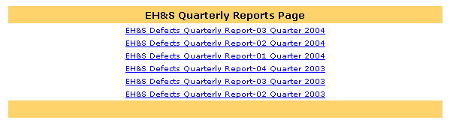

- After selecting the quarter for review, the user may see a warning message, as shown in the screen reproduction, below. The message, which is common when opening files on the Internet, allows the user to view the spreadsheet by selecting “Open it,” or to save the spreadsheet to a file without opening it first by selecting “Save it to disk.” After the user selects either option, the user will select “OK.”

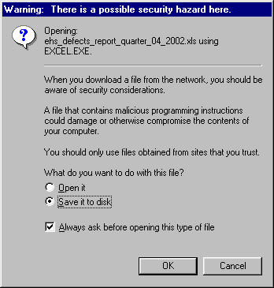

- If the user selects “Save it to disk,” the user will then need to select the file location to save the report, as shown in the screen reproduction, below.

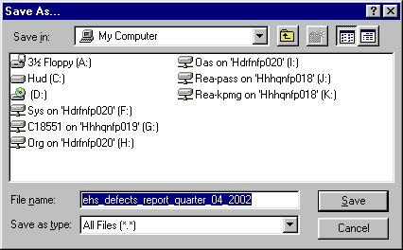
- If the user selects “Open it,” the Quarterly Report spreadsheet will be displayed. The spreadsheet contains the “Field Office Name,” “PHA Code,” “PHA Name,” “Number of EH&S Defects” and “Number of Properties Inspected” for all PHAs with properties inspected during the quarter, as shown in the screen reproduction, below. Because it is a nationwide report and may be quite large, the user can sort by any of the fields provided to view only the PHAs of interest.

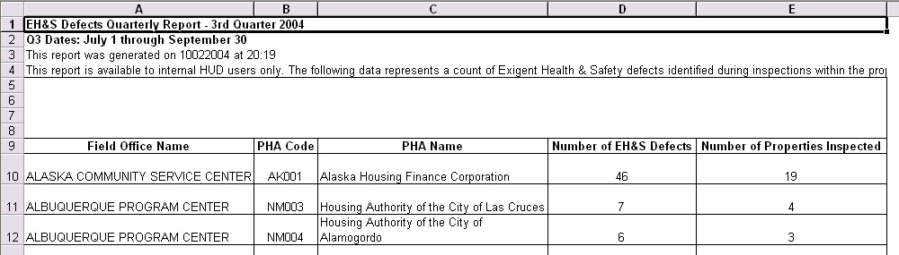

- At the bottom of each screen in the system is a “REAC Technical Assistance Center” link. If the user encounters any problems during use of the system, the user should select this link.

This link will take the user to the technical assistance web page. Holding the cursor over the link will display the Technical Assistance Center toll-free telephone number (1-888-245-4860). Users may contact the Center between the hours of 7:00 a.m. and 8:00 p.m. Eastern Standard Time for assistance with the use of the system, questions regarding the UPCS protocol, and user name and password issues.

