U.S. Department of Housing and Urban Development

Public and Indian Housing
Special Attention of: Notice PIH 2004-12
Office Directors of Public Housing; Issued: 7/19/2004
PIH Program Center Coordinators; Public
Housing Agencies Administering
Housing Choice Voucher Programs Expires: 7/19/2005
______________________________
Cross References:

Subject: Housing Choice Voucher Portability Procedures and Corrective Actions –
Revision of Family Portability Information, Form HUD-52665

1. Purpose. This notice provides guidance on public housing agency (PHA) administrative responsibilities related to portability moves. Specifically:

- It changes the deadlines by which initial billing information must be submitted by the receiving PHA;

- It requires the receiving PHA to now provide annual re-certification notification to the initial PHA;

- It establishes new requirements to address late billing payments by initial PHAs, including an explicit deadline by which on-going monthly billing amounts must be received by the receiving PHA;

- It outlines the procedures that will be used to transfer units from initial PHAs to receiving PHAs in cases where billing deadlines are not met;

- It describes penalties that will be imposed on receiving PHAs that fail to provide timely notification to initial PHAs when billing arrangements are terminated;

f. It transmits a revised Family Portability Information Form HUD-52665, which incorporates the new billing deadlines;

g. It clarifies Public and Indian Housing Information Center (PIC) data entry related to portability.

2. Effective Date. This notice is effective upon publication.

- Background. One of the features of the housing choice voucher program is the mobility of the assistance. Section 8(r) of the United States Housing Act of 1937 provides that housing choice voucher participants may choose a unit that meets program requirements anywhere in the United States, provided a PHA administering the tenant-based program has jurisdiction over the area in which the unit is located. The term “portability” refers to the process of leasing or purchasing a dwelling unit with housing voucher tenant-based assistance outside of the jurisdiction of the PHA that initially issues the family its voucher (the initial PHA). Program regulations covering where a family may move and the responsibilities of the initial PHA and the receiving PHA (the PHA with jurisdiction over the area to which the family moves) are found at 24 CFR sections 982.353 through 982.355.

The program regulations at section 982.355(e) provide that the receiving PHA may bill the initial PHA for housing assistance payments (HAP) and administrative fees to cover assistance for a portable family. The regulations require that the initial PHA must promptly reimburse the receiving PHA for the full amount of the HAP payments and for 80 percent of the initial PHA on-going administrative fee (effective January 1, 2004, 80 percent of the administrative fee per unit cost (PUC) as determined by HUD) or some other negotiated amount if both PHAs agree, for each unit month that the family receives assistance under the voucher program from the receiving PHA.

The regulations further require that in the administration of portability, the initial PHA and the receiving PHA must comply with financial procedures required by HUD, including the use of HUD-required billing forms. The initial PHA and the receiving PHA must also comply with billing and payment deadlines under the financial procedures. HUD may assess penalties against an initial PHA or a receiving PHA for violations, as determined by HUD, of the portability requirements. These penalties include reducing the administrative fee to an initial PHA if the PHA does not promptly reimburse the receiving PHA for housing assistance payments or fees for administering rental assistance for portable families.

Although the majority of PHAs are complying with existing billing procedures and reimbursement deadlines, the Department continues to receive complaints from PHAs that are not receiving billing payments in a timely manner. In some instances, the receiving PHA does not have the resources available to cover a significant number of outstanding or delinquent payments from initial PHAs. Billing problems may jeopardize the financial solvency of those agencies and adversely impact overall administrative performance.

Furthermore, a recent HUD Office of Inspector General audit revealed several instances where receiving PHAs failed to inform initial PHAs in a timely manner that portable families had been absorbed or left the program. As a result, the initial PHAs continued to make payments to the receiving PHAs for a significant period of time on behalf of families that were no longer receiving assistance under the initial PHA program, rather than immediately reissuing the available vouchers to families on their waiting list.

These new procedures are designed to ensure that receiving PHAs are promptly reimbursed for administering voucher assistance on behalf of portable families and that scarce subsidy dollars do not go unused because of poor communication between PHAs. The program regulations at section 982.355(f)(1) provide that HUD may transfer funds for assistance to portable families to the receiving PHA from funds available under the initial PHA annual contributions contract (ACC). HUD will exercise this authority to transfer units from the initial PHA to the receiving PHA in cases where the initial PHA fails to comply with the new billing procedures described below. Initial PHAs may also voluntarily request that HUD

transfer units from their ACC to the receiving PHA ACC in order to eliminate portability billing arrangements.

HUD further notifies PHAs that HUD intends to do periodic reviews of PHAs with respect to portability billing arrangements. PHAs will be required to submit information on families covered under billing arrangements and HUD will determine if the information is consistent between initial and receiving PHAs. HUD urges PHAs to compare portability billing records with their initial and receiving PHA partners in order to identify and address any discrepancies before the HUD review. Receiving PHAs that failed to inform initial PHAs, in accordance with this notice, that billing arrangements have been terminated in a timely manner will be subject to the penalties described later in this notice.

4. Initial PHA Responsibilities: Contacting the Receiving PHA. When a family wishes to move under portability, the family must inform the initial PHA of the area to which the family wishes to move. In the case where the family is not currently a program participant, the initial PHA must determine if the family is income eligible in the area to which the family wishes to move. If the family is not income eligible in the area to which the family wishes to move, the PHA must inform the applicant family they may not move to the area in question and receive voucher assistance. Income eligibility is not redetermined when a participant family (a family that is already under a HAP contract) exercises portability.

The initial PHA must contact the receiving PHA on the family’s behalf. The initial PHA must promptly notify the receiving PHA to expect the incoming family (see section 982.355(c)(2)). This means the initial PHA contacts the receiving PHA on the family’s behalf, typically by telephone, fax, or email. Simply referring the family to HUD or a website for information on the receiving PHA’s address does not fulfill the responsibilities of the initial PHA under the program regulations. The initial PHA must also advise the family how to contact and request assistance from the receiving PHA (e.g., the name and telephone number of the staff person responsible for working with incoming portability families and any procedures related to appointments for voucher issuance the receiving PHA has shared with the initial PHA). The revised Form HUD-52665 now contains a line that the initial PHA uses to identify the receiving PHA to which the initial PHA is referring the family.

5. Initial PHA Responsibilities: Completion of Part I of the Form HUD-52665. The initial PHA completes Part I of the Form HUD-52665 and mails or faxes it to the receiving PHA, along with a copy of the family’s voucher issued by the initial PHA, a current copy of Form HUD-50058, and copies of the income verification backing up the form. (Note that in the case of an applicant, the initial PHA has not completed the HUD-50058 and submitted the information to HUD because the family is not yet a new admission. However, the PHA must provide the family information and income information to the receiving PHA in a format similar to the Form HUD-50058 so that the information is easily available for use by the receiving PHA.)

Part I of the form contains the date by which the initial billing notice provided by the receiving PHA must be received by the initial PHA. Note that the initial billing deadline has changed. The initial billing submission must be received by the initial PHA no later than 60 days following the expiration date of the family voucher issued by the initial PHA.

If the initial PHA has not received a billing notice by the deadline, the initial PHA must contact the receiving PHA to determine the status of the family if the initial PHA intends not to honor a late billing submission. If the receiving PHA reports that the family is not yet under HAP contract, the initial PHA may inform the receiving PHA that they will not accept any subsequent billing on behalf of the family. Once the initial PHA has so notified the receiving PHA, the initial PHA is not required to honor any billing notice received after the billing deadline. If the initial PHA still subsequently receives a late billing notice on behalf of the family, it simply returns the late Form HUD-52665 to the receiving PHA, and the receiving PHA must absorb the family.

If the receiving PHA reports that the family is under HAP contract and it cannot absorb when the initial PHA contacts the receiving PHA to determine the status of the family, the initial PHA is required to accept the subsequent late billing. The initial PHA may contact HUD to report the receiving PHA’s failure to submit the bill in accordance with these procedures. HUD may take action to address the receiving PHA’s failure to do so, which may include reducing the receiving PHA’s administrative fee. In addition, in such a case HUD may subsequently transfer units from the receiving PHA to the initial PHA when it is feasible, since the initial PHA was required to accept the late billing.

6. Receiving PHA Responsibilities: Processing Responsibilities. The receiving PHA must promptly issue a voucher to the family for its search in the receiving PHA jurisdiction, the term of which may not expire before the expiration date of the initial PHA voucher. The receiving PHA may provide additional search time to the family beyond the expiration date of the initial PHA voucher, either when it initially issues its own voucher or by subsequently extending its own voucher’s term. However, if the receiving PHA provides the family with search time beyond the expiration date of the initial PHA’s voucher, it must inform the initial PHA of the extension and should bear in mind the billing deadline provided by the initial PHA. Unless willing and able to absorb the family, the receiving PHA should ensure that any voucher expiration date would leave sufficient time to process a Request for Lease Approval, execute a HAP contract, and cover the anticipated delivery time (if the PHA is not submitting the billing information by fax or email) so that it will be received by the initial PHA by the deadline date.

A receiving PHA should not process the family if the initial PHA voucher has already expired when it receives the paperwork from the initial PHA, but should refer the family back to the initial PHA. The initial PHA would have to decide to extend the term of the initial PHA voucher (and the billing deadline) before the receiving PHA would process the portability move in such an instance.

HUD expects the receiving PHA to process the family’s paperwork and issue the incoming family a voucher for its jurisdiction within two weeks of receiving the HUD-52665 and supporting documentation, provided the information is in order, the family has contacted the receiving PHA, and the family complies with the receiving PHA’s procedures. For example, it is unacceptable for the receiving PHA to delay processing the family’s paperwork and issuing a voucher because it wishes the family to attend a group briefing that is not scheduled for three weeks. The receiving PHA does not re-determine eligibility for a portable family that was already receiving voucher assistance and may not unduly delay the family’s housing search in issuing the voucher.

Should the PHA wish to conduct its own background checks and/or conduct a new income reexamination on a family that has already received housing assistance payments under the initial PHA, the receiving PHA may not delay issuing the family a voucher or otherwise delay approval of a unit until such time that those processes are completed. The PHA may of course take subsequent action (e.g., recalculating the HAP payment based on updated income information; terminating the family’s participation in the program due to criminal background or failing to disclose necessary information) against the family based on the results. In the case of an applicant family, the receiving PHA may delay issuing or otherwise delay approval of a unit only if the re-certification is necessary to determine income eligibility.

In any event, the PHA may always delay approval of the unit or issuance of the voucher if the family refuses to comply with the receiving PHA procedures (such as completing disclosure forms or certifications). In any case where the PHA is refusing to process or provide assistance under the portability procedures, the family must be given the opportunity for an informal review or hearing in accordance with sections 982.554 and 982.555.

If an incoming portable family ultimately decides not to lease in the jurisdiction of the receiving PHA, but instead wishes to return to the initial PHA or wishes to search in another jurisdiction, the receiving PHA must refer the family back to the initial PHA. In such a case the voucher of record for the family is once again the voucher originally issued by the initial PHA. Any extensions of search time provided by the receiving PHA voucher are only valid for the family’s search in the receiving PHA jurisdiction. Any extensions of the initial PHA voucher necessary to allow the family additional search-time to return to the initial PHA’s jurisdiction or to move to another jurisdiction would be at the discretion of the initial PHA.

The receiving PHA may absorb the family into its own program once the HAP contract is executed on behalf of the family by the receiving PHA, assuming it has funding available under its ACC to do so and such a decision will not result in over-leasing. The receiving PHA may also absorb a portable family assisted through a billing arrangement by terminating the billing arrangement with the initial PHA. In such a case, HUD encourages the receiving PHA to provide adequate advance notice to the initial PHA to avoid having to return an overpayment. The receiving PHA must specify the effective date of the absorption of the family.

To clarify any misunderstanding over the purpose and use of the absorption option, a PHA does not technically “absorb” a family into its program until the receiving PHA executes a HAP contract on behalf of the family in the receiving PHA jurisdiction. If the family is not placed under HAP contract in the receiving PHA jurisdiction, the receiving PHA cannot absorb the family.

7. Receiving PHA Responsibilities: Part II of Form HUD-52665. The receiving PHA must promptly inform the initial PHA if it intends to absorb or bill. The receiving PHA sends Part II of Form HUD-52665 to the initial PHA. If the receiving PHA decides to bill the initial PHA, the receiving PHA not only completes Part II of the Form HUD-52665, but also attaches a copy of the new Form HUD-50058 before returning it to the initial PHA. In addition to the initial billing deadline discussed above, the instructions of the Form HUD-52665 provide that the receiving PHA must complete and mail (which may include electronic mail or fax) Part II of the form within 10 working days from the date a HAP contract is executed on behalf of a family.

HUD is aware that in some instances receiving PHAs have submitted initial billings well after 10 working days, creating significant difficulties for initial PHAs. Effective 30 days following the issuance date of this notice, the initial PHA is generally not obligated to honor initial billings that are postmarked, emailed, or faxed more than 10 working days after the date the HAP contract is executed. (Note that it is the date the HAP contract is executed, not the effective date of the HAP contract, which is at issue. For instance, if a PHA executes a HAP contract within 60 days of the approval of the unit, the HAP contract may be retroactive to the date the unit was approved. It is the date the PHA executed the contract, not the retroactive effective date of the contract, that establishes the deadline by which the initial billing must be mailed, emailed or faxed.) The initial PHA must immediately inform the receiving PHA in writing of its decision not to accept the late billing submission. A receiving PHA that failed to send the initial billing within 10 working days following the date the HAP contract is executed is generally required to absorb the family into its own program unless the initial PHA is willing to accept the late submission.

HUD may in certain instances require the initial PHA to honor a billing submission that is received after the 10 day deadline (such as where the receiving PHA is over-leased and is in danger of not being able to stay under unit months available for its fiscal year). In such a case HUD may take action to address the receiving PHA’s failure to submit the notification in a timely manner, which may include reducing the receiving PHA’s administrative fee and subsequently transferring units from the receiving PHA to the initial PHA.

8. Timing of the Initial and Subsequent Billing Payments. The initial PHA must pay the first billing amount due within 30 calendar days of receipt of Part II of the Form HUD-52665. Subsequently, the initial PHA must make payment each month the billing arrangement is in effect. The payment must be provided in a form and manner that the receiving PHA is able and willing to accept. Initial PHAs involved in billing arrangements must ensure that subsequent monthly billing payments are received by the receiving PHA no later than the fifth working day of each month. This policy goes into effect for existing billing arrangements 60 days following the effective date of this notice.

In many cases billing difficulties simply result from miscommunications that are often resolved by the PHAs without HUD intervention. HUD continues to encourage PHAs to
work cooperatively to resolve billing difficulties. However, it is ultimately the responsibility of the initial PHA to make billing payments in a timely manner.
The program regulations at section 982.355(f)(1) provide that HUD may transfer funds for assistance to portable families to the receiving PHA from funds available under the initial PHA ACC. Upon request of the receiving PHA, HUD will exercise this authority to transfer units from the initial PHA to the receiving PHA in cases where the initial PHA fails to comply with the initial and subsequent monthly billing due dates described above.

The initial PHA may not terminate or delay making payments under existing billing arrangements as a result of over-leasing or funding shortfalls at the initial PHA program. PHAs may only terminate HAP contracts as the result of insufficient funding in accordance with 24 CFR 982.454 to which they are a party.

- Receiving PHA: On-going Responsibilities. Effective 30 days following the issuance date of this notice, the receiving PHA must send the initial PHA a copy of the updated Form HUD-50058 at each annual recertification for the duration of time the receiving PHA is billing the initial PHA on behalf of the family, regardless of whether there is a change in the billing amount. The purpose of this notification is to serve as an annual “reconciliation” to assist both PHAs in fulfilling their accounting and record-keeping responsibilities. Should the initial PHA fail to receive an updated Form HUD-50058 by the annual recertification date, it should contact the receiving PHA to verify the status of the family.

The receiving PHA is also required to send a new Form HUD-52665 along with the Form HUD-50058 to report any change in the billing amount, if applicable. The timing of the notice of the change in the billing amount should correspond with the notification to the owner and the family in order to provide the initial PHA with advance notice of the change. However, under no circumstances should the notification be later than 10 working days following the effective date of the change in the billing amount.

If the receiving PHA is absorbing a family for which it has been billing or if the housing assistance payments are terminated for any reason, the receiving PHA should provide adequate notice of the effective date of the absorption or termination to avoid having to return a payment. In no event should the receiving PHA fail to notify the initial PHA later than 10 working days following the effective date of the termination of the billing arrangement.

In the case where a family currently under a billing arrangement subsequently decides it wants to move under portability to yet another jurisdiction, the receiving PHA does not issue the family a voucher in order to do so. Instead, the receiving PHA notifies the initial PHA of the family request to port to another jurisdiction. The initial PHA is responsible for issuing the family's voucher and sending the Form HUD-52665 and supporting documentation to the new receiving PHA. Good communication between all three PHAs is very important in such a circumstance.

- Summary of Portability Billing Deadlines. The following summarizes the relevant deadlines under the portability billing procedures.

  - Submission of Initial Billing Amount (Part II of the Form HUD- 50058) -- Receiving PHA must submit initial billing notice (1) no later than 10 working days following the date the HAP contract was executed and (2) in time that it will be received no later than 60 days following the expiration date of the family’s voucher issued by the initial PHA.

  - Payment of First Billing Amount -- Initial PHA makes payment within 30 days of receipt of Part II of the Form HUD 50058 indicating billing amount.

  - Payment of Subsequent Billing Amounts – The initial PHA is responsible for ensuring that subsequent billing amounts are received no later than the fifth working day of each month for which the monthly billing amount is due.

  - Notification of Change in Billing Amount or Other Action – The receiving PHA notifies the initial PHA of any change in the billing amount as soon as possible (preferably before the effective date to avoid retroactive adjustments) but in no circumstance any later than 10 working days following the effective date of the change.

- Discontinuation of Mutually Agreed Upon Billing Arrangements. In the past, HUD has permitted PHAs to mutually agree in writing to a different billing schedule and arrangement, provided that accounting and record-keeping is such that HUD or an independent auditor can easily identify the families in question and the billing amounts paid and due, and easily reconcile the billing amounts with HAP payments made by the receiving PHA on behalf of the family and the administrative fee amount reimbursed by the initial PHA.

However, the wide variation in billing schedules and arrangements in effect have in some instances caused confusion and billing problems between PHAs and confusion over HUD requirements concerning prompt payment and notification regarding billing arrangements. In order to reduce the amount of complication associated with portability billing arrangements, all PHAs are now required to follow the HUD procedures on billing requirements, including the billing schedule and reimbursement deadlines.

12. Procedures for the Transfer of Units as a Result of Late Payments. In the case where the initial PHA fails to make the monthly payment to the receiving PHA by the fifth working day of the month, the receiving PHA must promptly notify the initial PHA in writing of the deficiency. The notice must identify the family or families, the total billing payment that was late or has yet to be paid, and the date the payment was ultimately received (if received at all). A copy of the notification must be sent to the Director (or the staff person designated by the Director) of the Office of Public Housing (OPH) in the HUD Area Office with jurisdiction over the receiving PHA. If the initial PHA fails to correct the problem by the second month following the notification (e.g., receiving PHA informs of late payment in June and the August payment is late), the receiving PHA may request by memorandum to the Director of the OPH with jurisdiction over the receiving PHA that HUD transfer the unit or units in question. A copy of the initial notification and any subsequent correspondence between the PHAs on the matter must be attached. A copy of the memorandum must be sent to the initial PHA.

The OPH will notify the initial PHA (and the OPH director in the HUD Area Office with jurisdiction over the initial PHA) within 15 working days of receiving the receiving PHA memorandum requesting the transfer of units. The OPH will provide the initial PHA with 15 working days to respond and provide any supporting documentation if the initial PHA is contesting whether the billing payments in question were late. The OPH in the HUD Area Office with jurisdiction over the receiving PHA is the lead HUD office in resolving any dispute over the timeliness of the billing payments. That office is responsible for examining all documentation submitted by the PHAs and then determining if the billing payments were late if the initial PHA contests the receiving PHA’s report. The OPH must render a decision no later than 15 working days following the deadline by which the initial PHA had to respond to the OPH memorandum.

If the OPH determines that the payments in question were late, the OPH will send a memorandum to the Housing Voucher Finance Division (with copies to the Area Office with jurisdiction over the initial PHA as well as to both PHAs) indicating the number of units to be permanently transferred from the initial PHA to the receiving PHA. The number will correspond with the number of families for which billing payments were late. Within 30 days of receiving the OPH memorandum recommending transfer of units, HUD will reduce the baseline number of units and concomitant budget authority from the initial PHA ACC and increase the baseline number of units and budget authority on the receiving PHA ACC in order to adjust the PHA program size as a result of poor portability billing performance. HUD will use the revised baseline numbers to readjust the funding. The billing arrangement on behalf of the family or families in question ceases with the transfer of the unit, although the initial PHA is still responsible for any outstanding payments due to the receiving PHA.

These transfer policies notwithstanding, failure to comply with the financial procedures required by HUD, including the billing and payment deadlines outlined above, may also result in administrative sanctions, including the reduction of administrative fees.

- Penalties for the Receiving PHA’s Failure to Inform the Initial PHA of the Termination of a Billing Arrangement in a Timely Manner. As noted earlier in this notice, HUD intends to do periodic reviews of PHAs with respect to portability billing arrangements. PHAs will be required to submit information on families covered under billing arrangements and HUD will determine if the information is consistent between initial and receiving PHAs. In cases where HUD determines that the receiving PHA has not notified the initial PHA that a billing arrangement has been terminated in a timely manner and has continued to accept payments from the initial PHA, HUD may reduce administrative fees for the receiving PHA.

In all cases where the receiving PHA has received billing payments for billing arrangements no longer in effect, the receiving PHA is responsible for returning the full amount of the overpayment (including the portion provided for administrative fees) to the initial PHA.

In the event that HUD determines billing payments have continued for at least three months because the receiving PHA failed to notify the initial PHA that the billing arrangement was terminated, the receiving PHA must take the following steps:

- Return the full amount of the overpayment, including the portion provided for administrative fees, to the initial PHA.

- Once full payment has been returned, notify the Office of Public Housing in the HUD Area Office with jurisdiction over the receiving PHA of the date and the amount of reimbursement to the initial PHA.

HUD will, in its discretion, take the following actions:

- Direct the PHA not to utilize their administrative fee reserve account in accordance with 24 C.F.R. 982.155(b)(3).

- Reduce the administrative fees for the receiving PHA by 10 percent of the monthly billing amount in question for each month that the billing payments continued after the billing arrangement was terminated. The OPH in the HUD Area Office with jurisdiction over the receiving PHA will inform the PHA by letter of the amount of the sanction imposed as a result of the PHA’s failure to promptly notify the initial PHA that the billing arrangement is terminated. The OPH must send a copy of the letter to the FMC no later than 15 days after the end of PHA's fiscal year, so that the administrative fee can be reduced as part of the approval of the year-end settlement statement. (For example, if the receiving PHA was billing the initial PHA $600 a month on behalf of a family and collected four monthly billing payments beyond the billing arrangement termination date ($2400), the receiving PHA is responsible for returning $2400 to the initial PHA. In addition, HUD would reduce the PHA administrative fee by $240 as the sanction for failing to terminate the billing arrangement in a timely manner.)

- Further reduce the administrative fee if the receiving PHA does not promptly return the overpayment to the initial PHA.

This general policy does not in any way restrict the OPH Director from exercising any remedial action available in the event that the receiving PHA failed to notify initial PHAs that the billing arrangements have been terminated.

Attachment 2 of this notice provides guidance on how refunded amounts should be recorded in the financial records by both the initial PHA and the receiving PHA.

14. PIC Data Entry. There has been conflicting information in various publications dealing with portability data entry into PIC. In order to alleviate any confusion, the following summarizes the correct action codes to use when completing the Form HUD-50058 for portable families.

- Portability Move-in or New Admission

HUD-50058 Line Number 2a

Action Code = 4 or 1

The receiving PHA classifies a family as a 4-Portability Move-in if the family moves into a receiving PHA’s jurisdiction after being previously assisted by an initial PHA regardless of whether the receiving PHA absorbs the family or bills the initial PHA.

The receiving PHA classifies a family as a 1-New Admission if the family exercises portability with its first admission into the voucher program. This family (generally off the waiting list) would have received a voucher for the first time from the initial PHA and exercised portability without ever having leased an assisted unit in the initial PHA’s jurisdiction.

Effective Date of Action (Line 2b) is the effective date of the HAP contract for the family.

b. Portability Move-out

HUD-50058 Line Number 2a

Action Code = 5

A family is classified as a 5-Portability Move-out if the family moves out of an initial PHA’s jurisdiction, where it had been previously assisted, and into a receiving PHA’s jurisdiction, regardless of whether the receiving PHA bills the initial PHA or absorbs the family.

The initial PHA submits a 5-Portability Move-Out report only after the receiving PHA reports that it has executed a HAP contract on behalf of the family as recorded in Boxes 2 or 3 in Part II-B of the Form HUD-52655.

The Effective Date of Action (2b) for the Portability Move-out is the date entered in Box 2 or 3 of the Form HUD-52655.

- Additional Data Entry Requirements

HUD-50058 Line Number 12d

If the family moved into a PHA’s jurisdiction under portability as a new admission or portability move-in, regardless of whether the family is absorbed into the receiving PHA’s jurisdiction or the initial PHA is billed, the PHA must enter Y in this field. That field will not change as long as the family continues to be assisted in the receiving PHA’s jurisdiction, even if the receiving PHA decides to absorb the family after first billing the initial PHA.

HUD-50058 lines 12f

Since a PHA is not responsible for submitting reports into PIC for families whose assistance is being administered by another PHA under portability, the PHA code of the billed PHA must be entered correctly in order for reporting rates to be accurate.

15. Further Information. Any questions pertaining to the portability procedures may be addressed to the Housing Voucher Management and Operations Division at (202) 708-0477.

The information collection requirements contained in this notice have been approved by the Office of Management and Budget (OMB) under the Paperwork Reduction Act of 1995 (44 U.S.C. 3501-3520) and assigned OMB control number 2577-0169. In accordance with the Paperwork Reduction Act, HUD may not conduct or sponsor, and a person is not required to respond to, a collection of information unless the collection displays a currently valid OMB control number.

/s/
_____________________________
Michael Liu, Assistant Secretary for
Public and Indian Housing

Attachments
Form HUD-52665 (available at www.hudclips.org)
Guidance on PHA Entries for Returning Unearned HAPs and Fees under Portability

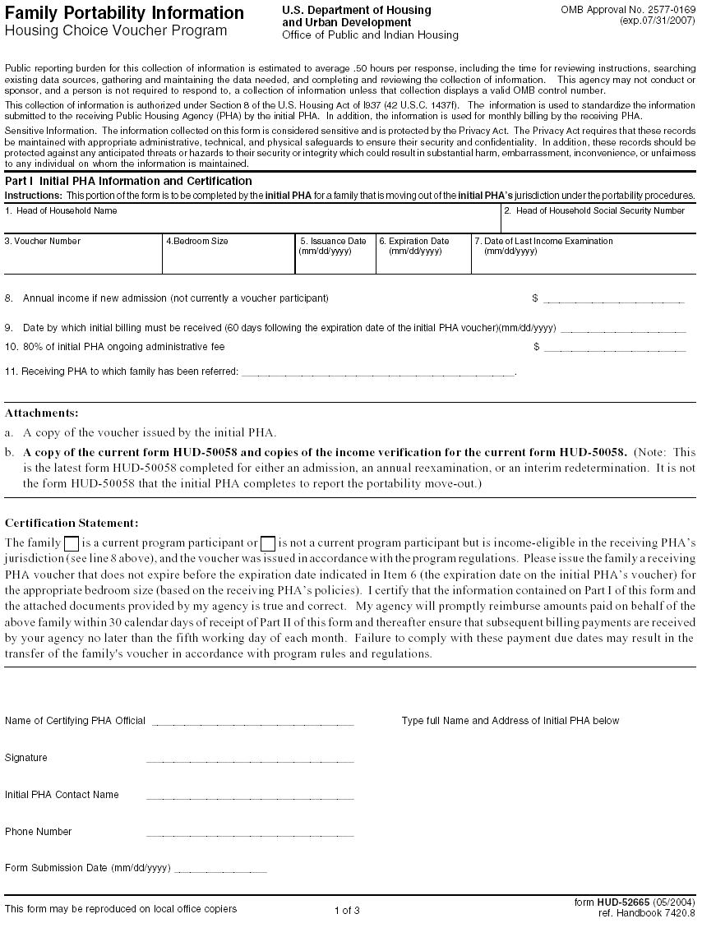
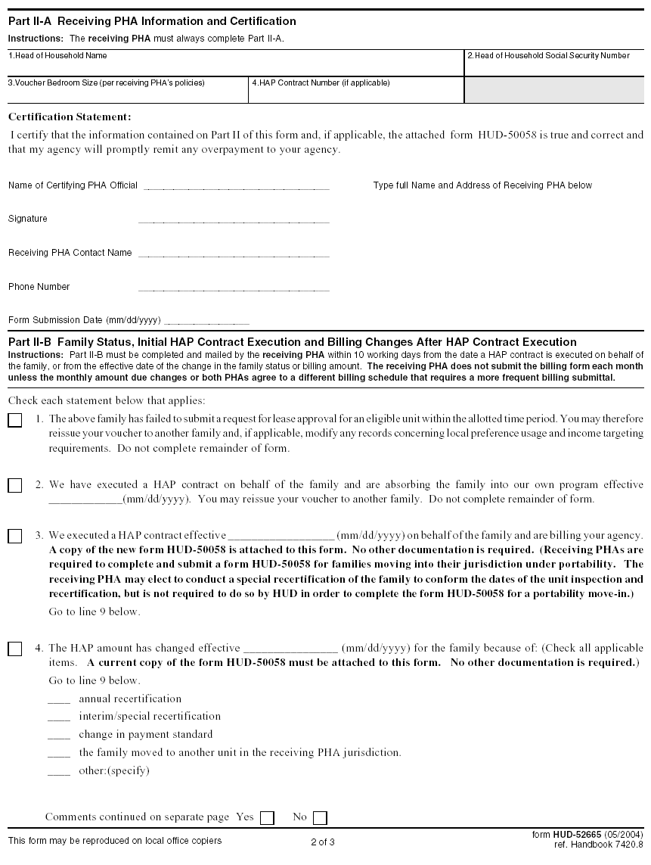
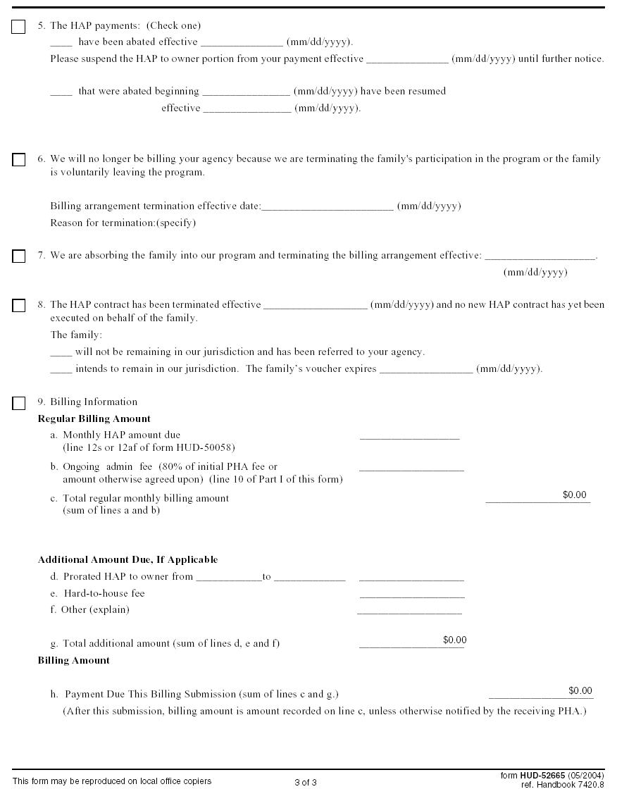

Guidance on PHA Entries for Returning Unearned HAPs and Fees under Portability

A number of cases have surfaced in which the receiving PHA did not promptly inform the initial PHA that billing arrangements were terminated as the result of absorption by the receiving PHA or families leaving the program. As a result the initial PHA continued to make monthly payments for housing assistance payments and administrative fees to the receiving PHA. The receiving PHA is required to refund the excess payments to the initial PHA.

The following guidance is provided regarding the appropriate accounting entries to accommodate the returned payments.

RECEIVING PHA:

Normally, the receiving PHA would have done the following when the HAP was paid to the owner on behalf of the family:
DR Accounts Receivable – Initial PHA (for HAP and fee)
CR Income (for Fee)
CR Cash (for HAP payment)

Upon receipt of payment of HAP and fees from the initial PHA, the Receiving PHA would have:
DR Cash
CR Accounts Receivable – Initial PHA

Typically, when the billing arrangement ceased the first set of transactions did not happen (the owners were not paid and the income was not recorded) because the receiving PHA had terminated the HAP contract. The receiving PHA failed to inform the initial PHA and continued to debit Cash and credit Accounts Receivable when the payment arrived from the initial PHA. The large CR balance in the Accounts Receivable is abnormal and the PHA should have recognized something was amiss.

When the receiving PHA returns funds it should not have received to the initial PHA, the receiving PHA would:
DR Accounts Receivable – Initial PHA
CR Cash

When all refunds are made, the Accounts Receivable balance should be zero or at normal levels.

INITIAL PHA:

When the initial PHA recognized the obligation under the billing arrangement for the family that moved under the portability procedures it would have created the expense and the payable:
DR Expense – Control (and subsidiaries for HAP and administrative expenses)
CR Accounts Payable – Receiving PHA

When the initial PHA then paid the receiving PHA:
DR Accounts Payable – Receiving PHA
CR Cash

When the initial PHA receives the funds back from the receiving PHA:
DR Cash
CR Expenses – Control (and subsidiaries)

