U.S. Department of Housing and Urban Development
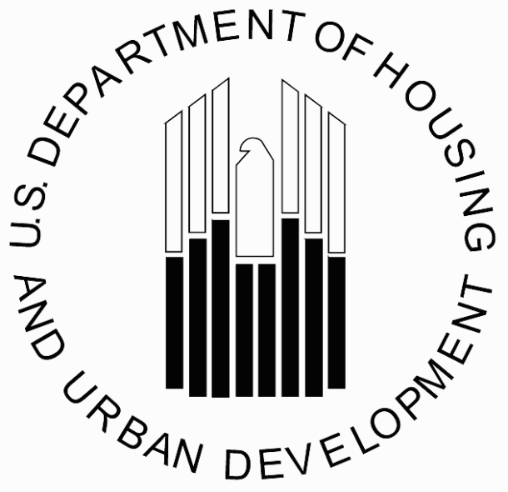

Office of Public and Indian Housing

Special Attention of: | NOTICE PIH 2003-3 (TDHEs)
Administrators, Offices of Native American Programs; Tribal Government Leaders; Tribally Designated Housing Entities | Issued: January 30, 2003  Expires: Indefinite
 | Cross References: 24 CFR Part 1000

Subject: Implementation of Statutory Change to the Native American Housing
Assistance and Self-Determination Act of 1996 (NAHASDA) related to Labor
Standards

Summary: In calendar year 2000, three laws were enacted which amended NAHASDA: the Fiscal Year (FY) 2001 HUD Appropriations Act, Public Law 106-377, approved October 27, 2000; the Omnibus Indian Advancement Act, Public Law 106-568, Title X – Native American Homeownership approved December 27, 2000; and the American Homeownership and Economic Opportunity Act of 2000, Public Law 106-569, Title V – Native American Homeownership approved December 27, 2000. With minor exception, the two laws approved on December 27, 2000 contain identical provisions. However, because the two laws enacted on December 27, 2000, cannot both amend NAHASDA, HUD considers the first – the Omnibus Indian Advancement Act, Public Law 106-568 – to contain the operative amendments.

Consultation with Tribal Governments: In accordance with Executive Order 13175, Consultation and Coordination with Indian Tribal Governments, and the Department’s Tribal Government-to-Government Consultation Policy (published in the Federal Register on September 28, 2001), the Department provided tribal leaders with an outline of all the statutory amendments and HUD’s proposed method for implementing the amendments. Approximately 800 copies of the proposed language were mailed to Indian tribal governments and tribally designated housing entities (TDHE) to solicit feedback in accordance with the Department’s Tribal Government-to-Government Consultation Policy. February 11, 2002 was established as the date for receipt of feedback. Written and electronic feedback was provided by one tribal government, six TDHEs, one attorney on behalf of six TDHEs, and two housing associations.

Based on the tribal comments received regarding the Labor Standards provision, the Department has reconsidered our position on this amendment. The Department is now taking the position that implementation of the amendment to sec. 104(b) related to tribally enacted prevailing wage laws and regulations does not require issuance of HUD implementing regulations. This Notice is to acknowledge that from enactment of the Omnibus Indian Advancement Act, Davis-Bacon and/or HUD-determined prevailing wage rates under sec. 104(b)(1) do not apply to contracts and agreements that are covered by tribal laws and regulations described in sec. 104(b)(3). A conforming rule will be published in the future.

NAHASDA Amendment: The following discusses the implementation of the statutory amendment related to Labor Relations:

Sec. 1003(j) of P.L. 106-568 amended sec. 104(b) of NAHASDA related to Labor Standards. Sec. 104(b)(1) was amended to change the Davis Bacon reference from “Davis Bacon Act (40 U.S.C. 276a-276a-5)” to the “Act of March 3, 1931 (commonly known as the Davis-Bacon Act; chapter 411; 46 Stat. 1494; 40 U.S.C. 276a et seq.)”. A new paragraph was added to the end of sec.104(b) and reads as follows:

“(3) APPLICATION OF TRIBAL LAWS- Paragraph (1) shall not apply to any contract or agreement for assistance, sale, or lease pursuant to this Act, if such contract or agreement is otherwise covered by one or more laws or regulations adopted by an Indian tribe that requires the payment of not less than prevailing wages, as determined by the Indian tribe.”

This Notice acknowledges that the above provision is in effect. A conforming rule will be published in the future. The Department will also publish Program Guidance to provide tribes and TDHEs with additional information on this issue.

__________/s__________________ Michael Liu, Assistant Secretary
Office of Public and Indian Housing

