Go to the View Opportunity | GRANTS.GOV webpage (which will take you to the screenshot page below) and follow the steps shown after the screenshot.

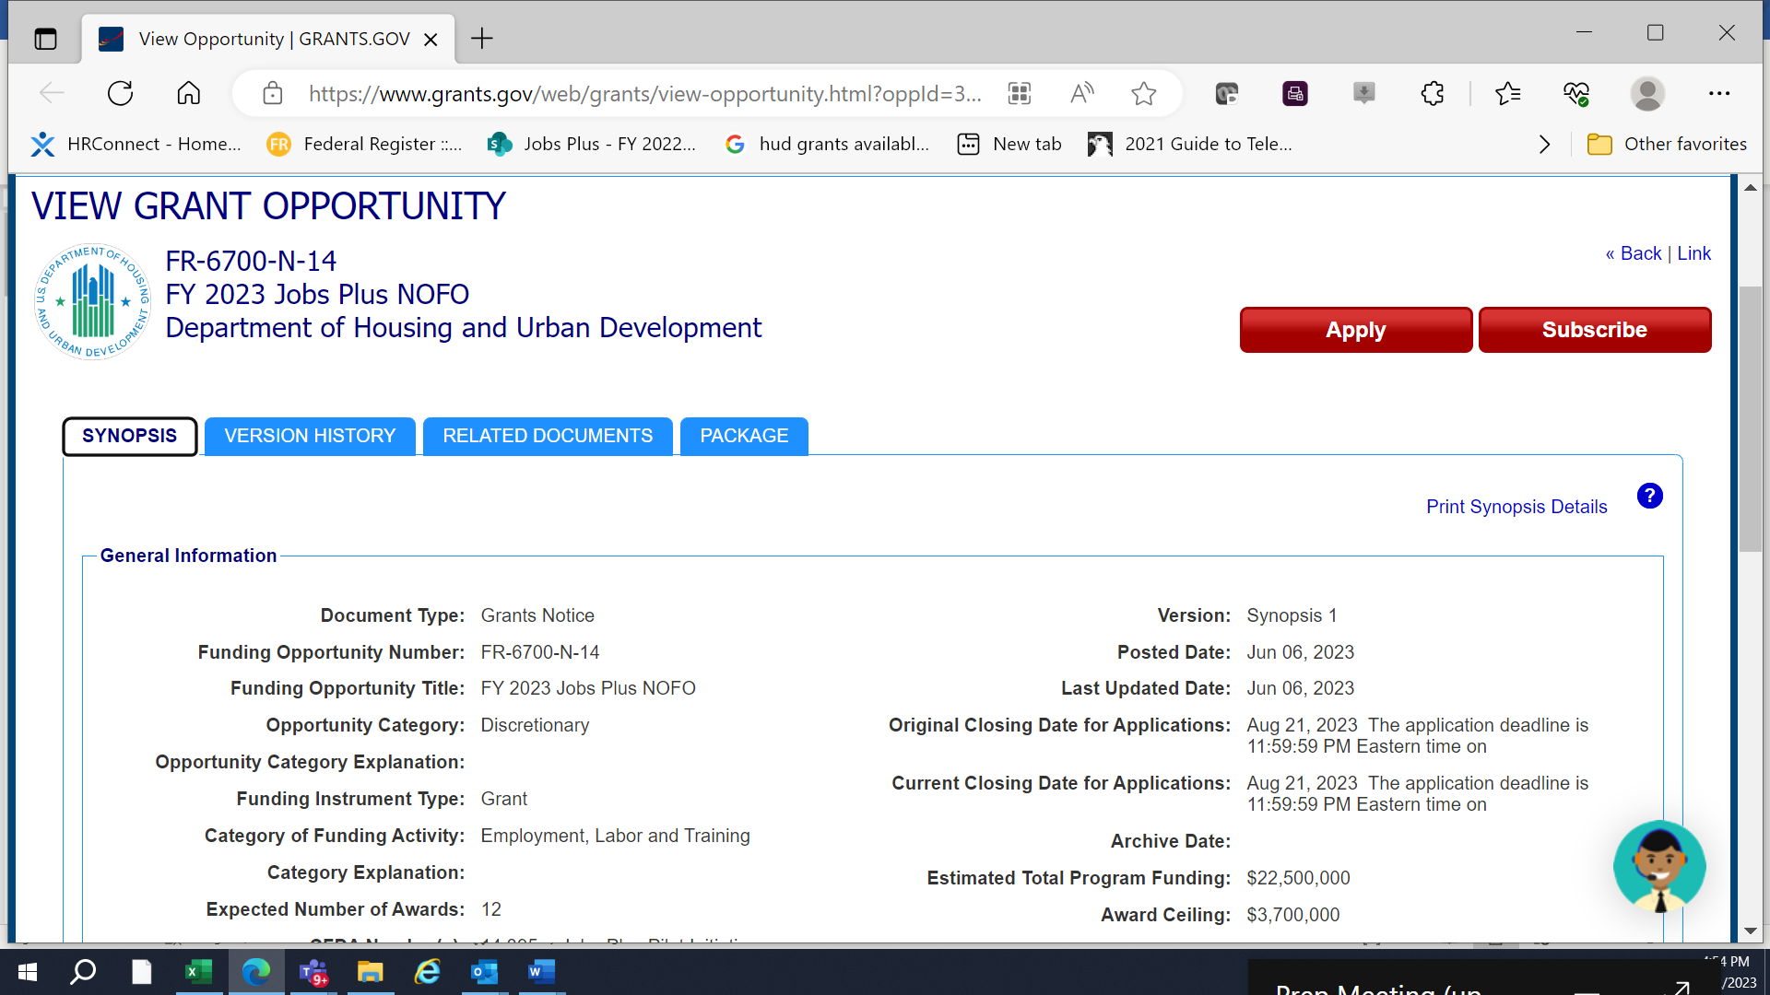

Click on the “Package” tab.

Click on the “Preview” link. (A window will appear where the “Mandatory Forms” and “Optional Forms” can be found.)

In the window, click on the “Download Instructions” button. A zip file will be downloaded to your computer. Therein you will see the Appendix B along with the NOFO, the Jobs Plus Budget Form and the HUD 50153.

