**LEAD-BASED PAINT NOFA Q AND A #3 - February 25, 2019**

1. **Where can I find the Program Notice of Funding Availability (NOFA)?**

*The Public and Indian Housing (PIH) Lead-Based Paint Capital Fund Program (LBPCF) (FR-6100-N-42A) can be found at:* [*https://www.hud.gov/program_offices/spm/gmomgmt/grantsinfo/fundingopps/fy2017LBPCF-reissue*](https://www.hud.gov/program_offices/spm/gmomgmt/grantsinfo/fundingopps/fy2017LBPCF-reissue)

1. **How do I apply?**

*You must apply through Grants.gov. The Public and Indian Housing Lead-Based Paint Capital Fund Program (LBPCF) (FR-6100-N-42A) application can be found at:*

[*https://www.grants.gov/web/grants/view-opportunity.html?oppId=311401*](https://www.grants.gov/web/grants/view-opportunity.html?oppId=311401)

1. *Application instructions and application packages must be downloaded from* [*grants.gov*](http://grants.gov) *and submitted electronically through* [*grants.gov*](http://grants.gov)*. HUD cannot email applications. Submissions are due by 11:59 p.m. E.T. on March 14, 2019.*
2. **Can a Public Housing Authority (PHA) that only administers Section 8 Housing Choice Vouchers (HCV), Project-Based Rental Assistance (PBRA), or Project-Based Vouchers (PBV) apply for funds under this NOFA?**

*No. The funds under this NOFA are designated for identifying and eliminating lead-based paint hazards in public housing (Section 9 of the United States Housing Act of 1937) only.*

1. **Can individuals, nonprofits, resident associations, tribes or Tribally Designated Housing Entities apply for this grant?**

*No. Only PHAs may apply.*

1. **How many applications can a PHA submit?**

*One. A PHA may submit only one application, but the request may be for more than one project/development as recorded in the Pubic and Indian Housing Information Center / Inventory Management System (IMS/PIC).*

**7. How will HUD confirm that properties are occupied by at least one family with a child under the age of six?**

*HUD will extract data submitted by PHAs in IMS/PIC via the form HUD-50058, Family Report, to determine that each property has at least one family with a child under age six at the time of application. It is not required that there be a child under age six in every unit. HUD will award points under Rating Factor 1 based on the proportion or percentage of units occupied by families with at least one child under age six in the properties proposed in the application as of the application due date. For applications comprised of multiple IMS/PIC developments, HUD will calculate a single percentage across all properties proposed in the application.*

*HUD posted preliminary IMS/PIC data as of the end of January on the Office of Capital Improvements (OCI) homepage at:* [*https://www.hud.gov/program_offices/public_indian_housing/programs/ph/capfund*](https://www.hud.gov/program_offices/public_indian_housing/programs/ph/capfund)*. PHAs may wish to use this preliminary data to evaluate which of their developments may meet certain threshold requirements as of the submission deadline, to identify the need for data corrections in IMS/PIC, and to consider how inclusion of various developments in their application may impact scoring.*

1. **Can applications be submitted for properties with only senior residents, if some of the households are regularly visited by grandchildren under the age of six?**

*No. Children must be included on the form HUD-50058, Family Report, to be counted as eligible.*

1. **Can a PHA submit an application that includes inspections that have already started?**

*Yes. A PHA can apply for funds under this program for work that has already started, but there is no guarantee of award (as the program is competitive) and HUD cannot guarantee when the funds would be available in the Line of Credit Control System (LOCCS)*.

1. **Will the application require an additional narrative to the form HUD-50075.1, *Annual* *Statement/Performance and Evaluation Report*?**

*No. Applicants may not supplement the form HUD-50075.1 with additional narrative and shall limit responses to the character and spacing limits imposed by the electronic version of the form.*

1. **Can funds be used for work at multiple properties?**

*Yes. Funds can be used for work at multiple properties. Each property (i.e., IMS/PIC development) should be identified in Part II of the form HUD-50075.1. All projects must meet the eligibility requirements in accordance with the NOFA.*

1. **Does form HUD- 2880, *Applicant/Recipient Disclosure/Update Report*, need to identify all projects where grant funds will be used?**

*No. Part II of the form HUD-50075.1 includes separate columns that will capture each project name and work to be performed at each project*.

1. **Does the application require a scope of work evaluation?**

*No. Applicants do not need to submit a lead-based paint evaluation or hazard/abatement scope of work as part of the application.*

1. **Does the Risk Assessor need to be certified by the Environmental Protection Agency (EPA)?**

*The answer varies by state. All persons performing lead-based paint evaluations or hazard control must be currently certified for the work they do in the state where the work will be performed. Most states have an EPA-authorized lead-based paint activities certification program covering individuals conducting lead-based paint activities, typically, lead-based paint inspection, lead risk assessment, lead abatement worker, and lead abatement supervisor. Most states also require the firms that employ or hire the certified individuals that conduct the lead-based paint activity to be certified. In the remaining states, certification is obtained from the EPA Regional Office's lead program. For more information, see* www.epa.gov/lead

1. **Do risk assessments need to be conducted by a third party?**

*No. The NOFA only requires that clearance examinations be conducted by a third-party organization. Lead evaluations and clearance examinations must be performed by persons or entities independent of the lead hazard control firm, unless the PHA uses in-house employees certified as lead inspectors and then uses certified risk assessors to conduct the evaluations or clearance.*

1. **What are the minimum and maximum grant award amounts and permitted periods of performance?**

*The minimum award amount is $25,000 per project period. The maximum award amount is $1,000,000 per project period. PHAs are not required to leverage or match these grant funds and may use funds from other sources (e.g., Capital Funds) even if the total project cost exceeds the maximum grant amount of $1,000,000. For properties built before 1960, PHAs can include the cost of testing and abatement. PHAs may use the standard estimate of approximately $10,000 per unit in multi-family properties and $15,000 for single family properties. Please refer to the* [*Guidelines for the Evaluation and Control of Lead-based Paint Hazards in Housing*](https://www.hud.gov/program_offices/healthy_homes/lbp/hudguidelines) *and the* [*Economic Analysis of the Proposed Rule on Lead-Based Paint*](https://www.hud.gov/sites/documents/LSHR_EBL_AMENDMENT_RIA17.PDF) *for additional guidance on cost estimates.*

*Additionally, eliminating lead-based paint hazards is an eligible Capital Fund expense*. As with any Capital Funds, a PHA must obligate 90% of its lead-based paint grant awards within 24 months of grant award and expend the funds within 48 months of grant award unless HUD grants an obligation extension.

1. **Is a PHA still eligible to receive a grant award if it is issued a Commitment to Enter**

**into a Housing Assistance Payments Contract (CHAP) after application submission?**

*No. Funds cannot be used for projects with active CHAPs. If an applicant is awarded grant funds and also has an active CHAP, the applicant will be required to withdraw the CHAP or refuse the grant award*.

1. **Can Lead-Based Paint Capital Fund Program awards be used to cover relocation costs?**

*Yes.*

1. **Can Lead-Based Paint Capital Fund Program awards be used to purchase equipment?**

*Yes. Grant funds can be used to purchase equipment such an XRF machine but cannot be used for additional ongoing costs such as user training, periodic state or EPA certifications, or registration of the nuclear source (if applicable). Those additional ongoing expenses must be paid for with operating subsidy or another source.*

1. **How can I complete the 50075.1 in the Energy and Performance Information Center (EPIC) system and then include it in my NOFA application submission?**

*PHAs wishing to create their Annual Statement/Budget (50075.1) in EPIC would first create a 5-Year Action Plan in EPIC including the lead-based paint activities they are proposing or revise their EPIC 5-Year Action Plan to include these activities and then obtain Field Office approval of the plan. Once the plan has received Field Office approval in EPIC, the PHA would create an Annual Statement/Budget in EPIC that includes the lead-based paint activities. The EPIC system will automatically enforce the 1,000-character limit.*

*After creating the Annual Statement/Budget in EPIC, the PHA would export a PDF to attach to their application in* [*Grants.gov*](http://Grants.gov) *by selecting the Activity Planning Module of EPIC, selecting the Annual Statement/Budget/P&E link, selecting the Edit link next to the appropriate Annual Statement/Budget, selecting the View PDF link, and saving the PDF to the location of their choice to then submit with their NOFA application. The review of the 50075.1 will be based on Part II of the form.*

*PHAs should note that the application deadline will not be extended based on any technical issues they may encounter in EPIC or an inability to receive Field Office approval of their 5-Year Action Plan in EPIC in advance of the deadline. PHAs may create their 50075.1 on paper in lieu of creating this document in EPIC.*

1. **As an outside Consultant, am I allowed to access EPIC to complete the 50075.1 for a Housing Authority within the system? If so, does the Housing Authority provide me with a user name and password, or do I get that from HUD?**

*PHAs are responsible for deciding who should have access to their PHA's information in EPIC and for the accuracy of the information submitted in EPIC. A PHA may request that EPIC access be granted to consultants working on their behalf.*

*Obtaining EPIC access is a multi-step process that also requires a HUD Secure Systems account. Instructions for obtaining access are available at:* [*https://portalapps.hud.gov/app_epic/*](https://portalapps.hud.gov/app_epic/) *. PHAs should note that the application deadline will not be extended based on an inability to timely obtain EPIC access for a staff member or consultant. PHAs may create their 50075.1 on paper in lieu of creating this document in EPIC.*

1. **The NOFA indicates that HUD will score each application on average property age based on construction dates in IMS/PIC. How can PHAs can ensure that their IMS/PIC**

**construction date information is accurate?**

*HUD will score average property age based on the construction dates at the building-entrance level in the IMS/PIC system.*

*HUD posted preliminary IMS/PIC data as of the end of January on the Office of Capital Improvements (OCI) homepage at:* [*https://www.hud.gov/program_offices/public_indian_housing/programs/ph/capfund*](https://www.hud.gov/program_offices/public_indian_housing/programs/ph/capfund)*. PHAs may wish to use this preliminary data to evaluate which of their developments may meet certain threshold requirements as of the submission deadline, to identify the need for data corrections in IMS/PIC, and to consider how inclusion of various developments in their application may impact scoring.*

*Note that a significant proportion of the building-entrance level construction dates are missing or appear to be erroneous in IMS/PIC.* ***It is very important that PHAs confirm that the construction dates have been entered and are accurate in IMS/PIC for all buildings in all developments proposed in the application, and that PHAs enter changes in IMS/PIC in the case of omissions or errors.*** *If the construction date is missing for any building in any development proposed in the application, the PHA will be ineligible because they will receive 0 points for average property age. HUD reserves the right to require successful applicants to confirm construction dates following award and may rescind awards made under this NOFA in the case of erroneous construction dates. Construction dates are defined in the IMS/PIC user manual for the Development sub-module as the date the building entrance finished construction.*

*PHA staff with the appropriate access to the IMS/PIC system may confirm the construction dates by running a Building Detail Report in IMS/PIC. To do so, a user should log in to IMS/PIC and select the Development sub-module on the left. Then, the user should select the Reports tab. Under the Reports tab, the first sub-tab is for Building Reports. On this screen (depicted in Figure 1, below), the user may select one or more developments, change the Building Status in the drop-down box to “All”, and select the radio button marking the “Detailed” report type. Upon then selecting Generate Report, the user will see a listing of buildings along with construction dates and other information. This information may be exported to Microsoft Excel via the Download in Excel link at the top right.*

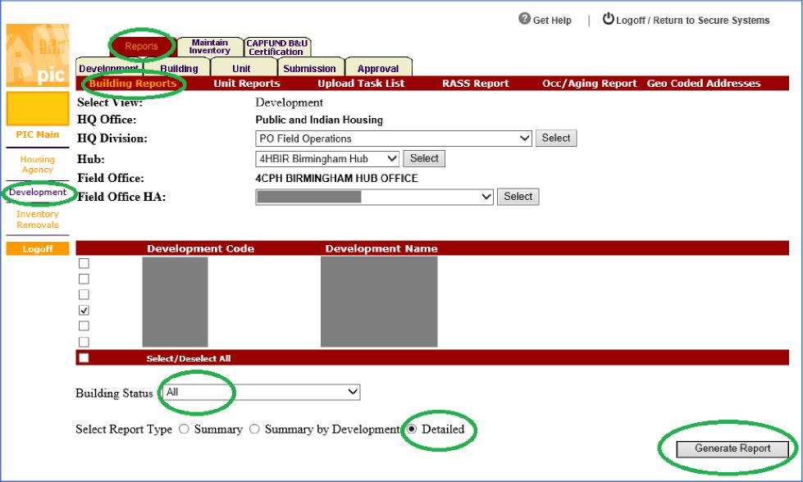

*Figure 1: Building Reports page in IMS/PIC*

*Any changes to construction dates should be entered in IMS/PIC by navigating to the Building tab and Building List sub-tab within the Development sub-module. On that screen (depicted in Figure 2, below), users may select the link on a building number to view the Building Detail screen (depicted in Figure 3, below). Here the user may change the Construction Date and select Save. PHAs should confirm that their changes registered in the system.*

*Note that PHAs may not change construction dates for building-entrances for which the units have been removed from inventory, and PHAs will need to coordinate with HUD’s Special Applications Center if changes are needed for units that are in a submitted or approved inventory removal application.*

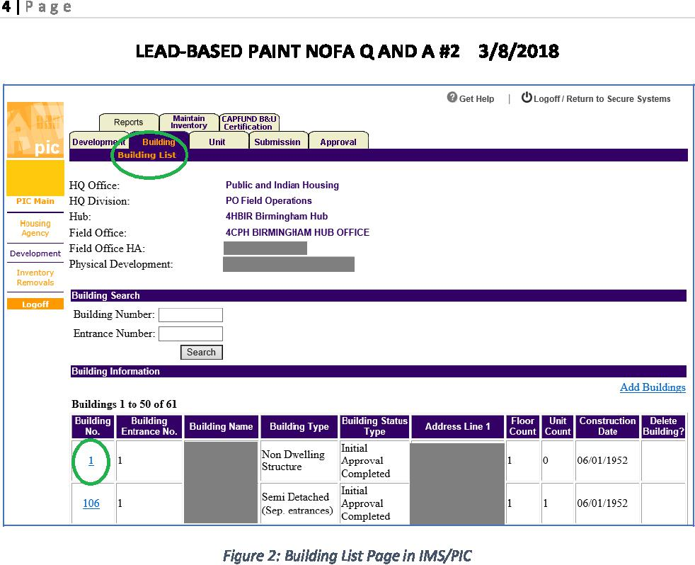

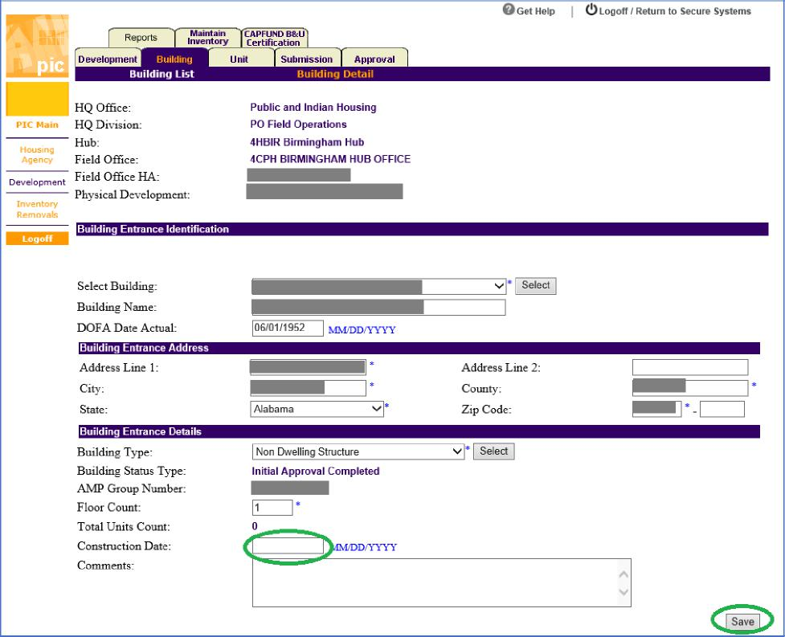

*Figure 3: Building Detail Page in IMS/PIC*

*Any changes to construction dates must be followed by a building and unit submission and approval process to properly record the changes. PHAs users submit the building and unit data for approval on the Submit Unit Information sub-tab under the Submission tab of the IMS/PIC Development sub-module. On this page, the user would enter any comments, select Save to record the comments, and select the Submit Data for Approval button. The PHA would need to ensure approval by their local Field Office.*

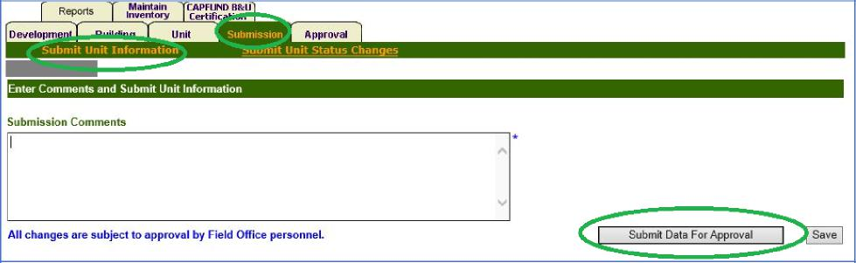

*Figure 4: Submit Unit Information Page in IMS/PIC*

*In order for any updates to construction dates to be reflected in the scoring of average property age, the process described above must be completed by the application deadline.*

1. **The NOFA indicates that HUD will score each application on the portion of units**

**occupied by at least one child under age six. Can you explain how these scores will be**

**calculated and how PHAs can ensure that their IMS/PIC occupancy information is**

**accurate**?

*HUD will construct this percentage by counting the total number of units occupied by at least one child under age six in all of the IMS/PIC developments proposed for funding in the application and dividing by the total number of standing ACC units in those developments. This information will be based on IMS/PIC data as of the application deadline of March 14, 2019. A unit will be deemed occupied by at least one child under age six if the date of birth for any household member as reported on the HUD Form-50058 is less than March 14, 2013.*

*PHAs should ensure that their tenant information reporting is complete in IMS/PIC in advance of the application deadline, including timely reporting all new admissions and end of participation 50058 records that may impact this scoring. HUD posted a snapshot of this data on the Office of Capital Improvements homepage at the link below so that applicants may review preliminary data prior to the application due date.*

[*https://www.hud.gov/program_offices/public_indian_housing/programs/ph/capfund*](https://www.hud.gov/program_offices/public_indian_housing/programs/ph/capfund)

*PHAs should ensure that at least one unit is occupied by a child under age six in each IMS/PIC development proposed in the application.*

*PHA staff with the appropriate access to the IMS/PIC system may run a Resident Characteristics Report in IMS/PIC to achieve a better understanding of the composition of the households they serve. To do so, a user should log in to IMS/PIC and select the Reports sub-module within the Form 50058 module on the left. The user may need to select “Agree” when the Privacy Act Statement and Compliance Notice displays. The user would then select the RCR tab to view the RCR Query page (depicted in Figure 5, below). On this page, the user would select a Program Type of Public Housing in the drop-down box and select the link to run the report at the Public Housing Agency level; the user would follow any prompts that may be displayed to generate the report.*

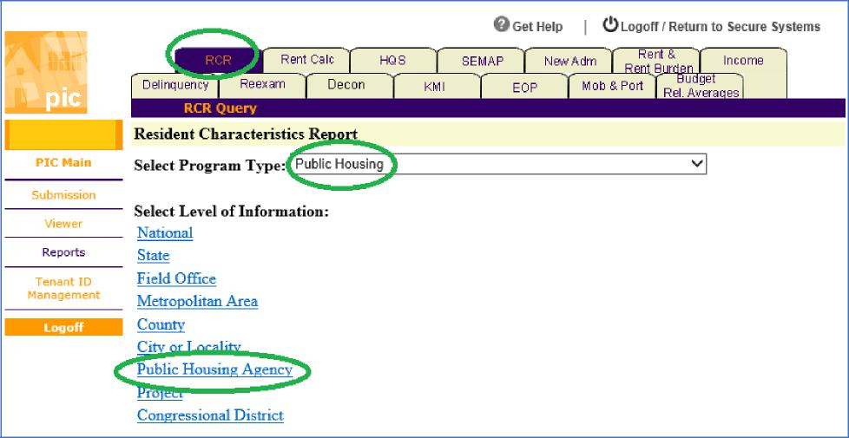

*Figure 5: RCR Query Page in IMS/PIC*

*On the Resident Characteristics Report that displays, users should select the Household tab to view a table displaying the distribution of household members age as a percentage of the total number of household members, including a category displaying information on members aged 0-5 years (depicted in Figure 6, below). The figures for the PHA will be displayed alongside a comparison group. Users should not expect the information displayed in the Resident Characteristics Report to exactly match the information that HUD extracts from IMS/PIC and uses to score applications under this NOFA, as the Resident Characteristics Report contains different logic than the specifications for scoring this factor described in the NOFA. Users may, however, gain a more general picture of household composition by viewing this report.*

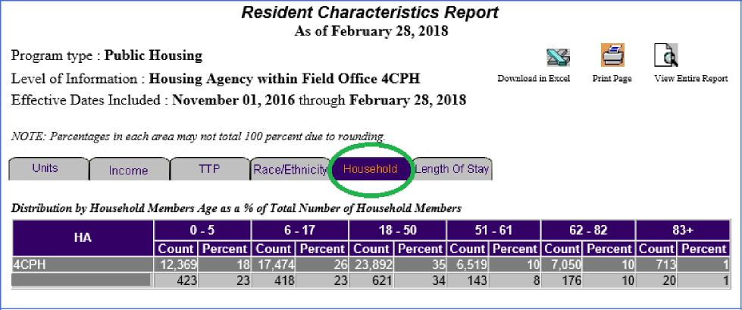

*Figure 6: Resident Characteristics Report in IMS/PIC*

1. **In the case of multiple buildings included under a single IMS/PIC development number, can some buildings be included in the application and other buildings excluded**?

*Applications by their nature are at the IMS/PIC development level, as this is how the 50075.1 is constructed. PHAs are permitted to target grant activities at less than the whole development, but that will not impact the processing of their application or their score.*

1. **How will applications be scored under the Past Performance factor?**

*Applications will be scored on Past Performance based on:*

*Meeting program requirements, as indicated by Office of Inspector General (OIG) audit findings issued in FFY 2016 and Independent Public Account (IPA) audit findings in FASS for FFY 2016. FFY 2017 corresponds to the following fiscal year end quarters: 12/31/2016, 3/31/2017, 6/30/2017, and 9/30/2017.*

*The language regarding the PHA’s Financial Assessment Sub-System (FASS) score has been removed.*

1. **Are developments that have converted under the Rental Assistance Demonstration (RAD) eligible for this grant?**

*No. Properties that have been converted under RAD are no longer considered public housing, as they have converted to the project-based voucher (PBV) or project-based rental assistance (PBRA) program.*

1. **The guidance says that funds may not be used at projects under CHAPs. Is it possible to**

**make an application for a development that we intend to place under a CHAP in the**

**future - as long as the work is completed before the CHAPs are in place**?

*It is allowable to use these funds on public housing properties that are not yet under a CHAP. The intent of this NOFA, however, is to provide funds for lead hazard evaluation and abatement or hazard control in public housing managed by public housing authorities. If a property in an awarded application subsequently goes under a CHAP, the funds must be returned. Owners participating in the PBV and PBRA programs have different requirements for lead-based paint evaluation and hazard control.*

1. **If a PHA proposes activities with costs exceeding the maximum grant amount of $1**

**million but will use other funds to make up the difference between the maximum grant**

**amount and the total cost, how should this be recorded on form SF-424?**

*In this case, the applicant should list $1 million on line 18a of the SF-424, and any other funds on lines 18b-18f.*

1. **Are we required to submit a narrative in response to Rating Factor 1, 2, and 3? What is the page and spacing limitations to the narrative? Are there any other forms, documents, and narratives which need to be submitted in addition to the documents listed on pages 19-21 of the NOFA? Should we list the costs of risk assessments, inspections, abatement, interim controls, and clearance examinations as separate budget lines for each AMP in the Form HUD-50075? How much detail should we provide in the Form HUD-50075.1?**

*Applicants may not supplement form HUD-50075.1 with additional narrative. Applicants shall use the space provided in the 50075.1 form to describe the evaluation and lead hazard control work expected. The 1,000-character limit (including numbers, letters, and spaces) stated in the NOFA applies to the General Description of Major Work Categories field for each work activity (row) on the 50075.1; if the 50075.1 is completed in EPIC, this limit will be applied by the system. The 50075.1 is the form PHAs regularly use to describe work planned under the capital fund program, and it is limited to only collect information necessary to report to HUD what work is planned and completed.*

*Applicants must use one row on the 50075.1 for each work activity. A single IMS/PIC development may have multiple work activities listed and therefore may be included on multiple rows of the form. Applicants must not split a single work activity across multiple rows of the form to circumvent the 1,000-character limit.*

*Applicants may use separate work activities (rows) for distinct work items such as risk assessments, inspections, abatement, interim controls, and clearance examinations or applicants may group this work under a single work activity, as long as the items are associated with a single Budget Line Item (BLI) and development. In either case, the costs tied to the work activity should be aligned with the description. A work activity covering all lead hazard control in a multi-unit property may use a standard estimate of approximately $10,000 per unit ($15,000 per unit for a single-family property), but a work activity covering only the risk assessment portion of the lead hazard control work would be expected to carry a lower cost.*

*For information on the level of detail required, applicants should refer to Section V of the NOFA, Application Review Information, Rating Factor 2. The NOFA lists all the forms required.*

1. **If we do not have an approved indirect cost rate, may we please include 10% administration costs?**

*As noted in Section III, F., if you have never received a Federally negotiated indirect cost rate and elect to use the de minimis rate, your application must clearly state you intend to use the de minimis rate of 10% of Modified Total Direct Costs (MTDC).*

1. **We would like to request the maximum amount of $1,000,000. Would HUD approve a lesser amount if funds are not available or should we submit a lower amount?**

*As stated in Part V of the NOFA, Application Review Information, applications will be ranked in order of total score and funded in order of rank, subject to funding availability. Under the NOFA, HUD reserved the right to only partially fund applications based on the selection information above. Therefore, the last applicant to be funded based on the ranking may receive only a portion of the requested amount, based on remaining funds available.*

1. **Do we need a Certificate of Consistency with the Consolidated Plan form?**

*No. Please see forms required in Section IV, B.*

1. **May we add any supporting materials such as MOUs with our jurisdiction and the health department?**

*No. You may only submit the required forms listed in the NOFA. Additional items will not be reviewed.*

1. **Are there any fair housing forms to be submitted with the application?**

*The required forms are identified in the NOFA package at:*

[*https://www.grants.gov/web/grants/view-opportunity.html?oppId=311401*](https://www.grants.gov/web/grants/view-opportunity.html?oppId=311401)

1. **The NOFA states that eligible properties may include playgrounds or child-care centers that are part of the public housing project. Will “community centers/management offices” also be considered as eligible if they are part of the public housing project? My PHA is working towards obtaining a “lead free” site certification and lead-based paint abatement related work is required on the Community Building to obtain this certification. Please advise if this property would be eligible?**

*Section III, Eligibility Information, part C of the NOFA refers to the types of properties eligible for funding. See Section IV, Application and Submission Information, part F, Funding Restrictions, for information about eligible uses of funds.*

*This NOFA does not encourage PHAs to render properties lead-based paint free. Full removal of all lead-based paint can be prohibitively expensive and exhaust available funds under the grant. For guidance on which areas should receive lead-based paint abatement or hazard control, PHAs should defer to the recommendation of a certified Lead-Based Paint Risk Assessor. Risk assessments performed in accordance with Chapter 5 of the HUD Guidelines (Risk Assessment) will consider where children live and play in the recommendations for lead hazard control methods and locations.*

1. **The application download packet did not include Form HUD-50075.1, Form HUD-50071 and Form HUD-50077-ST-HCV-HP. Will these be added to the** [**Grants.gov**](http://Grants.gov) **application packet? If not, how can the applicants be sure that they are using the correct forms?**

*The HUD forms can be found by visiting the Forms Library in HUD’s Client Information Policy System (HUDCLIPS) at* [*https://www.hud.gov/hudclips*](https://www.hud.gov/hudclips)*.*

1. **If HUD does not receive enough applications scoring 60 points or more, would consideration be given to lowering the funding threshold?**

*HUD cannot fund applicants under this NOFA that do not receive at least 60 points. See Section V.B.2; these applications would be deemed ineligible for funding.*

1. **Does the LBPCF grant allow for asbestos testing and abatement work?**

*No. See Section IV, Application and Submission Information, part F, Funding Restrictions.*

1. **On HUD Form 50075.1: Is Screening related equipment like cameras and air quality meters an allowable cost?**

*No. Lead-based paint evaluations as described in HUD Guidelines Chapter 5 (Risk Assessment) and Chapter 7 (Inspection) do not include the use of cameras and air quality meters. Lead-based paint evaluations may only be performed by a Lead-based Paint Risk Assessor or Inspector certified to work in the state where the property is located.*

1. **What are the differences between Round I and Round II of the NOFA?**

*Under Round I, applications scoring 75 points or more were eligible to receive an award. This score has been reduced to 60 points under Round II. In addition, through a Technical Correction, the Past Performance Factor using FASS score has been removed.*

1. **How should applicants populate the following fields on the 50075.1: Grant Type and**

**Number, Capital Fund Program Grant No, CFFP (Yes/ No) and Replacement Housing Factor**

**Grant No.?**

*If an applicant chooses to complete the HUD Form 50075.1 by hand, it does not have to complete these fields in the form. If an applicant chooses to use EPIC to complete the 50075.1, Part I of the Form will not be populated when the applicant prints the document, therefore this information is not required.*