**Tier 2 or Site-specific Review for Elder Rehab Program**

**Address:** ____773 33rd A Ave NE, Great Falls, MT 59404_________________________

**Year built:** ____1983______________________________________________

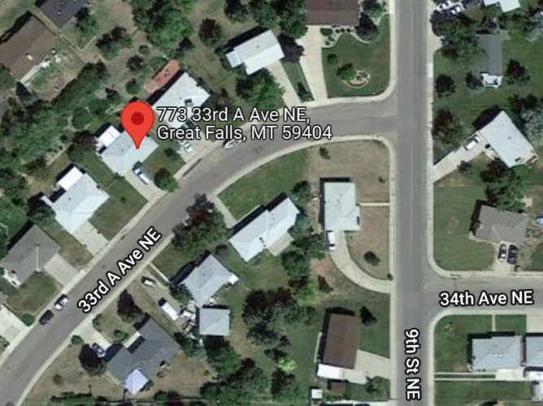

**Proposed scope of work:**

Furnace and window replacement

**Field inspection (date and completed by):** 12/7/22 by Stanley Zinn, Housing Inspector, WRT

**Compliance with Remaining 24 CFR 50.4, 58.5, and 58.6 Laws and Authorities**

|  |  |
| --- | --- |
| **Compliance Factors**: Statutes, Executive Orders, and Regulations listed at 24 CFR 50.4, 58.5, and 58.6 | **Compliance Determination** |
| **Flood Insurance**  Flood Disaster Protection Act of 1973 and National Flood Insurance Reform Act of 1994 [42 USC 4001-4128 and 42 USC 5154a] | The project is in Zone X, area of minimal flood hazard. See FEMA map panel #30013C0345E, effective 3/19/2013. Therefore, flood insurance is not required. |
| **Contamination and Toxic Substances**  24 CFR Part 50.3(i) & 58.5(i)(2)] | According to a search of the Montana Department of Environmental Quality (DEQ) LUST database, 64 confirmed leaking underground storage tanks (LUSTs) that have not been resolved or cleaned up are located in Great Falls. However, none of them are within 3,000 feet of the project.  Seven EPA-regulated facilities were found within 3,000 feet of the property according to a NEPAssist search. Two of them (Skyline Heights and Carroll Construction Site) have NPDES violations (administrative) that have since been resolved.  A site visit was performed by Stanley Zinn, WRT’s housing inspector. No hazardous materials were found that could conflict with the end use of the property or threaten the health and safety of the occupants. See Appendix C. Therefore, this project is in compliance with 24 CFR 58.5(i)(2). |
| **Floodplain Management**  Executive Order 11988, particularly section 2(a); 24 CFR Part 55 | The project is in Zone X, area of minimal flood hazard. See FEMA map panel #30013C0345E, effective 3/19/2013. Therefore, this project is in compliance with EO 11988. |
| **Historic Preservation**  National Historic Preservation Act of 1966, particularly sections 106 and 110; 36 CFR Part 800 | The Montana State Historic Preservation Office concurred that no historic properties will be affected by the project. Therefore, this project is in compliance with this section. |
| **Noise Abatement and Control**  Noise Control Act of 1972, as amended by the Quiet Communities Act of 1978; 24 CFR Part 51 Subpart B | The project is not within 3,000 feet of a railroad, but it is within 1,000 feet of a major road. The DNL calculation came out to 52, which is acceptable (≤65 dB is acceptable). |

Responsible Entity Signature:__________________________________________

Date:______________________

Name (Title/Organization):________________________________________________________