Home Equity Reverse Mortgage Information Technology
(HERMIT)

HERMIT System Changes – Release 7.4

Release Date: 09/23/23
Document Date: 09/26/23
Version 1.1

September 2023

INTRODUCTION
The Home Equity Reverse Mortgage Information Technology (HERMIT) software release version 7.4 consists of the following system changes:
Table of Contents
Servicer Related Changes 4
1. HUD Disbursements on Endorsed Loans: Scheduled and Unscheduled (586489) 4
2. Loan Header Scrolling Text - Display active Critical Alert (586938) 4
3. Loan Details: Remove Custodial Care Dates when a Repurchase is authorized by a Servicer in HERMIT or when a loan is terminated for specific termination reasons. (585935) 5
4. Timeline Welcome Letter: Endorsed Request for HUD Advance Remove the automatic Printing of the “Welcome letter” for Endorsed Loans (586869) 5
5. Added Batch Status and Batch Number to Loan > Transaction > Claims Screen and Over Claims Report (587410) 6
6. Claim Extensions of First Legal Curtailment Deadlines – Extension – At Risk and Extension – Property Charge Loss Mitigation (586708) 6
7. Claim Payment Rejections - Funds Being Returned to HUD for CT21, CT23, CT24 (585210) 7
8. Claims – Updates to No Pay Order flag, Update No Pay Flag and Claims Validations for No Pay and Indemnification, and Indemnification Data Report update (579020) 8
NSC / HUD Related Changes 9
9. NSC Contractor Timeline User Permissions: Restricted from inactivating Release Timelines (586835) 9
10. Timeline: Endorsed Due & Payable w/HUD Approval Timeline - New Steps Added and Steps Updates (587815) 9
11. Timeline: Assigned Release (1st and 2nd) Timelines automatically initiated upon Termination (586628) 10
12. Timelines: Inactivate Compliance Timelines when a Loan in HUD’s portfolio is Terminated (542583) 11
13. Assigned Welcome Letter Changes (539787) 12
14. Timeline: Assigned Certification of Indebtedness (COI) Timeline – new Letter and removal of Amount Claim (539321) 12
15. Timeline: Assigned Payoff Request Timeline Changes: Letter, & Auto Note (587373 & 539494) 12
16. Report: Assigned Due and Payable Report (586030) 14
17. Report: Assigned Timeline Activity Report (587583) 15
18. Report: Repurchase Timelines Report – Permission Access (588198) 16
19. Batch Alert Upload B2G New Page (586602) 17
20. Batch NSC Disbursement Uploads B2G New Page (586714) 17
21. Batch NSC File Uploads: New B2G to Generate PDF Reports (586948) 18
22. SFTP Server: Endorsed Exposure Report (585864) 19
23. Accounting > Disbursements: Increase max Authorization to 5,000 20
24. NSC Accounting > Transmittal Export to Excel 21

If you have any questions regarding the functionality of the software release, please contact the HERMIT Help Desk at 561-899-2610 or at servicingsupport@hermitsp.com. If you have any policy related questions, please send an email to HUD at answers@hud.gov.

Servicer Related Changes

HUD Disbursements on Endorsed Loans: Scheduled and Unscheduled (586489)
To support Mortgagee Letter 2023-15, enhancements were made to permit Disbursements to be created for Endorsed loans. This functionality will be used in circumstances where HUD needs to issue Borrower Scheduled or Unscheduled Payments.
The servicer must provide necessary information to HUD through the HERMIT SFTP Server in the supplied template, which will be loaded into HERMIT in order to initiate Disbursements. All Disbursements must be approved by the authorized HUD NSC contractor users in order to be generated. Template:
In a future release, functionality for the system to accept payments from servicers for the Disbursements sent out by HUD will be implemented.

Loan Header Scrolling Text - Display active Critical Alert (586938)
When a Critical Alert set as “Always Display” is active on a loan, a scrolling message will display the Alert text on the loan header. The Loan Header is displayed at the top of all pages in HERMIT. Alerts marked as “Always Display” are:
- PDMDA 4634
- PDMDA 4724
- Lost in Tax Sale
- Suspend All Servicing Actions – See Notes
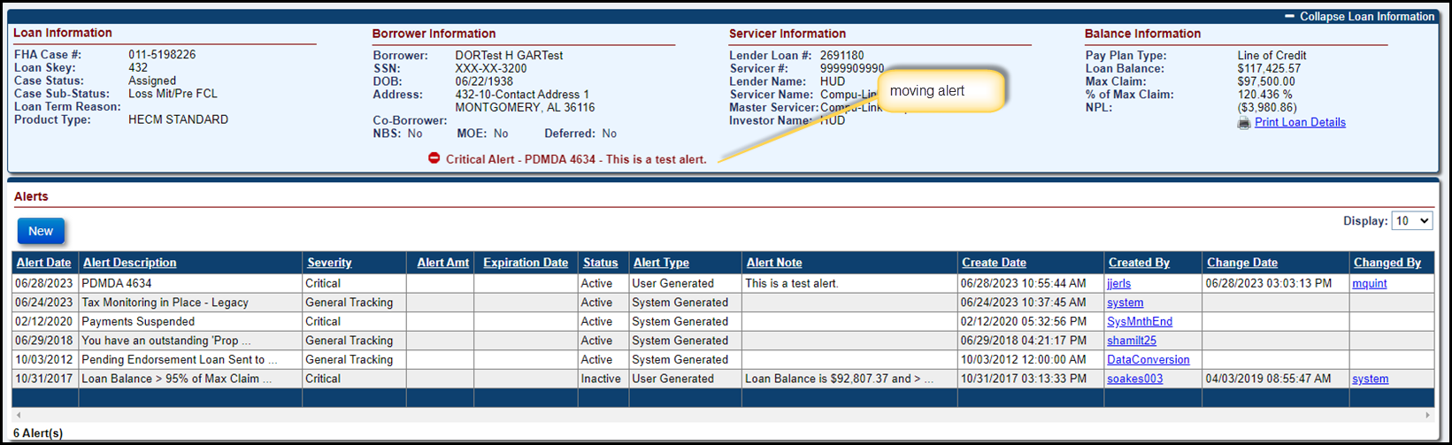

Loan Details: Remove Custodial Care Dates when a Repurchase is authorized by a Servicer in HERMIT or when a loan is terminated for specific termination reasons. (585935)
HUD adds Custodial Care dates on the loan as needed which are viewable on the Loan Details page. The system has been updated to automatically remove the Custodial Care Request Date, Custodial Care Place Date, and Vacancy Dates when either of the following occur:
- When the Servicer Approves a Repurchase (Clicks “Yes” on the Certify message) from the HERMIT Accounting > Authorizations Page , OR
- An Assigned loan is terminated with the following termination reasons:
  - Terminate – Paid in Full
  - Terminate – Short Sale
  - Terminate – Asset Sale
  - Terminate – Refinance
Updates were also made to the existing Auto Note when a loan is Repurchased to read “Repurchase was authorized by User Id for $XX,XXX.XX on MM/DD/YYYY. The Custodial Care Request Date, Custodial Care Date, and Vacancy Date were removed.”
A new Auto Note has been created for when loans are Terminated with Termination Reasons listed above, stating “The Custodial Care Request Date, Custodial Care Date and Vacancy Date were removed due to Terminate – (Reason) with an Effective Date of MM/DD/YYYY.”
Existing functionality still applies by displaying the removal of Custodial Care Dates on the Audit Tracking page.

Timeline Welcome Letter: Endorsed Request for HUD Advance Remove the automatic Printing of the “Welcome letter” for Endorsed Loans (586869)
An update has been made on the Endorsed > Request > Request for HUD Advance Timeline. The Step “Request for HUD Advance Received from Servicer” will no longer print the Welcome Letter. New Auto Notes have been updated for four Steps on the Endorsed > Request > Request for HUD Advance Timeline.
Once a Step has been completed the updated notes will display as:
- Step Request for HUD Advance Processed: Note “The Step “Request for HUD Advance Processed” was completed on MM/DD/YYYY by User Id.”
- Step Assignment Denied/Payoff Issued: Note “The Step “Assignment Denied / Payoff Issued” was completed on MM/DD/YYYY by User Id.”
- Step Servicer Notified of Intent to Offset: Note “The Step “Servicer Notified of Intent to Offset" was completed on MM/DD/YYYY by User Id.”
- Step Advance Denied – No Funds Issued: Note “The Step “Advance Denied - No Funds Issued” was completed on MM/DD/YYYY by User Id.”

Added Batch Status and Batch Number to Loan > Transaction > Claims Screen and Over Claims Report (587410)
Batch Status and Batch Number columns were added to the Loan > Transactions > Claims Screen results grid and the Export to Excel results, as well as to the Over Claims report results.

Claim Extensions of First Legal Curtailment Deadlines – Extension – At Risk and Extension – Property Charge Loss Mitigation (586708)
Extend / Recalculate First Legal Curtailment Deadline using “Extension – At Risk” or “Extension – Property Charge Loss Mitigation” Timeline’s Extension Expiration Date. Updates were made to automatically extend the First Legal Deadline using the Extension Expiration Date from the Extension – At Risk Timeline or the Extension – Property Charge Loss Mitigation Timeline if the Timeline meets the criteria to extend the Original First Legal Deadline . The Extension date will populate field “System Generated 1st Legal Deadline / Block 19 date” if it is the latest Extended First Legal Deadline found in the system. Existing functionality remains in place to use the maximum of all applicable Curtailment Extensions.
NOTE – As a reminder, Servicers are required to request these extensions by using the appropriate extension request timelines within the system. If approved and has an Extension Expiration Date, the system will auto-populate Block 19 with the extension date for the servicers. Block 19 will continue to be editable if the servicer needs to further amend the first legal extension deadline date beyond available extension timelines.
Add new Curtailment Auto Notes based on the reason First Legal Deadline was extended. When the claim is Approved for Payment, an Auto-Note will be saved on the Notes page stating the reason the First Legal Deadline was extended.
Curtailment Condition | Curtailment Extension Auto-Note
Extended First Legal Curtailment Deadline due to Extension – At Risk | New: Claim Type 21 - DIL/FCL - Curtailment Deadline Extended - Original Curtailment Deadline MM/DD/YYYY for First Legal extended due to Extension - At Risk
Extended First Legal Curtailment Deadline due to Extension – Property Charge Loss Mitigation | New: Claim Type 21 - DIL/FCL - Curtailment Deadline Extended - Claim would have Auto Curtailed on MM/DD/YYYY. First Legal extended due to Extension – Property Charge Loss Mitigation
Extended First Legal Curtailment Deadline due to Extension - COVID-19 Request to Delay Foreclosure | Existing: Claim Type 21 - DIL/FCL - Curtailment Deadline Extended - Original Curtailment Deadline MM/DD/YYYY for First Legal extended due to COVID Request to Delay Initiation of Foreclosure.
Extended First Legal Curtailment Deadline due to Extension – Request to Delay Foreclosure timeline | Existing: Claim Type 21 - DIL/FCL - Curtailment Deadline Extended - Claim would have Auto Curtailed on MM/DD/YYYY. First Legal extended due to Extension - Request to Delay Initiation of Foreclosure.
Extended First Legal Curtailment Deadline due to user-entered ““User Adjusted 1st Legal Deadline / Block 19, enter if applicable” | Existing: Claim Type 21 - DIL/FCL - Curtailment Deadline Extended - Claim would have Auto Curtailed on MM/DD/YYYY. First Legal extended due to Block 19 date “User Adjusted 1st Legal Deadline / Block 19, enter if applicable”.
Bankruptcy - Chapter 7 | Existing: Claim Type 21 - DIL/FCL - Curtailment Deadline Extended - Claim would have Auto Curtailed on MM/DD/YYYY. [Curtailment Event] extended due to Bankruptcy.
Bankruptcy - Chapter 13 | Existing: Claim Type 21 - DIL/FCL - Curtailment Deadline Extended - Claim would have Auto Curtailed on MM/DD/YYYY. [Curtailment Event] extended due to Bankruptcy.

Claim Payment Rejections - Funds Being Returned to HUD for CT21, CT23, CT24 (585210)
A Rejected Claim Payment occurs when an Investor rejects receipt of claim payment funds and the funds are returned back to HUD. Enhancements have been made to this process for Claim Types 21, 23, and 24 when a Rejected status is received from the Accounting Module for the claim for this reason. After receiving a Rejected claim payment, the Servicer will need to confirm or update the Investor information on the loan using the HERMIT System, then complete new timeline steps in order to reissue the claim for payment to the appropriate investor. All components of the claim other than the payee (investor) will remain unchanged, including the claim payment. This feature is only for reissuing the claim payment after a rejection. The claim will not be recalculated with additional interest or added expenses during this process.
The following actions will occur after a Rejection is received from the Accounting Module for a claim payment:
- Timeline:
  - Existing Submitted for Payment step changed to inactivate
  - Existing Claim Paid step changed to inactivate
  - New step Claim Payment Rejected added and auto-completed by the system
  - New step Re-Try Claim Payment added. Servicer must make any necessary update to the Investor information on the loan using the HERMIT System, then complete this step in order to initiate another attempt to pay the claim
- Endorsed > Claims > Search: After the Rejection is processed and the above steps added to the timeline, the Claim Status will be blank and Current Step Group will be assigned back to the Servicer.
- Transactions > Claims: an Adjustment transaction is displayed offsetting the Claim Payment. The Adjustment transaction shares the same Batch number as the original Claim Payment transaction. A new record will be added on this page after Re-Try Claim Payment is completed and the new claim payment is generated.
- Alert: New alert is added to the loan stating “Claim Payment returned by payee/ investor.” The alert is inactivated after the step Re-Try Claim Payment is completed.
- Notes Page: New note is added to the loan stating “Claim payment for $xx,xxxx.xx returned by investor or rejected. Servicer must review, correct if necessary and retry claim for processing.”
Multiple rejections may occur on the same claim payment. In this case, multiple steps are inactivated and added to the Claim Timeline.

Servicer actions to Re-Try Claim Payment
In order to prompt the Claim Payment to be re-sent, first the Servicer must update the current Investor information in HERMIT, if applicable. After the Investor information has been updated, Servicer will go to the Claim timeline and click on step Re-Try Claim Payment, then add Step Notes if necessary and click Submit on the Edit Step modal. A Certify popup modal is displayed with text “I certify the accuracy of the investor/payee information listed in HERMIT and request the previous claim payment be reissued.” To proceed with reissuing the claim payment click Yes, to stop click No.
After clicking Yes on Re-Try Claim Payment, the system will save the complete date to the step, update all Investor information fields on the Claim Form and the Advice of Payment (AOP), and save new versions to the Documents page. In general, all triggers that occur when Approved for Payment is completed in the normal claims process will also occur when the step Re-Try Claim Payment is completed: including creating a new batch for the Claim Payment and when end of day jobs are run, a new Submitted for Payment step will be added to the timeline.
NOTE – As a reminder, servicers should thoroughly review all claims for accuracy prior to certification and submission. This includes confirming the accuracy of the Investor information prior to claim submission.

Claims – Updates to No Pay Order flag, Update No Pay Flag and Claims Validations for No Pay and Indemnification, and Indemnification Data Report update (579020)
No Pay Order The functionality for No Pay Order flag set at the loan level and Servicer level has been revised. Going forward, if the No Pay Order is added on a loan with an Active Claim Timeline, the Timeline will no longer be Inactivated and a new claim hard stop validation error will prevent the claim from being filed, resubmitted, or approved by HUD while the No Pay Order is in place. The No Pay Order claim validation message states: “Unable to proceed with claim. Loan has an associated No Pay Order. Please contact HUD to resolve this matter.”
When the No Pay Order is added to a loan that does not have an Active Claim Timeline, a new Claims Timeline cannot be initiated (existing functionality). In order to set up a new Claims Timeline, the No Pay Order must be removed at the loan or servicer level.
Indemnification claims hard stop
A new claim hard stop validation message has been added to automatically check for an Indemnification record associated with a claim when the claim is being filed, resubmitted, or approved by HUD. The validation will confirm the Indemnification record is active and not deleted by HUD, the Indemnfication Expiration Date is in the future, and the Indemnified Party and Current Investor in HERMIT matches based on the Mortgagee ID. The Indemnification claim validation message states: “Unable to proceed with claim. Loan has an active Indemnification Agreement preventing claim submission.”
Servicers should follow up with the investor listed in HERMIT at the time of claim filing for further information about the active indemnification.

Indemnification Data Report
Two fields have been added to the Indemnification Data Report (viewable only by certain HUD users): Curr_Investor_Name and Curr_Investor_Mortgagee_ID. These fields reflect information for the Current Investor as stated in HERMIT at the time the report is generated.

NSC / HUD Related Changes

NSC Contractor Timeline User Permissions: Restricted from inactivating Release Timelines (586835)
Updates were made to prevent NSC Contractor user roles from inactivating Release Timelines (Assigned/Endorsed) for certain Termination Reasons.
If Termination Reason is one of the following,
- Endorsed – Paid in Full
- Endorsed – Short Sale
- Endorsed – DIL
- Assigned – Paid in Full
- Assigned – Short Sale
- Assigned – DIL
then NSC Contractor user roles listed below cannot inactive the Endorsed > Release timelines. Information about whether the User Role can inactivate Assigned > Release timelines is displayed below.
P: Permitted to inactivate timeline
X: Restricted from Inactivating timeline
User Role | Timeline: Assigned > 1st Release | Timeline: Assigned > 2nd Release | Timeline: Endorsed > 2nd Release
Cash – Cash | P | P | X
Cash – Cash Supervisor | P | P | X
Cash – Customer Service | P | P | X
Cash – Default | P | P | X
Cash – Documentation | P | P | X
Cash – First Mortgage | P | P | X
Cash – Release | X | X | X
Cash – Release Supervisor | X | X | X
Cash – Supervisor/Management | X | X | X

Timeline: Endorsed Due & Payable w/HUD Approval Timeline - New Steps Added and Steps Updates (587815)
The Endorsed > Request > Due & Payable w/HUD Approval Timeline was updated so Decision steps now display as HUD Steps instead of HUD Contractor steps, and nine new HUD/HUD Contractor Steps were added.
- The following current Steps were updated to HUD Steps instead of HUD Contractor Steps:
- HUD Decision – Approved
- HUD Decision – Denied
- HUD Decision – Pending Additional Information
- Received Required Additional Information
- List of new Endorsed – Due & Payable w/HUD Approval Timeline steps:
Data Group | Step Description | Servicing Type | Rule
HUD Contractor | Contractor Recommendation - Approved | Optional
HUD | Request to Call Due & Payable sent to HUD | Triggered | Trigged by completion of Step “Contractor Recommendation – Approved” and auto completed
HUD Contractor | Contractor Recommendation – Denied | Optional
HUD Contractor | Contractor Recommendation – Pending Additional Information | Optional
HUD Contractor | Pending Additional Information Received from Servicer | Triggered | Triggered by completion of Step “Contractor Recommendation – Pending Additional Information”
HUD Contractor | Additional Information provided by Servicer | Triggered | Triggered by completion of Step “Pending Additional Information Received from Servicer”
HUD Contractor | Contractor Reviewed Additional Information | Triggered | Triggered by completion of Step “Additional Information provided by Servicer”
HUD Contractor | Additional Information Sent to HUD | Optional
HUD Contractor | Received Required additional information | Triggered | Triggered by completion of Step “Additional Information Sent to HUD”

Timeline: Assigned Release (1st and 2nd) Timelines automatically initiated upon Termination (586628)
Updates have been made to the automatic initiation of Assigned > Release (1st and 2nd) Timelines when a user Terminates a loan.
- The following Termination types will auto initiate an Assigned > Release (1st and 2nd) Timeline when the user Terminates a loan with these:
- Terminate – Paid in Full (Trans Code 2831)
- Terminate – Refinance (Trans Code 2877)
- Terminate – Short Sale (PIF W/Write-Off) (Trans Code 2885)
- Terminate – DIL Conveyed (Trans Code 2888)

- The following Termination types will not auto initiate an Assigned > Release (1st and 2nd) Timeline when the user Terminates a loan with these:
- Terminate – Asset Sale (Trans Code 2883)
- Terminate – FCL Conveyed (Trans Code 2887)
- Terminate – 3rd Party FLC Sale (PIF) (Trans Code 2880)
- Terminate – Full Write-Off (Trans Code 2882)
- Terminate – 3rd Pty FCL Sale (PIF w/WOff) (Trans Code 2886)

When a loan is Re-Terminated (the loan is open back up with trailing expense /Disbursements, then the loan is Terminated again) the new Termination, regardless of Transaction code, will not prompt an auto initiated Assigned > Release (1st and 2nd) Timeline.
No other logic was changed for auto initiation on Assigned > Release (1st and 2nd) Timelines. The authorized users can still manually create an Assigned > Release (1st and 2nd) Timeline.

Timelines: Inactivate Compliance Timelines when a Loan in HUD’s portfolio is Terminated (542583)
When a loan in HUD’s Portfolio is terminated with any of the following Termination Transactions, all Assigned > Compliance Timelines will be inactivated.
- Terminate - Paid in Full (2831)
- Terminate – Refinance (2877)
- Terminate - 3rd Party FCL Sale (PIF) (2880)
- Terminate - Full Write-Off (2882)
- Terminate - Asset Sale (2883)
- Terminate - Short Sale (PIF W/Write-Off) (2885)
- Terminate - 3rd Pty FCL Sale (PIF w/WOff) (2886)
- Terminate - FCL Conveyed (2887)
- Terminate - DIL Conveyed (2888)
List of Assigned > Compliance > Servicing Types that are inactivated upon loan Termination:
- Insurance – Flood Policy
- Insurance – Hazard Policy
- Insurance/Hardest Hit Funds Administration
- Insurance/Loss Draft Administration
- Occupancy Compliance Certification
- Request For Unscheduled Advance
- Taxes Delinquent
A Data Change Request (DCR) was processed to change Assigned > Compliance timelines to Inactive for Terminated loans.

Assigned Welcome Letter Changes (539787)
The Welcome Letter available when loans are Assigned to HUD has been updated. In addition, a copy of the Unscheduled Advance Request form will now be printed with the Welcome Letter for Payment Plan Types Line of Credit, Modified Term, and Modified Tenure. From Loan Search a User is only permitted to “Print Welcome Letter(s)” if the Case Status is Assigned w/Case Sub-Status Loan Active. Payment Suspended, or Case Status is Endorsed w/Case Sub-Status CT 22 – Preliminary Title Approval.
The following language in the letter related to the Unscheduled Advance Request form has been updated.
- Changed the sentence “Or if you have a line of credit, we are enclosing several “unscheduled advance request forms” for your use when you would like to request an unscheduled advance” to “Should you have a line of credit available; we are providing an Unscheduled Advance Request Form. This form is provided for your convenience, to be utilized whenever you wish to request an unscheduled advance.”
- Removed the sentence “Additionally, please forward a copy of your most recent payment of real estate taxes and evidence of your homeowner’s insurance.” from the Welcome Letter

Timeline: Assigned Certification of Indebtedness (COI) Timeline – new Letter and removal of Amount Claim (539321)
On the Assigned > Requests > Certificate of Indebtedness (COI) timeline, the field Amount Claim was removed from Timeline setup and Edit Modal, and a new letter was added to the Step “COI Sent to Requestor” which auto-completes step “COI Sent to Requestor” when the letter is printed.

Timeline: Assigned Payoff Request Timeline Changes: Letter, & Auto Note (587373 & 539494)
Changes to the Assigned > Requests > Payoff Request timeline include renaming and adding new steps, a new Letter tied to one of the new steps, and Auto Notes saved to the loan’s Notes page.
  - List of renamed/ new Payoff Request timeline steps:
Update | Step Description | Servicing Type | Rule
Renamed | Forward Payoff Amount to OTC | Template
New | Contacted Remitter for Further Information | Optional
New | Cash Management Processed Payoff Refund | Optional
New | Rejected Funds Received, unable to process | Optional | Letter: Notice of Payoff Funds Rejected

  - New Letter named “Notice of Payoff Funds Rejected” has been added and tied to step “Rejected Funds Received, unable to process”.
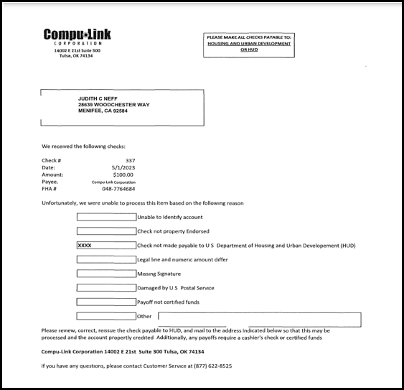
  - Auto Notes: when any step within the timeline is completed, an auto-note shall be saved to the Notes page. Information in the note is displayed as:
  - Note Type: Timeline Category
  - Note Type Status: Active
  - Note Text: <Timeline Name>. <Step Name> was completed on MM/DD/YYYY by User ID <User ID>. Step Note: (Text)*.
  - Create Date:
  - Created By:

Report: Assigned Due and Payable Report (586030)
A new report called Due & Payable has been added to the HERMIT reports area under Assigned Reports/Daily Reports. The Report will generate data for Active Assigned > Due & Payable Timelines.
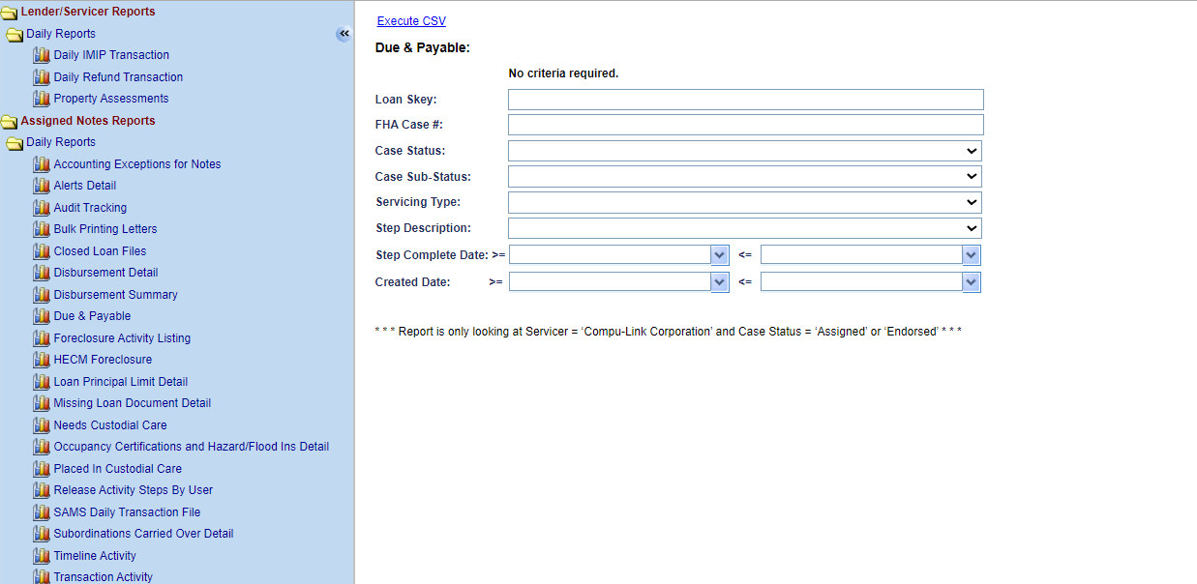

- Search Criteria includes:
- Loan Skey
- FHA Case #
- Case Status
- Case Sub-Status
- Servicing Type
- Step Description
- Step Completed Date (Date Range)
- Create Date (Date Range)

- Report output will be in CSV and have the following fields:
- Loan Skey
- FHA Case #
- Case Status
- Case Sub Status
- Lender Name
- Servicer Name
- Investor Name
- Status
- Step Description
- Step Complete Date
- Servicing Type
- Servicing Status
- Default Date
- Default Reason
- Default Status
- Default Paragraph
- Responsible Party
- First Legal Deadline
- Create Date
- Created By
- Changed Date
- Changed By

- The user can run the Report wide open without any criteria needed. The Report will only display all Active Assigned > Due & Payable Timelines in HUD’s portfolio where the Case Status is not Terminated. Users with Authorized Access to the Assigned > Daily Reports will be able to view this Report.

Report: Assigned Timeline Activity Report (587583)
A new report called Timeline Activity has been added to the HERMIT reports area under Assigned Reports/Daily Reports. The Report will generate data for all Endorsed and Assigned Timelines that have a HUD or HUD Contractor Step group.

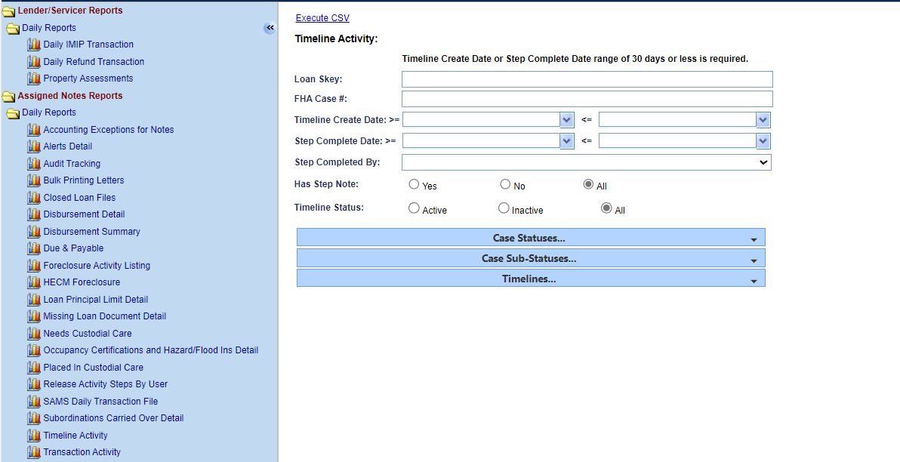

- Search Criteria includes:
- Loan Skey
- FHA Case #
- Timeline Create Date (Date Range)
- Step Complete Date (Date Range)
- Step Completed By
- Has Step Note
- Timeline Status
- Case Status
- Case Sub-Status
- Timelines

- Report output will be in CSV and have the following fields:
- Loan Skey
- FHA Case #
- Case Status
- Case Sub-Status
- Servicing Type
- Timeline Status
- Servicing Status
- Step Group for the Timeline Step
- Borrower LName
- Property Address
- Property City
- Property State
- Property Zip
- Property County
- Servicer Name
- Responsible Party
- Created By
- Timeline Create Date
- Step Completed By
- Step Note
- Unscheduled Advance Amount Assigned (From Servicing Management Screen on Compliance > Assigned > Request for Unscheduled Advance Timeline)
- Request from HUD Advance Amount (From the Management Screen on Requests > Endorsed > Request for HUD Advance (Assignment)
- The user will need to select a 30 day or less Date Range for either Timeline Create Date or Step Complete Date. Users with Authorized Access to the Assigned > Daily Reports will be able to view this Report.

Report: Repurchase Timelines Report – Permission Access (588198)
The HUD Contractor Cash Supervisor and HUD Contractor Supervisor/Management user Roles now have access to run the Reports > Servicer Reports > Repurchase Timelines Report. This Report can be filtered or run wide open.

Batch Alert Upload B2G New Page (586602)
The Alert Uploads page was added to HERMIT under the Batch Screen. Only Authorized users will be able to use and view this page. On the Alert Uploads page there is an Alerts link that provides a Template File. Please refer to the “HERMIT NSC B2G File Format and Layout” link on the HERMIT Resources page for more information on Alert Uploads.
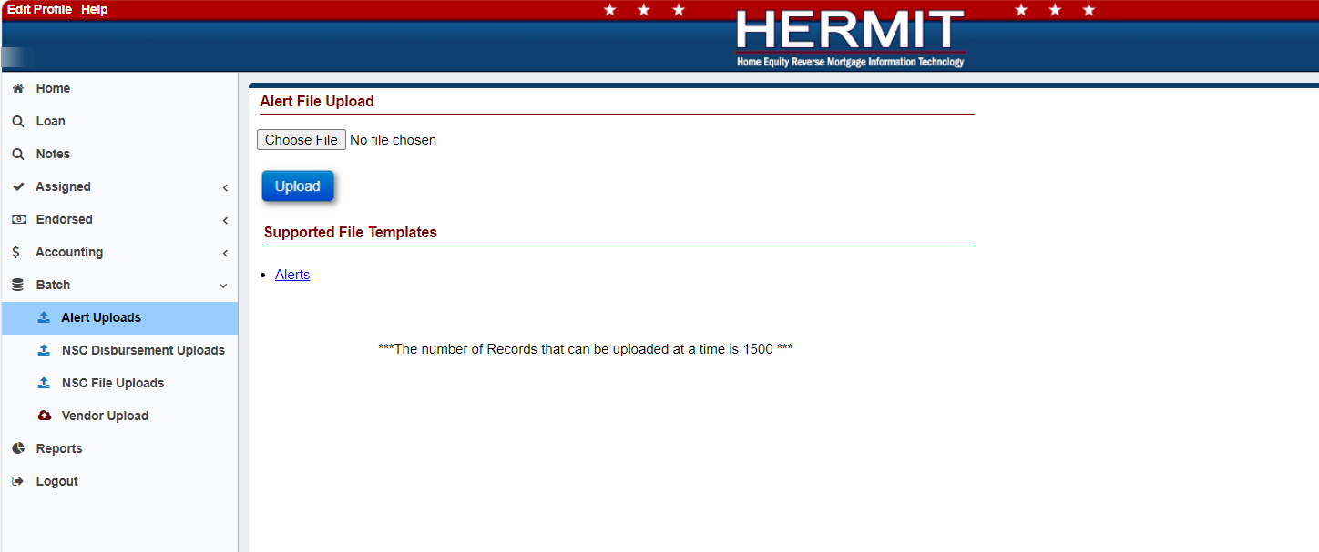
- The Alerts Uploads page is available under Batch on the left menu for the following Authorized users:
- Contractor Cash
- Contractor Cash Supervisor
- Contractor Default
- Contractor Supervisor/Management
- Contractor First Mortgage
- HUD NSC Manager

- The Alerts link provides the Alerts Template, this allows the user to upload multiple Assigned and Endorsed Alerts which can be uploaded into HERMIT using the Alert Uploads page.

- When the user uploads a file on the Alert Uploads page the Import Results will appear once the file has been uploaded. The Import Results will display as either a Success, Error, or Warning after the upload process. The user can click Export to Excel to display these Import Results in an Excel File. Once the user clicks outside of this page or tries to perform a different action on this page, the Import Results will no longer be displayed, and you will not be able to obtain these results again.

Batch NSC Disbursement Uploads B2G New Page (586714)
The NSC Disbursement Uploads page was added to HERMIT under the Batch Screen. Only Authorized users will be able to use and view this page. On the NSC Disbursement Uploads page there is a Vendor Disbursement link that provides a Template file. Please refer to the “HERMIT NSC B2G File Format and Layout” link on the HERMIT Resources page for more information on NSC Disbursement Uploads.
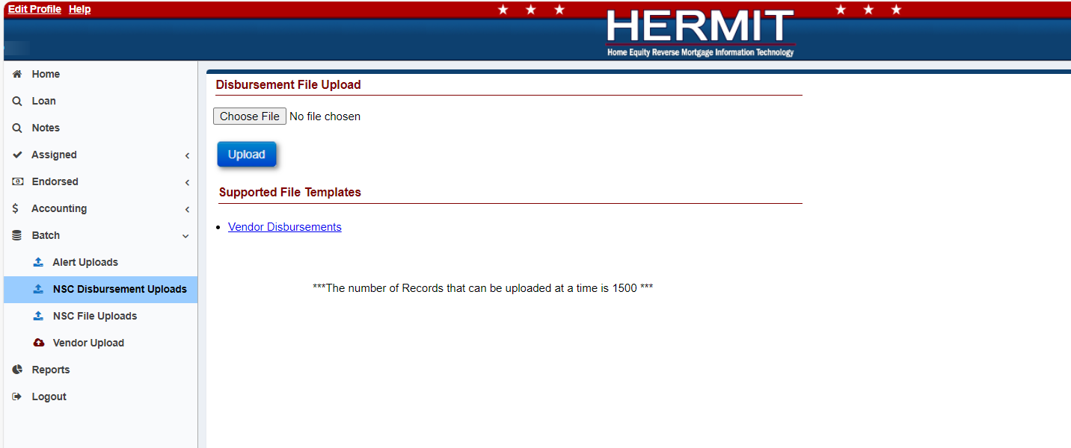
- The Alerts Uploads page is available under Batch on the left menu for the following Authorized user role Contractor Cash.

- The Vendor Disbursement link provides the Vendor Disbursement Template, this allows multiple “Disb – Unscheduled from LOC Inspections” Disbursements which can be uploaded into HERMIT using the NSC Disbursement Uploads page.

- When the user uploads a file on the NSC Disbursement Uploads page the Import Results will appear once the file has been uploaded. The Import Results will display as either a Success, Error, or Warning after the upload process. The user can click Export to Excel to display these Import Results in an Excel File. Once the user clicks outside of this page or tries to perform a different action on this page, the Import Results will no longer be displayed, and you will not be able to obtain these results again.

Batch NSC File Uploads: New B2G to Generate PDF Reports (586948)
A new link called “Loan Details/Transactions PDF” has been added to the Batch > NSC File Uploads page in HERMIT. The new link provides a Template file for users to upload on the NSC File Uploads page. Once the user uploads the Template, three new PDFs (Loan Details, Loan Transactions and Loan Historical Transactions) will generate in the download queue. Please refer to the “HERMIT NSC B2G File Format and Layout” link on the HERMIT Resources page for more information on NSC File Uploads.
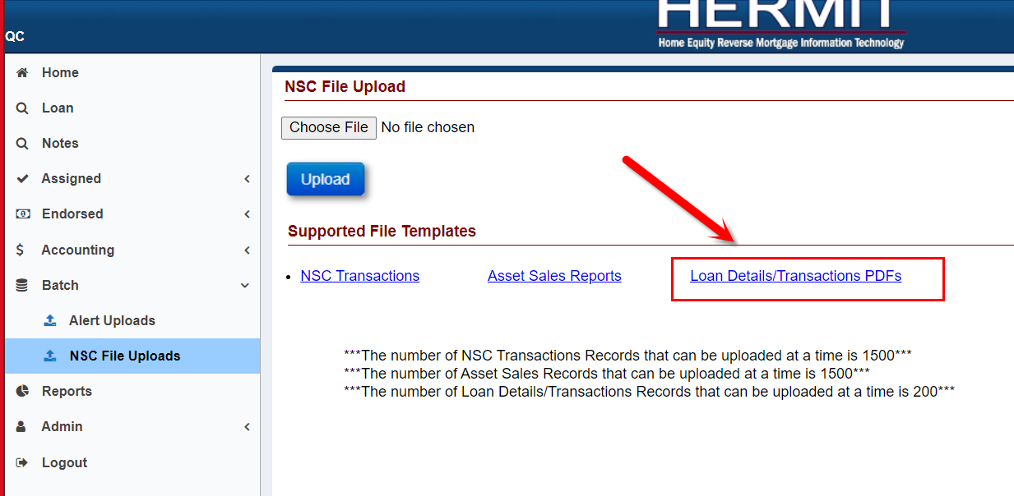

Only the following user Roles can upload using the new “Loan Details/Transactions PDF’s” template:
- NSC Contractor Cash
- NSC Contractor Cash Supervisor
- NSC Contractor Default
- NSC Contractor Supervisor/Management
- NSC Staff
- NSC Manager

SFTP Server: Endorsed Exposure Report (585864)
A new Report called the Endorsed Exposure Report will be available after the Month End process on the SFTP Server under Reporting/EndorsedExposureReport. This report mirrors the current HUD Exposure Report just for Endorsed loans.
Report output will be in CSV and have the following fields:
- Servicer Name
- Investor Name
- Loan Skey
- FHA Case Number
- Loan Number
- Loan Status
- Loan Sub Status
- Borrower First Name
- Borrower Last Name
- Product Type
- Rate Index Type
- Payment Plan
- Boarded Date
- Funded Date
- Remaining Payments
- Payment Status
- Credit Type
- Original Principal Limit
- Current Principal Limit
- Current Principal
- Current Interest
- Current MIP All
- Current Servicer Fee
- Current Loan Balance
- Servicer Fee Set Aside Balance
- Repair Set Aside Balance
- First Year Set Aside and Other Set Aside Balance
- Credit Line Set Aside Balance
- Current LESA Balance
- Current Loss Draft Balance
- Net Principal Limit
- NPL Calculation
- NPL Check
- Total Funds Due
- Max Claim Amount
- Collateral Value
- Fannie Mae Number
- Lender Skey
- Lender Name
The Report will be available for Authorized users who have access to SFTP Reporting folder. The Report will be available after the Month End process just like the HUD Exposure Report currently is.

Accounting > Disbursements: Increase max Authorization to 5,000
The Accounting > Disbursement page was updated to allow Authorized users to Authorize up to 5,000 disbursements at a time. The previous amount allowed was 1,000.

NSC Accounting > Transmittal Export to Excel
On the Accounting Transmittal Batch Details screen there was a limit of 150,000 on the number of cases that could be downloaded via Excel. This limit was in place to prevent a timeout when the user tried to download the data. The user currently must retrieve a file from the HERMIT SFTP Server for any Batch that has over 150,000 cases if they want to see the details of the batch. The HERMIT Project Team increased the limit to 500,000 so the details can now be downloaded from the Accounting Transmittals Batch Details screen via the link in the screen shot below.

