Home Equity Reverse Mortgage Information Technology
(HERMIT)

HERMIT System Changes – Release 7.5

Release Date: 01/27/24
Document Date: 01/31/24
Version 1.0

January 2024

INTRODUCTION
The Home Equity Reverse Mortgage Information Technology (HERMIT) software release version 7.5 consists of the following system changes:
Table of Contents
Servicer Related Changes 4
1. HUD Borrower Disbursements on Endorsed Loans: Related to ML 2023-15 (586189) 4
2. Claims – Debenture Interest (DBI) Rate based on Due and Payable Date instead of Endorsement Date (588568) 7
3. Claims – Do not include MIP Accruals on CT24 Supplemental Claim Form (587335) 7
4. Claims – Update Claim Form Description Text to use STOP MIP Date instead of MIP Accrual Date (587957) 7
5. Claim Type 22 - New validation to check for D&P during claim filing (586169) 8
6. Batch Servicer File Uploads: New B2G to allow Immediate Investor Transfer (589128) 8
7. Improve visibility of MIP collection status (586752) 8
8. Timeline Due and Payable with HUD Approval – Timeline Step Changes (588544 588688) 9
9. Timeline Due and Payable with HUD Approval – Due and Payable Decision Letter Updates (589021) 10
10. Timeline Due and Payable with HUD Approval – Inactivate Extension Timelines when D&P Timeline is inactivated (546091) 10
NSC / HUD Related Changes 11
11. Batch NSC File Uploads: Updated Asset Sale Reports Template (587801) 11
12. Timeline CT22: Update CT 22 Checklist to be in Accordance with ML 2023-10 (588457) 11
13. Timeline CT22: Welcome Letter is tied to New Step on the CT22 timeline (588744) 12
14. Assigned Timeline: D&P Timeline required to initiate Assigned > Loss Mitigation - Pre-Foreclosure Timeline (566182) 13
15. Assigned Timeline: Taxes Delinquent Timeline Updates to Svc Mgt Screen 13
16. Tax: Identify Active Cases sent to CoreLogic w/o a CoreLogic Contract Number (587546) 15
17. Reports: Tax Monitoring TAR Report captures Tax Due Dates for Assigned Loans (586979) 15
18. Reports: Update to Assigned Bulk Printing Report (585334) 17
19. Reports: Repayment Plan Report (539427) 17
20. Reports: Overage Report (586985) 18
21. SFDW - FHA Claim Data (585985) – (Internal Update for HUD) 18

If you have any questions regarding the functionality of the software release, please contact the HERMIT Help Desk at 561-899-2610 or at servicingsupport@hermitsp.com. If you have any policy related questions, please send an email to HUD at answers@hud.gov.

Servicer Related Changes

HUD Borrower Disbursements on Endorsed Loans: Related to ML 2023-15 (586189)
Authorized User Roles will be permitted to create HUD Borrower Disbursements in HERMIT. These Disbursements will be paid by HUD on Endorsed loans in certain situations as authorized by HUD. HUD Borrower Disbursements can be created by a Servicer Manager or HUD NSC Manager User Role only when the functionality is turned on by HUD. The HUD Borrower Disbursements must be approved by an authorized user in order to be paid to the Borrower using HUD’s existing Disbursement through Treasury process. After the Disbursement is made and the necessary status received back from the Accounting Module, then the Transaction will be added to the loan’s Transaction > Loan page.
Previous HERMIT Release 7.3 Help Desk Ticket 586489 related to ML 2023-15 implemented an SFTP process to make such payments, however, the changes in this Release replace the prior method of reporting via the SFTP server process with a process within the HERMIT UI.
Additional Enhancements for the Servicer to reimburse HUD for Borrower Disbursements made by HUD will be implemented in a future release.

Ability to Create and Identify HUD Borrower Disbursements
- A new Display Disbursements Page checkbox was added to the Admin > Servicer page, accessible by HUD NSC Manager user role. If the box is checked on Servicer’s profile, the Servicer Manager or HUD NSC Manager will be permitted to create HUD Borrower Disbursements for loans under that Servicer’s Mortgagee ID. When the box is not checked for a Servicer, HUD Borrower Disbursements cannot be created for loans under that Servicer’s Mortgagee ID. See additional information below for methods available to create HUD Borrower Disbursements.

- How to Identify HUD Borrower Disbursements in HERMIT. A new field named “Payment Type” (database: Endorsed Payment Type) was added to the Accounting > Disbursements page as a searchable field and in the grid results as “Payment Type”. A new Disbursement type “HUD Borrower Disbursement” is displayed in this dropdown as “Endorsed Borrower Disbursement.” A data change was completed on HUD Advance disbursements done prior to this release to identify those disbursements properly based on the dropdown option “Endorsed HUD Advance.”
Payment Type dropdown options are:
  - Endorsed Borrower Disbursement
  - Endorsed HUD Advance
  - Assigned Disbursement
  - ALL

Loan Level entry of HUD Borrower Disbursements on Endorsed Loans
From within a loan, Authorized user roles Servicer Manager and HUD NSC Manager can view the Loan > Disbursement page on the left menu. The New button will be displayed conditionally, based on whether the Servicer has permission to add HUD Borrower Disbursements to the loan via the “Display Disbursements Page” box.
  - Servicer Manager user role can only see the New button on the Loan > Disbursement page when the Servicer is granted permission to create HUD Borrower Disbursements. When permission is not granted, the New button will not be displayed on the page for the Servicer Manager.
  - HUD NSC Manager user role can only see the New button on the Loan > Disbursement page when the Servicer for the loan is granted permission to create HUD Borrower Disbursements. When permission is not granted, the New button will not be displayed on the page for the HUD NSC Manager.
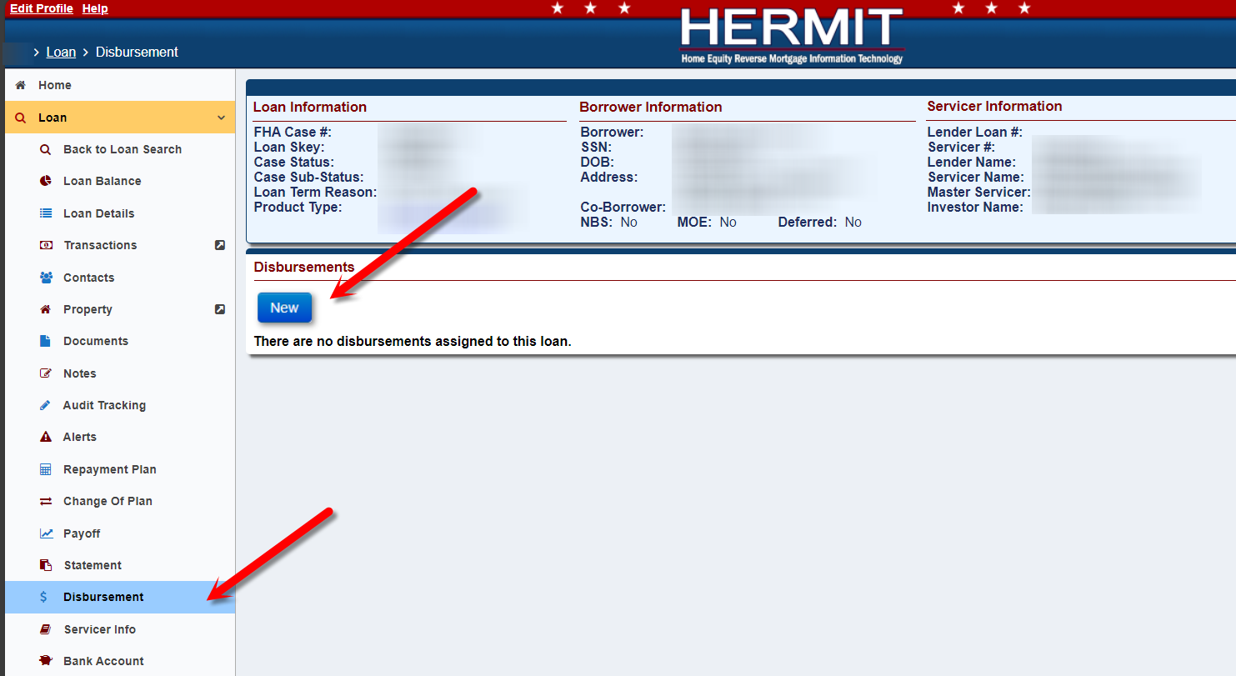

Batch Servicer File Uploads: New B2G to allow HUD Borrower Disbursements on Endorsed Loans
A new HUD Disbursements page was added under Batch on the left menu and is available for Authorized user roles Servicer Manager and HUD NSC Manager. Please refer to the “HERMIT Servicer & NSC B2G File Format and Layout” link on the HERMIT Resources page for more information on HUD Disbursements page.
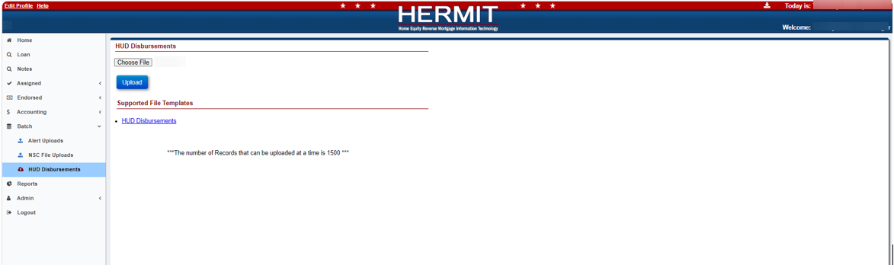
  - Servicer Manager user role can only see “Choose File” and “Upload” button when permission is granted by HUD via the “Display Disbursements Page” box. When permission is not granted, the “Choose File” and “Upload” button will not be displayed on the page for the Servicer Manager.
  - HUD NSC Manager user role can see “Choose File” and “Upload” button regardless of whether permission is granted to the Servicer. However, if permission is not granted for that Servicer, an error will be received when attempting to upload a file. If permission is granted, the user may upload a file.
- Under Supported File Templates, the HUD Disbursements link provides the HUD Disbursements Template, which allows the user to upload multiple Endorsed HUD Borrower Disbursements. The data the user inputs into the Template will be used to create the HUD Disbursement, in accordance with ML 2023-15.

- When the user uploads a file on the HUD Disbursements page the Import Results will appear once the file is uploaded. The Import Results will display as either a Success, Error, or Warning after the upload process. The user can click Export to Excel to display these Import Results in an Excel File.
Important: Once the user navigates away from this page or performs a different action on this page, the Import Results will no longer be displayed, and the user will not be able to obtain these results again.
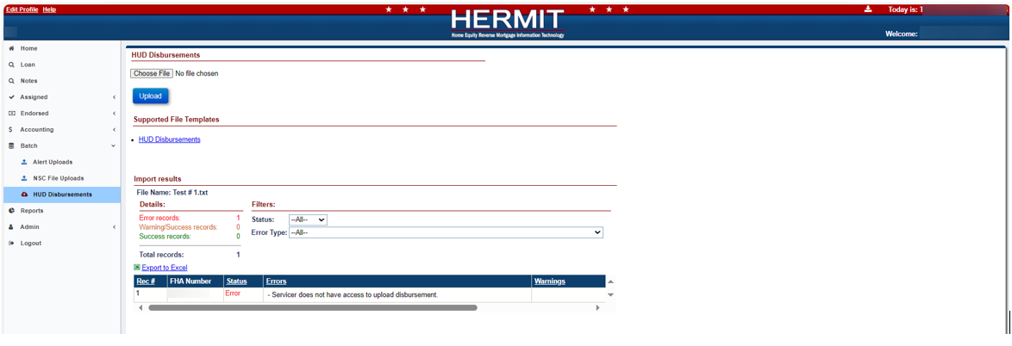

Claims – Debenture Interest (DBI) Rate based on Due and Payable Date instead of Endorsement Date (588568)
HUD directed HERMIT to make a change to the Debenture Interest (DBI) Rate used to calculate Debenture Interest on Claims to use the DBI Rate set forth based on the loan’s Due & Payable date instead of the Endorsement Date or Firm Commitment Date. This change applies to all FHA Case numbers, regardless of case number Assigned Dates and all loans with Parent Claims Approved for Payment on or after the Release Date.
Due and Payable Date for Claims is defined as follows:
- For Timeline Due and Payable w/o HUD Approval: Create Date of the D&P w/o HUD Approval timeline
- For Timeline Due and Payable with HUD Approval: “HUD Decision – Approved” step completion date
For loans that are not Due & Payable: the DBI rate will be set based on
- CT21 Block 29 for Claims Default Reason “16 - No Default – DIL”: Step Completion Date of the Loss Mitigation – Deed in Lieu timeline step “Date Borrower/Estate executed DIL Agreement”
- CT23 Block 8 when Disposition Information “Short Sale with no Due & Payable” box is checked: Step Completion Date of the Loss Mitigation – Short Sale timeline step “Deed Recorded Date”
The CT24 Supplemental Claim uses the same DBI rate used on the Parent Claim. If the Parent Claim used DBI rate based on Endorsement Date, any CT24 Supplemental Claims for the same loan will use the DBI Rate based on Endorsement Date.

Claims – Do not include MIP Accruals on CT24 Supplemental Claim Form (587335)
For all CT24 Supplemental claims, MIP will no longer auto-populate in Section 311 of the claim form with MIP from the Loan > Transactions > Loan page. This change is to align the CT24 after a CT23 with FHA Case # Assigned date on or after 09/19/2017 with changes that were made in 7.3. After a Parent Claim is paid, Monthly MIP is not collected and should not be paid out on the CT24 Supplemental Claim.
The MIP will continue to populate within the parent claim form with the final prorated MIP, when applicable.
If Transactions are added after the Parent Claim is paid causing Monthly MIP accrual adjustments, the transactions will continue to be displayed on the Transaction > Loan page but will not be automatically pulled into the CT24 claim form since they are not collected.

Claims – Update Claim Form Description Text to use STOP MIP Date instead of MIP Accrual Date (587957)
For Final Rule Loans with FHA Case # Assigned Date on or after 09/19/17, the Description on the last MIP Accrual included in Section 311 of the Claim Form was updated to reflect the date MIP was stopped on the loan instead of the last day of the month of that period. The Final Prorated Stopped MIP calculation has not changed and remains as MIP through the date MIP is stopped. Reminder: dates that cause MIP to stop on Final Rule loans are:
- “Foreclosure Sale Date” Step Completion Date from the Foreclosure Timeline
- “Deed Recorded Date” Step Completion Date from the Loss Mitigation – Deed in Lieu Timeline
- “Sale Closing Date” Step Completion Date from the Loss Mitigation – Short Sale Timeline

Claim Type 22 - New validation to check for D&P during claim filing (586169)
A new hard stop validation was added for CT22 Claims Assignment Timeline when the servicer attempts to submit the CT22, and an Active Due and Payable timeline exists on the loan. From the magnifying glass icon on step “Assignment to HUD sent for recording/Servicer Files Claim Type 22 - Form 27011”, after the user clicks either Validate Claim or Finalize & Submit Claim and a “Due & Payable with HUD Approval” or “Due & Payable without HUD Approval” exists on a loan, then the following hard stop validation will be displayed:
“Unable to proceed with Claim Type 22 as there is an Active D&P timeline on the loan.”

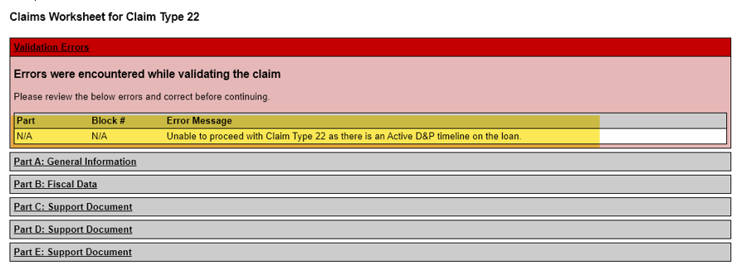

Batch Servicer File Uploads: New B2G to allow Immediate Investor Transfer (589128)
A new link called “Investor Transfer” was added to the Batch > Servicer File Uploads page in HERMIT. The new link provides a Template file for users to upload multiple “Investor Transfers” in HERMIT which will be updated the same day, instead of scheduled for update on the first day of the next month. Once the user uploads the Template, the system will immediately update the Investor on the loan. Please refer to the “HERMIT B2G File Format and Layout” link on the HERMIT Resources page for more information on Servicer File Uploads.

Improve visibility of MIP collection status (586752)
To improve visibility of the MIP batch status, fields Batch Number and Batch Status have been added to the Transactions > Loan search Grid results and the Export Transactions spreadsheet. The fields will display data from the corresponding batch information as displayed on Accounting > Transmittals for all 1160 Monthly Accruals and 1190 Accrual Adjustment Transactions.

Timeline Due and Payable with HUD Approval – Timeline Step Changes (588544 588688)
Multiple changes were made to the Endorsed > D&P with HUD approval Timeline, including triggers being added, changed, steps renamed, and steps removed. Step, “Additional information provided by Servicer” was inactivated.
- Step Pending Additional Information from Servicer: Step previously named “Contractor Recommendation – Pending Additional Information” was renamed to “Pending Additional Information from Servicer.” This step auto completes once initiated. Completion of this step triggers “Servicer Notified of Decision” but no longer triggers step “Additional Information Received from Servicer”.

- Step Servicer Notified of Decision is now triggered by completion of the step “Pending Additional Information from Servicer”. This step continues to be triggered by completion of any of the following other steps: “HUD Decision – Approved”, “HUD Decision – Denied” or “HUD Decision - Pending Additional Info.” Completion of this step triggers “Notification of Decision Received” and “Additional Documentation sent to HUD”.

- Step Notification of Decision Received is now triggered by completion of the step “Servicer Notified of Decision” but is no longer triggered by “HUD Decision – Approved”, “HUD Decision – Denied”, “HUD Decision - Pending Additional Info”, or “Pending Additional Information from Servicer”.

- Step Additional Documentation sent to HUD is now triggered by completion of the step “Servicer Notified of Decision” and is no longer an optional step. Completing of this step triggers “Additional Information Received from Servicer”.

- Step Additional Information Received from Servicer is now triggered by completion of the step “Additional Documentation sent to HUD” and is no longer triggered by “Additional information provided by Servicer.” Completion of this step triggers “Contractor Reviewed Additional Information”.

- Step Contractor Reviewed Additional Information is now triggered by completion of the step “Additional Information Received from Servicer” and is no longer triggered by the step “Additional information provided by Servicer”.

- Step Additional information provided by Servicer is now inactive.

Timeline Due and Payable with HUD Approval – Due and Payable Decision Letter Updates (589021)
Multiple changes were made to the Endorsed > D&P with HUD approval Timeline. A new field labeled "HUD Decision Date” was added to the "Due and Payable Decision Letter” and is located underneath the Date of Default. It is populated with the step completion date of one of the following steps:
- HUD Decision - Approved
- HUD Decision - Denied
- HUD Decision - Pending Additional Info
Note: The Step “Pending Additional Information from Servicer” date does not populate the HUD Decision Date.
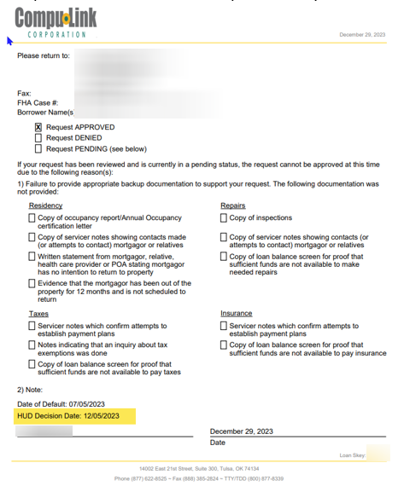

Timeline Due and Payable with HUD Approval – Inactivate Extension Timelines when D&P Timeline is inactivated (546091)
Multiple changes were made to the Endorsed > D&P with HUD approval Timeline. The “Extension - Req to Delay FCL” and “Extension - Delay Due & Payable” Timelines are now inactivated when the “D&P w HUD Approval” or “D&P w/o HUD Approval” Timelines are inactivated. Once the User inactivates the “D&P w HUD Approval” or “D&P w/o HUD Approval” the system will automatically set the “Extension - Delay Due & Payable” and the “Extension - Req to Delay FCL” Timelines to inactive.

NSC / HUD Related Changes

Batch NSC File Uploads: Updated Asset Sale Reports Template (587801)
The Asset Sale Reports Template on the Batch > NSC File Uploads page was updated to now allow nine-digit and/or ten-digit FHA Case #’s. The nine-digit FHA Case # acceptable in the Template will be the first nine-digits in the FHA Case #. Once the user uploads the Template the four reports (Contact Extract, Loan Extract, Loan Level Balance, and Loan Transaction Detail) will generate in the download queue. All four reports will display the full ten-digit FHA Case # even if the user only uploads a nine-digit FHA Case # in the Template. Please refer to the “HERMIT NSC B2G File Format and Layout” link on the HERMIT Resources page for more information on NSC File Uploads.

Timeline CT22: Update CT 22 Checklist to be in Accordance with ML 2023-10 (588457)
Multiple changes were made to the Endorsed – Claims – CT 22 – Assignment Timeline Compliance Package Checklist area, located on step “HECM Assignment Acceptance Checklist”. The modifications include removal of certain titles, tasks, and checkboxes.
A screen of the updated checklist is provided:

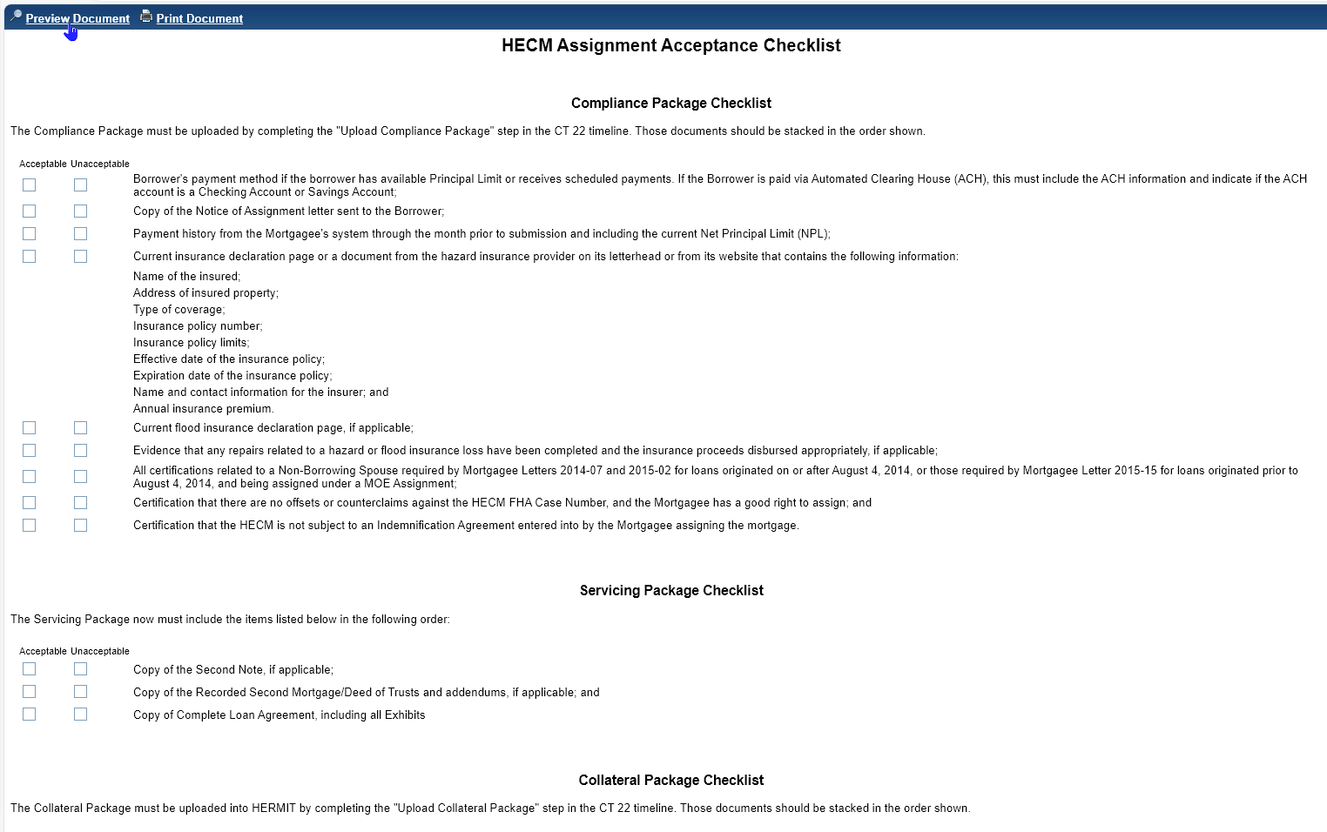

Timeline CT22: Welcome Letter is tied to New Step on the CT22 timeline (588744)
An update was made on the Endorsed > Claims > Claim Type 22 – Assignment Timeline. The Step “Assignment Package Received” will no longer print the Welcome Letter. The Welcome Letter will be printed from a new step called “Welcome Letter Sent.”

- The New Step “Welcome Letter Sent” will be added in HERMIT’s nightly job when certain criteria are met. The following criteria must be met in order for the new step to be added to the Timeline.
- Step “HUD Issued Preliminary Title” must be completed.
- There is No Active Due & Payable w/HUD Approval and/or No Active Due & Payable w/o HUD Approval Timeline.
- If Case Status is Endorsed, Case Sub-Status must be “Loan Active” or “Payment Suspended.”
- If the MOE box is not checked on the Servicing Management page on a Claim Type 22 – Assignment timeline, then the loan balance must be 98% or greater than the Max Claim Amount.
- If MOE box is checked on the Servicing Management page on a Claim Type 22 – Assignment timeline, then check the following MOE Assignment Conditions:
- There is an Eligible NBS on the loan.
- All Borrowers are deceased or in a health care facility.
- The MOE is marked YES on the loan header and the MOE checkbox is checked on the NBS under the Contacts page on the loan.
- The “Welcome Letter Sent” step will display the magnifying glass and printer icon next to the step. The user will only be able to complete the step when clicking on the printer icon. The user will not be able to complete the step by clicking on the step.
- The step “Assignment Package Received” will no longer display the printer icon. The magnifying glass icon will only appear next to the step if the Welcome Letter is archived.
- The step “Welcome Letter Sent” will display an Error Message when the user clicks on the printer icon and certain criteria is not met to print the Letter. If all criteria displayed above in Section A are met, then the user will be able to print the Letter without Error. If the above criteria in Section A is not met, then the user will get an Error message stating, “The Welcome Letter cannot be printed because the required conditions are not met.”

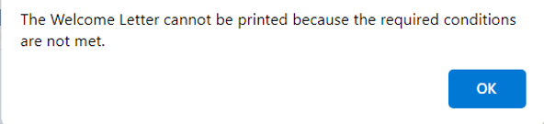

- A Data Change Request (DCR) was processed to Add the new “Welcome Letter Sent” step to all prior Claim Type 22 – Assignment Timelines where the Welcome Letter has not been printed and to Add the new “Welcome Letter Sent” step to all prior Claim Type 22 – Assignment Timelines where the Welcome Letter was printed. (Note: The prior Claim Type 22 – Assignment Timelines where the Welcome Letter was printed will still display the magnifying glass icon on the Step “Assignment Package Received” but not the printer icon.)

Assigned Timeline: D&P Timeline required to initiate Assigned > Loss Mitigation - Pre-Foreclosure Timeline (566182)
In order to create an Assigned > Disposition > “Loss Mitigation Pre-Foreclosure” Timeline, an active Assigned “Due and Payable” Timeline must exist on the loan. The Default Reason for the “Loss Mitigation Pre-Foreclosure” Timeline will transfer from the active “Due and Payable” Timeline Default Reason. If the Default Reason is changed on the “Due and Payable” Timeline, it will be reflected on the “Loss Mitigation Pre-Foreclosure” Timeline Default Reason. Once the Assigned “Due & Payable” timeline is inactivated, the “Loss Mitigation Pre-Foreclosure” will also be inactivated. A new note will be added to the Assigned loan when the system inactivates the Assigned “Loss Mitigation Pre-Foreclosure” Timeline due to the inactivation of the Assigned “Due & Payable” Timeline.

Assigned Timeline: Taxes Delinquent Timeline Updates to Svc Mgt Screen
Modifications were made to the Taxes Delinquent Timeline to allow for the payment of taxes.
- A new field was added Next to the Pay Taxes Button that displays the sum of the Total Installment Fields for all Tax Years for that specific Taxes Delinquent Timeline. The sum only sums Tax Years that have a Tax Delinquency Status of "Delinquent".
- An editable Total Installment Field was added on the Edit Disbursement Window for each Tax Year selected on the Servicing Management Information “Select Tax Year” dropdown.
- The Payee field can be selected on the popup window to pay the taxes. New Payees can be added through the Tax Authority screen.
- The Tax Year field was modified to be a dropdown of the Tax Years available for that Tax Delinquent Timeline.
- A Status Field dropdown was added to the Edit Servicing Management window the following fields:
- Delinquent
- Paid by Borrower
- Paid by Servicer
- Unpaid but Resolved - Pending
- If the User Select Type Unpaid but Resolved - Pending, then this will force the user to enter a comment-A box will display for the user to enter the Note.
- If the user clicks Submit and does not enter a Note, a Hard Stop message will appear stating “Note is Required when Tax Payment Status = Unpaid but Resolved – Pending.
- If Delinquency Status is updated to Unpaid but Resolved - Pending and Saved, two HUD System steps will be added to the Delinquency Timeline so that HUD can approve the status.
- HUD Approves Payment Status update to Type “Unpaid but Resolved”.
- HUD Denies Payment Status update to Type “Unpaid but Resolved”.
- The System Steps will be visible only if a Delinquency Status of Type “Unpaid but Resolved - Pending” is present for any of the Tax Years.
- The System Steps Will Inactivate the Timeline if all other Tax Years are Type “Paid by Servicer”, “Paid by Borrower” or “Unpaid but Resolved.”
- The "Tax ID #:" Field was updated to state "Tax Id/Parcel #:"
- When the Taxes are paid through Edit Disbursement window and the submit button is clicked a new Delinquency status will be created and will be Disbursement – Pending
- When the Delinquency Status is Disbursement – Pending, there will be a warning message displayed stating: “An Uncleared check in the amount of $xxx.xx has already been generated for XYZ.
- The current check will be voided before generating a new check.
- Do you want to Continue?”
- When the User changes the payment status from 'Delinquent' to 'Unpaid but Resolved - Pending' for a given tax year the following will occur:
- The status for that tax year will be changed to 'Unpaid but Resolved - Pending.'
- The Approval and Denial steps in the timeline will be created by the system for that tax year. The steps will have the tax year in the Step Note.
- An audit record will be created.
- When the User changes the payment status from 'Delinquent' to 'Unpaid but Resolved - Pending' for a given tax year the following will occur:
- The status for that tax year will be changed to 'Unpaid but Resolved - Pending.'
- Approval and Denial steps in the timeline will be created by the system for that tax year. The steps will have the tax year in the Step Note.
- An audit record will be created.
- When the User completes the Approval step for a given tax year the following will occur:
- The status for that tax year will be changed by the system to 'Unpaid but Resolved.'
- The Denial step will be inactivated for the same tax year.
- The Timeline will be changed by the system to Inactive and the steps "Received Proof of Taxes Paid, and "Authorization Received/Pay Taxes" will be completed if there is no other tax year with payment status = 'Delinquent', 'Unpaid but Resolved - Pending' or 'Disbursement - Pending'
- An audit record will be created.
- When the User completes the Denial step for a given tax year
- The status for that tax year will be changed to 'Delinquent.'
- The Approval step for the same tax year will be inactivated.
- An audit record will be created.
- When the User changes the total installment amount for a given tax year
- Generate audit record.
- When the Disbursement Status changes to “Cleared” Status, the Delinquency status for those Tax Years that were paid will be set to “Paid by Servicer” and the Taxes Delinquent Timeline will become “Inactive.”
Note: In rare cases when the Disbursement is submitted and before changing to a cleared status, a new Tax Year could come in from CoreLogic as Delinquent for the same Tax Authority, Parcel Number. In that situation a new Tax Year will be added to that Timeline and the Timeline will still be active after the Cleared Status is received.

Tax: Identify Active Cases sent to CoreLogic w/o a CoreLogic Contract Number (587546)
A new Alert “Case Not Processed by CoreLogic within 14 Calendar Days” was added to HERMIT Servicing Module when the contract # has not been received within 14 calendar days after the case was sent (Open Loan Sent for Tax Monitoring). Once the contract # is received from the ADDS file the “Case Not Processed by CoreLogic within 14 Calendar Days “alert is inactivated. This alert was also added to the Assigned Notes Report > Daily Reports > “Alerts Detail” Report Available Alerts selection list.
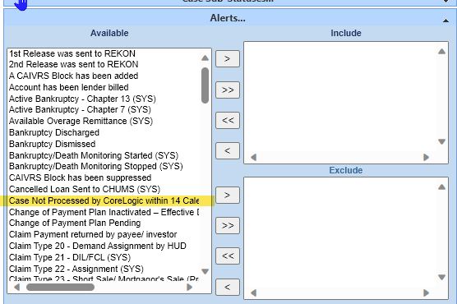

Reports: Tax Monitoring TAR Report captures Tax Due Dates for Assigned Loans (586979)
A new Report was added to the HERMIT reports area Assigned Notes Reports->Daily Reports named “Tax Amount Reporting” under “Subordinations Carried Over Detail” and above “Transaction Activity” which captures Tax Due Dates for Assigned Loans.
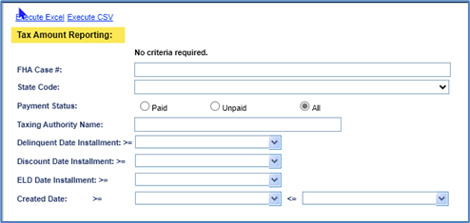
- The Report Search Criteria includes the following:
- FHA Case Number
- State Code (Dropdown of States)
- Payment Status (Paid or Unpaid)
- Taxing Authority Name
- DELQ DATE INSTALLMENT - The last day to pay before taxes start accruing Penalties and Interests.
- DISCOUNT DATE INSTALLMENT - Some states offer a discount for early payment. This is the last day to pay for the discounted amount to be honored.
- ELD DATE INSTALLMENT - Last day to pay without penalties/ interests, or loss of discount. This is the date CoreLogic uses for reporting escrowed taxes or C service loans. This date should match the discount date if one is offered or match the DELQ date.
- Create Date of TAR Data

- Report output will be in Excel or CSV and have the following fields:
- Tax Authority Name
- Taxing Authority Type
- Customer Number
- Loan Number
- Contract Order Number 1
- Contract Order Suffix
- Pending Apportionment Hit Code
- Exemption Code
- State Code
- County Code
- First Installment Payment Status
- First Installment Tax Amount
- First Installment Delinquent Date
- Second Installment Payment Status
- Second Installment Tax Amount
- Second Installment Delinquent Date
- Third Installment Payment Status
- Third Installment Tax Amount
- Third Installment Delinquent Date
- Fourth Installment Payment Status
- Fourth Installment Tax Amount
- Fourth Installment Delinquent Date
- Total Tax Amount
- Discounted Total Tax Amount
- Tax Identification Number
- Reference Number
- Prior Year Delinquency Indicator
- Service Bureau Customer Number
- Number of Installments
- Current Installment
- Create Date

- The user can run the Report wide open without any criteria needed.

Reports: Update to Assigned Bulk Printing Report (585334)
An update was made on the Reports > Assigned Notes Reports > Daily Reports > Bulk Printing page, the Welcome Letter can be printed through Bulk Printing.

- “Claim Type 22 – Assignment (Endorsed)” was added to the Servicing Type field and “Welcome Letter Sent” was added to the Step field on the Bulk Printing page.
- After the user clicks Execute PDF to Bulk Print the Welcome Letter, the Print Confirmation modal will appear. On the Print Confirmation modal, the Auto Complete and Auto Image will automatically be checked by the system. The user will not be allowed to uncheck the Auto Complete and Auto Image boxes as these boxes will be grayed out.
- The Print Confirmation modal will only display the number of Letters that are available to be printed. The Welcome Letter will only be available if it has not been completed (if the Step “Welcome Letter Sent” is not completed) and all the criteria is met to print the Welcome Letter.
- Current Functionality still exists for the number of Letters to be printed at a time. Only 600 letters will be printed at a time and the system will allow users to continue printing until all letters are printed for the day.

Reports: Repayment Plan Report (539427)
Under the Management / Budgetary area in Reports, the Repayment Plan Report criteria was enhanced to have search capability on both the Repayment Start Date (a date range) and Repayment End Date (a date range).
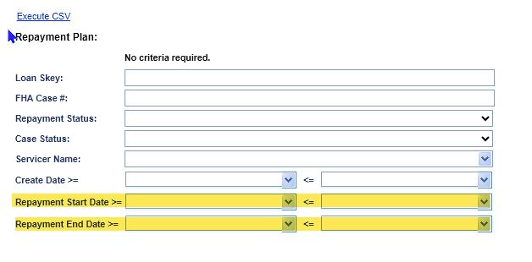

Reports: Overage Report (586985)
A new “Overage Report” was created under the HERMIT reports area Assigned Notes Reports > Daily Reports, underneath “Occupancy Certifications and Hazard/Flood Ins Detail.” The report contains positive and negative Overage Balances for Assigned Loans in HUD’s portfolio (Servicer 900000). The search criteria include Loan Skey and FHA Case number.
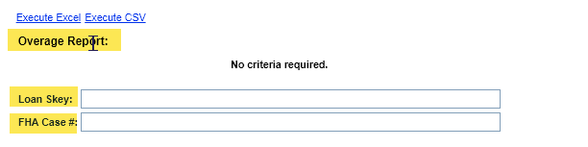
- Search Criteria includes the following:
- Loan Skey
- FHA Case #

- The report includes the following fields:
- Loan skey
- FHA Case Number
- Lender
- Servicer
- Investor
- Case Status
- Case Sub-Status
- Overage Balance

- The user can run the Report wide open without any criteria needed.

SFDW - FHA Claim Data (585985) – (Internal Update for HUD)
Two new fields were added to the SFHEDW Claims File:
- Field 1 = ABC/SBC, field length of 3 at position 462. Indicates if the claim was an Appraisal Based Claim or Sale Based Claim.
- Field 2 = Appraisal Amount, length of 12 at position 465.

