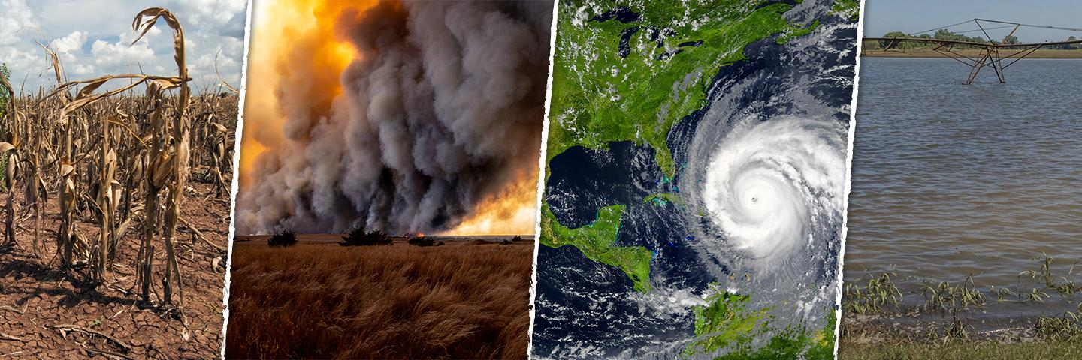

**Disaster Operations**

**Standard Operating Procedure**

**February 2023**

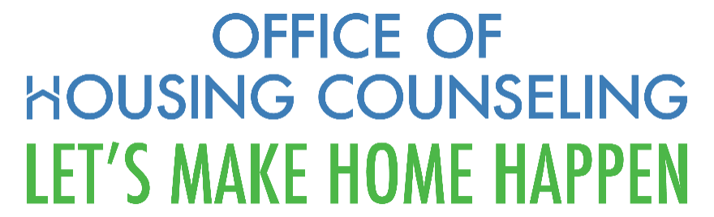

**Purpose**

This Standard Operating Procedure (SOP) provides detailed guidance to OHC staff and other relevant HUD stakeholders regarding the participation of HUD-approved housing counseling agencies, certified housing counselors and OHC staff regarding OHC and program participant engagement in HUD’s disaster assistance and recovery activities.

**Questions**

Any questions regarding this SOP may be directed to Virginia Holman, Housing Program Technical Specialist, Office of Outreach and Capacity Building, Office of Housing Counseling

**Approval**

David Berenbaum, Deputy Assistant Secretary, Office of Housing Counseling

**Table of Contents**

Chapter 1 – Introduction

Chapter 2 – OHC Disaster Assistance Procedures for OHC Staff and Program Participants

Chapter 3 – OHC Coordination with HUD’s Office of Disaster Management  and FEMA’s Disaster Recovery Centers (DRCs)

**Chapter 4 - State or Local Government Requests to HUD for housing counseling services after a Disaster**

**Chapter 5 - Funding and Recordkeeping**

**Appendices**

1. *Survey to Assess the**Operational Status and Capacity of Housing Counseling Agencies due to a Disaster/National Emergency (Disaster/National Emergency Survey)*
2. Housing Counseling Disaster Resources

# 

# Chapter 1 – Introduction

## Purpose

The Office of Housing Counseling (OHC) developed the following SOP to assist OHC management and staff with policy and procedures regarding: 1) when HUD-approved housing counseling agencies (HCAs) are located in a geographic area impacted by a disaster; 2) when OHC receives a request for HCAs to provide counseling at a Federal Emergency Management Agency (FEMA) Disaster Recovery Center (DRC) and; 3) when HUD receives a request from a state or local government for coordination with OHC for the participation of HCAs in their disaster recovery efforts.

* 1. **References and Authorizations**

The following legal authorities, administrative guidance, and grant agreements were used in the development of this guide:

1. 24 CFR 214
2. HUD Housing Counseling Handbook 7610.1 rev. 5
   1. **Definitions**

**Disaster Assistance Counseling**. Education and counseling

services, where the need for services is created by a disaster or national emergency, either

pending or occurred. A disaster may be a natural or man-made event that is local, regional or

national in scope. These services may be preparedness (pre-disaster) or recovery (post

disaster). Participating agencies can offer these services through group workshops or one-on-

one counseling, or both. The duration of such housing counseling may be short- or long term.

**Preparedness Assistance Housing Counseling and Education**. Includes preparedness

education and housing counseling that occurs before a disaster. It can be group

education or one-on-one counseling, or both. This education and housing counseling

provides clients the tools and information necessary to prepare and implement a

home and family emergency preparedness plan. A plan could include family information, communication plan, important papers, financial information, and an emergency kit.

**Recovery Assistance Housing Counseling**. Includes recovery assistance housing

counseling and education that occurs post disaster. It can be group education or on-eon-one counseling. Recovery assistance housing counseling will focus on the relocation, re-housing, and rebuilding process for those clients impacted by a disaster.

**1.4 Other HUD Offices**

**Disaster Assistance and Recovery Team (DART).** OHC’s DART team is responsible for:1) Prepare housing counseling agencies for disasters and build capacity with training and technical assistance; 2) Educate and support housing counseling agencies to assist clients with disasters; 3) Monitor response/recovery activities of agencies impacted by a disaster.; 4) Participating in Departmental Disaster responses to Major and Presidentially Declared Disasters.

**Office of Disaster Management** (ODM) in the Office of the Deputy Secretary

**Office of Disaster Recovery** (ODR) within the Office of Community Planning and Development

**Chapter 2 – OHC Disaster Assistance Procedures for OHC Staff and Program Participants**

**2-1** In advance of a disaster, OHC staff will reach out to participating agencies located in the impacted area, offering information, and resources on preparedness. See Appendix B.

**2-2** After a disaster is declared, the DART Point of Contact (POC) sends out a Disaster Survey to housing counseling agencies in the impacted areas to determine operating status, assess damage, and evaluate needs. The survey can be found at <https://www.surveymonkey.com/r/disaster2022>. A follow-up survey may be sent out if needed.

**2-3**  In addition, the OHC Points of Contact (POCs) for the housing counseling agencies will reach out to each agency in the impacted area to offer available information and resources on emergency response.

**2-4** OHC POCs submit the responses they receive from the agencies to the DART.

**2-5** The DART POC will compile the data from the Disaster Survey to create and submit a report to the SITREP. The DART analyzes the data from the individual agencies and responds as appropriate. For example, an agency in the impacted area may request local contact information for FEMA.

**2 -6** The DART will provide a weekly situational report (SITREP) to the POC in the Office of Housing that complies information for HUD’s Office of Disaster Management as well as OHC Management.

# Chapter 3 –Deploying Housing Counselors onsite or virtually at a FEMA Disaster Recovery Center

**3-1** Once HUD is issued a Mission Assignment by FEMA and HUD’s Office of Disaster Management and FEMA determine that there is a need for housing counselors on site at a FEMA Disaster Recovery Center, then the OHC DAS Office POC in coordination with the DART will work with the designated ESF or RSF Coordinator and HCAs to coordinate the deployment of housing counselors.

**3-2** The DART will reach out to HCAs to determine availability of housing counselors with disaster assistance counseling expertise and experience for on-site as well as virtual counseling if requested.

**3-3** The DART POC will also make available to the ESF or RSF Coordinator training materials for DRC staff on the role of housing counselors in disaster recovery efforts. A list of housing counseling agencies with disaster counseling experience available for virtual counseling will also be made available upon request at the DRCs.

**3-4** The DART will provide information and training for housing counselors who have agreed to deploy. For example, OHC will make available the Housing Counselors Disaster Field Guide: Action Oriented Tool for Disaster Response to those assisting at DRCs.

**Chapter 4– State and Local Government requests for disaster assistance housing counseling services**

**4-1** When HUD’s Office of Disaster Management reaches out to OHC with a request from a state or local government for assistance from housing counselors, the OHC DAS POC will reach out to the state or local government to receive specific details regarding the nature of the request.

**4-2** The OHC DAS Office POC in coordination with the DART will meet with local and state officials to explain OHC and HCAs role and responsibilities in the proposed partnership to respond to local disaster assistance need, outlined below.

**4-3** OHC DAS will assign a OHC lead for each request. The OHC lead for each engagement will work with DART to conduct outreach to HCAs to identify the agencies and housing counselors that can respond to the request and facilitate communication between the state or local government POC and the POCs for the agencies that agree to participate.

**4-4** The OHC lead will discuss with the state and local government POC the scope of housing counseling activities that may occur with the provision of disaster assistance related housing counseling. Counseling activities will include the following processes: Intake; financial and housing affordability analysis; an action plan; and a reasonable effort to have follow-up communication with the client when possible.

OHC lead will also convene to state or local POC that disaster recovery needs may impact counselors’ ability to provide as comprehensive counseling as they would in non-emergencies. For example, counselors may have to adapt their financial analysis and action plans for clients who have lost important documents or who are experiencing homelessness.

The OHC lead will also explain that counseling may be provided onsite or virtually based on local need and availability of housing counselors.

**Chapter 5 – Funding and Recordkeeping**

**5-1** Disaster related assistance counseling is a cost that is eligible for reimbursement under HUD’s Housing Counseling Grant Program. For counseling staff engaged in eligible activities, reasonable costs necessary to the provision of those services (e.g., traveling to the disaster site and related lodging expenses) may also be reimbursed.

**5-2** While counseling costs are eligible for reimbursement, they may not cover all costs incurred for agency participation in the recovery effort. Agencies may seek additional support from other sources. OHC does not have additional grant funds that can be awarded to supplement agency grant awards for their participation in these disaster assistance efforts.

**5-3** The revised Fiscal Year (FY) 2022 [HUD-9902 form](https://www.hudexchange.info/programs/housing-counseling/9902/completing-the-9902/) includes reporting data for disaster education, one-on- one disaster counseling, and impact of one-on-one disaster counseling. The agency’s workplan must include disaster counseling to report the data

**5-4** Reports for each deployment or DRC.

OHC will provide reporting templates for housing counselors at DCRs t gather data on clients and services

-

**Appendices**

1. *Survey to Assess the**Operational Status and Capacity of Housing Counseling Agencies due to a Disaster/National Emergency (Disaster/National Emergency Survey)* <https://www.surveymonkey.com/r/disaster2022>
2. Resources
   1. Housing Counseling Disaster Resources <https://www.hudexchange.info/programs/housing-counseling/disasters/>

Housing Counseling Recovery Toolkit https://www.hudexchange.info/programs/housing-counseling/housing-counseling-disaster-recovery-toolkit/

Preparing for a Disaster. This guide provides concrete guidance on how HCAs can prepare for a disaster including: 1) information to include in an Emergency Response Plan; 2) how to develop a Continuity of Operations Plan (COOP); 3)assessing community needs and building partnerships when planning disaster recovery services; 4) preparing clients by teaching disaster preparedness

Operating Post Disaster Guide. This guide provides guidance on what HCAs should do following a disaster including: 1)implementing plans to resume and maintain operations; 2) coordinating with local partners to implement effective post-disaster programs in the community; 3) helping clients address their individual recovery challenges; 4) identifying opportunities for housing counseling services.

* 1. Emergency and Disaster Preparedness Group Education Materials

These emergency and disaster preparedness group education materials are available for housing counselors to customize as part of their group education.

* 1. [**Disaster Recovery Flyers**](https://www.hudexchange.info/programs/housing-counseling/housing-counseling-works/ohc-disaster-recovery-flyers/) and other social media

These flyers are a helpful tool when participating in short-term and long-term disaster recovery outreach events in your area. Flyers are available in multiple languages and color schemes.

* 1. OHC Disaster Preparedness and Recovery Webinars (margins for this section need to be fixed)

|  |  |  |
| --- | --- | --- |
| [**Disaster Recovery Through an Equity Lens**](https://www.hudexchange.info/trainings/courses/housing-counseling-webinar-disaster-recovery-through-an-equity-lens/4691/) | This webinar provided a framework for thinking about equity in the disaster preparedness context and provided advice for promoting equity in the provision of disaster recovery housing counseling services. | July 13, 2022 |
| [**2022 OHC, CPD, and FPM Virtual Conference: Serving Communities Through Housing Counseling**](https://www.hudexchange.info/trainings/courses/2022-ohc-cpd-and-fpm-virtual-conference-serving-communities-through-housing-counseling/4579/) | This virtual conference discusses how housing counseling agencies and CPD grantees can collaborate to best serve clients. | May 10-11, 2022 |
| [**Delivering Group Education on Emergency and Disaster Preparedness**](https://www.hudexchange.info/trainings/courses/housing-counseling-webinar-delivering-group-education-on-emergency-and-disaster-preparedness1/) | This webinar prepares HCAs for the delivery of Emergency and Disaster Preparedness group education sessions. | December 7, 2021 |
| [**How to Support Disaster Housing Counseling Clients**](https://www.hudexchange.info/trainings/courses/housing-counseling-webinar-how-to-support-disaster-housing-counseling-clients/) | This webinar provides an overview to housing counselors on actionable next steps to support their communities post disaster. | September 30, 2021 |
| [**Agency COOP and Emergency Response Plan**](https://www.hudexchange.info/trainings/courses/housing-counseling-webinar-agency-coop-and-emergency-response-plan/) | This webinar covers preparing Continuity of Operations Plans (COOPs) and emergency response plans for agencies, as well as other aspects of the Housing Counseling Disaster Recovery Toolkit. | October 22, 2020 |
| [**National Homeownership Month 2020: Social Distancing and Its Effect on the Housing Industry**](https://www.hudexchange.info/trainings/courses/national-homeownership-month-2020-social-distancing-and-its-effect-on-the-housing-industry/) | This webinar discusses social distancing and its effect on the housing industry. | June 23, 2020 |
| [**Flood Insurance with FEMA**](https://www.hudexchange.info/trainings/courses/housing-counseling-webinar-flood-insurance-with-fema/) | This webinar is designed to help housing counselors help their clients navigate FEMA's National Flood Insurance Program (NFIP). The webinar covers insurance basics, how the NFIP works, and how to process claims. | August 18, 2018 |
| [**Disaster Preparedness and Recovery Toolkit Demonstration**](https://www.hudexchange.info/trainings/courses/housing-counseling-webinar-disaster-preparedness-and-recovery-toolkit/) | This webinar teaches participants how housing counseling agencies (HCAs) can play a meaningful role in disaster preparedness and recovery and provides a demonstration of the new online toolkit. | August 7, 2018 |
| [**Community Development Block Grant Disaster Recovery Program Basics**](https://www.hudexchange.info/trainings/courses/housing-counseling-webinar-community-development-block-grant-disaster-recovery-program-basics/) | The Community Development Block Grant Disaster Recovery Program (CDBG-DR) provides flexible grants to help cities, counties, and states recover from Presidentially declared disasters. HUD issued a Federal Register Notice in February 2018 requiring CDBG-DR grantees to coordinate with HUD-approved housing counseling agencies. This webinar outlines the program and provide tips for housing counselors on how to coordinate with their local CDBG-DR grantee. | May 21, 2018 |
| [**Severe Weather Preparedness for Housing Counseling Agencies**](https://www.hudexchange.info/trainings/courses/severe-weather-preparedness-for-housing-counseling-agencies/) | This webinar, hosted by HUD’s Office of Disaster and National Security, covers severe weather preparedness for Housing Counseling Agencies. | March 22, 2016 |
| [**FEMA’s National Flood Insurance Program for Housing Counselors**](https://www.hudexchange.info/trainings/courses/housing-counseling-webinar-fema-s-national-flood-insurance-program-for-housing-counselors1/) | This webinar gives an overview of the Federal Emergency Management Agency's (FEMA) National Flood Insurance Program (NFIP) and provides the information and resources you need to educate your clients on the NFIP, flood insurance premiums and federal assistance available to homeowners and renters. | September 22, 2015 |
| [**Small Business Administration (SBA) Disaster Programs**](https://www.hudexchange.info/trainings/courses/housing-counseling-webinar-small-business-administration-sba-disaster-programs1/) | This webinar presents the Office of Housing Counseling and the Small Business Association (SBA) to provide an overview of SBA programs and assist consumers after a disaster. | September 8, 2015 |
| [**Emergency Preparedness Planning for Housing Counseling Agencies**](https://www.hudexchange.info/trainings/courses/housing-counseling-webinar-emergency-preparedness-planning-for-housing-counseling-agencies1/) | This webinar is a stakeholder meeting that discusses the role of housing counseling agencies in community emergency responses and the importance of Emergency Preparedness Planning. | October 21, 2014 |