Home Equity Reverse Mortgage Information Technology
(HERMIT)

HERMIT System Changes – Release 7.0

Release Date: 10/09/22
Document Date: 10/09/22

INTRODUCTION
The Home Equity Reverse Mortgage Information Technology (HERMIT) software release version 7.0 consists of the following system changes:
Table of Contents
modernization Related Changes 4
1. New Login Page 4
2. New Link to the User Guide 5
3. New Modern Look 6
4. All Navigation is now in the Left Menu 7
5. Active Menu 8
6. Sub-Menu 9
7. More Options 10
8. NEW Features 11

If you have any questions regarding the functionality of the software release, please contact the HERMIT Help Desk at 561-899-2610 or at servicingsupport@hermitsp.com. If you have any policy related questions, please send an email to HUD at answers@hud.gov.

modernization Related Changes

New Login Page
The login page has been updated with a new HERMIT logo. The new HERMIT Login screen also contains the Multi-Factor Authentication previously implemented in Release 6.81.
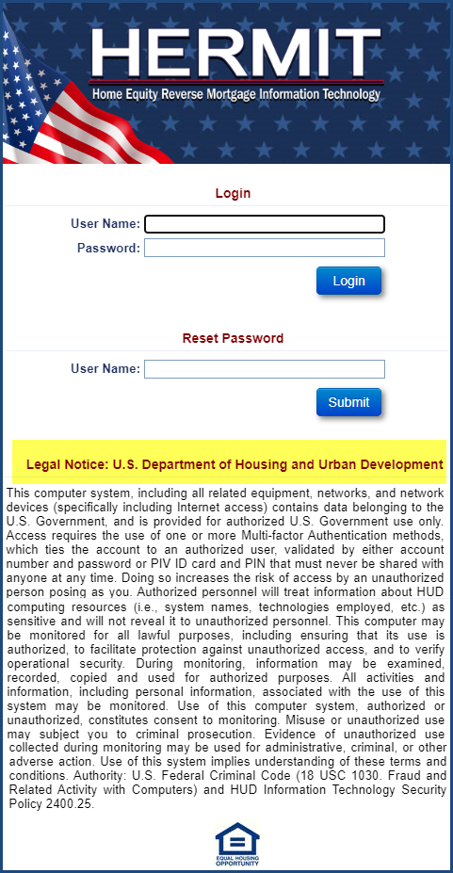

New Link to the User Guide
Under Help there is a New Link to access the User Guide while logged into HERMIT. Click to go to the HERMIT Resources Page and click HERMIT User Guide to access. The Welcome message and the date have also been moved to the right side of the screen.
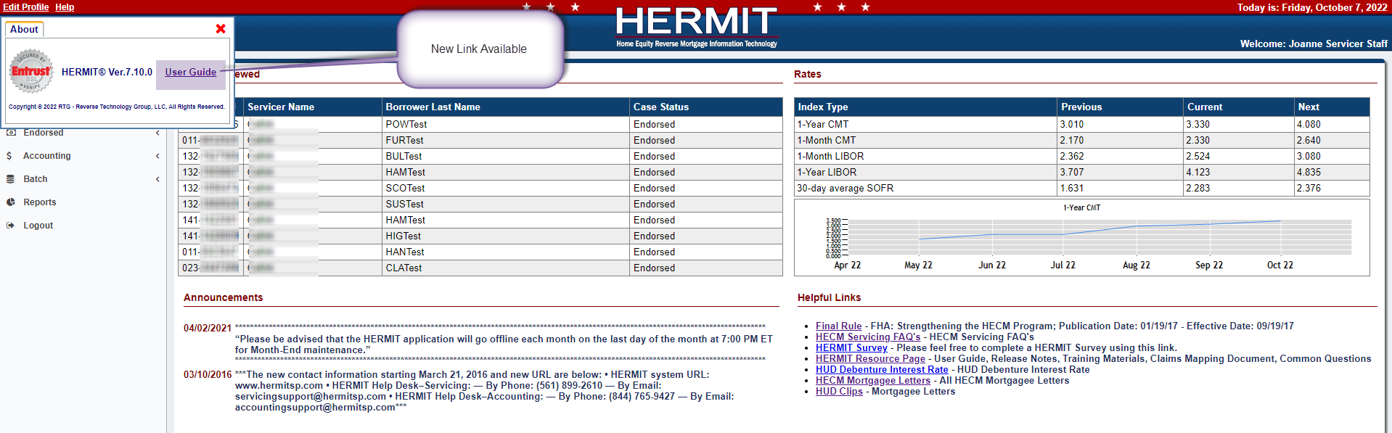
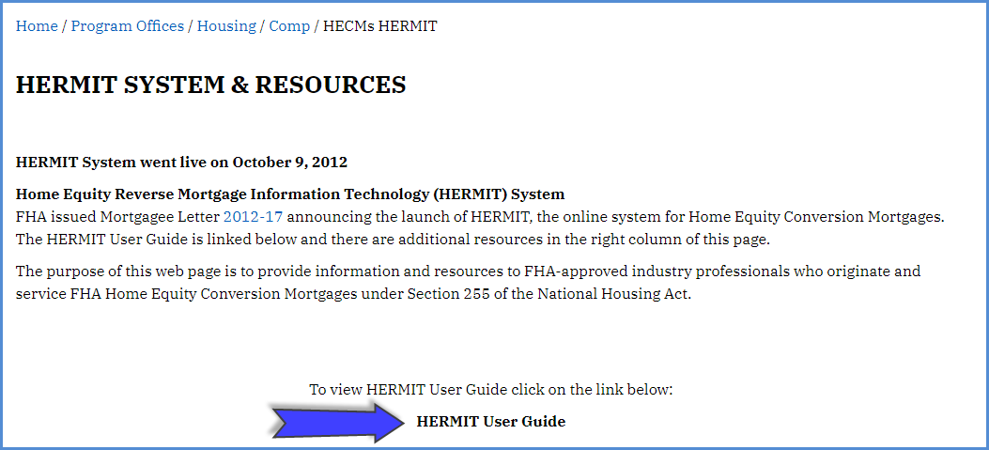

New Modern Look
HERMIT has been updated with a New Modern Look. All functionality remains the same the only change is the Left Menu Navigation.
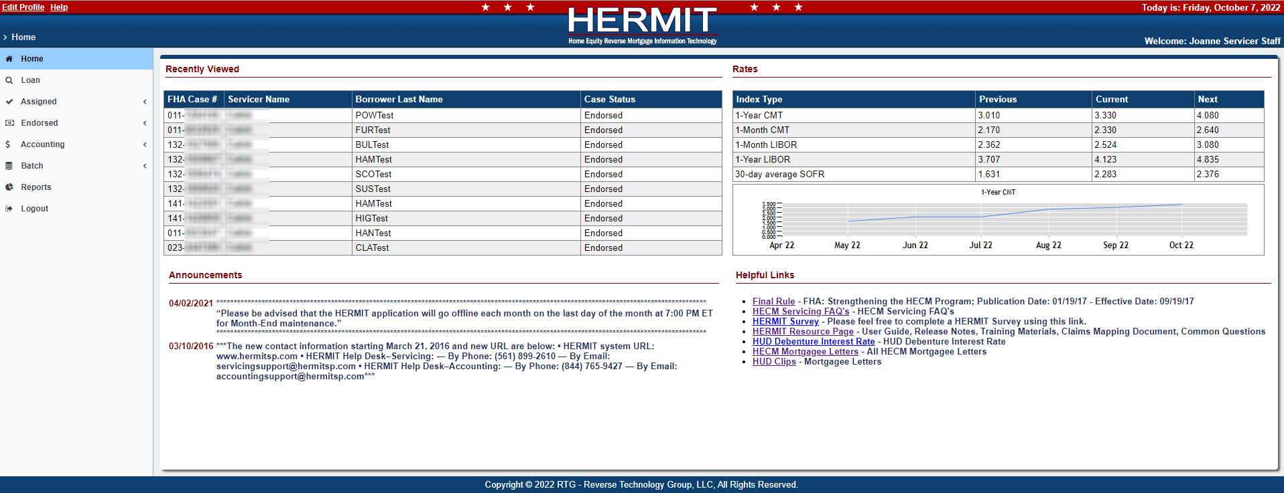

All Navigation is now in the Left Menu
Previously you accessed the left menu and a top menu, all Navigation has been moved to the Left Menu for easier access and to allow other new navigation features.

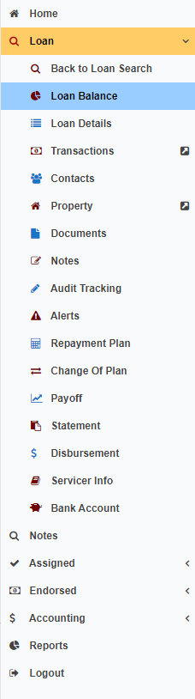

Active Menu
Gold represents the Active Menu. The Arrow indicates there are sub-menus available. Click the Arrow to see the sub-menu. Click again to collapse the sub-menu.
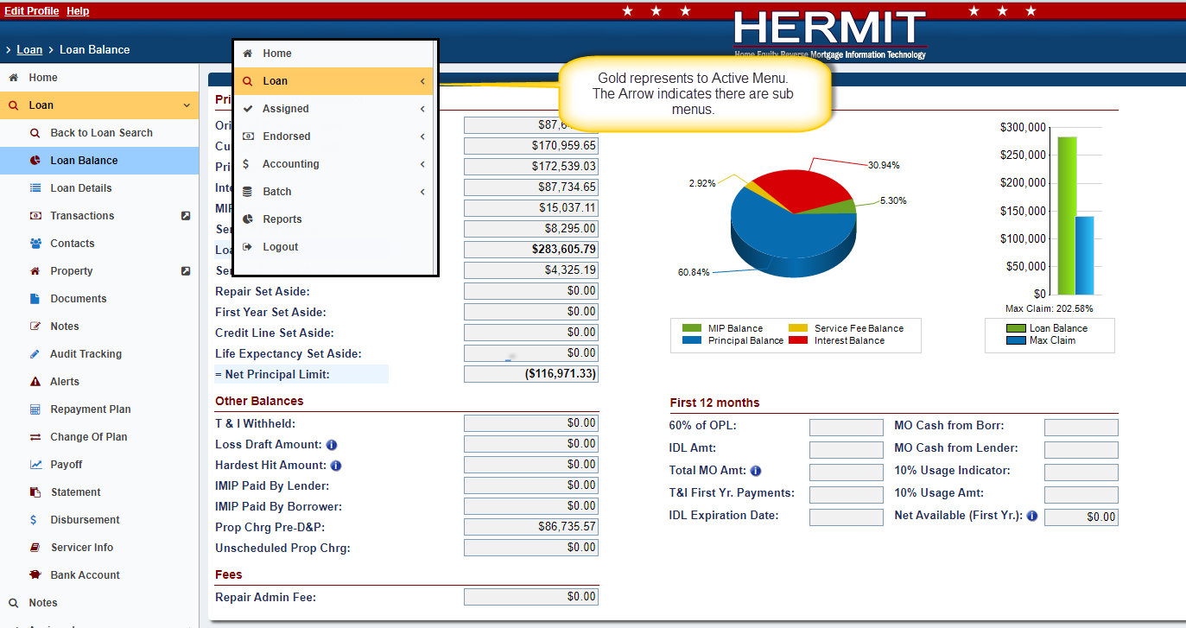

Sub-Menu
Blue indicates which page you are on. All pages are controlled by Security Roles so you may not see all options.
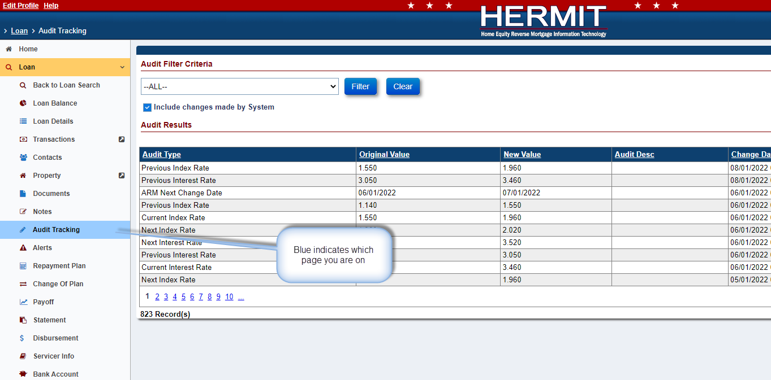

More Options
This Arrow indicates there are multiple options available within the sub-menu. Hover over to see the additional options and click to view.
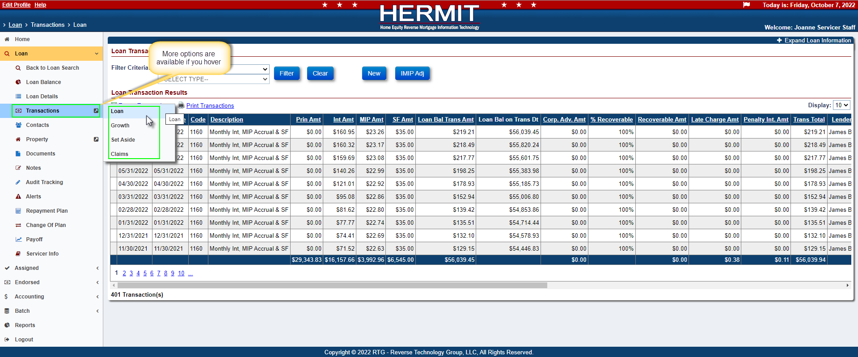

NEW Features
There is a Flag on the top right when you are in the Loan Module.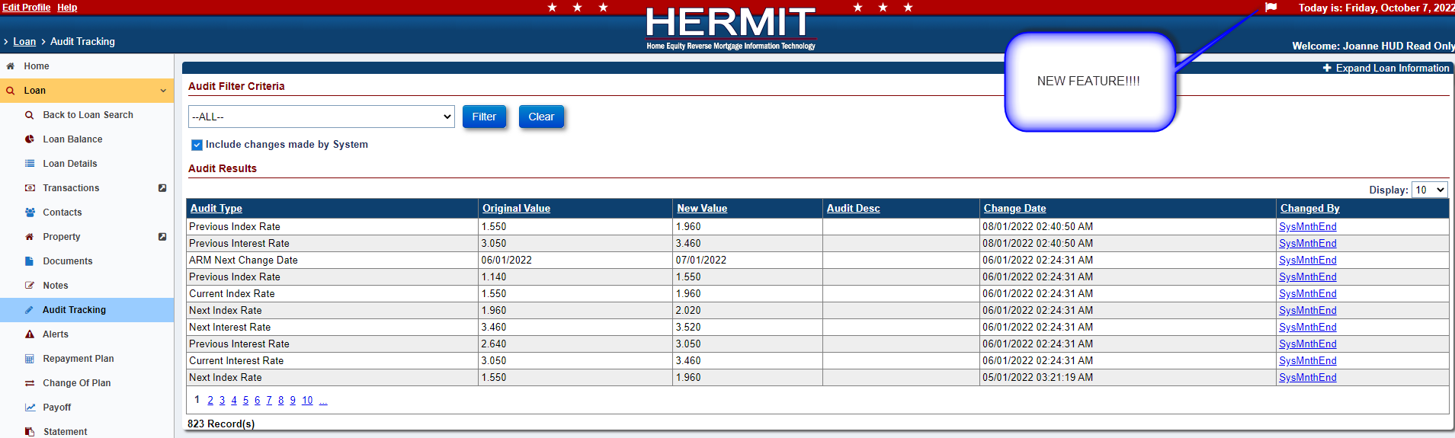
Clicking the Flag allows you to view Active Timelines while you are in the Loan Module.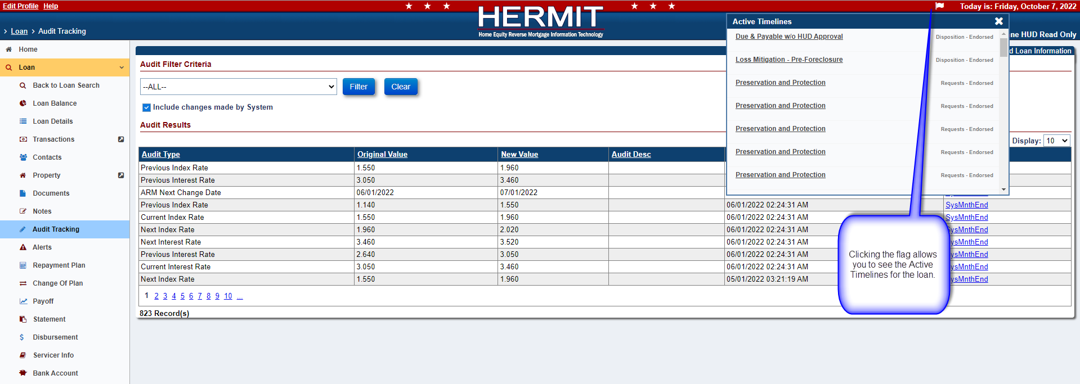

Clicking on a specific timeline will take you to that timeline.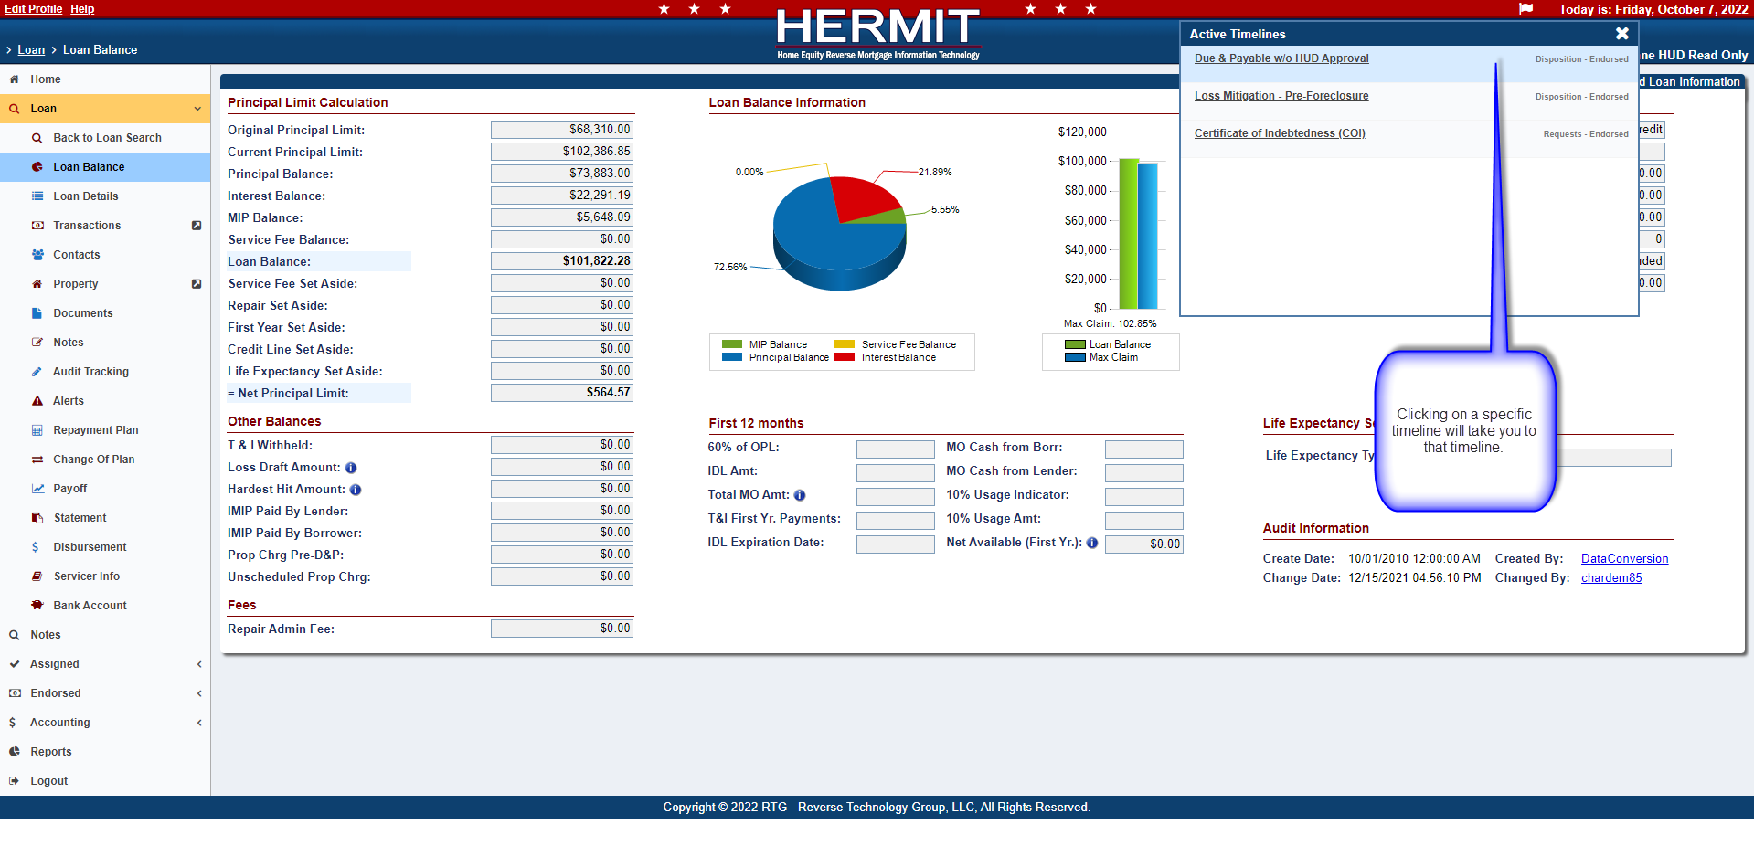
Once you are in the Timeline, Gold represents the Active Menus that are open.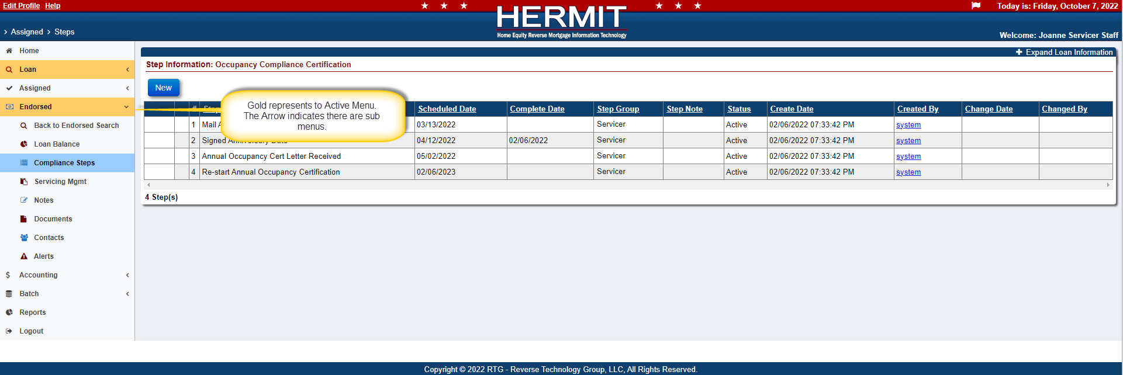

The Loan Module is still open and accessible to this loan.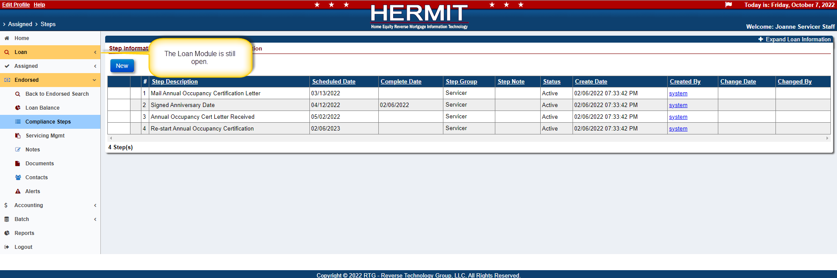
Now you can access the Loan Module and the Timeline you selected.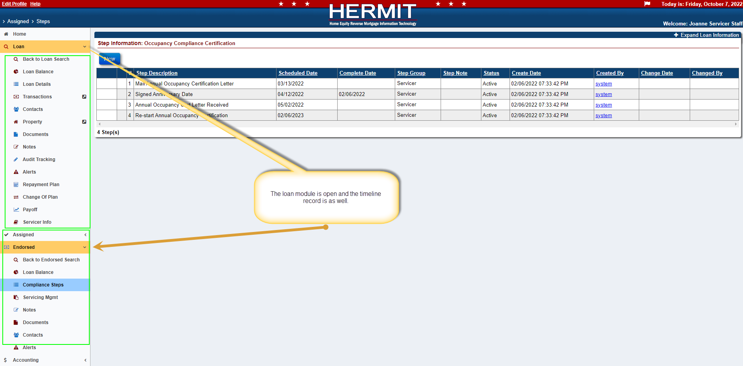

You can collapse and expand the sub-menus.