Home Equity Reverse Mortgage Information Technology
(HERMIT)

HERMIT System Changes – Release 6.7

Release Date: 03/26/22
Document Date: 03/25/22

March 2022

INTRODUCTION
The Home Equity Reverse Mortgage Information Technology (HERMIT) software release version 6.7 consists of the following system changes:
Table of Contents
Servicer / NSC related changes 3
1. Timeline Completion Date & Servicing Mgmt Date changes (579834, 580731) 3
2. Updates to D&P Timeline Orig First Legal Date & Extension - Request to Delay Foreclosure validation (578313) 6
3. Claim Type 22 update (34052) 6
4. Repurchase Activity Variances (579259) 7
Servicer / Claims Related Changes 8
1. Auto-Curtailment Rule change to Curtailment Event “Notify Borrower / Estate of D&P” for D&P w/o HUD Approval (574203) 8
2. Claim Type 21 – Deed in Lieu on loans not Due & Payable (569128) 10
3. Claim Type 21 – Hard Stop Validation when DIL Completion Date is more than 9 months after Due & Payable Date for loans with FHA Case # Assigned Date On or After 09/19/17 (569128) 11
4. Claims User Alert for Missing Legal Description (577019) 11
5. Claims Popup Displays Curtailment Message (581252) 12
Servicer Only Related Changes / Endorsed Loans 13
1. Property Charge Expenses on Claims (570269) 13
2. Restrict Which Transactions are Allowed After D&P Date (519784) 14
HUD Only Related Changes / Assigned Loans 15
1. Request for Assigned Due & Payable Letters (HUD) (580253) 15
2. Perform Un-Scheduled Disbursements on Term and Tenure Payment Plans Where the Servicer is HUD NSC Contractor (580253) 18
3. Mark a Voided Disbursement as Cleared (Payment Over Cancellations) 19

If you have any questions regarding the functionality of the software release, please contact the HERMIT Help Desk at 561-899-2610 or at servicingsupport@hermitsp.com. If you have any policy related questions, please send an email to HUD at answers@hud.gov.

Servicer / NSC related changes

Timeline Completion Date & Servicing Mgmt Date changes (579834, 580731)
Certain timeline Complete Dates and Servicing Mgmt dates are now editable by authorized user roles HUD NSC Manager and Servicer Manager. The purpose of this request is to eliminate the need for Data Change Requests (DCR’s) to be sent to the HERMIT Help Desk for key curtailment dates changes.

Editable Dates
The following is a list of Servicing Type and Step Descriptions where Complete Dates are editable. The columns “Allow Changes by HUD NSC Mgr” and “Allow Changes by Servicer Mgr” indicate whether that Timeline Step Description is editable by that user role.
Servicing Type / Timeline | Step Description | Allow Changes by HUD NSC Mgr | Allow Changes by Servicer Mgr
Due & Payable w/ HUD Approval | Ordered Appraisal | Yes | Yes
Due & Payable w/ HUD Approval | Upload Due & Payable Package | Yes | Yes
Due & Payable w/ HUD Approval | Submitted D&P Request to HUD | Yes | Yes
Due & Payable w/ HUD Approval | D&P Notice Sent to Borrower | Yes | Yes
Due & Payable w/ HUD Approval | HUD Decision - Approved | Yes | No
Due & Payable w/o HUD Approval | Servicer Notified of Death | Yes | Yes
Due & Payable w/o HUD Approval | Ordered Appraisal | Yes | Yes
Due & Payable w/o HUD Approval | Notification Sent to Borrower | Yes | Yes
Loss Mitigation - Deed-in-Lieu | Date Borrower/Estate executed DIL Agreement | Yes | Yes
Loss Mitigation - Deed-in-Lieu | Deed Recorded Date | Yes | Yes
Loss Mitigation - Pre-Foreclosure | Initiation of Foreclosure (First Legal Date) | Yes | Yes
Loss Mitigation - Pre-Foreclosure | Foreclosure Notice Sent to HUD | Yes | Yes
Loss Mitigation - Short Sale | Sale Closing Date | Yes | Yes
Loss Mitigation - Short Sale | Deed Recorded Date | Yes | Yes

The following is a list of Servicing Type and Servicing Mgmt field description by Default Reason where dates are editable. The columns “Allow Changes by HUD NSC Mgr” and “Allow Changes by Servicer Mgr” indicate whether that date is editable by that user role.
Servicing Type | Servicing Mgmt field Description | Allow Changes by HUD NSC Mgr | Allow Changes by Servicer Mgr
Due & Payable w/ HUD Approval | Default Date | Yes | Yes
Due & Payable w/ HUD Approval | Create Date | Yes | No
Due & Payable w/o HUD Approval | Default Date (not death) | Yes | Yes
Due & Payable w/o HUD Approval | DEATH Date (Default Reason DEATH only) | No | No
Due & Payable w/o HUD Approval | Create Date | Yes | No

Date Changes Restricted
Changes to above dates are not permitted when the loan has an Active Claim Type 21 or Claim Type 23 (parent claim) timeline that is currently pending HUD’s review. In other words, changes are not permitted when the claim’s Current Step Group is “HUD”. If HUD pends the claim back to servicer, date changes are permitted. Changes to above dates are also not permitted after the parent claim has been Approved for Payment.

Changing / Editing Dates
To update a step Complete Date, retrieve the necessary timeline and click on the step that needs to be changed. Enter corrected Complete Date and click SUBMIT. If the correct date is not known, the Complete Date can also be removed without inputting a new Complete Date. Retrieve the timeline and step, delete existing date and click SUBMIT.
To update a Servicing Mgmt date retrieve the necessary timeline and click on Servicing Mgmt on the left menu. Click EDIT. Enter corrected date in either the Default Date or Create Date field and click SUBMIT.
Note that only HUD NSC Managers can update Create Dates of timelines and servicers must continue to send Create Date timeline change requests to the HERMIT Help Desk to be compiled and sent to HUD to make the change if approved.
IMPORTANT REMINDER: Updating Default Date for Due & Payable w/o HUD Approval timeline, Default Reason Death.
The Default Date on the Due & Payable w/o HUD Approval timeline when Default Reason is Death is not editable from the Servicing Mgmt page by any user role. This date is automatically populated with the last surviving borrower / co-borrower’s Death Date as recorded on the Contacts page.
If the last surviving borrower / co-borrower’s Death Date is updated on the Contacts page, the same date will populate the Default Date field on D&P w/o HUD Approval timeline. However, if any of the 3 steps listed below are completed, the following must occur for the timeline to automatically update with new Default Date.
If the Default Date on the D&P w/o HUD Approval timeline is incorrect, perform the following steps to ensure the update is reflected in HERMIT:
- If any of the 3 steps listed below have a Complete Date, remove the Complete Date by clicking the step name, deleting the date, and clicking SUBMIT. These steps must not show as completed in order for the Default Date to update automatically:
  - Servicer Notified of Death
  - Ordered Appraisal
  - Notification Sent to Borrower
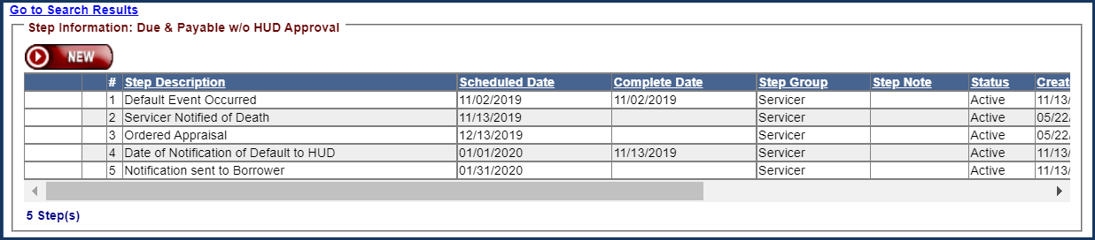
- Go to Contacts page on the left menu and enter corrected last surviving borrower / co-borrower’s death date for the appropriate Contact.
- The new Death Date will automatically populate in the Default Date field on the D&P w/o HUD Approval timeline
- Reenter the Complete Date or revised Complete Date for any of the timeline steps where it had been removed to allow for the date change/edit. .

Audit Tracking & Notes
When any of the dates above are changed, an Auto-Note will be saved to the Notes page and an Audit Tracking record detailing information of the change.
Sample Auto-Note for changes to Timeline Complete Dates: “Step (step name) completion date in timeline (name of timeline) changed from MM/DD/YYYY to MM/DD/YYYY.”
Sample Auto-Note for changes to Default Date or Create Date: “(Date Type) in timeline (name of timeline) changed from MM/DD/YYYY to MM/DD/YYYY.”

Reporting
A new report link was added to the Servicer Reports section in the Reports Module titled “Complete Date Changes”. In order to obtain both changes made to Complete Dates and to Servicing Mgmt dates, both reports shown at the top of the page must be executed.
To generate a report of Servicing Mgmt date changes that have been made, click the link “Execute Steps Audit CSV”.
Alternatively, to generate a report of Complete Date Changes that have been made, click the link “Execute Servicing Fields Audit CSV”.
Helpful notes are displayed under fields that pertain to one of the 2 report execute options.
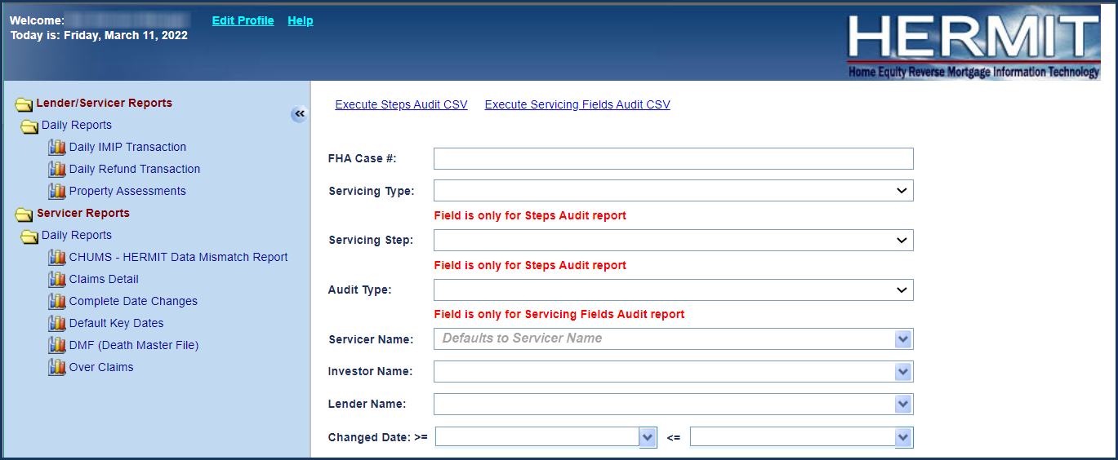

Updates to D&P Timeline Orig First Legal Date & Extension - Request to Delay Foreclosure validation (578313)
The field “Fcl Extension Exp” on both Endorsed Due & Payable with HUD Approval and Due & Payable w/o HUD approval timelines were renamed to “Orig First Legal Deadline” for clarity. The date logic was updated to calculate the original First Legal Curtailment Deadline currently used in the claims curtailment process based on the loan’s FHA Case # Assigned Date and Default Reason from the respective Endorsed D&P timeline.

These changes have a downstream impact Endorsed > Extension – Request to Delay Foreclosure timeline and the “Extension Expiration Date”. The same validation rules apply when setting up the first Extension - Request to Delay Foreclosure timeline and are now based on the updated “Orig First Legal Deadline” date from the D&P timelines. The Endorsed > Extension – Request to Delay Foreclosure timeline must be set up no earlier than 30 days before “Orig First Legal Deadline” date and cannot be set up after “Orig First Legal Deadline” date. The “Extension Expiration Date” continues to be automatically calculated as “Orig First Legal Deadline” plus 90 days. There are no changes to when a second timeline can be created.

The date “Orig First Legal Deadline” in the Endorsed D&P timelines does not drive whether a claim is curtailed for first legal or not but affects when the servicer can submit Extension – Request to Delay Foreclosure requests. These changes do not affect current claims curtailment logic. Extensions to First Legal Curtailment from the Extension – Request to Delay Foreclosure timeline still need to be reported on the Claim Form in Block #19 “Exp. Date of Approved Ext (1st Legal to Commence FCL / Deed in Lieu)”.

Claim Type 22 update (34052)
Claim Type 22 will be automatically inactivated when HUD adds and completes “Assignment Denied - No Funds Due” step.

Repurchase Activity Variances (579259)
Repurchase timeline was updated to not allow servicers to Authorize the Repurchase if there is an outstanding HUD NSC Contractor disbursement pending. When the Servicer clicks on the APPROVE button to Authorize Repurchase, the system will immediately change the Servicer on the loan from the HUD NSC Contractor to the Servicer that was selected to Repurchase the loan. The system will also remove the 10-days hold period for the batches.

An error message will be displayed only if a pending disbursement exists when the Servicer clicks on APRPOVE button to Authorize Repurchase.
Error Message: Repurchase cannot be authorized until all HUD pending disbursements have been processed.
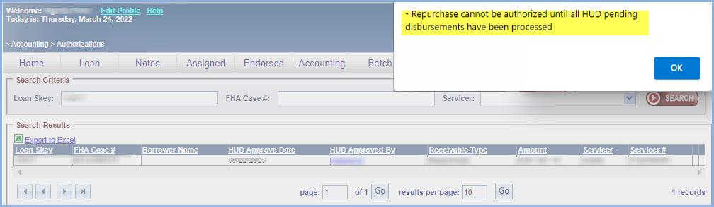

If there is no pending disbursement, the following message will be displayed when the Servicer clicks on APRPOVE button to Authorize Repurchase.
Message: You are about to transfer servicing of this loan to <Servicer from Servicing Mgmt>. Are you sure you want to continue?

Upon clicking YES on the Certify message, the Servicer on the loan will immediately be updated from the HUD NSC Contractor to the Servicer that was selected to Repurchase the loan.

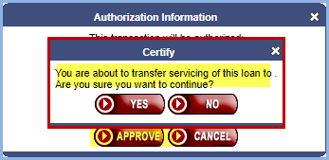

Current logic for inactivating CT 22 timeline remains when “Assignment to Servicer sent for recording” step is completed.

Servicer / Claims Related Changes

Auto-Curtailment Rule change to Curtailment Event “Notify Borrower / Estate of D&P” for D&P w/o HUD Approval (574203)
The Auto-Curtailment Rule for Curtailment Event “Notify Borrower / Estate of D&P” (also referred to as “Notification Sent to Borrower of D&P”) for D&P w/o HUD approval was updated to separate the rules by FHA Case # Assigned Date and Default Reason. This affects auto-curtailments only for claims going forward. Any adjustments to the prior Auto Curtailment dates must be self-reported by the servicer using the Claim Type 24 – HECM Supplemental by using the CT24 Disposition Information section and selecting YES under “Change Debenture Interest End Date / Curtailment Date?”.
Curtailment Effective Date: For D&P w/o HUD approval, this curtailment rule applies to loans with
- FHA Case # Assigned Date before 09/19/17 AND Default Date On or After 07/01/15
- FHA Case # Assigned Date On or After 09/19/17, with any Default Date.

Curtailment Rule: “Notify Borrower / Estate of D&P” for Due & Payable w/o HUD Approval
FHA Case # Assigned Date before 09/19/17 AND Default Date On or After 07/01/15: HERMIT will auto-curtail Claim Type 21 or Claim Type 23 if “Notification Sent to Borrower” step is not completed within 30 days of the Default Date on the Servicing Mgmt page. If curtailed for this reason HERMIT will set the Debenture Interest End Date to Default Date + 30 days. For death defaults, curtailment will be based on 30 days from the death date.
FHA Case # Assigned Date On or After 09/19/17: HERMIT will auto-curtail Claim Type 21 or Claim Type 23 if “Notification Sent to Borrower” step is not completed within 30 days of the Due Date / Create Date of D&P w/o HUD approval timeline. If curtailed for this reason HERMIT will set the Debenture Interest End Date to Due Date + 30 days.
Detailed Curtailment rules are as follows:

Default Reason Death (without the Extension for Late Notice of Death)
  - FHA Case # Assigned Date before 09/19/17 AND Default Date On or After 07/01/15:
    - Curtailment Deadline for “Notify Borrower / Estate of D&P” is last surviving borrower / co-borrower’s Death Date (Default Date) + 30 Days
    - Curtailment Message on Claim Form “HUD Comments, if Any” and Advice of Payment (AOP) “Comments”: “Notification to Borrower/Estate of Default Event w/o HUD Approval must be no later than 30 Days from Death Date, as Case # was assigned before 9/19/17.”

  - FHA Case # Assigned Date On or After 09/19/17:
    - Curtailment Deadline for “Notify Borrower / Estate of D&P” is Due Date* + 30 Days
    - Curtailment Message on Claim Form “HUD Comments, if Any” and Advice of Payment (AOP) “Comments”: “Notification to Borrower/Estate of Default Event must be no later than 30 Days from Due Date, as Case # was assigned on or After 9/19/17.”

Default Reasons Conveyed Title or End of Deferral Period
  - FHA Case # Assigned Date before 09/19/17 AND Default Date On or After 07/01/15:
    - Curtailment Deadline for “Notify Borrower / Estate of D&P” is Default Date + 30 Days
    - Curtailment Message on Claim Form “HUD Comments, if Any” and Advice of Payment (AOP) “Comments”: “Notification to Borrower/Estate of Default Event w/o HUD Approval: Conveyed Title or End of Deferral Period must be no later than 30 Days from Default Date.”

  - FHA Case # Assigned Date On or After 09/19/17:
    - Curtailment Deadline for “Notify Borrower / Estate of D&P” is Due Date* + 30 Days
    - Curtailment Message on Claim Form “HUD Comments, if Any” and Advice of Payment (AOP) “Comments”: “Notification to Borrower/Estate of Default Event w/o HUD Approval: Conveyed Title or End of Deferral Period must be no later than 30 Days from Due Date, as Case # was assigned On or After 9/19/17.”

Default Reason Death with Extension – Late Notification of Death
  - FHA Case # Assigned Date before 09/19/17 AND Default Date On or After 07/01/15:
    - Curtailment Deadline for “Notify Borrower / Estate of D&P” is Extension Expiration Date + 30 Days
    - Curtailment Message on Claim Form “HUD Comments, if Any” and Advice of Payment (AOP) “Comments”: “Notification to Borrower/Estate of Default Event with Late Notice of Death Extension must be no later than 30 Days from Extension Expiration Date.”

  - FHA Case # Assigned Date On or After 09/19/17:
    - Curtailment Deadline for “Notify Borrower / Estate of D&P” is Extension Expiration Date + 30 Days
    - Curtailment Message on Claim Form “HUD Comments, if Any” and Advice of Payment (AOP) “Comments”: “Notification to Borrower/Estate of Default Event with Late Notice of Death Extension must be no later than 30 Days from Extension Expiration Date, as Case # was assigned On or After 9/19/17.”

*REMINDER: The Due Date is also referred to as the "Due and Payable Date" and is indicated by the same rules that populate Block #29 on a Claim Type 21, or Block #8 on a Claim Type 23.
- For Due & Payable with HUD approval, the Due Date is the "HUD Decision - Approved" step Complete Date on the D&P with HUD approval timeline.
- For Due & Payable w/o HUD approval, the Due Date is the "Create Date" of the D&P w/o HUD approval timeline (in other words, the date the mortgagor notifies HUD of the Default).

Claim Type 21 – Deed in Lieu on loans not Due & Payable (569128)
HERMIT was updated to support filing of a Claim Type 21 if the loan was not Due & Payable. The purpose of these changes is to eliminate the HUD approved workaround for filing Claim Type 21 without a legitimate Due & Payable Date. Going forward, all Claim Type 21’s that are not Due & Payable must have the Loss Mitigation – Deed in Lieu timeline and the Claim Type 21 Timeline updated and submitted to HUD with accurate information instead of using the previously implemented HUD approved workaround (referred to as CT21 Deed in Lieu with No Due & Payable).

Loss Mitigation – Deed in Lieu Timeline Step: A new timeline step has been added to the Loss Mitigation – Deed in Lieu timeline called “Date Borrower/Estate executed DIL Agreement”. This step must be populated to file a Claim Type 21 if the loan is not Due & Payable. The servicer user must enter the step Complete Date with the date the borrower executed / signed the Deed in Lieu. For existing Active Loss Mitigation – Deed in Lieu timelines, the new step has been added to the existing timeline so the user may complete the step.

Claims Default Reason: A new Claims Default Reason was added to the Claim Type 21 timeline initiation / setup screen and the Servicing Mgmt Edit page “16 - No Default - DIL”. This Claims Default Reason must be selected when filing Claim Type 21 if the loan is not Due & Payable. There will be no auto-curtailments assessed by the system for Claims with this Default Reason.

Claim Form:
Block #4: When the new Default Reason "16 - No Default – DIL” is selected, the value in Block #4 will be “16”.

Block #29: When the new Default Reason "16 - No Default – DIL” is selected, the step Completion Date of new timeline step will populate Block #29 (Due Date) with the date the borrower signed / executed the DIL agreement. This date must be entered by the servicer on the “Loss Mitigation – Deed in Lieu” timeline under circumstances where there is a Deed in Lieu on a loan with no Due & Payable Date.

Block #8: When the new Default Reason "16 - No Default – DIL” is selected, the date in Block #8 will auto-populate with the last day of the month of the date in Block #29. This field will remain editable prior to claim filing.

Claim Hard Stop Validation Error:
When the new Default Reason "16 - No Default – DIL” is selected, step “Date Borrower/Estate executed DIL Agreement” from the Active “Loss Mitigation – Deed in Lieu timeline” must be completed in order to file the CT21. If the timeline step is not completed or there is no Active Loss Mitigation – Deed in Lieu timeline present on the loan, a validation error will be displayed stating “For Default Reason No Default - DIL, Complete Date is required for step Date Borrower/Estate executed DIL Agreement on the Loss Mitigation – Deed in Lieu timeline.”

Existing hard stop validation error “Notice Sent to Borrower cannot be blank, please go to the Due & Payable timeline and enter the Notice Sent to Borrower Completion Date.” will be bypassed for Claims Default Reason "16 - No Default – DIL”.

Claim Type 21 – Hard Stop Validation when DIL Completion Date is more than 9 months after Due & Payable Date for loans with FHA Case # Assigned Date On or After 09/19/17 (569128)
On Claim Type 21 for loans with FHA Case # Assigned Date On or After 09/19/17 (final rule date) and Deed In Lieu Obtained box is selected, the DIL Completion Date entered on the Claims Disposition screen cannot be later than 9 months after the loan’s Due Date / Block 29 date. If the DIL Completion Date is more than 9 months after Block #29 date; a validation error will be displayed stating “DIL not permitted more than 9 months from the Due Date in Block 29.”

If both Foreclosure Instituted and Deed In Lieu Obtained boxes are selected, the above validation does not apply.

Claims User Alert for Missing Legal Description (577019)
A new User Alerts section has been added to the claim form for Claim Types 21, 23, and 24. This is displayed to the servicer when the claim form is opened using the magnifying glass /edit icon next to steps “Servicer Files Claim – 27011” or “Resubmit Claim 27011”. The User Alerts section appears as a yellow box and is displayed when the Legal Description / Block 34 is NULL or Blank.

Note: The User Alerts box does not prevent the claim from being submitted to HUD. The purpose of this message is only to inform the user that the loan is missing the Legal Description.

To update the Legal Description on the loan: go to Loan Module, search for and retrieve the loan, then go to left menu Property > Property Info and click EDIT under the Property Info section. Add the necessary Legal Description information, then click SUBMIT.

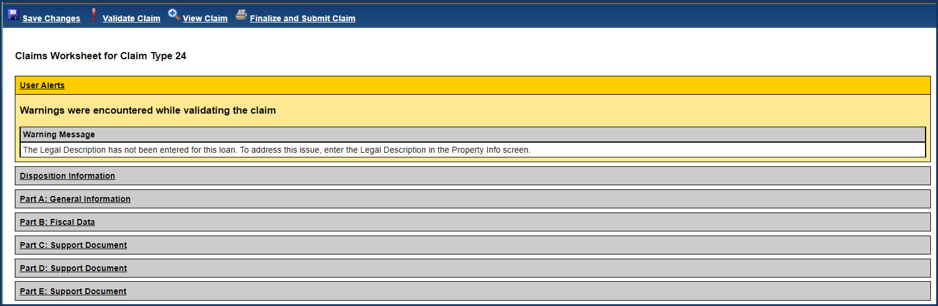
User Alerts section displaying missing Legal Description

Claims Popup Displays Curtailment Message (581252)
HUD has further enhanced HERMIT with a curtailment warning message to the servicers. The warning message provides notification to the servicer of the curtailment PRIOR TO submitting its claim.

Servicers should complete a thorough review of the initial claim when the curtailment warning message appears and take necessary corrective action, if needed, to address the curtailment. This functionality should reduce the need of filing a supplemental claim to correct erroneous curtailments due to the servicer failing to address their filing errors at the time of the initial claim submission.

The Curtailment Message from Part A: General Information “HUD Comments, if Any” field is displayed as the 3rd paragraph on the first Warning popup displayed when the servicer files or resubmits a Claim Type 21, 23, or 24.

The message does not display if the claim is not curtailed: when text is “Claim filed on time, debenture interest has not been curtailed.” in the “HUD Comments, if Any” field.

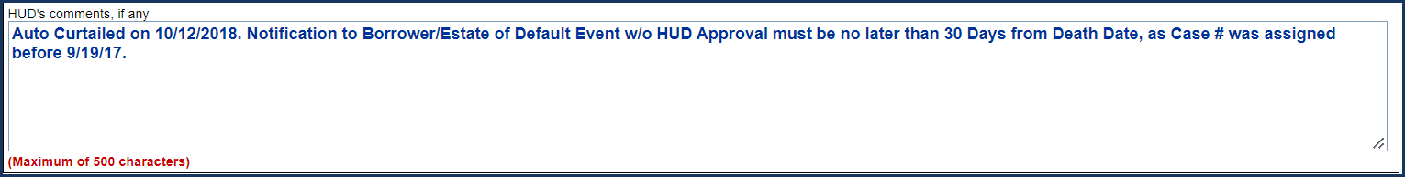
Part A: General Information, “HUD Comments, if Any” field

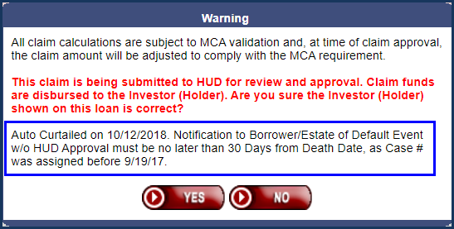
Curtailment Message displayed on claim filing Warning popup

Servicer Only Related Changes / Endorsed Loans

Property Charge Expenses on Claims (570269)
HERMIT was updated for certain section 305 Corporate Advance expense transactions referred to as Property Charge expenses. The enhancement will remove the manual entry of “Incurred Date” and auto-populate the field with the Effective Date. To clarify this change, HUD had determined that certain Property Change expenses are considered Incurred when the servicer makes the payment. Therefore, the incurred date and effective date will be the same for certain section 305 transaction types.
This change effects transactions being input using all 3 methods in HERMIT.

- User Interface - Incurred Date field will NOT be available
- B2G – Warning will be displayed in the B2g results.
Warning message: Incurred Date is automatically populated with Effective Date for Property Charge Corp Advance Transactions.
- Servicer Transaction - Incurred Date field will NOT be available
For the following “Property Charge” transaction types, auto-populate Incurred Date with the Effective Date.
- Corp Adv - s305 - Condominium dues
- Corp Adv - s305 - Condominium dues - Repay
- Corp Adv - s305 - Flood Insurance
- Corp Adv - s305 - Flood Insurance - Repay
- Corp Adv - s305 - Ground rent
- Corp Adv - s305 - Ground rent - Repay
- Corp Adv - s305 - Hazard Insurance
- Corp Adv - s305 - Hazard Insurance - Repay
- Corp Adv - s305 - HOA dues
- Corp Adv - s305 - HOA dues - Repay
- Corp Adv - s305 - Taxes
- Corp Adv - s305 - Taxes – Repay

Restrict Which Transactions are Allowed After D&P Date (519784)
HERMIT was updated to restrict certain transactions from being input by users based on the transaction category and transaction Effective Date. Corporate Advance Transactions should only apply ON or AFTER the loan’s Due Date (also referred to as Due & Payable Date), and transactions affecting loan balance should only apply PRIOR to the loan’s Due Date. These changes affect Endorsed loans only, and will affect all methods of transaction entry, including User Interface (UI), B2g (Servicer File Upload), and Servicer Transactions page.
Definition of Loan’s Due Date:
- For Due & Payable with HUD approval, the Due Date is the “HUD Decision – Approved” step Complete Date on the D&P with HUD approval timeline.
- For Due & Payable w/o HUD approval, the Due Date is the “Create Date” of the D&P w/o HUD approval timeline (in other words, the date the mortgagor notifies HUD of the Default
Following Error messages will be displayed based on each Transaction/Effective Date entered.
- Error message: Corporate Advance transactions cannot be added with Effective Date <user entered>. Effective Date must be < <Due Date>.
- Error message: Loan Balance transactions cannot be added with Effective Date <user entered>. Effective Date must be >= <Due Date>.
Summary:
- If loan is not Due & Payable - Corp Advance Transactions can be added anytime.
- If loan is not Due & Payable - Loan Balance Transactions can be added anytime.
- If loan is Due & Payable - Corp Advance Transactions can be added if Effective Date is ON or AFTER the Loan's Due Date.
- If loan is Due & Payable - Loan Balance Transactions can be added if Effective Date is PRIOR to the Loan's Due Date.
- If loan is Due & Payable - Repay Transactions can be added anytime regardless of Due Date.
- If loan is not Due & Payable - Repay Transaction can be added anytime.
List of Transactions are attached.

HUD Only Related Changes / Assigned Loans

Request for Assigned Due & Payable Letters (HUD) (580253)
The Assigned Due & Payable Repayment Letter was updated to make the D&P reason clear. The servicing contractor will be able to check-off all the Default Reason(s) that pertain to the loan just before the Due & Payable Repayment Letter is generated. These checked-off Default Reasons will flow directly into the Due & Payable Repayment Letter when generated.

When the user clicks the magnifying glass or printer icon on the “Mail Condolence / Repayment Letter” step the letter window will be shown where the user can select items that will flow into the letter. The letter window below will be updated to have 4 selectable Default Reason checkboxes. More than one Default Reason checkbox can be selected by the user.
- [] A mortgagor conveyed all of their title in the mortgaged property and no other mortgagor retains title to the property.
- [] No surviving mortgagor maintains the property as their principal residence.
- [] A mortgagor fails to occupy the property for a period of more than twelve consecutive months because of physical or mental illness, and the property is not the principal residence of at least one other mortgagor.
- [] An obligation of the mortgagor under the HECM is not fulfilled.

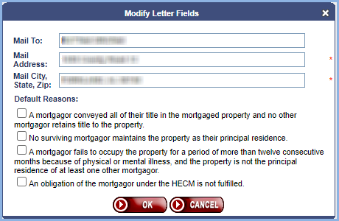

At least one of the 4 Default Reasons needs to be selected. If none are selected and the user clicks “OK” the following error message will be displayed.
Error Message: Default Reason is required. Please select at least one default reason.

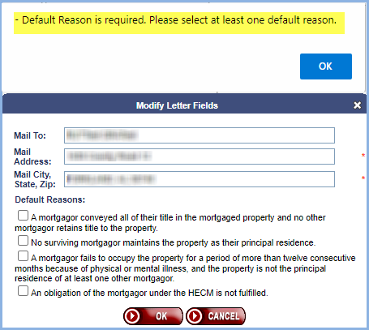

If the Default Reason “An obligation of the mortgagor under the HECM is not fulfilled” is checked then 4 additional checkboxes will be shown with more Default Reasons.
- [] Delinquent Property Taxes and/or Assessments.
- [] Homeowners Insurance.
- [] Delinquent Property Charges.
- [] Property in Disrepair.

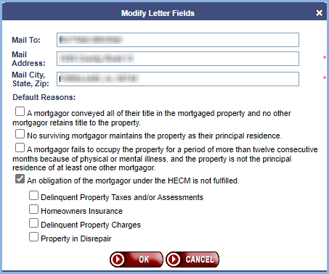

At least one of these 4 detailed reasons needs to be selected when Default Reason “An obligation of the mortgagor under the HECM is not fulfilled” is checked. If none of the 4 are selected, then the following error message will be displayed.
Error Message: Please select at least one detailed reason when ‘An obligation of the mortgagor under the HECM is not fulfilled’ is selected.

If the Default Reason “An obligation of the mortgagor under the HECM is not fulfilled” is unchecked these 4 additional checkboxes will be removed from the window.

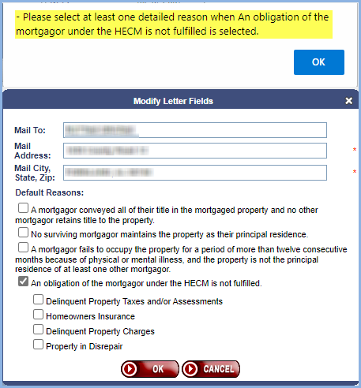

Example of letter with Default Reasons selected.

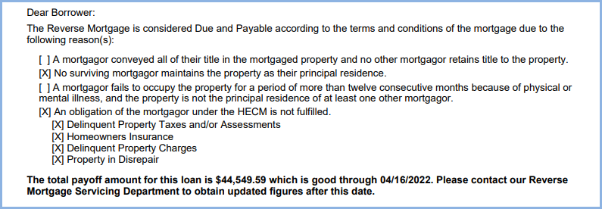

Perform Un-Scheduled Disbursements on Term and Tenure Payment Plans Where the Servicer is HUD NSC Contractor (580253)
HERMIT was updated to allow users (HUD NSC contractor) to create Un-Scheduled Disbursements on Cases that have Term or Tenure Payment Plans.

Performing Unscheduled Disbursements for Term and Tenure Payment Plans where the Servicer is HUD NSC Contractor.
  - The Transaction Category of “Disb – Unscheduled from LOC” will be displayed in the Transaction Category dropdown when the Payment Plan is Term or Tenure
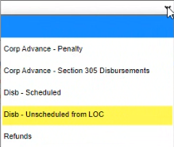

  - The Transaction Desc dropdown will contain the following list of transactions in the dropdown except Disb - Unscheduled from LOC
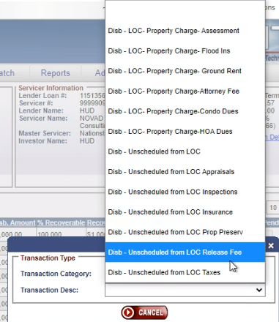

  - When the User clicks on the Submit Button to create the Disbursement, the following message will appear “Un-Scheduled Disbursements are unusual for Payment Plan Types of Term and Tenure. Creating this Disbursement will create a Negative Credit Line Set Aside and there will be less available NPL. Are you sure you want to continue?”

  - When the user creates a disbursement for a Term or Tenure Payment Plan a Note will be created on the loan which states “Unscheduled Disbursement (XXXX) in the amount of $XXX.XX was created on a XXXX Payment Plan for this loan.”
e.g. “Unscheduled Disbursement (Disb - Unscheduled from LOC Inspections) in the amount of $500.00 was created on a Term Payment Plan for this loan.”
e.g. “Unscheduled Disbursement (Disb - LOC- Property Charge-HOA Dues) in the amount of $450.00 was created on a Tenure Payment Plan for this loan.”

Mark a Voided Disbursement as Cleared (Payment Over Cancellations)
HERMIT was updated to receive a Check status of “P” in the TCIS file from Treasury. The status “P” will allow the system to be automatically updated to mark a Disbursement as Cleared if the Disbursement was previously Voided.

A new Void Type of Payment Over Cancellation was also added to the Accounting Disbursement Screen Void Type drop down box. A user can search for any Payment Over Cancellations using this option from the drop down and then export the data to Excel.

