Home Equity Reverse Mortgage Information Technology
(HERMIT)

HERMIT System Changes – Release 7.3

Release Date: 06/24/23
Document Date: 07/26/23

June 2023

INTRODUCTION
The Home Equity Reverse Mortgage Information Technology (HERMIT) software release version 7.3 consists of the following system changes:
Table of Contents
Servicer Related Changes 3
1. Claims – Do not auto-populate MIP on a CT24 Supplemental claim form other than a CT24 Supplemental claim form after CT23 with FHA Case # Assigned Date on or after 09/19/17 (586041) 3
2. Claims – Prevent Claim Filing, Resubmission, and Approval when Monthly MIP is currently in Failed/Retired batch status (585423) 3
3. Claims – CT21 Add Curtailment for Default Reason “16 No Default DIL” (586557) 3
4. Added Auto Note when Servicer Authorizes a Transaction on the Accounting > Authorization Page (541316) 4
5. New Over Claim Reason Code “Bankruptcy Payments Owed to HUD” (586590) 4
6. Reports Module Updates 5
7. Added Clear Button on the Timeline Search Screens (585111) 5
8. Updated HERMIT to prohibit Uploads of Editable PDF’s (585512) 5
NSC / HUD Related Changes 6
9. Updated Assigned loans transactions to allow Termination with an Effective Date prior to previous Transaction's Effective Date (582904 & 575232) 6
10. Updated loans in HUD’s portfolio to display an Error Message when Funds are available in the Overage. (539353) 9
11. Automatically Write-Off the “Disb-Unscheduled LOC Release Fee” Transaction when added to loans in HUD’s portfolio. (539353) 11
12. Added NSC File Upload page (582223) 11
13. Tax Services Interface 13

If you have any questions regarding the functionality of the software release, please contact the HERMIT Help Desk at 561-899-2610 or at servicingsupport@hermitsp.com. If you have any policy related questions, please send an email to HUD at answers@hud.gov.

Servicer Related Changes

Claims – Do not auto-populate MIP on a CT24 Supplemental claim form other than a CT24 Supplemental claim form after CT23 with FHA Case # Assigned Date on or after 09/19/17 (586041)
MIP in Section 311 on the CT24 Supplemental Claim form will no longer auto-populate with MIP from the Loan > Transactions > Loan page except for a CT24 after a CT23 with FHA Case # Assigned Date on or After 9/19/17. Prior to Release 7.3 MIP accruals and adjustments added to the Transaction>Loan history after the Parent claim had been paid were auto-populated to the claim form, but were not being collected/paid out.
The MIP will continue to populate on this population of claim with the final prorated MIP, when applicable. The reason for this change is that after a Parent Claim is paid, Monthly MIP is not collected and therefore should not be paid out on the CT24 Supplemental Claim.
- For CT24 following a CT23 with FHA Case # Assigned Date on or after 09/19/17: MIP will continue to populate the CT24 claim form and be collected/paid out.
- For all other CT24 Supplemental claims: MIP will not populate on the CT24. If Transactions are added to the loan which cause Monthly MIP accruals adjustments, they will continue to show in the Transaction > Loan page, but will not be automatically pulled into the CT24 claim form since they are not collected.

Claims – Prevent Claim Filing, Resubmission, and Approval when Monthly MIP is currently in Failed/Retired batch status (585423)
A claim will encounter a hard stop validation upon Claim Filing, Resubmission, or Approval by HUD if the loan has an uncollected Monthly MIP batch on it, indicated by a Batch Status for a Monthly MIP batch of “Retired (Failed).” MIP which is currently uncollected must be re-tried by the Servicer to restart the MIP collection process in order to clear the claims hard stop validation.
- New hard stop validation “A claim cannot be filed or paid until the MIP has been collected.”. For the Servicer, this validation applies when the user clicks either Validate Claim, or Finalize and Submit Claim. For the HUD user, this validation applies when the HUD user selects Approve Claim, then clicks Save Changes.
- To clear the hard stop validation, the servicer must Re-Try the batch to restart the MIP collection process.
- This hard stop validation applies to Claim Types 21, 22 and 23. It does not apply to CT24 because MIP stops being collected after the Parent Claim is paid.

Claims – CT21 Add Curtailment for Default Reason “16 No Default DIL” (586557)
HUD has requested an enhancement to modify the CT21 Default Reason “16 – No Default – DIL” to permit the claim to be curtailed for Late Claim Filing and/or Self-Curtailment reported in Block 31, if applicable.
- For CT21 with Default Reason “16 – No Default – DIL” and CT24 following a CT21 with this Default Reason: the claim shall be assessed for curtailment of “Late Claim Filing” and “Self-Curtailment” reported in Block 31.

Added Auto Note when Servicer Authorizes a Transaction on the Accounting > Authorization Page (541316)
When the user Authorizes a Repurchase or HUD Advance Transaction on the Accounting > Authorization page, an Auto Note will automatically be added on the Notes page.
- When the user Authorizes a Repurchase on the Accounting > Authorization page by clicking Approve on the Authorization Information modal then clicks yes on the Certify window, the system will automatically add an Auto Note on the Note page.
- Message: “{Authorization Type} was Authorized by {User Id} for {Total Amount} on {Transaction Date}”
- Example: Repurchase was Authorized by Test for $120,000 on 06/24/23.
- When the user Authorizes a HUD Advance on the Accounting > Authorization page by clicking Approve on the Authorization Information modal, the system will automatically add an Auto Note on the Note page.
- Message: “{Authorization Type} Repayment was Authorized by {User Id} for {Total Amount} on {Transaction Date}”
- Example: HUD Advance Repayment was Authorized by Test for $120,000 on 06/24/23.

New Over Claim Reason Code “Bankruptcy Payments Owed to HUD” (586590)
New Over Claim Reason Code “Bankruptcy Payments Owed to HUD” was added to Over Claims Transaction window (Transactions > Claims > Over Claim) for CT 21, CT 23, and CT 24. Servicers receiving payments related to a Bankruptcy or from Bankruptcy Courts after a claim has been processed and paid will use this code to report the Overclaim payment remittance to HUD.
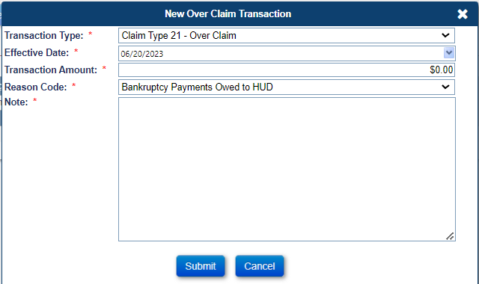

Reports Module Updates
New information has been added to the Reports module under each Report Name stating the criteria that is required for the report to be run. If there is no criteria required to run the report, “No criteria required” is shown under the report name.

Added Clear Button on the Timeline Search Screens (585111)
The Clear Button has been added to all Timeline Search Screens. When the user clicks the Clear Button, the search criteria will be cleared from the screen thus allowing the user to perform a new search.

Updated HERMIT to prohibit Uploads of Editable PDF’s (585512)
When a user tries to upload a PDF in HERMIT that is a bad (corrupt) or Editable (Dynamic or Fillable) PDF file, the system will not upload the PDF into HERMIT and will display an Error Message.
- When the user tries to upload a bad (corrupt) PDF or a document type other than PDF the system will display an Error Message.
- Message: “File type is invalid, please select only PDFs.”
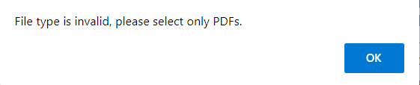
- When the user tries to upload an Editable (Dynamic or Fillable) PDF, the system will display an Error Message.
- Message: “PDF file cannot be uploaded. HERMIT will not accept PDF files that include interactive, or fillable form fields. Please make the necessary adjustments to the PDF document to address this issue, prior to uploading the document.”
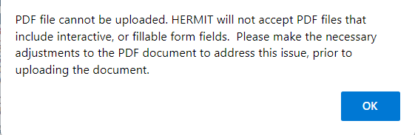

NSC / HUD Related Changes

Updated Assigned loans transactions to allow Termination with an Effective Date prior to previous Transaction's Effective Date (582904 & 575232)
The user will be able to Terminate an Assigned loan with an Effective Date prior to previous Transaction’s Effective Dates if there are no Pending Disbursements that affect loan balance. The remaining balance on the loan will be automatically written off.
- The system allows the user to Terminate an Assigned loan using an Effective Date that is prior to certain Transactions. Please see the following list of Transactions that will and will not allow the user to use a Termination Effective Date prior to the Transaction’s Effective Date.
- When a User is creating a Termination Transaction that has an Effective Date prior to a “Monthly Int, MIP Accrual & SF” Transaction’s Effective Date before the Termination is added, a “Please Confirm” window pops up with a list of bullets. The message text has been updated and is detailed below.

- Old Message: “You have selected to process a Payoff when transaction(s) exist with Effective Date later than the Payoff (Remittance Effective) Date. If you proceed, you will adjust off all loan balance transactions with Effective Dates later than the Payoff Date.”
- New Message: “You have selected to process a Payoff when transaction(s) exist with Effective Dates later than the Payoff (Remittance Effective) Date. If you proceed, you will adjust off MIP Accruals transactions with Effective Dates later than the Payoff Date and the system will Auto Write Off the remaining loan balance if it exists.”
- The new message will appear in bold and red font.
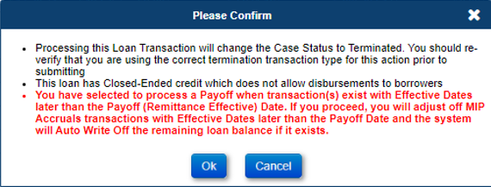

- The system previously displayed an Error when the user tried to Terminate an Assigned loan prior to the Transaction Effective Dates that affects loan balance. This Error message has been updated and will display when a user tries to Terminate a loan prior to Transactions such as Partial Repays, Write-off, Termination, and Loan Setup Transactions.
- Old Message: “Payoff cannot be processed. The entered payoff Effective Date cannot be earlier than the Effective Date of other transaction(s) in the system.”
- New Message: “Payoff cannot be processed. The entered payoff Effective Date cannot be earlier than the Effective Date of the payoff, partial repay, loan setup balance or write-off transaction(s) in the system.”
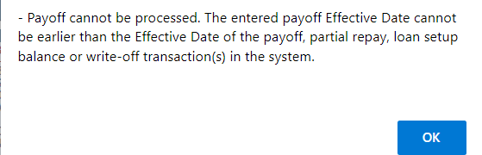

- When backdating a payoff, the payoff Effective date cannot be older than 365 days before the latest loan balance Transaction’s Effective Date (Excludes Monthly Accruals). If the payoff Effective date is older than this, the system will display an Error Message.
- Example: The latest loan balance Transaction (Disb – Unscheduled from LOC Inspections) with Effective Date 01/30/2023. The Earliest allowed payoff Effective Date is 01/30/2022. The Effective Date cannot be 01/29/2022 or prior.
- New Error Message: “Payoff cannot be processed. The entered payoff Effective Date cannot be greater than 365 days from the latest Effective Date of certain transactions which affect loan balance in the system.”
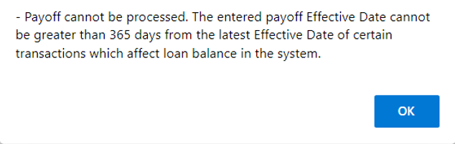
- When the user Terminates an Assigned loan with a Termination Effective Date prior to a previous Transaction Effective Date the system will automatically write off the remaining balance. The write off will be displayed as an Auto Write-Off Transaction.
- If the remaining balance is greater than or equal to $3,000 then the system will not allow the Termination and display an Error Message unless the Step “Approval of Write-Off by HUD” is completed on the Assigned > Disposition > Write-Off Review Timeline.
- The Termination types: Terminate - Short Sale (PIF W/Write-Off) [Trans Code 2885] and Terminate - 3rd Pty FCL Sale (PIF w/WOff) [Trans Code 2886] do not have a cap on the Auto Write Off.
- Error Message: “The loan is unable to be Terminated due to the remaining balance being >= $3,000 after the Termination Amount is applied. The Step “Approval of Write-Off by HUD” will need to be completed on the Assigned Write-Off Review Timeline to Terminate the loan. If this loan does not have an Assigned Write-Off Review Timeline this will need to be setup for this loan.
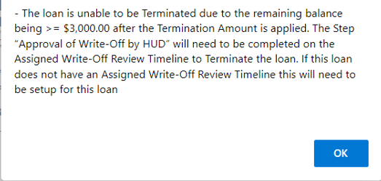
- The Roles “Contractor Cash” and “Contractor Cash Supervisor” will have the ability to Setup the Assigned > Disposition > Write-Off Review timeline. The Servicing Type “Write-Off Review” will be the only available option on the Setup window for these roles.
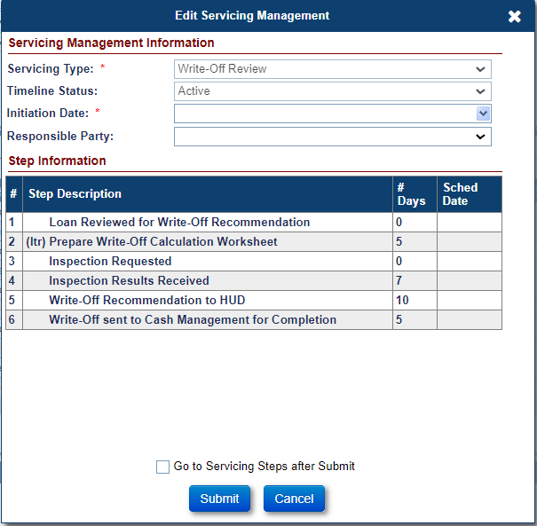
- Authorized users will be able to update the Auto Write Off amount under Admin > Investor page for the Investor HUD (9999909990) in the field “Max Auto Write-Off Amount.”
- The Roles associated with the Admin > Investor page will be able to update the Amount on the “Max Auto Write-Off Amount” field as needed.
- The “Max Auto Write-Off Amount” will not apply for the following Termination Transactions:
- Terminate - Short Sale (PIF W/Write-Off) [Trans Code 2885]
- Terminate - 3rd Pty FCL Sale (PIF w/WOff) [Trans Code 2886]

- An Auto Note will be added to the Note page when the user Terminates an Assigned loan prior to previous Transactions. The Auto Note will display the remaining balance that was written off.

- Message: “{Termination Transaction Description} with an Effective Date of {Termination Effective Date} in the amount of {Termination Transaction amount} created an Automatic Write -off for the remaining balance of {Auto Write Off Transaction amount}.”
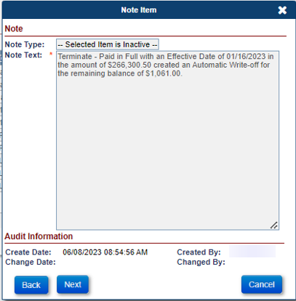

Updated loans in HUD’s portfolio to display an Error Message when Funds are available in the Overage. (539353)
Current Functionality is in place when a loan is Terminated for an amount greater than the payoff, the excess funds are referred to as an Overage. If a loan has available funds in the Overage and the user creates a Disbursement that affects loan balance, then an Error Message will be displayed. An Alert will also display when funds are available in the Overage.
- When the user creates a New Disbursement, the user will now see the Transaction Category “Refunds” and the Transaction Type “Disb – Refund Remittance Overage” were updated.
- The Transaction Category “Refunds” was updated to “Refunds/Payments” and the Transaction Type “Disb – Refund Remittance Overage” was updated to “Disb – Refund/Payment Remittance Overage.”
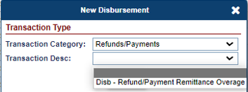
- When a user creates a Disbursement that affects loan balance and there are available funds in the Overage, the system will display a Certify Message.
- Certify Message: “There are available funds in the Overage Bucket, are you sure you want to create a disbursement that affects loan balance? Click ‘YES’ to continue or ‘NO’ to cancel.”
Note: If the disbursement is created, the loan will open back up once the disbursement has been disbursed through accounting and will need to be manually terminated.
- The Certify Message will display a YES and NO button. Clicking YES will create the Disbursement. Clicking NO will not create the Disbursement.
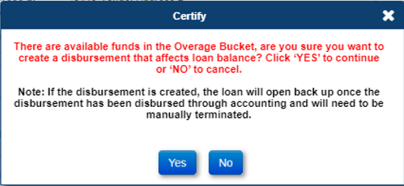
- A New Critical Alert has been added when the Transaction “Overage from Remittance” is created.
- The Alert Description “Available Overage Remittance” is displayed on the Critical Alert window on a loan when there are funds available.
- The Alert appears as Active on the Loan > Alert page when there are funds available in the Overage.
- When there are no more funds available in the Overage the Alert no longer appears on the Critical Alert window and the Alert displays as Inactive on the Loan > Alert page.
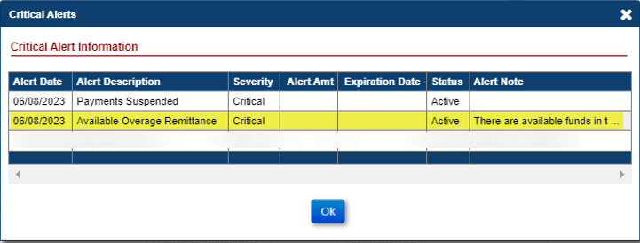
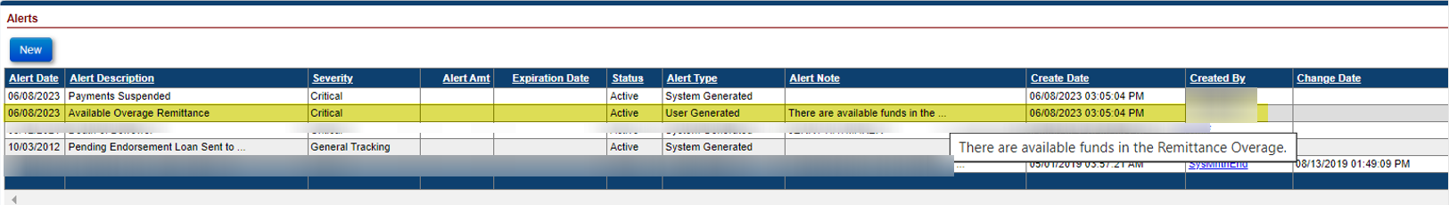
- When a Refund Disbursement is Authorized, the system adds an Auto Note on the Note page. The Refund Disbursement Auto Note has been updated to include additional information.
- Old Auto Note: “{Transaction Description} in the amount of {Amount} submitted to Treasury on {Authorized Date}”
- New Auto Note: “{Transaction Description} in the amount of {Amount} submitted to Treasury on {Authorized Date}. Payee Type: {Payee Type}, Vendor Type: {Vendor Type}, and Payee: {Payee}. Disb Note: {Text}.”
- The Vendor Type will only be added in the Auto Note when the Payee Type is Vendor.
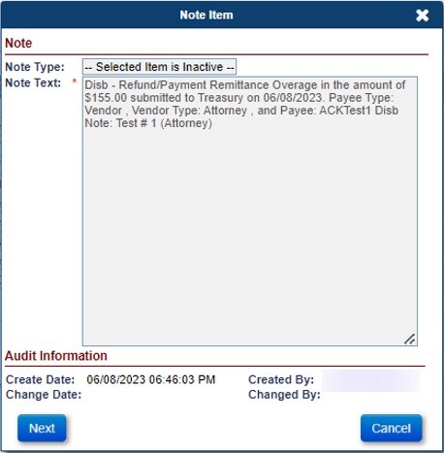

Automatically Write-Off the “Disb-Unscheduled LOC Release Fee” Transaction when added to loans in HUD’s portfolio. (539353)
- Write-Off: The system will automatically write-off the “Disb – Unscheduled LOC Release Fee” Transaction when the Batch Status is set to Disbursed and the Transaction is added to the Transactions > Loan page.
- Case Status Remains Terminated: If the loan is Terminated when “Disb – Unscheduled LOC Release Fee” is added and there is no other Transaction that affects loan balance, the loan will remain Terminated, and the existing Case Sub-Status will not change.
- Case Status Reopens: If the loan is Terminated when “Disb – Unscheduled LOC Release Fee” is added and another Transaction that affects loan balance is also added, the loan will reopen and no longer be Terminated. In this case the user will have to manually write off the other transaction that affects loan balance.
- Monthly Accrual Write-Offs: The system will automatically write-off Monthly Accruals and Adjustments (Trans Code 1190) due to Transaction “Disb – Unscheduled LOC Release Fee” being posted and the loan will remain Terminated. The system will not write-off Monthly Accruals due to a Transaction that affects loan balance other than “Disb – Unscheduled LOC Release Fee.”

Added NSC File Upload page (582223)
The NSC File Upload page was added to HERMIT under the Batch Screen. Only Authorized users will be able to use and view this page. On the NSC File Upload page there is an NSC Transactions link and Asset Sale Reports link, these links provide a Template file. Please refer to the “HERMIT NSC B2G File Format and Layout” link on the HERMIT Resources page for more information on NSC File Uploads.
- The NSC File Uploads page is available under Batch on the left menu for the following Authorized users.
- Contractor Cash
- Contractor Cash Supervisor
- Contractor Default
- Contractor Supervisor/Management
- HUD NSC Manager

- The NSC Transactions link provides the NSC Import Template, this allows multiple “Terminate – Asset Sale” Transactions which can be uploaded into HERMIT using the NSC File Upload page.
- The Amount filed on the NSC Import Template for Terminate – Asset Sale is automatically calculated by the system. If the user enters an Amount in the Amount Field on the Template, the system will ignore this amount and automatically Terminate the loan with the system calculated amount.

- The Asset Sale Reports link provides the B2G Asset Sale Reports Template, this allows multiple FHA Case #’s which can be uploaded into HERMIT using the NSC File Upload page to retrieve four reports (Contact Extract, Loan Extract, Loan Level Balance, and Loan Transaction Detail).
- Once the B2G Asset Sale Report Template is uploaded, the four reports will be generated into a download queue which is available at the top right corner of HERMIT (). The user will be able to move about HERMIT while the reports are being generated in the download queue. The Reports will display pending until they are completed. Once they are completed, the user can click on the Report to open the file. Once the user clicks on the Report, the report is no longer displayed in the queue. The Reports will stay in the download queue up to two hours before expiring.
- The user can upload the same Template for the Asset Sale Reports multiple times. There is an X next to each Report, if the user clicks the X next to the Report the report will be deleted from the queue and the report will not open. This X will be displayed when the Report is pending, completed, failed, or expired.
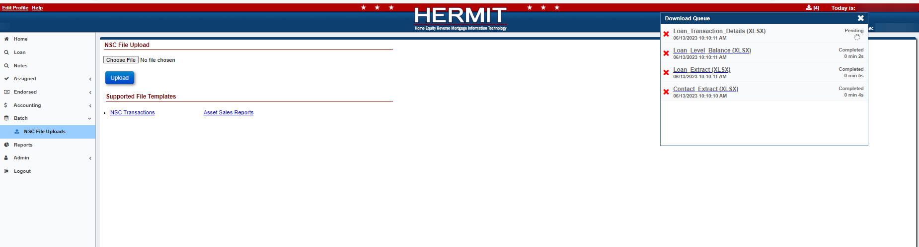
- When the user uploads a file on the NSC File Upload page the Import Results will appear once the file has been uploaded. The Import Results will display as either a Success, Error, or Warning after the upload process. The user can click Export to Excel to display these Import Results in an Excel File. Once the user clicks outside of this page or tries to perform a different action on this page, the Import Results will no longer be displayed, and you will not be able to obtain these results again.
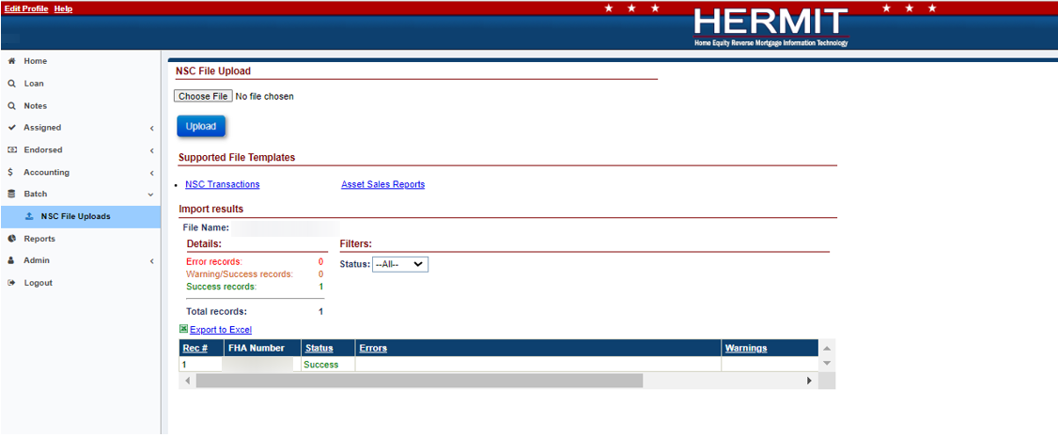

Tax Services Interface
The Tax Services Interface was implemented for the Cases that are being Serviced by HUD’s NSC Contractor. The new Interface will send a case to CoreLogic when the Step Claim Type 22 – Assignment to HUD sent for recording/Servicer Files Claim Type 22 – Form 27011 is completed. All of the business rules regarding this requirement are contained within the Interface Control Document and can be referred to for additional information.

