Home Equity Reverse Mortgage Information Technology
(HERMIT)

HERMIT System Changes – Release 7.1

Release Date: 11/19/22
Document Date: 12/21/22
Version 1.1

November 2022

INTRODUCTION
The Home Equity Reverse Mortgage Information Technology (HERMIT) software release version 7.1 consists of the following system changes:
Table of Contents
Servicer Related Changes 3
1. Claims - Reporting Rental Income, Rental Expense, and Escrow on a Claim (539389) 3
2. Claims – Claim Type 21, 3rd Party Sale changes (583984) 4
3. Claims – Update Appraisal Validation to 180 days for Appraisal Dates on or after 07/12/2022: ML 2022-11 (583744) 5
4. Claims – Update Curtailment Logic Notify Borrower of Default per ML 2022-15 (583569) 6
5. Claims – Extension - Request to Delay Foreclosure: Extended First Legal Deadline Date (581226) 6
6. Claims – Add cancelled step to Claims Timeline (539310) 8
7. Claims – Calculate 2/3 Calculation on the Over Claims (581639) 9
8. Upload Bulk Documents into HERMIT using SFTP (539433) 9
Servicer / NSC related changes 10
1. Inactivate Foreclosure Alerts when the Foreclosure Timeline is Inactivated (567909) 10
2. Extension Expiration Date for Extension – At Risk and Extension – Property Charge Loss Mitigation timelines (578525) 10
3. Extension – Property Charge Loss Mitigation Timeline Reason for Extension dropdown (583960 & 583961) 11
HUD / NSC Contractor related changes 12
1. CT22 Mortgagee Optional (MOE) Assignment Checklist has been updated (579033) 12
2. Update to HUD Pending Decision Report (582754) 12
3. Assigned - Exclude Loss Draft & Hardest Hit Funds Disbursements from Transactions included in Payoff Statement (582128) 13
4. Added Bulk Vendor Upload page (582493) 13

If you have any questions regarding the functionality of the software release, please contact the HERMIT Help Desk at 561-899-2610 or at servicingsupport@hermitsp.com. If you have any policy related questions, please send an email to HUD at answers@hud.gov.

Servicer Related Changes

Claims - Reporting Rental Income, Rental Expense, and Escrow on a Claim (539389)
Enhancements were made to activate three Blocks / Fields on the Claims Worksheet and Advice of Payment (AOP) for Claim Type 21, 23, and 24:
- Block 109: “Escrow Balance (as of date in Item 10, Part A)”
- Block 115: “Rental Income”
- Block 116: “Rental Expense”
- Block 109 Escrow can be populated by the user on Part B Fiscal Data on the Claims Worksheet prior to submitting or resubmitting the claim to HUD. This field reduces the total claim amount.

- New Transactions were added to the Transactions > Loan page and are located under a new Transaction Category Corp Advance – Misc Claim with Transaction Type and Code as follows:
- Corp Adv – Misc Claim – Rental Income 2448
- Corp Adv – Misc Claim – Rental Income Adj 2449
- Corp Adv – Misc Claim – Rental Expense 2441
- Corp Adv – Misc Claim – Rental Expense Adj 2442
The transactions can be entered on the loan via User Interface (UI), B2G, or Servicer Transactions.
These transactions populate the corresponding field on the Claims Worksheet.

- Block 115 Rental Income is automatically populated with the sum of Rental Income transactions and adjustments entered by the user in the Transactions > Loan page. Rental Income transactions are posted to the loan as negative amounts, and Rental Income Adjustments are posted as positive amounts. Rental Income transactions will reduce the total claim amount. Transactions affecting Block 115 Rental Income are:
- Corp Adv – Misc Claim – Rental Income 2448
- Corp Adv – Misc Claim – Rental Income Adj 2449

- Block 116 Rental Expense is automatically populated with the sum of Rental Expense transactions and adjustments entered by the user in the Transactions > Loan page. Rental Expense transactions are posted to the loan as positive amounts, and Rental Income Adjustments are posted as negative amounts. Rental Expense transactions will increase the total claim amount. Transactions affecting Block 116 Rental Expense are:
- Corp Adv – Misc Claim – Rental Expense 2441
- Corp Adv – Misc Claim – Rental Expense Adj 2442

- For CT24 Block 109 and Block 115 amounts count towards the $1,000 maximum Credits (Repays) permitted on the Supplemental Claim. Using the current process when the total of credits on the CT24 exceeds $1,000, servicer needs to remit funds owed to HUD via Over Claim then remove the credits remitted via Over Claim before being able to file the CT24.

- New Over Claims Reason Codes were added to the Over Claims page (Transactions > Claims > Over Claim) for CT21, CT23, and CT24:
- Part B/Block 109 - Escrow Credit
- Part B/Block 115 - Rental Income Credit
- Part B/Block 116 - Rental Expense

Claims – Claim Type 21, 3rd Party Sale changes (583984)
Enhancements were made to the logic for Claim Type 21 when the “Is This a Third Party Sale?” is YES. Additional fields are displayed on the Claims Disposition Information screen and other fields are no longer applicable for this claim condition. This condition is referred to as CT21 3rd Party Sale:
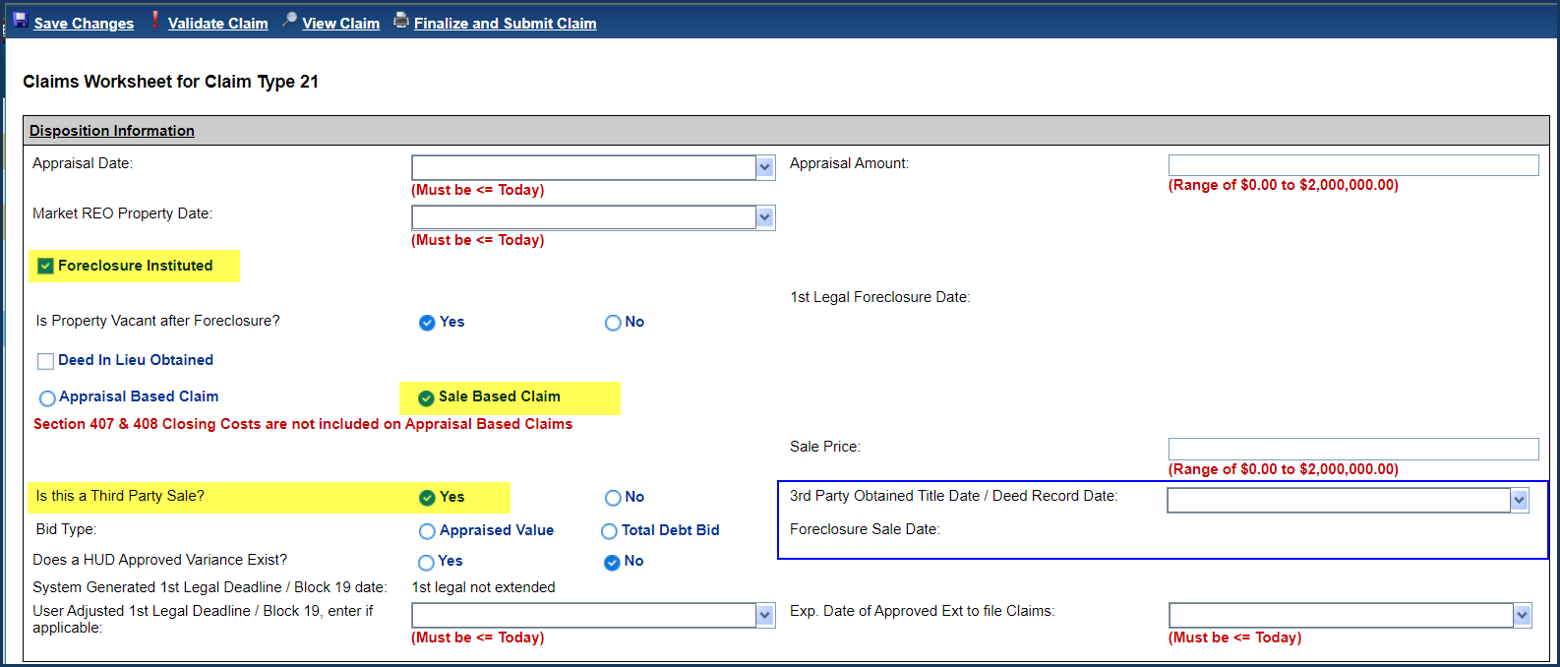

- CT21, 3rd Party Sale Changes to Claims Disposition Information Screen fields: Two new fields are required to file the claim: “Foreclosure Sale Date” and “3rd Party Obtained Title Date / Deed Record Date”. Two previous fields are no longer applicable: “Marketable Title Date” and “Sale Closing Date”.

- Foreclosure Sale Date displays the step completion date from the step “Foreclosure Sale Date” on the Foreclosure timeline and is not editable from the Claims Disposition Information Screen. This field is required to file CT21 3rd Party Sale. If the field is not populated a hard stop validation message will be displayed: “For 3rd Party Sale, complete date is required for step Foreclosure Sale Date on the Foreclosure timeline.”

- 3rd Party Obtained Title Date / Deed Record Date is entered by the user on the Claims Worksheet under the Disposition Information section. This date populates both Block 9 and Block 10 on the Claim Form. This field is required to file CT21 3rd Party Sale. If the field is not populated a hard stop validation message will be displayed: “For 3rd Party Sale, 3rd Party Obtained Title Date is required.”

- CT21, 3rd Party Sale Claim Mapping: Block 9 and Block 10 and Hard Stop Validations. “3rd Party Obtained Title Date / Deed Record Date” entered by the user on the Claims Disposition Information screen will populate Block 9 and Block 10 on the claim. Existing Hard Stop Validations which reference Block 9 and Block 10 will remain in place and will use the date populated in the corresponding Block / field.

- New text on the Warning message if there are more than 120 days between Foreclosure Sale Date and 3rd Party Sale Recorded Date. If 3rd Party Obtained Title Date/Deed Recorded Date is more than 120 days after Foreclosure Sale Date, then display conditional text on the Warning Message popup displayed when servicer clicks Finalize and Submit Claim: “Delay between FC Sale date to 3rd Party Obtain Title Date. Provide explanation of delay in Mortgagee comments, including when 3rd Party FC Deed sent for recording”.

Claims – Update Appraisal Validation to 180 days for Appraisal Dates on or after 07/12/2022: ML 2022-11 (583744)
- Hard Stop Validation for Appraisal. Based on Mortgagee Letter 2022-11 enhancements were made to the Appraisal Hard Stop Validation to be based on the Appraisal Date reported on the Claims Disposition screen. The logic was also updated to compare Appraisal Date against the specific date for the claim condition defined by HUD as stated below. Formerly the Appraisal Date was always compared to the date in Block 10.
- For Appraisal Dates before 07/12/2022, the Appraisal Date must be no older than 120 days before the date applicable for the Claim Type and condition stated below.
- For Appraisal Dates on or after 07/12/2022, the Appraisal Date must be no older than 180 days before the applicable for the Claim Type and condition stated below.

Note: The Appraisal Date for Claim Type 21 Appraisal Based Claim refers to the 2nd Appraisal Date entered on the Claims Disposition screen. The Appraisal Date for Claim Type 21 Sale Based Claim and Claim Type 23 refers to the only Appraisal Date entered on the Claims Disposition screen.

- Appraisal Validation and logic by Claim condition:
Claim Type | Is this a Third Party Sale? | Appraisal Date Before 7/12/22 | Appraisal Date On or After 7/12/22
Claim Type 23 | (N/A) | The Appraisal is considered invalid. Please review the Appraisal Date entered on the Claims Disposition screen. For Appraisal to be compliant: Sale Closing Date must occur within either 120 days of the Appraisal Date, OR before the Extension Expiration Date of Approved Extension - Appraisal (if applicable). For Late Appraisals, the Appraisal Date must be no later than 120 days after Sale Closing Date. | The Appraisal is considered invalid. Please review the Appraisal Date entered on the Claims Disposition screen. For Appraisal to be compliant: Sale Closing Date must occur within either 180 days of the Appraisal Date, OR before the Extension Expiration Date of Approved Extension - Appraisal (if applicable). For Late Appraisals, the Appraisal Date must be no later than 180 days after Sale Closing Date.
Claim Type 21 – SBC | No | The Appraisal is considered invalid. Please review the Appraisal Date entered on the Claims Disposition screen. For Appraisal to be compliant: Sale Closing Date must occur within either 120 days of the Appraisal Date, OR before the Extension Expiration Date of Approved Extension - Appraisal (if applicable). For Late Appraisals, the Appraisal Date must be no later than 120 days after Sale Closing Date." | The Appraisal is considered invalid. Please review the Appraisal Date entered on the Claims Disposition screen. For Appraisal to be compliant: Sale Closing Date must occur within either 180 days of the Appraisal Date, OR before the Extension Expiration Date of Approved Extension - Appraisal (if applicable). For Late Appraisals, the Appraisal Date must be no later than 180 days after Sale Closing Date."
 | Yes | The Appraisal is considered invalid. Please review the Appraisal Date entered on the Claims Disposition screen. For Appraisal to be compliant: Foreclosure Sale Date must occur within either 120 days of the Appraisal Date, OR before the Extension Expiration Date of Approved Extension - Appraisal (if applicable). For Late Appraisals, the Appraisal Date must be no later than 120 days after Foreclosure Sale Date." | The Appraisal is considered invalid. Please review the Appraisal Date entered on the Claims Disposition screen. For Appraisal to be compliant: Foreclosure Sale Date must occur within either 180 days of the Appraisal Date, OR before the Extension Expiration Date of Approved Extension- Appraisal (if applicable). For Late Appraisals, the Appraisal Date must be no later than 180 days after Foreclosure Sale Date ."
Claim Type 21 – ABC | n/a | The Appraisal is considered invalid. Please review the Appraisal Date entered on the Claims Disposition screen. For Appraisal to be compliant: Block 10 must occur within either 120 days of the Appraisal Date, OR before the Extension Expiration Date of Approved Extension – Appraisal (if applicable). For Late Appraisals, the Appraisal Date must be no later than 120 days after Block 10. | The Appraisal is considered invalid. Please review the Appraisal Date entered on the Claims Disposition screen. For Appraisal to be compliant: Block 10 must occur within either 180 days of the Appraisal Date, OR before the Extension Expiration Date of Approved Extension – Appraisal (if applicable). For Late Appraisals, the Appraisal Date must be no later than 180 days after Block 10.

Claims – Update Curtailment Logic Notify Borrower of Default per ML 2022-15 (583569)
Enhancements were made to the Curtailment logic for “Notify Borrower / Estate of Due & Payable” for Default Reason Death and FHA Case # Assigned Date before 09/19/17: to split the curtailment rule based on the last surviving Borrower’s Death Date. The curtailment rules are as follows:
FHA Case # Assigned Date | Death Date | Curtailment Deadline “Notify Borrower/ Estate of D&P” (Demand letter) | Curtailment Message
Before 9/19/2017 | Before 7/1/15 | None | None
 | 7/1/2015 – 8/30/2022 | Last Surviving Borrower / Co-Borrower’s Death Date + 30 days | Notification to Borrower/Estate of Default Event w/o HUD Approval must be no later than 30 Days from Death Date, as Case # was assigned before 9/19/17 and Death Date between 07/01/15 and 08/30/22
 | On or After 8/31/2022 | Create Date of D&P w/o HUD Approval timeline (Due Date) + 30 days | Notification to Borrower/Estate of Default Event w/o HUD Approval must be no later than 30 Days from Due Date, as Case # was assigned before 9/19/17 and Death Date on or After 8/31/22
On or After 9/19/2017 | Any | Create Date of D&P w/o HUD Approval timeline (Due Date) + 30 days | Notification to Borrower/Estate of Default Event must be no later than 30 Days from Due Date, as Case # was assigned on or After 9/19/17

Existing functionality will remain in place for the following:
- Curtailment Event Effective Date will remain using the Death Date not the Create Date of the D&P w/o HUD approval timeline to determine if this curtailment event shall be assessed
- Extensions to curtailment deadline based on Extension – Late Notification of Death timeline will remain in place
- Existing Curtailment Deadline rules were not changed for D&P w/o HUD approval, Default Reasons Conveyed Title and End of Deferral Period

Claims – Extension - Request to Delay Foreclosure: Extended First Legal Deadline Date (581226)
Enhancements were made to the Claims Worksheet to provide a field (System Generated 1st Legal Deadline) displaying the expiration date of extension(s) to the First Legal Deadline requested in & processed by the system. This field will make it easier for servicers to identify the system generated first legal deadline based off system request(s) and approval(s). A secondary field was added (User Adjusted 1st Legal deadline) to allow servicers to manually enter a first legal deadline date.
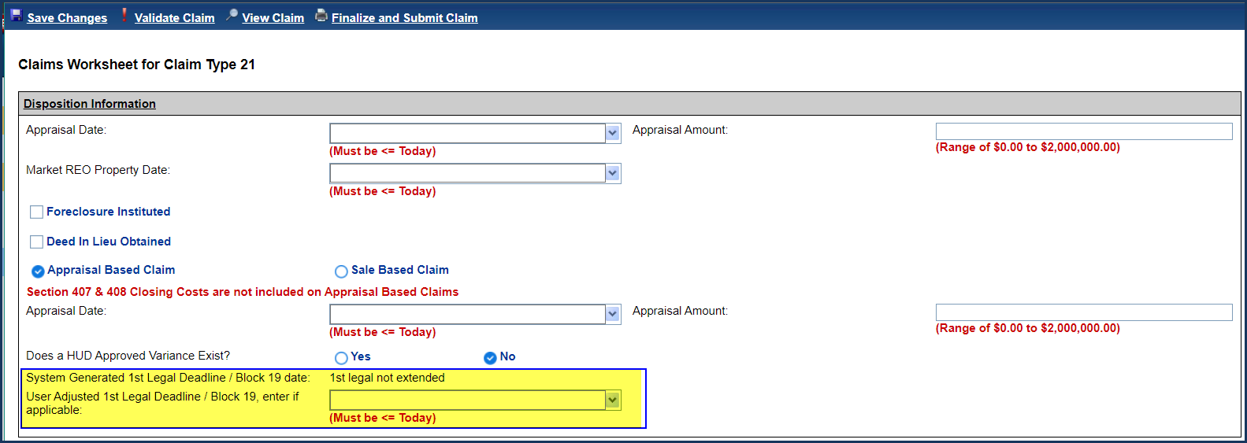

- Display new field on Disposition Information page “System Generated 1st Legal Deadline / Block 19 date”. This field may be used to populate Block 19: reported extension to First Legal Deadline. This field is auto-populated with the latest applicable extended First Legal Deadline from extension timelines and bankruptcies in the system, and pulls from the following sources:
- Extension - COVID-19 Request to Delay Foreclosure with Reason for Extension “Initiation of Foreclosure (First Legal Date)”: only used if the timeline meets necessary conditions to extend First Legal Deadline.
- Extension – Request to Delay Foreclosure (new functionality: see below)
- Bankruptcy – Chapter 7
- Bankruptcy – Chapter 13
This field is not editable by the user on the Claims Disposition Information screen. When there is no extension to First Legal Deadline in the system, this field will display “1st Legal not extended”.

- Rename label on the Disposition Information page from Exp. Date of Approved Ext (1st Legal to Commence FCL / Deed in Lieu)” to “User Adjusted 1st Legal Deadline / Block 19, enter if applicable”. This field may be used to populate Block 19: reported extension to First Legal Deadline. This field remains user-entered.

Conditional message that user agrees Block 19 is correct will be displayed on the Certify popup window when user submits or resubmits the claim if “User Adjusted 1st Legal Deadline / Block 19, enter if applicable” is populated. Message states: “The Claim reflects the maximum extended First Legal Deadline date of MM/DD/YYYY. User Adjusted Block 19 date is reported as MM/DD/YYYY. System Generated Block 19 date is reported as: MM/DD/YYYY. Servicer must assure that First Legal Deadline date is sufficiently supported by documentation provided in the claim file."

- Block 19 date will populate with the later of the following dates: “System Generated 1st Legal Deadline / Block 19 date” or “User Adjusted 1st Legal Deadline / Block 19, enter if applicable”.
Examples:
- If there is a “System Generated 1st Legal Deadline / Block 19 date” and NO User-Entered date in field “User Adjusted 1st Legal Deadline / Block 19, enter if applicable”; then Block 19 shall be populated with the system calculated extended First Legal Curtailment Deadline.
- If there is NO “System Generated 1st Legal Deadline / Block 19 date” and there is a User-Entered date in field “User Adjusted 1st Legal Deadline / Block 19, enter if applicable”; then Block 19 shall be populated with the user-entered date from field “User Adjusted 1st Legal Deadline / Block 19, enter if applicable”
- If there are BOTH a “System Generated 1st Legal Deadline / Block 19 date” and a User-Entered date in field “User Adjusted 1st Legal Deadline / Block 19, enter if applicable”; then Block 19 shall be populated with the maximum / later of the 2 dates.
- If there is NEITHER a “System Generated 1st Legal Deadline / Block 19 date” nor a User-Entered date in field “User Adjusted 1st Legal Deadline / Block 19, enter if applicable”; then Block 19 shall be NULL.

- Extend / Recalculate First Legal Curtailment Deadline using “Extension – Request to Delay Foreclosure” timeline Extension Expiration Date. Automatically extend the First Legal Deadline using the Extension Expiration Date from the Extension – Request to Delay Foreclosure timeline. The date will populate field “System Generated 1st Legal Deadline / Block 19 date” if it is the latest extended First Legal Deadline found in the system.

- Modify Curtailment Auto Note based on the reason First Legal Deadline was extended. When the claim is Approved for Payment, an Auto-Note will be saved on the Notes page stating the reason the First Legal Deadline was extended.
Curtailment Condition | Curtailment Extension Auto-Note
Extended First Legal Curtailment Deadline due to Extension – Request to Delay Foreclosure timeline | New: Claim Type 21 - DIL/FCL - Curtailment Deadline Extended - Claim would have Auto Curtailed on MM/DD/YYYY. First Legal extended due to Extension - Request to Delay Initiation of Foreclosure.
Extended First Legal Curtailment Deadline due to user-entered ““User Adjusted 1st Legal Deadline / Block 19, enter if applicable” | New: Claim Type 21 - DIL/FCL - Curtailment Deadline Extended - Claim would have Auto Curtailed on MM/DD/YYYY. First Legal extended due to Block 19 date “User Adjusted 1st Legal Deadline / Block 19, enter if applicable”.
Extended First Legal Curtailment Deadline due to Extension - COVID-19 Request to Delay Foreclosure | Existing: Claim Type 21 - DIL/FCL - Curtailment Deadline Extended - Original Curtailment Deadline MM/DD/YYYY for First Legal extended due to COVID Request to Delay Initiation of Foreclosure.
Bankruptcy - Chapter 7 | Existing: Claim Type 21 - DIL/FCL - Curtailment Deadline Extended - Claim would have Auto Curtailed on MM/DD/YYYY. [Curtailment Event] extended due to Bankruptcy.
Bankruptcy - Chapter 13 | Existing: Claim Type 21 - DIL/FCL - Curtailment Deadline Extended - Claim would have Auto Curtailed on MM/DD/YYYY. [Curtailment Event] extended due to Bankruptcy.

Claims – Add cancelled step to Claims Timeline (539310)
Enhancements were made to Claim Type 21, 23, and 24 after the Approved claim is Cancelled on the Accounting > Claims page to inactivate the previous Approved for Payment step and add a new step Claim Payment Cancelled which auto completes with the day the cancellation is completed. The step Re Review will continue to be added to the timeline when a cancellation occurs (Existing Functionality). The previously approved AOP document will also be renamed when a claim is cancelled.

A cancelled claim will not be sent to Accounting in the nightly batch and will not proceed to Submitted for Payment or Claim Paid. The only way a claim will be sent to Accounting for payment is if the claim is given a 2nd approval decision / re-approval using the Re Review step by an authorized HUD user.

The Claim Status will be “Claim Cancelled” until the Re Review step is completed by the HUD user. Using the Re Review step the HUD user may either re-approve the claim or Pend the claim back to servicer for resubmission. When HUD user completes the Re Review step after the claim was cancelled, the Claim Payment Cancelled step will be inactivated.

When the Claim is cancelled, the previous AOP document will be automatically renamed to the following based on claim type:
- Claim Type 21 – Cancelled/unissued Claim Payment – AOP
- Claim Type 23 – Cancelled/unissued Claim Payment – AOP
- Claim Type 24 – Cancelled/unissued Claim Payment - AOP
The Auto Imaged Claim form will not be renamed. Example: Claim Type 21 - Form HUD-27011.

Claims – Calculate 2/3 Calculation on the Over Claims (581639)
Enhancements were made to the Over Claim functionality under the Transactions > Claim page when the Reason Code selected is a 2/3 category based on the loan’s FHA Case # Assigned date.
- A conditional message will be displayed on the existing “Please Confirm” popup window stating
“You have chosen a transaction category that is reimbursed by HUD at 2/3’s the full amount. If the amount entered ($X.XX) represents 2/3’s of the full transaction refund amount, please click YES to continue. If the remittance amount entered ($X.XX) represents the full transaction refund amount, please click NO and adjust the amount to ($Y.YY), which represents 2/3’s. Documentation supporting this transaction should be uploaded to the claim file. Remittances submitted to HUD are final and cannot be changed or reversed.”
In the above message: $X.XX represents the Transaction amount input on the Over Claims page and $Y.YY represents that amount multiplied by 0.6666666, generally referred to as “2/3”.
- The following Over Claim Reason codes are 2/3 for loans with FHA Case # Assigned Date Before 09/19/17
- Part D/Block 306 – Attorney/Trustee Fees
- Part D/Block 307 – Recording Fees
- Part D/Block 307 – Sherriff Fees
- Part D/Block 307 – Clerk Costs
- Part D/Block 307 – Publication Fees
- Part D/Block 307 – Foreclosure and/or Acquisition, Conveyance Costs, other
- The following Over Claim Reason codes are 2/3 for loans with FHA Case # Assigned Date On or After 09/19/17
- Part D/Block 305 – Hazard Insurance Premiums
- Part D/Block 305 – Taxes
- Part D/Block 305 – Forced Place Insurance
- Part D/Block 305 – HOA Fees

Upload Bulk Documents into HERMIT using SFTP (539433)
Servicers with 100 cases or more in their portfolio will be able to upload Bulk documents into HERMIT through SFTP. Each Servicer will have an Images Folder in SFTP where they will place the Bulk Documents they want to be uploaded in HERMIT. The Documents will be uploaded into HERMIT through the overnight process. Please refer to the HERMIT Document Upload File Format link on the HERMIT Resources page for more information regarding Bulk Document Upload. If Servicers wish to use this function, they will need to reach out to the HERMIT Servicing Module to set up testing with the HERMIT Project Team.

Servicer / NSC related changes

Inactivate Foreclosure Alerts when the Foreclosure Timeline is Inactivated (567909)
- Once the Foreclosure Timeline on an Endorsed Loan has been inactivated the system will automatically set the “Foreclosure” System generated Alert to Inactive on the Alerts page and the corresponding Alert will no longer be displayed on the Critical Alerts popup when opening the loan.

- The “MIP Collection Stopped – Foreclosure Sale Date” User Generated Alert will be set to inactive once the Foreclosure Timeline on Endorsed or Assigned Loan is inactivated.

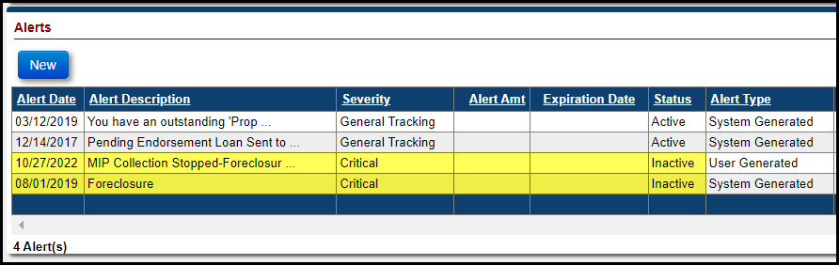

- The HUD Contractor or HUD will be able to review the Inactivated Foreclosure Alerts on the already existing Alert Details Report located on the Reports page.

Extension Expiration Date for Extension – At Risk and Extension – Property Charge Loss Mitigation timelines (578525)
For both Endorsed and Assigned timelines: Extension – At Risk and Extension – Property Charge Loss Mitigation, the Extension Expiration Date will be updated to the Last Surviving Borrower’s DOD when the last Surviving Borrower is deceased.

- When the last surviving Borrower or Co-Borrower’s DOD is entered into the system via HERMIT UI or DMF the Extension Expiration Date will automatically be set to the last surviving Borrower’s DOD if the Extension Expiration Date is not expired. If the extension expiration date is expired, then the Extension Expiration Date will not change.

- When the last surviving Borrower or Co-Borrower’s DOD is changed in the system via HERMIT UI or DMF the Extension Expiration Date will automatically be set to the last surviving Borrower’s changed DOD if the prior Extension Expiration Date is not expired. If the prior extension expiration date is expired at the time the DOD is changed, then the Extension Expiration Date will be set to the prior Extension Expiration Date.

- When the last surviving Borrower or Co-Borrower’s DOD is deleted in the system via HERMIT UI or DMF the Extension Expiration Date will automatically be set to the prior Extension Expiration Date.

- An Auto Note will be added to HERMIT when the Extension Expiration Date is changed to the Last Surviving Borrower’s DOD detailing the Extension timeline.

- Message: The Extension Expiration Date on the Extension – At Risk Timeline has been updated to MM/DD/YYYY. The timeline’s Extension Expiration Date has expired due to the last surviving Borrower being deceased.
- Message: The Extension Expiration Date on the Extension – Property Charge Loss Mitigation Timeline has been updated to MM/DD/YYYY. The timeline’s Extension Expiration Date has expired due to the last surviving Borrower being deceased.

Extension – Property Charge Loss Mitigation Timeline Reason for Extension dropdown (583960 & 583961)
- A new Reason for Extension has been added to the dropdown on the Extension – Property Charge Loss Mitigation Timeline for both Assigned and Endorsed timelines: “Covid – 19 Property Charge Repayment Plan”

- The Reason for Extension “At Risk Mortgagor” has been removed from the dropdown on the Extension – Property Charge Loss Mitigation Timeline for Assigned and Endorsed timelines. The Extension – At Risk Timeline needs to be used in replace of the Reason for Extension “At Risk Mortgagor.”

- For Endorsed and Assigned Timelines, a new column “Reason for Ext” was added to the search results which will display the Reason for Extension if it exists and allow you to pull a report using the export to excel link.
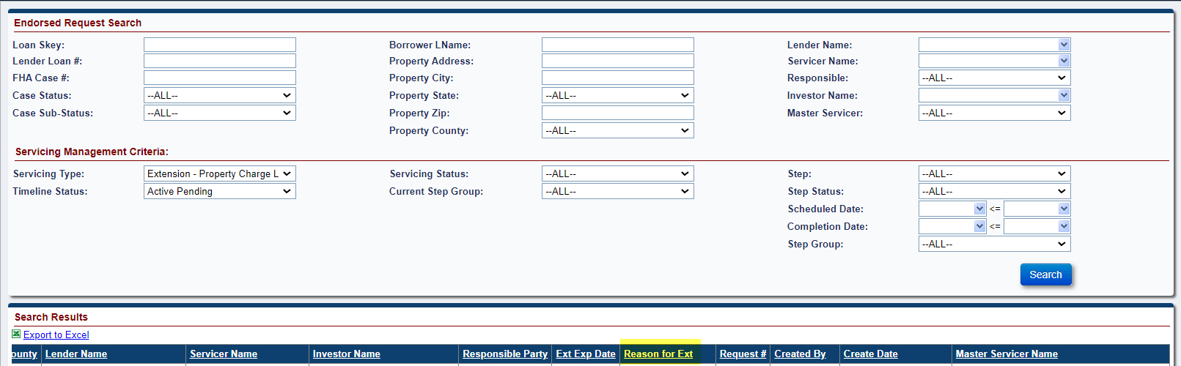

HUD / NSC Contractor related changes

CT22 Mortgagee Optional (MOE) Assignment Checklist has been updated (579033)
The Mortgagee Optional Election (MOE) Assignment Checklist Section on the HECM Assignment Acceptance Checklist has been updated.
  - The following task descriptions have been removed from the MOE Assignment Checklist

    - “MOE Election Letter from Mortgagee – Verify date of MOE Election letter is within 120 days from the death of the last surviving HECM borrower or within 120 days from 6/12/2015, whichever is later”
    - “Assignment Initiation: Verify create date of Assignment timeline is within 120 days from date of MOE Election Letter from Mortgagee”
    - “Evidence of the Eligible NBS’ title to the property or other ongoing legal right to remain in the property”

  - The task description “Copy of the Death Certificate for each deceased borrower” has been updated to “Copy of the Death Certificate for each deceased borrower and/or verification last borrower resides in a healthcare facility that exceeds 12 consecutive months” on the MOE Assignment checklist.

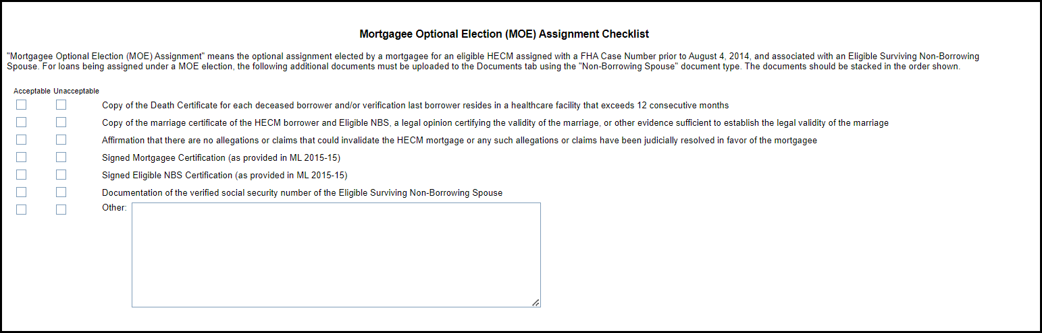

Update to HUD Pending Decision Report (582754)
The HUD Pending Decision Report has been updated to check for the Step “HUD Decision – Approved Repurchase” and “HUD Decision – Denied Repurchase”
- If the Step “Recommended Repurchase to HUD” is completed in the Assignment Repurchase Timeline and if the “HUD Decision – Approved Repurchase” Step exits and is completed, then the loan will not display on the report.

- If the Step “Recommended Repurchase to HUD” is completed in the Assignment Repurchase Timeline and if the “HUD Decision – Denied Repurchase” Step exits and is completed, then the loan will not display on the report.

Assigned - Exclude Loss Draft & Hardest Hit Funds Disbursements from Transactions included in Payoff Statement (582128)
Enhancements were made to the Payoff page that exclude Loss Draft and Hardest Hit Funds Disbursements from the Payoff statement for both Assigned loans and Endorsed Loans being serviced by HUD NSC Contractor. These transactions will not be displayed in either the Pending Disbursements section or the Total Payoff Amount. The following transactions are excluded:
- 6550 - Loss Draft Not Final
- 6551 - Loss Draft Final
- 6552 - Loss Draft Inspection
- 6590 - Loss Draft Final adj
- 6591 - Loss Draft Not Final adj
- 6592 - Loss Draft Inspection adj
- 6750 - Hardest Hit Not Final
- 6751 - Hardest Hit Final
- 6790 - Hardest Hit Not Final – Adj
- 6791 - Hardest Hit Final – Adj

Added Bulk Vendor Upload page (582493)
The Bulk Vendor Upload page was added to HERMIT under the Admin Screen. Only Authorized users will be able to use and view this page. Multiple vendors can be uploaded into HERMIT using the Bulk Vendor Upload page. On the Bulk Vendor Upload page there is a vendor link, this link provides the Template file needed for uploading Bulk Vendors. Please refer to the Bulk Vendor Upload File Format link on the HERMIT Resources page for more information on Bulk Vendor Upload.

