**Home Equity Reverse Mortgage Information Technology**

**(HERMIT)**

**HERMIT System Changes – Release 5.5**

**Release Date: 04/07/18**

**Document Date: 04/11/18**

April 2018

Version 1.1

**INTRODUCTION**

The Home Equity Reverse Mortgage Information Technology (HERMIT) software release version 5.5 consists of the following system changes:

Table of Contents

1 Late Charge and Penalty Interest on MIP will not be refunded if a loan is cancelled 1

2 Incurred Date Cannot Be Future Date 1

3 New Relocation Incentive Transaction Code 2

4 Cash for Keys Based on Incurred Date 3

5 Capture Dates Related to Recorded Assignments 4

6 Auto Note when Record is received from Death Master File (DMF) – Endorsed 4

7 CLAIMS – Auto-Curtailment change to “Notification to HUD of Default”, D&P w/o HUD Approval 5

8 CLAIMS – CT21 and CT24 Restrict Closing Costs for Appraisal Based Claim 6

9 CLAIMS – CT23 Short Sale updates 8

10 CLAIMS – CT24 more than 6 months after Parent Claim Paid Date 10

11 CLAIMS – CT24 Modify the 45 day Resubmit rule 13

12 CLAIMS – CT24 Block #27 14

13 CLAIMS – CT24 Include Block #132 b amount in Block #135 and #137 totals 15

14 CLAIMS – Rename Claims pop-up window 15

15 CLAIMS – Update Negative Claim Validation Message 15

16 CLAIMS – Add HUD Decision Notes 15

17 CLAIMS – Claims Detail Report 16

18 CLAIMS – Change to Advice of Payment Debenture Interest “To” date 16

19 CLAIMS – Add Paper Claims to HERMIT 17

20 CLAIMS - Claim Reimbursements - Over Claims: Servicers remit funds to HUD via HERMIT 18

21 Assigned – Auto Note when Record is received from DMF 23

22 Assigned – Occupancy Compliance Certification timeline DMF 23

23 Assigned – Reject CHUMS 98 record when Preliminary Title Approval 23

24 Assigned – New Disb-Unscheduled from LOC - Release Fee disbursement 24

If you have any questions regarding the functionality of the software release, please contact the HERMIT Help Desk at 561-899-2610 or at [servicingsupport@hermitsp.com](mailto:support@hecmsp.com). If you have any policy related questions, please send an email to HUD at [answers@hud.gov](mailto:answers@hud.gov).

## Late Charge and Penalty Interest on MIP will not be refunded if a loan is cancelled

When a loan is cancelled in HERMIT via FHAC/CHUMS, a MIP refund is issued. HERMIT will no longer refund Late Charge and Penalty Interest amounts when a loan is cancelled. If a loan that had a Late Charge and/or Penalty Interest amount is cancelled, the refund amount will be limited to Initial MIP and Monthly MIP.

## Incurred Date Cannot Be Future Date

When entering any transaction with an Incurred Date, the Incurred Date cannot be a future date. The Incurred Date must be >= Funded Date.

## New Relocation Incentive Transaction Code

* 1. 24 CFR 206.125(g)(4) – The Commissioner may provide financial incentive, in an amount to be determined by the Commissioner, to be paid by the mortgagee and reimbursed through a subsequent claim when a bona fide tenant vacates the property prior to an eviction being initiated by the mortgagee.
  2. For loans with FHA Case # Assignment Date on or after 09/19/2017, HERMIT will allow a new transaction of “Corp Adv – S305 – Relocation Incentive” to be added to the loan. If applicable, this new transaction code can be added to the loan balance via the HERMIT transactions page, B2G, or Batch Servicer Transaction page.
  3. The dollar amount cap that can be entered for “Relocation Incentive” is currently set at $3,000.

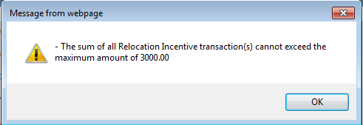

**Figure 1: Hard Stop message Relocation Incentive – exceeds Cap**

* 1. If Corp Adv - S305 - Relocation Incentive transaction(s) are recorded on the loan (transaction(s) total > 0), then the Cash for Keys transaction will not be allowed. A hard stop will be displayed.

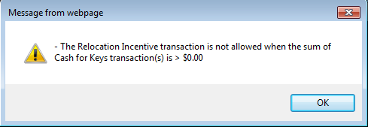

**Figure 2: Hard Stop message Relocation Incentive – has Cash for Keys**

* 1. Any Relocation Incentive transactions entered into HERMIT after the V5.50 release will be pulled into the 27011 claims form only for CT21 and CT21 Supplemental claims. They will not be pulled into the 27011 claims form for CT23 or CT23 Supplemental claims.

## Cash for Keys Based on Incurred Date

* 1. 24 CFR 206.125(f)(1)(ii) Cash for Keys. – The Commissioner may provide a financial incentive, in an amount to be determined by the Commissioner, to be paid by the mortgagee and reimbursed through any subsequent claim where a borrower or other party with a legal right to do so deeds the property within 6 months of the due date.
  2. The Cash for Keys incentive transaction Incurred Date cannot be prior to the Due & Payable date and cannot be more than 6 months after the Due & Payable date. If there is more than one active Due & Payable timeline on the same loan, the maximum Due & Payable date will be used to assess if Incurred date is allowed.

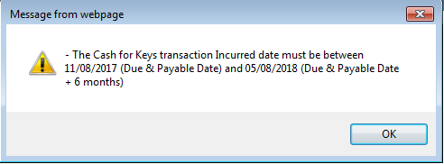

**Figure 3: Hard Stop message Cash for Keys – invalid Incurred Date**

* 1. The dollar amount cap that can be entered for “Cash for Keys” is currently set at $3,000.

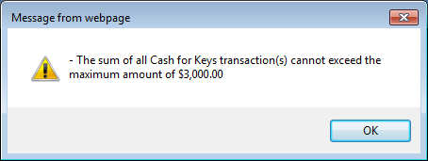

**Figure 4: Hard Stop message Cash for Keys – exceeds Cap**

* 1. If Corp Adv - S305 - Cash for Keys transaction(s) are recorded on the loan (transaction(s) total > 0), then Relocation Incentive transaction will not be allowed. Hard stop will be displayed.

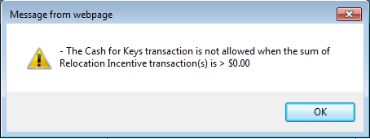

**Figure 5: Hard Stop message Cash for Keys - has Relocation Incentive**

* 1. Any Cash for Keys transactions entered into HERMIT after the V5.50 release will be pulled into the 27011 claims form only for CT21 and CT21 Supplemental claims. They will not be pulled into the 27011 claims form for CT23 or CT23 Supplemental claims.

## Capture Dates Related to Recorded Assignments

* 1. 24 CFR 206.135(c) – Servicers are reminded of their responsibility to provide the original recorded assignment of mortgage to the Commissioner as soon as received by the Mortgagee, but in no case shall it be longer than 12 months after recordation.
  2. HUD will capture the date of the recorded document as the completed date in new step “Assignment to HUD Recorded Date”.  This date will be compared to the Recorded Assignment Received date to determine whether the Servicer forwarded the recorded assignment of mortgage within 12 months after recordation.
  3. The new timeline step “Assignment to HUD Recorded Date” will be available in the Endorsed -> Claims -> CT 22 – Assignments Timeline. This step will be a system step that is triggered upon Completion from the step “Assignment to HUD sent for recording/Servicer Files CT 22 form HUD-27011”. The Scheduled Date for this step will be set equal to the Completion Date from the Step “Assignment to HUD sent for recording/Servicer Files CT 22 form HUD-27011”. This is a HUD Loan Servicing Center Contractor step.
  4. The Completion Date for the “Assignment to HUD Recorded Date” step will be entered with the actual date of recording of the document.
  5. In addition, the existing step name “HUD – Follow Up” has been updated to “HUD – Follow Up on Recorded Assignment” on the Endorsed -> Claims -> CT 22 – Assignments Timeline.

## Auto Note when Record is received from Death Master File (DMF) – Endorsed

An auto-note will be added to HERMIT any time a death date is added by the DMF on Endorsed loans. The note description will be displayed as “Death date added by DMF”.

See topic 21 for impacts to Assigned loans.

## CLAIMS – Auto-Curtailment change to “Notification to HUD of Default”, D&P w/o HUD Approval

* 1. The auto-curtailment for **“Notification to HUD of Default” on D&P w/o HUD Approval** was updated to be based on the death date, or for Conveyed Title: default date. Previously, this was based on Due Date (D&P) on or after 07/01/15. The new rule is:

**For default reason “Death”:** curtailment will be assessed on loans with a last surviving borrower’s death date on or after 07/01/15, regardless of when the death date is entered into HERMIT.

**For default reason “Conveyed Title”:** curtailment will be assessed on loans with a default date on or after 07/01/15, regardless of when the default date is entered into HERMIT.

* 1. **Unchanged Curtailment Rules for “Notification to HUD of Default”, D&P w/o HUD Approval:**

**For default reason “Death” and no extension,**  HERMIT will auto-curtail Claim Type 21 or Claim Type 23 if “HUD is not notified of a default within 60 days of Death Date” which means the HERMIT “D&P w/o HUD approval” timeline must be setup/created within 60 days of the death date to avoid curtailment. If curtailed for this reason the date of the curtailment will be the "Death Date" + 60 Days.

**For default reason “Death” and Extension Late Notification of Death**, HERMIT will auto-curtail Claim Type 21 or Claim Type 23 if “HUD is not notified of a default within 30 days of **Extension Late Notification of Death**” Expiration Date which means the HERMIT “D&P w/o HUD approval” timeline must be setup/created within 30 days of the Extension Expiration Date on the “Extension – Late Notification of Death” timeline to avoid curtailment. If curtailed for this reason the date of the curtailment will be the " Extension Late Notification of Death” Expiration Date" + 30 Days.

**For default reason “Conveyed Title”**, HERMIT will auto-curtail Claim Type 21 or Claim Type 23 if “HUD is not notified of a default within 60 days of Default Date” which means the HERMIT “D&P w/o HUD approval” timeline must be setup/created within 60 days of the default date to avoid curtailment. If curtailed for this reason the date of the curtailment will be the "Default Date" + 60 Days.

**Note:** **All other auto-curtailment rules other curtailment events remain unchanged.**

**Note:** **If the date of the curtailment is before the start date of Debenture Interest, then no debenture interest will be paid. Note Interest will not be curtailed.**

## CLAIMS – CT21 and CT24 Restrict Closing Costs for Appraisal Based Claim

* 1. **Closing cost transactions will not be pulled into the claim form for Appraisal Based Claims.** This applies in the following two scenarios:
     + Claim Type 21 (CT21) where the Appraisal Based Claim radio button is selected
     + Claim Type 24 Supplemental’s (CT24) when the parent was Claim Type 21 with Appraisal Based Claim radio button selected

There is no change to Sales Based Claim, closing cost transactions will continue to be pulled into the claim form.

The following transactions are considered Closing Cost transactions:

|  |
| --- |
| **HUD-1 Closing Costs - Owed to Borrower / Section 407** |
| Closing - S407 - Other |
| Closing - S407 - Special Assessments |
| Closing - S407 - Taxes |
| Closing - S407 - Water Rates |

**Table 1: List of Closing Cost from Section 407**

|  |
| --- |
| **HUD-1 Closing Costs - Additional / Section 408** |
| Closing - S408 - Appraisal |
| Closing - S408 - Discount Points |
| Closing - S408 - Other |
| Closing - S408 - Recording Fees |
| Closing - S408 - Sales Commission |
| Closing - S408 - Service Charges |
| Closing - S408 - Termite Report |
| Closing - S408 - Title Insurance |

**Table 2: List of Closing Costs from Section 408**

If the parent claim was submitted in error as an Appraisal Based Claim, please contact the SM Help Desk to request a DCR to change the CT24 Supplemental from Appraisal Based Claim to Sales Based Claim.

* 1. **The Claim Type 21 Claims Worksheet has a new comment in the Disposition Information section under Appraisal Based Claim radio button.** The comment states “Section 407 & 408 Closing Costs are not included on Appraisal Based Claims”.

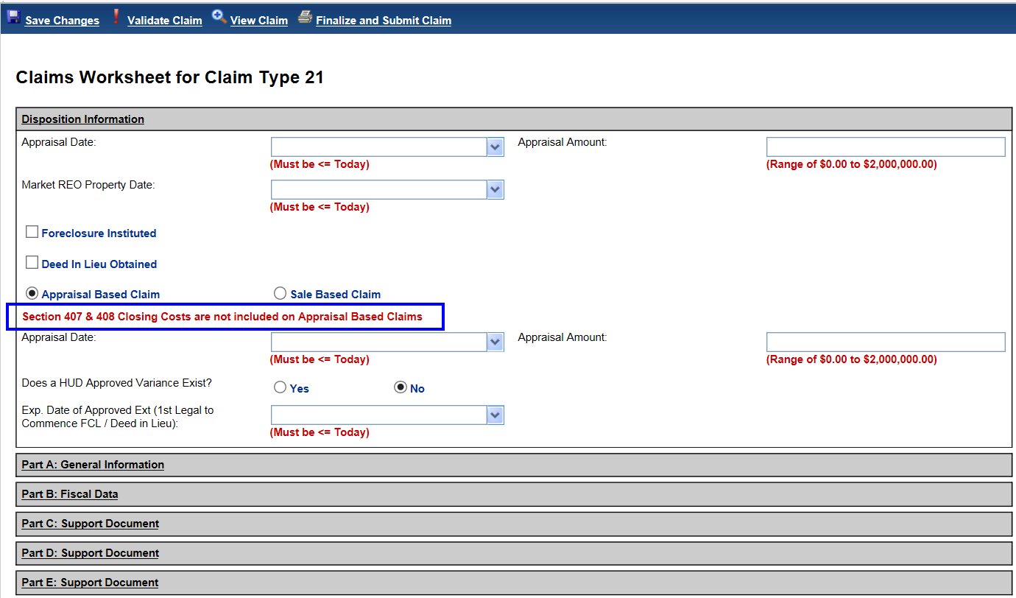

**Figure 7: CT21 New Claims Worksheet comment**

## CLAIMS – CT23 Short Sale updates

* 1. **“Deed Recorded Date” from Loss Mitigation – Short Sale timeline is required for Claim Type 23 – Short Sale**

For all Claim Type 23’s, the step “Deed Recorded Date” step completion date from the Loss Mitigation – Short Sale timeline will be required to submit the claim to HUD. If the “Deed Recorded Date” step completion date is missing, a hard stop validation message will be displayed. In addition, the “Sale Closing Date” is no longer displayed on the Claim Worksheet under Disposition Information and is replaced by the “Deed Recorded Date”. See topic 9.2 for details.

Claims Worksheet – Disposition Information screen without “Sale Closing Date”:

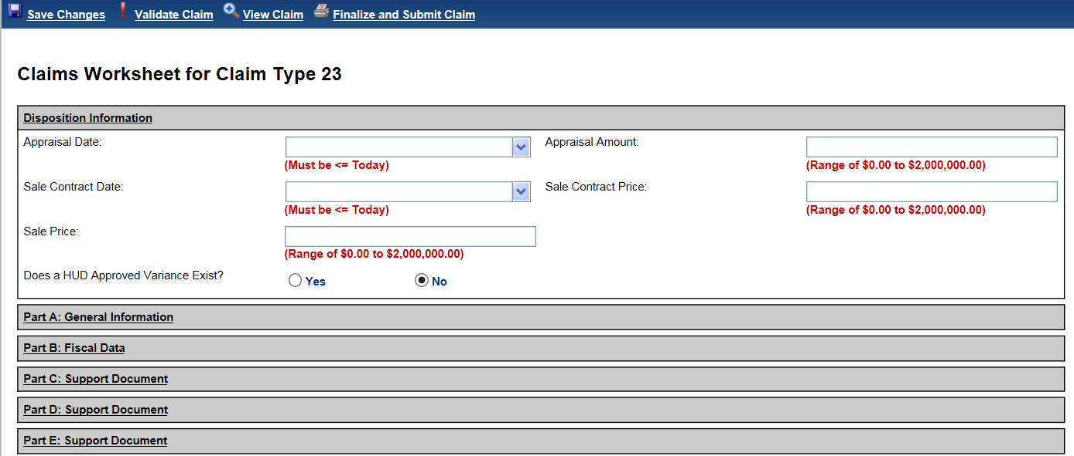

**Figure 8: CT23 Claims Worksheet – Disposition Information**

The hard stop validation message is “**Date deed or assignment filed for record or date of closing or appraisal is required. Please enter a Sale Closing Date / Deed Recorded Date**.”

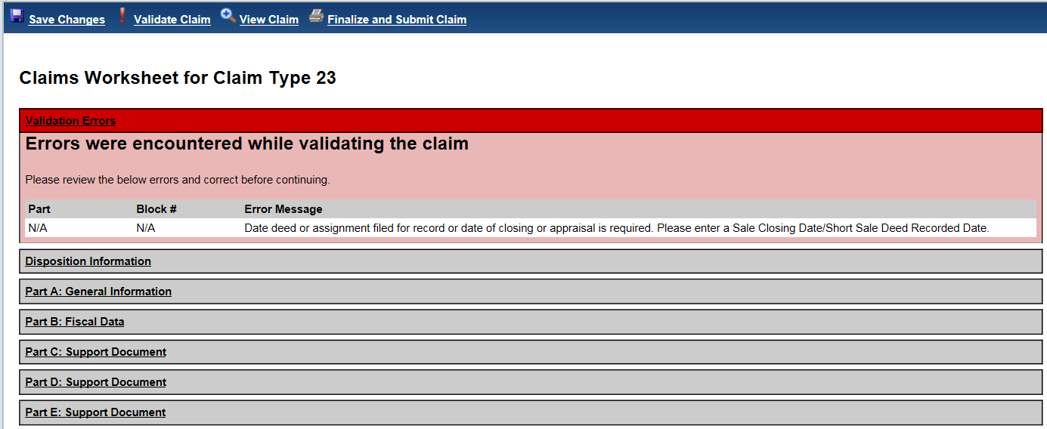

**Figure 9: CT23 Validation Message for missing “Deed Recorded Date”**

**To enter the “Deed Recorded Date” on the Loss Mitigation – Short Sale timeline.** Step “Deed Recorded Date” is triggered by completion of the step “Sale Closing Date”. Go to **Endorsed > Disposition > Setup** (or Search, if the timeline already exists), select “Loss Mitigation – Short Sale” timeline. If the “Deed Recorded Date” is not displayed, first enter a completion date for step “Sale Closing Date”. Completing this step will add the step “Deed Recorded Date” and a completion date can be entered for “Deed Recorded Date”.

“Sale Closing Date” step completion date should be populated with the sales closing date displayed on the settlement closing statement.

“Deed Recorded Date” step completion date should be populated with the date the sales deed is recorded with the local county clerk’s office.

* 1. **CT23 Block #10 date updated to “Deed Recorded Date”**

Block #10 for Claim Type 23 will be populated with the “Deed Recorded Date” step completion date from the Loss Mitigation – Short sale timeline.

**Added 04/11/18 - Note**: For CT23 the Claim Filing curtailment deadline is based on “Deed Recorded Date” instead of “Sale Closing Date”. For loans with FHA Case # Assignment Date Before 09/19/17, the claim is due by Block #10 date + 15 days. For loans with FHA Case # Assignment Date On or After 09/19/17, the claim is due by Block #10 date + 30 days.

* 1. **CT23 Update Interest Payments for Case # Assignment Date Before 09/19/17**

**Note Interest paid to Deed Recorded Date / update Block #17 amount**

For loans with FHA Case # Assignment Date Before 09/19/17 Note Interest will be paid up to and including the “Deed Recorded Date” step completion date from the Loss Mitigation – Short Sale timeline, regardless of whether the loan was Due and Payable or not. The calculation for Block #17 has been changed to calculate the balance up through and including the “Deed Recorded Date”. Block #17 will continue to include MIP, Note Interest, Service Fee, and Principal as normally calculated, but the end date will be Block #10 “Deed Recorded Date” instead of Due Date (CT23 Block #8).

**Debenture Interest start date:** As a result of the Note Interest changes, the Debenture Interest start dates were also changed for loans with FHA Case # Assignment Date Before 09/19/17:

**DBI on CT23 claim curtailed:** If a CT23 is curtailed on or before the Deed Recorded Date, then NO Debenture Interest will be paid. If a CT23 is curtailed after the Deed Recorded Date, then Debenture Interest will be paid from the Deed Recorded Date PLUS one day through the curtailment date.

**DBI on CT23 claims NOT curtailed**: If a CT23 is not curtailed, then Debenture Interest will be paid from the Deed Recorded Date PLUS one day through the claim settlement date.

* 1. **CT23 Sections 305 and 311 will exclude MIP and Service Fees included in Block #17**

MIP and Service Fee transactions included in Block #17 up through the Deed Recorded Date will not be itemized in sections 311 and 305 on the claim form. Corporate Advances and other expenses in section 305 that are not included in Block #17 will continue to be included as usual based on the rules for each transaction type.

## CLAIMS – CT24 more than 6 months after Parent Claim Paid Date

Per HUD policy, Claim Type 24 Supplemental claims must be submitted to HUD within 6 months of the parent claim paid date. An enhancement was made in HERMIT to provide warnings to servicers and HUD when the CT24 timeline is created or submitted after the permitted 6 month timeframe. The parent claim paid date is the “Claim Paid” completion date on the respective CT21 or CT23 Claims timeline.

* 1. **Servicers: creating CT24 timeline more than 6 months after parent claim paid date**

When a servicer creates a new “Claim Type 24 – HECM Supplemental” timeline past the 6 month timeframe, a pop-up message will be displayed stating “**Warning: CT24 Late Claim Filing. The CT24 – HECM Supplemental timeline is being created after the 6 month CT24 Claim Filing Deadline of MM/DD/YYYY. Are you sure you want to create the timeline?**” The pop-up message will display YES and NO buttons. Clicking “Yes” will initiate the CT24 timeline, clicking “No” will not create the CT24 timeline.

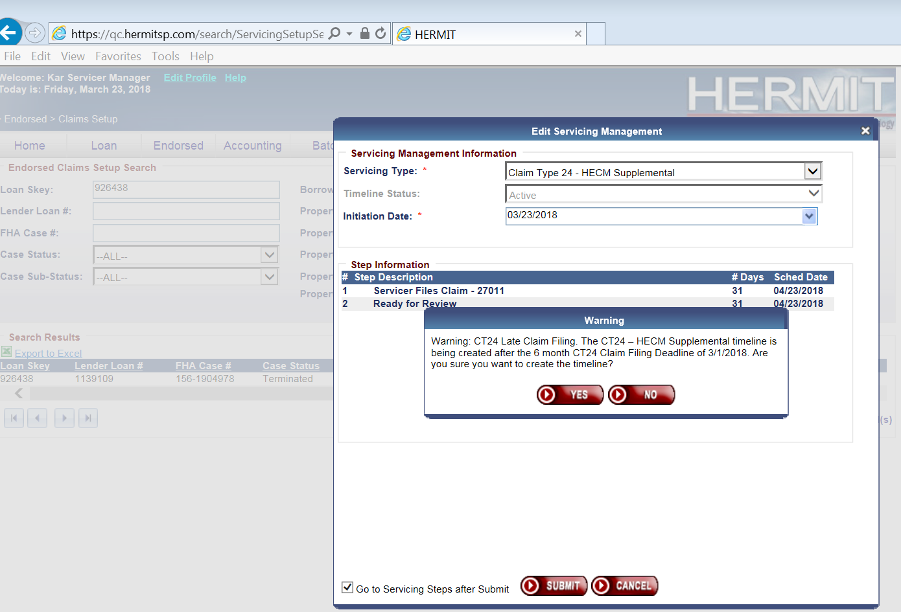

**Figure 11: CT24 timeline created after 6 month timeframe**

* 1. **Servicers: opening an existing CT24 more than 6 months after parent claim paid date**

When a servicer opens an existing “Claim Type 24 – HECM Supplemental” timeline past the 6 month timeframe, an informational pop-up message will be displayed stating “**Warning: CT24 Late Claim Filing. This CT24 – HECM Supplemental claim will be filed after the 6 month CT24 Claim Filing Deadline of MM/DD/YYYY Mortgagee Comments will be required.”** The pop-up message will display an OK button.

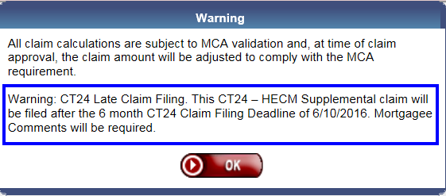

**Figure 12: CT24 timeline opened after 6 month timeframe**

* 1. **Servicers: submitting CT24 to HUD more than 6 months after parent claim paid date**

When a servicer clicks “Finalize and Submit Claim” on a Claim Type 24 Supplemental that is past the 6 month timeframe, a pop-up message will be displayed stating “Warning: CT24 Late Claim Filing. This CT24 – HECM Supplemental claim will be filed after the 6 month CT24 Claim Filing Deadline of MM/DD/YYYY Mortgagee Comments will be required.” The pop-up message will display YES and NO buttons. Clicking “Yes” will initiate the CT24 timeline, clicking “No” will not create the CT24 timeline.

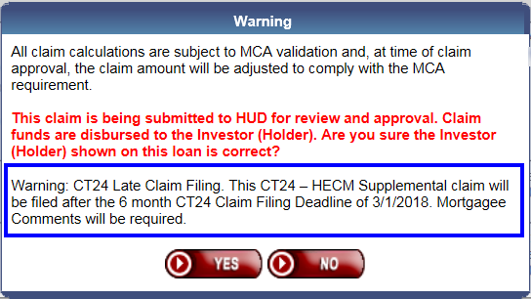

**Figure 13: CT24 submitted after 6 month timeframe**

When a CT24 is submitted or resubmitted past the 6 month timeframe, an Alert and auto-note will be added to the loan. See topic 10.5 for details.

* 1. **HUD: approving CT24 submitted more than 6 months after parent claim paid date**

When HUD approves a Claim Type 24 Supplemental that was submitted past the 6 month timeframe, an informational pop-up message will be displayed stating “**This CT24 was filed after the 6 month Supplemental Claim Filing Deadline of MM/DD/YYYY. Are you sure you want to Approve this claim?”** The pop-up message will display YES and NO buttons. Clicking “Yes” will approve the CT24, clicking “No” will not approve the CT24.

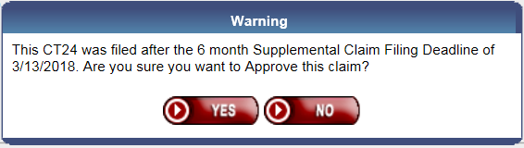

**Figure 14: CT24 Approved on claim filed after 6 month timeframe**

When HUD Pends or Approves a claim, the HUD Decision and the Decision Notes will be automatically saved to the Notes page. See topic 16 for details.

* 1. **New Alert: CT24 filed more than 6 months after Parent Claim Paid Date (542967 REQ 2.2, 2.4)**

A new alert “**Claim Type 24 - Filed Past Deadline**” was added to HERMIT. The alert will be added to a loan when a servicer submits the Claim Type 24 Supplemental more than 6 months after parent claim paid date.

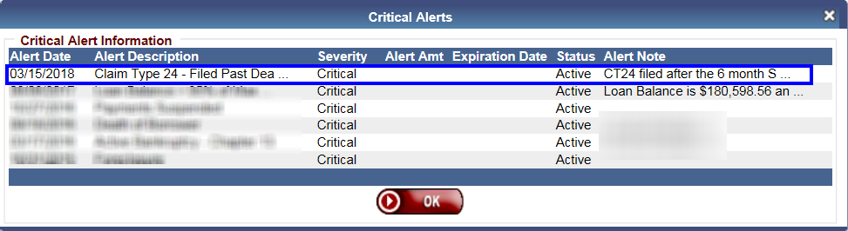

**Figure 15: New Alert “Claim Type 24 – Filed Past Deadline”**

When Alert type “Claim Type 24 – Filed Past Deadline” is added to a loan, an Alert Note is automatically saved to the Notes page.

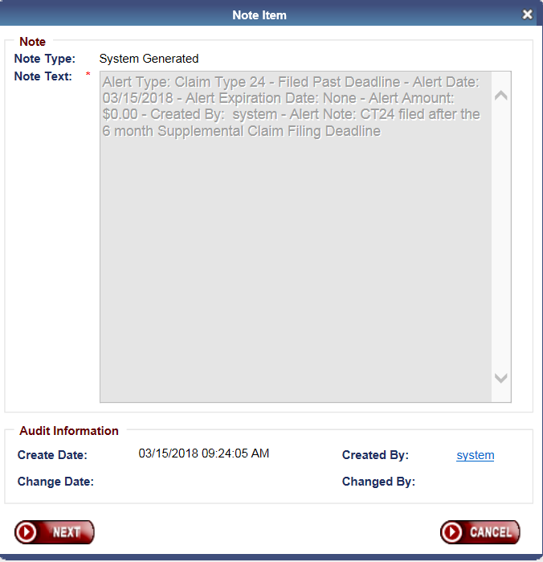

**Figure 16: Alert Note “Claim Type 24 – Filed Past Deadline”**

The alert will be available on the drop down for Assigned Notes Reports > Daily Reports > Alerts Detail report.

## CLAIMS – CT24 Modify the 45 day Resubmit rule

* 1. The following applies to Claim Type 24 Supplemental claims pended back to the servicer by HUD. Per HUD Policy, the servicer has 45 days to resubmit a claim to HUD after the CT24 claim was pended back to the servicer. If the servicer misses the 45 day timeframe, a hard stop prevents resubmission of the claim. This is current functionality in HERMIT.

HERMIT was modified to enforce the 45 day restriction only if the CT24 is resubmitted more than 6 months after parent claim paid date. If the CT24 is resubmitted within the original 6 months from parent claim paid date, the 45 day restriction will not apply.

* 1. **Example 1:** **If** **servicer resubmits a CT24 within 6 months of the parent claim paid date, the 45 day restriction is not applicable.** HERMIT will allow the claim to be resubmitted even if it is more than 45 days from the pended date.
* Parent claim paid date: 03/15/17
* 6 months from parent claim paid: **09/15/17**
* Servicer submitted initial CT24: 07/10/17
* HUD pended claim: 07/15/17
* Servicer resubmits CT24: 09/05/17

Result: CT24 can be resubmitted even though it is more than 45 days from pended date.

* 1. **Example 2:** **If servicer resubmits CT24 after 6 months from parent claim paid date, the 45 day check applies.** If resubmit date is past 45 days from the “HUD Decision - Pending Additional Info” Completion date, the claim cannot be resubmitted and a hard stop message will be displayed. This is current functionality.
* Parent claim paid date: 03/15/17
* 6 months from parent claim paid: **09/15/17**
* Servicer submitted initial CT24: 09/10/17
* HUD pended claim: 10/01/17
* HUD pended claim + 45 days: **11/15/17**
* Servicer attempts to resubmit CT24: 11/20/17

Result: CT24 cannot be resubmitted because it is more than 45 days from the pended date.

* 1. **Example 3: If servicer resubmits CT24 after 6 months from parent claim paid date, the 45 day check applies.** If resubmit date is within 45 days of the “HUD Decision - Pending Additional Info” Completion date, the claim may be resubmitted. This is current functionality.
* Parent claim paid date: 03/15/17
* 6 months from parent claim paid: **09/15/17**
* Servicer submitted initial CT24: 09/10/17
* HUD pended claim: 10/01/17
* HUD pended claim + 45 days: **11/15/17**
* Servicer attempts to resubmit CT24: 11/05/17

Result: CT24 can be resubmitted because it is within 45 days from pended date.

## CLAIMS – CT24 Block #27

Previously, the Block #27 amount on Claim Type 24 Supplemental was populated with the Block #27 amount from the parent claim. Going forward, Block #27 on the CT24 will be editable and will reduce the total claim amount.

* 1. **CT24 Block #27 “Recovery or Estimate of Damage” is** **editable** on the Claims Worksheet for Claim Type 24 Supplemental claims. The field reduces the total claim amount and accepts values between zero and $500.000.00. The field shall be used to report damage or loss proceeds received that were not reported on the parent claim. The amount entered in Block #27 will be displayed in the AOP “Damage / Escrow” section. This amount will not be included in the Block #135 or Block #137 total on the claim form.

Editable field:

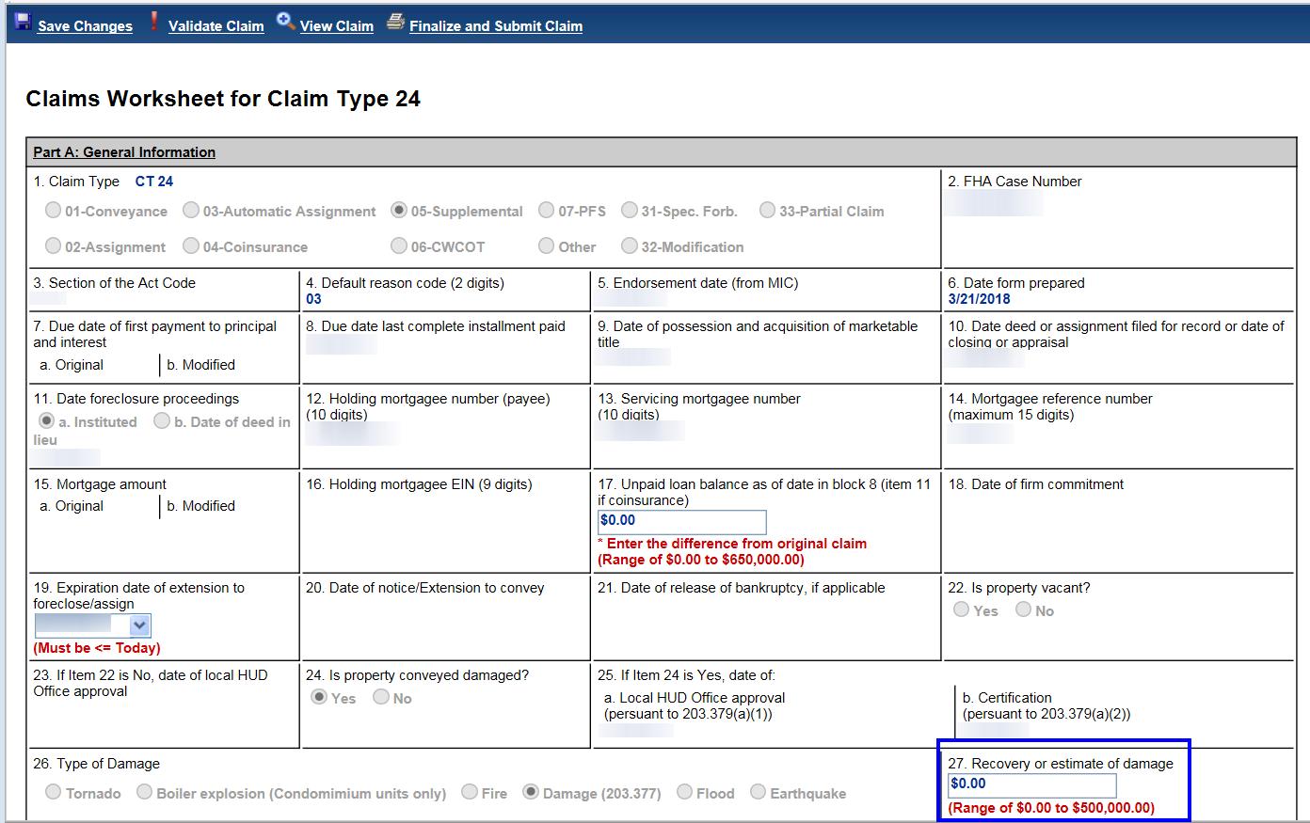

**Figure 10: Block #27 editable on CT24**

* 1. **All Claim Types: Damage / Escrow amount from Block #27 is on the Claims Detail Report**. For Claim Types 21, 23, and 24 the Damage Escrow amount in Block #27 was added to the Claims Detail report found under Servicer Reports > Daily Reports > Claims Detail.
  2. **Important**: Claim Type 24 Supplemental timelines already created but not approved by HUD before the 5.5 release will have the Block #27 amount carried over from the parent claim zeroed out. This will prevent the CT24 from being reduced by the Block #27 amount from the parent claim. After the amount is zeroed out, the servicer can update Block #27 with the amount appropriate for the CT24.
  3. **Note**: if a large amount is entered in Block #27 which causes the claim to become negative, the Negative Claim validation message will be displayed and servicers must use the Over Claim process to remit funds to HUD that are owed. See topic 15 for new negative claim validation message. See topic 20 for details on the Over Claim process.

## CLAIMS – CT24 Include Block #132 b amount in Block #135 and #137 totals

Block #135 “Column B Additions” subtotal and Block #137 “Net Claim Amount” subtotal fields were updated to include the Block #132b amount on the Claim Type 24 Supplemental.

## CLAIMS – Rename Claims pop-up window

The title of the pop-up window displayed when the servicer opens the Claims Worksheet and clicks “Finalize and Submit Claim” has been changed to “Warning” from “MCA validation”. Multiple messages may be displayed in this window.

## CLAIMS – Update Negative Claim Validation Message

The Negative Claim Validation message on all claim types has been updated to “**The total claim amount entered will result in a negative amount and cannot be filed. Refer to the HECM Worksheet for details. Please omit all funds due to HUD and remit them separate from this claim using the Over Claim transactions on the Loan > Transactions > Claims Page.”**

Examples of funds to be excluded from the claim form and remitted to HUD via the Over Claim process are Block #27 amounts, Repayments, or Refunds.

New validation message:

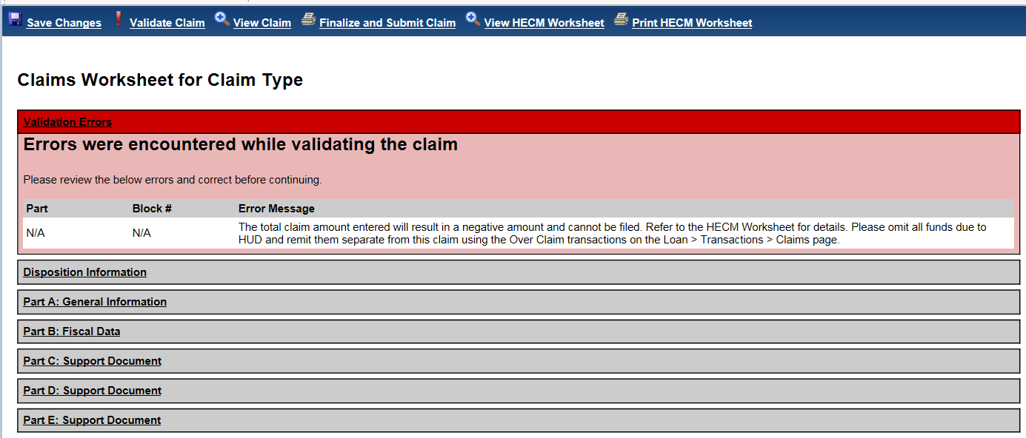

**Figure 14: Updated Validation Message for Negative Claim**

See topic 20 for details on the Over Claim remittance process.

**Note**: For the HECM Worksheet to be auto-saved to Documents, the “Print HECM Worksheet” icon must be clicked. If this is not clicked, the HECM Worksheet is not saved to Documents and the information can only be viewed in the edit screen. Before requesting assistance to research a negative claim, please ensure the “Print HECM Worksheet” button has been clicked.

## CLAIMS – Add HUD Decision Notes

For any Claim Type 21, 23, or 24 where HUD selects the decision “Approve Claim” or “Pending Addition Info”, the comments from the HUD “Decision Notes” box on the Claims Worksheet will be automatically saved to the Notes page. If no text is typed in the box, the auto-note will display the claim type and the HUD Decision.

## CLAIMS – Claims Detail Report

The “Claim Paid Amt” column on the Claims Detail report will now only be populated when the claim is actually paid in HERMIT.

## CLAIMS – Change to Advice of Payment Debenture Interest “To” date

Previously, the Advice of Payment (AOP) Debenture Interest “to” date field could display a date **before** the AOP Debenture Interest “from” date, such as when the curtailment date was before the Due Date (CT21: Block #29, CT23: Block #8). HERMIT was updated so the AOP date displayed in the Debenture Interest “to” date will not be before the Debenture Interest “from” date. The date of the auto-curtailment is still displayed in the HUD Comments and there is no change to the claim calculation as a result of this update.

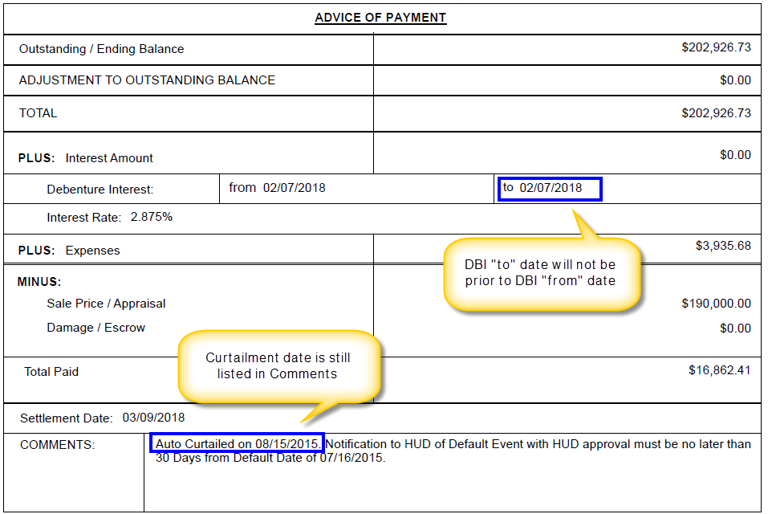

**Figure 6: Advice of Payment (AOP)**

## CLAIMS – Add Paper Claims to HERMIT

**Paper Claim Data viewable in HERMIT**. Paper claim data was added to HERMIT and can be viewed at the loan level in the Loan Module under Transactions > Claims. The “Created By” displays user name “PaperClaim”.

**HERMIT Validations for loans with Paper Claims**. For loans with Paper Claim transactions, a hard stop will prevent the user from creating a new Claims timeline. The pop-up box will display a message “**There is a Paper Claim Transaction on this loan, creating a new Claims Timeline is not allowed”** with the option to click OK. Please contact the SM Help Desk for any requests to remove the Paper Claim records. Supporting Documentation for the removal of the paper claim record must be included with the request.

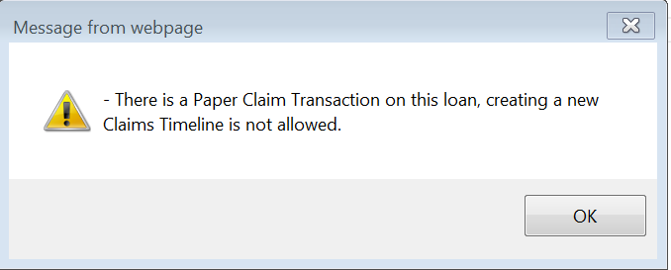

**Figure 15: Paper Claim message**

## CLAIMS - Claim Reimbursements - Over Claims: Servicers remit funds to HUD via HERMIT

New HECM Over Claim functionality is now available in the HERMIT application for CT21, CT23, and CT24 claims. The purpose of the Over Claim process is for servicers to use HERMIT to remit funds to HUD as needed after a claim was paid. Prior to the HERMIT 5.5 Release, the process to remit funds to HUD was conducted outside of the HERMIT system.

New HERMIT transactions have been built into the HERMIT Servicing Module and will be processed through the Accounting Module, which will enable these Over Claims to be collected via the existing Pay.Gov application designed for the Claims Accounting Area. The Over Claim transactions will be entered at the case level in the Servicing Module and will ensure the Servicing Module and the Accounting Module processes are reconciled. The Over Claim Transaction(s) cannot be entered in HERMIT unless a Claim Type 21, 22, 23 or 24 has previously been paid on the case. A new HERMIT Over Claim report is also available which will allow reports to be pulled to view Over Claim transactions that were entered into HERMIT.

#### 20.1 New HECM Over Claim Transaction Codes available for the remittance of HECM Over Claims:

* Claim Type 21 – Over Claim
* Claim Type 22 – Over Claim
* Claim Type 23 – Over Claim
* Claim Type 24 – Over Claim

#### 20.2 Claim Type 22

If a Claim Type 22 Overpayment is required, the user must submit a request to the HERMIT Help Desk. The Claim Type 22 Over Payment transaction is not available through the User Interface and will need to be completed through a DCR.

Please include the following information for each transaction with your request:

* Transaction Category
* Transaction Type
* Effective Date
* Transaction Amount
* Reason Code
* Note

#### 20.3 Claim Type 21, 23 and 24

The Over Claim transactions will be available in the Transaction -> Claims page for Claim Type 21, 23 and 24 when the user clicks the “New” button.

The “New” button for the Over Claim Transaction will not appear unless a Claim Type 21, 23 or 24 has been paid on the case previously.

User Role “Servicer Manager” will have access to create the Over Claim transactions in the Transaction -> Claims Screen with the “New” button.

The Over Claim Transaction Type will only appear for the Claim Type that was previously filed and paid in HERMIT.

* Example 1: If a Claim Type 21 was filed and Paid in HERMIT then only the CT 21 Over Claim transaction will appear
* Example 2: If a Claim Type 23 was filed and Paid in HERMIT then only the CT 23 Over Claim transaction will appear
* Example 3: If a Claim Type 23 and 24 were filed and Paid in HERMIT then a CT 23 and 24 Over Claim transaction will appear
* Example 4: If a Claim Type 21 and 24 were filed and Paid in HERMIT then a CT 21 and 24 Over Claim transaction will appear

When the “new” button is clicked, the following information will appear in the “New” transaction box. All fields are required.

* Transaction Category (Claims A/R)
* Transaction Type (The applicable transactions will be listed)
* Effective Date
* Transaction Amount
* Reason Code
* Note box (Must provide detailed explanation of reason code)

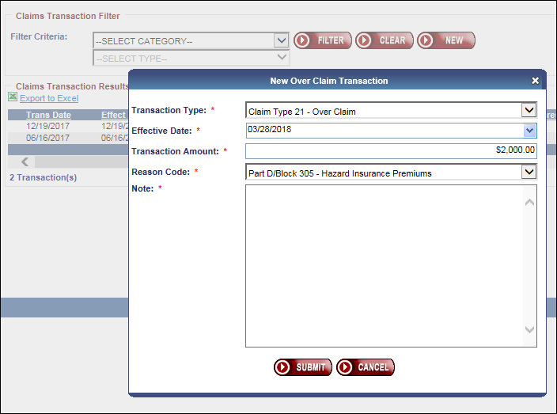

**Figure 15: New Over Claim Transaction**

A note box will appear when the transaction is created so that a user can enter a note explaining the reason for the Over Claim to HUD (capped at 500 characters).

The note from the note box on the “new” Transaction screen will be viewable in the Notes section of HERMIT

A popup box will be displayed when the user is creating the transaction as any amounts that are paid back to HUD will be final. No positive adjustments (Accounts Payable) can be made through HERMIT.

The message will state the following:

“Please ensure the Over Claim amount is correct and includes any associated computation of interest due back to HUD. Interest due back to HUD should be indicated separately using the appropriate interest related Reason Code. Submitting this transaction authorizes HUD to collect the amount of $XXXX.XX from your account. This amount cannot be reversed once submitted. Are you sure you want to continue?”

There will be a YES/NO button option to confirm the transaction

When the user clicks “Yes”, there will be a validation to ensure the Mortgagee ID associated with the user has valid banking information and a Tax Identification Number (TIN) in the Servicing Module.

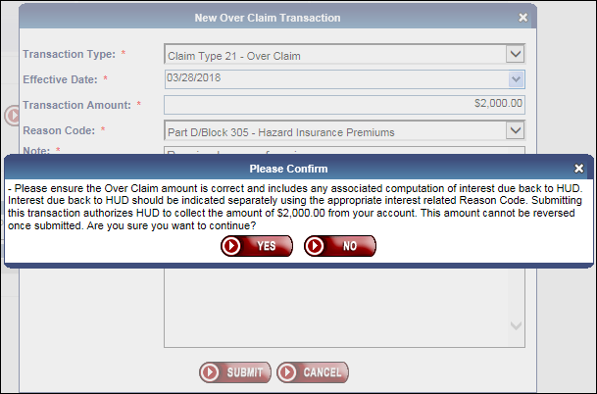

**Figure 16: Confirm Over Claim Transaction**

Over Claim transactions will be summed at the case level in a Claims Receivable batch at the end of each day. This batch and its batch details can be viewed in the Accounting -> Transmittal page.

The loan balance will not be affected by the Over Claim Transaction

#### 20.4 The following Reason Codes will be available for the Over Claim Transactions:

Multiple Over Claim transactions for a claim must be entered on the case when there is more than one reason code needed. If the amount(s) being paid back to HUD are for different reasons please enter these as separate amounts and choose correct Reason Code that the amount pertains to. A Reason Code dropdown will be available where the user can choose the reason for the Over Claim.

Reason code list:

* (Part A/Block 27) – Hazard Insurance/Loss Draft Funds
* (Part A/Block 27) – Property Damage Adjustment
* (Part C) – Disbursements for Protection & Preservation
* Part D/Block 305 – Hazard Insurance Premiums
* Part D/Block 305 – Taxes
* Part D/Block 305 – Utilities
* Part D/Block 305 – Servicing Fees
* Part D/Block 305 – Forced Place Insurance
* Part D/Block 305 – HOA Fees
* Part D/Block 305 – Eviction Fees & Costs
* Part D/Block 305 – Other
* Part D/Block 306 – Attorney/Trustee Fees
* Part D/Block 307 - Recording Fees
* Part D/Block 307 – Sheriff Fees
* Part D/Block 307 – Clerk Costs
* Part D/Block 307 - Publication Fees
* Part D/Block 307 - Foreclosure and/or Acquisition, Conveyance Costs – Other
* Part D/Block 311 - Mortgage Insurance Premiums
* Part E/Block 407 - Taxes Owed to Buyer at Closing
* Part E/Block 407 - Water Rates Owed to Buyer at Closing
* Part E/Block 407 - Special Assessments Owed to Buyer at Closing
* Part E/Block 407 - Amount Owed to Buyer at Closing – Other
* Part E/Block 408 - Sales Commission
* Part E/Block 408 – Recording Fees
* Part E/Block 408 – Title Insurance Policy
* Part E/Block 408 – Additional Closing Costs at Settlement – Other
* Part E/Block 409 – Appraisal Fees
* Note Interest Back to HUD
* Debenture Interest Back to HUD
* Erroneous Duplicate Payment
* Other

The Reason Code has been added to the Batch Details page of the Accounting Transmittal Screen and is included in the “Export to Excel” feature from the Batch Details page.

The total of the Over Claim transaction amounts cannot exceed the claim amount on the original claim that was paid. This total is measured at the claim level, not the loan level. The Over Claim transaction type that is selected will determine which claim is checked. For a loan with both a CT21 and a CT24 supplemental were paid, if the “Claim Type 21 – Over Claim” transaction is selected, HERMIT will check against the claim total from the Claim Type 21.

No Authorizations will be needed for the collection to be processed.

An adjustment icon will be displayed on the transaction on the transaction Claims until the transaction is batched and sent over to the Accounting Module at the end of the day.

The Over Claim transactions will be under the **Claims Receivable** Batch Type from the Accounting -> Transmittal page.

#### 20.5 Over Claim Transaction Validations

* Over Claim transactions for CT 21, 23 and 24 will only be allowed to be entered via the User Interface.
* This new transaction type will not be subject to the MCA limit check.
* This new transaction will not be subject to any claim validations.
* Multiple Over Claim transactions can be created on the same FHA Case Number.
* Over Claim transactions will be summed at the case level in a Claims Receivable batch at the end of each day.  This batch and its batch details can be viewed in the Accounting -> Transmittal page.
* There is no time limitation set forth to remit funds to HUD

#### 20.6 Over Claim Report

A new Over Claim Report will be available on the Servicer Reports -> Daily Reports Section of the HERMIT -> Reports page.

This Over Claim Report will only be available in Excel.

The **Search Criteria** for the Over Claim Report will be the following:

* Servicer Name (Defaulted to the servicer logging in, open to all for HUD Roles)
* FHA Case #
* Loan Skey
* Transaction Date (To and From)
* Transaction Description (Dropdown to display values to include all)
* Reason Code (Dropdown to display values to include all)

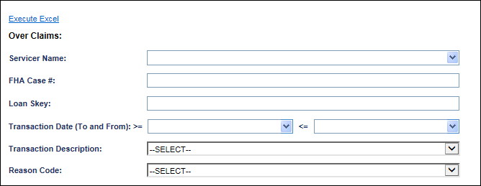

**Figure 17: Over Claim Report**

The **Search Results** will contain the following fields:

* Loan Skey
* FHA Case Number
* Transaction Date
* Effective Date
* Transaction Category
* Transaction Description
* Over Claim Amount
* Reason Code Description
* Note
* Created By
* Created Date
* Changed By
* Changed Date

## Assigned – Auto Note when Record is received from DMF

An auto-note will be added to HERMIT any time a death date is added, changed, or deleted by the DMF on Assigned loans. The note description will depend on the type of update:

* If DMF record is Added the note will be displayed as: “Death date added by DMF”
* If DMF record is Changed the note will be displayed as: “Death date changed by DMF”
* If DMF record is Deleted the note will be displayed as: “Death date deleted by DMF”

## Assigned – Occupancy Compliance Certification timeline DMF

Currently, when the death date of a last surviving borrower is entered into HERMIT on an Assigned loan, HERMIT inactivates the “Occupancy Compliance Certification” timeline from Assigned > Compliance > Occupancy. An enhancement was made to HERMIT to re-activate the newest “Occupancy Compliance Certification” timeline when the DMF file **deletes** a death date for a last surviving borrower.

## Assigned – Reject CHUMS 98 record when Preliminary Title Approval

HERMIT will reject any CHUMS 98 record changes on loans with a Case Status of Endorsed and Case Sub-Status of “CT 22 - Preliminary Title Approval”.

A new error message will be logged in the CHUMS Exception Report:

“CHUMS 98 record change cannot be processed when Case Status is Endorsed and Case Sub-Status is CT 22 - Preliminary Title Approval”

## Assigned – New Disb-Unscheduled from LOC - Release Fee disbursement

A new transaction called “Disb - Unscheduled from LOC - Release Fee” will be available to the HUD Loan Servicing Center Contractor and will be entered through the “New Disbursement” window. This new transaction does not apply to Endorsed loans and will not be available for Servicers.

The following below will show in the New Disbursement window:

* The Transaction Category will be “Disb – Unscheduled from LOC”
* The Transaction Description will be “Disb - Unscheduled from LOC - Release Fee”
* The Payee Type will default to “Vendor”.
* The Vendor Type “Release Fee” will be available under the Vendor Type drop down menu.
* The Payee “NOVAD (Release fees)” will be available under the Payee drop down menu

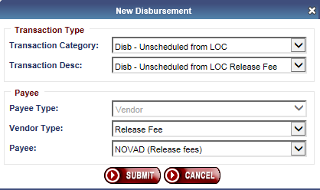

**Figure 18: New Transaction Disb-Unscheduled from LOC - Release Fee**

The “Disb – Unscheduled from LOC Release Fee” transaction will have a corresponding adjustment Transaction Code if the disbursement is voided.

The “Disb – Unscheduled from LOC Release Fee” can be entered via the UI on the Loan > Disbursement page for Assigned loans.

**Note: After the deployment of the V5.50 release, all existing disbursements under “Disb-LOC-Property Charge Ground Rents” with Vendor type - “Valuator” will be moved to “Disb - Unscheduled from LOC - Release Fee” with Vendor type - “Release Fee”. All existing adjustment to disbursements under “Disb-LOC-Property Charge Ground Rents Adj” with Vendor type - “Valuator” will be move to “Disb - Unscheduled from LOC - Release Fee Adj” with Vendor type - “Release Fee” and linked to the parent transaction.**