 of

December 22, 2021

Social Security Administration Office of Income Security Programs

Keys Section

2518 Robert M. Ball Building

6401 Security Boulevard

Baltimore, Maryland 21235

RE: 2022 Keys Amendment Certification

Dear Mr. Logan:

Pursuant to the provisions of Section 1616(e) of the Social Security Act, I certify that the Tennessee Department of Health (TDH), as the designated State Agency for coordinating compliance with the Keys Amendment; the Tennessee Department of Mental Health and Substance Abuse Services (TDMHSAS), based upon the information provided by Alex R. King, J.D., Director of Licensure at TDMHSAS; and the Tennessee Department of Intellectual and Developmental Disabilities (TDIDD), based upon the information provided by Daven N. Harrell, Director of Risk Management and Licensure at (TDIDD), are in compliance with the statutory and regulatory provisions of the Keys Amendments for the federal fiscal year of 2022.

The Office of Health Care Facilities at TDH is the regulatory agency for nursing homes, assisted care living facilities, as well as other types of health care facilities. TDMHSAS is the regulatory agency for Tennessee agencies providing mental health and alcohol and drug abuse services. TDIDD is the regulatory agency for Tennessee agencies providing services to those with developmental and intellectual disabilities. A complete copy of rules may be viewed as follows:

TDH http ://publications.tnsosfiles.com/rules/1200/1200-08/1200-08.htm

TDMHSAS https://publications.tnsosfiles.com/rules/0940/0940.htm

TDIDD http://(publications.tnsosflles.com/rules/0465/0465. htm

I certify that the standards promulgated through TDH, TDMHSAS, and TDIDD are made available annually to the public for review. In addition, any interested individual may obtain a copy of the standards along with a list of waivers of the standards, enforcement procedures, and any violations, upon request.

 of

Enclosed is a summary of revised standards and enforcement procedures for 2020. If you should need further assistance, please do not hesitate to contact me at (615) 741-6257.

Respectfully

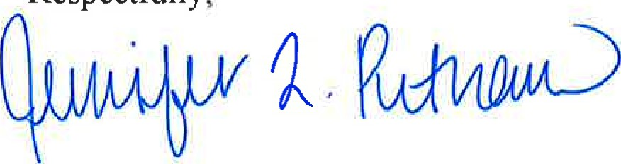

Jennifer L. Putnam, Esq.

Assistant Commissioner, Health Licensure and Regulation

Valerie Nagoshiner, Chief of' Staff, Department of Health

Ann R. Reed, Director of Licensure, Office of Health Care Facilities, Department of Health

Alex R. King, J.D., Director of Licensure, Department of Mental Health and Substance Abuse Services

Daven N. Harrell, Director of Risk Management and Licensure, Department of Intellectual and Developmental Disabilities

Enclosure