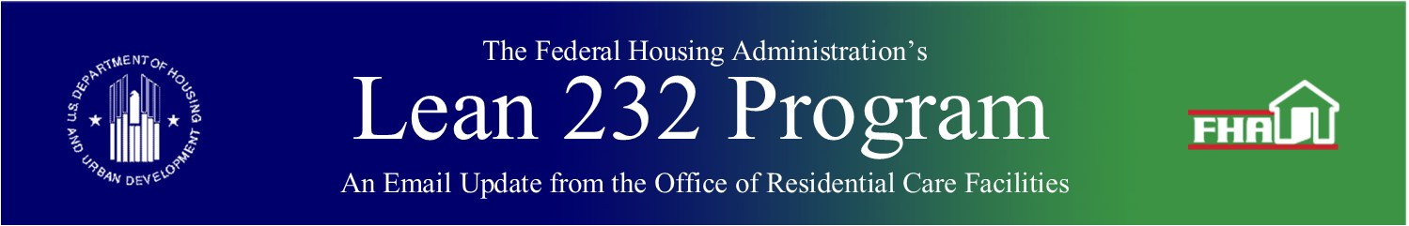

November 4, 2020

# ORCF Webinar Presentation – November 18, 2020, 3:00 P.M. Eastern, Focusing Primarily on Asset Management Matters Related to the Covid-19 Pandemic

In a webinar hosted by the American Health Care Association/National Center for Assisted Living (AHCA/NCAL), ORCF will provide a brief overview of the Section 232 program and address asset management matters related to the COVID-19 pandemic. The webinar will run from 3:00 p.m. to approximately 4:00 p.m. EST on November 18, 2020, and will be open to AHCA/NCAL members and nonmembers. There is no charge for participation.

Presentation topics will include:

* Understanding the options for flexibility available in ORCF programs.
* Understanding the HUD notification requirements if your facility seeks resources made available under the recent Federal emergency legislation.
* Understanding the accounting requirements for Quarterly Financial Statements if relief has been received and any impact on the Surplus Cash Computation.
* Understanding the changes in inspection procedures for PCNAs, Appraisals and other physical inspections during the Pandemic.
* Understanding the roles, responsibilities and methods of Lenders, Borrowers and Operators in responding to ORCF of perceived risks.
* Understanding the newly enacted 232 Portal Requirements for Asset Management activities.
* Understanding where to find notifications of updates, revisions in Questions and Answers, Email Blasts, etc.

Speakers:

* John Hartung, Director, Policy, Risk Analysis and Lender Relations Division, Office of Residential Care Facilities, HUD
* Philip Head, Director, Asset Management Division, Office of Residential Care Facilities, HUD
* Rita Dockery, Deputy Director, Asset Management Division, Office of Residential Care Facilities, HUD

**Event Date:** November 18, 2019 – 3:00 p.m. – 4:00 p.m. (EST)

**Registration Link:** [Here](https://educate.ahcancal.org/products/section-232-program-overview-and-orcfs-response-to-covid-19)

Although membership to AHCA/NCAL is not required to participate in the webinar, you will still need to create an AHCA/NCAL username and password to register for the webinar.

**How to Register for AHCA/NCAL webinar:**

* Webinar participants will need to [login](https://members.ahcancal.org/Home/Sign-In?returnUrl=https://educate.ahcancal.org) using their existing ahcancalED username and password first.
* Once you are logged in to the website you will be able to register for the webinar by clicking the green register button at the top of the page.
* If you have forgotten your password click [here](https://members.ahcancal.org/Dashboard/Sign-In-Help).

**How to Register for an AHCA/NCAL username and password**:

* + To avoid technical problems, use Google Chrome.
  + If you are new to the site, you can create an account [here](https://members.ahcancal.org/Dashboard/Create-New-User-Account). After creating an account, you will be able to register for the webinar.

If you need further assistance with creating an AHCA/NCAL account, please email [educate@ahca.org](mailto:educate@ahca.org)

***Keywords:*** *Webinar*

Back to top

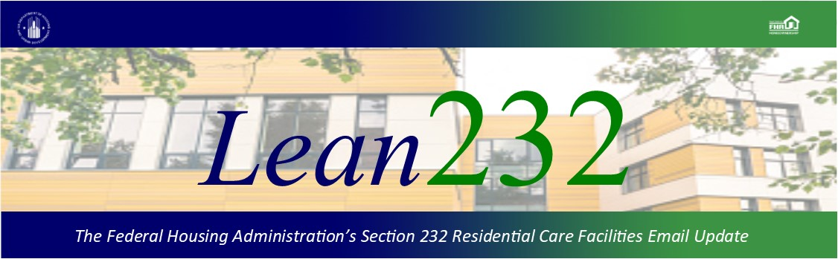

Past Lean 232 Updates are [available online](http://portal.hud.gov/hudportal/HUD?src=/federal_housing_administration/healthcare_facilities/residential_care/mail_blast_index).

Have questions about the Lean 232 Program? Please contact [LeanThinking@hud.gov](mailto:LeanThinking@hud.gov).

For more information on the Lean 232 Program, check out: <http://www.hud.gov/healthcare>.

Have your loan servicing colleagues joined our email list? The Email Blasts contain information relevant to them as well. You might suggest they [Join here](http://portal.hud.gov/hudportal/HUD?src=/subscribe/signup&listname=Lean%20232%20Updates&list=LEAN-232-UPDATES-L).

We hope that you will want to continue receiving information from HUD. We safeguard our lists and do not rent, sell, or permit the use of our lists by others, at any time, for any reason. If you wish to be taken off this mail list, please [go here](http://portal.hud.gov/hudportal/HUD?src=/subscribe/signup&listname=Lean%20232%20Updates&list=LEAN-232-UPDATES-L).

*Lean 232* is a publication of the Federal Housing Administration (FHA) Office of Healthcare Programs, U.S. Department of Housing and Urban Development, 451 7th Street, SE, Washington, DC 20410.

Connect with FHA on [Social Media](https://portal.hud.gov/hudportal/HUD?src=/program_offices/public_affairs/socialmedia) Twitter