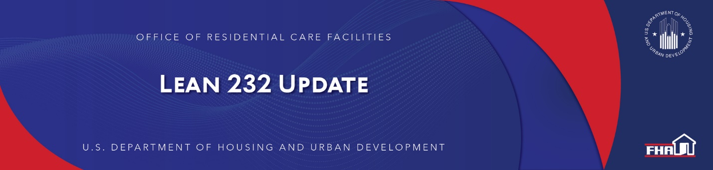

March 24, 2021

In This Update

- Delegation to FHA Lenders and Their Authorized Representatives to Initiate Section 106 Consultation with State Historic Preservation Offices
- Ward Beds, Room Density and Functional Obsolescence

Delegation to FHA Lenders and Their Authorized Representatives to Initiate Section 106 Consultation with State Historic Preservation Offices
The introductory chapter of Handbook 4232.1, Section I, Chapter 1.4 states, “If a particular Section 232 program matter is not addressed in this Handbook, and appears in other guidance, questions regarding applicability may be raised with ORCF.” This language is particularly apt with respect to the recent delegation memo to FHA lenders and their authorized representatives to initiate consultation with State Historic Preservation Offices. The MAP Guide provides lenders procedural guidance for implementing that delegated authority, but the Section 232 Handbook currently does not, and ORCF has been contacted for guidance on this issue. Unless and until ORCF issues guidance different than what is provided in the MAP Guide (specially at 9.6.4 thereof) on this particular matter, Lenders on Section 232 transactions must follow the procedures set forth at MAP 9.6.4 as to SHPO communications.

The delegation does not extend to consultation with the Tribes. For projects that require Section 106 consultation with Tribes, ORCF staff must still initiate and conduct consultation with Indian Tribes and Native Hawaiian Organizations (NHOs). Lenders must coordinate with ORCF by notifying LeanThinking@hud.gov so that HUD may begin consultation with Tribes. Lenders must consider comments received from Tribes or NHOs within review timeframes before submitting a finding of effect to the SHPO for concurrence.

Keywords: State Historic Preservation Office (SHPO)

Back to top

Ward Beds, Room Density and Functional Obsolescence
ORCF generally considers the presence of ward beds as a potential risk factor in underwriting 232 transactions. The National Emergency resulting from the COVID-19 virus adds even greater importance to the consideration of functional obsolescence associated with wards.

As a result, ORCF will consider the NOI’s sensitivity to the loss of three- and four-bed wards and the facility’s ability to meet the program’s required minimum debt service coverage ratio (1.45) as a key risk factor. The lender should clearly demonstrate the facility’s ability to adapt to the loss of ward usage in the application. For example, the Lender Narrative should provide additional analysis, such as a sensitivity analysis that assumes conversion of all three and four bed wards to at most semi-private rooms and shows that a DSCR of at least 1.45 can be attained in that scenario.

Consideration of functional obsolescence risk is vital to the underwriting of a residential care facility loan, and the requirement of this consideration is addressed in both Handbook 4232.1, Section II, Chapter 5.2.N and the Lender Narrative (p. 21). As stated in the Handbook, this consideration includes addressing the presence of wards. The Lender Narrative states specifically: “How the physical plant compares to an optimally configured project and how does that impact income potential? (Discuss for example, 3 and/or 4 bed wards, unusual design issues, etc.)”

Applications must demonstrate analysis of ward beds considering the changed—and continually changing—circumstances. An argument simply that past census suggests such beds “are accepted” in the market is not sufficient. As the industry is aware, some states have already imposed new limitations on the use of wards, and other states are publicly considering doing so. In addition, aside from restrictions or even complete prohibitions by regulators, the marketability of ward beds in the COVID and post-COVID environment may be greatly diminished.

Keywords: Wards, Marketability, Obsolescence

Back to top

Past Lean 232 Updates are available online

Have questions about the Lean 232 Program? Please contact LeanThinking@hud.gov.

For more information on the Lean 232 Program, check out: http://www.hud.gov/healthcare.

Have your loan servicing colleagues joined our email list? The Email Blasts contain information relevant to them as well. You might suggest they Join here.

We hope that you will want to continue receiving information from HUD. We safeguard our lists and do not rent, sell, or permit the use of our lists by others, at any time, for any reason. If you wish to be taken off this mail list, please go here.

Lean 232 is a publication of the Federal Housing Administration (FHA) Office of Healthcare Programs, U.S. Department of Housing and Urban Development, 451 7th Street, SE, Washington, DC 20410.

Connect with FHA on Social Media 

