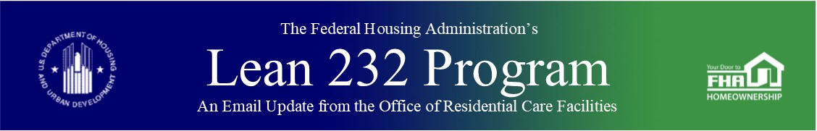

March 23, 2020

Global 30-day Extension for filing Borrower Entity Submissions with a Due Date of 3/31/20 and 4/30/20, Through HUD’s Financial Assessment subsystem

Due to possible lender business disruptions as a result of COVID-19, HUD has issued approval for a 30-day extension of all borrower entity submissions having due dates of 3/31/20 and 4/30/20, through HUD’s Financial Assessment Subsystem (FASSUB).  Such financial statements with a due date of 3/31/20 will now be due on 4/30/20, and those with a due date of 4/30/20 will now be due on 5/30/20.  This applies to **all** borrower entity FASS submissions with those due dates, both audited and unaudited.

This has been added to the Office of Healthcare Programs COVID-19 Questions and Answers for External Stakeholders ([here](https://www.hud.gov/sites/dfiles/Housing/documents/OHP%20Corona%20QA%20FINAL.pdf)).

***Keywords:*** *Financial Assessment Subsystem, FASSUB*



Past Lean 232 Updates are [available online](http://portal.hud.gov/hudportal/HUD?src=/federal_housing_administration/healthcare_facilities/residential_care/mail_blast_index).

Have questions about the Lean 232 Program? Please contact [LeanThinking@hud.gov](mailto:LeanThinking@hud.gov).

For more information on the Lean 232 Program, check out: <http://www.hud.gov/healthcare>.

Have your loan servicing colleagues joined our email list? The Email Blasts contain information relevant to them as well. You might suggest they [Join here](http://portal.hud.gov/hudportal/HUD?src=/subscribe/signup&listname=Lean%20232%20Updates&list=LEAN-232-UPDATES-L).

We hope that you will want to continue receiving information from HUD. We safeguard our lists and do not rent, sell, or permit the use of our lists by others, at any time, for any reason. If you wish to be taken off this mail list, please [go here](http://portal.hud.gov/hudportal/HUD?src=/subscribe/signup&listname=Lean%20232%20Updates&list=LEAN-232-UPDATES-L).

*Lean 232* is a publication of the Federal Housing Administration (FHA) Office of Healthcare Programs, U.S. Department of Housing and Urban Development, 451 7th Street, SE, Washington, DC 20410.

Connect with FHA on [Social Media](https://portal.hud.gov/hudportal/HUD?src=/program_offices/public_affairs/socialmedia) Twitter