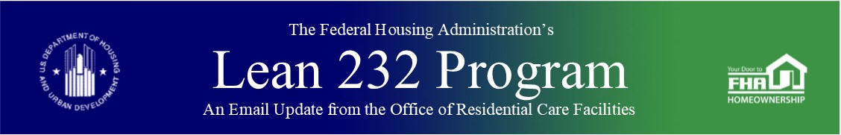

March 3, 2020

Office of Healthcare Programs

Earlier this week, HUD Secretary Dr. Ben Carson was added to the White House Coronavirus Task Force. All federal agencies are working aggressively on a multi-layered, cross-agency public health response to this evolving situation.

While the risk of infections for Americans remains low, we are encouraging Section 232 and Section 242 lenders to make the information below available to those residential care facilities and hospitals that you are doing business with, and your employees:

* [What you need to know about Coronavirus Disease 2019 (COVID-19)](https://www.cdc.gov/coronavirus/2019-ncov/downloads/2019-ncov-factsheet.pdf?utm_medium=email&utm_source=govdelivery)
* [Stop the Spread of Germs](https://content.govdelivery.com/attachments/USHUDPIH/2020/02/28/file_attachments/1389572/stop-the-spread-of-germs.pdf)
* [Symptoms of Coronavirus Disease 2019](https://content.govdelivery.com/attachments/USHUDPIH/2020/02/28/file_attachments/1389570/COVID19-symptoms.pdf)
* [What to do if you are sick with coronavirus disease 2019 (COVID-19)](https://content.govdelivery.com/attachments/USHUDPIH/2020/02/28/file_attachments/1389571/sick-with-2019-nCoV-fact-sheet.pdf)

Stakeholders are reminded to ensure that their responses remain faithful to obligations under the Constitution, Fair Housing Act and related regulations. Exigencies associated with important and timely response to issues surrounding COVID-19 are not the basis for unlawful discrimination based on race, color, religion, national origin, sex, disability or familial status.

Back to top

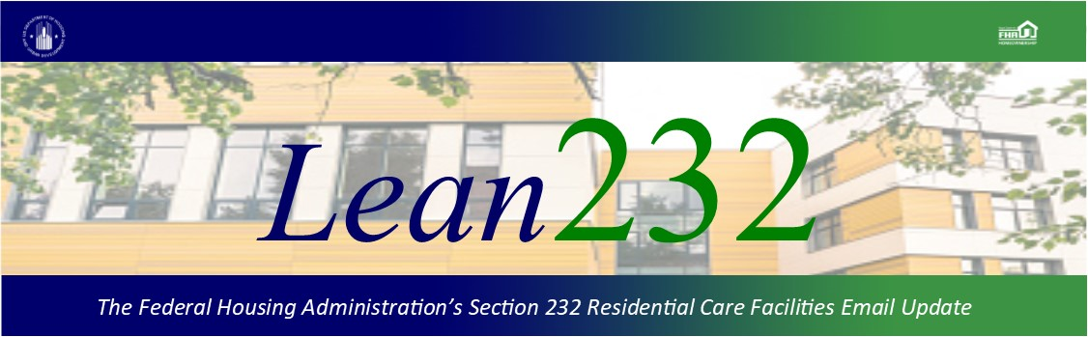

Past Lean 232 Updates are [available online](http://portal.hud.gov/hudportal/HUD?src=/federal_housing_administration/healthcare_facilities/residential_care/mail_blast_index).

Have questions about the Lean 232 Program? Please contact [LeanThinking@hud.gov](mailto:LeanThinking@hud.gov).

For more information on the Lean 232 Program, check out: <http://www.hud.gov/healthcare>.

Have your loan servicing colleagues joined our email list? The Email Blasts contain information relevant to them as well. You might suggest they [Join here](http://portal.hud.gov/hudportal/HUD?src=/subscribe/signup&listname=Lean%20232%20Updates&list=LEAN-232-UPDATES-L).

We hope that you will want to continue receiving information from HUD. We safeguard our lists and do not rent, sell, or permit the use of our lists by others, at any time, for any reason. If you wish to be taken off this mail list, please [go here](http://portal.hud.gov/hudportal/HUD?src=/subscribe/signup&listname=Lean%20232%20Updates&list=LEAN-232-UPDATES-L).

*Lean 232* is a publication of the Federal Housing Administration (FHA) Office of Healthcare Programs, U.S. Department of Housing and Urban Development, 451 7th Street, SE, Washington, DC 20410.

Connect with FHA on [Social Media](https://portal.hud.gov/hudportal/HUD?src=/program_offices/public_affairs/socialmedia) Twitter