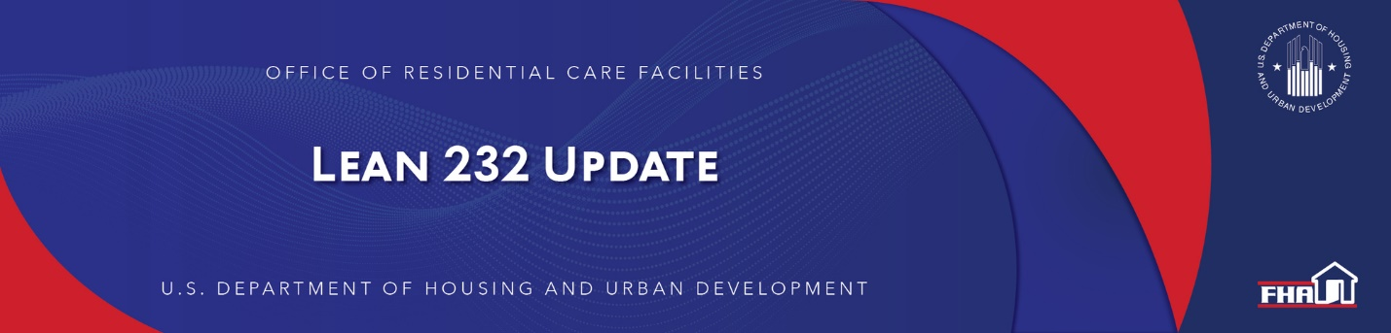

June 23, 2022

Office of Residential Care Facilities (ORCF) Position Vacancy
ORCF is pleased to announce that it is hiring for the following positions:

Production Division
Account Executive - Underwriter
The vacancy announcements are posted on USAJOBS:

Internal (Current or former federal employees qualifying as Status Candidates):

Locations – Des Moines, IA; Saint Louis, MO; Columbus, OH; Milwaukee, WI (here),
Locations – Indianapolis, IN; Minneapolis, MN; Greensboro, NC; New York, NY (here)
Locations – Washington, DC; Jacksonville, FL; Miami, FL; Chicago, IL (USAJOBS - Job Announcement)

Public:

Locations – Des Moines, IA; Saint Louis, MO; Columbus, OH; Milwaukee, WI (here),
Locations – Indianapolis, IN; Minneapolis, MN; Greensboro, NC; New York, NY (here),
Locations – Washington, DC; Jacksonville, FL; Miami, FL; Chicago, IL (USAJOBS - Job Announcement)

Because the application window is short, closing on July 11, 2022, we are asking you to help us spread the word.

Locations for the position are specified on the related vacancy announcements.

Asset Management Division
Account Executive
The vacancy announcements are posted on USAJOBS: (here) and (here).

Because the application window is short, closing on July 6, 2022, we are asking you to help us spread the word.

Locations for the position are specified on the related vacancy announcements.

Keyword: Vacancy Announcement

Back to top

Past Lean 232 Updates are available online.
Have questions about the Lean 232 Program? Please contact LeanThinking@hud.gov.
For more information on the Lean 232 Program, check out: http://www.hud.gov/healthcare.

Stay Connected with the Office of Housing and the Federal Housing Administration:

SUBSCRIBER SERVICES:
Manage Subscriptions | Help

