

June 26, 2020

In This Update

* Federal Housing Administration (FHA): Section 232 Healthcare Facility Insurance Program – Updating Section 232 Program Regulations for Memory Care Residents (FR 6022-F-02) Final Rule Published June 26, 2020
* Reminder to Carefully Review Pay.gov Submission Data
* Clarification on Professional Liability Insurance Reviews
* All Asset Management Transactions Must Be Submitted Through the Healthcare Portal Beginning September 1, 2020
* FROM THE CLOSING CORNER
* Key Items When Submitting a Closing Package to ORCF
* Reminders for Scheduling a Closing Date

Federal Housing Administration (FHA): Section 232 Healthcare Facility Insurance Program – Updating Section 232 Program Regulations for Memory Care Residents (FR 6022-F-02) Final Rule Published June 26, 2020

A Final Rule, “Federal Housing Administration (FHA):  Section 232 Healthcare Facility Insurance Program – Updating Section 232 Program Regulations for Memory Care Residents,” was published on June 26, 2020 (FR 6022-F-02). This Final Rule updates the requirements for the location of bathrooms in existing board and care homes and assisted living facilities providing memory care. The Final Rule is applicable to projects financed under Section 232 pursuant to Section 223(f) or 223(a)(7) of the National Housing Act. This Final Rule follows publication of a September 13, 2019 Proposed Rule and takes into consideration the public comments received on the Proposed Rule. These regulatory updates will improve the Section 232 Program’s availability for insuring certain existing facilities whose bathroom configuration meets the needs of their memory care residents but which have to date not comported with the applicable regulatory provision. This Final Rule is effective July 27, 2020. Please see the final rule ([here](https://www.federalregister.gov/documents/2020/06/26/2020-13090/federal-housing-administration-fha-section-232-healthcare-facility-insurance-program-updating)) for more details.

***Keywords:*** *24 CFR 232.7, Bathroom Waivers*

Back to top

Reminder to Carefully Review Pay.gov Submission Data

Since the April 30, 2020, Email Blast regarding reviewing Pay.gov submission data, HUD recorded a 25% increase in errors in the information provided with the Pay.gov fee/receipt submissions. Please be sure to carefully review your Pay.gov submissions before hitting “submit.” Examples from the April 30, 2020 Email Blast are included again here as a reminder:

If the “Section of the Act” is entered as new construction when it is actually a 223(f) refinance, or if a skilled nursing facility is listed as an assisted living facility, it will create an error in the system that requires a back-end correction.  We are asking that careful attention be paid to each piece of data provided, including the following:

* FHA #
* Project Name
* Correct Selection of Program (e.g., paid to the Office of Healthcare Programs rather than Multifamily)
* Correct Fee Type (e.g., application vs. inspection vs. MIP vs. TPA, etc.)
* Correct Program Type (e.g., SNF vs. ALF vs. Board & Care; 223(a)(7) vs. 223(f) vs. New Construction, etc.)

***Keywords:*** *Pay.gov*

Back to top

Clarification on Professional Liability Insurance Reviews

Handbook 4232.1, Section II, Appendix 14.1.A provides ORCF’s requirements for Professional Liability Insurance (PLI) Reviews. ORCF has developed sample tools to assist lenders with submissions related to this topic.

* **HUD-2 ORCF Waiver Requests:** ORCF has developed a sample tool to assist lenders with completing PLI waiver requests ([here](https://www.hud.gov/sites/dfiles/Housing/documents/HUD-2-ORCF_GLPLsample.docx)).
* **50+ PLI Reviews:** ORCF has developed a sample lender narrative discussion template ([here](https://www.hud.gov/sites/dfiles/Housing/documents/PLI_50.plus_sample%20narrative.docx)) for projects requiring a 50+ PLI review.

Lenders are reminded that if the Professional Liability and General Liability Insurance policies are combined, a waiver of Handbook 4232.1, Section II, Chapter 14.6.C may also be required.

***Keywords:*** *Professional Liability Insurance*

Back to top

All Asset Management Transactions Must Be Submitted Through the Healthcare Portal Beginning September 1, 2020

ORCF announced the roll-out of the 232 Healthcare Portal in the September 13, 2018 Email Blast ([here](https://www.hud.gov/sites/dfiles/Housing/documents/SeptEmailBlast09132018.docx)) that required Production applications to be submitted through the Healthcare Portal by December 1, 2018.  Currently, the majority of Asset Management transactions are submitted through the Portal.  Effective September 1, 2020, ORCF will no longer accept non-Portal submissions for Asset Management transactions.

***Keywords:*** *Asset Management, Portal*

Back to top

FROM THE CLOSING CORNER

Key Items When Submitting a Closing Package to ORCF

Please be reminded of the following when submitting a closing package to ORCF:

1. As stated in the August 28, 2019 and December 18, 2019 Email Blasts, all Firm Commitments that were underwritten in the Portal must be closed using the Portal. If there are issues, please contact the assigned Closing Coordinator.
2. After the assigned HUD Attorney has received a complete draft closing package**,** a complete draft closer package shouldbe submitted through the Portal. The current Section 232/223(f) Closer Checklist can be found ([here](https://www.hud.gov/sites/dfiles/Housing/documents/Closer_Checklist-f.docx)), and the current 232/223(a)(7) Closer Checklist can be found ([here](https://www.hud.gov/sites/dfiles/Housing/documents/Closer_Checklist-a7.docx)). After this has been done, a request for the assignment of an ORCF Closer should be sent to the Closer Mailbox at [ORCFCloser@hud.gov](mailto:ORCFCloser@hud.gov).
3. To facilitate timely processing, the request should include any knowncircumstancesthat influence the closing date. Please also include the name of the HUD attorney that received the package and the date it was submitted. The Lender will be notified by email when an ORCF Closer has been assigned.
4. If the draft closer package is incomplete or substantially incorrect, the assigned Closer’s review may be postponed until a complete/acceptable package has been submitted to the Portal.

Please note that a complete package includes:

* Critical repair documentation and the Borrower’s signed and dated Critical Repair Certification (HUD-91118-ORCF);
* Signed and dated Lender’s Certification of Insurance (HUD-92435-ORCF); and
* Documents required to satisfy **all** special conditions.

1. If any non-critical repairs are completed prior to closing documentation, the Borrower’s signed and datedHUD-92117-ORCFmust be submitted as early as possible.
2. For Section 223(f) projects, the final draft Cost Certification (HUD-2205A-ORCF) is due immediately after a closing date is agreed to by ORCF Closer, HUD Attorney and Lender, and must be provided ***no less than five (5) business days prior to closing.***
3. The individual signing closing documents must be authorized to sign on behalf of the entity; the HUD attorney will confirm that organizational documents include an acceptable resolution authorizing each individual signatory.

***Keywords****: ORCF Closer Packages, Signing Closing Documents; Closer Assignment*

Back to top

Reminders for Scheduling a Closing Date

A **tentative** closing will be scheduled by the ORCF closer and HUD Attorney taking into consideration:

1. The acceptability of required exhibits;
2. The need to allow three (3) business days for HUD to sign and return documents after authorization has been provided; and
3. The number of days needed for pre-recording.

The Closing date will not be confirmed (set/finalized) until all ORCF and HUD Attorney comments have been satisfied.

Please keep in mind that the closing will be postponed if the complete and acceptable closing package is not delivered to the HUD Attorney by the established deadline.

***Keywords****: Closings*

Back to top

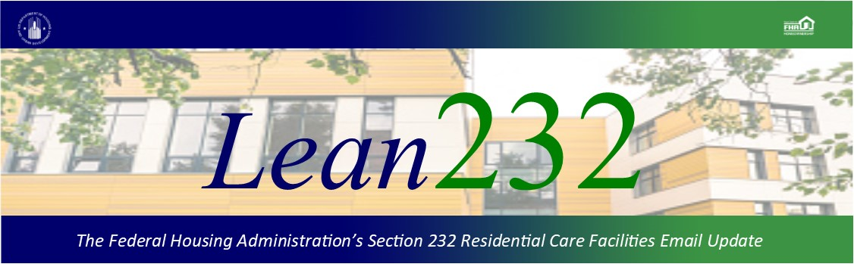

Past Lean 232 Updates are [available online](http://portal.hud.gov/hudportal/HUD?src=/federal_housing_administration/healthcare_facilities/residential_care/mail_blast_index).

Have questions about the Lean 232 Program? Please contact [LeanThinking@hud.gov](mailto:LeanThinking@hud.gov).

For more information on the Lean 232 Program, check out: <http://www.hud.gov/healthcare>.

Have your loan servicing colleagues joined our email list? The Email Blasts contain information relevant to them as well. You might suggest they [Join here](http://portal.hud.gov/hudportal/HUD?src=/subscribe/signup&listname=Lean%20232%20Updates&list=LEAN-232-UPDATES-L).

We hope that you will want to continue receiving information from HUD. We safeguard our lists and do not rent, sell, or permit the use of our lists by others, at any time, for any reason. If you wish to be taken off this mail list, please [go here](http://portal.hud.gov/hudportal/HUD?src=/subscribe/signup&listname=Lean%20232%20Updates&list=LEAN-232-UPDATES-L).

*Lean 232* is a publication of the Federal Housing Administration (FHA) Office of Healthcare Programs, U.S. Department of Housing and Urban Development, 451 7th Street, SE, Washington, DC 20410.

Connect with FHA on [Social Media](https://portal.hud.gov/hudportal/HUD?src=/program_offices/public_affairs/socialmedia) Twitter