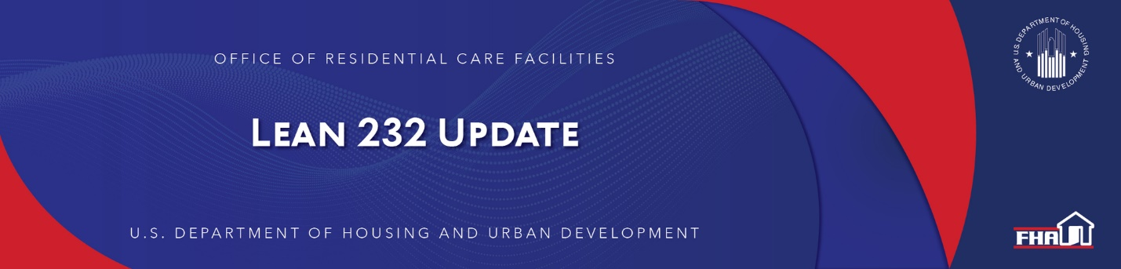

January 19, 2021

Mortgagee Letter 2021-01 Published Regarding Section 223(d) Loans Used to Mitigate COVID-Related TEMPORARY Revenue Reductions
The Office of Residential Care Facilities (ORCF) published Mortgagee Letter 2021-01 (here) on January 15, 2021. This Mortgagee Letter implements temporary statutory authority to insure operating loss loans under Section 223(d) of the National Housing Act to mitigate healthcare facilities’ COVID-related temporary revenue reductions.

Keywords: COVID-19, 223(d)

Past Lean 232 Updates are available online.
Have questions about the Lean 232 Program? Please contact LeanThinking@hud.gov.
For more information on the Lean 232 Program, check out: http://www.hud.gov/healthcare.

Stay Connected with the Office of Housing and the Federal Housing Administration:

SUBSCRIBER SERVICES:
Manage Subscriptions | Help

