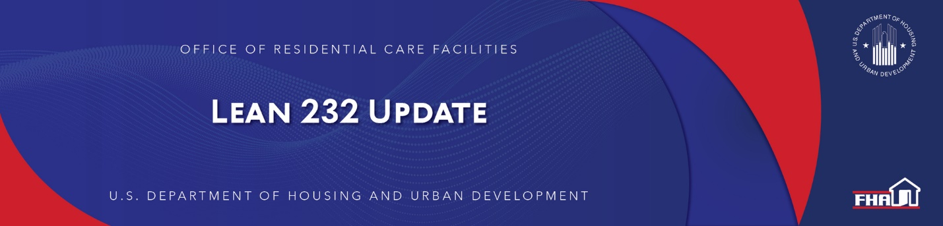

January 4, 2021

Mortgagee Letter 2020-50 Published Extending Temporary Revisions to Underwriting Standard Processes for Third-Party and Lender Site Inspections
The Office of Residential Care Facilities (ORCF) published Mortgagee Letter 2020-50 (here) on December 28, 2020, extending temporary revisions to underwriting standard processes for third-party and Lender site inspections as a result of the COVID-19 National Emergency previously detailed in ML 2020-15.

Keywords: COVID-19

Past Lean 232 Updates are available online.
Have questions about the Lean 232 Program? Please contact LeanThinking@hud.gov.
For more information on the Lean 232 Program, check out: http://www.hud.gov/healthcare.

Stay Connected with the Office of Housing and the Federal Housing Administration:

SUBSCRIBER SERVICES:
Manage Subscriptions | Help

