Waiver Sample for Professional Liability (PL) & General Liability (GL)
Insurance Waiver Requests

Please submit formal waiver requests in word format on form HUD-2-ORCF.

This section to be completed by Lender
- FHA Number, Project Name & Location: | FHA Number  Project Name  Project City and State
- Waiver Requested By: | Lender Company Name / Lender UW
- Relief Sought: | Provide the specific reference you are requesting to waive and explain what you are requesting be allowed  Waiver of [Insert Requirement you wish to waive], to allow [Insert what you are requesting we allow instead of the requirement listed in the handbook].  Example:  Handbook 4232.1, Rev. 1 Section II Production  General Liability Insurance  Section 14.6 C 3.a  Waive the minimum required $3,000,0000 per location GL aggregate and allow a $X policy aggregate.  Section 14.6 C 4.a  Waive the maximum allowed $25,0000 GL deductible and allow a $X GL deductible.  Professional Liability Insurance  Appendix 14.1 IV A 1.c  Waive the maximum allowed $25,0000 PL deductible and allow a $X PL deductible.
- Justification: | GLPL Policy Summary: Provide a narrative summary of the policy that you are requesting be approved, for example:  - This is a blanket policy covering X facilities, including the subject.  - The GLPL limits are $X per occurrence and $X aggregate.  - The GLPL deductible is $X.  - The GLPL policy has separate GLPL $X aggregate limits.  - The GL aggregate limit is a per location limit.  - There is a $X policy aggregate.  Six-Year Loss History (insert dates of loss history):  Provide a discussion of the loss history and an explanation of why you believe the waiver is justified based on the loss history. Include the summary table from the lender narrative:  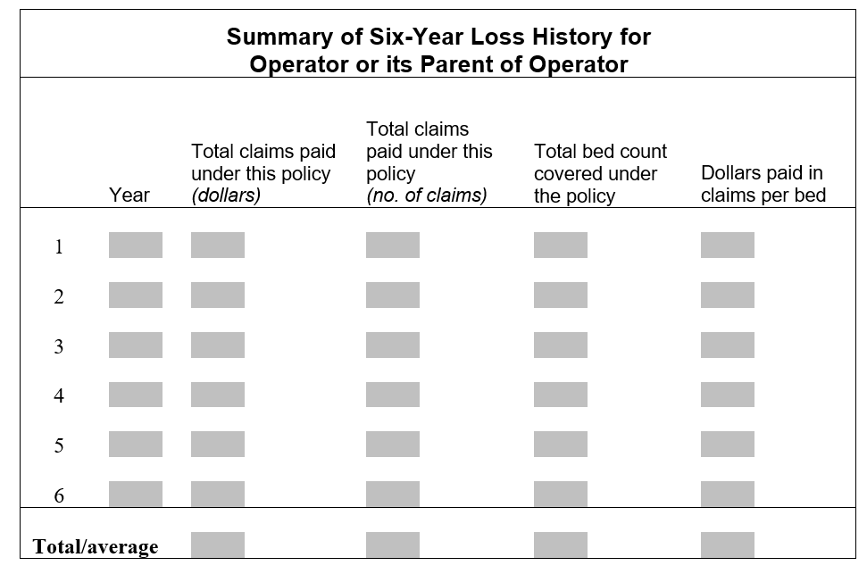  The loss history shows the policy had XX claims over the last 6 years with $XXX paid and reserved.  The average annual loss was $XXX, no single claim or annual loss exceeded the policy limits.  The $X deductible has allowed the facility to have lower premiums for the GLPL policy.  PLI Coverage Cost:  Describe the cost of compliant coverage and support this with quote(s). You should also demonstrate how this is a cost burden for the projects. Example:  The current cost of the GLPL policy is $XX,XXX. Quotes from the insurance agent indicated increased premiums of $X to $X for a $25,000 deductible. This would be a large burden based on the $XXX average annual loss. Each facility would have $X to $X additional premium allocated.  Financial Capacity:  Discuss the financial capacity quantitatively to show that there is sufficient capacity to cover the proposed waiver. Example:  The facilities have paid the deductibles from cash flow of each facility. (No/XX) claim exceeded the $X deductible. The DSCR for HUD Nursing Home is X.XX. The XX/XX/XX Operator Parent net worth was $XXX with a current ratio of X. The Operator parent and loss history demonstrate low loss rates and the financial capacity to support the $X deductible.  State Tort Reform:  If applicable - Appendix 14.1, IV C allows consideration of waivers where state legislation has limited PLI claim liability, for example, Texas.

PL/GL Addendum to Form HUD-2-ORCF

- Policy – General Questions
- Is this a combined GLPL policy? Yes/No
  - If yes, confirm if the GL and PL have separate aggregate limits, i.e. $3MM PL and $3MM GL aggregate limits, or combined aggregate limits. i.e. $3MM aggregate limit for both GL and PL claims.
  - Is there a policy aggregate? Yes/No If so, what is the policy aggregate?
- How many facilities are on the policy? <<insert number of facilities on the policy>>
  - If more than one facility, are there other HUD-insured loans on the policy? Yes/No
- Is the total replacement value on the property policy over $100MM? Yes/No
- Are there any excess GL or PL policies? Yes/No
  - If so, please describe.
- Is there a deductible aggregate or deductible corridor? Yes/No
  - If so, please describe.
- Any other unique features?
  - Non-IOI operators on the policy, using the HUD definition of IOI. Yes/No
    - If so, please describe.
  - Self-insurance / fronting carrier Yes/No
    - If so, please describe.
  - Other Yes/No
    - If so, please describe.

- Professional Liability Insurance (Handbook 4232.1, Rev. 1, Appendix 14.1)
- Professional liability per occurrence limit $
- Professional liability aggregate limit $
- Professional liability deductible $
- Claims made or per occurrence coverage <<insert claims made or per occurrence>>
  - If claims made coverage, retro date
  - If claims made, statute of limitations period <<insert # of years for the specific state>>

- Commercial General Liability Insurance (Handbook 4232.1, Rev. 1, Chapter 14.6)
1. Commercial general liability per occurrence limit $
2. Commercial general liability aggregate limit $
a. The GL aggregate limit applies to <<insert policy/project/location/other>>
3. Commercial general liability deductible $
4. Claims made or per occurrence coverage <<insert claims made or per occurrence>>
a. If claims made coverage, retro date
- If claims made, OHP 1336 is a blanket waiver allowing claims made GL coverage.
5. Is there a GL umbrella policy(s)? Yes/No
a. If so, amount(s) . Please describe coverage.
- Does it apply to PL, auto or other insurance? If so, please list.

Exhibits
Any insurance exhibits should be provided in the application, analyzed and discussed in Part 4 Justification, including:
Insurance Accord Evidencing Coverage, Exhibit 10-2
Current insurance ACORD to confirm the policy limits, retro dates (if any), policy aggregate (if any).
Loss History, Exhibit 10-4
Recent loss history for policy,
Tables - If a blanket policy, provide appropriate breakout tables for the HUD project(s).
Summary tables should be prepared by the lender and included in Part 4.
Actuarial Study, if available, Exhibit 10-6
Copy of the actuarial study for self-insured captives.
Part 4 - Include a comparison of the recommended reserves and funding levels to the financial statements of the captive. The captive should be funded to the recommended levels.

