**Home Equity Reverse Mortgage Information Technology**

**(HERMIT)**

**HERMIT System Changes – Release 6.1**

**Release Date: 08/08/20**

**Document Date: 08/08/20**

August 2020

**INTRODUCTION**

The Home Equity Reverse Mortgage Information Technology (HERMIT) software release version 6.1 consists of the following system changes:

Table of Contents

Endorsed and Assigned loan related changes 2

1. Extension Period for Home Equity Conversion Mortgages Affected by the COVID-19 National Emergency 2

Servicer Related Changes 8

2. Property Values Auto-fill Document Note 8

NSC Related Changes 10

3. Repayment Plan Report - Extend Create Date Range to Unlimited 10

4. Notes Disbursement Through Treasury Phase II 10

5. New NBS letter to the welcome letter and Occupancy letter 13

If you have any questions regarding the functionality of the software release, please contact the HERMIT Help Desk at 561-899-2610 or at [servicingsupport@hermitsp.com](mailto:support@hecmsp.com). If you have any policy related questions, please send an email to HUD at [answers@hud.gov](mailto:answers@hud.gov).

# Endorsed and Assigned loan related changes

## Extension Period for Home Equity Conversion Mortgages Affected by the COVID-19 National Emergency

Mortgagees may request an extension to delay Due Payable due to the COVID-19 National Emergency and Mortgagee Letter 2020-06. If the loan is already due and payable, then an extension can be requested to delay Foreclosure or the Claims process.

1. **New timelines – Endorsed & Assigned Loans**

### Extension - COVID-19 Request to Delay Due & Payable

### Extension - COVID-19 Request to Delay Foreclosure

### Extension - COVID-19 Request to Delay Claims Submission

1. **Timeline Mapping & Validations will apply to all 3 new timelines**

### The option to create these 1st and 2nd timelines will be available for a limited time; and will be configurable in the system to set or change the date as needed based on HUD direction. Initially this date will be 10/30/2020.

### The following roles can create and edit all 3 Extension-COVID-19 timelines:

* Servicer-Mgr.
* Servicer-Staff
* CLS-First Mortgage
* CLS-Supervisor/Management
* HUD NSC-Mgr.
* HUD NSC-Staff

### If a timeline was initiated in error, an authorized user will be able to inactivate the timeline from the Servicing Mgmt tab.

### The following fields will be on the timeline setup / initiation page for Extension-COVID-19 Request to Delay Due & Payable:

* + Servicing type: Required field
  + Timeline Status: Defaults to “Active” – Read only field
  + Initiation Date: Required field – Date entered must be <= Current Date
  + Reason for Request: field: Dropdown list showing option “COVID-19”
  + Reason for Extension: Required: Dropdown list of specific timeline steps for each Extension type. See detailed requirements below
  + Basis for Extension: Optional comment field. Servicer enters explanation of the request
  + Extension Request Date: Required field on FIRST TIMELINE ONLY. Date borrower requested to delay Due & Payable
    - Cannot be < 4/1/20
    - Upon 1st timeline initiation the user must enter the Extension Request Date. This field will also be displayed and editable on the Servicing Mgmt page and is subject to validation rules previously stated.
  + Extension Expiration Date from prior timeline: Auto-populated field on SECOND TIMELINE ONLY. Automatically set to Extension Expiration Date from 1st timeline. Is used instead of Extension Request Date on the 1st timeline.
  + Extension Expiration Date: Required field.
    - Cannot be > 6 months from Extension Request Date on 1st timeline, or Extension Expiration Date from prior timeline date on 2nd timeline.
    - Upon timeline initiation of the 1st or 2nd timeline, the user must enter the Extension Expiration Date. This field will also be displayed and editable in the Servicing Mgmt page and is subject to validation rules previously stated.
    - NOTE: this field is included in the search results from Endorsed > Requests > Search for Servicing Type Extension timelines. Field is named “Ext Exp Date”.
  + Requested By: user selects from dropdown of available types. Available types will be
    - Borrower
    - Non-Borrowing Spouse
    - Heir
    - Servicer
* Request: Auto-populated read only field: First or Second

1. **Features of the Second timeline**

### The 2nd extension request cannot be submitted/created prior to 30 days before the first expiration date. If user tries to create timeline prior to 30 days, following error will display.

Error: The request for second extension is too early. Please submit your request between <Date> and <Date>

### Second timeline will display field Extension Expiration Date from prior timeline as a read only field on the initiation screen instead of field Extension Request Date. The Extension Expiration Date from prior timeline will be set to the Extension Expiration Date from the 1st timeline.

### Extension Expiration Date on the 2nd timeline will be entered by the servicer during timeline setup. Extension Expiration Date cannot be < Extension Expiration Date from prior timeline AND cannot be > 6 months from Extension Expiration Date from prior timeline.

### After the timeline is created, Extension Expiration Date on the 2nd timeline will be editable under Servicing Mgmt page. The same date range validations apply to both the timeline initiation / setup process and edit from Servicing Mgmt page

**Example**: 1st timeline Extension Request Date entered by user: **04/05/2020**

1st Extension Expiration Date entered by user (and cannot be > 10/05/2020): **09/15/2020**

2nd timeline “Extension Expiration Date from prior timeline” auto-populated with 09/15/2020

2nd timeline Extension Expiration Date entered by user (cannot be > 03/15/2021): **02/01/2021**

### The following validations will apply to both timeline initiation / setup process and the edits from the Servicing Mgmt page:

### **Validations on FIRST timeline:** Extension Request Date must be >= 4/1/2020 and <= 10/30/2020 and cannot be > today. Timeline can be created or edited after 10/30/2020 but the request date must fall within the stated timeframe. Extension Expiration Date must be within 6 months of Extension Request Date and cannot be > today. Note: the end date (10/30/2020) will be configurable as stated in requirement 2.2.1

### **Validations on SECOND timeline**: Extension Expiration Date must be within 6 months of Extension Expiration Date from prior timeline and cannot be > today. Timeline can be created or edited after 10/30/2020 but the request date must fall within the stated timeframe. Extension Expiration Date from prior timeline will not be editable via timeline initiation page or edit Servicing Mgmt.

### **Validations at Timeline initiation**: Only two active timelines of the same type are allowed at a time. If a user tries to add a 3rd timeline, the following error message will display.

Error: First and Second COVID-19 Extension timelines already exist for this loan, third extension is not allowed. Please select another Servicing Request Type.

### **Edits on the Servicing Mgmt page**: After clicking EDIT, then SUBMIT on the Servicing Mgmt page, a popup message will be displayed with OK and CANCEL buttons with a message alerting the user “Verify the Extension Request Date and Extension Expiration Date are correct before proceeding.” If user clicks CANCEL the updates will not be saved, if user clicks OK the system will check for date compliance and display a validation error message if necessary. If no validation error message applies, the changes will be saved.

1. **New timeline:** **Extension-COVID-19 – Request to Delay Due & Payable**

### New timeline Extension-COVID-19 Request to Delay Due & Payable will be added to Endorsed/Requests area and to Servicer Requests on the left menu.

### New Servicing Type Extension-COVID-19 Request to Delay Due & Payable will be added to Endorsed/Requests Search page.

### New timeline Extension-COVID-19 Request to Delay Due & Payable will be added to Assigned / Requests area and to Search page.

### Attached spreadsheet for list of timeline steps on the new Extension-COVID-19 Request to Delay Due & Payable timeline. NOTE: Since both the 1st and 2nd extension requests are automatic extensions, all steps will be automatically completed.



### If Due & Payable w/ HUD approval timeline exists on a loan and has HUD Decision – Approved step completed, the user will not be able to add Extension-COVID-19 Request to Delay Due & Payable. If user attempts to add this timeline, an error will display.

### Error: A Due & Payable timeline approved by HUD already exists, therefore the Extension-COVID-19 Request to Delay Due & Payable timeline cannot be added. Please select another COVID-19 timeline if necessary.

### If the Extension-COVID-19 Request to Delay Due & Payable previously was not allowed due to the above validations; then the D&P w/o HUD approval timeline is rescinded or changed to Inactive, then the system will allow Extension-COVID-19 Request to Delay Due & Payable timeline to be created.

### Reason for Extension list for Extension-COVID-19 Request to Delay Due & Payable: Dropdown list of timeline steps. This field on the 1st and 2nd timeline may be different based on user’s selection at timeline initiation. The Reason for Extension will not be editable on the Servicing Mgmt screen.

1. **New timeline: Extension-COVID-19 – Request to Delay Foreclosure**

### New timeline Extension-COVID-19 Request to Delay Foreclosure will be added to Endorsed/Requests area and to Servicer Requests on the left menu.

### New Servicing Type Extension-COVID-19 Request to Delay Foreclosure will be added to Endorsed/Requests Search page.

### New timeline Extension-COVID-19 Request to Delay Foreclosure will be added to Assigned / Requests area and to Search page

### Attached spreadsheet for list of timeline steps on the new Extension - COVID-19 Request to Delay Foreclosure timeline. NOTE: Since both the 1st and 2nd extension requests are automatic, all steps will be automatically completed.



### When the user attempts to create timeline Extension-COVID-19 Request to Delay Foreclosure:

* + - If Foreclosure timeline exists, then system will allow user to add Extension-COVID-19 Request to Delay Foreclosure timeline.
    - If there is not a Foreclosure Timeline, the COVID 19 FCL extension will be allowed.

### Reason for Extension list for Extension-COVID-19 Request to Delay Foreclosure: Dropdown list of timeline steps. This field on the 1st and 2nd timeline may be different based on user’s selection at timeline initiation. The Reason for Extension will not be editable on the Servicing Mgmt screen.

* + - Initiation of Foreclosure (First Legal Date) – Loss Mitigation Pre-Foreclosure timeline. (Servicers are reminded to report any extension to First Legal using Block 19)
    - Reasonable Diligence – Refers to one of several tasks, not mapped to a specific step
    - Foreclosure Sale Date
    - Eviction Start Date – Claims Disposition Screen on the CT21 claim

1. **New timeline:** **Extension-COVID-19 – Request to Delay Claims Submission**

### New timeline Extension-COVID-19 Request to Delay Claims Submission will be added to Endorsed/Requests area and to Servicer Requests on the left menu.

### New Servicing Type Extension-COVID-19 request to Delay Claims Submission will be added to Endorsed/Requests Search page.

### New timeline Extension-COVID-19 Request to Delay Claims Submission will be added to Assigned / Requests area and to Search page.

### Attached spreadsheet for list of timeline steps on the new Extension - COVID-19 Request to Delay Claims Submission timeline. NOTE: Since both the 1st and 2nd extension requests are automatic, all steps will be automatically completed.



### Reason for Extension list for Claims: Dropdown list of timeline steps. This field on the 1st and 2nd timeline may be different based on user’s selection at timeline initiation. The Reason for Extension will not be editable on the Servicing Mgmt screen.

* + - Marketable Title – Timeline or Claims Disposition screen?
    - Claim Filing– Claims Disposition Screen / upon submission of claim by servicer. NOTE: this step can be delayed either for Parent Claim or CT24 Supplemental.

# Servicer Related Changes

## Property Values Auto-fill Document Note

As a reminder, servicers are required to enter all default servicing appraisal information into HERMIT using the Property Values tab.

* When the user adds a new property value on the Property Value page, HERMIT requires a document to be uploaded. When a document is uploaded to the Documents tab, the “Notes” column in the Document tab will now automatically update with pertinent appraisal information in the Loan Document Section.

Under Loan Documents, a “Note” will be auto populated to disclose the following:

“Value Date” – “Value Type” - “Reason/Purpose”– “As Is Value Estimated”

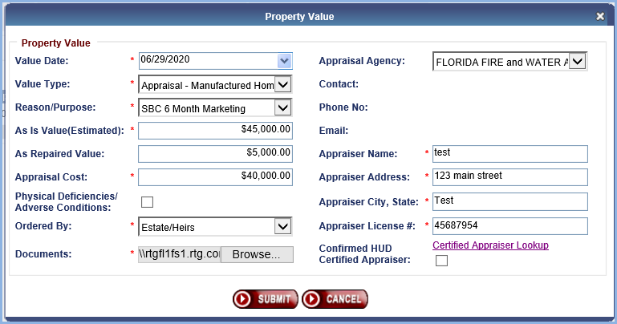

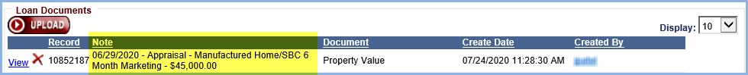

* System Generated Note with the same information will also be added under “Notes” area.

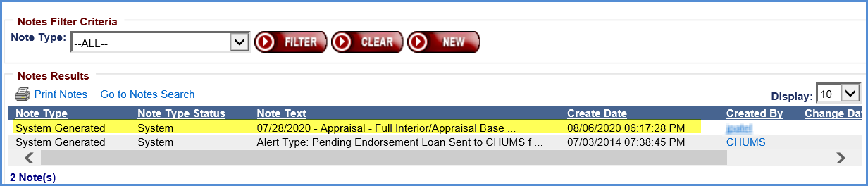

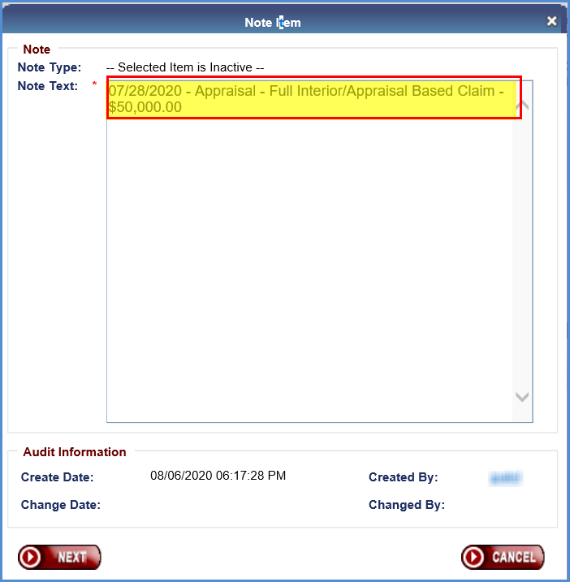

# NSC Related Changes

## Repayment Plan Report - Extend Create Date Range to Unlimited

HERMIT will allow Repayment Plan Report to run without create date.

## Notes Disbursement Through Treasury Phase II

1. **Routing Number Verification:**

HERMIT will receive a Routing Number Master File weekly from Treasury (Monday through Friday). Routing #s will be verified in HERMIT against the Treasury Routing Number Master file. Any Routing Numbers in HERMIT that are not contained within the Treasury Master Routing Number file will be rejected for collection or payment prior to creation in HERMIT.

**Validation will be in following areas of HERMIT:**

* Loan Setup Screen
* Loan Setup Import Screen
* Disbursement Screen when the Payment Method = “ACH”
* Admin Screen for Investors and Servicers
* Bank Account Screen
* Servicer Info Screen for Investors and Servicers

**Following error messages will be displayed in HERMIT when routing number is not valid.**

### The error message on the Loan Setup screen for Servicer will display as “Bank Routing Number for the Servicer cannot be found in the Treasury Master Routing Number data. Please contact the Servicing Module Help Desk to update this information”

### The error message on the Loan Setup screen for Investor will ***display as*** “Bank Routing Number for the Investor cannot be found in the Treasury Master Routing Number data. Please contact the Servicing Module Help Desk to update this information”

### For the Loan Setup Import screen, the validation for Servicer will display as “ “Bank Routing Number for the Servicer cannot be found in the Treasury Master Routing Number data. Please contact the Servicing Module Help Desk to update this information”

### For the Loan Setup Import screen, the validation for Investor will display as “Bank Routing Number for the Investor cannot be found in the Treasury Master Routing Number data. Please contact the Servicing Module Help Desk to update this information”

### The error message on the Disbursement Screen will display as “Bank Routing Number for borrower cannot be found in the Treasury Master Routing Number data. Please enter a valid Routing Number.”

### The error message on the Admin Screen will display as“Routing Number XXXXXXXXX cannot be found in the Treasury Master Routing Number data. Please enter a valid Routing Number.”

### The error message on the Bank Account Screen will display as“Routing Number XXXXXXXXX cannot be found in the Treasury Master Routing Number data. Please enter a valid Routing Number.”

### The error message on the Service Info Screen will display as “Routing Number XXXXXXXXX cannot be found in the Treasury Master Routing Number data. Please enter a valid Routing Number.”

### User will not be able to Authorize ACH (scheduled or Unscheduled) if the Routing Number does not match the Routing Number in the Treasury Master Routing Number data. The validation message will display as “Bank Routing Number for borrower cannot be found in the Treasury Master Routing Number data. Please enter a valid Routing Number.” Disbursement will be Inactivated, and new disbursement must be created.

1. **Accounting Transmittal Search Screen**

### The Check Number will be added to the Accounting Transmittal Search Results

### The Check Number will be added to the Export to Excel results on the Accounting Transmittal Search Screen

1. **Accounting Disbursements Screen**

### When searching for Undisbursed Disbursements, the Authorization link will appear for the Authorized user when the Disbursement Status of “Undisbursed” Is selected. Currently the user must search for each Disbursement Type. Going forward, user will not need to select Disbursement Type.

### No other Disbursement Statuses can be selected to search for disbursements that need to be authorized.

### Submitted Date will be added to the Search criteria

1. **Accounting Exceptions Report**

### The Accounting Exceptions Report for Notes will be added to the Assigned Notes Report -> Daily Reports Area.

### The Report will be identical to the Accounting Exceptions Report currently in the HERMIT Support -> Daily Reports area of HERMIT but will be limited to only Notes Transactions.

**This report will contain three type of errors in one report**

### Rejected disbursements that are sent to the Accounting Module (Should be rare occurrence)

### Issues with Disbursements when the TCIS file is imported

### Issues with Disbursements when the disbursements are authorized on the Accounting Disbursements screen.

**Following exceptions will be part of the exception report.**



1. **Voids and Cleared in HERMIT SM**

### Voids will only be allowed when a case is in a “Disbursed” status

### When a disbursement is in an “Inactive”, “Submitted”, or “Undisbursed” status the “Voided” box will be greyed out on the Edit Disbursement Screen in the Accounting Disbursement area.

### Cleared will only be allowed when a case is in a “Disbursed” status

### When a disbursement is in an “Inactive”, “Submitted”, or “Undisbursed” status the “Cleared” box will be greyed out on the Edit Disbursement Screen in the Accounting Disbursement area.

1. **Disbursement Detail Report**

### Submitted Date will be added to the search criteria for the Disbursement Detail Report

1. **Monthly Scheduled Disbursements**

### Monthly Scheduled Disbursements that are part of the Month End process will be split out from the normal process the morning of the 1st after the Month End Process Runs.

### The Monthly Scheduled Disbursements will be auto-approved and will be marked with an Approved By of “system”.

### The Monthly Scheduled Disbursements will be sent to the Accounting Module.

### All Monthly Scheduled disbursements will be sent to the Accounting Module to be processed but only ACH Payments will be sent for Same Day payment to Treasury.

## New NBS letter to the welcome letter and Occupancy letter

### New NBS letter is added to Welcome Letter

### A new NBS letter will be added to the Welcome letter. Welcome letter is available under Endorsed/Claims - Claim Type 22 - Assignment Package received step.

### The NBS letter will be added to every Welcome Letter, regardless if a Non-Borrowing Spouse exists on the loan

### New NBS letter is added to Occupancy letter – two different Occupancy letters

### The new NBS letter will be added to all three Occupancy letters. Occupancy letter is available under Assigned/Compliance - Occupancy Compliance Certification - Annual Occupancy Certification Letter Sent step.

### The NBS letter will be added to every Occupancy Letter, regardless if a Non-Borrowing Spouse exists on the loan