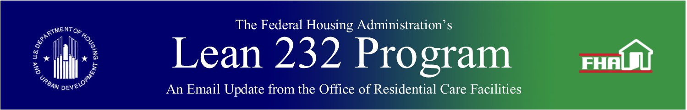

December 16, 2020

In This Update

* New FHA Email Delivery System Beginning in 2021
* Mortgage Reserve Funds and Debt Service Reserve Escrows on 223(a)(7) Loans
* August 2020 ORCF Lender Risk Monitoring Training Posted Online
* November 2020 ORCF Webinar Presentation Focusing Primarily on Asset Management Matters Related to the Covid-19 Pandemic Available Online
* FROM THE CLOSING CORNER
  + Insurance Requirements Prior to Issuance of Permission to Occupy (PTO)
  + Section 223(a)(7) Firm Commitments – Review [Bracket] Language Before Submitting
  + Required Language When Requesting an Extension to the Firm Commitment

New FHA Email Delivery System Beginning in 2021

FHA has implemented a new email delivery system. ORCF will use this improved system for our Lean 232 email messages in early 2021. If you are currently receiving our emails, you will automatically be enrolled in the new system, however, we ask you to please login under your email address and fill out your profile questions ([here](https://public.govdelivery.com/accounts/USHUDFHA/subscriber/topics?qsp=USHUDFHA_2)). Please also forward this link to any colleagues who would like to subscribe to our Lean 232 emails in the future.

***Keywords:*** *Email Blast*

Back to top

Mortgage Reserve Funds and Debt Service Reserve Escrows on 223(a)(7) Loans

ORCF has received requests to reduce Mortgage Reserve Funds and Debt Service Reserve Escrows as part of a 223(a)(7) loan. It is ORCF’s expectation that the entire existing amount of any mortgage reserve or debt service reserve escrow funds will be rolled over to a new reserve escrow at closing. Because of this, no reductions in the new reserve escrow will be allowed. The release provisions from the original transaction should remain the same in the new escrow agreement at the 223(a)(7) closing. The lender should disclose any mortgage reserve fund or debt service reserve escrows in the application and should include existing escrows as a source and a non-eligible use on the Maximum Insurable Loan Calculation form (HUD-92264a-ORCF).

***Keywords:*** *223(a)(7) Mortgage Reserve Funds, 223(a)(7) Debt Service Reserve Escrows*

Back to top

August 2020 ORCF Lender Risk Monitoring Training Posted Online

ORCF conducted a Lender Risk Monitoring Training on August 25, 2020 which provided an “A-Z Training” on Asset Management’s Risk Monitoring Routine. The training also includes question and answers which were recorded during the training. The training presentation has been posted on ORCF’s Training Presentations webpage ([here](https://www.hud.gov/federal_housing_administration/healthcare_facilities/residential_care/presentations)).

***Keywords:*** *Risk Monitoring, Training*

Back to top

November 2020 ORCF Webinar Presentation Focusing Primarily on Asset Management Matters Related to the Covid-19 Pandemic Available Online

On November 18, 2020, ORCF participated in a webinar hosted by the American Health Care Association/National Center for Assisted Living (AHCA/NCAL) on Asset Management matters. The webinar provided a brief overview of the Section 232 program and addressed asset management matters related to the COVID-19 pandemic. The webinar is now available online ([here](https://educate.ahcancal.org/products/section-232-program-overview-and-matters-related-to-the-covdi-19-pandemic)). Membership to AHCA/NCAL is not required to access this webinar. Please use your AHCA login used when registering for the webinar (*If you have forgotten your password click*[*here*](https://members.ahcancal.org/Dashboard/Sign-In-Help)*).*

If you did not register for the live webinar, you will need to create an account to access the recorded webinar.

**How to Create Account:**

* To avoid technical problems, use Google Chrome.
* If you are new to the AHCA site, you can create an account [here](https://members.ahcancal.org/Dashboard/Create-New-User-Account). After creating an account, you will be able to access the webinar.

For further assistance, please email [educate@ahca.org](mailto:educate@ahca.org).

***Keywords:*** *Webinar, COVID*

Back to top

FROM THE CLOSING CORNER

Insurance Requirements Prior to Issuance of Permission to Occupy (PTO)

As a reminder, Firm Commitments for New Construction, Substantial Rehabilitation and 241(a) transactions require all insurance must be in place prior to issuance of the Permission to Occupy (PTO). Please ensure all Property, Liability and Fidelity Insurance coverage is in place and in conformance with current program requirements prior to submitting to the ORCF Construction Manager for final approval. This will avoid delays with issuance of the Permission to Occupy (PTO). Insurance certificates/ACORDS must be valid and include, at a minimum, the coverages and deductibles cited in Item 32 of the Firm Commitment and Special Conditions, as may be amended.

Please contact Rick Price, ORCF Construction Manager if you have any questions.

***Keywords****:* *Permission to Occupy (PTO), Insurance*

Back to top

Section 223(a)(7) Firm Commitments – Review [Bracket] Language Before Submitting

Section 232/223(a)(7) loans apply to the refinancing of loans insured under Section 232 and loans originally insured under Section 232 pursuant to Section 223(f).  The firm commitment has several places with language in ***[brackets]***, which means a choice must be made and the inapplicable language deleted.  For example, in the second paragraph of the firm commitment:

*It is your intention to present the said Note and Security Instrument to the Federal Housing Commissioner acting herein on behalf of the Department of Housing and Urban Development ("HUD") for mortgage insurance under the provisions of Section 232 pursuant to [Section 223(a)(7) OR Section 223(f) pursuant to Section 223(a)(7)] of the National Housing Act (the "NHA"), and the Regulations thereunder now in effect (the "Regulations").*

The correct type of loan must also be correctly stated in closing documents, including the Healthcare Regulatory Agreement -Borrower (HUD-92466-ORCF) and Regulatory Agreement – Operator (HUD-92466a-ORCF).

*Please ensure that the draft firm commitment and closing documents include the correct type of loan when they are submitted to HUD for review.*

Please contact your assigned ORCF Underwriter directly if you have any questions.

***Keywords****: Section 223(a)(7), Firm Commitment, Closing Documents*

Back to top

Required Language When Requesting an Extension to the Firm Commitment

When submitting an Amendment Request to extend the term of the Firm Commitment, the request for extension must include the following statement (if true) from Handbook 4232.1, Section II, Chapter 9.3.B.1:

*“The requested delay is not likely to change significantly the underwriting data on which the commitment was based or to undermine the feasibility of the project due to a change in the market, inflation, or other factors affecting cost.”*

Extension requests that do not include such required language will be returned.

Please contact your assigned ORCF Closing Coordinator directly if you have any questions.

***Keywords****: Firm Commitment Extensions*

Back to top

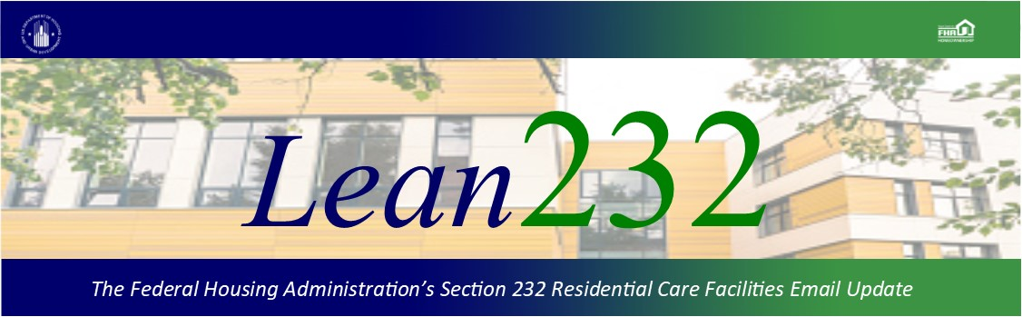

Past Lean 232 Updates are [available online](http://portal.hud.gov/hudportal/HUD?src=/federal_housing_administration/healthcare_facilities/residential_care/mail_blast_index).

Have questions about the Lean 232 Program? Please contact [LeanThinking@hud.gov](mailto:LeanThinking@hud.gov).

For more information on the Lean 232 Program, check out: <http://www.hud.gov/healthcare>.

Have your loan servicing colleagues joined our email list? The Email Blasts contain information relevant to them as well. You might suggest they [Join here](https://public.govdelivery.com/accounts/USHUDFHA/subscriber/topics?qsp=USHUDFHA_2).

We hope that you will want to continue receiving information from HUD. We safeguard our lists and do not rent, sell, or permit the use of our lists by others, at any time, for any reason. If you wish to be taken off this mail list, please [go here](https://public.govdelivery.com/accounts/USHUDFHA/subscriber/topics?qsp=USHUDFHA_2).

*Lean 232* is a publication of the Federal Housing Administration (FHA) Office of Healthcare Programs, U.S. Department of Housing and Urban Development, 451 7th Street, SE, Washington, DC 20410.

Connect with FHA on [Social Media](https://portal.hud.gov/hudportal/HUD?src=/program_offices/public_affairs/socialmedia) Twitter