|  |  |
| --- | --- |
| **Green and Resilient Retrofit Program**  **Completion Certification**  **(Comprehensive)** | **U.S. Department of Housing and Urban Development Office of Multifamily Housing** |

Public reporting burden for this collection of information is estimated to average 2 hours per response, including the time for reviewing instructions, searching existing data sources, gathering and maintaining the data needed, and completing and reviewing the collection of information. This agency may not collect this information, and you are not required to complete this form, unless it displays a currently valid OMB control number.

This collection of information is required to participate in the Green and Resilient Retrofit Program (GRRP) as authorized by Section 30002 of the Inflation Reduction Act of 2022, H.R. 5376 (“IRA”), titled “Improving Energy Efficiency or Climate Resilience of Affordable Housing and subsequent appropriations. Requirements for GRRP were established in HUD Notice H 2023-05 (the “GRRP Notice”) and subsequent notices. The information will be used to determine program eligibility and provide information necessary to close on the award. There are no assurances of confidentiality.

_____________________________

The Completion Certification is integrated into HUD's Green and Resilient Retrofit Program (GRRP) Greenlight Application. This system facilitates the processing and analysis of Green Retrofit and Resiliency Program (GRRP) grant and loan transactions. Greenlight will support case management, providing MFH with one central location to track and store client data, such as grant or loan information, client contact information, case notes, appointment scheduling and history, and client communications. The screenshots below represent the template as it appears in the Greenlight Application. (Note: The Comprehensive Completion Certification is in development the fields below are the basic data elements.)

**Screenshot 1.**

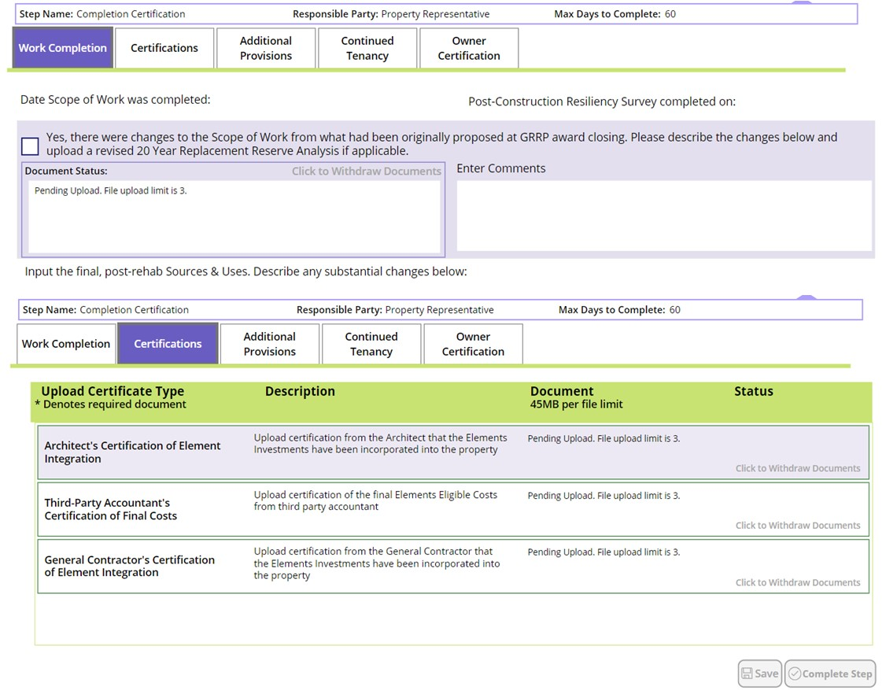

|  |
| --- |
| **Screenshot 2.** |

_______________________________

Public reporting burden for this collection of information is estimated to average 2 hours per response, including the time for reviewing instructions, searching existing data sources, gathering and maintaining the data needed, and completing and reviewing the collection of information. This information is required to obtain benefits. HUD may not collect this information, and you are not required to complete this form, unless it displays a currently valid OMB control number.

Title III of the Inflation Reduction Act of 2022, H.R. 5376 (IRA), section 30002 titled “Improving Energy Efficiency or Water Efficiency or Climate Resilience of Affordable Housing,” authorizes the Green and Resilient Retrofit Program (GRRP). The program provides grants or loans for building retrofits to HUD-assisted multifamily projects with utility efficiency or climate resilience needs. The Elements cohort of the program targets properties currently undergoing a recapitalization or other transaction with HUD and offers owners a menu of green and resilient building design features for reimbursement. This information collection is used to determine eligibility of HUD-assisted multifamily properties for participation in the GRRP Elements program and the terms on which participation should occur. The purpose of the program is to fund projects that improve energy or water efficiency, enhance indoor air quality or sustainability, implement the use of zero-emission electricity generation, low-emission building materials or processes, energy storage, or building electrification strategies, or address climate resilience, of an eligible property. While no assurances of confidentiality are pledged to respondents, HUD generally discloses this data only in response to a Freedom of Information Act request.