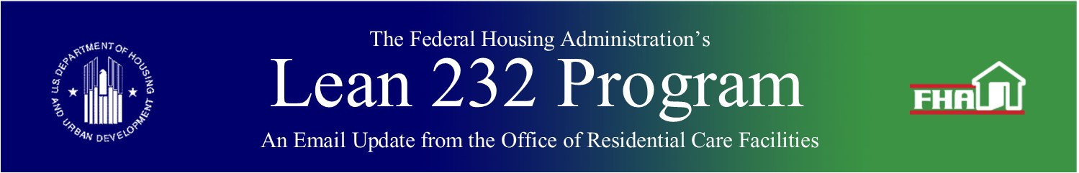

August 26, 2020

In This Update

* Production Queue Assignments
* HUD Underwriting Queue Questions
* Portfolio Names and Numbers
* Updated Email Address on Lender Narrative for Requests to Release or Modify Original Loan Collateral (form HUD-90030-ORCF)
* FROM THE CLOSING CORNER
  + Correctly Identifying Section of the Act Code in Pay.gov
  + Closing Document Changes

Production Queue Assignments

As ORCF has presented in various industry meetings, below is the general order of assigning applications out of the Production Queues for underwriting review:

* Section 223(f) transactions below $25M – ***Assigned to either ORCF Underwriters (UW’s) or Contract UW’s, based on capacity:***
  1. Opportunity Zone applications, by application submission date
  2. Oldest application submission date
* Section 223(f) transactions over $25M and all other loan types – ***Assigned only to ORCF UW’s; based on availability of UW capacity with specific loan type (i.e., $25M+ transactions, construction transactions):***
  1. Section 223(a)7 applications, by application submission date
  2. Section 223(f) Opportunity Zone applications, by application submission date
  3. Oldest application submission date and available specialized UW capacity.

Exceptions:

* Applications that are part of a portfolio may be assigned as a group, based on Underwriter capacity. As a result, some applications may be assigned ahead of individual deals with earlier application submission dates.
* Applications that are taken off Temporary Hold are placed back in the queue based on the original application date, as agreed to with lenders, and may go ahead of other applications in the queue.
* ORCF reserves the right to assign applications in a different order as needed, based on circumstances such as specific application details or specific Underwriter capacity.

***Keywords:*** *Application Processing*

Back to top

HUD Underwriting Queue Questions

As a reminder, any questions regarding the HUD Underwriting Queues posted on Hud.gov should be directed to LeanThinking, rather than individual ORCF staff. LeanThinking will coordinate with the appropriate contacts within ORCF to provide responses.

***Keywords:*** *Application Processing*

Back to top

Portfolio Names and Numbers

If a project is part of a portfolio, it requires a portfolio name. Lenders provide the portfolio name when an FHA Number Request is submitted*.

A portfolio number is also needed in order to complete FHA Number Requests.

If a project is part of an existing portfolio and the Lender does not know the portfolio name and/or portfolio number, this information can be requested through the FHA Number Request. Lenders should note the request and any related information in the comments box, or by submitting an email inquiry to LeanThinking.

Changes to portfolio names after an FHA Number has been issued require changes to multiple systems and may take a considerable amount of time to complete. ORCF requests that lenders identify their preferred portfolio name before an FHA Number is assigned to the portfolio.

*  Portfolio names are added to the name of the project for workload tracking in HUD systems so that the individual projects in the portfolio may be tracked together. This naming convention does not impact the legal name of the project.

***Keywords:*** *Portfolios*

Back to top

Updated Email Address on Lender Narrative for Requests to Release or Modify Original Loan Collateral (form HUD-90030-ORCF)

ORCF is in the process of updating the email address in the Environmental section of the *Lender Narrative for Requests to Release or Modify Original Loan Collateral (form HUD-90030-ORCF).* Please use [OHPTribeNotice@hud.gov](mailto:OHPTribeNotice@hud.gov) for submission of tribal notification documents. For further information, please see the associated Lender Checklist: *Requests to Release or Modify Original Loan Collateral Checklist* on the Loan Servicing website ([here](https://www.hud.gov/federal_housing_administration/healthcare_facilities/residential_care/loan_servicing)).

***Keywords:*** *Change of Collateral*

Back to top

FROM THE CLOSING CORNER

Correctly Identifying Section of the Act Code in Pay.gov

As stated in the June 26, 2020, Email Blast, it is crucial to use the correct Section of the Act (SOA) Code at the beginning of the process. Please ensure that the correct Program Type is used (e.g. SNF vs. ALF vs. Board & Care; 223(a)(7) vs. 223(f) vs. New Construction, etc.). Below are key times during the application process to double check the SOA Code to ensure it is correct:

* Application/Exam Fee at Firm Application Submission – Check before sending the Application (Exam) Fee to Pay.gov
* MIP Fee at Closing – Check before sending the MIP Fee to Pay.gov for Closing
* Inspection Fee, if applicable, at Closing – Check before sending the Inspection Fee to Pay.gov for Closing

(*Note: If you experience a problem with a Pay.gov payment, it can be canceled within 24 hours if you contact pay.gov directly. Contact the Pay.gov helpline via phone at (800) 624-1373).*

For a complete list of **SOA Codes** under the Section 232 Program, please refer to the list below:

(*Note: If the project is a mixed-use facility, the type of project will be determined by the highest number of underwritten bed type and the SOA Code to be used.)*

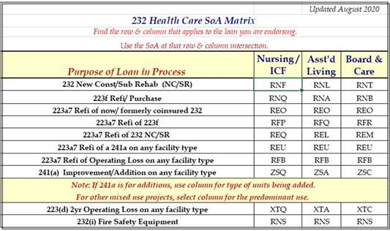

***Keywords:*** *Section of the Act, Pay.gov*

Back to top

Closing Document Changes

As a reminder, all changes to the closing documents must be approved by HUD and identified in the memo to form HUD Request for Endorsement, HUD-92023-ORCF. Section IC9 of the Request for Endorsement provides:

Lender certifies that all HUD form closing documents submitted to HUD in connection with this transaction (with the exception of the Opinion by Counsel to Borrower and the accompanying Certification by Borrower) conform to those documents Lender obtained from HUD and such documents have not been changed or modified in any manner except as suitably identified and approved by HUD as evidenced by the Closing Documents Memorandum attached as Exhibit (XX). It is understood that changes and modifications do not include filling in blanks, attaching exhibits or riders, deleting inapplicable provisions or making changes authorized by Program Obligations.  Lender further certifies that all closing documents submitted to and accepted by HUD at closing in connection with this transaction are listed in the Closing Documents Memorandum attached as Exhibit (XX).

The requirement for the memo of approved changes to the Request for Endorsement is to maintain consistency in the approval of revisions made to the closing documents as well as to ensure that the approved changes are consistent within a portfolio, a subject matter, or the transactional history of a project where the original loan is refinanced with a new HUD-insured loan.  The memo required by the Request for Endorsement is also essential where the revisions approved for one deal are cited as precedent for approving proposed changes to another deal. The memo is intended to create a record that efficiently tracks the revisions approved in each deal in one document certified by the lender.

The memorandum to the Request for Endorsement should identify the changes by listing the document title and section containing the change(s) and language redlined against the HUD form that shows how the redlined language deviates from the HUD form language.

For example:

*Borrower’s Regulatory Agreement, Section 11, Property Operation/Encumbrances*

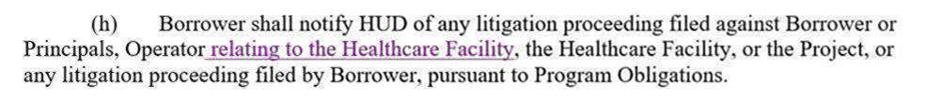

***Keywords:*** *Closings*

Back to top

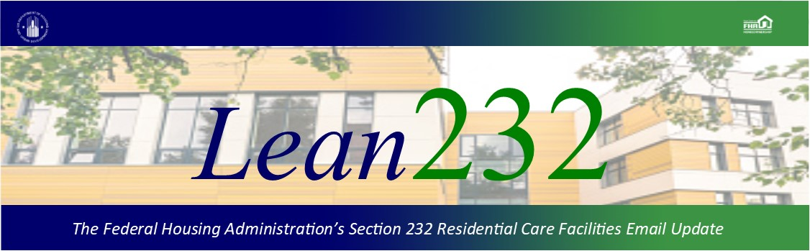

Past Lean 232 Updates are [available online](http://portal.hud.gov/hudportal/HUD?src=/federal_housing_administration/healthcare_facilities/residential_care/mail_blast_index).

Have questions about the Lean 232 Program? Please contact [LeanThinking@hud.gov](mailto:LeanThinking@hud.gov).

For more information on the Lean 232 Program, check out: <http://www.hud.gov/healthcare>.

Have your loan servicing colleagues joined our email list? The Email Blasts contain information relevant to them as well. You might suggest they [Join here](http://portal.hud.gov/hudportal/HUD?src=/subscribe/signup&listname=Lean%20232%20Updates&list=LEAN-232-UPDATES-L).

We hope that you will want to continue receiving information from HUD. We safeguard our lists and do not rent, sell, or permit the use of our lists by others, at any time, for any reason. If you wish to be taken off this mail list, please [go here](http://portal.hud.gov/hudportal/HUD?src=/subscribe/signup&listname=Lean%20232%20Updates&list=LEAN-232-UPDATES-L).

*Lean 232* is a publication of the Federal Housing Administration (FHA) Office of Healthcare Programs, U.S. Department of Housing and Urban Development, 451 7th Street, SE, Washington, DC 20410.

Connect with FHA on [Social Media](https://portal.hud.gov/hudportal/HUD?src=/program_offices/public_affairs/socialmedia) Twitter