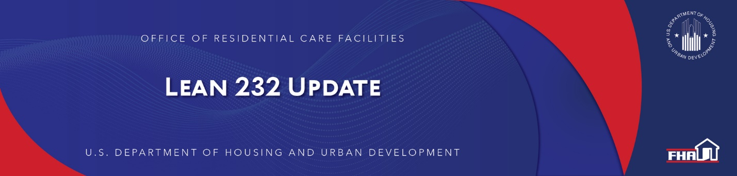

August 18, 2022

Mortgagee Letter 2022-13 “Green Mortgage Insurance Premium (MIP) Program Guidance for the Office of Health Care Facilities (ORCF)” Published
Mortgagee Letter 2022-13 “Green Mortgage Insurance Premium (MIP) Program Guidance for the Office of Health Care Facilities (ORCF)” was published on August 18, 2022. This Mortgagee Letter (ML) provides program guidance and reporting requirements for mortgages on properties that meet ORCF’s “Green MIP” requirements. The ORCF Green MIP initiative was announced in ORCF’s Green MIP Federal Register Notice (FR-6302-N-01) on May 19, 2022, and an additional notice published on August 12, 2022, (FR–6302–C–02). For further details, please see the ML 2022-13 and HUD press release.

Keywords: Mortgage Insurance Premium, Green MIP

Past Lean 232 Updates are available online.
Have questions about the Lean 232 Program? Please contact LeanThinking@hud.gov.
For more information on the Lean 232 Program, check out: http://www.hud.gov/healthcare.

Stay Connected with the Office of Housing and the Federal Housing Administration:

SUBSCRIBER SERVICES:
Manage Subscriptions | Help

