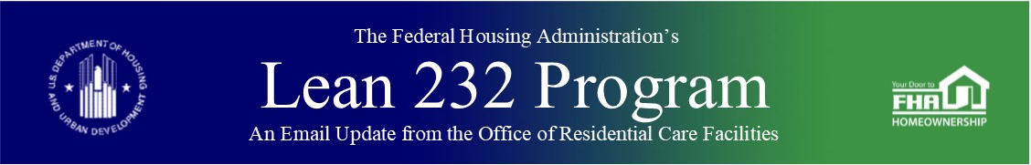

April 6, 2020

Updated COVID-19 Questions and Answers for External Stakeholders

The Office of Residential Care Facilities (ORCF) has updated the *COVID-19 Questions and Answers (Q&A) for External Stakeholders* [(here](https://www.hud.gov/sites/dfiles/Housing/documents/OHP%20Corona%20QA%20FINAL.pdf)). ORCF will continue to update this document as needed and ask stakeholders to check our website for updates. The Federal Housing Administration (FHA) encourages all stakeholders to provide input by submitting questions to [LeanThinking@hud.gov](mailto:LeanThinking@hud.gov).

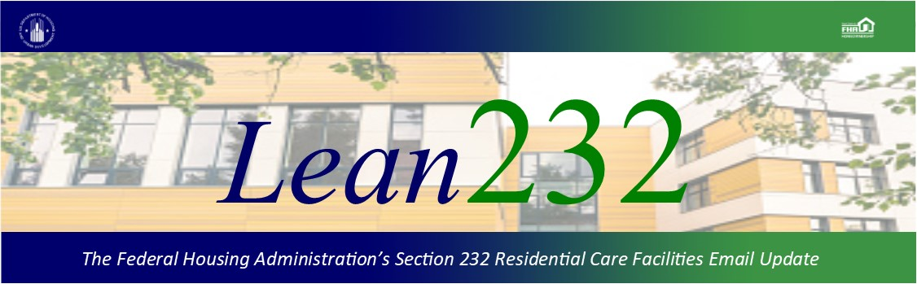

Past Lean 232 Updates are [available online](http://portal.hud.gov/hudportal/HUD?src=/federal_housing_administration/healthcare_facilities/residential_care/mail_blast_index).

Have questions about the Lean 232 Program? Please contact [LeanThinking@hud.gov](mailto:LeanThinking@hud.gov).

For more information on the Lean 232 Program, check out: <http://www.hud.gov/healthcare>.

Have your loan servicing colleagues joined our email list? The Email Blasts contain information relevant to them as well. You might suggest they [Join here](http://portal.hud.gov/hudportal/HUD?src=/subscribe/signup&listname=Lean%20232%20Updates&list=LEAN-232-UPDATES-L).

We hope that you will want to continue receiving information from HUD. We safeguard our lists and do not rent, sell, or permit the use of our lists by others, at any time, for any reason. If you wish to be taken off this mail list, please [go here](http://portal.hud.gov/hudportal/HUD?src=/subscribe/signup&listname=Lean%20232%20Updates&list=LEAN-232-UPDATES-L).

*Lean 232* is a publication of the Federal Housing Administration (FHA) Office of Healthcare Programs, U.S. Department of Housing and Urban Development, 451 7th Street, SE, Washington, DC 20410.

Connect with FHA on [Social Media](https://portal.hud.gov/hudportal/HUD?src=/program_offices/public_affairs/socialmedia) Twitter