|  |  |
| --- | --- |
| **Green and Resilient Retrofit Program**  **Resiliency Survey** | **U.S. Department of Housing and Urban Development Office of Multifamily Housing** |

Public reporting burden for this collection of information is estimated to average 1 hour per response, including the time for reviewing instructions, searching existing data sources, gathering and maintaining the data needed, and completing and reviewing the collection of information. This agency may not collect this information, and you are not required to complete this form, unless it displays a currently valid OMB control number.

This collection of information is required to participate in the Green and Resilient Retrofit Program (GRRP) as authorized by Section 30002 of the Inflation Reduction Act of 2022, H.R. 5376 (“IRA”), titled “Improving Energy Efficiency or Climate Resilience of Affordable Housing and subsequent appropriations. Requirements for GRRP were established in HUD Notice H 2023-05 (the “GRRP Notice”) and subsequent notices. The information will be used to determine program eligibility and provide information necessary to close on the award. There are no assurances of confidentiality.

_____________________________

The Resiliency Survey is integrated into HUD's Green and Resilient Retrofit Program (GRRP) Greenlight Application. This system facilitates the processing and analysis of Green Retrofit and Resiliency Program (GRRP) grant and loan transactions. Greenlight will support case management, providing MFH with one central location to track and store client data, such as grant or loan information, client contact information, case notes, appointment scheduling and history, and client communications. The screenshots below represent the template as it appears in the Greenlight Application.

**Screenshots: Survey Status**

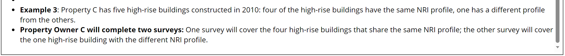

**Screenshots: Building Information**

**Screenshots: Assessment of NRI Hazards**

**Screenshots: Flood Control**

**Screenshots: Fire Mitigation**

**Screenshots: Building Exterior & Others**

**Screenshots: Community Resilience & Insurance**

