Proclamation of Healthy Homes Month

*DELETE BEFORE POSTING: If you are interested in promoting Healthy Homes Month in your state, contact your governor’s office and ask how to submit a request for a Governor’s Proclamation for Healthy Homes Month. Below is a sample proclamation.*

**Governor’s Proclamation Proclaiming June as (Name of State) Healthy Homes Month**

WHEREAS, home health and safety hazards, including physical safety hazards, lead-based paint, radon, mold, pests, and allergens, cause or contribute to a wide range of illnesses and diseases, including lead poisoning, asthma, cancer, and injuries;

WHEREAS, lead poisoning affects thousands of (name of state’s) children under six;

WHEREAS, accidents in the home hurt thousands of (name of state’s) people every year;

WHEREAS, hundreds of (name of state’s) children die from chemicals stored and used improperly in the home;

WHEREAS, dozens of (name of state’s) people die from carbon monoxide poisoning every year;

WHEREAS, many (name of state) families and households are unaware that their homes can have serious health hazards; and

WHEREAS, education and awareness about the dangers of unhealthy or unsafe housing can save (name of state) lives.

NOW THEREFORE BE IT RESOLVED, that Governor (name of Governor) proclaims June as (name of state) Healthy Homes Month; and

BE IT FURTHER RESOLVED that (name of state) citizens and government officials to observe this month with appropriate programs and activities designed to enhance public awareness of home health and safety hazards and the ways we can protect our families from these hazards.

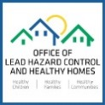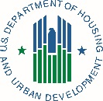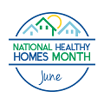 *LOGO/Contact Info Here*

www.hud.gov/healthyhomes