

United States Department of Housing and Urban Development

Home Equity Conversion Mortgage Business Service Provider (HECM BSP)

B2G File Format and Layout
For HECM Servicer Systems
And HERMIT/P271

HERMIT Release 8.4

Document Version 2.30

September 24, 2026
Revision History

COPIES CONTROLLED BY: Configuration Management

Version | Date | Revision Description | Author
1.0 | 05/03/2010 | Initial release | HECM BSP
1.1 | 06/21/2010 | - Section 1.2 – Removed definitions not applicable to this document  - Section 2.1 – Minor ICD document formatting only changes  - Section 2.1.3 – Removed reference to ‘three required elements’; only one element is currently required  - Table 4 – Added note regarding status of all Corporate Advance codes  - Table 4 - Added Terminate Code 2881  - Table 7 and Table 8 - Added fields: Application Date; Exp. Rate Index Date; Exp. Rate Locked:  - Changed all ‘Payoff’ references to ‘Termination’  - Section 2.1.1 – Removed .csv file type example to eliminate confusion. This file type may technically be used, however values must be tab separated not comma separated | HECM BSP
1.2 | 07/29/2010 | Table 4 – Added Unscheduled Advanced Code ‘2281 = Corp Adv – Refund’ | HECM BSP
1.3 | 08/04/2010 | - Table 8 – Change Index Type 240 description from ‘5-Year LIBOR Swap’ to ‘No Index’  - Table 8 – Changed allowable Basis Points range: ‘0 – 1000’ to ‘1 to 75’  - Table 8 – Changed allowable Exp. Interest Rate range: ‘0.001 to 100.000’ to ‘3.000 to 18.875’ | HECM BSP
1.4 | 09/29/2010 | - Table 4 – Removed temporary note indicating future addition of Corporate Advance codes in Release 2.5. These codes have been implemented in 2.5 as note indicated (see #3 in Rev 1.1 above)  - Tables 3 through 8 - Changed FHA Case Number max length from 20 to 10 to match UI validation  - Table 7 – Changed Servicer ID from Integer to String(10)  - Table 7 – Changed Investor ID from Integer to String (10) to reflect FHA Mortgagee Number that will be used starting in Version 2.6  - Table 8 – Added allowable Interest Rate At Closing range of ‘0.000 to 20.000’  - Table 6 – Added note to Transfer Date specifying allowable months / days  - Table 8 – Added clarification to Index Type regarding which types Index Types are allowable for each Rate Type  - Table 8 – Changed max allowable Margin for Rate Type A or M from to 5.000  - Table 8 – Added additional validation to ARM First Change Date  - Table 8 – Added max allowable date to Closing Date  - Table 8 – Added max allowable date to FHA Case # Assigned Date  - Table 8 – Added min allowable to Closing Costs  - Table 8 – Added min allowable to Discharge of Liens  - Table 8 – Added min allowable to Loan Advance/Other Draws  - Table 8 – Added min allowable to Repair Set Aside  - Table 8 – Added additional validation to Repair Set Aside  - Table 8 – Added min allowable to First Year Set Aside  - Table 8 – Added min allowable to Line of credit Set Aside  - Table 4 – Removed all Trans codes from the table  - Table 4.1 – Added a new table for Trans code and Description  - Table 4.1 – Added missing Trans Codes to the table  - Table 7, 8 – Added 2 new fields (Loan Origination Amt and Repair Admin Fee Collected)  - 2.1.5 – Changed max upload count from 500 to 1000  - Table 8 – Changed min allowable Interest Rate At Closing from 0.000 to 0.001  - Table 6 – Changed ‘To Investor’ description from ‘HERMIT Id’ to ‘FHA Mortgagee Number’  - Table 8 – Changed ‘Investor Name’ description from ‘HERMIT Id’ to ‘FHA Mortgagee Number’ | HECM BSP
1.5 | 03/11/2011 | Updated for 2.8 | HECM BSP
1.6 | 03/30/2011 | Updates to section 1.0 General Information:  - Detailed clarification has been provided in this section to describe the purpose of the file specification document  Updates to sub-section 1.1 Purpose and Scope:  - Note has been added to refer Appendix for sample record layout.  Updates to sub-section 1.2 Contents  - Additional point included in this section, specifying that detailed instructions on usage of upload function is provided in the document.  Updates to sub-section 1.3 Points of Contact:  - Contact information has been provided for questions on file specification: HERMITUAM@HUD.GOV  - Removed Accounting Operations Manager from System Support contact table  Updates to sub-section 1.4 Acronyms (modified title):  - Acronym for CHUMS has been added  Updates to sub-section 1.5 Security Controls (new section):  - This section has been added stating the security controls for HERMIT  Updates to section 2.0 Technical Specifications for Upload (modified title):  - This section is re-written stating the method of upload for each upload type  Updates to sub-section 2.1 Upload File Requirements:  - Details have been added on the upload function via UI. Screen shot has been added.  - Following clarifications have been made:  - Servicer will be notified with success/failure message; any errors that occur during upload process will be notified to the Servicer.  - No file naming restrictions  - Valid file extensions are: .txt, .csv, or .tsv  - Delimiter on file is tab, which must be used between every data element  - No restrictions on number of file uploads, recommended frequency one per daily/monthly  - Description has been added for the upload types  - First row of file must contain file type identifier, no other header row is permitted  - Valid type identifiers are: “TransactionsImport”, “ServicerTransferImport” and “LoanSetupImport”  “OPLCPL Import”  “MasterServicerImport”  Updates to sub-section 2.2 – 2.4 Transaction Import, Servicer Transfer Import and Loan Setup Import (record layout section 2.2 has been broken down to separate sections for each of the upload types)  Updates to sub-section 3.1 File Verification:  Below list of validations removed:  - Data elements level  - Required data for each record is present  - Valid combination of values in each record  Below list of validations added/clarified:  - Record layout aligns to file type identifier  - A value is provided for every data item defined  - Every data element is separated with a tab  Updates on warning messages:  - Clarified message for file size: File size limit is up to 1500 records  - Removed Data Integrity Considerations  - Removed Security Considerations  - Removed Information Sensitivity  - Removed Control Measures  - Removed Availability Considerations  Implementation Consideration paragraph has been added describing that the emulators function shall no longer be available. Choices will be provided to upload files. System availability and contact information for questions on file is included in this section.  New Section added: 4 HERMIT System Categorization:  - Brief overview of the system is provided  - Sub-section 4.1 added to include Information Sensitivity  - Sub-section 4.2 added to include Information Categories  - Sub-section 4.3 added to include Protection/Certification requirements  - Sub-section 4.4 added to include Authentication Level  Updates to section 5 Appendix:  - Transaction Codes and descriptions has been moved under Appendix  - Sub-sections 5.2-5.4 have been added for each of the sample file import layout | HECM BSP
1.7 | 07/21/2011 | Updates to Table 1: HECM System support Points of Contact have been updated.  - Added new PM details  - Added new DPM details  - Added new Operations Manager details  Updates to Table 5: New data item “Incurred Date” added  Updates to Section 2.4, Table 7: Updated existing data items and added new data items  - Added new Data items:  “IMIP Paid By Lender”  “Tax Ins Responsible Party”  “Title Held As”  - Updated range of values for data item Pay Plan Term to 480.  - Updated “Required” details for below data items to “No”  Closing Costs  Discharge of Liens  Loan Advance/Other Draws  Repair Set Aside  First Year Set Aside  Loan Origination Amount  Sale Date  Contract Date  - Updated data item “Line of Credit Set Aside” to “Credit Line Set Aside”  - Updated “Required” details of data item Was Prior Sale/Transfer as below:  “Conditionally required if Product Type = HECM for Purchase or HECM Saver for Purchase”  Updated data item “Prior Sale Price” to “Prior Sale Price Amount” and updated the range of values for the same to “Integer followed by Decimal(2)  Updates to Section 5.2: Updated the screenshot of Transaction Import File Layout to add the column “Incurred Date”. | HECM BSP
1.8 | 08/08/2011 | Updates to:  1. Updated the Revision History table for Rev 1.7.  2. Added the information “This document was prepared by a HECM BSP developing the HERMIT system and does not reflect opinions and recommendations herein by FHA. The purpose of this document is to provide the necessary information on minimum specification for data formatting and HECM data file uploads between servicer’s system and HERMIT.”  3. Updated page numbers of the document  4.Removed the below from Section 4 of the document:  “Due to the sensitivity of this information system, all Lender/Servicer personnel are required to follow HUD’s security policies and procedures.”/ This passage requires rephrasing. Lender/Servicers are not required to execute HUD’s Rules of Behavior for P271 application access”  5. Added the information:  “Must be >= ‘0.00’ and <= ‘1407.00’” for the range of values for data item Repair Set Aside  6. Updated section 5.4 to display the Loan Setup Import file | HECM BSP
1.9 | 09/07/2011 | 1. Updated Section 2.1 and Section 3.1 reflecting the File size limit for a B2G upload from 1000 to 1500 records.  2. Updated Section 2.4, Table 7 to reflect Closing Date and Funded Date cannot be a Federal Holiday (Exceptions to Federal Holidays: MLK Day, President’s Day, Columbus Day and Veterans Day) | HECM BSP
2.0 | 09/16/2011 | 1. Section 1.2: Capitalized word “mortgagee” to “Mortgagee”  2. Section 1.3: Updated “Function” of HERMIT POCs in Table 2 for Eric Davidson. Also, capitalized the first letter names for other POCs  3. Section 1.4: Added entry “B2G – Business To Government” to Table 3  3. The Format/Range of Values for FHA Case# is updated in Table 5, Table 6, Table 7 to String(11) with hyphen  4. Section 2.4: In Table 7, corrected spelling of Mortgager to Mortgagor for description of First Payment Date  5. Updated the required fields to “Yes” for below data items  5.1 Loan Origination Amount  5.2 Loan Advances/Draws  5.3 Repair Set Aside  5.4 First Year Set Aside  5.5 Discharge of Liens  5.6 Exp. Rate Index Date  5.7 Exp. Rate Locked  6. Section 3.1: Updated availability of HERMIT system to say: HERMIT system is available all days of the week. All Uploads will be immediately integrated and visible in HERMIT upon completion of a successful B2G upload  7. Section 2.4: Table 7 – Updated Format/Range of Values for “Repair Set Aside” to: “Must be >= ‘$0.00’ and <= ‘$93,825’  8. Section 2.4: Table 7 – Updated Range for data item “Basis Points” to “Range>=0.36% and <= 1.50%”  9. Section 2.4: Table 7 – Updated Format/Range of data values” to : Must be >= ‘0.00 and <= 1407.38” (Lender may charge a fee not to exceed the greater of one and one half(1 ½) percent of the funds used for repairs or $50 for administration of agreement)  10. Section 2.4: Table 7 – Updated Format/Range of Values for Loan Origination Amount to add ‘$’ before range values.  11. Section 2.4: Table 7 – Updated the “Required” description for data item from “Conditionally required for HECM for Purchase” to “Conditionally required for HECM Standard for Purchase”  12. Section 2.4: Table 7 – Added below information to data field Original Principal Limit “For HECM purchase transactions only, the maximum claim amount will be the least of: 1) the appraised value; 2) sale price; or 3) FHA mortgage limit for a one family residence” | HECM BSP
2.1 | 10/07/2011 | 1. Section 2.2: Table 5 – Updated the Format/Range of Values for FHA Case # to Numeric(10) from String(11)  Section 2.3: Table 6 – Updated the Format/Range of Values for FHA Case # to Numeric(10) from String(11)  Section 2.4: Table 7 – Updated the Format/Range of Values for FHA Case # to Numeric(10) from String(11)  2. Section 2.2 Table 5: Added more description to Effective Date and Incurred Date data fields in TransactionImport Record Layout  4. Section 2.4: Table 5 – Made data field Exp. Rate Index Date as Conditional required upon availability of data field Exp. Rate Index Date  4.1. Made data field Exp. Rate Locked as Conditional; required upon availability of data field Exp. Rate Locked  4.2. For data field First payment Date, the description was changed to ‘First Payment date to HECM Mortgagor’ from ‘First Payment date to Mortgagor’  4.3. First Payment Date – Added information “Funded Date must be <=30 days from Closing Date;”  4.4. For data field Discharge of Liens – Made required = No  4.5. For data field Loan Advances/Other Draws added information ‘For Purchase transaction must equal fully drawn LOC’  Made this data field Conditional; if Pay Plan is Modified Tenure or Modified Term or Line of Credit  4.6. For data field Repair Set Aside, made this a Conditional field If RSA is available  5.Updated the Loan Setup Import screenshots to reflect the latest color coding of Required, Optional and Conditional data fields | HECM BSP
2.2 | 12/19/2011 | Updated the below sections  1. Section 1.2 – Added disclaimer information for Servicers  2. Appendix A – Section 5.1 Table 12 has been updated to reflect the descriptions for all transactions along with transaction categories | HECM BSP
2.3 | 02/04/2012 | Updated the B2G File Layout document per Eric Davidson (HUD – Premiums) and Erica Jessup (HUD – Premiums) comments during working session held on 02/04/2012 | HECM BSP
2.4 | 06/26/2012 | Updated the B2G File Layout document Appendix A Table 12 to reflect the new TC codes for the 8 property charges transactions. | HECM BSP
2.5 | 08/02/2014 | Added new B2G for OPL/CPL for Release 3.8 | HECM BSP
2.6 | 04/09/2015 | Updated Table of Contents to remove the disclaimer, Table 2 to update PM, DPM, GTMS and GTR, Table 2.5, Section 2,5, Table 5.1 to add the LESA Transaction codes, Section 5.4 to add the LESA Semi Annual Amount to the Loan Set up File Format. | HECM BSP
2.7 | 06/29/2015 | 1. Updated Table 2.4 to add the Lump Sum to the Pay Plan Type in Loan Set up Import File.  2. Updated Table 7: Updated Required to “Yes” for the Credit Type line.  3. Updated Table 7: Added Lump Sum Payment Plan to Required field for Loan Advances/Other Draws line. | HECM BSP
2.8 | 08/04/2016 | - Updated email addresses from support@hecmsp.com to servicingsupport@hermitsp.com  - Updated Table 1 HERMIT System Contacts with current contact information  - Added Transaction Code 1250 – Disb – Scheduled to list of transaction codes | HECM BSP
2.9 | 01/11/2017 | Changed cover page and replaced HERMIT System Support Organization Contact information with updated phone numbers and email addresses | HECM BSP
2.10 | 08/09/2017 | Reviewed for Annual Document Deliverables | HECM BSP
2.11 | 09/01/2017 | Added New Transactions Codes to Section 5.1 for Release 5.40:  Corp Adv – S305 Utilities – Liens  Corp Adv – S305 Utilities – Liens Adj  Corp Adv – S305 – Cash for Keys  Corp Adv – S305 – Cash for Keys Adj | HECM BSP
2.12 | 08/21/2018 | Reviewed for Annual Document Deliverables | HECM BSP
2.13 | 07/13/2019 | Added new B2G for Master Servicers for Release 5.8 | HECM BSP
2.14 | 08/26/2019 | Reviewed for Annual Document Deliverables  Updated the following:  - Technical Specifications  - Table 4  - Figures 1 and 2 – Screenshots  - File header Description  Added Sections:  - 2.5 – OPL/CPL – Record Layout  - 2.6 – Master Servicer – Record Layout  - 5.5 – OPL/CPL Import File Layout  - 5.6 – Master Servicer Import File Layout | HECM BSP
2.15 | 09/19/2019 | Corrected Table #s for various tables | HECM BSP
2.16 | 01/31/2020 | Updated Transaction Name for 2238 (not adjustment). Updates to remove the following transaction codes from section 5.1: 2889 Terminate – Other, and the following transaction codes which are no longer allowed manually or via B2G:  - 2878 Terminate – Claim – 21  - 2879 Terminate – Claim – 23  - 2893 Terminate – Claim – 21 Supplemental  - 2894 Terminate – Claim – 23 Supplemental | HECM BSP
2.17 | 08/18/2020 | Updated Transactions in Table 14 to Remove the following transaction codes:  - 2870 – Terminate – Death  - 2871 – Terminate – Borr. Moved  - 2872 – Terminate – Borr. Paid  - 2875 – Terminate – Short Sale (Partial)  - 2880 – Terminate – 3rd Party FCL Sale(PIF)  - 2881 – Terminate – REO Sale (Partial)  Added the following transaction codes:  - 2831 – Terminate – Paid In Full  - 2841 – Terminate – Paid In Full Adj | HECM BSP
2.18 | 03/03/2021 | Reviewed for Annual Document Deliverables – No file format changes | HECM BSP
2.19 | 09/21/2021 | Release 6.5 changes  Updated Transactions in Table 14 to add 26 new 305 Repay and Repay adj transactions  Updated section 2.2 to add Lifetime Cap field | HECM BSP
2.20 | 03/25/2022 | Release 6.7 change restricting Corp Advances and Loan Balance transactions based on loan’s Due and Payable Date | HECM BSP
2.21 | 08/05/2022 | Release 6.8 – Updated validation for ARM First Change Date field. | HECM BSP
2.22 | 11/09/2022 | Release 7.1 – Replace pre-7.0 screen shots and added new transaction codes with adjustments for Rental Income and Rental Expense  - 2441 Corp Adv - Misc Claim - Rental Expense  - 2442 Corp Adv - Misc Claim - Rental Expense Adj  - 2448 Corp Adv - Misc Claim - Rental Income  - 2449 Corp Adv - Misc Claim - Rental Income Adj | HECM BSP
2.23 | 01/26/2024 | Updated the following:  2. Technical Specifications  2.1 File Requirements  4. File Header Descriptions  Table 4  Table 5  Figures 1 and 2 – Screenshots  Added Sections:  - Investor Transfer – Record Layout  5.7 Appendix – Investor Transfer Import File Layout | HECM BSP
2.24 | 03/23/2024 | Revised all of Section 2 and below.  Add the following to Section 2:  - Initial Transfer  - Servicer Transfer List  - Servicer Transactions  - Note Uploads | HECM BSP
2.25 | 02/06/2025 | Removed Transaction Code 1450 & 1490 from Table 8 Transaction Codes and Descriptions. Updated the naming on four Disb – Unscheduled from LOC Transactions related to the following Trans Codes 2350, 2450, 2390 & 2490. | HECM BSP
2.26 | 03/11/2025 | Reviewed for Annual Document Deliverables | HECM BSP
2.27 | 06/21/2025 | Removed Transaction Code 2890 and Add Trans Code 2843 & 2844 on Table 8 Transaction Codes | HECM BSP
2.28 | 09/22/2025 | Updated Screenshots in Section 2.3 and 2.4.8. Added “Borr Recoverable” to the Data item row in Table 7. | HECM BSP
2.29 | 03/04/2026 | Reviewed for Annual Document Deliverables  - Updated Contact Information | HECM BSP
2.30 | 09/16/2026 | Updated section 2.4.2 for 8.4 Release changes to rename field “Servicer/Sub Servicer” to IMIP Responsible and add new MMIP Responsible field on the Loan Setup Template. Screenshots updated in section 2.4.3. | HECM BSP

Table of Contents

1 General Information 3
1.1 Purpose and Scope 3
1.2 Contents 3
1.3 Points of Contact 3
1.4 Acronyms 4
1.5 Security Controls 5
2 Technical specifications 6
2.1 Initial Transfer 6
2.2 Servicer Transfer List 6
2.3 Servicer Transactions 7
2.4 Servicer File Upload (B2G) 7
2.4.1 Upload File Requirements 8
2.4.2 Loan Setup Import – Record Layout 10
2.4.3 Loan Setup Import – B2G File layout 16
2.4.4 Servicer Transfer - Record Layout 17
2.4.5 Servicer Transfer Import – B2G File Layout 17
2.4.6 Transactions - Record Layout 19
2.4.7 Transactions Import - Transaction Codes and Descriptions 19
2.4.8 Transaction Import – B2G File layout 43
2.4.9 OPL/CPL - Record Layout 44
2.4.10 OPL/CPL Import – B2G File Layout 44
2.4.11 Master Servicer - Record Layout 44
2.4.12 Master Servicer Import – B2G File Layout 45
2.4.13 Investor Transfer - Record Layout 45
2.4.14 Investor Transfer Import – B2G File Layout 45
2.5 Note Uploads 46
2.5.1 Upload File Requirements 46
2.5.2 Notes Import – Record Layout 48
2.5.3 Notes Import Transaction Codes and Descriptions 48
2.5.4 Notes Import – B2G File layout 49
3 Other Considerations 50
4 Quality Control and Verification 50
4.1 File Verification 50
5 HERMIT – System Categorization 51
5.1 Information Sensitivity 51
5.2 Information Categories 51
5.3 Protection/Certification Requirements 52
5.4 Electronic Authentication Level 53

List of Tables

Table 1: HERMIT System Support Points of Contact 4
Table 2: HERMIT Program Organization Points of Contact 4
Table 3: Acronyms, Abbreviations, System Names/Codes 4
Table 4: HECM File Upload Types 9
Table 5: Data Item Descriptions for File LoanSetupImport 10
Table 6: Data Item Description for File ServicerTransferImport 17
Table 7: Data Item Descriptions for File TransactionsImport 19
Table 8: Transaction Codes and Descriptions 20
Table 9: Data Item Description for File OPLCPLImport 44
Table 10: Data Item Description for File MasterServicerImport 44
Table 11: Data Item Description for File InvestorTransferImport 45
Table 12: HECM File Upload Types 47
Table 13: Data Item Descriptions for File NotesImport 48
Table 14: Transaction Codes and Descriptions 48
Table 15: HERMIT System Information Categories 51
Table 16: HERMIT System Information Types and Security Categories 52
Table 17: HERMIT System Security Category 52
Table 18: HERMIT System Transaction Types and Assurance Level 53

List of Figures
Figure 1: Lender/Servicer Batch Left Menu 6
Figure 2: Initial Transfer Screen 6
Figure 3: Servicer Transfer List Screen 7
Figure 4: Servicer Transactions Screen 7
Figure 5: Servicer File Upload Screen 8
Figure 6: File Processing In HERMIT 9
Figure 7: Loan Setup Import File 17
Figure 8: Servicer Transfer Import File 18
Figure 9: Transaction Import File 43
Figure 10: OPL/CPL Import File 44
Figure 11: Master Servicer Import File 45
Figure 12: Investor Transfer Import File 46
Figure 13: Note Upload Screen 46
Figure 14: File Processing In HERMIT 47
Figure 15: Notes Import File 49

General Information
This document serves as a reference for technical analysts who are responsible for enabling the functionality to move data from external servicing systems to the Home Equity Reverse Mortgage Information Technology (HERMIT) system. The specification describes the file layouts and outlines the alternative upload processes a Lender/Servicer may consider.
This document is organized to provide:
- General information
- Technical specifications for upload
- Quality control and verification
- HERMIT – system categorization
- Appendix

Purpose and Scope
The function of this document is to define and describe the data upload process between external servicing systems and the HERMIT system. This document specifies the file record layout required for the upload of loan-level HECM data to the HERMIT system.

Contents
The data upload process described in this document comprises the method and data elements involved in the data upload between external servicing systems and the HERMIT system. The specifications presented are:
- Define the requirements, design, procedures, and other relevant characteristics required for data uploads to HERMIT.
- Provide the syntax rules (file formats) and the semantic conventions (names, meanings, and physical units) used to generate and handle data products and data structures exchanged between an external servicing system and the HERMIT system.
Note: Please be advised that this is the current up-to-date B2G File Layout document. It is imminent that changes will be made to the B2G File Layout document in the future when system changes are made. When those system changes are prioritized for release by HUD, this document will be updated and distributed per direction from HUD.

Points of Contact
Questions about specifications within this document should be directed to the servicingsupport@hermitsp.com email address. The key points of contact for the HERMIT system are displayed below for escalation purposes.
Table 1: HERMIT System Support Points of Contact
Function | Name | Phone | E-mail Address
HERMIT Help Desk | HERMIT Help Desk | 561-899-2610 | servicingsupport@hermitsp.com
Program Manager | Mark Lusk | 561-283-8428 | Mark.Lusk@reversetg.com
Alternate Project Manager | Paul D’Aulisa | 561-283-8394 | PDaulisa@reversetg.com
Senior Consulting Analyst | Kevin Gherardi | 561-283-8398 | KGherardi@reversetg.com

Table 2: HERMIT Program Organization Points of Contact
Function | Name | Phone | E-mail Address
HERMIT System Owner | Cherylayne Walker | 215-301-2813 | cheryl.b.walker@hud.gov
HERMIT COR | Ayanna Gibson | 202-402-2544 | ayanna.s.gibson@hud.gov
HERMIT SCOR | Juanita Johnson | 202-402-5348 | Juanita.L.Johnson@hud.gov
HERMIT ISSO | Elaine Nguyen | 202-402-3221 | Elaine.C.Nguyen@hud.gov
DHOC SME | Angela Lee | 817-978-5549 | angela.r.lee@hud.gov

Acronyms
Table 3: Acronyms, Abbreviations, System Names/Codes
Acronym/Abbreviation/System Name | Definition
FHA | Federal Housing Administration
B2G | Business To Government
CHUMS | Computerized Homes Underwriting Management System/F17
HECM | Home Equity Conversion Mortgage
HERMIT | Home Equity Reverse Mortgage Information Technology
HUD | U.S. Department of Housing and Urban Development
HECM SP | Home Equity Conversion Mortgage Service Provider
MIP | Mortgage Insurance Premium
.csv | Comma Separated Values File extension
.tsv | Tab Separated Values File extension
.txt | Flat Text File extension
Seq. # | Sequence Number

Security Controls
HERMIT system security is under the ownership, operation, and maintenance of an external service provider, HECM SP. It follows the guidance and directives of the HUD Technical Reference Model, Federal Security Standard: NIST Special Publication 800-53 Revision 4, and HUD Handbook 2400.25 Information Technology Security Policy.

Technical specifications
The Batch area for Lenders and Servicers includes five pages, two upload types.
  - Initial Transfer
  - Servicer Transfer List
  - Servicer Transactions
  - Servicer File Upload
  - Note Uploads

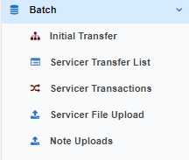
Figure 1: Lender/Servicer Batch Left Menu

Initial Transfer
This page is not a B2G upload, this is used for a user to input loan level initial transfers.
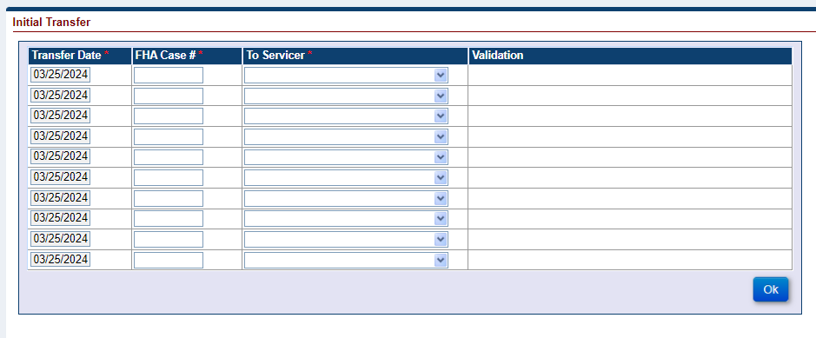
Figure 2: Initial Transfer Screen

Servicer Transfer List
This page is not a B2G upload, this is used for a user to search for scheduled Servicer Transfers.
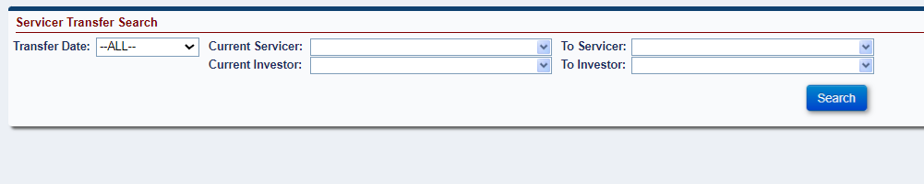
Figure 3: Servicer Transfer List Screen

Servicer Transactions
This page is not a B2G upload, this is used for a user to input loan level transactions.

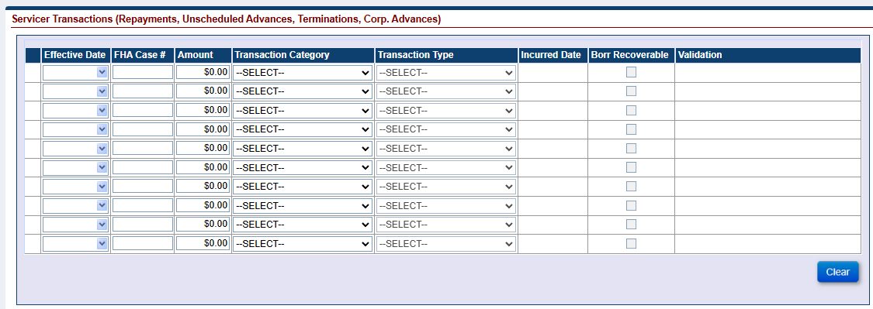
Figure 4: Servicer Transactions Screen

Servicer File Upload (B2G)
There are six upload types that can be used to update loan-level data in HERMIT. They are:
- Loan Setup
- Servicer Transfer
- Transactions
- OPL/CPL
- Master Servicer
- Investor Transfer
This section documents the method of upload and the file requirements for each upload type. This section also addresses the data transfer process and operational requirements. A sample record layout for each upload file type can be found in the Appendix.

Upload File Requirements
This section documents the record layout requirements used to generate a file that will successfully upload records to the HERMIT system. Below is a view of the HERMIT Upload Screen. It allows the authorized user to browse their internal sources for HECM data to retrieve the various files to be uploaded for the day. Once a file is selected, the authorized user pushes the Upload button for immediate processing of the file into HERMIT. The user would repeat this process for each file type as needed.

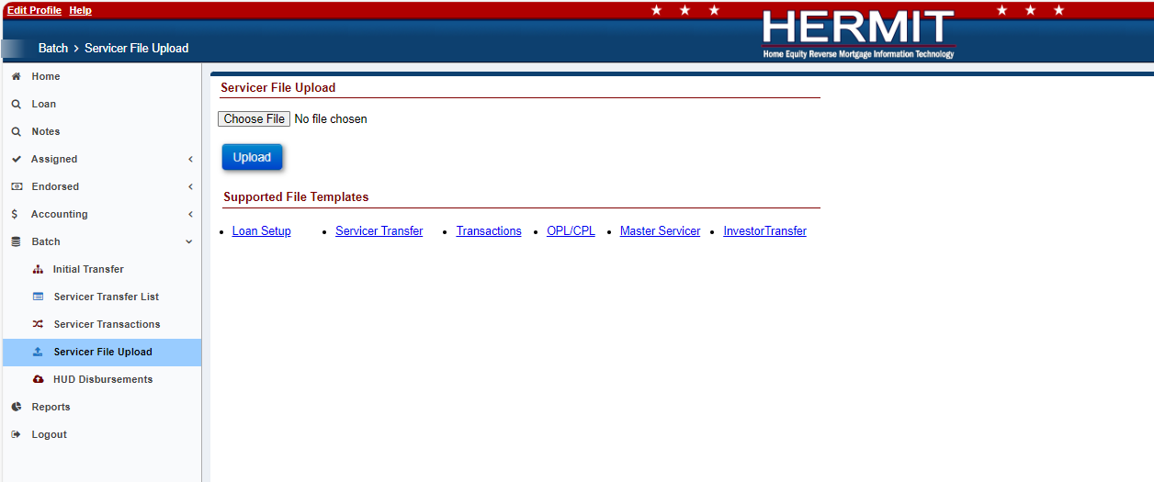
Figure 5: Servicer File Upload Screen

Each file may contain up to 1,500records for Loan Setup, Transactions, OPL/CPL, Master Servicer, and Investor Transfer. The Servicer Transfer files may contain up to 10,000. The processing time to upload a file, containing up to 10,000 records will normally take a few minutes. If there are any posting errors, the user will be notified during the process. The upload is deemed to be complete when the user is notified via a success or failure message on the screen. The message consists of three types of notifications:
- Error records
- Warnings/success records
- Success records

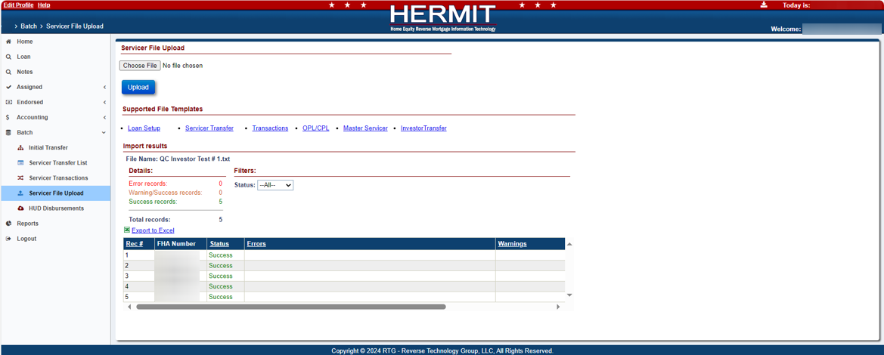
Figure 6: File Processing In HERMIT
- File name and type:
- Any file name may be used, there are no naming requirements
- A flat tab delimited file is expected. The valid file extensions are .txt, .csv or .tsv (Note: The Investor Transfer file will need to be .txt tab delimited.)
- Each row must contain only one record
- Each data element is expected to be separated by a ‘Tab’
- Frequency of upload file:
Uploading at least one file daily versus monthly is recommended. There is no restriction on the number of files uploaded on a given day. File layout examples can be found in the Appendix.
The Servicing module provides a feature to allow Lenders/Servicers to upload a volume of transactions for the following activities in Table 4.
Table 4: HECM File Upload Types
File Upload Type | Description
Loan Setup | Is used to provide additional loan set up details after the case is initiated in CHUMS. The CHUMS file from Day 1 will be posted by 7:00am ET on Day 2.
Servicer Transfer | Is used to transfer servicing rights
Transactions | Is used to inform HERMIT of all unscheduled transactions and other case level detail. File includes but not limited to repayment, unscheduled activities, and/or payoff records
OPL/CPL | Is used to update Original Principal Limit and Current Principal Limit
Master Servicer | Is used to transfer Master servicer rights
Investor Transfer | Is used to Transfer Investor rights.

- Data formatting:
Dashes (-) and decimal points (.) are permitted within the upload file; no other special characters or symbols should be present.
- File Header Description:
The first row of each file must contain the file type identifier. No other header row or header information is permitted. The presence of any other header information will result in file upload failure.
The valid file type identifier is as follows:
- “LoanSetupImport”
- “ServicerTransferImport”
- “TransactionsImport”
- “OPLCPLImport”
- “MasterServicerImport”
- “InvestorTransferImport”

Loan Setup Import – Record Layout
This table describes the required data elements, formats and their sequence within the file.
Table 5: Data Item Descriptions for File LoanSetupImport
File Type Identifier: LoanSetupImport
Data Item | Description | Format/Range of Values | Required | Seq. #
FHA Case # | FHA case number | Numeric(10); | Yes | 1
Interest Rate At Closing | Note interest Rate at closing | Integer followed by decimal(3);  Range >‘0.000’ and <’20.000’ | Yes | 2
Exp. Interest Rate | Expected Interest Rate | Integer followed by decimal(3);  Range >= ‘0.000’ <= ‘18.875’; | Yes | 3
Rate Type | Type of interest rate | String(1);  ‘A’ = Annual;  ‘F’ = Fixed;  ‘M’ = Monthly; | Yes | 4
Index Type | Interest rate index | Integer;  If Rate Type ‘A’ :  ‘100’ = 1-Year CMT;  ‘230’ = 1-YearSOFR;  If Rate Type ‘F’ :  ‘240’ = No Index;  If Rate Type ‘M’ :  ‘100’ = 1-Year CMT;  ‘110’ = 1-Month CMT;  ‘200’ = 1-MonthSOFR; | Yes | 5
Margin | Interest Rate margin | Integer followed by decimal(3);  If Rate Type A or M:  >‘0.000’ and <= ‘5.000’;  If Rate Type F:  ‘0.000’ or NULL | Conditional;  if Rate Type = Monthly or Annual | 6
ARM First Change Date | First interest rate change date | Date(10);  Format: YYYY-MM-DD;  If Rate Type Monthly:  When Closing Date other than Jan 31: 1st of the month AND >= 30 days and <= 3 months from Closing Date;  When Closing Date on Jan 31:  1st of the month AND > Closing Date and <= 3 months from Closing Date;  If Rate Type Annual:  1st of the month AND >12 months and <=18 months from Closing Date | Conditional;  if Rate Type = Monthly or Annual | 7
Credit Type | Type of credit | String(1);  ‘O’ = Open;  ‘C’ = Closed; | Yes | 8
Round to 1/8th | Interest rate rounding indicator | Integer(1);  ‘0’ = Will not be rounded;  ‘1’ = Will be rounded to 1/8th percent; | Yes | 9
Lender Loan # | Lender loan number | String (20); | No | 10
Responsible for IMIP | HUD assigned mortgagee number of the assigned servicer responsible for IMIP | Integer;  Must be > 0;  FHA Mortgagee Number | Yes | 11
Investor Name | HUD assigned mortgagee number of investor | Integer;  Must be > 0; | Yes | 12
Closing Date | Mortgage Closing Date | Date(10);  Format: YYYY-MM-DD;  Must be <=Today’s date; | Yes | 13
Funded Date | Funded Date | Date(10);  Format: YYYY-MM-DD;  Must be >=Closing Date and <=Today’s Date;  Funded Date must be within 30 days from the Closing Date; | Yes | 14
Application Date | Loan Application Date | Date(10);  Format: YYYY-MM-DD;  Must be <=Closing Date; | No | 15
Exp. Rate Index Date | Index date for Expected Interest Rate | Date(10);  Format: YYYY-MM-DD;  Must be <=Closing Date and >= Application Date - 14 days; | Conditional; on availability of data field Exp. Rate Index Date | 16
Exp. Rate Locked | Loan Rate lock status | Integer(1);  ‘0’ - No;  ‘1’ – Yes; | Conditional; on availability of data field Exp. Rate Locked | 17
IMIP Paid By Borrower | IMIP pay method | Integer followed by decimal(2);  Must be >= $0.00 and <= IMIP Total | Yes | 18
Pay Plan Type | Type of Payment Plan | Integer;  ’10’ = Line of Credit;  ‘20’ = Term;  ‘30’ = Tenure;  ‘40’ = Modified Term;  ‘50’ = Modified Tenure;  ‘60’ – Lump Sum; | Yes | 19
Pay Plan Term | # of monthly payments | Integer;  Range > ‘0’ and <= ‘480’ months; | Conditional;  if Pay Plan is Term or Modified Term | 20
Monthly Payment Amount | The monthly payment amount scheduled to be made to the borrower each month.  Note: The Monthly Tax and Insurance Withheld amount should NOT be deducted from this amount | Integer followed by decimal(2);  Range >= ‘0.00’ and <= ’25,000.00’; | Conditional;  if Pay Plan is Term, Tenure, Modified Term or Modified Tenure | 21
Monthly Tax & Ins. Withheld | The amount set aside monthly for taxes and insurance on the loan | Integer followed by decimal(2);  Range >= ‘0.00’ and <= ’25,000.00’;  Must be < =Monthly Payment Amount; | Conditional;  if Pay Plan is Term, Tenure, Modified Term or Modified Tenure | 22
First Payment Date | First payment date to HECM Mortgagor | Date(10);  Format: YYYY-MM-DD;  Must be > Funded Date;  Funded Date must be <= 30 days from Closing Date; | Conditional;  if Pay Plan is Term, Tenure, Modified Term or Modified Tenure | 23
Monthly Service Fee | Amount paid to Servicer / Lender for servicing the loan | Integer followed by decimal(2);  Fixed or Annual Rate Type >=‘0.00’ and <= ‘30.00’;  Monthly Rate Type >=‘0.00’ and <= ’35.00’; | Yes | 24
Original Principal Limit | Original Principal limit amount | Integer followed by decimal(2);  Must be <= FHA Loan Limit and < Max Claim Amount’ ;  For HECM purchase transactions only, the maximum claim amount will be the least of: 1) the appraised value; 2) Sales price; or 3) FHA mortgage limit for a one family residence. Principal Limit must equal Principal limit factor x Max Claim Amount; | Yes | 25
Closing Costs | Borrower closing expenses. The amount of fees and expense incurred by loan initiation. Financed into loan balance; not due to be paid until loan is terminated/paid in full. | Integer followed by decimal(2);  Must be >= ‘0.00’ and < Max Claim Amount;  Used in the calculation MO Fields. | No | 26
Discharge of Liens | Discharge of Liens. Release of financial liability to a debt of record (i.e. release of title). Applies to all HECM transaction types | Integer followed by decimal(2);  Must be >= ‘0.00’ and <= FHA Loan Limit;  Used in the calculation MO Fields. | No | 27
Loan Advance/ Other Draws | Loan advance / Other draws taken at closing. Applies to Traditional or Refinance. For Purchase Transaction must equal fully drawn LOC | Integer followed by decimal(2);  Must be >= ‘0.00’ and <= FHA Loan Limit;  Used in the calculation MO Fields. | Conditional;  If Pay Plan is Modified Term or Modified Tenure or Line Of Credit or Lump Sum | 28
Repair Set Aside | Repair set aside (RSA) amount | Integer followed by decimal(2);  Must be >= ‘0.00’  Used in the calculation MO Fields. | Conditional;  If Repair Set Aside is available | 29
First Year Set Aside | First Year taxes & insurance set aside (FYSA)  The amount of money set aside to cover property charges from the initial/net principal limit | Integer followed by decimal(2);  Must be >= ‘0.00’ and <= FHA Loan Limit; | Yes | 30
Credit Line Set Aside | This amount is the portion of the Principal Limit set aside drawn down as a Line of Credit. | Integer followed by decimal(2);  Must be >= ‘0.00’ <= FHA Loan Limit; | Conditional;  if Pay Plan is Modified Term or Modified Tenure | 31
Basis Points BPS | Basis points | Integer; Range >=36 AND <=150; | Conditional;  if Monthly Service Fee = 0 | 32
Repair Admin Fee | Repair Admin Fee | Integer followed by decimal(2);  Must be >= ‘0.00 and <= ’1407.00’  (Lender may charge a fee not to exceed the greater of one and one-half (1 1/2) percent of the funds used for repairs or $50 for administration of the agreement) | Conditional;  if Repair Set Aside is > $0.00 | 33
Loan Origination Amt | Loan Origination Amount | Integer followed by decimal(2);  If FHA Case # Assigned Date is >=10/31/08:  Must be >= ‘$0.00’ and <= ‘$6,000’;  2% of MCA up to $200,000;  Additional 1% of MCA > $200,000;  Used in the calculation MO Fields | Yes | 34
Sale Date | The date the HECM mortgaged property was sold to the mortgagor. This field is applicable only for HECM for Purchase product type. | Date(10);  Format: YYYY-MM-DD; | No | 35
Contract Date | Contract Date. This field is applicable only for HECM for Purchase product type. | Date(10);  Format: YYYY-MM-DD; | No | 36
Was Prior Sale/ Transfer | Was Prior sale/Transfer | Integer(1);  ‘0’ = No;  ‘1’ = Yes; | Conditionally required if Product Type = HECM Standard for Purchase, HECM for Purchase or HECM Saver for Purchase | 37
Prior Sale Date | Prior Sale Date | Date(10);  Format: YYYY-MM-DD; | Conditionally required if Was Prior Sale/Transfer is YES | 38
Prior Sale Price Amount | Prior Sale Price Amount | Integer followed by Decimal(2);  Must be >= ‘0.00’ | Conditionally required if Was Prior Sale/Transfer is YES | 39
Tax Ins Responsible Party | Tax Insurance Responsible Party | Integer:  ‘10’ - Borrower;  ‘20’ - Servicer; | No | 40
Title Held As | Title Held As | Integer:  ‘10’ - Fee Simple;  ‘20’ - Leasehold;  ‘30’ - Trust; | No | 41
IMIP Paid By Lender | IMIP Pay method | Integer followed by Decimal(2);  Must be >= $0.00 and <= IMIP Total  Used in the calculation MO Field. | Yes | 42
LESA Semi Annual Amount | Semi- annual payment amount for the Partially Funded LESA Type. | Integer followed by Decimal(2);  Must be > ‘0.00’ and <= T&I First Yr Payments Amount, | Conditionally Required if LESA Type is Partially Funded. | 43
Lifetime Cap | Actual interest rate value that the mortgage interest rate may not exceed | Integer followed by decimal(3);  Must be >‘0.000’.  Annual: Lifetime Cap must be <= Interest Rate at Closing plus 5%  Monthly: Lifetime Cap must be <= Interest Rate at Closing plus 15% | Conditionally Required if Index Type is Annual or Monthly. | 44
Responsible for MMIP | HUD assigned mortgagee number of the assigned servicer responsible for MMIP | Integer;  Must be > 0;  FHA Mortgagee Number | Yes | 11

Loan Setup Import – B2G File layout
This file can be used as a guide for creating the upload file. It can also be found on the upload screen within HERMIT.
Loan Setup Import File displayed below:
Note - The Loan Setup import file is just one file, which is split into three screenshots for readability purposes.

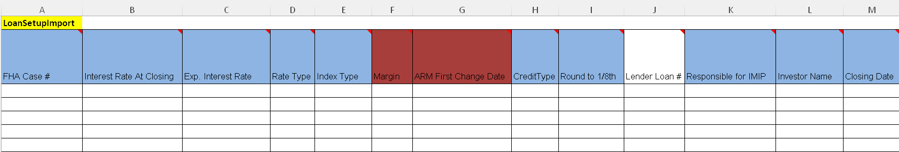

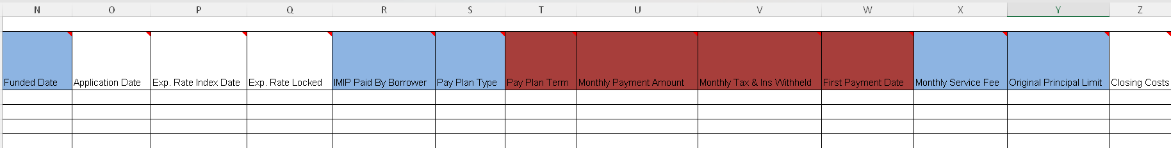

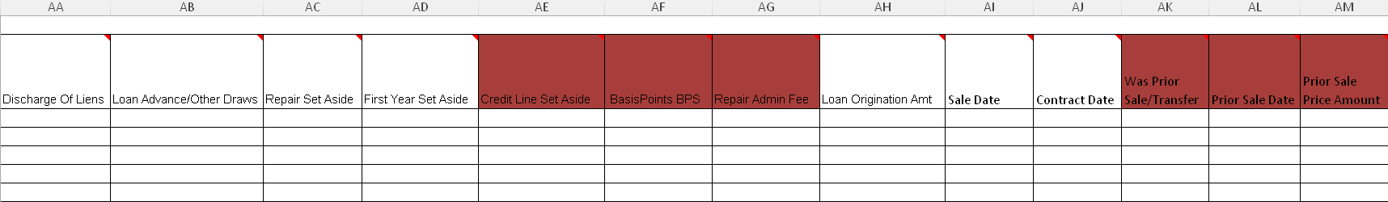

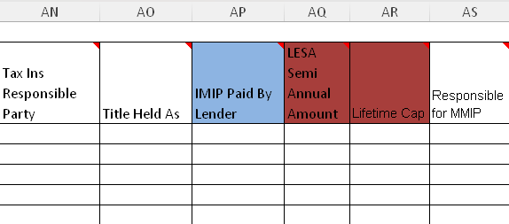
Figure 7: Loan Setup Import File

Servicer Transfer - Record Layout
This table describes the required data elements, formats and their sequence within the file.
Table 6: Data Item Description for File ServicerTransferImport
File Type Identifier: ServicerTransferImport
Data Item | Description | Format/Range of Values | Required | Seq. #
FHA Case # | FHA Case Number | Numeric(10); | Yes | 1
Transfer Date | Date of Loan Transfer to New Servicer/Investor | Date(10);  Format: YYYY-MM-DD  DD must be the first day of any of the upcoming three months, excluding the current month | Yes | 2
To Servicer | HUD assigned mortgagee number of the servicer that will service the loan | Integer;  Must be > 0;  Must be a valid FHA Mortgagee Number | Yes | 3
To Investor | HUD assigned mortgagee number of investor | Integer;  Must be > 0;  Must be a valid FHA Investor Number | Yes | 4

Servicer Transfer Import – B2G File Layout
This template can be used as a guide for creating the upload file. It can also be found on the upload screen within HERMIT.
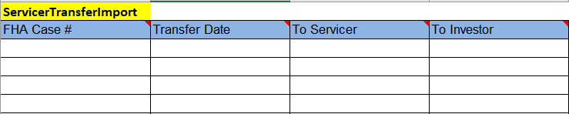
Figure 8: Servicer Transfer Import File

Transactions - Record Layout
This table describes the required data elements, formats and their sequence within the file.
Table 7: Data Item Descriptions for File TransactionsImport
File Type Identifier: TransactionsImport
Data Item | Description | Format/Range of Values | Required | Seq. #
FHA Case # | FHA Case Number | Numeric(10); | Yes | 1
Transaction Code | Transaction Type | String(4);  See Table12 for Transaction Codes and Description reference; | Yes | 2
Effective Date | The Date when the payment was applied to the loan balance | Date(10);  Format: YYYY-MM-DD; | Yes | 3
Amount | Transaction amount | Integer followed by decimal (2);  Must be > 0.00; | Yes | 4
Incurred Date | This is the date the expense was incurred by the Lender/Investor for Preservation and Protection activities when filing a Claim | Date(10);  Format: YYYY-MM-DD; | Conditional;  For Corp Adv Transactions only – See Table 12 in Appendix for a detailed description of Corporate Advance Transactions | 5
Borr Recoverable | Indicates whether the Corporate Advance Transaction is Borrower Recoverable (Yes) or not (No) | String (3);  Must be Yes or No. | No | 6

Transactions Import - Transaction Codes and Descriptions
Table 8 below depicts a list of Transaction Codes, Transaction Category, Transaction Names and their descriptions generated in Servicing Module.
HERMIT restricts certain transactions from being input by users based on the transaction category and transaction effective date. Corporate Advance Transactions should only apply ON or AFTER the loan’s Due Date (also referred to as Due & Payable date), and transactions affecting loan balance should only apply PRIOR to the loan’s Due Date.
- If loan is not Due & Payable - Corp Advance Transactions can be added anytime.
- If loan is not Due & Payable - Loan Balance Transactions can be added anytime.
- If loan is Due & Payable - Corp Advance Transactions can be added if Effective Date is ON or AFTER the Loan's Due Date.
- If loan is Due & Payable - Loan Balance Transactions can be added if Effective Date is PRIOR to the Loan's Due Date.
- If loan is Due & Payable - Repay Transactions can be added anytime regardless of Due Date.
- If loan is not Due & Payable - Repay transaction can be added anytime.

Table 8: Transaction Codes and Descriptions
Category | Transaction Code | Transaction Category | Transaction Name | Transaction Description
Repayments
 | 2710 | Repays | Part Repay - Reduce Loan Balance | This transaction is initiated by the Servicer (on-behalf of Borrower) to repay a partial amount to reduce the current unpaid loan balance. This transaction applies to ALL pay plan types.
 | 2720 | Repays | Part Repay - Increase CLSA+Reduce LB | This transaction is initiated by the Servicer (on-behalf of Borrower) to repay a partial amount to reduce the current unpaid loan balance and increase the available line of credit. This transaction applies to pay plan types Modified Term and Modified Tenure ONLY.
 | 2731 | Repays | Part Repay - LESA | This transaction is initiated by the Servicer (on-behalf of Borrower) to repay a partial amount to reduce the current unpaid loan balance from the Life Expectancy Set Aside amount. This transaction applies to ALL pay plan types.
 | 2739 | Repays | Part Repay - LESA Adj | Reversal of 2731. A reversal adjustment icon is available for this functionality.
 | 2780 | Repays | Part Repay - Increase CLSA+Reduce LB Adj | This transaction is initiated by the Servicer to adjust off transaction 2720
 | 2790 | Repays | Part Repay - Reduce Loan Balance Adj | This transaction is initiated by the Servicer to adjust off transaction 2710
 | 2791 | Repays | Part Repay - Prop Chrg Pre D&P Adj | This transaction is initiated by the Servicer to adjust off transaction 2711
Property Charges beyond drawable equity
 | 1850 | Property Charges | Prop Chrg - Pre D & P S305 - Condominium Fees | This transaction is initiated by Servicer to make a disbursement on behalf of Borrower to Vendor for condominium fees on the mortgaged property. This transaction applies to ALL pay plans.
 | 1851 | Property Charges | Prop Chrg - Pre D & P S305 - Flood Insurance | This transaction is initiated by Servicer to make a disbursement on behalf of Borrower to Vendor for flood insurance premiums on the mortgaged property. This transaction applies to ALL pay plans.
 | 1852 | Property Charges | Prop Chrg - Pre D & P S305 - Ground Rent | This transaction is initiated by Servicer to make a disbursement on behalf of Borrower to Vendor for ground rent expenses on the mortgaged property. This transaction applies to ALL pay plans.
 | 1853 | Property Charges | Prop Chrg - Pre D & P S305 - Hazard Insurance | This transaction is initiated by Servicer to make a disbursement on behalf of Borrower to Vendor for hazard insurance premiums on the mortgaged property. This transaction applies to ALL pay plans.
 | 1854 | Property Charges | Prop Chrg - Pre D & P S305 - HOA Dues | This transaction is initiated by Servicer to make a disbursement on behalf of Borrower for administration, operation, maintenance or repair of the community owned property. This transaction applies to ALL pay plans.
 | 1855 | Property Charges | Prop Chrg - Pre D & P S305 - Other | This transaction is initiated by Servicer to make a disbursement on behalf of Borrower for other expenses on the mortgaged property. This transaction applies to ALL pay plans.
 | 2711 | Property Charges | Prop Chrg - Pre D & P S305 - Repayment | This transaction is initiated by Servicer to make a repayment on behalf of Borrower to decrease the loan balance. This transaction applies to ALL pay plans.
 | 1856 | Property Charges | Prop Chrg - Pre D & P S305 - Taxes | This transaction is initiated by Servicer to make a disbursement on behalf of Borrower for payment of taxes on the mortgaged property. This transaction applies to ALL pay plans.
 | 1890 | Disb - Prop Chrg - Pre D&P | Disb - Prop Chrg Pre D&P-Condo Fees Adj | This transaction is initiated by the Servicer to adjust off transaction 1850
 | 1891 | Disb - Prop Chrg - Pre D&P | Disb - Prop Chrg Pre D&P-Flood Ins Adj | This transaction is initiated by the Servicer to adjust off transaction 1851
 | 1892 | Disb - Prop Chrg - Pre D&P | Disb - Prop Chrg Pre D&P-Ground Rent Adj | This transaction is initiated by the Servicer to adjust off transaction 1852
 | 1893 | Disb - Prop Chrg - Pre D&P | Disb - Prop Chrg Pre D&P-Hazard Ins Adj | This transaction is initiated by the Servicer to adjust off transaction 1853
 | 1894 | Disb - Prop Chrg - Pre D&P | Disb - Prop Chrg Pre D&P-HOA Dues Adj | This transaction is initiated by the Servicer to adjust off transaction 1854
 | 1895 | Disb - Prop Chrg - Pre D&P | Disb - Prop Chrg Pre D&P-Others Adj | This transaction is initiated by the Servicer to adjust off transaction 1855
 | 1896 | Disb - Prop Chrg - Pre D&P | Disb - Prop Chrg Pre D&P-Taxes Adj | This transaction is initiated by the Servicer to adjust off transaction 1856
Scheduled Payments
 | 1250 | Disb - Scheduled | Disb - Scheduled | This transaction is initiated by the Servicer (on-behalf of Borrower) to make a Scheduled Payment to the Borrower
 | 1290 | Disb - Scheduled | Disb - Scheduled Adj | This transaction is initiated by the Servicer to adjust off transaction 1250
Unscheduled Advances (Up to drawable equity)
 | 1350 | Disb - Unscheduled from LOC | Disb - Unscheduled from LOC - Other | This transaction is initiated by the Servicer (on-behalf of Borrower) to make an unscheduled disbursement from Borrower’s available Line Of Credit. This transaction applies to pay plan types Line Of Credit, Modified Term and Modified Tenure ONLY.
 | 1351 | Disb - Unscheduled from LOC | Disb - Unscheduled from LOC Release Fee | This transaction is initiated by the Servicer (on-behalf of Borrower) to make an unscheduled disbursement from Borrower’s available Line Of Credit. This transaction applies to pay plan types Line Of Credit, Modified Term and Modified Tenure ONLY.
 | 1352 | Disb - Unscheduled from LOC | Disb - Unscheduled from LOC Inspections | This transaction is initiated by the Servicer (on-behalf of Borrower) to make an unscheduled disbursement from Line of Credit for inspections on the mortgaged property. This transaction applies to pay plan types Line Of Credit, Modified Term and Modified Tenure ONLY.
 | 1353 | Disb - Unscheduled from LOC | Disb - Unscheduled from LOC Appraisals | This transaction is initiated by the Servicer (on-behalf of Borrower) to make an unscheduled disbursement from Line of Credit for appraisals on the mortgaged property. This transaction applies to pay plan types Line Of Credit, Modified Term and Modified Tenure ONLY.
 | 1354 | Disb - Unscheduled from LOC | Disb - Unscheduled from LOC Prop Preserv | This transaction is initiated by the Servicer (on-behalf of Borrower) to make an unscheduled disbursement from Line of Credit for preservation and protection of the mortgaged property. Preservation and protection activities may include Repairs, Landscaping etc. This transaction applies to pay plan types Line Of Credit, Modified Term and Modified Tenure ONLY.
 | 1550 | Disb - Taxes & Ins Withheld | Disb - Taxes & Ins Withheld | This transaction is initiated by the Servicer to make a disbursement for Taxes and Insurance from Borrower's available taxes and insurance set aside balance. This transaction applies to ALL pay plan types.
 |  |  |  | Note: Taxes and Insurance withheld balance must be > $0.00.
 | 1650 | Disb - 1st Yr Taxes & Ins Set Aside | Disb - 1st Yr TI Set Aside Not Final | This transaction is initiated by the Servicer to make a disbursement from Borrower's available 1st year taxes and insurance set aside amount. Servicer will be able to make these disbursements until all the 1st Yr TI set aside amount has exhausted (or) there is no Disb - 1st Yr TI Set Aside Final transaction. This transaction applies to ALL pay plan types.
 |  |  |  | Note: The 1st year taxes and insurance set aside balance must be > $0.00.
 | 1651 | Disb - 1st Yr Taxes & Ins Set Aside | Disb - 1st Yr TI Set Aside Final | This transaction is initiated by the Servicer to make a disbursement from Borrower's available 1st year taxes and insurance set aside amount. This will be a one-time transaction and Servicer will not be able to make any Disb - 1st Yr TI Set Aside Not Final transaction once a final transaction has been made. This transaction applies to ALL pay plan types.
 |  |  |  | Note: The 1st year taxes and insurance set aside balance must be > $0.00.
 | 1750 | Disb - Repair Set Aside | Disb - Repair Set Aside Not Final | This transaction is initiated by the Servicer to make a disbursement from borrower's set aside amount for any repairs on the mortgaged property. Servicer will be able to make these disbursements until all the Repair set aside Not Final amount has exhausted (or) there is no Disb - Repair Set Aside Final transaction. This transaction applies to ALL pay plan types.
 |  |  |  | Note: The Repair set aside balance must be > $0.00.
 | 1751 | Disb - Repair Set Aside | Disb - Repair Set Aside Final | This transaction is initiated by the Servicer to make a disbursement from Borrower's repair set aside amount for any repairs on the mortgaged property. This will be a one-time transaction and Servicer will not be able to make any Disb - Repair Set Aside Not Final transaction once a final transaction has been made. This transaction applies to ALL pay plan types.
 |  |  |  | Note: The Repair set aside balance must be > $0.00.
 | 2350 | Disb - Unscheduled from LOC | Disb – Property Charge - Taxes | This transaction is initiated by the Servicer to make an unscheduled disbursement from Line Of Credit to pay for taxes on behalf of Borrower. This transaction applies to ALL pay plan types.
 | 2450 | Disb - Unscheduled from LOC | Disb – Property Charge – Insurance | This transaction is initiated by the Servicer to make an unscheduled disbursement from Line Of Credit to pay for the insurance of the mortgaged property on behalf of Borrower. This transaction applies to ALL pay plan types.
 | 2550 | Refunds | Disb - Refund Remittance Overage | This transaction is initiated by the Servicer to refund the excess amount paid by Borrower after loan is paid-off. The loan status will have been 'Terminated' with an overage amount > $0.00 and < $10.00 for this transaction to be initiated.
 | 2590 | Refunds | Disb - Refund Remittance Overage - Adj | This transaction is initiated by the Servicer to adjust refund transaction. Reversal of 2550.
 | 2050 | Disb – Life Expectancy Set Aside | Disb - LESA Not Final | This transaction is initiated by the Servicer to make a disbursement from LESA Set Aside to pay for property taxes and insurance on behalf of Borrower.
 | 2051 | Disb – Life Expectancy Set Aside | Disb - LESA Final | This transaction is initiated by the Servicer to make disbursement from LESA Set Aside to pay for property taxes and insurance on behalf of Borrower.
 | 2090 | Disb – Life Expectancy Set Aside | Disb - LESA Not Final Adj | This transaction is initiated by the Servicer to adjust off transaction 2050
 | 2091 | Disb – Life Expectancy Set Aside | Disb - LESA Final Adj | This transaction is initiated by the Servicer to adjust off transaction 2051
 | 2390 | Disb - Unscheduled from LOC | Disb Property Charge - Taxes- Adj | This transaction is initiated by the Servicer to adjust off transaction 2350
 | 2490 | Disb - Unscheduled from LOC | Disb Property Charge – Insurance- Adj | This transaction is initiated by the Servicer to adjust off transaction 2450
 | 1390 | Disb - Unscheduled from LOC | Disb - Unscheduled from LOC Adj | This transaction is initiated by the Servicer to adjust off transaction 1350
 | 1391 | Disb - Unscheduled from LOC | Disb - Unscheduled from LOC Rel Fee Adj | This transaction is initiated by the Servicer to adjust off transaction 1351
 | 1392 | Disb - Unscheduled from LOC | Disb - Unscheduled from LOC Insp Adj | This transaction is initiated by the Servicer to adjust off transaction 1352
 | 1393 | Disb - Unscheduled from LOC | Disb - Unscheduled from LOC Appraise Adj | This transaction is initiated by the Servicer to adjust off transaction 1353
 | 1394 | Disb - Unscheduled from LOC | Disb - Unscheduled from LOC Prop Pres Ad | This transaction is initiated by the Servicer to adjust off transaction 1354
 | 1590 | Disb - Taxes & Insurance Withheld | Disb - Taxes & Ins Withheld Adj | This transaction is initiated by the Servicer to adjust off transaction 1550
 | 1690 | Disb - 1st Year Taxes & Ins Set Aside | Disb - 1st Yr TI Set Aside Not Final Adj | This transaction is initiated by the Servicer to adjust off transaction 1650
 | 1691 | Disb - 1st Year Taxes & Ins Set Aside | Disb - 1st Yr TI Set Aside Final Adj | This transaction is initiated by the Servicer to adjust off transaction 1651
 | 1790 | Disb - Repair Set Aside | Disb - Repair Set Aside Not Final Adj | This transaction is initiated by the Servicer to adjust off transaction 1750
 | 1791 | Disb - Repair Set Aside | Disb - Repair Set Aside Final Adj | This transaction is initiated by the Servicer to adjust off transaction 1751
Corporate Advances/Closing Fee
 | 2441 | Corp Advance - Misc Claim | Corp Adv - Misc Claim - Rental Expense | This transaction is initiated by the Servicer to report the expense incurred by Lender/Investor from Rental Agreement. This transaction applies to ALL pay plan types.
 | 2442 | Corp Advance - Misc Claim | Corp Adv - Misc Claim - Rental Expense Adj | This transaction is initiated by the Servicer to report the expense incurred by Lender/Investor from Rental Agreement. This transaction applies to ALL pay plan types.
 | 2448 | Corp Advance - Misc Claim | Corp Adv - Misc Claim - Rental Income | This transaction is initiated by the Servicer to report income received by Lender/Investor from Rental Agreement. This transaction applies to ALL pay plan types.
 | 2449 | Corp Advance - Misc Claim | Corp Adv - Misc Claim - Rental Income Adj | This transaction is initiated by the Servicer to report income received by Lender/Investor from Rental Agreement. This transaction applies to ALL pay plan types.
 | 2101 | Corp Advance - Property Preservation | Corp Adv - Prop Preserve - Boarding | This transaction is initiated by the Servicer to report the expense incurred by Lender/Investor for boarding of the mortgaged property as part of preservation and protection activity. This transaction applies to ALL pay plan types.
 | 2102 | Corp Advance - Property Preservation | Corp Adv - Prop Preserve - Remove Debris | This transaction is initiated by the Servicer to report the expense incurred by Lender/Investor for removal of debris on the mortgaged property as part of preservation and protection activity. This transaction applies to ALL pay plan types.
 | 2103 | Corp Advance - Property Preservation | Corp Adv - Prop Preserve - Hazard Abate | This transaction is initiated by the Servicer to report the expense incurred by Lender/Investor for abatement of any hazards on the mortgaged property as part of preservation and protection activity. This transaction applies to ALL pay plan types.
 | 2104 | Corp Advance - Property Preservation | Corp Adv - Prop Preserve - Utilities | Utilities must be reported using the Transaction Code : 2123 (Corp Adv - S305 – Utilities)
 | 2111 | Corp Advance - Property Preservation | Corp Adv - Prop Preserve - Prop Inspect | This transaction is initiated by the Servicer to report the expense incurred by Lender/Investor for property inspection charges on the mortgaged property as part of preservation and protection activity. This transaction applies to ALL pay plan types.
 | 2112 | Corp Advance - Property Preservation | Corp Adv - Prop Preserve - Landscape | This transaction is initiated by the Servicer to report the expense incurred by Lender/Investor for landscaping charges on the mortgaged property as part of preservation and protection activity. This transaction applies to ALL pay plan types.
 | 2113 | Corp Advance - Property Preservation | Corp Adv - Prop Preserve - Roof Repair | This transaction is initiated by the Servicer to report the expense incurred by Lender/Investor for roof repairs on the mortgaged property as part of preservation and protection activity. This transaction applies to ALL pay plan types.
 | 2114 | Corp Advance - Property Preservation | Corp Adv - Prop Preserve - Other Repair | This transaction is initiated by the Servicer to report the expense incurred by Lender/Investor for other repairs on the mortgaged property as part of preservation and protection activity. This transaction applies to ALL pay plan types.
 | 2115 | Corp Advance - Property Preservation | Corp Adv - Prop Preserve - Winterizing | This transaction is initiated by the Servicer to report the expense incurred by Lender/Investor for winterizing of the mortgaged property as part of preservation and protection activity. This transaction applies to ALL pay plan types.
 | 2116 | Corp Advance - Property Preservation | Corp Adv - Prop Preserve - Securing | This transaction is initiated by the Servicer to report the expense incurred by Lender/Investor for securing of the mortgaged property as part of preservation and protection activity. This transaction applies to ALL pay plan types.
 | 2117 | Corp Advance - Property Preservation | Corp Adv - Prop Preserve - Other | This transaction is initiated by the Servicer to report the expense incurred by Lender/Investor for other property and preservation activities on the mortgaged property. A descriptive title for the expenses must be entered on the electronic version of the claim form (HUD Form-27011) at the time of claim submission. This transaction applies to ALL pay plan types.
 | 2118 | Corp Advance - Property Preservation | Corp Adv - Prop Preserve - Repayment | This transaction is initiated by the Servicer to report repayments by the Borrower within this transaction category. This transaction applies to ALL pay plan types.
 | 2120 | Corp Advance - Section 305 Disbursements | Corp Adv - S305 - Flood Insurance | This transaction is initiated by the Servicer to report the expense incurred by the Lender/Investor for flood insurance premiums on the mortgaged property. This transaction applies to ALL pay plan types.
 | 2121 | Corp Advance - Section 305 Disbursements | Corp Adv - S305 - Hazard Insurance | This transaction is initiated by the Servicer to report the expense incurred by the Lender/Investor for hazard insurance premiums on the mortgaged property. This transaction applies to ALL pay plan types.
 | 2122 | Corp Advance - Section 305 Disbursements | Corp Adv - S305 - Taxes | This transaction is initiated by the Servicer to report the expense incurred by the Lender/Investor for taxes that are liens prior to the mortgage. This transaction applies to ALL pay plan types.
 | 2123 | Corp Advance - Section 305 Disbursements | Corp Adv - S305 - Utilities | This transaction is initiated by the Servicer to report the expense incurred by the Lender/Investor for utilities that are liens prior to the mortgage. This transaction applies to ALL pay plan types.
 | 2124 | Corp Advance - Section 305 Disbursements | Corp Adv - S305 - Eviction Fees | This transaction is initiated by the Servicer to report the expense incurred by the Lender/Investor for eviction in the event of foreclosure proceedings. This transaction applies to ALL pay plan types.
 | 2125 | Corp Advance - Section 305 Disbursements | Corp Adv - S305 - Other | This transaction is initiated by the Servicer to itemize other expenses incurred by the Lender/Investor in this category. A descriptive title for the expenses must be entered on the electronic version of the claim form (HUD Form-27011) at the time of claim submission. This transaction applies to ALL pay plan types.
 | 2126 | Corp Advance - Section 305 Disbursements | Corp Adv - S305 - Ground Rent | This transaction is initiated by the Servicer to report the expense incurred by the Lender/Investor for ground rent that are liens prior to the mortgage. This transaction applies to ALL pay plan types.
 | 2127 | Corp Advance - Section 305 Disbursements | Corp Adv - S305 - Condominium Dues | This transaction is initiated by the Servicer to report the expense incurred by the Lender/Investor for the condominium dues. This transaction applies to ALL pay plan types.
 | 2130 | Corp Advance - Section 305 Disbursements | Corp Adv - S305 - State Prohibited Legal | This transaction is initiated by the Servicer to report the expense incurred by the Lender/Investor for the legal dues. This transaction applies to ALL pay plan types.
 | 2134 | Corp Advance - Section 305 Disbursements | Corp Adv - S305 - Relocation Incentive | This transaction is initiated by the Servicer to report the expense incurred by the Lender/Investor for the relocation incentive dues. This transaction applies to ALL pay plan types.
 | 2137 | Corp Advance - Section 305 Disbursements | Corp Adv - S305 - HOA Dues | This transaction is initiated by the Servicer to report the expense incurred by the Lender/Investor for the administration, operation, maintenance or repair of the community owned property. This transaction applies to ALL pay plan types.
 | 2135 | Corp Advance - Section 305 Disbursements | Corp Adv - S305 Utilities - Liens | This transaction is initiated by the Servicer to report Utility Charges that are part of Liens. This transaction applies to ALL pay plan types.
 | 2335 | Corp Advance - Section 305 Disbursements | Corp Adv - S305 Utilities – Liens Adj | This transaction is initiated by the Servicer to adjust off the Utility Charges that are part of Liens. This transaction applies to ALL pay plan types.
 | 2136 | Corp Advance - Section 305 Disbursements | Corp Adv - S305 - Cash For Keys | This transaction is initiated by the Servicer to report Cash for Keys Transactions (Review ML 2017-11 - $3,000.00 Cap). This transaction applies to ALL pay plan types.
 | 2336 | Corp Advance - Section 305 Disbursements | Corp Adv - S305 - Cash For Keys Adj | This transaction is initiated by the Servicer to Adjust off Cash for Keys Transactions. This transaction applies to ALL pay plan types.
 | 4120 | Corp Advance - Section 305 Disbursements | Corp Adv - S305 - Flood Insurance - Repay | This transaction is initiated by the Servicer to report repayments by the Borrower towards balance of each group of transactions. This transaction applies to ALL pay plan types.
 | 4320 | Corp Advance - Section 305 Disbursements | Corp Adv - S305 - Flood Insurance - Repay Adj | This transaction is initiated by the Servicer to Adjust off Flood Insurance – Repay Transactions. This transaction applies to ALL pay plan types.
 | 4121 | Corp Advance - Section 305 Disbursements | Corp Adv - S305 - Hazard Insurance - Repay | This transaction is initiated by the Servicer to report repayments by the Borrower towards balance of each group of transactions. This transaction applies to ALL pay plan types.
 | 4321 | Corp Advance - Section 305 Disbursements | Corp Adv - S305 - Hazard Insurance - Repay Adj | This transaction is initiated by the Servicer to Adjust off Hazard Insurance - Repay Transactions. This transaction applies to ALL pay plan types.
 | 4122 | Corp Advance - Section 305 Disbursements | Corp Adv - S305 - Taxes - Repay | This transaction is initiated by the Servicer to report repayments by the Borrower towards balance of each group of transactions. This transaction applies to ALL pay plan types.
 | 4322 | Corp Advance - Section 305 Disbursements | Corp Adv - S305 - Taxes - Repay Adj | This transaction is initiated by the Servicer to Adjust off Taxes - Repay Transactions. This transaction applies to ALL pay plan types.
 | 4143 | Corp Advance - Section 305 Disbursements | Corp Adv - S305 - Utilities - Repay | This transaction is initiated by the Servicer to report repayments by the Borrower towards balance of each group of transactions. This transaction applies to ALL pay plan types.
 | 4343 | Corp Advance - Section 305 Disbursements | Corp Adv - S305 - Utilities - Repay Adj | This transaction is initiated by the Servicer to Adjust off Utilities - Repay Transactions. This transaction applies to ALL pay plan types.
 | 4124 | Corp Advance - Section 305 Disbursements | Corp Adv - S305 - Eviction Fees - Repay | This transaction is initiated by the Servicer to report repayments by the Borrower towards balance of each group of transactions. This transaction applies to ALL pay plan types.
 | 4324 | Corp Advance - Section 305 Disbursements | Corp Adv - S305 - Eviction Fees - Repay Adj | This transaction is initiated by the Servicer to Adjust off Eviction Fees - Repay Transactions. This transaction applies to ALL pay plan types.
 | 4125 | Corp Advance - Section 305 Disbursements | Corp Adv - S305 - Other - Repay | This transaction is initiated by the Servicer to report repayments by the Borrower towards balance of each group of transactions. This transaction applies to ALL pay plan types.
 | 4325 | Corp Advance - Section 305 Disbursements | Corp Adv - S305 - Other - Repay Adj | This transaction is initiated by the Servicer to Adjust off Other - Repay Transactions. This transaction applies to ALL pay plan types.
 | 4126 | Corp Advance - Section 305 Disbursements | Corp Adv - S305 - Ground Rent - Repay | This transaction is initiated by the Servicer to report repayments by the Borrower towards balance of each group of transactions. This transaction applies to ALL pay plan types.
 | 4326 | Corp Advance - Section 305 Disbursements | Corp Adv - S305 - Ground Rent - Repay Adj | This transaction is initiated by the Servicer to Adjust off Ground Rent - Repay Transactions. This transaction applies to ALL pay plan types.
 | 4127 | Corp Advance - Section 305 Disbursements | Corp Adv - S305 - Condominium Dues - Repay | This transaction is initiated by the Servicer to report repayments by the Borrower towards balance of each group of transactions. This transaction applies to ALL pay plan types.
 | 4327 | Corp Advance - Section 305 Disbursements | Corp Adv - S305 - Condominium Dues - Repay Adj | This transaction is initiated by the Servicer to Adjust off Condominium Dues - Repay Transactions. This transaction applies to ALL pay plan types.
 | 4130 | Corp Advance - Section 305 Disbursements | Corp Adv - S305 - State Prohibited Legal - Repay | This transaction is initiated by the Servicer to report repayments by the Borrower towards balance of each group of transactions. This transaction applies to ALL pay plan types.
 | 4330 | Corp Advance - Section 305 Disbursements | Corp Adv - S305 - State Prohibited Legal - Repay Adj | This transaction is initiated by the Servicer to Adjust off State Prohibited Legal - Repay Transactions. This transaction applies to ALL pay plan types.
 | 4134 | Corp Advance - Section 305 Disbursements | Corp Adv - S305 - Relocation Incentive - Repay | This transaction is initiated by the Servicer to report repayments by the Borrower towards balance of each group of transactions. This transaction applies to ALL pay plan types.
 | 4334 | Corp Advance - Section 305 Disbursements | Corp Adv - S305 - Relocation Incentive - Repay Adj | This transaction is initiated by the Servicer to Adjust off Relocation Incentive - Repay Transactions. This transaction applies to ALL pay plan types.
 | 4135 | Corp Advance - Section 305 Disbursements | Corp Adv - S305 - Utilities - Liens - Repay | This transaction is initiated by the Servicer to report repayments by the Borrower towards balance of each group of transactions. This transaction applies to ALL pay plan types.
 | 4335 | Corp Advance - Section 305 Disbursements | Corp Adv - S305 - Utilities - Liens - Repay Adj | This transaction is initiated by the Servicer to Adjust off Utilities - Liens - Repay Transactions. This transaction applies to ALL pay plan types.
 | 4136 | Corp Advance - Section 305 Disbursements | Corp Adv - S305 - Cash For Keys - Repay | This transaction is initiated by the Servicer to report repayments by the Borrower towards balance of each group of transactions. This transaction applies to ALL pay plan types.
 | 4336 | Corp Advance - Section 305 Disbursements | Corp Adv - S305 - Cash For Keys - Repay Adj | This transaction is initiated by the Servicer to Adjust off Cash For Keys - Repay Transactions. This transaction applies to ALL pay plan types.
 | 4137 | Corp Advance - Section 305 Disbursements | Corp Adv - S305 - HOA Dues - Repay | This transaction is initiated by the Servicer to report repayments by the Borrower towards balance of each group of transactions. This transaction applies to ALL pay plan types.
 | 4337 | Corp Advance - Section 305 Disbursements | Corp Adv - S305 - HOA Dues - Repay Adj | This transaction is initiated by the Servicer to Adjust off HOA Dues - Repay Transactions. This transaction applies to ALL pay plan types.
 | 2131 | Corp Advance - Section 306 Disbursements | Corp Adv - S306 - Attorney Fees | This transaction is initiated by the Servicer to report the expense incurred by the Lender/Investor for the attorney fee to vest title of the property in the name of the successful bidder. This transaction applies to ALL pay plan types.
 | 2132 | Corp Advance - Section 306 Disbursements | Corp Adv - S306 - Trustee Fees | This transaction is initiated by the Servicer to report the expense incurred by the Lender/Investor for the trustee fee to vest title of the property in the name of the successful bidder. This transaction applies to ALL pay plan types.
 | 2133 | Corp Advance - Section 306 Disbursements | Corp Adv - S306 - Other | This transaction is initiated by the Servicer to itemize other expenses incurred by the Lender/Investor in this category. A descriptive title for the expenses must be entered on the electronic version of the claim form (HUD Form-27011) at the time of claim submission. This transaction applies to ALL pay plan types.
 | 2138 | Corp Advance - Section 306 Disbursements | Corp Adv - S306 - Repayment | This transaction is initiated by the Servicer to report repayments by the Borrower within this transaction category. This transaction applies to ALL pay plan types.
 | 2141 | Corp Advance - Section 307 Disbursements | Corp Adv - S307 - Sheriff Fees | This transaction is initiated by the Servicer to report the expense incurred by the Lender/Investor for sheriff fees in the event of foreclosure proceedings. This transaction applies to ALL pay plan types.
 | 2142 | Corp Advance - Section 307 Disbursements | Corp Adv - S307 - Title Examination Fees | This transaction is initiated by the Servicer to report the expense incurred by the Lender/Investor for title search. This transaction applies to ALL pay plan types.
 | 2143 | Corp Advance - Section 307 Disbursements | Corp Adv - S307 - Recording Fees | This transaction is initiated by the Servicer to report the expense incurred by the Lender/Investor for sheriff fees in the event of foreclosure proceedings. This transaction applies to ALL pay plan types.
 | 2144 | Corp Advance - Section 307 Disbursements | Corp Adv - S307 - Other | This transaction is initiated by the Servicer to itemize other expenses incurred by the Lender/Investor in this category. A descriptive title for the expenses must be entered on the electronic version of the claim form (HUD Form-27011) at the time of claim submission. This transaction applies to ALL pay plan types.
 | 2148 | Corp Advance - Section 307 Disbursements | Corp Adv - S307 - Repayment | This transaction is initiated by the Servicer to report repayments by the Borrower within this transaction category. This transaction applies to ALL pay plan types.
 | 2151 | Corp Advance - Section 308 Disbursements | Corp Adv - S308 - State Taxes on Deed | This transaction is initiated by the Servicer to report the expense incurred by the Lender/Investor for taxes imposed upon any deed or other options by which the property was acquired by a successful bidder. This transaction applies to ALL pay plan types.
 | 2152 | Corp Advance - Section 308 Disbursements | Corp Adv - S308 - Other Taxes on Deed | This transaction is initiated by the Servicer to itemize other expenses incurred by the Lender/Investor in this category. A descriptive title for the expenses must be entered on the electronic version of the claim form (HUD Form-27011) at the time of claim submission. This transaction applies to ALL pay plan types.
 | 2158 | Corp Advance - Section 308 Disbursements | Corp Adv - S308 - Repayment | This transaction is initiated by the Servicer to report repayments by the Borrower within this transaction category. This transaction applies to ALL pay plan types.
 | 2161 | Corp Advance - Section 309 Disbursements | Corp Adv - S309 - Liens Paid | This transaction is initiated by the Servicer to report the expense incurred by the Lender/Investor for special assessments liens. A descriptive title for the expense, and the date the lien was attached or would be attached must be entered on the electronic version of the claim form (HUD Form-27011) at the time of claim submission.
 | 2162 | Corp Advance - Section 309 Disbursements | Corp Adv - S309 - Other | This transaction is initiated by the Servicer to itemize other special assessment expenses incurred by the Lender/Investor in this category. A descriptive title for the expense, and the date the lien was attached or would be attached must be entered on the electronic version of the claim form (HUD Form-27011) at the time of claim submission. This transaction applies to ALL pay plan types.
 | 2168 | Corp Advance - Section 309 Disbursements | Corp Adv - S309 - Repayment | This transaction is initiated by the Servicer to report repayments by the Borrower within this transaction category. This transaction applies to ALL pay plan types.
 | 2171 | Corp Advance - Section 310 Disbursements | Corp Adv - S310 - Bnk Attorney Fees | This transaction is initiated by the Servicer to report the expense incurred by the Lender/Investor for attorney fees due to Bankruptcy proceedings. This transaction applies to ALL pay plan types.
 | 2172 | Corp Advance - Section 310 Disbursements | Corp Adv - S310 - Other | This transaction is initiated by the Servicer to itemize other bankruptcy expenses incurred by the Lender/Investor in this category. A descriptive title for the expenses must be entered on the electronic version of the claim form (HUD Form-27011) at the time of claim submission. This transaction applies to ALL pay plan types.
 | 2178 | Corp Advance - Section 310 Disbursements | Corp Adv - S310 - Repayment | This transaction is initiated by the Servicer to report repayments by the Borrower within this transaction category. This transaction applies to ALL pay plan types.
 | 2231 | Corp Advance - Section 405 Disbursements | Corp Adv - S405 - Overhead Costs | This transaction is initiated by the Servicer to report overhead costs. This transaction applies to ALL pay plan types.
 | 2238 | Corp Advance - Section 405 Disbursements | Corp Adv - S405 – Repayment | This transaction is initiated by the Servicer to report repayments by the Borrower within this transaction category. This transaction applies to ALL pay plan types
 | 2181 | Corp Advance - Section 409 Disbursements | Corp Adv - S409 - Appraisal Fees | This transaction is initiated by the Servicer to report the expense incurred by the Lender/Investor for appraisal fees (for example: at the time of due and payable or at the time of filing appraisal based claim). A reason for the expense and the date of appraisal must be entered on the electronic version of the claim form (HUD Form-27011) at the time of claim submission. This transaction applies to ALL pay plan types.
 | 2182 | Corp Advance - Section 409 Disbursements | Corp Adv - S409 - Other | This transaction is initiated by the Servicer to itemize other appraisal fee incurred by the Lender/Investor in this category. A descriptive title for the expense, reason for the expense, and the date of appraisal must be entered on the electronic version of the claim form (HUD Form-27011) at the time of claim submission. This transaction applies to ALL pay plan types.
 | 2188 | Corp Advance - Section 409 Disbursements | Corp Adv - S409 - Repayment | This transaction is initiated by the Servicer to report repayments by the Borrower within this transaction category. This transaction applies to ALL pay plan types.
 | 2211 | Corp Advance - Penalty | Corp Advance - Penalty | This transaction is initiated by the Servicer to pay penalty to the Borrower in case of payments missed to the Borrower. This transaction applies to ALL pay plan types.
 | 2221 | Corp Advance - Release Fee | Corp Advance - Release Fee | This transaction is initiated by the Servicer to report the release fee associated with discharge of liens. This transaction applies to ALL pay plan types.
 | 2241 | HUD-1 Closing Costs - Due from Buyer | Closing - S406 - Taxes | This transaction is initiated by the Servicer to report the tax amounts due from buyer as part of HUD-1 closing costs. This transaction applies to ALL pay plan types.
 | 2242 | HUD-1 Closing Costs - Due from Buyer | Closing - S406 - Water Rates | This transaction is initiated by the Servicer to report the water rates due from buyer as part of HUD-1 closing costs. This transaction applies to ALL pay plan types.
 | 2243 | HUD-1 Closing Costs - Due from Buyer | Closing - S406 - Special Assessments | This transaction is initiated by the Servicer to report the special assessments lien amounts due from buyer as part of HUD-1 closing costs. This transaction applies to ALL pay plan types.
 | 2244 | HUD-1 Closing Costs - Due from Buyer | Closing - S406 - Other | This transaction is initiated by the Servicer to itemize other amounts due from buyer as part of HUD-1 closing costs. A descriptive title for the line item must be entered on the electronic version of the claim form (HUD Form-27011) at the time of claim submission. This transaction applies to ALL pay plan types.
 | 2251 | HUD-1 Closing Costs - Owed to Buyer | Closing - S407 - Taxes | This transaction is initiated by the Servicer to report the tax amounts owed to buyer as part of HUD-1 closing costs. This transaction applies to ALL pay plan types.
 | 2252 | HUD-1 Closing Costs - Owed to Buyer | Closing - S407 - Water Rates | This transaction is initiated by the Servicer to report the water rates owed to buyer as part of HUD-1 closing costs. This transaction applies to ALL pay plan types.
 | 2253 | HUD-1 Closing Costs - Owed to Buyer | Closing - S407 - Special Assessments | This transaction is initiated by the Servicer to report the special assessments lien amount owed to buyer as part of HUD-1 closing costs. This transaction applies to ALL pay plan types.
 | 2254 | HUD-1 Closing Costs - Owed to Buyer | Closing - S407 - Other | This transaction is initiated by the Servicer to itemize other amounts owed to buyer as part of HUD-1 closing costs. A descriptive title for the line item must be entered on the electronic version of the claim form (HUD Form-27011) at the time of claim submission. This transaction applies to ALL pay plan types.
 | 2261 | HUD-1 Closing Costs - Additional | Closing - S408 - Discount Points | This transaction is initiated by the Servicer to report the additional HUD 1 closing costs for discount points line item. This transaction applies to ALL pay plan types.
 | 2262 | HUD-1 Closing Costs - Additional | Closing - S408 - Sales Commission | This transaction is initiated by the Servicer to report the additional HUD 1 closing costs for sales commission line item. This transaction applies to ALL pay plan types.
 | 2263 | HUD-1 Closing Costs - Additional | Closing - S408 - Recording Fees | This transaction is initiated by the Servicer to report the additional HUD 1 closing costs for recording fees line item. This transaction applies to ALL pay plan types.
 | 2264 | HUD-1 Closing Costs - Additional | Closing - S408 - Service Charges | Service Charges on closing costs are not reimbursable by HUD. Do not submit this transaction.
 | 2265 | HUD-1 Closing Costs - Additional | Closing - S408 - Termite Report | This transaction is initiated by the Servicer to report the additional HUD 1 closing costs for termite inspection fee line item. This transaction applies to ALL pay plan types.
 | 2266 | HUD-1 Closing Costs - Additional | Closing - S408 - Title Insurance | This transaction is initiated by the Servicer to report the additional HUD 1 closing costs for title insurance line item. This transaction applies to ALL pay plan types.
 | 2267 | HUD-1 Closing Costs - Additional | Closing - S408 - Appraisal | Appraisal fees on closing costs are not reimbursable by HUD. Do not submit this transaction.
 | 2268 | HUD-1 Closing Costs - Additional | Closing - S408 - Other | This transaction is initiated by the Servicer to itemize other additional amounts as part of HUD-1 closing costs. A descriptive title for the line item must be entered on the electronic version of the claim form (HUD Form-27011) at the time of claim submission. This transaction applies to ALL pay plan types.
 | 2119 | Corp Advance - Property Preservation | Corp Adv - Prop Preserve - Repayment Adj | This transaction is initiated by the Servicer to adjust off transaction 2118
 | 2129 | Corp Advance - Section 305 Disbursements | Corp Adv - S305 - Repayment Adj | This transaction is initiated by the Servicer to adjust off transaction 2128
 | 2139 | Corp Advance - Section 306 Disbursements | Corp Adv - S306 - Repayment Adj | This transaction is initiated by the Servicer to adjust off transaction 2138
 | 2149 | Corp Advance - Section 307 Disbursements | Corp Adv - S307 - Repayment Adj | This transaction is initiated by the Servicer to adjust off transaction 2148
 | 2159 | Corp Advance - Section 308 Disbursements | Corp Adv - S308 - Repayment Adj | This transaction is initiated by the Servicer to adjust off transaction 2158
 | 2169 | Corp Advance - Section 309 Disbursements | Corp Adv - S309 - Repayment Adj | This transaction is initiated by the Servicer to adjust off transaction 2168
 | 2179 | Corp Advance - Section 310 Disbursements | Corp Adv - S310 - Repayment Adj | This transaction is initiated by the Servicer to adjust off transaction 2178
 | 2189 | Corp Advance - Section 409 Disbursements | Corp Adv - S409 - Repayment Adj | This transaction is initiated by the Servicer to adjust off transaction 2188
 | 2239 | Corp Advance - Section 405 Disbursements | Corp Adv - S405 - Repayment Adj | This transaction is initiated by the Servicer to adjust off transaction 2238
 | 2249 | HUD-1 Closing Costs - Due from Borrower | Closing - S406 - Adj | This transaction is initiated by the Servicer to adjust off following transactions: 2241, 2242, 2243, 2244
 | 2259 | HUD-1 Closing Costs - Owed to Borrower | Closing - S407 - Adj | This transaction is initiated by the Servicer to adjust off following transactions: 2251, 2252, 2253, 2254
 | 2269 | HUD-1 Closing Costs - Additional | Closing - S408 - Adj | This transaction is initiated by the Servicer to adjust off following transactions: 2261,2262,2263,2264,2265, 2266,2267,2268
 | 2271 | Corp Advance - Section 410 Disbursements | Corp Adv - S410 - Deficiency Judgement | This transaction is initiated by the Servicer to report Deficiency Judgement costs. This transaction applies to ALL pay plan types.
 | 2278 | Corp Advance - Section 410 Disbursements | Corp Adv - S410 - Repayment | This transaction is initiated by the Servicer to report repayments by the Borrower within this transaction category. This transaction applies to ALL pay plan types.
 | 2279 | Corp Advance - Section 410 Disbursements | Corp Adv - S410 - Repayment Adj | This transaction is initiated by the Servicer to adjust off transaction 2278
 | 2290 | Corp Advance - Adjustments | Corp Adv - Adj | This transaction is initiated by the Servicer to adjust off following transactions: 2171,2172,2161,2162,2151,2152, 2211,2221,2231,2181,2182, 2137, 2271, 2141,2142, 2143,2144,2131,2132,2133,2120, 2121,2122,2123,2124,2125,2126, 2127,2101,2102,2103,2104,2111, 2112,2113,2114,2115, 2116,2117
 | 2330 | Corp Advance - Section 305 Disbursements | Corp Adv - S305 - State Prohib Legal Adj | This transaction is initiated by the Servicer to adjust off transaction 2130
 | 2334 | Corp Advance - Section 305 Disbursements | Corp Adv - S305 - Relocat Incentive Adj | This transaction is initiated by the Servicer to adjust off transaction 2134
Termination
 | 2831 | Terminate | Terminate – Paid in Full | This transaction is initiated by the Servicer to Terminate the loan in case the loan is Paid In Full.
 | 2877 | Terminate | Terminate – Refinance | This transaction is initiated by the Servicer to terminate the loan due to refinancing.
 | 2841 | Terminate | Terminate – Paid In Full Adj | This transaction is initiated by the Servicer to adjust transaction 2831.
 | 2843 | Terminate | Terminate – Refinance Adj | This transaction is initiated by the Servicer to adjust transaction 2877
 | 2844 | Terminate | Terminate – 3rd Party FCL Sale (PIF) Adj | This transaction is initiated by the Servicer to adjust transaction 2880
 | 2891 | Terminate | Terminate - Partial - Adj | This transaction is initiated by the Servicer to adjust transaction 2881 and 2875
 | 2882 | Terminate | Terminate - Full Write-Off | This transaction is initiated by the Servicer to terminate the loan due to Full Write-Off
 | 2892 | Terminate | Terminate - Full Write-off Adj | This transaction is initiated by the Servicer to adjust off transaction 2882
 | 2897 | Terminate | Terminate - FCL Conveyed - Adj | This transaction is initiated by the Servicer to adjust off transaction 2887
 | 2898 | Terminate | Terminate - DIL Conveyed - Adj | This transaction is initiated by the Servicer to adjust off transaction 2888

Transaction Import – B2G File layout
This template can be used as a guide for creating the upload file. It can also be found on the upload screen within HERMIT.
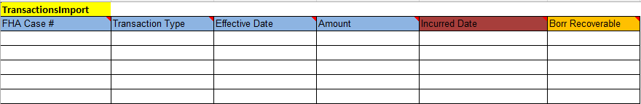
Figure 9: Transaction Import File

OPL/CPL - Record Layout
This table describes the required data elements, formats and their sequence within the file.
Table 9: Data Item Description for File OPLCPLImport
File Type Identifier: OPLCPLImport
Data Item | Description | Format/Range of Values | Required | Seq. #
FHA Case # | FHA Case Number | Numeric(10); | Yes | 1
OPL | Original Principal Limit amount loan should be updated | Must be > 0; | Yes | 2
CPL | Current Principal Limit amount loan should be updated | Must be > 0; | Yes | 3

OPL/CPL Import – B2G File Layout
This template can be used as a guide for creating the upload file. It can also be found on the upload screen within HERMIT.
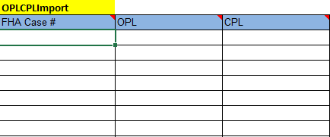
Figure 10: OPL/CPL Import File

Master Servicer - Record Layout
This table describes the required data elements, formats and their sequence within the file.
Table 10: Data Item Description for File MasterServicerImport
File Type Identifier: MasterServicerImport
Data Item | Description | Format/Range of Values | Required | Seq. #
FHA Case # | FHA Case Number | Numeric(10); | Yes | 1
To Master Servicer | HUD assigned mortgagee number of the Master servicer that will Master service the loan | Numeric(10);  Must be a valid FHA Mortgagee Number | Yes | 2

Master Servicer Import – B2G File Layout
This template can be used as a guide for creating the upload file. It can also be found on the upload screen within HERMIT.
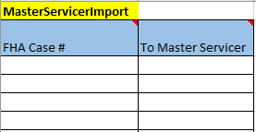
Figure 11: Master Servicer Import File

Investor Transfer - Record Layout
This table describes the required data elements, formats, and their sequence within the file.
Table 11: Data Item Description for File InvestorTransferImport
File Type Identifier: InvestorTransferImport
Data Item | Description | Format/Range of Values | Required | Seq. #
FHA Case # | FHA Case Number | Numeric(10); | Yes | 1
To Investor | HUD assigned mortgagee number of investor | Numeric(10)  Must be a valid FHA Investor Number | Yes | 2

Investor Transfer Import – B2G File Layout
This template can be used as a guide for creating the upload file. It can also be found on the upload screen within HERMIT.
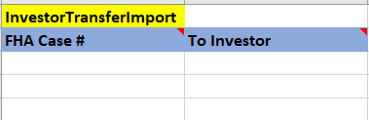
Figure 12: Investor Transfer Import File

Note Uploads
Note Uploads: There is one upload type that can be used to update loan-level data from this page.
- Notes

Upload File Requirements
This section documents the record layout requirements used to generate a file that will successfully upload Notes to the HERMIT system. Below is a view of the HERMIT Note Uploads Screen. It allows the authorized user to browse their internal sources for HECM data to retrieve the various files to be uploaded for the day. Once a file is selected using the Choose File button, the authorized user clicks the Upload button for immediate processing of the file into HERMIT. The user would repeat this process for each file type as needed.
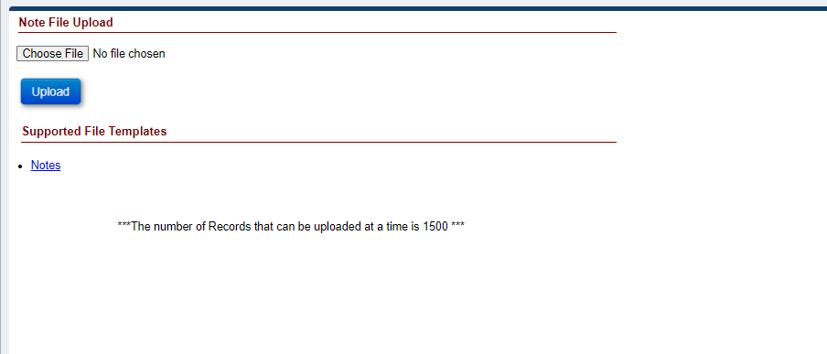
Figure 13: Note Upload Screen

Each file may contain up to 1,500 records. The processing time to upload a file containing up to 1,500 records will normally take a few minutes. If there are any posting errors, the user will be notified during the process. The upload is deemed to be complete when the user is notified via a success or failure message on the screen. The message consists of three types of notifications:
- Error records
- Warnings/success records
- Success records
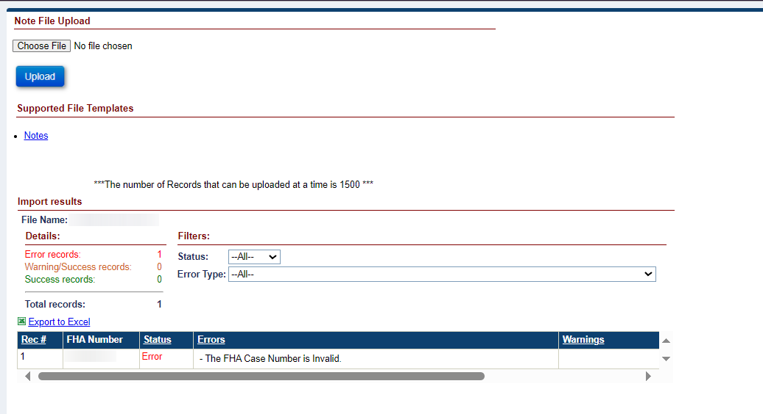
Figure 14: File Processing In HERMIT
File name and type:
- Any file name may be used, there are no naming requirements.
- A flat Text (Tab delimited) file is required. The valid file extension is .txt
- Each row must contain only one record.
Frequency of upload file:
There is no restriction on the number of files uploaded on a given day. File layout examples can be found in each section.
The Servicing Module provides a feature to allow a Servicer and HUD to upload a volume of transactions for the following activities in Table 4.
Table 12: HECM File Upload Types
File Upload Type | Description
Notes | Is used to inform HERMIT of all Notes

Data formatting:
Dashes (-) and decimal points (.) are permitted within the upload file; no other special characters or symbols should be present.
File Header Description:
The first row of each file must contain the file type identifier. No other header row or header information is permitted. The presence of any other header information will result in file upload failure.
The valid file type identifier is as follows:
- “NotesImport”

Notes Import – Record Layout
This table describes the required data elements, formats, and their sequence within the file.
Table 13: Data Item Descriptions for File NotesImport
File Type Identifier: NotesImport
Data Item | Description | Format/Range of Values | Required | Seq. #
FHA Case # | FHA case number | Numeric(10); | Yes | 1
Note Type Code | Note Type | String(4);  See Table for Note Type Codes and Description reference; | Yes | 2
Note | Informational field | String(500) | Yes | 3

Notes Import Transaction Codes and Descriptions

Table 14: Transaction Codes and Descriptions
Category | Note Type Code | Note Type | Note
Notes
 | 10 | Compliance
 | 19 | Closing Docs
 | 20 | Insurance
 | 30 | Servicer
 | 45 | Foreclosure - Assigned
 | 50 | Bankruptcy
 | 60 | Release
 | 80 | Taxes
 | 112 | Deleted Image
 | 113 | F12/IACS Foreclosure
 | 114 | F12/IACS Payoff
 | 120 | REO
 | 121 | Disposition
 | 130 | Contractor
 | 140 | HUD Specialist
 | 150 | EVARS
 | 180 | Claims
 | 270 | Request for HUD Advance
 | 280 | Request for Unsch. Adv(Assgn.)
 | 330 | Foreclosure
 | 500 | General Information
 | 520 | Congressional
 | 530 | Customer Service
 | 540 | HECM Complaint
 | 550 | Warning Note
 | 580 | Requests
 | 590 | Short Sale
 | 600 | SMART Alternate Contact
 | 610 | Extension
 | 630 | Repayment Plan

Notes Import – B2G File layout
This template can be used as a guide for creating the upload file. It can also be found on the upload screen within HERMIT.
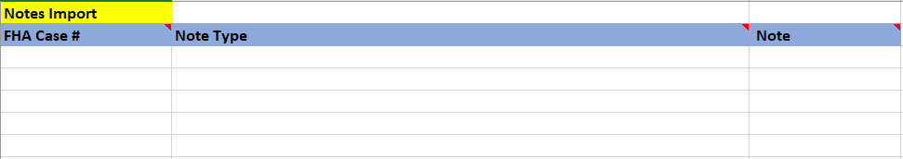
Figure 15: Notes Import File

Other Considerations
Emulators, which replicate keystrokes without an authorized user, will not work in HERMIT system. There are many options to reduce the impact to the Lender/Servicers’ operation staff. The choices are:
- Daily uploads that represent that day’s activity for the Lender/Servicer
- Daily uploads that represent each individual authorized user’s daily activity
- An upload upon completion of each activity within the Lender/Servicer’s HECM systems
Any questions related to the choices that you would need to make as part of realigning your systems should be directed to the servicingsupport@hermitsp.com email address.

Quality Control and Verification

File Verification
HECM files uploaded to HERMIT must pass multiple levels of validation to ensure the following:
- File extension
- Record layout aligns to file type identifier
- Data contained in the file is valid and formatted correctly for each expected data item
- A value is provided for every data item defined
- Every data element is separated with a tab
In case of error due to file format validation, the upload process will be stopped and an error message generated indicating the cause. If validation determines that individual records do not comply with business rules, data processing may continue and a report will be generated listing those records. This report will detail:
- Warnings – An unexpected value is present, but record uploaded successfully.
- Errors – Record was found to be out of compliance with business rules and record was not uploaded.
All uploads will be immediately integrated and visible in HERMIT upon completion of a successful B2G upload. The CHUMS cut-off for the Day 2 transactions has not changed. Any issues you encounter during the file upload process should be directed to HECM SP help desk – servicingsupport@hermitsp.com.

HERMIT – System Categorization
The HERMIT system is a business solution provided to support reverse mortgage processing from loan origination to disposition. The confidentiality, integrity, and availability of the HERMIT system are set forth in the sections below.

Information Sensitivity
In accordance with Federal Information Processing Standard (FIPS) 199, Standards for Security Categorization of Federal Information and Information Systems, information categorization is calculated based on the three basic security objectives: confidentiality, integrity, and availability to the various information types in the HERMIT system.

Information Categories
Table 11 below provides an explanation of the HERMIT system information categories and their protection requirements.

Table 15: HERMIT System Information Categories
Information Category | Explanation | Protection Requirements
Information about persons | Information related to personnel, including social security information, passwords, user identifiers (IDs), home address, and phone number | - Confidentiality – HERMIT contains Personally Identifiable Information (PII) relating to HECM loans for approximately 800,000 borrowers. The financial information includes property values, mortgage insurance premiums, rate, closing costs, payoffs, notes, and loan balances are also transmitted to the treasury department for tax-related purposes  - Integrity – The accuracy of the loan processing is based on the integrity of the information captured, stored, and communicated by the system  - Availability – Non-availability of the system would result in a noticeable impact on HUD mission support functions, image, or reputation
Budget and finance information | Information related to the individual loan i.e., the case number, the property address, assessed property value, the claim information, and the loan value
Operational information | Information related to banks (bank name, address, routing number, individual loan account numbers, loan amount) is considered operational information.

Protection/Certification Requirements
Table 12 describes the security category for the information types identified within the HERMIT system.
Table 16: HERMIT System Information Types and Security Categories
HERMIT System Information Types and Security Categories
SC _{persons =} { (confidentiality, MODERATE), (integrity, MODERATE), (availability, MODERATE)}
SC _{budget and finance} = {(confidentiality, MODERATE), (integrity, MODERATE), (availability, MODERATE)}
SC _{accounting information} = {(confidentiality, LOW), (integrity, MODERATE), (availability, LOW)}
SC _{operational information} = {(confidentiality, MODERATE), (integrity, MODERATE), (availability, MODERATE)}
SC _{help desk services} = {(confidentiality, MODERATE), (integrity, MODERATE), (availability, MODERATE)}
SC security management information = {(confidentiality, MODERATE), (integrity, MODERATE), (availability, LOW)}

Based on Table 13 above and using the high watermark guideline as recommended in NIST FIPS 199, SP 800-60 v1/v2 guidelines, the overall Security Category of the HERMIT system is moderate. This is shown in Table 10, HERMIT System Security Category, below.

Table 17: HERMIT System Security Category
Security Objective | Ranking (Low-Mod-High)
Confidentiality | Moderate
Integrity | Moderate
Availability | Moderate
Security Category (SC) | Moderate

Electronic Authentication Level
Table 14 describes the Electronic Authentication (E-authentication) Assurance Level for the transaction types identified within the HERMIT system.
Using the high watermark guideline as recommended in NIST FIPS 199, SP 800-63 v1 and OMB M-04-04 guidelines, the E-authentication Assurance level for the HERMIT system is 2.
Table 18: HERMIT System Transaction Types and Assurance Level
Transaction Type | Impact Categories | Impact  (Assurance Level) | Assurance Level
Loan Origination Transactions  (Loan setup, IMIP collection,  Loan Endorsement) | Inconvenience, distress, or damage to standing or reputation | Moderate (2) | 2
 | Financial loss or agency liability | Low (1) | 2
 | Harm to agency programs or public interests | Low (1) | 2
 | Unauthorized release of sensitive information | Moderate (2) | 2
 | Personal safety | N/A | 2
 | Civil or criminal violations | Moderate (2) | 2
Loan Servicing Transactions  ( MIP collections,  Interest Rate calculations,  Late charges, fees and Penalty interest calculations, adjustments, Corporate advances, Refunds, Partial Repayments, Claims Type 20 to 24, ) | Inconvenience, distress, or damage to standing or reputation | Moderate (2) | 2
 | Financial loss or agency liability | Moderate (2) | 2
 | Harm to agency programs or public interests | Moderate (2) | 2
 | Unauthorized release of sensitive information | Moderate (2) | 2
 | Personal safety | N/A | 2
 | Civil or criminal violations | Moderate (2) | 2
Loan Disposition transactions  (write-offs, Pay offs, Loan termination) | Inconvenience, distress, or damage to standing or reputation | Moderate (2) | 2
 | Financial loss or agency liability | Moderate (2) | 2
 | Harm to agency programs or public interests | Moderate (2) | 2
 | Unauthorized release of sensitive information | Moderate (2) | 2
 | Personal safety | N/A | 2
 | Civil or criminal violations | Moderate (2) | 2
Administrative Processing Transactions  (create/authorize users, assign roles, terminate users) | Inconvenience, distress, or damage to standing or reputation | Moderate (2) | 2
 | Financial loss or agency liability | Low (1) | 2
 | Harm to agency programs or public interests | Moderate (2) | 2
 | Unauthorized release of sensitive information | Moderate (2) | 2
 | Personal safety | N/A | 2
 | Civil or criminal violations | Low (1) | 2

