Home Equity Conversion Mortgage
Service Provider (HECM SP)



HERMIT User Guide
Servicing Module (SM)

Release 8.30
May 2026

TABLE OF CONTENTS
1. SYSTEM OVERVIEW 1-1
1.1 Program Overview 1-1
1.1.1 About the System 1-1
1.1.2 Background 1-1
1.1.3 About this User Guide 1-2
1.2 HERMIT Modules and Functionalities 1-2
1.2.1 Loan Setup/Premiums Collection 1-2
1.2.2 General Servicing Activities for Insurance-in-Force Cases (Endorsed Loans) and Assigned Loans 1-2
1.2.3 Claims Processing 1-3
1.2.4 The Accounting Module (AM) 1-4
1.2.5 Data Exchange with External Systems 1-4
1.3 HECM-Key Business Process Flow (Simplified) 1-6
1.4 System Functionality Overview 1-8
1.4.1 Desktop/System Requirements 1-8
1.4.2 Security 1-8
2. GETTING STARTED 2-1
2.1 Getting Help 2-1
2.1.1 Contacting the HERMIT Help Desk 2-1
2.2 Requesting Access to HERMIT 2-1
2.3 Resetting and Changing HERMIT Password 2-4
2.3.1.1 Unsuccessful Login Attempts or Forgotten Passwords 2-4
2.3.1.2 Changing Your Password 2-4
2.4 Log in to the Servicing Module 2-5
2.5 Navigating the Servicing Module 2-6
2.5.1 Loan Header 2-6
2.5.2 Home Screen 2-7
2.5.3 Constructing a Basic Loan Search 2-8
2.5.3.1 Search Criteria 2-8
2.5.4 Searching for a Loan 2-9
2.5.4.1 Loan Search Criteria 2-9
2.5.4.2 Writing Search Criteria 2-10
2.5.5 Navigating Search Results 2-10
2.5.5.1 Sorting Records 2-11
2.5.5.2 To See all the Columns in the Table 2-11
2.5.5.3 Scrolling by Page 2-11
2.5.5.4 Navigating by Specific Page Number 2-11
2.5.5.5 Viewing the Number of Records Returned in a Query 2-12
2.5.6 Exporting Loan Search Results to Excel 2-12
2.5.7 Left Menu and Loan Balance Screen 2-12
2.5.8 Sub Menu 2-14
2.5.8.1 Information Help Feature 2-16
3. INTRODUCTION TO USER GROUPS 3-1
3.1 Overview of User Groups 3-1
3.1.1 Changes to User Roles and Permissions 3-2
3.2 Lender User Group 3-3
3.3 Servicer User Group 3-4
3.4 Investor User Group 3-6
3.5 HUD Single Family Premiums User Group 3-6
3.6 HUD Claims Staff User Group 3-7
3.7 HUD NSC Contractor User Group 3-8
3.8 HUD NSC Staff User Group 3-9
4. LOAN SETUP 4-1
4.1 Loan Setup Overview Process 4-1
4.2 Manual Loan Setup 4-2
4.2.1 Performing Loan Setup 4-2
4.2.2 Details of Data Fields on the Loan Setup Screen 4-3
4.2.2.1 Loan Information 4-3
4.2.2.2 Rates Information 4-5
4.2.2.3 Lender/Servicer/Investor Information 4-6
4.2.2.4 HECM For Purchase Information 4-6
4.2.2.5 Loan Dates 4-7
4.2.2.6 Pay Plan 4-7
4.2.2.7 Late Charge and Penalty Interest 4-8
4.2.2.8 Principal Limit Calculation 4-8
4.2.2.9 Life Expectancy Set Aside (LESA) 4-9
4.3 Loan Setup: Business to Government (B2G) 4-10
4.3.1 Uploading a B2G Loan Setup Import File 4-10
4.3.1.1 Preparing Loan Setup Import file 4-10
4.3.1.2 Saving the Loan Setup Import file 4-11
4.3.1.3 Uploading the Loan Setup Import file 4-11
4.3.1.4 Viewing the Upload Status of Loan Setup Import File 4-11
4.4 IMIP Collection 4-13
4.4.1 Verifying IMIP Collection Status 4-13
4.5 Refunds 4-14
4.5.1 Refund of Late Charges and Penalty Interest 4-14
4.5.1.1 Requesting a Refund of Late Charges and Penalty Interest During Loan Setup 4-14
4.5.1.2 Requesting a Refund of Late Charges and Penalty Interest After Loan Setup 4-15
4.5.2 Automatic Refund of MIP – Cancellation from CHUMS 4-16
4.5.3 Approving or Denying a Refund 4-17
4.5.4 Processing Refund Disbursements 4-18
5. GENERAL SERVICING (PRE-ENDORSED/ENDORSED) 5-1
5.1 General Servicing Overview 5-1
5.2 Loan Search 5-1
5.2.1 Search Criteria 5-1
5.2.2 Searching for a Loan 5-2
5.2.3 Loan Search Results 5-2
5.3 Loan Balance 5-2
5.3.1 Activating or Suspending Payments 5-3
5.3.2 Viewing Audit Information 5-4
5.4 Loan Details 5-5
5.4.1 Editing Loan Rates 5-5
5.4.2 Editing Loan Dates 5-6
5.4.3 Editing Loan Identifiers 5-6
5.4.4 Viewing Audit Information 5-7
5.5 Transactions 5-8
5.5.1 Transactions – Loan 5-8
5.5.1.1 Transactions – Loan Filter Categories 5-8
5.5.1.2 New Loan Transactions 5-11
5.5.1.3 IMIP adjustments 5-30
5.5.1.4 Write-Off 5-30
5.5.1.5 Balance Adjustments 5-31
5.5.2 Transactions – Growth 5-32
5.5.2.1 Transactions – Growth Filter 5-33
5.5.3 Transactions – Set Asides 5-33
5.5.3.1 Transactions – Set Aside filter 5-33
5.5.3.2 Creating a New Set Aside Transaction 5-34
5.5.3.3 1st Yr Taxes and Ins – Setup 5-34
5.5.3.4 Repair Set Aside- Setup 5-35
5.5.4 Viewing Life Expectancy Set Aside Growth Transaction 5-35
5.5.5 Transactions – Claims 5-35
5.5.5.1 Filtering Claims Transactions 5-36
5.6 Contacts 5-38
5.6.1 Viewing a Contact 5-38
5.6.2 Adding a Contact 5-39
5.6.3 Editing a Contact 5-39
5.6.4 Viewing and editing “Borrower in Health Care Facility” checkbox 5-40
5.6.5 Deleting a Contact 5-40
5.6.6 Deactivating a Non Borrowing Spouse 5-41
5.6.7 Viewing Eligible and Ineligible Non Borrowing Spouse 5-41
5.6.8 Adding a Non-Borrowing Spouse Contact 5-41
5.6.9 Editing a Non-Borrowing Spouse Contact 5-42
5.6.10 Adding a Changed Borrower Name and Changed Co-Borrower Name Contact 5-42
5.6.11 Editing a Changed Borrower Name Contact 5-43
5.6.12 Adding Assessment Information 5-44
5.6.13 Viewing and Editing Assessment Information 5-44
5.7 Property 5-44
5.7.1 Property Information 5-45
5.7.1.1 Editing Property Information 5-45
5.7.2 Property Values 5-47
5.7.2.2 Adding a New Property Value 5-48
5.8 Documents 5-49
5.8.1 Viewing Loan Documents 5-49
5.8.2 Uploading Loan Documents 5-49
5.8.3 Deleting a Document 5-50
5.9 Notes 5-50
5.9.1 Filtering Notes 5-50
5.9.2 Viewing a Note 5-50
5.9.3 Adding a Note 5-51
5.9.4 Editing a Note 5-51
5.9.5 Deleting a Note 5-52
5.9.6 Printing Notes 5-52
5.10 Audit Tracking 5-52
5.10.1 Filtering Audit Information 5-53
5.11 Alerts 5-53
5.11.1 Creating New Alerts 5-54
5.11.2 Editing an Alert 5-54
5.12 Change of Plan 5-55
5.12.1 Viewing a Payment Plan 5-55
5.12.2 Creating a New Payment Plan 5-56
5.13 Payoff 5-56
5.13.1 Printing a Payoff Statement 5-56
5.14 Statement 5-57
5.14.1 Viewing and Printing a Monthly Statement 5-57
5.14.2 Editing the Monthly Statement Message 5-57
5.15 Disbursement 5-58
5.15.1 Performing a HUD Borrower Disbursement on Endorsed Loans and Reimbursing HUD 5-58
5.16 Servicer Info 5-61
5.16.1 Transferring a Case to a Servicer 5-61
5.16.2 Editing Servicer Bank Information 5-62
5.16.3 Transferring a Case to an Investor 5-62
5.16.4 Editing Investor Bank Information 5-63
5.16.5 Transfering a case to a Master Servicer 5-63
5.17 Bank Account 5-64
5.17.1 Editing Borrower Bank Account Information 5-64
5.18 Accounting 5-65
5.18.1 Transmittals 5-65
5.18.1.1 IMIP/Refunds/MMIP 5-65
5.18.1.2 Viewing Transmittal Details 5-66
5.18.1.3 Premiums Batch Statuses 5-67
5.18.1.4 Claims Batch Statuses 5-67
5.18.1.5 Viewing Batch Details 5-68
5.18.1.6 Approval of MMIP prior to Collection 5-69
5.18.1.7 Retry Batch 5-71
5.18.2 Premiums (IMIP) 5-72
5.18.3 Refunds 5-72
5.18.4 Claims 5-73
5.19 Batch 5-75
5.19.1 Initial Transfer 5-75
5.19.2 Servicer Transfer List 5-76
5.19.3 Servicer Transactions 5-77
5.19.4 Servicer File Upload 5-78
5.19.4.1 Servicer Transfer 5-79
5.19.4.2 Transactions Import 5-80
5.19.4.3 OPL/CPL Import 5-82
5.19.4.4 Master Servicer Import 5-84
5.19.4.5 Investor Transfer Import 5-86
5.19.5 Note Uploads 5-87
5.19.5.1 Preparing Notes Import File 5-87
5.19.5.2 Saving Notes Import File 5-88
5.19.5.3 Uploading Notes Import File 5-88
5.19.5.4 Viewing Status of Notes Import File 5-89
5.19.6 HUD Disbursements 5-90
5.19.6.1 Preparing HUD Disbursements Import File 5-90
5.19.6.2 Saving HUD Disbursements Import File 5-90
5.19.6.3 Uploading HUD Disbursements Import File 5-91
5.19.6.4 Viewing Status of HUD Disbursements Import File 5-91
5.20 Repayment Plan 5-92
5.20.1 Viewing a Repayment Plan 5-92
5.20.2 Creating a New Repayment Plan 5-93
5.20.3 Editing a Repayment Plan 5-94
5.21 Property Preservation: Transactions and Timelines 5-94
5.21.1 Property Preservation and Protection Overview 5-94
5.21.2 Property Preservation – Allowable 5-94
5.21.2.1 Creating New P&P Corporate Advance (Allowable) Transaction 5-95
5.21.3 Property Preservation – Over-Allowable 5-96
5.21.3.1 Timeline Steps 5-97
5.21.3.1 Servicer Activities – Bid Submission 5-97
5.21.3.2 Decision Activities (HUD or HUD Contractor) 5-98
5.21.3.3 Servicer Activity – Entering Transactions 5-100
5.21.3.4 Servicer and HUD or HUD Contractor Activities – Pending Decisions 5-101
5.21.4 Property Preservation – Exclude from Max 5-102
5.21.4.1 Creating New P&P Corporate Advance (Excluded from Max) Transaction 5-102
6. GENERAL SERVICING (ASSIGNED) 6-1
6.1 Assigned Servicing Overview 6-1
6.2 Approval Portal 6-1
6.2.1 Search Criteria 6-2
6.2.2 Searching for Approval Portal records 6-2
6.2.2.1 Approval Portal Search Criteria 6-2
6.2.2.2 Writing Search Criteria 6-2
6.2.3 Navigating Search Results 6-3
6.2.3.1 Sorting Records 6-3
6.2.3.2 Viewing All Available Columns in the Table 6-3
6.2.3.3 Scrolling by Page 6-4
6.2.3.4 Navigating by Specific Page Number 6-4
6.2.3.5 Viewing the Number of Records Returned in a Query 6-4
6.2.4 Exporting Approval Portal Search Results to Excel 6-4
6.2.5 Viewing or Decisioning an Approval Portal record 6-4
6.3 Loan Search 6-5
6.3.1 Search Criteria 6-5
6.3.2 Searching for a Loan 6-5
6.3.3 Loan Search Results 6-5
6.3.3.1 Bulk Print Advance Request Forms 6-6
6.4 Notes Search 6-6
6.4.1 Search Criteria 6-6
6.4.2 Searching for a Note 6-6
6.4.2.1 Note Search Criteria 6-7
6.4.2.2 Writing Search Criteria 6-7
6.4.3 Navigating Search Results 6-7
6.4.3.1 Sorting Records 6-8
6.4.3.2 To See all the Columns in the Table 6-8
6.4.3.3 Scrolling by Page 6-8
6.4.3.4 Navigating by Specific Page Number 6-8
6.4.3.5 Viewing the Number of Records Returned in a Query 6-9
6.4.4 Exporting Notes Search Results to Excel 6-9
6.4.5 Viewing a Note 6-9
6.5 Loan Balance 6-9
6.5.1 Activating or Suspending Payments 6-11
6.5.2 Viewing Audit Information 6-12
6.5.3 Activating or Suspending Life Expectancy Set Aside (LESA) Payments 6-12
6.6 Loan Details 6-13
6.6.1 Editing Loan Dates 6-13
6.6.2 Editing Loan Identifiers 6-14
6.6.3 Viewing Audit Information 6-15
6.7 Transactions 6-15
6.7.1 Transactions – Loan 6-15
6.7.1.1 Transactions - Loan Filter Categories 6-16
6.7.1.2 Creating a New Loan Transaction 6-18
6.7.1.3 Repays 6-18
6.7.1.4 Termination 6-19
6.7.1.5 Balance Adjustments 6-21
6.7.1.6 Write-Off 6-22
6.7.1.7 Life Expectancy Set Aside (LESA) Repays 6-22
6.7.2 Repay Transactions - Growth 6-23
6.7.2.1 Transactions – Growth Filter 6-24
6.7.3 Transactions - Set Asides 6-25
6.7.3.1 Transactions – Set Aside filter 6-25
6.7.3.2 Creating a New Set Aside Transaction 6-26
6.7.3.3 1st Yr Taxes and Ins - Setup 6-26
6.7.3.4 Repair Set Aside- Setup 6-27
6.7.3.5 Loss Draft Set Aside- Setup 6-28
6.7.3.6 Hardest Hit Funds Set Aside- Setup 6-28
6.7.4 Transactions - Claims 6-29
6.7.5 Transactions – Miscellaneous 6-30
6.7.6 Notes Collections 6-30
6.8 Contacts 6-31
6.8.1 Viewing a Contact 6-31
6.8.2 Adding a Contact 6-32
6.8.3 Editing a Contact 6-32
6.8.4 Viewing and editing “Borrower in Health Care Facility” checkbox 6-33
6.8.5 Deleting a Contact 6-33
6.8.6 Deactivating a Non-Borrowing Spouse 6-33
6.8.7 Viewing Eligible and Ineligible Non-Borrowing Spouse 6-34
6.8.8 Adding a Non-Borrowing Spouse Contact 6-35
6.8.9 Editing a Non-Borrowing Spouse Contact 6-35
6.8.10 Adding a Changed Borrower Name and Changed Co-Borrower Name Contact 6-35
6.8.11 Editing a Changed Borrower Name Contact 6-37
6.8.12 Adding Assessment Information 6-37
6.8.13 Viewing and Editing Assessment Information 6-38
6.9 Property 6-38
6.9.1 Property Info 6-38
6.9.1.1 Editing Property Info 6-39
6.9.1.2 Uploading a Property Photo 6-39
6.9.1.3 Editing the Description for a Property Photo 6-40
6.9.1.4 Deleting a Property Photo 6-40
6.9.2 Property Values 6-40
6.9.2.1 Viewing Property Values 6-41
6.9.2.2 Adding a New Property Value 6-41
6.9.2.3 Editing a Property Value 6-41
6.9.2.4 Deleting a Property Value 6-42
6.9.3 Property Tax Info 6-42
6.9.3.1 Filtering Property Tax Info 6-43
6.10 Documents 6-43
6.10.1 Viewing Loan Documents 6-43
6.10.2 Uploading Loan Documents 6-44
6.10.3 Deleting a Document 6-44
6.11 Notes 6-44
6.11.1 Filtering Notes 6-45
6.11.2 Viewing a Note 6-45
6.11.3 Adding a Note 6-46
6.11.4 Editing a Note 6-46
6.11.5 Deleting a Note 6-47
6.11.6 Printing Notes 6-47
6.12 Audit Tracking 6-47
6.12.1 Filtering Audit Information 6-47
6.13 Alerts 6-48
6.13.1 Creating New Alerts 6-49
6.13.2 Editing an Alert 6-49
6.14 Change of Plan 6-49
6.14.1 Viewing a Payment Plan 6-50
6.14.2 Creating a New Payment Plan 6-51
6.14.3 Approving a Pending Payment Plan 6-52
6.14.4 Printing a Pending Change of Plan 6-52
6.14.5 Deleting a Pending Change of Plan 6-53
6.15 Payoff 6-53
6.15.1 Printing a Payoff Statement 6-54
6.15.2 Add an Estimated Expense 6-54
6.16 Statement 6-55
6.16.1 Viewing and Printing a Monthly Statement 6-55
6.16.2 Editing the Monthly Statement Message 6-56
6.17 Disbursement 6-56
6.17.1 Performing a Corp Advance – Penalty Disbursement 6-57
6.17.2 Performing a Corp Advance - Section 305 Disbursement 6-59
6.17.3 Performing an Unscheduled from LOC Disbursement 6-60
6.17.4 Performing a Loss Draft Disbursement 6-63
6.17.5 Performing a Hardest Hit Funds Disbursement 6-64
6.17.6 Performing a Repair Set Aside Disbursement 6-66
6.17.7 Monthly Accruals 6-67
6.17.8 Performing a Refund/Payment Remittance Overage Disbursement 6-67
6.17.9 Performing a 1st Year Taxes & Ins Set Aside Disbursement 6-69
6.17.10 Performing a Life Expectancy Set Aside Disbursement 6-70
6.17.11 Manually Adding a Scheduled Payment Disbursement 6-72
6.17.12 Notes Disbursements 6-74
6.18 Servicer Info 6-75
6.18.1 Transferring a Case to a Servicer 6-76
6.18.2 Transferring a Case to an Investor 6-77
6.18.3 Transferring a Case to a Master Servicer 6-77
6.19 Bank Account 6-78
6.19.1 Editing Borrower Bank Account Information 6-78
6.20 Accounting 6-79
6.20.1 Accounting > Transmittals 6-79
6.20.1.1 Notes Batch Statuses 6-80
6.20.1.2 Claims Batch Statuses 6-80
6.20.2 Viewing Batch Details 6-81
6.20.3 Accounting > Disbursements 6-82
6.20.3.1 View Disbursements 6-84
6.20.3.2 Inactivate Disbursements – Check/ACH 6-85
6.20.3.3 Authorize Disbursements Check/ACH 6-86
6.20.3.4 Void/Clear Check 6-87
6.20.3.5 Void/Clear ACH 6-88
6.20.4 Accounting > Authorizations 6-91
6.21 Batch 6-92
6.21.1 NSC Bulk Disbursements 6-92
6.21.2 NSC Bulk Servicing Steps 6-93
6.21.3 Alert Uploads 6-94
6.21.3.1 Preparing Alerts Import File 6-94
6.21.3.2 Saving Alerts Import File 6-95
6.21.3.3 Uploading Alerts Import File 6-95
6.21.3.4 Viewing Status of Alerts Import File 6-95
6.21.4 NSC Disbursement Uploads – Multiple File Types 6-96
6.21.4.1 Preparing a Disbursements Import File 6-97
6.21.4.2 Saving a Disbursements Import File 6-97
6.21.4.3 Uploading a Disbursements Import File 6-98
6.21.4.4 Viewing Status of a Disbursements Import File 6-98
6.21.5 Note Uploads 6-99
6.21.5.1 Preparing Notes Import File 6-99
6.21.5.2 Saving Notes Import File 6-100
6.21.5.3 Uploading Notes Import File 6-100
6.21.5.4 Viewing Status of Notes Import File 6-100
6.21.6 NSC File Uploads – Multiple File Types 6-101
6.21.6.1 NSC Transactions 6-102
6.21.6.2 Asset Sales Reports 6-104
6.21.6.3 Loan Details / Transactions PDFs Import 6-106
6.22 Repayment Plan 6-108
6.22.1 Creating a New Repayment Plan 6-108
6.22.2 Viewing a Repayment Plan Details and Scheduled Repayments 6-109
6.22.3 Editing a Repayment Plan 6-111
7. TIMELINES 7-1
7.1 Timelines Overview 7-1
7.1.1 Navigating Timelines 7-1
7.1.1.1 Timeline Group 7-1
7.1.1.2 Timeline Categories 7-1
7.1.1.3 Servicing Types / Timeline name 7-2
7.1.2 Setup Criteria to Initiate Timelines 7-5
7.1.3 Search Criteria for Timelines that have been Initiated 7-7
7.1.3.1 All Loan Information Search Criteria 7-7
7.1.3.2 Servicing Management Search Criteria 7-8
7.1.4 Standard Timeline Fields 7-9
7.1.5 Additional Timeline Fields 7-10
7.1.6 Timeline Side / Left Menu Options 7-11
7.1.6.1 Servicing Management Screen 7-11
7.1.6.2 Steps 7-11
7.1.7 To Complete Timeline Steps 7-11
7.1.8 To Add Optional Timeline Steps 7-12
7.2 Endorsed Timelines 7-14
7.2.1 Compliance Timelines 7-14
7.2.1.1 Insurance – Flood Policy 7-14
7.2.1.2 Insurance – Forced Place 7-15
7.2.1.3 Insurance – Hazard Policy 7-16
7.2.1.4 Occupancy Compliance Certification 7-17
7.2.1.5 Repairs 7-18
7.2.1.6 Taxes Delinquent 7-20
7.2.2 Disposition Timelines 7-22
7.2.2.1 Due and Payable w/o HUD Approval 7-23
7.2.2.2 Loss Mitigation – Cash for Keys 7-24
7.2.2.3 Loss Mitigation – Deed-in-Lieu 7-25
7.2.2.4 Loss Mitigation – Family Sale Pending 7-26
7.2.2.5 Loss Mitigation – Pre-Foreclosure 7-27
7.2.2.6 Loss Mitigation – Short Sale 7-27
7.2.3 Requests Timelines 7-28
7.2.3.1 Certificate of Indebtedness 7-29
7.2.3.2 Consent of Lienholder 7-31
7.2.3.3 Due and Payable w/ HUD Approval 7-34
7.2.3.4 Extension – Appraisal 7-38
7.2.3.5 Extension – At-Risk 7-38
7.2.3.6 Extension – Claims Deadlines 7-40
7.2.3.7 Extension – COVID-19 Request to Delay Claims Submission 7-40
7.2.3.8 Extension – COVID-19 Request to Delay Due & Payable 7-41
7.2.3.9 Extension – COVID-19 Request to Delay Foreclosure 7-42
7.2.3.10 Extension – Deed-In-Lieu 7-43
7.2.3.11 Extension – Delay Due & Payable 7-44
7.2.3.12 Extension – Hardest Hit Fund (HHF) 7-45
7.2.3.13 Extension – Late Notification of Death 7-45
7.2.3.14 Extension – Other 7-46
7.2.3.15 Extension – Property Charge Loss Mitigation 7-47
7.2.3.16 Extension – Repairs 7-48
7.2.3.17 Extension – Request to Delay Foreclosure 7-48
7.2.3.18 Investor Short Sale 7-49
7.2.3.19 Partial Release 7-50
7.2.3.20 Payoff Request 7-54
7.2.3.21 Preservation and Protection 7-55
7.2.3.22 Request for HUD Advance (Assignment) 7-55
7.2.3.23 Subordination 7-57
7.2.3.24 Substitution of Collateral 7-60
7.2.3.25 Zero Balance 7-63
7.2.4 Foreclosure Timeline 7-65
7.2.5 Bankruptcy Timelines 7-66
7.2.5.1 Bankruptcy - Chapter 13 7-66
7.2.5.2 Bankruptcy - Chapter 7 7-67
7.2.6 Release Timelines (Endorsed) 7-69
7.2.6.1 Release 2nd (Release of HUD's Second Mortgage) 7-69
7.2.7 Claims Timelines (Endorsed) 7-71
7.3 Assigned Timelines 7-71
7.3.1 Compliance Timelines 7-71
7.3.1.1 Insurance - Flood Policy 7-71
7.3.1.2 Insurance - Hazard Policy 7-73
7.3.1.3 Insurance/Hardest Hit Funds Administration 7-74
7.3.1.4 Insurance/Loss Draft Administration 7-74
7.3.1.5 Occupancy Compliance Certification 7-76
7.3.1.6 Request for Payment 7-76
7.3.1.7 Request for Unscheduled Advance 7-77
7.3.1.8 Taxes Delinquent 7-77
7.3.2 Disposition Timelines 7-80
7.3.2.1 Asset Sale 7-80
7.3.2.2 Due and Payable 7-81
7.3.2.3 Loss Mitigation - Deed-in-Lieu 7-82
7.3.2.4 Loss Mitigation – Family Sale Pending 7-83
7.3.2.5 Loss Mitigation – Pre-Foreclosure 7-84
7.3.2.6 Loss Mitigation – Short Sale 7-86
7.3.2.7 Write-Off Review 7-87
7.3.3 Request Timelines 7-88
7.3.3.1 Certificate of Indebtedness (COI) 7-88
7.3.3.2 Extension – At-Risk 7-88
7.3.3.3 Extension – COVID-19 Request to Delay Due & Payable 7-89
7.3.3.4 Extension – COVID-19 Request to Delay Foreclosure 7-90
7.3.3.5 Extension – Property Charge Loss Mitigation 7-91
7.3.3.6 Extension – Request to Delay Foreclosure 7-91
7.3.3.7 Partial Release 7-92
7.3.3.8 Payoff Request 7-93
7.3.3.9 Substitution of Collateral timeline 7-94
7.3.3.10 Zero Balance 7-95
7.3.4 Assigned Foreclosure Timeline 7-95
7.3.5 Bankruptcy Timelines 7-97
7.3.5.1 Bankruptcy - Chapter 13 7-97
7.3.5.2 Bankruptcy - Chapter 7 7-98
7.3.6 Assigned Release Timelines 7-99
7.3.6.1 Release 1st (Release of HUD's First Mortgage) 7-99
7.3.6.2 Release 2nd (Release of HUD's Second Mortgage) 7-101
7.3.7 Assigned Claims Timelines 7-102
7.3.7.1 Assignment Repurchase 7-102
7.3.7.2 Title Approval 7-109
8. CLAIMS 8-1
8.1 Claims Overview 8-1
8.1.1 Claim Processing Activities 8-2
8.1.2 Claims Setup - Search Criteria 8-2
8.1.3 Claims - Search 8-4
8.1.3.1 Claims Search Screen – Field Definitions 8-4
8.2 Submitting Claim Type 20 8-7
8.2.1 CT20 Timeline Steps 8-7
8.2.2 CT20 Assignment Timeline Letters 8-8
8.2.3 Servicer Activities - Submit Assignment Request to HUD 8-9
8.2.4 HUD NSC Contractor Activities - Preliminary Title Approval 8-10
8.2.5 Servicer Activities - Claim Filing via “27011” step 8-11
8.2.6 Activities after Claim is submitted – Servicer and HUD NSC Contractor 8-14
8.2.6.1 Servicer Activities 8-14
HUD NSC Contractor Activities 8-15
8.2.7 Incomplete Assignment Package – HUD, HUD NSC Contractor, and Servicer Activities 8-15
8.2.8 Assignment Denials – HUD NSC Contractor and Servicer Activities 8-16
8.3 Submitting Claim Type 21 8-16
8.3.1 CT21 Timeline Steps 8-17
8.3.2 CT21 Process 8-17
8.4 Submitting Claim Type 22 8-23
8.4.1 CT22 Timeline Steps 8-24
8.4.2 CT22 Assignment Timeline Letters 8-25
8.4.3 Servicer Activities - Submit Assignment Request to HUD 8-26
8.4.4 HUD NSC Contractor Activities - Preliminary Title Approval 8-27
8.4.5 Servicer Activities - Claim Filing via “27011” step 8-28
8.4.6 Activities after Claim is filed – Servicer and HUD NSC Contractor 8-32
8.4.6.1 Servicer Activities 8-32
8.4.6.1 HUD NSC Contractor Activities 8-32
8.4.7 Assignment Denials – HUD NSC Contractor and Servicer Activities 8-33
8.5 Submitting Claim Type 23 8-33
8.5.1 CT23 Timeline Steps 8-33
8.5.2 CT23 Process 8-34
8.6 Submitting Claim Type 24 8-41
8.6.1 CT24 Timeline Steps 8-41
8.6.2 CT24 Process 8-41
8.7 Reviewing and Processing Claims 8-47
8.7.1 Approving a Claim 8-48
8.7.2 Denying a Claim 8-50
8.7.3 Requesting Pending Additional Information About a Claim 8-52
8.7.4 Granting Exceptions to file CT24 8-58
8.8 No Pay Order 8-60
8.8.1 Adding a No Pay Order on a Loan 8-60
8.8.2 Adding a No Pay Order on a Servicer 8-61
8.9 Cancel Payment 8-62
8.10 Payment Processing 8-64
8.11 Claim Reimbursements - Over Claims: Servicers remit funds to HUD via HERMIT 8-65
8.11.1 HECM Over Claim Transaction Codes available for the remittance of HECM Over Claims: 8-65
8.11.2 Claim Type 20 and 22 8-65
8.11.3 Claim Type 21, Claim Type 23, Claim Type 21 – Supplemental Over Claim and Claim Type 23 – Supplemental Over Claim 8-66
8.11.4 Reason Codes for Over Claim Transactions: 8-67
8.11.5 Over Claim Transaction Validations 8-69
8.12 Paper Claim Transactions 8-69
8.12.1 Servicer can Initiate a Claim if there was a Paper Claim Type 22 and a Repurchase on a loan. Conditions below. 8-70
8.13 Rejected / Returned Claim Payments from Investor 8-70
9. REPORTS 9-1
9.1 Reports Overview 9-1
9.2 Accessing Reports 9-2
9.3 Using the Search Criteria 9-5
9.4 Generating Reports 9-5
9.5 Lender/Servicer Reports 9-6
9.5.1 Daily IMIP Transaction Report 9-6
9.5.2 Daily Refund Transaction Report 9-6
9.5.3 Property Assessments Report 9-7
9.6 Assigned Notes Reports 9-8
9.6.1 Accounting Exceptions for Notes Report 9-9
9.6.2 Alerts Detail Report 9-9
9.6.3 Asset Sale Report 9-11
9.6.4 Audit Tracking Report 9-11
9.6.5 Bulk Printing Letters Report 9-12
9.6.6 Closed Loan Files Report 9-14
9.6.7 Contact Information Report 9-15
9.6.8 Disbursement Detail Report 9-15
9.6.9 Disbursement Summary Report 9-16
9.6.10 Document Tracking Report 9-18
9.6.11 Due & Payable Report 9-19
9.6.12 Foreclosure Activity Listing Report 9-19
9.6.13 HECM Foreclosure Report 9-20
9.6.14 Insurance Policy Information Report 9-21
9.6.15 Loan Principal Limit Detail Report 9-22
9.6.16 Missing Loan Document Detail Report 9-23
9.6.17 NBS Missing SSN Report 9-24
9.6.18 Needs Custodial Care Report 9-24
9.6.19 Occupancy Certifications and Hazard/Flood Ins Detail Report 9-25
9.6.20 Overage Amounts 9-27
9.6.21 Placed In Custodial Care Report 9-27
9.6.22 Property Charge Default Report 9-28
9.6.23 Release Activity Steps By User Report 9-29
9.6.24 SAMS Daily Transaction File Report 9-30
9.6.25 Subordinations Carried Over Detail Report 9-30
9.6.26 Tax Amount Report 9-31
9.6.27 Tax Payment Report 9-32
9.6.28 Timeline Activity Report 9-33
9.6.29 Transaction Activity Report 9-34
9.6.30 HUD Monthly Count Report 9-35
9.6.31 HUD Monthly Director Report – HECM Assigned Detail Report 9-36
9.6.32 HUD Monthly Management Report 9-37
9.6.33 Month-End Trial Balance Detail Report 9-38
9.6.34 Monthly Activity Detail Report 9-39
9.6.35 Monthly Claims Paid Report 9-39
9.6.36 Monthly Portfolio Activity Report 9-40
9.7 Management and Budgetary Reports 9-40
9.7.1 CT-22 Denial Reason 9-41
9.7.2 HUD Pending Decision Report 9-42
9.7.3 Indemnification Data Report 9-43
9.7.4 Repayment Plan Report 9-43
9.7.5 Monthly Cohort Summary Report 9-44
9.7.6 Monthly Portfolio Activity Report 9-45
9.7.7 Monthly Statistical Summary Report 9-45
9.8 Servicer Reports 9-47
9.8.1 CHUMS-HERMIT Data Mismatch Report 9-47
9.8.2 Claim AOP Amounts Report 9-48
9.8.3 Claims Detail Report 9-49
9.8.4 Complete Date Changes Report 9-50
9.8.5 Default Key Dates Report 9-51
9.8.6 DMF (Death Master File) Report 9-53
9.8.7 Document Tracking Report 9-54
9.8.8 LESA (Life Expectancy Set Aside) Report 9-54
9.8.9 No Pay Order Report 9-55
9.8.10 Over Claims Report 9-56
9.8.11 Prop Pres Detail Report 9-57
9.8.12 Repurchase Timelines Report 9-58
9.8.13 Servicer Alert Details Report 9-59
9.9 HERMIT Support 9-60
9.9.1 Accounting Exceptions Report 9-60
9.9.2 Audit Tracking – Non Loan Report 9-61
9.9.3 B2G Transaction Exception Report 9-61
9.9.4 File Upload Exception Report 9-62
10. ADMIN FUNCTIONS 10-1
10.1 Admin Functions Overview 10-1
10.2 Common Functionality 10-2
10.2.1 Restricting a Search (General Instructions) 10-3
10.2.2 Sorting the Search Results by Column (General Instructions) 10-3
10.2.3 Exporting your Search Results to Excel (General Instructions) 10-3
10.2.4 Create a New Record (General Instructions) 10-3
10.2.5 Editing an Existing Record 10-3
10.3 Alerts Screen 10-4
10.3.1 Filtering Alerts 10-4
10.3.2 Sorting Alerts 10-4
10.3.3 Creating an Alert 10-5
10.3.4 Editing an Alert 10-5
10.4 Announcements Screen 10-6
10.4.1 Filtering Announcements 10-6
10.4.2 Sorting Announcements 10-6
10.4.3 Creating an Announcement 10-7
10.4.4 Editing an Announcement 10-7
10.5 County Clerks Screen 10-8
10.5.1 Filtering County Clerks 10-8
10.5.2 Sorting County Clerks 10-8
10.5.3 Creating a County Clerk 10-9
10.5.4 Editing a County Clerk 10-10
10.6 Editable Timeline Steps 10-12
10.7 Helpful Links Screen 10-12
10.7.1 Filtering Helpful Links 10-12
10.7.2 Sorting Helpful Links 10-12
10.7.3 Creating Helpful Links 10-13
10.7.4 Editing a Helpful Link 10-13
10.8 Investor Screen 10-15
10.8.1 Filtering Investors 10-15
10.8.2 Sorting Investors 10-15
10.8.3 Editing an Investor 10-15
10.9 Lender Screen 10-16
10.9.1 Filtering Lenders 10-16
10.9.2 Sorting Lenders 10-17
10.9.3 Editing a Lender 10-17
10.10 Master Servicer Links 10-19
10.11 Servicer Screen 10-19
10.11.1 Filtering Servicers 10-19
10.11.2 Sorting Servicers 10-20
10.11.3 Editing a Servicer 10-21
10.12 Master Servicer 10-22
10.12.1 Filtering Master Servicers 10-22
10.12.2 Sorting Master Servicers 10-22
10.12.3 Editing a Master Servicer 10-23
10.13 Petitioner Screen 10-23
10.13.1 Filtering Petitioners 10-24
10.13.2 Sorting Petitioners 10-24
10.13.3 Creating a Petitioner 10-25
10.13.4 Editing a Petitioner 10-25
10.14 Tax Authority Screen 10-26
10.14.1 Filtering Tax Authorities 10-26
10.14.2 Sorting Tax Authorities 10-26
10.14.3 Creating a Tax Authority 10-27
10.14.4 Editing a Tax Authority 10-28
10.15 Vendors Screen 10-29
10.15.1 Filtering Vendors 10-29
10.15.2 Sorting Vendors 10-29
10.15.3 Creating a Vendor 10-30
10.15.4 Editing a Vendor 10-31
10.16 Claims Auto Delegation Screen 10-32
10.16.1 Claims Auto Delegation – Setting Responsible Party delegation 10-32
10.16.2 Claims Auto Delegation - Audit Information 10-33
10.17 Bulk Vendor Upload Screen 10-33
10.17.1 Creating Bulk Vendors 10-34
APPENDICES i
A. APPENDIX A: ACRONYMS 2
B. APPENDIX B: SM MENU MAP 6
C. APPENDIX C: HERMIT USER GUIDE VERSION 2.8 UPDATES (Release 4.1) 9
D. APPENDIX D: HERMIT User Guide Version 2.9 Updates (Release 4.2) 13
E. APPENDIX E: HERMIT User Guide Version 2.10 Updates (Release 4.3) 16
F. APPENDIX F: HERMIT User Guide Version 2.11 Updates (Release 5.0) 18
G. APPENDIX G: HERMIT User Guide Version 2.12 Updates (Release 5.1) 20
H. APPENDIX H: HERMIT User Guide Version 2.13 Updates (Release 5.2) 22
I. APPENDIX I: HERMIT User Guide Version 2.14 Updates (Release 5.3) 25
J. APPENDIX J: HERMIT User Guide Version 2.15 Updates (Release 5.4) 27
K. APPENDIX K: HERMIT User Guide Version 2.16 Updates (Release 5.5) 29
L. APPENDIX L: HERMIT User Guide Version 2.17 Updates (Release 5.6) 32
M. APPENDIX M: HERMIT User Guide Version 2.18 Updates (Release 5.7) 34
N. APPENDIX N: HERMIT User Guide Version 2.19 Updates (Release 5.8) 36
O. APPENDIX O: HERMIT User Guide Version 2.20 Updates (Release 5.9) 39
P. APPENDIX P: HERMIT User Guide Version 2.21 Updates (Release 6.0) 41
Q. APPENDIX Q: HERMIT User Guide Version 2.22 Updates (Release 6.1) 43
R. APPENDIX R: HERMIT User Guide Version 2.23 Updates (Release 6.2) 45
S. APPENDIX S: HERMIT User Guide Version 2.24 Updates (Release 6.3) 47
T. APPENDIX T: HERMIT User Guide Version 2.25 Updates (Release 6.4) 49
U. APPENDIX U: HERMIT User Guide Version 2.26 Updates (Release 6.5) 51
V. APPENDIX V: HERMIT User Guide Version 2.27 Updates (Release 6.6) 53
W. APPENDIX W: HERMIT User Guide Version 2.28 Updates (Release 6.7) 55
X. APPENDIX X: HERMIT User Guide Version 2.29 Updates (Release 6.8) 57
Y. APPENDIX Y: HERMIT User Guide Version Release 7.00 59
Z. APPENDIX Z: HERMIT User Guide Version Release 7.10 61
AA. APPENDIX AA: HERMIT User Guide Version Release 7.20 63
BB. APPENDIX BB: HERMIT User Guide Version Release 7.30 65
CC. APPENDIX CC: HERMIT User Guide Version Release 7.40 67
DD. APPENDIX DD: HERMIT User Guide Version Release 7.50 69
EE. APPENDIX EE: HERMIT User Guide Version Release 7.60 71
FF. APPENDIX FF: HERMIT User Guide Version Release 7.70 73
GG. APPENDIX GG: HERMIT User Guide Version Release 7.80 76
HH. APPENDIX HH: HERMIT User Guide Version Release 7.90 78
II. APPENDIX II: HERMIT User Guide Version Release 8.00 81
JJ. APPENDIX JJ: HERMIT User Guide Version Release 8.10 84
KK. APPENDIX KK: HERMIT User Guide Version Release 8.20 87
LL. APPENDIX LL: HERMIT User Guide Version Release 8.30 89

LIST OF TABLES
Table 2-1: Description of the Home Screen Sections 2-8
Table 2-2: Loan Search Criteria 2-10
Table 2-3: Description of the Servicing Module Left Menu 2-14
Table 2-4: Description of the Servicing Module Sub Menu 2-15
Table 3-1: Lender User Group Crosswalk 3-3
Table 3-2: Servicer User Group Crosswalk 3-5
Table 3-3: Investor User Group Crosswalk 3-6
Table 3-4: HUD Single-Family Premiums User Group Crosswalk 3-6
Table 3-5: HUD Claims Staff User Group Crosswalk 3-7
Table 3-6: HUD NSC Contractor User Group Crosswalk 3-9
Table 3-7: HUD NSC Staff User Group Crosswalk 3-9
Table 4-1: Data Fields - Loan Information Section 4-5
Table 4-2: Data Fields - Rates Information Section 4-6
Table 4-3: Data Fields - Lender/Servicer/Investor Information Section 4-6
Table 4-4: Data Fields - HECM for Purchase information Section 4-7
Table 4-5: Data Fields - Loan Dates Section 4-7
Table 4-6: Data Fields - Pay Plan Section 4-8
Table 4-7: Data Fields - Late Charge and Penalty Interest Section 4-8
Table 4-8: Data Fields - Principal Limit Calculation Section 4-9
Table 4-9: Data Fields – Life Expectancy Set Aside (LESA) Section 4-10
Table 4-10: B2G Interface Files 4-10
Table 5-1: Loan Screen – Transactions 5-11
Table 5-2: Transaction Categories 5-11
Table 5-3: Corp Advance Transactions 5-17
Table 5-4: Property Charges – Pre D&P Transactions 5-21
Table 5-5: Disbursement Transactions 5-23
Table 5-6: HUD -1 Closing Costs Transactions 5-25
Table 5-7: Repay Transactions 5-27
Table 5-8: LESA Repay Transactions 5-28
Table 5-9: Terminate Transactions 5-30
Table 5-10: Growth Transactions 5-33
Table 5-11: Claims Transactions 5-36
Table 5-12: Payment Plan Types 5-55
Table 5-13: Transmittal Screen Search Criteria 5-66
Table 5-14: Transmittal Search Result Dataset 5-67
Table 5-15: Premiums Batch Statuses 5-67
Table 5-16: Claims Batch Statuses 5-68
Table 5-17: Search Criteria for Premiums 5-72
Table 5-18: Search Criteria for Refunds 5-73
Table 5-19: Claims Search Criteria 5-74
Table 5-20: Initial Transfer Fields 5-75
Table 5-21: Servicer Transfer Search Screen 5-76
Table 5-22: B2G File Descriptions 5-78
Table 5-23: B2G File Descriptions 5-87
Table 5-24: B2G File Descriptions 5-90
Table 5-25: Corp Advance Transactions 5-96
Table 6-1: Approval Portal Search Criteria 6-2
Table 6-2: Note Search Criteria 6-7
Table 6-3: Transactions - Loan Screen 6-17
Table 6-4: Transaction Categories 6-18
Table 6-5: Repay Transactions 6-19
Table 6-6: Terminate Transactions 6-21
Table 6-7: LESA Repay Transactions 6-23
Table 6-8: Growth Transactions 6-24
Table 6-9: Claims Transactions 6-30
Table 6-10: Payment Plan Types 6-50
Table 6-11: Corp Advance – Section 305 Disbursements 6-60
Table 6-12: Unscheduled LOC Disbursements 6-63
Table 6-13: Loss Draft Disbursements 6-64
Table 6-14: Hardest Hit Funds Disbursements 6-66
Table 6-15: Repair Set Aside Disbursements 6-67
Table 6-16: Life Expectancy Set Aside (LESA) Disbursements 6-72
Table 6-17: Transmittal Screen Search Criteria 6-79
Table 6-18: Notes Batch Statuses 6-80
Table 6-19: Claims Batch Statuses 6-81
Table 6-20: Loan Information 6-83
Table 6-21: Disbursement Information 6-84
Table 6-22: Search Criteria for Authorizations 6-91
Table 6-23: B2G File Descriptions 6-96
Table 6-24: B2G File Descriptions 6-101
Table 7-1: Timeline Categories 7-2
Table 7-2: Timelines by Group and Category 7-4
Table 7-3: Search Criteria on the Setup Screen 7-5
Table 7-4: All Loan Information Criteria 7-7
Table 7-5: All Servicing Management Criteria 7-8
Table 7-6: Standard Timeline Fields 7-10
Table 7-7: Additional Timeline Fields 7-10
Table 8-1: Claims Setup Screen Search Criteria 8-3
Table 8-2: Claims Timeline Search Criteria 8-5
Table 8-3: Search Criteria by Claim Type 8-7
Table 8-4: Paid Amount of Corporate Advance Expenses 8-23
Table 8-5: Paid Amount of Corporate Advance Expenses 8-40
Table 8-6: Paid Amount of Corporate Advance Expenses 8-47
Table 8-7: Search Criteria by Claim Type 8-48
Table 8-8: Update of Case Status and Case Sub-Status - Receipt of Payment Confirmation 8-65
Table 10-1: Admin Functions 10-2

LIST OF FIGURES
Figure 1-1: Business Process Flow 1-6
Figure 2-1: Process for Requesting Access to HERMIT 2-3
Figure 2-2: Resetting Password 2-4
Figure 2-3: Edit Profile on Home Screen 2-4
Figure 2-4: Password Tab 2-4
Figure 2-5: Login Screen 2-5
Figure 2-6: MFA Screen 2-5
Figure 2-7: 6-digit code via Text Message 2-5
Figure 2-8: 6-digit code via Email 2-6
Figure 2-9: MFA Temporary Code 2-6
Figure 2-10: System Use Notification Screen 2-6
Figure 2-11: Loan Header 2-7
Figure 2-12: The Home Screen 2-7
Figure 2-13: Loan Search Screen 2-8
Figure 2-14: Building a Search 2-10
Figure 2-15: Navigating Search Results 2-10
Figure 2-16: Sorting Search Results 2-11
Figure 2-17: Navigating Search Results – Horizontal Bar 2-11
Figure 2-18: Scrolling by Page 2-11
Figure 2-19: Navigating by Specific Page Number 2-11
Figure 2-20: Viewing the Number of Records Returned 2-12
Figure 2-21: Exporting Loan Search Results to Excel 2-12
Figure 2-22: Example of the Left Menu 2-13
Figure 2-23: Example of the Sub Menu 2-14
Figure 2-24: Information Help Feature 2-16
Figure 4-1: Loan Search Screen - Suspense Loans 4-2
Figure 4-2: Loan Setup Screen 4-3
Figure 4-3: Sample Error Message - Loan Setup Screen 4-3
Figure 4-4: Sample Excel Template – B2G Loan Setup Import File 4-11
Figure 4-5: Servicer File Upload Screen – Import Results Section 4-12
Figure 4-6: Transmittal Search Results for Initial IMIP Due 4-14
Figure 4-7: Loan Setup Screen – Refund Request Section 4-15
Figure 4-8: Refund Request after Loan Setup 4-16
Figure 4-9: Refund Transaction on Cancelled Loan 4-17
Figure 4-10: Accounting Refund Search 4-17
Figure 4-11: Refund Information 4-18
Figure 5-1: Critical Alerts Window 5-2
Figure 5-2: Loan Balance 5-3
Figure 5-3: Payment Plan Information 5-3
Figure 5-4: Edit Payment Plan Window 5-4
Figure 5-5: Loan Balance Screen – Audit Information Section 5-4
Figure 5-6: User Information Window 5-4
Figure 5-7: Loan Details 5-5
Figure 5-8: Edit Loan Rates Window 5-6
Figure 5-9: Edit Loan Dates Window 5-6
Figure 5-10: Edit Loan Identifiers Window 5-7
Figure 5-11: Audit Information Section on Loan Details 5-7
Figure 5-12: User Information 5-7
Figure 5-13: Transactions 5-8
Figure 5-14: Loan Transactions Filter and Results Section 5-9
Figure 5-15: New Corporate Advance Transaction 5-12
Figure 5-16: New Prop Chrg Pre D&P Disbursement Transaction 5-20
Figure 5-17: New Disbursement Transaction 5-22
Figure 5-18: Closing Costs Transaction 5-24
Figure 5-19: Repay Transaction 5-26
Figure 5-20: Repays- LESA Transaction Window 5-27
Figure 5-21: Error message Termination amount exceeds limit 5-28
Figure 5-22: Error message Active HUD Advance timeline 5-28
Figure 5-23 New Loan Transaction – Terminate 5-29
Figure 5-24 Confirmation Message 5-29
Figure 5-25: Adjust IMIP Window 5-30
Figure 5-26: Write-Off Transaction 5-31
Figure 5-27: Adjust Loan Balance Window 5-31
Figure 5-28: Loan Balance Adjustment Transaction 5-32
Figure 5-29: Transactions – Growth 5-32
Figure 5-30: Growth Transactions Filter and Results Section 5-33
Figure 5-31: Set Aside Transactions Filter and Results Section 5-34
Figure 5-32: Set Aside – Taxes & Insurance Transaction 5-34
Figure 5-33: Set Aside – Repair Transaction 5-35
Figure 5-34: Viewing LESA-Growth Transaction 5-35
Figure 5-35: Claims Transactions Filter and Results Section 5-37
Figure 5-36: View Contact Information Screen 5-38
Figure 5-37: Add Contact Information Window 5-39
Figure 5-38: Edit Contact Information Window 5-40
Figure 5-39: Delete Contact Information 5-41
Figure 5-40: Deactivate a Non-Borrowing Spouse 5-41
Figure 5-41: New Changed Borrower / Co Borrower Name Contact Type 5-42
Figure 5-42: Add Changed Borrower Name 5-43
Figure 5-43: Add Changed Co Borrower Name 5-43
Figure 5-44: View Changed Borrower / Co Borrower Name 5-44
Figure 5-45: Add Assessments Information Window 5-44
Figure 5-46: View Assessment Information Screen 5-44
Figure 5-47: Property Information Screen 5-45
Figure 5-48: Edit Property Info Window 5-46
Figure 5-49: Upload Property Photo 5-46
Figure 5-50: Edit Property Description Window 5-47
Figure 5-51: Delete Property Photo Window 5-47
Figure 5-52: View Property Values Window 5-48
Figure 5-53: Add a New Property Value 5-48
Figure 5-54: Delete Property Value Window 5-48
Figure 5-55: Loan Documents Screen 5-49
Figure 5-56: Upload Document Window 5-49
Figure 5-57: Delete Document 5-50
Figure 5-58: Filter Notes Window 5-50
Figure 5-59: View Note Window 5-51
Figure 5-60: Create New Note Window 5-51
Figure 5-61: Edit Note Window 5-52
Figure 5-62: Delete Note Window 5-52
Figure 5-63: Print Notes 5-52
Figure 5-64: Audit Filter Window 5-53
Figure 5-65: Alerts Screen 5-53
Figure 5-66: New Alert Window 5-54
Figure 5-67: Edit Alert Window 5-54
Figure 5-68: View Payment Plan Window 5-56
Figure 5-69: Create New Pay Plan Window 5-56
Figure 5-70: View Payoff Statement Screen 5-57
Figure 5-71: View Monthly Statement Screen 5-57
Figure 5-72: Edit Monthly Statement Message Window 5-58
Figure 5-73: Reimbursements to HUD Search 5-59
Figure 5-74: Reimbursements to HUD Results 5-59
Figure 5-75: Reimbursements to HUD Selected Records 5-60
Figure 5-76: Reimbursements to HUD Authorization Information 5-60
Figure 5-77: Reimbursements to HUD Approve Authorization 5-60
Figure 5-78: Servicer Information Screen 5-61
Figure 5-79: Transfer Servicer 5-62
Figure 5-80: Edit Servicer Bank Account Information Window 5-62
Figure 5-81: Transfer Investor Window 5-63
Figure 5-82: Edit Investor Bank Account Information Window 5-63
Figure 5-83: Transfer Master Servicer Window 5-64
Figure 5-84: Edit Borrower Bank Account Information Window 5-64
Figure 5-85: Transmittals Search Results Screen 5-66
Figure 5-86: Batch Details Screen 5-69
Figure 5-87: Audit Results Screen 5-69
Figure 5-88: Audit Results Screen 5-70
Figure 5-89: Audit Results Screen 5-71
Figure 5-90: Retry Batch Window 5-71
Figure 5-91: Premiums Screen 5-72
Figure 5-92: Edit Refund Information Window 5-73
Figure 5-93: Accounting – Claims Screen 5-74
Figure 5-94: Edit Claim Window 5-74
Figure 5-95: Certify Window 5-75
Figure 5-96: Initial Transfer Screen 5-76
Figure 5-97: Servicer Transfer Search Results 5-76
Figure 5-98: Cancel Pending Transfer 5-77
Figure 5-99: Batch Servicer Transactions 5-77
Figure 5-100: Servicer File Upload 5-78
Figure 5-101: Sample Excel Template for B2G Servicer Transfer Import 5-79
Figure 5-102: Servicer Transfer Import Results 5-80
Figure 5-103: Sample Excel Template for B2G Transactions Import 5-81
Figure 5-104: Transactions Import Results 5-82
Figure 5-105: Sample Excel Template for B2G OPL/CPL Import 5-82
Figure 5-106: OPL/CPL Import Results 5-84
Figure 5-107: Sample Excel Template for B2G Master Servicer Import 5-84
Figure 5-108: Master Servicer Import Results 5-85
Figure 5-109: Sample Excel Template for B2G Investor Transfer Import 5-86
Figure 5-110: Investor Transfer Import Results 5-87
Figure 5-111: Sample Excel Template for B2G Notes Import 5-88
Figure 5-112: Notes Import Results 5-89
Figure 5-113: Sample Excel Template for B2G HUD Disbursements Import 5-90
Figure 5-114: HUD Disbursements Import Results 5-91
Figure 5-115: Repayment Plan Screen 5-92
Figure 5-116: View Repayment Plan Screen 5-93
Figure 5-117: New Repayment Plan Window 5-93
Figure 5-118: New Repayment Plan Displayed on Repayment Plans Section 5-93
Figure 5-119: Edit Repayment Plan Window 5-94
Figure 5-120: New Preservation & Protection Transaction - Allowable 5-95
Figure 5-121: Preserve & Protect Tab 5-97
Figure 5-122: New Request for Preservation and Protection 5-98
Figure 5-123: Preservation and Protection tab 5-99
Figure 5-124: Endorsed - Requests - Preservation and Protection - Edit Request 5-99
Figure 5-125: New Preservation & Protection Transaction 5-101
Figure 5-126: Exclude from Max Confirmation Window 5-103
Figure 6-1: Approval Portal Search Screen 6-2
Figure 6-2: Building a Search 6-3
Figure 6-3: Navigating Search Results 6-3
Figure 6-4: Navigating Search Results – Horizontal Bar 6-3
Figure 6-5: Scrolling by Page 6-4
Figure 6-6: Navigating by Specific Page Number 6-4
Figure 6-7: Viewing the Number of Records Returned 6-4
Figure 6-8: Exporting Approval Portal Search Results to Excel 6-4
Figure 6-9: Approval Portal Request Details modal displaying Approve or Deny Buttons 6-5
Figure 6-10: Print Unscheduled Advance Request Form Window 6-6
Figure 6-11: Notes Search Screen 6-6
Figure 6-12: Building a Search 6-7
Figure 6-13: Navigating Search Results 6-8
Figure 6-14: Navigating Search Results – Horizontal Bar 6-8
Figure 6-15: Scrolling by Page 6-8
Figure 6-16: Navigating by Specific Page Number 6-8
Figure 6-17: Viewing the Number of Records Returned 6-9
Figure 6-18: Exporting Notes Search Results to Excel 6-9
Figure 6-19: Critical Alerts Window 6-10
Figure 6-20: Loan Balance Screen 6-10
Figure 6-21: Payment Plan Information Section 6-11
Figure 6-22: Edit Payment Plan Window 6-11
Figure 6-23: Audit Information Section on Loan Balance Screen 6-12
Figure 6-24: User Information Window 6-12
Figure 6-25: LESA Payment Plan Information Section 6-12
Figure 6-26: Edit LESA Payment Plan Window 6-13
Figure 6-27: Loan Details Screen 6-13
Figure 6-28: Edit Loan Dates Window 6-14
Figure 6-29: Edit Loan Identifiers Window 6-14
Figure 6-30: Audit Information Section on Loan Details Screen 6-15
Figure 6-31: User Information Window 6-15
Figure 6-32: Transactions – Loan Screen 6-16
Figure 6-33: Loan Transactions Filter and Results Section 6-18
Figure 6-34: Repay Transaction Window 6-19
Figure 6-35: New Loan Transaction - Terminate 6-20
Figure 6-36: Confirmation Message 6-20
Figure 6-37: Adjust Loan Balance Window 6-21
Figure 6-38: Loan Balance Adjustment Transaction 6-22
Figure 6-39: Write-off Transaction Window 6-22
Figure 6-40: Repays- LESA Transaction Window 6-23
Figure 6-41: Transactions – Growth 6-23
Figure 6-42: Growth Transactions Filter and Results Section 6-25
Figure 6-43: Transactions - Set Aside 6-25
Figure 6-44: Set Aside Transactions Filter and Results Section 6-26
Figure 6-45: Set Aside - Taxes & Insurance Transaction 6-26
Figure 6-46: Document Icon Beside Set Aside Transaction 6-26
Figure 6-47: 1st Year Taxes & Ins. Set Aside Adjustment Transaction 6-27
Figure 6-48: Set Aside - Repair Transaction Window 6-27
Figure 6-49: Adjust Set Aside Transaction Window 6-27
Figure 6-50: Repair Set Aside Adjustment Transaction 6-27
Figure 6-51: Set Aside - Loss Draft Transaction Window 6-28
Figure 6-52: Set Aside - Hardest Hit Transaction Window 6-29
Figure 6-53: Miscellaneous Transaction Window 6-30
Figure 6-54: View Contact Information Screen 6-32
Figure 6-55: Add Contact Information Window 6-32
Figure 6-56: Edit Contact Information Window 6-33
Figure 6-57: Delete Contact Information 6-33
Figure 6-58: Deactivate a Non-Borrowing Spouse 6-34
Figure 6-59: Error message: “A 9 digit SSN is required for Eligible NBS.” 6-34
Figure 6-60: Add Changed Borrower / Co Borrower Contact Type 6-36
Figure 6-61: New Changed Borrower Contact Type 6-36
Figure 6-62: New Changed Co Borrower Contact Type 6-37
Figure 6-63: View Changed Borrower / Co Borrower Contact Type 6-37
Figure 6-64: Add Assessments Information Window 6-38
Figure 6-65: View Assessment Information Screen 6-38
Figure 6-66: Property Information Screen 6-39
Figure 6-67: Edit Property Info Window 6-39
Figure 6-68: Upload Property Photo 6-39
Figure 6-69: Edit Property Description Window 6-40
Figure 6-70: Delete Property Photo Window 6-40
Figure 6-71: View Property Values Screen 6-41
Figure 6-72: Adding a New Property Value Window 6-41
Figure 6-73: Edit Property Values Window 6-42
Figure 6-74: Delete Property Value Window 6-42
Figure 6-75: Property Tax Information Screen 6-43
Figure 6-76: Filter the Property Tax Info Window 6-43
Figure 6-77: Loan Documents Screen 6-44
Figure 6-78: Upload Document Window 6-44
Figure 6-79: Delete Document 6-44
Figure 6-80: Filter Notes Window 6-45
Figure 6-81: View Note Window 6-45
Figure 6-82: Create New Note Window 6-46
Figure 6-83: New Note Displayed on Notes Results Section 6-46
Figure 6-84: Edit Note Window 6-46
Figure 6-85: Delete Note Window 6-47
Figure 6-86: Deleted Note not Displayed on Notes Results Section 6-47
Figure 6-87: Print Notes 6-47
Figure 6-88: Audit Filter Window 6-48
Figure 6-89: Alerts Screen 6-48
Figure 6-90: New Alert Window 6-49
Figure 6-91: Edit Alert Window 6-49
Figure 6-92: Change of Plan Screen 6-50
Figure 6-93: View Payment Plan Screen 6-51
Figure 6-94: New Payment Plan Window 6-51
Figure 6-95: Change of Plan Worksheet 6-51
Figure 6-96: New Change of Plan Displayed on Pay Plans Section 6-51
Figure 6-97: Confirm Approval on Change of Plan 6-52
Figure 6-98: Change of Plan Status Updated 6-52
Figure 6-99: Print Pending Change of Plan Window 6-52
Figure 6-100: Delete Pending Change of Plan 6-53
Figure 6-101: Delete Pending Change of Plan Confirmation 6-53
Figure 6-102: View Payoff Statement Screen 6-54
Figure 6-103: View Payoff Statement Screen with line items 6-54
Figure 6-104: View Payoff Statement with line items 6-54
Figure 6-105: Add Estimated Expense 6-55
Figure 6-106: Delete Estimated Expense 6-55
Figure 6-107: View Monthly Statement Screen 6-56
Figure 6-108: Edit Monthly Statement Message Window 6-56
Figure 6-109: Export Disbursements link 6-57
Figure 6-110: Corp Advance Penalty - New Disbursement Window 6-57
Figure 6-111: Special Handling box 6-58
Figure 6-112: Confirmation of New Disbursement Screen 6-58
Figure 6-113: Corp Advance Section 305 Disbursements - New Disbursement Window 6-59
Figure 6-114: Confirmation of New Disbursement Screen 6-59
Figure 6-115: Unscheduled from LOC - New Disbursement Window 6-60
Figure 6-116: Disbursement Screen 6-61
Figure 6-117: Loss Draft - New Disbursement Window 6-63
Figure 6-118: Loss Draft - Disbursements 6-64
Figure 6-119: Hardest Hit Funds - New Disbursement Window 6-65
Figure 6-120: Hardest Hit Funds - Disbursements 6-65
Figure 6-121: Repair Set Aside - New Disbursement Window 6-66
Figure 6-122: Repair Set Aside - Disbursements 6-67
Figure 6-123: Refund Remittance Overage – Add Payee to timeline 6-68
Figure 6-124: Refund/Payment Remittance Overage – New Disbursement 6-68
Figure 6-125: 1st Year Taxes & Ins Set Aside – New Disbursement 6-69
Figure 6-126: 1st Year TI Set Aside - Disbursements 6-70
Figure 6-127: Life Expectancy Set Aside - New Disbursement Window 6-71
Figure 6-128: LESA - Disbursements 6-71
Figure 6-129: New Disbursement Button 6-72
Figure 6-130: New Disbursement Transaction Entry Window 6-72
Figure 6-131: New Disbursement Payee Entry Window 6-73
Figure 6-132: New Disbursement Record 6-73
Figure 6-133: Process Flow chart 6-74
Figure 6-134: Populating Vendor /Tax Authority Pay To Fields 6-75
Figure 6-135: Servicer Information Screen 6-76
Figure 6-136: Transferring a Servicer 6-76
Figure 6-137: Transfer Investor Window 6-77
Figure 6-138: Transfer Master Window 6-77
Figure 6-139: Edit Borrower Bank Account Information Window 6-78
Figure 6-140: Transmittals Search Results Screen 6-80
Figure 6-141: Batch Details Screen 6-82
Figure 6-142: Audit Results Screen 6-82
Figure 6-143: Batch Notes Screen 6-82
Figure 6-144: Disbursements Screen 6-83
Figure 6-145: Edit Disbursement Window 6-85
Figure 6-146: Export Exceptions on Authorization 6-85
Figure 6-147: Authorize Disbursements - Checks 6-86
Figure 6-148: Authorize Disbursements - ACH 6-87
Figure 6-149: Void Check 6-87
Figure 6-150: Clear Check 6-88
Figure 6-151: Void ACH 6-89
Figure 6-152: Clear ACH 6-89
Figure 6-153: Clear ACH 6-90
Figure 6-154: Void ACH 6-90
Figure 6-155: Authorize a Repurchase Transaction 6-91
Figure 6-156: NSC Bulk Disbursments 6-93
Figure 6-157: NSC Bulk Servicing Steps 6-94
Figure 6-158: Sample Excel Template for B2G Alerts Import 6-94
Figure 6-159: Alert Import Results 6-96
Figure 6-160: NSC Disbursement Uploads 6-97
Figure 6-161: Sample Excel Template for B2G Inspection Disbursements Import 6-97
Figure 6-162: Inspection Disbursement Import Results 6-99
Figure 6-163: Sample Excel Template for B2G Notes Import 6-100
Figure 6-164: Notes Import Results 6-101
Figure 6-165: NSC File Upload 6-102
Figure 6-166: Sample Excel Template for B2G NSC Transaction Import 6-103
Figure 6-167: NSC Transaction Import Results 6-104
Figure 6-168: Sample Excel Template for B2G Asset Sale Reports Import 6-104
Figure 6-169: Download Queue 6-106
Figure 6-170: Sample Excel Template for Loan Details & Transactions PDFs Import 6-106
Figure 6-171: Download Queue 6-108
Figure 6-172: Assigned Repayment Plan Screen 6-108
Figure 6-173: New Repayment Plan Window 6-109
Figure 6-174: New Repayment Plan Displayed on Repayment Plans Section 6-109
Figure 6-175: View Repayment Plan Screen 6-111
Figure 6-176: Edit Repayment Plan Window 6-111
Figure 7-1: Getting to Timeline Setup Page 7-5
Figure 7-2: Timeline Setup Search Page 7-6
Figure 7-3: Timeline Setup Search Results 7-6
Figure 7-4: Timeline Setup Popup Modal 7-6
Figure 7-5: Timeline Search Page 7-8
Figure 7-6: Servicing Management Tab 7-11
Figure 7-7: Servicing Management Screen 7-11
Figure 7-8: Edit Step – Endorsed Due and Payable with HUD Approval 7-12
Figure 7-9: Endorsed - Compliance - Setup Search 7-18
Figure 7-10: Endorsed - Compliance - Repairs - Edit Servicing Management 7-19
Figure 7-11: Endorsed - Compliance - Repairs - Timeline Steps 7-19
Figure 7-12: Endorsed - Compliance - Repairs - Edit Step 7-20
Figure 7-13: Endorsed - Compliance - Setup Search 7-21
Figure 7-14: Endorsed - Compliance - Taxes Delinquent - Edit Servicing Management 7-21
Figure 7-15: Endorsed - Compliance - Taxes Delinquent - Timeline Steps 7-21
Figure 7-16: Endorsed - Compliance - Taxes Delinquent - Edit Step 7-22
Figure 7-17: Endorsed - Compliance - Taxes Delinquent - New Step 7-22
Figure 7-18: Setup Search – Endorsed - Certificate of Indebtedness 7-29
Figure 7-19: Endorsed - Requests - Certificate of Indebtedness (COI) - Edit Servicing Management 7-30
Figure 7-20: Endorsed - Requests - Certificate of Indebtedness (COI) - Timeline Steps 7-30
Figure 7-21: Endorsed - Requests - Certificate of Indebtedness (COI) - Edit Step 7-30
Figure 7-22: Endorsed - Requests - Setup Search 7-31
Figure 7-23: Endorsed - Requests - Consent of Lienholder - Edit Servicing Management 7-32
Figure 7-24: Endorsed - Requests - Consent of Lienholder - Timeline Steps 7-32
Figure 7-25: Endorsed - Requests - Consent of Lienholder - Edit Step 7-33
Figure 7-26: Endorsed - Requests - Consent of Lienholder - New Step 7-33
Figure 7-27: Endorsed - Requests - Consent of Lienholder - New Step 7-34
Figure 7-28: Endorsed - Requests - Due & Payable w/ HUD Approval - Edit Step 7-36
Figure 7-29: Endorsed - Requests - Setup Search 7-51
Figure 7-30: Endorsed - Requests - Extension – Partial Release - Edit Servicing Management 7-51
Figure 7-31: Endorsed - Requests - Extension – Partial Release - Timeline Steps 7-52
Figure 7-32: Endorsed - Requests - Extension – Partial Release - Edit Step 7-52
Figure 7-33: Endorsed - Requests - Extension – Partial Release - New Step 7-53
Figure 7-34: Endorsed - Requests - Setup Search 7-54
Figure 7-35: Endorsed - Requests - Payoff Request - Edit Servicing Management 7-54
Figure 7-36: Endorsed - Requests - Payoff Request - Timeline Steps 7-55
Figure 7-37: Endorsed - Requests - Payoff Request - Edit Step 7-55
Figure 7-38: Accounting - Authorization – Request for HUD Advance (Assignment) 7-57
Figure 7-39: Endorsed - Requests - Setup Search 7-58
Figure 7-40: Endorsed - Requests - Subordination - Edit Servicing Management 7-58
Figure 7-41: Endorsed - Requests - Subordination - Timeline Steps 7-59
Figure 7-42: Endorsed - Requests - Subordination - Edit Step 7-59
Figure 7-43: Endorsed - Requests - Subordination - New Step 7-59
Figure 7-44: Endorsed - Requests - Setup Search 7-60
Figure 7-45: Endorsed - Requests - Extension – Substitution of Collateral - Edit Servicing Management 7-61
Figure 7-46: Endorsed - Requests - Extension – Substitution of Collateral - Timeline Steps 7-61
Figure 7-47: Endorsed - Requests - Extension – Substitution of Collateral - Edit Step 7-62
Figure 7-48: Endorsed - Requests - Extension – Substitution of Collateral - New Step 7-62
Figure 7-49: Endorsed - Requests - Setup Search 7-63
Figure 7-50: Endorsed - Requests - Zero Balance - Edit Servicing Management 7-64
Figure 7-51: Endorsed - Requests - Zero Balance - Timeline Steps 7-64
Figure 7-52: Endorsed - Requests - Zero Balance - Edit Step 7-64
Figure 7-53: Endorsed - Release - Search – Release 2nd 7-70
Figure 7-54: Endorsed - Release – Release 2nd - Timeline Steps 7-70
Figure 7-55: Endorsed - Release – Release 2nd – Edit Step 7-70
Figure 7-56: Endorsed - Release – Release 2nd – New Step 7-71
Figure 7-57: Assigned - Compliance - Setup Search 7-78
Figure 7-58: Assigned - Compliance - Taxes Delinquent - Edit Servicing Management 7-78
Figure 7-59: Assigned - Compliance - Taxes Delinquent - Timeline Steps 7-79
Figure 7-60: Assigned - Compliance - Taxes Delinquent - New Step 7-79
Figure 7-61: Assigned - Disposition - Loss Mitigation - Pre-Foreclosure - Edit Step 7-85
Figure 7-62: Assigned - Release - Search 7-100
Figure 7-63: Assigned - Release - Release 1st - Timeline Steps 7-100
Figure 7-64: Assigned - Release - Release 1st - New Step 7-101
Figure 7-65: Assigned - Release - Search 7-101
Figure 7-66: Assigned - Release - Release 2nd - Timeline Steps 7-101
Figure 7-67: Assigned - Release - Release 2nd - New Step 7-102
Figure 7-68: Assigned - Claims - Setup Search 7-103
Figure 7-69: Assigned - Claims - Assignment Repurchase - Edit Servicing Management 7-103
Figure 7-70: Assigned - Claims - Assignment Repurchase - Timeline Steps 7-104
Figure 7-71: Approve / Cancel Repurchase 7-108
Figure 7-72: Approve / Certify Repurchase 7-108
Figure 8-1: Endorsed - Claims - Setup 8-3
Figure 8-2: Endorsed - Claims - Setup Search 8-4
Figure 8-3: Endorsed - Claims - Search 8-5
Figure 8-4: Error Message to Enter Mortgagee Reference # 8-9
Figure 8-5: Certify Window – Submit Assignment Request Step 8-10
Figure 8-6: Certify Window – Preliminary Title Approval Step 8-10
Figure 8-7: Warning Message for CT20 8-11
Figure 8-8: Claims Worksheet for CT20 with Active Due & Payable Validation Error 8-13
Figure 8-9: Claims Worksheet for CT20 with No Validation Errors 8-13
Figure 8-10: Finalize and Submit Warning Message for CT20 8-13
Figure 8-11: Certify Window – CT20 8-14
Figure 8-12: Certify Window – Final Title Approval Step 8-15
Figure 8-13: Initiating Claim Type 21 8-17
Figure 8-14: Step Information for Claim Type 21 – DIL/FCL 8-18
Figure 8-15: Warning Message for CT 21 8-18
Figure 8-16: Disposition Information for CT 21 8-19
Figure 8-17: Warning Message 8-20
Figure 8-18: Claims Worksheet for CT 21 with Missing Banking Information Validation Error 8-20
Figure 8-19: Claims Worksheet for CT 21 with Cash for Keys Upload Package Validation Errors 8-21
Figure 8-20: Claims Worksheet for CT 21 with Validation Errors 8-21
Figure 8-21: Claims Worksheet for CT 21 with No Validation Errors 8-21
Figure 8-22: MCA and Investor Warning Message for CT 21 8-22
Figure 8-23: Certify Window for CT 21 8-22
Figure 8-24: Error Message to Enter Mortgagee Reference # 8-26
Figure 8-25: Certify Window – Submit Assignment Request Step 8-27
Figure 8-26: Certify Window – Preliminary Title Approval Step 8-27
Figure 8-27: Warning Message for CT 22 8-28
Figure 8-28: Claims Worksheet for CT 22 with Validation Errors 8-29
Figure 8-29: Claims Worksheet for CT 22 with Missing Banking Information Validation Error 8-30
Figure 8-30: Claims Worksheet for CT 22 with Active Due & Payable Validation Error 8-30
Figure 8-31: Claims Worksheet for CT 22 with No Validation Errors 8-30
Figure 8-32: Finalize and Submit Warning Message for CT 22 8-31
Figure 8-33: Certify Window – CT 22 8-31
Figure 8-34: Certify Window – Final Title Approval Step 8-32
Figure 8-35: Initiating CT 23 8-34
Figure 8-36: Error message when initiating CT 23 8-35
Figure 8-37: Step Information for CT 23 – DIL/FCL 8-35
Figure 8-38: Warning Message for CT 23 8-35
Figure 8-39: Claims Worksheet for CT 23 8-36
Figure 8-40: User Alerts message 8-36
Figure 8-41: Claims Worksheet for CT 23 8-37
Figure 8-42: Claims Worksheet for CT 23 with Missing Banking Information Validation Error 8-38
Figure 8-43: Claims Worksheet for CT 23 with Cash for Keys Upload Package Validation Error 8-38
Figure 8-44: Claims Worksheet for CT 23 with Validation Errors 8-38
Figure 8-45: Claims Worksheet for CT 23 with No Validation Errors 8-38
Figure 8-46: Finalize and Submit Warning Message for CT 23 8-39
Figure 8-47: Certify Window – CT 23 8-39
Figure 8-48: Initiating Claim Type 24 8-42
Figure 8-49: Warning Message for CT 24 8-42
Figure 8-50: Step Information for Claim Type 24 – HECM Supplemental 8-42
Figure 8-51: Warning Message for CT 24 8-43
Figure 8-52: User Alerts message 8-43
Figure 8-53: Claims Worksheet for CT 24 with Validation Errors 8-44
Figure 8-54: Claims Worksheet for CT 24 with Missing Investor Banking Information Validation Error 8-45
Figure 8-55: Claims Worksheet for CT 24 with no Validation Errors 8-45
Figure 8-56: Finalize and Submit Warning Message for CT 24 8-45
Figure 8-57: Certify Window – CT 24 8-46
Figure 8-58: Error Message Subsequent CT24 not permitted 8-46
Figure 8-59: Step Information for a Claim Type 8-49
Figure 8-60: Sample Claims Worksheet 8-49
Figure 8-61: Sample Claim Approval Step 8-50
Figure 8-62: Sample Claim Approval Step 8-50
Figure 8-63: Step Information for a Claim Type 8-51
Figure 8-64: Sample Claims Worksheet – Deny Claim 8-51
Figure 8-65: Sample Claim Denied Step 8-52
Figure 8-66: Step Information for a Claim Type 8-52
Figure 8-67: Sample Claims Worksheet – Pending Additonal Information 8-53
Figure 8-68: Sample Claim Pending Additonal Information Step 8-53
Figure 8-69: Step Information for a Claim Resubmission 8-54
Figure 8-70: Warning Message CT 21, CT 23 and CT 24 8-54
Figure 8-71: Sample Claims Worksheet with Validation Errors 8-55
Figure 8-72: Sample Claims Worksheet with no Validation Errors 8-55
Figure 8-73: Certify Window – CT 21, CT 23 and CT 24 8-56
Figure 8-74: Claim Ready for HUD Re Review 8-56
Figure 8-75: Step Information for a Claim Type – Re Review 8-57
Figure 8-76: Sample Claims Worksheet – Re Review 8-57
Figure 8-77: Sample Claim Re Review Step 8-58
Figure 8-78: No Pay Order – Edit Loan Identifiers Window 8-61
Figure 8-79: No Pay Order – Confirmation Window 8-61
Figure 8-80: Admin - Servicer Screen 8-62
Figure 8-81: No Pay - Servicer Profile Screen 8-62
Figure 8-82: No Pay – Confirmation Window 8-62
Figure 8-83: Accounting – Claims Screen 8-63
Figure 8-84: Edit Claim Window 8-63
Figure 8-85: Certify Window 8-63
Figure 8-86: Over Claim Transaction 8-66
Figure 8-87: Confirm Over Claim Transaction 8-67
Figure 8-88: Paper Claim Error message 8-70
Figure 8-89: Rejected Claim Payment 8-71
Figure 8-90: Certify on Re Try Claim Payment 8-71
Figure 9-1: Reports Tab 9-2
Figure 9-2: Expanded Reports Folder 9-4
Figure 9-3: Reports Search Screen 9-4
Figure 9-4: Reports Search Criteria Expanded 9-5
Figure 9-5: Execute PDF and Execute Excel Links 9-5
Figure 9-6: Daily IMIP Transaction Report 9-6
Figure 9-7: Daily Refund Transaction Report 9-7
Figure 9-8: Property Assessments 9-7
Figure 9-9: Accounting Exceptions For Notes Report 9-9
Figure 9-10: Alerts Detail Report 9-10
Figure 9-11: Audit Tracking Report 9-12
Figure 9-12: Bulk Printing Letters Report 9-13
Figure 9-13: Bulk Printing – Selecting Auto Complete and Auto Image 9-13
Figure 9-14: Bulk Printing – Verify Print 9-14
Figure 9-15: Closed Loan Files Report 9-14
Figure 9-16: Contact Information Report 9-15
Figure 9-17: Disbursement Detail Selection 9-16
Figure 9-18: Disbursement Summary Report 9-17
Figure 9-19: Document Tracking Report 9-18
Figure 9-20: Due & Payable Report 9-19
Figure 9-21: Foreclosure Activity Listing Report 9-20
Figure 9-22: HECM Foreclosure Report 9-21
Figure 9-23: Loan Principal Limit Detail Report 9-22
Figure 9-24: Missing Loan Document Detail Report 9-23
Figure 9-25: Missing Loan Document Detail Report 9-24
Figure 9-26: Needs Custodial Care Report 9-25
Figure 9-27: Occupancy Certifications and Hazard/Flood Ins Detail Report 9-26
Figure 9-28: Overage Report 9-27
Figure 9-29: Placed in Custodial Care Report 9-27
Figure 9-30: Property Charge Default 9-28
Figure 9-31: Release Activity Steps by User Report 9-29
Figure 9-32: SAMS Daily Transaction File Report 9-30
Figure 9-33: Subordinations Carried Over Detail Report 9-30
Figure 9-34: Tax Amount Report 9-31
Figure 9-35: Tax Payment Report 9-32
Figure 9-36: Timeline Activity Report 9-34
Figure 9-37: Transaction Activity Report 9-35
Figure 9-38: HUD Monthly Count Report 9-36
Figure 9-39: HUD Monthly Director Report 9-36
Figure 9-40: HUD Monthly Management Report 9-37
Figure 9-41: Month End Trial Balance Report (Excerpts) 9-38
Figure 9-42: Monthly Activity Detail Report 9-39
Figure 9-43: Monthly Claims Paid Report 9-39
Figure 9-44: Monthly Portfolio Activity Report 9-40
Figure 9-45: CT-22 Denial Reason Report 9-41
Figure 9-46: HUD Pending Decision Report 9-42
Figure 9-47: Indemnification Data Report 9-43
Figure 9-48: Repayment Plan Report 9-44
Figure 9-49: Monthly Cohort Summary Report 9-44
Figure 9-50: Monthly Statistical Summary Report 9-45
Figure 9-51: CHUMS-HERMIT Data Mismatch Report 9-47
Figure 9-52: Claims AOP Amounts Report 9-48
Figure 9-53: Claims Detail Report 9-49
Figure 9-54: Complete Date Changes Report 9-50
Figure 9-55: Default Key Dates Report 9-51
Figure 9-56: Death Master File report 9-53
Figure 9-57: Document Tracking Report 9-54
Figure 9-58: LESA (Life Expectancy Set Aside) Report 9-55
Figure 9-59: No Pay Order Report 9-56
Figure 9-60: Over Claim Report 9-57
Figure 9-61: Prop Pres Detail Report 9-57
Figure 9-62: Repurchase Timelines Report 9-58
Figure 9-63: Servicer Alert Details Report 9-59
Figure 9-64: Accounting Exceptions Report 9-60
Figure 9-65: Audit Tracking – Non Loan Report 9-61
Figure 9-66: B2G Transaction Exception Report 9-62
Figure 9-67: File Upload Exception Report 9-63
Figure 10-1: Alerts Screen 10-4
Figure 10-2: Creating an Alert 10-5
Figure 10-3: Editing an Alert 10-5
Figure 10-4: Announcements Screen 10-6
Figure 10-5: Creating an Announcement 10-7
Figure 10-6: Editing an Announcement 10-7
Figure 10-7: County Clerks Screen 10-8
Figure 10-8: Creating a County Clerk 10-9
Figure 10-9: Editing a County Clerk 10-11
Figure 10-10: Helpful Links Screen 10-12
Figure 10-11: Creating a Helpful Link 10-13
Figure 10-12: Editing a Helpful Link 10-14
Figure 10-13: Investor Screen 10-15
Figure 10-14: Editing an Investor 10-16
Figure 10-15: Lenders Screen 10-16
Figure 10-16: Editing a Lender 10-18
Figure 10-17: Master Loan Links 10-19
Figure 10-18: Servicer Screen 10-19
Figure 10-19: Editing a Servicer 10-21
Figure 10-20: Master Servicers 10-22
Figure 10-21: Editing a Master Servicer 10-23
Figure 10-22: Petitioners Screen 10-24
Figure 10-23: Creating a Petitioner 10-25
Figure 10-24: Editing a Petitioner 10-26
Figure 10-25: Tax Authority Screen 10-26
Figure 10-26: Creating a Tax Authority 10-27
Figure 10-27: Editing a Tax Authority 10-28
Figure 10-28: Vendors Screen 10-29
Figure 10-29: Creating a Vendor 10-30
Figure 10-30: Editing an Existing Vendor 10-32
Figure 10-31: Editing Claims Auto Delegation 10-33
Figure 10-32: Editing Claims Auto Delegation Priority 10-33

CHAPTER 1: SYSTEM OVERVIEW

SYSTEM OVERVIEW
This chapter is an introduction to HERMIT:
- Program Overview
- HERMIT Modules and Functionalities
- HECM-Key Business Process Flow (Simplified)
- System Functionality Overview

Program Overview
The Home Equity Conversion Mortgage (HECM) program was introduced to enable eligible borrowers (those who are at least 62 years old) to convert their home equity into cash assisting the borrowers to meet their individual needs without requiring to repay the loan, as long as the borrower resides in the mortgaged home and keeps up the obligations of the mortgage. To increase the liquidity of these loans and to protect the lenders from incurring losses due to non-repayment, the Federal Housing Administration (FHA) provides mortgage insurance to private lenders.
This application provides an end-to-end solution (origination to disposition) on the HECM Case processing activities and assists FHA in efficiently managing the HECM portfolio.

About the System
HUD’s Home Equity Reverse Mortgage Information Technology (HERMIT) application is the centerpiece of a newly designed and streamlined business service that manages and tracks the loans in HUD’s Mutual Mortgage Insurance (MMI) fund. HERMIT consists of a Servicing Module (SM), and an Accounting Module (AM) to track loans, calculate and record associated financial transactions. This user guide is focused on the Servicing Module only. The Accounting Module has a separate user guide for the HUD Accounting General Ledger Division (GLD) staff.

Background
The Servicing Module is built on a Commercial Off-The-Shelf (COTS) product. The HERMIT Servicing Module:
- Manages servicing activities throughout the loan lifecycle
- Accurately manages HECM Cases by Case Status and Case Sub-Status
- Calculates and collects Mortgage Insurance Premiums (MIP)
- Manages HUD-assigned Notes
- Supports management/budgetary reporting
- Supports monthly loan balance reconciliations
- Supports repair administration
- Calculates Claims payments
- Terminates insurance for a loan
These and other functions will be explained in detail within this User Guide.

About this User Guide
This document is a business service guide which provides instructions on the use of the Servicing Module and is not intended to establish or disseminate HUD program policy.

HERMIT Modules and Functionalities
As mentioned earlier, HERMIT has two modules, and key functionalities of each are listed below.
- The Servicing Module includes the following major components:
  - Loan Setup/Premiums Collection
  - General Servicing activities for Insurance-In-Force (IIF) cases and Assigned loans
  - Claims processing
- The Accounting Module includes the following major components:
  - Recording the General Ledger (GL) impact of financial transactions originating in the Servicing Module, payoffs, and reporting
Both modules are tightly coupled together and exchange data pertaining to receivables and collections, and payables and disbursements daily. They are interfaced with key legacy systems such as Computerized Home Underwriting Management System (CHUMS) for loan setup, Treasury (Pay.gov) for collections and disbursements, and FHA Subsidiary Ledger (FHASL) for the recording of General Ledger entries amongst other systems.

In the below sections, the constituents of the two modules are briefly explained.

Loan Setup/Premiums Collection
The Servicing Module exchanges data with CHUMS to receive and process HECM Cases. The system allows lenders/servicers to perform loan setup that will trigger collection of Initial Mortgage Insurance Premium (IMIP) and refunds, where applicable. The high-level functions within this component are:
- The system receives the case details from CHUMS daily
- Loan setup functions are performed by the user prior to the collection of the IMIP
- Information is exchanged for the collection of IMIP via Pay.gov with the Accounting Module
- Notifications are sent to CHUMS that IMIP has been collected
- CHUMS completes the endorsement process and sends the endorsed case to the Servicing Module
- Refunds of MIP and IMIP can also be performed in the application, which is explained in detail within the guide
Each of these functions is explained in detail in Chapter 4.

General Servicing Activities for Insurance-in-Force Cases (Endorsed Loans) and Assigned Loans
The Servicing Module allows lenders/servicers (for Insurance-in-Force loans) and HUD (for assigned loans) to perform general servicing (example: MIP collections, monthly accruals, unscheduled disbursements, scheduled disbursements) until the disposition of the loan. Timelines within the system allow for tracking of key business events. The high-level functions within this component are:
- Transactions:
  - The system allows the user to enter amounts for items such as unscheduled disbursements, corporate advances, payoffs, refunds, and other types of transactions. Monthly accrual transactions are also tracked here.
- Track compliance:
  - The system allows the user to track the compliance of occupancy, hazard and flood insurance, delinquent taxes, among other events. They are tracked through timelines within the system.
- Track due and payable events:
  - The system allows the user to track several due and payable events, such as death of the borrower and default. They are tracked through timelines within the system.
- Track loss mitigation and disposition options:
  - The system allows the user to track several loss mitigation and disposition events such as family sale pending, short sale, deed-in-lieu, and pre-foreclosure. They are tracked through timelines within the system.
- Terminations (Non-Claims):
  - The system allows the user to terminate a loan through reasons other than Claims such as a refinance, write-off, paid in full, and no claim.
- Track release:
  - To release the mortgage and automatically initiate release timeline, a termination transaction for payoff must be initiated in the system. The release process is managed through a timeline in the system.
- Track reassignments:
  - In cases of a discrepancy such as a title issue, non-payment of property charges, non-occupancy or any activity that could have prevented the loan from being assigned to HUD, a HUD National Servicing Center (NSC) Contractor initiates a timeline in the system and notifies the servicer of the title defect or mortgage default.

Each of these functions is explained in detail in Chapters 5, 6, and 7.

Claims Processing
The Servicing Module allows servicers to electronically submit a claim on behalf of lenders/investors. Additionally, the HUD Claims staff can review and manage claims processing in the Servicing Module. The high-level functions within this component are:
- Claims submission:
  - Claim Type (CT) 21 (Deed-In-Lieu/Foreclosure): The system allows for the submission of a sale-based or appraisal-based Claim Type 21 due to acquisition of title of the property through Foreclosure or Deed-in-Lieu proceedings. The system allows for the automated submission of a CT 21 that will be approved by the Claims Branch. This is managed through a timeline in the system.
  - Claim Type 22 (Assignment): The system allows for the submission of a CT 22 assignment. The loan will be assigned to HUD when it reaches the threshold percentage (as established by HUD) of the maximum claim amount. This is managed through a timeline in the system.
  - Claim Type 23 (Short Sale): The system allows for the submission of a CT 23 due to a short sale. The system allows for the automated submission of a CT 23 that will be approved by the Claims Branch. This is managed through a timeline in the system.
  - Claim Type 24 (HECM Supplemental): The system allows for the submission of a CT 24 Supplemental. This claim type is filed for reimbursement of expenses that are not covered on the original claim.
- Review and process claims:
  - Once a claim is submitted, the HUD Claims staff can use the Endorsed Claims search screen to review and process Claims. Only the authorized user with the proper permissions will be able to review and update a Claim’s status.
- Terminations (Claims):
  - The case status is updated to Terminated after the claim payment confirmation is received from the Accounting Module (Claim is submitted by a servicer and approved by HUD Claims staff).
- Track release:
  - To release the mortgage, a release timeline is automatically initiated in the system upon claim payment confirmation. The release process is managed through a timeline in the system.

Each of these functions is explained in detail in Chapter 8.

The Accounting Module (AM)
The (AM) records and processes accounting related transactions within the functional modules like GL, Receivables, Payables, reporting, and data exchange with FHASL and Treasury.
The high-level components within this module are:
- Record GL entries and maintain all HECM-related proprietary and budgetary general ledger account balances.
- Data exchange with the (SM) to establish vendors/customers; and to provide interface transactions and related response, error, and status files for accounts payable, accounts receivable, and adjustment transactions (Premiums, Notes, and Claims).
- Data exchange with Treasury Secure Payment System (SPS) and Pay.gov to process disbursements of accounts payable and the collection of accounts receivable, respectively (Premiums and Claims).
- Update FHASL with accounting entries.
- Financial Reports.

Data Exchange with External Systems
HERMIT receives/sends transactions, data, and status with key external systems. Their primary purpose, the frequency, and the direction (Outbound from/Inbound to HERMIT), is listed below.
- CHUMS (Computerized Homes Underwriting Management System) (Bi-directional daily)
  - Assists and supports Home Ownership Centers (HOCs) staff in the processing of Single-Family mortgage insurance applications, from initial receipt through endorsement.
- SFHEDW (Single-Family Housing Enterprise Data Warehouse) (Outbound monthly)
  - Allows queries and provides reporting tools to support HUD’s business needs. The Servicing Module will send monthly files containing the Claim, Lender, and Case Details along with payment plan information and transactions.
- SAMS (Single-Family Acquired Asset Management System) (Outbound monthly)
  - Tracks property acquisition, maintenance, and disposition, as well as processes collections, disbursements, and tax payments.
- Ginnie Mae - RFS (Reporting and Feedback System) (Outbound monthly)
  - The central processing system for monthly reporting of pool and loan level data from issuers of mortgage-backed securities.
- Imaging (Inbound daily)
  - Allows importation of documents from the HUD NSC Contractor so that the documents can be attached to loans using a predefined naming convention. Servicers also have the capability of bulk uploading documents from the SFTP site.
- Pay.gov (Bi-directional Daily)
  - Processes collection request files in Pay.gov non-interactive batch format. Receives notification of successful posting by Pay.gov.
- FHASL (Outbound Daily)
  - The HERMIT system provides aggregated disbursement and collection activity each business day using the FHASL journal import process. HERMIT will store case-level accounting details which, prior to interfacing with FHASL, will be summarized at the unique level of chart field structure and entry events.
- DMF (Death Master File) (Inbound weekly)
  - Allows importation of death records from the SSA so that the death dates can be updated on affected contacts in the Servicing Module.
- Tax Services (Corelogic) (Bi-directional Daily)
  - The HERMIT System receives and sends data to the Tax Services Vendor on a daily basis. It monitors taxes that are current or unpaid/delinquent on the HECM Assigned Notes that have completed the Claim Type 22 – Assignment to HUD sent for recording/Servicer Files Claim Type 22 – Form 27011 Step.

HECM-Key Business Process Flow (Simplified)
The business process flow documented below shows the lifecycle of a HECM Case.

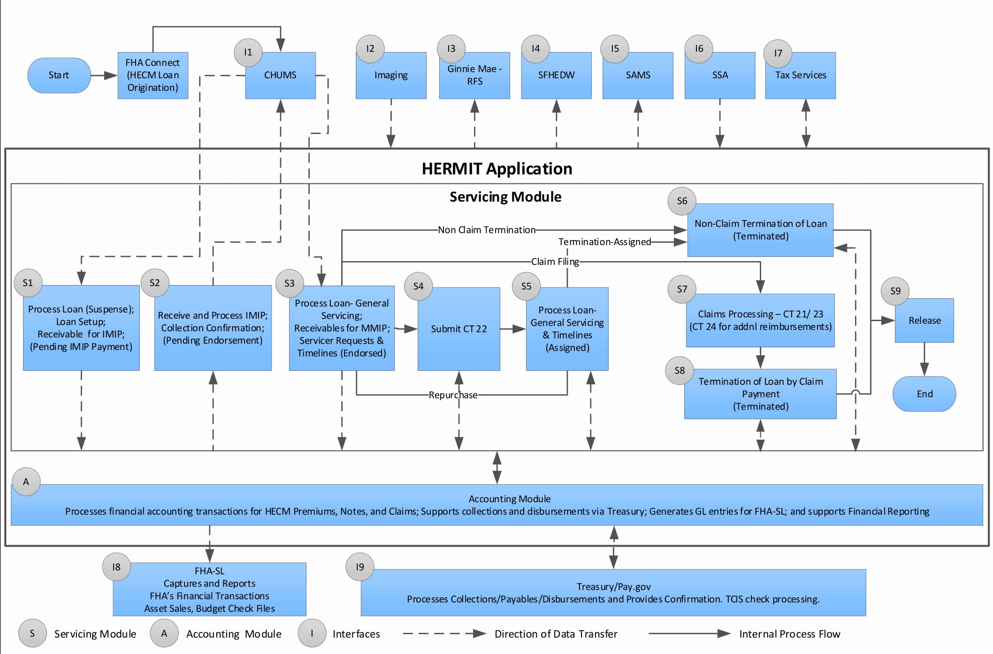
Figure 1-1: Business Process Flow
The boxes labeled I1 to I8 are the interfaces for the Servicing and Accounting Module. They exchange relevant data and statuses during the loan life cycle to provide the up-to-date loan status and details.
Details about the process are provided below, starting from top left side:
- S1: New loan information is received in the Servicing Module from CHUMS. The system then validates IMIP, Maximum Claim Amount (MCA), and principal limit calculations. This enables lenders/servicers to perform loan setup.
- S2: The Servicing Module processes collection of the IMIP due through the Accounting Module and sends a confirmation to CHUMS that collection was successful. The loan is now eligible for endorsement.
  - The Accounting Module generates payable transactions for refunds (if applicable) and collection transactions for IMIP and sends them to Treasury/Pay.gov. Upon confirmation of disbursements/collections, the status gets sent to the Servicing Module, which then updates the payment status for the transactions.
- S3: The Servicing Module calculates payment schedules and related MMIP based on the loan parameters upon confirmation of endorsement from CHUMS. The Servicing Module records all servicing transactions that impact the unpaid loan balance, including Line of Credit (LOC) withdrawals, scheduled payments, special assessments, set-aside amounts, and other payments on behalf of the borrower. The recorded transactions are sent to the Accounting Module for payments/collections. Endorsed - Requests also occur here (example: Extensions, Due and Payable, Preservation and Protection).
- S4: For Claims submission, the Servicing Module calculates the claim amount and sends the payables (CT 22 - Assignment) transactions to the Accounting Module.
- S5: For Assignments, the Servicing Module records all servicing transactions that impact the unpaid loan balance, including LOC withdrawals, scheduled payments, set-aside amounts, and other payments on behalf of the borrower. These transactions are sent to the Accounting Module. For Claims submission, the Servicing Module calculates the claim amount and sends the receivables (Repurchase) transactions to the Accounting Module.
  - The Accounting Module generates payable and receivable transactions for general servicing transactions (Insurance In Force and Assigned) and sends them to Treasury/Pay.gov. Upon confirmation of disbursements/collections, the status gets sent to the Servicing Module updates the payment status for the transactions.
- S6: In the event of non-claim termination activities for endorsed loans, the Servicing Module updates the case status, case sub-status, loan termination reason, and loan balance.
- S7: For Claims submission, the Servicing Module calculates the claim amount and sends the payables (Foreclosure/Deed-in-Lieu, Short Sale, and Supplemental) and receivables (Repurchase) transactions to the Accounting Module.
  - The Accounting Module generates transactions for payables and receivables and sends them to Treasury/Pay.gov. Upon confirmation of disbursements/collections, the status gets sent to the Servicing Module which then updates the payment status for the transactions.
- S8: For termination activities (for example: payoff or Foreclosure/Deed-In- Lieu Conveyed) for Assigned loans, the Servicing Module calculates the pay-off amount, sends the transactions to the Accounting Module, and updates the case status, case sub-status, loan termination reason, and loan balance.
  - The Accounting Module generates notes transactions for collections and sends them to FHASL.
- S9: The Servicing Modules allows release of liens as needed. Releases are initiated when a loan is terminated in the Servicing Module.

System Functionality Overview

Desktop/System Requirements
To effectively use the Servicing Module, a Personal Computer that is web-enabled with the latest version of Microsoft Edge (Default Settings), Windows XP operating system, and a minimum of broadband-speed connectivity to the Internet are required. Microsoft Excel or an Excel Viewer and an Adobe Acrobat Reader are also required. To get the free Acrobat Reader, which enables viewing of PDF files, go to: http://get.adobe.com/reader/.
To learn how to get a free Microsoft Excel viewer, which enables viewing of spreadsheets as read-only files, go to:
https://support.microsoft.com/en-us/help/273711/how-to-obtain-the-latest-excel-viewer

Security
Access to the Servicing Module is governed by user roles and permissions provided during user registration. A variety of personnel use HERMIT, and while many job functions overlap, users are restricted to only the functions that their job requires. Your login credentials govern the activities you can perform in HERMIT. Your supervisor will approve the user form that contains your user role. The next chapter will guide you to the content described in this document that are most relevant to the tasks you perform including the user form and related process.

CHAPTER 2: GETTING STARTED

GETTING STARTED
This chapter will provide users with an overview of the following functions:
- Getting Help
- Requesting Access to HERMIT
- Logging in to HERMIT
- Navigating HERMIT

Getting Help

Contacting the HERMIT Help Desk
The HERMIT Help Desk is the user’s ‘single point of contact’ for any issues related to the application during the normal working hours from 8am to 6pm Eastern Time (Monday to Friday). They can be contacted via email or phone. The Help Desk follows the Federal Holiday calendar.
To reach the HERMIT Servicing Module Help Desk directly, please send an email to:
servicingsupport@hermitsp.com or call the HERMIT Servicing Module Help Desk number at 561-899-2610. The caller will receive automated voice commands to speak with a live Servicing Module agent. The emails will go directly to the Help Desk and will be responded to as per the established protocols. Please provide specific information about the issue to help expedite the resolution. Along with it, please provide the details below:
- First and last name
- Email address and contact number
- Specific details of the problem including the loan skey or FHA case #, and the user role
The Servicing Module Help Desk will log the user’s issue and provide a ticket number for future reference. The ticket will be closed when the issue is resolved to the user’s satisfaction. The Servicing Module Help Desk will log issues for the Servicing Module. Discussed in detail below are the instructions on requesting access to the HERMIT system, logging in, and ways to navigate the application.
To reach the HERMIT Accounting Module Help Desk directly, please send an email to:
accountingsupport@hermitsp.com or call the HERMIT Accounting Module Help Desk number at 844-765-9427.

Requesting Access to HERMIT
New users must request access to HERMIT by completing the Applicant Access Request (AAR) form and submitting it to the appropriate Help Desk via email. It is used to collect information about the user to determine which functions they need to access in the system. One form is for HUD staff and contractors, and the other form is for HUD Business partners. One of the following forms is required to be submitted, per user:
- FHA Staff and Contractor P271 HERMIT AAR Form
- FHA Business Partners P271 HERMIT AAR Form (Lenders, Servicers, and Investors)
The forms will be provided by HUD. Please follow the process below to obtain access to the HERMIT Servicing Module:
User instructions to submit the AAR form:
- Obtain P271 AAR form from HUD.
- Please complete and sign the form, submit the form to your supervisor, if approved, your supervisor will email the P271 AAR form to servicingsupport@hermitsp.com.
- A ticket will be opened and sent to the non-HUD requestor by Help Desk.
- The ticket will be sent by the Help Desk to the HUD Government Technical Monitor (GTM) responsible for the business area of the HUD requestor (via an approved list).
- The HUD GTM will review the access request and send the approval or denial. They can request for additional information from the HERMIT Help Desk.
- The Help Desk will notify the requestor (both cases) if the request was approved or denied, or if additional information is needed.
- If the AAR form is approved, requestor will receive a user ID and password through two separate emails.
- If the AAR is denied, requestor will receive notification about the reason for denial.
- If the AAR needs additional information to be added, requestor will be notified to submit a new AAR form. You will then need to follow instructions starting from step two or three.
Figure 2-1: Process for Requesting Access to HERMIT

Resetting and Changing HERMIT Password

Unsuccessful Login Attempts or Forgotten Passwords
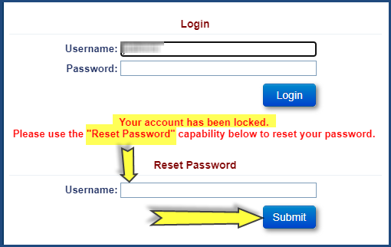
Figure 2-2: Resetting Password
If a user makes three unsuccessful login attempts, the account will be locked and an error message requesting them to use the Reset password capability below will be displayed. On the login screen, enter the Username associated with the user access account and a temporary password will be sent to the email on file. The User will need to follow the instructions to unlock their account and no longer need to call the Help Desk to reset their password.

Changing Your Password
When the user is granted access to HERMIT, the login credentials and passwords are sent via two separate emails. We recommend you change the password when you login for the first time. All passwords in the HERMIT system must have at least eight (8) characters. All passwords must also contain alphabetic and non-alphabetic characters. Non-alphabetic characters include numbers (0-9) and punctuation. We recommend that you do not write down or share your password.
To change the password:
- Once you’ve logged in, at the top of the screen, click the Edit Profile link.
Figure 2-3: Edit Profile on Home Screen
- Click the Password tab.
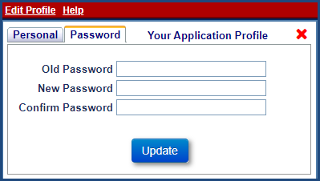
Figure 2-4: Password Tab
- Type in your old password, new password and confirm the new password.
- Click Update and you can continue working on the system. Next time the user will have to log in using the new password.

Log in to the Servicing Module
Upon receipt of login and password information from the Help Desk, please follow the instructions below to log into the Servicing Module:
- In the address bar of your browser, enter www.hermitsp.com.
- The HERMIT Servicing Module Login screen is displayed. On the Login screen, type your User Name and Password.
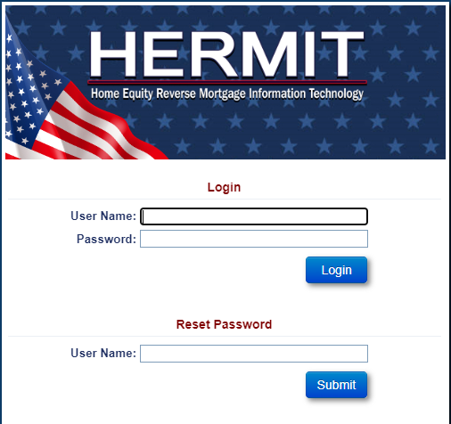
Figure 2-5: Login Screen
- Click Login.
- The Multi-Factor Authentication (MFA) Extra Security Step Required message is received.
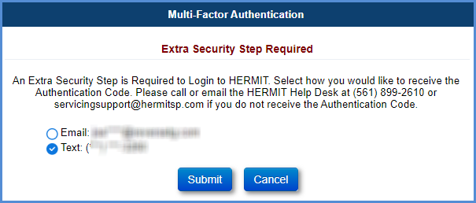
Figure 2-6: MFA Screen
- Select email or text as the way to receive the 6-digit code.
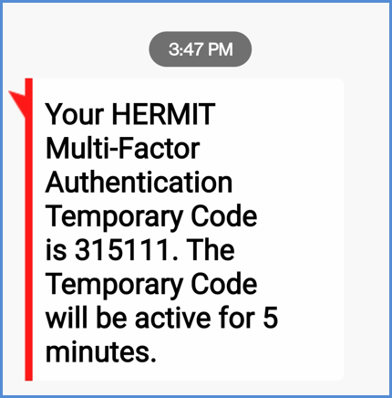
Figure 2-7: 6-digit code via Text Message
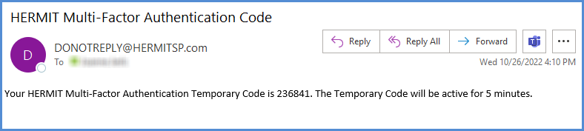
Figure 2-8: 6-digit code via Email
- Enter the MFA Code
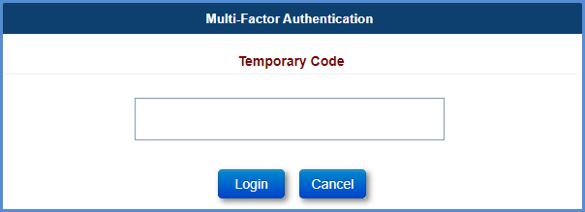
Figure 2-9: MFA Temporary Code
- The System Use Notification message is received. Review the message and click Ok to login or click Cancel to return to the login screen.
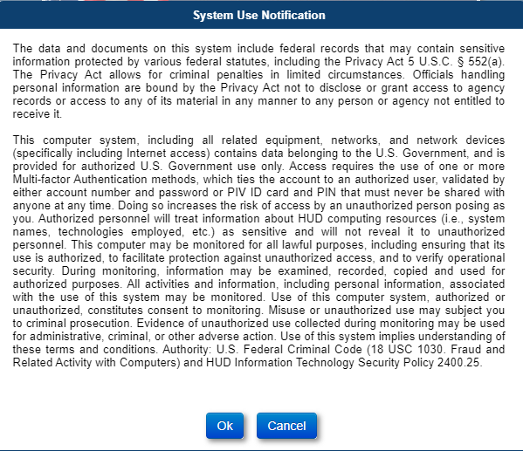
Figure 2-10: System Use Notification Screen

- The HERMIT Servicing Module Home screen is displayed.

Navigating the Servicing Module

Loan Header
At the top of each page, a collapsible loan header area is displayed. The loan header includes key information about the loan currently being viewed and is visible from most pages within the system. Components displayed in the header are Loan/ Borrower/ Servicer / Balance information.
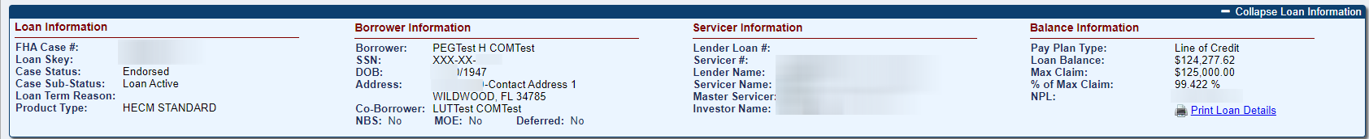
Figure 2-11: Loan Header

If Applicable, the header screen displays the following links:
- Go to Parent Loan: This link is displayed when the product type of the loan is HECM – Refinance, HECM Standard - Refinance or HECM Saver – Refinance. This link navigates the user to the Loan Balance screen of the parent loan.
- Print Loan Details: This link allows the user to generate Loan Summary in a PDF file that can be saved or printed. It contains the following data sections:
  - Loan Identifiers
  - Loan Dates
  - Borrower & Property Information
  - Loan Rates
  - Principal Limit Calculation
  - Payment plan Information
  - Credit Line Set Aside Information
  - Servicer Information
If Applicable, the header screen displays a scrolling alert which moves across the loan header. The scrolling alert is only applicable for Alerts labeled as “Always Display” in the system.

Home Screen
After you have logged in, the user will be on the default home screen as shown below.
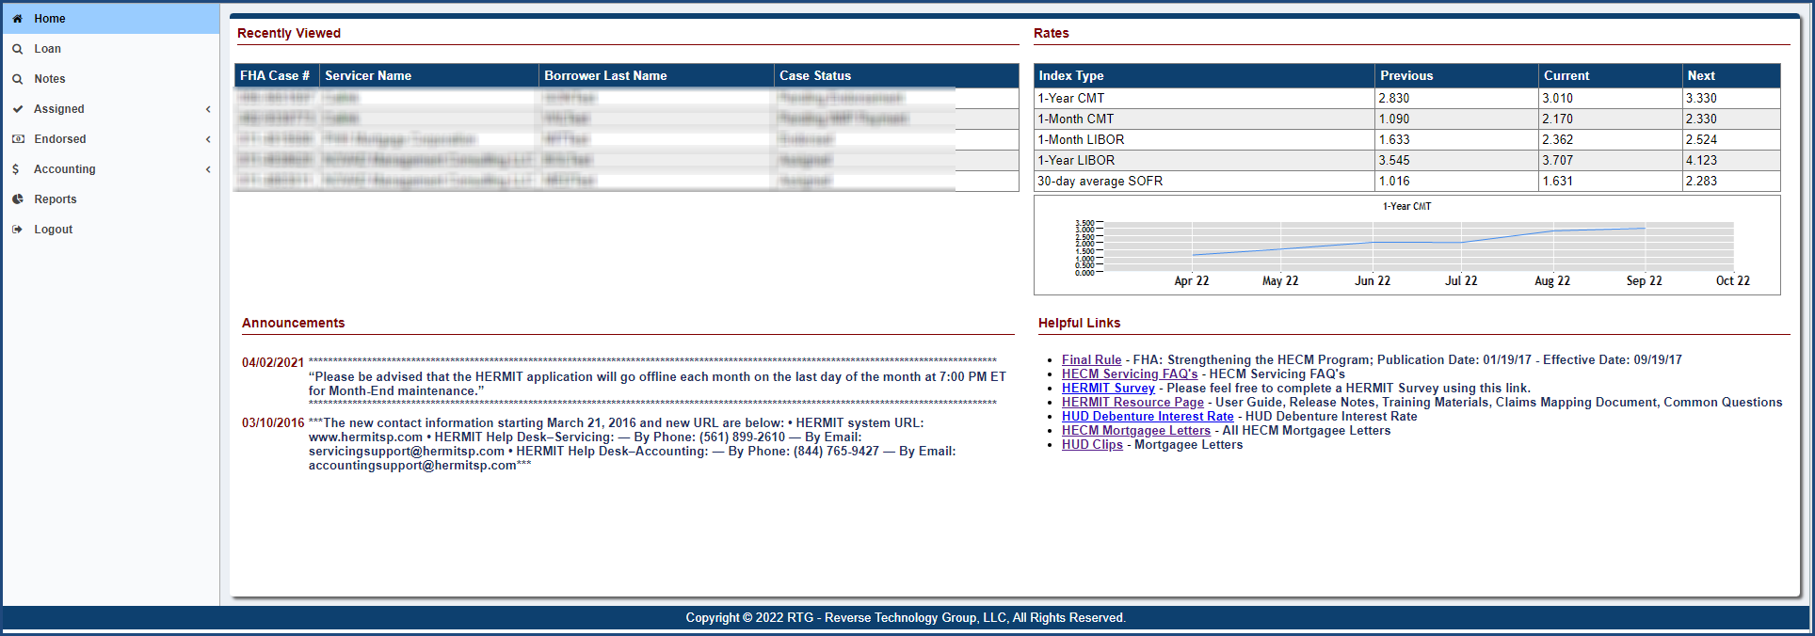
Figure 2-12: The Home Screen

On the home screen, there are several features which are explained in the table below. The screen is divided into sections which provide a quick overview of the most used functionalities.
Home Screen Section | Description
Recently viewed  (Top left) | A list of the last 10 FHA Cases that have been viewed by the user including servicer name, borrower name and the Case Status of the loan.
Rates  (Top right) | Lists previous, current, and next rates for certain index types along with a graph to show the trend.
Announcements  (Bottom left) | Information about the HECM program or the application about key events.
Helpful Links  (Bottom right) | Internal or external links to HUD policy and related information helpful to the user. Once a user clicks on a link, the site will be opened in a new browser.
Table 2-1: Description of the Home Screen Sections

Constructing a Basic Loan Search
This section provides tips to search for an individual loan and navigate Loan Search results. Later in this user guide, instructions are provided on how users can query, review, and edit information at a detailed level, and search for or setup specific types of loans in the application.
When the search screen is first displayed, several fields will display “ALL” to allow the user to search for ‘All Loans’. The user can enter or select different criteria to narrow the search results. Once a search is completed the results are displayed in the Search Results screen.
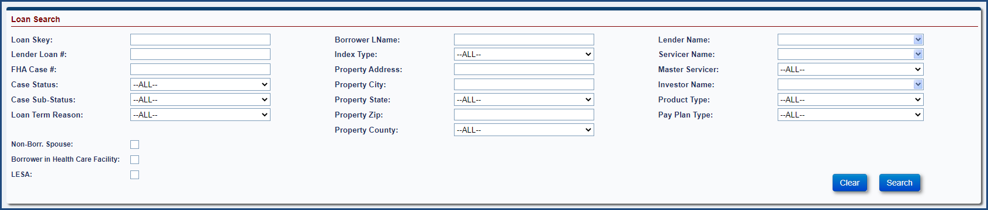
Figure 2-13: Loan Search Screen

Search Criteria
To retrieve loans, the user can set up a search using different combinations. In general:
- Entering additional search criteria will retrieve more specific search results, but fewer loan records and vice versa.
- For single record user can search via full or partial numbers. Partial will provide numerous records.
  - Lender Loan #
  - FHA case #
  - Loan Skey
- Search can be done via partial entry to return results (no need to enter a *):
  - Borrower LName
  - Property Address
  - Property City
  - Property Zip
- To retrieve loans with Non-Borrowing Spouse, Borrower in Health Care Facility or Life Expectancy Set Aside (LESA) data, the user can setup a search using different combinations and select the corresponding indicator on the bottom left of the Loan Search screen.
Basic search criteria on the Loan Search screen are Lender Loan #, FHA Case # and/or Case Status.

Searching for a Loan
User can build a search using the criteria below

Loan Search Criteria
Field | Description
Loan Skey | The Servicing Module system identification number unique to each loan.
Lender Loan # | Recorded identification number for each loan property (Enter a partial loan number, if the complete number is not known).
FHA Case # | FHA case number of the loan (Enter a partial FHA Case #, if the complete number is not known).
Case Status | Current high-level status of the loan, either suspense, pending IMIP payment, pending endorsement, endorsed, assigned, cancelled, or terminated.
Case Sub-Status | Detailed case sub-status of the loan.
Loan Term Reason | Disposition of the loan that is associated with the Termination Transaction
Borrower LName | Last name of the borrower (Enter a partial name if the complete name is not known).
Index Type | Organization and type of interest rate based on the interest rates at which banks borrow unsecured funds from other, either 1 month-CMT, 1 month – LIBOR, 1 Yr CMT, 1 Yr LIBOR, 30-day average Secured Overnight Financing Rate (SOFR) or No Index.
Property Address | Address of the loan property (Enter a partial address if the complete address is not known).
Property City | City where the loan property is located.
Property State | State where the loan property is located.
Property Zip | Zip Code where the loan property is located.
Property County | The county where the mortgaged property is located.
Lender Name | Name of the origination lender.
Servicer Name | Name of the company of record servicing the loan record.
Master Servicer | Name of the company of record Servicing Rights Holder also known as the MSR Holder.
Investor Name | Name of the mortgage lender that owns/finances the loan record name.
Product type | HECM, HECM for Purchase, HECM – Refinance, HECM Standard, HECM Standard for Purchase, HECM Standard – Refinance, HECM Saver, HECM Saver for Purchase, HECM Saver – Refinance.
Pay plan type | The payment plan type chosen by the borrower, either line of credit, lump sum, modified tenure, modified term, tenure, or term.
Non-Borr. Spouse | Indicator to retrieve loans with Non-Borrowing Spouse.
Borrower in Health Care Facility | Indicator to retrieve loans with Borrowers in health care facility
LESA | Indicator to retrieve loans with Life Expectancy Set Aside (LESA)
Table 2-2: Loan Search Criteria

Writing Search Criteria
To search for a loan:
- Select the loan tab on the Home screen.
- On the Loan Search screen, enter single or multiple search criteria, typically by selecting the criteria from various dropdown boxes. In general, the more criteria the user selects, the fewer results will be returned from the query. In the example below, we have selected a Case Status of ‘Endorsed”, a property state of Alaska, a pay plan type of Line of Credit (LOC) and a LESA. This will narrow the search to only the loans that match the criteria.
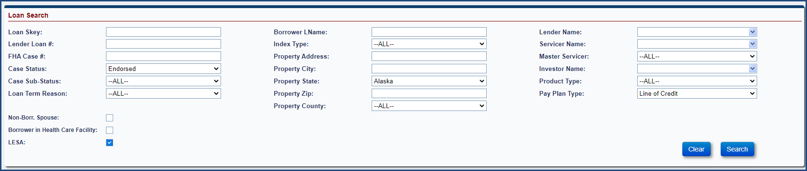
Figure 2-14: Building a Search
- Click Search and the results will be displayed.
- Click the Clear button to remove the previously entered search criteria and re-enter the new search criteria, if needed.

Navigating Search Results
In the search results table, each loan that meets the criteria of the search is displayed in a single row (called a table record), and there are 10 rows – or records – per page. The total number of records is shown in the bottom right of the screen. When the user clicks on a loan, the Loan Balance screen will be displayed for all loans except Suspense loans. For Suspense loans, the Loan Setup screen will be displayed. Only one loan can be selected at a time.
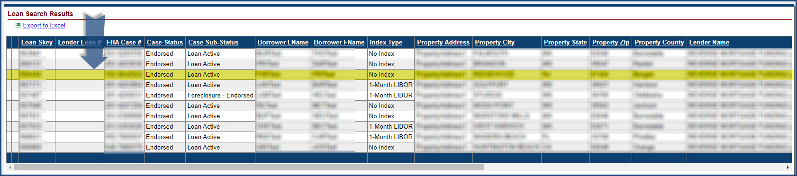
Figure 2-15: Navigating Search Results
Most likely, any general search performed will return more records than the user can view at one time. Likewise, for a single record, the user will not be able to view all the columns displayed in the loan search results table, unless the user uses the scroll bar at the bottom of the screen.
A suite of navigation tools is located at the bottom of the loan search results screen to help the user to navigate the table and the individual rows.

Sorting Records
By default, the records in the search results table are sorted by Loan Skey number but the user can re-sort them by clicking on any column header. This will sort it in alpha or numeric order depending on the column. If the user clicks the header again, it will sort the opposite way. Some of the column headers that can be sorted by are Loan Skey, Lender Loan #, FHA Case #, Case Status, Borrower LName and Borrower FName.
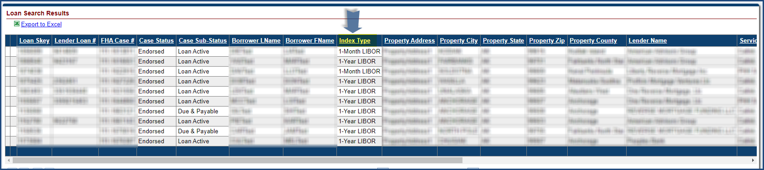
Figure 2-16: Sorting Search Results

To See all the Columns in the Table
To see the remaining columns displayed in the Loan Search Results section, click and drag the horizontal scroll bar to the right.
Figure 2-17: Navigating Search Results – Horizontal Bar

Scrolling by Page
To scroll down page by page, or to the very last or first page in the table, click the arrow buttons in the bottom left of the screen. Clicking the arrow to the far right will take the user to the last page. Clicking the arrow to the far left will take the user back to the first page. The arrows in the middle will take the user to the previous or subsequent page.

Figure 2-18: Scrolling by Page

Navigating by Specific Page Number
To go to a specific page, enter the value beside the field page and click Go. To select the results per page, enter the value (max of 300) beside the field results per page and click Go.

Figure 2-19: Navigating by Specific Page Number

Viewing the Number of Records Returned in a Query
View the total record count in the lower right corner at the bottom of the Search Results section.

Figure 2-20: Viewing the Number of Records Returned

Exporting Loan Search Results to Excel
The Export to Excel link will allow the user to export their Loan Search results to excel (Max of 160,000).
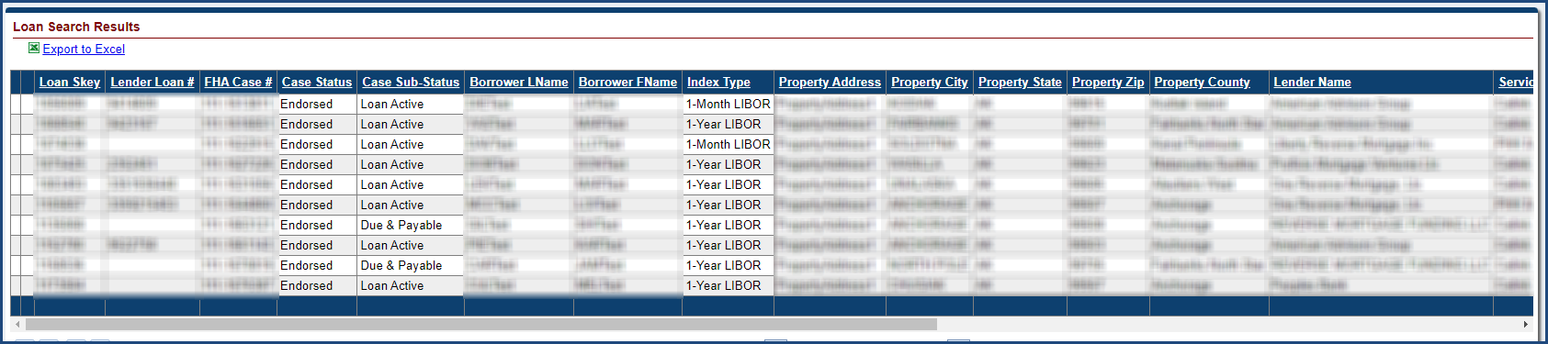
Figure 2-21: Exporting Loan Search Results to Excel
To export the Search Results table to Excel:
- Click the Export to Excel link at the top left of the list of the Search results
- On the File Download dialog box, click Open to export the search results to Excel.
- View or modify the search results when Excel opens a file.
- Click Save option to save the file to the desired location.

Left Menu and Loan Balance Screen
From the Home screen, click on a recently viewed loan to display the Loan Balance screen. User can also click on any loan to take them to the Loan Balance screen.

- Left Menu (Arrow- 1):
  - There are up to nine Servicing Module tabs available for selection, depending on the user’s security permissions. Users with specific user permissions will be able to see specific tabs.
- Back to Loan Search link (Arrow- 2):
  - The loan balance screen shows a Back to Loan Search link in the upper left under “Loan” which will take the user back to the original loan search.
- Print loan details (Arrow- 3):
  - It shows a print loan details link which allows user to print the loan details.
- Non-Borrowing Spouse and Deferred Status Indicators (Arrow-4)
  - The indicator shows whether there is any non-borrowing spouse on the loan.
  - The indicator shows whether the loan is in a deferred status.
- Pie Chart Graph (Arrow- 5):
  - On the loan balance screen, there is pie chart and bar graph for the loan balance information. The pie chart will show what percentage of the loan balance is MIP, Interest, Principal, and Service Fee Set Aside. The bar graph will show the loan balance and max claim amount.
- Audit Information (Arrow- 6):
  - At the bottom of the screen, there is an audit information box. The box will show the last time the information on the screen was changed. The box displays the create date, created by, change date, and changed by fields.

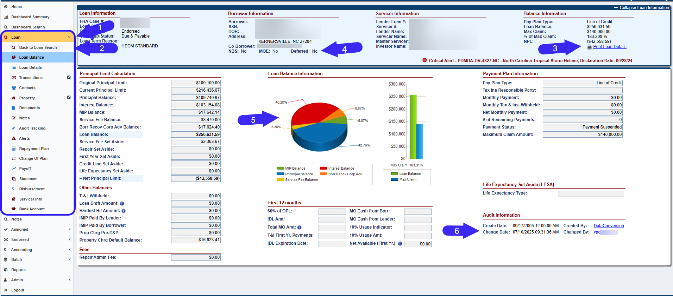
Figure 2-22: Example of the Left Menu

Table 2-3 describes the Left Menu in more detail.
Left Menu | Description
Home | - Lists the loans that were recently viewed, their FHA case #, Servicer Name, Borrower Name, and Case Status.  - Lists previous, current, and next rates for certain index types.  - Lists helpful links that can be added by certain user roles.  - Lists announcements that can be added by certain user roles.
Loan | This tab will enable the user to initiate a loan search using various search criteria.
Notes | This tab will enable the user to initiate a note search using various search criteria (This is available according to the user role).
Assigned | Click this tab to setup or search for servicing timelines on assigned loans: Compliance, Disposition, Requests, Foreclosures, Bankruptcy, Release, Claims and REO (These are available according to the user role).
Endorsed | Click this tab to setup or search for servicing timelines on endorsed loans: Compliance, Disposition, Requests, Foreclosures, Bankruptcy, Release, and Claims (These are available according to the user role).
Accounting | Click this tab to work with transmittals, premiums, claims, refunds, disbursements, and authorizations (These are available according to the user role).
Batch | Click this tab to initiate batch uploads for loan setup, transactions, servicer transfers. This tab also enables the user to transfer loans to other servicers.
Reports | Click this tab to generate daily and monthly reports.
Admin | Click this tab to perform several Admin activities such as denoting a Servicer as “Do Not Pay”. This tab has very limited access and is provided to select HUD Staff.
Logout | Exit the application.
Table 2-3: Description of the Servicing Module Left Menu

Sub Menu
The Sub Menu appears on the left side of the application from top to bottom when the user clicks on a loan in the search results screen on the loan tab. There can be up to sixteen tabs available for selection, depending on the user’s security permissions. Not all users will be able to see all tabs.
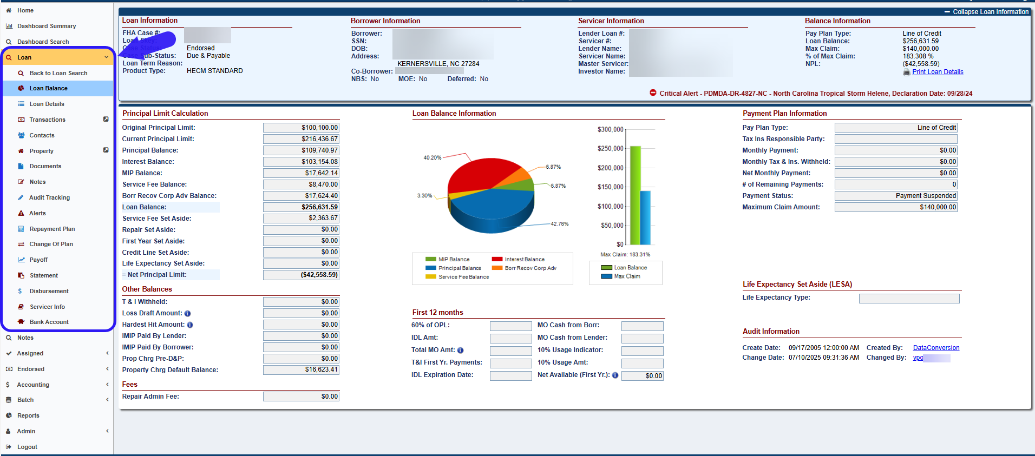
Figure 2-23: Example of the Sub Menu

The sub menu on the left side of the screen consists of these values from top to bottom for Loan:
Sub Menu | Description
Loan Balance | Allows the user to view the Loan balance details and payment plan information for the loan that has been queried.
Loan Details | Allows the user to view the loan details to include the loan rates, loan dates and the 1st and 2nd mortgage information.
Transactions | Allows the user to create, view and edit transactions in the system depending on the user’s permissions.
Contacts | Allows the user to create, view and edit the borrower, co-borrower and additional contacts for the loan depending on their permissions. They can also be deleted except for borrower and co-borrower.
Property | Allows the user to edit property details, and upload or delete a property photo depending on their permissions.
Documents | Allows the user to upload (PDF only), delete and view documents for the loan depending on their permissions.
Notes | Allows the user to view, delete and create notes depending on their permissions. The notes tab displays notes that have been added by the user and system generated notes.
Audit tracking | Allows the user to view events that have occurred in the Servicing Module during the life of the loan.
Alerts | Allows the user to view alerts for critical events that occur on the loan. New alerts can also be added in the system that can be viewed here.
Change of plan | Allows the user to change a loan’s payment plan if a borrower elects to do so. This screen will only allow user with the authorized permissions to change the pay plan. Payment plans can be changed for endorsed and assigned loans.
Repayment Plan | Allows the user to enter the repayment plan detail if a borrower elects to do so. This screen will only allow user with the authorized permissions to enter repayment plan details. Repayment plans can be created and updated for pre-endorsed, endorsed and assigned loans.
Payoff | Allows the user to view and print the payoff information for the loan.
Statement | This tab displays the monthly statement amount details as of the selected reporting period. Only authorized users have access to the Statement screen.
Disbursement | This screen displays the Notes disbursement transactions. The screen also allows the user to create disbursement transactions.
Servicer Info | This screen allows a user with the appropriate permissions to transfer servicer or investor and to update bank account information.
Servicer request | Allows the user to create an endorsed or assigned timeline depending on their permissions.
Bank Account | This screen allows authorized users with the ability to edit the Payment Method and Borrower’s Bank Account information.
Table 2-4: Description of the Servicing Module Sub Menu

Information Help Feature
On various screens there is a feature to help the user obtain relevant information. This feature is designated on various screens by a circle with an “i” in the middle of it as shown below. Hovering over the information button will display a short description of the field.
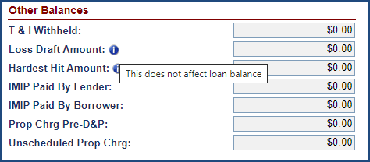
Figure 2-24: Information Help Feature

CHAPTER 3: INTRODUCTION TO USER GROUPS

INTRODUCTION TO USER GROUPS
This chapter will provide users with an understanding of the following functions:
- Overview of User Groups
- Servicers User Group
- Lender User Group
- Investor User Group
- HUD Single Family Premiums User Group
- HUD Claims Staff User Group
- HUD NSC Contractor User Group
- HUD NSC User Group

Overview of User Groups
The Servicing Module has seven different user groups containing different roles and permissions or responsibilities. They have been decided after extensive discussions with HUD GTMs and taking the day-to-day activities into consideration. The business partners can perform daily activities like loan set up, but the approval/denial roles are with the HUD staff.
Not all user roles within a user group have the same permission levels; these vary based on the roles/responsibilities assigned to the user. A user can only have one user role at a time in the system. A Supervisor has roles and permissions that allow them to perform certain functions. Their manager can perform their functions and have additional permissions to approve or deny activities performed by the Supervisor.
Currently, there are about 28 roles assigned to different user groups with over 400 permissions in total. Each role or permission is uniquely assigned to its group and is not repeated. Further, to impose security and segregation of various roles and responsibilities, each of them have permissions either enabled or disabled for a user role. Only authorized user roles with the enabled permissions can perform a particular function.
For example: The permission for the Loan Setup function in the Servicing Module is enabled for user roles associated with HUD Single Family, Lender and Servicer user groups. No other user role can perform loan setup in Servicing Module except for the role that has that permission.
The user groups available in the Servicing Module are:
- Servicers (Chapters 4, 5, 7, 8, 9)
  - The servicer manages the loan for the Lender/investor and performs day-to-day management of HECM mortgage loan accounts, including disbursing monthly payments, performing change-of-payment plans, performing any unscheduled disbursements on behalf of borrower amongst other functions.
- Lenders (Chapters 4, 5, 7, 9)
  - A person or company that makes loans for HECMS. They will use the system to track events that occur on the loan and perform day-to-day management of HECM mortgage loan accounts, including disbursing monthly payments, performing change-of-payment plans, performing any unscheduled disbursements on behalf of borrower amongst other functions.
- Master Servicers
  - “Master Servicing/MSR Holder”, holders are responsible to ensure all loans are serviced properly accordingly to all HUD guidelines, Mortgagee Letters, etc. Because of their overall accountability to their loans, they have “read-only” access to properly monitor and oversee of all servicing activities performed by their sub-servicers.

- Investors (Chapters 4, 5, 8)
  - The investor owns or finances the loans and will use the system to perform transactions and view information about the loan such as payoff statements, claims status and loan details. This group can also authorize repayments and activate and suspend payments.
- HUD Single Family Staff (Chapters 4, 5, 9, 10)
  - This user group will be able to perform day-to-day management of HECM mortgage loan accounts for the endorsed loans.
- HUD Claims Staff (Chapters 5, 8)
  - This user group will have the rights to approve/deny claims. They can also cancel payments and monitor the Claims activities within the system.
- HUD NSC Contractors (Chapters 6, 7, 9)
  - This user group will manage the day-to-day activities for the Assigned Notes portfolio for HUD and requests for servicing for the Insured HECM loan for Servicers.
- HUD NSC Staff (Chapters 6, 7, 9)
  - This user group will perform servicing management activities for the Assigned HECM portfolio and the Insured HECM portfolio for specific servicing requests.

Changes to User Roles and Permissions
After the user logs into the system, they will be able to perform the functions within their user group listed below. If a user desires to add/modify another user role, they will need to contact the HUD Staff (GTM), update the request form, and send it to the HERMIT Help Desk. Based on the approval, the changes would be made to the role and the user will be informed.

Lender User Group
The table below lists the most relevant functions for the Lender user group and provides links to the chapters and sections where instructions are documented to perform those functions.
Item # | Function | Chapter
 | Perform - Initial Servicer Transfer | 5 General Servicing
 | Loan Setup (manual and B2G) | 4 Loan Setup
 | Activate/Suspend Payments | 5 General Servicing
 | Edit Loan Details | 5 General Servicing
 | Add Transactions | 5 General Servicing
 | Edit Contacts | 5 General Servicing
 | Edit Property Information and Property Values | 5 General Servicing
 | Upload Documents | 5 General Servicing
 | Add Notes | 5 General Servicing
 | Add Alerts | 5 General Servicing
 | Perform Change of Plan (COP) | 5 General Servicing
 | Update Servicer/Investor Information | 5 General Servicing
 | Review Transaction Status – Accounting Transmittals | 5 General Servicing
 | View IMIP/Refund/MMIP Batch Details | 5 General Servicing
 | Authorize Repayments | 5 General Servicing
 | Review or Cancel Pending Servicer Transfers | 5 General Servicing
 | Perform - Batch Servicer Transactions | 5 General Servicing
 | Perform – Servicer File Uploads (B2G File Uploads) | 5 General Servicing
 | Release Timelines | 7.4 Release Timelines
 | Review Claims | 8 Claims
 | View Premium (Daily IMIP & Refunds Transactions) Reports | 9 Reports
Table 3-1: Lender User Group Crosswalk

Servicer User Group
The table below lists the most relevant functions for the Servicers user group and provides links to the chapters and sections where instructions are documented to perform those functions.
Item # | Function | Chapter
 | Perform - Initial Servicer Transfer | 5 General Servicing
 | Loan Setup (manual and Business 2 Government (B2G)) | 4 Loan Setup
 | Activate/Suspend Payments | 5 General Servicing
 | Edit Loan Details | 5 General Servicing
 | Add Transactions | 5 General Servicing
 | Edit Contacts | 5 General Servicing
 | Edit Property Information and Property Values | 5 General Servicing
 | Upload Documents | 5 General Servicing
 | Add Notes | 5 General Servicing
 | Add Alerts | 5 General Servicing
 | Perform Change of Plan (COP) | 5 General Servicing
 | Update Servicer/Investor/Master Servicer Information | 5 General Servicing
 | Edit Servicer Bank Account Information | 5 General Servicing
 | Review Transaction Status – Accounting Transmittals | 5 General Servicing
 | View IMIP/Refund/MMIP Batch Details | 5 General Servicing
 | Authorize Repayments | 5 General Servicing
 | Review or Cancel Pending Servicer Transfers | 5 General Servicing
 | Perform - Batch Servicer Transactions | 5 General Servicing
 | Perform – Servicer File Uploads (B2G File Uploads) | 5 General Servicing
 | Create and Edit Repayment Plan | 5 General Servicing
 | Endorsed - Compliance Timelines | 7.2 Endorsed Timelines
 | Endorsed - Disposition Timelines | 7.2 Endorsed Timelines
 | Endorsed - Foreclosure Timelines | 7.2 Endorsed Timelines
 | Endorsed - Bankruptcy Timelines | 7.2 Endorsed Timelines
 | Endorsed - Requests Timelines | 7.3 Endorsed Timelines
 | Endorsed - Release Timelines | 7.3 Endorsed Timelines
 | Claims | 8 Claims
 | View Premium (Daily IMIP & Refunds Transactions) Reports | 9 Reports
Table 3-2: Servicer User Group Crosswalk

Investor User Group
The table lists the most relevant functions for the Investor user group and provides links to chapters and sections where instructions are documented to perform those functions.
Item # | Function | Section #
 | Loan Setup (manual and B2G) | 4 Loan Setup
 | Activate/Suspend Payments | 5 General Servicing
 | Edit Loan Details | 5 General Servicing
 | Add Transactions | 5 General Servicing
 | Upload Documents | 5 General Servicing
 | Edit Investor Bank Account Information | 5 General Servicing
 | Authorize Repayments | 5 General Servicing
 | Review Claims | 8 Claims
Table 3-3: Investor User Group Crosswalk

HUD Single Family Premiums User Group
The table below lists the most relevant functions for the HUD Single Family Premiums user group and provides links to the chapters and sections where instructions are documented to perform those functions.
Item # | Function | Section #
 | Verify IMIP Collection | 4 Loan Setup
 | Approve/Deny Refund (Accounting – Refund) | 4 Loan Setup
 | Add Notes on a Loan | 5 General Servicing
 | Add Alerts on a Loan | 5 General Servicing
 | View IMIP/Refund/MMIP Batch Details | 5 General Servicing
 | View IMIP Daily Transactions Report | 9 Reports
 | View Refunds Daily Transactions Report | 9 Reports
 | View CHUMS Exception Report | 9 Reports
Table 3-4: HUD Single-Family Premiums User Group Crosswalk
The Single-Family Staff have permissions enabled for servicer activities (for example: loan setup, transactions). For servicer functions and corresponding links to chapters/sections, refer to Table 3-2 in Section 3.3.

HUD Claims Staff User Group
The table below lists the most relevant functions for the HUD Claims Staff user group and provides links to chapters and sections where instructions are documented to perform those functions.
Item # | Function | Section #
 | Add Notes on a Loan | 5 General Servicing
 | Add Alerts on a Loan | 5 General Servicing
 | View Claims Transaction Status | 5 General Servicing
 | Review and Process Claims | 8 Claims
 | Approve Claim | 8 Claims
 | Deny Claim | 8 Claims
 | Request Additional Information | 8 Claims
 | Re-Review Claim | 8 Claims
 | Set No Pay Order | 8 Claims
 | Cancel Payment | 8 Claims
Table 3-5: HUD Claims Staff User Group Crosswalk

HUD NSC Contractor User Group
The table below provides a list of the most relevant functions for HUD NSC Contractor user group and provides links to chapters/sections where instructions are documented to perform those functions.
Item # | Function | Section #
 | Activate/Suspend Payments | 6 General Servicing Assigned
 | Edit Loan Details | 6 General Servicing Assigned
 | Add Transactions | 6 General Servicing Assigned
 | Edit Contacts | 6 General Servicing Assigned
 | Edit Property Information and Property Values | 6 General Servicing Assigned
 | Upload Documents | 6 General Servicing Assigned
 | Add Notes | 6 General Servicing Assigned
 | Add Alerts | 6 General Servicing Assigned
 | Perform, Print & Approve Change of Plan (COP) | 6 General Servicing Assigned
 | Print Payoff | 6 General Servicing Assigned
 | Print Monthly Statement | 6 General Servicing Assigned
 | Create Disbursements | 6 General Servicing Assigned
 | Update Servicer/Investor Information | 6 General Servicing Assigned
 | Edit Borrower Bank Account Information | 6 General Servicing Assigned
 | Review Transaction Status – Accounting Transmittals | 6 General Servicing Assigned
 | Print Check/Generate NACHA File/Clear or Void Check | 6 General Servicing Assigned
 | Upload Vendor Files | 6 General Servicing Assigned
 | Create and Edit Repayment Plan | 6 General Servicing Assigned
 | Endorsed – Request Timelines (HUD NSC Contractor review & approval) | 7 Timelines
 | Endorsed – Release Timelines (HUD NSC Contractor review & approval) | 7 Timelines
 | Assigned - Compliance Timelines | 7 Timelines
 | Assigned - Disposition Timelines | 7 Timelines
 | Assigned - Requests Timelines | 7 Timelines
 | Assigned - Foreclosure Timelines | 7 Timelines
 | Assigned - Bankruptcy Timelines | 7 Timelines
 | Assigned - Release Timelines | 7 Timelines
 | Claims – Repurchase | 7 Timelines
 | Claim Type 22 - Assignment | 8 Claims
 | View Assigned Notes Report | 9 Reports
Table 3-6: HUD NSC Contractor User Group Crosswalk

HUD NSC Staff User Group
The table below lists the most relevant functions for the HUD NSC Staff user group and provides links to chapters and sections where instructions are documented to perform those functions. The HUD NSC user group works in conjunction with the HUD NSC Contractor user group to manage the activities on the Assigned Notes portfolio.
Item # | Function | Section #
 | Add Notes on a Loan | 6 General Servicing Assigned
 | Add Alerts on a Loan | 6 General Servicing Assigned
 | View Notes Transaction Status | 6 General Servicing Assigned
 | Create and Edit Repayment Plan | 6 General Servicing Assigned
 | Approve Preservation and Protection Expenses | 7 Timelines
 | Approve/Deny Partial Release | 7 Timelines
 | Approve/Deny Consent of Lienholder | 7 Timelines
 | Approve Attorney Assignment on Loss Mitigation - Pre-Foreclosure | 7 Timelines
 | Approve/Deny Loss Mitigation - Short Sale | 7 Timelines
 | Approve/Deny Write-Off Review | 7 Timelines
 | Approve Assignment Pre- Repurchase and Repurchase | 7 Timelines
 | View Assigned Notes Report | 9 Reports
 | View Management and Budgetary Reports | 9 Reports
Table 3-7: HUD NSC Staff User Group Crosswalk

CHAPTER 4: LOAN SETUP

LOAN SETUP
This chapter discusses loan setup, IMIP collection and refund processes.
- Loan Setup Overview Process
  - Manual Process
  - B2G Process
- IMIP Collection
- Refunds
  - IMIP
  - Late Charges and Interest

Loan Setup Overview Process
This section describes the loan setup, IMIP collection and case status transition in the Servicing Module at a high level.
- Suspense: After day one activities are performed in FHA Connection (FHAC), the Servicing Module receives initial case details from CHUMS via the daily interface file. This file is processed in the Servicing Module and loans that pass all validations are recorded with a case status of Suspense. Reinstatement of previously cancelled cases are received via the daily interface file from CHUMS and are recorded in the Servicing Module with a case status of Suspense.
- Pending IMIP Payment: The loan is now available for the lender/servicer to perform loan setup. The lender/servicer must populate the required loan details to complete the loan setup and initiate the IMIP collection. Once the loan setup is completed, the case status is updated to Pending IMIP Payment.
- Pending Endorsement: The Servicing Module sends the request for IMIP receivable to the Accounting Module via a daily batch interface file, triggering the collection of IMIP.
  - Upon receiving the notification of IMIP collection from Accounting Module, the case status is updated to Pending Endorsement.
  - Upon failure to collect IMIP, the Servicing Module will not change the case status. The Servicing Module provides the ability to retry the IMIP collection batch request once the problem causing the Non-Sufficient Funds (NSF) has been corrected. Refer to the Accounting-Transmittals section 5.18.1.4 documented in this User Guide in Chapter 5 for details.
- Endorsed: The Servicing Module notifies CHUMS of the successful IMIP collection through a daily interface file. Upon issuance of the mortgage insurance certificate, CHUMS will update the case status to Endorsed and send the update information through a daily interface file to the Servicing Module. Upon processing this information, the case status is updated to Endorsed.
TIP: HUD charges two mortgage insurance premiums on HECM reverse mortgages: an initial premium – IMIP, and an annual premium (calculated per HUD regulations for each month and collected as MMIP). The IMIP amount is calculated and received from CHUMS in the Servicing Module; however, the MMIP is calculated every month in the Servicing Module as part of monthly accruals.
The loan setup can be performed by lenders/servicers manually through the Loan Setup screen or electronically through B2G (loan setup import file) which are described in detail in the following sections.

Manual Loan Setup
This section describes the manual loan setup through the Loan Setup screen. This screen allows the user to setup one loan at a time.
The key case-level data on the Loan Setup screen is populated with the information received from CHUMS. On day two, an authorized user is required to enter additional loan data to complete the loan setup to remit IMIP.

Performing Loan Setup
To perform loan setup:
- Select the Loan tab.
- Enter the FHA Case # of the loan. Click Search.
- Click Setup link beside the loan displayed under the Loan Search Results section.
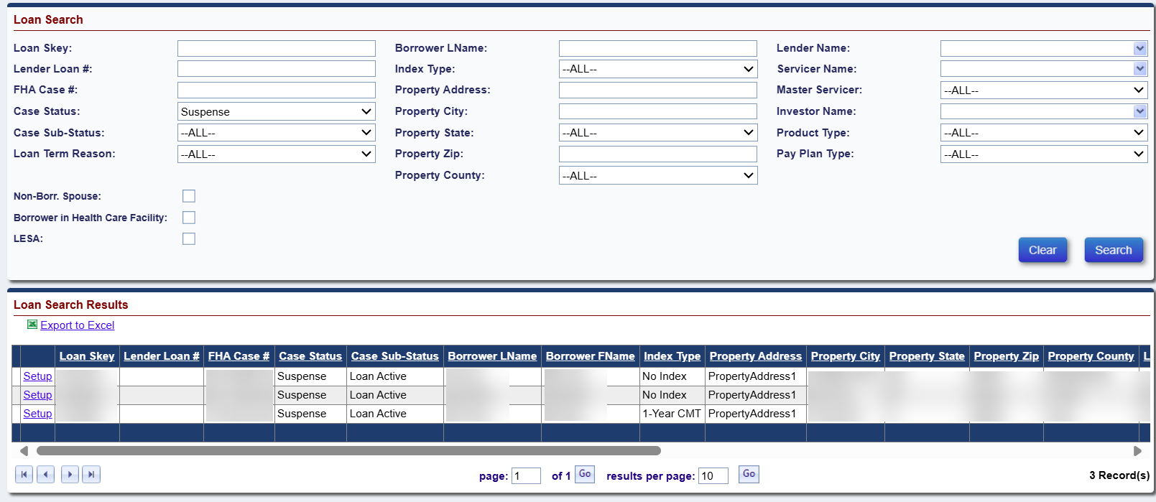
Figure 4-1: Loan Search Screen - Suspense Loans
- On the Loan Setup screen, enter the loan details (Required fields are marked with an asterisk) to complete the loan setup. Refer to Section 4.2.2 for details on each of the fields displayed on the loan setup screen. On this screen the following buttons are displayed:
  - Save & Close – This button allows the user to save changes and complete the loan setup.
  - Save & Next – This button allows the user to save changes, complete the loan setup and display the next loan with a case status of Suspense.
  - Cancel – This button allows the user to exit the loan setup screen without saving the information.
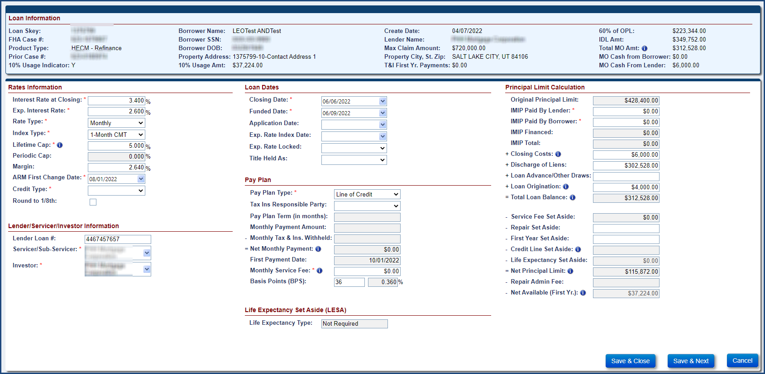
Figure 4-2: Loan Setup Screen
- Enter the required data fields on the loan setup screen and click the Save & Next button. The system will validate the data fields and display the error messages when the validations fail. Click OK to close the message window. The user must fix the errors to continue with the loan setup.
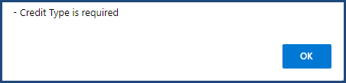
Figure 4-3: Sample Error Message - Loan Setup Screen
- If all the validations pass the loan setup is complete and the case status is updated to Pending IMIP Payment. The user is navigated back to the Loan Search screen.

Details of Data Fields on the Loan Setup Screen
The tables below describe the data fields on the Loan Setup screen.

Loan Information
The table below provides the details of data fields within Loan Information section. The data fields within this section cannot be edited by the user.
Field name | Description
Loan Skey | A unique system-generated number assigned for each FHA case.
FHA Case# | The 10-digit case number, received from CHUMS.
Product Type | The type of HECM Case received from CHUMS:  - HECM (New HECM Product Type per ML 2013-27)  - HECM for Purchase (New HECM Product Type per ML 2013-27)  - HECM – Refinance (New HECM Product Type per ML 2013-27)  - HECM Standard (HECM Traditional with a Standard IMIP designation)  - HECM Standard for Purchase (HECM for Purchase with a Standard IMIP designation)  - HECM Standard – Refinance (HECM Refinance with a Standard IMIP designation)  - HECM Saver (HECM Traditional with a Saver IMIP designation)  - HECM Saver for Purchase (HECM for Purchase with a Saver IMIP designation)  - HECM Saver - Refinance (HECM Refinance with a Saver IMIP designation)
Prior Case # | The FHA Case # of a previously refinanced case. This field is available only for HECM Refinance, HECM Standard Refinance or HECM Saver Refinance product types.
10% Usage Indicator | An indicator to identify if the borrower has elected to use an additional 10% of their Principal Limit amount at the time of loan closing or during the First 12-Month Disbursement Period so that the correct amount of initial MIP is collected. This data is received from CHUMS.
Borrower Name | The name of the borrower on the HECM Case received from CHUMS.
Borrower SSN | The social security number of the borrower on the HECM Case received from CHUMS.
Borrower DOB | The data of birth of the borrower on the HECM Case received from CHUMS.
Property Address | The address of the mortgaged property received from CHUMS.
10% Usage Amt | The amount of the additional 10% of the Principal Limit amount that the borrower has elected to have available. This data is received from CHUMS.
Create Date | The date when the loan/case was received in Servicing Module from CHUMS; this is a system-generated date.
Lender Name | The name of the originating lender received from CHUMS.
Max Claim Amt | The maximum claim amount of home value insured by HUD for the case. It is the least of appraised value, national mortgage limit, or sales price. This data is received from CHUMS.
Property City, St, State, Zip | The city, state and zip code information of the mortgaged property. This data is received from CHUMS.
T&I First Yr Payments | Tax and Insurance Payments scheduled for payment from the Property Charge Set Aside or from HECM proceeds within the First 12-Month Disbursement Period. This data is received from CHUMS.
60% of OPL | 60% of the Original Principal Limit amount. This field is used in the calculation of the Initial Disbursement Limit (IDL). This data is received from CHUMS.
IDL Amt | The amount of mortgage proceeds that can be advanced at loan closing or during the First 12-Month Disbursement Period after loan closing. The sum of Loan Advances/Other Draws and the fields that comprise the Total Mandatory Obligation (IMIP Financed, Closing Costs, Discharge of Liens, Loan Origination, Repair Set Aside, and T&I First Yr Payments) cannot exceed the IDL amount on submission on the Loan Setup screen. This data is received from CHUMS.
Total MO Amt | The Total Mandatory Obligations Amount received from CHUMS. The Total Mandatory Obligations should be the sum of IMIP Financed, Closing Costs, Discharge of Liens, Loan Origination, Repair Set Aside, and T&I First Yr Payments on submission on the Loan Setup screen.
MO Cash from Borrower | The Mandatory Obligation Cash amount paid by the borrower at Loan Closing. The data is received from CHUMS.
MO Cash from Lender | The Mandatory Obligation Cash amount paid by the lender at Loan Closing. The data is received from CHUMS.
Table 4-1: Data Fields - Loan Information Section

Rates Information
The table below provides the details of data fields within Rates Information section. All required fields are denoted by an asterisk.
Field | Description
Interest Rate at Closing* | The note interest rate at closing of the loan. This is a required field.
Exp. Interest Rate* | The expected average mortgage interest rate of the loan, which is used to determine the principal limit on a loan. This is a required field.
Rate Type* | The interest rate type for the case. This is a required field. The selectable options are:
Rate Type* | • Annual
Rate Type* | • Fixed
Rate Type* | • Monthly
Index Type* | The index type for the case. Used by a lender to determine the interest rate for an adjustable-rate mortgage (ARM) Valid index types are U.S. Constant Maturity Treasury Index (CMT) and Secured Overnight Financing Rate (SOFR). This is a required field. Select the Index Type based on the Rate Type. The selectable options are:
Index Type* | • 1 Month CMT
Index Type* | • 1 Yr-CMT
Index Type* | • 30-Day Average SOFR
Index Type* | • No Index
Lifetime Cap* | The maximum interest rate on an adjustable-rate mortgage that may be charged at any point over the life of the mortgage. This field is required for annual or monthly rate types.
Periodic Cap | The maximum the interest rate can increase from one adjustment period to the next. This field is system-generated for annual rate types.
Margin | The margin for adjustable loans. This is required only for monthly and annually adjustable loans.
ARM First Change Date* | The first Change Date that the adjustable interest rate may change on the mortgage. This is required only for monthly and annually adjustable loans.
Credit Type* | Either open-ended or close-ended. This is a required field.
Round to 1/8th | Refers to the interest rate adjustment rounding feature. Select the checkbox to cause future rate adjustments to be rounded to the nearest 1/8th. This is an optional field.
Table 4-2: Data Fields - Rates Information Section

Lender/Servicer/Investor Information
The table below provides the details of data fields within Lender/Servicer/Investor Information section. All required fields are denoted by an asterisk.
Field | Description
Lender Loan # | The unique loan identifier assigned by the lender. This is an optional field.
Servicer/Sub-Servicer* | The current servicer of the HECM Case. This is a required field.
Investor Name* | The investor of the HECM Case. This is a required field.
Table 4-3: Data Fields - Lender/Servicer/Investor Information Section

HECM For Purchase Information
The table below provides the details of data fields within HECM for Purchase Information section. This section is visible and available only for HECM for Purchase, HECM Standard for Purchase (HECM for Purchase with a Standard IMIP designation) or HECM Saver for Purchase (HECM for Purchase with a Saver IMIP designation) loans. All required fields are denoted by an asterisk.
Field | Description
Sale Date | The date the mortgagor and mortgagee agree on the terms of the contract for the HECM mortgaged property. This is an optional field.
Contract Date | The contract date of the HECM mortgaged property. This is an optional field.
Borrower Investment Amount | The amount needed to satisfy the difference between the sales price and HECM principal limit. This is an optional field.
Was Prior Sale/Transfer* | This field allows a user to choose if there was a prior sale of the property. This is a required field with values of “Yes” or “No”.
Prior Sale Date* | The sale date of the prior property of the borrower. This is a required field if Prior Sale/Transfer is “yes”.
Prior Sale Price* | The sale price of the prior property of borrower. This is a required field if Prior Sale/Transfer is “yes”.
Table 4-4: Data Fields - HECM for Purchase information Section

Loan Dates
The table below provides the details of data fields within the Loan Dates section. All required fields are denoted by an asterisk.
Field | Description
Closing Date* | The date the loan was closed. It is the date the borrower and mortgagee sign the closing documents. This is a required field.
Funded Date* | The date when the funds are disbursed. This is a required field.
Application Date | The date borrower signed the initial 1009 form. This is an optional field.
Exp. Rate Index Date | This field identifies the index date of expected interest rate. This is an optional field.
Exp. Rate Locked* | Captures whether the expected interest rate was locked. This is a required field with values of “Yes” or “No”.
Title Held As | Used to determine if mortgage meets statutory and regulatory requirements. This is an optional field.
Table 4-5: Data Fields - Loan Dates Section

Pay Plan
The table below provides the details of data fields within the Pay Plan section. All required fields are denoted by an asterisk.
Field | Description
Pay Plan Type* | The payment plan type to be setup for a loan. This is a required field. The selectable options are:
Pay Plan Type* | • Line of credit
Pay Plan Type* | • Term
Pay Plan Type* | • Tenure
Pay Plan Type* | • Modified term
Pay Plan Type* | • Modified tenure
Pay Plan Type* | • Lump Sum
Tax Ins Responsible Party | The responsible party for payment of taxes and insurance. Choose either borrower or servicer. This is an optional field.
Pay Plan Term (in months) | The number of months for which monthly payments are made. This is required only for term or modified term pay plan types.
Monthly Payment Amount | The monthly payment amount scheduled to be made to the borrower each month. This is required only for term, tenure, modified term and modified tenure payment plan types.
Monthly Tax & Ins Withheld | The amount set aside monthly for taxes and insurance on the loan. This is an optional field.
Net Monthly Payment | This is a system-calculated value, difference between Monthly Payment Amount and Monthly Tax & Ins Withheld.
First Payment Date | The date monthly payments are to begin. This is required only for term, tenure, modified term, and modified tenure payment plan types.
Monthly Service Fee* | The service fee charged by the lender/servicer for each month throughout the life of the loan. This is a required field.
Basis Points | The servicing fee margin associated with the HECM loan. This is required only if Monthly Service Fee equals $0.00.
Table 4-6: Data Fields - Pay Plan Section

Late Charge and Penalty Interest
The table below provides the details of data fields within the Late Charge and Penalty Interest section. All required fields are denoted by an asterisk.
 | Type | FHA Case Number Assigned Date prior to 09/19/2017 (Pre-Final Rule) | FHA Case Number Assigned Date On or After 09/19/2017 (Final Rule)
Initial MIP | Late Charge | Late Charges will be assessed to the loan if payment is not received within 15 days of the Closing Date | Late Charges will be assessed to the loan if payment is not received within 20 days of the Closing Date
Initial MIP | Penalty Interest (Interest Charge) | Penalty Interest will be assessed to the loan if payment is not received within 30 days of the Closing Date | Penalty Interest will be assessed to the loan if payment is not received within 20 days of the Closing Date
Monthly MIP | Late Charge | Late Charges will be assessed to the loan if payment is not received within 10 days of the 1st Business Day of the month | Late Charges will be assessed to the loan if payment is not received within 5 days of the 1st Business Day of the month
Monthly MIP | Penalty Interest (Interest Charge) | Penalty Interest will be assessed to the loan if payment is not received within 30 days of the 1st Business Day of the month | Penalty Interest will be assessed to the loan if payment is not received within 5 days of the 1st Business Day of the month

Table 4-7: Data Fields - Late Charge and Penalty Interest Section

Principal Limit Calculation
The table below provides the details of data fields within the Principal Limit Calculation section. All required fields are denoted by an asterisk.
Field | Description
Original Principal Limit | The maximum loan amount for which a borrower is eligible. This field is a system generated value.
IMIP Paid by Lender* | The Initial Mortgage Insurance Premium (IMIP) paid by lender. This is a required field.
IMIP Paid by Borrower* | The Initial Mortgage Insurance Premium (IMIP) paid by the borrower. This is a required field.
IMIP Financed | The Initial Mortgage Insurance Premium (IMIP) financed. This is system-generated value, adjusted according to the data entered in fields IMIP Paid by Lender and IMIP Paid By Borrower.
IMIP Total | The total IMIP that will be collected once the loan is successfully setup. This value is received from CHUMS.
Closing Costs | The amount of fees and expense incurred by initiation of loan. This is an optional field.
Discharge of Liens | Captures the release of financial liability to a debt of record. This is an optional field.
Loan Advance/Other Draws | Captures the loan advances/other draws taken at closing. This is required only for Modified Term, Modified Tenure, Line of Credit or Lump Sum.
Loan Origination* | This field captures the origination fee charged by the lender. This is a required field.
Total Loan Balance | This field is calculated by the Servicing Module. Equals the sum of IMIP Total + Closing Costs + Discharge of Liens + Loan Advance/Other Draws + Loan Origination fee.
Service Fee Set Aside | This field is calculated by the Servicing Module and is the amount of funds set aside from the initial/net principal limit for payment of future monthly servicing fees.
Repair Set Aside | The amount of money set aside to cover home repairs needed from the initial/net principal limit. This is an optional field.
First Year Set Aside | The amount of money set aside to cover property charges from the initial/net principal limit. This is an optional field.
Credit Line Set Aside | The line of credit amount for modified term and modified tenure pay plans. This is required only for modified term and modified tenure pay plans.
Life Expectancy Set Aside | The amount of money set aside to cover property insurance, taxes and borrower paid charges. This field is received from CHUMS.
Net Principal Limit | This field is calculated by the Servicing Module and identifies the principal limit available for borrower.
Repair Admin Fee | The repair admin fee when amount is set aside for repairs during loan setup. This is required only if data field Repair Set Aside is > $0.00.
Net Available (First Yr.) | This field is calculated by the Servicing Module and identifies the principal limit available for borrower in the first year when the loan has an IDL.
Table 4-8: Data Fields - Principal Limit Calculation Section

Life Expectancy Set Aside (LESA)
The table below provides the details of data fields within Life Expectancy Set Aside (LESA) section.
Field | Description
Life Expectancy Type | The LESA type is received from CHUMS. The different LESA types are:  - Fully Funded  - Partially Funded  - Voluntary  - Not Required
Semi -Annual Payment | The semi-annual payment is the amount scheduled to be made to the Borrower once the case is Assigned. This is required for Partially Funded LESA Type loans only.
Table 4-9: Data Fields – Life Expectancy Set Aside (LESA) Section

Loan Setup: Business to Government (B2G)
The lender/servicer has an ability to upload HECM Case data to the Servicing Module using different B2G interface files. The table below provides a brief description of the files. For additional technical guidance, refer to current version of the B2G File Format and Layout Document. Available at FHA HERMIT | HUD.gov / U.S. Department of Housing and Urban Development (HUD).
Field | Description
Loan Setup Import | Enables lenders/servicers to setup one or multiple loans in the Servicing Module.
Servicer Transfer Import | Enables lenders/servicers to record the transfer of servicers on HECM Cases in the Servicing Module.
Transactions Import | Enables lenders/servicers to record loan transactions in the Servicing Module.
OPL/CPL | Enables lenders/servicers to update the OPL and CPL in the SM.
Master Servicer | Enables lenders/servicers to record the transfer of Master Servicers on HECM Cases in the Servicing Module.
Investor Transfer | Enables lenders/servicers to record the transfer of investors in the Servicing Module.
Table 4-10: B2G Interface Files

Uploading a B2G Loan Setup Import File
The Servicing Module allows the lender/servicer to perform loan setup on multiple loans (maximum of 10,000 records) using a single B2G loan setup import file. The data fields within the B2G loan setup import files are like the data fields displayed on the Loan Setup screen (with exception to the system derived fields like calculations). Once the user uploads the file, the system performs validations (like the validations performed on the Loan Setup screen) and loans that pass all validations are recorded in the Servicing Module with a Case Status of Pending IMIP Payment. If any of the critical validations fail, the loan setup is not completed, and an error message is displayed for the loan. The details are covered in the below sections.

Preparing Loan Setup Import file
To prepare a B2G loan setup import file:
- Select Servicer File Upload, from the Batch tab.
- Select Loan Setup.
- On the File Download screen, click Open; this action opens an Excel template.
- Enter valid values for each column. For each of the fields a comment is displayed when user points on the column name. The comment provides the user with the following information:
  - whether the field is required, optional or conditionally required
  - format/valid values for each field

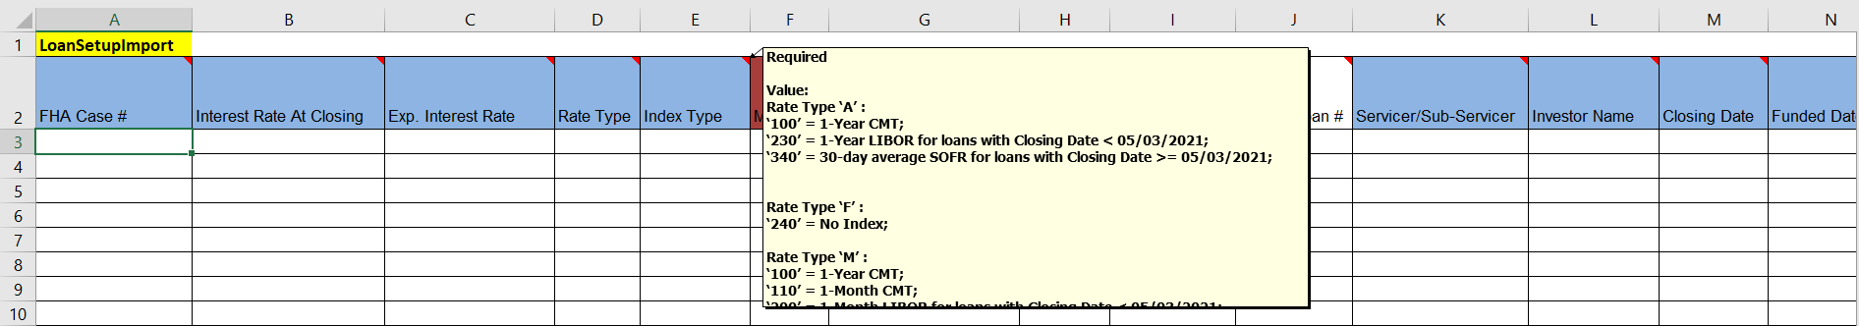
Figure 4-4: Sample Excel Template – B2G Loan Setup Import File

Saving the Loan Setup Import file
To save the B2G loan setup import file:
- Once all required fields are entered in the B2G Loan Setup import file, the file is ready for upload. The file should be saved in a text (tab-delimited/.txt) file format:
- Click File > Save in the Loan Setup Import file.
- Select the folder in which to save the Excel file.
- Rename the file if desired.
- Click File > Save As and save the file as text (tab-delimited/.txt).
- Click Save.

Uploading the Loan Setup Import file
To upload the import file:
- Click Browse on the Servicer File Upload screen to attach the previously saved loan setup import file.
- Click Upload. The Import Results section displays the details of the upload results.
- The system will process the file and validate the records within the loan setup import file:
  - If all the critical validations pass for the record, the record is uploaded with Pending IMIP Payment case status
  - If any of the critical validations fail, the record is not uploaded in the Servicing Module
- Upon completion of the file processing, the system displays the processing status of each record within the file.

Viewing the Upload Status of Loan Setup Import File
The Import Results section displays the details of the processed B2G Loan Setup Import file. It allows user to view:
- Error Records: count of records within the file that failed critical validations
- Warning/Success Records: count of records that generated a warning but were successfully uploaded in the Servicing Module
- Success Records: count of records that were successfully uploaded without generating a warning or error
- Filters: This section allows the user to filter the import results by status and error message
- Export to Excel: This link allows the user to export the file upload results to an Excel file
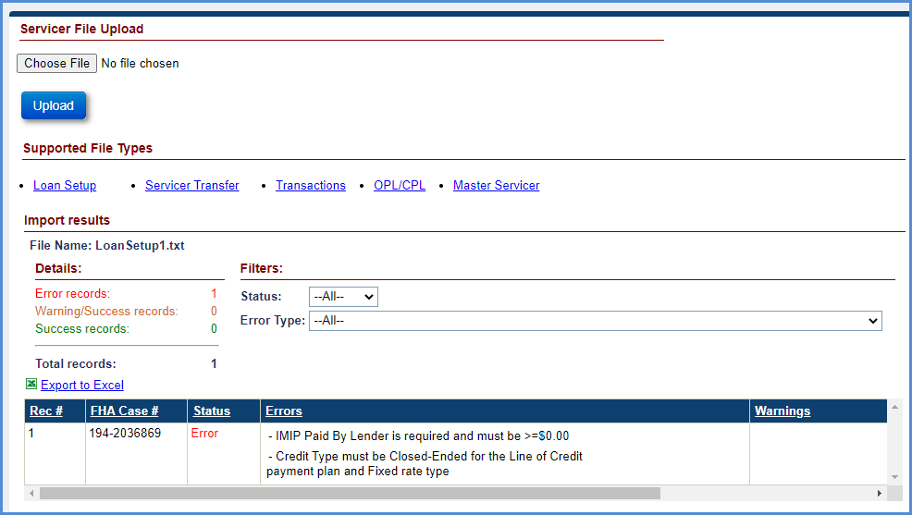
Figure 4-5: Servicer File Upload Screen – Import Results Section
The processing status of each record within the file is displayed:
- Rec#: The record number of the case within the file
- FHA Case #: The case number associated with the record
- Status: The status of the uploaded record (Success, error or warning)
- Errors: Description of the errors associated with the record. For example: FHA Case# is invalid
- Warnings: Description of the warnings associated with the record

IMIP Collection
This section explains the IMIP collection processing in HERMIT (Servicing and Accounting Modules) system.
- The Case Status is updated to Pending IMIP Payment and the IMIP transaction is generated when a loan setup is performed in the Servicing Module. These FHA cases are sent to the Accounting Module for collection of IMIP via an interface file.
- The Servicing Module assigns a batch ID and batch status for the IMIP receivable request to track the IMIP collection status. Once the file is generated and sent to the Accounting Module, the batch status (Sent to GL) is updated to indicate that the transaction has been sent to the Accounting Module.
- The Accounting Module processes the file, records the IMIP receivable transactions and sends a response file to the Servicing Module. The Servicing Module processes the response file from the Accounting Module and updates the batch status (Success – Collect).
- The Accounting Module processes the IMIP receivable and generates a non interactive-batch file per Treasury Pay.gov’s specification. The file is sent to Pay.gov for collection. Upon posting the collection by pay.gov, the deposit is recorded in the Accounting Module.
- The Accounting Module will send the IMIP collection confirmation to the Servicing Module via an interface file. The Servicing Module processes this file and the batch status is updated to Settled and case status to Pending Endorsement. This completes the IMIP collections processing in HERMIT.
- The Servicing Module sends the IMIP collection confirmation to CHUMS via a daily interface file. CHUMS will endorse the cases based on their endorsement process and will send the endorsed cases to Servicing Module. Upon processing this information, case status in Servicing Module is updated to Endorsed.

Verifying IMIP Collection Status
To verify IMIP collection status on a Pending IMIP Payment case:
- Select the Accounting -> Premiums (IMIP) tab.
- Enter the specific criteria and click Search. A Trans Date range is required: enter start date in Trans Date: From, and end date in Trans Date: To. Additional search criteria may be entered but are not required unless an asterisk is displayed. The loan(s) are displayed along with basic batch details. For the next step, retain the Batch #.
- To view the complete Batch details select the Accounting -> Transmittals tab. Enter the Batch # (from Step 2) and click Search. The results are displayed under the Transmittals Search Results section.
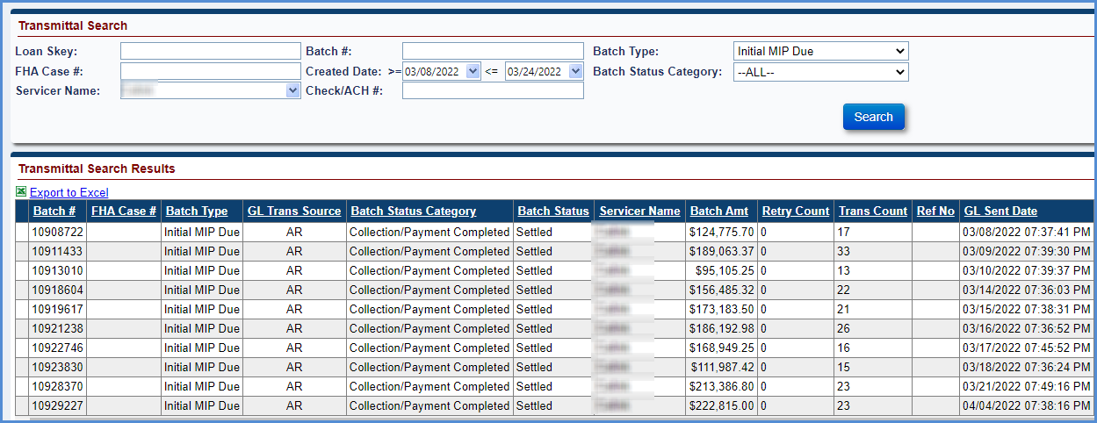
Figure 4-6: Transmittal Search Results for Initial IMIP Due
- Select the batch # from the results to view the Batch Details screen. This screen displays the IMIP transaction details for the associated FHA case number(s).
- The IMIP collection status can be viewed through the Daily IMIP Transaction Report from the Reports tab. Refer to Section 9.5 for report generation instructions.

Refunds
This section covers the refund transactions initiated manually by the lender/servicer during or after loan setup, refund transactions initiated automatically by the system for canceled loans, and refunds payment processing in HERMIT (Servicing and Accounting Modules) system.

Refund of Late Charges and Penalty Interest
The Servicing Module allows the lender/servicer to manually request a refund of late charges/penalty interest, if any, during loan setup or after loan setup. Some of the reasons to request a refund are:
Late charges and penalty interest cannot be refunded separately. The system generates a single transaction for loan setup charges, and penalty interest.
- Any penalty adjustments
- Invalid MCA sent from CHUMS
- Erroneous closing date was entered and corrected
Upon initiation of the refund request, the HUD Single Family Premiums Manager reviews the request and may approve or deny the refund request. If a refund is approved, the system generates the refund transaction on the loan and transmits the refund request to the Accounting Module for refund disbursement.

Requesting a Refund of Late Charges and Penalty Interest During Loan Setup
To request a refund:
- Select the Loan tab.
- Enter the FHA case# of the loan. Click Search.
- Click Setup link beside the loan displayed under the Loan Search Results section.
- The Loan Setup screen is displayed.
- Enter a closing date under the Loan Dates section (This date must cause a late charge or penalty interest occurrence) for the Late Charge and Penalty Interest section to be displayed at the bottom of the screen.
- Select the Refund Request checkbox.
- Select a Refund Reason and optionally enter the Refund Comments.
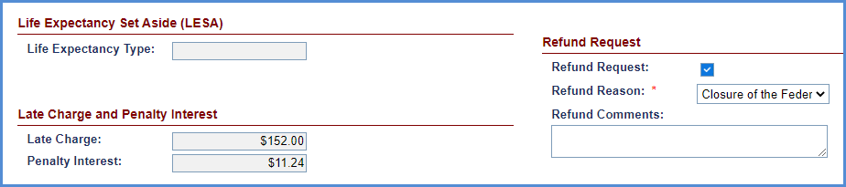
Figure 4-7: Loan Setup Screen – Refund Request Section
- Complete the loan setup of the case, by entering all other required details. Click Save & Next.
- The refund request is added on the loan and displayed on the Refunds screen under the Accounting tab with a status of Pending.
- The HUD SF Premiums Manager can now select the loan and approve or deny the refund.

Requesting a Refund of Late Charges and Penalty Interest After Loan Setup
To request a refund:
- Select the Loan tab.
- Enter the FHA case# of the loan. Click Search.
- Select the loan displayed under the Loan Search Results section.
- The Loan Balance screen is displayed.
- Select the Refund Request from the vertical menu options on the left hand of the screen. The Refund Request menu option is only available for the Servicer Manager role.
- If there is a refund request available, select a Refund Reason and optionally enter the Refund Comments under the Refund Request section. Click Submit to save the changes. If there is no refund request available, a message will be displayed on the Refund Request page stating “There is currently no refund request for this loan”

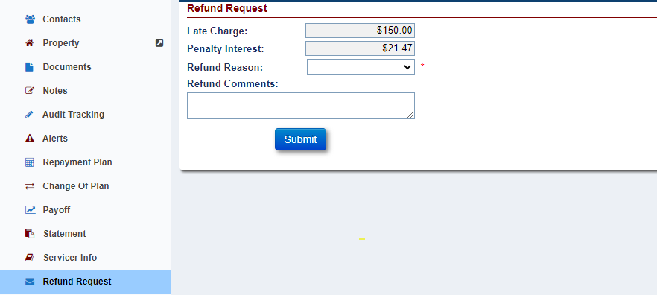
Figure 4-8: Refund Request after Loan Setup
- The refund request is added on the loan and displayed on the Refunds screen under Accounting tab with a status of Pending.
- The HUD SF Premiums Manager can select the loan and approve or deny the refund.

Automatic Refund of MIP – Cancellation from CHUMS
The system updates the Case Status to Cancelled when a cancellation record is received from CHUMS via the daily interface file. The system automatically generates the refund transaction on the loan for any mortgage insurance premium (IMIP and MMIP) collected on the loan. Only MIP that is approved will be refunded. Uncollected MIP with a Batch Status that is “Ready for Approval”, “Failure – Technical Issues”, or “Failed” (Retired) will not be refunded.
In addition, the system updates loan balance on the loan to zero dollars and the payment status of the loan to Payment Suspended (displayed on the Loan Balance screen). Late Charge and Penalty Interest are not refunded.
The refund transactions automatically generated by the system on Cancelled loan do not require approval from HUD SF Premiums Manager. Refund request of MMIP cannot be initiated manually in Servicing Module.
To view a refund transaction on Cancelled loan:
- Select the Loan tab.
- Enter the FHA case# of the cancelled loan. Click Search.
- Select the loan displayed under the Loan Search Results section.
- The Loan Balance screen is displayed.
- Select the Loan Transactions under the Transactions menu option.
- An adjustment transaction Loan Setup – Adj displaying the refund amount is displayed in the Loan Transaction Results section, along with a Write-Off for the Uncollected MIP, if applicable.
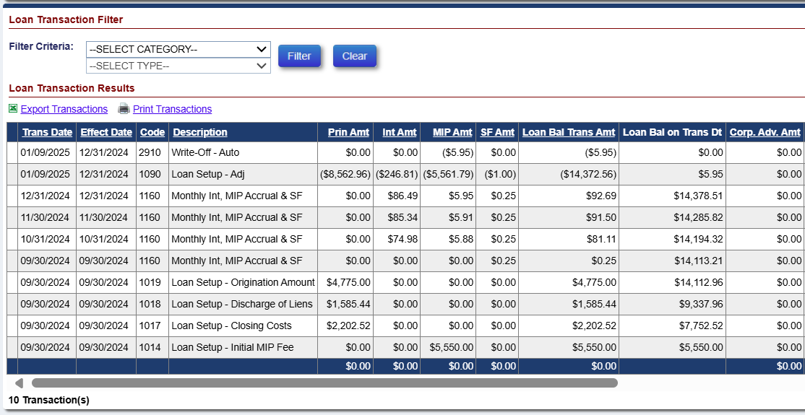
Figure 4-9: Refund Transaction on Cancelled Loan

Approving or Denying a Refund
The Servicing Module allows the HUD SF Premiums Manager to review the Pending refund requests for late charges and penalty interest and approve/deny the request.
To approve or deny a refund request:
- Select the Accounting -> Refunds tab.
- Enter the FHA Case # or select Refund Status of Pending.
- Click Search.
- Select a case from the Refund Search Results section to approve or deny the request.
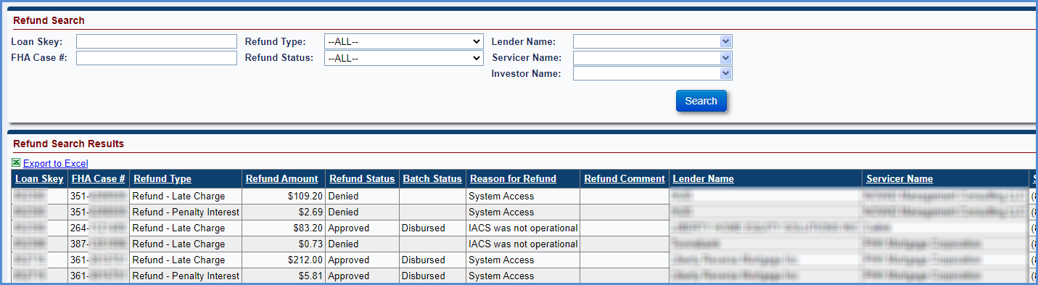
Figure 4-10: Accounting Refund Search
- On the Refund Information window, select Approved or Denied values from the Refund Status dropdown box. Optionally add Appr/Deny Reason and Refund Comments. Click Submit to save the changes. To exit the window without saving the changes, click Cancel.
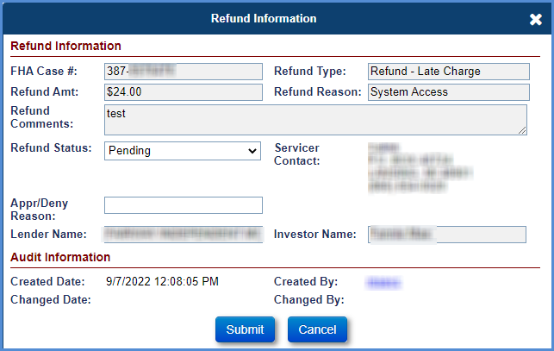
Figure 4-11: Refund Information
- The Refund Status is updated to Approved/Denied based on the selection in previous step.

Processing Refund Disbursements
This section explains the refund disbursements processing in HERMIT (Servicing and Accounting Modules) system.
- The Servicing Module generates the refund transaction when a refund is approved, or a loan is cancelled. The refund payable requests are sent to the Accounting Module for refund disbursements via an interface file.
- The Accounting Module processes the refund payable requests and notifies the Servicing Module of the successful disbursement through an interface file.
- The Servicing Module processes this file, and the batch status of the refund disbursement is updated to Disbursed. This completes the refunds disbursement processing in HERMIT.

CHAPTER 5: GENERAL SERVICING (PRE-ENDORSED/ENDORSED)

GENERAL SERVICING (PRE-ENDORSED/ENDORSED)
This chapter discusses general servicing for loans that are in Pre-Endorsed and Endorsed case statuses:
- General Servicing Overview
- Loan Search
- Loan Balance
- Loan Details
- Transactions
- Contacts
- Property
- Documents
- Notes
- Audit Tracking
- Alerts
- Repayment Plan
- Change of Plan
- Payoff
- Statement
- Servicer Info
- Bank Account
- Accounting
- Batch

General Servicing Overview
The Servicing Module enables FHA-approved lenders/servicers to perform day-to-day management of HECM Cases such as performing change-of-payment plans, unscheduled disbursement transactions, adding scheduled disbursements, IMIP adjustments, transactions related to repair set asides, updating contact information, etc. This chapter describes in detail all the general servicing functionalities that can be performed by the lender/servicers for Pre-Endorsed and Endorsed case statuses.

Loan Search
The Loan Search screen enables users to search loans, review and edit the loan information.

Search Criteria
Loan records can be retrieved using various combinations of search criteria. In general,
- Enter more search criteria to retrieve more specific search results, but fewer loan records
- Enter fewer search criteria to retrieve a larger number and broader range of loan records
- Basic search criteria include FHA case # and case status

Searching for a Loan
To search for a loan, please refer to Chapter 2.

Loan Search Results
To view and navigate the loan search results, please refer to Chapter 2.

Loan Balance
When the user selects a loan from the Loan Search Results section, the Loan Balance screen is displayed. This screen allows the user to view the loan balance information. The information displayed on this screen is received from CHUMS or recorded/derived during the loan setup process. This screen also allows the authorized user to activate or suspend payments made to the borrower based on the roles and permissions enabled for the users. If a critical alert exists on the loan, then Critical Alerts window is displayed on the Loan Balance screen. Click OK to view the Loan Balance screen.
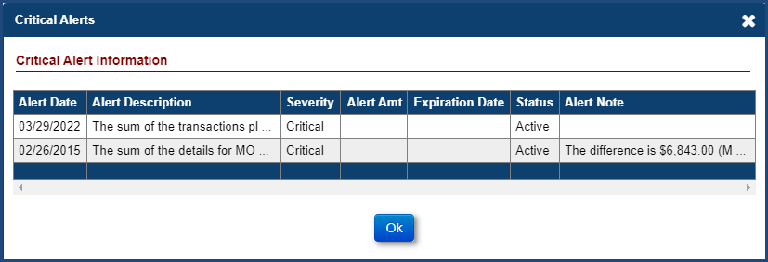
Figure 5-1: Critical Alerts Window
The Loan Balance screen displays the following data sections:
- Principal Limit Calculation
  - The Current Principal Limit (CPL), which is part of the Principal Limit Calculation, is calculated at the first month by taking the Original Principal Limit and adding the current month’s growth (if any) to determine the CPL. In subsequent months, the CPL is determined by taking the previous month’s CPL and adding the current month’s growth.
- Other Balances
- Credit Line Set Aside Information
- Audit Information
- Loan Balance Information (represented as pie chart and bar graph)
- Payment Plan Information (Editable): The plan can be activated/suspended using this function
- Life Expectancy Set Aside (LESA)
- First 12 months

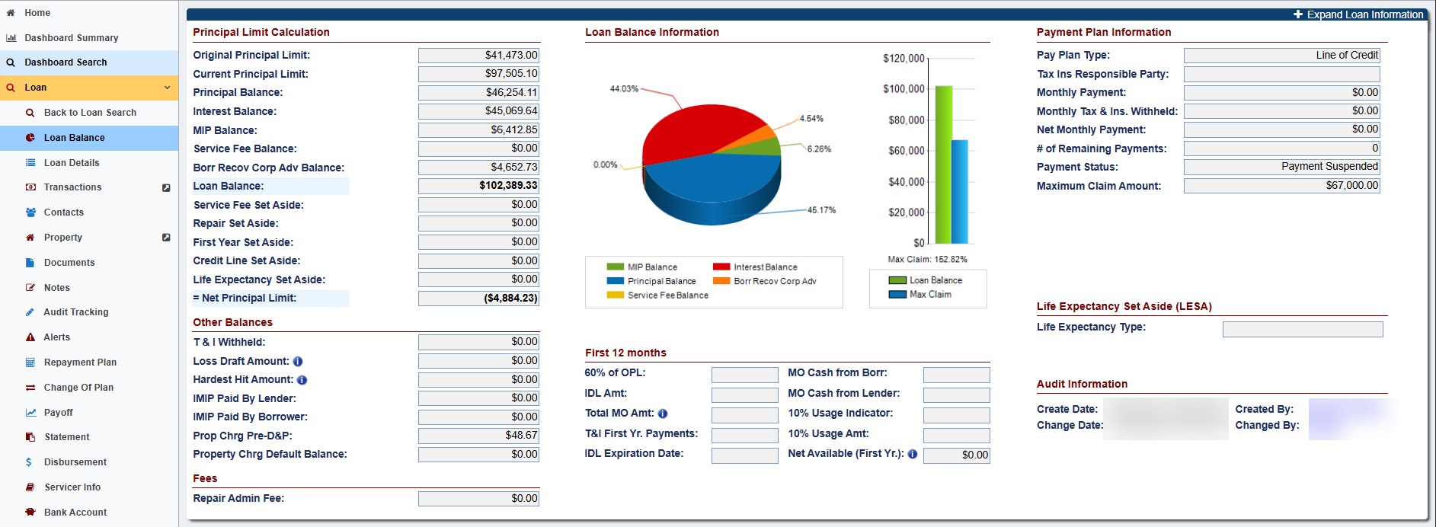
Figure 5-2: Loan Balance

Activating or Suspending Payments
HERMIT will automatically suspend payments when a case sub-status is changed to Due and Payable.
To activate or suspend payments manually:
- Click Edit in the Payment Plan Information section on the Loan Balance screen.
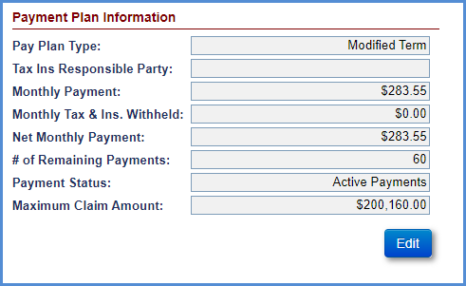
Figure 5-3: Payment Plan Information
- On the Edit Payment Plan window, select Active Payments or Payment Suspended from the Payment Status dropdown.
  - If the Payment Suspended option is selected – the case sub-status is updated to Payment Suspended and a critical alert is added on the loan
  - If Active Payments are selected, then the case sub-status is updated accordingly. The Payment Suspended critical alert becomes inactive once the active payment option is selected
- To change the responsible party for tax payments, select Borrower or Servicer from the Tax Ins Responsible Party dropdown.
- Click Submit to save the changes. The changes will be displayed on the Loan Balance screen. To exit the window without saving the changes select Cancel.

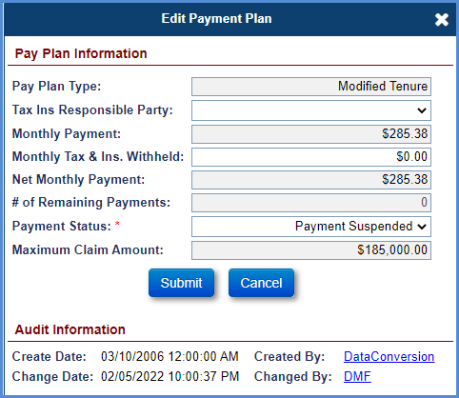
Figure 5-4: Edit Payment Plan Window

Viewing Audit Information
The Audit Information section is displayed in the lower left corner of the Loan Balance screen. This section displays the date and user that modified the fields within the Pay Plan Information section.
To view details of the user that updated the information:
- Click Changed By link under the Audit Information section.
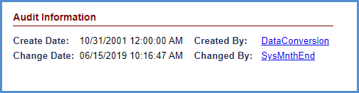
Figure 5-5: Loan Balance Screen – Audit Information Section
- A User Information window is displayed with the contact details of the user. Click OK to exit the window.
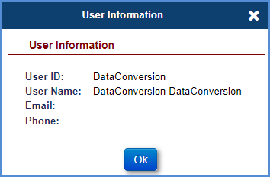
Figure 5-6: User Information Window

Loan Details
The Loan Details screen is displayed when a user selects the Loan Details tab from the menu options on the left side of the screen. The information displayed on this screen is received from CHUMS or recorded during the loan setup process. This screen also allows the authorized user to edit the data fields.
The Loan Details screen displays the following data sections:
- Loan Rates
- Loan Dates
- Loan Identifiers
- 2nd Mortgage/DOT
- 1st Mortgage/DOT
- Audit Information

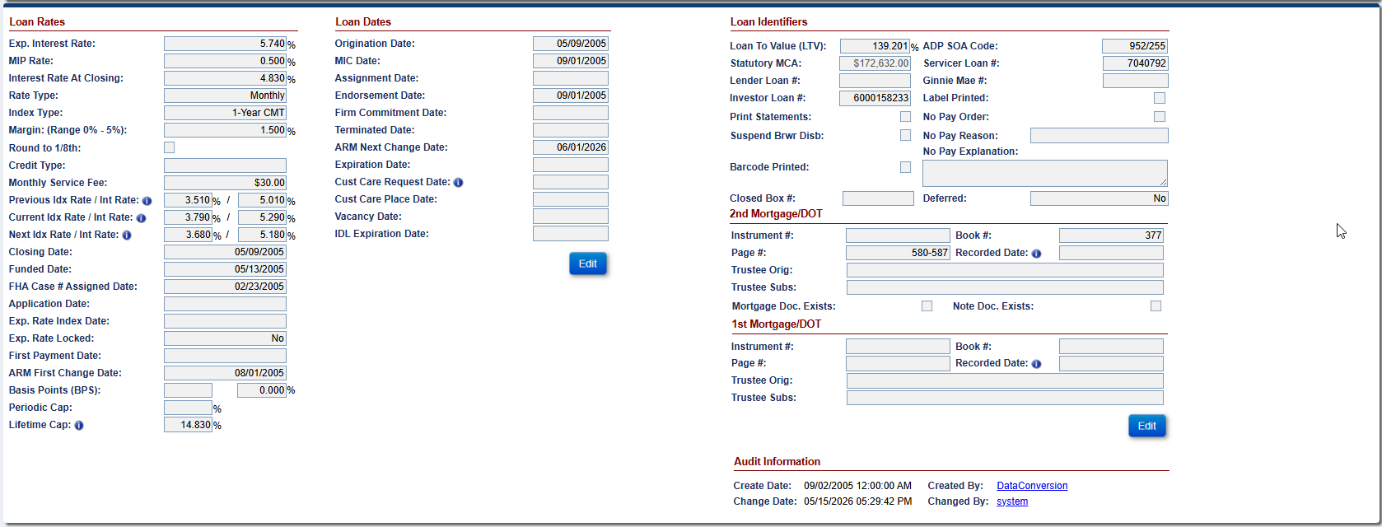
Figure 5-7: Loan Details

Editing Loan Rates
To edit fields in Loan Rates section:
- Click Edit in the Loan Rates section on the Loan Details screen.
- On the Edit Loan Rates window, edit the fields as needed.
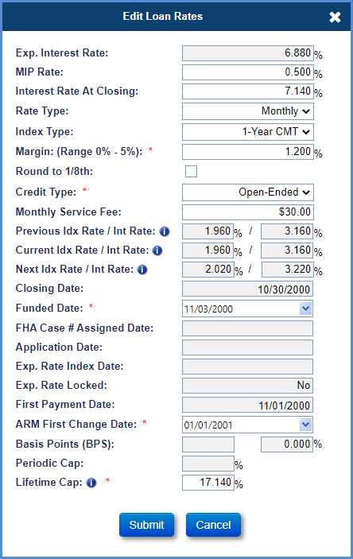
Figure 5-8: Edit Loan Rates Window
- Click Submit to save the changes. The changes will be displayed on the Loan Details screen. To exit the window without saving the changes select Cancel.

Editing Loan Dates
To edit fields in Loan Dates section:
- Click Edit in the Loan Dates section on the Loan Details screen.
- On the Edit Loan Dates window, edit the fields as needed.
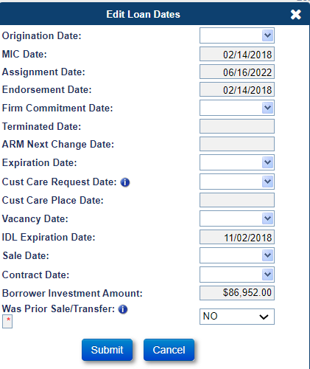
Figure 5-9: Edit Loan Dates Window
- Click Submit to save the changes. The changes will be displayed on the Loan Details screen. To exit the window without saving the changes select Cancel.

Editing Loan Identifiers
To edit fields in Loan Identifiers section:
- Click Edit in the Loan Identifiers section on the Loan Details screen.
- On the Edit Loan Identifiers window, edit the fields as needed. Only authorized user roles with this permission to edit the No Pay Order checkbox will be able to edit this field.

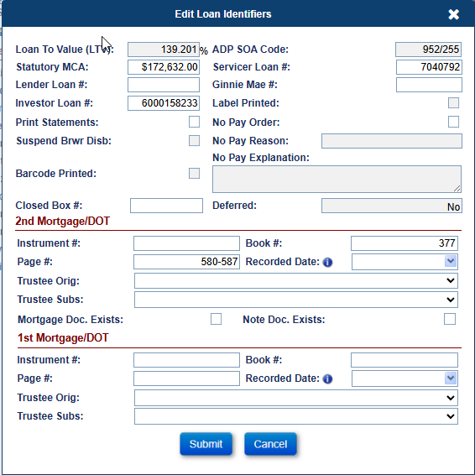
Figure 5-10: Edit Loan Identifiers Window
- Click Submit to save the changes. The changes will be displayed on the Loan Details screen. To exit the window without saving the changes select Cancel.

Viewing Audit Information
The Audit Information section is displayed in the lower right corner of the Loan Details screen. This section displays the date and user that modified the fields within any of the data sections.
To view details of the user that updated the information:
- Click Changed By link under the Audit Information section.
Figure 5-11: Audit Information Section on Loan Details
- A User Information window is displayed with the contact details of the user. Click OK to exit the window.
Figure 5-12: User Information

Transactions
The Loan Transactions screen is displayed when a user selects the Transactions tab from the menu options on the left side of the screen. This screen allows authorized users (example: lenders/servicers) to report transaction activities on a loan.
The transactions tab has four sub-menu options:
- Loan (Corp Advances, Disbursements, Monthly Accruals, Refunds, Repays, Termination, IMIP Adjustments, Write-off etc.)
- Growth (for example: Principal Limit and Line of Credit transactions etc.)
- Set Asides (for example: 1st Year Taxes and Insurance and Repair etc.)
- Claims (for example: Claim Type 21, Claim Type 22, Claim Type 23, Claim Type 24 etc.)

Transactions – Loan
This screen displays all the loan transactions associated with the loan. This screen allows the user to perform the following functions:
- Loan Transaction Filter: Enables the user to filter and view specific transactions within a transaction category
- New Transactions: Enables the authorized user to add transactions on the loan
- IMIP Adjustment: Enables an authorized user to adjust the IMIP amount between the Lender and Borrower.
- Write-Off: Enables an authorized user to perform partial write-off on the loan balance
- Balance Adjustment: Allows the authorized user to adjust the loan balance

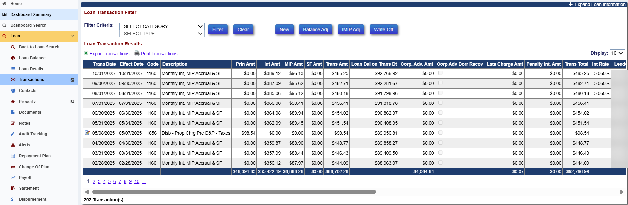
Figure 5-13: Transactions

Transactions – Loan Filter Categories
The Loan Transaction Filter section of the Transactions – Loan screen allows authorized users to apply filters and view selected transactions within the selected transaction category. The transactions can be filtered by the following categories:
- Corporate advances (multiple sections)
- Disbursements (multiple sections)
- Fees
- HUD-1 Closing costs
- Loan setup – loan balance
- Monthly accruals
- Partial Repay - LESA
- Refunds/Payments
- Repays
- Terminate
- Write-Offs
To filter the transactions by transaction category:
- Select the Transaction Category from the dropdown.
- Select the Transaction Type from the dropdown (if needed).
- Click Filter to view the filtered transactions under the Loan Transactions Results section. No results are displayed if no transactions match the filter criteria entered by the user.
- Click Clear to clear the selected filters and view all transactions.

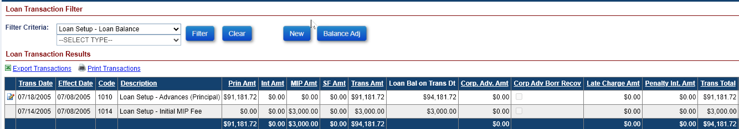
Figure 5-14: Loan Transactions Filter and Results Section

The table below provides the list of data fields and descriptions displayed Loan Transaction Results
Field | Description
Trans Date | The date transaction is posted in the Servicing Module either manually or through B2G.
Effect Date | The date the payment was made by the Lender/Investor for the incurred expense (Example: The date payment was made to the contractor for lawn mowing or the date the Taxes were paid to the Tax Authority).
Code | A 4-digit unique transaction code assigned by the system for a specific transaction.
Description | Short description of the transaction.
Prin Amt | The principal amount associated with the transaction.
Int Amt | The interest amount associated with the transaction.
MIP Amt | The Mortgage Insurance Premium amount associated with the transaction.
SF Amt | The Service fee amount associated with the transaction.
Trans Amt | Sum of principal, interest, MIP, and service fee amount.
Loan Bal on Trans Dt | Displays balance (running balance) as of Trans Date after each posted transaction.
Corp Adv Amt | Transaction amount associated with the Corp Advance expense paid by the Lender/Investor.
Corp Adv Borr Recov | This checkbox indicates whether the Corp Advance Transaction is Borrower Recoverable or not. Borrower Recoverable Corp Advances accrue Interest and MIP beginning on the later of the Effective Date or the Accrual Start Date of 09/01/2025.
Late Charge Amt | The late charge amount associated with the transaction. Example: A late charge will be applied when the loan setup is not performed within 15 days of the closing date.
Penalty Int Amt | The penalty interest associated with the transaction. Example: A penalty interest will be applied when the loan setup is not performed within 30 days of the closing date.
Trans Total | Sum of loan balance, late charge, and penalty interest amount.
Int Rate | The Interest Rate percentage of the “Monthly Int, MIP Accrual & SF” (Trans Code 1160) and “Auto-Adjust Int Mip SF” (Trans Code 1190) transactions.
Lender | Lender associated with the loan.
Servicer | Servicer associated with the loan.
Investor | Investor/holder associated with the loan.
Incurred Date | This is the date the expense was incurred by the Lender/Investor. Example: The date the lawn mowing service was completed. For Property Charges this is the date the taxes were paid and is expected to be the same as the effective date. This field is required for the following transaction categories:  - Corp Advance Sections 305, 306, 307, 308, 309, 310 and 409.  - Corp Advance – Property Preservation  - Property Charges Pre D&P
P&P Approved | This checkbox indicates whether the P&P transaction was linked to a HUD approval request for P&P
Excluded from Max | This checkbox indicates whether the P&P transaction should be excluded from cap of $5,000. Must be identified as either Utility Costs or Vacant Property Registration.
Excluded from Max Type | This field displays the corresponding Excluded from Max Type for the P&P transaction with “P&P Excluded from Max” box checked
Created By | The User Name who initiated the transaction.
Create Date | The date and time the transaction is recorded in the system.
Batch Number | The batch number associated with MIP collection for that transaction.
Batch Status | The batch status for the batch number associated with MIP collection for that transaction.
Table 5-1: Loan Screen – Transactions

New Loan Transactions
Transactions can be created by authorized users based on user role. Required fields vary based on the Transaction Category and Transaction Type selected. The next sections provide detailed instructions for creating new transactions associated with the transaction categories listed in the following table.
Transaction categories in the New Loan Transaction window:
Transaction Category | Description
Corporate Advances | Transactions within this category are initiated by the servicer to report any expenses incurred by Lender/Investor for any disbursements made on behalf of Borrower/Mortgagor after the loan becomes Due and Payable. Borr Recoverable must be reported during transaction entry.
Disbursements  (Unscheduled Advances, Scheduled Disbursements and Property Charges Pre D&P) | Transactions within this category are initiated by the servicer to perform any disbursements on behalf of the Borrower/Mortgagor which include unscheduled advances, scheduled disbursements and property charges pre D&P (ML 2011-01). These transactions affect Loan Balance. Some charges require Incurred Date in addition to Effective Date.
Fees | Transactions within this category are generated by the Servicing Module to indicate any change of plan fees incurred by the borrower when a change of plan is performed on the loan. These transactions do not affect Loan Balance.
HUD-1 Closing Costs | Transactions within this category are initiated by the servicer to report HUD -1 closing costs either due by a borrower or owed to the borrower. These transactions do not affect Loan Balance.
Monthly Accruals | Transactions within this category are generated by the Servicing Module to display the monthly accruals Interest amount, MIP amount, and Service Fee amount on the loan for each month. These transactions affect Loan Balance.
Refunds/Payments | Transactions within this category are initiated by the servicer to request refund of the overage amount to the borrower. These transactions affect Loan Balance.
Repays | Transactions within this category are initiated by the servicer (on-behalf of a borrower) to repay a partial amount to reduce the current unpaid loan balance. These transactions affect Loan Balance.
Terminate | Transactions within this category are initiated by the servicer to terminate a loan and provide a reason for termination. These transactions affect Loan Balance.
Table 5-2: Transaction Categories

Creating New Corporate Advance Transactions
Corporate Advance transactions are added to the Loan Balance if the transaction is reported as “Borr Recoverable” (referred to as Borrower Recoverable Corporate Advance, or abbreviated as “BRCA”, and reflected the Transactions > Loan page with a checkbox in field “Corp Adv Borr Recov”). Whether a transaction is BRCA or not is reported during transaction entry from the User Interface, the Batch > Servicer Transactions screen, or the Batch > Servicer Transactions screen using the Transactions upload feature. If BRCA is incorrect on a transaction, it must be Adjusted and re-entered with the proper BRCA selection.
IMPORTANT: BRCA Transactions with the “Corp Adv Borr Recov” checkbox selected are included in the Loan Balance and accrue Interest and MIP beginning on the later of the Transaction Effective Date or the Accrual Start Date of 09/01/2025. Interest and MIP Accruals for BRCA transactions are included in the 1160 Monthly Int, MIP Accrual & SF transaction and the 1190 Auto-Adjust Int Mip SF transaction.
To create a new corporate advance transaction:
- Click New on the Transactions – Loan screen.
- On the New Loan Transaction window, select one of the following transaction categories:
  - Corp Advance – Misc Claim
  - Corp Advance – Penalty
  - Corp Advance – Property Preservation (*See next section for details on entering P&P)
  - Corp Advance – Release Fee
  - Corp Advance – Section 305 Disbursements
  - Corp Advance – Section 306 Disbursements
  - Corp Advance – Section 307 Disbursements
  - Corp Advance – Section 308 Disbursements
  - Corp Advance – Section 309 Disbursements
  - Corp Advance – Section 310 Disbursements
  - Corp Advance – Section 409 Disbursements
  - Corp Advance – Section 410 Disbursements
- Populate the below listed fields (required fields are marked with red asterisk):
  - Transaction Type
  - Borr Recoverable (if applicable)
  - Effective Date
  - Incurred Date (if applicable)
  - Transaction Amount
- Click Submit. If successful, the new transaction is displayed in the Loan Transaction Results section. To exit the window without adding the transaction click Cancel.

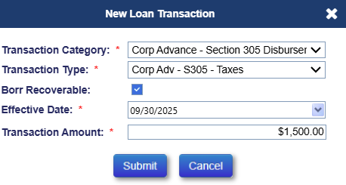
Figure 5-15: New Corporate Advance Transaction
- To adjust the Corp Advance transaction, select the document icon beside the transaction then on the Adjust Loan Transaction window click Submit to reverse the transaction.
- A new Corp Advance adjustment transaction is added and displayed under the Loan Transactions Results section reflecting the reversed amount.
The table below lists all the allowable Corp Advance transactions that can be manually created using the New Loan Transactions window.
Category | Transaction | Description
Corp Advance – Misc Claim | Rental Expense | This Transaction is initiated by the Servicer to report any Rental Expenses.
Corp Advance – Misc Claim | Rental Income | This Transaction is initiated by the Servicer to report any Rental Income.
Corp Advance – Penalty | Corp Adv – Penalty | This transaction is initiated by the Servicer to report the penalty payments for payments made late to Borrowers / Co Borrowers. This transaction applies to all pay plan types.
Corp Advance – Property Preservation | Corp Adv – Prop Preserve  (MULTIPLE) | These transactions are initiated by the Servicer to report expenses incurred by the lender/investor for preservation and protection on the mortgaged property. This transaction applies to all pay plan types.
Corp Advance – Release Fee | Release Fee | This transaction is initiated by the Servicer to report the release fee associated with discharge of liens. This transaction applies to ALL pay plan types.
Corp Advance Section – 305 | Cash for Keys | Initiated by the Servicer to report expenses paid to Borrower or other party with a legal right to dispose of the property in association with a DIL transaction.
Corp Advance Section – 305 | Flood Insurance | Initiated by the servicer to report the expense incurred by the lender/investor for flood insurance premiums on the mortgaged property. This transaction applies to all pay plan types.
Corp Advance Section – 305 | Hazard Insurance | Initiated by the servicer to report the expense incurred by the lender/investor for hazard insurance premiums on the mortgaged property. This transaction applies to all pay plan types.
Corp Advance Section – 305 | Taxes | Initiated by the servicer to report the expense incurred by the lender/investor for taxes that are liens prior to the mortgage. This transaction applies to all pay plan types.
Corp Advance Section – 305 | Utilities | Initiated by the servicer to report the expense incurred by the lender/investor for utilities that are liens prior to the mortgage. This transaction applies to all pay plan types.
Corp Advance Section – 305 | Eviction Fees | Initiated by the servicer to report the expense incurred by the lender/investor for eviction in the event of foreclosure proceedings. This transaction applies to all pay plan types.
Corp Advance Section – 305 | Ground Rent | Initiated by the servicer to report the expense incurred by the lender/investor for ground rent that are liens prior to the mortgage. This transaction applies to all pay plan types.
Corp Advance Section – 305 | Condominium Dues | Initiated by the servicer to report the expense incurred by the lender/investor for the condominium dues. This transaction applies to all pay plan types.
Corp Advance Section – 305 | HOA Dues | Initiated by the servicer to report the expense incurred by a lender/investor for the administration, operation, maintenance or repair of the community owned property. This transaction applies to all pay plan types.
Corp Advance Section – 305 | Mortgagee Incentive | Initiated by the servicer to report an incentive to be paid to the mortgagee / Servicer when completing a Deed in Lieu of Foreclosure or Sale of the acquired property.
Corp Advance Section – 305 | Other | Initiated by the servicer to itemize other expenses incurred by a lender/investor in this category. This transaction applies to all pay plan types.
Corp Advance Section – 305 | Probate Cost | Initiated by the servicer to report expenses for Probate incurred associated with Cash for Keys Incentive.
Corp Advance Section – 305 | Utilities – Liens | Initiated by the Servicer to report expenses for utilities that are paid to satisfy liens.
Corp Advance Section – 305 | Repayment | Initiated by the servicer to report repayments by the borrower within the transaction category Section 305. This transaction applies to all pay plan types.
Corp Advance Section – 305 | State Prohibited Legal | Initiated by the servicer to itemize other legal expenses which are prohibited by state and/or local jurisdiction from being applied to the loan balance and incurred by a lender/investor in this category. This transaction applies to all pay plan types and shall not affect the loan balance.
Corp Advance Section – 305 | Relocation Incentive | Initiated by the Servicer on a FCL or DIL transaction to report expenses paid by the mortgagee when a tenant vacates the property prior to an eviction being initiated by the mortgagee.
Corp Advance Section – 305 | Flood Insurance – Repay | This transaction is initiated by the Servicer to report repayments by the Borrower towards balance of each group of transactions. This transaction applies to ALL pay plan types.
Corp Advance Section – 305 | Hazard Insurance – Repay | This transaction is initiated by the Servicer to report repayments by the Borrower towards balance of each group of transactions. This transaction applies to ALL pay plan types.
Corp Advance Section – 305 | Taxes – Repay | This transaction is initiated by the Servicer to report repayments by the Borrower towards balance of each group of transactions. This transaction applies to ALL pay plan types.
Corp Advance Section – 305 | Utilities – Repay | This transaction is initiated by the Servicer to report repayments by the Borrower towards balance of each group of transactions. This transaction applies to ALL pay plan types.
Corp Advance Section – 305 | Eviction Fees – Repay | This transaction is initiated by the Servicer to report repayments by the Borrower towards balance of each group of transactions. This transaction applies to ALL pay plan types.
Corp Advance Section – 305 | Other – Repay | This transaction is initiated by the Servicer to report repayments by the Borrower towards balance of each group of transactions. This transaction applies to ALL pay plan types.
Corp Advance Section – 305 | Ground Rent – Repay | This transaction is initiated by the Servicer to report repayments by the Borrower towards balance of each group of transactions. This transaction applies to ALL pay plan types.
Corp Advance Section – 305 | Condominium Dues – Repay | This transaction is initiated by the Servicer to report repayments by the Borrower towards balance of each group of transactions. This transaction applies to ALL pay plan types.
Corp Advance Section – 305 | State Prohibited Legal – Repay | This transaction is initiated by the Servicer to report repayments by the Borrower towards balance of each group of transactions. This transaction applies to ALL pay plan types.
Corp Advance Section – 305 | Relocation Incentive – Repay | This transaction is initiated by the Servicer to report repayments by the Borrower towards balance of each group of transactions. This transaction applies to ALL pay plan types.
Corp Advance Section – 305 | Utilities – Liens – Repay | This transaction is initiated by the Servicer to report repayments by the Borrower towards balance of each group of transactions. This transaction applies to ALL pay plan types.
Corp Advance Section – 305 | Cash For Keys – Repay | This transaction is initiated by the Servicer to report repayments by the Borrower towards balance of each group of transactions. This transaction applies to ALL pay plan types.
Corp Advance Section – 305 | HOA Dues – Repay | This transaction is initiated by the Servicer to report repayments by the Borrower towards balance of each group of transactions. This transaction applies to ALL pay plan types.
Corp Advance Section – 305 | Attorney Fees | Initiated by the servicer to report the expense incurred by the lender/investor for the attorney fee to vest title of the property in the name of the successful bidder. This transaction applies to all pay plan types.
Corp Advance Section – 306 | Trustee Fees | Initiated by the servicer to report the expense incurred by the lender/investor for the trustee fee to vest title of the property in the name of the successful bidder. This transaction applies to all pay plan types.
Corp Advance Section – 306 | Other For Endorsed Loans | Initiated by the servicer to itemize other expenses incurred by the lender/investor in this category. This transaction applies to all pay plan types.
Corp Advance Section – 306 | Repayment For Endorsed Loans | Initiated by the servicer to report repayments by the borrower within the transaction category Section 306. This transaction applies to all pay plan types.
Corp Advance Section – 306 | Title Examination Fees | Initiated by the servicer to report the expense incurred by the lender/investor for title search. This transaction applies to all pay plan types.
Corp Advance Section – 307 | Recording Fees | Initiated by the servicer to report the expense incurred by the lender/investor for recording fees in foreclosure proceedings. This transaction applies to all pay plan types.
Corp Advance Section – 307 | Sheriff Fees | Initiated by the servicer to report the expense incurred by the lender/investor for sheriff fees in foreclosure proceedings. This transaction applies to all pay plan types.
Corp Advance Section – 307 | Other | Initiated by the servicer to itemize other expenses incurred by the lender/investor in this category. This transaction applies to all pay plan types.
Corp Advance Section – 307 | Repayment | Initiated by the servicer to report repayments by the borrower within this transaction category. This transaction applies to all pay plan types.
Corp Advance Section – 307 | State Taxes on Deed | Initiated by the servicer to report the expense incurred by the lender/investor for taxes imposed upon any deed or other options by which the property was acquired by a successful bidder. This transaction applies to all pay plan types.
Corp Advance Section – 308 | Other Taxes on Deed | Initiated by the servicer to itemize other expenses incurred by the lender/investor in this category. This transaction applies to all pay plan types.
Corp Advance Section – 308 | Repayment | Initiated by the servicer to report repayments by a borrower within the transaction category section 308. This transaction applies to all pay plan types.
Corp Advance Section – 308 | Liens Paid | Initiated by the servicer to report the expense incurred by a lender/investor for special assessments liens.
Corp Advance Section – 309 | Other | Initiated by the servicer to itemize other special assessment expenses incurred by a lender/investor in this category. This transaction applies to all pay plan types.
Corp Advance Section – 309 | Repayment | Initiated by the servicer to report repayments by a borrower within the transaction category section 309. This transaction applies to all pay plan types.
Corp Advance Section – 309 | Bnk Attorney Fees | Initiated by the servicer to report the expense incurred by a lender/investor for attorney fees due to bankruptcy proceedings. This transaction applies to all pay plan types.
Corp Advance Section – 310 | Other | Initiated by the servicer to itemize other bankruptcy expenses incurred by a lender/investor in this category. This transaction applies to all pay plan types.
Corp Advance Section – 310 | Repayment | Initiated by the servicer to report repayments by a borrower within the transaction category section 310. This transaction applies to all pay plan types.
Corp Advance Section – 310 | Appraisal Fees | Initiated by the servicer to report the expense incurred by the Lender/Investor for appraisal fees. This transaction applies to ALL pay plan types.
Corp Advance Section – 409 | Other | Initiated by the Servicer to itemize other appraisal fees incurred by the Lender/Investor in this category. This transaction applies to ALL pay plan types.
Corp Advance Section – 409 | Repayment | Initiated by the Servicer to report repayments by the borrower within this transaction category. This transaction applies to ALL pay plan types.
Table 5-3: Corp Advance Transactions

Creating New Corp Advance – Property Preservation Transactions
TIP: Refer to section 5.21 “Property Preservation: Transactions and Timelines” for details on entering Corp Advance - Property Preservation transactions.

Creating New Property Charges Pre Due and Payable (D&P) Transactions
The “Disb – Prop Chrg – Pre D&P” or Property Charges Pre-D&P transactions are initiated by the lenders/servicers to make disbursements on behalf of borrower as stated in Mortgagee Letter 2011-01. These transactions can be initiated ONLY when all the drawable equity on the loan is exhausted. If there is drawable equity on the loan, the lender/servicer must use appropriate transaction under the transaction category of Disb – Unscheduled from LOC or Disb – Delinquent Taxes. If the drawable equity on the loan is not sufficient to pay the transaction amount, then the lender/servicer must first exhaust the drawable equity using unscheduled advances followed by Property Charges for the remaining transaction amount.
To create a new Property Charge Pre D&P disbursement transaction:
- Click New on the Transactions – Loan screen.
- On the New Loan Transaction window, select Disb-Prop Chrg – Pre D&P from transaction category dropdown.
- Populate the below listed required fields (marked with an asterisk):
  - Transaction Type
  - Effective Date
  - Incurred Date
  - Transaction Amount
- Click Submit. The new transaction is displayed in the Loan Transaction Results section. To exit the window without adding the transaction click Cancel.
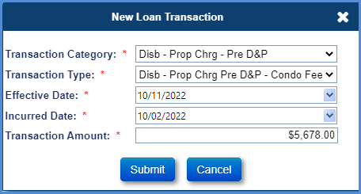
Figure 5-16: New Prop Chrg Pre D&P Disbursement Transaction
- To adjust the Disbursement transaction, select the document icon beside the transaction, on the Adjust Loan Transaction window, click Submit to reverse the transaction. The transaction is fully reversed, the system does not allow partial adjustments.
- A new Disbursement adjustment transaction is added and displayed under the Loan Transactions Results section reflecting the reversed amount.

The table below lists all the Property Charge Pre D&P transactions that can be manually created using the New Loan Transaction window.
Category | Transaction | Description
Disb – Prop Chrg – Pre D&P | Disb – Prop Chrg – Pre D&P – Condo Fees | Initiated by the servicer (on-behalf of borrower) to make a disbursement to Vendor for condominium fees on the mortgaged property. This transaction applies to ALL pay plan types.
 | Disb – Prop Chrg – Pre D&P – Flood Insurance | Initiated by the servicer (on-behalf of borrower) to make a disbursement to Vendor for flood insurance premiums on the mortgaged property. This transaction applies to ALL pay plan types.
 | Disb – Prop Chrg – Pre D&P – Ground Rent | Initiated by the servicer (on-behalf of borrower) to make a disbursement to Vendor for ground rent expenses on the mortgaged property. This transaction applies to ALL pay plan types.
 | Disb – Prop Chrg – Pre D&P – Hazard Ins | Initiated by the servicer (on-behalf of borrower) to make a disbursement to Vendor for hazard insurance premiums on the mortgaged property. This transaction applies to ALL pay plan types.
 | Disb – Prop Chrg – Pre D&P – HOA Dues | Initiated by the servicer (on-behalf of borrower) to make a disbursement for administration, operation, maintenance or repair of the community owned property. This transaction applies to ALL pay plan types.
 | Disb – Prop Chrg – Pre D&P – Others | Initiated by the servicer (on-behalf of borrower) to make a disbursement for other expenses on the mortgaged property. This transaction applies to ALL pay plan types.
 | Disb – Prop Chrg – Pre D&P – Taxes | Initiated by the servicer (on-behalf of borrower) to make a disbursement for payment of taxes on the mortgaged property. This transaction applies to ALL pay plan types.
Table 5-4: Property Charges – Pre D&P Transactions

Creating New Disb Transactions
To create a new disbursement transaction:
- Click New on the Transactions – Loan screen.
- On the New Loan Transaction window, select one of the following transaction categories:
  - Disb – Prop Chrg – Pre D&P (*See previous section for details on entering Prop Chrg – Pre D&P)
  - Disb – 1st Year Taxes & Ins Set Aside
  - Disb – Delinquent Taxes
  - Disb – Life Expectancy Set Aside
  - Disb – Repair Set Aside
  - Disb – Scheduled
  - Disb – Taxes & Insurance withheld
  - Disb - Unscheduled from LOC
- Populate the below listed required fields (marked with an asterisk):
  - Transaction Type
  - Effective Date
  - Transaction Amount
- Click Submit. The new transaction is displayed in the Loan Transaction Results section. To exit the window without adding the transaction click Cancel.
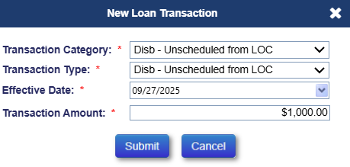
Figure 5-17: New Disbursement Transaction
- To adjust the Disbursement transaction, select the document icon beside the transaction, on the Adjust Loan Transaction window, click Submit to reverse the transaction.
- A new Disbursement adjustment transaction is added and displayed under the Loan Transactions Results section reflecting the reversed amount.
- The table below lists all the Disbursement transactions that can be manually created using the New Loan Transactions window.
Category | Transaction | Description
Disb – 1st Yr TI Set Aside | Not Final | Initiated by the servicer to make a disbursement from borrower’s available 1st year taxes and insurance set aside amount. A servicer will be able to make these disbursements until all the 1st Yr TI set aside amount has exhausted (or) there is no Disb – 1st Yr TI Set Aside Final transaction. This transaction applies to ALL pay plan types.
Disb – 1st Yr TI Set Aside | Final | Initiated by the servicer to make a disbursement from borrower’s available 1st year taxes and insurance set aside amount. This will be a one-time transaction and servicer will not be able to make any Disb – 1st Yr TI Set Aside Not Final transaction once a final transaction has been made. This transaction applies to ALL pay plan types.
Disb – Repair Set Aside | Not Final | Initiated by the servicer to make a disbursement from borrower’s set aside amount for any repairs on the mortgaged property. Servicer will be able to make these disbursements until all Repairs set aside Not Final amount has exhausted (or) there is no Disb – Repair Set Aside Final transaction. This transaction applies to ALL pay plan types.
Disb – Repair Set Aside | Disb – Repair Set Aside Final | Initiated by the servicer to make a disbursement from borrower’s repair set aside amount for any repairs on the mortgaged property. This will be a one-time transaction and servicer will not be able to make any Disb – Repair Set Aside Not Final transaction once a final transaction has been made. this transaction applies to ALL pay plan types.
Disb – Taxes and Insurance Withheld | Disb – Taxes and Insurance Withheld | Initiated by the servicer to make a disbursement for Taxes and Insurance from borrower’s available taxes and insurance set aside balance. This transaction applies to ALL pay plan types.
Disb - Unscheduled from LOC | Other | Initiated by the servicer (on-behalf of a borrower) to make an unscheduled disbursement from borrower’s available line of credit. This transaction applies only to line of credit, modified term, and modified tenure pay plans.
Disb - Unscheduled from LOC | Inspections | Initiated by the servicer (on-behalf of a borrower) to make an unscheduled disbursement from line of credit for inspections on the mortgaged property. This transaction applies only to line of credit, modified term and modified tenure.
Disb - Unscheduled from LOC | Appraisals | Initiated by the servicer (on-behalf of borrower) to make an unscheduled disbursement from Line of Credit for appraisals on the mortgaged property. This transaction applies only to line of credit, modified term and modified tenure pay plan types.
Disb - Unscheduled from LOC | Prop Preserv | Initiated by the servicer (on-behalf of borrower) to make an unscheduled disbursement from Line of Credit for preservation and protection of the mortgaged property. Preservation and protection activities may include Repairs, Landscaping etc. This transaction applies to only to line of credit, modified term, and modified tenure –pay plan types.
Disb - Unscheduled from LOC | Insurance | Initiated by the servicer to make an unscheduled disbursement from Line of Credit to pay for the insurance of the mortgaged property on behalf of borrower. This transaction applies to all pay plan types.
Disb - Unscheduled from LOC | Taxes | Initiated by the servicer to make an unscheduled disbursement from Line of Credit to pay for taxes on behalf of borrower. This transaction applies to all pay plan types.
Disb – Life Expectancy Set Aside | Not Final | Initiated by the servicer to make a disbursement from borrower’s available Life Expectancy Set Aside (LESA) amount. A servicer will be able to make these disbursements until the entire LESA amount is exhausted. This transaction applies to ALL pay plan types.
Disb – Life Expectancy Set Aside | Final | Initiated by the servicer to make a disbursement from borrower’s available Life Expectancy Set Aside (LESA) amount. This will be a one-time transaction and servicer will not be able to make any Disb – Life Expectancy Set Aside Not Final transaction once a final transaction has been made. this transaction applies to ALL pay plan types.
Table 5-5: Disbursement Transactions

Creating New HUD-1 Closing Costs Transactions
To create a closing cost transaction:
- Click New on the Transactions – Loan screen.
- On the New Loan Transaction window, select one of the following transaction categories:
  - HUD – 1 Closing Costs – Owed to Borrower
  - HUD – 1 Closing Costs – Due from Borrower
  - HUD – 1 Closing Costs – Additional
- Populate the below listed required fields (marked with red asterisk):
  - Transaction Type
  - Effective Date
  - Transaction Amount
- Click Submit. The new transaction is displayed in the Loan Transaction Results section. To exit the window without adding the transaction, click Cancel.
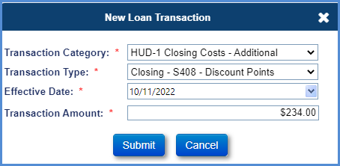
Figure 5-18: Closing Costs Transaction
The table below lists all the Closing Costs transactions that can be manually created using the New Loan Transactions window.
Category | Transaction | Description
HUD – 1 Closing Costs – Due from Borrower - | Closing – S406 – Taxes | Initiated by the servicer to report the tax amounts due from buyer as part of HUD-1 closing costs. This transaction applies to ALL pay plan types.
HUD – 1 Closing Costs – Due from Borrower - | Closing – S406 – Water Rates | Initiated by the servicer to report the water rates due from buyer as part of HUD-1 closing costs. This transaction applies to ALL pay plan types.
HUD – 1 Closing Costs – Due from Borrower - | Closing – S406 – Special Assessments | Initiated by the servicer to report the special assessments lien amounts due from buyer as part of HUD-1 closing costs. This transaction applies to ALL pay plan types.
HUD – 1 Closing Costs – Due from Borrower - | Closing – S406 – Other | Initiated by the servicer to itemize other amounts due from buyer as part of HUD-1 closing costs. This transaction applies to ALL pay plan types.
HUD – 1 Closing Costs – Owed to Borrower | Closing – S407 – Taxes | Initiated by the servicer to report the tax amounts owed to buyer as part of HUD-1 closing costs. This transaction applies to ALL pay plan types.
HUD – 1 Closing Costs – Owed to Borrower | Closing – S407 – Water Rates | Initiated by the servicer to report the water rates owed to buyer as part of HUD-1 closing costs. This transaction applies to ALL pay plan types.
HUD – 1 Closing Costs – Owed to Borrower | Closing – S407 – Special Assessments | Initiated by the servicer to report the special assessments lien amount owed to buyer as part of HUD-1 closing costs. This transaction applies to ALL pay plan types.
HUD – 1 Closing Costs – Owed to Borrower | Closing – S407 – Other for Endorsed Loans | Initiated by the servicer to itemize other amounts owed to buyer as part of HUD-1 closing costs. This transaction applies to ALL pay plan types.
HUD – 1 Closing Costs – Additional | Closing – S408 – Discount Points | Initiated by the servicer to report the additional HUD-1 closing costs for discount points line item. This transaction applies to ALL pay plan types.
HUD – 1 Closing Costs – Additional | Closing – S408 – Sales Commission | Initiated by the servicer to report the additional HUD-1 closing costs for sales commission line item. This transaction applies to ALL pay plan types.
HUD – 1 Closing Costs – Additional | Closing – S408 – Recording Fees | Initiated by the servicer to report the additional HUD-1 closing costs for recording fees line item. This transaction applies to ALL pay plan types.
HUD – 1 Closing Costs – Additional | Closing – S408 – Service Charges | Initiated by the servicer to report the additional HUD-1 closing costs for service charges line item. This transaction applies to ALL pay plan types.
HUD – 1 Closing Costs – Additional | Closing – S408 – Termite Report | Initiated by the servicer to report the additional HUD-1 closing costs for termite inspection fee line item. This transaction applies to ALL pay plan types.
HUD – 1 Closing Costs – Additional | Closing – S408 – Title Insurance | Initiated by the servicer to report the additional HUD-1 closing costs for title insurance line item. This transaction applies to ALL pay plan types.
HUD – 1 Closing Costs – Additional | Closing – S408 – Appraisal | Initiated by the servicer to report the additional HUD-1 closing costs for appraisal fees line item. This transaction applies to ALL pay plan types.
HUD – 1 Closing Costs – Additional | Closing – S408 – Other | Initiated by the servicer to itemize other additional amounts as part of HUD-1 closing costs. This transaction applies to ALL pay plan types.
Table 5-6: HUD -1 Closing Costs Transactions

Creating New Refunds/Payments Transactions
Remittance Overage disbursement can be performed when a loan is terminated and has an overage amount that can be refunded to the borrower. A transaction is generated automatically once an overage is created.
To perform a Refund Remittance Overage transaction:
- Click New on the Transactions – Loan screen.
- On the New Loan Transaction window, select Refund from Transactions Category dropdown.
- Select Disb – Refund/Payment Remittance Overage from the Transactions Type dropdown.
- Populate the below listed required fields (marked with red asterisk):
  - Effective Date
  - Transaction Amount
- Click Submit. The new transaction is displayed in the Loan Transaction Results section. To exit the window without adding the transaction click Cancel.

Creating New Repays Transactions

Repayment of Loan Balance
A partial repayment of loan balance transaction is initiated by servicer on behalf of a borrower to repay a partial amount to reduce the current unpaid loan balance. The system will not allow repayment amount same as payoff amount. For full repayment, terminate transaction must be used.
To perform a Repay transaction:
- Click New on the Transactions – Loan screen.
- On the New Loan Transaction window, select Repay from Transactions Category dropdown. Select one of the following transaction categories:
  - Part Repay – Reduce Loan Balance
  - Part Repay – Prop Chrg – Pre D&P (*This transaction must be used to repay the Property Charges Pre D&P balance, and the system restricts repayment amounts from exceeding the Total Property Charge Pre D&P balance.)
- Populate the below listed required fields (marked with red asterisk):
  - Effective Date
  - Transaction Amount
- Click Submit. The new transaction is displayed in the Loan Transaction Results section. To exit the window without adding the transaction, click Cancel.
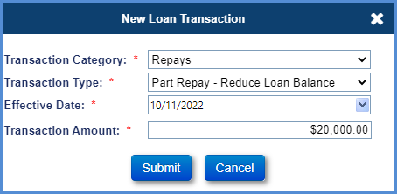
Figure 5-19: Repay Transaction
- To adjust the repay transaction, select the document icon beside the transaction, on the Adjust Loan Transaction window, click Submit to reverse the transaction.
- A new repay adjustment transaction is added and displayed under the Loan Transactions Results section reflecting the reversed amount.
The table below lists the Repay transactions that can be manually created using the New Loan Transactions window.
Transaction | Description
Partial Repay – Reduce Loan Balance | This transaction is initiated by the servicer (on-behalf of borrower) to repay a partial amount to reduce the current unpaid loan balance. This transaction applies to ALL pay plan types.
Partial Repay – Increase CLSA + Reduce Loan Balance | This transaction is initiated by the servicer (on-behalf of borrower) to repay a partial amount to reduce the current unpaid loan balance and increase the available line of credit. This transaction applies to pay plan types Modified Term and Modified Tenure ONLY.
Partial Repay – Prop Chrg Pre D&P | This transaction is initiated by the servicer (on-behalf of borrower) to repay the Property Charge balance. This transaction applies to ALL pay plans.
Table 5-7: Repay Transactions

Repayment of Life Expectancy Set Aside (LESA)
This transaction will display only when the required loan conditions are met, and it must be used to repay Life Expectancy Set Aside (LESA) balance on the loan. The system will prevent the servicer from entering a repayment amount that exceeds the Total LESA balance on the loan. To perform a Repay transaction:
- Click New on the Transactions – Loan screen.
- On the New Loan Transaction window, select Repays-LESA from Transactions Category dropdown. The Transaction Type field automatically populates with the entry Part Repays –LESA.
- Populate the below listed required fields (marked with red asterisk):
  - Transaction Type
  - Effective Date
  - Transaction Amount
- Click Submit. The Loan Balance field under the Balance Information section (header) reflects the updated loan balance. The Life Expectancy Set Aside amount increase in the Principal Limit Calculation section in the Loan Balance page. The new transaction is displayed in the Loan Transaction Results section. To exit the window without adding the transaction click Cancel.
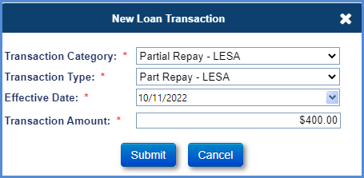
Figure 5-20: Repays- LESA Transaction Window
- To adjust the repay transaction, select the document icon beside the transaction, on the Adjust Loan Transaction window, click Submit to reverse the transaction.
- A new repay adjustment transaction is added and displayed under the Loan Transactions Results section reflecting the reversed amount.
The table below lists the Repay transactions that can be manually created using the New Loan Transactions window.
Transaction | Description
Partial Repay-LESA | This transaction is initiated by the servicer (on-behalf of borrower) to repay a partial amount to reduce the current unpaid loan balance. This transaction applies to ALL pay plan types.

Table 5-8: LESA Repay Transactions

Creating New Terminate Transctions
The Termination transaction is initiated by the lender/servicer to notify HUD of the termination of the HECM Case insurance. Upon termination, the case status of the loan is updated to “Terminated” and loan balance is set to zero. The case sub status is updated based on the transaction type selected by the lender/servicer at the time of termination transaction. The loan’s termination reason is set based on the reason identified by the lender/servicer at the time of termination transaction. For payoff terminations if the payoff amount is not within the threshold limit set by HUD, the system will not allow the authorized user to submit the transaction. For “Terminate – No Claim” terminations, any payoff amount is accepted, and the remaining loan balance and corporate advance amount is written off. If there is an active HUD Advance Timeline on this loan, system will not allow the authorized user to submit the transaction.
To terminate a loan:
- Click New on the Transactions – Loan screen.
- On the New Loan Transaction window, select Terminate from Transactions Category dropdown.
- Any errors that will prevent the Termination from being posted will be displayed and the error must be cleared to proceed with Terminating the loan. For example, an error message will appear if there is an unpaid HUD Advance on the loan.
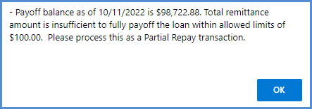
Figure 5-21: Error message Termination amount exceeds limit
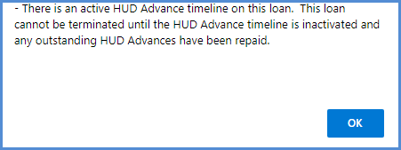
Figure 5-22: Error message Active HUD Advance timeline
- Populate the below listed required fields (marked with red asterisk):
  - Transaction Type
  - Effective Date
  - Transaction Amount
- Click Submit.
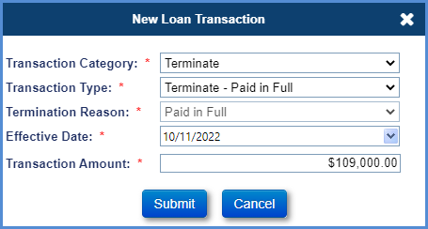
Figure 5-23 New Loan Transaction – Terminate
- A pop-up window is displayed requesting the user to confirm the action and notifying user that the case status will be updated to Terminated.
- Click OK on the pop-up window. The new transaction is displayed in the Loan Transaction Results section and case status and case sub status is updated. To exit the pop-up window without adding the transaction click Cancel.

TIP: Termination Prior to Endorsement: When HECM case status is “Pending IMIP Payment” or “Pending Endorsement and the transaction is terminated, the following warning message will be displayed along with the existing warning message in the Termination confirmation pop window.
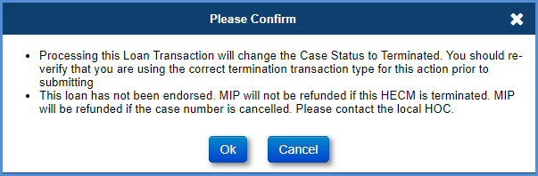
Figure 5-24 Confirmation Message

- To adjust the terminate transaction, select the document icon beside the transaction, on the Adjust Loan Transaction window, click Submit to reverse the transaction.
- A new terminate adjustment transaction is added and displayed under the Loan Transactions Results section reflecting the reversed amount.
The table below lists the Terminate transactions that can be manually created using the New Loan Transactions window.
Transaction | Description
Terminate – Full Write-Off | This transaction is initiated by the servicer to terminate the loan by full write-off.
Terminate – No Claim | This transaction is initiated by the servicer to terminate the loan when a claim would have been filed but was not. For example: a zero or negative claim, a date out of sequence issue (Example – CT21 – Servicer completed foreclosure and sold property but never obtained D&P approval), Short payoff was accepted, or Title Claim paid due to origination errors  TIP – For endorsed loans that are paid in full as a result of a 3rd Party foreclosure sale or an REO Sale and no claim will be filed, this should be reported as Terminate – No Claim with Termination Reason = Foreclosure or DIL.
Terminate – Paid in Full | This transaction is initiated by the servicer to terminate the loan as a full payoff.  TIP: If the pay-off amount is not within the overage or shortage threshold limit set by HUD, system will not allow the termination of the loan for this termination type.  TIP: For endorsed loans that are paid in full as a result of a 3rd Party foreclosure sale or an REO Sale and no claim will be filed, this should be reported as Terminate – No Claim with Termination Reason = Foreclosure or DIL.
Terminate – Refinance | This transaction is initiated by the servicer to terminate the loan due to refinancing.  TIP: If the pay-off amount is not within the overage or shortage threshold limit set by HUD, system will not allow the termination of the loan for this termination type.
Table 5-9: Terminate Transactions

Monthly Accruals
The Servicing Module generates transactions (Monthly Int, MIP accrual and SF) for monthly accruals automatically every month to track the collection of MIP, Interest, and Service Fee.

IMIP adjustments
The IMIP paid by Lender or Borrower can be adjusted using the IMIP Adj button in the Transactions – Loan screen.
To perform an IMIP adjustment of a loan for a borrower:
- Click IMIP Adj on the Transactions – Loan screen.
- On the Adjust IMIP window, enter the amounts in the IMIP Paid by Lender and IMIP Paid by Borrower fields.
- Click Submit. This will adjust the IMIP Financed field.
- This action will automatically generate the Auto-Adjust Int MIP SF transaction in the system.
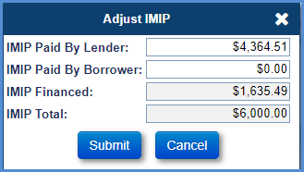
Figure 5-25: Adjust IMIP Window

Write-Off
The Write-Off button enables the authorized user to perform a partial write-off.
To perform a partial write-off:
- Click Write-Off on the Transactions – Loan screen.
- On the Write-Off window, enter the amounts in the following fields:
  - Principal
  - Interest
  - MIP
  - Service Fee
  - Corp Advance
- Click Submit. This will create the partial write-off transaction.
- A new transaction, Write-Off – Manual, is added reflecting the updated amounts under the Loan Transactions Results section.
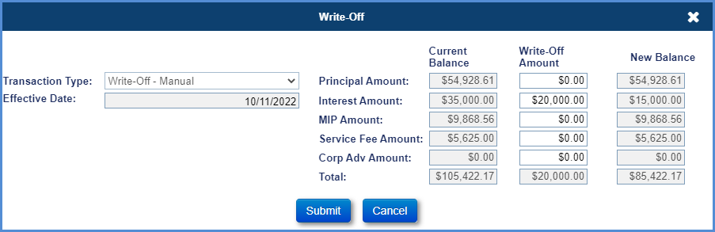
Figure 5-26: Write-Off Transaction
- To adjust the transaction, select the document icon beside the transaction on the Adjust Loan Transaction window and click Submit to reverse the transaction.
- A new transaction, Write-Off – Manual Adj, is added and displayed under the Loan Transactions Results section reflecting the reversed amount.

Balance Adjustments
The Balance Adj button enables the authorized user to correct the loan balance. Only an authorized role with this permission enabled can perform this function. HUD has established a threshold for these fields (MIP,Interest Amount and Service Fee Amount) and the user will get an error message if they enter an amount greater than the threshold. The threshold for the three fields are subject to change by HUD.
Updating the MIP Amount affects the amount of MIP that is collected via the Accounting Module.
To perform a Balance adjustment of a loan:
- Click Balance Adj. on the Transactions – Loan screen.
- On the Adjust Loan Transaction window, enter the amounts in the Correct Amount column.
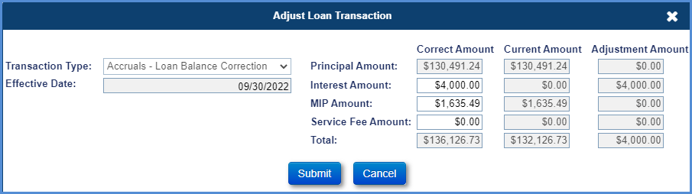
Figure 5-27: Adjust Loan Balance Window
- Click Submit. A new transaction “Accruals – Loan Balance Correction” is added reflecting the corrected amounts under the Loan Transactions Results section.
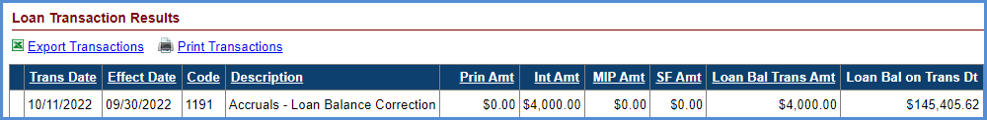
Figure 5-28: Loan Balance Adjustment Transaction

Transactions – Growth
This screen displays the growth transactions associated with line of credit, principal limit and unscheduled line of credit disbursements. This screen allows the authorized user to filter and view specific growth transactions within a transaction category. The growth transactions are automatically initiated by the system.
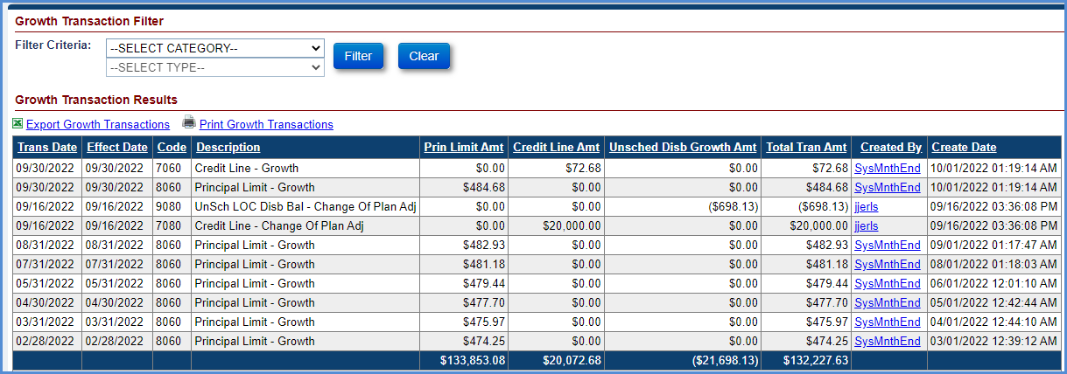
Figure 5-29: Transactions – Growth
The table below lists the Growth transactions that are automatically initiated by the system.
Transaction | Description
Credit Line Transactions | Transactions generated for loans which have an available line of credit for borrower.
Credit Line Original – Setup | This transaction is generated in Servicing Module when certain amount is set aside from line of credit. This transaction is generated for pay plan types Modified Tenure and Modified Term.
Credit Line Original – Setup Adj | This transaction is an adjustment/reversal of transaction ‘Credit Line Original – Setup’.
Credit Line – Growth | This transaction is generated in Servicing Module to depict the monthly Credit Line growth.
Credit Line – Growth Adj | This transaction is an adjustment/reversal of transaction ‘Credit Line – Growth’.
Credit Line – Change Of Plan Adj | This transaction is generated in Servicing Module when a change of payment plan occurs. This transaction is generated when there is a change of payment plan from Modified Tenure to Modified Term or vice-versa.
Principal Limit Transaction | Transaction generated for all loans to depict the monthly Principal limit changes.
Principal Limit Original – Setup | This transaction is generated in Servicing Module when the original principal limit is setup during the loan setup.
Principal Limit Original – Setup Adj | This transaction is an adjustment/reversal of transaction ‘Principal Limit Original – Setup’.
Principal Limit – Growth | This transaction is generated in Servicing Module to depict the monthly principal limit growth.
Principal Limit – Growth Adj | This transaction is an adjustment/reversal of transaction ‘Principal Limit – Growth’.
Unscheduled Credit Line Disbursement Transaction | Transactions generated for loans eligible for unscheduled line of credit disbursements.
UnSch LOC Disb – Int & MIP Accrual | This transaction is generated in Servicing Module to display the interest and MIP accruals on an unscheduled disbursements taken from available line of credit. This is applicable for pay plan types Modified Tenure and Modified Term.
Table 5-10: Growth Transactions

Transactions – Growth Filter
The Growth Transaction Filter section allows the authorized user to view the transactions according to the filter criteria selected.
To filter the transactions by transaction category:
- Select the Transaction Category from the dropdown.
- Select the Transaction Type from the dropdown (if needed).
- Click Filter to view the filtered transactions under the Growth Transactions Results section. No results are displayed if no transactions match the filter criteria entered by the user.
- Click Clear to clear the selected filters and view all transactions.
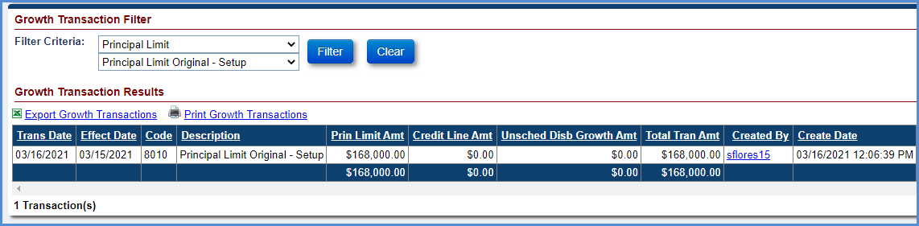
Figure 5-30: Growth Transactions Filter and Results Section

Transactions – Set Asides
This screen displays all the Set Aside transactions associated with the loan. This screen allows the user to perform the following functions:
- Set Aside Transaction Filter: This allows the user to filter and view specific transactions within a transaction category.
- New Transactions: This allows the authorized user with the ability to add set aside transactions on the Loan.

Transactions – Set Aside filter
The Set Aside Transaction Filter section allows the authorized user to view the transactions according to the filter criteria selected.
To filter the transactions by transaction category:
- Select the Transaction Category from the dropdown.
- Select the Transaction Type from the dropdown (if needed).
- Click Filter to view the filtered transactions under the Set Aside Transactions Results section. No results are displayed if no transactions match the filter criteria entered by the user.
- Click Clear to clear the selected filters and view all transactions.
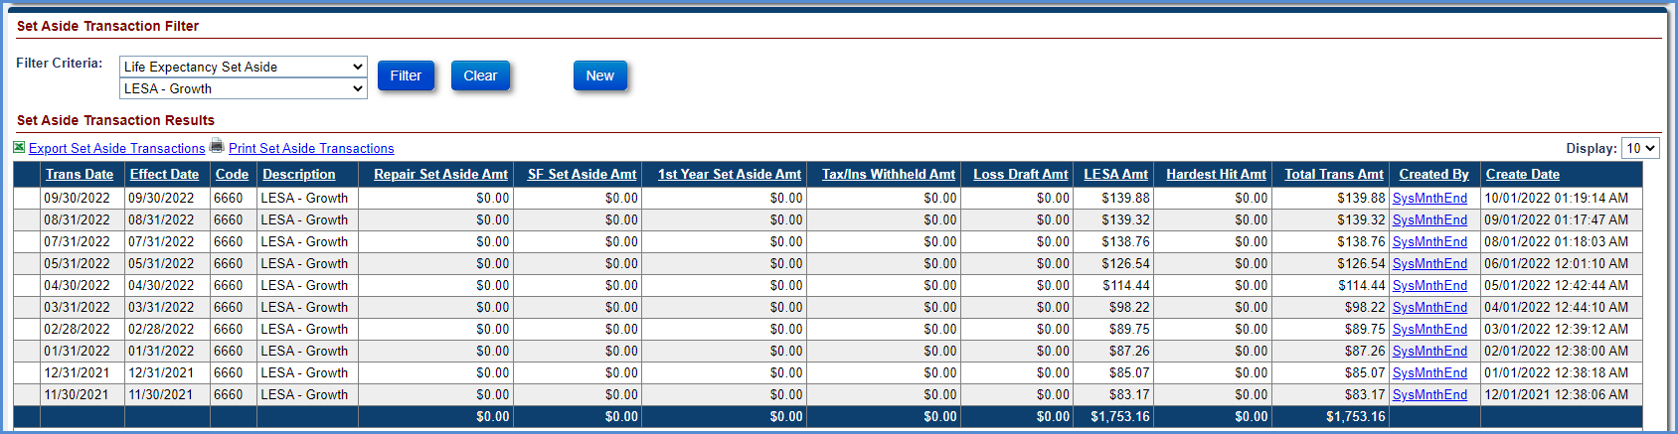
Figure 5-31: Set Aside Transactions Filter and Results Section

Creating a New Set Aside Transaction
The New button allows the authorized user to add Set Aside transactions. The following transactions can be initiated manually by the user:
- 1st Yr Taxes & Ins – Setup
- Repair Set Aside – Setup

1st Yr Taxes and Ins – Setup
This transaction is initiated by a lender/servicer to set aside an amount for Taxes and Insurance paid on behalf of borrower. This transaction can be applied to all pay plans.
To create a 1st Yr Taxes and Ins Set Aside transaction:
- Click New on the Transactions – Set Aside screen.
- On the New Set Aside Transaction window, select 1st Yr Taxes & Ins – Setup from the Transaction Type dropdown.
- Populate the below listed required fields (marked with red asterisk):
  - Effective Date
  - Transaction Amount
- Click Submit. The new transaction is displayed in the Set Aside Transaction Results section. To exit the window without adding the transaction click Cancel.
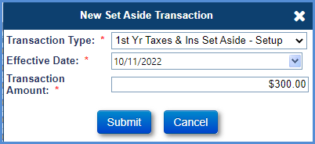
Figure 5-32: Set Aside – Taxes & Insurance Transaction
- To adjust the Set Aside transaction, select the document icon beside the transaction, on the Adjust Set Aside Transaction window, click Submit to reverse the transaction.
- A new 1st Yr Taxes & Ins – Setup Adj transaction is added and displayed under the Set Aside Transactions Results section reflecting the reversed amount.

Repair Set Aside- Setup
This transaction is initiated by a lender/servicer to set aside an amount for any repairs of the mortgaged property. This transaction can be applied to all pay plans.
To create a Repair Set Aside transaction:
- Click New on the Transactions – Set Aside screen.
- On the New Set Aside Transaction window, select Repair Set Aside – Setup from the Transaction Type dropdown.
- Populate the below listed required fields (marked with red asterisk):
  - Effective Date
  - Transaction Amount
- Click Submit. The new transaction is displayed in the Set Aside Transaction Results section. To exit the window without adding the transaction click Cancel.
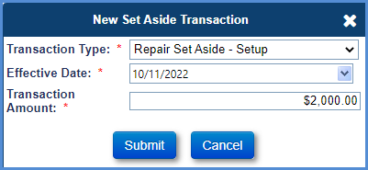
Figure 5-33: Set Aside – Repair Transaction
- To adjust the Set Aside transaction, select the document icon beside the transaction, on the Adjust Set Aside Transaction window, click Submit to reverse the transaction.
- A new Repair Set Aside – Setup Adj transaction is added and displayed under the Set Aside Transactions Results section reflecting the reversed amount.

Viewing Life Expectancy Set Aside Growth Transaction
An authorized user can view the LESA Growth Transaction created in the Set Aside Transaction Window for loans that have LESA Set Aside balance.
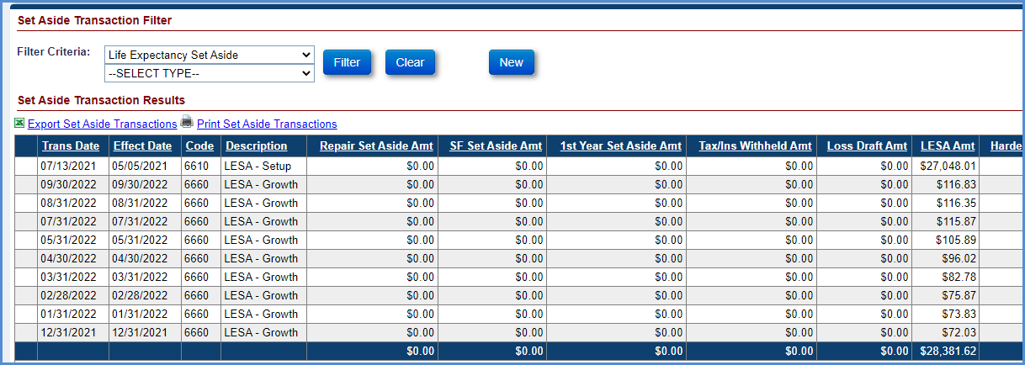
Figure 5-34: Viewing LESA-Growth Transaction

Transactions – Claims
This screen displays the claims transactions associated with claim submissions. This screen allows the user to filter and view specific claim transactions within a transaction category. The claim transactions are automatically initiated by the system when a claim is approved by HUD.
The table below lists the Claim transactions that are automatically initiated by the system.
Transaction | Description
Claim Type 21 – FCL/DIL | This transaction is automatically initiated by the Servicing Module upon approval of Claim Type 21 by HUD.
Claim Type 22 – Optional Assignment | This transaction is automatically initiated by the Servicing Module upon auto-approval of Claim Type 22.
Claim Type 23 – Mortgagor Sale | This transaction is automatically initiated by the Servicing Module upon approval of Claim Type 23 by HUD.
Claim Type 21 – Supplemental | This transaction is automatically initiated by the Servicing Module upon approval of Claim Type 24 by HUD provided the initial claim is a Claim Type 21.
Claim Type 23 – Supplemental | This transaction is automatically initiated by the Servicing Module upon approval of Claim Type 24 by HUD provided the initial claim is a Claim Type 23.
Claim Type 22 – Funds Due HUD | Automatically initiated by the Servicing Module upon denial of assignment (Claim Type 22 post preliminary title approval and pre final title approval) by HUD. The transaction is initiated to recover the advances made previously by HUD.
Interest on HUD Advances | Automatically initiated by the Servicing Module upon denial of Assignment (Claim Type 22 post preliminary title approval and pre final title approval) by HUD. The transaction is initiated to recover the interest amount on the advances made previously by HUD.
Claim Type 22 – Repurchase | For assigned loans, this transaction is automatically initiated by the Servicing Module upon approval of Assignment Repurchase by HUD.
Claim Type 22 – Repurchase Adj | Automatically initiated by the Servicing Module if there is a difference in payoff amount between the date HUD approved repurchase and servicer authorized the repayment transaction.
Table 5-11: Claims Transactions

Filtering Claims Transactions
The Claims Transaction Filter section allows the authorized user to view the transactions according to the filter criteria selected.
To filter the transactions by transaction category:
- Select the Transaction Category from the dropdown.
- Select the Transaction Type from the dropdown (if needed).
- Click Filter to view the filtered transactions under the Claims Transactions Results section. No results are displayed if no transactions match the filter criteria entered by the user.
- Click Clear to clear the selected filters and view all transactions.
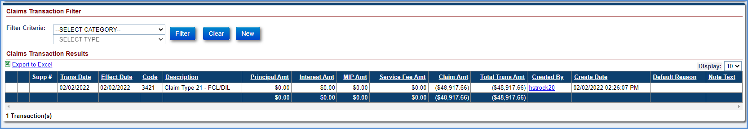
Figure 5-35: Claims Transactions Filter and Results Section

Contacts
The Contact screen is displayed when a user selects the Contacts tab from the menu on the left side of the screen. This screen displays the borrower, co-borrower and non-borrowing spouse information received from CHUMS at the time of loan setup. In addition, the screen enables authorized users to add new contacts other than borrower and co-borrower, edit existing contact information, and delete a contact. The screen also enables user to deactivate a non-borrowing spouse, if available, and add property contact assessment information related to Home Ownership Associations (HOA) and Condominiums.
The Contacts screen displays the following sections:
- New button – Contact Information
- Contacts
- New button – Assessment Information
- Assessment Contacts

Viewing a Contact
To view a contact:
- Click a Contact Type displayed under the Contact Information section.
- The Mailing Information, Other Information and Audit Information of the selected contact are displayed below the contact.
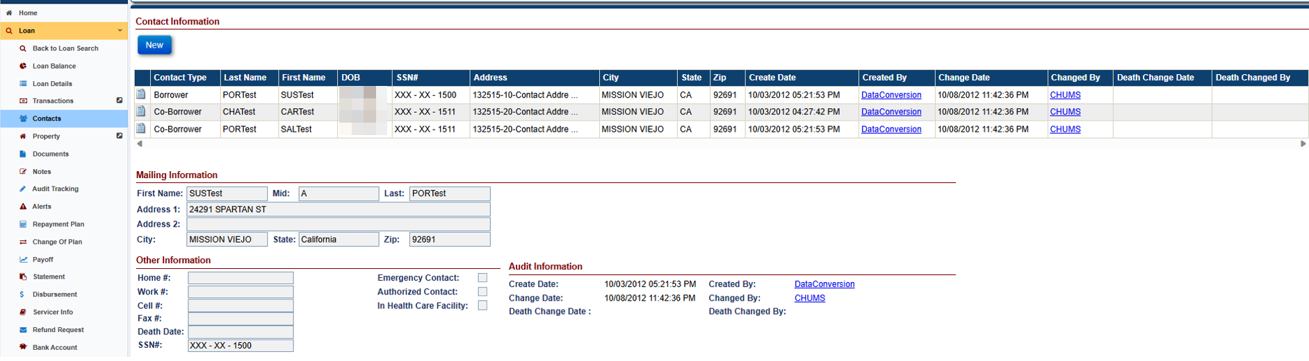
Figure 5-36: View Contact Information Screen

Adding a Contact
To add a contact:
- Click New in the Contact Information section.
- On the Contact Info window, populate the fields as needed (fields marked with red asterisk must be populated). Selecting the button Same as Contact Address will auto-fill the Contact Name and address from the Contact Name & Address section to the Contact Mailing Info section.
- Click Submit to save the changes. The new contact is displayed under the Contact Information section. To exit the window without saving the changes click Cancel.
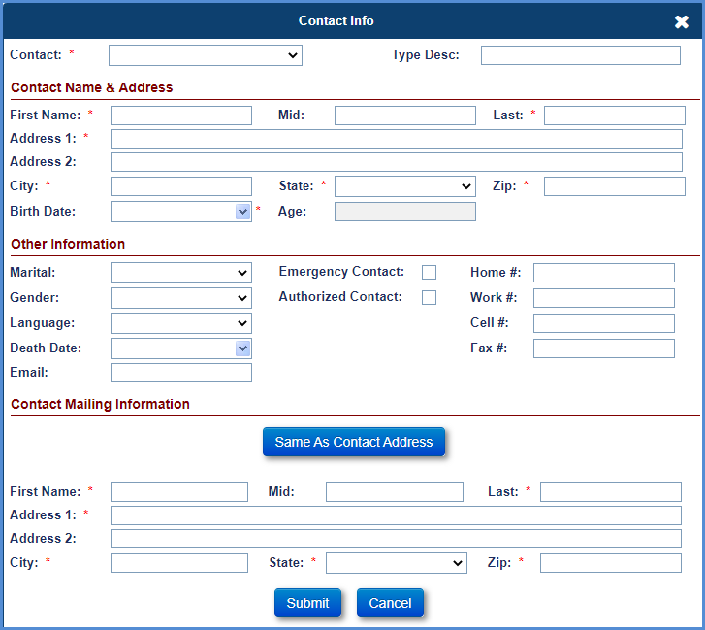
Figure 5-37: Add Contact Information Window

Editing a Contact
To edit a contact:
- Click the document icon beside the contact type in the Contact Information section.
- On the Contact Info window, edit the fields as needed (fields marked with red asterisk must be populated).
- Click Submit to save the changes. The updated information is displayed under the Contact Information section. To exit the window without saving the changes click Cancel.
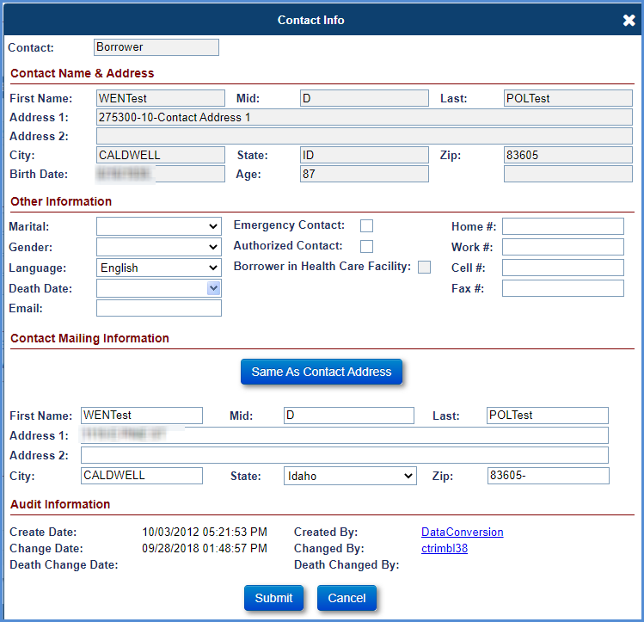
Figure 5-38: Edit Contact Information Window

Viewing and editing “Borrower in Health Care Facility” checkbox
The Borrower in Health Care facility checkbox is placed under the Authorized Contact checkbox in the Contact Info Screen for Borrowers only. The checkbox when selected indicates that the Borrower is in health care facility. Borrower in Health Care Facility checkbox will only be editable for loans with NBS regardless of status. Upon checking this checkbox for the last living borrower, Deferred Status will be updated to “YES” when a NBS contact is on the loan. System will not allow to add Due & Payable w/HUD Approval or Due & Payable w/o HUD Approval timelines if Borrower in Health Care Facility checkbox is checked and Deferred is set to YES.

Deleting a Contact
To delete a contact:
The contact information of the Borrower and Co-Borrower Contact Type cannot be deleted.
- Click the cross icon beside the contact type in the Contact Information section.
- A pop-up window is displayed requesting the user to confirm the action.
- Click OK on the pop-up window, the selected contact will be deleted. To exit the message window without deleting a contact select Cancel.

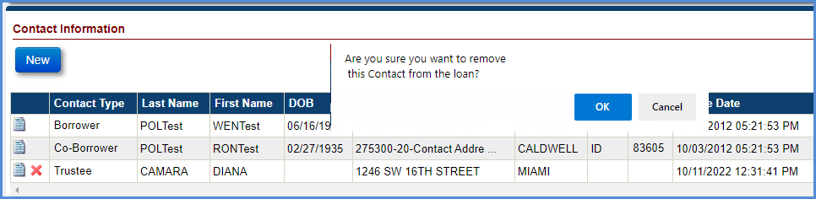
Figure 5-39: Delete Contact Information

Deactivating a Non Borrowing Spouse
To deactivate a non-borrowing spouse:
- Click the document icon beside the contact type Non-Borrowing Spouse in the Contact Information section
- On the Contact Info window, select the Deactivate NBS box. Entering the death date for NBS will cause the NBS to become inactive.
- Click Submit to save the changes. The updated information is displayed under the Contact Information section. To exit the window without saving the changes click Cancel.
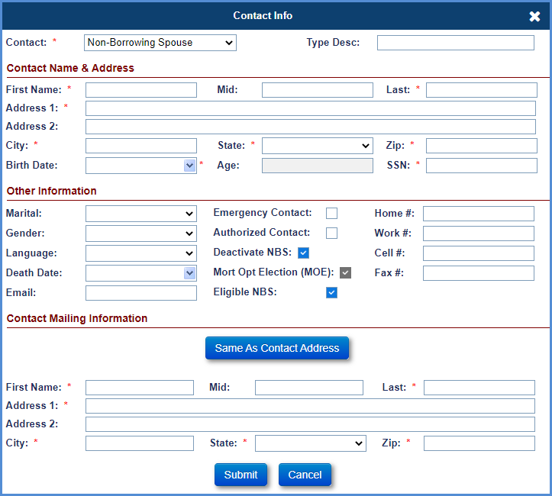
Figure 5-40: Deactivate a Non-Borrowing Spouse

Viewing Eligible and Ineligible Non Borrowing Spouse
The Eligible NBS checkbox is displayed on the Contact Info Screen. The checkbox when selected indicates that the Non-Borrowing Spouse present on the loan is Eligible. The Checkbox when not selected indicates that Non-Borrowing Spouse present on the loan is Ineligible.

Adding a Non-Borrowing Spouse Contact
An authorized user can enter up to three Non-Borrowing Spouses for the FHA Case numbers assigned prior to 08/04/2014. These are identified as MOE NBS in the Contact Information page and in the Borrower Information section of the loan header. For FHA Case numbers assigned on or after 08/04/2014, the NBS information is sent to HERMIT via CHUMS /FHA Connections and are not MOE.

To add a contact:
- Click New in the Contact Information section.
- On the Contact Info Window, select Non-Borrowing Spouse from the drop-down menu.
- On the Contact Info window, populate the remaining fields as needed (fields marked with red asterisk must be populated). Selecting the button Same as Contact Address will auto-fill the Contact Name and address from the Contact Name & Address section to the Contact Mailing Info section. Contact field should be selected as Non-Borrowing Spouse.
- Click Submit to save the changes. The new contact is displayed under the Contact Information section. To exit the window without saving the changes click Cancel.

Editing a Non-Borrowing Spouse Contact
To edit a Non-Borrowing Spouse contact:
- Click the document icon beside the Non-Borrowing Spouse contact type in the Contact Information section.
- On the Contact Info window, edit the fields as needed (fields marked with red asterisk must be populated).
- Click Submit to save the changes. The updated information is displayed under the Contact Information section. To exit the window without saving the changes click Cancel.
The MOE checkbox is not editable: it is automatically selected on NBS records with FHA Case numbers assigned prior to 08/04/2014, and not selected for NBS records with FHA Case numbers assigned on or after 08/04/2014,

Adding a Changed Borrower Name and Changed Co-Borrower Name Contact
An authorized user can add Contact Type: Changed Borrower Name and Changed Co-Borrower Name. If the Changed Borrower Name is selected to add, the system will populate information from original Borrower. If the Changed Co-Borrower Name is selected to add, the system will populate information from original Co-Borrower. User can update information as needed before submitting new contact. Only one Changed Borrower Name is allowed per original Borrower. Only one Changed Co-Borrower Name is allowed per original Co-Borrower. Death Date for any borrower will need to populate under original borrower(s) only.
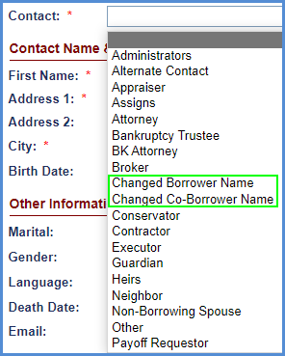
Figure 5-41: New Changed Borrower / Co Borrower Name Contact Type

To add a contact:
- Click New in the Contact Information section.
- On the Contact Info Window, select Changed Borrower Name from the drop-down menu.
- Contact field should be selected as Changed Borrower Name. On the Contact Info window, all fields are pre-populated from the original Borrower. Selecting the button Same as Contact Address will auto-fill the Contact Name and address from the Contact Name & Address section to the Contact Mailing Info section. Update information, if needed.
- Click Submit to save the changes. The new contact is displayed under the Contact Information section. To exit the window without saving the changes click Cancel.
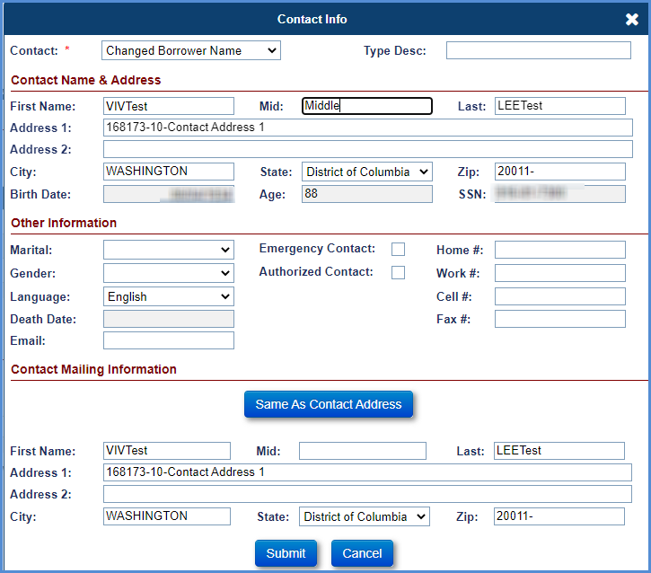
Figure 5-42: Add Changed Borrower Name

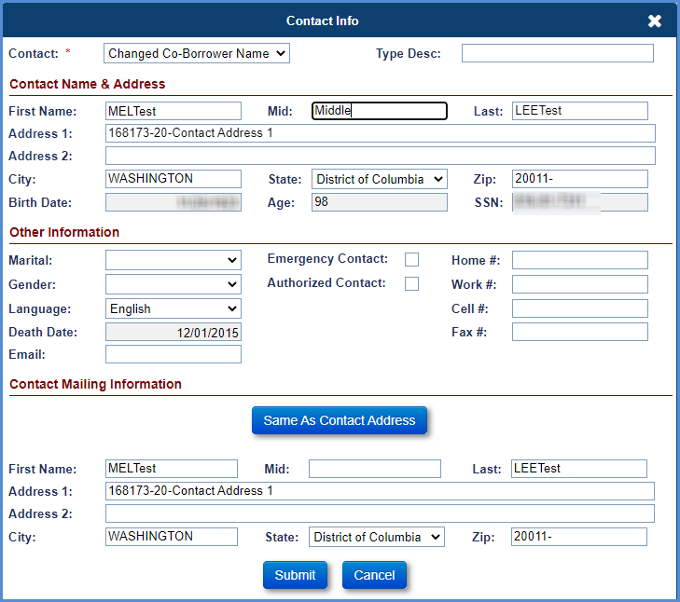
Figure 5-43: Add Changed Co Borrower Name

Editing a Changed Borrower Name Contact
An authorized user can edit Changed Borrower Name and Changed Co-Borrower Name contacts.
To edit a Changed Borrower Name contact:
- Click the document icon beside the Changed Borrower Name contact type in the Contact Information section.
- On the Contact Info window, edit the fields as needed (fields marked with red asterisk must be populated).
- Click Submit to save the changes. The updated information is displayed under the Contact Information section. To exit the window without saving the changes click Cancel.
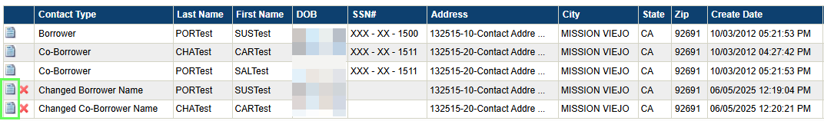
Figure 5-44: View Changed Borrower / Co Borrower Name

Adding Assessment Information
An authorized user can enter property contact assessment information related to Home Ownership Associations (HOA) and Condominiums.
To add a contact:
- Click New in the Assessment Information section.
- On the Assessments Information window, populate the fields as needed (fields marked with red asterisk must be populated).
- Click Submit to save the changes. The new contact is displayed under the Contact Information section. To exit the window without saving the changes click Cancel.
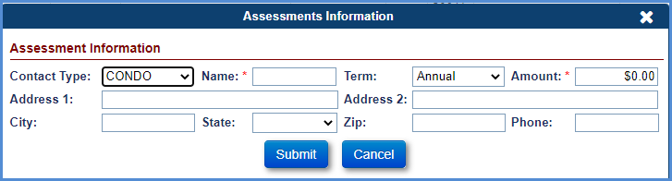
Figure 5-45: Add Assessments Information Window

Viewing and Editing Assessment Information
To view and/or edit Assessment Information:
- Click on the Edit Icon displayed for the desired record under the Assessment Information section.
- The Mailing Information, Other Information and Audit Information of the selected contact are displayed below the contact.
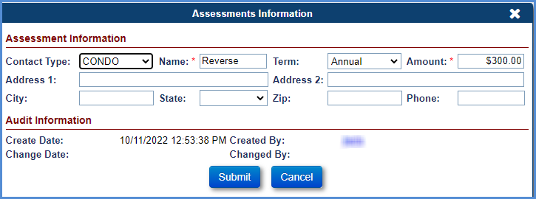
Figure 5-46: View Assessment Information Screen

Property
The Property screen is displayed when a user selects the Property tab from the menu on the left side of the screen. This tab has two sub-menu options:
- Property Info
- Property Values

Property Information
This screen displays the property details received from CHUMS at the time of loan setup. In addition, the screen allows authorized users to edit property details, upload or delete a property photo. The data fields received from CHUMS cannot be edited. A flag is also displayed allowing users to determine if Assessment Type information for a Condominium (Condo) or Home Ownership Association (HOA) has been added on the Contacts page.
The Property Information screen displays the following sections:
- Property Details
- Audit Information
- Property Photo
- Property Location
- Local Statistics

The screen also displays the following links:
- View Property Values – This link navigates the user to the Property Values screen.
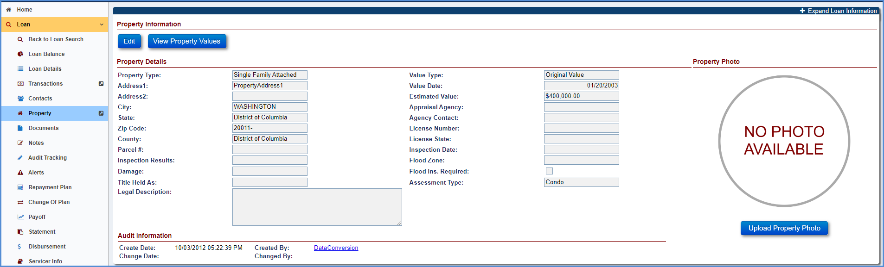
Figure 5-47: Property Information Screen

Editing Property Information
To edit the fields in the Property Details section:
- Click Edit in the Property Details section on the Property Information screen.
- On the Edit Property Info window, edit the fields.
- When Damage value is selected, the Damage Date and Damage Amounts are required. The values from the Damage, Damage Amount, Damage Date, and Legal Descriptions fields will be used by the system to pre-fill Claim Form HUD-27011 (if initiated by the servicer).
- Click Submit to save the changes. The updated information is displayed under the Property Details section. To exit the window without saving the changes click Cancel.
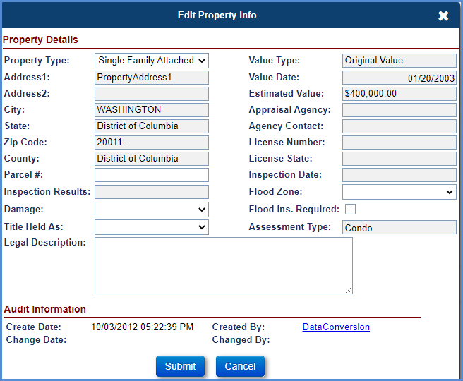
Figure 5-48: Edit Property Info Window

      - Uploading a Property Photo
To add a Property Photo:
- Click the Upload Property Photo link on the Property Photo section.
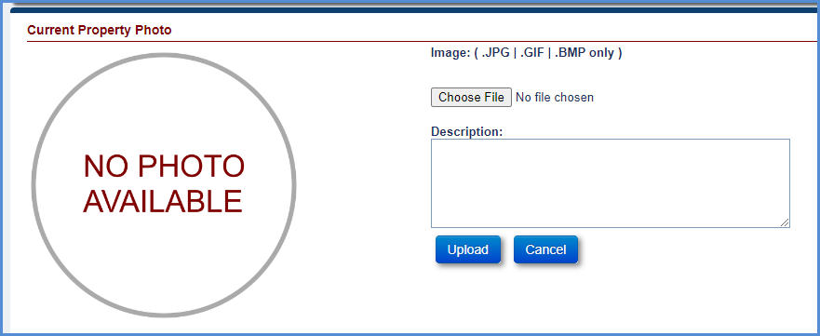
Figure 5-49: Upload Property Photo
- A new window is displayed with the upload option. Only images with .JPG, .GIF, and .BMP file extensions can be uploaded.
- Click Browse.
- Select the image to upload and click Open.
- Enter description in the Description field (optional).
- Click Upload to save the property photo. To exit the screen without uploading click Cancel.
      - Editing the description for a property photo
To edit the property photo description:
- Click document icon below the Description field under the Property Photo section.
- On the Edit Property Description window, edit the description field and click OK to save the changes. To exit the screen without saving the description click Cancel.
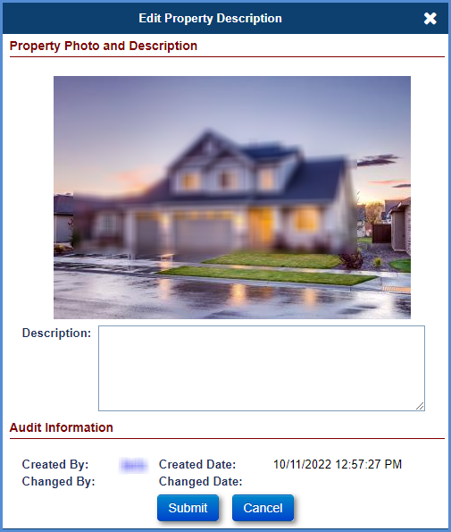
Figure 5-50: Edit Property Description Window
      - Deleting a Property Photo
To delete a property photo:
- Click the cross icon below the Description field under the Property Photo section.
- A pop-up window is displayed requesting the user to confirm the action. Click OK on the pop-up window; the photo and description will be deleted. To exit the pop-up window without deleting the photo click Cancel.
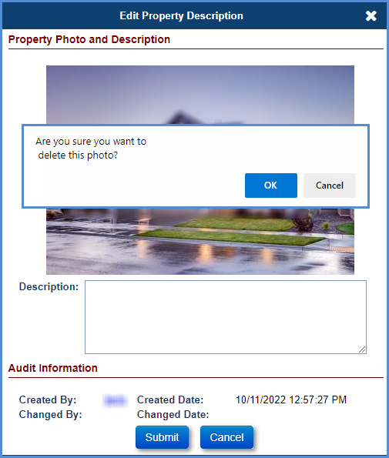
Figure 5-51: Delete Property Photo Window

Property Values
This screen displays the property values received from CHUMS at the time of loan setup (indicated by value type of Original Value). In addition, the screen allows authorized users to add new property values, edit or delete the property values that were previously added.
The Property Values screen displays the following data sections:

- New button
- Property Values
      - Viewing Property Values
The Property Values are displayed as individual rows for each value. Scroll the horizontal bar to view additional details on the property value.
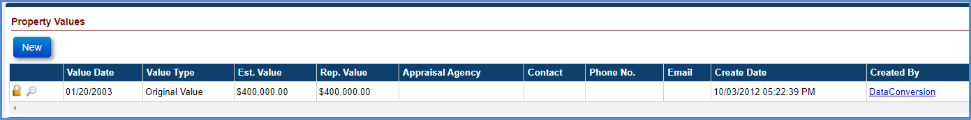
Figure 5-52: View Property Values Window

Adding a New Property Value
To add a Property Value:
- Click New in the Property Values screen.
- On the Property Value window, populate the fields (fields marked with red asterisk must be populated). Note: a PDF document must be attached to save the Property Value record.
- Click Submit to save the changes. The new property value is displayed under the Property Values section. To exit the window without saving the changes click Cancel.
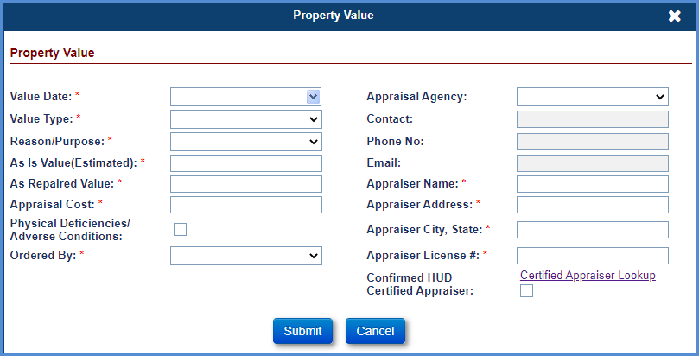
Figure 5-53: Add a New Property Value

      - Deleting a Property Value
Users cannot edit property value information. Only the User that added a property value can delete that property value entry.
To delete a property value:
- Click the cross icon beside the value type in the Property Values section.
The property value of Original Value Type cannot be deleted.
- A pop-up window is displayed requesting the user to confirm the action.
- Click OK on the pop-up window; the selected value will be deleted. To exit the pop-up window without deleting a value click Cancel.

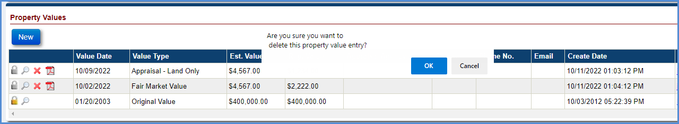
Figure 5-54: Delete Property Value Window

Documents
The Loan Documents screen is displayed when a user selects the Documents tab from the menu on the left side of the screen. This screen displays the letters, forms and documents associated with the loans. Authorized users can upload or delete documents.
The Documents screen displays the following sections:
- Upload button
- View documents

Viewing Loan Documents
To view a document:
- Click the Magnifying Glass beside the document.
- The document opens as a PDF.
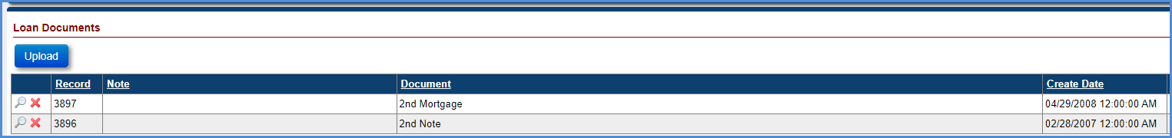
Figure 5-55: Loan Documents Screen

Uploading Loan Documents
There is a separate process for uploading bulk documents using SFTP. For details on this process please refer to the HERMIT resources document named “HERMIT Document Upload File Format.”
To upload a document in the Servicing Module:
- Click Upload under the Loan Documents section.
- On the Upload Document window, select a document type to upload from the Document Type dropdown. Only PDF documents with maximum file size of 30 MB can be uploaded. Editable PDFs are not permitted.
- Click Browse to select the location of the file (PDF).
- Enter a description of the document in the Notes field.
- Click Upload to save the document. An entry for this document is added to the Loan Documents section. To exit the window without uploading the document click Cancel.
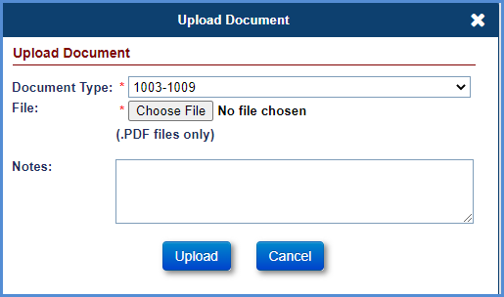
Figure 5-56: Upload Document Window

Deleting a Document
To delete a document:
- Click the cross icon beside the document in the Loan Documents screen.
- A pop-up window is displayed requesting the user to confirm the action.
- Click OK on the pop-up window, the selected document will be deleted. To exit the message window without deleting the document click Cancel.
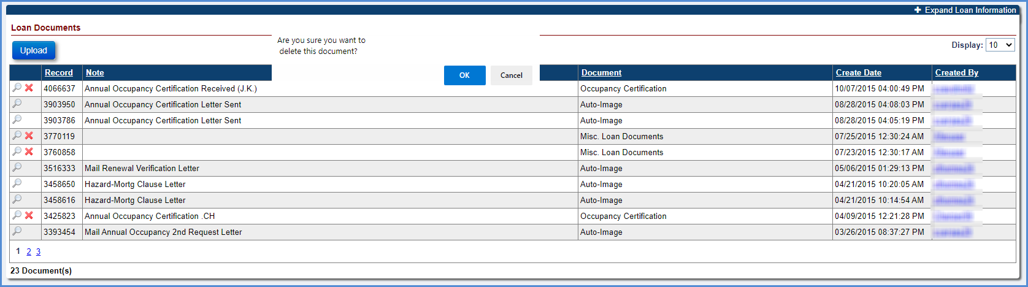
Figure 5-57: Delete Document

Notes
The Notes screen is displayed when a user selects the Notes tab from the menu on the left side of the screen. The notes screen displays notes added by the system (auto notes) and manually created by the users. Authorized users can add, edit or delete a note.
The Notes screen displays the following sections:
- Notes Filter Criteria – Allows users to filter and view specific notes type
- New Notes – Allows authorized users to add a note type
- Print Notes – Allows authorized users to print notes

Filtering Notes
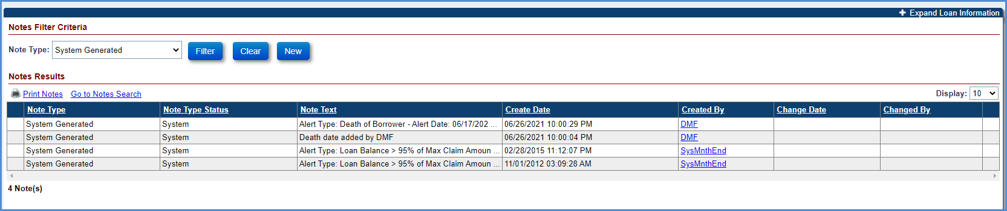
Figure 5-58: Filter Notes Window
The Notes Filter Criteria section of the Notes screen allows the user to apply filter and view selected notes type:
- Select the Note Type from the Note Type dropdown.
- Click Filter to view the filtered notes under the Notes Results section.
- Select Clear to clear the selected filers and view all notes.

Viewing a Note
To view a new Note Type:
- Click on the Note you want to view in the Notes Filter Criteria section.
- On the Note Item, click Next to view the next note on the loan.
- Click Back to view the previous note on the loan.
- Click Cancel to exit the screen.
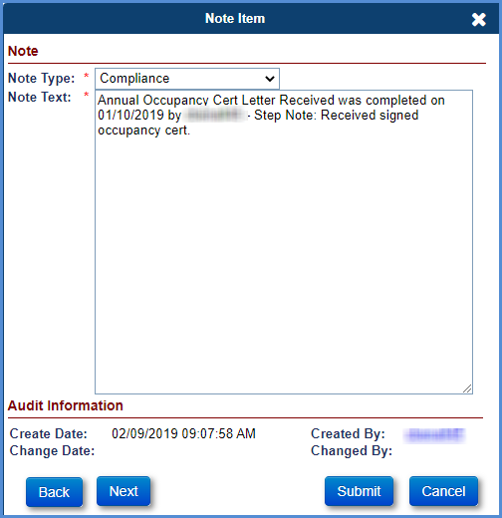
Figure 5-59: View Note Window

Adding a Note
To create a new Note Type:
- Click New in the Notes Filter Criteria section.
- On the Note Item screen, select a Note Type and enter a Note Text.
- Click Submit. The new note is reflected in the Notes Results section. To exit the screen without adding the note, click Cancel.
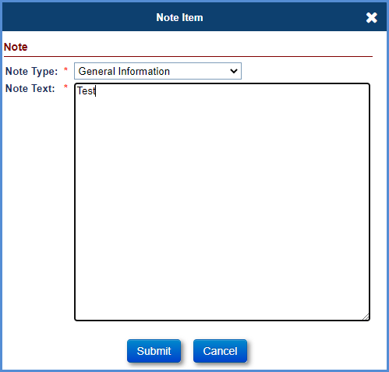
Figure 5-60: Create New Note Window

Editing a Note
To edit a Note Type:
- Click the Note you want to edit (system-generated auto notes cannot be edited), in the Notes Filter Criteria section.
- On the Note Item screen, edit the Note Type and Note Text.
- Click Submit. The updated note is reflected in the Notes Results section.
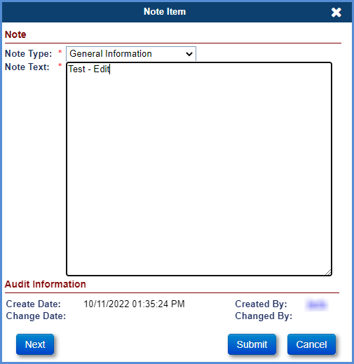
Figure 5-61: Edit Note Window

Deleting a Note
To delete a Note Type:
- Click the cross icon beside the note in the Notes Filter Criteria section. Authorized users other than managers can delete a note only on the same day as the day it was created. Manager roles can delete any note (except those that were system generated) created on any day.
- A pop-up window is displayed requesting the user to confirm the action.
- Click OK on the pop-up window, the selected note will be deleted. To exit the message window without deleting the document click Cancel.
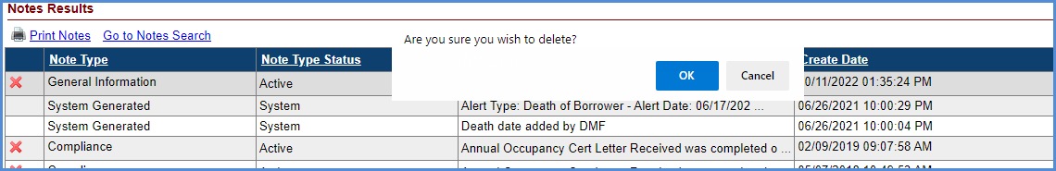
Figure 5-62: Delete Note Window

Printing Notes
To print the notes on a loan: Click the Print Notes link in the Notes Filter Criteria section. The notes are opened in a PDF file for printing.
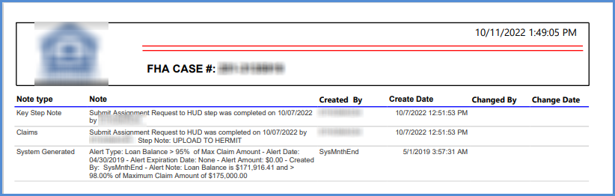
Figure 5-63: Print Notes

Audit Tracking
The Audit Filter Criteria screen is displayed when a user selects the Audit Tracking tab from the menu on the left side of the screen. The screen displays all audit data captured for the loan. Only authorized users can view the audit tracking information. Users can filter the audit data using the audit filter criteria.

Filtering Audit Information
The Audit Filter Criteria section of the Audit screen allows users to filter and view the audit information:
- Select the Audit field from the dropdown.
- Click Filter to view the filtered audit data under the Audit Results section.
- Click Clear to clear the selected filers and view all audit data.

The Audit Results section displays the following fields:
- Audit Type: The type of Audit on the loan
- Original Value: The original value of the audit type
- New Value: The new value of the audit type
- Change Date: The date the audit type values were modified
- Changed By: The name of the user role associated with the audit change
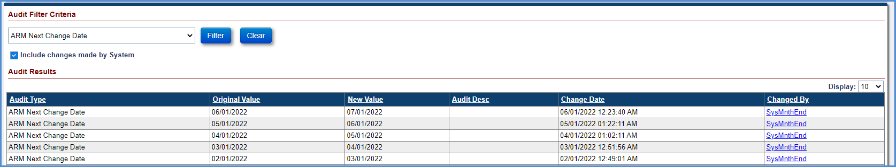
Figure 5-64: Audit Filter Window

Alerts
The Alerts screen is displayed when a user selects the Alerts tab from the menu on the left side of the screen. The Alerts screen shows all the active alerts added to the loan. The system automatically adds an alert when the alert condition is identified. In addition, the authorized users can manually add an alert to the loan. Authorized users can also create new alert types using the Alerts tab within Admin menu tab. (See Chapter 10).
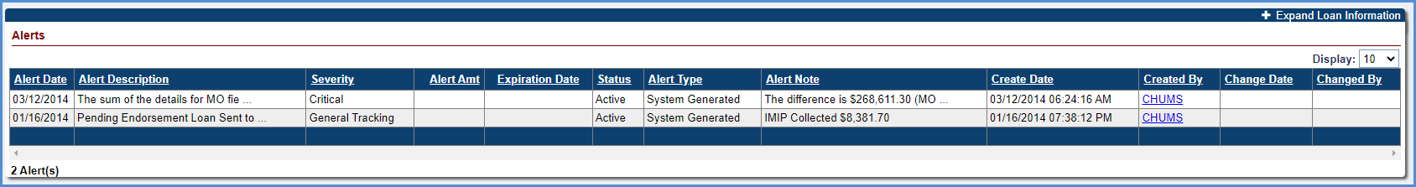
Figure 5-65: Alerts Screen
The Alerts section displays the following fields:
- Alert Date: The date the alert was generated
- Alert Description: The description associated with the alert type
- Severity : Severity of the alert, Critical or General Tracking
- Alert Amt : Any monetary amount associated with the alert
- Expiration Date: The date the alert expires. If the current system date is greater than the alert, expiration date, the alert is no longer displayed in the critical alerts pop-up window
- Status: Indicates the status of the alert (Active/Inactive)
- Alert Type : Indicates whether the alert is system generated or user generated
- Alert Note : A short note associated with the alert
- Create Date: The date the alert was created in the system
- Created By : The name of the user role who created the alert
- Change Date: The date the alert was modified/changed
- Changed By : The user that changed/modified the alert

Creating New Alerts
To create a new alert on a loan:
- Click New in the Alerts section.
- On the New Alert screen, select Alert Type, Alert Date, Expiration Date, Alert Amount, and Status. Enter an Alert Note.
- Click Submit. The new alert is displayed in the Alerts section. To exit without adding alert click Cancel.
- Once an alert is added, the alert cannot be deleted, but can be made inactive.
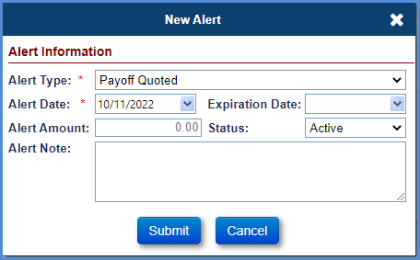
Figure 5-66: New Alert Window

Editing an Alert
To edit an alert on a loan:
- Click the Alert you want to edit (system-generated alerts cannot be edited), in the Alerts section.
- On the Edit Alert screen, edit the Alert Date, Expiration Date, Alert Amount, Status and Alert Note.
- Click Submit. The updated alert is reflected in the Alerts section. To exit without updating alert click Cancel.
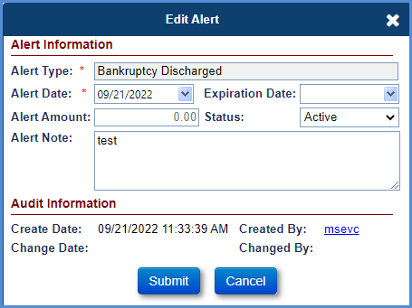
Figure 5-67: Edit Alert Window

Change of Plan
The Change of Plan screen is displayed when a user selects the Change of Plan tab from the menu on the left side of the screen. The Change of Plan screen shows the current payment plan and any prior payment plans associated with the loan.
The following conditions must be satisfied to initiate a change of plan:
- Authorized users can perform Change of Plan.
- The loan must have a case status of Pending IMIP Payment, Pending Endorsement or Endorsed and a sub-status of Loan Active.
- An effective date for a payment plan change must be after the last transaction and must be within the month in which the change takes effect.
- There is no option to edit the Change of Plan on a loan with pay plan type of Lump Sum.
- Authorized users cannot change from an existing pay plan type (Line of Credit, Tenure, Term, Modified tenure, or Modified term) to Lump Sum.

The Servicing Module currently allows the following five payment plans for HECM Cases:
Payment Plan | Description
Line of credit | A borrower can make withdrawals up to a maximum amount, at times, and in amounts, of the borrower’s choosing.
Lump Sum | A borrower receives one lump disbursement of available funds at closing. No other borrower disbursements can be made for the life of the loan, even if the borrower makes a repayment towards the loan balance.
Tenure | A borrower receives monthly payments from the lender for as long as the borrower lives and continues to occupy the home as a principal residence.
Term | A borrower receives monthly payments for a fixed period selected by the borrower.
Modified tenure | The tenure option is combined with a line of credit.
Modified term | The term option is combined with a line of credit
Table 5-12: Payment Plan Types

Viewing a Payment Plan
To view a payment plan: Select the record to display the Pay Plan Details section and Audit Information sections. The Pay Plan Details section displays the following details of the payment plan selected in Pay Plans section:
  - Gross Monthly Payment: The monthly payment made to a borrower
  - Monthly T&I Wld: The monthly taxes and insurance amount withheld
  - Net Monthly Payment: The gross monthly payment – Monthly T & I withheld
  - Term of Payments: The number of payment months
  - Monthly Serv Fee: The monthly service fee charged by the servicer
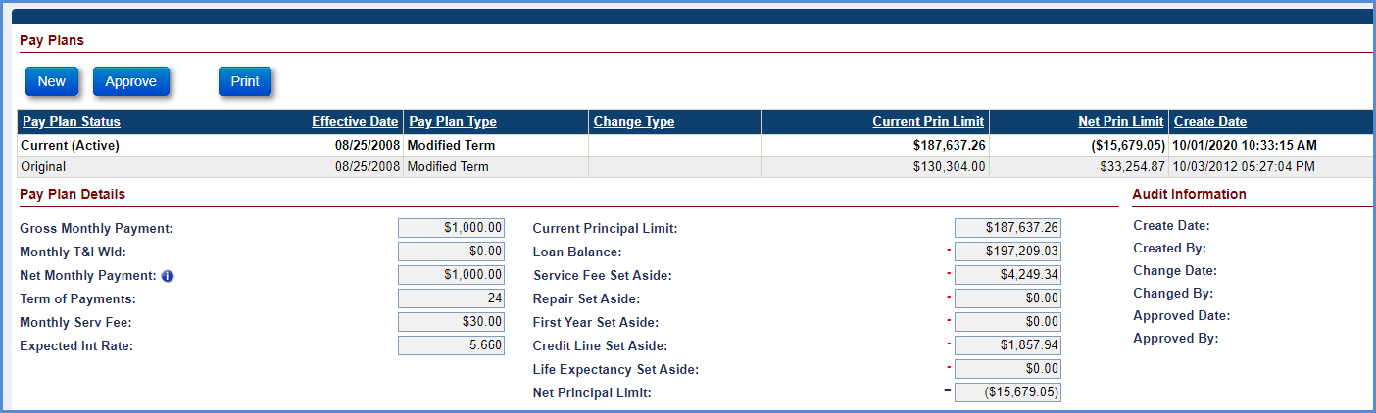
Figure 5-68: View Payment Plan Window

Creating a New Payment Plan
To create a new payment plan:
- Click New in the Pay Plans section.
- On the Change Payment Plan window, enter the required data fields (marked with red asterisk).
- Click OK to save the changes. The new pay plan is displayed in the Pay Plans section. To exit without adding a new pay plan click Cancel.
- The pay plan status of the new payment plan will be the Current (Active) and the previous payment plan will be updated to the Previous.
- Based on the change of plan fee entered on the Change Payment Plan window, the change of plan fee transaction is automatically generated by the system and displayed in the Transactions – Loan screen.
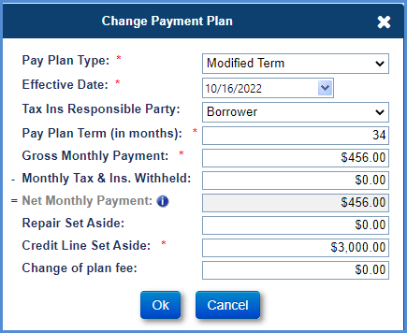
Figure 5-69: Create New Pay Plan Window

Payoff
The Payoff Info screen is displayed when a user selects the Payoff tab from the menu on the left side of the screen. The screen displays the payoff amount as of the selected payoff date. Only authorized users can access the Payoff Info screen. The system also allows authorized users to view the payoff amount and print the Payoff Statement.

Printing a Payoff Statement
To print a borrower’s loan payoff statement:
- Select the Payoff date and then click Print Payoff Statement link on the Payoff Info screen.
- The Payoff Statement for this loan is displayed and is automatically saved on the Documents tab.
- Click the Print option on the PDF file to print the statement.

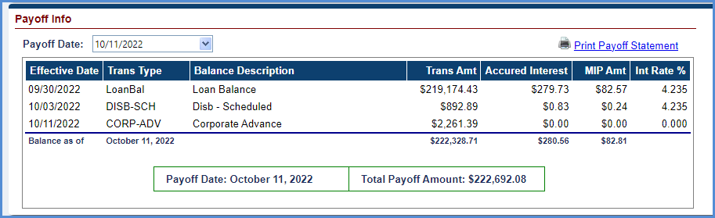
Figure 5-70: View Payoff Statement Screen

Statement
The Monthly Statement screen is displayed when an authorized user selects the Statement tab from the menu on the left side of the screen. The screen displays the monthly statement amount details as of the selected reporting period. Only authorized users have access to the Statement screen. This screen also allows printing the Monthly Statement for a selected month.

Viewing and Printing a Monthly Statement
To view and print a monthly statement:
- From the Reporting Period dropdown box, select the month for which the statement needs to be viewed or printed.
- Click Print Monthly Statement.
- The monthly statement is displayed in a PDF file.
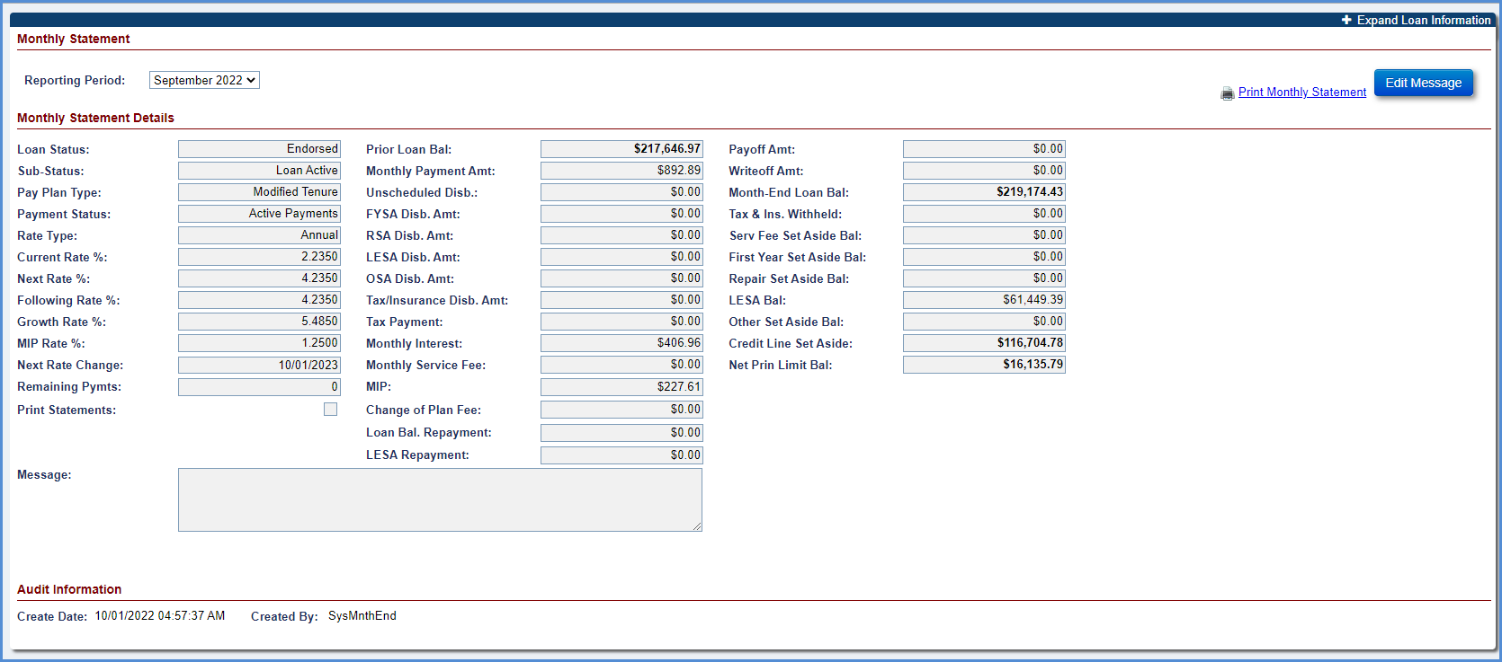
Figure 5-71: View Monthly Statement Screen

Editing the Monthly Statement Message
To edit the monthly statement message:
- Click Statement.
- Click Edit Message.
- In the Custom Message section, enter the message.
- Select the checkbox for Repeat this message on future statement if required.
- Click OK to save the message.
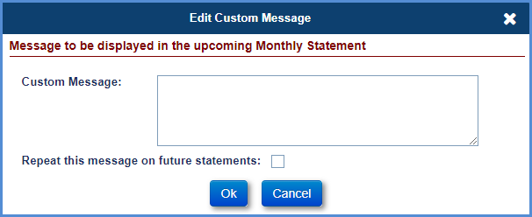
Figure 5-72: Edit Monthly Statement Message Window

Disbursement
The Disbursement screen is displayed when an authorized user selects the Disbursement tab from the menu on the left side of the screen. Only authorized users (Example: HUD NSC Contractor) have access to the tab. This screen displays all the disbursement transactions associated with the loan. If HUD has granted access for a Servicer to be permitted to make HUD Borrower Disbursements on Endorsed loans, then the New button is displayed on this page. The New button is only displayed for a loan if the current Servicer has “Display Disbursements Page” box checked on the Admin Servicer page.
- Disb – Unscheduled from LOC
- Disb – Scheduled
- Corp Advance – Penalty

Performing a HUD Borrower Disbursement on Endorsed Loans and Reimbursing HUD
This disbursement is initiated by the authorized user for HUD to make a payment to a borrower on Endorsed loans when the investor is unwilling or unable to make a disbursement. A HUD Borrower Disbursement is required before initiating a Claim Type 20 – Demand Assignment timeline. Reimbursement of a HUD Borrower Disbursement is the process of remitting funds back to HUD after the HUD Borrower Disbursement was made. The total amount Reimbursed to HUD includes the HUD Borrower Disbursement Amount plus interest owed to HUD for the Disbursement.
To perform HUD Borrower Disbursement:
- Click New on the Disbursements screen.
- On the New Disbursement window, select from Transactions Category dropdown.
- Populate the below listed required fields (marked with red asterisk):
- Click Submit. The New Disbursement window is refreshed with additional fields.
- Enter the information in the below listed fields
  - Disbursement Amount
  - The “Pay To” field is not editable
- Click Submit to save the changes. This disbursement is displayed in the Disbursement screen.
- The supervisor role must Authorize Disbursements to be sent for Accounting. See Section – 6.19.4

HUD Borrower Disbursements that are eligible to be Reimbursed to HUD will be displayed in the Reimbursements to HUD page. A Disbursement can only be Reimbursed to HUD once, and the total Reimbursement amount includes the Disbursement amount plus owed Interest calculated by the system. To be available for Reimbursement, the HUD Borrower Disbursement transaction must be displayed on the Loan > Transactions > Loan page with a Disbursement Status of “Disbursed” and the Disbursement must not be Voided.
To perform Reimbursement of a HUD Borrower Disbursement:
- Go to Accounting > Reimbursements to HUD

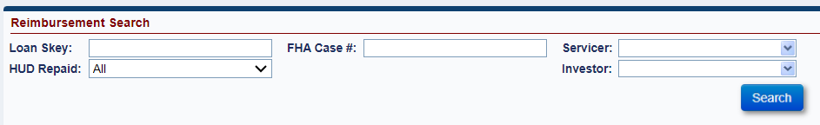
Figure 5-73: Reimbursements to HUD Search

- To search for all HUD Borrower Disbursements under a specific Servicer that are eligible to be Reimbursed to HUD, select the “Servicer” and filter by field “HUD Repaid” status of Not Authorized, then click Search. This field corresponds to the column in the Reimbursement Search Results grid “HUD Repaid Status” which is displayed in the results in a column to the right.
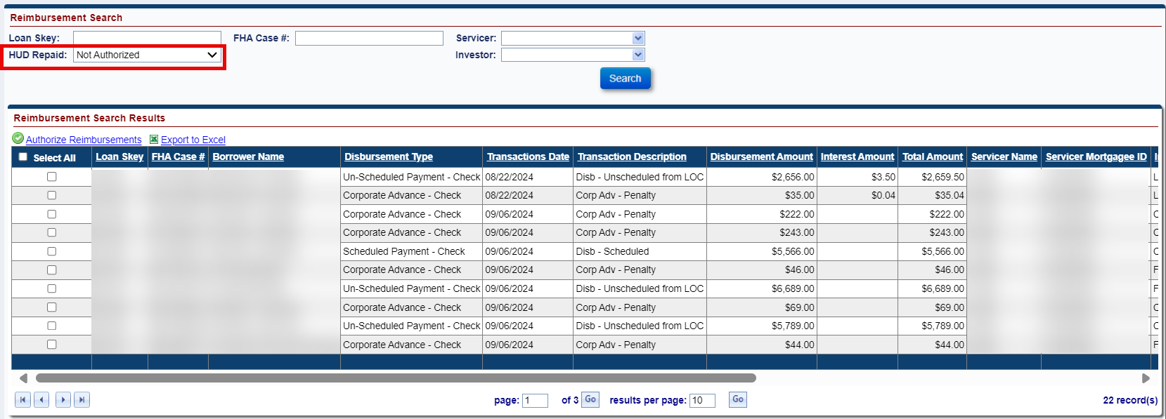
Figure 5-74: Reimbursements to HUD Results
- A checkbox is displayed on each row under heading Authorize Reimbursements. The user may either Select All records on the page by clicking the Select All checkbox at the top of the column or may select certain records by clicking the box for specific rows.
- After selecting which Disbursements to Reimburse, click Authorize Reimbursements link.
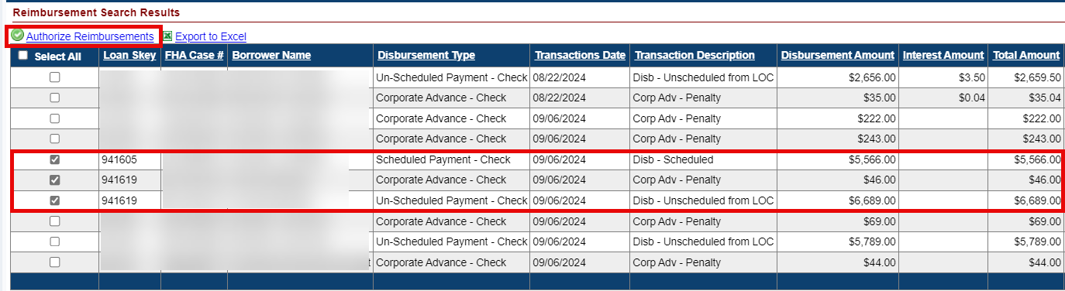
Figure 5-75: Reimbursements to HUD Selected Records
- The Authorization Information window will be displayed with FHA Case #, Authorization Type Reimburse HUD, Reimbursement Amount, Interest Amount, and Total Amount. The FHA Case # is only displayed if one row is selected, for multiple rows it will state “Multiple Case Numbers.” The Reimbursement Amount is the total of the selected HUD Borrower Disbursements. The Interest Amount is the total Interest owed on the selected HUD Borrower Disbursements. The Total Amount is the sum of the Reimbursement Amount plus the Interest Amount and is the final amount that will be paid to HUD for this Reimbursement action.
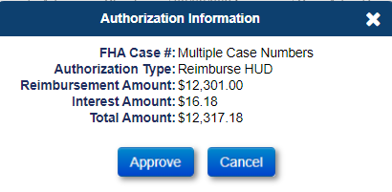
Figure 5-76: Reimbursements to HUD Authorization Information
- After clicking Approve, a window is displayed to confirm the collection. Click YES to proceed, or NO to cancel.
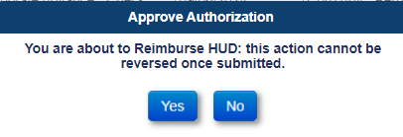
Figure 5-77: Reimbursements to HUD Approve Authorization
- After clicking YES, a window is displayed stating “Reimbursements processed successfully”: click OK.
- The collection is sent to the Accounting Module in the nightly process. Authorized records are updated with the following:
- The checkbox next to the Authorized record is no longer available
- “HUD Repaid” Status is updated from Not Authorized to Authorized not Settled
- Interest Amount in the Reimbursement Search Results is populated with total calculated interest as of the date the Reimbursement to HUD was Authorized.
- Total Amount in the Reimbursement Search Results is populated with the final total of Disbursement Amount plus Interest Amount
- Accounting > Transmittals Batch Type “Claims Receivable-HUD Borrower Disb” will be created
- Loan > Transactions > Claims transactions will be created that correspond to the Reimbursement
Interest owed to HUD for HUD Borrower Disbursements. Interest begins accruing on the HUD Borrower Disbursement transaction’s Effective Date and go through the Reimbursement to HUD date / the date HUD is reimbursed for the HUD Borrower Disbursement.
Terminations: A loan cannot be Terminated if the loan has a HUD Borrower Disbursement that has not been Reimbursed to HUD. An error message will be displayed stating the following “Loan Cannot be terminated because a HUD Borrower Disbursement exists on the loan which has not been Reimbursed.” After the Reimbursement to HUD is successful, the Termination can be posted.
Claims Impacts: A Claim Type 20 – Demand Assignment may be filed if there is an unreimbursed HUD Borrower Disbursement on the loan. However, the system will prevent Claim Types 21, 23, and 24 Supplemental if the loan has a HUD Borrower Disbursement that has not been Reimbursed to HUD. After the Reimbursement to HUD is successful, the Claim can be filed.

Servicer Info
The Lender, Servicer, Master Servicer and Investor information is displayed when a user selects the Servicer Info tab from the menu on the left side of the screen. This screen allows servicers, lenders, master servicers and investors to transfer the Case from one servicer/investor/master servicer to other. The Servicer Information, Master Servicer Information and Investor Information can be viewed and edited by the authorized (Servicer or Investor role) users. Bank information of a particular servicer/investor can only be viewed or edited by the authorized users belonging to the same firm. For loans in a cancelled status, no user can view or modify the bank account information for a Servicer or Investor.
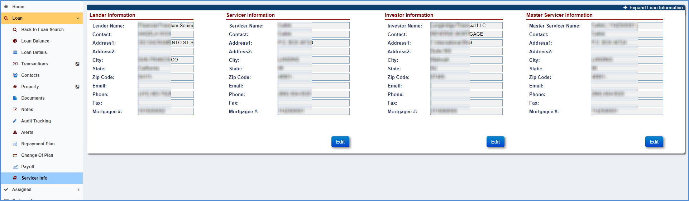
Figure 5-78: Servicer Information Screen

Transferring a Case to a Servicer
To transfer the servicer information for the selected loan:
- Click Edit in the Servicer Information section.
- On the Edit Servicer window, select a servicer from the dropdown.
- Change the Servicer Name.
- Select the effective Transfer Date (this is the first date of the month when the transfer must occur) from the dropdown.
- The contact information for the selected servicer is displayed before clicking Submit.
- Click Submit to save the changes. The original information will be displayed until the Servicer Transfer is completed on the Transfer Date, then the new information is displayed in the Servicer Information section.
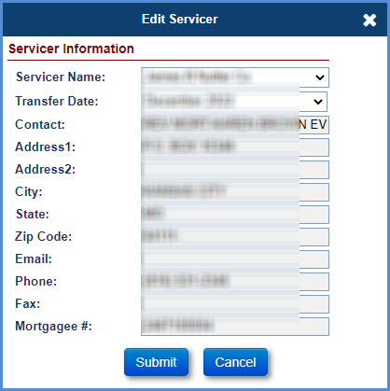
Figure 5-79: Transfer Servicer
- If necessary, a Pending Servicer Transfer can be cancelled under Batch > Servicer Transfer List before the Transfer Date: Search for Pending transfers then select the checkbox for the desired record and click on Cancel Transfer(s).

Editing Servicer Bank Information
To edit the servicer bank information for a selected loan:
- Click Options in the Servicer Information section.
- On the Edit Servicer Bank Account window, modify ABA Routing #, Account #, Confirm Account # Tax ID#.
- Click Submit to save the changes.
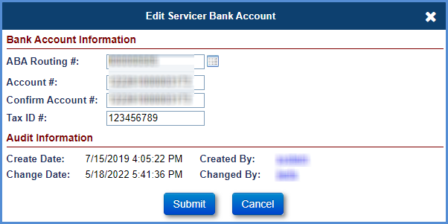
Figure 5-80: Edit Servicer Bank Account Information Window

Transferring a Case to an Investor
To transfer the investor information for the selected loan:
- Click Edit in the Investor Information section.
- On the Edit Investor screen, select an investor from the dropdown.
- The contact information for the selected investor is displayed.
- Click Submit to save the changes. The new information is displayed in the Investor Information section.
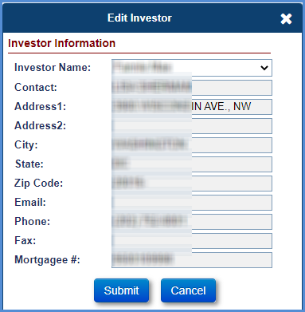
Figure 5-81: Transfer Investor Window

Editing Investor Bank Information
To edit the investor bank information for a selected loan:
- Click Options in the Investor Information section.
- On the Edit Investor Bank Account window, modify ABA Routing #, Account #, Confirm Account #.
- Click Submit to save the changes.
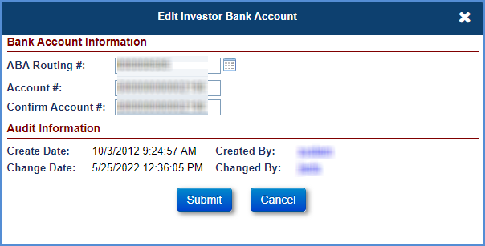
Figure 5-82: Edit Investor Bank Account Information Window

Transfering a case to a Master Servicer
To transfer the Master Servicer information for the selected loan:
- Click Edit in the Master Servicer Information section.
- On the Edit Master Servicer screen, select a Master Servicer from the dropdown.
- The contact information for the selected master servicer is displayed.
- Click Submit to save the changes. The new information is displayed in the Master Servicer Information section.
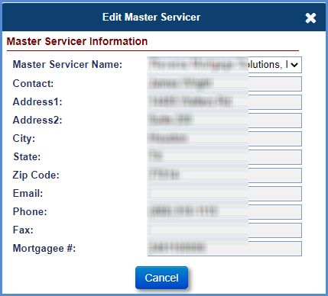
Figure 5-83: Transfer Master Servicer Window

Bank Account
The Borrower Bank Account Information screen is displayed when an authorized user selects the Bank Account tab from the menu on the left side of the screen. The Bank Account information will be used by the system to make the payments to the borrower (if payment method is selected as ACH). For Endorsed loans, when a CT 22 – Assignment timeline is initiated and step HUD Issued Preliminary Title Approval is completed, the lender/servicer will not have access to general servicing functions to initiate any transactions. This screen can be used by lender/servicer prior to Assignment process to edit the Payment Method and Borrower’s Bank Account information.

Editing Borrower Bank Account Information
To edit the bank account or payment method:
- Click Edit on the Borrower Bank Account Information section.
- To auto-populate the ABA routing number, click the Edit Icon beside the field. A new window is displayed with bank name.
- Enter the Bank Name and click Search.
- From the search results, select the Bank Name. The ABA Routing Number of the Bank is populated.
- Enter the other fields on the Bank Account Information section.
- Click the dropdown list to update the Payment Method and select Check/ACH.
- Click Submit to save the changes. The updated information is displayed on the Borrower Bank Account Information section.

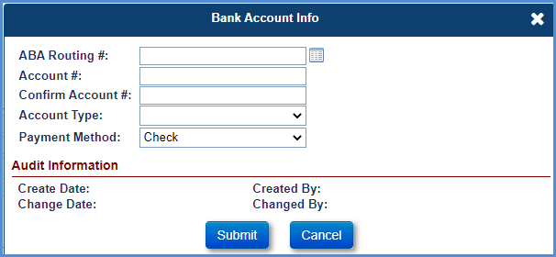
Figure 5-84: Edit Borrower Bank Account Information Window

Accounting
The Accounting tab available on the Left Menu allows authorized users to track the status of the payable and receivable transactions associated with a loan. The Accounting tab has the following sub-menu options:
- Transmittals
- Disbursements
- Authorizations
- Premiums
- Refunds
- Claims

Transmittals
Authorized Users can select Transmittals from the Left Menu. This screen provides the history of all the batches generated in the Servicing Module and sent to the Accounting Module for payment processing. The transactions include Premiums (IMIP, MIP, and Refunds), Notes (Disbursements, Monthly Accruals, Other) and Claims (Payables and Receivables).

IMIP/Refunds/MMIP
To generate the daily IMIP and Refunds transactions initiated in HERMIT system for the prior day, the lenders/servicers must access the Transmittals screen the next day. Given below is the suggested search criteria:
- For IMIP transactions: Select Batch Type = Initial MIP Due and the Created Date = Prior day
- For approved Refund transactions: Select Batch Type = Refunds and the Created Date = Prior day
To generate the MMIP transactions initiated in HERMIT system, select Batch Type = Monthly MIP Due and the Created Date = current month
To generate the batch extract:
- Enter the search criteria and click Search on the Transmittals Search section.
- The search results matching the search criteria are displayed in the Transmittal Search Results section.
- Select Export to Excel to export the results in an excel file.
The Transmittal screen provides the following search criteria:
Field | Description
Loan Skey | The Servicing Module system identification number unique to each loan.
FHA Case # | FHA case number of the loan (Enter a partial FHA Case #, if the complete number is not known).
Servicer Name | Name of the Servicer servicing the loan.
Investor Name | Name of the Investor
Batch # | Unique ID for each batch
Created Date (From and To Dates) | Date the batch was created
GL Sent Date (From and To Dates) | Date the batch was sent to GL notifying collection/payment request.
Sent Conf Date | Date the batch was sent to GL confirming collection/payment request.
Posted Date | Date the collection was successful at Pay.Gov.
Check/ACH # | Check or ACH number from disbursement
Batch Type | Selection from dropdown values
Batch Status Category | Selection from dropdown values
Batch Status | Status of the Batch. Refer below tables for descriptions.
Batch Amount | Total amount associated with the batch.
Table 5-13: Transmittal Screen Search Criteria
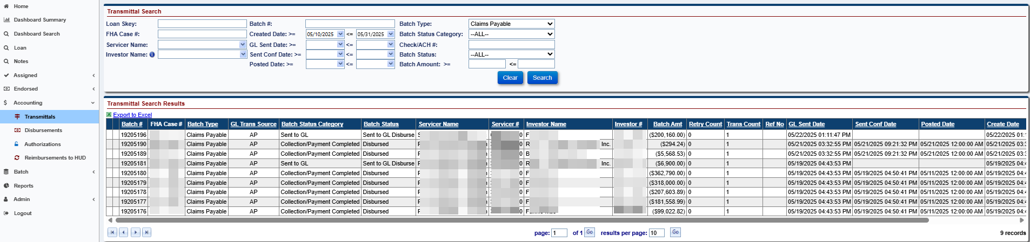
Figure 5-85: Transmittals Search Results Screen

Viewing Transmittal Details
The Transmittal Search Results data set is listed in the below table.
Field Name | Detailed Description
Batch# | Unique ID for each batch.
FHA Case # | FHA case number of the loan Note: will display for batches with Trans Count of one.
Batch Type | Type of Batch for which collection/payment is made.
GL Trans Source | Receivable or Payable generated for the batch.
Batch Status Category | Category of the Batch Status. Refer below tables for descriptions.
Batch Status | Status of the Batch. Refer below tables for descriptions.
Servicer Name | Name of the Servicer servicing the loan.
Servicer # | Mortgagee ID of the Servicer servicing the loan.
Investor Name | Name of the Investor.
Investor # | Mortgagee ID of the Investor.
Batch Amt | Total amount associated with the batch.
Retry Count | Count of retry of the batch sent for collection/payment if initial attempt was failed.
Trans Count | Count of transactions in a batch.
Ref No | Reference Number of the batch.
GL Sent Date | Date the batch was sent to GL notifying collection/payment request.
Sent Conf Date | Date the batch was sent to GL confirming collection/payment request.
Posted Date | Date the collection was successful at Pay.Gov.
Create Date | Date the batch was created in the system.
ADP Code | The ADP code on the loan.
Check/ACH# | The check number or ACH number associated with the batch.
Table 5-14: Transmittal Search Result Dataset

Premiums Batch Statuses
The Premiums transaction batch statuses are listed in the table below.
Batch Status Category | Batch Status | Detailed Description
Ready for Approval | Ready for Approval | Batch waiting for Servicer approval.
Ready to Transmit/Retry | Ready to Transmit | Batch created but interface file not generated yet.
Ready to Transmit/Retry | Ready To Retry | Servicer has fixed bank info or NSF issues and has authorized a retry of Collection.
Sent to GL | Sent to GL | Batch created and file sent to Accounting Module and waiting on Response from Accounting Module.
Receivable/Payable Established | Success – Disburse | Batch was successfully uploaded in AM.
Collection/Payment Collected | Disbursed | Payment was successfully completed.
Collection/Payment Collected | Settled | Collection was successfully completed in Pay.gov.
Collection/Payment Collected | Rejected | Payment was cancelled for some reason in Pay.gov.
Failed | Retired | Collection was not completed in pay.gov (probably due to NSF).
Failure – Technical Issues | Failure | Batch could not be uploaded primarily due to technical or format issues.
Failure – Technical Issues | Failure-Collect | Collection batch had an interface error with Pay.gov.
Receivable/Payable Established | Success-Collect | Batch was successfully uploaded in AM.
Table 5-15: Premiums Batch Statuses

Claims Batch Statuses
The Claims transaction batch statuses are listed in the table below
Batch Status Category | Batch Status | Detailed Description
Ready to Transmit/Retry | Ready to Transmit Held | Claims payable/receivable batch created but interface file not generated yet.
Ready to Transmit/Retry | Ready To Retry | Lender has fixed bank info or NSF issues and has authorized a retry of collection.
Sent to GL | Sent to GL Held | Claims payable/receivable batch created and file sent to Accounting Module and waiting on response from Accounting Module.
Receivable/Payable Established | Success – Held | Claims payable/receivable batch was Successfully uploaded in Accounting Module.
Failure – Technical Issues | Failure – Held | Claims payable/receivable batch could not be uploaded primarily due to technical or format issues.
Ready to Transmit/Retry | Ready to Transmit Disburse | Claims payable release batch created but interface file not generated yet.
Sent to GL | Sent to GL Disburse | Claims payable release batch created and file sent to Accounting Module and waiting on response from Accounting Module.
Receivable/Payable Established | Success – Disburse | Claims payable batch release was successfully uploaded in Accounting Module.
Failure – Technical Issues | Failure – Disburse | Claims payable release batch could not be uploaded primarily due to technical or format issues.
Receivable/Payable Established | Disbursed | Payment was successfully completed.
Failed | Rejected | Claims Payment was cancelled for some reason in pay.gov.
Ready to Transmit/Retry | Ready to Transmit Collect | Claims receivable release batch created but Interface file not generated yet.
Sent to GL | Sent to GL Collect | Claims receivable release batch created and file sent to Accounting Module and waiting on response from Accounting Module.
Collection/Payment Collected | Success – Collect | Claims receivable release batch was successfully uploaded in Accounting Module.
Failure – Technical Issues | Failure – Collect | Claims receivable release batch could not be uploaded primarily due to technical or format issues.
Collection/Payment Collected | Settled | Collection was Successful in Pay.gov.
Failed | Retired | Collection was not completed in Pay.gov (probably due to NSF).
Table 5-16: Claims Batch Statuses

Viewing Batch Details
To view batch details:
- Enter the search criteria and click Search on the Transmittals Search section.
- The search results matching the search criteria are displayed in the Transmittal Search Results section.
- Select a record displayed in the search results. The Batch Details screen is displayed.
  - Batch Details: Displays the loans/FHA cases sent to the Accounting Module in that batch. The details of the batch vary and depend on the batch type selected.
  - Audit Tracking: Enables users to view the audit of the batch status values
  - Batch Note: Displays additional information if the batch failed.

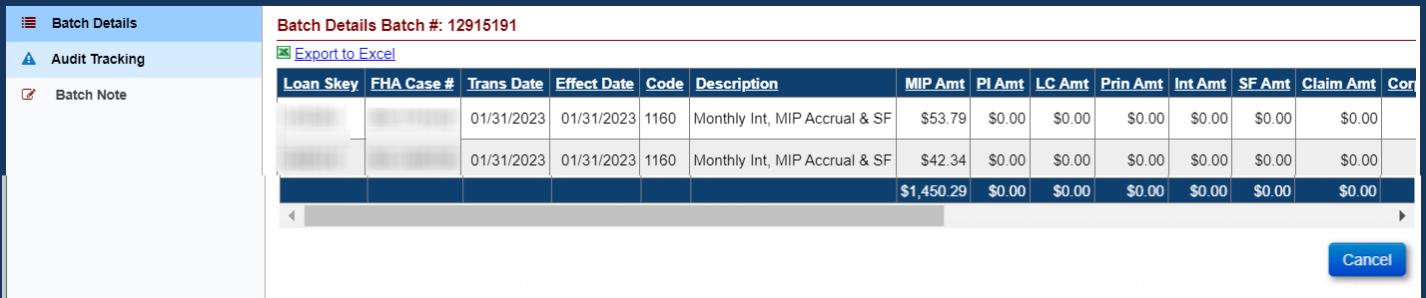
Figure 5-86: Batch Details Screen
- Select the Audit Tracking menu on the Batch Details screen to view the Audit Results screen.
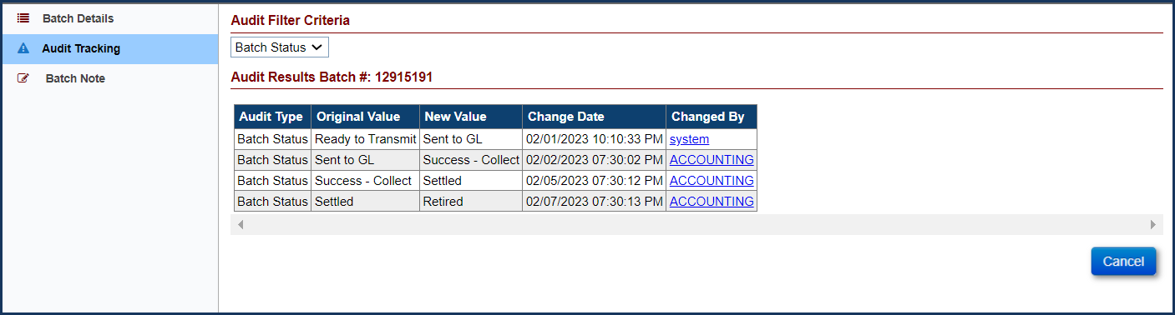
Figure 5-87: Audit Results Screen

Approval of MMIP prior to Collection
Monthly MIP (MMIP) batches are grouped at the Servicer / Investor level and MMIP batches must be Approved by the Servicer before MMIP is collected via Treasury. This applies to all MMIP on the loan including large batches generated after month end accruals are posted to the loan, Daily MIP activity due to Payoffs, MIP adjustments, or other changes to loan data that affect a loan’s MIP accruals. Multiple batches under the same Servicer can occur. MIP batches are generated daily for approval.
Late fees and Penalty Interest will be charged on each batch when Approval of MIP is completed after the HUD established deadlines.
This section does not apply to Initial MIP collection.

Approving MIP Batches:
The Approve MIP link is displayed on the Accounting > Transmittal screen on the left menu in HERMIT. This screen displays the MIP Batches that need Approval from a servicer. Each Investor’s Batch must be approved by the Servicer. Upon Approval, the Approve MIP link will no longer be displayed on the screen. Monthly MIP Batches will need to be Approved once generated in the Servicing Module. Daily MIP batches will need to be approved individually as needed based on a Servicer’s loan activity. MMIP batches cannot be removed from an Investors batch once it is batched up on the Accounting Transmittal screen. Servicers will need to ensure the loans in their portfolio are assigned to the correct Investor prior to the transaction being created.

To Approve a MIP Batch:
- Enter the search criteria and click Search on the Transmittals screen to display the Approve MIP link(s).
- The search results matching the search criteria are displayed in the Search Results section. Available search criteria are:
      - Loan Skey
      - FHA Case #
      - Servicer Name
      - Batch #
      - Created Date
      - Investor Name (User can filter by Investor Name to see the batches for a given Investor after Release 7.6)
      - Batch Type
      - Batch Status Category (User can filter by Ready for Approval to display Batches with Approve MIP link)
      - Check/ACH #
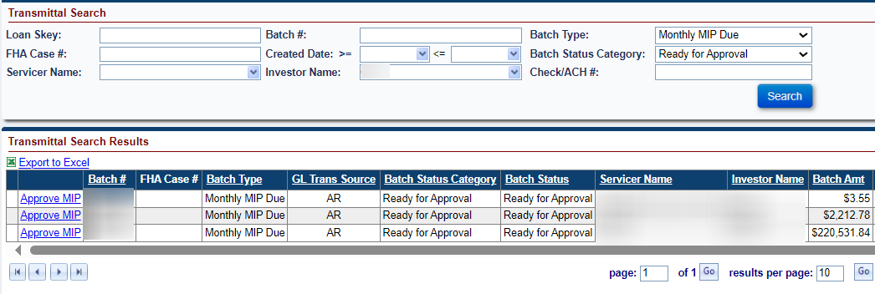
Figure 5-88: Audit Results Screen
- Click Approve MIP link on the record in the search results. The Approve MIP window is displayed. (The Approve MIP window will display Penalty Interest and Late Charge when the servicer approves the MIP late if applicable)
- Click Submit on the Approve MIP window. To exit without approving click Cancel.
- Click OK on the pop-up message “Are you sure you want to approve this batch” to approve the batch. To exit without approving click Cancel.
- Once approved, the MIP Batch is released to the Accounting Module for payment collection. The updated batch status will be displayed in the Transmittals Search Results.
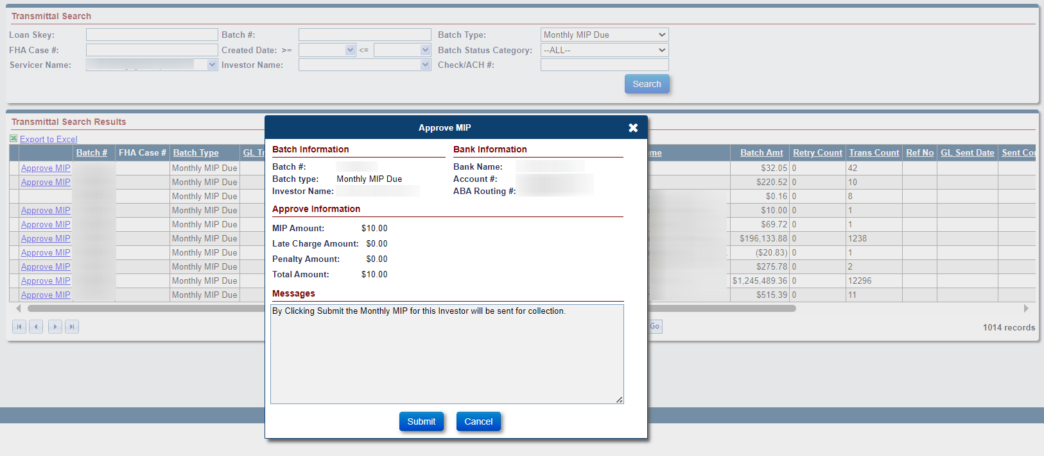
Figure 5-89: Audit Results Screen
- Repeat previous steps for each Batch available for approval (with Approve MIP link).

Once the Servicer has approved the MIP Batch a note will be added to the MIP Batch record. The Note will read: “The Monthly MIP was Approved by User ID on MM/DD/YYYY in the amount of $xxxxxx.xx for the Investor (Investor Name).” The Servicer can view this note by clicking on the approved MIP Batch record under the Transmittal search results. Once the Batch Details window pops up click Batch Note on the left menu to see the added Batch Note.

Retry Batch
To retry a failed batch:
- Enter the search criteria and click Search on the Transmittals Search section to display the failed transactions.
- The search results matching the search criteria are displayed in the Transmittal Search Results section.
- Select the Retry link beside the record displayed in the search results. The Retry Batch window is displayed.
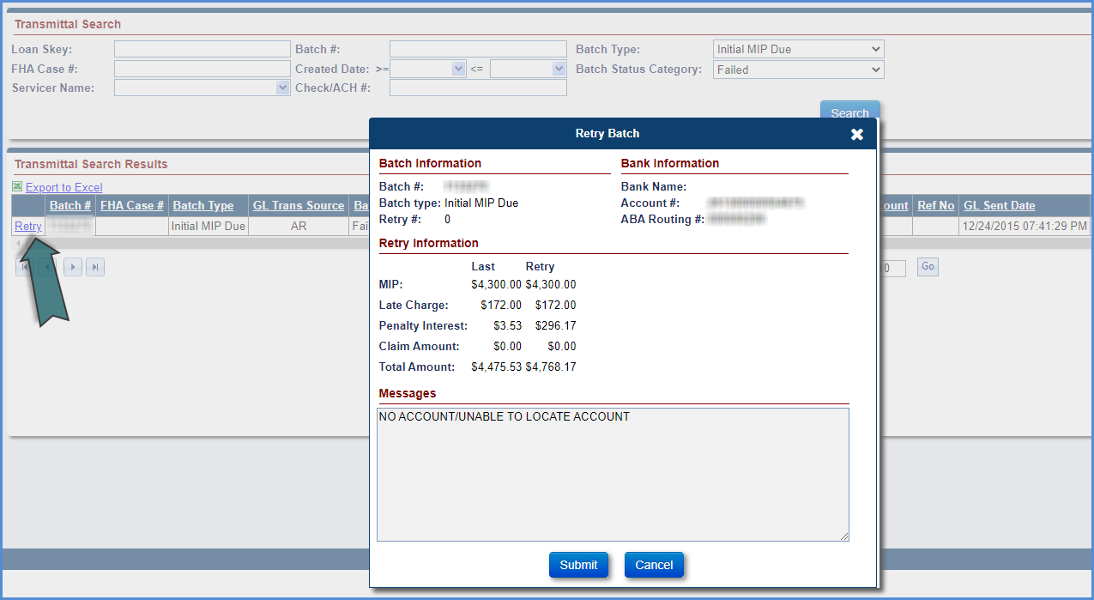
Figure 5-90: Retry Batch Window
- Edit the message if needed and click Submit to resend the transactions within the batch to Accounting Module for collections.
- If there is a difference in the collection amount (such as late charge or penalty) at the time of retry, the batch will create supplemental adjustment transaction for the additional amount.

Premiums (IMIP)
Authorized Users can select Accounting – Premiums (IMIP) from the Left Menu. This screen displays the IMIP and IMIP-adjustment transactions.
The Premiums screen provides the following search criteria:
Field | Description
Loan Skey | Unique ID for each FHA Case.
FHA Case # | The HECM Case number.
Case Status | Selection from dropdown values.
Batch Status | Selection from dropdown values.
Trans Date | The transaction created date (from and to dates).
Lender Name | Name of the lender on the loan.
Servicer Name | Name of the servicer on the loan.
Table 5-17: Search Criteria for Premiums
To view Premiums: Enter the search criteria and click Search on the Premiums screen to display the transactions. Upon selection of a record, the user is navigated to the Loan Balance screen for the selected loan.
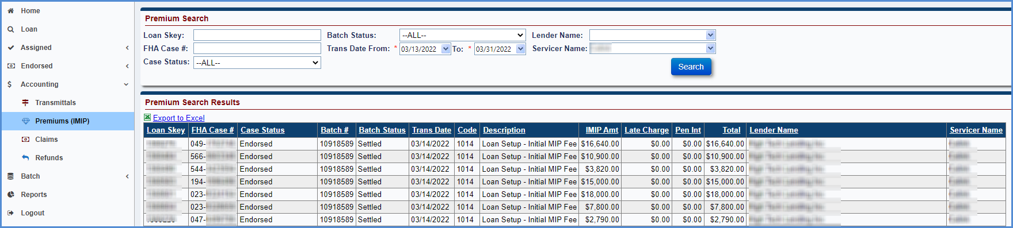
Figure 5-91: Premiums Screen

Refunds
Authorized Users can select Accounting – Refunds from the Left Menu. This screen displays the refund transactions for late charges and penalty interests that need an approval for payment. Only the HUD SF premiums manager can approve or deny the refund. Upon approval, the transaction will be released to the Accounting Module for disbursement.
The Refund screen provides the following search criteria:
Field | Description
Loan Skey | Unique ID for each FHA Case.
FHA Case # | The HECM Case number.
Refund Type | Selection from dropdown values.
Refund Status | Selection from dropdown values.
Servicer Name | Name of the servicer on the loan.
Lender Name | Name of the lender on the loan.
Investor Name | Name of the investor on the loan.
Table 5-18: Search Criteria for Refunds
To approve or deny a refund:
- Enter the search criteria and click Search on the Refunds screen to display the Pending refund transactions.
- The search results matching the search criteria are displayed in the Search Results section.
- Select the record displayed in the search results. The Refund Information window is displayed.
- On the Refund Information window, select Approved or Denied values from the Refund Status dropdown box. Optionally add Appr/Deny Reason and Refund Comments.
- Click Submit to save the changes. The Refund Status changes to Approved/Denied based on the selection in previous step. To exit the window without saving the changes, click Cancel.
- Once approved by the HUD SF Premiums Manager, the payable transaction is released to the Accounting Module for disbursement. The updated batch status of the transaction can be viewed using the Transmittals screen.
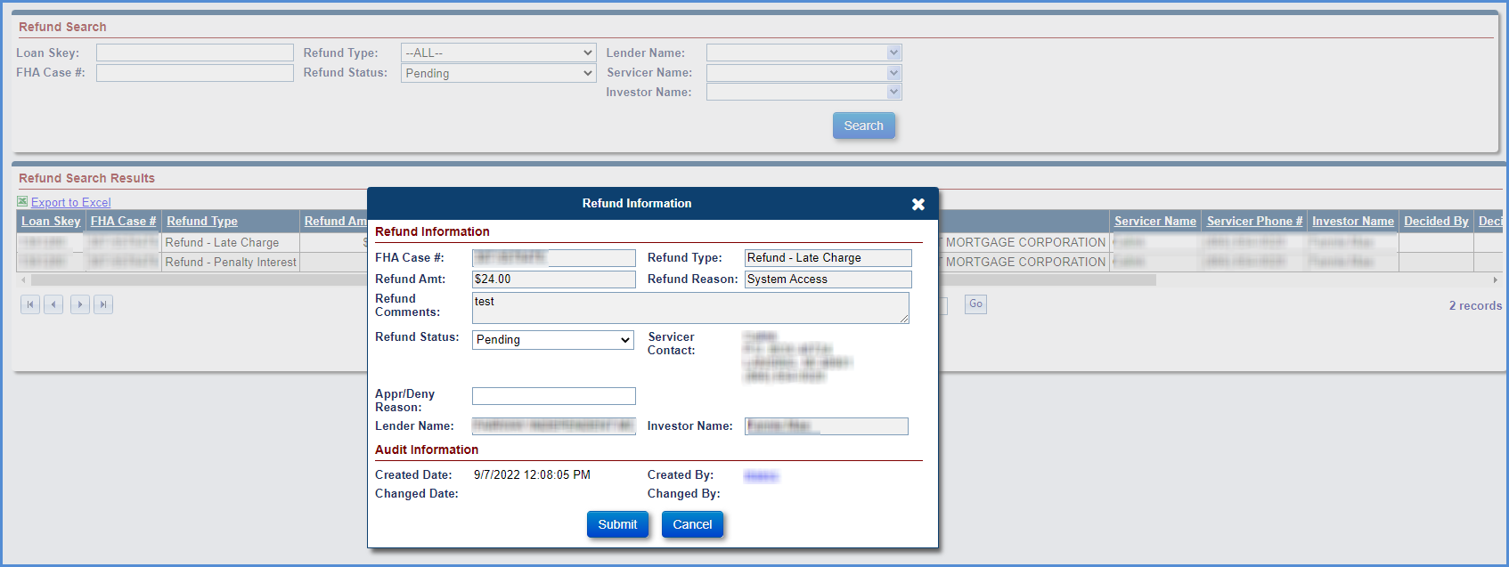
Figure 5-92: Edit Refund Information Window

Claims
Authorized Users can select Accounting – Claims from the Left Menu. This screen displays the claims payable transactions upon approval of a claim by the HUD Claims Branch. Authorized users can cancel the claim payment on this screen. The cancellation must be done before the claims transaction file is sent to the Accounting Module for that day. Once the transaction has been sent to the Accounting Module, the payment cannot be cancelled (see section 8.8). Upon payment confirmation from the Accounting Module, the claim transaction will no longer be displayed on the screen.
The screen also allows the user to search for claims that have been approved, denied and cancelled for payment after an approval, and no pay order after approval of claim.
The Claims screen provides the following search criteria:
Field | Description
Loan Skey | Unique ID for each FHA Case.
FHA Case # | The HECM Case number.
Case Status | Selection from dropdown values.
Batch Status | Selection from dropdown values.
Claim Status | Selection from dropdown values.
Trans Date | The transaction created date (from and to dates)
Lender Name | Name of the lender on the loan
Servicer Name | Name of the servicer on the loan
Investor Name | Name of the investor on the loan
Table 5-19: Claims Search Criteria
To cancel a claim payment before 7:30 pm on the same day the claim is approved for payment:
- Enter the search criteria and click Search on the Claims screen to display the claims transactions. Claims that need cancellation can also be searched by selecting the Batch status of Pending and Claim Status of Approved for Payment.
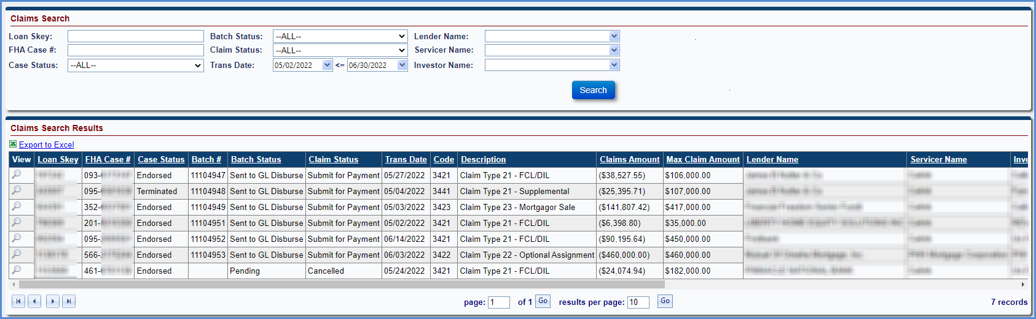
Figure 5-93: Accounting – Claims Screen
- The search results matching the search criteria are displayed in the Search Results section.
- Select the record displayed in the search results. The Edit Claim window is displayed.
- On the Edit Claim window, select Cancelled from the Claim Status dropdown.
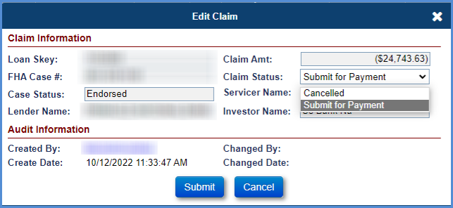
Figure 5-94: Edit Claim Window
- Click Submit to save the changes. A certify window is displayed requesting the user to confirm action. Enter password and click Yes.

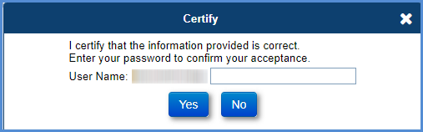
Figure 5-95: Certify Window
- The Claim Status is updated to Cancelled. To exit the window without saving the changes, click Cancel.
- Select the magnifying glass icon beside the claim record to view the HUD Claim Form- 27011 for the claim transaction.

Batch
The Batch tab available on the left menu allows authorized users (example: lenders/servicers) to perform an action on multiple loans at the same time. The Batch tab has the following sub-menu options:
- Loan Setup
- Initial Transfer
- Servicer Transfer List
- Servicer Transactions
- Servicer File Upload

See Section 4.3 for details on Loan Setup B2G.

Initial Transfer
The Initial Transfer screen is displayed when an authorized user selects Initial Transfer under the Batch tab displayed in the Left Menu. The Initial Transfer page allows lenders to assign a servicer for multiple FHA cases (10 cases at a time) in Suspense status. The lender must select the servicer from a subset of servicers linked to the current lender; otherwise, the system will not allow the initial transfer process and a validation error message will be displayed.
The Initial Transfer displays the following fields:
Field | Description
Transfer Date | The date the loan is transferred to a servicer.
FHA Case# | The 10-digit FHA case number.
To Servicer | The servicer’s name to whom the loan is transferred.
Validation | The validation message for the initial transfer process, this is populated automatically by the system when the transfer request is submitted.
Table 5-20: Initial Transfer Fields
To perform an initial transfer:
- On the Initial Transfer screen, enter the FHA Case # of the case for transfer to a servicer. The case status must be Suspense.
- Enter the name/mortgagee# of the new Servicer to transfer the case.
- Click OK to submit the transfer request. The status of Initial Transfer is Pending is displayed if no validation errors occur. The Validation column will display Pending. If there is a validation error, the system displays the validation message in the Validation column of the screen.
- Click Submit if the status of Initial Transfer is pending and no validation messages are displayed.
- A message box displays, Initial Transfer Successful. Click OK. The new servicer name can be viewed in the Loan Search page.
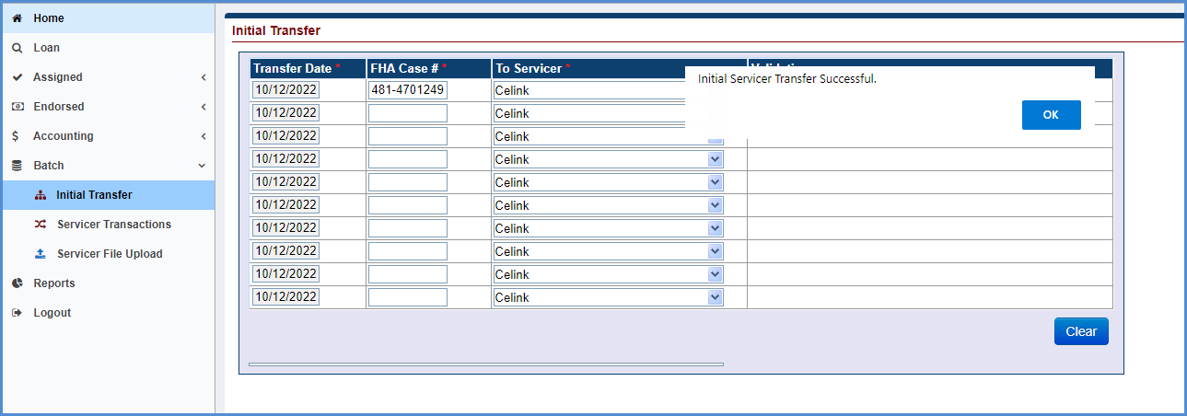
Figure 5-96: Initial Transfer Screen

Servicer Transfer List
The Servicer Transfer List screen is displayed when an authorized user selects Servicer Transfer List under the Batch tab displayed in the Left Menu. The Servicer Transfer List screen allows lenders to view the pending transfers of loans from one lender/servicer to another lender/servicer. The screen also allows the user to cancel the pending transfers.
The Servicer Transfer List provides the following search criteria:
Field | Description
Transfer Date | The date the FHA case transfers from current Servicer to another Servicer or Current Investor to another Investor.
Current Servicer | The name of the current Servicer.
To Servicer | The name of the Servicer to which the FHA case was transferred.
Current Investor | The name of the current Investor.
To Investor | The name of the current Investor to which the FHA case was transferred.
Table 5-21: Servicer Transfer Search Screen
To view the servicer transfer case details:
- Enter the search criteria and click Search on the Servicer Transfer Search section to display the transfers.
- The search results matching the search criteria are displayed in the Search Results section.
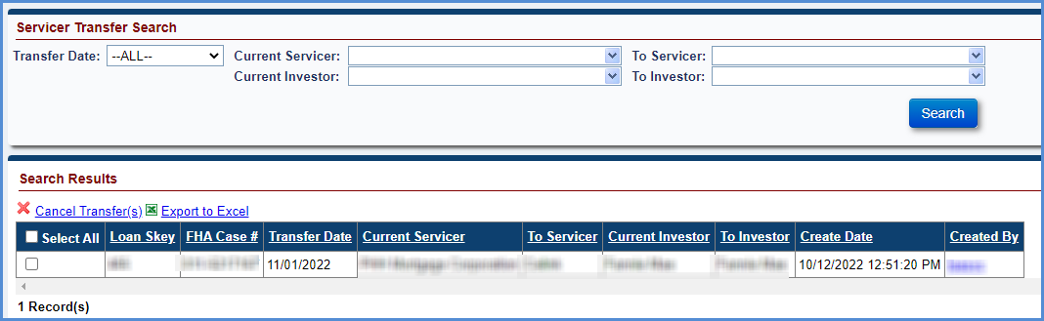
Figure 5-97: Servicer Transfer Search Results

To cancel a pending transfer:
- Enter the search criteria and click Search on the Servicer Transfer Search section to display the transfers.
- The search results matching the search criteria are displayed in the Search Results section.
- Enter the checkbox of the transfers that must be cancelled. Click Cancel Transfer link in the Search Results section.
- A pop-up message window is displayed to confirm the action. Click OK to cancel the transfer.
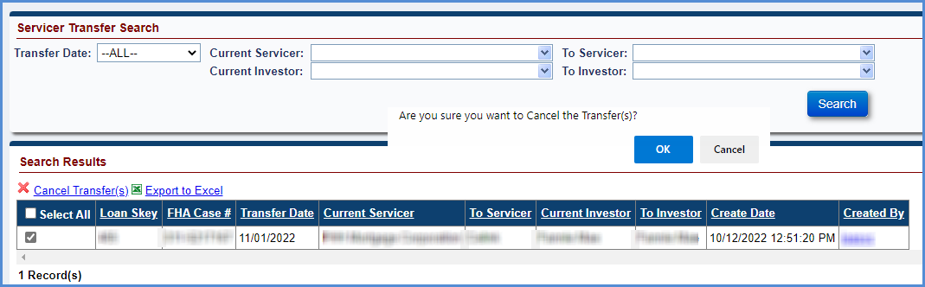
Figure 5-98: Cancel Pending Transfer

Servicer Transactions
The Servicer Transactions screen is displayed when an authorized user selects Servicer Transactions under the Batch tab displayed in the Left Menu. The Servicer Transactions screen allows the authorized user (example: lenders/servicers) to add multiple transactions on a single or multiple loans (maximum of 10 transactions at a time).
To enter transactions on the Servicer Transactions page:
- Enter the required fields to add a transaction and click Validate. The Incurred Date field is required only for Corp Advance transaction categories.
- If any validations failed, the Validation column of this will display the error/warning messages.
- If no validations fail, the Validation column will display Pending.
- Click Submit to add the transactions on the loan.

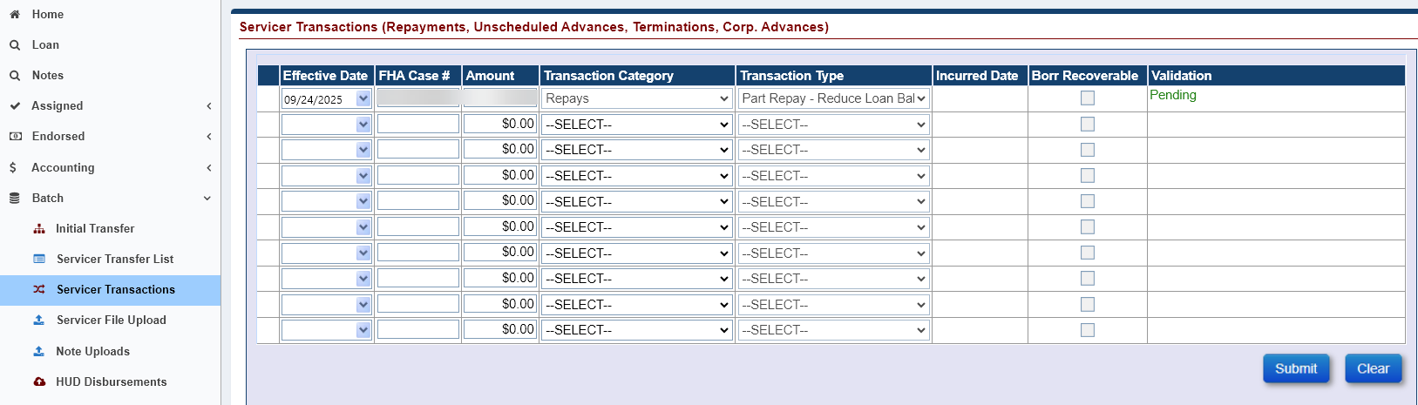
Figure 5-99: Batch Servicer Transactions

Servicer File Upload
The Servicer File Upload screen is displayed when an authorized user selects Servicer File Upload under the Batch tab displayed in the Left Menu. The Servicer File Upload screen allows the authorized user (example: lenders/servicers) to upload various types of B2G files.
Field | Description
Loan Setup Import | Enables lenders/servicers to setup one or multiple loans in the Servicing Module.
Servicer Transfer Import | Enables lenders/servicers to record the transfer of servicers on HECM Cases in the Servicing Module.
Transactions Import | Enables lenders/servicers to record loan transactions in the Servicing Module.
OPL/CPL | Enables lenders/servicers to update Original Principal Limit/Current principal Limit fields in the Servicing Module.
Master Servicer Import | Enables lenders/servicers to record the transfer of master servicers on HECM Cases in the Servicing Module.
Investor Transfer Import | Enables lenders/servicers to record the transfer of Investor on HECM Cases in the Servicing Module.
Table 5-22: B2G File Descriptions

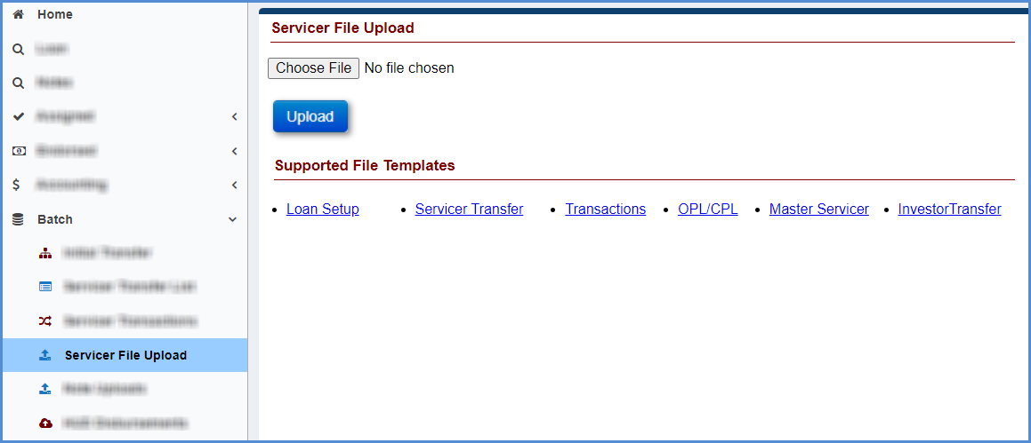
Figure 5-100: Servicer File Upload

Servicer Transfer

Preparing Servicer Transfer Import File
To prepare Servicer Transfer Import file:
- From the Batch tab, select Servicer File Upload.
- Select Servicer Transfer.
- On the File Download screen, click Open; this action opens an Excel template.
- Enter valid values for each column. For each of the field a comment is displayed when user points on the column name. The comment provides the user with the following information:
  - whether the field is required, optional or conditionally required
  - format/valid values for each field
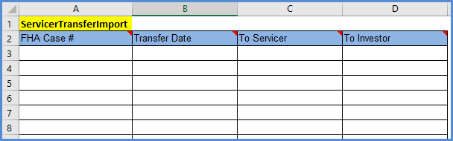
Figure 5-101: Sample Excel Template for B2G Servicer Transfer Import

Saving Servicer Transfer Import File
To save the Servicer Transfer Import file:
- Once all required fields are entered in the B2G servicer transfer import file and the file ready for upload, the file should be saved in a text (tab-delimited) file format.
- Click File > Save in the Servicer Transfer Import file.
- Select the folder in which to save the Excel file.
- Rename the file if desired.
- Click File > Save As and save the file as text (tab-delimited).
- Click Save.

Uploading Servicer Transfer Import File
To upload the Servicer Transfer Import file:
- Click Browse on the Servicer File Upload screen to attach the previously saved servicer transfer import file.
- Click Upload. The Import Results section displays the details of the upload results.
- The system will process the file and validate the records within the Servicer Transfer import file:
  - If all the critical validations pass for the record, the record is uploaded
  - If any of the critical validations fail, the record is not uploaded in the Servicing Module
- Upon completion of the file processing, the system displays the processing status of each record within the file.

Viewing Status of Servicer Transfer Import File
The Import Results section displays the details of the processed B2G Servicer Transfer Import file. It allows user to view:
- Error Records: count of records within the file that failed critical validations
- Warning/Success Records: count of records that generated a warning but were successfully uploaded in the Servicing Module
- Success Records: count of records that were successfully uploaded without generating a warning or error
- Filters: This section allows the user to filter the import results by status and error message
- Export to Excel: This link allows the user to export the file upload results to an Excel file
The processing status of each record within the file is displayed:
- Rec#: The record number of the case within the file
- FHA Case#: The case number associated with the record
- Status: The status of the uploaded record (Success, error or warning)
- Errors: Description of the errors associated with the record. For example: FHA Case# is invalid
- Warnings: Description of the warnings associated with the record
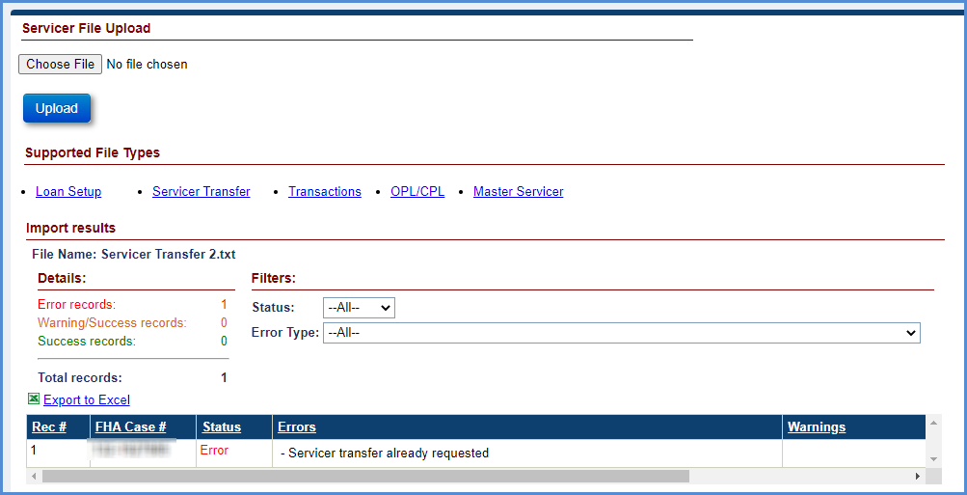
Figure 5-102: Servicer Transfer Import Results

Transactions Import

Preparing Transactions Import File
To prepare Transactions Import file:
- From the Batch tab, select Servicer File Upload.
- Select Transactions.
- On the File Download screen, click Open; this action opens an Excel template.
- Enter valid values for each column. For each of the field a comment is displayed when user points on the column name. The comment provides the user with the following information:
  - whether the field is required, optional or conditionally required
  - format/valid values for each field

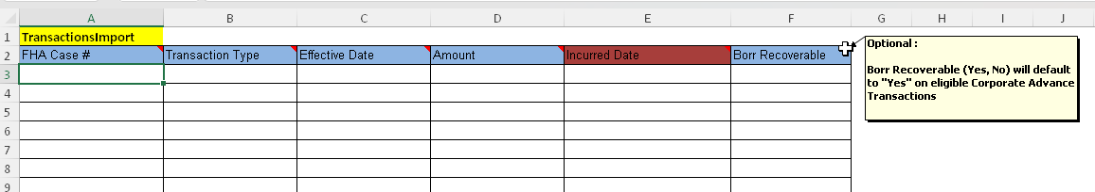
Figure 5-103: Sample Excel Template for B2G Transactions Import

Saving Transactions Import File
To save Transactions Import file:
- Once all required fields are entered in the B2G transactions import file and the file ready for upload, the file should be saved in a text (tab-delimited) file format.
- Click File > Save in the Transactions Import file.
- Select the folder in which to save the Excel file.
- Rename the file if desired.
- Click File > Save As and save the file as text (tab-delimited).
- Click Save.

Uploading Transactions Import File
To upload Transactions Import file:
- Click Browse on the Servicer File Upload screen to attach the previously saved transactions import file.
- Click Upload. The Import Results section displays the details of the upload results.
- The system will process the file and validate the records within the transactions import file:
  - If all the critical validations pass for the record, the record is uploaded
  - If any of the critical validations fail, the record is not uploaded in the Servicing Module
- Upon completion of the file processing, the system displays the processing status of each record within the file.

Viewing Status of Transactions Import File
The Import Results section displays the details of the processed B2G Transactions Import file. It allows user to view:
- Error Records: Count of records within the file that failed critical validations
- Warning/Success Records: Count of records that generated a warning but were successfully uploaded in the Servicing Module
- Success Records: Count of records that were successfully uploaded without generating a warning or error
- Filters: This section allows the user to filter the import results by status and error message
- Export to Excel: This link allows the user to export the file upload results to an Excel file
The processing status of each record within the file is displayed:
- Rec#: The record number of the case within the file
- FHA Case#: The case number associated with the record
- Status: The status of the uploaded record (Success, error or warning)
- Errors: Description of the errors associated with the record (for example: FHA Case# is invalid)
- Warnings: Description of the warnings associated with the record

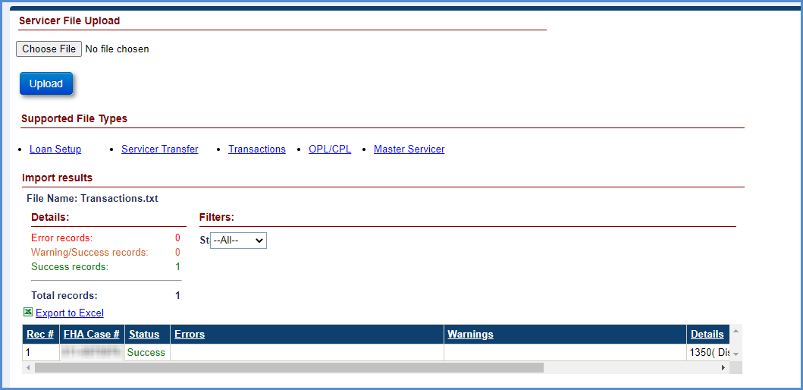
Figure 5-104: Transactions Import Results

OPL/CPL Import

Preparing OPL/CPL File
To prepare OPL/CPL Import file:
- From the Batch tab, select Servicer File Upload.
- Select OPL/CPL.
- On the File Download screen, click Open; this action opens an Excel template.
- Enter valid values for each column. For each of the field a comment is displayed when user points on the column name. The comment provides the user with the following information:
  - whether the field is required, optional or conditionally required
  - format/valid values for each field
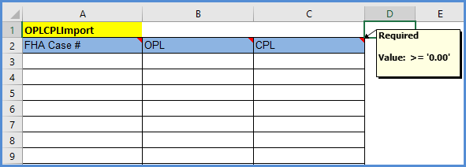
Figure 5-105: Sample Excel Template for B2G OPL/CPL Import

Saving OPL/CPL File
To save the OPL/CPL Import file:
- Once all required fields are entered in the B2G OPL/CPL and the file is ready for upload, the file should be saved in a text (tab-delimited) file format.
- Click File > Save in the OPL/CPL file.
- Select the folder in which to save the Excel file.
- Rename the file if desired.
- Click File > Save As and save the file as text (tab-delimited).
- Click Save.

Uploading OPL/CPL Import File
To upload the OPL/CPL Import file:
- Click Browse on the Servicer File Upload screen to attach the previously saved OPL/CPL import file.
- Click Upload. The Import Results section displays the details of the upload results.
- The system will process the file and validate the records within OPL/CPL import file:
  - If all the critical validations pass for the record, the record is uploaded
  - If any of the critical validations fail, the record is not uploaded in the Servicing Module
- Upon completion of the file processing, the system displays the processing status of each record within the file.
TIP: Update to OPL/CPL values take place ONLY after the scheduled nightly job runs in Servicing Module.

Viewing Status of OPL/CPL Import File
The Import Results section displays the details of the processed B2G OPL/CPL file. It allows user to view:
- Error Records: count of records within the file that failed critical validations
- Warning/Success Records: count of records that generated a warning but were successfully uploaded in the Servicing Module
- Success Records: count of records that were successfully uploaded without generating a warning or error
- Filters: This section allows the user to filter the import results by status and error message
- Export to Excel: This link allows the user to export the file upload results to an Excel file
The processing status of each record within the file is displayed:
- Rec#: The record number of the case within the file
- FHA Case#: The case number associated with the record
- Status: The status of the uploaded record (Success, error or warning)
- Errors: Description of the errors associated with the record. For example: FHA Case# is invalid
- Warnings: Description of the warnings associated with the record
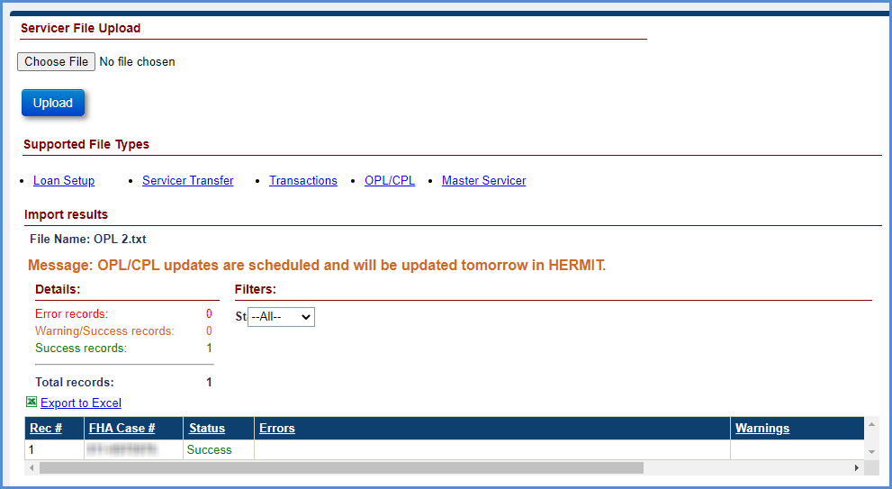
Figure 5-106: OPL/CPL Import Results

Master Servicer Import

Preparing Master Servicer Import File
To prepare Master Servicer Import file:
- From the Batch tab, select Master Servicer File Upload.
- Click on Master Servicer.
- On the File Download screen, click Open; this action opens an Excel template.
- Enter valid values for each column. For each of the field a comment is displayed when user points on the column name. The comment provides the user with the following information:
  - whether the field is required, optional or conditionally required
  - format/valid values for each field
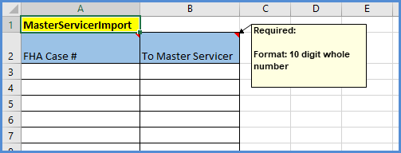
Figure 5-107: Sample Excel Template for B2G Master Servicer Import

Saving Master Servicer Import File
To save the Master Servicer Import file:
- Once all required fields are entered in the B2G Master servicer import file and the file ready for upload, the file should be saved in a text (tab-delimited) file format.
- Click File > Save in the Master Servicer Import file.
- Select the folder in which to save the Excel file.
- Rename the file if desired.
- Click File > Save As and save the file as text (tab-delimited).
- Click Save.

Uploading Master Servicer Import File
To upload the Master Servicer Import file:
- Click Browse on the Servicer File Upload screen to attach the previously saved master servicer import file.
- Click Upload. The Import Results section displays the details of the upload results.
- The system will process the file and validate the records within the Master Servicer import file:
  - If all the critical validations pass for the record, the record is uploaded
  - If any of the critical validations fail, the record is not uploaded in the Servicing Module
- Upon completion of the file processing, the system displays the processing status of each record within the file.

Viewing Status of Master Servicer Import File
The Import Results section displays the details of the processed B2G Master Servicer Import file. It allows user to view:
- Error Records: count of records within the file that failed critical validations
- Warning/Success Records: count of records that generated a warning but were successfully uploaded in the Servicing Module
- Success Records: count of records that were successfully uploaded without generating a warning or error
- Filters: This section allows the user to filter the import results by status and error message
- Export to Excel: This link allows the user to export the file upload results to an Excel file
The processing status of each record within the file is displayed:
- Rec#: The record number of the case within the file
- FHA Case#: The case number associated with the record
- Status: The status of the uploaded record (Success, error or warning)
- Errors: Description of the errors associated with the record. For example: FHA Case# is invalid
- Warnings: Description of the warnings associated with the record
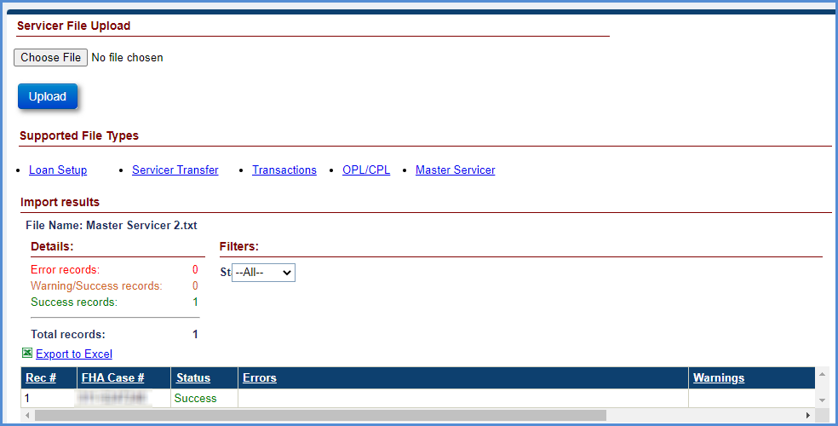
Figure 5-108: Master Servicer Import Results

Investor Transfer Import

Preparing Investor Transfer Import File
To prepare Investor Transfer Import file:
- From the Batch tab, select Investor Transfer Upload.
- Click on Investor Transfer.
- On the File Download screen, click Open; this action opens an Excel template.
- Enter valid values for each column. For each of the field a comment is displayed when user points on the column name. The comment provides the user with the following information:
  - whether the field is required, optional or conditionally required
  - format/valid values for each field
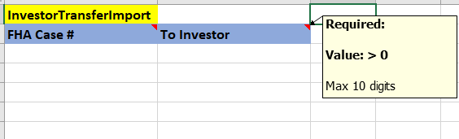
Figure 5-109: Sample Excel Template for B2G Investor Transfer Import

Saving Investor Transfer Import File
To save the Investor Transfer Import file:
- Once all required fields are entered in the B2G Investor Transfer import file and the file ready for upload, the file should be saved in a text (tab-delimited) file format.
- Click File > Save in the Investor Transfer Import file.
- Select the folder in which to save the Excel file.
- Rename the file if desired.
- Click File > Save As and save the file as text (tab-delimited).
- Click Save.

Uploading Investor Transfer Import File
To upload the Investor Transfer Import file:
- Click Browse on the Servicer File Upload screen to attach the previously saved Investor Transfer import file.
- Click Upload. The Import Results section displays the details of the upload results.
- The system will process the file and validate the records within the Investor Transfer import file:
  - If all the critical validations pass for the record, the record is uploaded
  - If any of the critical validations fail, the record is not uploaded in the Servicing Module
- Upon completion of the file processing, the system displays the processing status of each record within the file.

Viewing Status of Investor Transfer Import File
The Import Results section displays the details of the processed B2G Investor Transfer Import file. It allows user to view:
- Error Records: count of records within the file that failed critical validations
- Warning/Success Records: count of records that generated a warning but were successfully uploaded in the Servicing Module
- Success Records: count of records that were successfully uploaded without generating a warning or error
- Filters: This section allows the user to filter the import results by status and error message
- Export to Excel: This link allows the user to export the file upload results to an Excel file
The processing status of each record within the file is displayed:
- Rec#: The record number of the case within the file
- FHA Case#: The case number associated with the record
- Status: The status of the uploaded record (Success, error or warning)
- Errors: Description of the errors associated with the record. For example: FHA Case# is invalid
- Warnings: Description of the warnings associated with the record
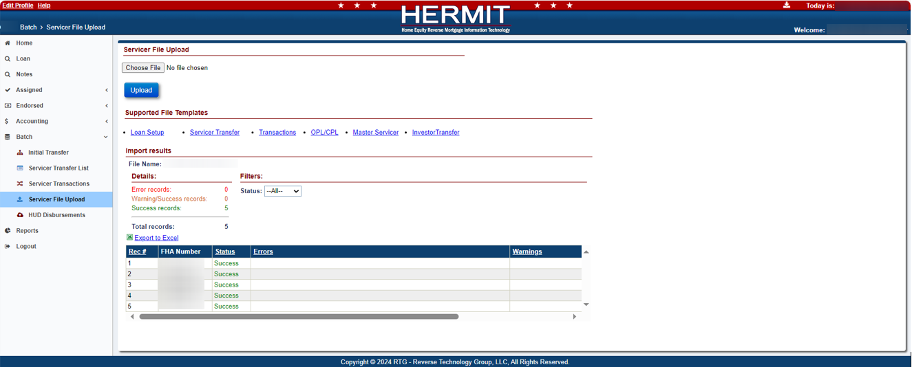
Figure 5-110: Investor Transfer Import Results

Note Uploads
The Notes File Uploads screen is displayed when an authorized user selects Note Uploads under the Batch tab displayed in the Left Menu. The Notes File Uploads screen allows the authorized user (example: Lenders/Servicers) to upload B2G files.

Field | Description
Notes Import | Enables lenders/servicers to upload one or multiple Notes.
Table 5-23: B2G File Descriptions

Preparing Notes Import File
To prepare Notes Import file:
- From the Batch tab, select Notes Uploads.
- Select Notes
- On the File Download screen, click Open; this action opens an Excel template.
- Enter valid values for each column. For each of the fields a comment is displayed when user points on the column name. The comment provides the user with the following information:
  - whether the field is required, optional or conditionally required
  - format/valid values for each field
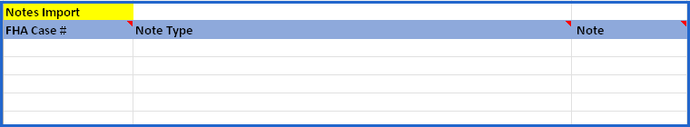
Figure 5-111: Sample Excel Template for B2G Notes Import

Saving Notes Import File
To save the Notes Import file:
- Once all required fields are entered in the B2G Notes import file and the file ready for upload, the file should be saved in a text (tab-delimited) file format.
- Click File > Save in the Notes Import file.
- Select the folder in which to save the Excel file.
- Rename the file if desired.
- Click File > Save As and save the file as text (tab-delimited).
- Click Save.

Uploading Notes Import File
To upload the Notes Import file:
- Click Choose File on the Notes Upload screen to attach the previously saved Notes Import File.
- Click Upload. The Import Results section displays the details of the upload results.
- The system will process the file and validate the records within the Notes import file:
  - If all the critical validations pass for the record, the record is uploaded
  - If any of the critical validations fail, the record is not uploaded in the Servicing Module
- Upon completion of the file processing, the system displays the processing status of each record within the file.

Viewing Status of Notes Import File
The Import Results section displays the details of the processed B2G Notes Import file. It allows user to view:
- Error Records: count of records within the file that failed critical validations
- Warning/Success Records: count of records that generated a warning but were successfully uploaded in the Servicing Module
- Success Records: count of records that were successfully uploaded without generating a warning or error
- Filters: This section allows the user to filter the import results by status and error message
- Export to Excel: This link allows the user to export the file upload results to an Excel file
The processing status of each record within the file is displayed:
- Rec#: The record number of the case within the file
- FHA Case#: The case number associated with the record
- Status: The status of the uploaded record (Success, error or warning)
- Errors: Description of the errors associated with the record. For example: FHA Case# is invalid
- Warnings: Description of the warnings associated with the record

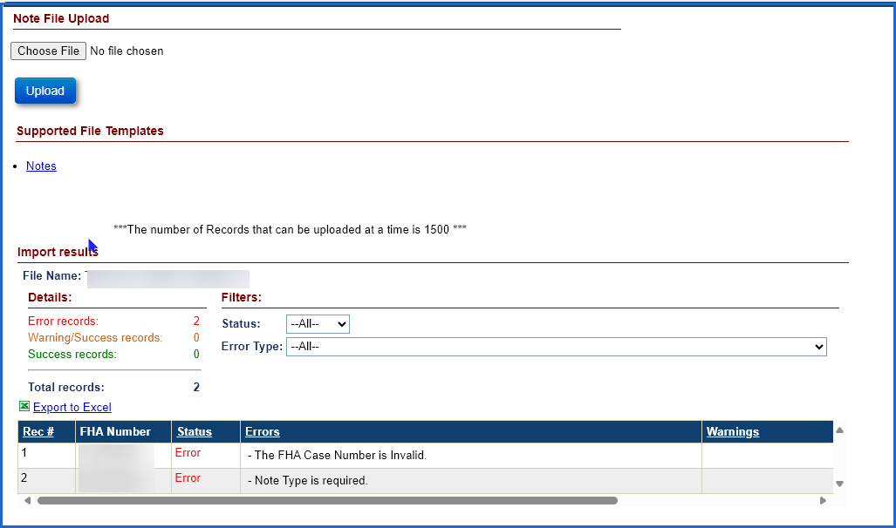
Figure 5-112: Notes Import Results

HUD Disbursements
The HUD Disbursements screen is displayed when an authorized user selects HUD Disbursements under the Batch tab displayed in the Left Menu. The HUD Disbursements screen allows the authorized user (example: Servicer Manager/HUD NSC Manager) to upload B2G files. The user will only be allowed to upload a file when HUD has granted access for the Servicer. Disbursements will be created with data supplied in the template, regardless of whether the data matches HERMIT.

Field | Description
HUD Disbursements Import | Enables Servicer Manager/HUD NSC Manager to upload one or multiple Borrower Disbursements.
Table 5-24: B2G File Descriptions

Preparing HUD Disbursements Import File
To prepare HUD Disbursements Import file:
- From the Batch tab, select HUD Disbursements.
- Select HUD Disbursements.
- On the File Download screen, click Open; this action opens an Excel template.
- Enter valid values for each column. For each of the field a comment is displayed when user points on the column name. The comment provides the user with the following information:
  - whether the field is required, optional or conditionally required
  - format/valid values for each field
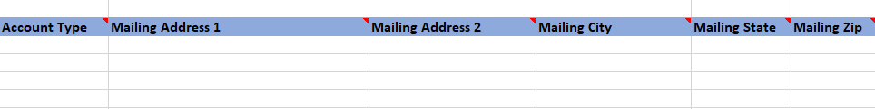
Figure 5-113: Sample Excel Template for B2G HUD Disbursements Import

Saving HUD Disbursements Import File
To save the HUD Disbursements Import file:
- Once all required fields are entered in the B2G HUD Disbursements import file and the file ready for upload, the file should be saved in a text (tab-delimited) file format.
- Click File > Save in the HUD Disbursements Import file.
- Select the folder in which to save the Excel file.
- Rename the file if desired.
- Click File > Save As and save the file as text (tab-delimited).
- Click Save.

Uploading HUD Disbursements Import File
To upload the HUD Disbursements Import file:
- Click Browse on the HUD Disbursements Upload screen to attach the previously saved HUD Disbursements import file.
- Click Upload. The Import Results section displays the details of the upload results.
- The system will process the file and validate the records within the HUD Disbursements import file:
  - If all the critical validations pass for the record, the record is uploaded
  - If any of the critical validations fail, the record is not uploaded in the Servicing Module
- Upon completion of the file processing, the system displays the processing status of each record within the file.

Viewing Status of HUD Disbursements Import File
The Import Results section displays the details of the processed B2G HUD Disbursements Import file. It allows user to view:
- Error Records: count of records within the file that failed critical validations
- Warning/Success Records: count of records that generated a warning but were successfully uploaded in the Servicing Module
- Success Records: count of records that were successfully uploaded without generating a warning or error
- Filters: This section allows the user to filter the import results by status and error message
- Export to Excel: This link allows the user to export the file upload results to an Excel file
The processing status of each record within the file is displayed:
- Rec#: The record number of the case within the file
- FHA Case#: The case number associated with the record
- Status: The status of the uploaded record (Success, error or warning)
- Errors: Description of the errors associated with the record. For example: FHA Case# is invalid
- Warnings: Description of the warnings associated with the record
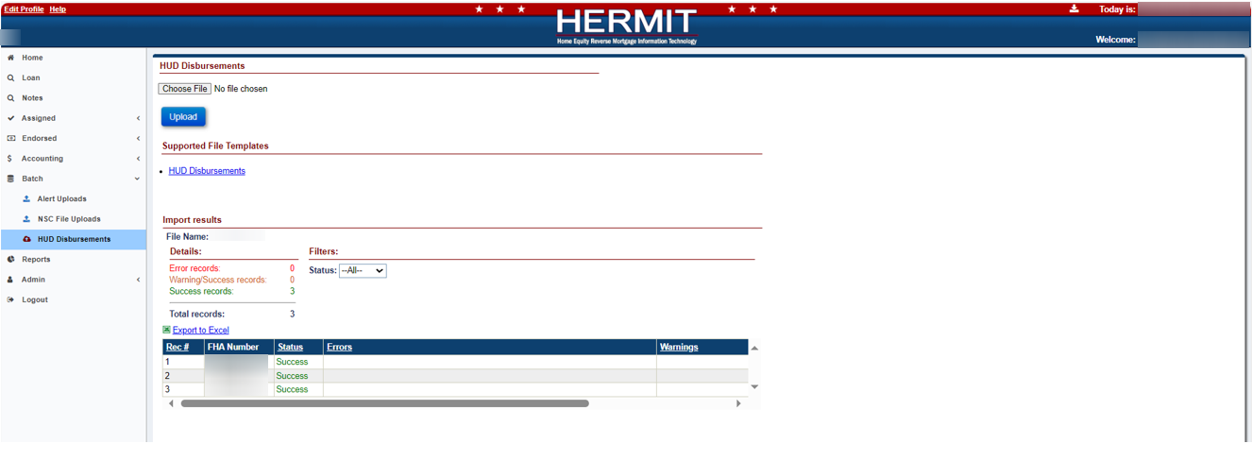
Figure 5-114: HUD Disbursements Import Results

Repayment Plan
The Repayment Plan screen is displayed when a user selects the Repayment Plan tab from the Left Menu. The Repayment Plan screen shows the current repayment plan and any prior repayment plans associated with the loan. Only authorized user roles can create and edit a repayment plan.
The following conditions must be satisfied to initiate a repayment plan:
- Authorized users can create and edit Repayment Plan.
- The loan must have a case status of Pending IMIP, Pending Endorsement, Endorsed, and Assigned.
- The Repayment Plan Start Date must be less than the Repayment Plan End Date.
- The Next Monthly Payment Due Date is greater than the Repayment Plan Start Date.
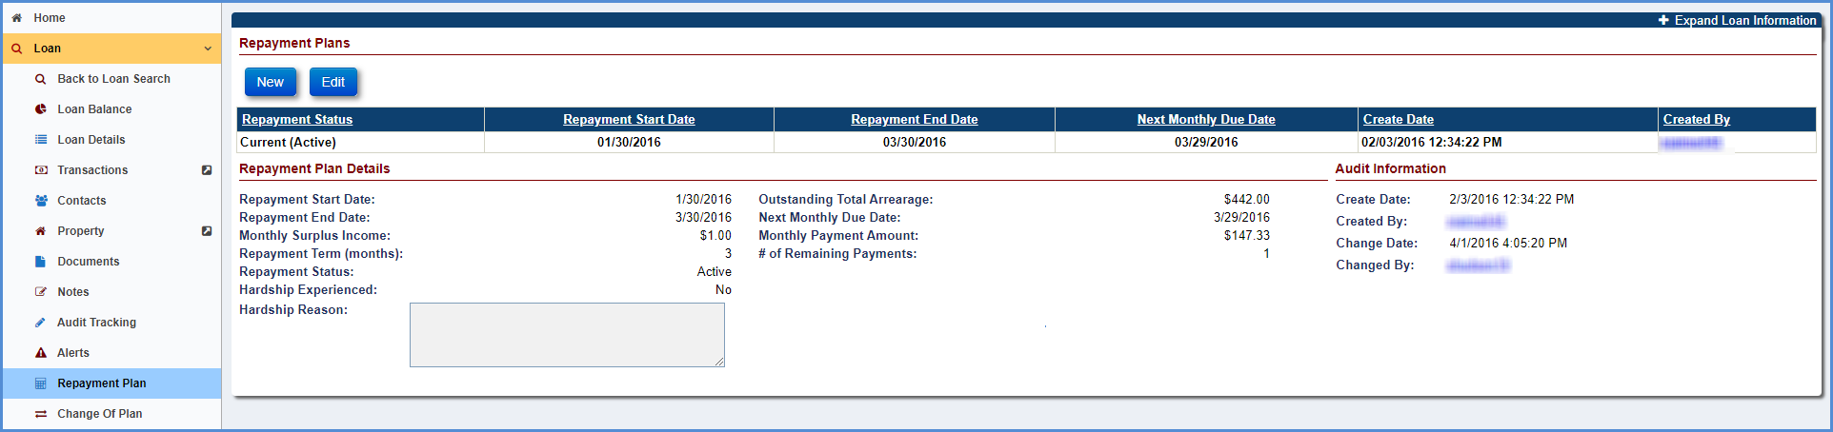
Figure 5-115: Repayment Plan Screen

Viewing a Repayment Plan
To view a repayment plan: Select the record to display the Repayment Plan Details section and Audit Information sections. The Repayment Plan Details section displays the following details of the payment plan selected in Pay Plans section:
  - Repayment Start Date: The date, repayment plan was initiated.
  - Repayment End Date: The date, repayment plan ended.
  - Next Monthly Due Date: The date next monthly payement is due.
  - Repayment Term (months): Total number of payments to be paid by the Servicer. The repayment term cannot exceed 60 months.
  - # of Remaining Payments: The number of payments remaining to be paid by the servicer. The number of payments cannot exceed 60 months.
  - Outstanding Total Arrearage: Is determined by adding the outstanding corporate advances made for the account to any property charges, less any for HOA fees, due for the next 90 days.
  - Monthly Surplus Income: Is determined by subtracting the mortgagor’s necessary living expenses – including healthcare, revolving and installment debt, any payment obligations, utility bills, and other household-related expenses - and a monthly amount needed for property charges due over the next twelve months from available sources of income as stated by the mortgagor.
  - Monthly Payment Amount: Is the amount determined by the servicer to be paid towards the repayment plan each month.
  - Repayment Status: Repayment Status can be Active, Inactive or Completed.
  - Hardship Experienced: Is determined if the mortgagor experiences a decrease in their available amount of surplus income due to a verified hardship (e.g., illness, death of a household member who was identified as a contributor of income in a previous Repayment Plan calculation, emergency home repair, loss of employment income, etc.) and seeks to have a Repayment Plan adjustment, mortgagees must solicit new financial information from the mortgagor to conduct a new Repayment Plan assessment.
  - Hardship Experienced: The field Hardship Reason is mandatory if the user selects the Hardship Experienced.
TIP: All of the fields mentioned above needs to be entered manually by the authorized users in HERMIT. HERMIT does not capture any fields for the Repayment Plan.
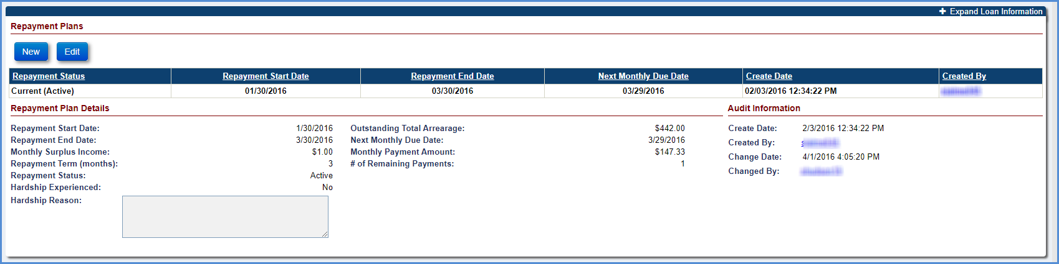
Figure 5-116: View Repayment Plan Screen

Creating a New Repayment Plan
To create a new repayment plan:
- Click New in the Repayment Plan section.
- On the Repayment Plan window, enter all the mandatory fields.
- Click OK
TIP: After a new Repayment Plan is created the previous repayment plan will be automatically inactivated.
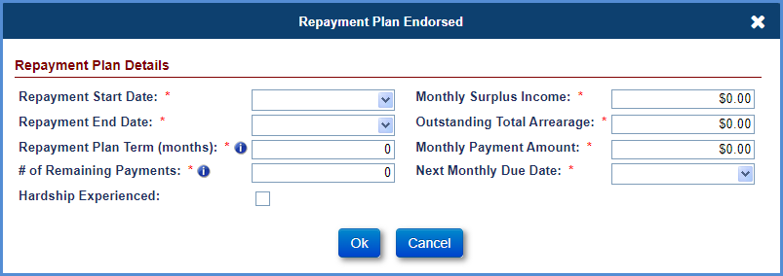
Figure 5-117: New Repayment Plan Window
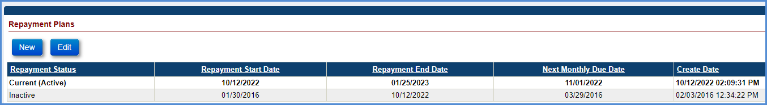
Figure 5-118: New Repayment Plan Displayed on Repayment Plans Section

Editing a Repayment Plan
To edit a repayment plan:
- Click EDIT in the Repayment Plan section.
- On the Repayment Plan window, edit the fields as needed.
- Click OK. The changes will be displayed on the Repayment Plan Detail section screen.
TIP: The # of remaining payments has to be zero if the Repayment Status has to be changed to Completed.
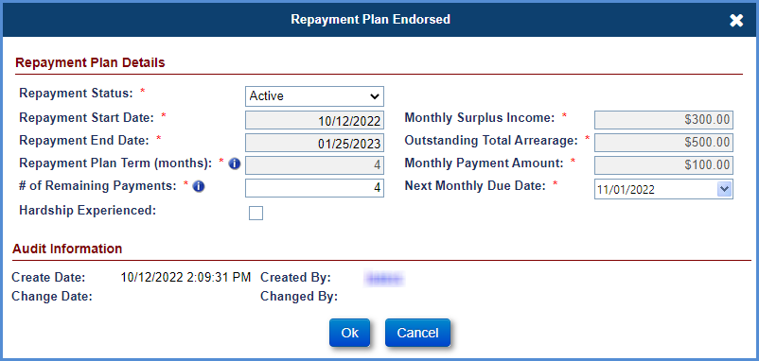
Figure 5-119: Edit Repayment Plan Window

Property Preservation: Transactions and Timelines
This section discusses Property Preservation activities for loans that are in Endorsed case status:
- Property Preservation and Protection Overview
- Property Preservation - Allowable
- Property Preservation - Over-Allowable
- Property Preservation – Excluded from Max

Property Preservation and Protection Overview
Property Preservation and Protection (P&P) actions are maintenance, security, and repair work required by HUD to ensure the Property meets HUD’s conveyance condition standards.
HUD will reimburse Mortgagees for Property Preservation and Protection (P&P) actions as follows:
  - Allowable: Up to the maximum Allowance amount as predetermined by HUD.
  - Over-Allowable: Additional amounts if specifically approved by HUD as over-allowables requests.
  - Exclude from Max: HUD permitted exceptions to the maximum allowable or over-allowable requests.

Property Preservation – Allowable
HUD will reimburse Mortgagees up to the Maximum Property Preservation Allowance. The list of Preservation measures—such as ongoing inspections, scheduled maintenance (e.g., grass cuts, snow removal), standard securing actions (e.g., lockbox installation, rekeying), winterizations— are considered allowable and do not require prior approval. These transactions are not linked to an Approved over-allowable line item on the Preservation & Protection timeline, and are not reported as Excluded from Max.

Creating New P&P Corporate Advance (Allowable) Transaction
To view and navigate the loan search results, please refer to Chapter 2.

Transaction – Loan
To create a new corporate advance allowable transaction:
- Click New on the Transactions – Loan screen.
- On the New Loan Transaction window, select Corp Advance – Property Preservation for transaction category.
- Populate the below listed fields (required fields are marked with a red asterisk):
  - Transaction Type
  - Borr Recoverable (if applicable)
  - Effective Date
  - Incurred Date
  - Transaction Amount
  - Excluded from Max (for Allowable, this will remain un-checked)
- Click Submit. If successful, the new transaction is displayed in the Loan Transaction Results section. To exit the window without adding the transaction, click Cancel. To navigate back to other transaction categories, click Back.
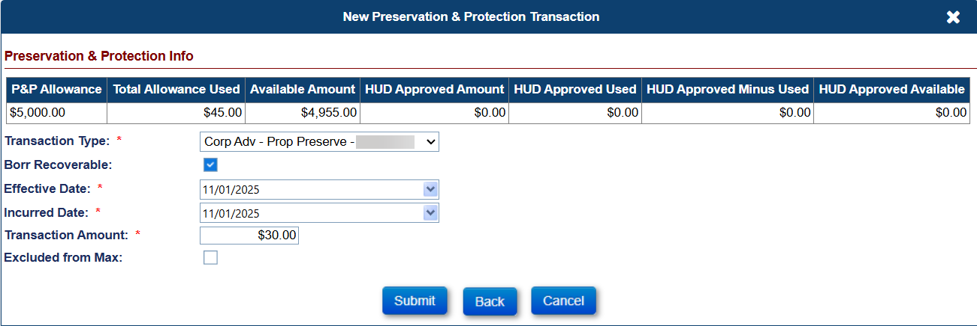
Figure 5-120: New Preservation & Protection Transaction - Allowable
The Preservation & Protection Info section fields:
  - P&P Allowance: The total amount of allowable expenses as pre-determined by HUD.
  - Total Allowance Used: The sum of all allowable transactions, either those not tied to an approved P&P timeline, nor marked as Excluded from Max.
  - Available Amount: The remaining allowance, calculated as the total allowance minus the total allowance used.
The table below lists all the Corp Advance Property Preservation transaction types that can be manually created using the New Loan Transactions window.

Transaction Type | Description
Boarding | Initiated by the servicer to report the expense incurred by Lender/Investor for boarding of the mortgaged property as part of preservation and protection activity. This transaction applies to all pay plan types.
Hazard Abate | Initiated by the servicer to report the expense incurred by Lender/Investor for abatement of any hazards on the mortgaged property as part of preservation and protection activity. This transaction applies to all pay plan types.
Landscape | Initiated by the servicer to report the expense incurred by Lender/Investor for landscaping charges on the mortgaged property as part of preservation and protection activity. This transaction applies to all pay plan types.
Other | Initiated by the servicer to report the expense incurred by Lender/Investor for other property and preservation activities on the mortgaged property. This transaction applies to all pay plan types.
Other Repair | Initiated by the servicer to report the expense incurred by Lender/Investor for other repairs on the mortgaged property as part of preservation and protection activity. This transaction applies to all pay plan types.
Prop Inspect | Initiated by the servicer to report the expense incurred by Lender/Investor for property inspection charges on the mortgaged property as part of preservation and protection activity. This transaction applies to all pay plan types.
Remove Debris | Initiated by the servicer to report the expense incurred by Lender/Investor for removal of debris on the mortgaged property as part of preservation and protection activity. This transaction applies to all pay plan types.
Repayment | Initiated by the servicer to report repayments by the borrower within this transaction category. This transaction applies to all pay plan types.
Roof Repair | Initiated by the servicer to report the expense incurred by Lender/Investor for roof repairs on the mortgaged property as part of preservation and protection activity. This transaction applies to all pay plan types.
Securing | Initiated by the servicer to report the expense incurred by Lender/Investor for securing of the mortgaged property as part of preservation and protection activity. This transaction applies to all pay plan types.
Utilities | Initiated by the servicer to report the expense incurred by Lender/Investor for utility charges on the mortgaged property as part of preservation and protection activity. This transaction applies to all pay plan types.
Winterizing | Initiated by the servicer to report the expense incurred by Lender/Investor for winterizing of the mortgaged property as part of preservation and protection activity. This transaction applies to all pay plan types.
Table 5-25: Corp Advance Transactions
TIP: For bulk posting Property Preservation Corporate Advance, refer to section 5.19.3 “Servicer Transactions”, and section 5.19.4.2 “Transaction Import” for general information.

Property Preservation – Over-Allowable
Preservation actions that exceed the HUD allowable limit, or occur after the allowable limit has been reached, are classified as over-allowable requests, which require HUD decisions. The Servicer initiates the “Preservation and Protection” timeline, which is located under Endorsed > Request, and completes necessary steps to submit the over-allowable request. This timeline requires HUD interaction and interaction from the HUD Contractor to review and make decisions on submitted requests. These transactions must be linked to an Approved over-allowable line item on the Preservation & Protection timeline, and cannot be reported as Excluded from Max.
Multiple active Preservation and Protection timelines can be initiated on a loan, and each timeline may include multiple over-allowable line items requiring individual decisions. The Servicing Management tab can be used to activate or inactivate the timeline. Once the timeline is inactivated, none of the steps can be edited.

Timeline Steps
TIP: Refer to section 7.1.2 “Setup Criteria to Initiate Timelines” for general steps to initiate timelines, and section 7.1.7 “To Complete Timeline Steps” for general information how to complete steps within a timeline.
The Servicer attaches all required documentation and completes the necessary steps on the timeline. The following Template Steps are displayed when the timeline is initiated. The steps are servicer steps unless otherwise stated:
- Initiate Request to Exceed Costs for P&P
- Upload P&P Package
- Send P&P Package to HUD
- Request to Exceed Package Reviewed – HUD Contractor Step
- Servicer Notified of Decision – HUD Contractor Step
The following Optional Steps are available on this timeline. Refer to section 7.1.8 “To Add Optional Timeline Steps” for general information how to add and complete optional steps within a timeline. The steps are HUD Contractor steps unless otherwise stated
- Sent to HUD for Review – Servicer Step
- HUD Decision issued to Contractor – HUD Step
- HUD Decision - Approved
- HUD Decision - Denied
- HUD Decision - Pending Additional Info
- Follow-up
The following Trigger Steps are available on this timeline.
- Resubmit P&P package to HUD

Servicer Activities – Bid Submission
Once the timeline has been initiated, the servicer selects the Preserve & Protect tab to add additional line item expenses that require HUD Contractor review and response.
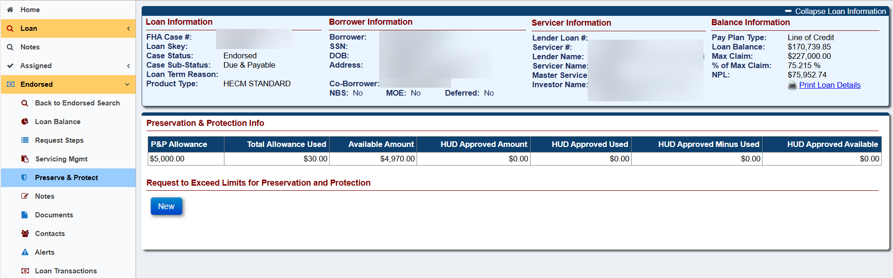
Figure 5-121: Preserve & Protect Tab
To submit New Request to Exceed Limits:
- Click New.
- On the New Request window, populate the details of the expense (required field marked with an asterisk).
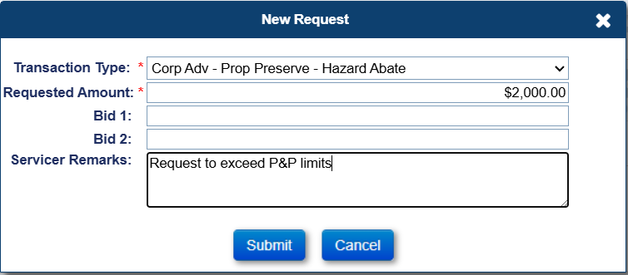
Figure 5-122: New Request for Preservation and Protection
- Click Submit to add the requested expense. Repeat from Step 1 for additional expenses.
- Upon completion of entering new requests in the Preserve & Protect tab, select the Request Steps tab to return to the timeline steps.
The servicer must next upload the P&P Package to provide additional documentation of the request to HUD.
- Click the upload attachment icon beside Upload P&P Package step and the Edit Step window is displayed.
- Optionally add Step Note, attach required document and click Submit for the document to be attached and step completed. Once the Edit Step window is completed, the attachment is auto-saved in the Documents tab.
- The step Upload P&P Package is auto-completed by the system.
The servicer must then generate the P&P request exceed cost letter.
- Click the printer icon beside Send P&P Package to HUD step and the Modify Letter Fields window is displayed.
- Populate the fields (required fields marked with an asterisk) and click OK. The P&P request exceed cost letter is then displayed.
- Close the letter window and click OK on the Information window. Once the letter window is closed, the letter is auto-saved in the Documents tab.
- The step Send P&P Package to HUD is auto-completed by the system.

Decision Activities (HUD or HUD Contractor)
To provide decisions on the request:
Upon submission and completion of the step Send P&P Package to HUD, the step Request to Exceed Package Reviewed should be completed.
- To complete select the step Request to Exceed Package Reviewed.
- Populate the completion date and click Submit on the Edit Step window.
- Select the Preserve & Protect tab to provide a decision for the request(s).

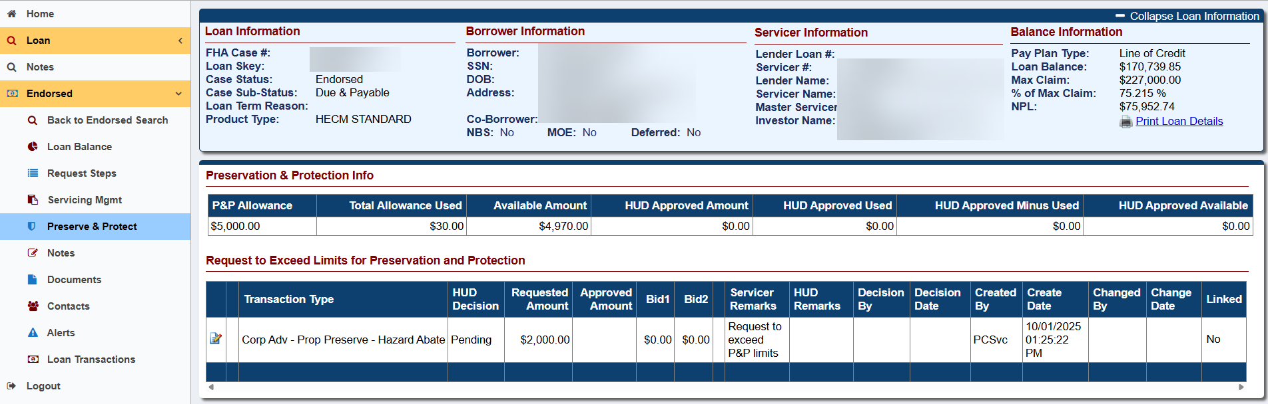
Figure 5-123: Preservation and Protection tab
- Select the edit document icon beside the expense previously submitted by the Servicer.
- On the Edit Request window, select the dropdown for HUD Decision field.
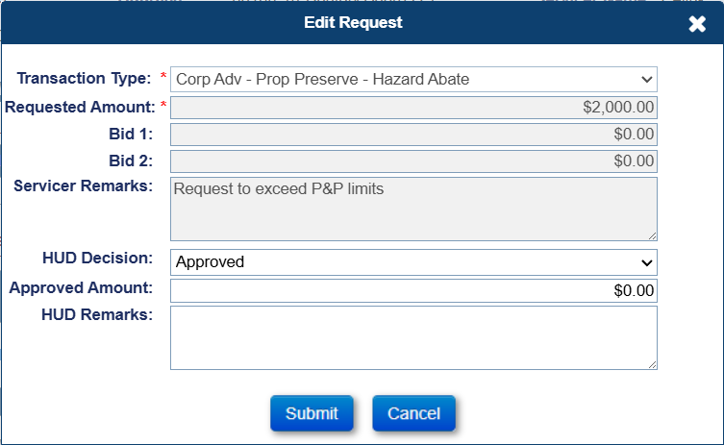
Figure 5-124: Endorsed - Requests - Preservation and Protection - Edit Request
  - If Approved is selected, enter the approved amount and optionally enter the HUD Remarks.
  - If Denied is selected optionally enter the HUD Remarks..
  - If Pending is selected optionally enter the HUD Remarks..
- Click Submit. Repeat starting at Step 4 for additional submitted requests.
- Upon completion of decision(s), select the Request Steps tab.
- Add an optional step (Approved, Denied, or Pending) indicating the decision by clicking New.
- Select from the Step Description dropdown (HUD Decision -Approved, HUD Decision -Denied, or HUD Decision –Pending) and optionally enter the HUD Remarks under Step Note.
IMPORTANT: The HUD Decision step (Approved, Denied, Pending) placed on the timeline is independent of the decisions made within the Preserve & Protect tab. Each request or line item under Preserve & Protect has its own HUD Decision, separate from the decisions recorded in the Property Preservation timeline. These two decision paths operate independently and are not linked to one another.
- Click Submit on the new window. The step will be added to the Request Steps.
Upon completion of the timeline decision, generate the Preservation and Protection Decision Letter.
- To generate, click the magnifying glass beside optional step that was added (HUD Decision -Approved, HUD Decision -Denied, or HUD Decision –Pending). The Preservation and Protection Decision Letter is displayed with the HUD Decision.
- Selecting the printer icon will auto-save the Preservation and Protection Decision Letter to the Documents tab and auto-complete the step. Click OK on the Information window.
- Select the step Servicer Notified of Decision
- Populate the completion date and click Submit on the Edit Step window.

Servicer Activity – Entering Transactions
If the Preservation and Protection Timeline has the step HUD Decision - Approved, the servicer links the Corporate Advance – Property Preservation transaction for the requests which were approved on the Preserve & Protect tab by entering in the Loan > Transactions screen.
- Search and enter the loan through Loan Search screen > click Transactions.
- Click New and select Corp Advance – Property Preservation under the dropdown menu for Transaction Category.
- The approved expense is displayed on the New Preservation & Protection Transaction window.
- Select the approved expense.
Note: By selecting the approved expense from the Excess Preservation and Protection Allowances section, links the transaction between the Transaction – Loan screen and the over-allowable request within the Preserve and Protect tab. This is displayed in the transaction grid within the Loan Transaction Results screen, as well as the Export Transactions results, as P&P Approved.
- Populate the required fields and click Submit. The transaction is added to Loan > Transactions.
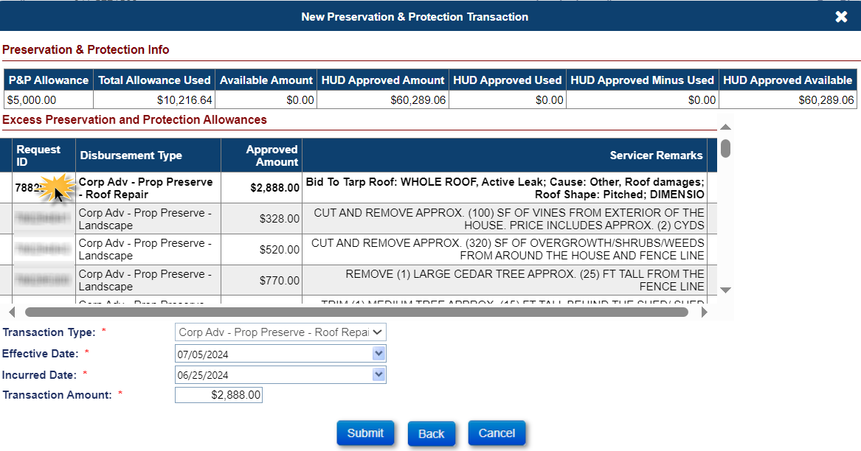
Figure 5-125: New Preservation & Protection Transaction
The Preservation & Protection Info section fields (cont.):
  - HUD Approved Amount: Sum of the amounts approved by HUD from all P&P timelines.
  - HUD Approved Used: The sum of transactions with “P&P Approved” TRUE in the Transaction Export file, which are linked to specific Approved over-allowables.
  - HUD Approved Minus Used: The difference between the HUD Approved Amount and the actual amount of the linked transaction.
  - HUD Approved Available: The remaining approved available, calculated as the total HUD Approved Amount minus the sum of HUD Approved Used minus the sum of HUD Approved Minus Used.
The Excluded from Max and the Excluded from Max Type results are displayed in the transaction grid within the Loan Transaction Results screen, as well as the Export Transactions results.

Servicer and HUD or HUD Contractor Activities – Pending Decisions
If the Property Preservation Timeline has the optional step completed by HUD or the HUD Contractor of HUD Decision – Pending Additional Info, the step Resubmit P&P package to HUD will automatically display in the timeline steps.
Only requests showing HUD Decision of Pending can be edited from the Preserve & Protect screen. To resubmit, the Servicer will need to update the expenses, upload additional documentation and re-generate the P&P Request Exceed Cost letter
- Select the printer icon beside Resubmit P&P package to HUD
- Populate the fields (required fields marked with an asterisk) in the Modify Letter Fields window and select OK. The P&P request exceed cost letter is then displayed.
- Close the letter window and click OK on the Information window. Once the letter window is closed, the letter is auto-saved in the Documents tab.
HUD or the HUD Contractor reviews the updated package and obtains a decision. If additional documentation is required, HUD or the NSC Contractor can add the optional step, Follow-Up.
If additional HUD review is needed, then the optional step Sent to HUD for review must be added and completed by the Servicer on the timeline.
Once a decision has been made, HUD will need to add the optional step HUD Decision issued to Contractor. To add the optional step
- HUD will click New in the Preservation and Protection timeline.
- Select the optional step from the step description dropdown HUD Decision issued to Contractor
- Populate the complete date and click Submit. The optional step is added to Request Steps.

Property Preservation – Exclude from Max
Preservation transactions which have a HUD permitted exception are to be entered under the category of Exclude from Max. These transactions are not linked to an Approved over-allowable line item on the Preservation & Protection timeline.

Creating New P&P Corporate Advance (Excluded from Max) Transaction

Transaction - Loan
To create a new corporate advance Excluded from Max transaction:
- Click New on the Transactions – Loan screen.
- On the New Loan Transaction window, select Corp Advance – Property Preservation for transaction category.
- Populate the below listed fields (required fields are marked with a red asterisk):
  - Transaction Type
  - Borr Recoverable (if applicable)
  - Effective Date
  - Incurred Date
  - Transaction Amount
  - Excluded from Max
- Select the checkbox next to Excluded from Max. Note: when “Excluded from Max” is selected, the following message is displayed: “By checking Excluded from Max you are confirming the amount represents the actual cost and is supported by documentation in the claim package. HUD Approval may still be required if the amount exceeds the Single Line Item allowable as designated by HUD.”
- Once selected, populate the Max Exclusion Type from the drop-down menu. Note: If none are selected, a popup modal will display error stating a “Max Exclusion Type is required”
- Click Submit.
- Click Ok on the Exclude from Max Confirmation.
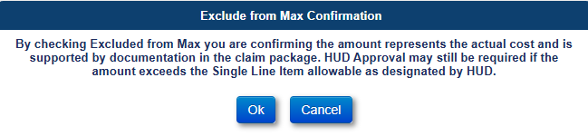
Figure 5-126: Exclude from Max Confirmation Window
- If successful, the new transaction is displayed in the Loan Transaction Results section. To exit the window without adding the transaction, click Cancel.
The Max Exclusion Types:
  - Boarding
  - Debris Removal
  - Demolition
  - Grass Cut
  - Property Inspection
  - Securing – Swimming Pool
  - Sump Pump
  - Utility Costs
  - Vacant Property Registration

The Excluded from Max and the Excluded from Max Type results are displayed in the transaction grid within the Loan Transaction Results screen, as well as the Export Transactions results.

CHAPTER 6: GENERAL SERVICING (ASSIGNED)

GENERAL SERVICING (ASSIGNED)
This chapter discusses general servicing for loans that are in Assigned case status:
- Assigned Servicing Overview
- Approval Portal
- Loan Search
- Loan Balance
- Loan Details
- Transactions
- Contacts
- Property
- Documents
- Notes
- Audit Tracking
- Alerts
- Change of Plan
- Payoff
- Statement
- Disbursement
- Servicer Info
- Bank Account
- Accounting
- Batch

Assigned Servicing Overview
When the loan balance on a HECM loan reaches the threshold percentage (as established by HUD) of the maximum claim amount, a servicing lender can request assignment to HUD. A Claim Type 22 timeline must be initiated and steps within the timeline completed (step - Assignment to HUD sent for recording/Servicer Files Claim Type 22 – Form 27011) to transfer the servicing of the loan to HUD. This also updates the Lender and Investor fields on the Loan to HUD.
Upon completion of the step HUD Issued Final Title Approval on the Claim Type 22 timeline, the case status is updated to Assigned.
HUD assumes all the general servicing loan functions that the previous servicing lender performed. This chapter explains in detail all the functions available for assigned loans and discusses in detail how to perform these functions.

Approval Portal
Approval Portal will display depending on user’s permission.
When the search screen is first displayed, Request Category will display “Bank Account” and Request Status will display “Pending Contractor Approval” or “Pending HUD Approval” depending on the user role to allow the user to search for ‘All Bank Account’ records that are pending. The user can enter or select different criteria to narrow the search results. Once a search is completed the results are displayed below the Export to Excel link.
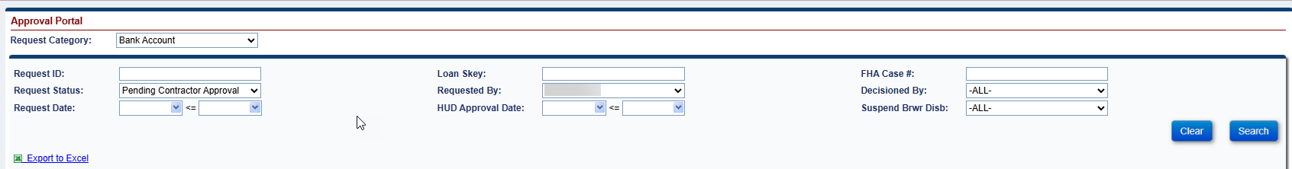
Figure 6-1: Approval Portal Search Screen

Search Criteria
Approval Portal records can be retrieved using single or combined search criteria. Applying more search filters will return more specific, but fewer results, while broader searches will return a higher volume of records.

Searching for Approval Portal records
User can build a search using the criteria below

Approval Portal Search Criteria
Field | Description
Request Category: | List Request Categories such as Bank Account
Request ID | Enter Request ID #
Loan Skey | The Servicing Module system identification number unique to each loan.
FHA Case # | FHA case number of the loan
Request Status | The Status of the request record; ALL, Pending Contractor Approval, Pending HUD Approval, HUD Approved – Changed Processed, Denied, or Failed
Requested By | User who initiated the request record.
Decisioned By | User who has made a decision on the record.
Request Date | Enter Date range when request was created
HUD Approval Date | Enter Date range when request was Approved.
Suspend Brwr Disb | Indicates if the Suspended Borrower Disbursement Flag is checked or unchecked
Table 6-1: Approval Portal Search Criteria

Writing Search Criteria
To search for a Note:
- Select Approval Portal on the Left Menu.
- On the Approval Portal screen, enter single or multiple search criteria, typically by selecting the criteria from various dropdown boxes. In general, the more criteria the user selects, the fewer results will be returned from the query. In the example below, we have selected a Request Category of Bank Account, Request Status Denied and Suspend Brwr Disb Yes. This will narrow the search to only the records that match the criteria.
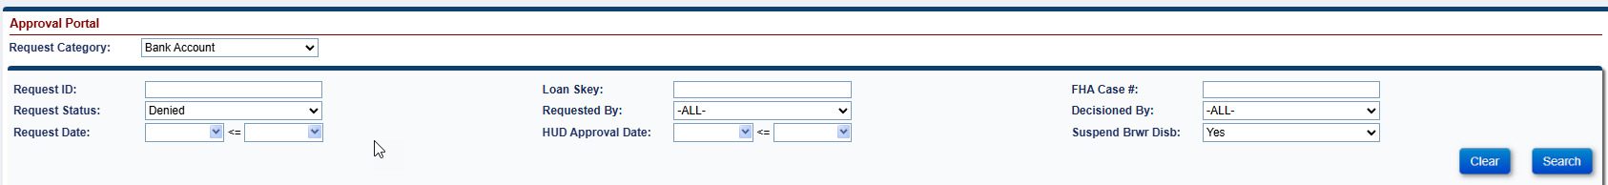
Figure 6-2: Building a Search
- Click Search and the results will be displayed.
- Click the Clear button to remove the previously entered search criteria and re-enter the new search criteria, if needed.

Navigating Search Results
In the search results table, each record that meets the criteria of the search is displayed in a single row (called a table record), and there are 10 of these rows – or records – per page. The total number of records is shown in the bottom right of the screen. When the user clicks on a record, the record will be displayed in a pop-up screen displaying all the request information.
Figure 6-3: Navigating Search Results
Any general search performed will typically return more records than the user can view at one time.
A suite of navigation tools is located at the bottom of the search results screen to help the user to navigate the table and the individual rows.

Sorting Records
By default, the records in the search results table are sorted by Request ID number but the user can re-sort them by clicking on any column header. This will sort it in alpha or numeric order depending on the column. If the user clicks the header again, it will sort the opposite way.

Viewing All Available Columns in the Table
To see the remaining columns displayed in the Approval Portal Search Results section, click and drag the horizontal scroll bar to the right.
Figure 6-4: Navigating Search Results – Horizontal Bar

Scrolling by Page
To scroll down page by page, or to the very last or first page in the table, click the arrow buttons in the bottom left of the screen. Clicking the arrow to the far right will take the user to the last page. Clicking the arrow to the far left will take the user back to the first page. The arrows in the middle will take the user to the previous or subsequent page.
Figure 6-5: Scrolling by Page

Navigating by Specific Page Number
To go to a specific page, enter the value beside the field page and click Go. To select the results per page, enter the value (max of 300) beside the field results per page and click Go.
Figure 6-6: Navigating by Specific Page Number

Viewing the Number of Records Returned in a Query
View the total record count in the lower right corner at the bottom of the Search Results section.

Figure 6-7: Viewing the Number of Records Returned

Exporting Approval Portal Search Results to Excel
The Export to Excel link will allow the user to export their Approval Portal Search results to excel (Max of 160,000).
Figure 6-8: Exporting Approval Portal Search Results to Excel

To export the Search Results table to Excel:
- Click the Export to Excel link at the top left of the list of the Search results
On the File Download dialog box, click Open to export the search results to Excel.
View or modify the search results when Excel opens a file.
Click Save option to save the file to the desired location.

Viewing or Decisioning an Approval Portal record
To view or decision an Approval Portal record:
- Click on the record you want to view or decision in the Approval Portal Search Results section.
- Pop up screen opens with the Approval Portal record information showing current data and the new requested data
- Click Cancel to go back to the search results.
- Authorized users can decision a record by clicking the Approve or Deny button. If denying a record, the user must enter a Denial Reason.

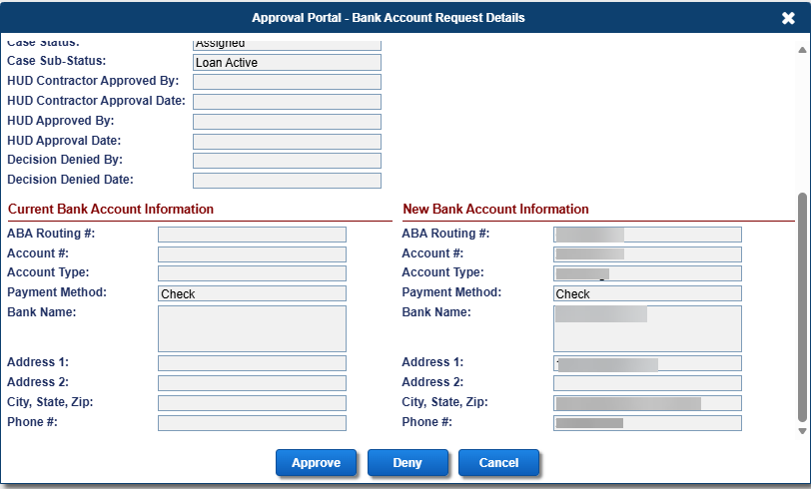
Figure 6-9: Approval Portal Request Details modal displaying Approve or Deny Buttons

Loan Search
In the Servicing Module, the Loan Search screen enables users to search loans and review and edit the loan information.

Search Criteria
Loan records can be retrieved using various combinations of search criteria. In general,
- Enter more search criteria to retrieve more specific search results, but fewer loan records
- Enter fewer search criteria to retrieve a larger number and broader range of loan records
- Basic search criteria include FHA case # and case status

Searching for a Loan
To search for a loan, please refer to Chapter 2.

Loan Search Results
To view and navigate the loan search results, please refer to Chapter 2.

Bulk Print Advance Request Forms
To print the advance request forms:
- Enter the search criteria and click Search on the Loan Search screen to display the search results matching the search criteria in the Loan Search Results section. This form is available only for loans with Pay Plan types of: Modified Tenure, Modified Term and Line of Credit.
- Enter the checkbox beside the loan record in the search results.
- Click the Print Advance Request(s) link in the Loan Search Results section.
- Enter the number of copies needed for each loan on the Print Unscheduled Advance Request Form window, click OK. To exit without printing the letter click Cancel.
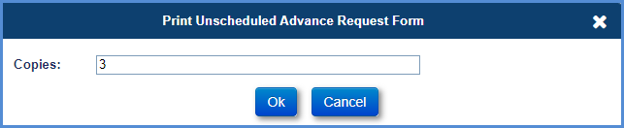
Figure 6-10: Print Unscheduled Advance Request Form Window
- A PDF document is displayed with the selected number of unscheduled advance request copies for each of the selected loans. For example: If three copies are selected for two loans, six copies are displayed.

Notes Search
Notes will display depending on user’s permission.
When the search screen is first displayed, several fields will display “ALL” to allow the user to search for ‘All Notes’. The user can enter or select different criteria to narrow the search results. Once a search is completed the results are displayed in the Search Results screen.
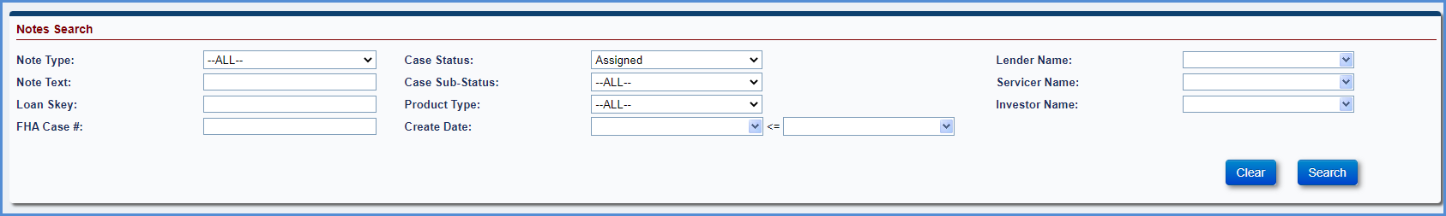
Figure 6-11: Notes Search Screen

Search Criteria
To retrieve Notes, the user can setup a search using different combinations. In general, entering additional search criteria will retrieve more specific search results, but fewer notes records and vice versa.

Searching for a Note
User can build a search using the criteria below

Note Search Criteria
Field | Description
Note Type: | List Note Types
Note Text | Enter text to search
Loan Skey | The Servicing Module system identification number unique to each loan.
FHA Case # | FHA case number of the loan
Case Status | Current high-level status of the loan, either suspense, pending IMIP payment, pending endorsement, endorsed, assigned, cancelled, terminated, or all.
Case Sub-Status | Detailed case sub-status of the loan.
Product type | HECM, HECM for Purchase, HECM – Refinance, HECM Standard, HECM Standard for Purchase, HECM Standard – Refinance, HECM Saver, HECM Saver for Purchase, HECM Saver – Refinance.
Create Date | Enter Date range when Note was created
Lender Name | Name of the company of record servicing the loan record.
Servicer Name | Name of the company of record servicing the loan record.
Investor Name | Name of the mortgage lender that owns/finances the loan record name.
Table 6-2: Note Search Criteria

Writing Search Criteria
To search for a Note:
- Select Notes on the Left Menu.
- On the Note search screen, enter single or multiple search criteria, typically by selecting the criteria from various dropdown boxes. In general, the more criteria the user selects, the fewer results will be returned from the query. In the example below, we have selected a Note Type of Disposition, Case Status Assigned and Product Type HECM Standard. This will narrow the search to only the notes that match the criteria.
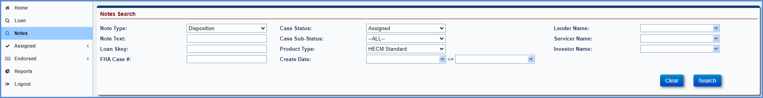
Figure 6-12: Building a Search
- Click Search and the results will be displayed.
- Click the Clear button to remove the previously entered search criteria and re-enter the new search criteria, if needed.

Navigating Search Results
In the search results table, each note that meets the criteria of the search is displayed in a single row (called a table record), and there are 10 of these rows – or records – per page. The total number of records is shown in the bottom right of the screen. When the user clicks on a note, the actual note will be displayed in a pop up screen. Only one note can be selected at a time.
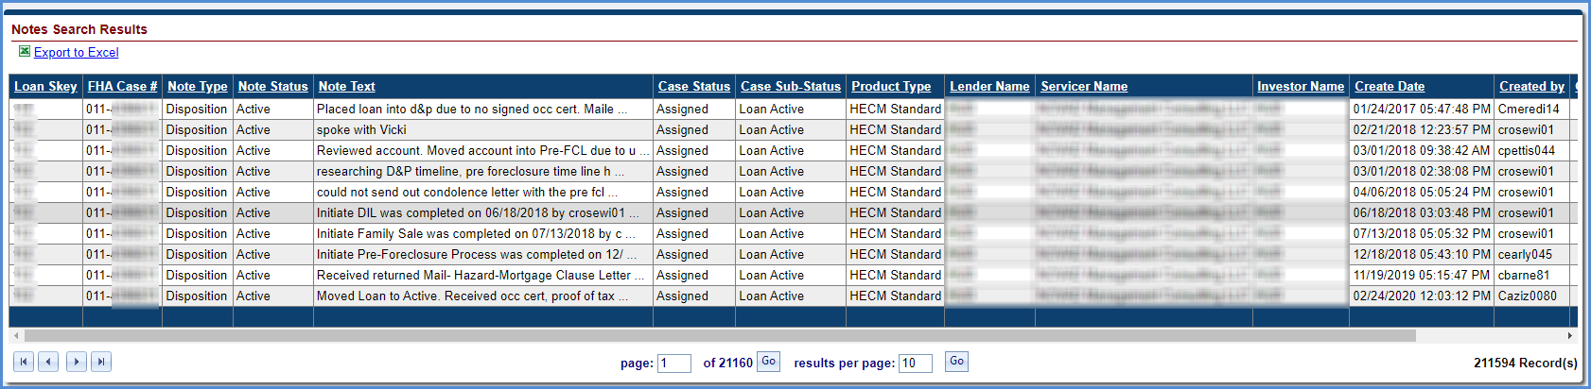
Figure 6-13: Navigating Search Results
Any general search performed will typically return more records than the user can view at one time.
A suite of navigation tools is located at the bottom of the loan search results screen to help the user to navigate the table and the individual rows.

Sorting Records
By default, the records in the search results table are sorted by Loan Skey number but the user can re-sort them by clicking on any column header. This will sort it in alpha or numeric order depending on the column. If the user clicks the header again, it will sort the opposite way.

To See all the Columns in the Table
To see the remaining columns displayed in the Notes Search Results section, click and drag the horizontal scroll bar to the right.
Figure 6-14: Navigating Search Results – Horizontal Bar

Scrolling by Page
To scroll down page by page, or to the very last or first page in the table, click the arrow buttons in the bottom left of the screen. Clicking the arrow to the far right will take the user to the last page. Clicking the arrow to the far left will take the user back to the first page. The arrows in the middle will take the user to the previous or subsequent page.
Figure 6-15: Scrolling by Page

Navigating by Specific Page Number
To go to a specific page, enter the value beside the field page and click Go. To select the results per page, enter the value (max of 300) beside the field results per page and click Go.
Figure 6-16: Navigating by Specific Page Number

Viewing the Number of Records Returned in a Query
View the total record count in the lower right corner at the bottom of the Search Results section.
Figure 6-17: Viewing the Number of Records Returned

Exporting Notes Search Results to Excel
The Export to Excel link will allow the user to export their Notes Search results to excel (Max of 160,000).
Figure 6-18: Exporting Notes Search Results to Excel

To export the Search Results table to Excel:
- Click the Export to Excel link at the top left of the list of the Search results
On the File Download dialog box, click Open to export the search results to Excel.
View or modify the search results when Excel opens a file.
Click Save option to save the file to the desired location.

Viewing a Note
To view Note:
- Click on the Note you want to view in the Notes Search Results section.
- Pop up screen opens with actual Note
- Click Go to Notes Search to go back to Notes Search Results.

Loan Balance
When the user selects a loan from the Loan Search Results section, the Loan Balance screen is displayed. This screen allows the user to view the loan balance information. The information displayed on this screen is received from CHUMS or recorded /derived during the loan setup process. This screen also allows the authorized user to update the payment status on the loan based on the roles and permissions enabled for the users.

If a critical alert exists on the loan, then Critical Alerts window is displayed on the Loan Balance screen warning the user with the critical alert information. Click OK to view the Loan Balance screen.

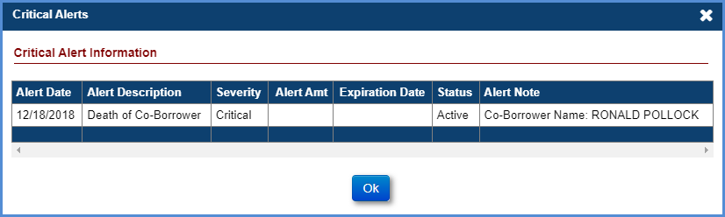
Figure 6-19: Critical Alerts Window
The Loan Balance screen displays the following data sections:
- Principal Limit Calculation
- Loan Balance Information (represented as pie chart and bar graph)
- Other Balances
- Fees
- Payment Plan Information (Editable): The plan can be activated/suspended using this function
- Credit Line Set Aside Information
- Life Expectancy Set Aside LESA (Editable): The LESA Payment plan can be activated/suspended using this function
- Audit Information
- First 12 Months

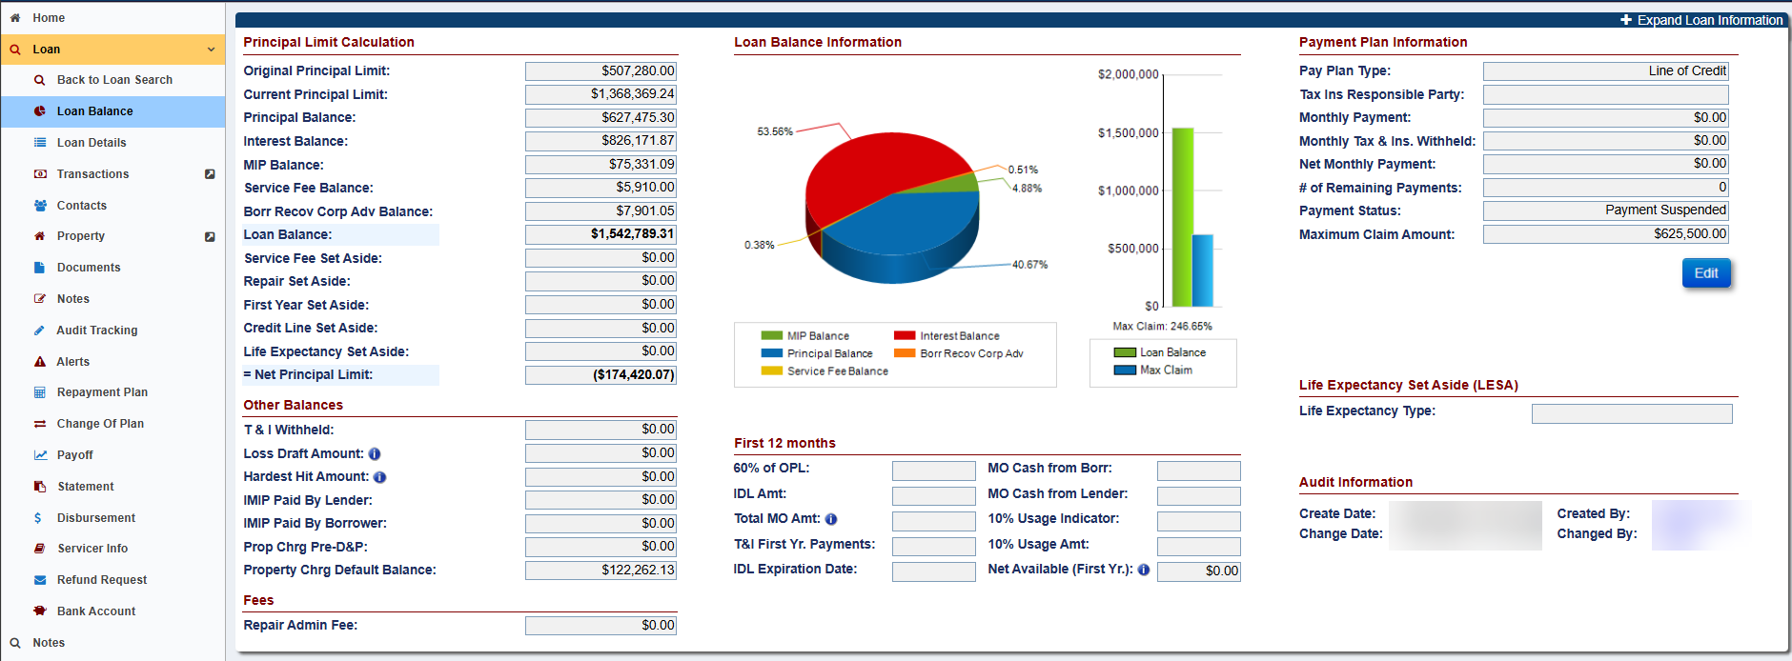
Figure 6-20: Loan Balance Screen

If applicable, the header screen displays the following links:
- Go to Parent Loan: This link is displayed when the product type of the loan is HECM – Refinance or HECM Saver – Refinance. This link navigates the user to the Loan Balance screen of the parent loan.
- Print Loan Details: This link allows the user to generate Loan Summary in a PDF file that can be saved or printed. It contains the following data sections:

  - Loan Identifiers
  - Loan Dates
  - Borrower & Property Information
  - Loan Rates
  - Principal Limit Calculation
  - Payment plan Information
  - Credit Line Set Aside Information
  - Servicer Information

Activating or Suspending Payments
To activate or suspend payments:
- Click Edit in the Payment Plan Information section on the Loan Balance screen.
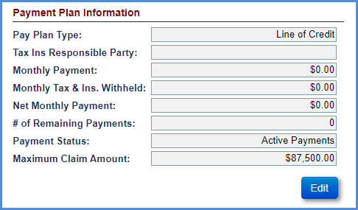
Figure 6-21: Payment Plan Information Section
- On the Edit Payment Plan window, select Active Payments or Payment Suspended from the Payment Status dropdown.
  - If the Payment Suspended option is selected - the case sub-status is updated to Payment Suspended and a critical alert is added on the loan.
  - If Active Payments is selected, then the case sub-status is updated accordingly. The Payment Suspended critical alert becomes inactive once the active payment option is selected.
- To change the responsible party for tax payments, select Borrower or Servicer from the Tax Ins Responsible Party dropdown.
- Click Submit to save the changes. The changes will be displayed on the Loan Balance screen. To exit the window without saving the changes select Cancel.

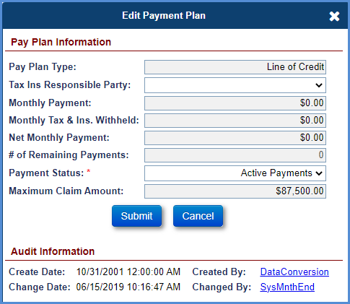
Figure 6-22: Edit Payment Plan Window

Viewing Audit Information
The Audit Information section is displayed in the lower left corner of the Loan Balance screen. This section displays the date and user that modified the fields within the Pay Plan Information section.
To view details of the user that updated the information:
- Click Changed By link under the Audit Information section.
Figure 6-23: Audit Information Section on Loan Balance Screen

- The User Information window is displayed with the contact details of the user. Click OK to exit the window.
Figure 6-24: User Information Window

Activating or Suspending Life Expectancy Set Aside (LESA) Payments
To activate or suspend Life Expectancy Set Aside (LESA) payments:
- Click Edit in the Payment Plan Information section on the Loan Balance screen.
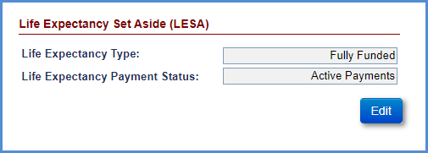
Figure 6-25: LESA Payment Plan Information Section
- On the Edit Payment Plan window, select Active Payments or Payment Suspended from the Payment Status dropdown.
  - If the Payment Suspended option is selected - the case sub-status is updated to Payment Suspended and a critical alert is added on the loan.
  - If Active Payments is selected, then the case sub-status is updated accordingly. The Payment Suspended critical alert becomes inactive once the active payment option is selected.
- Click Submit to save the changes. The changes will be displayed on the Loan Balance screen. To exit the window without saving the changes select Cancel.
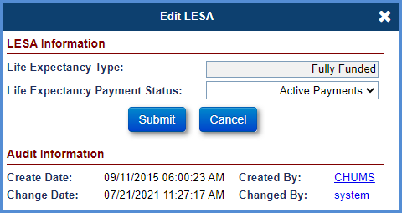
Figure 6-26: Edit LESA Payment Plan Window

Loan Details
The Loan Details screen is displayed when a user selects the Loan Details tab from the menu options on the left side of the screen. The information displayed on this screen is received from CHUMS or recorded during the loan setup process. This screen also allows authorized users (example: HUD NSC Contractor) to edit the data fields.
The Loan Details screen displays the following data sections:
- Loan Rates
- Loan Dates
- Loan Identifiers
- 2nd Mortgage/DOT
- 1st Mortgage/DOT
- Audit Information

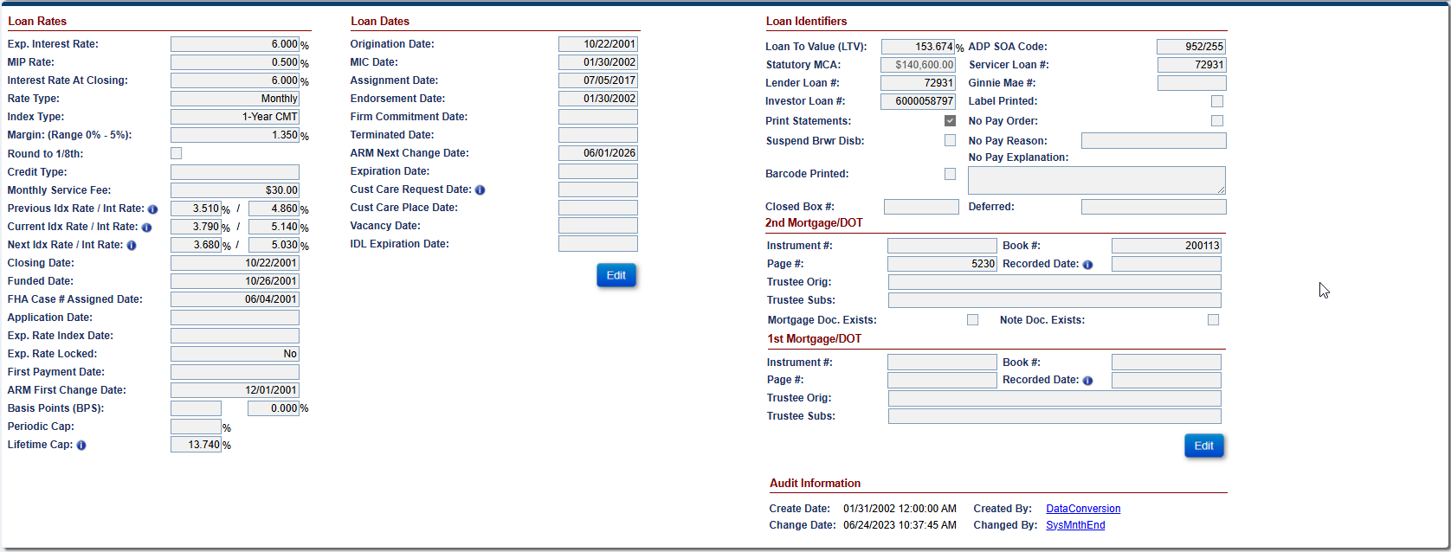
Figure 6-27: Loan Details Screen

Editing Loan Dates
To edit fields in Loan Dates section:
- Click Edit in the Loan Dates section on the Loan Details screen.
- On the Edit Loan Dates window, edit the fields as needed.
Figure 6-28: Edit Loan Dates Window
- Click Submit to save the changes. The changes will be displayed on the Loan Details screen. To exit the window without saving the changes select Cancel.

Editing Loan Identifiers
To edit fields in Loan Identifiers section:
- Click Edit in the Loan Identifiers section on the Loan Details screen.
- On the Edit Loan Identifiers window, edit the fields as needed.
- Click Submit to save the changes. The changes will be displayed on the Loan Details screen. To exit the window without saving the changes click Cancel.

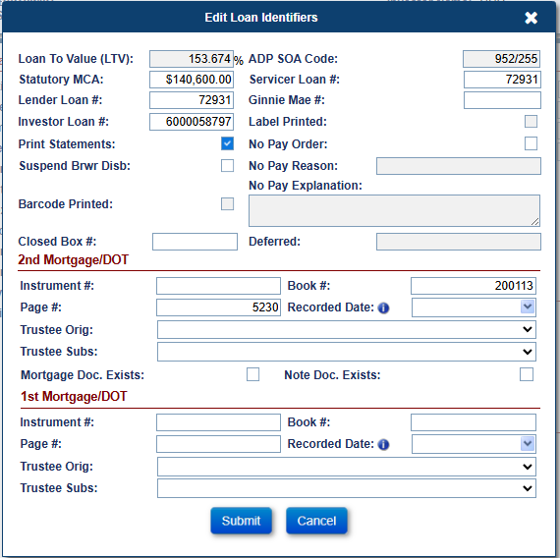
Figure 6-29: Edit Loan Identifiers Window

Viewing Audit Information
The Audit Information section is displayed in the lower right corner of the Loan Details screen. This section displays the date and user that modified the fields within any of the data sections.
To view details of the user that updated the information:
- Click Changed By link under the Audit Information section.
Figure 6-30: Audit Information Section on Loan Details Screen
- The User Information window is displayed with the contact details of the user. Click OK to exit the window.
Figure 6-31: User Information Window

Transactions
The Loan Transactions screen is displayed when a user selects the Transactions tab from the menu options on the left side of the screen. This screen allows authorized users (example: HUD NSC Contractor) to report transaction activities on a loan.
The transactions tab has four sub-menu options:
- Loan
- Growth
- Set Asides
- Claims
- Miscellaneous

Transactions – Loan
This screen displays all the current and historical loan transactions (prior to Assigned status) associated with the loan. This screen allows the user to perform the following functions:
- Loan Transaction Filter: Allows the user to filter and view specific transactions within a transaction category.
- New Transactions: Allows the authorized user to add transactions on the loan
- Balance Adjustment: Allows the authorized user to adjust the loan balance
- Write-off: Allows the authorized user to perform partial write-off on the loan balance
- Export Transactions: Allows the authorized user to export transactions generated in the Servicing Module (SM)
- Print Transactions: Allows the authorized user to print the transactions (file generated in PDF) generated in the Servicing Module
- Export Historical Transactions: Allows the authorized user to export transactions generated in the Insurance Accounting Collection System (IACS) system prior to data conversion in the Servicing Module
- Print Historical Transactions: Allows the authorized user to print the transactions (file generated in PDF) for the transactions generated in the Insurance Accounting Collection System (IACS) system prior to data conversion in the Servicing Module
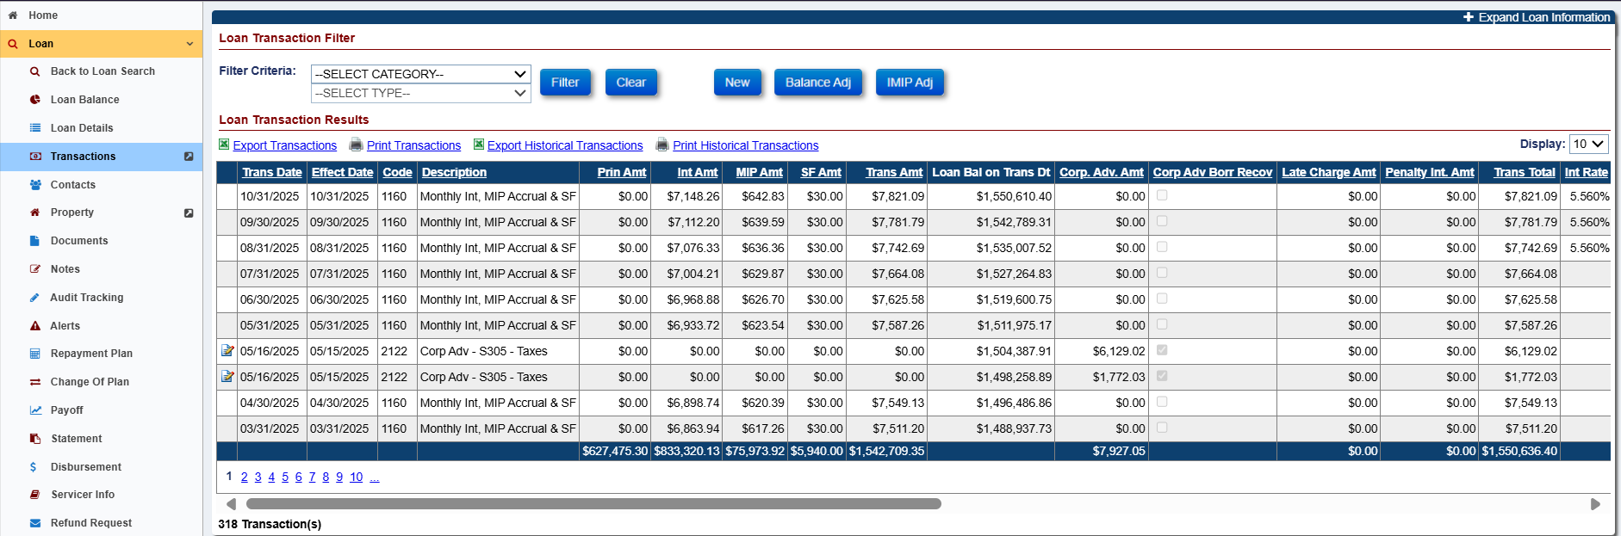
Figure 6-32: Transactions – Loan Screen

Transactions - Loan Filter Categories
The Loan Transaction Filter section of the Transactions - Loan screen allows authorized users to apply filters and view selected transactions within the selected transaction category. The transactions can be filtered by the following categories:
- Corporate Advances
- Disbursements
- Fees
- Closing costs
- Loan setup – Loan Balance
- Monthly Accruals
- Refunds
- Repayments
- Terminations
- Perform Adjustment of Initial MIP
The table below provides the list of data fields and descriptions displayed under the Transactions – Loan Filter section.
Field | Description
Trans Date | The date transaction is posted in the Servicing Module either manually or through B2G.
Effect Date | The date the payment was made by the previous/current Lender/Investor for the incurred expense (Example: The date payment was made to the contractor for lawn mowing or the date the Taxes were paid to the Tax Authority).
Code | A 4-digit unique transaction code assigned by the system for a specific transaction.
Description | Short description of the transaction.
Prin Amt | The principal amount associated with the transaction.
Int Amt | The interest amount associated with the transaction.
MIP Amt | The Mortgage Insurance Premium amount associated with the transaction (for pre-assigned transactions).
SF Amt | The Service fee amount associated with the transaction.
Loan Bal Trans Amt | Sum of principal, interest, MIP and service fee amount.
Corp Adv Amt | Transaction amount associated with the Corp Advance expense paid by the Lender/Investor (N/A for assigned loans).
%Recoverable | The percentage of the transaction amount that can be recovered by the Lender/Investor (for pre-assigned transactions).
Recoverable Amt | The transaction amount which is recoverable by the Lender/Investor for Corp Advance transactions (N/A for assigned loans).
Late Charge Amt | The late charge amount associated with the transaction.
Penalty Int Amt | The penalty interest associated with the transaction.
Trans Total | Sum of loan balance, late charge and penalty interest amount.
Lender | Lender associated with the loan.
Servicer | Servicer associated with the loan.
Investor | Investor/holder associated with the loan.
Incurred Date | This is the date the expense was incurred by the Lender/Investor (N/A for Assigned loans). Example: The date the lawn mowing service was completed or for Property Charges the date the taxes were paid and is expected to be the same as the effective date. This field is required for the following transaction categories:  - Corp Advance Sections 305, 306, 307, 308, 309, 310 and 409.  - Corp Advance - Property Preservation
Exclude from Max | This checkbox indicates whether the P&P transaction is excluded from $5,000 cap (N/A for assigned loans).
Max. Approved | This checkbox indicates whether the P&P transaction amount is within the maximum allowable limit. HUD approval is not required if this box is checked (N/A for assigned loans).
Created By | The User Name who initiated the transaction.
Create Date | The date and time the transaction is recorded in the system.
Table 6-3: Transactions - Loan Screen
To filter the transactions by transaction category:
- Select the Transaction Category from the dropdown.
- Select the Transaction Type from the dropdown (if needed).
- Click Filter to view the filtered transactions under the Loan Transactions Results section. No results are displayed if no transactions match the filter criteria entered by the user.
- Click Clear to clear the selected filters and view all transactions.
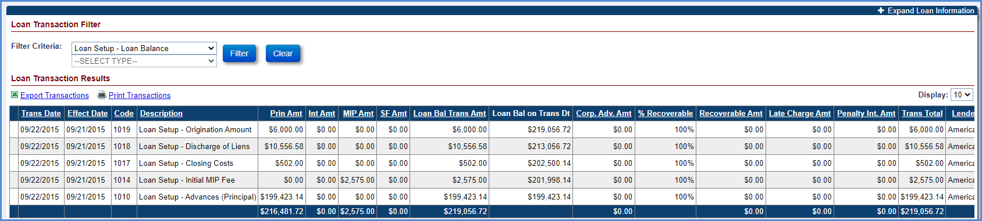
Figure 6-33: Loan Transactions Filter and Results Section

Creating a New Loan Transaction
The table below lists the Transaction categories in the New Loan Transaction window for Assigned loans:
Transaction Category | Description
Repays | Transactions within this category are initiated by the servicer (on-behalf of a borrower) to repay a partial amount to reduce the current unpaid loan balance.
Terminate | Transactions within this category are initiated by the servicer to terminate a loan and provide a reason for termination.
Table 6-4: Transaction Categories

Repays
A partial repayment transaction is initiated by HUD NSC Contractor on behalf of a borrower to repay a partial amount to reduce the current unpaid loan balance. The system will not allow repayment amount same as payoff amount. For full repayment, terminate transaction must be used.
To perform a Repay transaction:
- Click New on the Transactions - Loan screen.
- On the New Loan Transaction window, select Repay from Transactions Category dropdown. The Transaction Type field automatically populates with the entry Part Repay – Reduce Loan Balance if the pay plan is not modified term or modified tenure.
- Populate the below listed required fields (marked with red asterisk):
  - Transaction Type
  - Effective Date
  - Transaction Amount
- Click Submit. The Loan Balance field under the Balance Information section (header) reflects the updated loan balance. The new transaction is displayed in the Loan Transaction Results section. To exit the window without adding the transaction click Cancel.
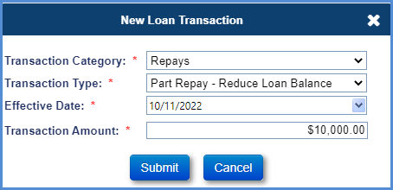
Figure 6-34: Repay Transaction Window
- To adjust the repay transaction, select the document icon beside the transaction, on the Adjust Loan Transaction window, click Submit to reverse the transaction.
- A new repay adjustment transaction is added and displayed under the Loan Transactions Results section reflecting the reversed amount.
The table below lists the Repay transactions that can be manually created using the New Loan Transactions window.
Transaction | Description
Partial Repay - Reduce Loan Balance | When the partial repayment transaction is complete, HUD NSC can view the updated (reduced) loan balance in the Loan Balance header. This transaction applies to all pay plan types.
Partial Repay - Increase CLSA + Reduce Loan Balance | When the partial repayment transaction is complete, HUD NSC can view the updated (reduced) unpaid loan balance and increases to the available line of credit. This transaction applies only to modified term and modified tenure pay plans.
Partial Repay – Property Charges/Tax & Insurance Repayment | This transaction can be entered against the balance of Unscheduled Property Charge transactions. This transaction follows the waterfall approach. This transaction applies to all pay plan types.  - MIP Amount  - Service Fee  - Interest Amount  - Principal Amount
Table 6-5: Repay Transactions

Termination
The Termination transaction is initiated by the HUD NSC Contractor to notify HUD of the termination of the HECM loan. Upon termination, the case status of the loan is updated to “Terminated” and loan balance is set to zero. The case sub status and loan’s termination reason are set based on the transaction type selected by the HUD NSC Contractor at the time of termination transaction.
To terminate a loan for a borrower:
- Click New on the Transactions - Loan screen.
- On the New Loan Transaction window, select Terminate from Transactions Category dropdown.
  - Populate the below listed required fields (marked with red asterisk):
  - Transaction Type
  - Effective Date
- Transaction Amount
- Click Submit.
Figure 6-35: New Loan Transaction - Terminate
- Any errors that will prevent the Transaction from being posted will be displayed and the error must be cleared to successfully enter the Transaction.
- A pop-up window is displayed requesting the user to confirm the action and notifying user that the case status will be updated to Terminated.
- Click OK on the pop-up window. The new transaction is displayed in the Loan Transaction Results section and case status and case sub status is updated. To exit the pop-up window without adding the transaction click Cancel.
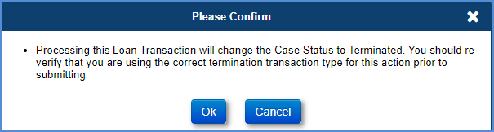
Figure 6-36: Confirmation Message
- To adjust the terminate transaction, select the document icon beside the transaction, on the Adjust Loan Transaction window, click Submit to reverse the transaction.
- A new terminate adjustment transaction is added and displayed under the Loan Transactions Results section reflecting the reversed amount.
The table below lists the Terminate transactions that can be manually created using the New Loan Transactions window.
Transaction | Description | Re-Termination (Used to record trailing expenses when case is re-opened)
Terminate - 3rd Party FCL Sale (PIF) | Initiated by HUD NSC Contractor to terminate a loan due to a third-party sale of the property via foreclosure sale when the proceeds are sufficient to pay off outstanding mortgage debt in full. No claim will be filed. The pay-off amount will be treated as a COLLECTION by HUD. | Terminate - 3rd Party FCL Sale (PIF)
Terminate - Asset Sale | Initiated by HUD NSC Contractor to terminate a loan due to sale of the asset. | Terminate - Asset Sale
Terminate - Paid in Full | Initiated by HUD NSC Contractor to terminate the loan if the loan pays in full. The pay-off amount will be treated as a COLLECTION by HUD. | Terminate - Full Write-Off
Terminate - Paid in Full | Note: If the pay-off amount is not within the overage or shortage threshold limit set by HUD, system will not allow the termination of the loan for this termination type. | Terminate - Full Write-Off
Terminate - DIL Conveyed | Initiated by HUD NSC Contractor once HUD owns the deed of the mortgaged property in lieu of foreclosure. | Terminate - DIL Conveyed
Terminate - DIL Conveyed | Note: If the pay-off amount is not within the overage or shortage threshold limit set by HUD, system will not allow the termination of the loan for this termination type. | Terminate - DIL Conveyed
Terminate - FCL Conveyed | Initiated by HUD NSC Contractor to terminate the loan after the mortgaged property is foreclosed. | Terminate - FCL Conveyed
Terminate - FCL Conveyed | Note: If the pay-off amount is not within the overage or shortage threshold limit set by HUD, system will not allow the termination of the loan for this termination type. | Terminate - FCL Conveyed
Terminate - Full Write-Off | Initiated by HUD NSC Contractor (upon approval from HUD NSC) to terminate the loan with full write-off. The pay-off amount will be treated WRITTEN OFF by HUD. | Terminate - Full Write-Off
Terminate - Refinance | Initiated by HUD NSC Contractor to terminate the loan due to refinancing. | N/A
Terminate - Short Sale (PIF W/Write –Off) | Initiated by HUD NSC Contractor to terminate the loan when a short sale is initiated by HUD via foreclosure. The pay-off amount will be treated as a COLLECTION by HUD. | Terminate - Full Write-Off
Table 6-6: Terminate Transactions

Balance Adjustments
The Balance Adj button enables the authorized user to correct the loan balance. Only an authorized role with this permission enabled can perform this function.
To perform a Balance adjustment of a loan:
- Click Balance Adj. on the Transactions - Loan screen.
- On the Adjust Loan Transaction window, enter the amounts in the Correct Amount column.
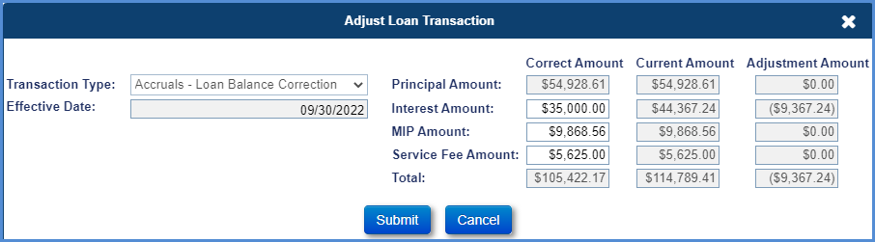
Figure 6-37: Adjust Loan Balance Window
- Click Submit. A new transaction “Accruals – Loan Balance Correction” is added reflecting the corrected amounts under the Loan Transactions Results section.
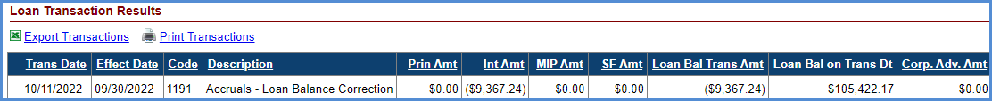
Figure 6-38: Loan Balance Adjustment Transaction

Write-Off
The Write-Off button enables the authorized user to perform a partial write-off. Only authorized roles with this permission enabled can perform this function. To perform a partial write-off:
- Click Write-Off on the Transactions - Loan screen.
- On the Write-Off window, enter the amounts in the following fields:
  - Principal
  - Interest
  - MIP
  - Service Fee
  - Corp Advance
- Click Submit. This will create the partial write-off transaction.
- A new transaction, Write-Off - Manual, is added reflecting the updated amounts under the Loan Transactions Results section.
Figure 6-39: Write-off Transaction Window
- To adjust the transaction, select the document icon beside the transaction on the Adjust Loan Transaction window and click Submit to reverse the transaction.

- A new transaction, Write-Off - Manual Adj, is added and displayed under the Loan Transactions Results section reflecting the reversed amount.

Life Expectancy Set Aside (LESA) Repays
A partial repayment transaction is initiated by HUD NSC Contractor on behalf of a borrower to repay a Partial Life Expectancy Set Aside amount to reduce the current unpaid loan balance. The system will not allow repayment amount same as payoff amount. For full repayment, terminate transaction must be used.
To perform a Repay transaction:
- Click New on the Transactions - Loan screen.
- On the New Loan Transaction window, select Repays-LESA from Transactions Category dropdown. The Transaction Type field automatically populates with the entry Part Repays –LESA if the pay plan is not modified term or modified tenure.
- Populate the below listed required fields (marked with red asterisk):
  - Transaction Type
  - Effective Date
  - Transaction Amount
- Click Submit. The Loan Balance field under the Balance Information section (header) reflects the updated loan balance. The Life Expectancy Set Aside amount increase in the Principal Limit Calculation section in the Loan Balance page. The new transaction is displayed in the Loan Transaction Results section. To exit the window without adding the transaction click Cancel.
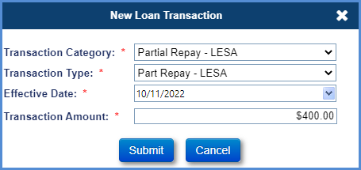
Figure 6-40: Repays- LESA Transaction Window
- To adjust the repay transaction, select the document icon beside the transaction, on the Adjust Loan Transaction window, click Submit to reverse the transaction.
- A new repay adjustment transaction is added and displayed under the Loan Transactions Results section reflecting the reversed amount.
The table below lists the Repay transactions that can be manually created using the New Loan Transactions window.

Transaction | Description
Partial Repay-LESA | When the partial repayment transaction is complete, HUD NSC can view the updated (reduced) loan balance in the Loan Balance header. This transaction applies to all pay plan types.

Table 6-7: LESA Repay Transactions

Repay Transactions - Growth
This screen displays the growth transactions associated with line of credit, principal limit and unscheduled line of credit disbursements. This screen allows the authorized user to filter and view specific growth transactions within a transaction category. The growth transactions are automatically initiated by the system.
Figure 6-41: Transactions – Growth

The table below lists the Growth transactions that are automatically initiated by the system.
Transaction | Description
Credit Line Transactions | Transactions generated for loans which have an available line of credit for borrower.
Credit Line Original – Setup | This transaction is generated in Servicing Module when certain amount is set aside from line of credit. This transaction is generated for pay plan types Modified Tenure and Modified Term.
Credit Line Original - Setup Adj | This transaction is an adjustment/reversal of transaction 'Credit Line Original - Setup'.
Credit Line – Growth | This transaction is generated in Servicing Module to depict the monthly Line of credit growth.
Credit Line - Growth Adj | This transaction is an adjustment/reversal of transaction 'Credit Line - Growth'.
Credit Line - Change Of Plan Adj | This transaction is generated in Servicing Module when a change of payment plan occurs. This transaction is generated when there is a change of payment plan from Modified Tenure to Modified Term or vice-versa.
Principal Limit Transaction | Transaction generated for all loans to depict the monthly Principal limit changes.
Principal Limit Original – Setup | This transaction is generated in Servicing Module when the original principal limit is setup during the loan setup.
Principal Limit Original - Setup Adj | This transaction is an adjustment/reversal of transaction 'Principal Limit Original - Setup'.
Principal Limit – Growth | This transaction is generated in Servicing Module to depict the monthly principal limit growth.
Principal Limit - Growth Adj | This transaction is an adjustment/reversal of transaction 'Principal Limit - Growth'.
Unscheduled Credit Line Disbursement Transaction | Transactions generated for loans eligible for unscheduled line of credit disbursements.
UnSch LOC Disb - Int & MIP Accrual | This transaction is generated in Servicing Module to display the interest and MIP accruals on an unscheduled disbursements taken from available line of credit. This is applicable for pay plan types Modified Tenure and Modified Term.
Table 6-8: Growth Transactions

Transactions – Growth Filter
The Growth Transaction Filter section allows the authorized user to view the transactions according to the filter criteria selected.
To filter the transactions by transaction category:
- Select the Transaction Category from the dropdown.
- Select the Transaction Type from the dropdown (if needed).
- Click Filter to view the filtered transactions under the Growth Transactions Results section. No results are displayed if no transactions match the filter criteria entered by the user.
- Click Clear to clear the selected filters and view all transactions.
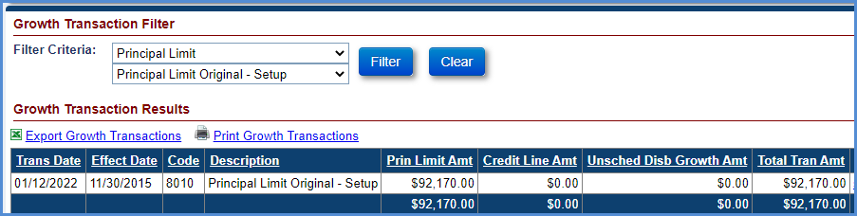
Figure 6-42: Growth Transactions Filter and Results Section

Transactions - Set Asides
This screen displays all the Set Aside transactions associated with the loan. This screen allows the user to perform the following functions:
- Set Aside Transaction Filter: This allows the user to filter and view specific transactions within a transaction category.
- New Transactions: This allows the authorized user with the ability to add set aside transactions on the Loan.
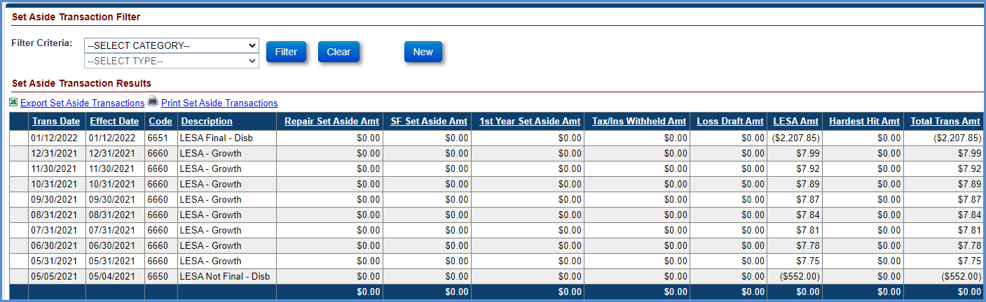
Figure 6-43: Transactions - Set Aside

Transactions – Set Aside filter
The Set Aside Transaction Filter section allows the authorized user to view the transactions according to the filter criteria selected.
To filter the transactions by transaction category:
- Select the Transaction Category from the dropdown.
- Select the Transaction Type from the dropdown (if needed).
- Click Filter to view the filtered transactions under the Set Aside Transactions Results section. No results are displayed if no transactions match the filter criteria entered by the user.
- Click Clear to clear the selected filters and view all transactions.
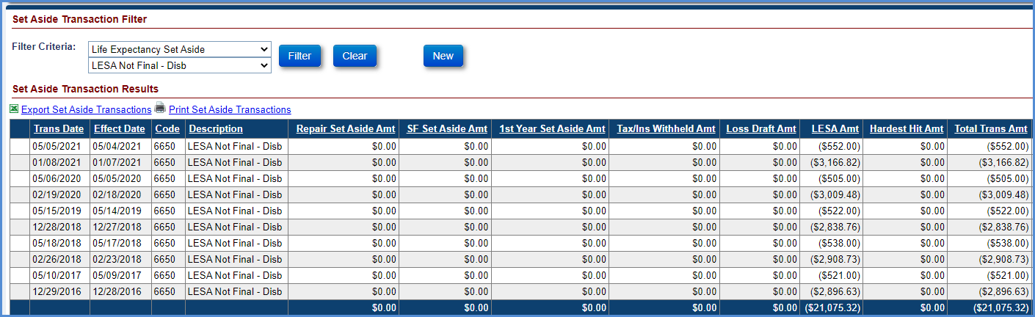
Figure 6-44: Set Aside Transactions Filter and Results Section

Creating a New Set Aside Transaction
The New button allows the authorized user to add Set Aside transactions. The following transactions can be initiated manually by the user:
- 1st Yr Taxes & Ins – Setup
- Repair Set Aside – Setup
- Loss Draft – Setup

1st Yr Taxes and Ins - Setup
This transaction is initiated by the HUD NSC Contractor when an amount is set aside for payment of Taxes and Insurance on the mortgaged property. This transaction can be applied to all pay plans.
To create a 1st Yr Taxes and Ins Set Aside transaction:
- Click New on the Transactions – Set Aside screen.
- On the New Set Aside Transaction window, select 1st Yr Taxes & Ins – Setup from the Transaction Type dropdown.
- Populate the below listed required fields (marked with red asterisk):
  - Effective Date
  - Transaction Amount
- Click Submit. The new transaction is displayed in the Set Aside Transaction Results section. To exit the window without adding the transaction click Cancel.
Figure 6-45: Set Aside - Taxes & Insurance Transaction
- To adjust the Set Aside transaction, select the document icon beside the transaction, on the Adjust Set Aside Transaction window, enter the transaction amount and click Submit to adjust the transaction.
Figure 6-46: Document Icon Beside Set Aside Transaction
- A new 1st Yr Taxes & Ins – Setup Adj transaction is added and displayed under the Set Aside Transactions Results section reflecting the adjusted amount.
Figure 6-47: 1st Year Taxes & Ins. Set Aside Adjustment Transaction

Repair Set Aside- Setup
This transaction is initiated by the HUD NSC Contractor when an amount is set aside for any repairs on the mortgaged property, this transaction will be used for loans converted from HUD’s legacy system (SMART) with repair set aside amount greater than zero dollars. For the loans where repairs are initiated in the Servicing Module, Loss Draft Set Aside transaction will be used. This transaction can be applied to all pay plans.
To create a Repair Set Aside transaction:
- Click New on the Transactions – Set Aside screen.
- On the New Set Aside Transaction window, select Repair Set Aside – Setup from the Transaction Type dropdown.
- Populate the below listed required fields (marked with red asterisk):
  - Effective Date
  - Transaction Amount
- Click Submit. The new transaction is displayed in the Set Aside Transaction Results section. To exit the window without adding the transaction click Cancel.
Figure 6-48: Set Aside - Repair Transaction Window
- To adjust the Set Aside transaction, select the document icon beside the transaction, on the Adjust Set Aside Transaction window, enter the transaction amount and click Submit to adjust the transaction.
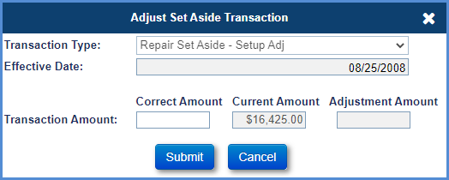
Figure 6-49: Adjust Set Aside Transaction Window
- A new Repair Set Aside – Setup Adj transaction is added and displayed under the Set Aside Transactions Results section reflecting the adjusted amount.
Figure 6-50: Repair Set Aside Adjustment Transaction

Loss Draft Set Aside- Setup
This transaction is initiated by the HUD NSC Contractor when a hazard insurance claim payment is received from the mortgagor or the hazard insurance company. The insurance proceeds are placed into the set-aside account to be disbursed based on appropriate documentation received. This transaction can be applied to all pay plans.
To create a Loss Draft Set Aside transaction:
- Click New on the Transactions – Set Aside screen.
- On the New Set Aside Transaction window, select Loss Draft – Setup from the Transaction Type dropdown.
- Populate the below listed required fields (marked with red asterisk):
  - Effective Date
  - Transaction Amount
- Click Submit. The new transaction is displayed in the Set Aside Transaction Results section. To exit the window without adding the transaction click Cancel.
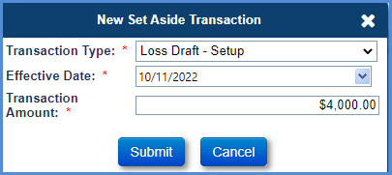
Figure 6-51: Set Aside - Loss Draft Transaction Window
- To adjust the Set Aside transaction, select the document icon beside the transaction, on the Adjust Set Aside Transaction window, enter the transaction amount and click Submit to adjust the transaction.
- A new Loss Draft – Setup Adj transaction is added and displayed under the Set Aside Transactions Results section reflecting the adjusted amount.

Hardest Hit Funds Set Aside- Setup
This transaction is initiated by the HUD NSC Contractor when a Hardest Hit Fund payment is received. The Hardest Hit Fund proceeds are placed into the set-aside account to be disbursed based on appropriate documentation received. This transaction can be applied to all pay plans
To create a Hardest Hit Funds Set Aside transaction:
- Click New on the Transactions – Set Aside screen.
- On the New Set Aside Transaction window, select Hardest Hit Funds – Setup from the Transaction Type dropdown.
- Populate the below listed required fields (marked with red asterisk):
  - Effective Date
  - Transaction Amount
- Click Submit. The new transaction is displayed in the Set Aside Transaction Results section. To exit the window without adding the transaction click Cancel.
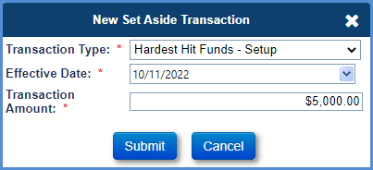
Figure 6-52: Set Aside - Hardest Hit Transaction Window
- To adjust the Set Aside transaction, select the document icon beside the transaction, on the Adjust Set Aside Transaction window, enter the transaction amount and click Submit to adjust the transaction.
- A new Hardest Hit Funds – Setup Adj transaction is added and displayed under the Set Aside Transactions Results section reflecting the adjusted amount.

Transactions - Claims
This screen displays the claims transactions associated with claim submissions. This screen allows the user to filter and view specific claim transactions within a transaction category. The claim transactions are automatically initiated by the system when a claim is approved by HUD. Only transactions associated with Claim Type 22 are applicable for Assigned loans.
The table below lists the Claim transactions that are automatically initiated by the system.

Transaction | Description
Claim Type 21 - FCL/DIL | This transaction is automatically initiated by the Servicing Module upon approval of Claim Type 21 by HUD.
Claim Type 22 - Optional Assignment | This transaction is automatically initiated by the Servicing Module upon auto-approval of Claim Type 22.
Claim Type 23 - Mortgagor Sale | This transaction is automatically initiated by the Servicing Module upon approval of Claim Type 23 by HUD.
Claim Type 21 – Supplemental | This transaction is automatically initiated by the Servicing Module upon approval of Claim Type 24 by HUD provided the initial claim is a Claim Type 21.
Claim Type 23 – Supplemental | This transaction is automatically initiated by the Servicing Module upon approval of Claim Type 24 by HUD provided the initial claim is a Claim Type 23.
Claim Type 22 - Funds Due HUD | Automatically initiated by the Servicing Module upon denial of assignment (Claim Type 22 post preliminary title approval and pre final title approval) by HUD. The transaction is initiated to recover the advances made previously by HUD.
Interest on HUD Advances | Automatically initiated by the Servicing Module upon denial of Assignment (Claim Type 22 post preliminary title approval and pre final title approval) by HUD. The transaction is initiated to recover the interest amount on the advances made previously by HUD.
Claim Type 22 – Repurchase | For assigned loans, this transaction is automatically initiated by the Servicing Module upon approval of Assignment Repurchase by HUD.
Claim Type 22 - Repurchase Adj | Automatically initiated by the Servicing Module if there is a difference in payoff amount between the date HUD approved repurchase and servicer authorized the repayment transaction.
Table 6-9: Claims Transactions

Transactions – Miscellaneous
This screen displays the Miscellaneous Income transactions. Users with permission will be able to view and add Miscellaneous transactions. Miscellaneous Income transactions are restricted to loans serviced by HUD where the Servicer ID is 9999909990. This screen allows the user to filter and view Miscellaneous Income transactions. The Miscellaneous Income Transaction shall be recorded as an income transaction and will not affect the Loan balance.
To create a Miscellaneous Income Transaction:
- Click New on the Transactions – Miscellaneous screen.
- On the New Miscellaneous Transaction window, select Miscellaneous Income from the Transaction Category dropdown.
- Populate the below listed required fields (marked with red asterisk):
  - Transaction Type
  - Effective Date
  - Transaction Amount
- Click Submit.
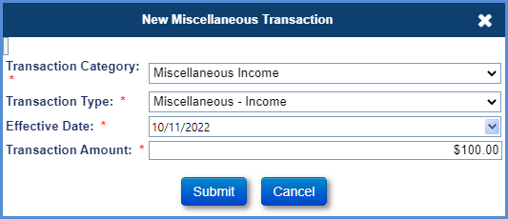
Figure 6-53: Miscellaneous Transaction Window

- To adjust the Miscellaneous Income transaction, select the document icon beside the transaction, on the Adjust Misc Transaction window, click Submit to reverse the transaction.
- A new Miscellaneous Income adjustment transaction is added and displayed under the Miscellaneous Transactions Results section reflecting the reversed amount.

Notes Collections
This section explains the notes collection processing in HERMIT (Servicing and Accounting Modules) system.
- The Servicing Module generates the notes receivable transaction when the collection transactions are initiated in the system by the HUD NSC Contractor for Assigned loans (for example: Payoff). The loan balance is adjusted in the system. These FHA cases are sent to the Accounting Module via an interface file.
- The Servicing Module assigns a batch ID and batch status for the notes receivable request to track the status. Once the file is generated and sent to the Accounting Module, the batch status (Sent to GL) is updated to indicate that the transaction has been sent to the Accounting Module.
- The Accounting Module processes the file, records the receivable transactions and sends a response file to the Servicing Module. The Servicing Module processes the response file from the Accounting Module and updates the batch status (Success).
- The HUD NSC Contractor generates the notes collection transactions report (based on transaction date) from the Accounting Transmittals screen in the Servicing Module.
- The HUD NSC Contractor scans checks received and enters other pertinent data into Treasury’s Paper Check Conversion Over the Counter (PCC-OTC) application. Upon completion, a daily PCC-OTC collections report is generated.
- The PCC-OTC daily collections report is reconciled to the Servicing Module daily collections transactions report. This validation confirms that all transactions entered to the Servicing Module were also scanned into PCC-OTC and that all applicable dollar amounts match.
- Treasury PCC-OTC processes collections. Treasury submits the collection through the Federal Reserve and the payer bank account is debited.

Contacts
The Contact screen is displayed when a user selects the Contacts tab from the menu on the left side of the screen. This screen displays the borrower, co-borrower and non-borrowing spouse information received from CHUMS at the time of loan setup. In addition, the screen enables authorized users to add new contacts other than borrower and co-borrower, edit existing contact information, and delete a contact. The screen also enables user to deactivate a non-borrowing spouse, if available, and add property contact assessment information related to Home Ownership Associations (HOA) and Condominiums.
The Contacts screen displays the following sections:
- New button – Contact Information
- Contacts
- New button – Assessment Information
- Assessment Contacts

Viewing a Contact
To view a contact:
- Click a Contact Type displayed under the Contact Information section.
- The Mailing Information, Other Information and Audit Information of the selected contact are displayed below the contact.
Figure 6-54: View Contact Information Screen

Adding a Contact
To add a contact:
- Click New in the Contact Information section.
- On the Contact Info window, populate the fields as needed (fields marked with red asterisk must be populated). Selecting the button Same as Contact Address will auto-fill the contact’s name and address from the Contact Name & Address section to the Contact Mailing Info section.
- Click Submit to save the changes. The new contact is displayed under the Contact Information section. To exit the window without saving the changes click Cancel.
Figure 6-55: Add Contact Information Window

Editing a Contact
To edit a contact:
- Click the document icon beside the contact type in the Contact Information section.
- On the Contact Info window, edit the fields as needed (fields marked with red asterisk must be populated).
- Click Submit to save the changes. The updated information is displayed under the Contact Information section. To exit the window without saving the changes click Cancel.
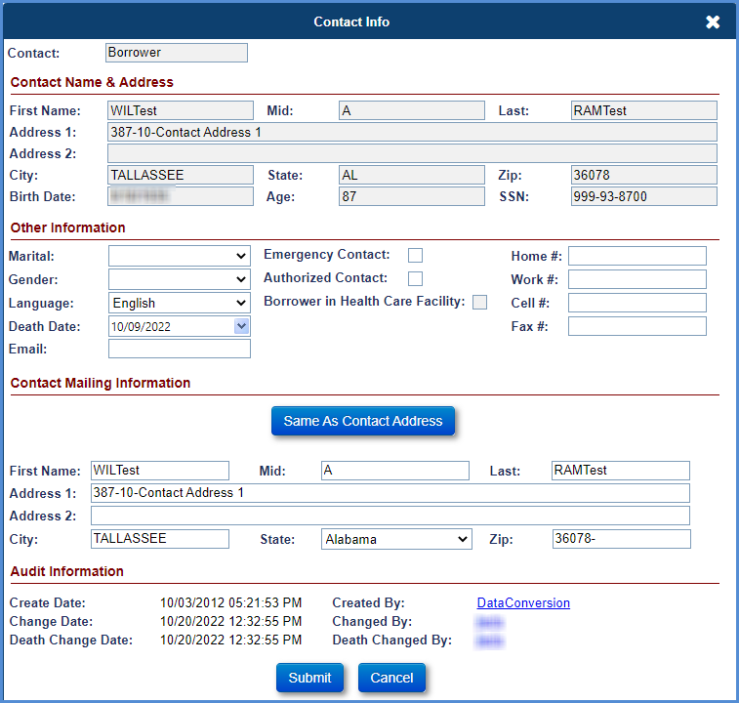
Figure 6-56: Edit Contact Information Window

Viewing and editing “Borrower in Health Care Facility” checkbox
The Borrower in Health Care Facility checkbox is placed under the Authorized Contact checkbox in the Contact Info Screen for Borrowers only. The checkbox when selected indicates that the Borrower is in health care facility. Borrower in Health Care Facility checkbox will only be editable for loans with NBS regardless of MOE status. Upon checking this checkbox for the last living borrower, Deferred Status will be updated to “YES”. System will not allow to add Due & Payable timelines if Borrower in Health Care Facility checkbox is checked and Deferred is set to YES.

Deleting a Contact
To delete a contact:
- Click the cross icon beside the contact type in the Contact Information section.
The contact information of the Borrower and Co-Borrower Contact Type cannot be deleted.
- A pop-up window is displayed requesting the user to confirm the action.
- Click OK on the pop-up window, the selected contact will be deleted. To exit the message window without deleting a contact select Cancel.
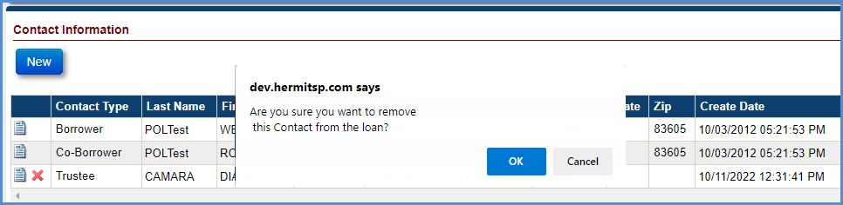
Figure 6-57: Delete Contact Information

Deactivating a Non-Borrowing Spouse
To deactivate a non-borrowing spouse:
- Click the document icon beside the contact type Non-Borrowing Spouse in the Contact Information section.
- On the Contact Info window, select the Deactivate NBS box. Entering the death date for NBS will cause the NBS to become inactive.
- Click Submit to save the changes. The updated information is displayed under the Contact Information section. To exit the window without saving the changes click Cancel.
Figure 6-58: Deactivate a Non-Borrowing Spouse

Viewing Eligible and Ineligible Non-Borrowing Spouse
The Eligible NBS checkbox is placed under the Mort Opt Election (MOE) checkbox in the Contact Info Screen. The checkbox when selected indicates that the Non-Borrowing Spouse present on the loan is Eligible. The Checkbox when not selected indicates that Non-Borrowing Spouse present on the loan is Ineligible. If the Eligible NBS Checkbox is checked then a 9 digit SSN is required to add or edit an NBS Contact. If the NBS Checkbox is NOT checked then SSN is not required to create or edit an NBS Contact. An error message will be displayed if the Eligible NBS Checkbox is checked and the user attempts to enter an NBS Contact without a 9 digit SSN. The error message will read, “A 9 digit SSN is required for eligible NBS.”
- Contact Information section. To exit the window without saving the changes click Cancel.
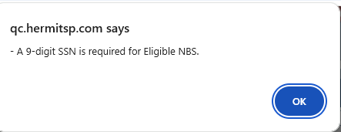
Figure 6-59: Error message: “A 9 digit SSN is required for Eligible NBS.”

Adding a Non-Borrowing Spouse Contact
An authorized user can enter up to three Non-Borrowing Spouses for the FHA Case numbers assigned prior to 08/04/2014. These are identified as MOE NBS in the Contact Information page and in the Borrower Information section of the loan header. For FHA Case numbers assigned on or after 08/04/2014, the NBS information is sent to HERMIT via CHUMS /FHA Connections and are not MOE.
To add a contact:
- Click New in the Contact Information section.
- On the Contact Info Window, select Non-Borrowing Spouse from the drop-down menu.
- On the Contact Info window, populate the remaining fields as needed (fields marked with red asterisk must be populated). Selecting the button Same as Contact Address will auto-fill the contact’s name and address from the Contact Name & Address section to the Contact Mailing Info section. Contact field should be selected as Non-Borrowing Spouse.
- Click Submit to save the changes. The new contact is displayed under the Contact Information section. To exit the window without saving the changes click Cancel.

Editing a Non-Borrowing Spouse Contact
To edit a Non-Borrowing Spouse contact:
- Click the document icon beside the Non-Borrowing Spouse contact type in the Contact Information section.
- On the Contact Info window, edit the fields as needed (fields marked with red asterisk must be populated).
- Click Submit to save the changes. The updated information is displayed under the Contact Information section. To exit the window without saving the changes click Cancel.
TIP: The MOE checkbox is not editable: it is automatically selected on NBS records with FHA Case numbers assigned prior to 08/04/2014, and not selected for NBS records with FHA Case numbers assigned on or after 08/04/2014,

Adding a Changed Borrower Name and Changed Co-Borrower Name Contact
An authorized user can add Contact Type: Changed Borrower Name and Changed Co-Borrower Name. If the Changed Borrower Name is selected to add, the system will populate information from original Borrower. If the Changed Co-Borrower Name is selected to add, the system will populate information from original Co-Borrower. User can update information as needed before submitting new contact. Only one Changed Borrower Name is allowed per original Borrower. Only one Changed Co-Borrower Name is allowed per original Co-Borrower. Death Date for any borrower will need to populate under original borrower(s) only.
Figure 6-60: Add Changed Borrower / Co Borrower Contact Type

To add a contact:
- Click New in the Contact Information section.
- On the Contact Info Window, select Changed Borrower Name from the drop-down menu.
- Contact field should be selected as Changed Borrower Name. On the Contact Info window, all fields are populating from the original Borrower. Selecting the button Same as Contact Address will auto-fill the Contact Name and address from the Contact Name & Address section to the Contact Mailing Info section. Update information, if needed.
- Click Submit to save the changes. The new contact is displayed under the Contact Information section. To exit the window without saving the changes click Cancel.
Figure 6-61: New Changed Borrower Contact Type

Figure 6-62: New Changed Co Borrower Contact Type

Editing a Changed Borrower Name Contact
An authorized user can edit Changed Borrower Name and Changed Co-Borrower Name contacts. To edit a Changed of Borrower Name contact:
- Click the document icon beside the Changed Borrower Name contact type in the Contact Information section.
- On the Contact Info window, edit the fields as needed (fields marked with red asterisk must be populated).
- Click Submit to save the changes. The updated information is displayed under the Contact Information section. To exit the window without saving the changes click Cancel.
Figure 6-63: View Changed Borrower / Co Borrower Contact Type

Adding Assessment Information
An authorized user can enter property contact assessment information related to Home Ownership Associations (HOA) and Condominiums.
To add a contact:
- Click New in the Assessment Information section.
- On the Assessments Information window, populate the fields as needed (fields marked with red asterisk must be populated).
- Click Submit to save the changes. The new contact is displayed under the Contact Information section. To exit the window without saving the changes click Cancel.
Figure 6-64: Add Assessments Information Window

Viewing and Editing Assessment Information
To view and/or edit Assessment Information:
- Click on the Edit Icon displayed for the desired record under the Assessment Information section.
- The Mailing Information, Other Information and Audit Information of the selected contact are displayed below the contact.
Figure 6-65: View Assessment Information Screen

Property
The Property screen is displayed when a user selects the Property tab from the menu on the left side of the screen. This tab has three sub-menu options:
- Property Info
- Property Values
- Property Tax Info

Property Info
This screen displays the property details received from CHUMS at the time of loan setup. In addition, the screen allows authorized users to edit property details, upload or delete a property photo. A flag is also displayed allowing users to determine if Assessment Type information for a Condominium (Condo) or Home Ownership Association (HOA) has been added on the Contacts page.
The Property Information screen displays the following sections:
- Property Details
- Audit Information
- Property Photo
- Property Location
- Local Statistics

The screen also displays the following links:
- View Property Values – This link navigates the user to the Property Values screen.
Figure 6-66: Property Information Screen

Editing Property Info
To edit the fields in the Property Details section:
- Click Edit in the Property Details section on the Property Information screen.
- On the Edit Property Info window, edit the fields.
- When Damage value is selected, the Damage Date and Damage Amounts are required.
- Click Submit to save the changes. The updated information is displayed under the Property Details section. To exit the window without saving the changes click Cancel.
Figure 6-67: Edit Property Info Window

Uploading a Property Photo
To add a Property Photo:
- Click the Upload Property Photo link on the Property Photo section.
Figure 6-68: Upload Property Photo
- A new window is displayed with the upload option. Only images with .JPG, .GIF, and .BMP file extensions can be uploaded.
- Click Browse.
- Select the image to upload and click Open.
- Enter description in the Description field (optional).
- Click Upload to save the property photo. To exit the screen without uploading click Cancel.

Editing the Description for a Property Photo
To edit the property photo description:
- Click the document icon below the Description field under the Property Photo section.
- On the Edit Property Description window, edit the description field and click OK to save the changes. To exit the screen without saving the description click Cancel.
Figure 6-69: Edit Property Description Window

Deleting a Property Photo
To delete a property photo:
- Click the cross icon below the Description field under the Property Photo section.
- A pop-up window is displayed requesting the user to confirm the action. Click OK on the pop-up window; the photo and description will be deleted. To exit the pop-up window without deleting the photo click Cancel.
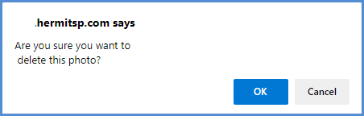
Figure 6-70: Delete Property Photo Window

Property Values
This screen displays the property values received from CHUMS at the time of loan setup (indicated by value type of Original Value). In addition, the screen allows authorized users to add new property values and edit or delete the property values that were previously added. The Property Values screen displays the following data sections:
- Header section - Loan/Borrower/Servicer/Balance Information
- New button
- Property Values

Viewing Property Values
The Property Values are displayed as individual rows for each value. Scroll the horizontal bar to view additional details on the property value.
Figure 6-71: View Property Values Screen

Adding a New Property Value
To add a Property Value:
- Click New in the Property Values section.
- On the Property Value window, populate the fields (fields marked with red asterisk must be populated). Note: a PDF document must be attached to save the Property Value record.
- Click Submit to save the changes. The new property value is displayed under the Property Values section. To exit the window without saving the changes click Cancel.
Figure 6-72: Adding a New Property Value Window

Editing a Property Value
To edit a Property Value:
- Click the icon beside the value type in the Property Values section.
- On the Property Value window, edit the fields (fields marked with red asterisk must be populated). Note: a PDF document must be attached to save the Property Value record.
- Click Submit to save the changes. The updated property value is displayed under the Property Values section. To exit the window without saving the changes click Cancel.
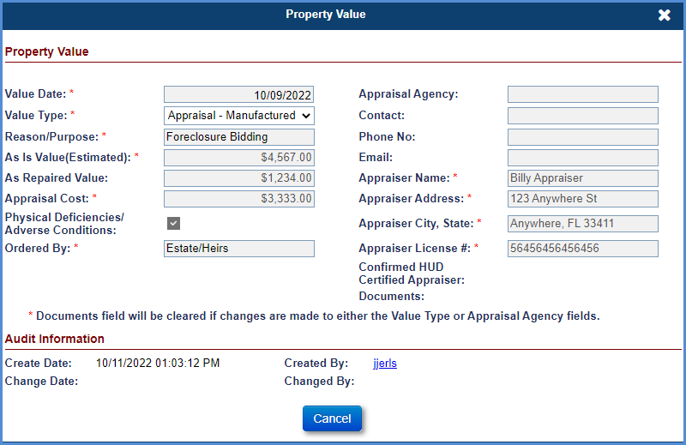
Figure 6-73: Edit Property Values Window

Deleting a Property Value
To delete a property value:
- Click the cross icon beside the value type in the Property Values section.
The property value of Original Value Type cannot be deleted.
- A pop-up window is displayed requesting the user to confirm the action.
- Click OK on the pop-up window; the selected value will be deleted. To exit the pop-up window without deleting a value click Cancel.
Figure 6-74: Delete Property Value Window

Property Tax Info
This screen displays the property tax details received from CoreLogic or taxes paid from HERMIT.
The Property Tax Information screen displays the following sections:
- Property Tax Information
- Unscheduled From LOC – Taxes

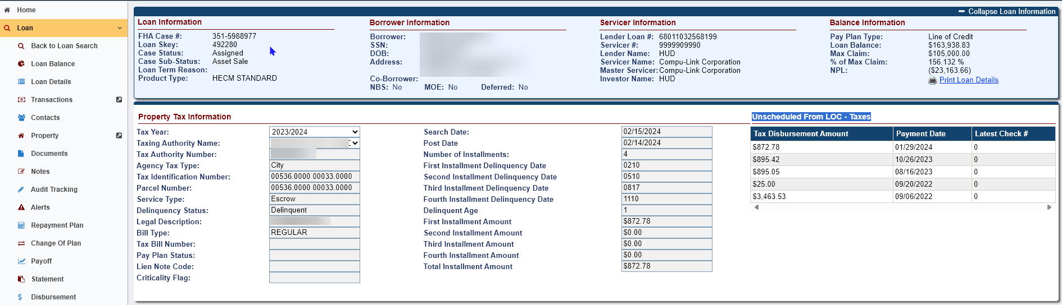
Figure 6-75: Property Tax Information Screen

Filtering Property Tax Info
To filter the fields in the Property Tax Information section: click the Tax Year drop-down to select tax year or click the Taxing Authority Name to select Tax Authority Name.
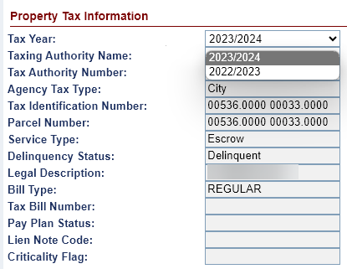
Figure 6-76: Filter the Property Tax Info Window

Documents
The Loan Documents screen is displayed when a user selects the Documents tab from the menu on the left side of the screen. This screen displays the letters, forms and documents associated with the loans. Authorized users can upload or delete documents. The Documents screen displays the following sections:
- Upload button
- View documents

Viewing Loan Documents
To view a document:
- Click the View link beside the document.
- The document opens as a PDF.
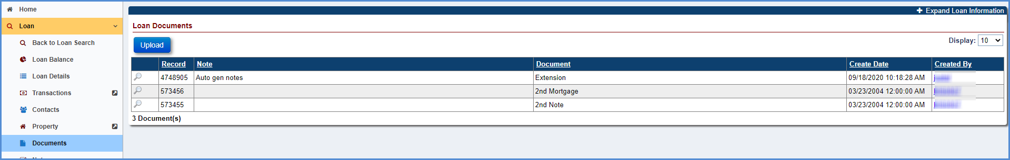
Figure 6-77: Loan Documents Screen

Uploading Loan Documents
To upload a document:
- Click Upload under the Loan Documents section.
- On the Upload Document window, select a document type to upload from the Document Type dropdown. Only PDF documents with maximum file size of 30 MB can be uploaded. Editable PDFs are not permitted.
- Click Browse to select the location of the file (PDF).
- Enter a description of the document in the Notes field.
- Click Upload to save the document. An entry for this document is added to the Loan Documents section. To exit the window without uploading the document click Cancel.
Figure 6-78: Upload Document Window

Deleting a Document
To delete a document:
- Click cross icon beside the document in the Loan Documents screen.
- A pop-up window is displayed requesting the user to confirm the action.
- Click OK on the pop-up window, the selected document will be deleted. To exit the message window without deleting the document click Cancel.
Figure 6-79: Delete Document

Notes
The Notes screen is displayed when a user selects the Notes tab from the menu on the left side of the screen. The notes screen displays notes added by the system (auto notes) and notes that are manually created by the users. Authorized users can add, edit or delete a note. The Notes screen displays the following sections:
- Notes Filter Criteria – Allows users to filter and view specific notes type.
- New Notes – Allows authorized users to add a note type.
- Print Notes – Allows authorized users to print notes.

Filtering Notes
The Notes Filter Criteria section of the Notes screen allows the user to apply filter and view selected notes type:
- Select the Note Type from the Note Type dropdown.
- Click Filter to view the filtered notes under the Notes Results section.
- Select Clear to clear the selected filers and view all notes.
Figure 6-80: Filter Notes Window

Viewing a Note
To view a note:
- Click on the Note you want to view in the Notes Filter Criteria section.
- On the Note Item, click Next to view the next note on the loan.
- Click Back to view the previous note on the loan.
- Click Cancel to exit the window.
Figure 6-81: View Note Window

Adding a Note
To create a new note:
- Click New in the Notes Filter Criteria section.
- On the Note Item window, select a Note Type and enter a Note Text.
Figure 6-82: Create New Note Window
- Click Submit. The new note is reflected in the Notes Results section. To exit the screen without adding the note, click Cancel.
Figure 6-83: New Note Displayed on Notes Results Section

Editing a Note
To edit a note:
- Click the Note you want to edit (system-generated auto notes cannot be edited), in the Notes Filter Criteria section.
- On the Note Item window, edit the Note Type and Note Text.
- Click Submit. The updated note is reflected in the Notes Results section.
Figure 6-84: Edit Note Window

Deleting a Note
To delete a note:
- Click cross icon beside the note in the Notes Filter Criteria section. Authorized users other than managers can delete a note only on the same day as the day it was created. Manager roles can delete any note (except those that were system generated) created on any day.
Figure 6-85: Delete Note Window
- A pop-up window is displayed requesting the user to confirm the action.
- Click OK on the pop-up window, the selected note will be deleted. To exit the message window without deleting the document click Cancel.
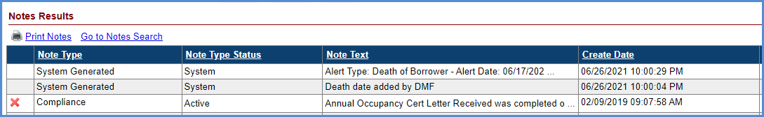
Figure 6-86: Deleted Note not Displayed on Notes Results Section

Printing Notes
To print the notes on a loan: Click Print Notes link in the Notes Filter Criteria section. The notes are opened in a PDF file for printing.
Figure 6-87: Print Notes

Audit Tracking
The Audit Filter Criteria screen is displayed when a user selects the Audit Tracking tab from the menu on the left side of the screen. The screen displays all audit data captured for the loan. Only authorized users can view the audit tracking information. Users can filter the audit data using the audit filter criteria.

Filtering Audit Information
The Audit Filter Criteria section of the Audit screen allows users to filter and view the audit information:
- Select the Audit field from the dropdown.
- Click Filter to view the filtered audit data under the Audit Results section.
- Click Clear to clear the selected filters and view all audit data.
- The Audit Results section displays the following fields:
  - Audit Type: The type of Audit on the loan.
  - Original Value: The original value of the audit type.
  - New Value: The new value of the audit type.
  - Change Date: The date the audit type values were modified.
  - Changed By: The name of the user role associated with the audit change.
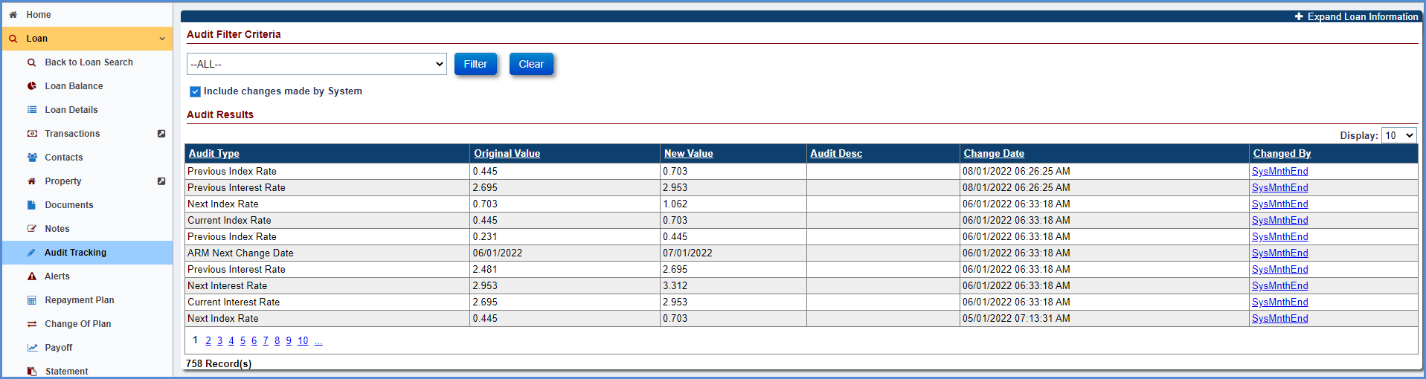
Figure 6-88: Audit Filter Window

Alerts
The Alerts screen is displayed when a user selects the Alerts tab from the menu on the left side of the screen. The Alerts screen shows all the active and inactive alerts on the loan. The system automatically adds an alert when the alert condition is identified. In addition, the authorized users can manually add an alert to the loan. Authorized users can also create new alert types using the Alerts tab within Admin menu tab (See Chapter 10).

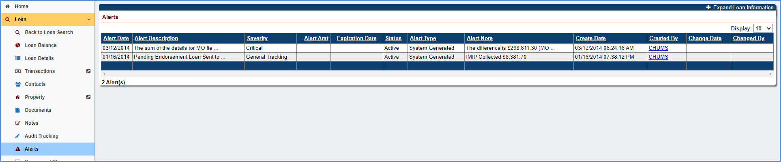
Figure 6-89: Alerts Screen
The Alerts section displays the following fields:
- Alert Date: The date the alert was generated
- Alert Description: The description associated with the alert type
- Severity : Severity of the alert, Critical or General Tracking
- Alert Amt : Any monetary amount associated with the alert
- Expiration Date: The date the alert expires. If the current system date is greater than the alert expiration date, the alert is no longer displayed in the critical alerts pop-up window.
- Status: Indicates the status of the alert (Active/Inactive)
- Alert Type : Indicates whether the alert is system generated or user generated
- Alert Note : A short note associated with the alert
- Create Date: The date the alert was created in the system
- Created By : The name of the user role who created the alert
- Change Date: The date the alert was modified/changed
- Changed By : The user that changed/modified the alert

Creating New Alerts
To create a new alert on a loan:
- Click New in the Alerts section.
- On the New Alert screen, select Alert Type, Alert Date, Expiration Date, Alert Amount, and Status. Enter an Alert Note.
- Click Submit. The new alert is displayed in the Alerts section. To exit without adding alert click Cancel.
- Once an alert is added, the alert cannot be deleted but can be made inactive.
Figure 6-90: New Alert Window

Editing an Alert
To edit an alert on a loan:
- Click the Alert you want to edit (system-generated alerts cannot be edited) in the Alerts section.
- On the Edit Alert window, edit the Alert Date, Expiration Date, Alert Amount, Status and Alert Note.
- Click Submit. The updated alert is reflected in the Alerts section. To exit without updating alert click Cancel.
Figure 6-91: Edit Alert Window

Change of Plan
The Change of Plan screen is displayed when a user selects the Change of Plan tab from the menu on the left side of the screen. The Change of Plan screen shows the current payment plan and any prior payment plans associated with the loan. Only authorized user roles from HUD NSC Contractor can approve the Change of Plan to be effective.
The following conditions must be satisfied to initiate a change of plan:
- Authorized users can perform Change of Plan.
- The loan must have a case status of Assigned and a sub-status of Loan Active.
- An effective date for a payment plan change must be after the last transaction and must be within the month in which the change takes effect.
- There is no option to edit the Change of Plan on a loan with pay plan type of Lump Sum.
- Authorized users cannot change from an existing pay plan type (Line of Credit, Tenure, Term, Modified tenure or Modified term) to Lump Sum.
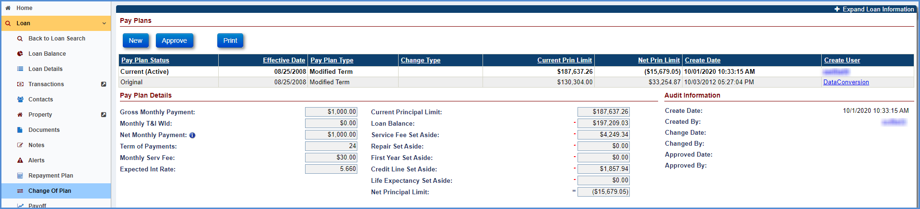
Figure 6-92: Change of Plan Screen
The Servicing Module currently allows the following five payment plans for HECM loans:
Payment Plan | Description
Line of credit | A borrower can make withdrawals up to a maximum amount, at times, and in amounts, of the borrower's choosing.
Tenure | A borrower receives monthly payments from the lender for as long as the borrower lives and continues to occupy the home as a principal residence.
Term | A borrower receives monthly payments for a fixed period selected by the borrower.
Modified tenure | The tenure option is combined with a line of credit.
Modified term | The term option is combined with a line of credit.
Table 6-10: Payment Plan Types

Viewing a Payment Plan
To view a payment plan: Select the record to display the Pay Plan Details section and Audit Information sections. The Pay Plan Details section displays the following details of the payment plan selected in Pay Plans section:
  - Gross Monthly Payment: The monthly payment made to a borrower
  - Monthly T&I Wld: The monthly taxes and insurance amount withheld
  - Net Monthly Payment: The gross monthly payment – Monthly T & I withheld
  - Term of Payments: The number of payment months
  - Monthly Serv Fee: The monthly service fee charged by the servicer
Figure 6-93: View Payment Plan Screen

Creating a New Payment Plan
To create a new payment plan:
- Click New in the Pay Plans section.
- On the New Payment Plan window, enter the effective date and change type (selectable values of Forced or Voluntary).
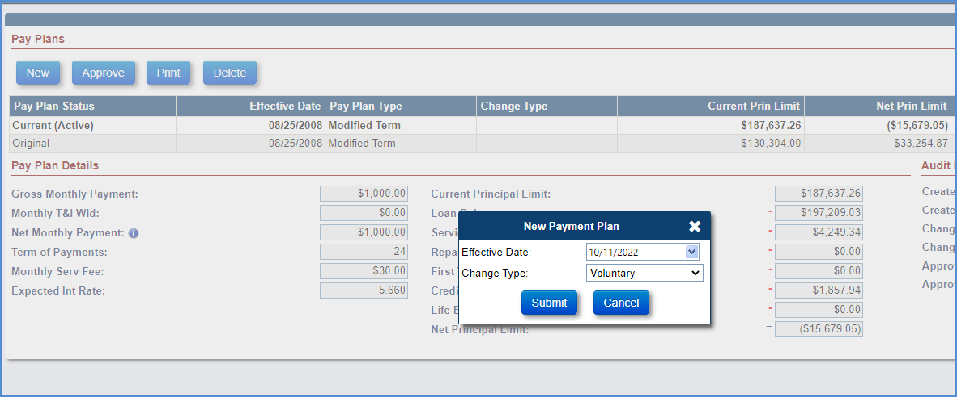
Figure 6-94: New Payment Plan Window
- Click Submit to save the changes. The Payment Option Worksheet is displayed.
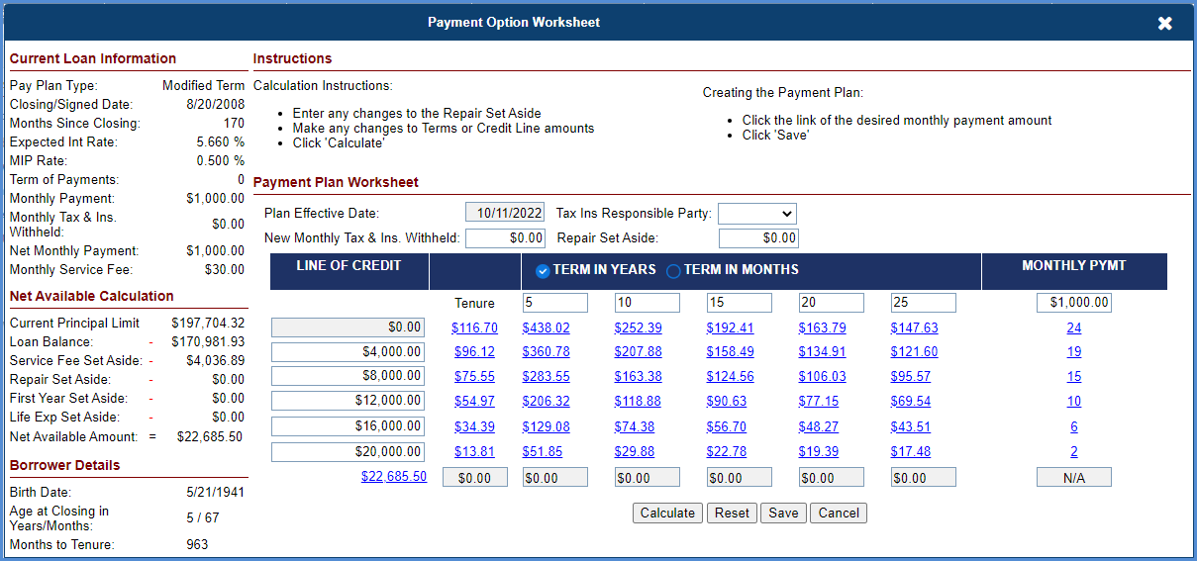
Figure 6-95: Change of Plan Worksheet
- Select the new payment plan. Instructions are provided within the worksheet (at the header), enter the values as needed and click Calculate to view the updated amounts.
- Click Save to save the changes.
- The pay plan status of the new payment plan will be in Pending Approval.
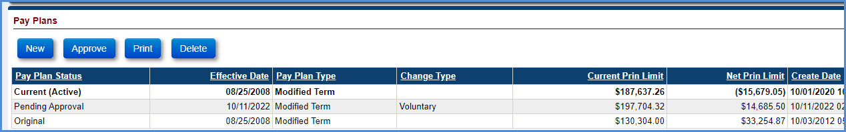
Figure 6-96: New Change of Plan Displayed on Pay Plans Section

Approving a Pending Payment Plan
After a payment plan is initiated and is in Pending Approval status, the payment plan can be approved.
To approve a pending payment plan:
- Select the payment plan with a status of Pending Approval under the Pay Plans section.
- Click Approve.
- A pop-up window is displayed requesting the user to confirm the action. The user must enter the Change of Plan fee and Click OK.
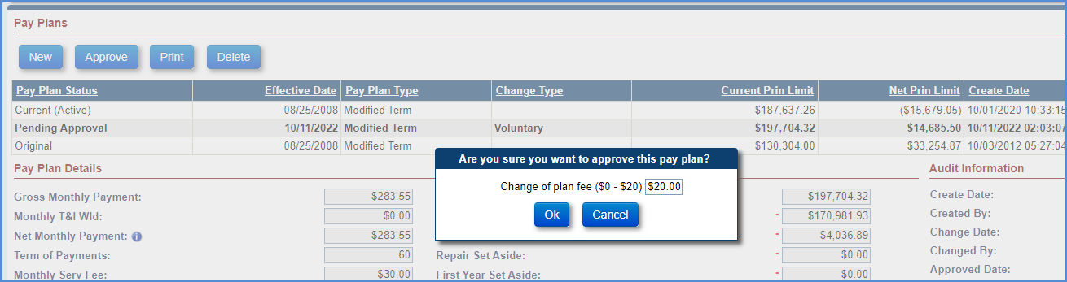
Figure 6-97: Confirm Approval on Change of Plan
- The pay plan status of the new payment plan will be Current (Active) and the previous payment plan will be updated to the Previous.
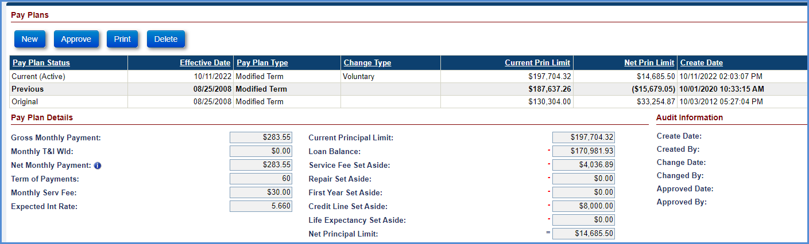
Figure 6-98: Change of Plan Status Updated

Printing a Pending Change of Plan
After a payment plan is initiated and is in Pending Approval status, the payment plan can be printed.
To print a pending payment plan:
- Select the payment plan with a status of Pending Approval under the Pay Plans section.
- Click Print.
- Enter the subject and salutation on the Print Change of Payment Plan window.
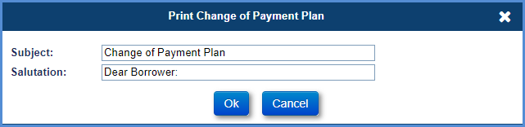
Figure 6-99: Print Pending Change of Plan Window
- Click OK on the window. The change of plan letter is displayed in PDF version.

Deleting a Pending Change of Plan
After a payment plan is initiated and is in Pending Approval status, the payment plan can be deleted.
To delete a pending payment plan:
- Select the payment plan with a status of Pending Approval under the Pay Plans section.
- Click Delete.
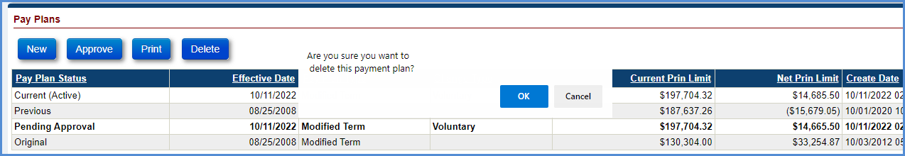
Figure 6-100: Delete Pending Change of Plan
- A pop-up window is displayed requesting the user to confirm the action.
- Click OK on the pop-up window, the selected payment plan will be deleted. To exit the message window without deleting the document click Cancel.
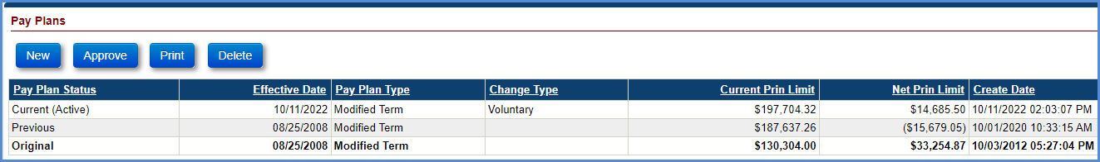
Figure 6-101: Delete Pending Change of Plan Confirmation

Payoff
The Payoff Info screen is displayed when a user selects the Payoff tab from the menu on the left side of the screen. The screen displays the payoff amount as of the selected payoff date. Only authorized users can access the Payoff Info screen. The system also allows authorized users to view the payoff amount and print the Payoff Statement.
Two line items are displayed on the Payoff Screen and Payoff Statement.
- “Pending Disbursements” lists the summary amount of all “Pending” disbursements that have been created but are not yet posted to the loan. This amount will be included in the “Total Payoff Amount”. Pending Disbursements appear under the Payoff Information section of the Payoff Statement if any exist on the Payoff screen.
- “Estimated Expenses” line item will list summary amount of all Estimated Expenses. Estimated Expenses include incurred costs that have not yet been charged to the loan. For example: Attorney fees, Appraisals, Inspections etc. Estimated Expenses appear under the Payoff Information section of the Payoff Statement if any exist on the Payoff screen.
Authorized users can access Estimated Expenses section on Payoff screen. Authorized users can view, create, delete, and inactivate Estimated Expenses for all the loans serviced by HUD.
Loss Draft and Hardest Hit Funds Disbursement transactions are not included on the Payoff Statement.

Printing a Payoff Statement
To print a borrower’s loan payoff statement:
- Click the Print Payoff Statement link on the Payoff Info screen.
- The Payoff Statement for this loan is displayed and is automatically saved on the Documents tab.
- Click the Print option on the PDF file to print the statement.
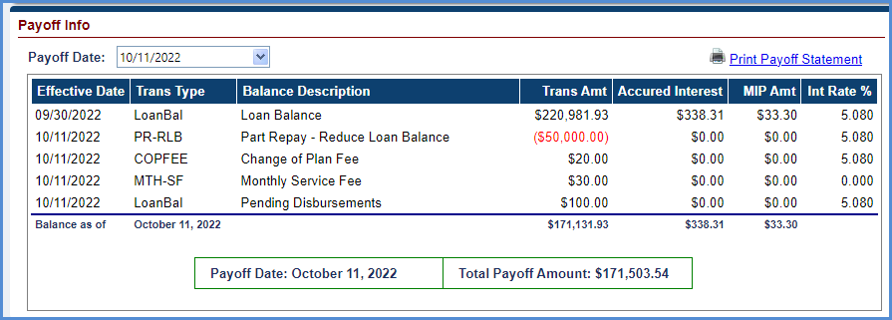
Figure 6-102: View Payoff Statement Screen
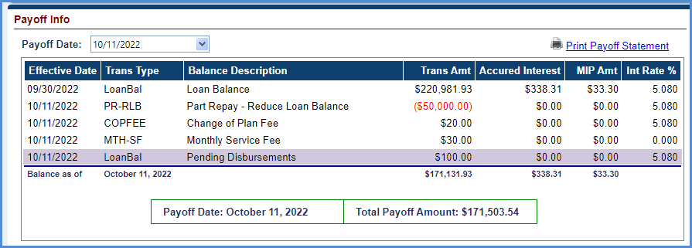
Figure 6-103: View Payoff Statement Screen with line items
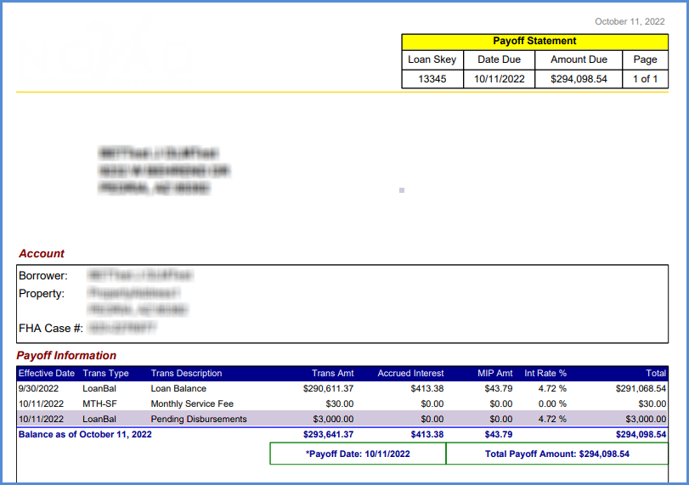
Figure 6-104: View Payoff Statement with line items

Add an Estimated Expense
To Add an Estimated Expense:
- Click on NEW button under “Estimated Expenses info” section on the Payoff Info screen.
- Enter Expense Description and Expense Amount
- Click OK
- Authorized users can add multiple expenses using NEW button
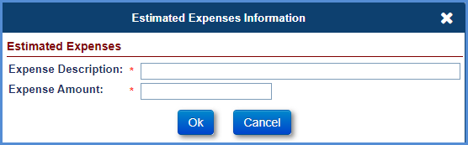
Figure 6-105: Add Estimated Expense
To Delete an Estimated Expense: Click on red X icon next to the Expense to delete an expense record.
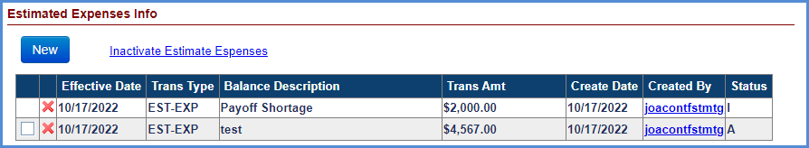
Figure 6-106: Delete Estimated Expense
To Inactivate an Estimated Expense:
- Click on checkbox next to the Expense.
- Click Inactivate Estimate Expenses link to inactivate an expense record.

Statement
The Monthly Statement screen is displayed when an authorized user selects the Statement tab from the menu on the left side of the screen. The screen displays the monthly statement amount details as of the selected reporting period. Only authorized users have access to the Statement screen. This screen also allows printing the Monthly Statement for a selected month. Only certain monthly statements are available in the Reporting Period dropdown.

Viewing and Printing a Monthly Statement
To view and print a monthly statement:
- From the Reporting Period dropdown box, select the month for which the statement needs to be viewed or printed.
- Click Print Monthly Statement.
- The monthly statement is displayed in a PDF file.
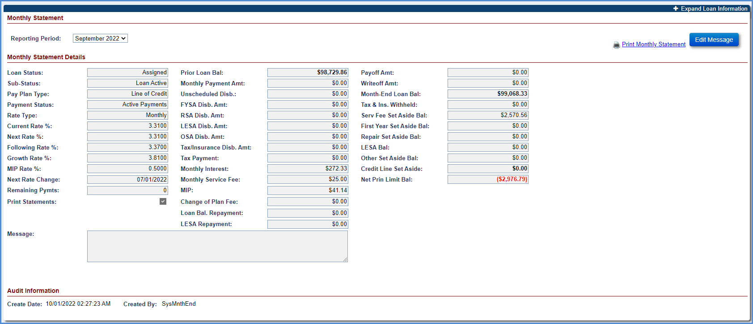
Figure 6-107: View Monthly Statement Screen

Editing the Monthly Statement Message
To edit the monthly statement message:
- Click Statement.
- Click Edit Message.
- In the Custom Message section, enter the message.
- Select the check box for Repeat this message on future statement if required.
- Click OK to save the message.
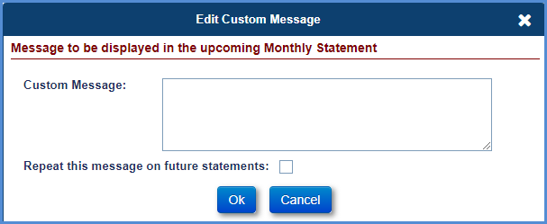
Figure 6-108: Edit Monthly Statement Message Window

Disbursement
The Disbursement screen is displayed when an authorized user selects the Disbursement tab from the menu on the left side of the screen. Only authorized users (Example: HUD NSC Contractor) have access to the tab. This screen displays all the disbursement transactions associated with the loan. This screen allows the user to add new disbursements transactions. The following Disbursement Transaction Categories are available:
- Corp Advance - Penalty
- Corp Advance - Section 305 Disbursements
- Disb- 1st Year Taxes & Ins Set Aside
- Disb- Life Expectancy Set Aside
- Disb- Repair Set Aside
- Disb- Scheduled
- Disb- Unscheduled from LOC (Also available when Pay Plan is TERM or TENURE)
- Hardest Hit Funds
- Loss Draft
- Refunds

The Disbursements results are displayed along with an Export Disbursements link to save a spreadsheet with the results. For user roles who are allowed to create Disbursements, the New button is also displayed.
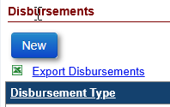
Figure 6-109: Export Disbursements link

Performing a Corp Advance – Penalty Disbursement
This transaction is initiated by the HUD NSC Contractor to pay penalty to the borrower in case of payments missed to the borrower. HUD NSC Contractor makes this payment to the borrower.
To perform a Corp Advance Penalty:
- Click New on the Disbursements screen.
- On the New Disbursement window, select Corp Advance - Penalty from Transactions Category dropdown.
- Populate the below listed required fields (marked with red asterisk):
  - Transaction Desc
  - Payee Type – Choose Borrower, Vendor or Tax Authority
  - Payee - pre-filled with Borrower name if Borrower is chosen
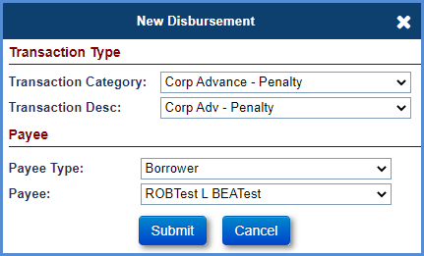
Figure 6-110: Corp Advance Penalty - New Disbursement Window
- Click Submit. The New Disbursement window is refreshed with additional fields.
- Enter the information in the below listed fields
  - Disbursement Amount
  - The “Pay To” field is not editable
- Update the Process Date if required.
- Enter the Check Stub Note for check disbursements, if applicable
  - The Check Stub Note field is limited to 55 characters for each line
- Select the Special Handling Box if the Check needs to be sent to the NSC Contractor.
  - Special Handling is applicable only for Check disbursements.
- The Invoice # should be filled in, if applicable.

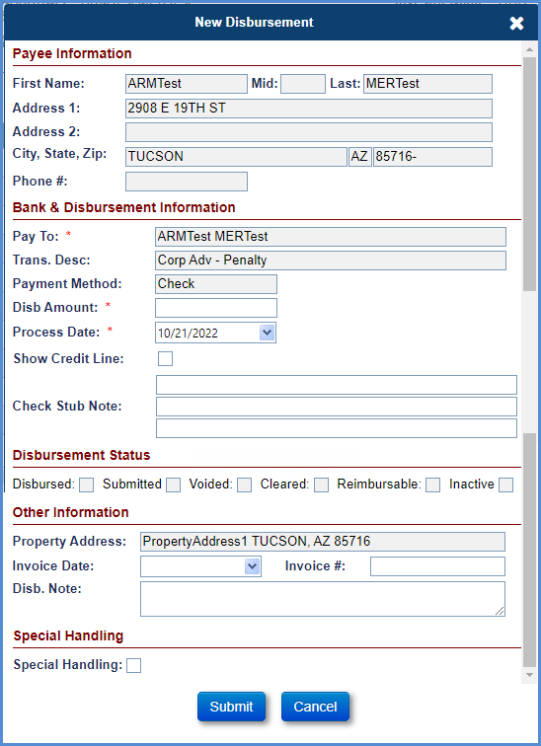
Figure 6-111: Special Handling box

- Click Submit to save the changes. This disbursement is displayed in the Disbursement screen.
Figure 6-112: Confirmation of New Disbursement Screen
- For payment method Check or ACH, the supervisor role must Authorize Disbursements to be sent for Accounting. See Section - 6.19.3.3
- For invoice payments, the invoice# can be input on the screen above and will appear on the check in the 2nd line of the check legend.
TIP: The “Invoice #” will not appear for any Disbursement that is a “Tax Authority.”.
- For Tax Authority payments, the “Parcel #” will populate for the “Property Information screen for any Disbursement that is “Tax Authority and will appear on the check in the 2nd line of the Check legend.

Performing a Corp Advance - Section 305 Disbursement
This transaction is initiated by the HUD NSC Contractor to pay Corporate Advance for a legal expense which is prohibited by state and/or local jurisdiction from being applied to the loan balance to the vendor. This transaction does not affect the balance of the loan.
To perform a Corp Advance - Section 305 Disbursement:
- Click New on the Disbursement screen.
- On the New Disbursement window, select Corp Advance - Section 305 Disbursements from Transactions Category dropdown.
- Populate the below listed required fields:
  - Transaction Desc
  - Payee Type – Choose Borrower, Vendor or Tax Authority and may depend on the Transaction Desc
  - Payee – pre-filled with Borrower name if Borrower is chosen

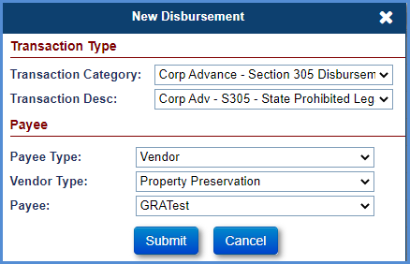
Figure 6-113: Corp Advance Section 305 Disbursements - New Disbursement Window
- Click Submit. The New Disbursement window is refreshed with additional fields.
- Enter the information in the below listed fields
  - Disbursement Amount
  - The “Pay To” field is not editable
- Update the Process Date if required.
- Enter the Check Stub Note for check disbursements, if applicable
  - The Check Stub Note field is limited to 55 characters for each line
- Select the Special Handling Box if the Check needs to be sent to the NSC Contractor.
  - Special Handling is applicable only for Check disbursements.
- The Invoice # should be filled in, if applicable.
- Click Submit to save the changes. This disbursement is displayed in the Disbursement screen.

Figure 6-114: Confirmation of New Disbursement Screen
- For payment method Check or ACH, the supervisor role must Authorize Disbursements to be sent for Accounting. See Section - 6.19.3.3
- For invoice payments, the invoice# can be input on the screen above and will appear on the check in the 2nd line of the check legend.
TIP: The “Invoice #” will not appear for any Disbursement that is a “Tax Authority.”.
- For Tax Authority payments, the “Parcel #” will populate for the Property Information screen for any Disbursement that is “Tax Authority” and will appear on the check in the 2nd line of the Check legend.
- The table below lists the allowable disbursement transactions that can be created within the Corp Advance – Section 305 Disbursements category:
Transaction | Description
Corp Adv – S305 – State Prohibited Legal | Initiated by HUD NSC Contractor to make a Corporate Advance – Section 305 Disbursements for a legal expense which is prohibited by state and/or local jurisdiction from being applied to the loan balance.
Corp Adv – S305 – State Prohibited Legal – Appraisals | Initiated by HUD NSC Contractor to make a Corporate Advance – Section 305 Disbursement for Appraisal expenses which is prohibited by state and/or local jurisdiction for the state of New York and Maryland from being applied to the loan balance.
Corp Adv – S305 – State Prohibited Legal – Inspections | Initiated by HUD NSC Contractor to make a Corporate Advance – Section 305 Disbursement for Inspection expenses which is prohibited by state and/or local jurisdiction for the state of New York and Maryland from being applied to the loan balance.
Table 6-11: Corp Advance – Section 305 Disbursements

Performing an Unscheduled from LOC Disbursement
To perform a Disb- Unscheduled from LOC:
- Click New on the Disbursements screen.
- On the New Disbursement window, select Disb- Unscheduled from LOC from Transactions Category dropdown. TIP: Transaction Category “Disb – Unscheduled from LOC” is also available on TERM and TENURE Pay Plan Types. When Transaction Category “Disb – Unscheduled from LOC” is selected on TERM and TENURE Pay Plan Types all Transactions within this category are available except for Transaction Desc “Disb – Unscheduled from LOC”.
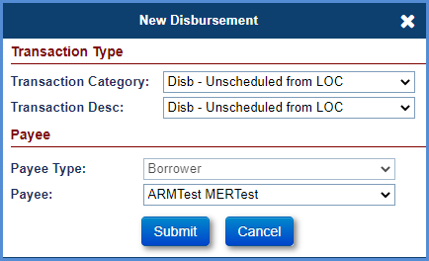
Figure 6-115: Unscheduled from LOC - New Disbursement Window
- Populate the below listed required fields (marked with red asterisk):
  - Transaction Desc
  - Payee Type - Select from the dropdown
  - Payee – pre-filled only with Borrower name if Borrower is chosen
- Click Submit. The New Disbursement window is refreshed with additional fields.
- Enter the information in the below listed fields
  - Disbursement Amount
  - The “Pay To” field is not editable
- Update the Process Date if required.
- Enter the Check Stub Note for check disbursements, if applicable
  - The Check Stub Note field is limited to 55 characters for each line
- Select the Special Handling Box if the Check needs to be sent to the NSC Contractor.
  - Special Handling is applicable only for Check disbursements.
- The Invoice # should be filled in, if applicable.
- Click Submit to save the changes. This disbursement is displayed in the Disbursement screen.
Figure 6-116: Disbursement Screen
- For payment method Check or ACH, the supervisor role must Authorize Disbursements to be sent for Accounting. See Section - 6.19.3.3
- For invoice payments, the invoice# can be input on the screen above and will appear on the check in the 2nd line of the check legend.
TIP: The “Invoice #” will not appear for any Disbursement that is a “Tax Authority.”.
- For Tax Authority payments, the “Parcel #” will populate for the Property Information screen for any Disbursement that is “Tax Authority” and will appear on the check in the 2nd line of the Check legend.
The table below lists all the allowable disbursement transactions that can be manually created within the Unscheduled from LOC category:
Transaction | Description
Disb - Property Charge - Assessment | Initiated by HUD NSC Contractor to make an unscheduled disbursement when the borrower has insufficent funds available for special assessment liens on the mortgaged property.
Disb - Property Charge - Flood Ins | Initiated by HUD NSC Contractor to make an unscheduled disbursement when the borrower has insufficent funds available for flood insurance premiums on the mortgaged property.
Disb - Property Charge - Ground Rent | Initiated by HUD NSC Contractor to make an unscheduled disbursement when the borrower has insufficent funds available for ground rent expenses on the mortgaged property.
Disb - Property Charge - Condo Dues | Initiated by HUD NSC Contractor to make an unscheduled disbursement when the borrower has insufficent funds available for condominium fees on the mortgaged property.
Disb -Property Charge - HOA Dues | Initiated by HUD NSC Contractor to make an unscheduled disbursement when the borrower has insufficent funds available for HOA fees on the mortgaged property.
Disb – Property Charge – Insurance | Initiated by HUD NSC Contractor to make an unscheduled disbursement when the borrower has insufficent funds for Insurance on the mortgaged property.
Disb – Property Charge – Taxes | Initiated by HUD NSC Contractor to make an unscheduled disbursement when the borrower has insufficent funds for Taxes on the mortgaged property.
Disb - Unscheduled from LOC | Initiated by HUD NSC Contractor to make an unscheduled disbursement from borrower's available Line Of Credit. This transaction applies to line of credit, modified term and modified tenure pay plans only.
Disb - Unscheduled from LOC Appraisals | Initiated by HUD NSC Contractor to make an unscheduled disbursement from borrower's available Line Of Credit for appraisals on the mortgaged property. This transaction applies to line of credit, modified term and modified tenure pay plans only.
Disb – Unscheduled from LOC Assessment | Initiated by HUD NSC Contractor to make an unscheduled disbursement when the borrower has has available funds to pay the Assessment of the mortgaged property on behalf of borrower.
Disb - Unscheduled from LOC Condo Dues | Initiated by HUD NSC Contractor to make an unscheduled disbursement when the borrower has has available funds to pay for the Condo Dues of the mortgaged property on behalf of borrower.
Disb - Unscheduled from LOC Flood Ins | Initiated by HUD NSC Contractor to make an unscheduled disbursement when the borrower has has available funds to pay for the Flood Insurance of the mortgaged property on behalf of borrower.
Disb - Unscheduled from LOC Ground Rent | Initiated by HUD NSC Contractor to make an unscheduled disbursement when the borrower has has available funds to pay for the ground rent of the mortgaged property on behalf of borrower.
Disb - Unscheduled from LOC HOA Dues | Initiated by HUD NSC Contractor to make an unscheduled disbursement when the borrower has has available funds to pay for the HOA Dues of the mortgaged property on behalf of borrower.
Disb - Unscheduled from LOC Inspections | Initiated by HUD NSC Contractor to make an unscheduled disbursement from borrower's available Line Of Credit for property inspections on the mortgaged property. This transaction applies to line of credit, modified term and modified tenure pay plans only.
Disb - Unscheduled from LOC Insurance | Initiated by HUD NSC Contractor to make an unscheduled disbursement when the borrower has available funds to pay for the insurance of the mortgaged property on behalf of borrower. This transaction applies to line of credit, modified term and modified tenure pay plans only.
Disb - Unscheduled from LOC Prop Preserv | Initiated by HUD NSC Contractor to make an unscheduled disbursement from line of credit for preservation and protection of the mortgaged property. Preservation and protection activities may include repairs, landscaping etc. This transaction applies to pay plan types line of credit, modified term and modified tenure only.
Disb - Unscheduled from LOC Taxes | This transaction is initiated by HUD NSC Contractor to make an unscheduled disbursement when the borrower has available funds to pay for taxes of the mortgaged property on behalf of borrower. This transaction applies to pay plan types line of credit, modified term and modified tenure only.
Disb - Unscheduled from LOC Release Fee | Initiated by HUD NSC Contractor to make an unscheduled disbursement from borrower's available Line Of Credit for Release Fee on the mortgaged property. This transaction applies to line of credit, modified term and modified tenure pay plans only. County Clerk is available as a Payee Type for this transaction only. The Disb – Unscheduled from LOC Release Fee is automatically written off when Disbursed through accounting.
Disb – Unscheduled from LOC Utilities | This transaction is initiated by HUD NSC Contractor to make an unscheduled disbursement from line of credit to pay for utilities of the mortgaged property on behalf of borrower. This transaction applies to pay plan types line of credit, modified term and modified tenure only.
Disb – Unscheduled from LOC Title Report Fee | This transaction is initiated by HUD NSC Contractor to make an unscheduled disbursement from line of credit to pay for Title Report Fee of the mortgaged property on behalf of borrower. This transaction applies to pay plan types line of credit, modified term and modified tenure only.
Table 6-12: Unscheduled LOC Disbursements

Performing a Loss Draft Disbursement
HUD issues hazard insurance proceeds from the loss draft set-aside for the payment of the repair or restoration of a damaged property. The set-aside funds are typically disbursed in one-third increments as the repair work progresses. The Loss Draft Disbursements cannot be made without the Loss Draft Set Aside- Setup transaction. Refer to Transactions section 6.6 Set Aside screen for more details.
To perform a Loss Draft Disbursement:
- Click New on the Disbursements screen.
- On the New Disbursement window, select Loss Draft from Transactions Category dropdown.

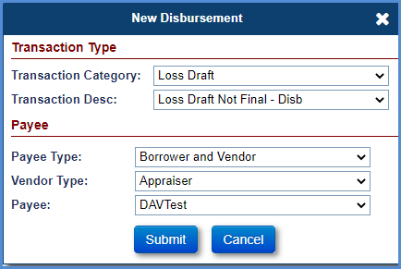
Figure 6-117: Loss Draft - New Disbursement Window
- Populate the below listed required fields (marked with red asterisk):
  - Transaction Desc
  - Payee Type – Choose Borrower, Vendor or Borrower and Vendor
  - Payee – pre-filled with Borrower name if Borrower is chosen
- Click Submit. The New Disbursement window is refreshed with additional fields.
- Enter the information in the below listed fields:
  - Disbursement Amount
  - The “Pay To” field is not editable
- Update the Process Date if required.
- Enter the Check Stub Note for check disbursements, if applicable
  - The Check Stub Note field is limited to 55 characters for each line
- Select the Special Handling Box if the Check needs to be sent to the NSC Contractor.
  - Special Handling is applicable only for Check disbursements.
- The Invoice # should be filled in, if applicable.
- Click Submit to save the changes. This disbursement is displayed in the Disbursement screen.
Figure 6-118: Loss Draft - Disbursements
- For payment method Check or ACH, the supervisor role must Authorize Disbursements to be sent for Accounting. See Section - 6.19.3.3
- For invoice payments, the invoice# can be input on the screen above and will appear on the check in the 2nd line of the check legend.
TIP: The “Invoice #” will not appear for any Disbursement that is a “Tax Authority.”
- For Tax Authority payments, the “Parcel #” will populate for the Property Information screen for any Disbursement that is “Tax Authority” and will appear on the check in the 2nd line of the Check legend.

The table below lists all the allowable disbursement transactions that can be manually created within the Loss Draft Disbursements category.
Transaction | Description
Loss Draft Not Final – Disb | Initiated in the Servicing Module to make a disbursement from borrower's available Loss Draft amount. HUD NSC Contractor will be able to make a disbursement until all the amount has been exhausted.
Loss Draft Final - Disb | Initiated in the Servicing Module to make a disbursement from borrower's available Loss Draft amount.
Loss Draft Inspection - Disb | Initiated in the Servicing Module for inspection of loss draft.
Table 6-13: Loss Draft Disbursements

Performing a Hardest Hit Funds Disbursement
HUD issues proceeds from the Hardest Hit Fund set-aside for the payment of the property charges and insurance. The Hardest Hit Funds Disbursements cannot be made without Hardest Hit Fund Set Aside- Setup transaction. Refer to Transactions section 6.6 Set Aside screen for more details.
To perform a Hardest Hit Funds Disbursement:
- Click New on the Disbursements screen.
- On the New Disbursement window, select Hardest Hit Funds from Transactions Category dropdown.

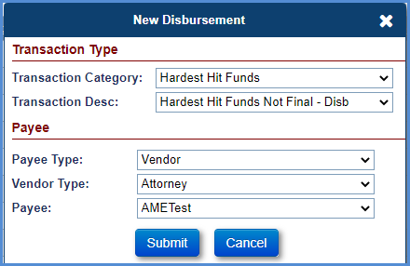
Figure 6-119: Hardest Hit Funds - New Disbursement Window
- Populate the below listed required fields (marked with red asterisk):
  - Transaction Desc
  - Payee Type – Choose Vendor Tax Authority or Insurance Agent (For Loan)
- Click Submit. The New Disbursement window is refreshed with additional fields.
- Enter the information in the below listed fields:
  - Disbursement Amount
  - The “Pay To” field is not editable
- Update the Process Date if required.
- Enter the Check Stub Note for check disbursements, if applicable
  - The Check Stub Note field is limited to 55 characters for each line
- Select the Special Handling Box if the Check needs to be sent to the NSC Contractor.
  - Special Handling is applicable only for Check disbursements.
- The Invoice # should be filled in, if applicable.
- Click Submit to save the changes. This disbursement is displayed in the Disbursement screen.
Figure 6-120: Hardest Hit Funds - Disbursements
- For payment method Check or ACH, the supervisor role must Authorize Disbursements to be sent for Accounting. See Section - 6.19.3.3
- For invoice payments, the invoice# can be input on the screen above and will appear on the check in the 2nd line of the check legend.
TIP: The “Invoice #” will not appear for any Disbursement that is a “Tax Authority.”.
- For Tax Authority payments, the “Parcel #” will populate for the Property Information screen for any Disbursement that is “Tax Authority” and will appear on the check in the 2nd line of the Check legend.
The table below lists all the allowable disbursement transactions that can be manually created within the Hardest Hit Funds Disbursements category.
Transaction | Description
Hardest Hit Funds Not Final – Disb | Initiated in the Servicing Module to make a disbursement from borrower's available Hardest Hit Funds amount. HUD NSC Contractor will be able to make a disbursement until all the amount has been exhausted.
Hardest Hit Funds Final - Disb | Initiated in the Servicing Module to make a disbursement from borrower's available Hardest Hit Funds amount.
Table 6-14: Hardest Hit Funds Disbursements

Performing a Repair Set Aside Disbursement
The HUD NSC Contractor will initiate this disbursement from borrower’s available repair set aside amount. The Repair Set Aside transaction will be used for loans converted from HUD’s legacy system (SMART) with repair set aside amount greater than zero dollars. For the loans where repairs are initiated in the Servicing Module, Loss Draft Set Aside transaction will be used. The Repair Set Aside Disbursements cannot be made without the Repair Set Aside - Setup transaction. Refer to Transactions section 6.5 Set Aside screen for more details.

To perform a repairs Repair Set Aside Disbursement:
- Click New on the Disbursements screen.
- On the New Disbursement window, select Disb - Repair Set Aside from Transactions Category dropdown.
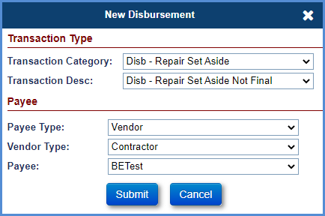
Figure 6-121: Repair Set Aside - New Disbursement Window
- Populate the below listed required fields (marked with red asterisk):
  - Transaction Desc
  - Payee Type – Choose Borrower, Vendor or Borrower and Vendor
  - Payee – pre-filled with Borrower name if Borrower is chosen
- Click Submit. The New Disbursement window is refreshed with additional fields.
- Enter the information in the below listed fields:
  - Disbursement Amount
  - The “Pay To” field is not editable
- Update the Process Date if required.
- Enter the Check Stub Note for check disbursements, if applicable
  - The Check Stub Note field is limited to 55 characters for each line
- Select the Special Handling Box if the Check needs to be sent to the NSC Contractor.
  - Special Handling is applicable only for Check disbursements.
- The Invoice # should be filled in, if applicable.
- Click Submit to save the changes. This disbursement is displayed in the Disbursement screen.
Figure 6-122: Repair Set Aside - Disbursements
- For payment method Check or ACH, the supervisor role must Authorize Disbursements to be sent for Accounting. See Section - 6.19.3.3
- For invoice payments, the invoice# can be input on the screen above and will appear on the check in the 2nd line of the check legend.
TIP: The “Invoice #” will not appear for any Disbursement that is a “Tax Authority.”.
- For Tax Authority payments, the “Parcel #” will populate for the Property Information screen for any Disbursement that is “Tax Authority” and will appear on the check in the second line of the Check legend.
The table below lists all the allowable disbursement transactions that can be manually created within the Repair Set Aside Disbursements category.

Transaction | Description
Disb - Repair Set Aside Not Final | Initiated in the Servicing Module to make a disbursement from borrower's set aside amount for any repairs on the mortgaged property. Servicer will be able to make these disbursements until all Repairs set aside Not Final amount has exhausted. This transaction applies to ALL pay plan types.
Disb - Repair Set Aside Final | Initiated in the Servicing Module to make a disbursement from borrower's repair set aside amount for any repairs on the mortgaged property. This transaction applies to ALL pay plan types.
Table 6-15: Repair Set Aside Disbursements

Monthly Accruals
For Assigned loans with payment plan type of Term or Tenure, the system will automatically generate scheduled disbursement transactions (Disb – Scheduled) to track month accruals.

Performing a Refund/Payment Remittance Overage Disbursement
Remittance Overage disbursement can be performed when a loan has an overage amount that can be refunded to the borrower. Refund can be sent to heir/person (Payee Type: Payoff Request) or Vendor (Vendor Type: Refund). Payee information can be added to the Assigned -> Payoff timeline Svc Mgmt page. Vendor Type: Refund can be added to the Admin/Vendors page.
When Overage funds are available and user attempts to enter a different transaction type, a message is displayed for the user to confirm if they want to use the available overage instead or proceed with selected transaction type.
To add Payee to the Assigned -> Payoff timeline Svc Mgmt page
- From the Assigned menu, select Request, and click Search.
- On the Assigned Request Search Screen, enter the loan skey and click Search.
- Select Payoff timeline and Click Servicing Mgmt tab
- Click EDIT button
- Enter Pay To, Address 1, Address 2, City, State, and Zip.
- Click Submit.
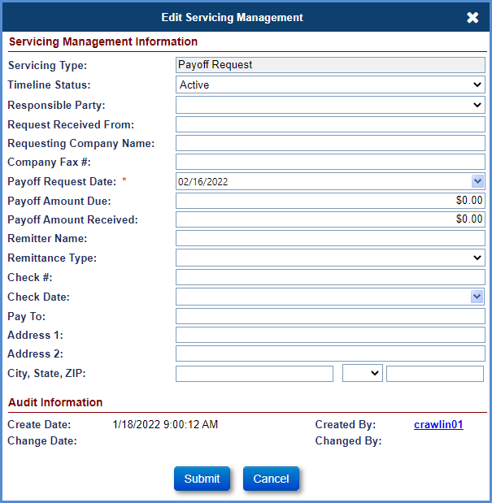
Figure 6-123: Refund Remittance Overage – Add Payee to timeline

To perform a Refund/Payment Remittance Overage Disbursement:
- Click New on the Disbursements screen.
- On the New Disbursement window, select Disb – Refund/Payment Overage Disbursement from Transactions Category dropdown.

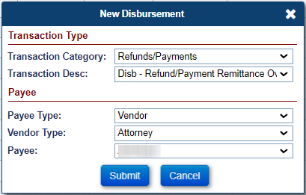
Figure 6-124: Refund/Payment Remittance Overage – New Disbursement
- Populate the below listed required fields (marked with red asterisk):
  - Transaction Desc
  - Payee Type – Choose Borrower, Vendor or Tax Authority, Payoff Refund
  - Payee – pre-filled with Borrower name if Borrower is chosen
- Click Submit. The New Disbursement window is refreshed with additional fields.
- Enter the information in the below listed fields:
  - Disbursement Amount
  - The “Pay To” field is not editable
- Update the Process Date if required.
- Enter the Check Stub Note for check disbursements, if applicable
  - The Check Stub Note field is limited to 55 characters for each line
- Select the Special Handling Box if the Check needs to be sent to the NSC Contractor.
  - Special Handling is applicable only for Check disbursements.
- The Invoice # should be filled in, if applicable.
- Click Submit to save the changes. This disbursement is displayed in the Disbursement screen.
- For payment method Check or ACH, the supervisor role must Authorize Disbursements to be sent for Accounting. See Section - 6.19.3.3
- For invoice payments, the invoice# can be input on the screen above and will appear on the check in the 2nd line of the check legend.
TIP: The “Invoice #” will not appear for any Disbursement that is a “Tax Authority.”.
- For Tax Authority payments, the “Parcel #” will populate for the Property Information screen for any Disbursement that is “Tax Authority” and will appear on the check in the 2nd line of the Check legend.

Performing a 1st Year Taxes & Ins Set Aside Disbursement
The HUD NSC Contractor will initiate this disbursement from borrower’s available 1st Year Taxes & Ins Set Aside amount. The 1st Year Taxes & Ins Set Aside Disbursements cannot be made without the 1st Year Taxes & Ins Set Aside - Setup transaction. Refer to Transactions section 6.5 Set Aside screen for more details
To perform a 1st Year Taxes & Ins Set Aside Disbursement:
- Click New on the Disbursements screen.
- On the New Disbursement window, select Disb – 1st Year Taxes & Ins Set Aside Disbursement from Transactions Category dropdown.

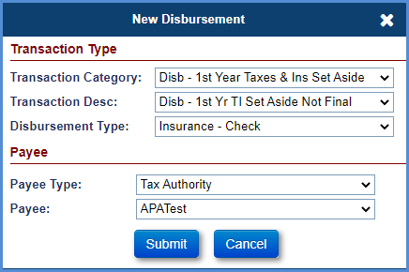
Figure 6-125: 1st Year Taxes & Ins Set Aside – New Disbursement
- Populate the below listed required fields (marked with red asterisk):
  - Transaction Desc
  - Disbursement Type – Choose Insurance – Check or Taxes -Check
  - Payee Type – Choose Vendor, Tax Authority or Insurance Agent (For Loan)
  - Payee
- Click Submit. The New Disbursement window is refreshed with additional fields.
- Enter the information in the below listed fields:
  - Disbursement Amount
  - The “Pay To” field is not editable
- Update the Process Date if required.
- Enter the Check Stub Note for check disbursements, if applicable
  - The Check Stub Note field is limited to 55 characters for each line
- Select the Special Handling Box if the Check needs to be sent to the NSC Contractor.
  - Special Handling is applicable only for Check disbursements.
- The Invoice # should be filled in, if applicable.
- Click Submit to save the changes. This disbursement is displayed in the Disbursement screen.
Figure 6-126: 1st Year TI Set Aside - Disbursements
- For payment method Check or ACH, the supervisor role must Authorize Disbursements to be sent for Accounting. See Section - 6.19.3.3
- For invoice payments, the invoice# can be input on the screen above and will appear on the check in the 2nd line of the check legend.
TIP: The “Invoice #” will not appear for any Disbursement that is a “Tax Authority.”.
- For Tax Authority payments, the “Parcel #” will populate for the Property Information screen for any Disbursement that is “Tax Authority” and will appear on the check in the 2nd line of the Check legend.

Performing a Life Expectancy Set Aside Disbursement
The HUD NSC Contractor will initiate this disbursement from borrower’s available Life Expectancy set aside (LESA) amount. The Life Expectancy Set Aside transaction will be used for loans received from CHUMS with Life Expectancy Set Aside (LESA) amount is greater than zero dollars. The Life Expectancy Set Aside Disbursements cannot be made without the Life Expectancy Set Aside - Setup transaction. Refer to Transactions section 6.5 Set Aside screen for more details.

To perform a Life Expectancy Set Aside(LESA) Disbursement:
- Click New on the Disbursements screen.
- On the New Disbursement window, select Disb – Life Set Aside from Category dropdown.
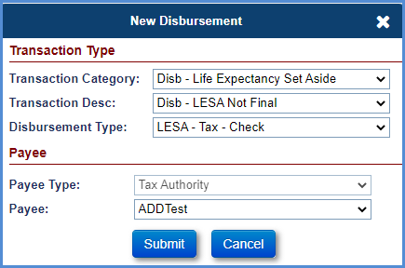
Figure 6-127: Life Expectancy Set Aside - New Disbursement Window
- Populate the below listed fields:
  - Transaction Desc
  - Disbursement Type – Choose LESA Insurance – Check or LESA Taxes -Check
  - Payee Type – Choose Vendor, Tax Authority or Insurance Agent (For Loan)
  - Payee – Pre-filled depending on the selection for Payee Type
Note: Payee Type Borrower is available when LESA type on a loan is Partially Funded.
- Click Submit. The New Disbursement window is refreshed with additional fields.
- Enter the information in the below listed fields:
  - Disbursement Amount
  - The “Pay To” field is not editable
- Update the Process Date if required.
- Enter the Check Stub Note for check disbursements, if applicable
  - The Check Stub Note field is limited to 55 characters for each line
- Select the Special Handling Box if the Check needs to be sent to the NSC Contractor.
  - Special Handling is applicable only for Check disbursements.
- The Invoice # should be filled in, if applicable.
- Click Submit to save the changes. This disbursement is displayed in the Disbursement screen.
Figure 6-128: LESA - Disbursements

- For payment method Check or ACH, the supervisor role must Authorize Disbursements to be sent for Accounting. See Section - 6.19.3.3
- For invoice payments, the invoice# can be input on the screen above and will appear on the check in the 2nd line of the check legend.
TIP: The “Invoice #” will not appear for any Disbursement that is a “Tax Authority.”.
- For Tax Authority payments, the “Parcel #” will populate for the Property Information screen for any Disbursement that is “Tax Authority” and will appear on the check in the 2nd line of the Check legend.
The table below lists all the allowable disbursement transactions that can be manually created within the Life Expectancy Set Aside Disbursements category.
Transaction | Description
Disb – Life Expectancy Set Aside Not Final | Initiated in the Servicing Module to make a disbursement from borrower's Life Expectancy set aside amount for any taxes and insurances on the mortgaged property. NSC Contractor will be able to make these disbursements until all Life Expectancy set aside Not Final amount has exhausted.. This transaction applies to ALL pay plan types.
Disb - Life Expectancy Set Aside Final | Initiated in the Servicing Module to make a disbursement from borrower's Life expectancy set aside amount for any taxes and insurances on the mortgaged property. This transaction applies to ALL pay plan types.
Table 6-16: Life Expectancy Set Aside (LESA) Disbursements

Manually Adding a Scheduled Payment Disbursement
The Servicing Module allows the authorized user to manually add a scheduled payment as a disbursement on assigned loans.
To manually add a scheduled payment as a disbursement:
- Search for the loan skey or FHA Case #, and click on the Disbursements screen to display the transactions.
- Click on the “New” button above the search results.
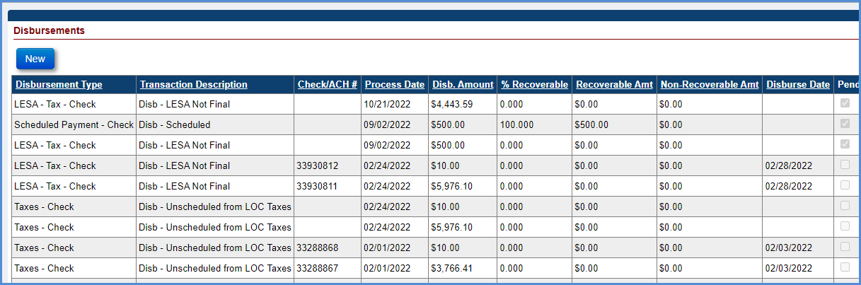
Figure 6-129: New Disbursement Button
- A New Disbursement window pops up, choose “Disb - Scheduled” for Transaction Category, and “Disb - Scheduled” again for Transaction Desc.
- The Payee Type and Payee fields should auto populate with the borrower’s information. Click on “Submit”.
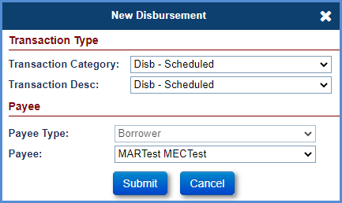
Figure 6-130: New Disbursement Transaction Entry Window
- Enter the information in the below listed fields:
  - Disbursement Amount
  - The “Pay To” field is not editable
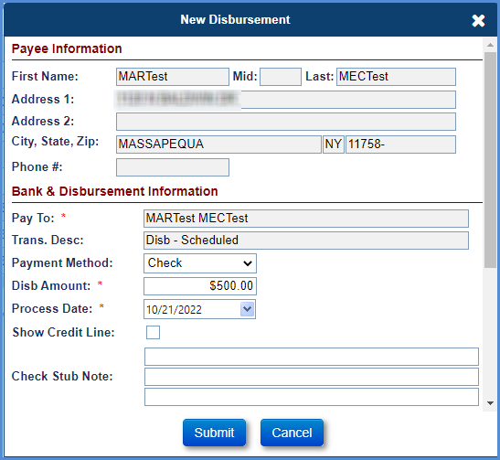
Figure 6-131: New Disbursement Payee Entry Window
- Update the Process Date if required.
- Enter the Check Stub Note for check disbursements, if applicable
  - The Check Stub Note field is limited to 55 characters for each line
- Select the Special Handling Box if the Check needs to be sent to the NSC Contractor.
  - Special Handling is applicable only for Check disbursements.
- The Invoice # should be filled in, if applicable.
- Click Submit to save the changes. This disbursement is displayed in the Disbursement screen
Figure 6-132: New Disbursement Record

- For payment method Check or ACH, the supervisor role must Authorize Disbursements to be sent for Accounting. See Section - 6.19.3.3
- For invoice payments, the invoice# can be input on the screen above and will appear on the check in the 2nd line of the check legend.
TIP: The “Invoice #” will not appear for any Disbursement that is a “Tax Authority.”.
- For Tax Authority payments, the “Parcel #” will populate for the “Property Information screen for any Disbursement that is “Tax Authority and will appear on the check in the 2nd line of the Check legend.

Notes Disbursements
This section explains the notes disbursements processing in HERMIT (Servicing and Accounting Modules) system.
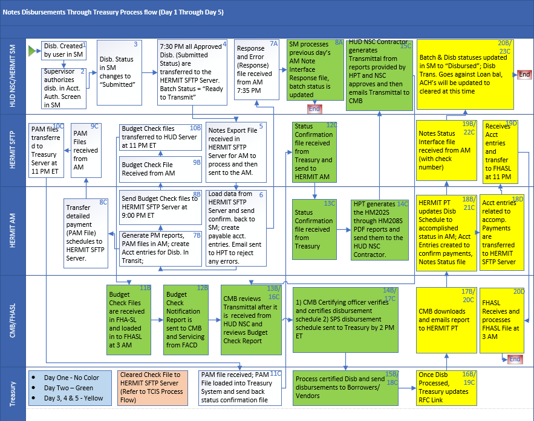
Figure 6-133: Process Flow chart
The following chart shows the applicable Payee Type for each Transaction Desc:

Transaction Category | Transaction Desc | Payee Type
Corp Advance - Penalty | Corp Adv - Penalty | Borrower  Vendor  Tax Authority
Corp Advance - Section 305 Disbursements | Corp Adv - S305 - State Prohibited Legal | Vendor  Tax Authority  Borrower
Disb - 1st Year Taxes & Ins Set Aside | Disb - 1st Yr TI Set Aside Final  Disb - 1st Yr TI Set Aside Not Final | Vendor  Tax Authority  Insurance Agent (For Loan)
Disb - Repair Set Aside | Disb - Repair Set Aside Final  Disb - Repair Set Aside Not Final | Borrower  Vendor  Borrower and Vendor
Loss Draft | Loss Draft Final - Disb  Loss Draft Not Final - Disb  Loss Draft Inspection – Disb | Borrower  Vendor  Borrower and Vendor
Hardest Hit Funds | Hardest Hit Final - Disb  Hardest Hit Not Final – Disb | Vendor  Tax Authority  Insurance Agent (For Loan)
Refunds | Disb - Refund Remittance Overage | Borrower  Vendor  Tax Authority
Disb - Scheduled | Disb - Scheduled | Borrower
Disb - Unscheduled from LOC | Disb - LOC - Property Charge - Assessment  Disb - LOC - Property Charge - Flood Ins  Disb - LOC - Property Charge - Ground Rent  Disb - LOC - Property Charge - Attorney Fee  Disb - LOC - Property Charge - Condo Dues  Disb - LOC - Property Charge - HOA Dues | Vendor  Tax Authority
Disb - Unscheduled from LOC | Disb - Unscheduled from LOC | Borrower
Disb - Unscheduled from LOC | Disb - Unscheduled from LOC Appraisals  Disb - Unscheduled from LOC Inspections  Disb - Unscheduled from LOC Prop Preserv | Vendor  Tax Authority
Disb - Unscheduled from LOC | Disb - Unscheduled from LOC Release Fee | Vendor  County Clerk  Tax Authority
Disb - Unscheduled from LOC | Disb - Unscheduled from LOC Insurance | Insurance Agent (For Loan)
Disb - Unscheduled from LOC | Disb - Unscheduled from LOC Taxes | Vendor  Tax Authority
Figure 6-134: Populating Vendor /Tax Authority Pay To Fields

Servicer Info
The Lender, Servicer, Master Servicer, and Investor information is displayed when a user selects the Servicer Info tab from the menu on the left side of the screen. Only authorized HUD NSC Contractor and HUD NSC Staff users will have the permission to transfer the HECM loan from one servicer/investor/Master Servicer to other.
Bank information of a particular servicer/investor can only be viewed or edited by the authorized users belonging to the same firm. Upon completion of transfer of HECM loan to a servicer or Investor, the servicer manager or the Lender Manager of the new company can edit the Bank Account information. If loan is repurchased, then the loan is transferred from HUD to the previous lender/servicer. Refer to Section 5.15 for the instructions to edit the Bank Account Information.
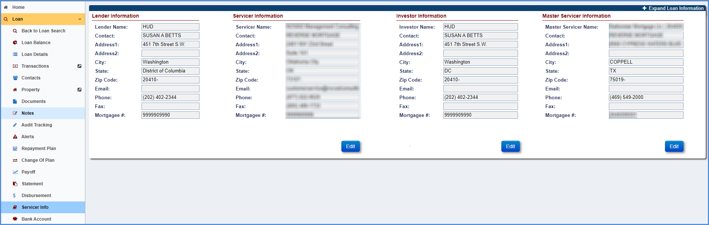
Figure 6-135: Servicer Information Screen

Transferring a Case to a Servicer
To transfer the servicer information for the selected loan:
- Click Edit in the Servicer Information section.
- On the Edit Servicer window, select a servicer from the dropdown.
- Change the Servicer Name.
- The contact information for the selected servicer is displayed.
- Select the effective transfer date (this is the first date of the month when the transfer must occur) from the dropdown.
- Click Submit to save the changes. The new information is displayed in the Servicer Information section.
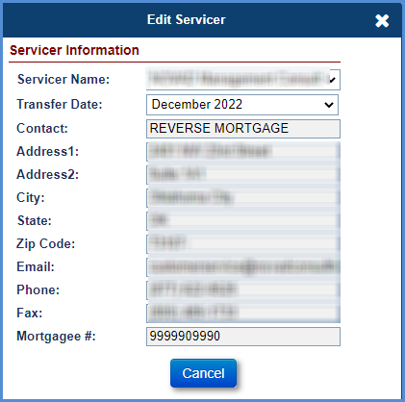
Figure 6-136: Transferring a Servicer

Transferring a Case to an Investor
To transfer the investor information for the selected loan:
- Click Edit in the Investor Information section.
- On the Edit Investor screen, select an investor from the dropdown.
- The contact information for the selected investor is displayed.
- Click Submit to save the changes. The new information is displayed in the Investor Information section.
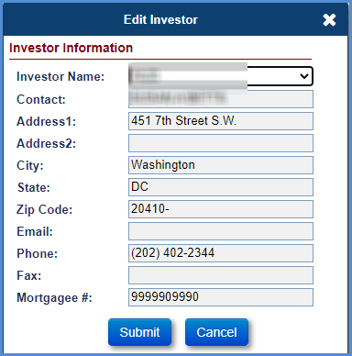
Figure 6-137: Transfer Investor Window

Transferring a Case to a Master Servicer
To transfer the Master Servicer information for the selected loan:
- Click Edit in the Master Servicer Information section.
- On the Edit Master Servicer screen, select a Master Servicer from the dropdown.
- The contact information for the selected Master Servicer is displayed.
- Click Submit to save the changes. The new information is displayed in the Master Servicer Information section.
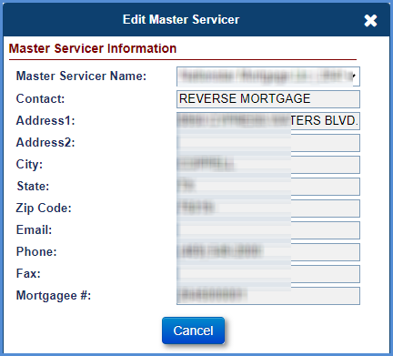
Figure 6-138: Transfer Master Window

Bank Account
The Borrower Bank Account Information screen is displayed when an authorized user selects the Bank Account tab from the menu on the left side of the screen. The Bank Account information will be used by the system to make the payments to the borrower (if payment method is selected as ACH). This screen allows authorized users with the ability to edit the Payment Method and Borrower’s Bank Account information.

Editing Borrower Bank Account Information
To edit the bank account or payment method:
- Click Edit on the Borrower Bank Account Information section.
- To auto-populate the ABA routing number, click the Edit Icon beside the field. A new window is displayed with bank name.
- Enter the Bank Name and click Search.
- From the search results, select the Bank Name. The ABA Routing Number of the Bank is populated.
- Enter the other fields on the Bank Account Information section.
- Click the dropdown list to update the Payment Method and select Check/ACH.
- Click Submit to save the changes. The updated information is displayed on the Borrower Bank Account Information section.
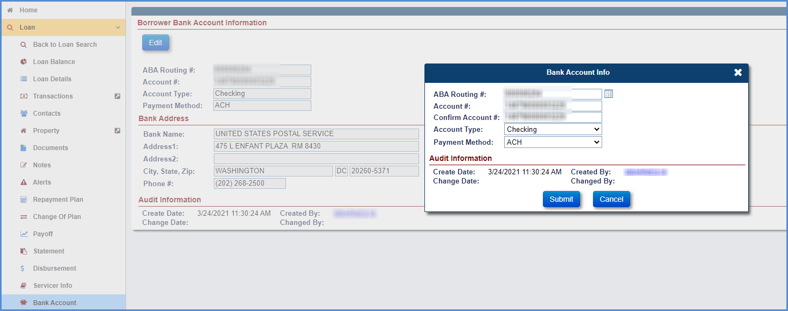
Figure 6-139: Edit Borrower Bank Account Information Window

Accounting
The Accounting tab enables authorized users to track the status of the payables and receivables transactions generated for a loan. The Accounting Menu option has the following sub-menu options:
- Transmittals
- Disbursements
- Authorizations
- Premiums
- Refunds
- Claims

Accounting > Transmittals
The Transmittal screen is displayed when an authorized user selects the Transmittal under the Accounting tab displayed in the Left Menu. This screen provides the history of all the batches generated in the Servicing Module and sent to the Accounting Module for payment processing. The transactions include Premiums (IMIP, MIP, and Refunds), Notes (Disbursements, Monthly Accruals, Other) and Claims (Payables and Receivables).
The Transmittal screen provides the following search criteria:
Field | Description
Batch # | Unique ID for each batch.
Loan Skey | The Servicing Module system identification number unique to each loan.
FHA Case# | FHA case number of the loan Note: will display for batches with Trans Count of one.
Batch Type | Selection from dropdown values.
Servicer Name | Name of the Servicer servicing the loan.
Investor Name | Name of Investor
Batch Amount | Total amount associated with the batch.
Created Date (From and To Dates) | Date the batch was created.
GL Sent Date (From and To Dates) | Date the batch was sent to GL notifying collection/payment request.
Sent Conf Date | Date the batch was sent to GL confirming collection/payment request.
Posted Date | Date the collection was successful at Pay.Gov
Check/ACH # | Check or ACH number from disbursement
Batch Status Category | Selection from dropdown values.
Batch Status | Status of the Batch. Refer below tables for descriptions.
Table 6-17: Transmittal Screen Search Criteria
Figure 6-140: Transmittals Search Results Screen

Notes Batch Statuses
The Notes transaction batch statuses are listed in the table below.
Batch Status Category | Batch Status | Detail Description
Ready to Transmit/Retry | Ready to Transmit | Batch Created but Interface file not generated yet.
Sent to GL | Sent to GL | Batch Created and File Sent to Accounting Module and waiting on Response from Accounting Module.
Receivable/Payable Established | Success – Disbursed | Payment was successfully completed.
Receivable/Payable Established | Success | Batch was successfully uploaded in the Accounting Module.
Failure – Technical Issues | Failure | Batch could not be uploaded primarily due to technical or format issues.
Table 6-18: Notes Batch Statuses

Claims Batch Statuses
The Claims transaction batch statuses are listed in the table below.
Batch Status Category | Batch Status | Detailed Description
Ready to Transmit/Retry | Ready to Transmit Held | Claims payable/receivable batch created but interface file not generated yet.
Ready to Transmit/Retry | Ready To Retry | Lender has fixed bank info or NSF issues and has authorized a retry of collection.
Sent to GL | Sent to GL Held | Claims payable/receivable batch created and file sent to Accounting Module and waiting on response from Accounting Module.
Receivable/Payable Established | Success - Held | Claims payable/receivable batch was Successfully uploaded in Accounting Module.
Failure – Technical Issues | Failure - Held | Claims payable/receivable batch could not be uploaded primarily due to technical or format issues.
Ready to Transmit/Retry | Ready to Transmit Disburse | Claims payable release batch created but interface file not generated yet.
Sent to GL | Sent to GL Disburse | Claims payable release batch created and file sent to Accounting Module and waiting on response from Accounting Module.
Receivable/Payable Established | Success - Disburse | Claims payable batch release was successfully uploaded in Accounting Module.
Failure – Technical Issues | Failure - Disburse | Claims payable release batch could not be uploaded primarily due to technical or format issues.
Receivable/Payable Established | Disbursed | Payment was successfully completed.
Failed | Rejected | Claims Payment was cancelled for some reason in pay.gov.
Ready to Transmit/Retry | Ready to Transmit Collect | Claims receivable release batch created but Interface file not generated yet.
Sent to GL | Sent to GL Collect | Claims receivable release batch created and file sent to Accounting Module and waiting on response from Accounting Module.
Collection/Payment Collected | Success - Collect | Claims receivable release batch was successfully uploaded in Accounting Module.
Failure – Technical Issues | Failure – Collect | Claims receivable release batch could not be uploaded primarily due to technical or format issues
Collection/Payment Collected | Settled | Collection was Successful in Pay.gov.
Failed | Retired | Collection was not completed in pay.gov (probably due to NSF).
Table 6-19: Claims Batch Statuses

Viewing Batch Details
To view batch details:
- Enter the search criteria and click Search on the Transmittals Search section.
- The search results matching the search criteria are displayed in the Transmittal Search Results section.
- Select a record displayed in the search results. The Batch Details screen is displayed.
  - Batch Details: Displays the loans/FHA cases sent to the Accounting Module in that batch. The details of the batch vary and depend on the batch type selected.
  - Audit Tracking: Enables users to view the audit of the batch status values.
  - Batch Note: Displays additional information if the batch failed.
Figure 6-141: Batch Details Screen
- Select Audit Tracking menu on the Batch Details screen to view the Audit Results screen.
Figure 6-142: Audit Results Screen
- Select Batch Note menu on the Batch Details screen to view the Notes if the batch failed.
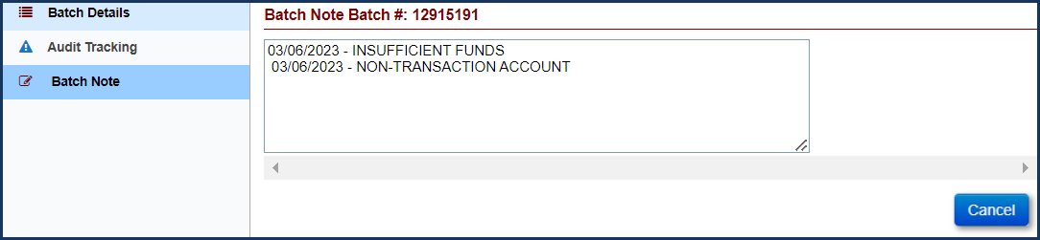
Figure 6-143: Batch Notes Screen

Accounting > Disbursements
The Disbursements screen is displayed when an authorized user selects Disbursements under the Accounting tab displayed in the Left Menu. This screen displays the Notes disbursement transactions that need a cash supervisor to Authorize the Check/ACH transaction. After authorization, the transaction is released to the Accounting Module for disbursement.
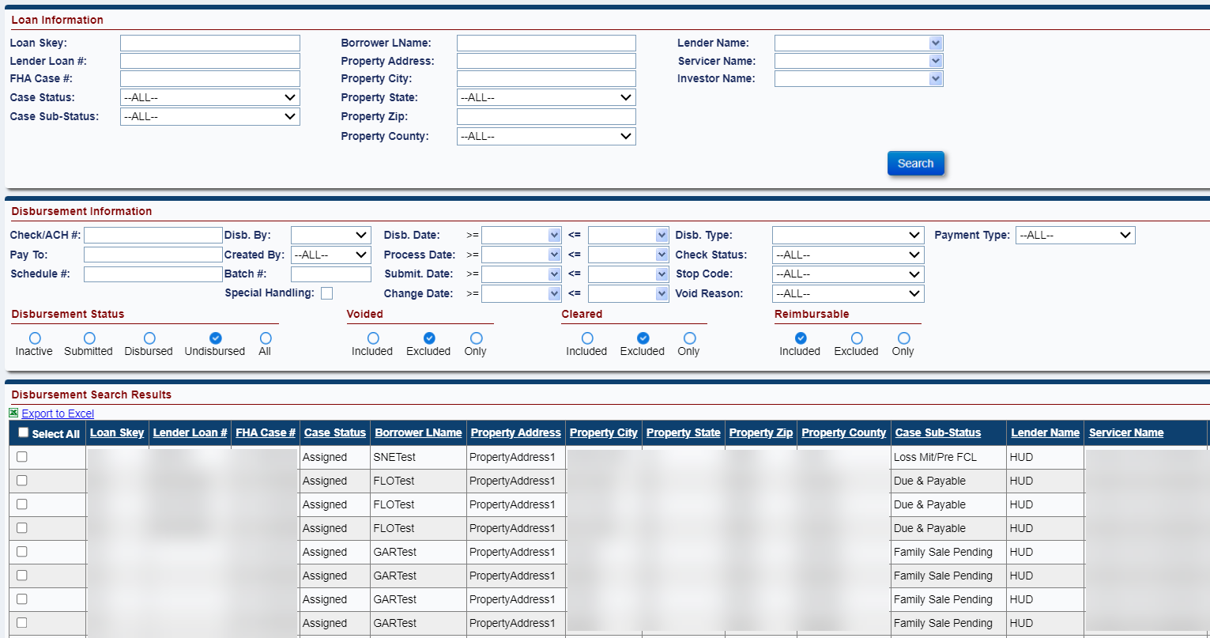
Figure 6-144: Disbursements Screen
The Disbursements screen provides the following search criteria:
Field | Description
Loan Skey | Unique ID for each FHA case.
Lender Loan # | Unique Loan Number assigned by the lender.
FHA Case # | The HECM Case number.
Case Status | Selection from dropdown values.
Case Sub-Status | Selection from dropdown values for the selected case status.
Borrower LName | The last name of the borrower.
Property Address | The line 1 of the property address.
Property City | The property city.
Prop State | The property state.
Property Zip | Property Zip code
Property County | Selection from dropdown values for the selected Property State
Servicer Name | Name of the servicer on the loan.
Lender Name | Name of the lender on the loan.
Investor Name | Name of the investor on the loan.
Table 6-20: Loan Information
Field | Description
Check/ACH # | Unique ID for each check or Trace Number for ACH
Pay To | Populate the value.
Schedule # | The automatically generated schedules that comes from Accounting
Disb. By | The user ID that approved the Disbursement transaction.
Created By | The user ID that initiated the Disbursement transaction.
Batch # | Unique ID for each disbursement that are authorized for accounting
Disb. Date | The date the Disbursement transaction was approved.
Process Date | The date the Disbursement transaction was initiated.
Submit. Date | The date the Disbursement transaction was submitted/authorized.
Change Date | The date the Disbursment transaction was changed
Special Handling | Special Handling Box is a checkbox that needs to be checked if the Check needs to be sent back to the NSC Contractor. Special Handling is only for Checks.
Disb Type | Selection from dropdown values.
Check Status | Selection from dropdown values.
Stop Code | Selection from dropdown values. Conditional based on Check Status.
Void Reason | Selection from dropdown values. Conditional based on Check Status.
Payment Type | Selectable options of Assigned Disbursement, Endorsed HUD Advance, Endorsed HUD Borrower Disbursement, or ALL.
Disbursement Status | Selectable options of Inactive, Submitted, Disbursed, Undisbursed, or All.
Voided | Selectable options of Included, Excluded, or Only.
Cleared | Selectable options of Included, Excluded, or Only.
Reimbursable | Selectable options of Included, Excluded, or Only.
Table 6-21: Disbursement Information

View Disbursements
To view the disbursement:
- Enter the search criteria and click Search on the Disbursements screen to display the disbursements.
- The search results matching the search criteria are displayed in the Search Results section.
- Click the record displayed in the search results. The Edit Disbursement window is displayed.
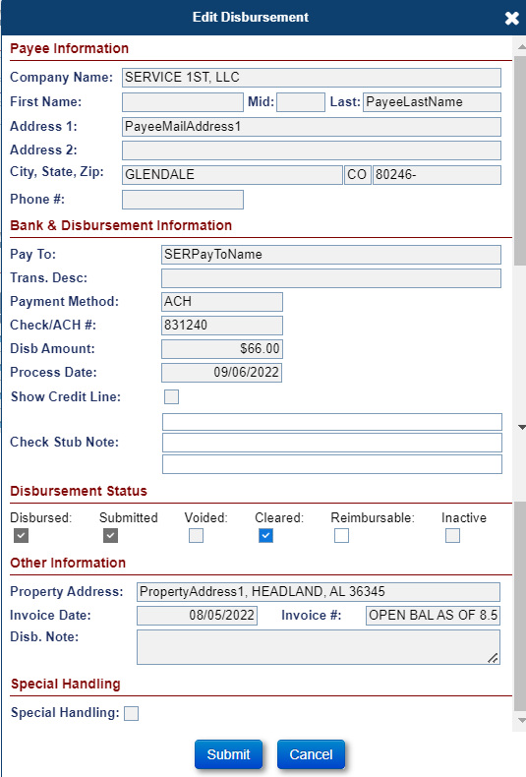
Figure 6-145: Edit Disbursement Window

Inactivate Disbursements – Check/ACH
Any disbursement can be inactivated before it is authorized. To Inactivate the disbursement:
- Select Disbursement Status: Undisbursed and any other search criteria and click Search on the Disbursements screen to display the disbursement record.
- The search results matching the search criteria are displayed in the Search Results section.
- Click the record displayed in the search results. The Edit Disbursement window is displayed.
- Check the Inactivate checkbox to inactivate this disbursement record.
- Click Submit
Note: a Scheduled Payment that does not meet all required validations will automatically be inactivated when the user attempts to Authorize the disbursement. The user can view the details by clicking “Exceptions to Excel” and make note of the missing data that needs to be corrected.
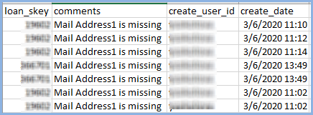
Figure 6-146: Export Exceptions on Authorization

Authorize Disbursements Check/ACH
A user with necessary access must authorize Checks and ACHs for the payment to be made and related transaction to be recorded on the loan. Upon authorization, the system will create the Batch # and assigned to each disbursement record to send to Accounting Module. The below steps are used to authorize checks and ACHs for disbursements.
To Authorize Check:
- On Accounting/Disbursement page, select a Disbursement Type – Checks and Disbursement Status – Undisbursed and Search. Selecting these fields will enable the Authorize Disbursements link to Authorize the checks. Disbursement Type is not required to select.
- The search results matching the search criteria are displayed in the Search Results section.
- Select the checkboxes for the record that need to be authorized or Select All checkbox to select all records to authorize. Click the Authorize Disbursements link under the Disbursement Search Results section.
- Status for the authorized disbursement records will be updated to “Submitted” and Batch Skey is assigned.
To Search for submitted records, select Disbursement Status to “Submitted”
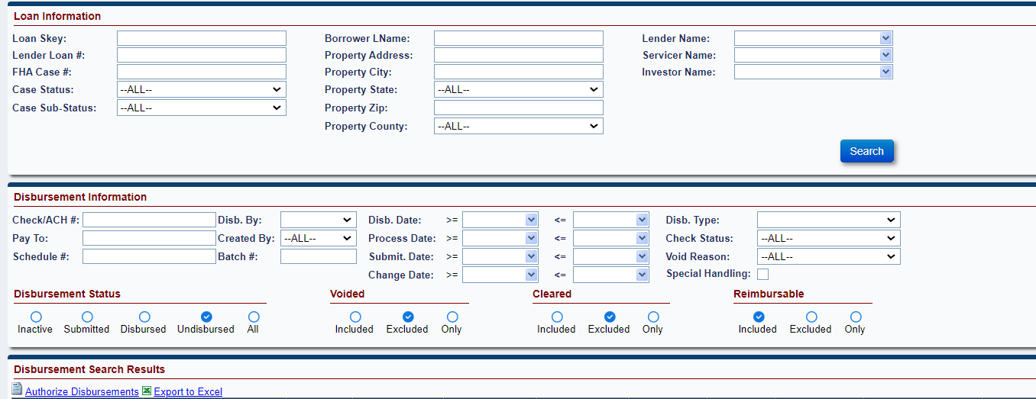
Figure 6-147: Authorize Disbursements - Checks
To Authorize ACH:
- On Accounting/Disbursement page, select a Disbursement Type – ACH and Disbursement Status – Undisbursed and Search. Selecting these fields will enable the Authorize Disbursements link to Authorize the ACHs. Disbursement Type is not required to select.
- The search results matching the search criteria are displayed in the Search Results section.
- Select the checkboxes for the record that need to be authorized or Select All checkbox to select all records to authorize. Click the Authorize Disbursements link under the Disbursement Search Results section.
- Status for the authorized disbursement records will be updated to “Submitted” and Batch Skey is assigned.
- To Search for submitted records, select Disbursement Status to “Submitted”
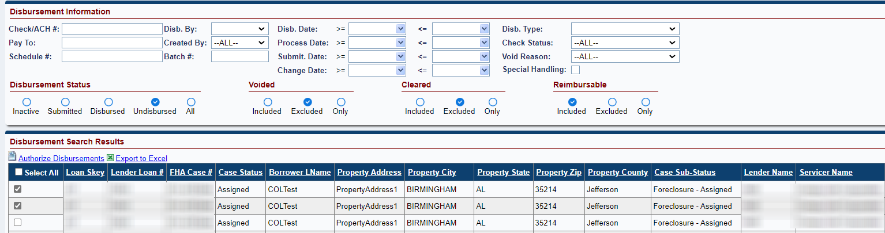
Figure 6-148: Authorize Disbursements - ACH

Void/Clear Check
The Servicing Module allows a user with necessary access to void or clear a check if the disbursement transaction was added prior to Release 6.0 (4/25/2020). Any disbursements created after this release cannot be voided or cleared in the Servicing Module. The Cleared Check file from TCIS will load Void and Clear checks in HERMIT.
To void a Check that was added prior to Release 6.0 (4/25/2020):
- Enter search criteria; click Search on the Disbursements screen to display the transactions.
- The search results matching the search criteria are displayed in the Search Results section.
- Select the Check record that you want to void.
- Scroll to the bottom of the Edit Disbursement window.
- Click the checkbox next to Voided at the Disbursement Status section of the Edit Disbursement screen.
- View the “You are about to (un)void a disbursement” message.

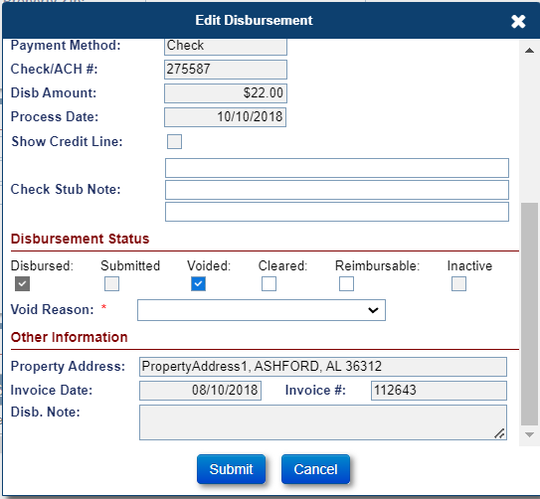
Figure 6-149: Void Check

- Click Submit to confirm the action.
To Clear a check that was added prior to Release 6.0 (4/25/2020):
- The search results matching the search criteria are displayed in the Search Results section.
- Select the Check record that you want to clear.
- Scroll to the bottom of the Edit Disbursement window.
- Click the checkbox next to Cleared at the Disbursement Status section of the Edit Disbursement screen.
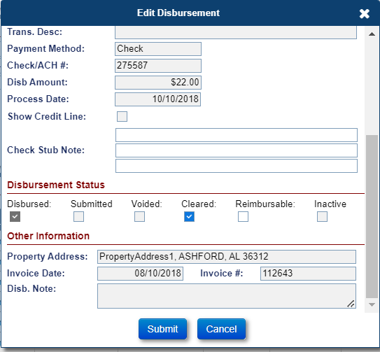
Figure 6-150: Clear Check
- Click Submit to confirm the action.

Void/Clear ACH
The Servicing Module allows the authorized user to void and clear ACH if the disbursement transaction was added prior to Release 6.0 (4/25/2020). Any disbursements created after this release will be cleared automatically. The NSC Manager will be the only Authorized user to void an ACH in HERMIT after the release.
To void an ACH that was added prior to Release 6.0 (4/25/2020):
- Enter search criteria; click Search on the Disbursements screen to display the transactions.
- The search results matching the search criteria are displayed in the Search Results section.
- Select the ACH record that you want to void.
- Scroll to the bottom of the Edit Disbursement window.
- Click the checkbox next to Voided at the Disbursement Status section of the Edit Disbursement screen.
- View the “You are about to (un)void a disbursement” message.
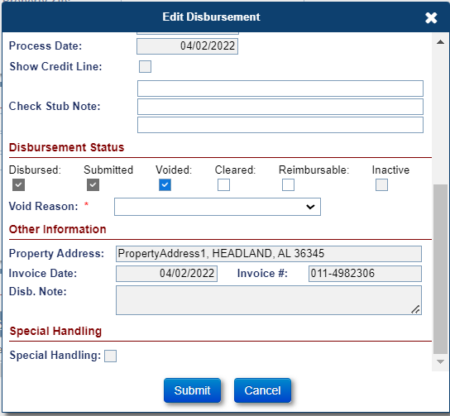
Figure 6-151: Void ACH

- Select the Void Reason on the Void Reason dropdown that appears after checking the voided checkbox.
- Click Submit to confirm the action.

To Clear an ACH that was added prior to Release 6.0 (4/25/2020):
- Enter search criteria; click Search on the Disbursements screen to display the transactions.
- The search results matching the search criteria are displayed in the Search Results section.
- Select the ACH record that you want to clear.
- Scroll to the bottom of the Edit Disbursement window.
- Click the checkbox next to Cleared at the Disbursement Status section of the Edit Disbursement screen.
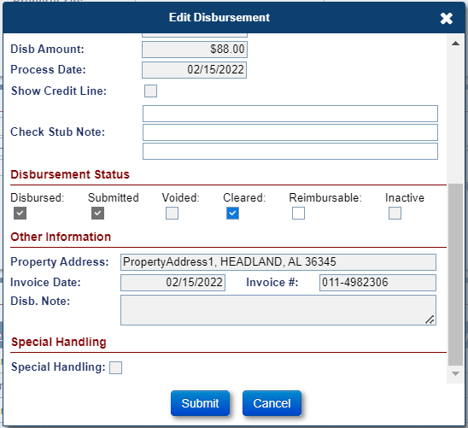
Figure 6-152: Clear ACH
- Click Submit to confirm the action.

To void/clear an ACH that was added after Release 6.0 (4/25/2020):
- Enter search criteria; click Search on the Disbursements screen to display the transactions.
- The search results matching the search criteria are displayed in the Search Results section.
- Select the ACH record that you want to void.
- Scroll to the bottom of the Edit Disbursement window. Note: Cleared is checked. ACHs are automatically Cleared.
Figure 6-153: Clear ACH
- Click the checkbox next to Cleared at the Disbursement Status section of the Edit Disbursement screen.
- Click SUBMIT.
- Search for the same ACH and Click to view disbursement. Note: Voided checkbox is editable.
Figure 6-154: Void ACH

- Click the checkbox next to Voided at the Disbursement Status section of the Edit Disbursement screen.
- View the “You are about to (un)void a disbursement” message.
- Select the Void Reason on the Void Reason dropdown that appears after checking the voided checkbox.
- Click Submit to confirm the action.

Accounting > Authorizations
The Authorizations screen is displayed when a user with necessary access selects Authorizations under the Accounting tab displayed in the Left Menu. This screen displays the transactions that need authorization for collection from a lender/investor/servicer, such as a Repurchase or repayment of a HUD advance. Upon authorization, the transaction will no longer be displayed on the screen.
The Authorizations screen provides the following search criteria:
Field | Description
Loan Skey | Unique ID for each FHA Case.
FHA Case # | The HECM Case number.
Servicer Name | Name of the Servicer that previously serviced the loan.
Table 6-22: Search Criteria for Authorizations
To authorize a Repurchase transaction:
- Enter the search criteria and click Search on the Authorizations screen to display the Repurchase transactions.
- The search results matching the search criteria are displayed in the Search Results section.
- Select the record displayed in the search results. The Authorization Information window is displayed.
- Click Approve on the Authorization Information window. To exit without approving click Cancel.
- Once approved, the claims receivable transaction is released to the Accounting Module for payment collection. The updated batch status of the transaction can be viewed using the Transmittals screen of the Servicing Module.

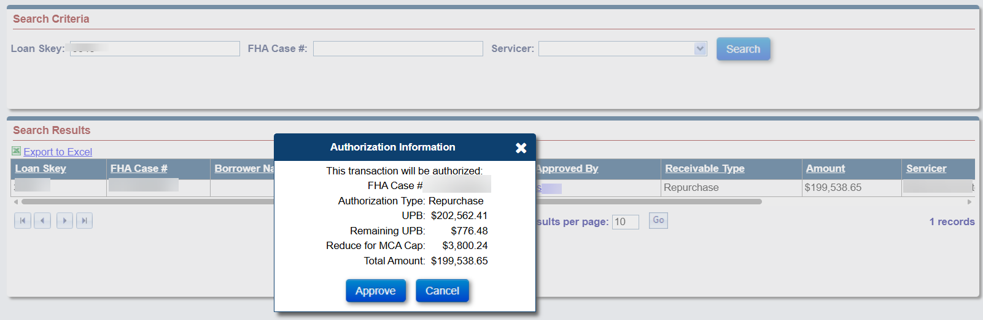
Figure 6-155: Authorize a Repurchase Transaction

Batch
The Batch tab available on the left menu allows authorized users (example: HUD/HUD Contractor) to perform an action on multiple loans at the same time. The Batch tab has the following sub-menu options:
- NSC Bulk Disbursements
- NSC Bulk Servicing Steps
- Note Uploads
- Alert Uploads
- NSC Disbursement Uploads
- NSC File Uploads

NSC Bulk Disbursements
The NSC Bulk Disbursements screen is displayed when an authorized user selects NSC Bulk Disbursements under the Batch tab displayed in the Left Menu. The NSC Bulk Disbursements screen allows the authorized user (HUD Contractor Cash) to add multiple disbursement transactions on a single or multiple loans (maximum of 50 disbursement transactions at a time).
To enter disbursement transactions on the NSC Bulk Disbursements page:
- Enter the required fields to add a disbursement transaction and click Validate.
- If any validations fail, the Validation column will display the error message.
- If no validations fail, the Validation column will display Pending or warning messages.
- Click Submit to add the disbursement transactions on the loan. Tip: The Submit Button will only appear when all data has passed validation.
- After clicking Submit the Validation column will display Processed indicating the Disbursement has been added to the Loan > Disbursement page. Tip: Only the Clear Button will display at this time and the user will need to click Clear in order to start the process over again.
To use the copy checkbox feature on the NSC Bulk Disbursements page:
- Select a Transaction Category in the first row.
- Select a Transaction Description in the first row.
- Select a Payee Type Vendor in the first row. Tip: The Checkbox feature for this column will be read only if another Payee Type is used other than Vendor in the first row.
- Select a Vendor Type in the first row. Tip: The Checkbox feature for this column will be read only if another Payee Type is used other than Vendor in the first row.
- Select a Payee in the first row. Tip: The Checkbox feature for this column will be read only if another Payee Type is used other than Vendor in the first row.
- Enter a Disb Amount in the first row.
- Click on the Checkbox next to the column you want to be copied down all rows. Tip: The Checkbox feature copies the information down all 50 rows.
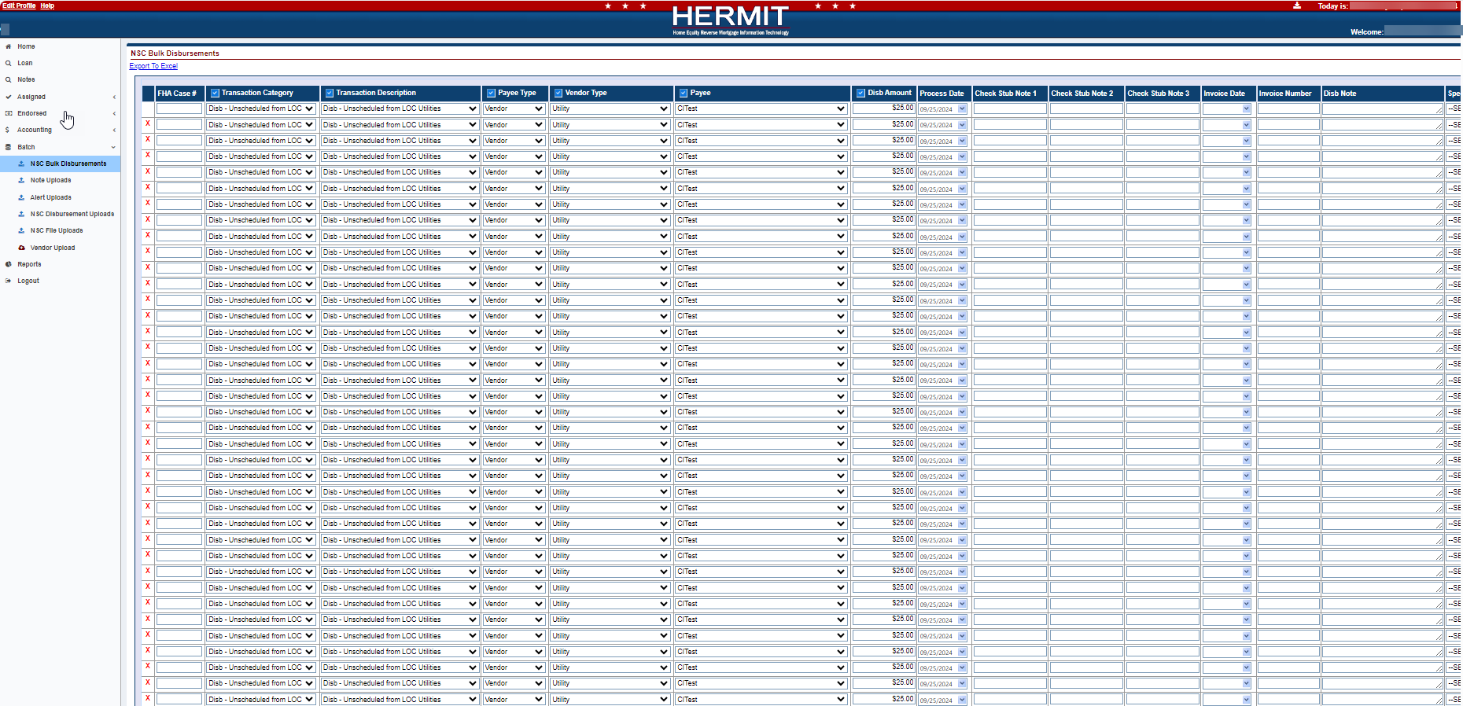
Figure 6-156: NSC Bulk Disbursments

NSC Bulk Servicing Steps
The NSC Bulk Servicing Steps screen is displayed when an authorized user selects NSC Bulk Servicing Steps under the Batch tab displayed in the Left Menu. The NSC Bulk Servicing Steps screen allows the authorized user to add multiple Steps at time to certain Timelines (maximum of 50 Steps at a time).
To enter Steps on the NSC Bulk Servicing Steps page:
- Enter the required fields to add a Step and click Validate.
- If any validations failed, the Validation column will display the error messages.
- If no validations fail, the Validation column will display Pending or warning messages.
- Click Submit to add the Step on the Timeline. Tip: The Submit Button will only appear when all data has passed validation.
- After clicking Submit the Validation column will display Processed indicating the Step has been added to the selected Timeline. Tip: Only the Clear Button will display at this time and the user will need to click Clear in order to start the process over again.
To use the copy checkbox feature on the NSC Bulk Servicing Steps page:
- Select a Timeline Category in the first row.
- Select a Servicing Type in the first row.
- Select a Step Name in the first row.
- Click on the Checkbox next to the column you want to be copied down all rows. Tip: The Checkbox feature copies the information down all 50 rows.
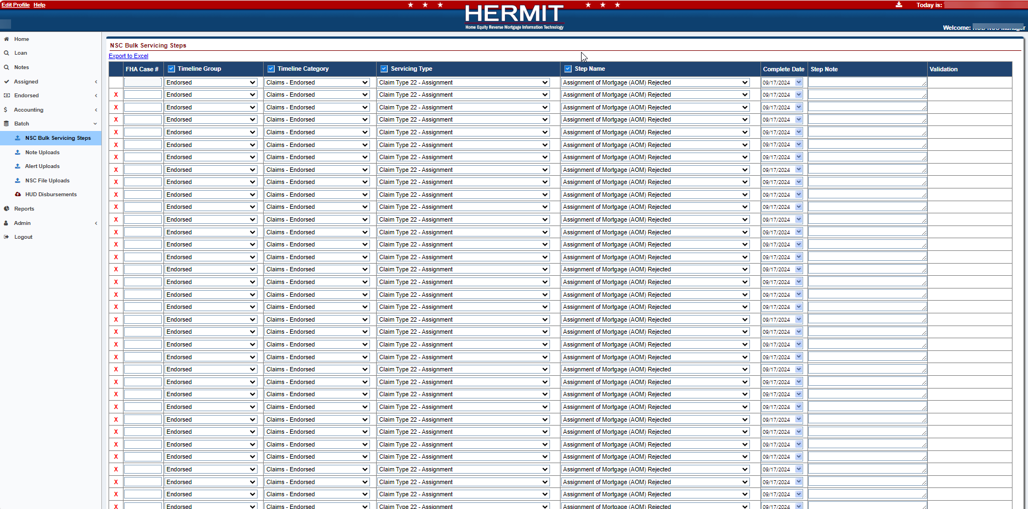
Figure 6-157: NSC Bulk Servicing Steps

Alert Uploads
The Alert Uploads screen is displayed when an authorized user selects Alert Uploads under the Batch tab displayed on the Left menu. The Alert Uploads screen allows the authorized user (example: HUD/HUD Contractor) to upload B2G Assigned and Endorsed Alerts in the Servicing Module.

Preparing Alerts Import File
To prepare Alerts Import file:
- From the Batch tab, select Alert Uploads.
- Select Alerts.
- On the File Download screen, click Open; this action opens an Excel template.
- Enter valid values for each column. For each of the fields a comment is displayed when user points on the column name. The comment provides the user with the following information:
  - whether the field is required, optional or conditionally required.
  - format/valid values for each field
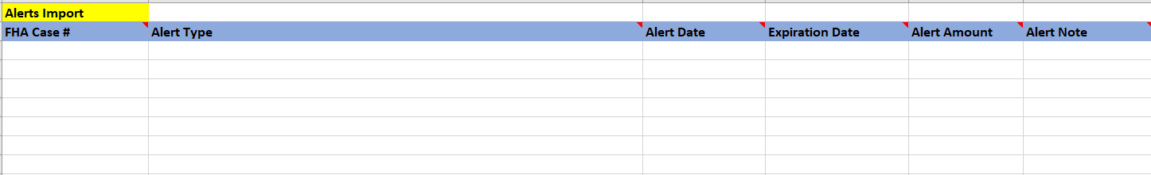
Figure 6-158: Sample Excel Template for B2G Alerts Import

Saving Alerts Import File
To save the Alerts Import file:
- Once all required fields are entered in the B2G Alerts import file and the file is ready for upload, the file should be saved in a text (tab-delimited) file format.
- Click File > Save in the Alerts Import file.
- Select the folder in which to save the Excel file.
- Rename the file if desired.
- Click File > Save As and save the file as text (tab-delimited).
- Click Save.

Uploading Alerts Import File
To upload the Alerts Import file:
- Click Choose File on the Alert Uploads screen to attach the previously saved Alerts Import File.
- Click Upload. The Import Results section displays the details of the upload results.
- The system will process the file and validate the records within the Alerts import file:
  - If all the critical validations pass for the record, the record is uploaded
  - If any of the critical validations fail, the record is not uploaded in the Servicing Module
- Upon completion of the file processing, the system displays the processing status of each record within the file.

Viewing Status of Alerts Import File
The Import Results section displays the details of the processed B2G Alert Import file. It allows user to view:
- Error Records: count of records within the file that failed critical validations
- Warning/Success Records: count of records that generated a warning but were successfully uploaded in the Servicing Module
- Success Records: count of records that were successfully uploaded without generating a warning or error
- Filters: This section allows the user to filter the import results by status and error message
- Export to Excel: This link allows the user to export the file upload results to an Excel file
The processing status of each record within the file is displayed:
- Rec#: The record number of the case within the file
- FHA Case#: The case number associated with the record
- Status: The status of the uploaded record (Success, error or warning)
- Errors: Description of the errors associated with the record. For example: FHA Case# is invalid
- Warnings: Description of the warnings associated with the record
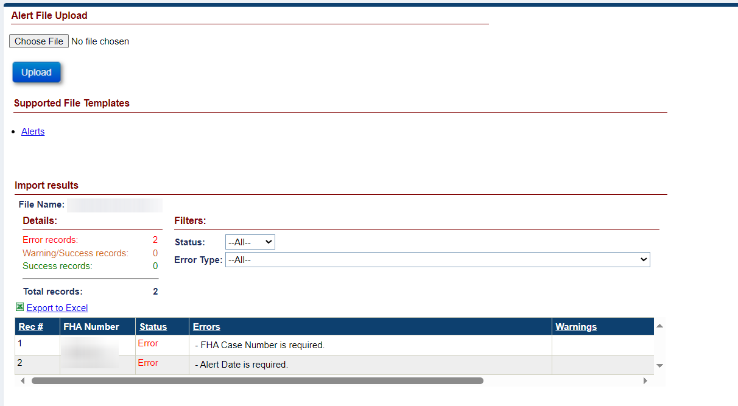
Figure 6-159: Alert Import Results

NSC Disbursement Uploads – Multiple File Types
Disbursements are initiated when a payment via Check or ACH needs to be sent out to a Borrower or another party. Disbursements Import is different from Transactions Import stated under the NSC File Uploads page because Transactions are not sent out as monetary payments from the HERMIT System.
The NSC Disbursement Uploads screen is displayed when an authorized user selects NSC Disbursement Uploads under the Batch tab displayed on the Left menu. The NSC Disbursement Uploads screen allows the authorized user (example: HUD Contractor) to upload B2G NSC Disbursements in the Servicing Module. Multiple Disbursement file types are available on this page. The process of preparing, saving, uploading, and viewing the files are the same for each file type available on this page.

Upload Type | Description
Inspection Disbursements | Enables HUD Contractor to upload one or multiple Unscheduled from LOC Inspection Disbursements
Release Fee Disbursements | Enables HUD Contractor to upload one or multiple Unscheduled from LOC Release Fee Disbursements
State Prohib Legal – Appraisal Disbursements | Enables HUD Contractor to upload one or multiple Corp Adv – S305 State Prohibited Legal Appraisal Disbursements
State Prohib Legal – Inspection Disbursements | Enables HUD Contractor to upload one or multiple Corp Adv – S305 State Prohibited Legal Inspection Disbursements
Table 6-23: B2G File Descriptions

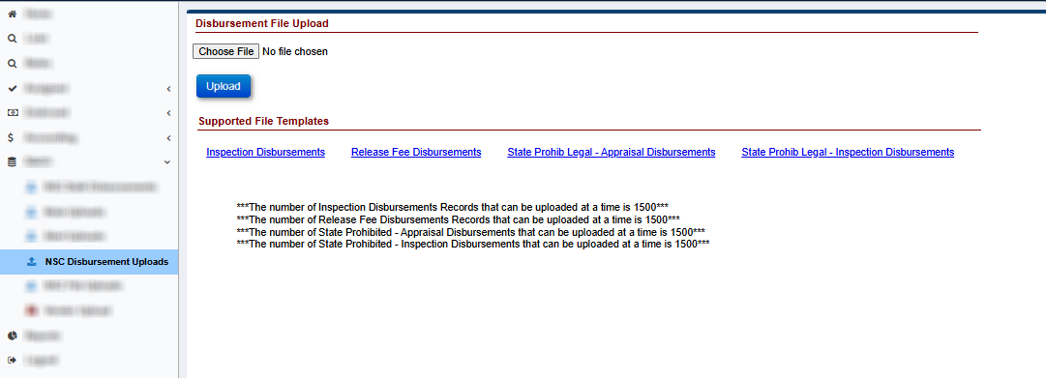
Figure 6-160: NSC Disbursement Uploads

Preparing a Disbursements Import File
To prepare a Disbursements Import file:
- From the Batch tab, select NSC Disbursement Uploads.
- Select from available Supported File Templates.
- On the File Download screen, click Open; this action opens an Excel template.
- Enter valid values for each column. For each of the fields a comment is displayed when user points on the column name. The comment provides the user with the following information:
  - whether the field is required, optional or conditionally required.
  - format/valid values for each field
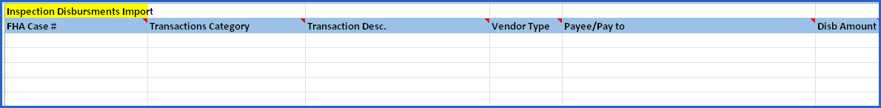
Figure 6-161: Sample Excel Template for B2G Inspection Disbursements Import

Saving a Disbursements Import File
To save the Disbursements Import file:
- Once all required fields are entered in the necessary B2G Disbursement import file and the file is ready for upload, save as a text (tab-delimited) file format.
- Click File > Save in the Disbursements Import file.
- Select the folder in which to save the Excel file.
- Rename the file if desired.
- Click File > Save As and save the file as text (tab-delimited).
- Click Save.

Uploading a Disbursements Import File
To upload the Disbursements Import file:
- Click Choose File on the NSC Disbursement Uploads screen to attach the previously saved Disbursements Import File.
- Click Upload. The Import Results section displays the details of the upload results.
- The system will process the file and validate the records within the Disbursements import file:
  - If all the critical validations pass for the record, the record is uploaded
  - If any of the critical validations fail, the record is not uploaded in the Servicing Module
- Upon completion of the file processing, the system displays the processing status of each record within the file.

Viewing Status of a Disbursements Import File
The Import Results section displays the details of the processed B2G Disbursements Import file. The Import Results are only available immediately after the upload. Once the user navigates away from this page or performs a different action on this page the Import Results will no longer be displayed and the user will not be able to obtain these results again. Import Result section allows user to view:
- Error Records: count of records within the file that failed critical validations
- Warning/Success Records: count of records that generated a warning but were successfully uploaded in the Servicing Module
- Success Records: count of records that were successfully uploaded without generating a warning or error
- Filters: This section allows the user to filter the import results by status and error message
- Export to Excel: This link allows the user to export the file upload results to an Excel file
The processing status of each record within the file is displayed:
- Rec#: The record number of the case within the file
- FHA Case#: The case number associated with the record
- Status: The status of the uploaded record (Success, error or warning)
- Errors: Description of the errors associated with the record. For example: FHA Case# is invalid
- Warnings: Description of the warnings associated with the record

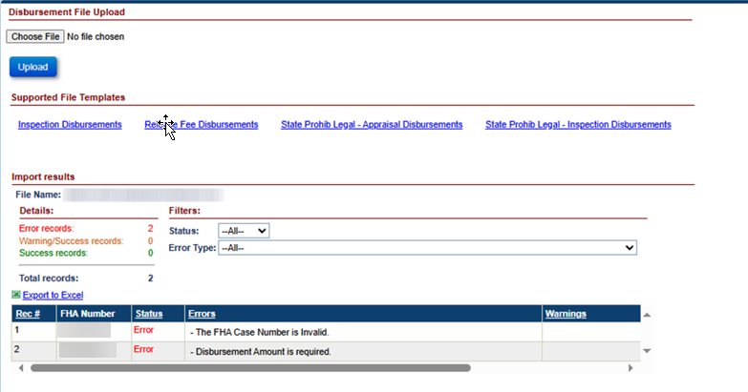

Figure 6-162: Inspection Disbursement Import Results

Note Uploads
The Notes File Uploads screen is displayed when an authorized user selects Note Uploads under the Batch tab displayed in the Left Menu. The Notes File Uploads screen allows the authorized user (example: HUD/HUD Contractor) to upload B2G files with one or more loan notes.

Preparing Notes Import File
To prepare Notes Import file:
- From the Batch tab, select Notes Uploads.
- Select Notes
- On the File Download screen, click Open; this action opens an Excel template.
- Enter valid values for each column. For each of the fields a comment is displayed when user points on the column name. The comment provides the user with the following information:
  - whether the field is required, optional or conditionally required
  - format/valid values for each field
Figure 6-163: Sample Excel Template for B2G Notes Import

Saving Notes Import File
To save the Notes Import file:
- Once all required fields are entered in the B2G Notes import file and the file ready for upload, the file should be saved in a text (tab-delimited) file format.
- Click File > Save in the Notes Import file.
- Select the folder in which to save the Excel file.
- Rename the file if desired.
- Click File > Save As and save the file as text (tab-delimited).
- Click Save.

Uploading Notes Import File
To upload the Notes Import file:
- Click Choose File on the Notes Upload screen to attach the previously saved Notes Import File.
- Click Upload. The Import Results section displays the details of the upload results.
- The system will process the file and validate the records within the Notes import file:
  - If all the critical validations pass for the record, the record is uploaded
  - If any of the critical validations fail, the record is not uploaded in the Servicing Module
- Upon completion of the file processing, the system displays the processing status of each record within the file.

Viewing Status of Notes Import File
The Import Results section displays the details of the processed B2G Notes Import file. The Import Results are only available immediately after the upload. Once the user navigates away from this page or performs a different action on this page the Import Results will no longer be displayed and the user will not be able to obtain these results again. Import Result section allows user to view:
- Error Records: count of records within the file that failed critical validations
- Warning/Success Records: count of records that generated a warning but were successfully uploaded in the Servicing Module
- Success Records: count of records that were successfully uploaded without generating a warning or error
- Filters: This section allows the user to filter the import results by status and error message
- Export to Excel: This link allows the user to export the file upload results to an Excel file
The processing status of each record within the file is displayed:
- Rec#: The record number of the case within the file
- FHA Case#: The case number associated with the record
- Status: The status of the uploaded record (Success, error or warning)
- Errors: Description of the errors associated with the record. For example: FHA Case# is invalid
- Warnings: Description of the warnings associated with the record

Figure 6-164: Notes Import Results

NSC File Uploads – Multiple File Types
The NSC File Uploads screen is displayed when an authorized user selects NSC File Uploads under the Batch tab displayed in the Left Menu. The NSC File Uploads screen allows the authorized user (example: HUD/HUD Contractor) to upload B2G files. Multiple file types are available on this page. The process of preparing, saving, uploading, and viewing the files are different for each file type available on this page. See section pertaining to each file type for specific instructions.

Upload Type | Description
NSC Transactions Import | Enables HUD/HUD Contractors to record loan transactions in the Servicing Module.
B2G Asset Sale Report | Enables HUD/HUD Contractor to generate four reports (Contact Extract, Loan Extract, Loan Level Balance, and loan Transaction Detail) in the Servicing Module.
Loan Details & Transactions PDFs Import | Enables HUD/HUD Contractor to generate three PDFs (Loan Details, Loan Transactions, and Loan Historical Transactions) in the Servicing Module.
Table 6-24: B2G File Descriptions

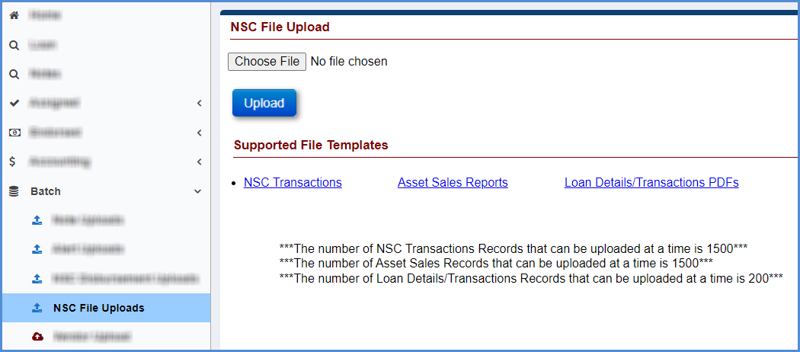
Figure 6-165: NSC File Upload

NSC Transactions
Transactions are used to report activity on the loan which does not require a Check or ACH payment to be sent out to a Borrower or another party. Transactions Import differs from Disbursements Import is different from stated under the NSC Disbursement Uploads page because Disbursements are sent out as monetary payments from the HERMIT System and payments are not sent for Transactions.

Preparing NSC Transaction Import File
To prepare NSC Transaction Import file:
- From the Batch tab, select NSC File Uploads.
- Select NSC Transaction.
- On the File Download screen, click Open; this action opens an Excel template.
- Enter valid values for each column. For each of the field a comment is displayed when user points on the column name. The comment provides the user with the following information:
  - whether the field is required, optional or conditionally required
  - format/valid values for each field
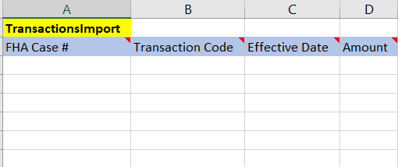
Figure 6-166: Sample Excel Template for B2G NSC Transaction Import

Saving NSC Transaction Import File
To save the NSC Transaction Import file:
- Once all required fields are entered in the B2G NSC Transaction import file and the file ready for upload, the file should be saved in a text (tab-delimited) file format.
- Click File > Save in the NSC Transaction Import file.
- Select the folder in which to save the Excel file.
- Rename the file if desired.
- Click File > Save As and save the file as text (tab-delimited).
- Click Save.

Uploading NSC Transaction Import File
To upload the NSC Transaction Import file:
- Click Choose File on the NSC File Upload screen to attach the previously saved NSC Transaction Import File.
- Click Upload. The Import Results section displays the details of the upload results.
- The system will process the file and validate the records within the NSC Transaction import file:
  - If all the critical validations pass for the record, the record is uploaded
  - If any of the critical validations fail, the record is not uploaded in the Servicing Module
- Upon completion of the file processing, the system displays the processing status of each record within the file.

Viewing Status of NSC Transaction Import File
The Import Results section displays the details of the processed B2G NSC Transaction Import file. It allows user to view:
- Error Records: count of records within the file that failed critical validations
- Warning/Success Records: count of records that generated a warning but were successfully uploaded in the Servicing Module
- Success Records: count of records that were successfully uploaded without generating a warning or error
- Filters: This section allows the user to filter the import results by status and error message
- Export to Excel: This link allows the user to export the file upload results to an Excel file
The processing status of each record within the file is displayed:
- Rec#: The record number of the case within the file
- FHA Case#: The case number associated with the record
- Status: The status of the uploaded record (Success, error or warning)
- Errors: Description of the errors associated with the record. For example: FHA Case# is invalid
- Warnings: Description of the warnings associated with the record

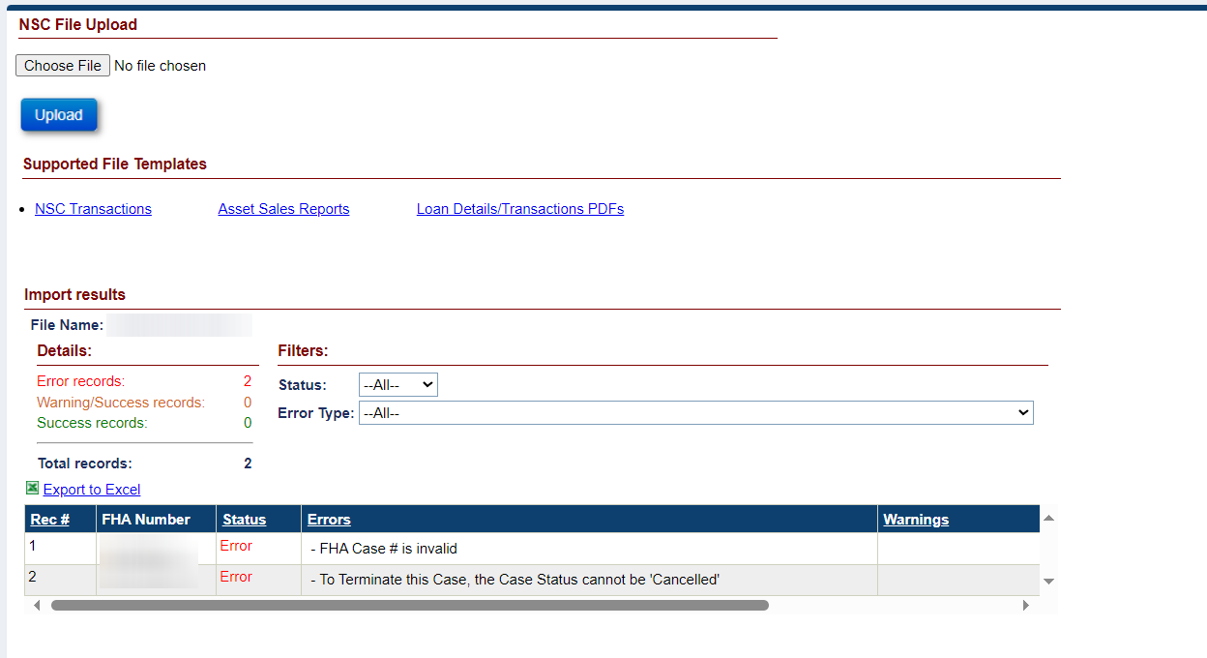
Figure 6-167: NSC Transaction Import Results

Asset Sales Reports

Preparing Asset Sale Reports Import File
To prepare Asset Sale Report Import file:
- From the Batch tab, select NSC File Uploads.
- Select Asset Sale Reports.
- On the File Download screen, click Open; this action opens an Excel template.
- Enter valid values for each column. This file will accept the first nine digits as well as the full 10 digits of the FHA Case Number. For each of the fields a comment is displayed when user points on the column name. The comment provides the user with the following information:
  - whether the field is required, optional or conditionally required
  - format/valid values for each field
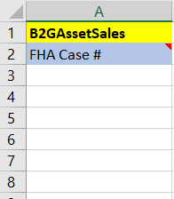
Figure 6-168: Sample Excel Template for B2G Asset Sale Reports Import

Saving Asset Sale Reports Import File
To save Transactions Import file:
- Once all required fields are entered in the B2G Asset Sale Reports import file and the file ready for upload, the file should be saved in a text (tab-delimited) file format.
- Click File > Save in the B2G Asset Sale Reports Import file.
- Select the folder in which to save the Excel file.
- Rename the file if desired.
- Click File > Save As and save the file as text (tab-delimited).
- Click Save.

Uploading Asset Sale Reports Import File
To upload Asset Sale Reports Import file:
- Click Choose File on the NSC File Uploads screen to attach the previously saved Asset Sale Reports import file.
- Click Upload. The Import Results section displays the details of the upload results.
- The system will process the file and validate the records within the transactions import file:
  - If all the critical validations pass for the record, the record is uploaded and the four Report generate in the download queue (Contact Extract, Loan Extract, Loan Level Balance, and loan Transaction Detail).
  - If any of the critical validations fail, the record is not uploaded in the Servicing Module
- Upon completion of the file processing, the system displays the processing status of each record within the file.

Viewing Reports when the Asset Sale Reports Import File is successful
To Open the four Asset Sale Reports:
- Once the B2G Asset Sale Reports import file is uploaded successfully, the four reports will generate in the download report queue located at the top right of HERMIT.
- After the reports no longer display pending next to the report, click on the report.
- Click Open on the file, the report data will be displayed.
- Once you click on the report, the report will no longer appear in the download queue.
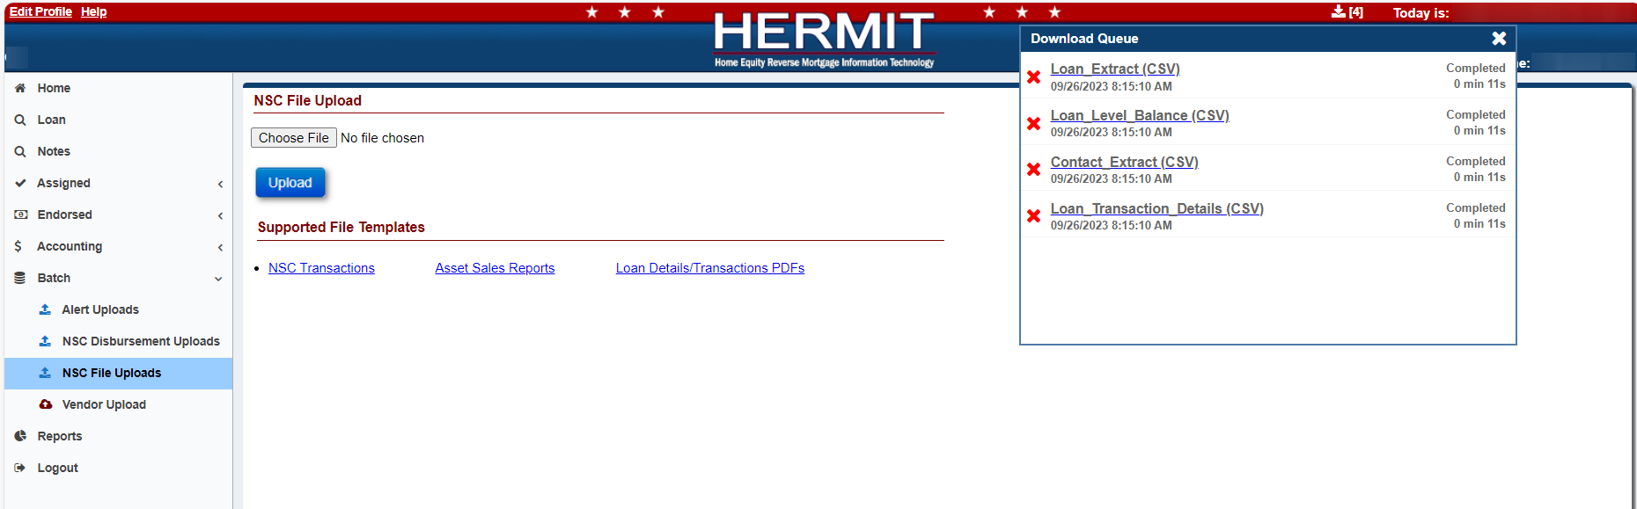
Figure 6-169: Download Queue

Loan Details / Transactions PDFs Import

Preparing Loan Details & Transactions PDFs Import File
To prepare Loan Details & Transactions PDFs Import file:
- From the Batch tab, select NSC File Uploads.
- Select Loan Details/Transactions PDFs.
- On the File Download screen, click Open; this action opens an Excel template.
- Enter valid values for each column. For each of the field a comment is displayed when user points on the column name. The comment provides the user with the following information:
  - whether the field is required, optional or conditionally required
  - format/valid values for each field
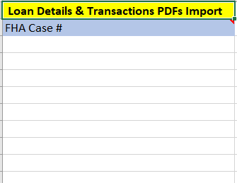
Figure 6-170: Sample Excel Template for Loan Details & Transactions PDFs Import

Saving Loan Details & Transactions PDFs Import File
To save Transactions Import file:
- Once all required fields are entered in the Loan Details & Transactions PDFs import file and the file is ready for upload, the file should be saved in a text (tab-delimited) file format.
- Click File > Save in the Loan Details & Transactions PDFs Import file.
- Select the folder in which to save the Excel file.
- Rename the file if desired.
- Click File > Save As and save the file as text (tab-delimited).
- Click Save.

Uploading Loan Details & Transactions PDFs Import File
To upload Loan Details & Transactions PDFs Import file:
- Click Choose File on the NSC File Uploads screen to attach the previously saved Loan Details & Transactions PDFs import file.
- Click Upload. The Import Results section displays the details of the upload results.
- The system will process the file and validate the records within the transactions import file:
  - If all the critical validations pass for the record, the record is uploaded, and the three PDFs generate in the download queue (Loan Details, Loan Transactions, and Loan Historical Transactions).
  - If any of the critical validations fail, the record is not uploaded in the Servicing Module
- Upon completion of the file processing, the system displays the processing status of each record within the file.

Viewing Reports when the Loan Details & Transactions PDFs Import File is successful
To Open the three Loan Details & Transactions PDFs:
- Once the Loan Details & Transactions PDFs import file is uploaded successfully, the three PDFs will generate in the download report queue located at the top right of HERMIT.
- After the PDFs no longer display pending next to the PDF, click on the report.
- Click Open on the file, the PDF data will be displayed.
- Once you click on the PDFs, the report will no longer appear in the download queue.
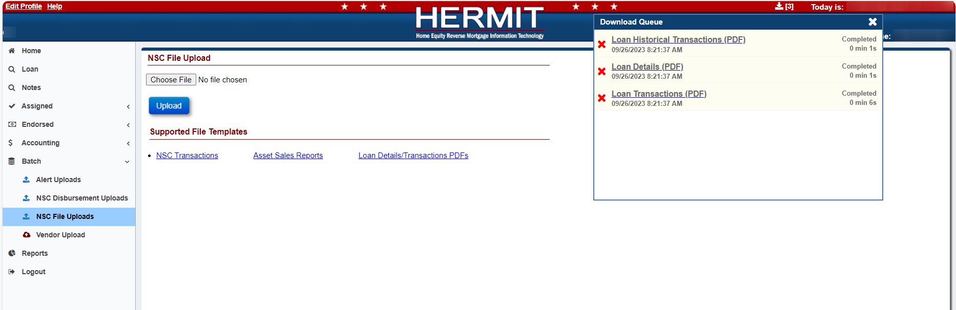
Figure 6-171: Download Queue

Repayment Plan
The Repayment Plan screen is displayed when a user selects the Repayment Plan tab from the menu on the left side of the screen. The Repayment Plan screen shows the current repayment plan and any prior repayment plans associated with the loan. Only authorized user roles can create and edit a repayment plan.
The following conditions must be satisfied to initiate a repayment plan:
- Authorized users can create and edit Repayment Plan.
- The loan must have Outstanding Total Arrearage is > $0.00. This balance is listed on Loan Balance page under Other Balances section. Field is called “Property Chrg Default Balance”
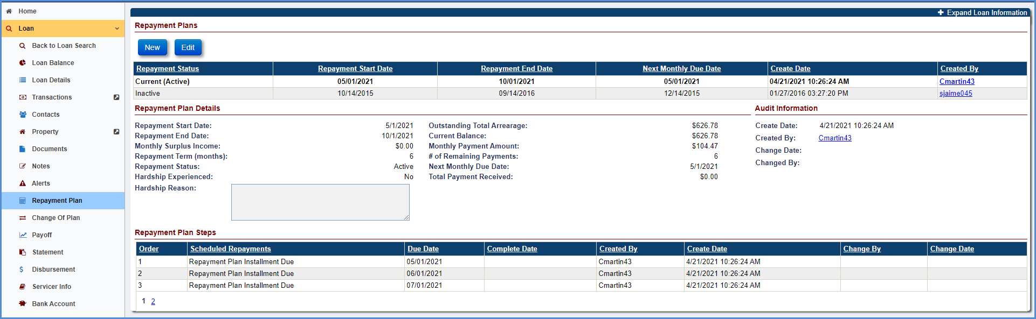
Figure 6-172: Assigned Repayment Plan Screen

Creating a New Repayment Plan
To create a new repayment plan:
- Click New in the Repayment Plan section.
- On the Repayment Plan window, enter all the mandatory fields.
  - Repayment Start Date: Required field
  - Repayment Plan Term (months): Range (1 months to 60 months) – will be auto calculated if Monthly Payment Amount is entered and will not be editable
OR
  - Monthly Payment Amount: will be auto calculated if Repayment Plan Term (months) is entered and will not be editable.
  - Monthly Surplus Income: Required field
  - Outstanding Total Arrearage: Amount will populate from “Property Chrg Default Balance” from Loan Balance/Other Balances area
  - Hardship Experienced: Is determined if the mortgagor experiences a decrease in their available amount of surplus income due to a verified hardship (e.g., illness, death of a household member who was identified as a contributor of income in a previous Repayment Plan calculation, emergency home repair, loss of employment income, etc.) and seeks to have a Repayment Plan adjustment, mortgagees must solicit new financial information from the mortgagor to conduct a new Repayment Plan assessment.
  - Hardship Experienced: The field Hardship Reason is mandatory if the user selects the Hardship Experienced.
- Click OK
TIP: After a new Repayment Plan is created the previous repayment plan will be automatically inactivated.
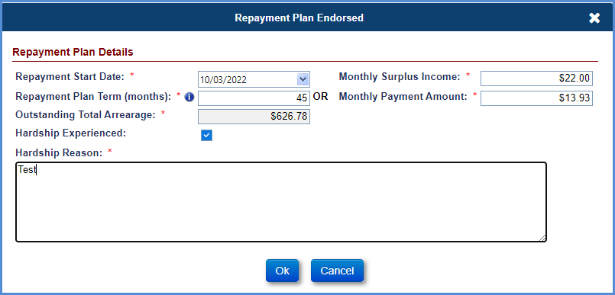
Figure 6-173: New Repayment Plan Window
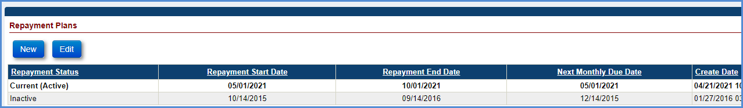
Figure 6-174: New Repayment Plan Displayed on Repayment Plans Section

Viewing a Repayment Plan Details and Scheduled Repayments
To view a repayment plan:
- Select the record to display the Repayment Plan Details, Audit Information and Repayment Plan Steps sections. The Repayment Plan Details section displays the following details of the payment plan selected in Pay Plans section:
  - Repayment Start Date: The date, repayment plan was initiated.
  - Repayment End Date: Auto calculated date based on Repayment Plan Term (months) field.
  - Monthly Surplus Income: Is determined by subtracting the mortgagor’s necessary living expenses – including healthcare, revolving and installment debt, any payment obligations, utility bills, and other household-related expenses - and a monthly amount needed for property charges due over the next twelve months from available sources of income as stated by the mortgagor.
  - Repayment Plan Term (months): The number of payments remaining to be paid by the Mortgagor(s). The number of payments cannot exceed 60 months. Auto calculated at Repayment plan creation if Monthly Payment Amount is entered
  - Repayment Status: Repayment Status can be Active, Inactive or Completed.
  - Hardship Experienced: Is determined if the mortgagor experiences a decrease in their available amount of surplus income due to a verified hardship (e.g., illness, death of a household member who was identified as a contributor of income in a previous Repayment Plan calculation, emergency home repair, loss of employment income, etc.) and seeks to have a Repayment Plan adjustment, mortgagees must solicit new financial information from the mortgagor to conduct a new Repayment Plan assessment.
  - Hardship Reason: The field Hardship Reason is mandatory if the user selects the Hardship Experienced checkbox.
  - Outstanding Total Arrearage: Amount will populate from “Property Chrg Default Balance” from Loan Balance/Other Balances area
  - Current Balance: Outstanding Total Arrearage - Total Payment Received
  - Monthly Payment Amount: Is the amount determined by the servicer to be paid towards the repayment plan each month. Amount is auto calculated at Repayment plan creation if Repayment Plan Term (months) is entered
  - # of Remaining Payments: The number of payments remaining to be paid by the Mortgagor(s). It will default to Repayment Plan Term (months) when plan is created. It will be auto calculated based on # of payments received after creating repayment plan.
  - Next Monthly Due Date: The date next monthly payment is due. Auto calculate to same days each month from the Repayment Start Date and will be updated every month based on # of payments receive after creating Repayment Plan
  - Total Payment Received: Summary of all Repayment transactions (2717 - Part Repay – Prop Chrg/T&I Repayment; 2797 - Part Repay - Prop Chrg/T&I Repayment Adj) entered in the system. It will be auto calculated based on # of payments received/adjust after creating repayment plan.
- System will auto generate Scheduled Repayment records under Repayment Plan Details. Number of Scheduled Repayments will match Repayment Term (months).
- Repayment Plan Installment Due steps are completed automatically based on Repayment transactions (2717 - Part Repay – Prop Chrg/T&I Repayment) entered in the system.
- Complete Date for Repayment Plan Installment Due steps will be removed automatically based on Repayment transactions (2797 - Part Repay - Prop Chrg/T&I Repayment Adj) entered in the system.

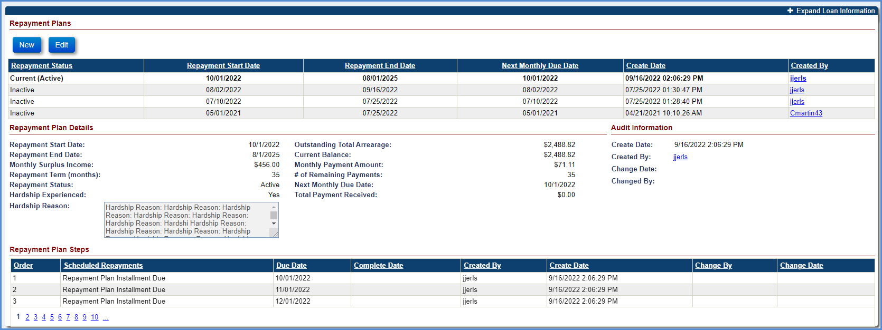
Figure 6-175: View Repayment Plan Screen

Editing a Repayment Plan
To edit a repayment plan:
- Click EDIT in the Repayment Plan section.
- On the Repayment Plan window, edit the fields as needed.
- Click OK. The changes will be displayed on the Repayment Plan Detail section screen.
Note:
  - Authorized users will be able to Inactivate Repayment Plan at any time if needed. If Repayment transactions were entered against the outstanding balance and plan was inactivated, new Repayment Plan will show new outstanding balance
  - Authorized users will create a new Repayment Plan if # of Repayment Term (months) or Monthly Payment Amount need to be updated
  - If new disbursements are added to the loan after Repayment Plan has started, user must create a new Repayment Plan. New Repayment Plan will use the new outstanding balance including new disbursements
  - Repayment Plan will be completed automatically when # of Remaining Payments go down to 0
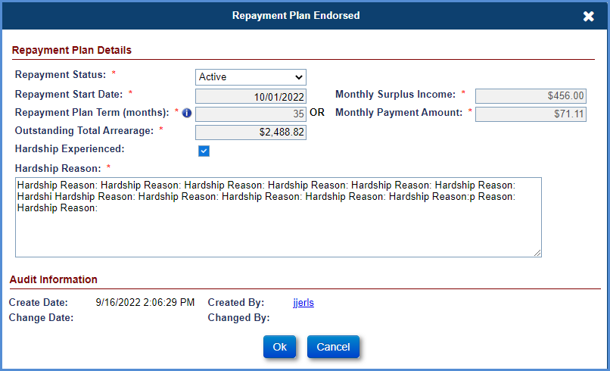
Figure 6-176: Edit Repayment Plan Window

CHAPTER 7: TIMELINES

TIMELINES
This chapter discusses the process to initiate, submit and review the timelines in the Servicing Module:
- Timelines Overview
- Endorsed Timelines (Servicers Only)
- Endorsed Timelines (Servicers and HUD NSC Interaction)
- Assigned Timelines

Timelines Overview
Timelines are predefined steps grouped to notify HUD and track certain business events on a loan. Permissions are built into the Servicing Module allowing authorized users to initiate a timeline and complete the steps within the timeline at a loan level. Timeline step completion dates are used by HUD to determine when specific business events occurred on a loan.

Navigating Timelines
Each Timeline, also referred to as Servicing Type, is available based on the Timeline Group and Timeline Category.
Timeline Group is the first tier of navigating to a timeline.
Timeline Category is the second tier of navigating to a timeline and lists which category the timeline is in.
Servicing Type is the third tier of navigating to a loan’s timeline. Also referred to as Timeline Name or Timeline Description.

Timeline Group
Timeline Group is the first tier of navigating to a timeline. This describes if a timeline is located under the “Assigned” or “Endorsed” on the left menu. The timeline group is different from Case Status, but generally timeline group Endorsed pertains to Endorsed and Pre-Endorsed loans, and group Assigned pertains to loans Assigned or in the process of HUD Assignment.

Timeline Categories
Timeline Category is the second tier of navigating to a timeline. After identifying Timeline Group Assigned or Endorsed the user identifies which timeline category to navigate to. Each specific Servicing Type that conforms to a business event are grouped by timeline category. Each timeline category has two standard sub-menu options:
- Setup: Allows authorized users to initiate a timeline within the timeline category.
- Search: Allows authorized users to search timelines that have already been initiated within the timeline category.

The timeline categories in the system are:
Timeline Category | Description
Compliance | Includes timelines to track a borrower’s compliance towards the HECM Case (For example: Annual Occupancy Certification, Hazard Insurance, etc.).
Disposition | Includes timelines to notify HUD if a borrower defaults on a loan (Loan is Due and Payable), and to track the loss mitigation options (For example: Short Sale, Deed-In-Lieu, etc.).
Requests | Includes specific requests that need HUD approval (For example: Zero Balance Letter, Certificate of Indebtedness, etc.).
Foreclosure | Includes foreclosure timelines to follow up on a foreclosure event.
Bankruptcy | Includes bankruptcy timelines to follow up on a bankruptcy event.
Release | Includes release timelines after disposition of the property (For example: Release 1st, Release 2nd).
Claims | Includes claims timelines that need HUD approval (For example: Claim Type 21 (DIL/FCL).
Table 7-1: Timeline Categories

Servicing Types / Timeline name
Servicing Types are listed along with their corresponding Timeline Group and Timeline Category:
Timeline Group | Timeline Category | Servicing Type / Timeline Name
Endorsed | Compliance | Insurance - Flood Policy
Endorsed | Compliance | Insurance - Forced Place
Endorsed | Compliance | Insurance - Hazard Policy
Endorsed | Compliance | Occupancy Compliance Certification
Endorsed | Compliance | Repairs
Endorsed | Compliance | Taxes Delinquent
Endorsed | Disposition | Due & Payable w/o HUD Approval
Endorsed | Disposition | Cash for Keys
Endorsed | Disposition | Loss Mitigation - Deed-in-Lieu
Endorsed | Disposition | Loss Mitigation - Family Sale Pending
Endorsed | Disposition | Loss Mitigation - Pre-Foreclosure
Endorsed | Disposition | Loss Mitigation - Short Sale
Endorsed | Requests | Certificate of Indebtedness (COI)
Endorsed | Requests | Consent of Lienholder
Endorsed | Requests | Due & Payable w/ HUD Approval
Endorsed | Requests | Extension - Appraisal
Endorsed | Requests | Extension - At-Risk
Endorsed | Requests | Extension - Claims Deadlines
Endorsed | Requests | Extension - COVID-19 Request to Delay Claims Submission
Endorsed | Requests | Extension - COVID-19 Request to Delay Due & Payable
Endorsed | Requests | Extension - COVID-19 Request to Delay Foreclosure
Endorsed | Requests | Extension - Deed-in-Lieu
Endorsed | Requests | Extension - Delay Due & Payable
Endorsed | Requests | Extension - Hardest Hit Fund (HHF)
Endorsed | Requests | Extension - Late Notification of Death
Endorsed | Requests | Extension - Other
Endorsed | Requests | Extension - Property Charge Loss Mitigation
Endorsed | Requests | Extension - Repairs
Endorsed | Requests | Extension - Request to Delay Foreclosure
Endorsed | Requests | Investor Short Sale
Endorsed | Requests | Partial Release
Endorsed | Requests | Payoff Request
Endorsed | Requests | Preservation and Protection
Endorsed | Requests | Request for HUD Advance (Assignment)
Endorsed | Requests | Subordination
Endorsed | Requests | Substitution of Collateral
Endorsed | Requests | Zero Balance
Endorsed | Foreclosure | Foreclosure
Endorsed | Bankruptcy | Bankruptcy - Chapter 13
Endorsed | Bankruptcy | Bankruptcy - Chapter 7
Endorsed | Release | Release 2nd
Endorsed | Claims | Claim Type 21 - DIL/FCL
Endorsed | Claims | Claim Type 22 - Assignment
Endorsed | Claims | Claim Type 23 - Short Sale/ Mortgagor's Sale (Pre-Fcl)
Endorsed | Claims | Claim Type 24 - HECM Supplemental
Assigned | Compliance | Insurance - Flood Policy
Assigned | Compliance | Insurance - Forced Place
Assigned | Compliance | Insurance - Hazard Policy
Assigned | Compliance | Insurance/Hardest Hit Funds Administration
Assigned | Compliance | Insurance/Loss Draft Administration
Assigned | Compliance | Occupancy Compliance Certification
Assigned | Compliance | Request for Payment
Assigned | Compliance | Request for Unscheduled Advance
Assigned | Compliance | Taxes Delinquent
Assigned | Disposition | Asset Sale
Assigned | Disposition | Due & Payable
Assigned | Disposition | Loss Mitigation - Deed-in-Lieu
Assigned | Disposition | Loss Mitigation - Family Sale Pending
Assigned | Disposition | Loss Mitigation - Pre-Foreclosure
Assigned | Disposition | Loss Mitigation - Short Sale
Assigned | Disposition | Write-Off Review
Assigned | Requests | Certificate of Indebtedness (COI)
Assigned | Requests | Extension - At-Risk
Assigned | Requests | Extension - COVID-19 Request to Delay Due & Payable
Assigned | Requests | Extension - COVID-19 Request to Delay Foreclosure
Assigned | Requests | Extension - Property Charge Loss Mitigation
Assigned | Requests | Extension - Request to Delay Foreclosure
Assigned | Requests | Partial Release
Assigned | Requests | Payoff Request
Assigned | Requests | Substitution of Collateral
Assigned | Requests | Zero Balance
Assigned | Foreclosure | Foreclosure
Assigned | Bankruptcy | Bankruptcy - Chapter 13
Assigned | Bankruptcy | Bankruptcy - Chapter 7
Assigned | Release | Release 1st
Assigned | Release | Release 2nd
Assigned | Claims | Assignment Repurchase
Assigned | Claims | Title Approval
Assigned | REO | REO
Table 7-2: Timelines by Group and Category
In this chapter, the timeline categories have been separated into whether they fall under Endorsed or Assigned groups.

Setup Criteria to Initiate Timelines
The setup screen for each of the timeline categories has common search criteria as listed below.
Field | Description
Loan Skey | Servicing Module system identification number unique to each loan.
Lender Loan # | Recorded identification number for each loan property (Enter a partial loan number if the complete address is not known).
FHA Case # | FHA case number of the loan (Enter a partial FHA case number if the complete FHA case # is not known).
Case Status | FHA case status (example: Endorsed).
Case Sub-Status | Sub status of the case (example: Loan Active).
Borrower LName | Last name of the borrower.
Property Address | Address of the loan property (Enter a partial address if the complete address is not known).
Property State | State where the loan property is located.
Property Zip | Zip Code where the loan property is located.
Property County | County where the loan property is located.
Lender Name | Lender of the HECM loan.
Servicer Name | Servicer of the HECM loan.
Investor Name | Investor of the HECM loan.
Index Type | Organization and type of interest rate based on the interest rates at which banks borrow unsecured funds from other.
Table 7-3: Search Criteria on the Setup Screen
- To setup / initiate a new timeline, the user identifies and navigates to the appropriate Timeline Group, then selects the Timeline Category and clicks on Setup. In the example below, the user is selecting Timeline Group: Endorsed, Timeline Category: Requests, then clicks on Setup:
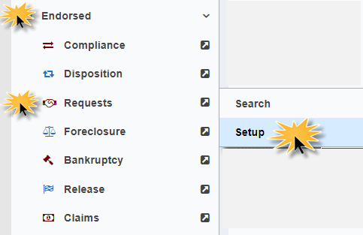
Figure 7-1: Getting to Timeline Setup Page

- Next the user searches for a loan by entering enter loan skey, FHA Case #, or other information, then click the SEARCH button.
Example of the Timeline Setup page:
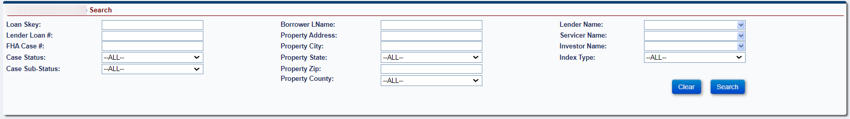
Figure 7-2: Timeline Setup Search Page

- Click on a record from the search results. In this example, the search criteria for Case Status Endorsed and Case Sub-Status DIL were populated
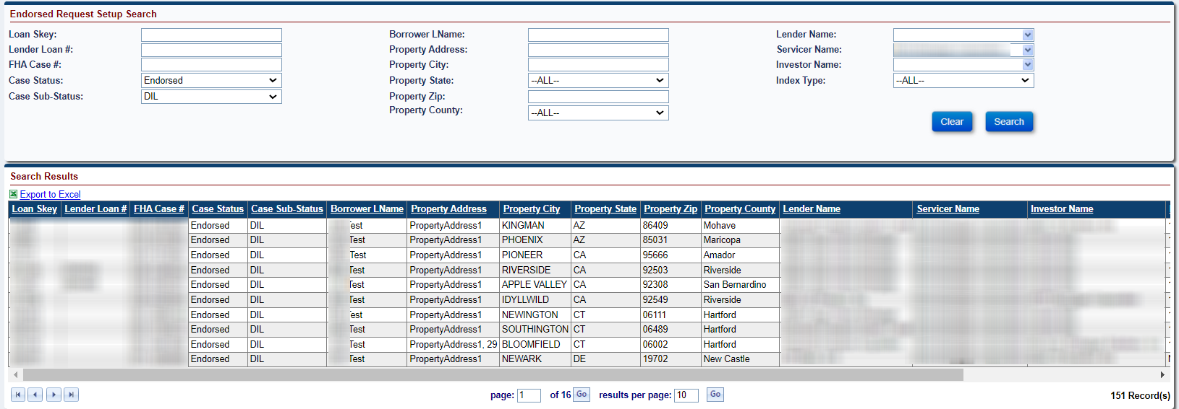
Figure 7-3: Timeline Setup Search Results
- Click on a record in the search results to enter required information and initiate / setup the timeline.
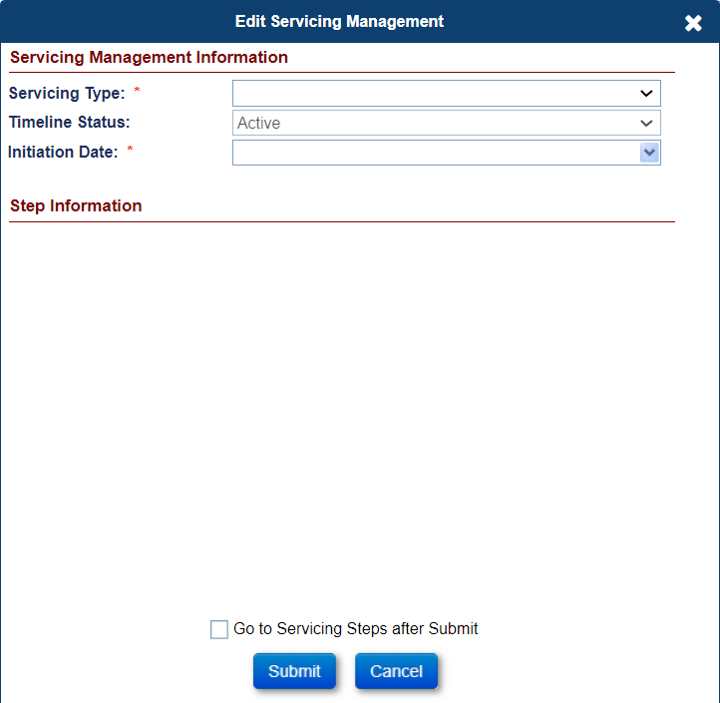
Figure 7-4: Timeline Setup Popup Modal
- Populate required fields for the selected Timeline / Servicing Type. Refer to specific Timeline section below for additional details for each Timeline.
- Select Go to Servicing Steps after Submit checkbox (at the bottom of the Edit Servicing Management screen) to go directly to timeline steps after initiating the timeline.
- Click Submit. If you click Cancel, the Setup Search screen will be displayed.
After a new timeline is set up, the Case Sub Status on the loan may be updated based on rules associated with each timeline type. If the timeline is inactivated, the Case Sub Status will be updated according to the same rules on the timeline type.

Search Criteria for Timelines that have been Initiated
The search criteria vary slightly for each timeline. Search criteria can be divided into two sections:
- Loan information search criteria contain standard search criteria for a loan.
- Servicing management search criteria provides extra timeline-related criteria that will help narrow the search appropriate to timelines.
The below table provides the list of search criteria fields on the timeline search screen. This screen is used to view or edit the timelines that were previously initiated using the setup screen.

All Loan Information Search Criteria
Field | Description
Loan Skey | Servicing Module system identification number unique to each loan.
Lender Loan # | Recorded identification number for each loan property (Enter a partial loan number if the complete address is not known).
FHA Case # | FHA case number of the loan (Enter a partial FHA case number if the complete FHA case # is not known).
Case Status | FHA case status (example: Endorsed).
Case Sub-Status | Sub status of the case (example: Loan Active).
Borrower LName | Last name of the borrower.
Property Address | Address of the loan property (Enter a partial address if the complete address is not known).
Property City | City where the loan property is located.
Property State | State where the loan property is located.
Property Zip | Zip Code where the loan property is located.
Property County | County where the loan property is located.
Lender Name | Lender of the HECM loan.
Servicer Name | Servicer of the HECM loan.
Responsible | User name for the responsible party tied to the timeline.
Investor Name | Investor of the HECM loan.
Master Servicer | Master Servicer of the HECM loan.
Table 7-4: All Loan Information Criteria

Servicing Management Search Criteria
Field | Description
Servicing Type | Type of the servicing activity associated with a loan, also known as the timeline.
Timeline Status | Indicator of whether the corresponding servicing activity on a loan is Active, Active Pending, Active Completed or Inactive.
TL Mgmt Skey | Unique identifier which is assigned when the timeline is initiated.
Servicing Status | Next pending step of the active timeline.
Current Step Group | The current step group associated with a step.
Step | Servicing activity step associated with the servicing activity timeline.
Step Status | Indicator of whether the servicing timeline step is completed or is still pending completion by the user.
Scheduled Date | The date that a servicing activity step is scheduled to be completed by the user.
Completion Date | The date that a servicing activity step is actually completed by the user.
Step Group | The group associated with a step, for example, servicer, HUD contractor.
Attorney | Conditional field: For the Foreclosure timeline this is an additional search criteria which allows the user to search for the attorney of the foreclosure.
Case # | Conditional field: For the foreclosure and bankruptcy timelines these are additional search criteria which allows the user to search for the case #.
Claim Status | Conditional field: For claim timelines, the Status of the claim.
Table 7-5: All Servicing Management Criteria
To search for an existing timeline, the user identifies the Timeline Group and Timeline Category, clicks Search. Entering Servicing Type or loan skey is optional if you wish to filter by a certain timeline or for a certain loan. After necessary criteria is entered, click the SEARCH button.
Example of the Endorsed Timeline Group and Request Category
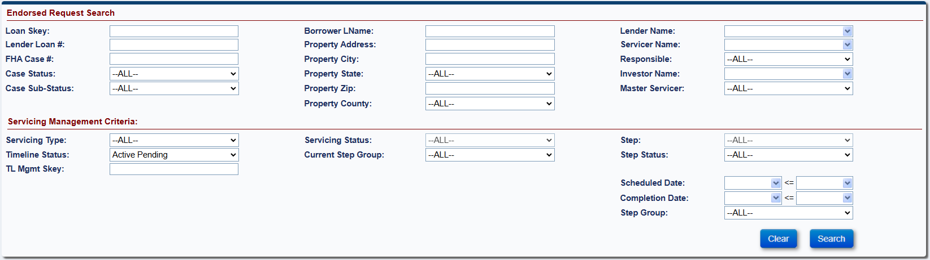
Figure 7-5: Timeline Search Page
After the Search has been executed, a list of results matching the search criteria is displayed. From these results, a specific timeline can be clicked on to view the Timeline Steps. Once a timeline has been identified and selected, the timeline’s Steps page appears. On the timeline’s Steps page, the system displays standard Template steps needed to complete the business event. Along with the standard steps, optional steps can be added to the timeline. For certain timelines, the system automatically adds steps within the timelines when the trigger conditions for a previous steps are satisfied or a condition is met within the system. The trigger steps do not appear in the optional steps or the standard steps that appear when the timeline is created.
The system allows authorized users with permission to inactivate a step within the timeline. Only steps with pending status (completion date is not populated) can be made inactive using the Edit Step window.
A user can initiate one or more timelines for an activity based on the business rules to complete that activity. The Servicing Module has a set of rules for each timeline which must be met for the timeline to be initiated. If user attempts to initiate a timeline and the business rules are not met, the Servicing Module generates a validation message preventing the timeline from being created. For example, if the user attempts to create multiple timelines for the same activity on a loan when it is not allowed by the system, the validation message will indicate multiple timelines are not allowed.
Explanation of Timeline Status on Search screen:
- All Active - Timeline Status is Active
- Active Pending - Timeline Status is Active AND has Active Steps that do not have a Complete Date
- Active Completed - Timeline Status is Active AND all Active Steps have a Complete Date
- Inactive - Timeline Status is Inactive (Steps are automatically inactivated)

Standard Timeline Fields
All timelines within the Servicing Module have the standard fields listed below. The fields can be viewed from the timeline’s Steps screen:
Field | Description
Step Description | Each step within a timeline includes a brief description of the action or activity that needs to be performed for that step.
Scheduled Date | Each timeline step has a scheduled date, this schedule date alerts the user regarding the time available to complete the step.
Completion Date | This date is populated by the user/system when the activity corresponding to the step is completed.
Step Group | Steps within the timeline identify the user group that must complete the activity associated with the step. The step can be completed only by users who are members of the relevant step group. The step groups within the Servicing Module are Servicer, HUD Contractor and HUD. Only one step group is associated with each step.
Step Note | Populated if user types and saves a note saved in the Step Note field when editing the step.
Status | Shows if the timeline step is Active or Inactive
Create Date | Create Date of the Timeline
Created By | User ID who created the Timeline
Change Date | Change Date of the step, for example when the step is completed
Changed By | User ID of who changed the Timeline, for example when the step is completed
Step Completed By Date | Date the Step is Completed by the user
Step Completed By | User ID of who Completed the Step
Step Inactive Date | Date the Step is Inactivated
Step Inactivated By | User ID of who Inactivated the Step
Timeline Inactive Date | Date the Timeline was Inactivated
Timeline Inactivated By | User ID of who Inactivated the Timeline
Table 7-6: Standard Timeline Fields

Additional Timeline Fields
The table below provides the list of additional fields for the timelines which can be viewed from the timeline’s Steps screen, if applicable, based on Servicing Type:
Field | Description
Responsible Party | When the timeline is initiated, for HUD user groups, the system allows the assignment of a responsible party to manage the timeline. The responsible party is a HUD staff member that will follow up on the timeline and will ensure that the activities within the timeline are completed in a timely manner. The search screen for each timeline category has the responsible party as a query field to search and generate the timeline results.
Documents Upload | Some timelines have steps that require the step group to upload documentation supporting the completion of the activity. These steps cannot be completed without uploading the required documents. Once the documents are uploaded, the system will auto-save the documents on the documents tab. It will also provide a PDF icon beside the step to view the attached documents. Only documents in a PDF file format can be attached.
Letters/Forms | Some timeline steps have activities that require the generation of letters from the system. Similarly, certain steps have forms associated with the activity that require completion of the form. Such steps with letters/forms are distinguished in the system with a magnifying glass icon displayed beside the step. Only the step group associated with the step can view the magnifying glass icon. The system allows the member of the step group to edit the letter/form (if required) and print the document. Printing the document also auto-saves the document to the documents tab.  Note: No letters will be generated from the Servicing Module where the step group on the step in the timeline is Servicer. Servicers Letters will be generated from their own system.
Table 7-7: Additional Timeline Fields
The Servicing Module allows authorized users to Bulk Print letters associated with the following compliance timelines for Assigned loans. Refer to Chapter 9 for more details:
- Claim Tye 20 – Demand Assignment (Endorsed)
- Claim Tye 22 – Assignment (Endorsed)
- Insurance Flood Policy
- Insurance Hazard Policy
- Occupancy Compliance Certification
- Taxes Delinquent

Timeline Side / Left Menu Options
All timelines have left menu options Steps and Servicing Mgmt. Steps displays all timeline steps on that timeline and Servicing Mgmt displays additional information and varies based on which timeline is being viewed.
In addition to the above features for timelines, the Servicing Module provides additional menu options for each timeline (visible per the permissions enabled for the user’s role). Most of these menu options (with the exception of the Servicing Management screen) are available as part of the loan menu options and are covered in detail in Chapter 5.

Servicing Management Screen
The Servicing Management screen displays data fields captured when the timeline is initiated. These fields can be edited on the Servicing Management tab after the timeline has been initiated. For authorized user roles, this screen provides options to:
- Update timeline status (selectable options of active or inactive)
- Update the responsible party
- Various timelines have a selection of other fields that can be updated
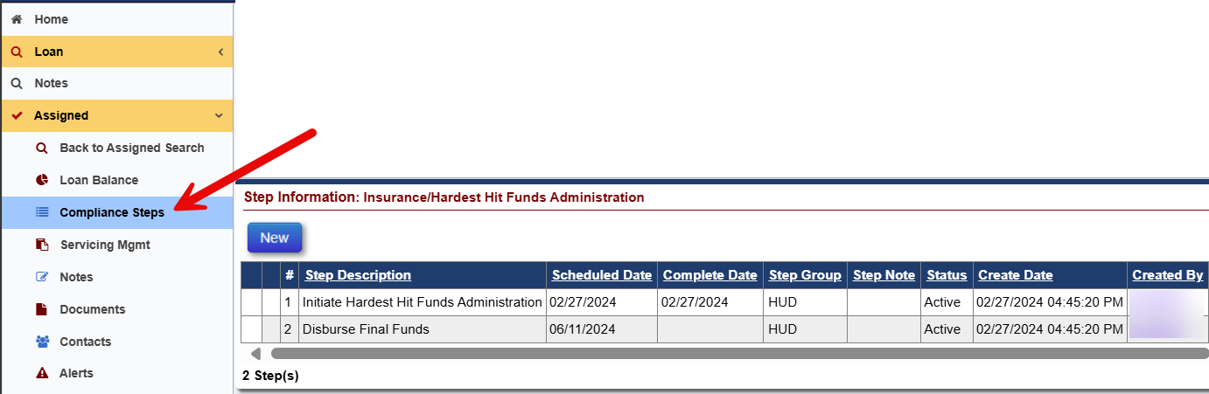
Figure 7-6: Servicing Management Tab
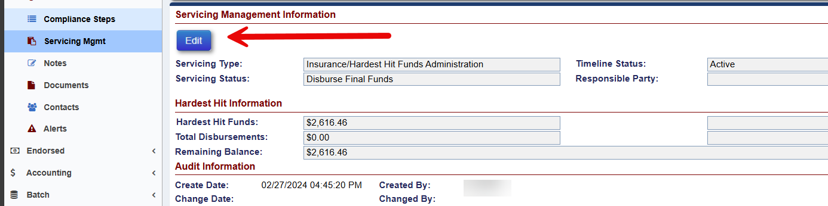
Figure 7-7: Servicing Management Screen

Steps
See specific timelines below for information displayed under Steps.

To Complete Timeline Steps
Complete the steps in the timeline when the activity corresponding to the step is complete. There are various types of timeline steps as indicated by icons in the left two columns of Step Information from within a timeline:
- Standard timeline steps: no icons displayed in either left two columns. Click on the step and enter Complete Date then click Submit
- Magnifying glass: use to Fill Out required form or to Preview Letter before printing
- Printer: use to Print Letter and complete step
- Upload Attachment: use to Attach a PDF document. Upload steps cannot be completed without attaching the required document. Once the document is attached, a user will click Submit for the document to be attached and step completed. The document is auto saved to the Documents tab.
- Download / view Attachment: use to view an Attached PDF document for a step with a Document attached. The document is also viewable from the Documents table.
- To complete a step in the timeline, click the step (For example: D&P Notice Sent to Borrower).
- Populate the completion date, add a note in the Step Note field if applicable, and click Submit on the Edit Step window.
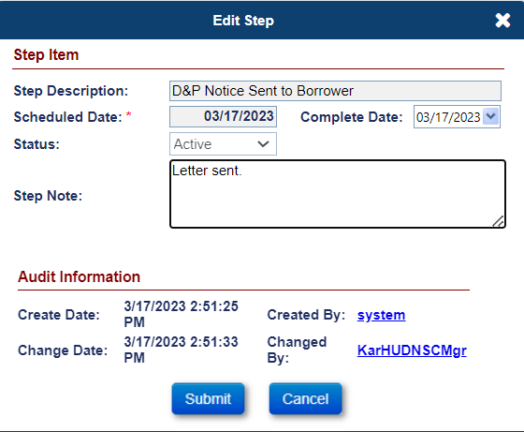
Figure 7-8: Edit Step – Endorsed Due and Payable with HUD Approval
- The completion date is populated in the field Complete Date on the Steps screen.

To Add Optional Timeline Steps
Add and Complete Optional steps in the timeline when the activity corresponding to the step is applicable to the timeline.
- To add an optional step, click New from the timeline steps page.
- Select an optional step from the Step Description dropdown that needs to be added on the timeline and click Submit on the new window. The step will be added to the list of steps.
- To complete the step, refer to the types of timeline steps, for standard timeline steps with no icons, click the step and populate the completion date, add a note in the Step Note field if applicable, and click Submit on the Edit Step window.
- Repeat the above instructions to add and complete other optional steps.

In the remaining sections of this chapter, the timeline categories have been separated into Timeline Groups Endorsed and Assigned.

Endorsed Timelines

Compliance Timelines
The following timelines are available under Endorsed > Compliance:
- Insurance – Flood Policy
- Insurance – Forced Place
- Insurance – Hazard Policy
- Occupancy Compliance Certification
- Repairs
- Taxes Delinquent

Insurance – Flood Policy
This timeline is located under Endorsed > Compliance, Servicing Type “Insurance – Flood Policy” and is initiated by a servicer when an Insurance – Flood Policy is required to comply with flood insurance requirements. If a mortgaged property is located in a flood zone, the mortgagor is required to provide proof of flood insurance. If evidence of required flood insurance is not provided to the mortgagee, the loan could be considered in default. Upon initiation of this timeline, the case sub-status does not change.
Multiple active Insurance Flood Policy timelines cannot be initiated on a loan. The Servicing Management tab can be used to inactivate the timeline. Once the timeline is inactivated, none of the steps can be edited and the timeline cannot be reactivated.
TIP: Refer to section 7.1.2 “Setup Criteria to Initiate Timelines” for general steps to initiate timelines, and section 7.1.7 “To Complete Timeline Steps” for general information how to complete steps within a timeline.
The Servicer attaches all required documentation and completes the necessary steps on the timeline. The following Template Steps are displayed when the timeline is initiated:
- Policy Effective
- Insurance Declaration Received
- Policy Expires
The following Optional Steps are available on this timeline. Refer to section 7.1.8 “To Add Optional Timeline Steps” for general information how to add and complete optional steps within a timeline:
- Generate Mortgagee Clause
- Received Notification of Policy Cancellation
- Return Receipt Received from Borrower
- Received Notification of Policy Reinstatement
- Renewal Insurance Declaration Received
- Follow Up
The following Trigger and Automated Steps are available on this timeline:
- Mail Certified Letter to Borrower - Policy Cancellation
- Mail Renewal Verification Letter
- Send 2nd Request for Policy Verification
- Mail Certified Letter to Borrower – Policy Expiration
- Review for Due & Payable
- Renewal Insurance Declaration Effective

The following additional Servicing Mgmt fields are available for this timeline:
- Policy #
- Premium
- Effective Start Date
- Effective End Date
- Policy Holder
- Company Name
- Agent Name
- Tax ID
- Address 1
- Address 2
- City
- State, Zip
- Email
- Website URL
- Phone #
- Fax #

Insurance – Forced Place
This timeline is located under Endorsed > Compliance, Servicing Type “Insurance – Forced Place” and is initiated by a servicer to verify actions required to comply with force placed insurance requirements. If a mortgagor fails to maintain and provide evidence of force placed insurance coverage on his or her property, the mortgagee could acquire force placed insurance on their behalf. Upon initiation of this timeline, the case sub-status does not change.
Multiple active Insurance - Force Placed timelines cannot be initiated on a loan. The Servicing Management tab can be used to inactivate the timeline. Once the timeline is inactivated, none of the steps can be edited.
TIP: Refer to section 7.1.2 “Setup Criteria to Initiate Timelines” for general steps to initiate timelines, and section 7.1.7 “To Complete Timeline Steps” for general information how to complete steps within a timeline.
The Servicer attaches all required documentation and completes the necessary steps on the timeline. The following Template Steps are displayed when the timeline is initiated. The steps are servicer steps unless otherwise stated
- Policy Effective
- Insurance Declaration Received
- Mail Renewal Verification Letter
- Policy Expires
- Mail Certified Letter to Borrower
- Return Receipt Received from Borrower
The following Optional Steps are available on this timeline. Refer to section 7.1.8 “To Add Optional Timeline Steps” for general information how to add and complete optional steps within a timeline. The steps are HUD Contractor steps unless otherwise stated
- Received Notification of Policy Cancellation
- Policy Cancellation
The following Trigger and Automated steps are available on this timeline:
- Send 2nd Request for Policy Verification
- Notify Loan Counselor
The following additional Servicing Mgmt fields are available for this timeline:
- Policy #
- Premium
- Policy Holder
- Company Name
- Agent Name
- Tax ID
- Address 1
- Address 2
- City
- State, Zip
- Email
- Website URL
- Phone #
- Fax #

Insurance – Hazard Policy
This timeline is located under Endorsed > Compliance, Servicing Type “Insurance – Hazard Policy” and is initiated by a servicer when an Insurance – Hazard Policy is required to comply with hazard insurance requirements. Hazard insurance ensures the property in the event there is physical damage to the improvements on the property. Upon initiation of this timeline, the case sub-status does not change.
Multiple active Insurance Hazard Policy timelines cannot be initiated on a loan by a user. The Servicing Management tab can be used to inactivate the timeline. Once the timeline is inactivated, none of the steps can be edited and the timeline cannot be reactivated.
TIP: Refer to section 7.1.2 “Setup Criteria to Initiate Timelines” for general steps to initiate timelines, and section 7.1.7 “To Complete Timeline Steps” for general information how to complete steps within a timeline.
The Servicer attaches all required documentation and completes the necessary steps on the timeline. The following Template Steps are displayed when the timeline is initiated:
- Policy Effective
- Insurance Declaration Received
- Policy Expires
The following Optional Steps are available on this timeline. Refer to section 7.1.8 “To Add Optional Timeline Steps” for general information how to add and complete optional steps within a timeline:
- Generate Mortgagee Clause
- Received Notification of Policy Cancellation
- Return Receipt Received from Borrower
- Received Notification of Policy Reinstatement
- Renewal Insurance Declaration Received
- Follow Up

The following Trigger and Automated Steps are available on this timeline:
- Mail Certified Letter to Borrower - Policy Cancellation
- Mail Renewal Verification Letter
- Send 2nd Request for Policy Verification
- Mail Certified Letter to Borrower – Policy Expiration
- Review for Due & Payable
- Renewal Insurance Declaration Effective
The following additional Servicing Mgmt fields are available for this timeline:
- Policy #
- Premium
- Effective Start Date
- Effective End Date
- Policy Holder
- Company Name
- Agent Name
- Tax ID
- Address 1
- Address 2
- City
- State, Zip
- Email
- Website URL
- Phone #
- Fax #

Occupancy Compliance Certification
This timeline is located under Endorsed > Compliance, Servicing Type “Occupancy Compliance Certification” and is initiated by a servicer to track the HUD required occupancy inspection process. This timeline is automatically initiated when a loan is established. Upon initiation of this timeline, the case sub-status does not change.
Multiple active Occupancy Compliance timelines cannot be initiated on a loan. The Servicing Management tab can be used to inactivate the timeline. Once the timeline is inactivated, none of the steps can be edited.
TIP: Refer to section 7.1.2 “Setup Criteria to Initiate Timelines” for general steps to initiate timelines, and section 7.1.7 “To Complete Timeline Steps” for general information how to complete steps within a timeline.
The Servicer attaches all required documentation and completes the necessary steps on the timeline. The following Template Steps are displayed when the timeline is initiated:
- Mail Annual Occupancy Certification Letter
- Signed Anniversary Date
- Annual Occupancy Cert Letter Received
- Re-start Annual Occupancy Certification
The following Optional Steps are available on this timeline. Refer to section 7.1.8 “To Add Optional Timeline Steps” for general information how to add and complete optional steps within a timeline:
- Telephone/Verbal Confirmation of Occupancy Made
- Transfer File to Disposition Module
- Annual Occupancy Cert Letter Returned for Non-Delivery
- Re-send Annual Occupancy Certification Letter
- Follow Up
- Order Supplemental Occupancy Inspection
The following Trigger and Automated Steps are displayed when the timeline is initiated:
- Mail Annual Occupancy 2nd Request Letter
- Order Property Inspection and SSI Search
- Received Property Inspection
- Supplemental Occupancy Inspection Received
The following additional Servicing Mgmt fields are available for this timeline:
- Inspector Company
- Inspection Date
- Contact Name
- Occupancy Results
- Inspection Results

Repairs
When a mortgagor needs to access Repair Set Aside funds, the Servicer will initiate this timeline to track the completion and payment of the repairs. This timeline can be initiated only if the loan has Repair Set Aside amount.
Multiple active Repairs timelines can be initiated on a loan to track multiple repairs. The Servicing Management tab can be used to inactivate the timeline. Once the timeline is inactivated, none of the steps can be edited.
To initiate and complete the Repair timeline:
- From the Endorsed menu, select Compliance and click Setup.
On the Endorsed Compliance Setup Search Screen, enter the loan search criteria and click Search.
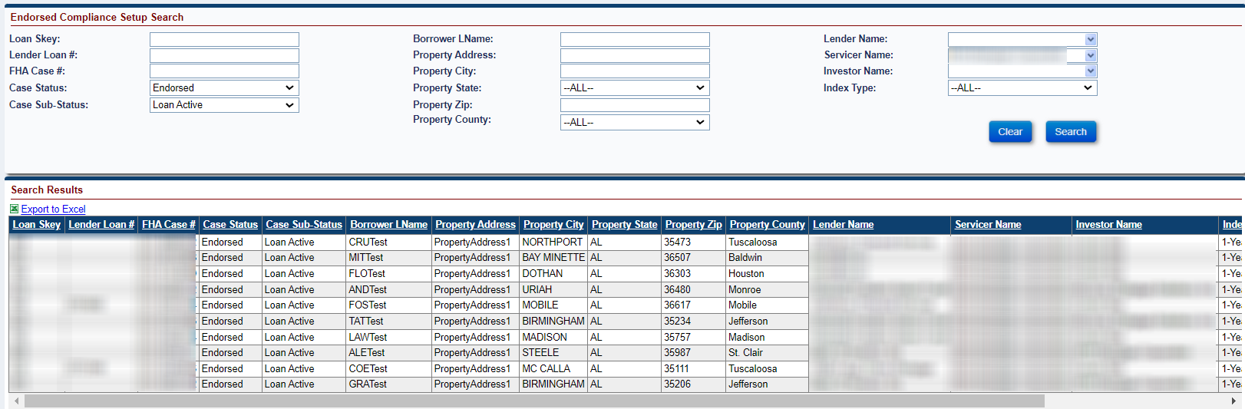
Figure 7-9: Endorsed - Compliance - Setup Search
From the search results, select a loan to initiate the timeline.
On the Edit Servicing Management screen, select Repair from the Servicing Type dropdown and populate the required fields (marked with an asterisk). The repair information can be edited on the Servicing Management tab after the initiation of timeline.
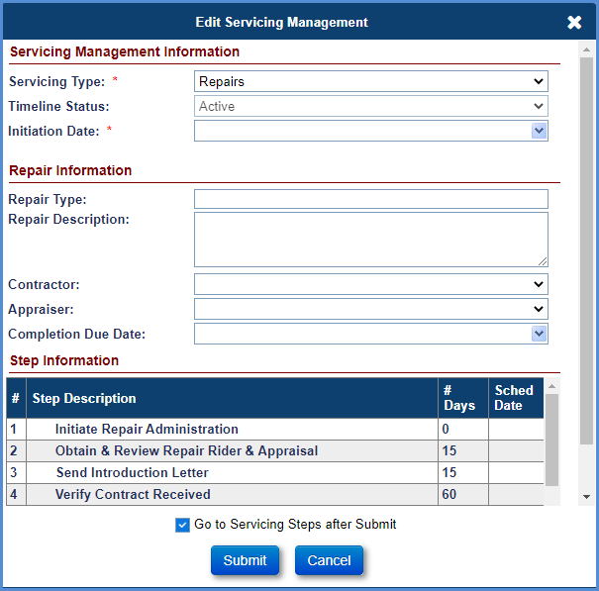
Figure 7-10: Endorsed - Compliance - Repairs - Edit Servicing Management
Click the Go to Servicing Steps after Submit checkbox (at the bottom of the Edit Servicing Management screen).
Click Submit. (If you click Cancel, the Endorsed Disposition Setup Search Screen will be displayed).
The Compliance Steps screen for the Repairs timeline is displayed.
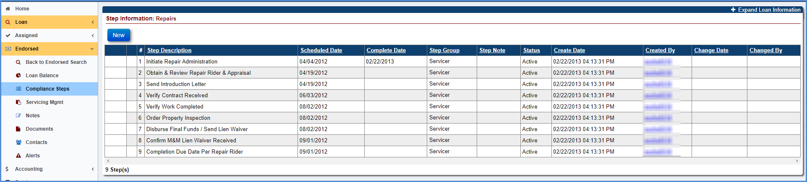
Figure 7-11: Endorsed - Compliance - Repairs - Timeline Steps
The step Initiate Repair Administration completion date is pre-populated with the timeline created date.
Initiation Date is populated at the time of timeline initiation.
Complete the remaining steps in the timeline when activity corresponding to the step is complete. To complete any step in the timeline, click the step (For example: Obtain & Review Repair Rider & Appraisal).
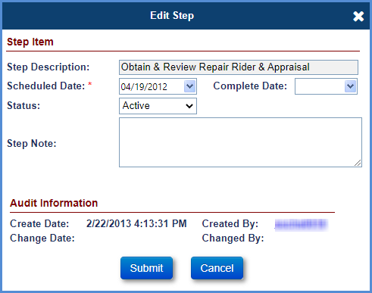
Figure 7-12: Endorsed - Compliance - Repairs - Edit Step
Populate the completion date, add a note in the Notes field if applicable, click Submit on the Edit Step window.
The completion date is populated beside the step Obtain & Review Repair Rider & Appraisal on the Compliance Steps screen.
To add an optional step, click New.
Select an optional step from the Step Description dropdown that needs to be added on the timeline and click Submit on the new window. The step will be added to the list of steps.
To complete the step, select the step and populate the completion date, add a note in the Notes field if applicable, and click Submit on the Edit Step window.
Repeat the above instructions to add and complete other optional steps.
To add multiple Repairs timelines, repeat the steps to initiate and complete the timeline as mentioned above for the second timeline.

Taxes Delinquent
When the mortgagor defaults on taxes, the servicer initiates this timeline to track the tax payment. The delinquent notification is sent to the mortgagor requesting the tax payment to avoid the loan being Due and Payable.
Multiple active Taxes Delinquent timelines can be initiated on a loan to track multiple delinquencies. The Servicing Management tab can be used to inactivate the timeline. Once the timeline is inactivated, none of the steps can be edited.
To initiate and complete the Taxes Delinquent timeline:
- From the Endorsed menu, select Compliance and click Setup.
On the Endorsed Compliance Setup Search screen, enter the loan search criteria and click Search.

Figure 7-13: Endorsed - Compliance - Setup Search
From the search results, select a loan to initiate the timeline.
The Edit Servicing Management screen is displayed.
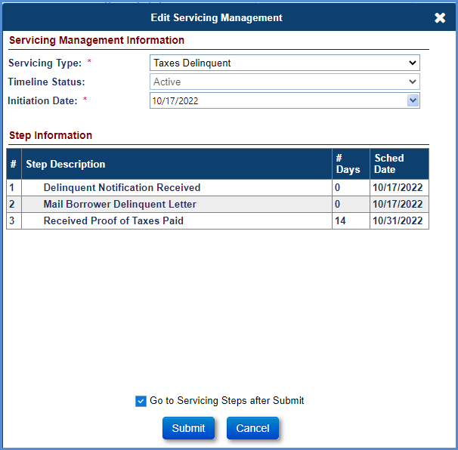
Figure 7-14: Endorsed - Compliance - Taxes Delinquent - Edit Servicing Management
Select Taxes Delinquent from the Servicing Type dropdown and populate the required fields (marked with an asterisk).
Click Go to Servicing Steps after Submit checkbox (at the bottom of the Edit Servicing Management screen).
Click Submit. (If you click Cancel, the Endorsed Compliance Setup Search Screen will be displayed).
The Compliance Steps screen for Taxes Delinquent timeline is displayed.
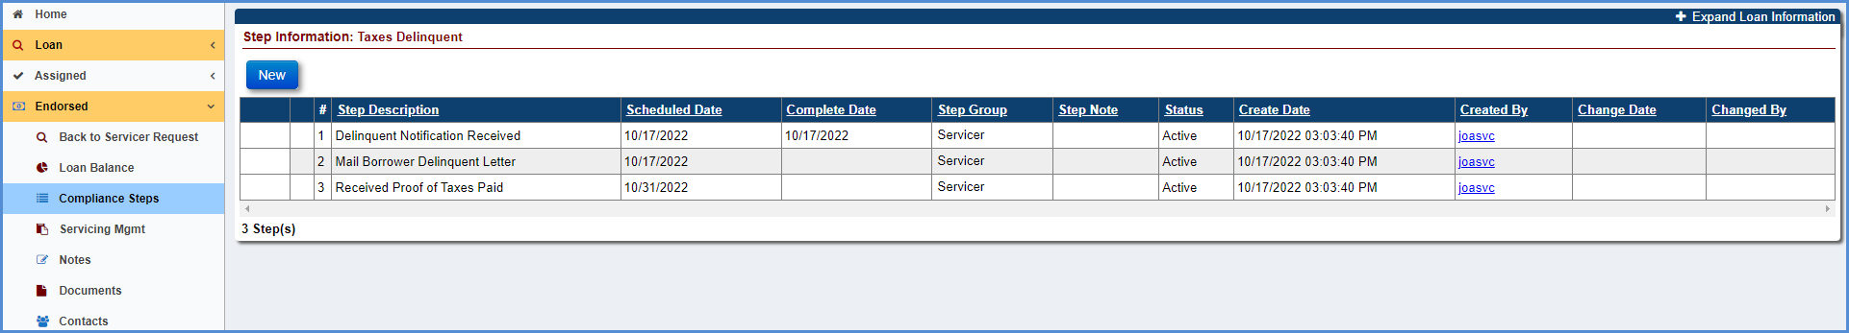
Figure 7-15: Endorsed - Compliance - Taxes Delinquent - Timeline Steps
The step Delinquent Notification Received completion date is pre-populated with the timeline created date.
Complete the remaining steps in the timeline when the corresponding is complete. To complete any step in the timeline, click the step, (For example: Mail Borrower Delinquent Letter).
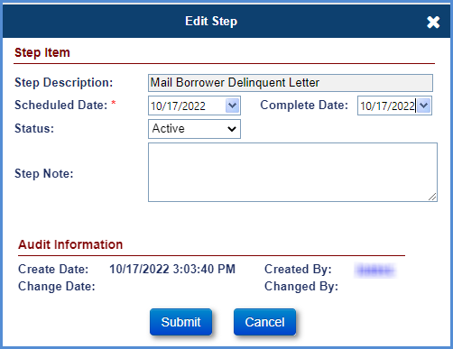
Figure 7-16: Endorsed - Compliance - Taxes Delinquent - Edit Step
Populate the completion date, add a note in the Notes field if applicable, click Submit on the Edit Step window.
The completion date is populated beside the step Mail Borrower Delinquent Letter on the Compliance Steps screen.
To trigger the step, Mail Letter of Taxes Paid, the following criteria must be satisfied: The optional step Authorization Received/Pay Taxes must be added on the timeline and completed.
Repeat the steps above to complete the other remaining steps.
To add an optional step. Click New.
Select an optional step from the Step Description dropdown that needs to be added on the timeline and click Submit on the new window. The step will be added to the list of steps.
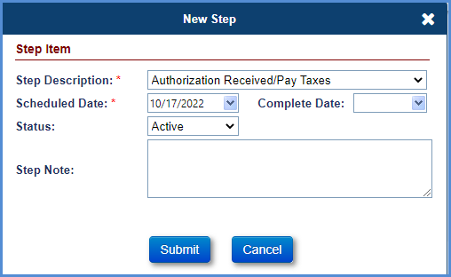
Figure 7-17: Endorsed - Compliance - Taxes Delinquent - New Step
To complete the step, select the step and populate the completion date, add a note in the Notes field if applicable, click Submit on the Edit Step window.
Repeat the above instructions to add and complete other optional steps.
To add multiple Taxes Delinquent timelines, repeat the steps to initiate and complete the timeline as mentioned above for the second timeline.

Disposition Timelines
The following timelines are available under Endorsed > Disposition:
- Due & Payable w/o HUD Approval
- Loss Mitigation – Cash for Keys
- Loss Mitigation – Deed-in-Lieu
- Loss Mitigation – Family Sale Pending
- Loss Mitigation – Pre-Foreclosure
- Loss Mitigation – Short Sale

Due and Payable w/o HUD Approval
This timeline is located under Endorsed > Disposition, Servicing Type “Due & Payable w/o HUD Approval” and is initiated by a servicer to notify HUD of the Due and Payable event. The servicer does not need HUD approval for the following default reasons: Conveyed Title, Death, or End of Deferral Period.
For default reason Death: when a servicer populates the death date of the last surviving mortgagor (That is the death date entered on the Contacts Screen), the system validates for the below and updates the Case Sub-Statuses appropriately:
- If one or more Non-Borrowing Spouse is/are active on the loan, the Case Sub-Status is automatically updated to Payment Suspended. System will not allow user to manually initiate a Due & Payable w/o HUD Approval timeline.
- If all available Non-Borrowing Spouses are deactivated, the Case Sub-Status is automatically updated to Due & Payable.
- If no Non-Borrowing Spouse is available on the loan, the Case Sub-Status is automatically updated to Due & Payable.
- If the Due & Payable w/o HUD approval timeline is created when deferred status on a loan is changed from “Yes” to “No” (No more eligible NBSs on the loan), a new triggered step NBS Deferral Period has Ended will be added to the Due & Payable w/o HUD approval timeline
For the default reasons Conveyed Title or End of Deferral Period: the servicer must manually initiate the Due & Payable w/o HUD Approval timeline. When this timeline is initiated, the Case Sub-Status is updated to Due and Payable. If the timeline is inactivated, the Case Sub-Status is updated accordingly.
Multiple active Due & Payable w/o HUD Approval timelines cannot be initiated on a loan. The Servicing management tab can be used to activate or inactivate the timeline and update the default date (only if default reason is Conveyed Title or End of Deferral Period). Once the timeline is inactivated, none of the steps can be edited.
TIP: Refer to section 7.1.2 “Setup Criteria to Initiate Timelines” for general steps to initiate timelines, and section 7.1.7 “To Complete Timeline Steps” for general information how to complete steps within a timeline.
The Servicer attaches all required documentation and completes the necessary steps on the timeline. The following Template Steps are displayed when the timeline is initiated:
- Default Event Occurred
- Ordered Appraisal
- Date of Notification of Default to HUD
- Notification sent to Borrower
- Servicer Notified of Death
The following Optional Steps are available on this timeline. Refer to section 7.1.8 “To Add Optional Timeline Steps” for general information how to add and complete optional steps within a timeline:
- Follow Up Phone Attempt
- Initiate DIL
- Initiate Short Sale
- Initiate Family Sale
- Initiate Pre-Foreclosure Process
- Follow Up
The following step is triggered if the Due & Payable w/o HUD approval timeline is created when deferred status on a loan is changed from “Yes” to “No” (No more eligible NBSs on the loan)
- NBS Deferral Period has Ended

Loss Mitigation – Cash for Keys
This timeline is located under Endorsed > Disposition, Servicing Type “Loss Mitigation – Cash for Keys” and is initiated by a servicer to notify HUD of a Cash for Keys incentive payable to the Borrower, Heir, or party vacating the property, to expedite a Deed in Lieu, a Short Sale, or as an alternative to legal eviction. Upon initiation of this timeline, the case sub-status does not change.
When initiating a Cash for Keys timeline, the system will determine the incentive based on the selected Reason for Request:
- Deed in Lieu
- Post Foreclosure Eviction Avoidance
- Short Sale
Multiple active Loss Mitigation - Cash for Keys timelines cannot be initiated on a loan. The Servicing Management tab can be used to inactive the timeline. Once the timeline is inactivated, none of the steps can be edited.
TIP: Refer to section 7.1.2 “Setup Criteria to Initiate Timelines” for general steps to initiate timelines, and section 7.1.7 “To Complete Timeline Steps” for general information how to complete steps within a timeline.
The Servicer attaches all required documentation and completes the necessary steps on the timeline. The following Template Steps are displayed when the timeline is initiated:
- Loss Mitigation – Cash for Keys (Reason for Request: Deed in Lieu)
  - Cash for Keys Offer Letter Sent
  - Cash for Keys Offer Letter Received (Confirmation)
  - DIL was executed
  - DIL returned to the Mortgagee
  - DIL was filed for recording
  - Recorded DIL received
  - Verified Occupant has vacated/Inspected
  - Vacated Prop confirmed Broom Swept
  - Vacated Prop built in appliances and fixes
  - Occupant received funds
  - Upload Cash for Keys Package
- Loss Mitigation – Cash for Keys (Reason for Request: Post Foreclosure Eviction Avoidance)
  - Cash for Keys Offer Letter Sent
  - Cash for Keys Offer Letter Received (Confirmation)
  - Date and amount of the relocation offer
  - Verified Occupant has vacated/Inspected
  - Vacated Prop confirmed Broom Swept
  - Vacated Prop built in appliances and fixes
  - Occupant received funds
  - Upload Cash for Keys Package
- Loss Mitigation – Cash for Keys (Reason for Request: Short Sale)
  - Cash for Keys Offer Letter Sent
  - Cash for Keys Offer Letter Received (Confirmation)
  - Short sale closing date
  - Date and amount of the Cash for Keys offer
  - Occupant received funds
  - Upload Cash for Keys Package

Loss Mitigation – Deed-in-Lieu
This timeline is located under Endorsed > Disposition, Servicing Type “Loss Mitigation – Deed-in-Lieu” and is initiated by a servicer when a mortgagor or their estate is willing to surrender the property to the mortgagee and to be released of the mortgage obligations. Upon initiation of this timeline, the case sub-status is updated to DIL. If the timeline is inactivated, the case sub-status is updated accordingly.
Multiple active Loss Mitigation–Deed-in-Lieu timelines cannot be initiated on a loan. The Servicing Management tab can be used to inactivate the timeline. Once the timeline is inactivated, none of the steps can be edited.
TIP: Refer to section 7.1.2 “Setup Criteria to Initiate Timelines” for general steps to initiate timelines, and section 7.1.7 “To Complete Timeline Steps” for general information how to complete steps within a timeline.
The Servicer attaches all required documentation and completes the necessary steps on the timeline. The following Template Steps are displayed when the timeline is initiated:
- Initiate DIL
- Refer to Atty for DIL
- Review Title Report from Attorney
- Atty Instructed to have Deed Executed per Referral Instructn
- Order Occupancy Inspection
- Inspection Received
- Atty Instructed to Record Executed Deed (Copy Received)
- Copy of Recorded Deed Received
- Deed Recorded Date
- Date Borrower/Estate executed DIL Agreement
The following Optional Steps are available on this timeline. Refer to section 7.1.8 “To Add Optional Timeline Steps” for general information how to add and complete optional steps within a timeline:
- Borrower requested DIL (Not Due & Payable)
- DIL Approved
- DIL Denied
- Follow-up
The following Servicing Mgmt fields are available for this timeline during timeline initiation/ setup, in addition to Initiation Date:
- Foreclosure Attorney

Loss Mitigation – Family Sale Pending
This timeline is located under Endorsed > Disposition, Servicing Type “Loss Mitigation – Family Sale Pending” and is initiated by a servicer to track the status on a pending family sale effort. Upon initiation of this timeline, the case sub-status is updated to Family Sale Pending. If the timeline is inactivated, the case sub-status is updated accordingly.
Multiple active Loss Mitigation–Family Sale Pending timelines cannot be initiated on a loan. The Servicing Management tab can be used to inactivate the timeline. Once the timeline is inactivated, none of the steps can be edited.
TIP: Refer to section 7.1.2 “Setup Criteria to Initiate Timelines” for general steps to initiate timelines, and section 7.1.7 “To Complete Timeline Steps” for general information how to complete steps within a timeline.
The Servicer attaches all required documentation and completes the necessary steps on the timeline. The following Template Steps are displayed when the timeline is initiated:
- Initiate Family Sale Pending
- Received Listing Agreement
- Received Copy of Offer and Sales Contract
- Received Sales Proceeds
- Send Release Authorization to Release Dept.
The following Optional Steps are available on this timeline. Refer to section 7.1.8 “To Add Optional Timeline Steps” for general information how to add and complete optional steps within a timeline:
- Family Sale Approved
- Family Sale Denied
- Follow Up
To trigger the Automated step Follow up for Status of Sales Effort, the following criteria must be satisfied:
- Less than 8 months since step Initiate Family Sale Pending was completed
- 30 or more days passed since optional step Follow Up was completed
- Step Received Sales Proceeds has not been completed

Loss Mitigation – Pre-Foreclosure
This timeline is located under Endorsed > Disposition, Servicing Type “Loss Mitigation – Pre-Foreclosure” and is initiated by a servicer to track the pre-foreclosure activities. When this timeline is initiated, the case sub-status is updated to Loss Mit/Pre FCL. If the timeline is inactivated, the case sub-status is updated accordingly.
Multiple active Loss Mitigation – Pre-Foreclosure timelines cannot be initiated on a loan. The Servicing Management tab can be used to activate or inactivate the timeline and edit the attorney and contract information. Once the timeline is inactivated, none of the steps can be edited.
TIP: Refer to section 7.1.2 “Setup Criteria to Initiate Timelines” for general steps to initiate timelines, and section 7.1.7 “To Complete Timeline Steps” for general information how to complete steps within a timeline.
The Servicer attaches all required documentation and completes the necessary steps on the timeline. The following Template Steps are displayed when the timeline is initiated:
- Send NOI
- Transfer to Foreclosure Department
- Initiation of Foreclosure (First Legal Date)
- Foreclosure Notice Sent to HUD
- Servicer Prepares Foreclosure Documents
The following Optional Steps are available on this timeline. Refer to section 7.1.8 “To Add Optional Timeline Steps” for general information how to add and complete optional steps within a timeline:
- Follow Up
The following Servicing Mgmt fields are available for this timeline during timeline initiation/ setup, in addition to Initiation Date:
- Foreclosure Attorney
- MM Contractor
- Default Reason (Required)

Loss Mitigation – Short Sale
This timeline is located under Endorsed > Disposition, Servicing Type “Loss Mitigation – Short Sale” and is initiated by a servicer to track a short sale on a HECM loan. A short sale is when a HECM loan is sold by the mortgagor for less than the payoff amount or less than the appraised value of the property. If the loan is Due & Payable, the property must sell for no less than the threshold percentage (as established by HUD) of the appraised value. If the loan is not Due & Payable, the sale price of the property must be the appraised value. When this timeline is completed, the case sub-status is updated to Short Sale Initiated. If the timeline is inactivated, the case sub-status is updated accordingly.
Multiple active Loss Mitigation–Short Sale timelines cannot be initiated on a loan. The Servicing Management tab can be used to inactivate the timeline. Once the timeline is inactivated, none of the steps can be edited.
TIP: Refer to section 7.1.2 “Setup Criteria to Initiate Timelines” for general steps to initiate timelines, and section 7.1.7 “To Complete Timeline Steps” for general information how to complete steps within a timeline.
The Servicer attaches all required documentation and completes the necessary steps on the timeline. The following Template Steps are displayed when the timeline is initiated:
- Initiate Short Sale Process
- Received Required Documents
- Received Closing Proceeds
- Send Release Authorization to Release Dept.
- Sale Closing Date
The following Optional Steps are available on this timeline. Refer to section 7.1.8 “To Add Optional Timeline Steps” for general information how to add and complete optional steps within a timeline:
- Obtain Appraisal
- Short Sale Approved
- Short Sale Denied
- Follow-up
The following step is triggered once the Complete Date has been entered on the template step Sale Closing Date:
- Deed Recorded Date / Post-Death Title Transfer
The following Servicing Mgmt fields are available for this timeline during timeline initiation/ setup, in addition to Initiation Date:
- Loan Status of 1st Mortgage
- Payoff Amount of 1st Mortgage
- Offered Sales Price
- Repair Costs
- Appraised Value
- Percentage of Appraised Value (Calculated)

Requests Timelines
The following timelines are available under Endorsed > Requests:
- Certificate of Indebtedness
- Consent of Lienholder
- Due and Payable w/ HUD Approval
- Extension – Appraisal
- Extension – At Risk
- Extension – Claims Deadlines
- Extension – COVID-19 Request to Delay Claims Submission
- Extension – COVID-19 Request to Delay Due & Payable
- Extension – COVID-19 Request to Delay Foreclosure
- Extension – Deed-In-Lieu
- Extension – Delay Due & Payable
- Extension – Hardest Hit Fund (HHF)
- Extension – Late Notification of Death
- Extension – Other
- Extension – Property Charge Loss Mitigation
- Extension – Repairs
- Extension – Request to Delay Foreclosure
- Investor Short Sale
- Partial Release
- Payoff Request
- Preservation and Protection
- Request for HUD Advance (Assignment)
- Subordination
- Substitution of Collateral
- Zero Balance

Certificate of Indebtedness
A HUD NSC Contractor initiates the Certificate of Indebtedness (COI) timeline when a request is received to show the loan balance or the total debt on HUD’s second mortgage. This timeline is initiated and completed by the HUD NSC Contractor and does not require servicer interaction.
Multiple active Certificate of Indebtedness timelines can be initiated on a loan. The Servicing Management tab can be used to activate or inactivate the timeline. Once the timeline is inactivated, none of the steps can be edited.
To initiate and complete the Certificate of Indebtedness timeline:
- From the Endorsed menu, select Request, and click Setup.
- On the Endorsed Request Setup Search Screen, enter the loan search criteria and click Search.
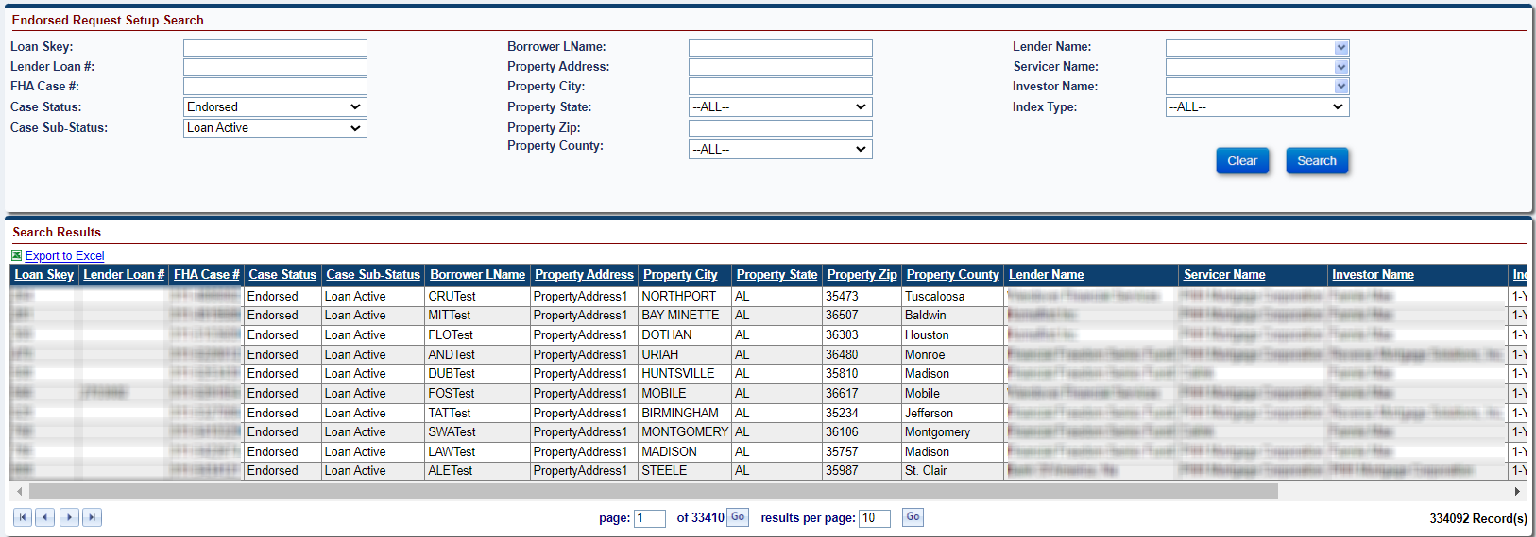
Figure 7-18: Setup Search – Endorsed - Certificate of Indebtedness
- From the search results, select a loan to initiate the timeline.
- On the Edit Servicing Management window, select Certificate of Indebtedness from the Servicing Type dropdown and populate the required fields (marked with an asterisk).
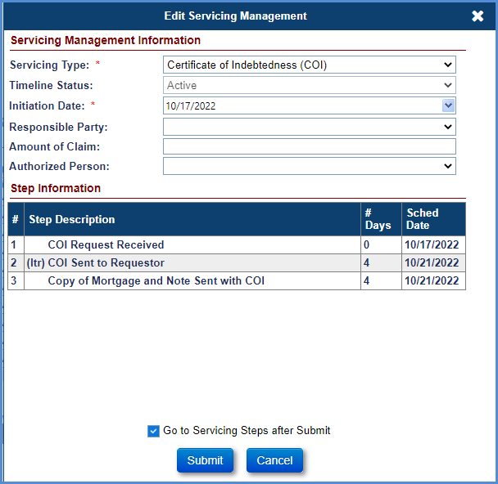
Figure 7-19: Endorsed - Requests - Certificate of Indebtedness (COI) - Edit Servicing Management
Click the Go to Servicing Steps after Submit checkbox (at the bottom of the Edit Servicing Management Window).
Click Submit. (If you click Cancel, the Endorsed Request Setup Search Screen will be displayed).
The Request Steps screen for Certificate of Indebtedness timeline is displayed.
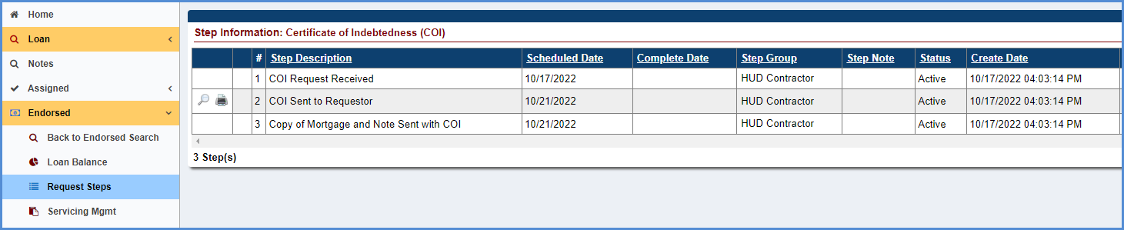
Figure 7-20: Endorsed - Requests - Certificate of Indebtedness (COI) - Timeline Steps
To complete any step in the timeline, click the step, for example, step COI Request Received.
Populate the completion date, add a note in the Notes field if applicable, and click Submit on the Edit Step window.
The completion date is populated beside the step COI Request Received on the Request Steps screen.
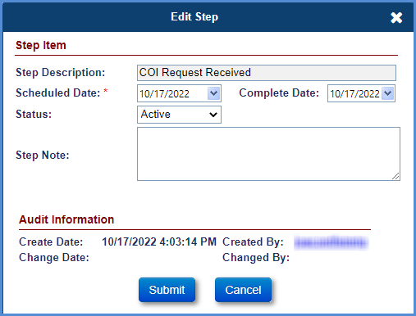
Figure 7-21: Endorsed - Requests - Certificate of Indebtedness (COI) - Edit Step
To generate the Certificate of Indebtedness Letter, click the magnifying glass beside COI Sent to Requestor; the Certificate of Indebtedness Letter is displayed.
The printer icon beside the step allows the HUD Contractor to auto-save the document to the Documents tab. Select the printer icon the Certificate of Indebtedness Letter is displayed. This action auto-saves the document in the Documents tab and auto-completes the step.

Consent of Lienholder
This timeline is initiated when the mortgagee receives a request from the mortgagor to consent to an action that would affect the mortgagee's interest in the property. With this timeline, the mortgagee submits their decision to HUD, who holds a second mortgage on the property. When consent is required from all lien holders, a servicer initiates this timeline. The request is reviewed, and a recommendation is made by a HUD NSC Contractor to HUD. HUD reviews the recommendation and the submitted documents and makes a decision. This timeline requires Servicer, HUD NSC Contractor and HUD interactions.
Multiple active Consent of Lienholder timelines cannot be initiated on a loan. The Servicing Management tab can be used to activate or inactivate the timeline. Once the timeline is inactivated, none of the steps can be edited.
To initiate and complete the Consent of Lienholder timeline:

Initiate Timeline – Servicer Activities
The servicer must perform the following steps to initiate the timeline:
- From the Endorsed menu, select Request, and click Setup.
- On the Endorsed Request Setup Search screen, enter the loan search criteria and click Search.

Figure 7-22: Endorsed - Requests - Setup Search
From the search results, select a loan to initiate the timeline.
On the Edit Servicing Management window, select Consent of Lien Holder from the Servicing Type dropdown and populate the required fields (marked with an asterisk).
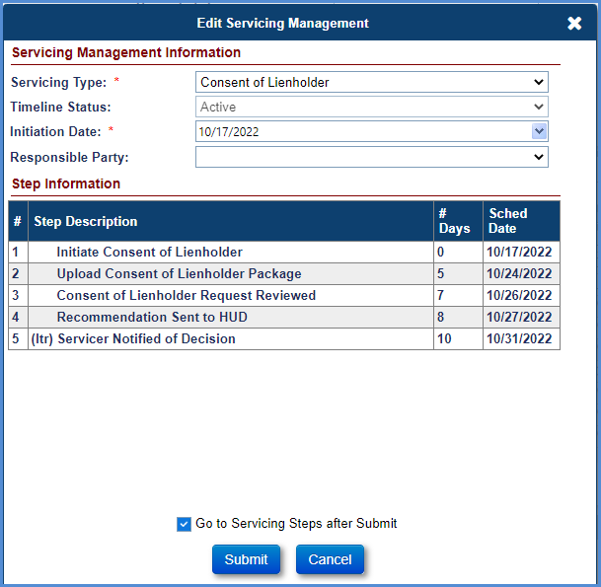
Figure 7-23: Endorsed - Requests - Consent of Lienholder - Edit Servicing Management
Click the Go to Servicing Steps after Submit checkbox (at the bottom of the Edit Servicing Management Window).
Click Submit (If you click Cancel, the Endorsed Request Setup Search screen is displayed).
The Request Steps screen for Consent of Lienholder timeline is displayed.
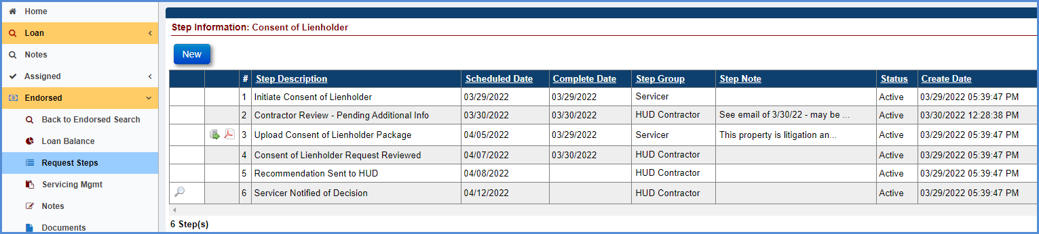
Figure 7-24: Endorsed - Requests - Consent of Lienholder - Timeline Steps
The step Initiate Consent of Lienholder completion date is pre-populated with the timeline created date.
For the step Upload Consent of Lienholder Package, the Complete Date is pre-populated with current system date. For this step, a servicer must upload the Consent of Lienholder Package document. The step cannot be completed without attaching the required document. Once the document is attached, a servicer will click Submit for the document to be attached. A PDF icon is added next to the step. Select this icon to view the attached document. This document is also auto-saved in the Documents tab.
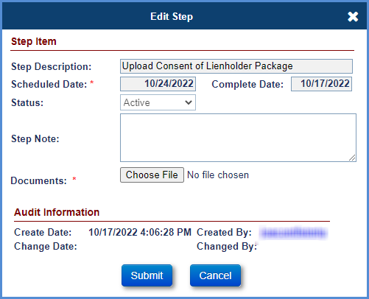
Figure 7-25: Endorsed - Requests - Consent of Lienholder - Edit Step

HUD NSC Contractor and HUD NSC Staff Activities
HUD NSC Contractor must perform the following steps:
- Upon completion of Consent of Lienholder Package review, a HUD NSC Contractor will complete the step Consent of Lienholder Request Reviewed. To complete the step, select it and populate the completion date, add a note in the Notes field (if applicable), click Submit on the Edit Step window.
- Once a decision has been made about whether to approve, deny or request additional information. The HUD NSC Contractor adds the respective optional step.
- To add an optional step (Contractor Recommendation – Approved, Contractor Recommendation - Denied, or Contractor Recommendation – Pending Additional Info), click New.
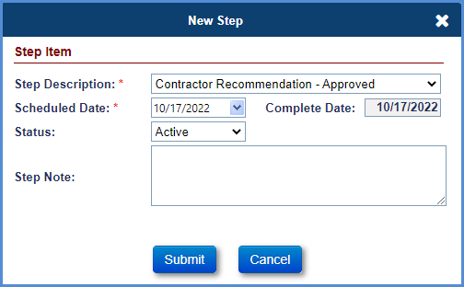
Figure 7-26: Endorsed - Requests - Consent of Lienholder - New Step
Select an optional step from the Step Description dropdown (contractor Recommendation – Approved, contractor Recommendation - Denied, or contractor Recommendation – Pending Additional Info) that needs to be added on the timeline, populate the completion date, and click Submit on the new window. The step will be added to the list of steps.
The HUD NSC Contractor completes the step Recommendation Sent to HUD to let HUD know their recommendation. To complete the step, select the step and populate the completion date, add a note in the Notes field if applicable, click Submit on the Edit Step window.
HUD NSC staff must perform the following steps:
The HUD NSC staff reviews the HUD NSC Contractor recommendation and makes a decision.
Once a decision has been made about whether to approve, deny or request additional information. The HUD NSC staff adds the respective optional step.
To add an optional step (HUD Decision – Approved, HUD Decision - Denied, or HUD Decision – Pending Additional Info), click New.
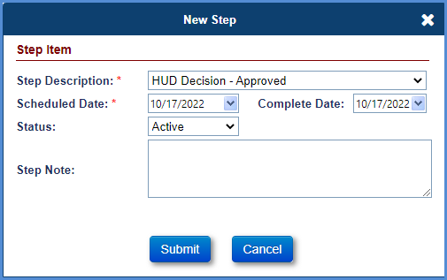
Figure 7-27: Endorsed - Requests - Consent of Lienholder - New Step
Select an optional step from the Step Description dropdown (HUD Decision–Approved, HUD Decision - Denied, or HUD Decision – Pending Additional Info) that needs to be added on the timeline, populate the completion date, click Submit on the new window. The step will be added to the list of steps.
  - If the HUD NSC staff requested additional information, servicer must submit additional information for continuation of this timeline (refer to above steps for the review cycle).
  - If the servicer does not submit the required documents within 45 days from the initial decision, then HUD NSC Contractor will add the optional step Follow Up on Pending Information.
HUD NSC Contractor must perform the following steps:
The HUD NSC Contractor will generate the Consent of Lienholder decision letter.
To generate the Consent of Lienholder Decision Letter, click the magnifying glass beside Servicer Notified of Decision. The Consent of Lienholder Decision letter is displayed with options to preview or print the document. The letter displays the HUD decision.
Update the letter (if pending additional information) and select the Preview Document link to view the updated document. To auto-save the changes made to the document, click the Print Document link. Click Open on the File Download window. This saves the Consent of Lienholder Decision letter to the Documents tab. Refresh the screen to auto complete the step with current system date.

Due and Payable w/ HUD Approval
This timeline is located under Endorsed > Requests, Servicing Type “Due & Payable w/ HUD Approval”. This timeline is initiated by a servicer to notify HUD of a Due and Payable event and request a HUD decision (approve, deny, or request additional information to call the loan due and payable). If the timeline is approved, the Case Sub-Status is updated to Due and Payable. If the timeline is inactivated, the Case Sub-Status is updated accordingly.
System will not allow user to initiate a Due & Payable w/ HUD Approval timeline manually, if one or more Non-Borrowing Spouse is active on the loan and the loan is Deferred.
HUD approval is required for the following default reasons:
- Occupancy - Compliance
- Occupancy - Residency
- Repairs and upkeep
- Unpaid Condo Fees (Categorized as “Missed Property Charges”)
- Unpaid Ground Rents (Categorized as “Missed Property Charges”)
- Unpaid HOA Fees (Categorized as “Missed Property Charges”)
- Unpaid insurance (Categorized as “Missed Property Charges”)
- Unpaid taxes (Categorized as “Missed Property Charges”)
- Unpaid PUD’s (Categorized as “Missed Property Charges”)
- Unpaid Special Assessments (Categorized as “Missed Property Charges”)
Multiple active Due & Payable w/ HUD Approval timelines cannot be initiated on a loan. The Servicing Management tab can be used to activate or inactivate the timeline and update the default date and default reason. Once the timeline is inactivated, none of the steps can be edited. Only the HUD NSC Manager user role can re-activate an Inactive timeline.

Timeline – Servicer Activities / Timeline Steps
TIP: Refer to section 7.1.2 “Setup Criteria to Initiate Timelines” for general steps to initiate timelines, and section 7.1.7 “To Complete Timeline Steps” for general information how to complete steps within a timeline.
The Servicer attaches all required documentation and completes the necessary steps on the timeline. The following Template Steps are displayed when the timeline is initiated:
- Default Event Occurred
- Upload Due & Payable Package
- Request to Call Due & Payable Reviewed – HUD Contractor step
- Ordered Appraisal
- Servicer Notified HUD of Missed Payment – Only for Missed Property Charges
- Mail Missed Payment Notice to Borrower – Only for Missed Property Charges
- Upload Missed Payment Notice to Borrower – Only for Missed Property Charges
- Submitted D&P Request to HUD
The following Optional Steps are available on this timeline. Refer to section 7.1.8 “To Add Optional Timeline Steps” for general information how to add and complete optional steps within a timeline:
- Follow Up Phone Attempt
- Initiate DIL
- Initiate Family Sale
- Initiate Pre-Foreclosure Process
- Initiate Short Sale
- HUD Decision – Approved – HUD step
- HUD Decision - Denied – HUD step
- Follow-up – HUD Contractor step
- HUD Decision - Pending Additional Info – HUD step
- Received Required additional information – HUD step
- Request to Rescind D&P
- HUD Request to Rescind Decision - Approved – HUD Contractor step
- HUD Request to Rescind Decision - Denied – HUD Contractor step
- Contractor Recommendation – Approved – HUD Contractor step
- Contractor Recommendation – Denied – HUD Contractor step
- Pending Additional Information from Servicer – HUD Contractor step
- Additional Information Sent to HUD – HUD Contractor step
The following Trigger Steps are available on this timeline:
- Notification of Decision Received
- D&P Notice Sent to Borrower
- Servicer Notified of Decision – HUD Contractor step
- Additional Documentation sent to HUD
- Upload D&P Notice Sent to Borrower
- Upload the Request to Rescind D&P Package
- Request to Rescind D&P Reviewed – HUD Contractor step
- Servicer Notified of Rescind Decision – Approved – HUD Contractor step
- Servicer Notified of Rescind Decision – Denied – HUD Contractor step
- HUD Review Contractor Recommendation – HUD step
- Additional Information Received from Servicer – HUD Contractor step
- Contractor Recommendation Submitted – HUD Contractor step
- For Property Charge default reasons, also referred to as “Missed Property Charges”, three additional steps are automatically included in the timeline.
  - Servicer Notified HUD of Missed Payment. The Complete Date is auto-populated with the timeline created date and serves to notify HUD of the missed payment.
  - Mail Missed Payment Notice to Borrower. The Complete Date serves to notify the Borrower of the missed payment as well as Notify HUD when the Borrower was notified.
  - Upload Missed Payment Notice to Borrower
- The user completes step Submitted D&P Request to HUD when they are ready to submit this request to HUD.
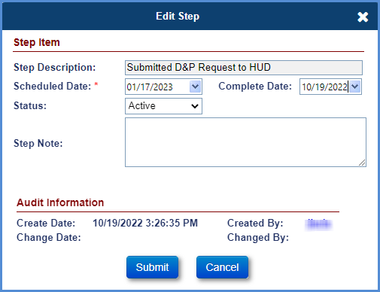
Figure 7-28: Endorsed - Requests - Due & Payable w/ HUD Approval - Edit Step
TIP: For specific timeline steps, the completion date can be changed by authorized user roles even if the step already had a completion date reported. On the Due & Payable with HUD approval timeline, the steps with editable completion dates are as follows:
      - Ordered Appraisal
      - Upload Due & Payable Package
      - Notification Sent to Borrower
      - Submitted D&P Request to HUD
      - HUD Decision – Approved – only editable by HUD NSC User Role

HUD NSC Contractor and HUD Review Activities
HUD NSC Contractor must perform the following steps:
- Upon completion of Due & Payable package review, a HUD NSC Contractor completes the step Request to Call Due & Payable Reviewed.
- HUD NSC Contractor adds the respective optional step to make a recommendation to HUD of the decision.
  - Contractor Recommendation - Approved
  - Contractor Recommendation - Denied
  - Pending Additional Information from Servicer
- If Contractor Recommendation – Approved or Contractor Recommendation – Denied is completed, HUD step Contractor Recommendation Submitted is added to the timeline and is ready for HUD to review.
- HUD user reviews the request and issues a decision from one of the following:
  - HUD Decision - Approved
  - HUD Decision - Denied
  - HUD Decision - Pending Additional Info
- Completion of one of the above steps triggers HUD NSC Contractor step Servicer Notified of Decision to be added to the timeline and is ready to be issued to the requestor.
- HUD NSC Contractor generates the Due and Payable Decision Letter by clicking the print icon on Servicer Notified of Decision. Click Open on the File Download window. This action will save the Due and Payable letter to the Documents tab. Refresh the screen to auto complete the step with current system date.

Post Due & Payable Timeline – Servicer Activities
The servicer must perform the following steps:
- After step Servicer Notified of Decision is completed, a servicer will complete the step Notification of Decision Received and step Upload D&P Notice Sent to Borrower. Step D&P Notice Sent to Borrower is completed by uploading the actual Notification Letter that was sent to the Borrower (The Acceptable Doc Type for this is “Missed Payment Notice Letter”, completing the document upload will complete this step). Then complete the Step D&P Notice Sent to Borrower.

Request Rescission of HUD Approved Timeline – Servicer Activities
To request Rescission of the Due and Payable w/ HUD Approval timeline after HUD has approved the Due and Payable request, the servicer must perform the following:
- To request rescission from within the timeline, click New.
- Select the optional step Request to Rescind D&P from the Step Description dropdown, populate the completion date, and click Submit on the new window. The step will be added to the list of steps along with the step Upload the Request to Rescind D&P Package.
- Attach the rescission package to the step “Upload the Request to Rescind D&P Package”. The rescission request is now ready for HUD NSC contractor to review.

Rescission of HUD Approved Timeline – HUD NSC Contractor Activities
HUD NSC Contractor must perform the following steps to approve or deny a request to rescind the Due and Payable approval:
- HUD NSC Contractor completes the step Request to Rescind D&P Reviewed.
- Once a decision has been made whether to approve or deny the rescission request, the HUD NSC Contractor adds the respective optional step.
- Select an optional step from the Step Description dropdown that needs to be added on the timeline, populate the completion date, and click Submit on the new window. The step will be added to the list of steps. Upon addition of the timeline step HUD Request to Rescind Decision – Approved the Due and Payable with HUD Approval timeline is changed to Inactive. This timeline cannot be re-activated.

Extension – Appraisal
This timeline is located under Endorsed > Requests, Servicing Type “Extension–Appraisal” and is initiated by a servicer to request an extension of time to the appraisal expiration date if they have pending sale scheduled to close within 30 days from the expiration of the appraisal.
Multiple active Extension–Appraisal timelines cannot be initiated on a loan. The Servicing Management tab can be used to activate or inactivate the timeline and view/update extension data fields. Once the timeline is inactivated, none of the steps can be edited.
TIP: Refer to section 7.1.2 “Setup Criteria to Initiate Timelines” for general steps to initiate timelines, and section 7.1.7 “To Complete Timeline Steps” for general information how to complete steps within a timeline.
The Servicer attaches all required documentation and completes the necessary steps on the timeline. The following Template Steps are displayed when the timeline is initiated. The steps are servicer steps unless otherwise stated:
- Initiate Extension (Automatically completed)
- Upload Extension Package
The following Trigger Steps are available on this timeline. The steps are HUD Contractor steps unless otherwise stated:
- Appraisal Effective End Date
- HUD Auto-Approved
Once the Appraisal Effective End Date is entered, the Timeline is automatically approved, the Triggered step HUD Auto-Approved is added/completed, and the field Extension Expiration Date in the Servicing Management screen is updated to the Appraisal Effective End Date Complete Date + 180 Days.

Extension – At-Risk
This timeline is located under Endorsed > Requests, Servicing Type “Extension–At-Risk” and is initiated by a servicer to request an at-risk extension. This request is considered an additional extension to the foreclosure timeframes, if the following criteria are met:
- Youngest living mortgagor is at least 80 years of age; and
- The mortgagee, after employing acceptable and prudent servicing practices, has determined that the mortgagor has critical circumstances such as a supported terminal illness, substantiated long-term physical disability, or a “unique” occupancy need (e.g., terminal illness of family member receiving care at the residence).

The Servicer must also include supporting documentation validating that the conditions stated above are met. And provide (on no less than an annual basis) supporting documentation that the conditions continue to be met.
Multiple active Extension–Appraisal timelines cannot be initiated on a loan. The Servicing Management tab can be used to activate or inactivate the timeline and view/update extension data fields. Once the timeline is inactivated, none of the steps can be edited.
TIP: Refer to section 7.1.2 “Setup Criteria to Initiate Timelines” for general steps to initiate timelines, and section 7.1.7 “To Complete Timeline Steps” for general information how to complete steps within a timeline.
The Servicer attaches all required documentation and completes the necessary steps on the timeline. The following Template Steps are displayed when the timeline is initiated. The steps are servicer steps unless otherwise stated:
- Initiate Extension (Automatically completed)
- Upload Extension Package
The following Optional Steps are available on this timeline. Refer to section 7.1.8 “To Add Optional Timeline Steps” for general information how to add and complete optional steps within a timeline. The steps are Servicer steps unless otherwise stated:
- Extension Eligibility End Date
The following Trigger Steps are available on this timeline. The steps are HUD steps unless otherwise stated:
- HUD Auto-Approved

Once the Servicer completes Upload Extension Package step, the Triggered step HUD Auto-Approved is added/completed, the Timeline is automatically approved, and the Extension Expiration Date in the Servicing Management screen is updated as follows:
- For new Extension Timelines (with no other active/inactive timelines) the Extension Expiration Date = “HUD Auto-Approved” Complete Date + 12 Months.
- If one or more Extension Timelines exists:
  - If the MAX Extension Expiration Date from the other Extension Timelines are greater than or equal to the latest Step “HUD Decision – Approved” Complete Date from the Endorsed > Requests > Due & Payable w/ HUD Approval Timeline, then the Extension Expiration Date for the new timeline = MAX Extension Expiration Date + 12 Months.
  - If the MAX Extension Expiration Date from the other Extension Timelines are less than the latest Step “HUD Decision – Approved” Complete Date from the Endorsed > Requests > Due & Payable w/ HUD Approval Timeline, then the Extension Expiration Date for the new timeline = “HUD Auto-Approved” Complete Date + 12 Months.

Extension – Claims Deadlines
This timeline is located under Endorsed > Requests, Servicing Type “Extension–Claims Deadlines” and is initiated by a servicer to request an extension to either the end of the Marketable Title period or to the claim filing deadline using timeline Extension – Claims Deadlines and selecting the appropriate Reason for Extension at timeline initiation. An extension to the end of the CT21 - Marketable Title period can be granted when there is a pending sale and allows the servicer additional time to file the Claim Type 21 as a Sales Based Claim. The servicer should initiate this timeline prior to the end of the six month period from the date the mortgagee acquired title. An extension to CT21 - Claim Filing or CT23 – Claim Filing extends the claim filing deadline. For a Claim Filing Extension, the Claim Timeline must be initiated before the Extension in order to select the corresponding Reason for Extension.
Multiple active Extension–Claims Deadlines timelines cannot be initiated on a loan. The Servicing Management tab can be used to activate or inactivate the timeline and update extension data fields. Once the timeline is inactivated, none of the steps can be edited.
TIP: Refer to section 7.1.2 “Setup Criteria to Initiate Timelines” for general steps to initiate timelines, and section 7.1.7 “To Complete Timeline Steps” for general information how to complete steps within a timeline.
The Servicer attaches all required documentation and completes the necessary steps on the timeline. The following Template Steps are displayed when the timeline is initiated. The steps are servicer steps unless otherwise stated:
- Initiate Extension
- Upload Extension Package
- Submit Extension Request for Time
The following Optional Steps are available on this timeline. Refer to section 7.1.8 “To Add Optional Timeline Steps” for general information how to add and complete optional steps within a timeline. The steps are HUD steps unless otherwise stated:
- HUD Decision – Approved
- HUD Decision – Denied
- HUD Decision - Pending Additional Info – HUD Contractor Step
- Follow Up – HUD Contractor Step
The following Trigger Steps are available on this timeline. The steps are HUD steps unless otherwise stated:
- Extension Request Reviewed
- Servicer Notified of Decision
- Request for Extension of Time Recd
The following Servicing Mgmt fields are required for this timeline during timeline initiation/ setup, in addition to Initiation Date:
- Reason for Request
- Reason for Extension

Extension – COVID-19 Request to Delay Claims Submission
This timeline is located under Endorsed > Request, Servicing Type “Extension – COVID-19 Request to Delay Claims Submission” and is initiated by the servicer to delay Claims Submission due to the COVID-19 National Emergency and Mortgagee Letter 2020-06. The latest permitted COVID Extension Expiration Date is 11/30/2023.
For first timelines, user must enter the Extension Request Date and Extension Expiration Date, which must be within 6 months of the Extension Request Date. The first timeline Extension Expiration Date may be changed if necessary but must be within the required date range and within 6 months or 3 months of the Extension Request Date, depending on the Reason for Request selected. If the first timeline Extension Expiration date is edited, the new date will be displayed in field Prior Extension Expiration Date on the second timeline.
For second timelines of the same type, user will not need to enter an Extension Request Date but must enter the Extension Expiration Date, which must be within 6 months or 3 months of the Prior Extension Expiration Date from the first timeline, depending on the Reason for Request selected. On second timelines, the Extension Request Date is optional and is not used in validations for this timeline.
Multiple active Extension – COVID-19 Request to Delay Claims Submission timelines can be initiated on a loan. The Servicing Management tab can be used to inactivate the timeline. Once the timeline is inactivated, none of the steps can be edited.
TIP: Refer to section 7.1.2 “Setup Criteria to Initiate Timelines” for general steps to initiate timelines, and section 7.1.7 “To Complete Timeline Steps” for general information how to complete steps within a timeline.
The Servicer attaches all required documentation and completes the necessary steps on the timeline. The following Template Steps are displayed when the timeline is initiated. The steps are servicer steps unless otherwise stated
- Initiate Extension
- Submit Extension Request for Time
- Extension Request Reviewed – HUD Step
- Servicer Notified of Decision – HUD Step
- HUD Decision – Approved – HUD Step
The following Servicing Mgmt fields are required for this timeline during timeline initiation/ setup, in addition to Initiation Date:
- Reason for Request
- Reason for Extension
- Extension Request Date
- Extension Expiration Date
- Requested By

Extension – COVID-19 Request to Delay Due & Payable
This timeline is located under Endorsed > Request, Servicing Type “Extension – COVID-19 Request to Delay Due & Payable” and is initiated by the Servicer to delay Due & Payable due to the COVID-19 National Emergency and Mortgagee Letter 2020-06. If the loan is already due and payable, then an extension can be granted to Foreclosure or Claims process. The latest permitted COVID Extension Expiration Date is 11/30/2023.
For first timelines, user must enter the Extension Request Date and Extension Expiration Date, which must be within 6 months of the Extension Request Date. The first timeline Extension Expiration Date may be changed if necessary but must be within the required date range and within 6 months or 3 months of the Extension Request Date, depending on the Reason for Request selected. If the first timeline Extension Expiration date is edited, the new date will be displayed in field Prior Extension Expiration Date on the second timeline.
For second timelines of the same type, user will not need to enter an Extension Request Date, but must enter the Extension Expiration Date, which must be within 6 months or 3 months of the Prior Extension Expiration Date from the first timeline, depending on the Reason for Request selected. On second timelines, the Extension Request Date is optional and is not used in validations for this timeline.
Multiple active Extension – COVID-19 Request to Delay Due & Payable timelines can be initiated on a loan. The Servicing Management tab can be used to inactivate the timeline. Once the timeline is inactivated, none of the steps can be edited.
TIP: Refer to section 7.1.2 “Setup Criteria to Initiate Timelines” for general steps to initiate timelines, and section 7.1.7 “To Complete Timeline Steps” for general information how to complete steps within a timeline.
The Servicer attaches all required documentation and completes the necessary steps on the timeline. The following Template Steps are displayed when the timeline is initiated. The steps are servicer steps unless otherwise stated
- Submit Extension Request for Time
- Extension Request Reviewed
- Servicer Notified of Decision – HUD Step
- HUD Decision – Approved – HUD Step
- Initiate Extension – HUD Step
The following Servicing Mgmt fields are required for this timeline during timeline initiation/ setup, in addition to Initiation Date:
- Reason for Request
- Reason for Extension
- Extension Request Date
- Extension Expiration Date
- Requested By

Extension – COVID-19 Request to Delay Foreclosure
This timeline is located under Endorsed > Request, Servicing Type “Extension – COVID-19 Request to Delay Foreclosure” and is initiated by the Servicer to delay Foreclosure due to the COVID-19 National Emergency and Mortgagee Letter 2020-06. The latest permitted COVID Extension Expiration Date is 11/30/2023.
For first timelines, user must enter the Extension Request Date and Extension Expiration Date, which must be within 6 months or 3 months of the Extension Request Date, depending on the Reason for Request selected. The first timeline Extension Expiration Date may be changed if necessary but must be within the required date range and within 6 months of the Extension Request Date. If the first timeline Extension Expiration date is edited, the new date will be displayed in field Prior Extension Expiration Date on the second timeline.
For second timelines of the same type, user will not need to enter an Extension Request Date, but must enter the Extension Expiration Date, which must be within 6 months or 3 months of the Prior Extension Expiration Date from the first timeline, depending on the Reason for Request selected. On second timelines, the Extension Request Date is optional and is not used in validations for this timeline.
Multiple active Extension – COVID-19 Request to Delay Foreclosure timelines can be initiated on a loan. The Servicing Management tab can be used to inactivate the timeline. Once the timeline is inactivated, none of the steps can be edited.
TIP: Refer to section 7.1.2 “Setup Criteria to Initiate Timelines” for general steps to initiate timelines, and section 7.1.7 “To Complete Timeline Steps” for general information how to complete steps within a timeline.
The Servicer attaches all required documentation and completes the necessary steps on the timeline. The following Template Steps are displayed when the timeline is initiated. The steps are servicer steps unless otherwise stated
- Initiate Extension
- Submit Extension Request for Time
- Extension Request Reviewed
- Servicer Notified of Decision
- HUD Decision – Approved
The following Servicing Mgmt fields are required for this timeline during timeline initiation/ setup, in addition to Initiation Date:
- Reason for Request
- Reason for Extension
- Extension Request Date
- Extension Expiration Date
- Requested By

Extension – Deed-In-Lieu
This timeline is located under Endorsed > Requests, Servicing Type “Extension - Deed-in-Lieu” and is initiated by a servicer to request an extension of time to negotiate a deed-in-lieu of foreclosure. A servicer will initiate the first Extension – DIL request within 30 days of the expiration of the second extension request to delay foreclosure. The second request should be initiated within 30 days of the expiration of the initial extension expiration date.
Multiple active Extension – Deed-in-Lieu timelines can be initiated on a loan. The Servicing Management tab can be used to activate or inactivate the timeline and view extension data fields. Once the timeline is inactivated, none of the steps can be edited.
TIP: Refer to section 7.1.2 “Setup Criteria to Initiate Timelines” for general steps to initiate timelines, and section 7.1.7 “To Complete Timeline Steps” for general information how to complete steps within a timeline.
The Servicer attaches all required documentation and completes the necessary steps on the timeline. The following Template Steps are displayed when the timeline is initiated. The steps are servicer steps unless otherwise stated:
- Initiate Extension
- Upload Extension Package
The following Trigger Steps are available on this timeline. The steps are HUD steps unless otherwise stated:
- HUD Auto-Approved
Once the Servicer completes Upload Extension Package step, the Triggered step HUD Auto-Approved is added/completed, the Timeline is automatically approved, and the Extension Expiration Date in the Servicing Management screen is updated as follows:
- First Extension: If the “Request” field in the Servicing Management tab is “First”, the Extension Expiration Date = “HUD Auto-Approved” Complete Date + 90 Days.
- Second Extension: If the “Request” field in the Servicing Management tab is “Subsequent”, the Extension Expiration Date = Extension Expiration Date from the First Extension (Active) + 90 Days.

Extension – Delay Due & Payable
This timeline is located under Endorsed > Requests, Servicing Type “Extension–Delay Due & Payable” and is initiated by a servicer to request an extension during the Due & Payable. There are multiple Reasons for Extension that may be cited.
Multiple active Extension–Delay Due & Payable timelines can be initiated on a loan. The Servicing Management tab can be used to activate or inactivate the timeline. This timeline will automatically be inactivated by the system when the Due & Payable with HUD Approval or Due & Payable without HUD Approval Timelines are inactivated. Once the timeline is inactivated, none of the steps can be edited.
TIP: Refer to section 7.1.2 “Setup Criteria to Initiate Timelines” for general steps to initiate timelines, and section 7.1.7 “To Complete Timeline Steps” for general information how to complete steps within a timeline.
The Servicer attaches all required documentation and completes the necessary steps on the timeline. The following Template Steps are displayed when the timeline is initiated. The steps are servicer steps unless otherwise stated:
- Initiate Extension
- Extension Start Date

The following Trigger Steps are available on this timeline. The steps are HUD steps unless otherwise stated:
- HUD Auto-Approved
The following Servicing Mgmt fields are required for this timeline during timeline initiation/ setup, in addition to Initiation Date:
- Reason for Request
- Reason for Extension

Once the Extension Start Date is entered, the Timeline is automatically approved, the Triggered step HUD Auto-Approved is added/completed, and the field Extension Expiration Date in the Servicing Management screen is updated to the Extension Start Date Complete Date + 180 Days.

Extension – Hardest Hit Fund (HHF)
This timeline is located under Endorsed > Requests, Servicing Type “Extension–Hardest Hit Fund” and is initiated by a servicer to request a 45-day extension to initiate foreclosure or reasonable diligence in completing foreclosure as follows:
- Upon receiving a copy of the State Housing Finance Agency’s or other entity administering a State’s HHF conditional commitment from the mortgagor, the mortgagee must review its servicing file and confirm that the mortgagor’s account is still active and due and payable.
- The mortgagor has up to 45 days after the mortgagee’s deadline to initiate foreclosure or, if applicable, complete foreclosure to receive the HHF funds and apply them in satisfying the HECM mortgage or otherwise curing the default. Should HHF funds not be disbursed to the mortgagor, the mortgagee must retain documentation regarding this delay in initiating or completing foreclosure in its servicing file to avoid curtailment.
Multiple active Extension–Hardest Hit Fund timelines cannot be initiated on a loan. The Servicing Management tab can be used to activate or inactivate the timeline and view extension data fields. Once the timeline is inactivated, none of the steps can be edited.
TIP: Refer to section 7.1.2 “Setup Criteria to Initiate Timelines” for general steps to initiate timelines, and section 7.1.7 “To Complete Timeline Steps” for general information how to complete steps within a timeline.
The Servicer attaches all required documentation and completes the necessary steps on the timeline. The following Template Steps are displayed when the timeline is initiated. The steps are servicer steps unless otherwise stated:
- Initiate Extension
- Upload Extension Package
The following Trigger Steps are available on this timeline. The steps are HUD steps unless otherwise stated:
- HUD Auto-Approved

The following Servicing Mgmt fields are required for this timeline during timeline initiation/ setup, in addition to Initiation Date:
- Reason for Extension
Once the Servicer completes Upload Extension Package step, the Triggered step HUD Auto-Approved is added/completed, the Timeline is automatically approved, and the field Extension Expiration Date in the Servicing Management screen is updated to the HUD Auto Approved complete date + 90 Days.

Extension – Late Notification of Death
This timeline is located under Endorsed > Requests, Servicing Type “Extension–Late Notification of Death” and is initiated by a servicer to request an extension to take the first legal action to initiate foreclosure due to a late notification of death of a borrower. The reasons for late notification of death can include:
- State Privacy Laws Restricted Information Access (Note: Extension request to the deadline to initiate foreclosure extended 30 days from end of state's privacy law restriction on the mortgagee’s access to the information)
- Other Reason (Note: Extension request from Date of Death to Mortgagee’s discovery of death)
Multiple active Extension–Late Notification of Death timelines cannot be initiated on a loan. The Servicing Management tab can be used to activate or inactivate the timeline and view extension data fields. Once the timeline is inactivated, none of the steps can be edited.
TIP: Refer to section 7.1.2 “Setup Criteria to Initiate Timelines” for general steps to initiate timelines, and section 7.1.7 “To Complete Timeline Steps” for general information how to complete steps within a timeline.
The Servicer attaches all required documentation and completes the necessary steps on the timeline. The following Template Steps are displayed when the timeline is initiated. The steps are servicer steps unless otherwise stated:
- Initiate Extension
- Upload Extension Package
The following Trigger Steps are available on this timeline. The steps are HUD steps unless otherwise stated:
- HUD Auto-Approved
The following Servicing Mgmt fields are required for this timeline during timeline initiation/ setup, in addition to Initiation Date:
- Reason for Extension
Once the Servicer completes Upload Extension Package step, the Triggered step HUD Auto-Approved is added/completed, the Timeline is automatically approved, and the field Extension Expiration Date in the Servicing Management screen is updated to the Step Servicer Notified of Death Complete Date from the active Endorsed > Disposition > Due & Payable w/o HUD Approval Timeline + 90 Days.

Extension – Other
This timeline is located under Endorsed > Requests, Servicing Type “Extension–Other” and is initiated by a servicer to request an extension when no other extension types apply.
Multiple active Extension–Other timelines cannot be initiated on a loan. The Servicing Management tab can be used to activate or inactivate the timeline and view extension data fields. Once the timeline is inactivated, none of the steps can be edited.
TIP: Refer to section 7.1.2 “Setup Criteria to Initiate Timelines” for general steps to initiate timelines, and section 7.1.7 “To Complete Timeline Steps” for general information how to complete steps within a timeline.
The Servicer attaches all required documentation and completes the necessary steps on the timeline. The following Template Steps are displayed when the timeline is initiated. The steps are servicer steps unless otherwise stated:
- Initiate Extension
- Upload Extension Package
The following Trigger Steps are available on this timeline. The steps are HUD steps unless otherwise stated:
- HUD Auto-Approved
The following Servicing Mgmt fields are required for this timeline during timeline initiation/ setup, in addition to Initiation Date:
- Reason for Request
Once the Servicer completes Upload Extension Package step, the Triggered step HUD Auto-Approved is added/completed, the Timeline is automatically approved, and the field Extension Expiration Date in the Servicing Management screen is updated to the HUD Auto Approved complete date + 90 Days.

Extension – Property Charge Loss Mitigation
This timeline is located under Endorsed > Requests, Servicing Type “Extension - Property Charge Loss Mitigation” and is initiated by a servicer to offer the following loss mitigation options for a mortgagor in default due to unpaid property charges:
- Refinancing the defaulted HECM into a new HECM if possible, under all applicable HECM origination requirements
- Providing information on the availability of free assistance from HUD-approved HECM Housing Counselors and local assistance programs (e.g., ELMORE) available for mortgagors.
If the aforementioned loss mitigation options are unavailable or have been exhausted, mortgagees may offer the following:
- Option (1): The option for an extension of the foreclosure timeframes due to a Corporate Advance/Repayment Plan (Note: Maximum 60 months from date of repayment).
- Option (2): The option for an extension of the foreclosure timeframes due to a “COVID -19 Property Charge Repayment Plan”.
Multiple active Extension–Property Charge Loss Mitigation timelines cannot be initiated on a loan. The Servicing Management tab can be used to activate or inactivate the timeline and view extension data fields. Once the timeline is inactivated, none of the steps can be edited.
TIP: Refer to section 7.1.2 “Setup Criteria to Initiate Timelines” for general steps to initiate timelines, and section 7.1.7 “To Complete Timeline Steps” for general information how to complete steps within a timeline.
The Servicer attaches all required documentation and completes the necessary steps on the timeline. The following Template Steps are displayed when the timeline is initiated. The steps are servicer steps unless otherwise stated:
- Initiate Extension (Automatically completed)
- Upload Extension Package
The following Optional Steps are available on this timeline. Refer to section 7.1.8 “To Add Optional Timeline Steps” for general information how to add and complete optional steps within a timeline. The steps are HUD steps unless otherwise stated:
- Repayment Plan Default Date

The following Trigger Steps are available on this timeline. The steps are HUD steps unless otherwise stated:
- Repayment Plan Start Date
- Repayment Plan End Date
The following Servicing Mgmt fields are required for this timeline during timeline initiation/ setup, in addition to Initiation Date:
- Reason for Extension
Once the Servicer completes Repayment Plan End Date, the Triggered step HUD Auto-Approved is added/completed, the Timeline is automatically approved, and the field Extension Expiration Date in the Servicing Management screen is updated to the Repayment Plan End Date complete date.
If Optional Step “Repayment Plan Default Date” is added/completed to the timeline, then the Extension Expiration Date is automatically updated to the Repayment Plan Default Date complete date + 90 days.

Extension – Repairs
This timeline is located under Endorsed > Requests, Servicing Type “Extension – Repairs” and is initiated by a servicer to request to complete the required repairs. The initial request is initiated within 30 days of the expiration of the Repair Rider date. When the initial request is initiated, the Servicing Module defaults the request field to First and the second request to Subsequent.
Multiple active timelines can be initiated on a loan. The Servicing Management tab can be used to activate or inactivate the timeline and extension data fields. Once the timeline is inactivated, the steps can no longer be edited. The field Repair Rider Expiration Date can be edited until the Extension Expiration Date is populated, which happens once the Servicer completes the step Upload Extension Package, the Triggered step HUD Auto-Approved is added/completed and the Timeline is automatically approved.. The repair rider expiration date must be greater than the closing date and less than or equal to number of months (as established by HUD) from the closing date.
For the first extension request, this date must be compliant with the number of days or months from the repair rider established by HUD. For a subsequent request, this date must be less than or equal to
- The number of days (as established by HUD) from the first extension expiration date or
- The number of months (as established by HUD) from the closing date.
TIP: Refer to section 7.1.2 “Setup Criteria to Initiate Timelines” for general steps to initiate timelines, and section 7.1.7 “To Complete Timeline Steps” for general information how to complete steps within a timeline.
The Servicer attaches all required documentation and completes the necessary steps on the timeline. The following Template Steps are displayed when the timeline is initiated. The steps are servicer steps unless otherwise stated:
- Initiate Extension (Automatically completed)
- Upload Extension Package
The following Trigger Steps are available on this timeline. The steps are HUD steps unless otherwise stated:
- HUD Auto-Approved

Extension – Request to Delay Foreclosure
This timeline is located under Endorsed > Request, Servicing Type “Extension – Request to Delay Foreclosure” and is initiated by the Servicer to delay foreclosure. The servicer initiates this timeline before the Orig First Legal Deadline date on the Due and Payable w/o HUD Approval timeline (which is the end of the six-month time period to initiate foreclosure), but not earlier than a certain number of days (as established by HUD) in advance of the expiration date. If Orig First Legal Deadline date is blank, then the date required to calculate this date must be completed before the Extension – Request to Delay Foreclosure timeline can be initiated.
Multiple active Extension – Request to Delay Foreclosure timelines can be initiated on a loan. The second request should be initiated within 30 days of the prior Extension Expiration date. The system will auto-approve the first two extension requests and set the Extension Expiration Date equal to number of days (as established by HUD) from the Orig First Legal Deadline on the Due and Payable timeline. The third request must be manually reviewed and approved. The Servicing Management tab can be used to inactivate the timeline. Once the timeline is inactivated, none of the steps can be edited. The extension expiration date is populated on the Servicing Mgmt tab by users authorized to input this date (applicable only from third request).
TIP: Refer to section 7.1.2 “Setup Criteria to Initiate Timelines” for general steps to initiate timelines, and section 7.1.7 “To Complete Timeline Steps” for general information how to complete steps within a timeline.
The Servicer attaches all required documentation and completes the necessary steps on the timeline. The following Template Steps are displayed when the timeline is initiated. The steps are servicer steps unless otherwise stated
- Initiate Extension - Request to Delay Foreclosure
- Upload Extension Package
- Submit Extension Request for Time
- Extension Request Reviewed – HUD Contractor Step
- Servicer Notified of Decision – HUD Contractor Step
- Request for Extension of Time Recd – HUD Contractor Step
The following Optional Steps are available on this timeline. Refer to section 7.1.8 “To Add Optional Timeline Steps” for general information how to add and complete optional steps within a timeline. The steps are HUD Contractor steps unless otherwise stated
- Follow Up
- HUD Decision - Approved
- HUD Decision – Denied
The following Servicing Mgmt fields are required for this timeline during timeline initiation/ setup, in addition to Initiation Date:
- Reason for Request
- Reason for Extension

Investor Short Sale
This timeline is initiated by a servicer to track a short sale after acquisition of the property. When this timeline is completed, the case sub-status is updated to Short Sale Initiated. If the timeline is inactivated, the case sub-status is updated accordingly.
Multiple active Investor Short Sale timelines cannot be initiated on a loan. The Servicing Management tab can be used to inactivate the timeline and update the short sale information prior to the Step HUD Auto-Approved being completed. Once the timeline is inactivated, none of the steps can be edited.

TIP: Refer to section 7.1.2 “Setup Criteria to Initiate Timelines” for general steps to initiate timelines, and section 7.1.7 “To Complete Timeline Steps” for general information how to complete steps within a timeline.
The Servicer attaches all required documentation and completes the necessary steps on the timeline. The following Template Steps are displayed when the timeline is initiated. The steps are servicer steps unless otherwise stated:
- Initiate Investor Short Sale Process (Automatically completed)
- Upload Short Sale package to HUD
The following Trigger Steps are available on this timeline. The steps are HUD steps unless otherwise stated:
- HUD Auto-Approved
- Servicer Approval Notification HUD Contractor
The following Servicing Mgmt fields are required for this timeline during timeline initiation/ setup, in addition to Initiation Date:
- Contract Date
- Contract Sales Price
- Net Sale Proceeds
- Appraised Value
NOTE: The Timeline can only be initiated once the calculated field Percentage of Appraised Value is equal to (or greater than) 95.00%

The following fields in the Servicing Mgmt screen are editable, up and until the Servicer completes the Step Upload Short Sale package to HUD:
- Loan Status of 1st Mortgage
- Contract Date
- Contract Sales Price
- Net Sale Proceeds
- Repair Costs
- Appraised Value

Once the Servicer completes Upload Short Sale package to HUD, the Triggered step HUD Auto-Approved is added/completed, the Timeline is automatically approved, and the fields within the Servicing Management screen are no longer editable.
Once the Timeline is approved, the Short Sale Approval letter is available. To generate the Short Sale Approval letter, click on the magnifying glass beside step “Servicer Approval Notification.” Select Open button on the File Download pop-up window. This action will save the Short Sale Calculation Worksheet to the Documents tab. Refresh the screen to auto complete the step with current system date. Once the Step “Servicer Approval Notification” is completed, the Print icon will appear.

Partial Release
This timeline is initiated by the Servicer when the mortgagee receives a request from the mortgagor to release a portion of the property secured by the HECM mortgage. With this timeline, the mortgagee submits their decision to HUD, who holds a second mortgage on the property. The request is reviewed, and a recommendation is made by a HUD NSC Contractor to HUD. A HUD staff member reviews a HUD NSC Contractor recommendation and the submitted documents and makes a decision. This timeline requires Servicer, HUD NSC Contractor and HUD interaction.
Multiple active Partial Release timelines cannot be initiated on a loan. The Servicing Management tab can be used to activate or inactivate the timeline and update release details such as reason for release, amount offered, and description of land to be released. Once the timeline is inactivated, none of the steps can be edited.
To initiate and complete the Partial Release timeline:

Initiate Timeline – Servicer Activities
The servicer must perform the following steps to initiate the timeline:
- On the Endorsed menu, select Request, and click Setup.
On the Endorsed Request Setup Search Screen, enter the loan search criteria and click Search.

Figure 7-29: Endorsed - Requests - Setup Search
From the search results, select a loan to initiate the timeline.
On the Edit Servicing Management screen, select Partial Release from the Servicing Type dropdown and populate the required fields (marked with an asterisk).
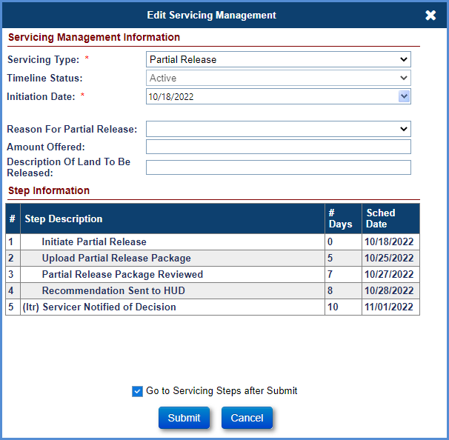
Figure 7-30: Endorsed - Requests - Extension – Partial Release - Edit Servicing Management
Click the Go to Servicing Steps after Submit checkbox (at the bottom of the Edit Servicing Management screen). Details of the partial release such as reason, amount offered and description of land to be released can be edited on the Servicing Management tab after initiation of the timeline.
Click Submit. (If you click Cancel, the Endorsed Request Setup Search screen will be displayed).
The Request Steps screen for Partial Release timeline is displayed.
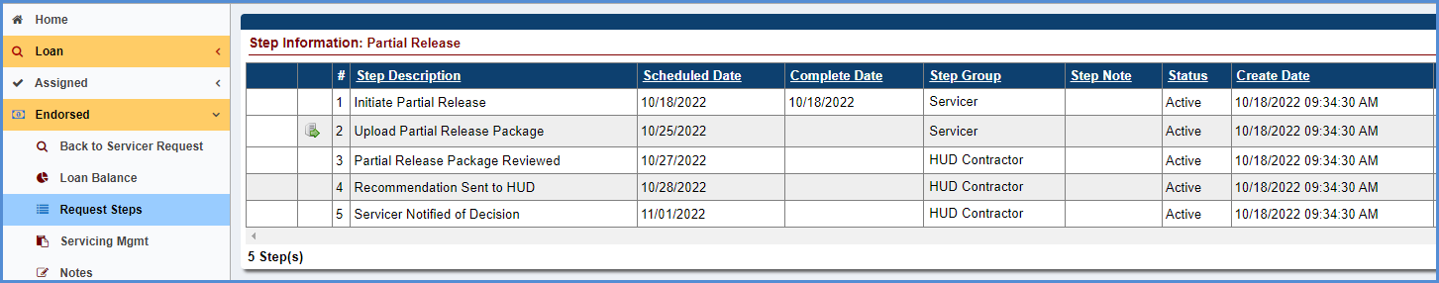
Figure 7-31: Endorsed - Requests - Extension – Partial Release - Timeline Steps
The Step Initiate Partial Release completion date is pre-populated with the timeline created date.
For Step Upload Partial Release Package, the Complete Date will be pre-populated with current system date. For this step, a servicer must upload the Partial Release Package document. The step cannot be completed without attaching the required document. Once the document is attached, a servicer will click Submit for the document to be attached. A PDF icon is added next to the step; select this icon to view the attached document. This document is also auto-saved in the Documents tab.

HUD NSC Contractor and HUD NSC Staff Activities
HUD NSC Contractor and HUD NSC Staff must perform the following steps:
- Upon completion of the Partial Release Package review, a HUD NSC Contractor will complete the step Partial Release Package Reviewed. To complete the step, select the step and populate the completion date, add a note in the Notes field if applicable, click Submit on the Edit Step window.
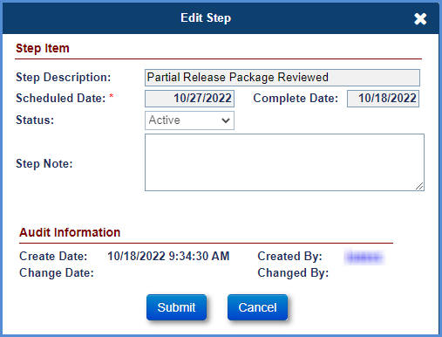
Figure 7-32: Endorsed - Requests - Extension – Partial Release - Edit Step
Once a decision has been made whether to approve, deny or request additional information. The HUD NSC Contractor will add the respective optional step.
To add an optional step (Approved, Denied, or Pending Additional Information), click New.
Select an optional step from the Sep Description dropdown (Contractor Recommendation - Approved, Contractor Recommendation -Denied, or Contractor Review - Pending Additional Info) that needs to be added on the timeline, populate the completion date, click Submit on the new window. The step will be added to the list of steps.
The HUD NSC Contractor will complete the step Recommendation Sent to HUD to let HUD know their recommendation. To complete the step, select the step and populate the completion date, add a note in the Notes field if applicable, click Submit on the Edit Step window.
HUD NSC staff must perform the following steps:
The HUD NSC staff will review the recommendation and make a decision.
Once a decision has been made about whether to approve, deny or request additional information. The HUD NSC staff will add the respective optional step.
To add an optional step (HUD Decision – Approved, HUD Decision – Approved with Contingency, HUD Decision - Denied, or HUD Decision – Pending Additional Info), click New.
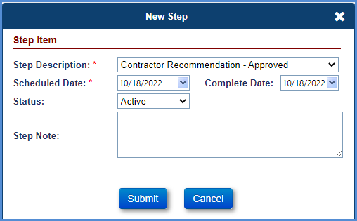
Figure 7-33: Endorsed - Requests - Extension – Partial Release - New Step
Select an optional step from the Step Description dropdown (HUD Decision – Approved, HUD Decision – Approved with Contingency, HUD Decision - Denied, or HUD Decision – Pending Additional Info) that needs to be added on the timeline, populate the completion date, click Submit on the new window. The step will be added to the list of steps.
The next steps must be completed by HUD NSC Contractor:
The HUD NSC Contractor will generate the Partial Release decision letter.
To generate the Partial Release Decision Letter, click the magnifying glass beside Servicer Notified of Decision, the Modify Letter Fields window is displayed. Edit the subject and salutation and select OK. The Partial Release Decision Letter is displayed. Note: The HUD decision chosen via the optional step will be pre-populated in this letter.
The printer icon beside the step allows the HUD Contractor to auto-save the document to the Documents tab. Select the printer icon, the Modify Letter Fields window is displayed. Edit the Subject and select “OK”. The Partial Release Decision Letter is displayed. This action auto-saves the document in the Documents tab and auto-completes the step.
If the HUD NSC staff requested more information, upon submission of the information, a HUD NSC Contractor reviews the additional documents requested and adds the optional step, Received Required Additional Information.
The HUD NSC Contractor updates the decision by selecting the appropriate optional step (approved, denied, or pending additional information) followed by the HUD NSC staff decision. If a servicer does not submit the required documents within 45 days from the initial decision, a HUD NSC Contractor adds the optional step, Follow Up on Pending Information.

Payoff Request
A servicer initiates this timeline to track the payoff request from the mortgagor to payoff his or her outstanding loan balance on a HECM loan. Upon the full payoff of the outstanding loan balance, a loan is terminated.
Multiple active Payoff Request timelines cannot be initiated on a loan. The Servicing Management tab can be used to inactivate the timeline. Once the timeline is inactivated, none of the steps can be edited.
To initiate and complete the Payoff Request timeline:
- From the Endorsed menu, select Requests and click Setup.
- On the Endorsed Requests Setup Search screen, enter the loan search criteria and click Search.
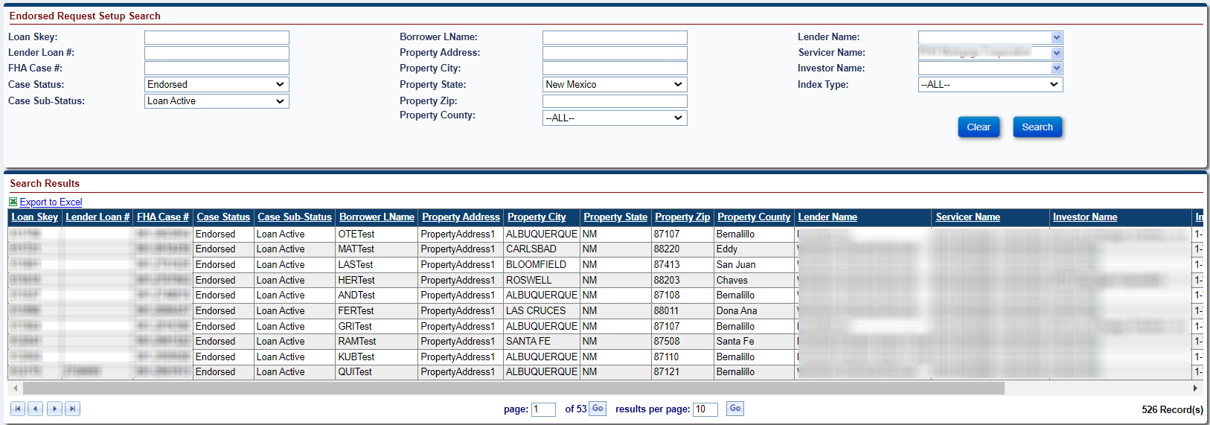
Figure 7-34: Endorsed - Requests - Setup Search
- From the search results, select a loan to initiate the timeline.
- From the Edit Servicing Management screen, select Payoff Requests from the Servicing Type dropdown and populate the required fields (marked with an asterisk).
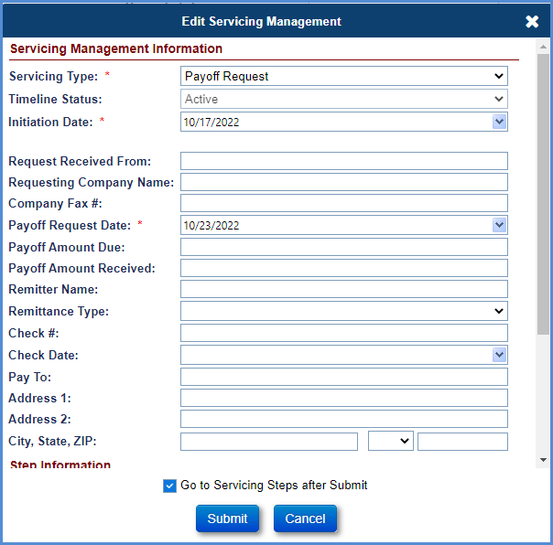
Figure 7-35: Endorsed - Requests - Payoff Request - Edit Servicing Management
- Click the Go to Servicing Steps after Submit checkbox at the bottom of the Edit Servicing Management screen.
- Click Submit. (If you click Cancel, the Endorsed Compliance Setup Search screen is displayed).
- The Requests Steps screen for Payoff Requests timeline is displayed.
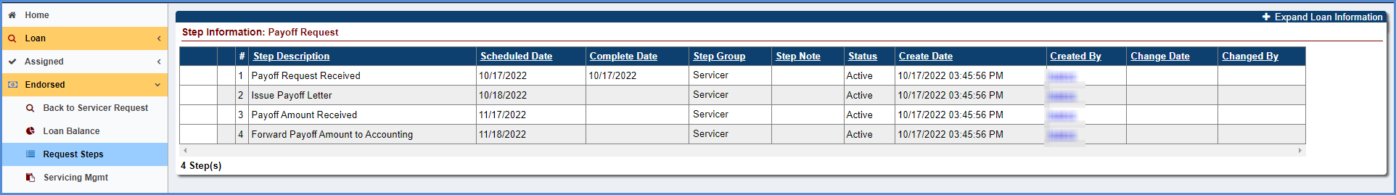
Figure 7-36: Endorsed - Requests - Payoff Request - Timeline Steps
- The step, Payoff Request Received completion date is pre-populated with the timeline created date.
- Complete the steps in the timeline when the activity corresponding to the step is complete. To complete any step in the timeline, click the step. (For example: Issue Payoff Letter).
- Populate the completion date, add a note in the Notes field if applicable, and click Submit on the Edit Step window.
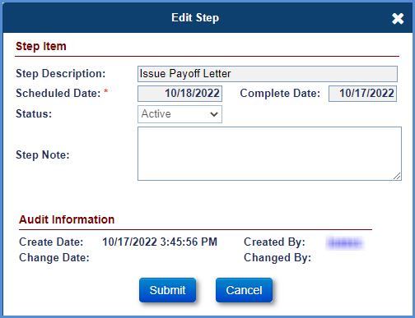
Figure 7-37: Endorsed - Requests - Payoff Request - Edit Step
- The completion date is populated beside the step Issue Payoff Letter on the Requests Steps screen.
- Repeat the steps above to complete the other remaining steps.

Preservation and Protection
TIP: Refer to section 5.21 “Property Preservation: Transactions and Timelines” for details on requesting and approvals within the Preservation and Protection timeline.

Request for HUD Advance (Assignment)
This timeline is located under Endorsed > Requests, Servicing Type “Request for HUD Advance (Assignment)”. The Servicer initiates the timeline and completes necessary steps to submit the Request. This timeline is initiated by a servicer when an unscheduled advance request from the mortgagor would push the loan balance greater than 100 percent of the maximum claim amount. This timeline can be initiated only if the pay plan type on the loan is modified term, modified tenure or line of credit. The case status must be Endorsed, and the case sub-status must be Loan Active. This timeline requires interaction with a HUD NSC Contractor.
Multiple active requests for HUD Advance (Assignment) timelines cannot be initiated on a loan. The Servicing Management tab can be used to activate or inactivate the timeline. Once the timeline is inactivated, none of the steps can be edited.

Timeline – Servicer Activities / Timeline Steps
TIP: Refer to section 7.1.2 “Setup Criteria to Initiate Timelines” for general steps to initiate timelines, and section 7.1.7 “To Complete Timeline Steps” for general information how to complete steps within a timeline.
The Servicer attaches all required documentation and completes the necessary steps on the timeline. The following Template Steps are displayed when the timeline is initiated:
- Unscheduled Request for Funds Received - pushes MCA > 100%
- Upload Request for HUD Advance Package
The following Optional Steps are available on this timeline. Refer to section 7.1.8 “To Add Optional Timeline Steps” for general information how to add and complete optional steps within a timeline:
- Assignment Denied / Payoff Issued
- Advance Denied - No Funds Issued

The following Trigger Steps are available on this timeline:
- Request for HUD Advance Received from Servicer
- Request for HUD Advance Processed
- Request for HUD Advance Voided

HUD NSC Contractor Activities
To Approve the Request:
- HUD NSC Contractor reviews the Servicer’s Request by completing step Request for HUD Advance Received from Servicer.
- If the advance request is Approved, the HUD NSC Contractor will create a disbursement “Unscheduled from LOC” on the loan and disburse the check (refer to Disbursement section in Chapter 6 of this User Guide to create the transaction).
- Complete the step Request for HUD Advance Processed. This changes the Timeline Status to Active Completed.
- Associated Timeline: If a servicer has already initiated the Claim Type 22 – Assignment timeline and submitted the Assignment package, HUD NSC Staff will complete the step Assignment Package Received step on the CT 22.
To Deny the Request:
- HUD NSC Contractor reviews the Servicer’s Request by completing step Request for HUD Advance Received from Servicer.
- If the advance request is Denied, the HUD NSC Contractor will add and complete Optional Step Advance Denied - No Funds Issued
- If the Assignment is denied and the Funds Due HUD step is triggered on CT 22 timeline, a HUD NSC Contractor will add the optional step Assignment Denied / Payoff Issued.

Servicer Activities after HUD NSC Contractor Denial
After HUD NSC Contractor Approves the Request:
- The Servicer must go to the Accounting > Authorizations tab and enter the Loan Skey or FHA Case # and click on Search.
- Click on the selected the Search Result to display an Authorization screen to Approve or Cancel the request.
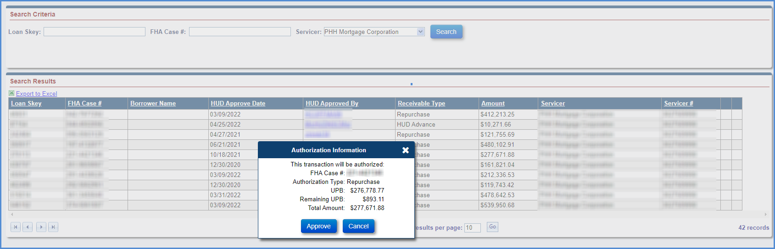
Figure 7-38: Accounting - Authorization – Request for HUD Advance (Assignment)
- Upon clicking Approve, the step Servicer Authorizes Repayment of Claim is automatically added by the system and auto-completed when the following criteria are satisfied: The Servicer authorizes / approves the transaction in the step above via the Accounting – Authorizations screen (authorized by lender/investor/servicer).
Important information:
- Servicers will not be able to terminate a loan until all outstanding HUD Advances have been authorized and paid back.
- HUD NSC Manager will not be able to Inactivate a Timeline once the Step “Request for HUD Advance Processed” is completed.
- The step HUD Verifies Repayment of HUD Advance is automatically added by the system and auto-completed when the following criteria are satisfied: Confirmation received from the AM that the collection has been successfully made for the receivable request and the FHA Case for the Batch moves to Settled status from Pre Settled Status. The case will change from a Pre Settled status to a Settled status on the same day the confirmation is received from the AM. HUD may change the calendar day setting in Pre Settled status at any time. Currently, there is no delay in HERMIT moving from Pre Settled to Settled. Once Settled, the case sub-status changes to the prior servicing's sub status..
- An Auto note is added to the Notes Section HUD verifies Repayment of HUD Advance once the Batch Status for the FHA Case changes to Settled after ten calendar days.

Subordination
HUD’s second mortgage is subordinate to a lender’s mortgage. If it is determined that the first and second mortgages are recorded out of order, a servicer initiates a subordination timeline in order to make the correction. The loan must be in an Endorsed status to begin the subordination process. A servicer initiates the timeline and HUD will approve the subordination agreement.
Multiple active Subordination timelines cannot be initiated on a loan. The Servicing Management tab can be used to activate or inactivate the timeline. Once the timeline is inactivated, none of the steps can be edited.
To initiate and complete the Subordination timeline:

Initiate Timeline – Servicer Activities
The servicer must perform the following steps to initiate the timeline:
- The Servicer will initiate the timeline. From the Endorsed menu, select Request and click Setup.
- On the Endorsed Request Setup Search Screen, enter the loan search criteria and click Search.
Figure 7-39: Endorsed - Requests - Setup Search
From the search results, select a loan to initiate the timeline.
On the Edit Servicing Management screen, select Subordination from the Servicing Type dropdown and populate the required fields (marked with an asterisk).
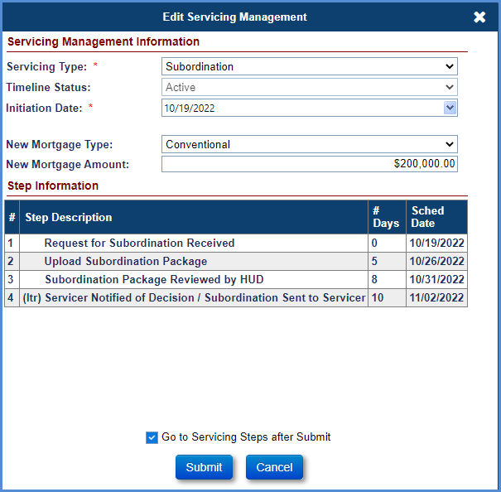
Figure 7-40: Endorsed - Requests - Subordination - Edit Servicing Management

Click the Go to Servicing Steps after Submit checkbox (at the bottom of the Edit Servicing Management screen).
Click Submit. (If you click Cancel, the Endorsed Request Setup Search Screen will be displayed).
The Request Steps screen for Subordination timeline is displayed.
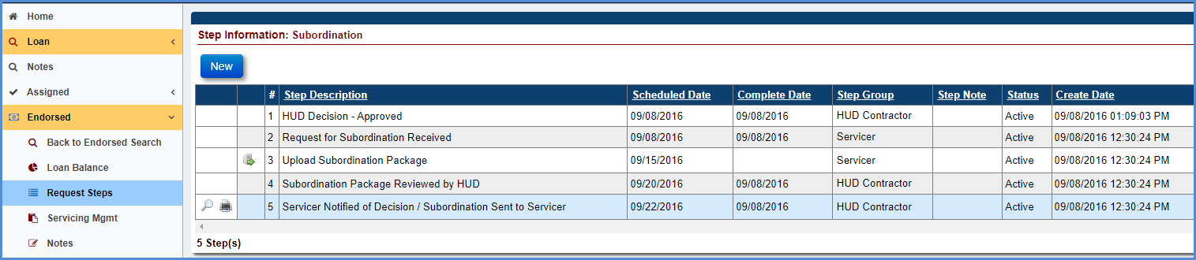
Figure 7-41: Endorsed - Requests - Subordination - Timeline Steps
The step Request for Subordination Received completion date is pre-populated with the timeline created date.
For the step Upload Subordination Package, the completion date will be pre-populated with the current system date. For this step, a servicer must upload the Subordination Package document. The step cannot be completed without attaching the required document. Once the document is attached, a servicer will click Submit for the document to be attached.
A PDF icon is added next to the step. Select the PDF icon to view the attached document. This document is also auto-saved in the Documents tab.
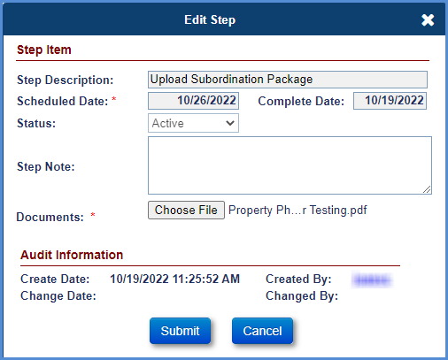
Figure 7-42: Endorsed - Requests - Subordination - Edit Step

HUD NSC Staff Activities
HUD NSC Staff must perform the following steps:
- Upon completion of Subordination package review, HUD NSC Staff will complete the step Subordination Package Reviewed by HUD. To complete the step, select it and populate the completion date, add a note in the Notes field if applicable, click Submit on the Edit Step window.
- Once a decision has been made about whether to approve, deny or request additional information, the HUD NSC Contractor will add the respective optional step.
- To add an optional step (HUD Decision-Approved, HUD Decision-Denied, or HUD Decision-Pending Additional Information), click New.
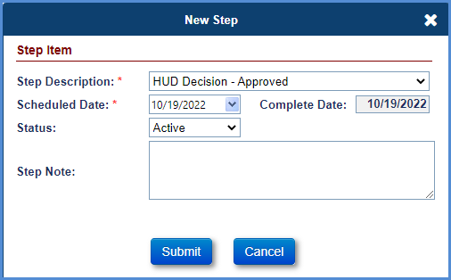
Figure 7-43: Endorsed - Requests - Subordination - New Step
Select an optional step from the Step Description dropdown that needs to be added on the timeline, populate the completion date, and click Submit on the New Step window. The step will be added to the list of steps.
To generate the Subordination Agreement Letter, click the magnifying glass beside Servicer Notified of Decision / Subordination Sent to Servicer. The Modify Letter Fields window is displayed. Edit the subject and salutation and click OK. The Subordination Agreement Letter is displayed. The decision chosen via the optional step will be pre-populated in this letter.
The printer icon beside the step allows the HUD Contractor to auto-save the document to the Documents tab. Select the printer icon, the Modify Letter Fields window is displayed. Edit the Subject and select OK. The Subordination Agreement Letter is displayed. This action auto-saves the document in the Documents tab and auto-completes the step.

Substitution of Collateral
This timeline is initiated by the Servicer. The request is reviewed, and a recommendation is made by a HUD NSC Contractor to HUD. A HUD staff member reviews a HUD NSC Contractor recommendation and the submitted documents and makes a decision. This timeline requires Servicer, HUD NSC Contractor and HUD interaction.
Multiple active Substitution of Collateral timelines cannot be initiated on a loan. The Servicing Management tab can be used to activate or inactivate the timeline and update reasons for Substitution of Collateral, recoverable funds, and description of event that occurred. Once the timeline is inactivated, none of the steps can be edited.
To initiate and complete the Substitution of Collateral timeline:

Initiate Timeline – Servicer Activities
The servicer must perform the following steps to initiate the timeline:
- On the Endorsed menu, select Request, and click Setup.
On the Endorsed Request Setup Search Screen, enter the loan search criteria and click Search.

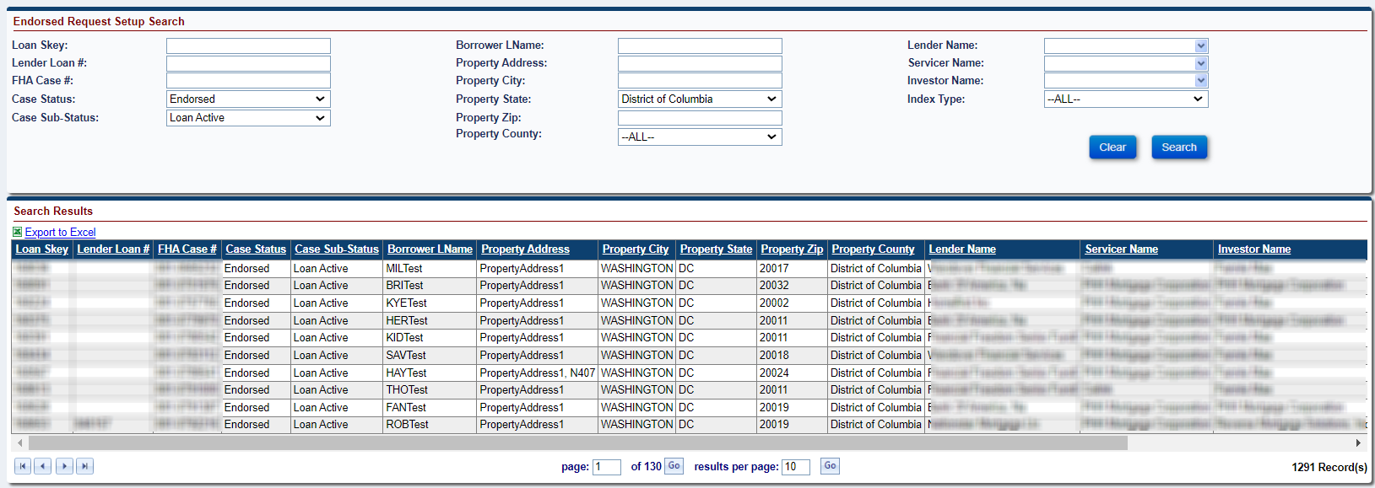
Figure 7-44: Endorsed - Requests - Setup Search
From the search results, select a loan to initiate the timeline.

On the Edit Servicing Management screen, select Substitution of Collateral from the Servicing Type dropdown and populate the required fields (marked with an asterisk).
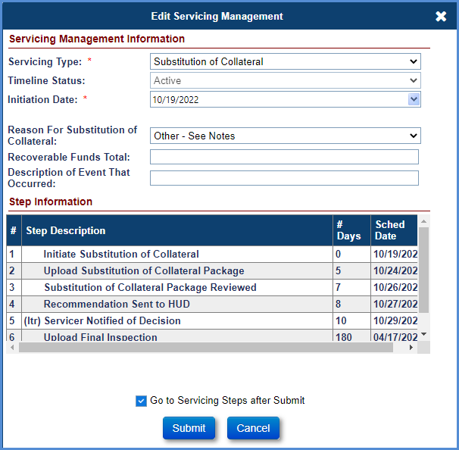
Figure 7-45: Endorsed - Requests - Extension – Substitution of Collateral - Edit Servicing Management
Select or enter details of the Substitution of Collateral such as reasons for Substitution of Collateral, recoverable funds, and description of event that occurred. These details can be edited on the Servicing Management tab after initiation of the timeline. Click the Go to Servicing Steps after Submit checkbox (at the bottom of the Edit Servicing Management screen).
Click Submit. (If you click Cancel, the Endorsed Request Setup Search screen will be displayed).
The Request Steps screen for Substitution of Collateral timeline is displayed.
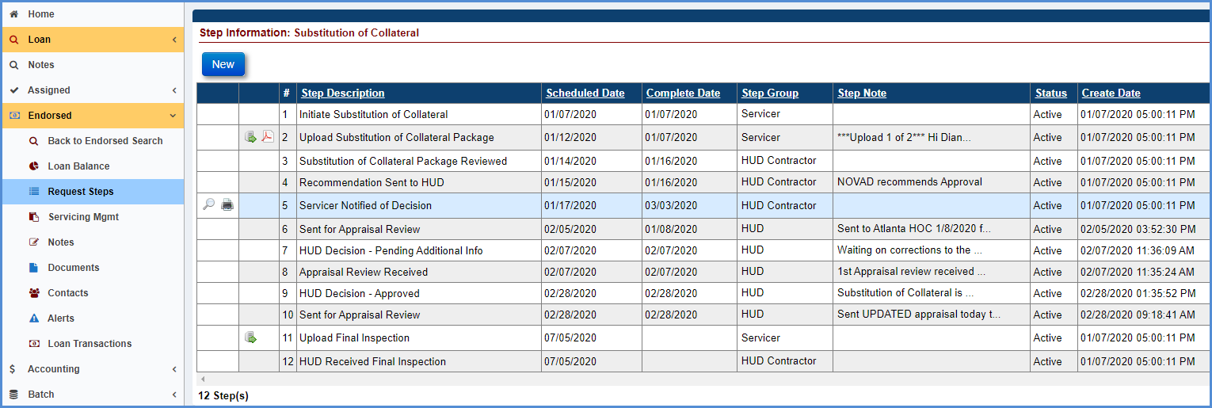
Figure 7-46: Endorsed - Requests - Extension – Substitution of Collateral - Timeline Steps
The Step Initiate Substitution of Collateral completion date is pre-populated with the timeline created date.
For Step Upload Substitution of Collateral Package, the servicer must upload the Substitution of Collateral Package documents. The step cannot be completed without attaching the required documents. Once the documents are attached, the servicer will click Submit for the document to be attached. A PDF icon is added next to the step; select this icon to view the attached document. This document is also auto-saved in the Documents tab.

HUD NSC Contractor and HUD NSC Staff Activities
HUD NSC Contractor and HUD NSC Staff must perform the following steps:
- Upon completion of the Substitution of Collateral package review, a HUD NSC Contractor will complete the step Substitution of Collateral Package Reviewed. To complete the step, select the step and populate the completion date, add a note in the Notes field if applicable, click Submit on the Edit Step window.
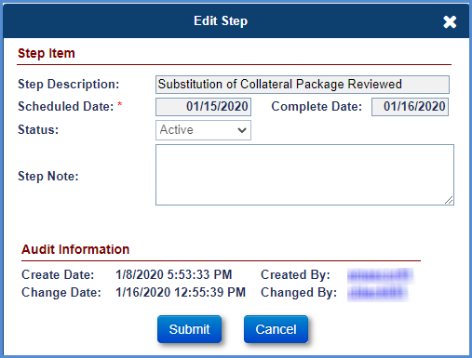
Figure 7-47: Endorsed - Requests - Extension – Substitution of Collateral - Edit Step
Once a decision has been made whether to approve, deny or request additional information., the HUD NSC Contractor will add the respective optional step.
To add an optional step (Approved, Denied, or Pending Additional Information), click New.
Select an optional step from the Step Description dropdown (Contractor Recommendation - Approved, Contractor Recommendation -Denied, or Contractor Review - Pending Additional Info) that needs to be added on the timeline, populate the completion date, click Submit on the new window. The step will be added to the list of steps.
The HUD NSC Contractor will complete the step Recommendation Sent to HUD to let HUD know their recommendation. To complete the step, select the step and populate the completion date, add a note in the Notes field if applicable, click Submit on the Edit Step window.
HUD NSC staff must perform the following steps:
The HUD NSC staff will review the recommendation and make a decision.
Once a decision has been made to approve, deny, or request additional information, the HUD NSC staff will add the respective optional step.
To add an optional step (HUD Decision – Approved, HUD Decision – Approved with Contingency, HUD Decision - Denied, or HUD Decision – Pending Additional Info), click New.
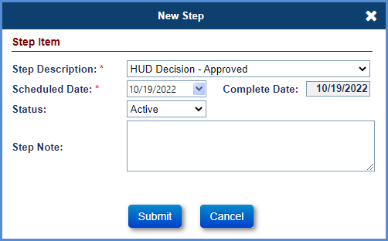
Figure 7-48: Endorsed - Requests - Extension – Substitution of Collateral - New Step
Select an optional step from the Step Description dropdown (HUD Decision – Approved, HUD Decision – Approved with Contingency, HUD Decision - Denied, or HUD Decision – Pending Additional Info) that needs to be added on the timeline, populate the completion date, click Submit on the new window. The step will be added to the list of steps.
The next steps must be completed by HUD NSC Contractor:
The HUD NSC Contractor will generate the Substitution of Collateral decision letter.
To generate the Substitution of Collateral Decision Letter, click the magnifying glass beside Servicer Notified of Decision, the Modify Letter Fields window is displayed. Edit the subject and salutation and select OK. The Substitution of Collateral Decision Letter is displayed. Note: The HUD decision chosen via the optional step will be pre-populated in this letter.
The printer icon beside the step allows the HUD Contractor to auto-save the document to the Documents tab. Select the printer icon, the Modify Letter Fields window is displayed. Edit the Subject and select “OK”. The Substitution of Collateral Decision Letter is displayed. This action auto-saves the document in the Documents tab and auto-completes the step.
If the HUD NSC staff requested more information, upon submission of the information, a HUD NSC Contractor reviews the additional documents requested and adds the optional step, Received Required Additional Information.
The HUD NSC Contractor updates the decision by selecting the appropriate optional step (Contractor Recommendation - Approved, Contractor Recommendation - Denied, or Contractor Recommendation - Pending Additional Info) followed by the HUD NSC staff decision. If a servicer does not submit the required documents within 45 days from the initial decision, a HUD NSC Contractor adds the optional step, Follow Up on Pending Information.

Zero Balance
When a payoff statement is requested on HUD's second mortgage, the HUD NSC contractor initiates this timeline to show that there are no funds advanced under the second note. This timeline is initiated and completed by a HUD NSC contractor. There is no interaction with the servicer.
Multiple active Zero Balance timelines can be initiated on a loan. The Servicing Management tab can be used to activate or inactivate the timeline. Once the timeline is inactivated, none of the steps can be edited.
To initiate and complete the Zero Balance timeline:
- From the Endorsed menu, select Request, and click Setup.
- On the Endorsed Request Setup Search Screen, enter the loan search criteria and click Search.
Figure 7-49: Endorsed - Requests - Setup Search
- From the search results, select a loan to initiate the timeline.
- On the Edit Servicing Management screen, select Zero Balance from the Servicing Type dropdown and populate the required fields (marked with an asterisk).
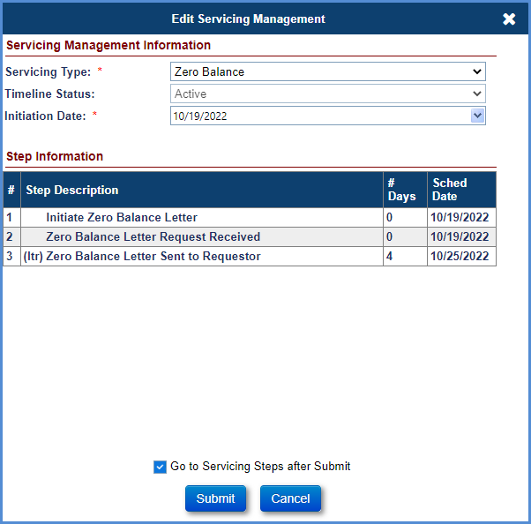
Figure 7-50: Endorsed - Requests - Zero Balance - Edit Servicing Management
- Click the Go to Servicing Steps after Submit checkbox (at the bottom of the Edit Servicing Management screen).
- Click Submit. (If you click Cancel, the Endorsed Request Setup Search Screen will be displayed).
- The Request Steps screen for Zero Balance timeline is displayed.
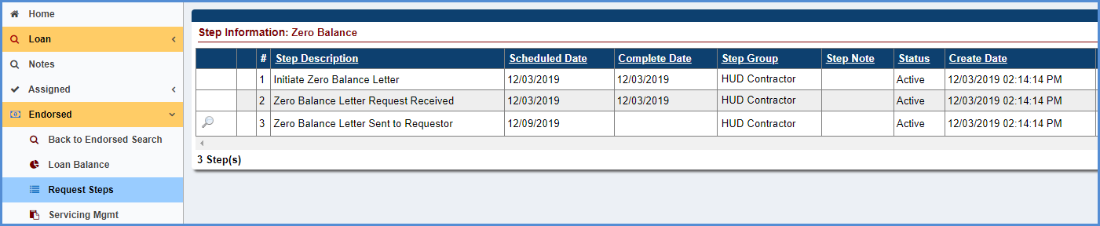
Figure 7-51: Endorsed - Requests - Zero Balance - Timeline Steps
- The step Initiate Zero Balance Letter completion date is pre-populated with the timeline created date.
- Complete the steps in the timeline when activity corresponding to the step is complete. To complete any step in the timeline, click the step (For example: Zero Balance Letter Request Received).
- Populate the completion date, add a note in the Notes field if applicable, and click Submit on the Edit Step window.
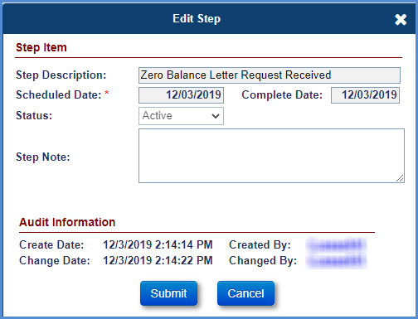
Figure 7-52: Endorsed - Requests - Zero Balance - Edit Step
- The completion date is populated beside the step Zero Balance Letter Request Received on the Request Steps screen.
- Click the magnifying glass beside the step Zero Balance Letter Sent to Requestor to update and print the Zero Balance Letter.
- A new window is displayed with the Zero Balance Letter with options to preview or print the document. Update the letter, and once the changes have been made, select the Preview Document link to view the updated document. To auto-save the changes made to the document, select the Print Document link. Select Open on the File Download window. This action will save the updated Zero Balance Letter to the Documents tab. Refresh the screen to auto-complete the step.
- Select the Document tab to view the updated version of the Zero Balance Letter. Version history is maintained on the Documents tab each time the Print Document link is selected.

Foreclosure Timeline
This timeline is located under Endorsed > Foreclosure, Servicing Type “Foreclosure” and is initiated by a servicer to track the foreclosure process and the proceeds of the sale are issued to repay the debt. When this timeline is initiated, the case sub-status is updated to Foreclosure-Endorsed. If the timeline is inactivated the case sub-status is updated accordingly.
Multiple active foreclosure timelines cannot be initiated on a loan. The Servicing management tab can be used to activate or inactivate the timeline and edit the foreclosure information. Once a timeline is inactivated, none of the steps can be edited.
TIP: Refer to section 7.1.2 “Setup Criteria to Initiate Timelines” for general steps to initiate timelines, and section 7.1.7 “To Complete Timeline Steps” for general information how to complete steps within a timeline.
Foreclosure Timelines Steps and Scheduled Dates are based on Property State and are not identical among different states. An example of Template Steps that are displayed when the timeline is initiated (list for Property State AL):
- Refer to Counsel
- Notice of Sale
- Prepare FCL Bid Amt
- Obtain Approval of FCL Bid Amt
- Foreclosure Sale Appraisal Date
- Foreclosure Sale Date
- Redemption Expires
- Record Deed
- Final Title

Optional Steps on the Foreclosure timeline are the same for all Property States. Refer to section 7.1.8 “To Add Optional Timeline Steps” for general information how to add and complete optional steps within a timeline.
Available Optional Steps are:
- 3rd Party Funds Recd
- Contested Litigation
- Eviction Initiation
- Eviction Restriction Expired
- File Received - Power of Sale
- Follow Up
- Foreclosure Hold
- Foreclosure Resume
- Foreclosure Sale Postponed/Restarted
- Notice of Default
- Obtain Appraisal- 15 days prior the end of 6 Month Marketing Period
- Obtain Marketable Title
- Order BPO
- Order Property Inspection
- Record Substitution of Trustee
- Refer to Attorney
- Sale Postponed
- Sale Publication
- Statement of Account – Optional HUD step
- Submit Affidavit
TIP: Step Foreclosure Sale Postponed/Restarted is used to report when an original Foreclosure Sale Date has been rescheduled or postponed. The step completion date of this step may be edited after the step has been completed.

Bankruptcy Timelines
The following timelines are available under Endorsed > Bankruptcy:
- Bankruptcy - Chapter 13
- Bankruptcy - Chapter 7

Bankruptcy - Chapter 13
This timeline is located under Endorsed > Bankruptcy, Servicing Type “Bankruptcy – Chapter 13” and is initiated by a servicer when a Chapter 13 bankruptcy is filed where the court appoints a trustee and establishes a payment plan under a reorganization agreement. Upon initiation of this timeline, the case sub-status is updated to Bankruptcy/Chapter 13.
Multiple active Bankruptcy – Chapter 13 timelines cannot be initiated on a loan. The Servicing Management tab can be used to inactivate the timeline. Once the timeline is inactivated, none of the steps can be edited.
TIP: Refer to section 7.1.2 “Setup Criteria to Initiate Timelines” for general steps to initiate timelines, and section 7.1.7 “To Complete Timeline Steps” for general information how to complete steps within a timeline.
The Servicer attaches all required documentation and completes the necessary steps on the timeline. The following Template Steps are displayed when the timeline is initiated:
- BNK Filed - Chapter 13
- Bankruptcy Notification is Received
- Copy of Voluntary Petition is Received
- Plan Filed
- Copy of Plan received
- Print Proof of Claim
- File Proof of Claim
- Conf Hearing Date
- Plan is Confirmed
The following Optional Steps are available on this timeline. Refer to section 7.1.8 “To Add Optional Timeline Steps” for general information how to add and complete optional steps within a timeline:
- Abandonment Filed
- BNK Transfer - Chapter 13
- Confirmation Pending
- Consent Order/Stipulation
- Contested action
- Discharged
- Dismissed
- File Motion For Relief
- File Notice of Appearance
- File Notice of Assignment
- File Reaffirmation Agreement
- Late Filed Claim Allowed
- Late Filed Proof of Claim
- Monthly Payments Not Made
- Motion For Relief Denied
- Motion For Relief Granted
- Motion For Relief Hearing
- Motion to Dismiss
- Motion to Sell Property
- Notice of Disposition
- Order BPO
- Order Property Inspection
- Plan is Completed
- Prepare Assignment
- Prepare Reaffirmation Agreement
- Proof of Claim Filed by Others
- Property Surrendered
- Reaffirmation Agreement Approved
- Refer to Attorney
- Requested Motion For Relief
- Research
- Send Proof of Claim to Counsel
- Statement of Account – Optional HUD step
- Transfer of Claim Issue

Bankruptcy - Chapter 7
This timeline is located under Endorsed > Bankruptcy, Servicing Type “Chapter 7” and is initiated by a servicer when a Chapter 7 bankruptcy is filed which releases the mortgagor from unsecured liabilities and retains their secured debt. When this timeline is initiated, the case sub-status is updated to Bankruptcy/Chapter 7. If the timeline is inactivated, the case sub-status is updated accordingly.
Multiple active Bankruptcy–Chapter 7 timelines cannot be initiated on a loan. The Servicing Management tab can be used to inactivate the timeline. Once the timeline is inactivated, none of the steps can be edited.
TIP: Refer to section 7.1.2 “Setup Criteria to Initiate Timelines” for general steps to initiate timelines, and section 7.1.7 “To Complete Timeline Steps” for general information how to complete steps within a timeline.
The Servicer attaches all required documentation and completes the necessary steps on the timeline. The following Template Steps are displayed when the timeline is initiated:
- BNK Filed - Chapter 7
- Bankruptcy Notification is Received
- Copy of Voluntary Petition is Received
- File Statement of Intent
- 341 Hearing
- File Proof of Claim
The following Optional Steps are available on this timeline. Refer to section 7.1.8 “To Add Optional Timeline Steps” for general information how to add and complete optional steps within a timeline:
- Abandonment Filed
- Confirmation Pending
- Consent Order/Stipulation
- Contested Action
- Discharged
- Dismissed
- File Motion For Relief
- File Notice of Appearance
- File Notice of Assignment
- Follow Up
- Late Filed Claim Allowed
- Late Filed Proof of Claim
- Monthly Payments Not Made
- Motion For Relief Denied
- Motion For Relief Granted
- Motion For Relief Hearing
- Motion to Dismiss
- Motion to Sell Property
- Notice of Disposition
- Order BPO
- Order Property Inspection
- Plan is Completed
- Prepare Assignment
- Proof of Claim Filed by Others
- Property Surrendered
- Reaffirmation Agreement Approved
- Reaffirmation Agreement Filed
- Refer to Attorney
- Request Motion For Relief
- Research
- Statement of Account – Optional HUD step
- Transfer of Claim Issue
The following Servicing Mgmt fields are required for this timeline during timeline initiation/ setup, in addition to Initiation Date:
- State Filed
- Bankruptcy District

Release Timelines (Endorsed)

Release 2nd (Release of HUD's Second Mortgage)
This timeline is automatically initiated by the system when a loan status is terminated. The timeline can also be initiated by a user if the specific criteria are met for loans with Loss Mitigation timelines.
- For termination by non-claim: The case status is updated to Terminated after the creation of termination transaction on loan by a servicer.
- For termination by claim: The case status is updated to Terminated after the claim payment confirmation is received from the AM (claim is submitted by a servicer and approved by HUD claims staff).
The timeline will not be auto-initiated if any of the following applies:
- The case sub-status is “Terminate – CT 21”
- An Active Release 2nd Timeline already exists on the loan
- The Pay Plan Type is Lump Sum with Rate Type Fixed, and FHA Case # was issued on or after 6/25/2014.
HUD NSC Contractor will complete the steps within the timeline after system initiation. There is no interaction with the servicer. Multiple active Release 2nd timelines cannot be initiated on a loan. The Servicing Management tab can be used to activate or inactivate the timeline. Once the timeline is inactivated, none of the steps can be edited.
To initiate and complete the Release 2nd timeline:
- From the Endorsed menu, select Release, and click Search.
On the Endorsed Release Search Screen, enter the search criteria and click Search to retrieve the timelines that have been auto-initiated by the system.
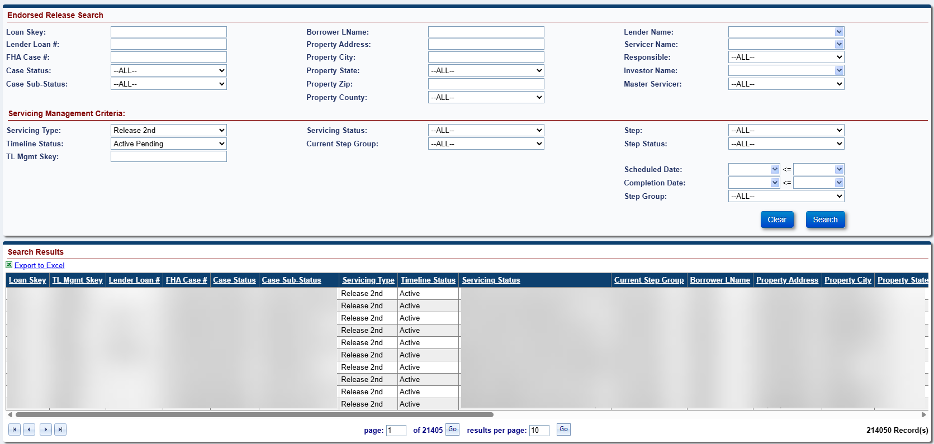

Figure 7-53: Endorsed - Release - Search – Release 2nd
From the search results, select a loan to view or edit the timeline.
The Release Steps screen for Release 2nd timeline is displayed.
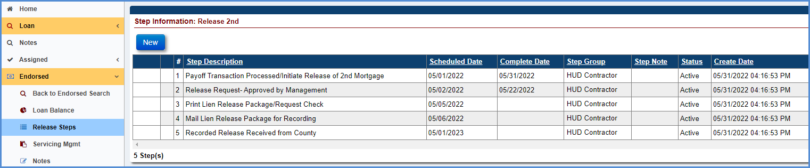
Figure 7-54: Endorsed - Release – Release 2nd - Timeline Steps
The Step Payoff Transaction Processed/Initiate Release of 2nd Mortgage completion date is pre-populated with timeline created date.
Complete the steps in the timeline when activity corresponding to the step is complete. To complete any step in the timeline, click the step, for example, Release Request – Approved by Management.
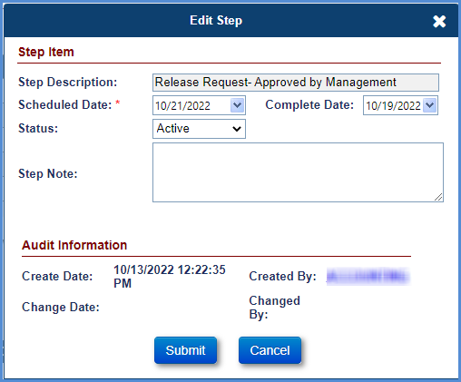
Figure 7-55: Endorsed - Release – Release 2nd – Edit Step
Populate the completion date, add a note in the Notes field if applicable, and click Submit on the Edit Step window.
The completion date is populated beside the step Release Request – Approved by Management on the Release Steps screen.
Repeat the steps above to complete the remaining steps.
The system will automatically Inactivate the timeline upon completion of the step Recorded Release Received from County.
To add an optional step, click New.
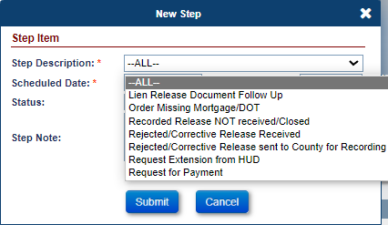
Figure 7-56: Endorsed - Release – Release 2nd – New Step
Select an optional step from the Step Description dropdown that needs to be added on the timeline and click Submit on the new window. The step will be added to the list of steps.
To complete the step, select the step and populate the completion date, add a note in the Notes field if applicable, click Submit on the Edit Step window.
Repeat the above instructions to add and complete other optional steps.
The step Received Missing Mortgage/Deed of Trust (DOT) is automatically added by the system. To add this step automatically by the system, the following criteria must be satisfied: The optional step Order Missing Mortgage/DOT must be added on the timeline.
To add the optional step Order Missing Mortgage/DOT, click New.
An Auto note is added in the Notes Section upon completion of any step.

Claims Timelines (Endorsed)
See Chapter 8 for details on Endorsed > Claims Timelines.

Assigned Timelines

Compliance Timelines
The following Assigned > Compliance timelines are available:
- Insurance - Flood Policy
- Insurance - Hazard Policy
- Insurance/Hardest Hit Funds Administration
- Insurance/Loss Draft Administration
- Occupancy Compliance Certification
- Request for Payment
- Request for Unscheduled Advance
- Taxes Delinquent

Insurance - Flood Policy
This timeline is located under Assigned > Compliance, Servicing Type “Insurance –Flood Policy”. If a mortgaged property is located within a flood zone, the mortgagor should meet the flood insurance requirements in an amount acceptable by HUD. A HUD NSC Contractor initiates this timeline to verify actions required to comply with flood insurance requirements. Upon initiation of this timeline, the case sub-status does not change.
Multiple active Insurance – Flood Policy timelines cannot be initiated on a loan by a user, but in certain conditions it is permitted for the system to create another timeline before the prior one is inactive. The Servicing Management tab can be used to inactivate the timeline. Once the timeline is inactivated, none of the steps can be edited and the timeline cannot be reactivated.
TIP: Refer to section 7.1.2 “Setup Criteria to Initiate Timelines” for general steps to initiate timelines, and section 7.1.7 “To Complete Timeline Steps” for general information how to complete steps within a timeline.
The HUD NSC Contractor attaches all required documentation and completes the necessary steps on the timeline. The following Template Steps are displayed when the timeline is initiated:
- Policy Effective
- Insurance Declaration Received
- Policy Expires
The following Optional Steps are available on this timeline. Refer to section 7.1.8 “To Add Optional Timeline Steps” for general information how to add and complete optional steps within a timeline:
- Generate Mortgagee Clause
- Received Notification of Policy Cancellation
- Return Receipt Received from Borrower
- Received Notification of Policy Reinstatement
- Renewal Insurance Declaration Received
- Follow Up

The following Trigger and Automated Steps are available on this timeline:
- Mail Certified Letter to Borrower - Policy Cancellation
- Mail Renewal Verification Letter
- Send 2nd Request for Policy Verification
- Mail Certified Letter to Borrower – Policy Expiration
- Review for Due & Payable
- Renewal Insurance Declaration Effective

The following additional Servicing Mgmt fields are available for this timeline:
- Policy #
- Premium
- Effective Start Date
- Effective End Date
- Company Name
- Agent Name
- Tax ID
- Address 1
- Address 2
- City
- State, Zip
- Email
- Website URL
- Phone #
- Fax #

Insurance - Hazard Policy
This timeline is located under Assigned > Compliance, Servicing Type “Insurance –Hazard Policy”. A mortgagor is required to maintain hazard insurance in an amount acceptable to HUD. The HUD NSC Contractor initiates this timeline to verify compliance with insurance requirements. This timeline is automatically created when a loan is established. However, it can also be initiated manually to track the renewal after the initial timeline. The system sends alerts to a HUD NSC Contractor 30 days before the expiration of the certificate of insurance. Upon initiation of this timeline, the case sub-status does not change.
Multiple active Insurance – Hazard Policy timelines cannot be initiated on a loan by a user, but in certain conditions it is permitted for the system to create another timeline before the prior one is inactive. The Servicing Management tab can be used to inactivate the timeline. Once the timeline is inactivated, none of the steps can be edited and the timeline cannot be reactivated.
TIP: Refer to section 7.1.2 “Setup Criteria to Initiate Timelines” for general steps to initiate timelines, and section 7.1.7 “To Complete Timeline Steps” for general information how to complete steps within a timeline.
The HUD NSC Contractor attaches all required documentation and completes the necessary steps on the timeline. The following Template Steps are displayed when the timeline is initiated:
- Policy Effective
- Insurance Declaration Received
- Policy Expires
The following Optional Steps are available on this timeline. Refer to section 7.1.8 “To Add Optional Timeline Steps” for general information how to add and complete optional steps within a timeline:
- Generate Mortgagee Clause
- Received Notification of Policy Cancellation
- Return Receipt Received from Borrower
- Received Notification of Policy Reinstatement
- Renewal Insurance Declaration Received
- Follow Up
The following Trigger and Automated Steps are available on this timeline:
- Mail Certified Letter to Borrower - Policy Cancellation
- Mail Renewal Verification Letter
- Send 2nd Request for Policy Verification
- Mail Certified Letter to Borrower – Policy Expiration
- Review for Due & Payable
- Renewal Insurance Declaration Effective
The following additional Servicing Mgmt fields are available for this timeline:
- Policy #
- Premium
- Effective Start Date
- Effective End Date
- Company Name
- Agent Name
- Tax ID
- Address 1
- Address 2
- City
- State, Zip
- Email
- Website URL
- Phone #
- Fax #

Insurance/Hardest Hit Funds Administration
This timeline is located under Assigned > Compliance, Servicing Type “Insurance/Hardest Hit Funds Administration” and is initiated by the HUD NSC Contractor in the immediate aftermath of a declared disaster when mortgagors may be eligible to participate in the Hardest Hit Funds program. HUD will work with the mortgagor to determine how the proceeds will be used. Upon initiation of this timeline, the case sub-status does not change.
This timeline can be initiated only if Hardest Hit funds are available. The system will automatically add the initial timeline when the Hardest Hit Funds transaction is created on the loan. TIP: Refer to the Disbursements – Hardest Hit Funds transactions for details about how to generate the transaction.
Multiple active Insurance/Hardest Hit Funds Administration timelines can be initiated on a loan. The Servicing Management tab can be used to activate or inactivate the timeline. Once the timeline is inactivated, none of the steps can be edited.
TIP: Refer to section 7.1.7 “To Complete Timeline Steps” for general information how to complete steps within a timeline.
The Contractor will navigate to the Assigned Compliance Search Screen, enter the search criteria, including a Servicing Type of Insurance/Hardest Hit Funds Administration and click Submit to retrieve the timelines that have been auto-initiated by the system. The contractor completes the necessary steps on the timeline. The following Template Steps are displayed when the timeline is initiated. The steps are HUD steps unless otherwise stated
- Initiate Hardest Hit Funds Administration
- Disburse Final Funds
The following Optional Steps are available on this timeline. Refer to section 7.1.8 “To Add Optional Timeline Steps” for general information how to add and complete optional steps within a timeline. The steps are HUD steps unless otherwise stated
- Disburse Funds - Taxes
- Disburse Funds – Insurance

Insurance/Loss Draft Administration
This timeline is located under Assigned > Compliance, Servicing Type “Insurance/Loss Draft Administration”. The mortgagor files a claim with their hazard insurance company when the HECM property has been damaged by fire, flood, windstorm, or similarly insurable hazards. HUD will work with the mortgagor to determine how the insurance proceeds will be used. If it is determined that the property will be repaired, this timeline will be initiated by HUD NSC Contractor to monitor the restoration process and ensure the appropriate use of the insurance claim funds. Upon initiation of this timeline, the case sub-status does not change.
This timeline can be initiated only if loss draft funds are available. The system will automatically add the initial timeline when the Loss Draft transaction is created on the loan. Refer to the Disbursements – Loss Draft transactions for details about how to generate the transaction. This timeline does not require HUD NSC Staff interaction.
Multiple active Insurance/Loss Draft Administration timelines can be initiated on a loan. The Servicing Management tab can be used to activate or inactivate the timeline. Once the timeline is inactivated, none of the steps can be edited.
TIP: Refer to section 7.1.2 “Setup Criteria to Initiate Timelines” for general steps to initiate timelines, and section 7.1.7 “To Complete Timeline Steps” for general information how to complete steps within a timeline.
The HUD NSC Contractor attaches all required documentation and completes the necessary steps on the timeline. The following Template Steps are displayed when the timeline is initiated:
- Initiate Insurance/Loss Draft Administration
The following Optional Steps are available on this timeline. Refer to section 7.1.8 “To Add Optional Timeline Steps” for general information how to add and complete optional steps within a timeline:
- Issue Initial Disbursement of Repair Funds
- Issue Subsequent Disbursement of Repair Funds
- Issue Final Disbursement of Repair Funds
- Order Supplemental Repair Inspection
- Follow Up
- Repairs will not be Completed – Review for D&P
- Prepare for Final Disbursement of Repair Funds
- Missing Lien Waiver
- Missing Adjuster's Report
- Missing Contract
The following Trigger and Automated Steps are available on this timeline:
- Verify Contract / Adjuster's Report Received
- Order Repair Inspection
- Lien Waiver Received
- Repair Inspection Received
- Review for Disbursement of Repair Funds
- Order Subsequent Repair Inspection
- Subsequent Repair Inspection Received
- Transfer of Repair Funds to Loan Balance
- Send Lien Waiver
- Supplemental Repair Inspection Received
The following additional Servicing Mgmt fields are available for this timeline:
- Loss Draft Funds
- Contractor
- Total Disbursements
- Inspector
- Remaining Balance

Occupancy Compliance Certification
This timeline is located under Assigned > Compliance, Servicing Type “Occupancy Compliance Certification” and is initiated by the NSC Contractor to track the HUD required occupancy inspection process. This timeline is automatically initiated when a loan is established and can also be initiated manually to track the annual occupancy compliance. Upon initiation of this timeline, the case sub-status does not change.
Multiple active Occupancy Compliance timelines cannot be initiated on a loan. The Servicing Management tab can be used to activate or inactivate the timeline and edit inspection information. Once the timeline is inactivated, none of the steps can be edited.
TIP: Refer to section 7.1.2 “Setup Criteria to Initiate Timelines” for general steps to initiate timelines, and section 7.1.7 “To Complete Timeline Steps” for general information how to complete steps within a timeline.
The HUD NSC Contractor attaches all required documentation and completes the necessary steps on the timeline. The following Template Steps are displayed when the timeline is initiated:
- Annual Occupancy Certification Letter Sent
- Signed Anniversary Date
- Annual Occupancy Cert Letter Received
- Re-start Annual Occupancy Certification
The following Trigger Steps are displayed when the timeline is initiated:
- Review for Due & Payable
- Mail Annual Occupancy 2nd Request Letter
- Order Property Inspection and SSI Search
- Received Property Inspection
- Supplemental Occupancy Inspection Received
The following Optional Steps are available on this timeline. Refer to section 7.1.8 “To Add Optional Timeline Steps” for general information how to add and complete optional steps within a timeline:
- Annual Occupancy Cert Letter Returned for Non-Delivery
- Annual Occupancy Cert Letter Not Returned
- Telephone/Verbal Confirmation of Occupancy Made
- Mortgagor's Certification of Ineligible NBS
- Re-send Annual Occupancy Certification Letter
- Follow Up
- Order Supplemental Occupancy Inspection

Request for Payment
This timeline is initiated by a HUD NSC Contractor when a Request for Payment is received. This timeline does not require interaction with HUD NSC Staff.
Multiple active Request for Payment timelines can be associated with a loan. The Servicing Management tab can be used to activate or inactivate the timeline and edit Request for Payment information. Once the timeline is inactivated, none of the steps can be edited.
This timeline is located under Assigned > Compliance, Servicing Type “Request for Payment”.
TIP: Refer to section 7.1.2 “Setup Criteria to Initiate Timelines” for general steps to initiate timelines, and section 7.1.7 “To Complete Timeline Steps” for general information how to complete steps within a timeline.
The Servicer attaches all required documentation and completes the necessary steps on the timeline. The following Template Steps are displayed when the timeline is initiated:
- Payment Requested
- Request Verifed by Specialist
- Cash Management Processed Payment
The following Optional Steps are available on this timeline. Refer to section 7.1.8 “To Add Optional Timeline Steps” for general information how to add and complete optional steps within a timeline:
- Request Revoked for Changes
- Unable to Verify/Cancel Request
- Vendor Request Submitted
HUD NSC Contactor completes the necessary steps on the timeline to track payment requests payable to parties other than the borrower.

Request for Unscheduled Advance
This timeline is located under Assigned > Compliance, Servicing Type “Request for Unscheduled Advance”. This timeline is initiated by a HUD NSC Contractor when a Request for Unscheduled Advance is received from a mortgagor/borrower. This timeline can be initiated only if the pay plan type is modified term, modified tenure, or line of credit. This timeline does not require interaction with HUD NSC Staff.
Multiple active Unscheduled Advance timelines can be associated with a loan. The Servicing Management tab can be used to activate or inactivate the timeline and edit inspection information. Once the timeline is inactivated, none of the steps can be edited.
TIP: Refer to section 7.1.2 “Setup Criteria to Initiate Timelines” for general steps to initiate timelines, and section 7.1.7 “To Complete Timeline Steps” for general information how to complete steps within a timeline.
The Servicer attaches all required documentation and completes the necessary steps on the timeline. The following Template Steps are displayed when the timeline is initiated:
- Request for funds Received
- Request for funds verified by Loan Counselor
- Cash Management Approved Unscheduled Request for Funds
The following Optional Steps are available on this timeline. Refer to section 7.1.8 “To Add Optional Timeline Steps” for general information how to add and complete optional steps within a timeline:
- Contacted Borrower/POA for further verification
- Unable to Verify/Void Request for Funds
HUD NSC Contactor completes the necessary steps on the timeline to track payment requests payable to the borrower.

Taxes Delinquent
When the mortgagor defaults on taxes, a HUD NSC Contractor can initiate this timeline to track the tax payment or the Timeline can be auto created from the CoreLogic Interface Tax Payment Status (TPS) File. The delinquent notification is sent to the mortgagor requesting the tax payment to avoid the loan becoming due and payable.
It does not require HUD NSC Staff interactions and can be initiated and completed by a HUD NSC Contractor or can be auto created from the CoreLogic Interface Tax payment Status (TPS) File. Multiple active Taxes Delinquent timelines can be initiated on a loan to track multiple delinquencies. Multiple Tax Years will be tracked within the same Timeline if the Tax Authority and Parcel match. If the Tax Authority or Parcel are different for the same FHA Case Number, then a separate Taxes Delinquent Timeline will be created (manually or through the TPS file). The Servicing Management tab can be used to activate or inactivate the timeline and edit inspection information. Once the timeline is inactivated, none of the steps can be edited.
To initiate and complete the Taxes Delinquent timeline manually:
From the Assigned menu, select Compliance, and click Setup.
On the Assigned Compliance Setup Search Screen, enter the loan search criteria and click Search.
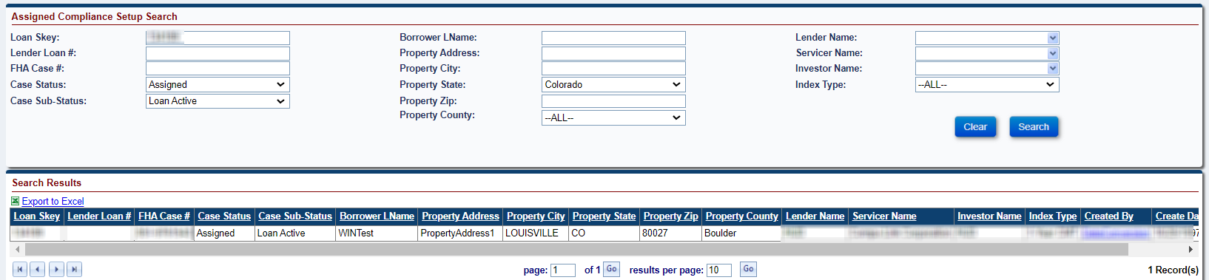
Figure 7-57: Assigned - Compliance - Setup Search
From the search results, select a loan to initiate the timeline.
From the Edit Servicing Management screen, select Taxes Delinquent from the Servicing Type dropdown and populate the required fields (marked with an asterisk).
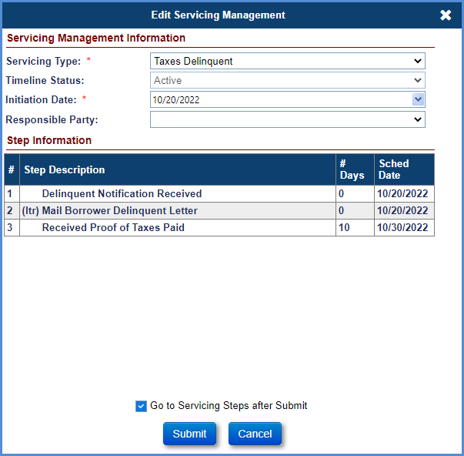
Figure 7-58: Assigned - Compliance - Taxes Delinquent - Edit Servicing Management
Click the checkbox beside Go to Servicing Steps after Submit (at the bottom of the Edit Servicing Management Window).
Click Submit (If you click Cancel, the Assigned Compliance Setup Search Screen will be displayed).
The Compliance Steps screen for Taxes Delinquent timeline is displayed.
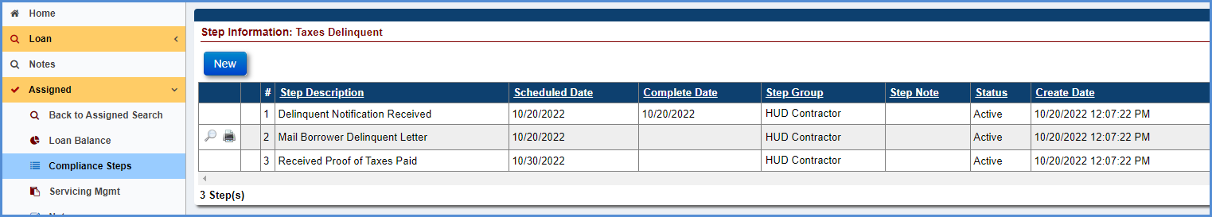
Figure 7-59: Assigned - Compliance - Taxes Delinquent - Timeline Steps
The step Delinquent Notification Received completion date is pre-populated with the timeline created date.
To generate the Taxes Delinquent – 10 Day Letter, click the magnifying glass beside Mail Borrower Delinquent Letter step to preview the letter; the Modify Letter Fields screen is displayed. Edit the subject and salutation and select OK. The Taxes Delinquent – 10 Day Letter is displayed.
The printer icon beside the step enables the HUD contractor to auto-save the document to the Documents tab. Select the printer icon; the Modify Letter Fields screen is displayed. Edit the subject and salutation and click OK. The Taxes Delinquent – 10 Day Letter is displayed. This action auto-saves the document in the Documents tab and auto-completes the step.
If proof of taxes paid is received, complete the step Received Proof of Taxes Paid. To complete step in the timeline, click the step, populate the completion date, add a note in the Notes field if applicable, and click Submit on the Edit Step window.
If authorization received to pay taxes, add the optional step Authorization Received/Pay Taxes, this will make the Pay Taxes Button appear on the Servicing Management Screen.
To add an optional steps, click New.
Select an optional step from the Step Description dropdown that needs to be added on the timeline and click Submit on the new screen. The step will be added to the list of steps.
To complete the step, select the step and populate the completion date, add a note in the Notes field if applicable, and click Submit on the New Step window.
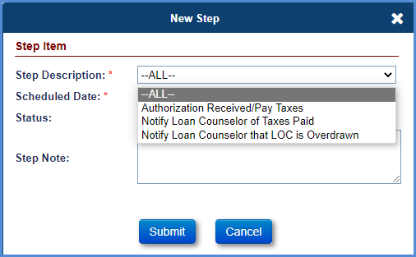
Figure 7-60: Assigned - Compliance - Taxes Delinquent - New Step
To pay the taxes, the HUD NSC Contractor must select the Servicing Management tab. On the Servicing Management tab, click Pay Taxes. A new screen is displayed with New Tax Disbursement; select the Payee from the dropdown and click Submit. A new screen is displayed with Edit Disbursement; populate the disbursement amount and click Submit. The Disbursements tab is displayed with the new Taxes transaction.
To trigger the step, Mail Letter of Taxes Paid, the following criteria must be satisfied: The optional step Authorization Received/Pay Taxes must be added on the timeline and completed, and the taxes must be paid as explained in the above step.
To generate the Taxes Delinquent/Paid For Borrower Letter, click on the magnifying glass beside Mail Letter of Taxes Paid step to preview the letter, the Modify Letter Fields window is displayed. Edit the Subject and Salutation and select OK. The Taxes Delinquent/Paid For Borrower Letter is displayed.
The printer icon beside the step allows the HUD Contractor to auto-save the document to the Documents tab. Select the printer icon, the Modify Letter Fields screen is displayed. Edit the Subject and Salutation and select OK. The Taxes Delinquent/Paid For Borrower Letter is displayed. This action auto-saves the document in the Documents tab and auto-completes the step.
Repeat the above instructions to add and complete other optional steps.
To add multiple Taxes Delinquent timelines, repeat the steps above to initiate and complete the timeline as mentioned above for the second timeline.
On the Servicing Management Screen, if the User clicks the Edit button, there will be an option to change the Tax Payment Status. The user can choose between 4 statuses; “Delinquent”, “Paid by Borrower”, “Paid by Servicer” and “Unpaid but Resolved – Pending”.
If the User selects “Unpaid but Resolved – Pending”, the User will have to enter a Note on the Edit Servicing Management screen to provide the reason they have updated the Tax Payment Status to “Unpaid but Resolved – Pending”. Once the user enters the note and clicks submit, two System Steps will be populated on the Timeline; “HUD Approves Payment Status update to “Unpaid but Resolved”” and “HUD Denies Payment Status update to “Unpaid but Resolved””. The HUD user will then need to complete one of those steps. The Tax Year those steps belong to will also be displayed in the Step Note. Once the HUD user Completes the “HUD Approves Payment Status update to “Unpaid but Resolved”” step, the Delinquency Status will be updated to “Unpaid but Resolved”. If all tax years have a Delinquency Status of “Paid by Servicer, Paid by Borrower or Unpaid but Resolved, the Timeline will be inactivated automatically.

Disposition Timelines
The following Assigned > Disposition timelines are available:
- Asset Sale
- Due & Payable
- Loss Mitigation - Deed-in-Lieu
- Loss Mitigation - Family Sale Pending
- Loss Mitigation - Pre-Foreclosure
- Loss Mitigation - Short Sale
- Write-Off Review

Asset Sale
This timeline is located under Assigned > Disposition, Servicing Type “Asset Sale” and is initiated by NSC Staff or HUD NSC Manager to record an Asset Sale event. Upon initiation of this timeline, the case sub-status is updated to Asset Sale. If the timeline is inactivated, the case sub-status is updated accordingly. There must be an Active Due & Payable timeline to initiate the Asset Sale Timeline.
Multiple active Asset Sale timelines cannot be initiated on a loan. The Servicing Management tab can be used to activate or inactivate the timeline. Once the timeline is inactivated, none of the steps can be edited.
TIP: Refer to section 7.1.2 “Setup Criteria to Initiate Timelines” for general steps to initiate timelines, and section 7.1.7 “To Complete Timeline Steps” for general information how to complete steps within a timeline.
The Contractor attaches all required documentation and completes the necessary steps on the timeline. The following Template Steps are displayed when the timeline is initiated. The steps are HUD steps unless otherwise stated
- Asset Sale Eligibility Confirmed (All borrowers deceased, no NBS present, Placed in Custodial)
- Asset Sale Eligible Alert Created
- Confirm Property in Custodial Care
- Confirm all HECM borrowers are deceased
- Confirm no indication of living/eligible non-borrowing spouse (NBS)
- Confirm if loan has been referred to NJF or DOJ Foreclosure
- Confirm if NJF or DOJ Foreclosure was cancelled
- Confirm if Estate is trying to purchase or market the property
- Confirm 1st Note is imaged
- Confirm Recorded 1st Mortgage is imaged
- Confirm all Recorded Assignments are imaged (complete chain required)
- Asset Sale Complete Date
- Goodbye Letter sent to Borrower – HUD Contractor Step

Due and Payable
This timeline is located under Assigned > Disposition, Servicing Type “Due & Payable” and is initiated by a HUD NSC Contractor to record the Due and Payable event. The HUD NSC Contractor does not need HUD NSC staff approval on this timeline.
When a HUD NSC Contractor populates the death date of last surviving mortgagor on the Contact Screen, the system automatically initiates the Due & Payable timeline with the default reason of Death. For all other default reasons, a HUD NSC Contractor must manually initiate the timeline.
When this timeline is initiated, the case sub-status is updated to Due and Payable. If the timeline is inactivated, the case sub-status is updated accordingly.
Multiple active Due & Payable timelines cannot be initiated on a loan. The Servicing Management tab can be used to activate or inactivate the timeline and update the default date and default reason (other than Death). Once the timeline is inactivated, none of the steps can be edited.
TIP: Refer to section 7.1.2 “Setup Criteria to Initiate Timelines” for general steps to initiate timelines, and section 7.1.7 “To Complete Timeline Steps” for general information how to complete steps within a timeline.
The Contractor attaches all required documentation and completes the necessary steps on the timeline. The following Template Steps are displayed when the timeline is initiated. The steps are HUD Contractor steps unless otherwise stated
- Disposition Event Occurred
- Mail Condolence / Repayment Letter
- Mail Loss Mit Letter(s)
- Follow Up Phone Attempt
The following Optional Steps are available on this timeline. Refer to section 7.1.8 “To Add Optional Timeline Steps” for general information how to add and complete optional steps within a timeline. The steps are HUD Contractor steps unless otherwise stated
- Initiate DIL
- Initiate Short Sale
- Initiate Family Sale
- Initiate Pre-Foreclosure Process
The following step is triggered if the Due & Payable timeline is created when deferred status on a loan is changed from “Yes” to “No” (No more eligible NBSs on the loan)
- NBS Deferral Period has Ended
The following Servicing Mgmt fields are required for this timeline during timeline initiation/ setup, in addition to Initiation Date:
- Default Reason:
  - Conveyed Title
  - End of Deferral Period
  - Occupancy – Compliance
  - Occupancy – Residency
  - Repairs & Upkeep
  - Unpaid Condo Fees
  - Unpaid Ground Rents
  - Unpaid HOA Fees
  - Unpaid Insurance
  - Unpaid PUD’s
  - Unpaid Special Assessments
  - Unpaid Taxes

Loss Mitigation - Deed-in-Lieu
This timeline is located under Assigned > Disposition, Servicing Type “Loss Mitigation – Deed-in-Lieu” and is initiated when a mortgagor is willing to surrender the property to the mortgagee (HUD) and to be released from the mortgage obligations. This timeline is initiated and completed by a HUD NSC Contractor to track the Deed-in-Lieu process; it does not require HUD NSC Staff interaction. Upon initiation of this timeline, the case sub-status is updated to DIL. If the timeline is inactivated, the case sub-status is updated accordingly.
Multiple active Loss Mitigation–Deed-in-Lieu timelines cannot be initiated on a loan. The Servicing Management tab can be used to activate or inactivate the timeline and update the attorney information. Once the timeline is inactivated, none of the steps can be edited.
TIP: Refer to section 7.1.2 “Setup Criteria to Initiate Timelines” for general steps to initiate timelines, and section 7.1.7 “To Complete Timeline Steps” for general information how to complete steps within a timeline.
The Contractor attaches all required documentation and completes the necessary steps on the timeline. The following Template Steps are displayed when the timeline is initiated. The steps are HUD Contractor steps unless otherwise stated
- Initiate DIL
- Refer to Atty for DIL
- Review Title Report from Attorney
- Atty Instructed to have Deed Executed per Referral Instructn
- Order Occupancy Inspection
- Inspection Received - Verified as Vacant
- Atty Instructed to Record Executed Deed (Copy Received)
- Copy of Recorded Deed Received
- Conveyance File Sent to Cash Management
- Send Release Authorization to Release Dept.
- Loan Conveyed - Balances Removed
- Final Title Policy Received / Sent to HOC
- Deed Recorded Date
- Conveyance Entered into P260
The following Optional Steps are available on this timeline. Refer to section 7.1.8 “To Add Optional Timeline Steps” for general information how to add and complete optional steps within a timeline. The steps are HUD Contractor steps unless otherwise stated
- DIL Approved
- DIL Denied / Transferred to F/C Dept
The following Servicing Mgmt field is available for this timeline during timeline initiation/ setup, in addition to Initiation Date:
- Foreclosure Attorney

Loss Mitigation – Family Sale Pending
This timeline is located under Assigned > Disposition, Servicing Type “Loss Mitigation – Family Sale Pending” and is initiated to track the status on a pending family sale effort and to complete the process to terminate the loan.
This timeline is initiated and completed by a HUD NSC Contractor; it does not require HUD NSC staff interactions. When this timeline is initiated, the case sub-status is updated to Family Sale Pending. If the timeline is inactivated, the case sub-status is updated accordingly.
Multiple active Loss Mitigation–Family Sale Pending timelines cannot be initiated on a loan. The Servicing Management tab can be used to activate or inactivate the timeline. Once the timeline is inactivated, none of the steps can be edited.
TIP: Refer to section 7.1.2 “Setup Criteria to Initiate Timelines” for general steps to initiate timelines, and section 7.1.7 “To Complete Timeline Steps” for general information how to complete steps within a timeline.
The Contractor attaches all required documentation and completes the necessary steps on the timeline. The following Template Steps are displayed when the timeline is initiated. The steps are HUD Contractor steps unless otherwise stated
- Initiate Family Sale Pending
- Received Listing Agreement
- Received Copy of Offer and Sales Contract
- Received Sales Proceeds
- Send Release Authorization to Release Dept.
The following Optional Steps are available on this timeline. Refer to section 7.1.8 “To Add Optional Timeline Steps” for general information how to add and complete optional steps within a timeline. The steps are HUD Contractor steps unless otherwise stated
- Short Sale Request Received
- Refer for DIL
- Refer for Foreclosure
- Family Sale Extension Expired/Terminated
- Follow Up on Documentation
To trigger the step Follow up for Status of Sales Effort, the following criteria must be satisfied:
- Less than 8 months since step Initiate Family Sale Pending was completed
- 30 or more days passed since optional step Follow Up was completed
- Step Received Sales Proceeds has not been completed

Loss Mitigation – Pre-Foreclosure
This timeline is located under Assigned > Disposition, Servicing Type “Loss Mitigation – Pre-Foreclosure”. If the mortgagor's loan becomes due and payable, the HUD NSC Contractor initiates this timeline to track pre-foreclosure activities until the loan is referred for Foreclosure. This timeline is initiated and completed by a HUD NSC Contractor and requires HUD NSC Staff approval. At the time of initiation there must be an Active Assigned > Due & Payable timeline. When this timeline is initiated, the Case Sub-Status is updated to Loss Mit/Pre FCL. If the timeline is inactivated, the case sub-status is updated accordingly.
Multiple active Loss Mitigation – Pre-Foreclosure timelines cannot be initiated on a loan. The Servicing Management tab can be used to update components of the timeline, such as inactivate the timeline or edit default reason. This timeline will automatically be inactivated by the system when the Assigned Due & Payable Timeline is inactivated, and a note will be added to the notes page in HERMIT. Once the timeline is inactivated, none of the steps can be edited.
TIP: Refer to section 7.1.2 “Setup Criteria to Initiate Timelines” for general steps to initiate timelines, and section 7.1.7 “To Complete Timeline Steps” for general information how to complete steps within a timeline.
The HUD NSC Contractor attaches all required documentation and completes the necessary steps on the timeline. The following Template Steps are displayed as HUD Contractor Steps when the timeline is initiated:
- Prepare Foreclosure Check List
- Prepare Form 92218
- Request Approval by HUD to Foreclose
- Transfer to Foreclosure Department
- Send NOI
- NOI Timeframe expired
The following Optional Steps are available on this timeline. Refer to section 7.1.8 “To Add Optional Timeline Steps” for general information how to add and complete optional steps within a timeline:
- Follow Up
- HUD Approval / Attorney Assignment - HUD step
- Request Denied by HUD
The HUD NSC Contractor must perform the following steps:
- Generate the HECM Foreclosure/DIL checklist for HUD review by clicking the magnifying glass beside step Prepare Foreclosure Check List. A new screen is displayed with the Foreclosure/DIL checklist with options to Preview Document and Print Document after the necessary details are recorded.
- Update the sheet and once the changes have been made, select the Print Document link to auto-save the changes made to the document. Select Open on the File Download pop-up window. This action will save the updated HECM Foreclosure/DIL checklist to the Documents tab. Refresh the screen to auto-complete the step.
- Generate the Foreclosure check sheet by clicking the magnifying glass beside Prepare Form 92218 step to update and print the Foreclosure check sheet. A new screen is displayed with the Foreclosure check sheet with options to Preview Document and Print Document after the necessary details are recorded.
- Complete the step “Request Approval by HUD to Foreclose” when the request has been sent for HUD approval to initiate the foreclosure proceedings. Validation: User will not be able to complete “Request Approval by HUD to Foreclosure” step if there is an active, unexpired Extension(s) on the loan. If multiple Assigned Extension timelines exist, system will check for the unexpired timelines with the expiration date furthest out.
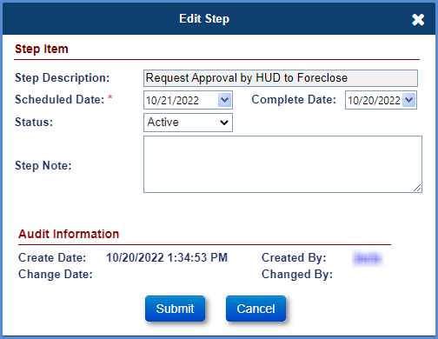
Figure 7-61: Assigned - Disposition - Loss Mitigation - Pre-Foreclosure - Edit Step
- The HUD NSC staff will add the optional step “HUD Approval / Attorney Assignment” or “Request Denied by HUD” when the decision has been made.
- After HUD approves the request, the HUD NSC Contractor must complete the step “Transfer to Foreclosure Department”. Upon completion of this step, the Foreclosure timeline is automatically initiated by the system.
- To generate the Notice of Intent (NOI) Letter, click the magnifying glass beside send NOI and Occupied Conveyance step to preview the letter, the Modify Letter Fields screen is displayed. Edit the subject and salutation and select OK. The NOI Letter & Occupied Conveyance Letter is displayed.
- The printer icon beside the step allows the HUD contractor to auto-save the document to the Documents tab. Select the printer icon, the Modify Letter Fields window is displayed. Edit the subject and salutation and select OK. The NOI Letter is displayed. This action auto-saves the document in the Documents tab and auto-completes the step.

Loss Mitigation – Short Sale
This timeline is located under Assigned > Disposition, Servicing Type “Loss Mitigation – Short Sale” and is initiated to track a short sale on a HECM loan. A short sale is when a HECM loan is sold by the mortgagor for less than the payoff amount or less than the appraised value of the property.
If the loan is Due & Payable the property must sell for no less than a certain threshold percentage of the appraised value as established by HUD. If the loan is not Due & Payable then the sale price of the property must be the appraised value. This timeline is initiated and completed by a HUD NSC Contractor; this timeline requires HUD NSC Staff interaction. Upon initiation of this timeline, the case sub-status is updated to Short Sale Initiated. If the timeline is inactivated, the case sub-status is updated accordingly.
Multiple active Loss Mitigation–Short Sale timelines cannot be initiated on a loan. The Servicing Management tab can be used to activate or inactivate the timeline and edit the short sale information. Once the timeline is inactivated, none of the steps can be edited.
TIP: Refer to section 7.1.2 “Setup Criteria to Initiate Timelines” for general steps to initiate timelines, and section 7.1.7 “To Complete Timeline Steps” for general information how to complete steps within a timeline.
The Contractor attaches all required documentation and completes the necessary steps on the timeline. The following Template Steps are displayed when the timeline is initiated. The steps are HUD Contractor steps unless otherwise stated
- Initiate Short Sale Process
The following Optional Steps are available on this timeline. Refer to section 7.1.8 “To Add Optional Timeline Steps” for general information how to add and complete optional steps within a timeline. The steps are HUD Contractor steps unless otherwise stated
- Short Sale Approved by LSC
- Short Sale Pending Additional Documentation
- Short Sale Denied by LSC
- Missing Required Documents
- Follow Up
- Supplemental Short Sale Calculation Worksheet
- Short Sale Closing Extension Approved
- Short Sale Cancelled
The following Trigger and Automated Steps are available on this timeline:
- Received Required Documents Prepare Short Sale Calculation Worksheet
- Received Closing Proceeds
- Send Short Sale Approval request to HUD
- Send Short Sale Approval Letter
- Sale Closing Date
- Short Sale Decision Issued
- Additional Documentation Requested
- Additional Documentation Received
- Revise Short Sale Calculation Worksheet
- Additional Documentation Sent to HUD
- Scheduled Short Sale Closing Date
- Short Sale Approval Expired (automated)
- Borrower Notified of Short Sale Denial
- Referred for Additional Loss Mitigation Review
The following Servicing Mgmt fields are available for this timeline during timeline initiation/ setup, in addition to Initiation Date:
- Loan Status of 1st Mortgage
- Payoff Amount of 1st Mortgage
- Offered Sales Price
- Repair Costs
- Appraised Value
- Percentage of Appraised Value (Calculated)

Write-Off Review
This timeline is located under Assigned > Disposition, Servicing Type “Write-Off Review” and is initiated to complete the review process and seek HUD’s approval for the write-off.
Multiple active Write-Off Review timelines cannot be initiated on a loan. The Servicing Management tab can be used to activate or inactivate the timeline. Once the timeline is inactivated, none of the steps can be edited.
TIP: Refer to section 7.1.2 “Setup Criteria to Initiate Timelines” for general steps to initiate timelines, and section 7.1.7 “To Complete Timeline Steps” for general information how to complete steps within a timeline.
The Contractor attaches all required documentation and completes the necessary steps on the timeline. The following Template Steps are displayed when the timeline is initiated. The steps are HUD Contractor steps unless otherwise stated
- Loan Reviewed for Write-Off Recommendation
- Prepare Write-Off Calculation Worksheet
- Inspection Requested
- Inspection Results Received
- Write-Off Recommendation to HUD
- Write-Off sent to Cash Management for Completion
The following Optional Steps are available on this timeline. Refer to section 7.1.8 “To Add Optional Timeline Steps” for general information how to add and complete optional steps within a timeline. The steps are HUD Contractor steps unless otherwise stated
- Title Report Requested
- Title Report Results Received
- Valuation Requested
- Valuation Results Received
- Follow-Up with HUD on Write-Off review
- Forward to HQ / Principal balance > $100,000
- Approval of Write-Off by HUD – HUD Step
- Denial of Write-Off by HUD – HUD Step

Request Timelines
The following Assigned > Request timelines are available:
- Certificate of Indebtedness (COI)
- Extension - At-Risk
- Extension - COVID-19 Request to Delay Due & Payable
- Extension - COVID-19 Request to Delay Foreclosure
- Extension - Property Charge Loss Mitigation
- Extension - Request to Delay Foreclosure
- Partial Release
- Payoff Request
- Substitution of Collateral
- Zero Balance

Certificate of Indebtedness (COI)
This timeline is located under Assigned > Request, Servicing Type “Certificate of Indebtedness” and is initiated by the HUD NSC Contractor when a request is received to show the loan balance. This timeline is completed by the HUD NSC Contractor and does not require HUD NSC staff interaction.
Multiple active timelines can be initiated on a loan. The Servicing Management tab can be used to activate or inactivate the timeline. Once the timeline is inactivated, none of the steps can be edited.
TIP: Refer to section 7.1.2 “Setup Criteria to Initiate Timelines” for general steps to initiate timelines, and section 7.1.7 “To Complete Timeline Steps” for general information how to complete steps within a timeline.
The Contractor attaches all required documentation and completes the necessary steps on the timeline. The following Template Steps are displayed when the timeline is initiated. The steps are HUD Contractor steps unless otherwise stated
- COI Request Received
- COI Sent to Requestor
- Copy of Mortgage and Note Sent

Extension – At-Risk
This timeline is located under Assigned > Requests, Servicing Type “Extension–At-Risk” and is initiated by the HUD NSC contractor. The NSC Contractor completes all work within this timeline, including issuing a Decision. There is no interaction with HUD staff.
Multiple active Extension–At-Risk timelines cannot be initiated on a loan. The Servicing Management tab can be used to activate or inactivate the timeline and update extension data fields. Once the timeline is inactivated, none of the steps can be edited.
TIP: Refer to section 7.1.2 “Setup Criteria to Initiate Timelines” for general steps to initiate timelines, and section 7.1.7 “To Complete Timeline Steps” for general information how to complete steps within a timeline.
The HUD NSC Contractor attaches all required documentation and completes the necessary steps on the timeline. The following Template Steps are displayed when the timeline is initiated:
- Initiate Extension
- Upload Extension Package
- Submit Extension Request for Time
The following Trigger Steps are displayed when the timeline is initiated:
- Extension Request Reviewed
- Servicer Notified of Decision
- Request for Extension of Time Recd
The following Optional Steps are available on this timeline. Refer to section 7.1.8 “To Add Optional Timeline Steps” for general information how to add and complete optional steps within a timeline:
- Follow Up
- HUD Decision - Approved
- HUD Decision - Denied
- HUD Decision - Pending Additional Info

Extension – COVID-19 Request to Delay Due & Payable
This timeline is located under Assigned > Request, Servicing Type “Extension – COVID-19 Request to Delay Due & Payable” and is initiated by the HUD Contractor to delay Due & Payable due to the COVID-19 National Emergency and Mortgagee Letter 2020-06. If the loan is already due and payable, then an extension can be granted to Foreclosure or Claims process.
For first timelines, user must enter the Extension Request Date and Extension Expiration Date, which must be within 6 months of the Extension Request Date. The first timeline Extension Expiration Date may be changed if necessary but must be within the required date range and within 6 months or 3 months of the Extension Request Date, depending on the Reason for Request selected. If the first timeline Extension Expiration date is edited, the new date will be displayed in field Prior Extension Expiration Date on the second timeline.
For second timelines of the same type, user will not need to enter an Extension Request Date, but must enter the Extension Expiration Date, which must be within 6 months or 3 months of the Prior Extension Expiration Date from the first timeline, depending on the Reason for Request selected. On second timelines, the Extension Request Date is optional and is not used in validations for this timeline.
Multiple active Extension – COVID-19 Request to Delay Due & Payable timelines can be initiated on a loan. The Servicing Management tab can be used to inactivate the timeline. Once the timeline is inactivated, none of the steps can be edited.
TIP: Refer to section 7.1.2 “Setup Criteria to Initiate Timelines” for general steps to initiate timelines, and section 7.1.7 “To Complete Timeline Steps” for general information how to complete steps within a timeline.
The Contractor attaches all required documentation and completes the necessary steps on the timeline. The following Template Steps are displayed when the timeline is initiated. The steps are contractor steps unless otherwise stated
- Submit Extension Request for Time
- Extension Request Reviewed
- Servicer Notified of Decision – HUD Step
- HUD Decision – Approved – HUD Step
- Initiate Extension – HUD Step
The following Servicing Mgmt fields are required for this timeline during timeline initiation/ setup, in addition to Initiation Date:
- Reason for Request
- Reason for Extension
- Extension Request Date
- Extension Expiration Date
- Requested By

Extension – COVID-19 Request to Delay Foreclosure
This timeline is located under Assigned > Request, Servicing Type “Extension – COVID-19 Request to Delay Foreclosure” and is initiated by the Contractor to delay Foreclosure due to the COVID-19 National Emergency and Mortgagee Letter 2020-06. The latest permitted COVID Extension Expiration Date is 11/30/2023.
For first timelines, user must enter the Extension Request Date and Extension Expiration Date, which must be within 6 months or 3 months of the Extension Request Date, depending on the Reason for Request selected. The first timeline Extension Expiration Date may be changed if necessary but must be within the required date range and within 6 months of the Extension Request Date. If the first timeline Extension Expiration date is edited, the new date will be displayed in field Prior Extension Expiration Date on the second timeline.
For second timelines of the same type, user will not need to enter an Extension Request Date, but must enter the Extension Expiration Date, which must be within 6 months or 3 months of the Prior Extension Expiration Date from the first timeline, depending on the Reason for Request selected. On second timelines, the Extension Request Date is optional and is not used in validations for this timeline.
Multiple active Extension – COVID-19 Request to Delay Foreclosure timelines can be initiated on a loan. The Servicing Management tab can be used to inactivate the timeline. Once the timeline is inactivated, none of the steps can be edited.
TIP: Refer to section 7.1.2 “Setup Criteria to Initiate Timelines” for general steps to initiate timelines, and section 7.1.7 “To Complete Timeline Steps” for general information how to complete steps within a timeline.
The Contractor attaches all required documentation and completes the necessary steps on the timeline. The following Template Steps are displayed when the timeline is initiated. The steps are contractor steps unless otherwise stated
- Initiate Extension
- Submit Extension Request for Time
- Extension Request Reviewed – HUD Step
- Servicer Notified of Decision – HUD Step
- HUD Decision – Approved – HUD Step
The following Servicing Mgmt fields are required for this timeline during timeline initiation/ setup, in addition to Initiation Date:
- Reason for Request
- Reason for Extension
- Extension Request Date
- Extension Expiration Date
- Requested By

Extension – Property Charge Loss Mitigation
This timeline is located under Assigned > Requests, Servicing Type “Extension–Property Charge Loss Mitigation” and is initiated by the HUD NSC contractor to request an extension of time to delay foreclosure and allow loss mitigation options for property charges.
Multiple active Extension–Property Charge Loss Mitigation timelines can be initiated on a loan after a warning message is displayed informing the user a timeline already exists. The Servicing Management tab can be used to activate or inactivate the timeline and update extension data fields. Once the timeline is inactivated all the steps are greyed out and none of the steps can be edited.
TIP: Refer to section 7.1.2 “Setup Criteria to Initiate Timelines” for general steps to initiate timelines, and section 7.1.7 “To Complete Timeline Steps” for general information how to complete steps within a timeline.
The HUD NSC Contractor attaches all required documentation and completes the necessary steps on the timeline. The following Template Steps are displayed when the timeline is initiated:
- Initiate Extension
- Upload Extension Package
- Submit Extension Request for Time
The following Trigger Steps are displayed when the timeline is initiated:
- Extension Request Reviewed
- Servicer Notified of Decision
- Request for Extension of Time Recd
The following Optional Steps are available on this timeline. Refer to section 7.1.8 “To Add Optional Timeline Steps” for general information how to add and complete optional steps within a timeline:
- Follow Up
- HUD Decision - Approved
- HUD Decision - Denied

Extension – Request to Delay Foreclosure
This timeline is located under Assigned > Request, Servicing Type “Extension – Request to Delay Foreclosure” and is initiated by a HUD NSC Contractor to record the delay foreclosure extension. The HUD NSC Contractor does not need HUD NSC staff approval on this timeline.
This timeline must be initiated before the expiration of the first legal filing deadline which is 6 months after the date of death of the last living borrower or, for other Due & Payable reasons, the date the notice letter calling the loan due and payable is sent to the borrower. System will use complete date of the timeline step “(ltr) Mail Condolence / Repayment Letter” for non-death Due & Payable.
Initiate the first extension request within 30 days of the expiration of the first legal filing deadline. System will automatically calculate “Extension Expiration Date” to 90 days. “Extension Expiration Date” is displayed on the Servicing Mgmt page and will be read only.
Initiate the second extension request within 30 days of the expiration of the prior Extension Expiration date. System will automatically calculate “Extension Expiration Date” to 90 days from the first Extension Expiration Date. “Extension Expiration Date” is displayed on the Servicing Mgmt page and will be read only.
Servicing Module allows two active timelines for Extension – Request to Delay Foreclosure timelines. Two extensions may be granted in 90-day intervals (two 90-day extensions are allowed) but the total of these 180 days cannot exceed 12 months from the date of death, or the date the due and payable notice was sent to the borrower. The system will auto-approve the first two extension requests with the expiration date equal to number of days (as established by HUD) from the request submitted date. When this timeline is initiated, the case sub-status is updated to Due and Payable. If the timeline is inactivated, the case sub-status is updated accordingly.
TIP: Refer to section 7.1.2 “Setup Criteria to Initiate Timelines” for general steps to initiate timelines, and section 7.1.7 “To Complete Timeline Steps” for general information how to complete steps within a timeline.
The Contractor attaches all required documentation and completes the necessary steps on the timeline. The following Template Steps are displayed when the timeline is initiated. The steps are HUD Contractor steps unless otherwise stated
- Initiate Extension - Request to Delay Foreclosure
- Upload Extension Package
- Submit Extension Request for Time
The following step is triggered and auto-completed on the first two extension requests:
- HUD Decision – Approved
The following Servicing Mgmt fields are required for this timeline during timeline initiation/ setup, in addition to Initiation Date:
- Reason for Request
- Reason for Extension

Partial Release
This timeline is located under Assigned > Request, Servicing Type “Partial Release” and is initiated by the HUD NSC Contractor when a request is received to release a portion of the property secured by the HECM mortgage. The request is reviewed, and a recommendation is made by the HUD NSC Contractor to HUD. A HUD staff member reviews the HUD NSC Contractor recommendation and the submitted documents and approves or denies the request. This timeline requires HUD NSC Contractor and HUD interaction.
Multiple active timelines cannot be initiated on a loan. The Servicing Management tab can be used to activate or inactivate the timeline and update release details such as reason for release, amount offered, and description of land to be released. Once the timeline is inactivated, none of the steps can be edited.
TIP: Refer to section 7.1.2 “Setup Criteria to Initiate Timelines” for general steps to initiate timelines, and section 7.1.7 “To Complete Timeline Steps” for general information how to complete steps within a timeline.
The HUD NSC Contractor attaches all required documentation and completes the necessary steps on the timeline. The following Template Steps are displayed when the timeline is initiated. The steps are HUD Contractor steps unless otherwise stated
- Initiate Partial Release
- Upload Partial Release Package
- Partial Release Package Reviewed
- Recommendation Sent to HUD
- Requestor Notified of Decision
- Partial Release Document Executed
The following Optional Steps are available on this timeline. Refer to section 7.1.8 “To Add Optional Timeline Steps” for general information how to add and complete optional steps within a timeline. The steps are HUD Contractor steps unless otherwise stated
- HUD Decision - Pending Additional Info – HUD Step
- HUD Decision – Approved - HUD Step
- HUD Decision - Approved with Contingency - HUD Step
- HUD Decision – Denied - HUD Step
- Contractor Recommendation - Approved
- Follow-up on Pending Information
- Received Required additional information
- Contractor Recommendation - Denied
- Contractor Review - Pending Additional Info
- Sent for HOC Review - HUD Step
The following Trigger and Automated steps are available on this timeline:
- HOC Review Complete

Payoff Request
This timeline is located under Assigned > Request, Servicing Type “Payoff Request” and is initiated by the HUD NSC Contractor to track the payoff request from a mortgagor to payoff the outstanding loan balance. A loan is terminated when the outstanding loan balance is paid in full. This timeline is initiated by the HUD NSC Contractor and does not require HUD NSC staff interactions.
Multiple active timelines cannot be initiated on a loan. The Servicing Management tab can be used to activate or inactivate the timeline and edit payoff request information for authorized user roles. Once the timeline is inactivated, none of the steps can be edited.
TIP: Refer to section 7.1.2 “Setup Criteria to Initiate Timelines” for general steps to initiate timelines, and section 7.1.7 “To Complete Timeline Steps” for general information how to complete steps within a timeline.
The HUD NSC Contractor attaches all required documentation and completes the necessary steps on the timeline. The following Template Steps are displayed when the timeline is initiated. The steps are HUD Contractor steps unless otherwise stated
- Payoff Request Received
- Issue Payoff Letter
- Payoff Amount Received
- Forward Payoff Amount to OTC
The following Optional Steps are available on this timeline. Refer to section 7.1.8 “To Add Optional Timeline Steps” for general information how to add and complete optional steps within a timeline. The steps are HUD Contractor steps unless otherwise stated
- Contacted Remitter for Further Information
- Cash Management Processed Payoff Refund
- Rejected Funds Received, Unable to Process
The following Servicing Mgmt fields are required for this timeline during timeline initiation/ setup, in addition to Initiation Date:
- Payoff Request Date

Substitution of Collateral timeline
This timeline is located under Assigned > Request, Servicing Type “Substitution of Collateral and is initiated by the HUD NSC contractor and does not require interaction with the servicer.
Multiple active Substitution of Collateral timelines cannot be initiated on a loan. The Servicing Management tab can be used to activate or inactivate the timeline and update reasons for Substitution of Collateral, recoverable funds, and description of event that occurred. Once the timeline is inactivated, none of the steps can be edited.
TIP: Refer to section 7.1.2 “Setup Criteria to Initiate Timelines” for general steps to initiate timelines, and section 7.1.7 “To Complete Timeline Steps” for general information how to complete steps within a timeline.
The HUD NSC Contractor attaches all required documentation and completes the necessary steps on the timeline. The following Template Steps are displayed when the timeline is initiated. The steps are HUD Contractor steps unless otherwise stated
- Initiate Substitution of Collateral
- Upload Substitution of Collateral Package
- Substitution of Collateral Package Reviewed
- Recommendation Sent to HUD
- Borrower Notified of Decision
- Upload Final Inspection
- HUD Received Final Inspection
The following Optional Steps are available on this timeline. Refer to section 7.1.8 “To Add Optional Timeline Steps” for general information how to add and complete optional steps within a timeline. The steps are HUD steps unless otherwise stated
- HUD Decision - Pending Additional Info
- HUD Decision - Approved
- HUD Decision - Approved with Contingency
- HUD Decision - Denied
- Contractor Recommendation - Approved for Appraisal Review – HUD Contractor Step
- Follow-up on Pending Information – HUD Contractor Step
- Received Required additional information – HUD Contractor Step
- Contractor Recommendation - Denied for Appraisal Review – HUD Contractor Step
- Contractor Review - Pending Additional Info – HUD Contractor Step
- Sent for Appraisal Review
- Appraisal Review Received
- Appraisal Review - Pending Additional Info
- Appraisal Review - Additional info Sent

Zero Balance
This timeline is located under Assigned > Request, Servicing Type “Zero Balance” and is initiated by the HUD NSC Contractor when a payoff statement is requested on HUD’s second Mortgage to show that there are no funds advanced under the second note. This timeline is completed by the HUD NSC contractor and does not require interaction with the servicer.
Multiple active timelines can be initiated on a loan. The Servicing Management tab can be used to activate or inactivate the timeline. Once the timeline is inactivated, none of the steps can be edited.
TIP: Refer to section 7.1.2 “Setup Criteria to Initiate Timelines” for general steps to initiate timelines, and section 7.1.7 “To Complete Timeline Steps” for general information how to complete steps within a timeline.
The Servicer attaches all required documentation and completes the necessary steps on the timeline. The following Template Steps are displayed when the timeline is initiated. The steps are HUD Contractor steps unless otherwise stated
- Zero Balance Letter Request Received
- Zero Balance Letter Sent to Requestor

Assigned Foreclosure Timeline
This timeline is located under Assigned > Foreclosure to track the foreclosure process. It is automatically initiated by the system if the step ‘Transfer to Foreclosure Department” is completed on the Loss Mitigation – Pre-Foreclosure timeline. This timeline can also be manually initiated by a HUD NSC Contractor when there is an Active Due & Payable timeline and the Notice of Intent (NOI) expires. This timeline requires HUD NSC Staff interaction. Upon initiation of this timeline, the case sub-status is updated to Foreclosure-Assigned. If the timeline is inactivated, the case sub-status is updated accordingly.
Multiple active Foreclosure timelines cannot be initiated on a loan. The Servicing Management tab can be used to activate or inactivate the timeline. Once the timeline is inactivated, none of the steps can be edited.
TIP: Refer to section 7.1.2 “Setup Criteria to Initiate Timelines” for general steps to initiate timelines, and section 7.1.7 “To Complete Timeline Steps” for general information how to complete steps within a timeline.
The HUD NSC Contractor attaches all required documentation and completes the necessary steps on the timeline. The following Template Steps are displayed as HUD Contractor Steps when the timeline is initiated:
- Attorney Assignment
- Loan Referred to Commissioner
- Received Acknowledgement of referral
- Order Appraisal
- Title Search Received
- Notice of Sale mailed to borrowers, lienholders & occupants
- Publication of Sale
- Foreclosure Bidding Instructions Sent
- Foreclosure Sale Date
- Received copy of unrecorded fcl deed
- Received copy of recorded fcl deed
- Recorded Date of Deed
- Received Final Title Policy (NJF F/C)
- Attorney Invoice Received
- Invoice Sent to Cash Management for Payment
The following Optional Steps are available on this timeline. Refer to section 7.1.8 “To Add Optional Timeline Steps” for general information how to add and complete optional steps within a timeline:
- Conveyance File sent to Cash Management
- DOJ CCLR Form
- Foreclosure Contested / Transfer to DOJ
- Foreclosure Terminated
- Order Occupancy Inspection
- Property sold 3rd Party
- Recvd original unrecorded Deed from DOJ
- Request Received for Statement of Account - 698 Form
- Send 698 Form to Requestor
- Statement of Account – HUD Contractor step
- Title Issues
- Vacate Letter Sent to Occupant
The following Trigger and Automated Steps are available on this timeline:
- Balance of 3rd party funds received
- Conveyance Entered into P260 - HUD step
- Eviction Complete / Verification received
- Eviction Date Set / Schedule Lockout
- Eviction Hearing Date Set
- Follow Up on Vacate Letter
- Foreclosure Deed sent for recording
- HUD Placed in Custodial Care - HUD step
- Inspection Results Received
- Loan Conveyed - Balances Removed
- Received 10% down payment
- Recvd copy of recorded Deed from County
- Refer to Attorney for Eviction
- Request Custodial Care
- Title Issues Resolved
TIP: see below for information about completion of step Attorney Assignment.
- To complete step Attorney Assignment, select a Foreclosure Attorney from the dropdown menu, enter a completion date, and add a note in the Notes field (if applicable), click Submit on the Edit Step window.
- After Completion of the step “Attorney Assignment”, the HUD Contractor can view/print the Department of Justice (DOJ)/ Non-Judicial Foreclosure (NJF) Referral Letter on step Loan Referred to Commissioner by clicking the printer icon. TIP: If the Foreclosure Attorney has not been selected on either the Step “Attorney Assignment” or on the Servicing Mgmt page the Letter the user cannot view/print the Letter.
- Complete the steps in the timeline when the corresponding activity tied to the step is complete. To complete any step in the timeline, click the step.

Bankruptcy Timelines
The following Assigned > Bankruptcy timelines are available:
- Bankruptcy - Chapter 13
- Bankruptcy - Chapter 7

Bankruptcy - Chapter 13
This timeline is located under Assigned > Bankruptcy, Servicing Type “Bankruptcy – Chapter 13”. This timeline is initiated by a HUD NSC Contractor when a Chapter 13 bankruptcy is filed where the court appoints a trustee and establishes a payment plan under a reorganization agreement. Upon initiation of this timeline, the case sub-status is updated to Bankruptcy/Chapter 13. If the timeline is inactivated, the case sub-status is updated accordingly.
Multiple active Bankruptcy–Chapter 13 timelines cannot be initiated on a loan. The Servicing Management tab can be used to activate or inactivate the timeline. Once the timeline is inactivated, none of the steps can be edited.
TIP: Refer to section 7.1.2 “Setup Criteria to Initiate Timelines” for general steps to initiate timelines, and section 7.1.7 “To Complete Timeline Steps” for general information how to complete steps within a timeline.
The HUD NSC Contractor attaches all required documentation and completes the necessary steps on the timeline. The following Template Steps are displayed as HUD Contractor Steps when the timeline is initiated:
- Bankruptcy Filed
- Bankruptcy Notification Received
- Proof of Claim Prepared
- Proof of Claim Filed
- Review of Plan/Statement of Intention
- Proof of Claim Recorded
- Confirmation of Plan/Statement of Intention
The following Optional Steps are available on this timeline. Refer to section 7.1.8 “To Add Optional Timeline Steps” for general information how to add and complete optional steps within a timeline:
- Bankruptcy Dismissed
- Bankruptcy Discharged
- Contested Action
- Notified HUD of Contested Action
- Ordered Appraisal/BPO
- Ordered Missing Mortgage/Deed of Trust
- Statement of Account – HUD Contractor step
- Write-off Requested
- Write-off Approved
The following Servicing Mgmt fields are required for this timeline during timeline initiation/ setup, in addition to Initiation Date:
- State Filed
- Bankruptcy District
The HUD NSC Contractor must perform the following steps:
- To generate the Proof of Claim Form, click the magnifying glass beside step Proof of Claim Prepared. A new screen is displayed with the Proof of Claim Form with options to Preview and Print Document after the necessary details are recorded.
- Update the sheet and once the changes have been made, select the Preview Document link to view the updated document. To auto-save the changes made to the document select the Print Document link.
- Select Open on the File Download screen. This action will save the updated Proof of Claim Form to the Documents tab. Refresh the screen to auto-complete the step.
  - TIP: If the Proof of Claim form does not display, go to the Servicing Management Screen and populate the Bankruptcy District name. This will allow the Proof of Claim form to be viewed.

Bankruptcy - Chapter 7
This timeline is located under Assigned > Bankruptcy, Servicing Type “Bankruptcy – Chapter 7”. This timeline is initiated by a HUD NSC Contractor when a Chapter 7 bankruptcy is filed which releases the mortgagor from unsecured liabilities and retains their secured debt. This timeline does not require HUD NSC Staff interaction. When this timeline is initiated, the case sub-status is updated to Bankruptcy/Chapter 7. If the timeline is inactivated, the case sub-status is updated accordingly.
Multiple active Bankruptcy – Chapter 7 timelines cannot be initiated on a loan. The Servicing Management tab can be used to activate or inactivate the timeline. Once the timeline is inactivated, none of the steps can be edited.
TIP: Refer to section 7.1.2 “Setup Criteria to Initiate Timelines” for general steps to initiate timelines, and section 7.1.7 “To Complete Timeline Steps” for general information how to complete steps within a timeline.
The HUD NSC Contractor attaches all required documentation and completes the necessary steps on the timeline. The following Template Steps are displayed as HUD Contractor Steps when the timeline is initiated:
- Bankruptcy Filed
- Bankruptcy Notification Received
- Proof of Claim Prepared
- Proof of Claim Filed
- Review of Plan/Statement of Intention
- Proof of Claim Recorded
- Confirmation of Plan/Statement of Intention
The following Optional Steps are available on this timeline. Refer to section 7.1.8 “To Add Optional Timeline Steps” for general information how to add and complete optional steps within a timeline:
- Appraisal/BPO Received
- Bankruptcy Discharged
- Bankruptcy Dismissed
- Contested Action
- Contested Action Concluded
- Missing Mortgage/Deed of Trust Received
- Notified HUD of Contested Action
- Ordered Appraisal/BPO
- Ordered Missing Mortgage/Deed of Trust
- Statement of Account – HUD Contractor step
- Write-off Approved
- Write-off Requested
The following Servicing Mgmt fields are required for this timeline during timeline initiation/ setup, in addition to Initiation Date:
- State Filed
- Bankruptcy District
The HUD NSC Contractor must perform the following steps:
- To generate the Proof of Claim Form, click the magnifying glass beside the Proof of Claim Prepared step to update and print the Proof of Claim Form. A new window is displayed with the Proof of Claim Form with options to preview or print the document.
- Update the sheet and once the changes have been made, select the Preview Document link to view the updated document. To auto-save the changes made to the document select the Print Document link. Select Open on the File Download pop-up window. This action will save the updated Proof of Claim Form to the Documents tab. Refresh the screen to auto-complete the step.
  - TIP: If the Proof of Claim form does not display, go to the servicing management screen and populate the Bankruptcy District name. This will allow the Proof of Claim form to be viewed.

Assigned Release Timelines
The following Assigned > Release timelines are available:
- Release 1st
- Release 2nd

Release 1st (Release of HUD's First Mortgage)
This timeline is automatically initiated by the system when the loan status is updated to Terminated. The status is updated to Terminated when the terminate transaction is added on the loan. Refer to the Transactions – Loan - Termination section in General Servicing chapter of this User Guide for details. The scheduled date of the first step is set to 10 business days after the effective date of the payoff transactions.
Multiple active Release 1st timelines cannot be initiated on a loan. The Servicing Management tab can be used to activate or inactivate the timeline for user roles authorized to do so. Once the timeline is inactivated, none of the steps can be edited. An Auto note is added in the Notes Section upon completion of any step.
To initiate and complete the Release 1st timeline:
From the Assigned menu, select Release, and click Search.
On the Assigned Release Search Screen, enter the search criteria, select Servicing Type as Release 1st and click Submit to retrieve the timelines that have been auto-initiated by the system.
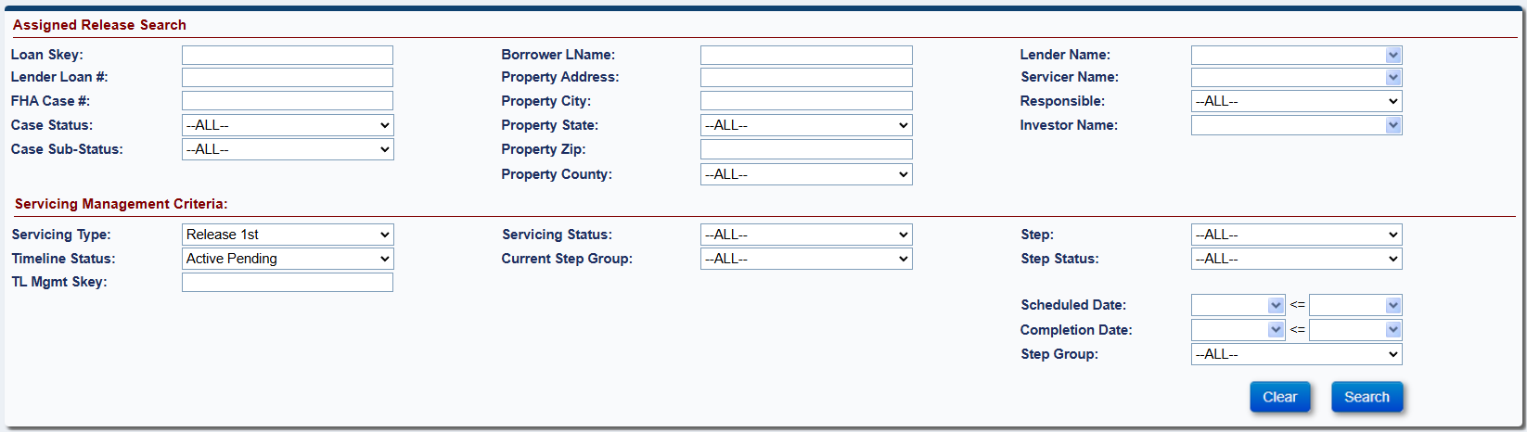

Figure 7-62: Assigned - Release - Search
From the search results, click a loan to view or edit the timeline.
The Release Steps screen for Release 1st timeline is displayed.
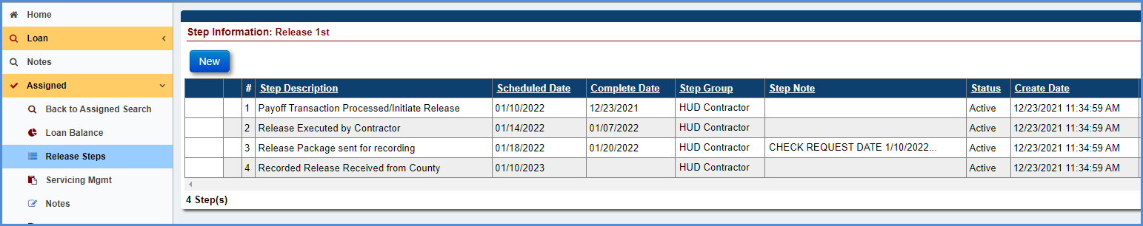
Figure 7-63: Assigned - Release - Release 1st - Timeline Steps
The Step Payoff Transaction Processed/Initiate Release completion date is pre-populated with the timeline created date.
Complete the steps in the timeline when the corresponding activity tied to the step is complete. To complete any step in the timeline, click the step, for example, step Release Executed by Contractor.
Populate the completion date, add a note in the Notes field if applicable, and click Submit on the Edit Step window.
The completion date is populated beside the step Release Executed by Contractor on the Release Steps screen for Release 1st.
The system will automatically Inactivate the timeline upon completion of the step Recorded Release Received from County.
The step Received Missing Mortgage/Deed of Trust (DOT) is automatically added by the system. To add this step automatically by the system, the following criteria must be satisfied: The optional step Order Missing Mortgage/DOT must be added on the timeline.
To add the optional step Order Missing Mortgage/DOT, click New.
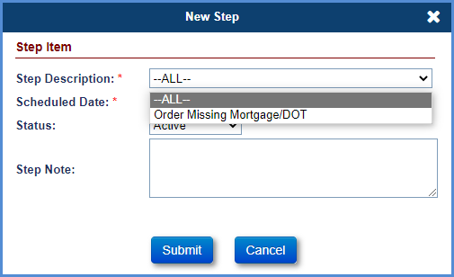
Figure 7-64: Assigned - Release - Release 1st - New Step
Select the optional step from the Step Description dropdown.
To complete the step, populate the complete date, add a note in the Notes field if applicable, and click Submit on Edit Step window.

Release 2nd (Release of HUD's Second Mortgage)
This timeline is automatically initiated by the system when the loan status is updated to Terminated. The status is updated to Terminated when the terminate transaction is added on the loan. Refer to the Transactions- Loan- Termination section in General Servicing chapter of this User Guide for details on how to add the transaction on the loan. The scheduled date of the first step is set to 10 business days after the effective date of the payoff transaction.
The HUD NSC Contractor will follow up and complete the steps within the timeline after system initiation. There is no interaction with the HUD NSC Staff. Multiple active Release 2nd timelines cannot be initiated on a loan. The Servicing Management tab can be used to activate or inactivate the timeline for user roles authorized to do so. Once the timeline is inactivated, none of the steps can be edited.
To initiate and complete the Release 2nd timeline:
From the Assigned menu, select Release, and click Search.
On the Assigned Release Search Screen, enter the search criteria, select Servicing Type as Release 2nd and click Search to retrieve the timelines that have been auto-initiated by the system.
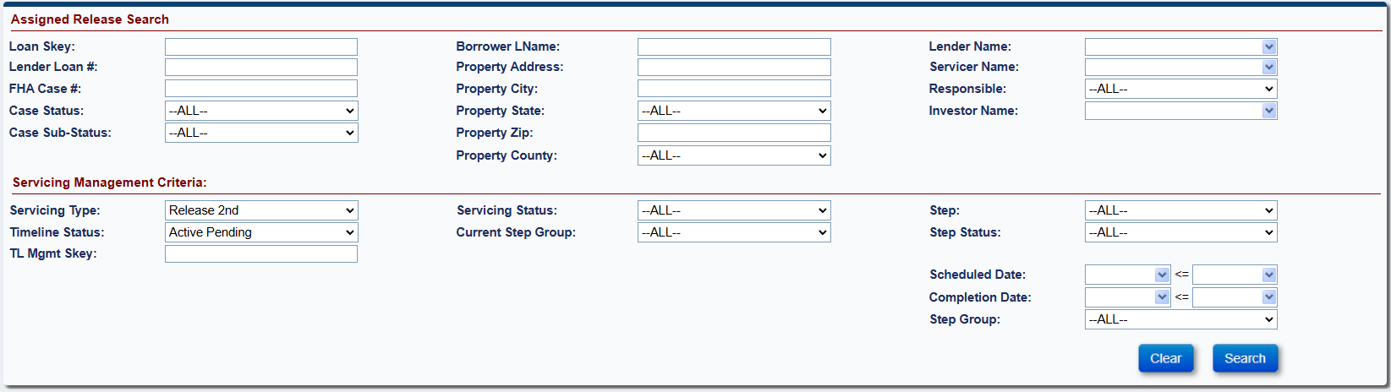

Figure 7-65: Assigned - Release - Search
From the search results, select a loan to view or edit the timeline.
The Release Steps screen for Release 2nd timeline is displayed.
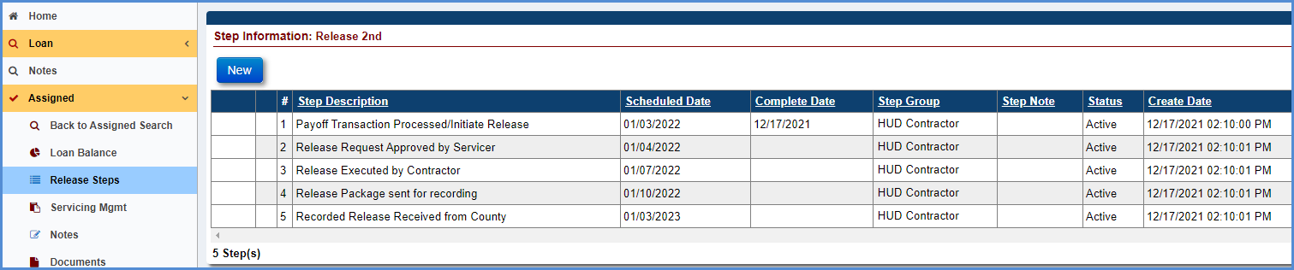
Figure 7-66: Assigned - Release - Release 2nd - Timeline Steps
The step Payoff Transaction Processed/Initiate Release completion date is pre-populated with timeline created date.
Complete the steps in the timeline when activity corresponding to the step is complete. To complete any step in the timeline, click the step, for example, step Release Executed by Contractor.
Populate the completion date, add a note in the Notes field if applicable, and click Submit on the Edit Step window.
The completion date is populated beside the step Release Executed by Contractor on the Release Steps screen for Release 2nd.
The system will automatically Inactivate the timeline upon completion of the step Recorded Release Received from County.
The step Received Missing Mortgage/DOT is automatically added by the system. The following criteria must be satisfied: The optional step Order Missing Mortgage/DOT must be added on the timeline (this is an optional step).
To add the optional step Order Missing Mortgage/DOT, click New.
Figure 7-67: Assigned - Release - Release 2nd - New Step
Select the optional step from the Step Description dropdown.
To complete the step, populate the complete date, add a note in the Notes field if applicable, and click Submit on Edit Step window.
An Auto note is added in the Notes Section upon completion of any step.

Assigned Claims Timelines
The following Assigned > Claims timelines are available:
- Assignment Repurchase
- Title Approval

Assignment Repurchase
When a discrepancy is identified on a loan for reasons determined by HUD and a repurchase of the loan needs to occur, the HUD NSC Contractor initiates this timeline and notifies the servicer of the discrepancy. The HUD NSC Staff approval is required. When this timeline is initiated, the case sub-status is updated to Repurchase. When this process is completed, the loan status is updated to Endorsed – Loan Active.
Multiple active Assignment Repurchase timelines cannot be initiated on a loan. The Servicing Management tab can be used to activate or inactivate the timeline. Once the timeline is inactivated, none of the steps can be edited.
To initiate and complete the Assignment Repurchase timeline:

Initiate Timeline – HUD NSC Contractor Activities
The HUD NSC Contractor completes the following steps to initiate the timeline:
From the Assigned menu, select Claims, and click Setup.
On the Assigned Claims Setup Search Screen, enter the loan search criteria and click Search.

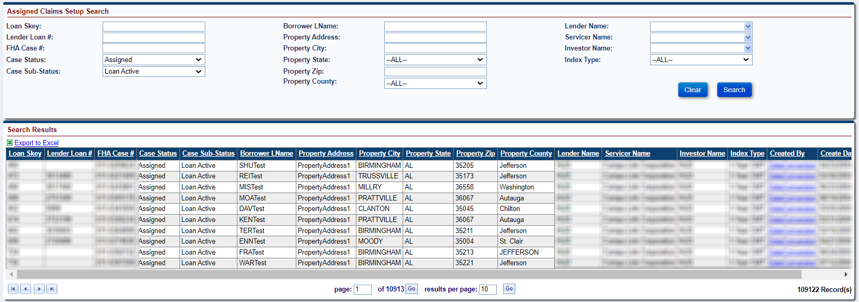
Figure 7-68: Assigned - Claims - Setup Search

From the search results, select a loan to initiate the timeline.
From the Edit Servicing Management Screen, select Assignment Repurchase from the Servicing Type dropdown and populate the required fields (marked with an asterisk).
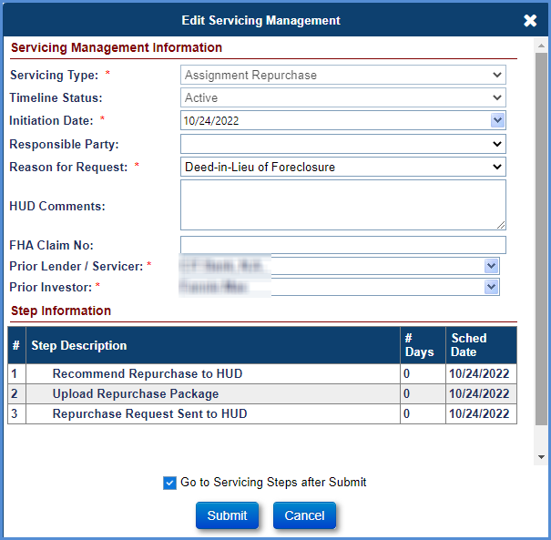
Figure 7-69: Assigned - Claims - Assignment Repurchase - Edit Servicing Management
Click the checkbox beside Go to Servicing Steps after Submit (At the bottom of the Edit Servicing Management Window) to go to into the timeline.
Click Submit (If you click Cancel, the Assigned Claims Setup Search Screen will be displayed).
The Claims Steps screen for Assignment Repurchase timeline is displayed.
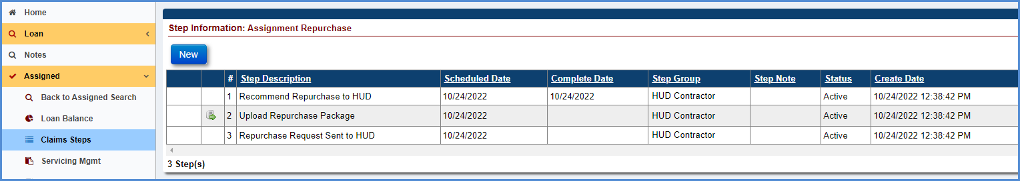
Figure 7-70: Assigned - Claims - Assignment Repurchase - Timeline Steps
The step Recommend Repurchase to HUD completion date is pre-populated with the initiation date on the timeline.

Upload Repurchase Package
HUD NSC Contractor completes the following step:
To upload the Repurchase Package, the HUD NSC Contractor clicks the upload icon next to step Upload Repurchase Package.
In the Edit Step pop-up, the HUD NSC Contractor clicks on Choose File, select the document then click open,
Add a note in the Notes field (if applicable) and click Submit on the Edit Step window. This completes the upload repurchase process.

Submit Repurchase Request to HUD
HUD NSC Contractor completes the following step:
The HUD NSC Contractor selects the step Repurchase Request sent to HUD, populate the complete date, add a note in the Notes field (if applicable), and click Submit on the Edit Step window. This completes the repurchase request sent to HUD process.

Approve/Deny Pre-Repurchase - HUD NSC Staff Activity
HUD NSC Staff must perform one of the following steps:
To Approve Pre-Repurchase, the HUD NSC Staff selects the optional step HUD Approved Pre-Repurchase, populate the complete date, add a note in the Notes field (if applicable), and click Submit on the Edit Step window. This completes the pre-approval process. Completing this step will add the Pre-Repurchase Letter Issued to Servicer step into the timeline and enables the prior Servicer to view the loan in the system.
To Deny Pre-Repurchase, the HUD NSC Staff selects the optional step HUD Denied Pre-Repurchase, populate the complete date, add a note in the Notes field (if applicable), and click Submit on the Edit Step window. Completing this step inactivates the Repurchase timeline.

Perform Repurchase - HUD NSC Contractor Activities
HUD NSC Contractor completes the following steps:
Generate the Pre-Repurchase Letter, click the magnifying glass beside the Pre-Repurchase Letter Issued to Servicer step to preview the letter. The Modify Letter Fields window is displayed. Edit the subject and salutation and select OK. The Pre-Repurchase Letter is displayed.
Print the pre-Repurchase Letter, the printer icon beside the Pre-Repurchase Letter Issued to Servicer step allows the HUD contractor to auto-save the document to the Documents tab. Select the printer icon, the Modify Letter Fields window is displayed. Edit the subject and salutation and select OK. The Pre-Repurchase Letter is displayed. This action auto-saves the document in the Documents tab and auto-completes the step.
Approve /Deny Repurchase Extension Request, if an extension is requested by the servicer by adding the Servicer 30 Day Extension Requested step, the step Extension Request Reviewed will be added into the timeline.
  - To grant the extension, the HUD NSC Contractor adds the optional step 30 Day Pre-Repurchase Extension Granted. To add the optional step, click New. Select the step from the Step Description dropdown, populate the complete date, add a note in the Notes field (if applicable), and click Submit on the new window. The completed step will be added to the list of steps.
  - To deny the extension, the HUD NSC Contractor adds the optional step 30 Day Pre-Repurchase Extension Denied. To add the optional step, click New. Select the step from the Step Description dropdown, populate the complete date, add a note in the Notes field (if applicable), and click Submit on the new window. The completed step will be added to the list of steps.

Servicer Upload Curative/Appeal Documents Package (optional Servicer step)
To upload curative/appeal documents the Servicer adds the optional step Servicer Upload Curative/Appeal Documents Package. To add the optional step, click New. Select the step from the Step Description drop down. Select Choose File to upload the documents, add a note in the Notes field (if applicable) and click submit. If the Servicer adds the step Servicer Upload Curative/Appeal Documents Package the steps Servicer Curative/Appeal Documents Submitted and Curative/Appeal Documents Reviewed are automatically added into the timeline.
HUD NSC Staff completes the following steps when the servicer submits step Servicer Upload Curative/Appeal Documents Package:
HUD NSC Staff will review the Curative/Appeal Documents. HUD NSC Staff then complete the step Curative/Appeal Documents Reviewed.
To reject the Curative/Appeal documentation that was uploaded, the HUD NSC staff selects the optional Curative/Appeal documents rejected step by clicking New, Select the optional step from the Step Description dropdown populate the complete date, add a note in the Notes field (if applicable), and click Submit on the New Step window. This completes the rejection process.
HUD NSC Contractor completes the following steps:
If the Repurchase is cured, The HUD NSC Contractor selects the optional step Servicer Clears Repurchase Issue on the timeline by clicking New. Select the optional step from the Step Description dropdown and click Submit on the New Step screen. The step will be added to the list of steps. Completing this step inactivates the timeline and removes the loan from the Repurchase Case Sub-Status. The loan will no longer be available to view by the prior servicer

Approve/Deny Repurchase - HUD NSC Staff Activity
HUD NSC Staff completes one of the following step:
To approve Repurchase, the HUD NSC Staff selects the optional step HUD Approved Repurchase, populate the complete date, add a note in the Notes field (if applicable), and click Submit on the Edit Step window. This completes the approval process. Completing this step will add the Repurchase Letter Issued to Investor step into the timeline
If there are any Estimated Expenses on the Loan an Error message will be displayed stating “HUD Decision Approved Repurchase” Step cannot be completed until all Estimated Expenses have been removed from the Payoff”.
To Deny Repurchase, the HUD NSC Staff selects the optional step HUD Denied Repurchase, populate the complete date, add a note in the Notes field (if applicable), and click Submit on the Edit Step window. Completing this step inactivates the Repurchase timeline.

Post Repurchase Approval - HUD NSC Contractor Activities
During the Repurchase Payment Process the servicer will authorize the Repurchase Payment (For more on the details on the Repurchase Payment Process see section (7.3.7.1.10). Once the servicer authorizes the Repurchase Claim Payment a Goodbye Letter sent to Borrower step will be automatically added into the Repurchase timeline.
HUD NSC Contractor completes the following steps:
Generate the Goodbye Letter, click the magnifying glass beside the Goodbye Letter sent to Borrower step to preview the letter. The Modify Letter Fields window is displayed. Edit the subject and salutation and select OK. The Goodbye Letter is displayed.
Print the Goodbye Letter, the printer icon beside the Goodbye Letter sent to Borrower step allows the HUD contractor to auto-save the document to the Documents tab. Select the printer icon, the Modify Letter Fields window is displayed. Edit the subject and salutation and select OK. The Goodbye Letter is displayed. This action auto-saves the document in the Documents tab and auto-completes the step.
Generate the Repurchase Letter, click the magnifying glass beside the Repurchase Letter Issued to Investor step to preview the letter; the Modify Letter Fields window is displayed. Edit the subject and salutation and click OK. The Repurchase Letter is displayed. The comments section of the modify Letter Fields will auto-populate with the comments that were entered during the timeline initiation if the Pre-Repurchase Letter Issued to Servicer Step has been completed, otherwise the comments section will be blank and allow the user to enter their own comments
Print the Repurchase Letter, the printer icon beside the Repurchase Letter Issued to Investor step allows the HUD NSC Contractor to auto-save the document to the Documents tab. Select the printer icon, the Modify Letter Fields window is displayed. Edit the subject and salutation and click OK. The Repurchase Letter is displayed. This action auto-saves the document in the Documents tab and auto-completes the step.
The following steps are triggered when the step HUD Verifies Repayment of Claim is added and completed by the system. This step is added when the confirmation of the collection is received from the AM.
  - Repurchase Package Sent to Servicer (HUD NSC Contractor Step)
  - Assignment to Servicer Sent for Recording (HUD NSC Contractor Step)
  - Received Recorded Assignment (HUD NSC Contractor Step)

To complete the step Repurchase Package Sent to Servicer step the HUD NSC Contractor selects the step, populate the complete date optionally add the note and click Submit on the Edit Step window.
To complete the step Assignment to Servicer Sent for Recording, the HUD NSC Contractor selects the step, populate the complete date optionally add the note and click Submit on the Edit Step window. A certify pop-up window is displayed confirming the transfer of the servicer. Click Yes. This completes the step. The case status is updated to Endorsed and the case sub-status is updated to Loan Active. If the payment status is suspended the sub-status is updated to Payment Suspended.
When the Assignment of Mortgage recording is completed and received, complete the step Received Recorded Assignment. To complete this step, select the step, populate the complete date, add the note, if applicable and click Submit on Edit Step window.

Servicers view of loans in Repurchase status with the Secretary
Servicers can access loan with Investor HUD (9999909990) via Assigned/Claims/Search page if HUD/HUD’s NSC Contractor has assigned them as the prior servicer on the repurchase. Servicers will be able to complete new servicer steps and upload documents under Repurchase timeline after “HUD Decision - Approved Pre-Repurchase” step is completed.
System allows services to upload documents. Servicer will not be able to delete documents.
System allows servicers to enter notes. Servicer will not be able to delete notes.
System will allow servicers (Servicer Manager and Servicer Staff user roles) to see the following tabs on the left menu.
  - Claims Steps
  - Notes
  - Documents
  - Servicing Mgmt – Read only
When HUD completes “Servicer Clears Repurchase Issue” step under Repurchase timeline, Servicer will no longer have access to the Assigned/ Repurchase timeline. System shall inactivate the timeline

Repurchase Claim Payment Processing
This section explains the repurchase collection processing in HERMIT (Servicing and AM) system.
The Servicer must go to the Accounting > Authorizations tab and enter the Loan Skey or FHA Case # and click on Search.
Upon clicking on a Repurchase from the Search Result, the Servicer is displayed an Authorization screen to Approve or Cancel the request.

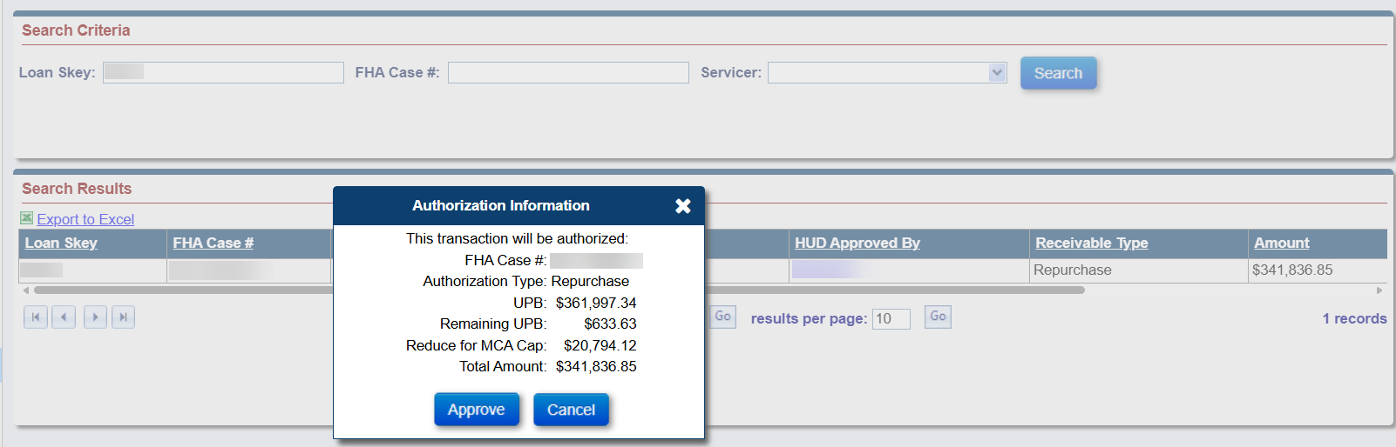
Figure 7-71: Approve / Cancel Repurchase
Upon clicking APPROVE button to Authorize Repurchase, system will display a Certify message.
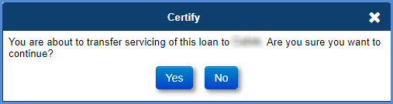
Figure 7-72: Approve / Certify Repurchase
Upon clicking YES button, system will immediately change Servicer from HUD Contractor to the Servicer selected for Repurchase timeline.
The step Servicer Authorizes Repayment of Claim is automatically added by the system and auto-completed when the following criteria are satisfied: The Servicer authorizes / approves the transaction in the step above via the Accounting – Authorizations screen (authorized by lender/investor/servicer). The step Goodbye Letter sent to Borrower is also automatically added by the system at this time.
The Accounting Module processes the file and sends a response file to the Servicing Module. The Servicing Module processes the response file from the Accounting Module and updates the batch status (Success – Collect).
The Accounting Module generates a non-interactive-batch file per Treasury Pay.gov’s specification. The file is sent to Pay.gov for collection. Upon posting the collection by Pay.gov, the deposit is recorded in the Accounting Module.
The Accounting Module sends the receivable collection confirmation to the Servicing Module via an interface file. The Servicing Module processes this file and the batch status is updated to Settled. The system adds a new step HUD Verifies Repayment of Claim on the repurchase timeline, the step is auto-completed with the date the file has been processed. An Auto note is added in the Notes Section HUD verifies this completes the repurchase collections processing in HERMIT.

Inactivate Claim Type 22 timeline once Repurchase is complete
System will automatically inactivate the Claim Type 22 timeline once the step “Assignment to Servicer sent for recording” has been completed in the Repurchase timeline.

Title Approval
This timeline is located under Assigned > Claims, Servicing Type “Title Approval.” NOTE: This timeline cannot be created by the user in the system. The Servicing Management tab can be used to inactivate the timeline. Once the timeline is inactivated, none of the steps can be edited.
TIP: Refer to section 7.1.7 “To Complete Timeline Steps” for general information how to complete steps within a timeline.
The following Template Steps are displayed when the timeline is initiated. The steps are HUD Contractor steps unless otherwise stated:
- Title Package Received
- Package Reviewed
- Worksheet Completed
- Package Approved
- Package Denied
- Recorded Assignment Received

CHAPTER 8: CLAIMS

CLAIMS
This chapter discusses the processing of Claim Types 20, 21, 22, 23, and 24.
- Claims Overview
- Submitting Claim Type 20
- Submitting Claim Type 21
- Submitting Claim Type 22
- Submitting Claim Type 23
- Submitting Claim Type 24
- Reviewing and Processing Claims
- No Pay Order
- Cancel Payment
- Payment processing
- Claim Reimbursements – Over Claims
- Paper Claim Transactions
- Rejected / Returned Claim Payments from Investor

Claims Overview
The Servicing Module allows servicers to electronically submit and follow up on a claim on behalf of lenders/investors. Additionally, the HUD Claims staff can review and process the claims. Claims are worked from their respective Claims Timelines. For general information on working timelines, refer to section 7.1.2 “Setup Criteria to Initiate Timelines” to initiate timelines, section 7.1.7 “To Complete Timeline Steps” to complete steps within a timeline, and section 7.1.8 “To Add Optional Timeline Steps” to add and complete optional steps within a timeline.
The following claim types can be processed in the system.
- Demand Assignment (Claim Type 20): This claim is initiated by a servicer on behalf of a lender/investor when a HUD Borrower Disbursement is made on a loan. HUD Borrower Disbursements are payments made to borrowers by HUD when the investor is unable or unwilling to make the payment. This timeline tracks the process to exercise the option to assign the loan to HUD. No Interest is included in the claim payment amount for this claim type.
- Foreclosure/Deed-In-Lieu (Claim Type 21): This claim is initiated by a servicer on behalf of a lender/investor due to acquisition of title of the property through foreclosure proceedings or deed-in-lieu of foreclosure. In these cases, servicers can file:
  - Sale Based Claim: If the property was disposed in a manner that was insufficient to satisfy the debt.
  - Appraisal Based Claim: If the property was not disposed within six months after the acquisition of the title and property.
- Assignment (Claim Type 22): This claim is initiated by a servicer on behalf of a lender/investor if the principal balance, including accrued interest and monthly insurance premium, reaches the threshold percentage (as established by HUD) of the maximum claim amount, and the servicer asks for approval to exercise the option to assign the loan to HUD.
- Mortgagor’s Short Sale (Claim Type 23): This claim is initiated by a servicer on behalf of a lender/investor if the mortgagor or the mortgagor's estate sells the property, but the sales proceeds are insufficient to satisfy the debt.
- Supplemental (Claim Type 24): This claim is initiated by a servicer on behalf of a lender/investor if additional reimbursements are required from HUD on a previously settled claim (Claim Type 21 or 23).

Claim Amounts are calculated based on information in the claims worksheet. Before the claim is paid, the Calculated Claim Amount is assessed against the loan’s Maximum Claim Amount (MCA) and Statutory Maximum Claim Amounts to determine if the Claim must be reduced / capped for exceeding the MCA or Statutory MCA. If the claim is capped for exceeding either of those limits, messaging is displayed on the claim form and a Note is saved to the Notes page of the loan stating the reason the claim was capped.

The below sections explain the submission and processing of the above-mentioned claim types.

Claim Processing Activities
CT 20, 21, 22, or 23 can be initiated on loans with a case status of Endorsed and CT 24 can be initiated on loans with a case status of Terminated. For all claim types, a servicer must initiate the respective claim timeline on the loan and complete the required steps to submit the claim using the online Form HUD-27011. The system pre-fills Form HUD-27011 with information captured based on loan activities and timelines (Example: loan transactions, due and payable and loss mitigation activities) which cannot be manually edited by the user.
The claim is submitted to HUD for review when the timeline step to submit Form HUD-27011 is completed. HUD can approve, deny, request additional information, or indicate the claim is still being reviewed. The following activities are performed by servicers and HUD Claims staff.
- Servicer activities:
  - Initiate a claim timeline
  - Review and edit claim data
  - Finalize and submit a claim
  - Resubmit a claim if additional information is required by HUD
- HUD Claims staff activities:
  - Process a claim (approvals, denials, pending additional information)
  - Assign a no pay order if needed
  - Cancel a claim payment if needed

Claims Setup - Search Criteria
The Claims Setup screen allows authorized users to initiate a claims timeline. A timeline is a set of steps that must be completed before a claim can be submitted to HUD for processing. Please refer to Chapter 7 for additional details on timelines.
To access the Claims Setup screen:
- Move the cursor to Endorsed from the Left Menu.
- Move the cursor to the Claims option and then click Setup.
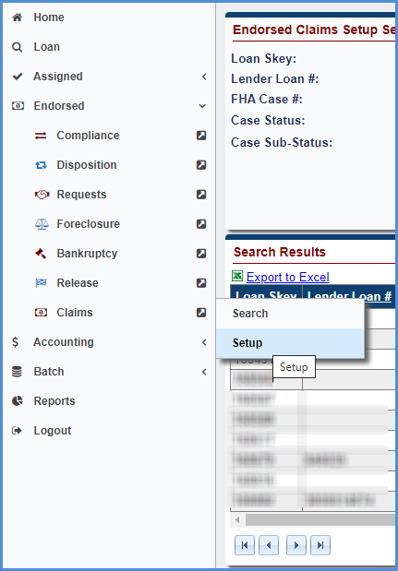
Figure 8-1: Endorsed - Claims - Setup
The Claims Setup screen provides the following search criteria:
Field | Description
Loan Skey | Servicing Module system identification number unique to each loan.
Lender Loan # | Recorded identification number for each loan property (Enter a partial loan number if the complete address is not known).
FHA Case # | FHA case number of the loan (Enter a partial FHA case number if the complete FHA case # is not known).
Case Status | FHA case status (example: Endorsed).
Case Sub-Status | Sub status of the case (example: Loan Active).
Borrower LName | Last name of the borrower.
Property Address | Address of the loan property (Enter a partial address if the complete address is not known).
Property City | City where the loan property is located.
Property State | State where the loan property is located.
Property Zip | Zip Code where the loan property is located.
Property County | County where the loan property is located.
Lender Name | Lender of the HECM loan.
Servicer Name | Servicer of the HECM loan.
Investor Name | Investor of the HECM loan.
Index Type | Organization and type of interest rate based on the interest rates at which banks borrow unsecured funds from other.
Table 8-1: Claims Setup Screen Search Criteria

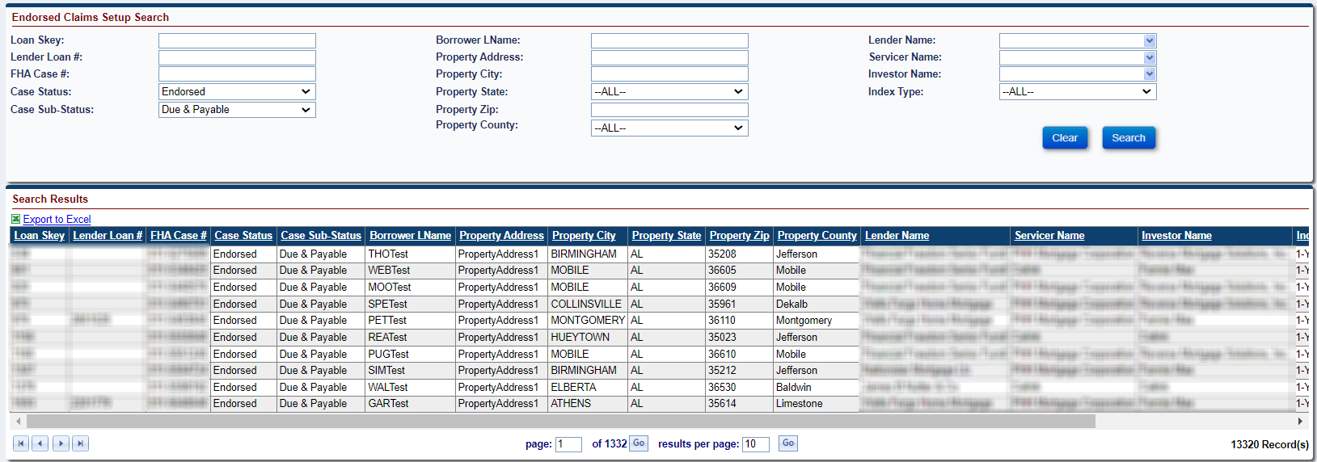
Figure 8-2: Endorsed - Claims - Setup Search

Claims - Search
The Claims Search screen allows authorized users to search for the timelines that have been initiated using the Claims Setup screen.
To access the Claims Search screen: From the Endorsed menu select Claims and then click Search.

Claims Search Screen – Field Definitions
The Claims Search screen provides the following search criteria:
Field | Description
Loan Information Criteria
Loan Skey | Servicing Module system identification number unique to each loan.
Lender Loan # | Recorded identification number for each loan property (Enter a partial loan number if the complete address is not known).
FHA Case # | FHA case number of the loan (Enter a partial FHA case number if the complete FHA case # is not known).
Case Status | FHA case status (example: Endorsed).
Case Sub-Status | Sub status of the case (example: Loan Active).
Borrower LName | Last name of the borrower.
Property Address | Address of the loan property (Enter a partial address if the complete address is not known).
Property City | City where the loan property is located.
Property State | State where the loan property is located.
Property Zip | Zip Code where the loan property is located.
Property County | County where the loan property is located.
Lender Name | Lender of the HECM loan.
Servicer Name | Servicer of the HECM loan.
Responsible | HUD specialist assigned to manage the specific claim timeline.
Investor Name | Investor of the HECM loan.
Master Servicer | Master Servicer of the HECM loan.
Servicing Management Criteria
Servicing Type | Type of claim servicing activity assigned to a loan in the form of a predefined template of claim servicing steps.
Timeline Status | Indicator of whether the servicing activity on a loan is active or inactive
TL Mgmt Skey | Unique identifier set when the timeline is initiated.
Claim Status | Status of the claim.
Servicing Status | Next pending step of the active timeline.
Current Step Group | The group that performs the step.
Step | Claim servicing activity step associated with the servicing activity timeline.
Step Status | Indicator of whether the servicing activity step has been completed or is still pending completion.
Scheduled Date | The date that a servicing activity step is scheduled to be completed.
Completion Date | The date that a servicing activity step is actually completed.
Step Group | The group that performs the step.
Table 8-2: Claims Timeline Search Criteria
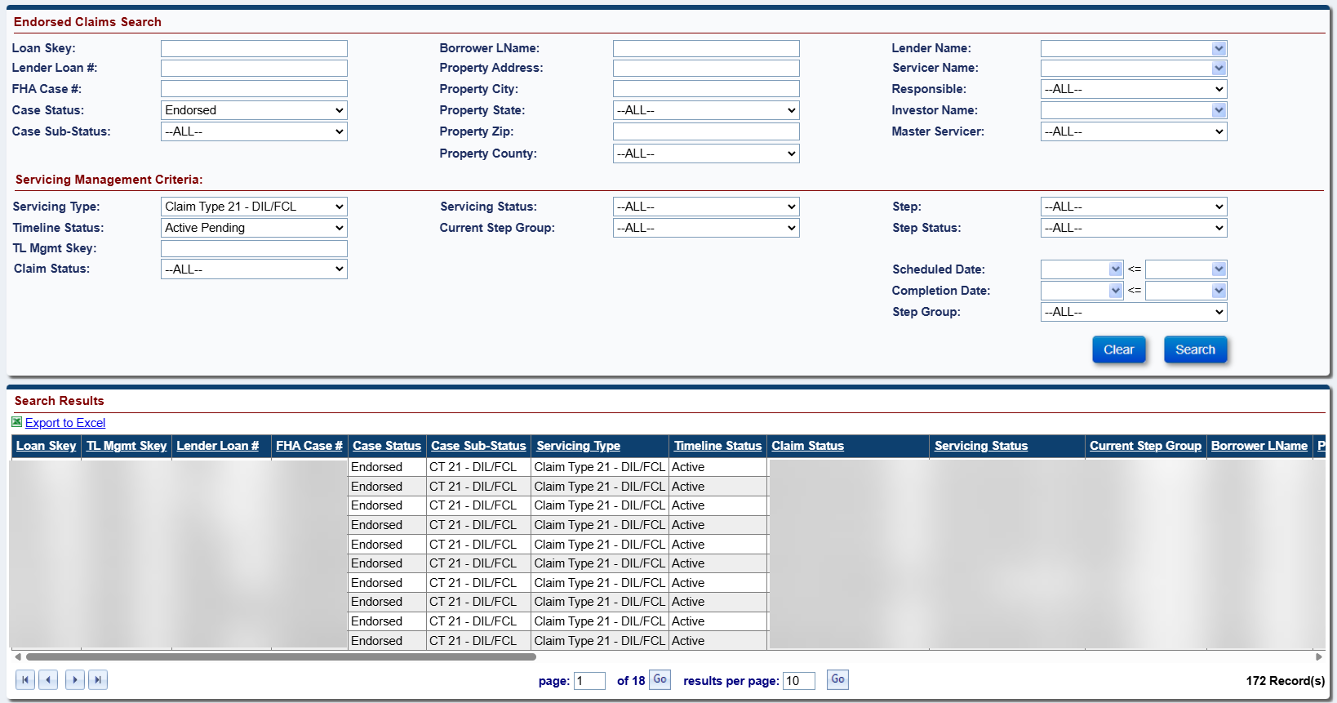
Figure 8-3: Endorsed - Claims - Search
      - Claims Search Criteria by Claim Type
The following table provides the claim type and status search criteria:
Workflow Activity | Servicing Type | Claim Status | Servicing Status
Search claims that have been initiated but not submitted | - Claim Type 21 – DIL/FCL  - Claim Type 23 – Short Sale/ Mortgagor's Sale (Pre-Fcl)  - Claim Type 24 – HECM Supplemental | Claim Filed by Servicer | Servicer Files Claim – 27011
Search claims that have been initiated but not submitted | - Claim Type 20 – Assignment  - Claim Type 22 – Assignment | Claim Filed by Servicer | Assignment to HUD sent for recording/Servicer Files Claim Type 22 – Form 27011
Search claims that need re-submission  Note: Applicable only for CT 21, 23 & 24 | - Claim Type 21 – DIL/FCL  - Claim Type 23 – Short Sale/ Mortgagor's Sale (Pre-Fcl)  - Claim Type 24 – HECM Supplemental | Claim Pending Additional Info | Resubmit Claim 27011
Search approved claims  Note: The timeline status must be selected as “All”. Also, the original servicer will be restricted from editing most fields after the claim has been submitted. | - Claim Type 20 – Assignment  - Claim Type 21 – DIL/FCL  - Claim Type 22 – Assignment  - Claim Type 23 – Short Sale/ Mortgagor's Sale (Pre-Fcl)  - Claim Type 24 – HECM Supplemental | Claim Approved for Payment | N/A
Search denied claims  TIP: Applicable only for CT 21, 23 & 24. The timeline status must be selected as “All”. | - Claim Type 21 – DIL/FCL  - Claim Type 23 – Short Sale/ Mortgagor's Sale (Pre-Fcl)  - Claim Type 24 – HECM Supplemental | Claim Denied | N/A
Search claims that have been submitted for payment  Note: The timeline status must be selected as “All”. Also, the original servicer will not be able to view CT 22 after the claim has been submitted. | - Claim Type 20 – Assignment  - Claim Type 21 – DIL/FCL  - Claim Type 22 – Assignment  - Claim Type 23 – Short Sale/ Mortgagor's Sale (Pre-Fcl)  - Claim Type 24 – HECM Supplemental | Claim Submitted for Payment | N/A
Search paid claims  TIP: The timeline status must be selected as “All”. Also, the original servicer will not be able to view CT 22 after the claim has been submitted. | - Claim Type 20 – Assignment  - Claim Type 21 – DIL/FCL  - Claim Type 22 – Assignment  - Claim Type 23 – Short Sale/ Mortgagor's Sale (Pre-Fcl)  - Claim Type 24 – HECM Supplemental | Claim Paid | N/A
Table 8-3: Search Criteria by Claim Type
To search for loans with specific steps completed in a certain date range, the user must select the Claim Type, Step, Step Status: Completed, and enter a Completion Date range. If Step Status is not selected, the result set will display both Scheduled Dates and Completion Dates within the date range.

Submitting Claim Type 20
This claim timeline is located under Endorsed > Claims, Servicing Type “Claim Type 20-Demand Assignment”. This claim is initiated by a servicer on behalf of a lender/investor if a HUD Borrower Disbursement is made on a loan. HUD Borrower Disbursements are payments made to borrowers by HUD when the investor is unable or unwilling to make the payment. The case status must be Endorsed, with case sub-status either Loan Active, Bankruptcy, or Payment Suspended (if the loan is in a Deferral period). This timeline tracks the process to exercise the option to assign the loan to HUD. No Interest is included in the claim payment amount for this claim type.
This timeline requires HUD NSC Contractor and HUD interaction. Upon initiation of this timeline, the case sub-status is updated to CT 20-Pending Assignment. If the timeline is inactivated, the case sub-status is updated accordingly. Only one active Claim Type 20-Demand Assignment timeline can be associated with a loan. The Servicing Management tab can be used to inactivate the timeline. Once the timeline is inactivated, none of the steps can be edited. The timeline cannot be activated once inactivated.
Claim Type 20 cannot be filed on a loan that has Corp Advance Transactions and / or Pre D&P Transactions – (Taxes, Flood INS, Condo Fees, Ground Rent, Hazard INS, HOA Dues) at the time of assignment of the loan.
TIP: Refer to section 7.1.2 “Setup Criteria to Initiate Timelines” for general steps to initiate timelines, and section 7.1.7 “To Complete Timeline Steps” for general information how to complete steps within a timeline.

CT20 Timeline Steps
The Servicer attaches all required documentation and completes the necessary steps on the timeline. The following Template Steps are displayed when the timeline is initiated. The steps are Servicer steps unless otherwise stated:
- Borrower Disbursement made by HUD
- HUD Issues Demand Assignment Letter – HUD step
- Confirm Clear Title
- Confirm Occupancy
- Verify Hazard Insurance current
- Verify Flood Insurance current (if required)
- Verify Property Taxes current
- Upload Compliance Package
- Upload Collateral Package
- Upload Servicing Package
- Submit Assignment Request to HUD
- HECM Assignment Acceptance Checklist Completed – HUD step
- Original Mortgage/Deed of Trust & Note sent to HUD
- Original Mortgage/Deed of Trust & Note received by HUD – HUD Contractor step
The following Optional Steps are available on this timeline. Certain steps are only available for specific user role groups, such as HUD or HUD Contractor, and are not available for Servicer user roles. Refer to section 7.1.8 “To Add Optional Timeline Steps” for general information how to add and complete optional steps within a timeline. The steps are Servicer steps unless otherwise stated:
- HUD – Follow Up on Recorded Assignment – HUD Contractor step
- Servicer - Follow Up
- Received HUD Decision - Pending Incomplete Package
- HUD Decision - Pending Incomplete Package – HUD step
- Assignment Denied - Funds Due HUD – HUD step
- Assignment Denied - No Funds Due HUD – HUD step
- HUD Issued Preliminary Title Approval – HUD step
- Reimbursement to HUD Completed
- Insurance Termination Completed – HUD step
- Assignment of Mortgage (AOM) Rejected – HUD Contractor Step
The following Trigger Steps are available on this timeline. The steps are Servicer steps unless otherwise stated:
- Assignment Package Received – HUD step
- Assignment Package Reviewed – HUD step
- Assignment to HUD sent for recording/Servicer Files Claim Type 20 - Form 27011
- Recorded Assignment Received – HUD Contractor step
- HUD Issued Final Title Approval – HUD Contractor step
- HUD Decision Denied Letter – HUD Contractor step
- HUD Approves Claim Type 20 for Payment – HUD step
- Submitted for Payment – HUD step
- Claims Paid – HUD step
- Servicer Notified of Preliminary Title Approval Decision – HUD Contractor step
- Follow-up on Incomplete Package – HUD Contractor step
- Assignment to HUD Recorded Date – HUD Contractor step
- Receipt of recorded assignment from county
- Sent recorded assignment to HUD
- Welcome Letter Sent – HUD Contractor step
- Review for Insurance Termination – HUD step
- Corrected AOM has been submitted
- Contractor received AOM for review – HUD Contractor Step

CT20 Assignment Timeline Letters
Multiple letters are available on this timeline. To generate and save Letters, click the Print icon next to the step name and enter necessary information in the popup modal. Using the Print icon will automatically save the Letter to the Documents page in the system, whereas using the Preview / magnifying glass icon will not save the document. It is recommended to use the Print icon.
The following Letters are available on the Claim Type 20-Demand Assignment timeline:
- Letter “HECM Assignment Acceptance Checklist” is tied to step “HECM Assignment Acceptance Checklist Completed” and tied to form “Checklist for assigning a Loan to HUD”.
- Letter “Preliminary Title Approval” is tied to step “Servicer Notified of Preliminary Title Approval Decision”
- Letter “Incomplete Package - Request for Assignment Letter” is tied to step “Follow-up on Incomplete Package”
- Letter “HECM Recorded Assignment to HUD Not Received” is tied to step “HUD - Follow Up on Recorded Assignment”
- Letter “HUD Issued Final Title Approval” is tied to step “HUD Issued Final Title Approval”
- Letter “Denial Request for Assignment Letter” is tied to step “HUD Decision Denied Letter”
- Letter “Welcome Letter” is tied to step “Welcome Letter Sent”
  - CT20 Welcome letter is added automatically during the nightly jobs and is permitted to be printed if all the following criteria are met:
    - “HUD Issued Preliminary Title” Step is completed.
    - There is NEITHER an Active Due & Payable w/HUD Approval OR Active Due & Payable w/o Approval Timeline
    - If Case Status is Endorsed, Case Sub Status must be “CT 20 – Preliminary Title Approval" or "Payment Suspended" or “Bankruptcy”
    - If Case Status is Assigned, then Case Sub Status must be "Loan Active” or “Payment Suspended."

Servicer Activities - Submit Assignment Request to HUD
- Prior to requesting preliminary title approval, ensure that the Lender Loan number is populated on the loan. This can be populated on the Loan Details screen under Loan Identifiers section.
- From the Claim Type 20-Demand Assignment timeline steps page, select Submit Assignment Request to HUD, populate the Completion Date and click Submit on the Edit Step window.
- Errors: If any of the required conditions are not met an error message will appear. Example of error: Mortgagee’s reference number is required:
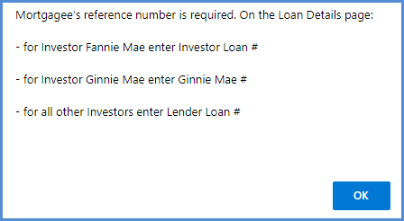
Figure 8-4: Error Message to Enter Mortgagee Reference #
- If all required conditions to complete Submit Assignment Request to HUD are met, a Certify pop-up window is displayed to certify that the documents attached in the previous steps are true and correct. Click Yes. The request is ready for review by HUD NSC Contractor.
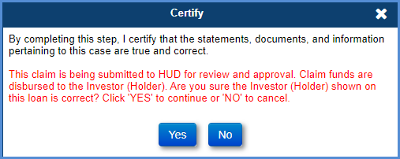
Figure 8-5: Certify Window – Submit Assignment Request Step
- The step Original Mortgage/Deed of Trust & Note sent to HUD must be completed by Servicer. To complete the step, select the step, enter the Completion Date, provide the FedEx tracking number in the step note (if available) and click Submit.

HUD NSC Contractor Activities - Preliminary Title Approval
- From the Timeline Steps page, Click the magnifying glass icon beside the step HECM Assignment Acceptance Checklist Completed to generate the document Checklist. A new window with the checklist is displayed with options to preview or print the document.
- Update the checklist and click Print Document to review the document.
- To auto-save the changes made to the assignment checklist document, click the Print Document link. Click Open on the File Download pop-up window. This action will save the updated HECM Assignment Acceptance Checklist to the Documents tab. Refresh the screen to auto-complete the step.
- Click New and select Step Description HUD Issued Preliminary Title Approval, enter Complete Date and click Submit. All validations must pass to grant preliminary title approval.
- If assignment package is incomplete and preliminary title approval will not be granted, follow the instructions in sections 8.2.7 or 8.2.8.
- A Certify pop-up window is displayed to certify that after this action the servicer will be able to transfer servicing of the loan. Click Yes. The preliminary title approval is complete.
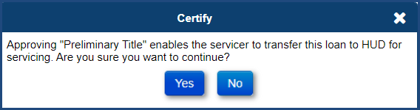
Figure 8-6: Certify Window – Preliminary Title Approval Step
- The completion of the step HUD Issued Preliminary Title Approval triggers the following activities:
  - Case sub-status is updated to CT 20-Preliminary Title Approval
  - General Loan Servicing menu functions, such as Transactions, Change Of Plan, Payoff, Servicer Request, Property, Audit Tracking and Alerts, are no longer available to the servicer
  - The following steps are added to the timeline:
    - Servicer Notified of Preliminary Title Approval Decision
    - Recorded Assignment Received
    - Receipt of recorded assignment from county
    - Sent recorded assignment to HUD
    - Assignment to HUD sent for recording/Servicer Files Claim Type 20 – Form 27011
- Click the print icon beside the step Servicer Notified of Preliminary Title Approval to generate and auto-save the Preliminary Title Approved letter. On the Modify Letter Fields window edit the subject and salutation and click OK. The Preliminary Title Approved letter is displayed and auto-saved in the Documents tab. The step is completed upon printing of the letter.
The Welcome Letter Sent step is added to the timeline during a nightly job when the necessary criteria is met. The step will not be displayed until all criteria are present.
- Click the print icon beside the step Welcome Letter Sent to generate the Welcome letter. On the Modify Letter Fields window, edit the subject and salutation and click OK. The Welcome Letter is displayed and auto-saved in the Documents tab. The step is completed upon printing of the letter. If the current Payment Plan Type is Line of Credit, Modified Term, or Modified Tenure, and the loan has funds available to be drawn by the borrower, then one Unscheduled Advance Request Form will be printed with the Welcome Letter.
- The step Original Mortgage/Deed of Trust & Note received by HUD must be completed by HUD NSC Contractor when the Servicer completed step Original Mortgage/Deed of Trust & Note sent to HUD.

Servicer Activities - Claim Filing via “27011” step
- On the Claims Steps screen for Claim Type 20-Demand Assignment timeline, click the magnifying glass icon beside Step Assignment to HUD sent for recording/Servicer Files Claim Type 20 - Form 27011. This step does not allow completion directly from the timeline.
- The Claims Worksheet for Claim Type 20 window is displayed. A pop-up warning message is displayed indicating that the claim amount will be adjusted if it exceeds Maximum Claim Amount. Click OK to proceed.
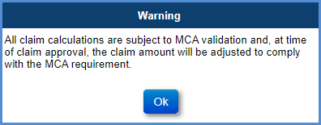
Figure 8-7: Warning Message for CT20
- The Claims Worksheet for Claim Type 20 window is an electronic version of Claim Form HUD-27011. Data fields are pre-filled by the system. The following links are available in the window header:
  - Save Changes: Save changes made to the claim for
  - Validate Claim: Execute the validations on the claim form. Failed validations are displayed with a validation message.
  - View Claim: Generate a PDF of the Claim Form HUD-27011
  - Finalize and Submit Claim: Enables servicers to submit a claim. Claims with failed validations cannot be submitted.
- Review the data populated on the Claim Form HUD-27011 by selecting each of the sections listed below and make any required updates.
  - Part A: General Information
  - Part B: Fiscal Data
  - Part C: Support Documents (this section is N/A for CT20)
  - Part D: Support Documents (this section is N/A for CT20)
  - Part E: Support Documents (this section is N/A for CT20)
TIP: For CT20, the total claim amount to be paid is displayed in Block 137 under Part B prior to claim submission.
- Click Save Changes after populating any data (for example: Update Mortgagee Comments field in Part A).
- Click Validate Claim, after completing the review.
- Validation Errors: The following information is displayed at the top of the screen if any of the validations fail:
  - Part of the Form HUD-27011 where the error occurred
  - Field name associated with the error occurred
  - Description of the error

  - Validation Error examples:
  - Mortgagee’s reference number is required
  - Missing Investor Banking Information: If the Investor Banking information (Routing#, Tax ID or Account#) is missing, the system will not allow the servicer to submit the claim. A validation error message will be displayed on the Claims Worksheet informing the user that the information is required to submit a claim.
  - Active Due & Payable: If there is an Active Due & Payable with HUD Approval Timeline or an Active Due & Payable without HUD Approval Timeline, the system will not allow the servicer to submit the claim. A validation error message will be displayed on the Claims Worksheet informing the user that there is an Active Due & Payable on the loan.
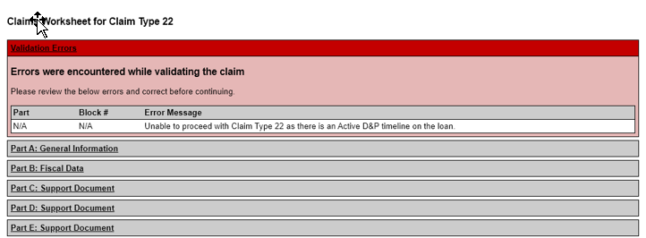
Figure 8-8: Claims Worksheet for CT20 with Active Due & Payable Validation Error
- Update the information and click Save Changes. Then, click Validate Claim to check for any validation errors.
- The success validation message is displayed if there are no validation errors.
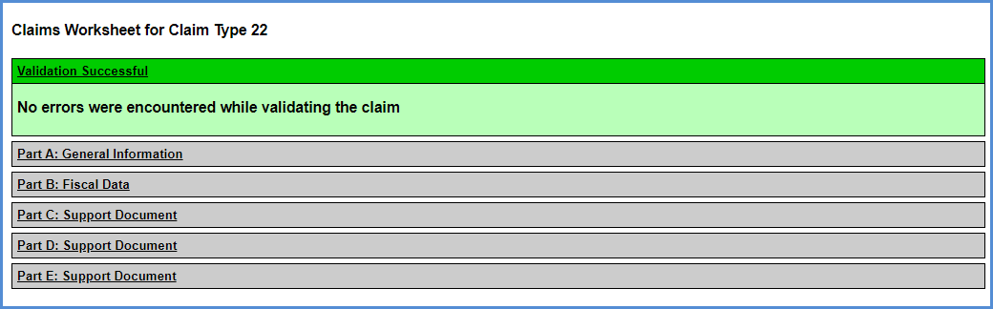
Figure 8-9: Claims Worksheet for CT20 with No Validation Errors
- Click Finalize and Submit Claim when the claim is ready for submission. After the claim is submitted, the claim form can no longer be updated.
- A pop-up warning message displays indicating that the claim amount will be adjusted if the Maximum Claim Amount is exceeded. The pop-up message to verify the investor (Holder of the property) is also displayed. Click Yes.
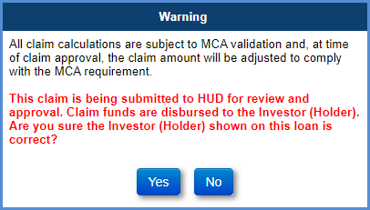
Figure 8-10: Finalize and Submit Warning Message for CT20
- A pop-up message is displayed requesting the user to Certify the claim form and confirm the transfer of servicing. Click Yes.
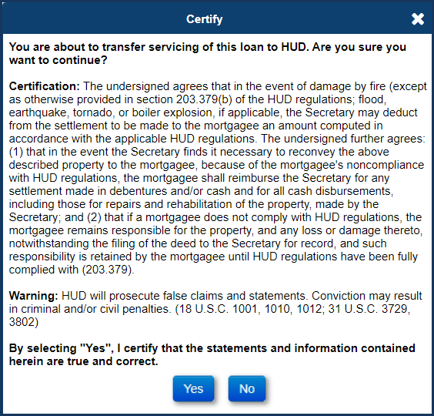
Figure 8-11: Certify Window – CT20
  - The final Claim Form HUD-27011 is auto-saved in the Documents tab. Only the View Claim link is available on the header; the remaining links to Save Changes, Validate Claim and Finalize and Submit Claim will no longer be displayed.
  - The final claim form is displayed in a file download window with options to Open, Save or Cancel.
  - The completion date on the step Assignment to HUD sent for recording/Servicer Files Claim Type 20 – Form 27011 is pre-filled with the date the claim is submitted.
- The claim is auto-approved. The system automatically adds the step HUD Approves Claim Type 20 for Payment which is auto-completed with the approval date.
  - The Advice of Payment is auto-generated and saved in the Documents tab for review. Select the Documents screen from the menu on the left side of the screen and click the View link beside the Claim Type 20 – Final Claim Calculation – AOP. Select Open on the file download window to view the document.
  - The loan is now transferred to HUD for servicing. The servicer name on the loan is updated to the HUD NSC Contractor name. The case status is still Endorsed.
TIP: Servicer can access loan with Servicer = HUD via Endorsed/Claims/Search page if you are the prior servicer on the loan and now loan is set to Servicer = 9999909990 . Servicer can access Claims steps, Notes, and Documents until final title approval.

Activities after Claim is submitted – Servicer and HUD NSC Contractor

Servicer Activities
Servicers can access Claims steps until final title approval. Servicer must complete these steps before final title approval.
- The step Receipt of recorded assignment from county must be completed by Servicer when the recorded assignment is received from the county.
- The step Sent recorded assignment to HUD must be completed by Servicer when the recorded assignment is sent to HUD.

HUD NSC Contractor Activities
- Step Assignment to HUD Recorded Date is triggered and added to the timeline when the Assignment to HUD sent for recording/Servicer Files Claim Type 22 – Form 27011 step has been completed. . The HUD NSC will enter Completion Date for the Assignment to HUD Recorded Date step as the actual date of recording of the document.
- Upon receipt and verification of documents associated with recording the assignment to HUD, complete the step Recorded Assignment Received. This triggers the addition of a new step, HUD Issued Final Title Approval.
- Click the printer icon beside the step HUD Issued Final Title Approval to generate the Final Title Approval letter. On the Modify Letter Fields window edit the salutation and click OK. The Final Title Approval letter is displayed and auto-saved in the Documents tab. The step is completed upon printing of the letter.
- A Certify pop-up window is displayed to certify that the case status will be updated. Click Yes. The final title approval is complete.
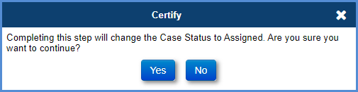
Figure 8-12: Certify Window – Final Title Approval Step
- This completes the assignment process. The case status is updated to Assigned and the case sub-status is updated to Loan Active.
TIP: Once the HUD completes step HUD Issued Final Title Approval, Case Status is updated to Assigned and case sub-status is updated to Loan Active. The servicer can no longer access the loan.

Incomplete Assignment Package – HUD, HUD NSC Contractor, and Servicer Activities
- If the assignment package is incomplete, HUD will click New and add the optional step, HUD Decision - Pending Incomplete Package.
- HUD NSC Contractor Letter Step Follow-up on Incomplete Package is triggered and added to the timeline when the HUD Decision - Pending Incomplete Package step has been completed.
- HUD NSC Contractor clicks the printer icon beside the step Follow-up on Incomplete Package to generate the Incomplete Package - Request for Assignment letter. On the Modify Letter Fields window edit the salutation and click OK. The Pending Incomplete Package letter is displayed and auto-saved in the Documents tab. The step is completed upon printing of the letter.
- HUD NSC Contractor will review the additional documents and if complete will follow the steps mentioned in section 8.2.4 above.

Assignment Denials – HUD NSC Contractor and Servicer Activities
HUD contractors can deny the assignment process between Preliminary Title Approval and Final Title Approval. To deny assignment:
- Click New and add the relevant step using the Step Description dropdown and click Submit. The optional steps are:
  - Assignment Denied - Funds Due HUD
  - Assignment Denied - No Funds Due HUD
- For the scenario where funds are due HUD:
  - add the Assignment Denied- Funds Due HUD step on the "Request for HUD Advance - Assignment timeline" to create the account receivable and the repayment of the funds due to HUD recorded.
  - add optional step Funds Due HUD Received to the CT20 timeline after the funds are received.
- For the scenario where No funds are due HUD add optional Step Assignment Denied- No Funds Due HUD to the timeline. From the New Step window:
- Enter the denial reason(s) into the step note.
- Enter the complete date.
- Click Submit.
- HUD NSC Contractor Letter Step HUD Decision Denied Letter is triggered and added to the timeline when either Assignment Denied - Funds Due HUD or Assignment Denied - No Funds Due HUD have been completed. The Denial Reason from the HECM Assignment Checklist Completed will be pulled into the Denial Request for Assignment Letter.
- When done, the CT20 timeline will be automatically inactivated.

Submitting Claim Type 21
This claim timeline is located under Endorsed > Claims, Servicing Type “Claim Type 21-DIL/FCL”. This claim is initiated by a servicer on behalf of a lender/investor due to acquisition of title of the property through foreclosure proceedings or deed-in-lieu of foreclosure. In these cases, servicers can file:
- Sale Based Claim: If the property was disposed in a manner that was insufficient to satisfy the debt.
- Appraisal Based Claim: If the property was not disposed within six months after the acquisition of the title and property.
This timeline requires HUD Claims Staff interaction. Upon initiation of this timeline, the case sub-status is updated to CT 21 – DIL/FCL. Only one active Claim Type 21 – DIL/FCL timeline can be associated with a loan.
The Servicing Management tab can be used to inactivate the timeline. If the timeline is inactivated, the case sub-status is updated accordingly. Once the timeline is inactivated, none of the steps can be edited. The timeline cannot be activated once inactivated.

CT21 Timeline Steps
The Servicer attaches all required documentation and completes the necessary steps on the timeline. The following Template Steps are displayed when the timeline is initiated.
- Servicer Files Claim - 27011
- Ready for Review
The following Trigger Steps are available on this timeline.
- HUD Decision - Pending Additional Info
- Resubmit Claim 27011
- Re Review
- Approved for Payment
- Submitted for Payment
- Claim Paid
- HUD Decision - Denied
- Claim Payment Cancelled
- Claim Payment Rejected
- Re-Try Claim Payment

CT21 Process
To initiate a Claim Type 21 – DIL/FCL timeline:
- On the Endorsed Claims Setup Search screen, enter the loan search criteria and click Search.
- From the search results, select a loan to initiate the timeline.
Servicers must report a Due and Payable event prior to Claim Type 21 initiation, if applicable. Refer to Endorsed Disposition/Requests timelines to initiate a Due and Payable timeline.
.
- On the Edit Servicing Management Window, select Claim Type 21 – DIL/FCL from the Servicing Type dropdown and populate the required fields (marked with an asterisk).
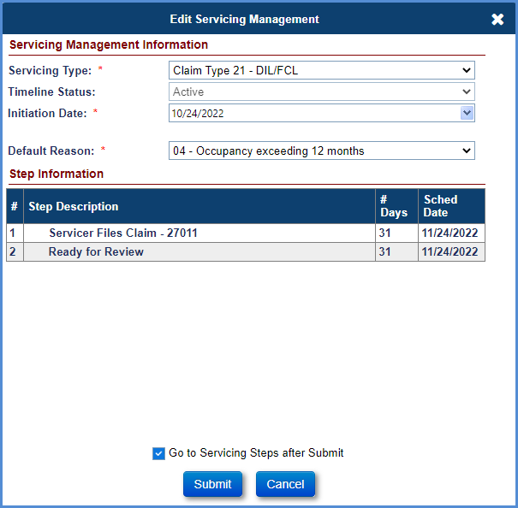
Figure 8-13: Initiating Claim Type 21
TIP: For Claim Type 21 without Due & Payable, select claims Default Reason “16 – No Default DIL” from the dropdown. When this reason is selected the step “Date Borrower/Estate executed DIL Agreement” must be completed on the Loss Mitigation – Deed in Lieu timeline for the claim to be filed.
- If applicable, Error messages will be displayed when attempting to initiate the timeline. All errors must be resolved before the timeline can be set up. If there is no error, proceed to Step 6.
  - Unpaid HUD Advance. An error message would be displayed if there is an unpaid HUD Advance on the loan. The User cannot initiate the CT 21 timeline, the Servicer needs to go to the Authorization tab and approve the unpaid HUD Advance.
  - Existing Claim timeline. An error message would be displayed if there is an existing claim timeline. The existing claim timeline needs to be inactivated before a new claim timeline can be opened.
  - Paper Claim record. An error message would be displayed if there is a Paper Claim record. The Paper Claim record must be removed via DCR if a new claims timeline is needed.
- At the bottom of this window, check the box Go to Servicing Steps after Submit.
- Click Submit. The Claims Steps screen for Claim Type 21 – DIL/FCL timeline is displayed. If you click Cancel, the Endorsed Claims Setup Search Screen will be displayed.
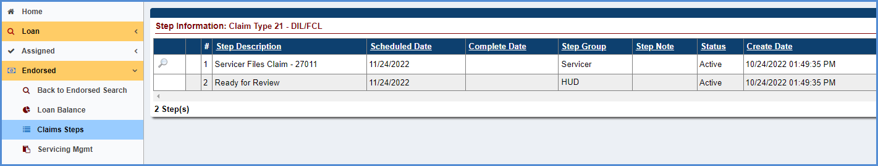
Figure 8-14: Step Information for Claim Type 21 – DIL/FCL
- On the Claims Steps screen for Claim Type 21 – DIL/FCL timeline, click the magnifying glass icon beside Step Servicer Files Claim – 27011.
- The Claims Worksheet for Claim Type 21 window is displayed. A pop-up warning message is displayed indicating that the claim amount will be adjusted if it exceeds Maximum Claim Amount. The pop-up box may include other warning messages as applicable. Click OK to proceed.
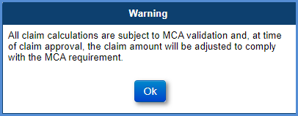
Figure 8-15: Warning Message for CT 21
- The Claims Worksheet for Claim Type 21 window is an electronic version of Claim Form HUD-27011. Data fields are pre-filled by the system from loan transactions and timelines (Due and Payable, Extension – Claim Filing). The following links are available in the window header:
  - Save Changes: Save changes made to the claim form
  - Validate Claim: Execute the validations on the claim form. Failed validations are displayed with a validation message.
  - View Claim: Generate a PDF of the Claim Form HUD-27011
  - Finalize and Submit Claim: Enables servicers to submit a claim. Claims with failed validations cannot be submitted.
- Enter foreclosure and/or deed-in-lieu information in the Disposition Information section. You must also mention the basis for the claim: appraisal or sale. This information is used by the system to prefill data fields in Part A of the claim form and Block 108 on Part B.
- Click the Save Changes link after populating the relevant fields in the Disposition Information section.
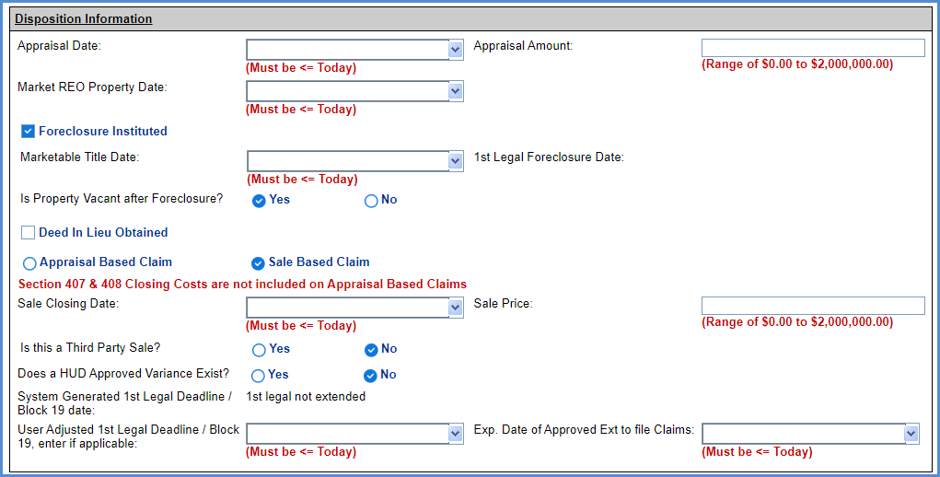
Figure 8-16: Disposition Information for CT 21
- User Alerts. A yellow User Alerts section will be displayed at the top of the Claims Worksheet, if applicable. This User Alert is informational only and does not prevent the claim from being submitted or resubmitted to HUD. To clear the User Alert for Legal Description, navigate to the Property Info page and enter a Legal Description. See section 6.8.1.1 for Editing Property Info. The User Alert for reimbursement of an Incentive appears when either Transaction Code 2134 “Relocation Incentive” or Transaction Code 2136 “Cash for Keys” is populated on the Claims Worksheet. The User Alerts for reimbursement amounts of Cash for Keys incentive appears when the Transaction Code 2136 “Cash for Keys” is populated on the Claims Worksheet and incentive amounts are displayed based on the Reason for Request listed in the Cash for Keys applicable timeline.
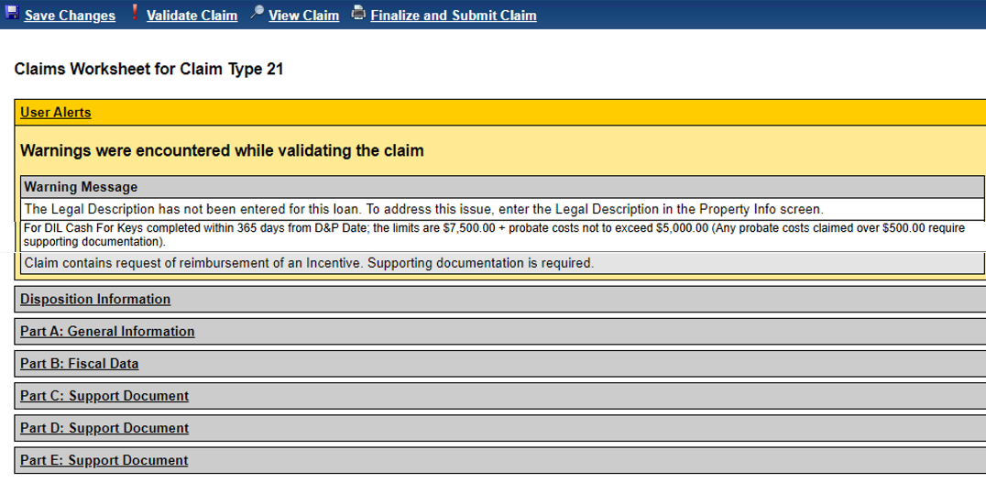
Figure 8-17: Warning Message

- Review the data populated on the Claim Form HUD-27011 by selecting each of the sections listed below and make any required updates.
At the time of claim submission, if any of the required timeframes are not met, the system will use the curtailment date (first missed date) to calculate the debenture interest on expenses (Part C, Part D and Item 409 in part E) and outstanding loan balance.
  - Disposition Information
  - Part A: General Information
  - Part B: Fiscal Data
  - Part C: Support Documents
  - Part D: Support Documents
  - Part E: Support Documents
- Provide the description of the expenses for description type - Other. The maximum field length is 100 characters.
- Attach the support documentation (such as HUD-1 form, invoices for the expenses etc.) in the Documents tab as part of the claim package.
- Parts C, D, and E will be pre-filled with data only if the transactions are added on the loan. This can be done manually via Transactions-> Loan screen, or through B2G transactions file upload. Click Validate Claim after completing the review.
- Validation Errors. The following information is displayed at the top of the screen if any of the validations fail:
  - Part of the Form HUD-27011 where the error occurred
  - Field name associated with the error occurred
  - Description of the error

  - Validation Error examples:
  - Missing Investor Banking Information: If the Investor Banking information (Routing#, Tax ID or Account#) is missing, the system will not allow the servicer to submit the claim. A validation error message will be displayed on the Claims Worksheet informing the user that the information is required to submit a claim.
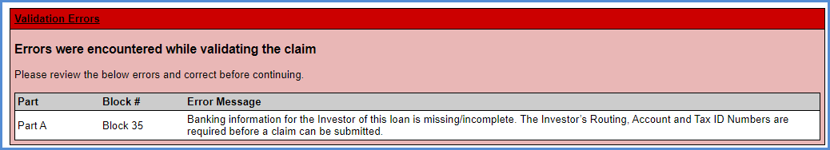
Figure 8-18: Claims Worksheet for CT 21 with Missing Banking Information Validation Error
  - Cash for Keys Upload Package: If there is a Cash for Keys transaction on the claim form (Transaction Code 2136) and the supporting documents are not included in the Cash for Keys timeline, the system will not allow the servicer to submit the claim. A validation error message will be displayed on the Claims Worksheet informing the user that the information is required to submit a claim.
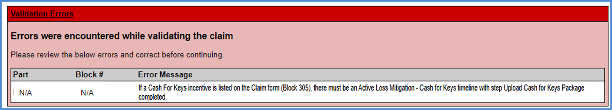
Figure 8-19: Claims Worksheet for CT 21 with Cash for Keys Upload Package Validation Errors
  - Negative claim amount: If the total claim amount does not exceed the proceeds received from sale of the property by the lender/investor (Holder of the property), the system will not allow the servicer to submit the claim. A validation error message will be displayed on the Claims Worksheet. Additional links to View HECM Worksheet and Print HECM Worksheet will be displayed with the calculation details of the negative or zero claim amount. To auto-save the HECM Worksheet to Documents, click “Print HECM Worksheet”.
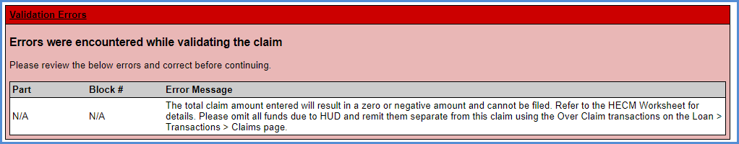
Figure 8-20: Claims Worksheet for CT 21 with Validation Errors
- Update the information and click Save Changes. Then, click Validate Claim to check for any validation errors.
- The success validation message is displayed if there are no validation errors.
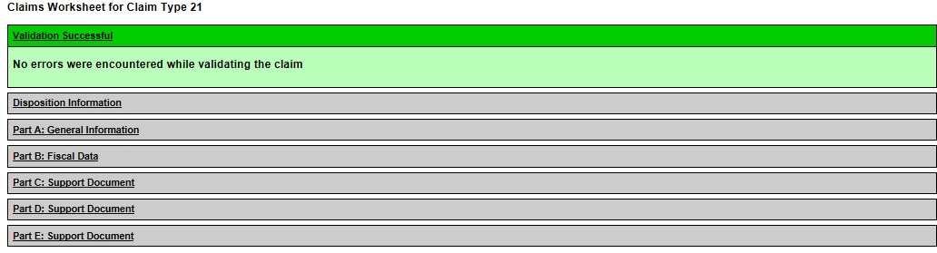
Figure 8-21: Claims Worksheet for CT 21 with No Validation Errors
- Click Finalize and Submit Claim when the claim is ready for submission. After the claim is submitted, the claim form can no longer be updated.
- A pop-up warning message displays the following information. If user agrees with all statements, click Yes. If additional changes are needed or the claim is not ready to be filed, click No to cancel the claim submission, and the Claims Worksheet will be displayed.
  - Notification that the claim amount will be adjusted if the Maximum Claim Amount is exceeded.
  - Notification to verify the investor (Holder of the property) is correct.
  - Notification of the current curtailment message, if applicable, from Part A: General Information “HUD Comments, if Any”.
  - Notification of Cash for Keys incentive amounts and timeframes based on Reason for Request.
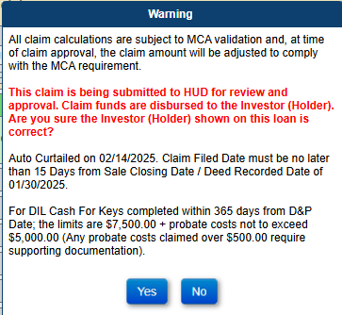
Figure 8-22: MCA and Investor Warning Message for CT 21
- A pop-up message is displayed requesting the user to Certify the claim form. Click Yes.
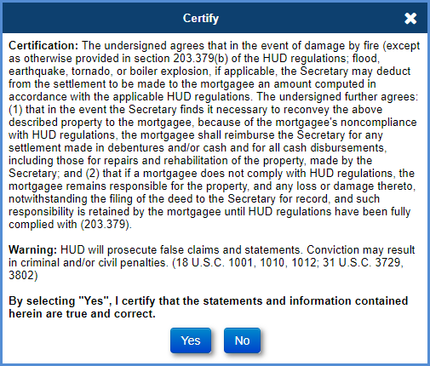
Figure 8-23: Certify Window for CT 21
- The claim is now ready for HUD review.
  - The final Claim Form HUD-27011 is auto-saved in the Documents tab. Only the View Claim link is available on the header; the remaining links to Save Changes, Validate Claim and Finalize and Submit will no longer be displayed.
  - The final claim form is displayed in a file download window with options to Open, Save or Cancel. If the number of line items exceed in the current page of the Claim Form HUD-27011, then the additional line items are displayed on the next page for the corresponding part (for example: If MIP expenses exceed on Part D, then the additional MIP’s are displayed in the next page showing the Part D expenses).
  - The completion date on the step Servicer Files Claims – 27011 is pre-filled with the date the claim is submitted.
- HUD Reviews the claim. See Section 8.7 for decisioning the claim. After the claim is approved by HUD, the Advice of Payment is automatically generated and displayed on the Documents screen. The claim will not be approved if there is a negative or zero claim.
- To view the auto-saved Claim Form HUD-27011, select the Documents screen from the menu on the left side of the screen and click the View link beside the Claim Type 21 – Final Claim Calculation – AOP. Select Open on the file download window to view the document.

TIP – Not all expenses listed on the Claim Form HUD-27011 are reimbursed at 100%.
The table below displays which Corporate Advance Expenses are paid at FULL Amount or paid at 2/3rd’s. The Columns in the table identify logic for both FHA Case # Assigned Date before 09/19/2017 and FHA Case # Assigned Date on or after 09/19/2017.
Corporate Advance Transactions | Loan with FHA Case # Assigned BEFORE 09/19/2017 | Loan with FHA Case # Assigned ON or AFTER 09/19/2017
Corp Adv - S305 - Flood Insurance | 100% | 2/3
Corp Adv - S305 - Condominium | 100% | 2/3
Corp Adv - S305 - Ground Rent | 100% | 2/3
Corp Adv - S305 - Hazard Insurance | 100% | 2/3
Corp Adv - S305 - HOA Dues | 100% | 2/3
Corp Adv - S305 - Taxes | 100% | 2/3
Corp Adv - S305 - Utilities - Liens | 2/3 | 2/3
Corp Adv - S306 - Attorney - Fees | 2/3 | 100%
Corp Adv - S306 - Other | 2/3 | 100%
Corp Adv - S306 - Repayment | 2/3 | 100%
Corp Adv - S306 - Trustee Fees | 2/3 | 100%
Corp Adv - S307 - Other | 2/3 | 100%
Corp Adv - S307 - Recording Fees | 2/3 | 100%
Corp Adv - S307 - Repayment | 2/3 | 100%
Corp Adv - S307 - Sheriff Fees | 2/3 | 100%
Corp Adv - S307 - Title Examination Fees | 2/3 | 100%
Corp Adv - S310 - Bnk Attorney Fees | 2/3 | 100%
Corp Adv - S310 - Other | 2/3 | 100%
Corp Adv - S310 - Repayment | 2/3 | 100%
Table 8-4: Paid Amount of Corporate Advance Expenses

Submitting Claim Type 22
To initiate a CT 22 timeline, the case status must be Endorsed, case sub-status must be Loan Active, Bankruptcy, Assignment Denied – Funds Due HUD, or Payment Suspended for a Deferred loan, and the loan balance must be greater than or equal to the threshold percentage (as established by HUD) of the maximum claim amount.

Multiple active Claim Type 22 – Assignment timelines cannot be created on a loan. This timelines requires Servicer, HUD NSC Contractor and HUD NSC staff interaction.
This is a note box.
This claim timeline is located under Endorsed > Claims, Servicing Type “Claim Type 22-Assignment”. This claim is initiated by a servicer on behalf of a lender/investor if the principal balance, including accrued interest and monthly insurance premium, reaches the threshold percentage (as established by HUD) of the maximum claim amount and the servicer asks for approval to exercise the option to assign the loan to HUD; or for Mortgagee Optional Election: MOE_Assignment.
This timeline requires HUD NSC Contractor and HUD interaction. Upon initiation of this timeline, the case sub-status is updated to CT 22-Pending Assignment. If the timeline is inactivated, the case sub-status is updated accordingly. Only one active Claim Type 22-Assignment timeline can be associated with a loan. The Servicing Management tab can be used to inactivate the timeline. Once the timeline is inactivated, none of the steps can be edited. The timeline cannot be activated once inactivated.
Claim Type 22 cannot be filed on a loan that has Corp Advance Transactions and / or Pre D&P Transactions – (Taxes, Flood INS, Condo Fees, Ground Rent, Hazard INS, HOA Dues) at the time of assignment of the loan.
TIP: Refer to section 7.1.2 “Setup Criteria to Initiate Timelines” for general steps to initiate timelines, and section 7.1.7 “To Complete Timeline Steps” for general information how to complete steps within a timeline.

CT22 Timeline Steps
The Servicer attaches all required documentation and completes the necessary steps on the timeline. The following Template Steps are displayed when the timeline is initiated. The steps are Servicer steps unless otherwise stated:
- Confirm loan balance is 97.000% or greater than MCA
- Confirm Clear Title
- Confirm Occupancy
- Verify Hazard Insurance current
- Verify Property Taxes current
- Upload Compliance Package
- Upload Collateral Package
- Upload Servicing Package
- Submit Assignment Request to HUD
- Original Mortgage/Deed of Trust sent to HUD
- Original Note sent to HUD
The following Optional Steps are available on this timeline. Certain steps are only available for specific user role groups, such as HUD or HUD Contractor, and are not available for Servicer user roles. Refer to section 7.1.8 “To Add Optional Timeline Steps” for general information how to add and complete optional steps within a timeline. The steps are Servicer steps unless otherwise stated:
- Verify Flood Insurance current
- HUD – Follow Up on Recorded Assignment – HUD Contractor step
- Servicer - Follow Up
- Assignment Denied - Funds Due HUD – HUD step
- Funds Due HUD Received – HUD Contractor step
- Assignment Denied - No Funds Due HUD – HUD step
- HUD Issued Preliminary Title Approval – HUD step
- Assignment of Mortgage (AOM) Rejected – HUD Contractor Step
The following Trigger Steps are available on this timeline. The steps are Servicer steps unless otherwise stated
- Assignment to HUD sent for recording/Servicer Files Claim Type 22 - Form 27011
- HECM Assignment Acceptance Checklist Completed – HUD step
- Original Mortgage/Deed of Trust received by HUD – HUD Contractor step
- Original Note received by HUD – HUD Contractor step
- Receipt of recorded assignment from county
- Sent recorded assignment to HUD
- Recorded Assignment Received – HUD Contractor step
- HUD Issued Final Title Approval – HUD Contractor step
- HUD Decision Denied Letter – HUD Contractor step
- Servicer Notified of Preliminary Title Approval Decision – HUD Contractor step
- Assignment to HUD Recorded Date – HUD Contractor step
- Welcome Letter Sent – HUD Contractor step
- HUD Approves Claim Type 22 for Payment – HUD step
- Submitted for Payment – HUD step
- Claims Paid – HUD step
- Corrected AOM has been submitted
- Contractor received AOM for review – HUD Contractor Step

CT22 Assignment Timeline Letters
Multiple letters are available on this timeline. To generate and save Letters, click the Print icon next to the step name and enter necessary information in the popup modal. Using the Print icon will automatically save the Letter to the Documents page in the system, whereas using the Preview / magnifying glass icon will not save the document. It is recommended to use the Print icon.
The following Letters are available on the Claim Type 22 - Assignment timeline:
- Letter “HECM Assignment Acceptance Checklist” is tied to step “HECM Assignment Acceptance Checklist Completed” and tied to form “Checklist for assigning a Loan to HUD”.
- Letter “Preliminary Title Approval” is tied to step “Servicer Notified of Preliminary Title Approval Decision”
- Letter “HECM Recorded Assignment to HUD Not Received” is tied to step “HUD - Follow Up on Recorded Assignment”
- Letter “HUD Issued Final Title Approval” is tied to step “HUD Issued Final Title Approval”
- Letter “Denial Request for Assignment Letter” is tied to step “HUD Decision Denied Letter”
- Letter “Welcome Letter” is tied to step “Welcome Letter Sent”
  - CT22 Welcome letter is added automatically during the nightly jobs and is permitted to be printed if all the following criteria are met:
    - “HUD Issued Preliminary Title” Step is completed.
    - There is NEITHER an Active Due & Payable w/HUD Approval OR Active Due & Payable w/o Approval Timeline
    - If Case Status is Endorsed, Case Sub Status must be “CT 22 – Preliminary Title Approval", "Payment Suspended", or "Bankruptcy".
    - If Case Status is Assigned, then Case Sub Status must be "Loan Active”, “Payment Suspended", or "Bankruptcy".
    - If the MOE box is not checked on the Servicing Management page on a Claim Type 22 – Assignment timeline, then the loan balance must be 98% or greater than the Max Claim Amount.
    - If the MOE box is checked on the Servicing Management page on a Claim Type 22 – Assignment timeline, then check the following MOE Assignment Conditions (to permit the Welcome Letter to be generated):
      - There is No Eligible NBS on the loan.
      - And all Borrowers are deceased or in a health care facility.
      - The MOE is marked YES on the Loan Header and the MOE checkbox is checked on the NBS under the Contact page on the loan.

Servicer Activities - Submit Assignment Request to HUD
Before initiating a Claim Type 22 – Assignment timeline, the Servicer must determine whether the CT22 is a MOE Assignment or not.
TIP: MOE Assignment field on the Claim Type 22 – Assignment timeline is not the same as the MOE field in the loan header. The MOE field in the loan header is automatically populated based on FHA Case # Assignment Date and whether an NBS appears on the loan, and is not editable by the user. The MOE Assignment field on the CT22 timeline is editable by the user and subject to system validations.
- If the claim is being submitted as a MOE Assignment, check the MOE Assignment box on the timeline setup modal. When MOE Assignment box is checked, certify text is displayed: “I certify that this loan will be assigned as a MOE Assignment and that a non-borrowing spouse exists on this loan. All supporting Mortgagee Optional Assignment (MOE) documentation has been uploaded to the loan documents screen.”
When MOE Assignment box is checked and user clicks Submit button, system will check for eligible NBS on this loan. If there is no eligible NBS on this loan, system will display an error. Error: “There is currently no eligible NBS (Non Borrowing Spouse) on this loan. Please add the eligible NBS through the HERMIT Contact Page.”
- Prior to submission of assignment request to HUD, ensure that the MOE Assignment box under Servicing Mgmt tab is correct for the loan. If not, click Edit under Servicing Mgmt tab and either check or uncheck the MOE Assignment box, then click Submit. This field must be accurate because MOE Assignments are subject to curtailment while regular assignments are not currently curtailed.
- Prior to requesting preliminary title approval, ensure that the Lender Loan number is populated on the loan. This can be populated on the Loan Details screen under Loan Identifiers section.
- Select Submit Assignment Request to HUD, populate the Completion Date and click Submit on the Edit Step window.
- Errors: If any of the required conditions are not met an error message will appear. Example of error: Mortgagee’s reference number is required:
Figure 8-24: Error Message to Enter Mortgagee Reference #
- If all required conditions to complete Submit Assignment Request to HUD are met, a Certify pop-up window is displayed to certify that the documents attached in the previous steps are true and correct. Click Yes. The request is ready for review by HUD NSC Contractor.
Figure 8-25: Certify Window – Submit Assignment Request Step
- The steps Original Mortgage/Deed of Trust sent to HUD and Original Note sent to HUD must be completed by Servicer. To complete these steps, select the step, enter the Completion Date, provide the FedEx tracking number in the step note (if available) and click Submit.

HUD NSC Contractor Activities - Preliminary Title Approval
- From the Timeline Steps page, Click the magnifying glass icon beside the step HECM Assignment Acceptance Checklist Completed to generate the document Checklist. A new window with the checklist is displayed with options to preview or print the document.
- Update the checklist and click Print Document to review the document.
- To auto-save the changes made to the assignment checklist document, click the Print Document link. Click Open on the File Download pop-up window. This action will save the updated HECM Assignment Acceptance Checklist to the Documents tab. Refresh the screen to auto-complete the step.
- Click New and select Step Description HUD Issued Preliminary Title Approval, enter Complete Date and click Submit. Validations must pass to grant preliminary title approval, such as the principal balance must be above the threshold percentage (as established by HUD) of the maximum claim amount.
- If assignment package is incomplete and preliminary title approval will not be granted, follow the instructions in section 8.4.7 or 8.4.8.
- A Certify pop-up window is displayed to certify that after this action the servicer will be able to transfer servicing of the loan. Click Yes. The preliminary title approval is complete.
Figure 8-26: Certify Window – Preliminary Title Approval Step
- The completion of the step HUD Issued Preliminary Title Approval triggers the following activities:
  - Case sub-status is updated to CT 22-Preliminary Title Approval
  - General Loan Servicing menu functions, such as Transactions, Change Of Plan, Payoff, Servicer Request, Property, Audit Tracking and Alerts, are no longer available to the servicer
  - The following steps are added to the timeline:
    - Servicer Notified of Preliminary Title Approval Decision
    - Recorded Assignment Received
    - Receipt of recorded assignment from county
    - Sent recorded assignment to HUD
    - Assignment to HUD sent for recording/Servicer Files Claim Type 22 – Form 27011
- Click the print icon beside the step Servicer Notified of Preliminary Title Approval to generate and auto-save the Preliminary Title Approved letter. On the Modify Letter Fields window edit the subject and salutation and click OK. The Preliminary Title Approved letter is displayed and auto-saved in the Documents tab. The step is completed upon printing of the letter.
The Welcome Letter Sent step is added to the timeline during a nightly job when the necessary criteria is met. The step will not be displayed until all criteria are present.
- Click the printer icon beside the step Welcome Letter Sent to generate the Welcome letter. On the Modify Letter Fields window, edit the subject and salutation and click OK. The Welcome Letter is displayed and auto-saved in the Documents tab. The step is completed upon printing of the letter. If the current Payment Plan Type is Line of Credit, Modified Term, or Modified Tenure, and the loan has funds available to be drawn by the borrower, then one Unscheduled Advance Request Form will be printed with the Welcome Letter.
- The steps Original Mortgage/Deed of Trust received by HUD and Original Note received by HUD must be completed by HUD NSC Contractor when the Servicer completed steps Original Mortgage/Deed of Trust sent to HUD and Original Note sent to HUD.

Servicer Activities - Claim Filing via “27011” step
- On the Claims Steps screen for Claim Type 22-Assignment timeline, click the magnifying glass icon beside Step Assignment to HUD sent for recording/Servicer Files Claim Type 22 – Form 27011. This step does not allow completion directly from the timeline.
- The Claims Worksheet for Claim Type 22 window is displayed. A pop-up warning message is displayed indicating that the claim amount will be adjusted if it exceeds Maximum Claim Amount. Click OK to proceed.
Figure 8-27: Warning Message for CT 22
- The Claims Worksheet for Claim Type 22 window is an electronic version of Claim Form HUD-27011. Data fields are pre-filled by the system. The following links are available in the window header:
  - Save Changes: Save changes made to the claim for
  - Validate Claim: Execute the validations on the claim form. Failed validations are displayed with a validation message.
  - View Claim: Generate a PDF of the Claim Form HUD-27011
  - Finalize and Submit Claim: Enables servicers to submit a claim. Claims with failed validations cannot be submitted.
- Review the data populated on the Claim Form HUD-27011 by selecting each of the sections listed below and make any required updates.
  - Part A: General Information
  - Part B: Fiscal Data
  - Part C: Support Documents (this section is N/A for CT 22)
  - Part D: Support Documents (this section is N/A for CT 22)
  - Part E: Support Documents (this section is N/A for CT 22)
TIP: For CT22, the total claim amount to be paid is displayed in Block 137 under Part B prior to claim submission.
- Click Save Changes after populating any data (for example: Update Mortgagee Comments field in Part A).
- Click Validate Claim, after completing the review.
- Validation Errors: The following information is displayed at the top of the screen if any of the validations fail:
  - Part of the Form HUD-27011 where the error occurred
  - Field name associated with the error occurred
  - Description of the error

  - Validation Error examples:
  - Mortgagee’s reference number is required
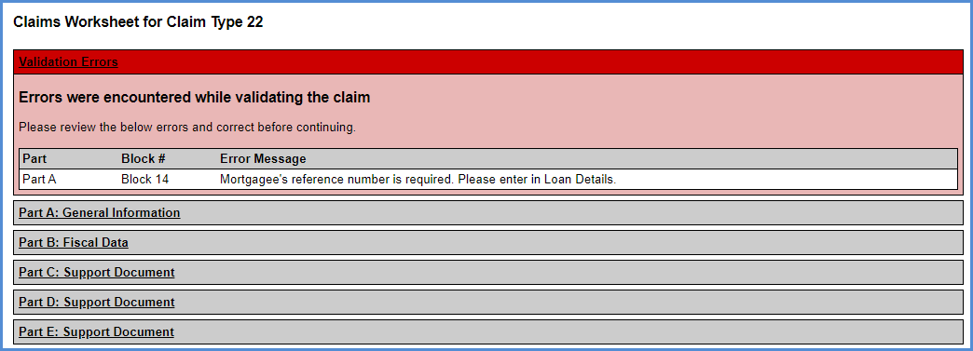
Figure 8-28: Claims Worksheet for CT 22 with Validation Errors
  - Missing Investor Banking Information: If the Investor Banking information (Routing#, Tax ID or Account#) is missing, the system will not allow the servicer to submit the claim. A validation error message will be displayed on the Claims Worksheet informing the user that the information is required to submit a claim.
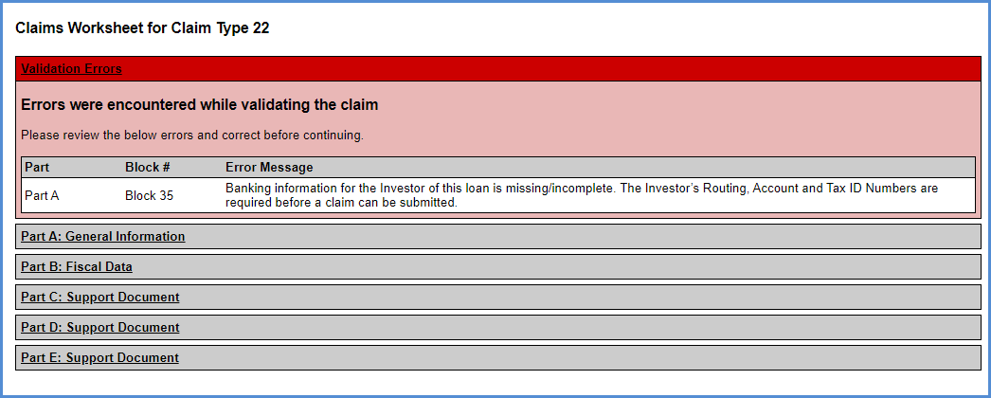
Figure 8-29: Claims Worksheet for CT 22 with Missing Banking Information Validation Error
  - Active Due & Payable: If there is an Active Due & Payable with HUD Approval Timeline or an Active Due & Payable without HUD Approval Timeline, the system will not allow the servicer to submit the claim. A validation error message will be displayed on the Claims Worksheet informing the user that there is an Active Due & Payable on the loan.
Figure 8-30: Claims Worksheet for CT 22 with Active Due & Payable Validation Error

- Update the information and click Save Changes. Then, click Validate Claim to check for any validation errors.
- The success validation message is displayed if there are no validation errors.
Figure 8-31: Claims Worksheet for CT 22 with No Validation Errors
- Click Finalize and Submit Claim when the claim is ready for submission. After the claim is submitted, the claim form can no longer be updated.
- A pop-up warning message displays indicating that the claim amount will be adjusted if the Maximum Claim Amount is exceeded. The pop-up message to verify the investor (Holder of the property) is also displayed. Click Yes.
Figure 8-32: Finalize and Submit Warning Message for CT 22
- A pop-up message is displayed requesting the user to Certify the claim form and confirm the transfer of servicing. Click Yes.
Figure 8-33: Certify Window – CT 22
  - The final Claim Form HUD-27011 is auto-saved in the Documents tab. Only the View Claim link is available on the header; the remaining links to Save Changes, Validate Claim and Finalize and Submit Claim will no longer be displayed.
  - The final claim form is displayed in a file download window with options to Open, Save or Cancel.
  - The completion date on the step Assignment to HUD sent for recording/Servicer Files Claim Type 22 – Form 27011 is pre-filled with the date the claim is submitted.
- The claim is auto-approved. The system automatically adds the step HUD Approves Claim Type 22 for Payment which is auto-completed with the approval date.
  - The Advice of Payment is auto-generated and saved in the Documents tab for review. Select the Documents screen from the menu on the left side of the screen and click the View link beside the Claim Type 22 – Final Claim Calculation – AOP. Select Open on the file download window to view the document.
  - The loan is now transferred to HUD for servicing. The servicer name on the loan is updated to the HUD NSC Contractor name. The case status is still Endorsed.
TIP: Servicer can access loan with Servicer = HUD via Endorsed/Claims/Search page if you are the prior servicer on the loan and now loan is set to Servicer = 9999909990 . Servicer can access Claims steps, Notes, and Documents until final title approval.

Activities after Claim is filed – Servicer and HUD NSC Contractor

Servicer Activities
Servicers can access Claims steps until final title approval. Servicer must complete these steps before final title approval.
- The step Receipt of recorded assignment from county must be completed by Servicer when the recorded assignment is received from the county.
- The step Sent recorded assignment to HUD must be completed by Servicer when the recorded assignment is sent to HUD.

HUD NSC Contractor Activities
- Step Assignment to HUD Recorded Date is triggered and added to the timeline when the Assignment to HUD sent for recording/Servicer Files Claim Type 22 – Form 27011 step has been completed. . The HUD NSC will enter Completion Date for the Assignment to HUD Recorded Date step as the actual date of recording of the document.
- Upon receipt and verification of documents associated with recording the assignment to HUD, complete the step Recorded Assignment Received. This triggers the addition of a new step, HUD Issued Final Title Approval.
- Click the printer icon beside the step HUD Issued Final Title Approval to generate the Final Title Approval letter. On the Modify Letter Fields window edit the salutation and click OK. The Final Title Approval letter is displayed and auto-saved in the Documents tab. The step is completed upon printing of the letter.
- A Certify pop-up window is displayed to certify that the case status will be updated. Click Yes. The final title approval is complete.
Figure 8-34: Certify Window – Final Title Approval Step
- This completes the assignment process. The case status is updated to Assigned and the case sub-status is updated to Loan Active.
TIP: Once the HUD completes step HUD Issued Final Title Approval, Case Status is updated to Assigned and case sub-status is updated to Loan Active. The servicer can no longer access the loan.

Assignment Denials – HUD NSC Contractor and Servicer Activities
HUD contractors can deny the assignment process between Preliminary Title Approval and Final Title Approval. To deny assignment:
- Click New and add the relevant step using the Step Description dropdown and click Submit. The optional steps are:
  - Assignment Denied - Funds Due HUD
  - Assignment Denied - No Funds Due HUD
- For the scenario where funds are due HUD:
  - add the Assignment Denied- Funds Due HUD step on the "Request for HUD Advance - Assignment timeline" to create the account receivable and the repayment of the funds due to HUD recorded.
  - add optional step Funds Due HUD Received to the CT22 timeline after the funds are received.
- For the scenario where No funds are due HUD add optional Step Assignment Denied- No Funds Due HUD to the timeline. From the New Step window:
- Enter the denial reason(s) into the step note.
- Enter the complete date.
- Click Submit.
- HUD NSC Contractor Letter Step HUD Decision Denied Letter is triggered and added to the timeline when either Assignment Denied - Funds Due HUD or Assignment Denied - No Funds Due HUD have been completed. The Denial Reason from the HECM Assignment Checklist Completed will be pulled into the Denial Request for Assignment Letter.
- When done, the CT22 timeline will be automatically inactivated.

Submitting Claim Type 23
This claim timeline is located under Endorsed > Claims, Servicing Type “Claim Type 23-Short Sale/ Mortgagor’s Sale (Pre-Fcl)”. This claim is initiated by a servicer on behalf of a lender/investor if the mortgagor or the mortgagor's estate sells the property and the mortgagee releases the title to facilitate the sale, but the sales proceeds are not sufficient to satisfy the debt.
This timeline requires HUD Claims Staff interaction. Upon initiation of this timeline, the case sub-status is updated to CT 23 – Short Sale. If the timeline is inactivated, the case sub-status is updated accordingly. Only one active Claim Type 23 - Short Sale/ Mortgagor's Sale (Pre-Fcl) timeline can be associated with a loan.
The Servicing Management tab can be used to inactivate the timeline. If the timeline is inactivated, the case sub-status is updated accordingly. Once the timeline is inactivated, none of the steps can be edited. The timeline cannot be activated once inactivated.

CT23 Timeline Steps
The Servicer attaches all required documentation and completes the necessary steps on the timeline. The following Template Steps are displayed when the timeline is initiated.
- Servicer Files Claim - 27011
- Ready for Review
The following Trigger Steps are available on this timeline.
- HUD Decision - Pending Additional Info
- Resubmit Claim 27011
- Re Review
- Approved for Payment
- Submitted for Payment
- Claim Paid
- HUD Decision - Denied
- Claim Payment Cancelled
- Claim Payment Rejected
- Re-Try Claim Payment

CT23 Process
To initiate a Claim Type 23 - Short Sale/ Mortgagor's Sale (Pre-Fcl) timeline:
- On the Endorsed Claims Setup Search screen, enter the loan search criteria and click Search.
- From the search results, select a loan to initiate the timeline.
Servicers must report a Due and Payable event prior to Claim Type 23 initiation if the loan is Due and Payable. Refer to Endorsed Disposition/Requests timelines to initiate a Due and Payable timeline.
.
- On the Edit Servicing Management Window, select Claim Type 23 - Short Sale/ Mortgagor's Sale (Pre-Fcl) from the Servicing Type dropdown and populate the required fields (marked with an asterisk).
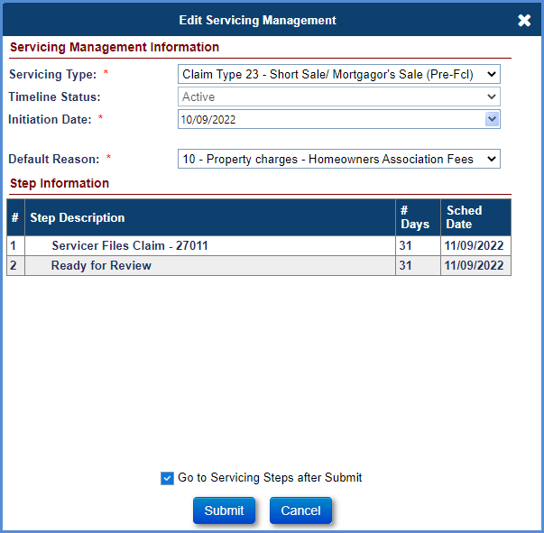
Figure 8-35: Initiating CT 23
- If applicable, Error messages will be displayed when attempting to initiate the timeline. All errors must be resolved before the timeline can be set up. If there is no error, proceed to Step 5.
  - Unpaid HUD Advance. An error message would be displayed if there is an unpaid HUD Advance on the loan. The User cannot initiate the CT 23 timeline, the Servicer needs to go to the Authorization tab and approve the unpaid HUD Advance.
  - Existing Claim Timeline. An error message would be displayed if there is an existing claim timeline. The existing claim timeline needs to be inactivated before a new claim timeline can be opened.
  - Paper Claim record. An error message would be displayed if there is a Paper Claim record. The Paper Claim record must be removed via DCR if a new claims timeline is needed.
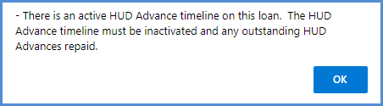
Figure 8-36: Error message when initiating CT 23
- At the bottom of this window, check the box Go to Servicing Steps after Submit.
- Click Submit. If you click Cancel, the Endorsed Claims Setup Search Screen will be displayed. The Claims Steps screen for Claim Type 23 - Short Sale/ Mortgagor's Sale (Pre-Fcl) timeline is displayed.
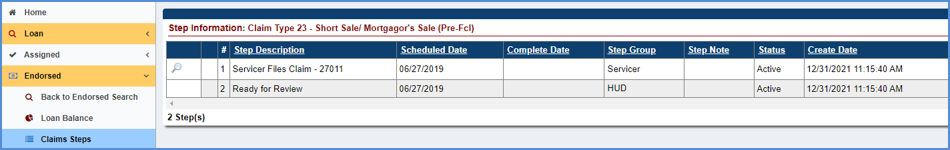
Figure 8-37: Step Information for CT 23 – DIL/FCL
- On the Claims Steps screen for Claim Type 23 - Short Sale/ Mortgagor's Sale (Pre-Fcl) timeline, click the magnifying glass icon beside Step1 Servicer Files Claim – 27011.
- The Claims Worksheet for Claim Type 23 window is displayed. A pop-up warning message is displayed indicating that the claim amount will be adjusted if it exceeds MCA. Other warning messages may also be displayed in this pop-up as necessary. Click OK to proceed.
Figure 8-38: Warning Message for CT 23
- The Claims Worksheet for Claim Type 23 window is an electronic version of Claim Form HUD-27011. Data fields are pre-filled by the system from loan transactions and timelines (Due and Payable). Note: The transactions will be added on the claim form only if due and payable timeline has been initiated on the loan with exception to HUD-1 closing costs. The following links are available in the window header:
  - Save Changes: Save changes made to the claim form
  - Validate Claim: Execute the validations on the claim form. Failed validations are displayed with a validation message.
  - View Claim: Generate a PDF of the Claim Form HUD-27011
  - Finalize and Submit Claim: Enables servicers to submit a claim. Claims with failed validations cannot be submitted.
- Enter short sale information in the Disposition Information. This information is used by the system to prefill data fields in Part A of the claim form and Block 108 on Part B.
- Click the Save Changes link after populating the relevant fields in the Disposition Information section.
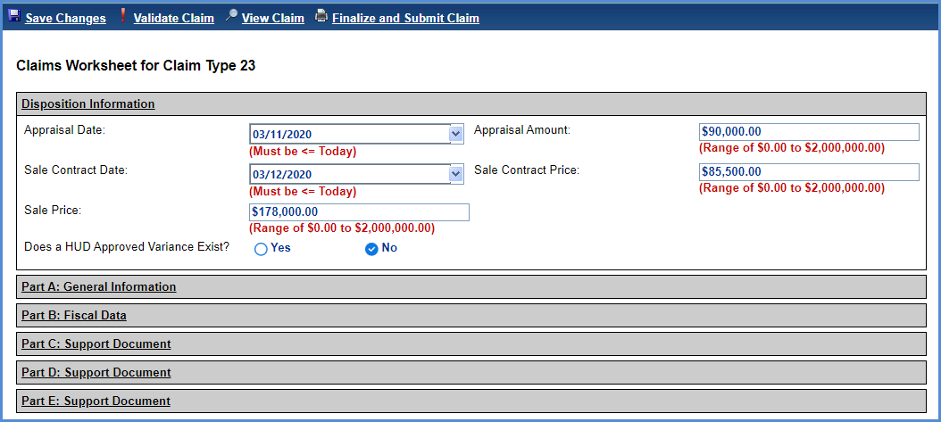
Figure 8-39: Claims Worksheet for CT 23
- User Alerts. A yellow User Alerts section will be displayed at the top of the Claims Worksheet, if applicable. This User Alert is informational only and does not prevent the claim from being submitted or resubmitted to HUD. To clear the User Alert for Legal Description, navigate to the Property Info page and enter a Legal Description. See section 6.8.1.1 for Editing Property Info. The User Alert for reimbursement of an Incentive appears when either Transaction Code 2134 “Relocation Incentive” or Transaction Code 2136 “Cash for Keys” is populated on the Claims Worksheet. The User Alerts for reimbursement amounts of Cash for Keys incentive appears when the Transaction Code 2136 “Cash for Keys” is populated on the Claims Worksheet and incentive amounts are displayed based on the Reason for Request listed in the Cash for Keys applicable timeline.
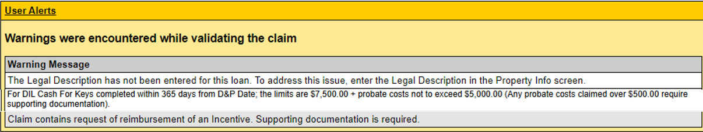
Figure 8-40: User Alerts message

- Review the data populated on the Claim Form HUD-27011 by selecting each of the sections listed below and make any required updates.
  - Disposition Information
  - Part A: General Information
  - Part B: Fiscal Data
  - Part C: Support Documents
  - Part D: Support Documents
  - Part E: Support Documents
- Provide the description of the expenses for description type - Other. The maximum field length is 100 characters.
- Attach the support documentation (such as HUD-1 form, invoices for the expenses etc.) in the Documents tab as part of the claim package.
  - Parts C, D, and E will be pre-filled with data only if the transactions are added on the loan. This can be done manually via Transactions-> Loan screen, or through B2G transactions file upload.
- Click Validate Claim, after completing the review.
- Validation Errors: The following information is displayed at the top of the screen if any of the validations fail:
  - Part of the Form HUD-27011 where the error occurred
  - Field name associated with the error occurred
  - Description of the error

  - Validation Error examples:
  - Missing “Deed Recorded Date / Post-Death Title Transfer”: If the “Deed Recorded Date/ Post-Death Title Transfer” step completion date from the Loss Mitigation – Short Sale timeline is missing, the system will not allow the servicer to submit the Claim Type 23. A validation error message will be displayed on the Claims Worksheet. For step “Deed Recorded Date/ Post-Death Title Transfer” to appear, the step “Sale Closing Date” on the same timeline must have a step completion date entered. Enter step completion date for “Sale Closing Date” then step completion date for “Deed Recorded Date/ Post-Death Title Transfer” and proceed with filing the claim.
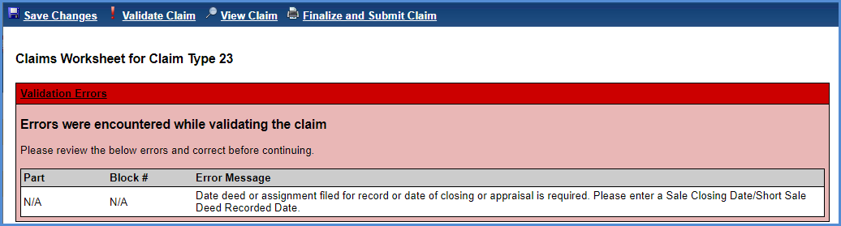
Figure 8-41: Claims Worksheet for CT 23

  - Missing Investor Banking Information: If the Investor Banking information (Routing#, Tax ID or Account#) is missing, the system will not allow the servicer to submit the claim. A validation error message will be displayed on the Claims Worksheet.
Figure 8-42: Claims Worksheet for CT 23 with Missing Banking Information Validation Error
  - Cash for Keys Upload Package: If there is a Cash for Keys transaction on the claim form (Transaction Code 2136) and the supporting documents are not included in the Cash for Keys timeline, the system will not allow the servicer to submit the claim. A validation error message will be displayed on the Claims Worksheet informing the user that the information is required to submit a claim.
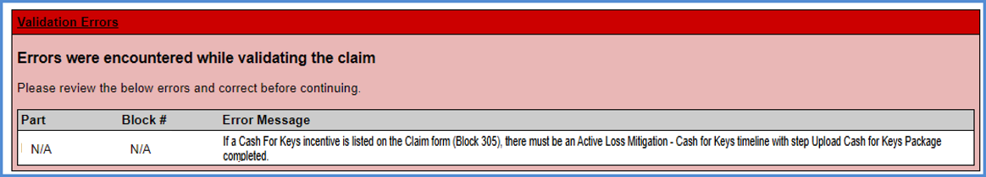
Figure 8-43: Claims Worksheet for CT 23 with Cash for Keys Upload Package Validation Error
  - Negative claim amount: If the total claim amount does not exceed the proceeds received from sale of the property by the lender/investor (Holder of the property), the system will not allow the servicer to submit the claim. A validation error message will be displayed on the Claims Worksheet. Additional links to View HECM Worksheet and Print HECM Worksheet will be displayed with the calculations details of the negative or zero claim amount. To auto-save the HECM Worksheet to Documents, click “Print HECM Worksheet”.
Figure 8-44: Claims Worksheet for CT 23 with Validation Errors
- Update the information and click Save Changes. Then, click Validate Claim to check for any validation errors.
- The success validation message is displayed if there are no validation errors.
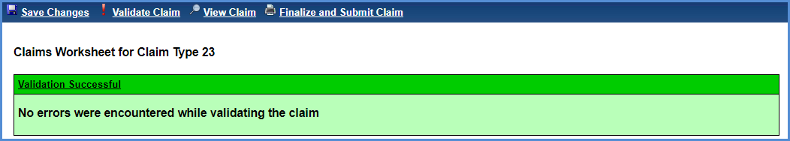
Figure 8-45: Claims Worksheet for CT 23 with No Validation Errors
- Click Finalize and Submit when the claim is ready for submission. After the claim is submitted, the claim form can no longer be updated.
- A pop-up warning message displays the following information. If user agrees with all statements, click Yes. If additional changes are needed or the claim is not ready to be filed, click No to cancel the claim submission, and the Claims Worksheet will be displayed.
  - Notification that the claim amount will be adjusted if the Maximum Claim Amount is exceeded.
  - Notification to verify the investor (Holder of the property) is correct.
  - Notification of the current curtailment message, if applicable, from Part A: General Information “HUD Comments, if Any”.
  - Notification of Cash for Keys incentive amounts and timeframes based on Reason for Request.
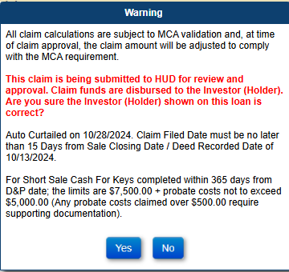
Figure 8-46: Finalize and Submit Warning Message for CT 23
- A pop-up message is displayed requesting the user to Certify the claim form. Click Yes.
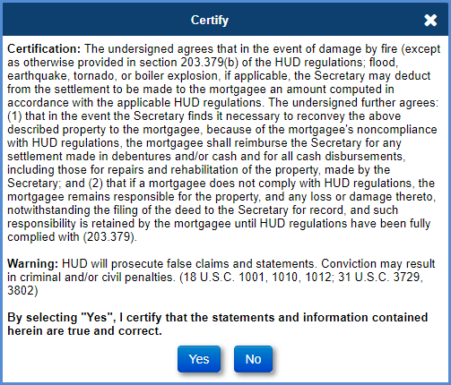
Figure 8-47: Certify Window – CT 23
- The claim is now ready for HUD review.
  - The final Claim Form HUD-27011 is auto-saved in the Documents tab. Only the View Claim link is available on the header; the remaining links to Save Changes, Validate Claim and Finalize and Submit Claim will no longer be displayed.
  - The final claim form is displayed in a file download window with options to Open, Save or Cancel. If the number of line items exceed in the current page of the Claim Form HUD-27011, then the additional line items are displayed on the next page for the corresponding part (for example: If MIP expenses exceed on Part D, then the additional MIPs are displayed in the next page showing the Part D expenses).
  - The completion date on the step Servicer Files Claims – 27011 is pre-filled with the date the claim is submitted.
- HUD Reviews the claim. See Section 8.7 for decisioning the claim After the claim is approved by HUD, the Advice of Payment is automatically generated and displayed on the Documents screen. The claim will not be approved if there is a negative or zero claim.
- To view the auto-saved Claim Form HUD-27011, select the Documents screen from the menu on the left side of the screen and click the View link beside the Claim Type 23 – Final Claim Calculation – AOP. Select Open on the file download window to view the document.
TIP – Not all expenses listed on the Claim Form HUD-27011 are reimbursed at 100%.
The table below displays which Corporate Advance Expenses are paid at FULL Amount or paid at 2/3rd’s. The Columns in the table identify logic for both FHA Case # Assigned Date before 09/19/2017 and FHA Case # Assigned Date on or after 09/19/2017.
Corporate Advance Transactions | Loan with FHA Case # Assigned BEFORE 09/19/2017 | Loan with FHA Case # Assigned ON or AFTER 09/19/2017
Corp Adv - S305 - Flood Insurance | 100% | 2/3
Corp Adv - S305 - Condominium | 100% | 2/3
Corp Adv - S305 - Ground Rent | 100% | 2/3
Corp Adv - S305 - Hazard Insurance | 100% | 2/3
Corp Adv - S305 - HOA Dues | 100% | 2/3
Corp Adv - S305 - Taxes | 100% | 2/3
Corp Adv - S305 - Utilities - Liens | 2/3 | 2/3
Corp Adv - S306 - Attorney - Fees | 2/3 | 100%
Corp Adv - S306 - Other | 2/3 | 100%
Corp Adv - S306 - Repayment | 2/3 | 100%
Corp Adv - S306 - Trustee Fees | 2/3 | 100%
Corp Adv - S307 - Other | 2/3 | 100%
Corp Adv - S307 - Recording Fees | 2/3 | 100%
Corp Adv - S307 - Repayment | 2/3 | 100%
Corp Adv - S307 - Sheriff Fees | 2/3 | 100%
Corp Adv - S307 - Title Examination Fees | 2/3 | 100%
Corp Adv - S310 - Bnk Attorney Fees | 2/3 | 100%
Corp Adv - S310 - Other | 2/3 | 100%
Corp Adv - S310 - Repayment | 2/3 | 100%
Table 8-5: Paid Amount of Corporate Advance Expenses

Submitting Claim Type 24
CT 24 can be submitted only if prior claims CT 21 or CT 23 are submitted in the Servicing Module. The initial claim (CT 21 or CT 23) must be in paid status.
This claim timeline is located under Endorsed > Claims, Servicing Type “Claim Type 24-HECM Supplemental”. This claim is initiated by a servicer on behalf of a lender/investor if additional reimbursements are required from HUD on a previously settled claim (case sub- status Terminate – CT 21 or Terminate – CT 23). This timeline requires HUD Claims Staff interaction.
Generally, only one active Claim Type 24 – HECM Supplemental timeline can be associated with a loan. In extenuating circumstances HUD may grant permission for a multiple / subsequent CT24 to be filed. See section 8.7.4. The Servicing Management tab can be used to inactivate the timeline. Once the timeline is inactivated, none of the steps can be edited. The timeline cannot be activated once inactivated.
The Claim Type 24 must be submitted within 6 months from the corresponding parent claim paid date. The “Claim Paid” date is found on the respective Claim Type 21 or Claim Type 23 timeline, “Claim Paid” step completion date. In extenuating circumstances HUD may grant permission for a Claim Type 24 to be submitted more than 6 months after the parent Claim Paid date. See section 8.7.4.

CT24 Timeline Steps
The Servicer attaches all required documentation and completes the necessary steps on the timeline. The following Template Steps are displayed when the timeline is initiated.
- Servicer Files Claim - 27011
- Ready for Review
The following Optional Steps are available on this timeline. Certain steps are only available for specific user role groups, such as HUD Claims Manager and are not available for Servicer user roles. Refer to section 7.1.8 “To Add Optional Timeline Steps” for general information how to add and complete optional steps within a timeline:
- Allow CT24 after 6 month deadline
- Allow Subsequent CT24
- Allow CT24 Resubmit after 45 days
The following Trigger Steps are available on this timeline.
- HUD Decision - Pending Additional Info
- Resubmit Claim 27011
- Re Review
- Approved for Payment
- Submitted for Payment
- Claim Paid
- HUD Decision - Denied
- Claim Payment Cancelled
- Claim Payment Rejected
- Re-Try Claim Payment

CT24 Process
To initiate a Claim Type 24 – HECM Supplemental timeline:
- On the Endorsed Claims Setup Search screen, enter the loan search criteria and click Search.
- From the search results, select a loan to initiate the timeline.
- On the Edit Servicing Management Window, select Claim Type 24 – HECM Supplemental from the Servicing Type dropdown and populate the required fields (marked with an asterisk).
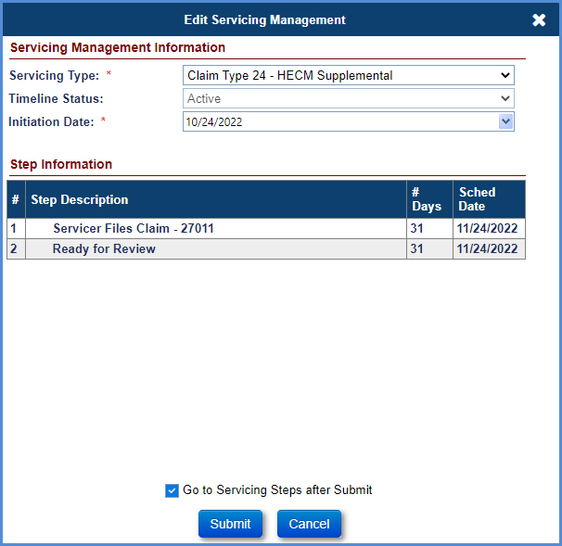
Figure 8-48: Initiating Claim Type 24
- At the bottom of this window, check the Go to Servicing Steps after Submit.
- Click Submit. If you click Cancel, the Endorsed Claims Setup Search Screen will be displayed. The Claims Steps screen for Claim Type 24 – HECM Supplemental timeline is displayed.
- If applicable, a pop-up warning message is displayed indicating that the Claim Type 24 Supplemental claim is being filed after the parent claim paid date PLUS 6 months. This is referred to as the 6 month filing deadline. Click YES to create the Claim Type 24 timeline and the Claims Worksheet for Claim Type 24 window is displayed. Click NO to return to the claim setup window without creating the timeline. Note that although the servicer may initiate this timeline; the claim cannot be filed unless an authorized HUD user adds the optional step “Allow CT24 after 6 month deadline”.
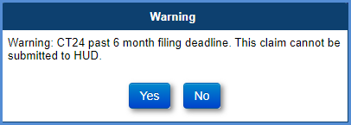
Figure 8-49: Warning Message for CT 24
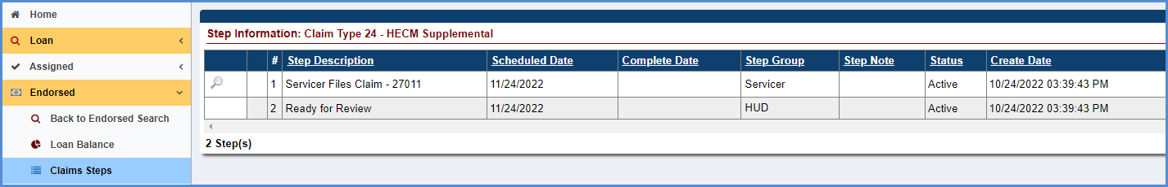
Figure 8-50: Step Information for Claim Type 24 – HECM Supplemental
- On the Claims Steps screen for Claim Type 24 – HECM Supplemental timeline, click the magnifying glass icon beside Step1 Servicer Files Claim – 27011.
- The Claims Worksheet for Claim Type 24 window is displayed, A pop-up warning message is displayed indicating that the claim amount will be adjusted if it exceeds Maximum Claim Amount. If applicable, the warning message indicating that the Claim Type 24 Supplemental claim is being filed after the 6 month filing deadline. Click OK to proceed.
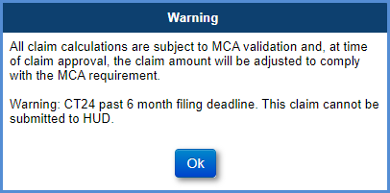
Figure 8-51: Warning Message for CT 24

- The Claims Worksheet for Claim Type 24 window is an electronic version of Claim Form HUD-27011. Data fields are pre-filled by the system from the initial claim. Only the new transactions or transactions that have been adjusted post initial claim payment will be pre-filled on the claim form. The following links are available in the window header:
  - Save Changes: Save changes made to the claim form
  - Validate Claim: Execute the validations on the claim form. Failed validations are displayed with a validation message
  - View Claim: Generate a PDF of the Claim Form HUD-27011
  - Finalize and Submit Claim: Enables servicers to submit a claim. Claims with failed validations cannot be submitted
- Update the data fields on claim worksheet as needed. Click the Save Changes.
- User Alerts. A yellow User Alerts section will be displayed at the top of the Claims Worksheet, if applicable. This User Alert is informational only and does not prevent the claim from being submitted or resubmitted to HUD. To clear the User Alert for Legal Description, navigate to the Property Info page and enter a Legal Description. See section 6.8.1.1 for Editing Property Info. The User Alert for reimbursement of an Incentive appears when either Transaction Code 2134 “Relocation Incentive” or Transaction Code 2136 “Cash for Keys” is populated on the Claims Worksheet.
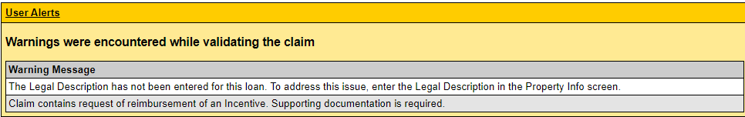
Figure 8-52: User Alerts message

- Review the data populated on the Claim Form HUD-27011 by selecting each of the sections listed below and make any required updates.
  - Part A: General Information
  - Part B: Fiscal Data
  - Part C: Support Documents
  - Part D: Support Documents
  - Part E: Support Documents
- Provide the description of the expenses for description type - Other. The maximum field length is 100 characters.
- Attach the support documentation (such as HUD-1 form, invoices for the expenses etc.) in the Documents tab as part of the claim package.
  - Parts C, D, and E will be pre-filled with data only if the transactions are added on the loan. This can be done manually via Transactions-> Loan screen, or through B2G transactions file upload.
- Click Validate Claim, after completing the review.
- Validation Errors: The following information is displayed at the top of the screen if any of the validations fail:
  - Part of the Form HUD-27011 where the error occurred
  - Field name associated with the error occurred
  - Description of the error
Validation Error examples:
  - Missing Block 9 date:
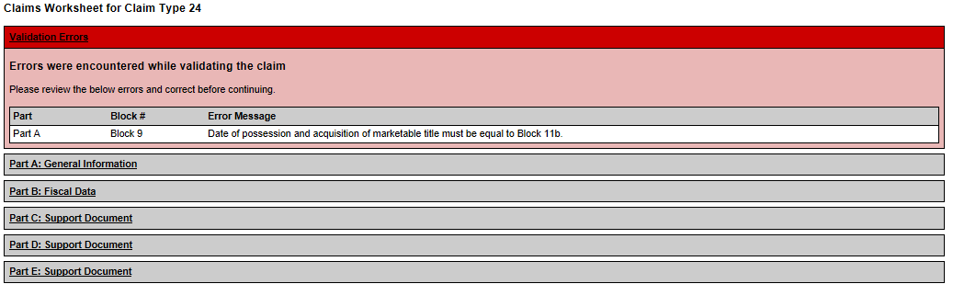
Figure 8-53: Claims Worksheet for CT 24 with Validation Errors
  - Missing Banking Information: If the Investor Banking information (Routing#, Tax ID or Account#) is missing, the system will not allow the servicer to submit the claim. A validation error message will be displayed on the Claims Worksheet.
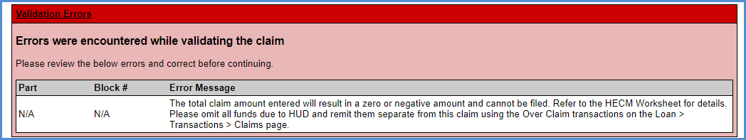
Figure 8-54: Claims Worksheet for CT 24 with Missing Investor Banking Information Validation Error
  - Negative Claim Amount: If the total claim amount does not exceed the proceeds received from sale of the property by the lender/investor (Holder of the property), the system will not allow the servicer to submit the claim. A validation error message will be displayed on the Claims Worksheet. Additional links to View HECM Worksheet and Print HECM Worksheet will be displayed with the calculations details of the negative or zero claim amount. To auto-save the HECM Worksheet to Documents, click “Print HECM Worksheet”.
- Update the information and click Save Changes. Then, click Validate Claim to check for any validation errors.
- Success validation message is displayed if there are no validation errors.
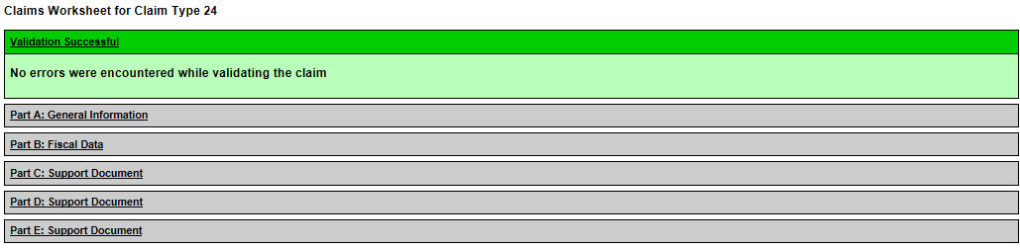
Figure 8-55: Claims Worksheet for CT 24 with no Validation Errors
- Click Finalize and Submit Claim when the claim is ready for submission. After the claim is submitted, the claim form can no longer be updated.
- A pop-up warning message displays the following information. If user agrees with all statements, click Yes. If additional changes are needed or the claim is not ready to be filed, click No to cancel the claim submission, and the Claims Worksheet will be displayed.
  - Notification that the claim amount will be adjusted if the Maximum Claim Amount is exceeded.
  - Notification to verify the investor (Holder of the property) is correct.
  - Notification of the current curtailment message, if applicable from Part A: General Information “HUD Comments, if Any”.
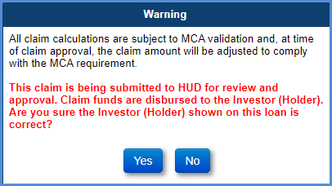
Figure 8-56: Finalize and Submit Warning Message for CT 24
- A pop-up message is displayed requesting the user to Certify the claim form. Click Yes.
Figure 8-57: Certify Window – CT 24
- The claim is now ready for HUD review.
  - The final Claim Form HUD-27011 is auto-saved in the Documents tab. Only the View Claim link is available on the header; the remaining links to Save Changes, Validate Claim and Finalize and Submit Claim will no longer be displayed.
  - The final claim form is displayed in a file download window with options to Open, Save or Cancel. If the number of line items exceed in the current page of the Claim Form HUD-27011, then the additional line items are displayed on the next page for the corresponding part (for example: If MIP expenses exceed on Part D, then the additional MIPs are displayed in the next page showing the Part D expenses).
  - The completion date on the step Servicer Files Claims – 27011 is pre-filled with the date the claim is submitted.
- HUD Reviews the claim. See Section 8.7 for decisioning the claim After the claim is approved by HUD, the Advice of Payment is automatically generated and displayed on the Documents screen. The Claim will not be approved if it is a negative or zero claim amount. Select the Documents screen from the menu on the left side of the screen and click the View link beside the Claim Type 24 – Final Claim Calculation – AOP. Select Open on the file download window to view the document.
- To initiate a Claim Type 24 – HECM Supplemental timeline within 30 days of HUD granting permission for Multiple / Subsequent CT24, servicer will follow the same process as for any other CT24 timeline initiation. If the optional step “Allow Subsequent CT24” was not added, or has a step completion date of more than 30 days ago, the following error message will be displayed:
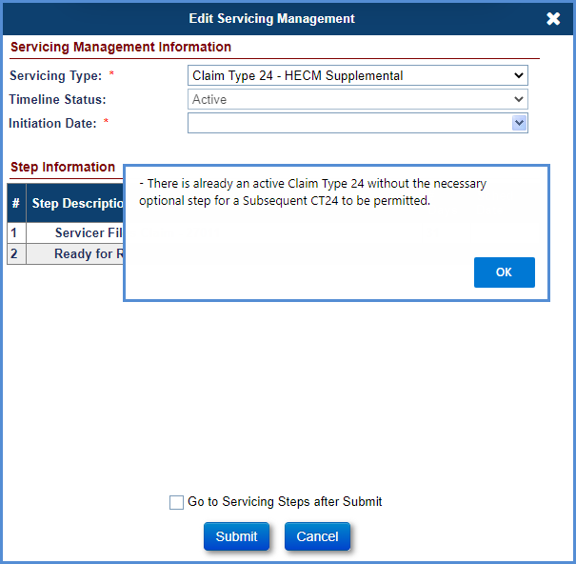
Figure 8-58: Error Message Subsequent CT24 not permitted

TIP – Not all expenses listed on the Claim Form HUD-27011 are reimbursed at 100%.
The table below displays which Corporate Advance Expenses are paid at FULL Amount or paid at 2/3rd’s. The Columns in the table identify logic for both FHA Case # Assigned Date before 09/19/2017 and FHA Case # Assigned Date on or after 09/19/2017.
Corporate Advance Transactions | Loan with FHA Case # Assigned BEFORE 09/19/2017 | Loan with FHA Case # Assigned ON or AFTER 09/19/2017
Corp Adv - S305 - Flood Insurance | 100% | 2/3
Corp Adv - S305 - Condominium | 100% | 2/3
Corp Adv - S305 - Ground Rent | 100% | 2/3
Corp Adv - S305 - Hazard Insurance | 100% | 2/3
Corp Adv - S305 - HOA Dues | 100% | 2/3
Corp Adv - S305 - Taxes | 100% | 2/3
Corp Adv - S305 - Utilities - Liens | 2/3 | 2/3
Corp Adv - S306 - Attorney - Fees | 2/3 | 100%
Corp Adv - S306 - Other | 2/3 | 100%
Corp Adv - S306 - Repayment | 2/3 | 100%
Corp Adv - S306 - Trustee Fees | 2/3 | 100%
Corp Adv - S307 - Other | 2/3 | 100%
Corp Adv - S307 - Recording Fees | 2/3 | 100%
Corp Adv - S307 - Repayment | 2/3 | 100%
Corp Adv - S307 - Sheriff Fees | 2/3 | 100%
Corp Adv - S307 - Title Examination Fees | 2/3 | 100%
Corp Adv - S310 - Bnk Attorney Fees | 2/3 | 100%
Corp Adv - S310 - Other | 2/3 | 100%
Corp Adv - S310 - Repayment | 2/3 | 100%
Table 8-6: Paid Amount of Corporate Advance Expenses

Reviewing and Processing Claims
Once a claim is submitted, HUD Claims staff can use the Endorsed Claims Search screen to search for submitted claims.
The following table provides the claim type and status search criteria:
Workflow Activity | Servicing Type | Claim Status | Servicing Status
Search claims that have been submitted and require review by HUD  TIP: Applicable only for CT 21, 23 & 24 | - Claim Type 21 – DIL/FCL  - Claim Type 23 - Short Sale/ Mortgagor's Sale (Pre-Fcl)  - Claim Type 24 – HECM Supplemental | Claim Filed by Servicer | Ready for Review
Search claims that have been re-submitted and require re-review by HUD  TIP: Applicable only for CT 21, 23 & 24 | - Claim Type 21 – DIL/FCL  - Claim Type 23 - Short Sale/ Mortgagor's Sale (Pre-Fcl)  - Claim Type 24 – HECM Supplemental | Claim Pending Additional Info | Re Review
Search approved claims  TIP: The timeline status must be selected as “All”. | - Claim Type 21 – DIL/FCL  - Claim Type 22 – Assignment  - Claim Type 23 - Short Sale/ Mortgagor's Sale (Pre-Fcl)  - Claim Type 24 – HECM Supplemental | Claim Approved for Payment | N/A
Search for claims that have been approved but cancelled prior to payment submission to the AM | - Claim Type 21 – DIL/FCL  - Claim Type 23 - Short Sale/ Mortgagor's Sale (Pre-Fcl)  - Claim Type 24 – HECM Supplemental | Claim Approved for Payment | Re Review
Search denied claims  TIP: The timeline status must be selected as “All”. | - Claim Type 21 – DIL/FCL  - Claim Type 23 - Short Sale/ Mortgagor's Sale (Pre-Fcl)  - Claim Type 24 – HECM Supplemental | Claim Denied | N/A
Search for claims that have been submitted for payment  TIP: The timeline status must be selected as “All”. | - Claim Type 21 – DIL/FCL  - Claim Type 22 – Assignment  - Claim Type 23 - Short Sale/ Mortgagor's Sale (Pre-Fcl)  - Claim Type 24 – HECM Supplemental | Claim Submitted for Payment | N/A
Search for claims that have been paid  TIP: The timeline status must be selected as “All”. | - Claim Type 21 – DIL/FCL  - Claim Type 22 – Assignment  - Claim Type 23 - Short Sale/ Mortgagor's Sale (Pre-Fcl)  - Claim Type 24 – HECM Supplemental | Claim Paid | N/A
Table 8-7: Search Criteria by Claim Type

Approving a Claim
Claim Type 22 is auto-approved upon submission.
To approve a claim:
- On the Endorsed Claims Search Screen, enter the search criteria to review the submitted claims and click Search.
- From the search results, select a claim to review.
- On the Claims Steps screen for the claim type timeline, select the magnifying glass icon beside Step 2 Ready for Review.
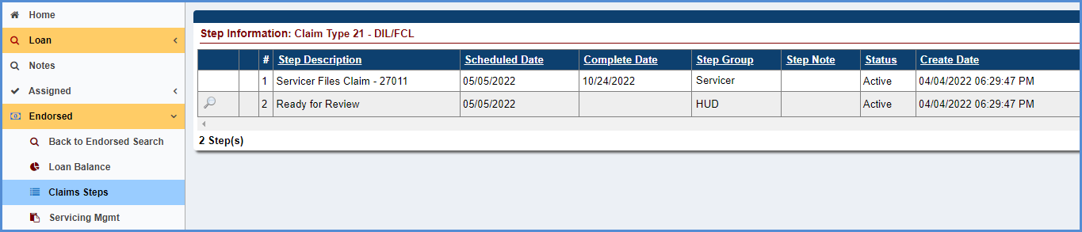
Figure 8-59: Step Information for a Claim Type
- A new window with the Claims Worksheet for Claim Type is displayed.
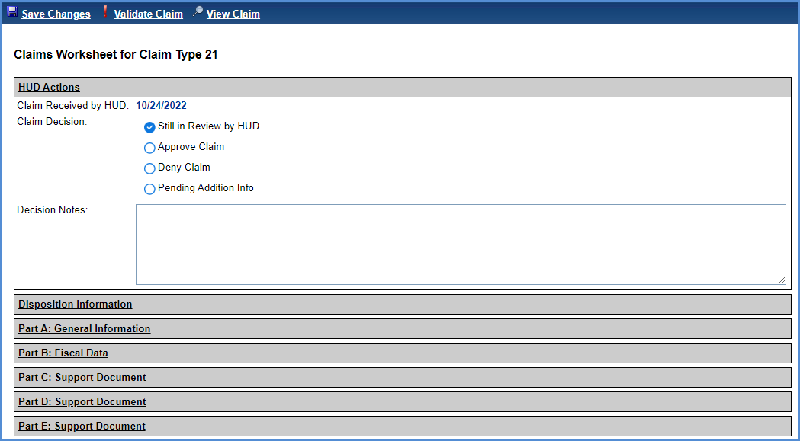
Figure 8-60: Sample Claims Worksheet
- The Claims Worksheet for Claim Type window is an electronic version of Claim Form HUD-27011 that was submitted by a servicer. The following links are available on the window header:
  - Save Changes: Save the changes made to the HUD Actions section
  - Validate Claim: Executes the validations on the claim form. Failed validations are displayed with validation message.
  - View Claim: Generates a PDF of the Claim Form HUD-27011
- Review the claim by each section. Note: Refer to Documents tab for claims package attached by the servicers during claims submission.
  - HUD Actions
  - Disposition Information (only for CT 21 and CT 23)
  - Part A: General Information
  - Part B: Fiscal Data
  - Part C: Support Documents
  - Part D: Support Documents
  - Part E: Support Documents
- After completing the review, click Approve. You can optionally add Decision Notes. Decision Notes will be auto-saved to the Notes page upon selecting a HUD decision.
- Click Save Changes to save the HUD Actions section. If applicable on a Claim Type 24 only, a warning message indicating that the Claim Type 24 Supplemental claim is being filed after the 6 month filing deadline is displayed. Click YES to approve the claim, click NO to return to the HUD Actions page.
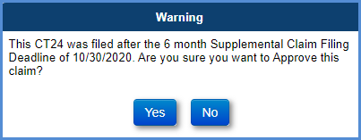
Figure 8-61: Sample Claim Approval Step
- The Claim Form HUD-27011 is auto-saved in the Documents tab.
- The claim form is displayed via a file download window with options to Open, Save or Cancel.
- Close the Claims Worksheet after viewing the claim form.
- The Completion Date on the step, Ready for Review, is pre-filled with the approved date. The claim is now approved for payment.
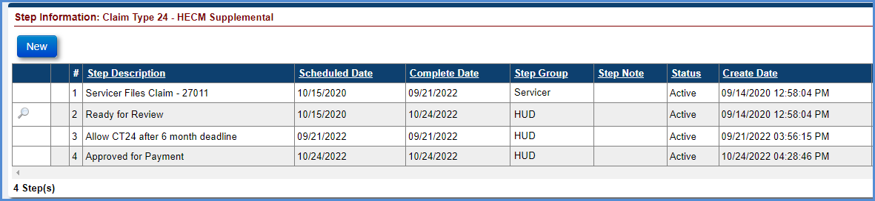
Figure 8-62: Sample Claim Approval Step
  - Step Approved for Payment is automatically added with Completion Date pre-filled with the approved date.
  - When the claim is approved by HUD, the Advice of Payment is automatically generated and displayed on the Documents screen. Select the Documents screen from the menu on the left side of the screen and click the View link beside the Claim Type XX – Final Claim Calculation – AOP. Select Open on the file download window to view the document.
  - When the claim is approved for payment, a transaction code is captured on the Transactions - Claim screen. This transaction code is sent to the AM for payment processing.

Denying a Claim
Claim Type 22 is auto-approved upon submission and cannot be denied.
To deny a claim:
- On the Endorsed Claims Search Screen, enter the search criteria to review the submitted claims and click Search.
- From the search results, select a claim to review.
- On the Claims Steps screen for the claim type timeline, select the magnifying glass icon beside Step 2 Ready for Review.
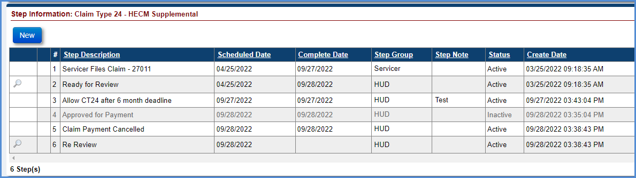
Figure 8-63: Step Information for a Claim Type
- A new window with the Claims Worksheet for Claim Type is displayed.
- The Claims Worksheet for Claim Type window is an electronic version of Claim Form HUD-27011 that was submitted by a servicer. The following links are available on the window header:
  - Save Changes: Save the changes made to the HUD Actions section
  - Validate Claim: Executes the validations on the claim form. Failed validations are displayed with validation message.
  - View Claim: Generates a PDF of the HUD Claim Form-27011
- Review the claim by each section. Note: Refer to Documents tab for claims package attached by the servicers during claims submission.
  - HUD Actions
  - Disposition Information
  - Part A: General Information
  - Part B: Fiscal Data
  - Part C: Support Documents
  - Part D: Support Documents
  - Part E: Support Documents
- After completing the review, click Deny. Enter Decision Notes to proceed. Decision Notes will be auto-saved to the Notes page.
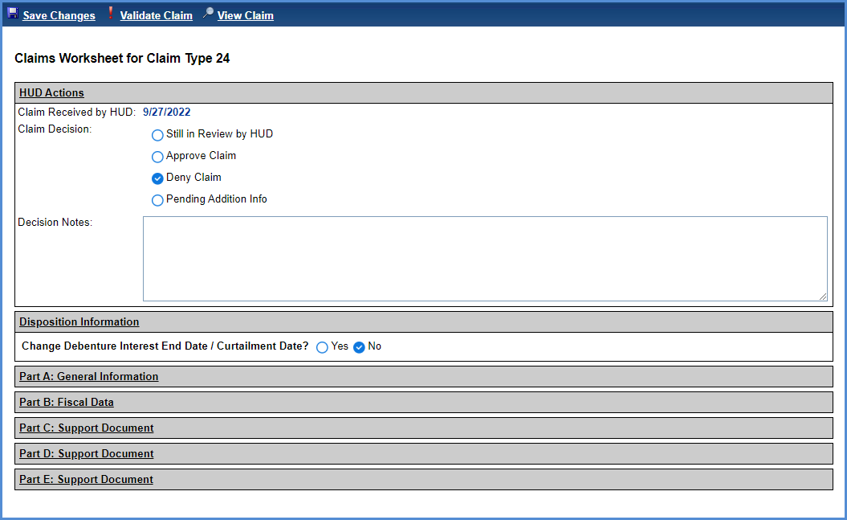
Figure 8-64: Sample Claims Worksheet – Deny Claim
- Click Save Changes to save the HUD Actions section. The Claim Form HUD-27011 is auto-saved in the Documents tab.
- The claim form is displayed via a file download window with options to Open, Save or Cancel.
- Close the Claims Worksheet after viewing the claim form.
- The Completion Date on the step, Ready for Review, is pre-filled with the denied date. The claim is now denied.
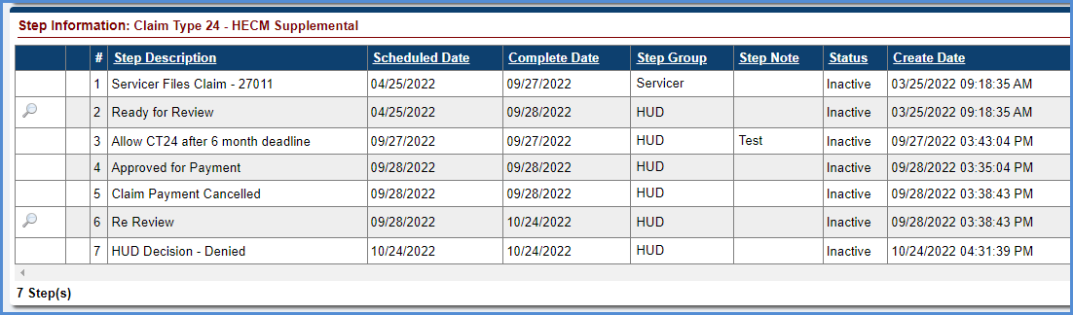
Figure 8-65: Sample Claim Denied Step
- A new step, HUD Decision - Denied, is automatically added with Completion Date pre-filled with the denied date.

Requesting Pending Additional Information About a Claim
Claim Type 22 is auto-approved upon submission and cannot be re-sent to Servicer requesting for additional information.
To request additional information:
- On the Endorsed Claims Search Screen, enter the search criteria to review the submitted claims and click Search.
- From the search results, select a claim to review.
- On the Claims Steps screen for the claim type timeline, select the magnifying glass icon beside Step 2 Ready for Review.
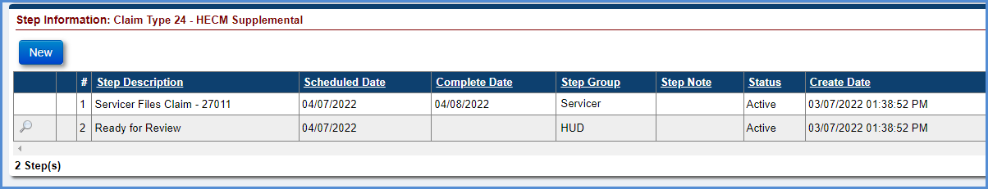
Figure 8-66: Step Information for a Claim Type
- A new window with the Claims Worksheet for Claim Type is displayed.
- The Claims Worksheet for Claim Type window is an electronic version of Claim Form HUD-27011 that was submitted by a servicer. The following links are available on the window header:
  - Save Changes: Save the changes made to the HUD Actions section
  - Validate Claim: Executes the validations on the claim form. Failed validations are displayed with validation message.
  - View Claim: Generates a PDF of the Claim Form HUD-27011
- Review the claim by each section. Note: Refer to Documents tab for claims package attached by the servicers during claims submission.
  - HUD Actions
  - Disposition Information
  - Part A: General Information
  - Part B: Fiscal Data
  - Part C: Support Documents
  - Part D: Support Documents
  - Part E: Support Documents
- After completing the review, click Pending Additional Info. Enter Decision Notes to proceed. Decision Notes will be auto-saved to the Notes page.
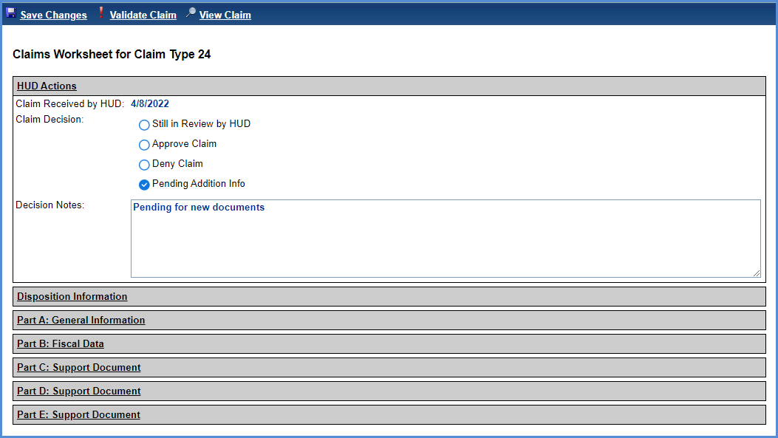
Figure 8-67: Sample Claims Worksheet – Pending Additonal Information
- Click Save Changes to save the HUD Actions section. The Claim Form HUD-27011 is auto-saved in the Documents tab.
- The claim form is displayed via a file download window with options to Open, Save or Cancel.
- Close the Claims Worksheet after viewing the claim form.
- The Completion Date on the step, Ready for Review, is pre-filled with the request date.
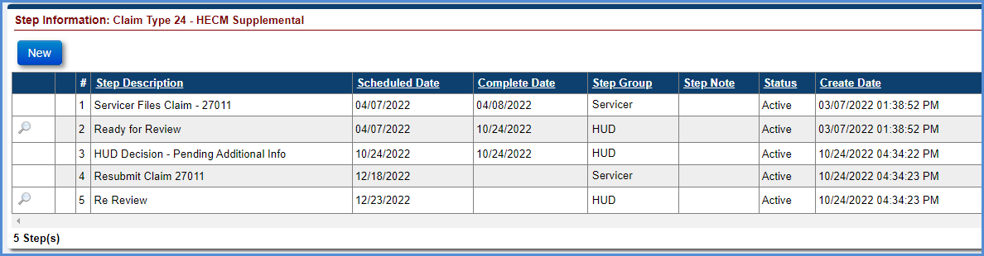
Figure 8-68: Sample Claim Pending Additonal Information Step
- Three new steps are added:
  - HUD Decision - Pending Additional Info is automatically added with Completion date pre-filled with the request date.
  - Resubmit Claim 27011: The servicer must re-submit the Claim Form HUD-27011. Upon resubmission the completion date is pre-filled with the date the claim was re-submitted.
  - Re Review: The HUD Claims staff must re review the Claim Form HUD-27011. Upon HUD action (approve, deny or pending additional info), the completion date is pre-filled with the date.
      - Resubmitting a Claim
For Servicer to resubmit a claim:
- On the Endorsed Claims Search screen, enter the loan search criteria and click Search.
- From the search results, select a claim to resubmit.
- The Claims Step screen for the claim type timeline is displayed.
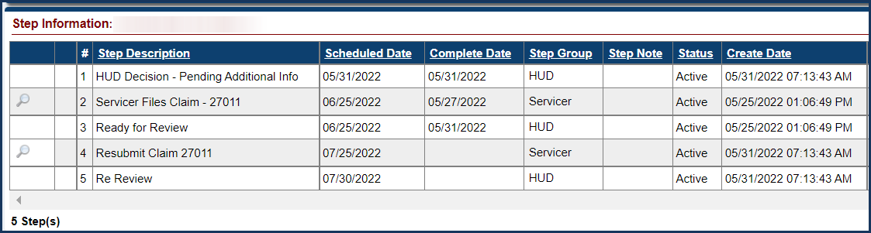
Figure 8-69: Step Information for a Claim Resubmission
- Click the magnifying glass icon beside Step - Resubmit Claim 27011.
- The Claims Worksheet is displayed. A pop-up warning message is displayed indicating that the claim amount will be adjusted if it exceeds Maximum Claim Amount. The pop-up box may include other warning messages as applicable. Click OK to proceed.
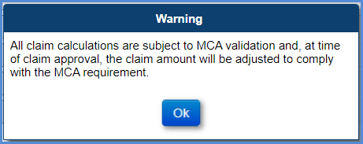
Figure 8-70: Warning Message CT 21, CT 23 and CT 24
- Comments entered by HUD Claims staff requesting additional information is displayed in the Claims Worksheet window. The following links are available in the window header:
  - Save Changes: Save changes made to the claim form
  - Validate Claim: Execute the validations on the claim form. Failed validations are displayed with a validation message.
  - View Claim: Generate a PDF of the Claim Form HUD-27011
  - Finalize and Submit Claim: Enables servicers to submit a claim. Claims with failed validations cannot be submitted.
- Enter the requested information on claim worksheet. Click Save Changes.
- Review the data populated on the Claim Form HUD-27011 by selecting each of the sections listed below and make any required updates.
  - Disposition Information (only for CT 21 and CT 23)
  - Part A: General Information
  - Part B: Fiscal Data
  - Part C: Support Documents
  - Part D: Support Documents
  - Part E: Support Documents
- Provide the description of the expenses for description type - Other. The maximum field length is 100 characters.
- Attach the support documentation (such as HUD-1 form, invoices for the expenses etc.). in the Documents tab as part of the claim package.
  - Parts C, D, and E will be pre-filled with data only if the transactions are added on the loan. This can be done manually via Transactions - Loan screen, or through B2G transactions file upload.
- Click Validate Claim, after completing the review.
- Validation Errors: The following information is displayed at the top of the screen if any of the validations fail:
  - Part of the Form HUD-27011 where the error occurred
  - Field name associated with the error occurred
  - Description of the error
Figure 8-71: Sample Claims Worksheet with Validation Errors
- Update the information and click Save Changes. Then, click Validate Claim to check for any validation errors.
- Success validation message is displayed if there are no validation errors.
Figure 8-72: Sample Claims Worksheet with no Validation Errors
- Click Finalize and Submit Claim when the claim is ready for submission. After the claim is submitted, the claim form can no longer be updated.
- A pop-up warning message is displayed indicating that the claim amount will be adjusted if the Maximum Claim Amount is exceeded. If applicable, the warning message indicating that the Claim Type 24 Supplemental claim is being filed after the 6 month filing deadline is also displayed. Click OK.
- A pop-up message is displayed requesting the user to certify the claim form. Click Yes.
Figure 8-73: Certify Window – CT 21, CT 23 and CT 24
- The final Claim Form HUD-27011 is auto-saved in the Documents tab. Only the View Claim link is available on the header; the remaining links to Save Changes, Validate Claim and Finalize and Submit Claim will no longer be displayed.
- The final claim form is displayed in a file download window with options to Open, Save or Cancel.
- The completion date on the step Resubmit Claim 27011 is pre-filled with the date the claim is re-submitted.
- The claim is now ready for HUD re review.
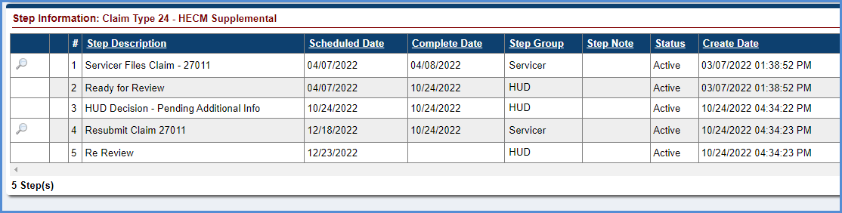
Figure 8-74: Claim Ready for HUD Re Review
      - Re Reviewing a Claim
To re review a claim:
- On the Endorsed Claims Search Screen, enter the search criteria to review the submitted claims and click Search.
- From the search results, select a claim to review.
- On the Claims Steps screen for the claim type timeline, select the magnifying glass icon beside Step Re Review.
Figure 8-75: Step Information for a Claim Type – Re Review
- A new window with the Claims Worksheet for Claim Type is displayed.
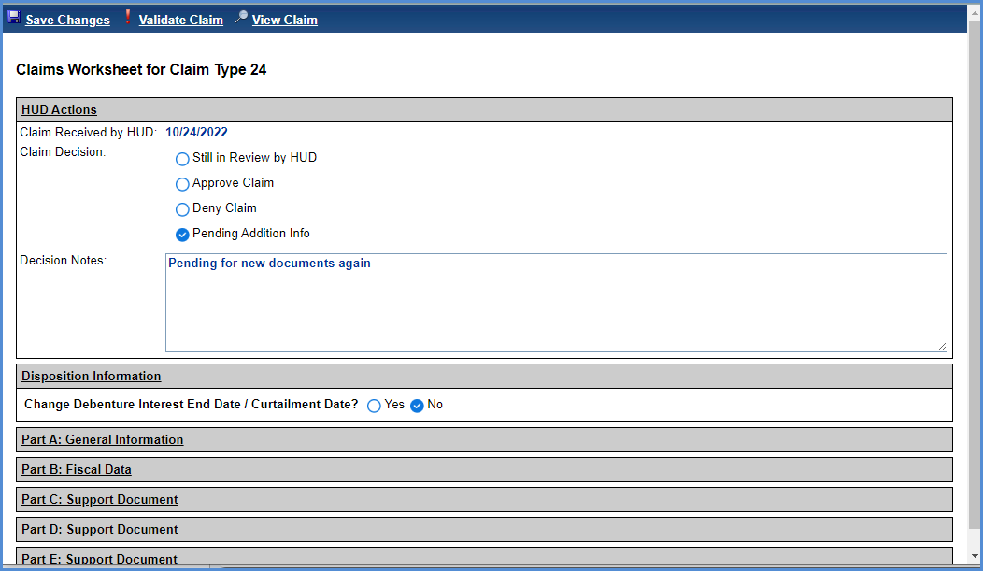
Figure 8-76: Sample Claims Worksheet – Re Review
- The Claims Worksheet for Claim Type window is an electronic version of Claim Form HUD-27011 that was submitted by a servicer. The following links are available on the window header:
  - Save Changes: Save the changes made to the HUD Actions section
  - Validate Claim: Executes the validations on the claim form. Failed validations are displayed with validation message.
  - View Claim: Generates a PDF of the Claim Form HUD-27011
- Review the claim by each section. Note: Refer to Documents tab for claims package attached by the servicers during claims submission.
  - HUD Actions
  - Disposition Information
  - Part A: General Information
  - Part B: Fiscal Data
  - Part C: Support Documents
  - Part D: Support Documents
  - Part E: Support Documents
- After completing the review, select an Approve, Deny or Pending Additional Info under HUD Actions section. Decision Notes are required for Deny or Pending Additional Info.
- Click Save Changes to save the HUD Actions section. The Claim Form HUD-27011 is auto-saved in the Documents tab.
- The claim form is displayed via a file download window with options to Open, Save or Cancel.
- Close the Claims Worksheet after viewing the claim form.
- The Completion Date on the step Re Review is pre-filled with the above decision date.
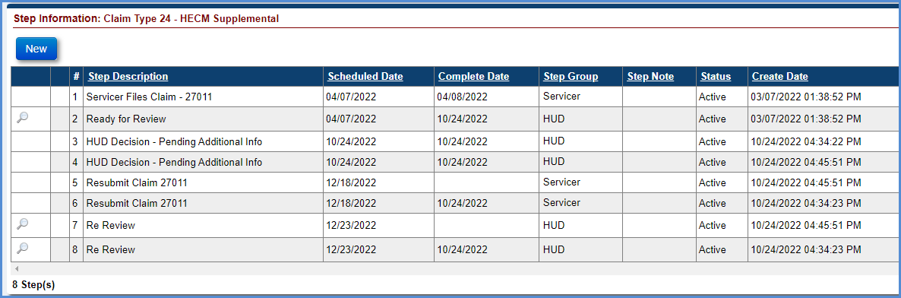
Figure 8-77: Sample Claim Re Review Step
- Based on the action taken by HUD new steps will be automatically added:
  - Approved for Payment is automatically added with Completion date pre-filled with the decision date. Advice of Payment will be displayed on the Documents tab.
  - Denied HUD Decision - Denied is automatically added with Completion date pre-filled with the decision date.
  - Pending Additional Info:
    - HUD Decision - Pending Additional Info is automatically added with Completion date pre-filled with the decision date.
    - Resubmit Claim 27011: The servicer must re-submit the Claim Form HUD-27011. Upon resubmission the completion date is pre-filled with the date the claim was re-submitted.
    - Re Review: The HUD Claims staff must re review the Claim Form HUD-27011. Upon HUD action (approve, deny or pending additional info), the Completion Date is pre-filled with the decision date.

Granting Exceptions to file CT24
There are situations where an authorized HUD user may grant permission for a claim that is otherwise prevented by the system:
  - Filing CT24 more than 6 months after parent Claim Paid date
  - Filing CT24 more than 45 days after the HUD Decision – Pending Additional Info step
  - Multiple / Subsequent CT24
      - Granting permission for CT24 more than 6 months after parent Claim Paid date
Servicer may initiate a CT24 timeline beyond the 6 month deadline but the claim cannot be filed unless optional step “Allow CT24 after 6 month deadline” is added by the authorized HUD user. The servicer has 30 days from the date HUD grants permission to complete the initial claim submission. If the servicer attempts to submit the claim more than 30 days from the date that step was added, they will receive a hard stop validation error message.
HUD user adds optional step “Allow CT24 after 6 month deadline” to the Claim Type 24 Supplemental timeline:
- On the Endorsed Claims Search Screen, enter the search criteria for the loan and click Search.
- Click on the loan result for Claim Type 24 - HECM Supplemental.
- Click the NEW button.
- Select Step Description “Allow CT24 after 6 month deadline” and click SUBMIT.
- The step will be added to the timeline with step completion date TODAY.
- Servicer has 30 days from this date to submit the claim to HUD, or a hard stop validation will prevent the claim from being submitted.
TIP: This option may be available to servicers when the failure to meet the initial 6 month filing deadline was due to circumstances beyond their control, subject to HUD’s approval.
      - Granting permission for CT24 more than 45 days after claim was pended
Servicer will receive a hard stop on resubmitting the claim if they are attempting to resubmit beyond both the original 6 months from parent claim paid date AND beyond 45 days from the latest HUD Decision – Pending Additional Info step completion date. The resubmission of the claim cannot be completed unless optional step “Allow CT24 resubmit after 45 days” is added by the authorized HUD user. The servicer has 45 days from the date HUD grants permission for the resubmission to be allowed after the original 45 day deadline. If the servicer attempts to submit the claim more than 45 days from the date this step was added, a hard stop validation error message will be displayed.
This optional step can only be added on loans with an incomplete Resubmit Claim 27011 step, and the HUD Decision – Pending Additional Info step was completed more than 45 days ago. This step cannot be added if it is still within the original 6 months from Parent Claim Paid Date.
HUD user adds optional step “Allow CT24 Resubmit after 45 days” to the Claim Type 24 Supplemental timeline:
- On the Endorsed Claims Search Screen, enter the search criteria for the loan and click Search.
- Click on the loan result for Claim Type 24 - HECM Supplemental.
- Click the NEW button.
- Select Step Description “Allow CT24 Resubmit after 45 days” and click SUBMIT.
- The step will be added to the timeline with step completion date TODAY.
- Servicer has 45 days from this date to submit the claim to HUD, or a hard stop validation will prevent the claim from being submitted.
TIP: This option may be available to servicers when the failure to meet the 45 Day resubmit rule due to circumstances beyond their control, subject to HUD’s approval.
      - Permission for a Multiple / Subsequent CT24
Servicer cannot initiate a multiple / subsequent CT24 timeline unless optional step “Allow Subsequent CT24” is added to the prior CT24 timeline by the authorized HUD user. The servicer has 30 days from the date HUD grants permission to complete the initial claim submission. If the servicer attempts to submit the claim more than 30 days from the date that step was added, they will receive a hard stop validation error message.
All previous claims on the loan must be in claim status “Claim Paid” for the HUD user to be able to add the step. If any other claims exist and are not Claim Paid, the step cannot be added.
HUD user adds optional step “Allow Subsequent CT24” to the prior Claim Type 24 Supplemental timeline:
- On the Endorsed Claims Search Screen, enter the search criteria for the loan and click Search.
- Click on the loan result for the most recent Claim Type 24 - HECM Supplemental.
- Click the NEW button.
- Select Step Description “Allow Subsequent CT24” and click SUBMIT.
- The step will be added to the timeline with step completion date TODAY.
- Servicer has 30 days from this date to initiate the new Subsequent CT24 timeline and submit the claim to HUD, or a hard stop validation will prevent the claim from being submitted.
TIP: The subsequent CT24 option may be available in limited situations where it has been clearly demonstrated that circumstances beyond the control of the servicer prevented them from claiming all expenses to which they otherwise should have been entitled, subject to HUD’s approval. It is not available to servicers to request additional expenses that the servicer may have inadvertently omitted or overlooked in the initial parent or the initial supplemental claim.

No Pay Order
The Servicing Module allows the authorized user to add a No Pay Order on a loan or Servicer. When a No Pay Order is added on a loan or Servicer:
  - The Servicer will not be able to initiate a new Claims timeline while the No Pay Order is in place.
  - If a claim timeline was already initiated prior to No Pay Order being added, the No Pay claims hard stop validation will prevent the Servicer from submitting the claim and HUD claims Staff will be prevented from approving the claim.
  - If a claim has already been submitted for payment, the system cannot withdraw the payment request sent to the AM.
In addition to authorized users adding a No Pay Order on a loan, there is a claim hard stop validation that automatically checks for an active indemnification record associated with a claim when the claim is being filed, resubmitted, or approved by HUD. The indemnification claim validation message states: “Unable to proceed with claim. Loan has an active Indemnification Agreement preventing claim submission.” Servicers are expected to follow up with the investor listed in HERMIT at the time of claim filing for further information about the active indemnification.

Adding a No Pay Order on a Loan
To add a No Pay Order on a loan:
- Click the Loan tab.
- Enter the search criteria for the loan that requires no pay order and click Search.
- Select the loan from the Search Results section.
- Click Loan Details on the left side of the Loan Balance screen.
- Click Edit at the bottom of the Loan Identifiers section on the Loan Details screen.

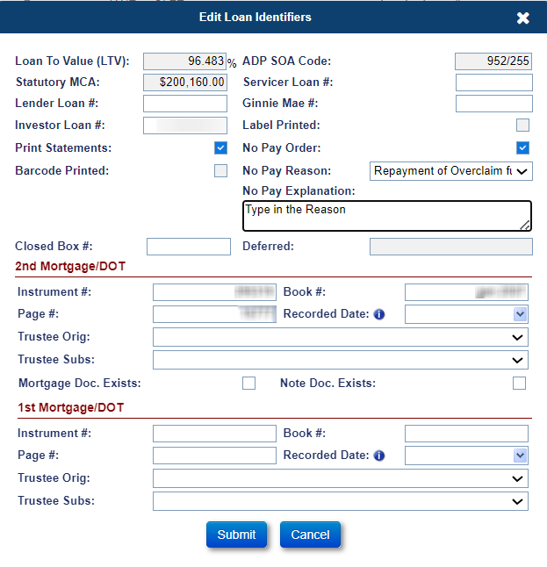
Figure 8-78: No Pay Order – Edit Loan Identifiers Window
- Select the checkbox beside the No Pay Order field then select an option from the No Pay Reason dropdown and enter text in the field No Pay Explanation. When the No Pay Order box is checked, No Pay Reason and No Pay Explanation fields are required. After entering all required fields, click Submit on the Edit Loan Identifiers window.
- A pop-up window is displayed, requesting the user to confirm action. Click OK.
- The text entered in No Pay Explanation field will be viewable in the Notes section of HERMIT.
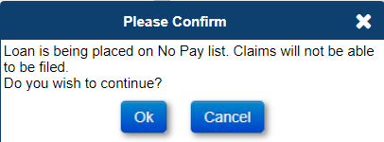
Figure 8-79: No Pay Order – Confirmation Window
- This completes the no pay order on a loan.
- To remove the no pay order, select the loan and uncheck the No Pay Order checkbox then enter No Pay Explanation text in the field No Pay Explanation, and click Submit.
- The text entered in No Pay Explanation field will be viewable in the Notes section of HERMIT.

Adding a No Pay Order on a Servicer
To add a No Pay Order on a servicer:
- Click Admin from the Left Menu and then click Servicer
- Enter the search criteria of the Servicer that requires the No Pay Order, click Search.
- Select the Servicer from the Search results.
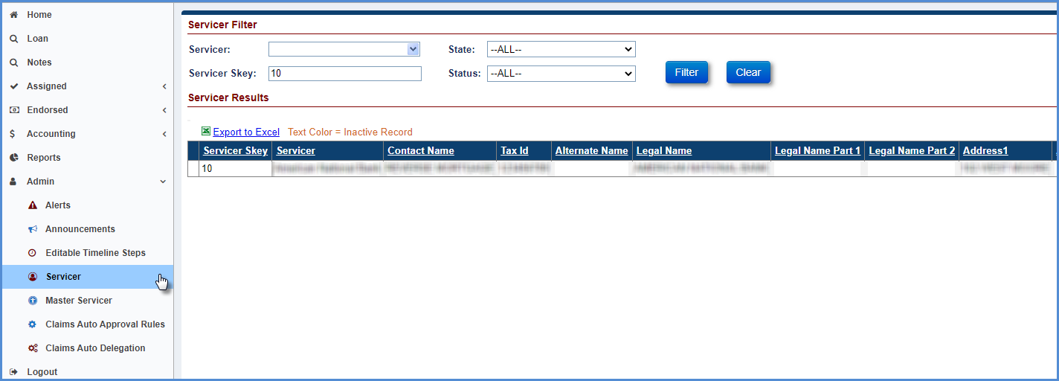
Figure 8-80: Admin - Servicer Screen
- Select the checkbox beside the No Pay field under the No Pay Information section and click OK.
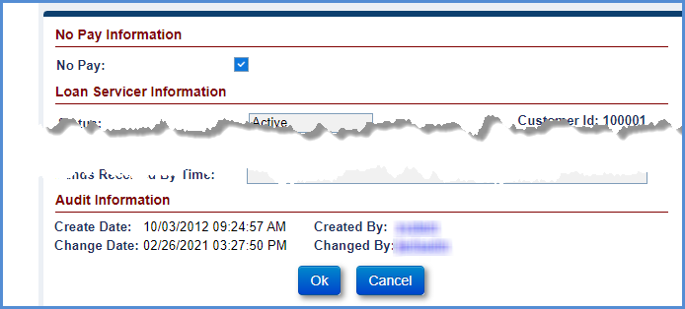
Figure 8-81: No Pay - Servicer Profile Screen
- A pop-up window is displayed, requesting the user to confirm action. Click OK.
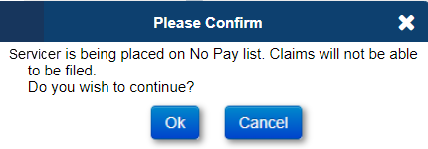
Figure 8-82: No Pay – Confirmation Window
- This completes the no pay order on the Servicer.
- To remove the no pay order, select the Servicer and uncheck the No Pay checkbox and click OK.

Cancel Payment
The Servicing Module allows cancellation of claim payment for claim types 21, 23, or 24, if a claim was approved for payment inadvertently, provided the claim payable request has not been sent to AM. Once the transaction has been sent to the AM, the payment cannot be cancelled. In order to accomplish this please contact Foc_hecm@hud.gov. The HERMIT Servicing Module Help Desk has Read Only Access to HERMIT and CANNOT assist with cancelling a Claim Payment.
- To Cancel an approved Claim Payment: Click Accounting - Claims tab from the Left Menu
- Enter the search criteria and click Search on the Claims Search screen to display the claims transactions. Claims that need cancellation can also be searched by selecting the Batch status of Pending and Claim Status of Approved for Payment.
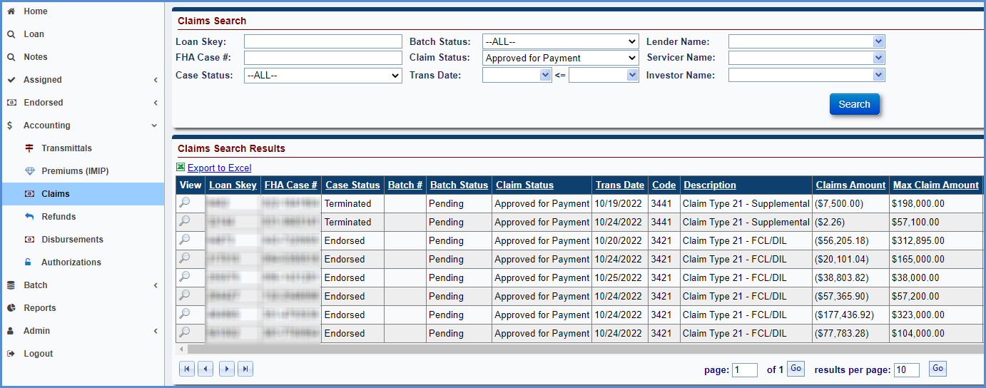
Figure 8-83: Accounting – Claims Screen
- The search results matching the search criteria are displayed in the Search Results section.
- Select the record displayed in the search results. The Edit Claim window is displayed.
- On the Edit Claim window, select Cancelled from the Claim Status dropdown.
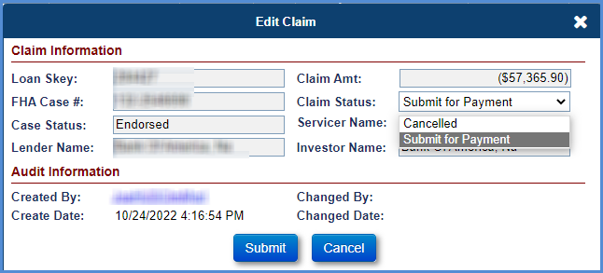
Figure 8-84: Edit Claim Window
- Click Submit to save the changes. A certify window is displayed requesting the user to confirm action. Enter the password and click Yes.

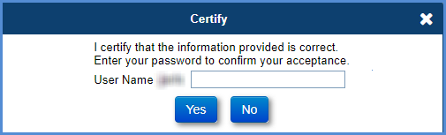
Figure 8-85: Certify Window
- The Claim Status is updated to Cancelled. To exit the window without saving the changes, click Cancel.
- Once the Claim has been Cancelled the step Claim Payment Cancelled is added to the Claims Timeline and the previous step Approved for Payment is inactivated. The existing AOP document is renamed to “Claim Type xx – Cancelled/unissued Claim Payment – AOP.”
- The HUD user needs to re-decision the claim.

Payment Processing
This section explains the claims payment processing in HERMIT (SM & AM).
- The claim transaction is generated when the claim is approved in the Servicing Module. These FHA cases are sent to the Accounting Module for generation of payables via an interface file with exception to payment cancellation (documented in Cancel Payment section) or a No Pay flag (documented in No Pay Order section).
- The Servicing Module assigns a batch ID and batch status for the payable request to track the payment status. Once the file is generated and sent to the Accounting Module, the batch status (Sent to GL - Held) is updated to indicate that the transaction has been sent to the Accounting Module. The system adds a new step Submitted for Payment on the claims timeline, this step is auto-completed with the date the interface file is sent to Accounting Module.
- The Accounting Module processes the file, records the payable in a held status and sends a response file to the Servicing Module. The Servicing Module processes the response file from the Accounting Module and updates the batch status (Success – Held).
- The Servicing Module sends the release transaction to the Accounting Module via an interface file. The Accounting Module processes the file, records the payable in the release status and sends a response file to the Servicing Module. The Servicing Module processes the response file from the Accounting Module and updates the batch status (Success – Disburse).
- The HUD Financial Operations and Control Section (FOCS) will receive the PM 103 report for the claims processed in the Accounting Module. The HUD FOCS will generate the claims batch transmittal report from the Transmittals screen in the Servicing Module and manually validate the claims batch transmittal report against the PM 103. Upon completion, the HUD FOCS will populate the Disbursement Transmittal Report and send, via email or fax, the Disbursement Transmittal Report along with the Claims Payable Batch Transmittal Report to HUD's CMB.
- The CMB will complete budget check processes in the FHASL and attach the budget check report to the transmittal. The Accounting Module will generate a disbursement schedule file in Treasury SPS format for all daily approved claims payable requests. The daily SPS files will be placed on the HUD server for access by CMB.
- The completed, approved transmittal with all attachments is used by a CMB DEO to select the appropriate Accounting Module Disbursement files placed on HUD’s server for final review. If the disbursement file and Disbursement Transmittal Report are in agreement, a CMB certifying officer certifies the schedules and transmits them to the Treasury Regional Finance Center for payment.
- Once Treasury completes the payments, the HERMIT accounting support team will download the RFC report and confirm the payment schedules in the Accounting Module. The Accounting Module will then send the disbursement confirmation to the Servicing Module via an interface file.
- The Servicing Module processes this file and the batch status is updated to Disbursed. The system updates the claim status to Paid and adds a step Claim Paid on the claims timeline, this step completion date is set to the date sent from Accounting: this reflects the date HUD sent the claim payment funds. The create date on the step is auto-completed with the date the file has been processed.
The table below shows the claim type, case status and case sub-status updates upon receipt of payment confirmation from AM:
Claim Type | Case Status | Case Sub-Status
CT 21 | Terminated | Terminate – CT 21
CT 22 | No Update | No Update
CT 23 | Terminated | Terminate – CT 23
CT 24 | Terminated | Terminate – CT 21/23
Table 8-8: Update of Case Status and Case Sub-Status - Receipt of Payment Confirmation

Claim Reimbursements - Over Claims: Servicers remit funds to HUD via HERMIT
HECM Over Claim functionality is available in HERMIT for CT21, CT22 (via DCR), CT23, and CT24 claims. The purpose of the Over Claim process is for servicers to use HERMIT to remit funds automatically to HUD as needed after a claim was paid.
The Over Claim transactions will be entered at the case level in the SM. The Over Claim Transaction(s) cannot be entered in HERMIT unless a Claim Type 21, 22 (via DCR), 23 or 24 has previously been paid on the case through HERMIT. Over Claim transactions are processed through the AM, which will be collected via the existing Pay.Gov application designed for the Claims Accounting Area. A new HERMIT Over Claim report is also available which will allow reports to be pulled to view Over Claim transactions that were entered into HERMIT.

HECM Over Claim Transaction Codes available for the remittance of HECM Over Claims:
- Claim Type 21 – Over Claim
- Claim Type 22 – Over Claim or Claim Type 20 – Over Claim (DCR only)
- Claim Type 23 – Over Claim
- Claim Type 24 – Over Claim

Claim Type 20 and 22
If a Claim Type 20 or 22 Overpayment is required, the user must submit a request to the HERMIT Help Desk. Claim Type 20 and 22 Over Payment transactions are not available through the User Interface and will need to be completed through a DCR.
The following information must be included for each transaction being requested via DCR:
- Transaction Category
- Transaction Type
- Effective Date
- Transaction Amount
- Reason Code
- Note

Claim Type 21, Claim Type 23, Claim Type 21 – Supplemental Over Claim and Claim Type 23 – Supplemental Over Claim
The Over Claim transactions are available in the Transaction -> Claims page for Claim Type 21, Claim Type 23, Claim Type 21 – Supplemental Over Claim and Claim Type 23 – Supplemental Over Claim when the user clicks the “New” button.

The “New” button for the Over Claim Transaction does not appear unless a Claim Type 21, Claim Type 23, Claim Type 21 – Supplemental Over Claim or Claim Type 23 – Supplemental Over Claim has been paid on the case previously.
User Role “Servicer Manager” has access to create the Over Claim transactions in the Transaction -> Claims Screen with the “New” button.
The Over Claim Transaction Type only appears for the Claim Type that was previously filed and paid in HERMIT.
- Example 1: If a Claim Type 21 was filed and Paid in HERMIT then only the Claim Type 21 Over Claim transaction will appear
- Example 2: If a Claim Type 23 was filed and Paid in HERMIT then only the Claim Type 23 Over Claim transaction will appear
- Example 3: If a Claim Type 23 and Claim Type 23 – Supplemental Over Claim were filed and Paid in HERMIT then a Claim Type 23 and Claim Type 23 – Supplemental Over Claim Over Claim transaction will appear
- Example 4: If a Claim Type 21 and Claim Type 21 – Supplemental Over Claim were filed and Paid in HERMIT then a Claim Type 21 and Claim Type 21 – Supplemental Over Claim Over Claim transaction will appear
When the “new” button is clicked, the following information appears in the “New” transaction box. All fields are required.
- Transaction Category (Claims A/R)
- Transaction Type (The applicable transactions will be listed)
- Effective Date
- Transaction Amount
- Reason Code
- Note box (Must provide detailed explanation of reason code)
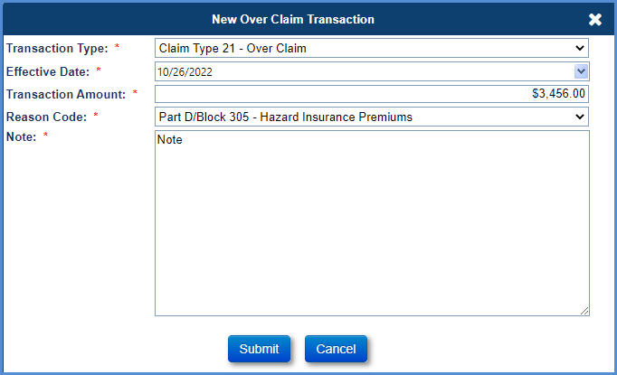
Figure 8-86: Over Claim Transaction
A note box appears when the transaction is created so that a user can enter a note explaining the reason for the Over Claim to HUD (capped at 500 characters).

The note from the note box on the “new” Transaction screen is viewable in the Notes section of HERMIT.
A popup box is displayed when the user is creating the transaction as any amounts that are paid back to HUD will be final. No positive adjustments (Accounts Payable) can be made through HERMIT for Over Claims.
The message states the following:
“Please ensure the Over Claim amount is correct and includes any associated computation of interest due back to HUD. Interest due back to HUD should be indicated separately using the appropriate interest related Reason Code. Submitting this transaction authorizes HUD to collect the amount of $XXXX.XX from your account. This amount cannot be reversed once submitted. Are you sure you want to continue?”
There is a YES/NO button option to confirm the transaction

When the user clicks “Yes”, there is a validation to ensure the Mortgagee ID associated with the user has valid banking information and a Tax Identification Number (TIN) in the SM.
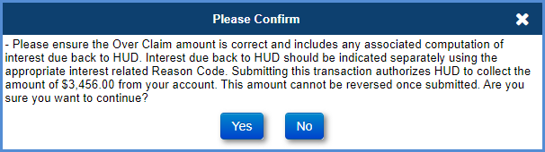
Figure 8-87: Confirm Over Claim Transaction
Over Claim transactions are summed at the case level in a Claims Receivable batch at the end of each day. This batch and its batch details can be viewed in the Accounting -> Transmittal page.
The loan balance is not affected by the Over Claim Transaction
System adds an Auto Note when Over Claim is processed with following information:
TIP: Over Claim transaction in the amount of $XXXX.XX was processed with Transaction Date mm/dd/yyyy by User ID, with Reason Code: xxx.

Reason Codes for Over Claim Transactions:
Multiple Over Claim transactions for a claim can be entered on the case when there is more than one reason code needed. If the amount(s) being paid back to HUD are for different reasons, enter these as separate amounts and choose correct Reason Code that the amount pertains to. A Reason Code dropdown will be available where the user can choose the reason for the Over Claim.
Reason code list:
- (Part A/Block 27) – Hazard Insurance/Loss Draft Funds
- (Part A/Block 27) – Property Damage Adjustment
- Part B/Block 109 – Escrow Credit
- Part B/Block 115 – Rental Income Credit
- Part B/Block 116 – Rental Expense
- (Part C) – Disbursements for Protection & Preservation
- Part D/Block 305 – Hazard Insurance Premiums
- Part D/Block 305 – Taxes
- Part D/Block 305 – Utilities
- Part D/Block 305 – Servicing Fees
- Part D/Block 305 – Forced Place Insurance
- Part D/Block 305 – HOA Fees
- Part D/Block 305 – Eviction Fees & Costs
- Part D/Block 305 – Cash for Keys
- Part D/Block 305 – Probate Cost
- Part D/Block 305 – Mortgagee Incentive
- Part D/Block 305 – Other
- Part D/Block 306 – Attorney/Trustee Fees
- Part D/Block 307 – Recording Fees
- Part D/Block 307 – Sheriff Fees
- Part D/Block 307 – Clerk Costs
- Part D/Block 307 – Publication Fees
- Part D/Block 307 – Foreclosure and/or Acquisition, Conveyance Costs – Other
- Part D/Block 311 – Mortgage Insurance Premiums
- Part E/Block 407 – Taxes Owed to Buyer at Closing
- Part E/Block 407 – Water Rates Owed to Buyer at Closing
- Part E/Block 407 – Special Assessments Owed to Buyer at Closing
- Part E/Block 407 – Amount Owed to Buyer at Closing – Other
- Part E/Block 408 – Sales Commission
- Part E/Block 408 – Recording Fees
- Part E/Block 408 – Title Insurance Policy
- Part E/Block 408 – Additional Closing Costs at Settlement – Other
- Part E/Block 409 – Appraisal Fees
- Note Interest Back to HUD
- Debenture Interest Back to HUD
- Erroneous Duplicate Payment
- Part A – UPB
- Other
- Bankruptcy Payments Owed to HUD
The Reason Code is included on the Batch Details page of the Accounting Transmittal Screen and in the “Export to Excel” feature from the Batch Details page.
The total of the Over Claim transaction amounts cannot exceed the claim amount on the original claim that was paid. This total is measured at the claim level, not the loan level. The Over Claim transaction type that is selected will determine which claim is checked. For a loan with both a Claim Type 21 and a Claim Type 21 supplemental paid, if the “Claim Type 21 – Over Claim” transaction is selected, HERMIT will check against the claim total from the Claim Type 21. If the Transaction is a 2/3’s transaction additional information will be displayed on the popup window prompting the user to confirm the amount being remitted to HUD.
No Authorizations are needed for the collection to be processed.
An adjustment icon is displayed on the Over Claim transaction until the end of the day on the day the transaction is made. After the end of the day, the adjustment icon will no longer be available for that transaction.
The Over Claim transactions are under the Claims Receivable Batch Type from the Accounting -> Transmittal page.

Over Claim Transaction Validations
Over Claim transactions for Claim Type 21, Claim Type 23, Claim Type 21 supplemental and Claim Type 23 supplemental (CT24) are only allowed to be entered via the User Interface. Over Claim transactions are not subject to any claim validations, but are taken into account for the MCA limit check and capping of the claim at Maximum Claim Amount. Over Claims for Expenses that are permitted to be paid in excess of MCA do not affect the cap, for example: Part D/Block 305 – Cash for Keys, Part D/Block 305 – Probate Cost, and Part D/Block 305 – Mortgagee Incentive; and DBI for non-Final Rule loans.
Multiple Over Claim transactions are allowed for the same FHA Case Number. Over Claim transactions will be summed at the case level in a Claims Receivable batch at the end of each day. This batch and its batch details can be viewed in the Accounting -> Transmittal page. There is no time limitation set forth to remit funds to HUD

Paper Claim Transactions
Paper Claims paid outside of HERMIT are viewable under the Transactions – Claims page. Paper Claim transactions are identified by a Created By “PaperClaim” User Name. These transactions are not automatically initiated by the system and are not editable by users. Transaction types are:
    - Claim Type 21 - FCL/DIL
    - Claim Type 22 - Optional Assignment
    - Claim Type 23 - Mortgagor Sale
    - Claim Type 21 - Supplemental
    - Claim Type 22 - Supplemental
    - Claim Type 23 - Supplemental
If a loan has a paper claim record, a new claims timeline cannot be created in HERMIT. A pop-up message will be displayed.

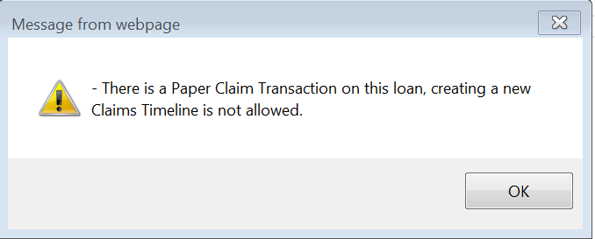
Figure 8-88: Paper Claim Error message

Servicer can Initiate a Claim if there was a Paper Claim Type 22 and a Repurchase on a loan. Conditions below.
- There is a Paper Claim transaction in the Transactions > Claim page that is transcode = 3422 “Claim Type 22 – Optional Assignment” with Created By = “PaperClaim”
- There is a Repurchase Timeline with step completed date “Assignment to Servicer sent for Recording” populated
The logic will apply for both ACTIVE and INACTIVE Repurchase Timelines

Rejected / Returned Claim Payments from Investor
A Rejected Claim Payment occurs when an Investor rejects receipt of claim payment funds and the funds are returned back to HUD. For Claim Types 21, 23, and 24, when a Rejected status is received from the Accounting Module, the Servicer must confirm or update the Investor information in HERMIT, then complete added timeline steps in order to reissue the claim for payment to the appropriate investor. This feature is only for reissuing the claim payment after a rejection and the claim is not recalculated with additional interest or added expenses during this process.
After a Rejection is received from the Accounting Module for a claim payment:
- Claim Timeline:
  - Previous step Submitted for Payment changed to inactivate
  - Previous step Claim Paid step changed to inactivate
  - Step Claim Payment Rejected added and auto-completed by the system
  - Step Re-Try Claim Payment added. Servicer must complete this step
- Endorsed > Claims > Search: After the Rejection is processed and the above steps added to the timeline, the Claim Status will be blank and Current Step Group will be assigned back to the Servicer.
- Transactions > Claims: an Adjustment transaction is displayed offsetting the Claim Payment. The Adjustment transaction shares the same Batch number as the original Claim Payment transaction. A new record will be added on this page after Re-Try Claim Payment is completed and the new claim payment is generated.
Multiple rejections may occur on the same claim payment. In this case, multiple steps are inactivated and added to the Claim Timeline.
Servicer actions to Re-Try Claim Payment
To reissue the Claim Payment, the Servicer must update the current Investor information in HERMIT, if applicable. Then the Servicer will complete Claim Timeline step Re-Try Claim Payment, add Step Notes if necessary, then click Submit . A Certify popup modal is displayed: click Yes, to stop click No.
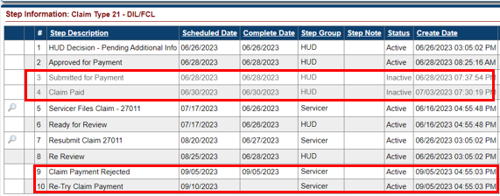
Figure 8-89: Rejected Claim Payment
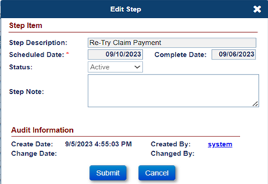
Figure 8-90: Certify on Re Try Claim Payment
After clicking Yes on Re-Try Claim Payment, the system will save the complete date to the step, update all Investor information fields on the Claim Form and the Advice of Payment (AOP), and save new versions to the Documents page. In general, all triggers that occur when Approved for Payment is completed in the normal claims process will also occur when the step Re-Try Claim Payment is completed: including creating a new batch for the Claim Payment and when end of day jobs are run, a new Submitted for Payment step will be added to the timeline.

CHAPTER 9: REPORTS

REPORTS
This chapter provides users with an overview of the following reporting features and report sections:
- Reports Overview
- Accessing Reports
- Using the Search Criteria
- Generating Reports
- Lender/Servicer Reports
- Assigned Notes Reports
- Management and Budgetary Reports
- Servicer Reports
- HERMIT Support

Reports Overview
In the Servicing Module, there are a variety of reports for various audiences. The reports are grouped so that users with the unique permissions will only see the reports that are pertinent to their user role. Users can create and save the reports as PDFs, Excel spreadsheets, or CSV files. Not all reports are available in each format. The reports are additionally grouped in two active report types, based on the grouping of the data used to compile the report:
- Daily reports provide live data current through the day the report is run.
- Monthly reports pull data that was captured and stored at the end of the month.
The grouping of the data differs, however, from the range of time a report may cover. That is, a daily report may include data current through today for an entire week, year, or month. A monthly report, in contrast, will include data through the end of the month, but cover a week, year, or month.
Reports fall into five basic categories:
- Lender/Servicer Reports
- Assigned Notes Reports
- Management and Budgetary Reports
- Servicer Reports
- HERMIT Support
Access to reports is role-dependent and is granted at the category level.

Accessing Reports
To select search criteria for a report:
- On the Left Menu , click Reports.
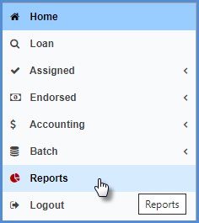
Figure 9-1: Reports Tab
- On the Welcome to the Reports Page screen, click the folder icon to view the list of reports for the relevant business area.
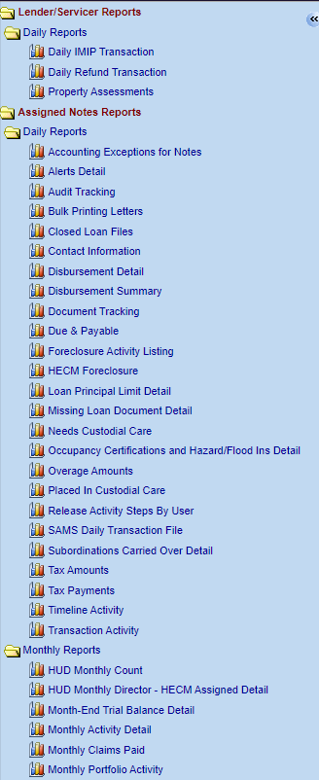
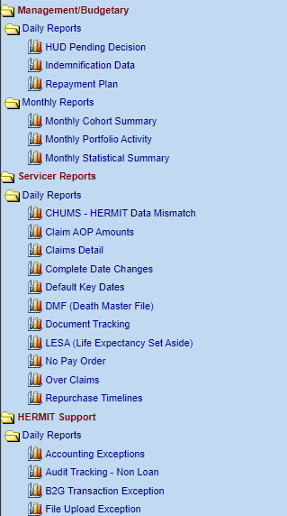
Figure 9-2: Expanded Reports Folder

- On the left side of the screen, select a report to query and the reports search screen will be displayed.
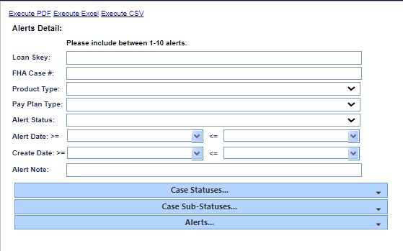
Figure 9-3: Reports Search Screen

Using the Search Criteria
To modify search criteria for a report after clicking on a report link:
- Expand the search criteria by clicking on the down arrows in the screenshot below:
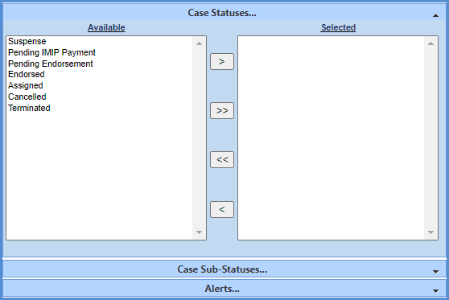
Figure 9-4: Reports Search Criteria Expanded
- To move a selection to the right, click on the item on the left side and click the single arrow pointing to the right. The opposite arrow can be used to move an item to the left.
- To select the entire list from the left and move it to the right, click the right double arrow. The opposite double arrow can be used to move the entire list to the left.
- To select several contiguous items on the list, hold down the shift key while making your selection and then click the arrow.
- To select non-contiguous items, hold down the CTRL key, click each item, and then click the arrow.

Generating Reports
Reports can be generated as PDFs or Excel spreadsheets.
To generate a report:
- Complete the search criteria for the report you would like to see results for.
- Select the Execute PDF link, Execute Excel or the Execute CSV link (if available).

Figure 9-5: Execute PDF and Execute Excel Links
- Follow the screen prompts to save the file.

Lender/Servicer Reports
The following daily reports are available for Lender/Servicer:
- Daily IMIP Transaction
- Daily Refund Transaction
- Property Assessments

Daily IMIP Transaction Report
The Daily IMIP Transaction report enables authorized users to view the IMIP transactions generated in the Servicing Module along with transaction details within a specified date range.

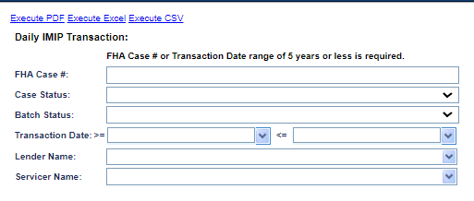
Figure 9-6: Daily IMIP Transaction Report
To generate this report:
- Click on the report link on the left menu and the report search screen will display.
- You must enter a value for either the FHA Case # or Transaction Date range.
  - For Transaction Date Range, you must enter both the start and end dates, and the range cannot exceed5 years.
- To further narrow the results of your report, you can filter your report by:
  - Case Status
  - Batch Status
  - Lender Name
  - Servicer Name
- Click the Execute PDF, Execute Excel or Execute CSV link.
The following results are displayed (please note: PDF results may differ):
Loan Skey, Loan No, FHA Case No, Loan Status, Batch Skey, Loan Status Desc, Batch Status Skey, Batch Status Desc, Trans Date, Trans Code, Trans Desc, MIP Amt, Late Charge Amt, Penalty Int Amt, Total MIP, Servicer Name, Lender Name, Created By, Created Date, Loan Servicer Skey, and Lender Skey.

Daily Refund Transaction Report
The Daily Refund Transaction report enables authorized users to view the refunds generated in the SM, along with transaction details within a specified date range.

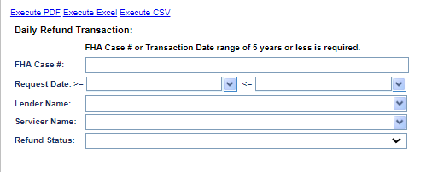
Figure 9-7: Daily Refund Transaction Report
To generate this report:
- Click on the report link on the left menu and the report search screen will display.
- You must enter a value for either FHA Case # or Transaction Date Range.
  - For Transaction Date Range, the user must enter both the start and end dates, and the range cannot exceed5 years.
- To further narrow the results of your report, the user can filter the report criteria by:
  - Lender name
  - Servicer name
  - Refund Status
- Click the Execute PDF, Execute Excel or Execute CSV link.
The following results are displayed (please note: PDF results may differ):
FHA Case No, Lender Name, Investor Name, Servicer Name, Loan Skey, Payable Type Skey, Payable Type Desc, Payable Reason Desc, Payable Amt, Payable Status Desc, Comment, Decision User Name, Decision Date, Create User Id, Create Date, Maint User Id, and Maint Date.

Property Assessments Report
The Property Assessments report enables authorized users to view the Property Assessments details in the SM.
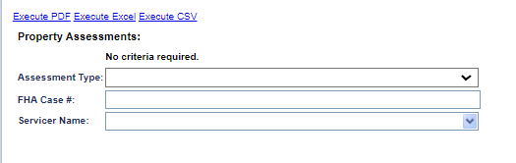
Figure 9-8: Property Assessments
To generate this report:
- Click on the report link on the left menu and the report search screen will display.
- You may enter a value for either FHA Case # or Assessment Type.
- Click the Execute PDF, Execute Excel or Execute CSV link.
The following results are displayed (please note: PDF results may differ):
Loan Servicer Skey, Loan Servicer Name, FHA Case No, Borrower First Name, Borrower Last Name, Assessment Term Skey, Assessment Term Desc, Assessment Type Skey, Assessment Type Desc, Loan Status, Loan Status Desc, Loan Sub Status Code, Loan Sub Status Desc, Assessment Amount, Association Name, Association Address, Association City, Association State, Association Zip, and Association Phone No.

Assigned Notes Reports
The following Assigned Notes reports, compiled using daily data, are available:
- Accounting Exception for Notes
- Alerts Detail
- Asset Sale
- Audit Tracking
- Bulk Printing Letters
- Closed Loan Files
- Contact Information
- Disbursement Detail
- Disbursement Summary
- Document Tracking
- Due & Payable
- Foreclosure Activity Listing
- HECM Foreclosure
- Insurance Policy Information
- Loan Principal Limit Detail
- Missing Loan Document Detail
- Needs Custodial Care
- Occupancy Certifications and Hazard/Flood Ins Detail
- Overage Amounts
- Placed In Custodial Care
- Property Charge Default
- Release Activity Steps By User
- SAMS Daily Transaction File
- Subordinations Carried Over Detail
- Tax Amounts
- Tax Payments
- Timeline Activity
- Transaction Activity
The following monthly reports are available:
- HUD Monthly Count
- HUD Monthly Director Report – HECM Assigned Detail
- HUD Monthly Management
- Month-End Trial Balance Detail
- Monthly Activity Detail
- Monthly Claims Paid
- Monthly Portfolio Activity

Accounting Exceptions for Notes Report
The Accounting Exceptions for Notes report enables authorized users to view the exceptions from 3 areas of HERMIT.
This report will contain three types of exceptions in this report
- Rejected disbursements that are sent to the AM (Should be rare occurrence)
- Issues with Disbursements when the TCIS file is imported
- Issues with Disbursements when the disbursements are authorized on the Accounting Disbursements screen.

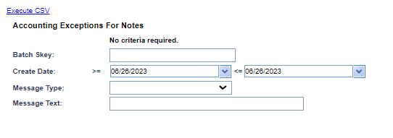
Figure 9-9: Accounting Exceptions For Notes Report
To generate this report:
- Click on the report link on the left menu and the report search screen will display.
- Click the Execute CSV link.
The following results are displayed:
Batch Category Desc, Batch Skey, Comments, Create Date, Sent To Gl Date, Customer Name, Error
Type, Source Issue, Loan Skey, FHA Case No, and Check # or ACH #..

Alerts Detail Report
The Alerts Detail report enables authorized users to view the alerts on a specific FHA Case # or list of FHA case numbers with a specific alert type.

Figure 9-10: Alerts Detail Report
To generate this report:
- Click on the report link on the left menu and the report search screen will display.
- You must enter a value for the Alert criteria (FHA Case # or Loan Skey).
- To further narrow the results of your report, you can filter by:
  - Product Type
  - Pay Plan Type
  - Alert Status
  - Alert Date
  - Create Date
  - Alert Note
- To limit the results of the report, if necessary, the user can expand the selection boxes for:
  - Case Statuses
  - Case Sub-Statuses
  - Alerts
- Click the Execute PDF, Execute Excel or Execute CSV link.
The following results are displayed (please note: PDF results may differ):
Loan Servicer Skey, Investor Skey, Loan Pool Skey, Product Type Skey, Payment Plan Type, Servicer Name, Investor Name, Investor Pool, Borrower Last Name, Borrower First Name, Loan Skey, Loan No, FHA Case No, Investor Loan No, Product Type Desc, Payment Plan Desc, Loan Status, Alert Date, Alert Type Skey, Alert Type Desc, Alert Amt, Alert Status, Alert Expiration Date, Alert Note, Create User Id, Loan Sub Status Code, Loan Sub Status Desc, Maint User Id, Alert Create Date, Maint Date, Lender skey, and Lender Name.

Asset Sale Report
The Asset Sale Report displays all Endorsed and Assigned Loans for Servicer 900000 (Loan Servicing Contractor) that have an active Due & Payable Timeline (with any Default Reason) and all borrowers, co-borrowers or eligible NBSs are deceased.
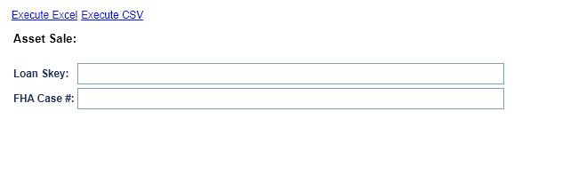
To generate this report:
- Click on the report link on the left menu and the report search screen will be displayed.
- To further narrow the results of your report, you can filter by:
  - Loan Skey
  - FHA Case #
- Click the Execute Excel or Execute CSV link.
The following results are displayed:
FHA Case # , Case Status , Case Sub-Status, Property Address 1 , Property Address 2 , Property City, Property State , Property Zip Code , Property County, Eligible NBS: Yes/No , As-Of-Date: TODAY (in MM/DD/YYYY format) , Loan Balance , Principal Balance , Interest Balance , MIP Balance , Service Fee Balance , Default Date (from the Active - Assigned - Disposition - Due & Payable timeline), MAX Date of Death for Borrower, Co-Borrower or eligible NBS , Assignment Date , Vacancy Date , Cust Care Place Date, Product Type , Pay Plan Type , Loan Type: IF, Payment Plan Type Skey: 20 (Term) = "01 - Term", Payment Plan Type Skey: 10 (Line of Credit) = "02 - Line of Credit (LOC)", Payment Plan Type Skey: 30 (Tenure) = "03 - Tenure (TEN)", Payment Plan Type Skey: 40 (Modified Term) = "04 - Term and LOC (TMLC)", Payment Plan Type Skey: 50 (Modified Tenure) = "05 - Tenure and LOC (TNLC)", Payment Plan Type Skey: 60 (Lump Sum) = "06 - Lump Sum Payment (LSP)" , Index Type , Margin , Rate Type , Lifetime Cap , Current Interest Rate , Monthly Service Fee , Max Claim Amount, Lender Name , Servicer Name, and Investor Name.

Audit Tracking Report
The Audit Tracking report enables authorized users to view the audit information on a specific FHA Case # or list of FHA case numbers with a specific audit update.

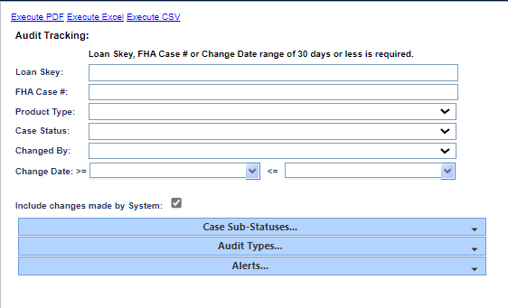
Figure 9-11: Audit Tracking Report
To generate this report:
- Click on the report link on the left menu and the report search screen will be displayed.
- You must enter a value for one of the following criteria: Loan Skey, FHA case #, Change date.
- To further narrow the results of your report, you can filter by:
  - Product Type
  - Case Status
  - Changed By
  - Include audit information associated with system updates
- To limit the results of the report, if necessary, the user can expand the selection boxes for:
  - Case Sub-statuses
  - Audit Types
  - Alerts
- Click the Execute PDF, Execute Excel or Execute CSV link.
The following results are displayed (please note: PDF results may differ):
Servicer Name, Investor Name, Case Status, Case Sub-Status, Loan Skey, FHA Case No, Loan Number, Audit Type Desc, Org Value, New Value, Changed By, Changed Date, Audit Type Skey, Audit Desc, Lender Skey, Lender Name, Prev Loan Status, and Prev Loan Sub Status.

Bulk Printing Letters Report
The Bulk Printing Letters report enables authorized users to print letters in bulk associated with the following compliance timelines for Assigned loans: User can print 600 letters at a time and allow users to continue printing until all letters are printed for the day.
  - Claim Tye 20 – Demand Assignment (Endorsed)
  - Claim Tye 22 – Assignment (Endorsed)
  - Insurance Flood Policy (Assigned)
  - Insurance Hazard Policy (Assigned)
  - Occupancy Compliance Certification (Assigned)
  - Taxes Delinquent (Assigned)

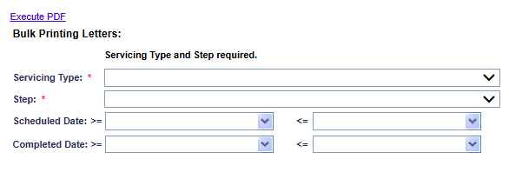
Figure 9-12: Bulk Printing Letters Report
To generate this report:
- Select the timeline (Servicing Type dropdown) and then select the letter name within the timeline. Optionally, the scheduled date/completed date range can be selected.
- Click Execute PDF. The Print Confirmation window is displayed with the quantity of letters available for bulk printing.
- Authorized users can also auto-complete the steps associated with the letter generation and auto-save the letters on the Documents tab of the corresponding loan. To do this, select the checkbox beside Auto Complete and Auto Image and click OK. For the Step “Welcome Letter Sent” the user cannot select the checkboxes Auto Complete and Auto Image as these are automatically checked by the system.
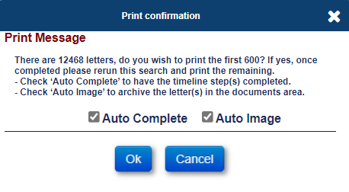
Figure 9-13: Bulk Printing – Selecting Auto Complete and Auto Image

- A print message window is displayed warning the user that it may take some time to generate the PDF; Click YES to print or NO to cancel.
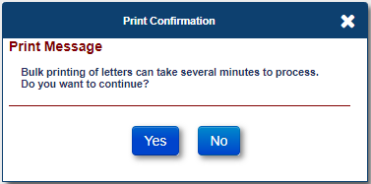
Figure 9-14: Bulk Printing – Verify Print
For the selected letter, the PDF document is displayed with the letters for each of the FHA case numbers.

Closed Loan Files Report
The Closed Loan Files Report enables authorized users to view the terminated loans via the terminated transactions generated in the SM.
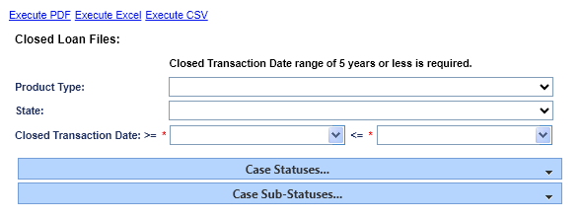

Figure 9-15: Closed Loan Files Report
To generate this report:
- Click on the report link on the left menu and the report search screen will display.
- To narrow the results of your report, you can filter by:
  - Product Type
  - State
  - Closed Transaction Date Range
- To limit the results of the report, if necessary, the user can expand the selection boxes for:
  - Case Status
  - Case Sub-status
- Click the Execute PDF, Execute Excel or Execute CSV link.
The following results are displayed (please note: PDF results may differ):
Servicer Name, Investor Name, FHA Case No, Loan Skey, Product Type Skey, Product Type Desc, Loan Status, Loan Status Desc, Loan Sub-Status Code, Loan Sub-Status, Lender Skey, Lender Name, Status Code, Borrower Name, Property Address, Signed Date, Assign Record Date, Closed Trans Date, Prop Address, Prop City, Prop ZIP, and Prop County.

Contact Information Report
The Contact Information Report enables authorized users to view phone numbers and mailing addresses within each loan from every available contact on the loan.

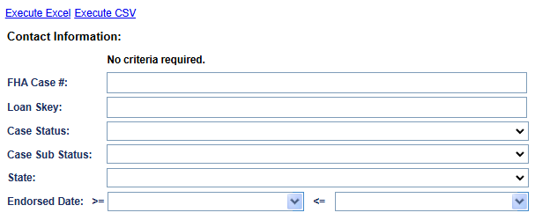
Figure 9-16: Contact Information Report
To generate this report:
- Click on the report link on the left menu and the report search screen will display.
- To narrow the results of your report, you can filter by:
  - FHA Case #
  - Loan Skey
  - Case Status
  - Case Sub Status
  - State
  - Endorsed Date
- Click the Execute Excel or Execute CSV link.
The following results are displayed:
Loan Skey, FHA Case No, Case Status, Case Sub-Status, Servicer Name, Closing Date, Origination Date (if applicable), Borrower Last Name, Borrower First Name, Property Address, Property City, Property State, Property Zip, Property County, Contact Type, Contact Type Description (if applicable), Contact First Name, Contact Last Name, Contact Address 1 , Contact Address 2, Contact City, Contact State , Contact Zip, Contact Language, Contact Death Date, Contact Email, Is Authorized Contact Checked (Y/N), Contact Home Number, Contact Work Number, Contact Cell Number, Contact Mailing Information Address 1, Contact Mailing Information Address 2, Contact Mailing Information City, Contact Mailing Information State, and Contact Mailing Information Zip

Disbursement Detail Report
The Disbursement Detail Report enables authorized users to view the disbursement details on all loans, regardless of case status.
To generate this report:
- Click on the report link on the left menu and the report search screen will display.

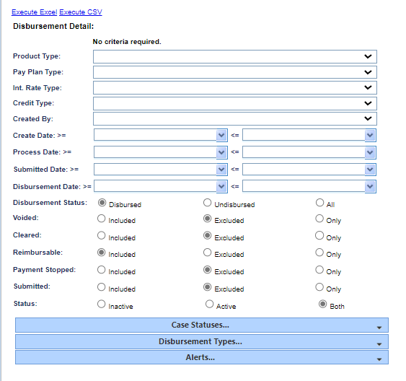
Figure 9-17: Disbursement Detail Selection
- To narrow the results of your report, you can filter by:
  - Product type
  - Pay Plan type
  - Int. Rate type
  - Credit Type
  - Created by
  - Create Date (date range)
  - Process Date (date range)
  - Submitted Date (date range)
  - Disbursement Date (date range)
  - Disbursement Status
  - Voided
  - Cleared
  - Reimbursable
  - Payment Stopped
  - Submitted
  - Status
- To limit your report, if necessary, expand the selection boxes for the following:
  - Case Statuses
  - Disbursement Types
  - Alerts
- Click the Execute Excel or Execute CSV link.
The following results are displayed:
Disbursement Skey, Pay To, Payor Name, Aba Number, Account Number, Check Number, Process Date, Disb Amt, Disbursed, Voided, Cleared, Created By, Create Date, Disbursed By, Disburse Date, Reimbursable, Invoice Date, Invoice Number, Trans Desc, Loan Skey, Disbursement Type, Loan No, FHA Case No, Investor Loan No, Product Type, Payment Plan Desc, Investor Name, Servicer Name, Investor Pool, Loan Status Desc, Loan Status Desc, Payment Stopped, Arm Type Desc, Credit Type, Rate Index Type Desc, Lender Skey, Company Name, Batch Skey, Submitted Date, and Status.

Disbursement Summary Report
The Disbursement Summary report provides authorized users with a summary of all disbursements grouped by user ID depending on the criteria submitted by the user.
To generate this report:
- Click on the report link on the left menu and the report search screen will display.
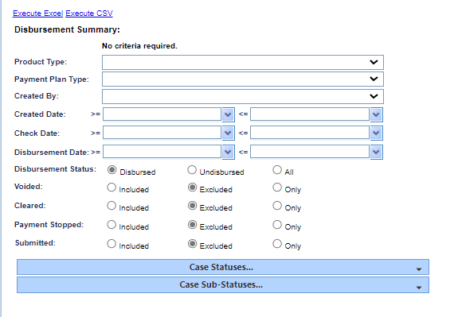
Figure 9-18: Disbursement Summary Report
- To narrow the results of your report, you can filter by:
  - Product Type
  - Payment Plan Type
  - Created By
  - Created Date (date range)
  - Check Date (date range)
  - Disbursement Date (date range)
  - Disbursement Status
  - Cleared
  - Payment Stopped
  - Submitted
- To limit your report, if necessary, expand the selection boxes for:
  - Case Statuses
  - Case Sub-statuses
- Click the Execute Excel or Execute CSV link.
The following results are displayed:
Product Type Desc, Username , User Full Name, Disbursement Desc, Num Checks, and Check Total.

Document Tracking Report
The Document Tracking Report allows authorized users to view the document notes and types in HERMIT for all loans. This report is also available under Servicer Reports.
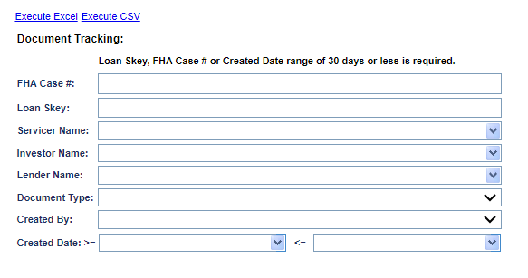
Figure 9-19: Document Tracking Report
To generate this report:
- Click on the report link on the left menu and the report search screen will display.
- To narrow the results of your report, you can filter by:
  - FHA Case #
  - Loan Skey
  - Servicer Name
  - Investor Name
  - Lender Name
  - Document Type
  - Created By
  - Created Date (From / To)
- Click the Execute Excel or Execute CSV link.
The following results are displayed:
Loan Skey , FHA Case No , Lender Name , Servicer Name , Investor Name , Record Number , Document Note , Document Type , File Name , Created By , and Created Date .

Due & Payable Report
The Due & Payable Report allows authorized users to view loans in HUD’s portfolio where the Case Status is not Terminated and has an Active Assigned Due & Payable Timeline.
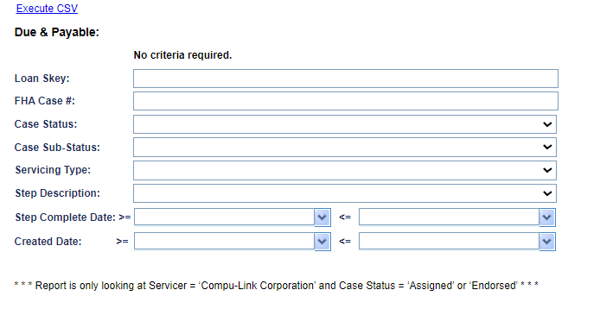
Figure 9-20: Due & Payable Report
To generate this report:
- Click on the report link on the left menu and the report search screen will display.
- To narrow the results of your report, you can filter by:
  - Loan Skey
  - FHA Case #
  - Case Status
  - Case Sub-Status
  - Servicing Type
  - Step Description
  - Step Complete Date
  - Create Date
- Click the Execute CSV link.
The following results are displayed:
Loan Skey, FHA Case No, Case Status, Case Sub-Status, Lender Name, Servicer Name, Investor Name, Status, Step Description, Step Complete Date, Servicing Type, Servicing Status, Default Date, Default Reason, Default Status, Default Paragraph, Responsible Party, First Legal Deadline, Create Date, Created By, Changed Date, and Changed By.

Foreclosure Activity Listing Report
The Foreclosure Activity Listing report enables authorized users to provide a list of loans with various foreclosure activities as specified by the user.

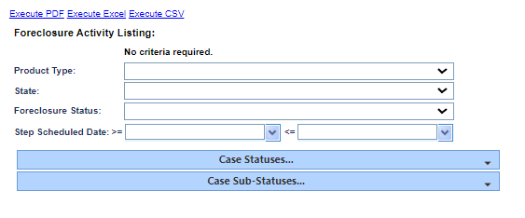
Figure 9-21: Foreclosure Activity Listing Report
To generate this report:
- Click on the report link on the left menu and the report search screen will display.
- To narrow the results of your report, you can filter by:
  - Product Type
  - State
  - Foreclosure Status
  - Step Scheduled Date (date range)
- To limit your report, if necessary, expand the selection boxes for:
  - Case Statuses
  - Case Sub-statuses
- Click the Execute PDF, Execute Excel or Execute CSV link.
The following results are displayed:
FHA Case No, Loan Skey, Investor Loan No, Loan Status Desc, Prop Address Formatted, Borrower Name , Servicing Step Desc, Create Date, Schedule Date, Vendor Name, Prop Address, Prop City, Prop State, Prop ZIP, and Prop County.

HECM Foreclosure Report
The HECM Foreclosure Report enables authorized users to view the loans in the Servicing Module that have had a Foreclosure timeline created.

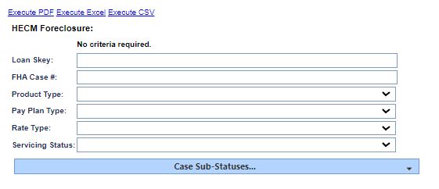
Figure 9-22: HECM Foreclosure Report
To generate this report:
- Click on the report link on the left menu and the report search screen will display.
- To narrow the results of your report, you can filter by:
  - Loan Skey
  - FHA Case #
  - Product Type
  - Pay Plan Type
  - Rate Type
  - Servicing Status
- To limit your report, if necessary, expand the selection box for the following:
  - Case Sub Statuses
- Click the Execute PDF, Execute Excel or Execute CSV link.
The following results are displayed (please note: PDF results may differ):
Loan Skey, FHA Case No, Loan No, Borrower Name, Property Address, Formatted Zip, Responsible Party, Timeline Status, Servicing Status, Appraised Value, Loan Type (Rate Type), Pay Plan Type, UPB, Attorney Name, Last Note Date, Last Note Text, Prop Address, Prop City, Prop State, Prop ZIP, and Prop County.

Insurance Policy Information Report
The Insurance Policy Information Report enables authorized users to view specific fields from the Servicing Management Information screen on all active Assigned > Compliance > Insurance – Hazard Policy Insurance and Assigned > Compliance > Insurance – Flood Policy Timelines for loans with a Case Status = “Assigned” or loans with a Case Status = “Endorsed” that have a Servicer Skey = “900000”.
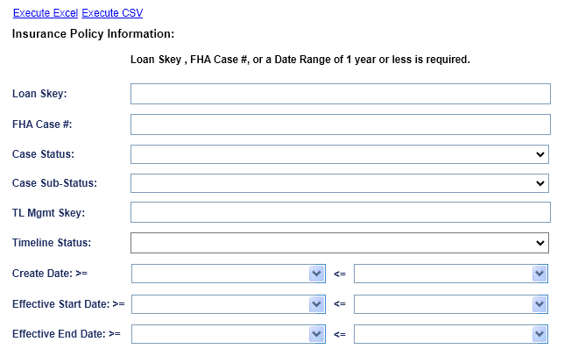
To generate this report:
- Click on the report link on the left menu and the report search screen will be displayed.
- To further narrow the results of your report, you can filter by:
  - Loan Skey
  - FHA Case Number
  - Case Status
  - Case Sub-Status
  - Timeline Management Skey
  - Timeline Status (Active or Inactive)
  - Create Date (Range)
  - Effective Start Date (Range)
  - Effective End Date (Range)
- Click the Execute Excel or Execute CSV link.
The following results are displayed:
FHA Case Number, Loan Skey, Case Status, Case Sub-Status, Lender Name, Servicer Name, Investor Name, Timeline Skey, Servicing Type, Create Date, Created By, Servicing Status, Timeline Status, Change Date, Changed By, Responsible Party, Policy Effective Start Date, Policy Effective End Date, Policy #, Premium, Policy Holder, Company Name, Agent Name, Tax ID, Address 1, Address 2, City, State, Zip, Email, Website URL, Phone #, and Fax #.

Loan Principal Limit Detail Report
The Loan Principal Limit Detail Report enables authorized users to view the loan balance details for their loans in the SM, including the current principal limit and the loan balance.
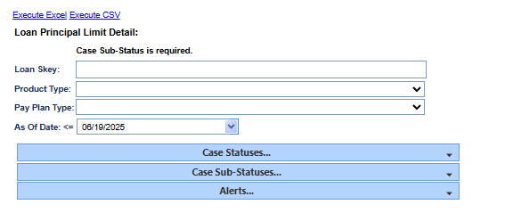
Figure 9-23: Loan Principal Limit Detail Report
To generate this report:
- Click on the report link on the left menu and the report search screen will display.
- To narrow the results of your report, you can filter by:
  - Loan Skey
  - Product Type
  - Pay Plan Type
  - As of Date
- To limit your report, if necessary, expand the selection boxes for the following:
  - Case Statuses
  - Case Sub Statuses
  - Alerts
- Click the Execute Excel or Execute CSV link.
The following results are displayed:
Servicer Name, Investor Name, FHA Case No, Loan Skey, Loan Status, Loan Sub Status, Loan No, Borrower First Name, Borrower Middle Name, Borrower Last Name, Product Type , Payment Plan, Principal Limit, Principal Balance, Interest Balance, MIP Balance, Service Fee Balance, Loan Balance, Service Fee Set Aside, First Year Set Aside, Repair Set Aside, Other Set Aside, Credit Line Set Aside, Net Principal Limit, Create Date, Funded Date, Lender Skey, Lender Name, Property State, Loss Draft Balance, Hardest Hit Funds, Property Charges, Termination Date, Custodial Care Date, Vacancy Date, and Loan Term Reason.

Missing Loan Document Detail Report
The Missing Loan Document Detail Report enables authorized users to view information about loans that are missing Notes documents or mortgage documents.

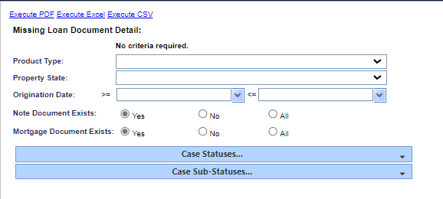
Figure 9-24: Missing Loan Document Detail Report
To generate this report:
- Click on the report link on the left menu and the report search screen will display.
- To narrow the results of your report, you can filter by:
  - Product Type
  - Property State
  - Origination Date (date range)
  - Note Document Exists
  - Mortgage Document Exists
- To limit your report, if necessary, expand the selection boxes for the following:
  - Case Statuses
  - Case Sub-Statuses
- Click the Execute PDF, Execute Excel or Execute CSV link.
The following results are displayed:
FHA Case No, Loan Skey, Lender Loan No, Product Type, Origination Date, Current Case Status, Borrower Name, Property Address, Note Doc Exists, and Mortgage Doc Exists, Property City, Property State, Property ZIP, and Property County.

NBS Missing SSN Report
The NBS Missing SSN Report enables authorized users to view information about loans that are missing Non-Borrowing Spouse Social Security # (SSN) in the Loan > Contacts screen
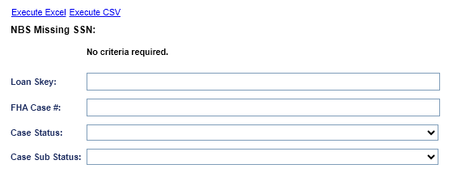
Figure 9-25: Missing Loan Document Detail Report
To generate this report:
- Click on the report link on the left menu and the report search screen will display.
- To narrow the results of your report, you can filter by:
  - Loan Skey
  - FHA Case #
  - Case Status
  - Case Sub Status
- Click the Execute Excel or Execute CSV link.

The following results are displayed:
FHA Case No, Loan Skey, FHA Case No Assigned Date, Eligible Non-Borrowing Spouse, Mort Opt Election (MOE), Case Status, Case Sub-Status, Non- Borrowing Spouse First Name. Non- Borrowing Spouse Middle Name, Non- Borrowing Spouse Last Name, Non-Borrowing Spouse record Create Date, Social Security No

Needs Custodial Care Report
The Needs Custodial Care Report enables authorized users to view the specifics or list of Custodial Care information in the SM.

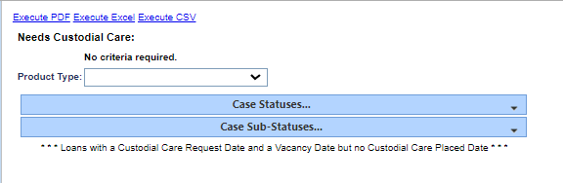
Figure 9-26: Needs Custodial Care Report
To generate this report:
- Click on the report link on the left menu and the report search screen will display.
- To narrow the results of your report, you can filter by:
  - A Product Type (You can also leave this blank to run a report for all product types).
- To limit your report, if necessary, expand the selection boxes for:
  - Case sub-statuses
  - Product types
- Click the Execute PDF, Execute Excel or Execute CSV link.

The following results are displayed:
Loan Skey, Lender Loan No, FHA Case No, Case Status, Borrower Name, Property Address, Property Condition (if available), Vacancy Date, Date vacancy was confirmed (if known), Estimated Value , and Total Balance , Section of Act (SOA), Custodial Care Request Date, Custodial Care placed date, Area for Custodial Property, and Recorded Date of Deed. The estimated value and total balance are totaled for all records on the report.

Occupancy Certifications and Hazard/Flood Ins Detail Report
The Occupancy Certifications and Hazard/Flood Ins Detail Report enables authorized users to view details on the Insurance – Flood Policy, Insurance - Hazard Policy, and Occupancy Compliance Certification timelines within HUD’s portfolio.
- When Servicing Type = Insurance – Flood Policy (Assigned/ Endorsed) or Insurance - Hazard Policy (Assigned/ Endorsed) the report pull the details of the Step = Policy Effective
- When Servicing Type = Occupancy Compliance Certification (Assigned/ Endorsed) the report pulls the details of the Signed Anniversary Date

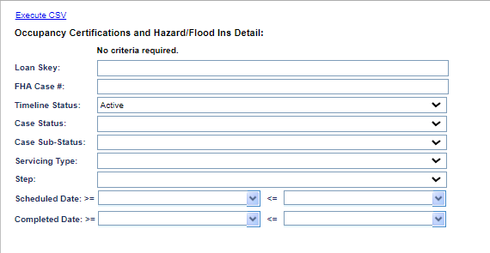
Figure 9-27: Occupancy Certifications and Hazard/Flood Ins Detail Report
To generate this report:
- Click on the report link on the left menu and the report search screen will display.
- To narrow the results of your report, you can filter by:
  - Loan Skey
  - FHA Case #
  - Timeline Status
  - Case Status
  - Case Sub-Status
  - Servicing Type
  - Step
  - Scheduled Date
  - Completed Date
- Click the Execute CSV link.
To execute a report without any filters, Click the Execute CSV link. The report will provide information on the most recent timeline in the system for Hazard Insurance, Flood insurance, and Occupancy Compliance.

The following results are displayed:
Loan Skey, FHA Case No, Case Status, Case Sub Status, Servicer Name, Lender Name, Investor Name, Insurance Hazard Policy, Does Insurance Hazard Policy Timeline exists Yes No, Insurance Hazard Policy Endorsed Assigned, Insurance Hazard Policy Active Inactive, Insurance Hazard Policy Step Name, Insurance Hazard Policy Expires Scheduled Date, Insurance Hazard Policy Expires Is Complete Yes No, Insurance Hazard Policy Expires Complete Date, Insurance Flood Policy, Does Insurance Flood Policy Timeline exists Yes No, Insurance Flood Policy Endorsed Assigned, Insurance Flood Policy Active Inactive, Insurance Flood Policy Step Name, Insurance Flood Policy Expires Scheduled Date, Insurance Flood Policy Expires Is Complete Yes No, Insurance Flood Policy Expires Complete Date, Occupancy Compliance Certification, Does Occupancy Compliance Certification Timeline exists Yes No, Occupancy Compliance Certification Endorsed Assigned, Occupancy Compliance Certification Active Inactive, Occupancy Compliance Certification Step Name, Occupancy Compliance Certification Signed Anniversary Date Scheduled Date, Occupancy Compliance Certification Signed Anniversary Date Is Complete Yes No, and Occupancy Compliance Certification Signed Anniversary Date Complete Date.

Overage Amounts
The Overage Amounts Report allows authorized users to view positive and negative overage balances for Assigned loans in HUD’s portfolio.
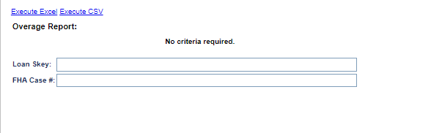
Figure 9-28: Overage Report
To generate this report:
- Click on the report link on the left menu and the report search screen will display.
- To narrow the results of your report, you can filter by:
  - Loan Skey
  - FHA Case #
- Click the Execute Excel or Execute CSV link.
The following results are displayed:
Loan skey, FHA Case No, Lender, Servicer, Investor, Case Status, Case Sub-Status, and Overage Balance.

Placed In Custodial Care Report
The Placed in Custodial Care report enables authorized users to view certain loans or a list of loans that have been placed in custodial care.
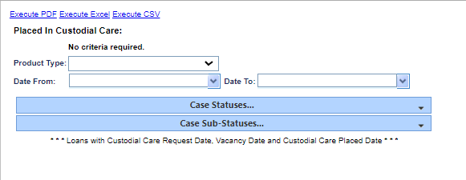
Figure 9-29: Placed in Custodial Care Report
To generate this report:
- Click on the report link on the left menu and the report search screen will display.
- To narrow the results of your report, you can filter by:
  - A Product Type (You can also leave this blank to run a report for all product types).
- To limit your report, if necessary, expand the selection boxes for:
  - Case Statuses
  - Case Sub-Statuses
- Click the Execute PDF, Execute Excel or Execute CSV link.
The following results are displayed:
Loan Skey, Lender Loan Number, FHA Case No, Borrower Name, Property Address, Date Property placed in Custodial Care, Date Property became Vacant, Estimate value, Total Balance, Loan Status, Customer Care Request Date, Section of Act (SOA), Fee Status, Area for Custodial Property, Property City, Property State, Property ZIP, Property County, Recoded Date of Deed. *Estimated value and total balance are totaled for all records on the report.

Property Charge Default Report
The Property Charge Default Report allows authorized users to view Assigned Loans with Property Charge Default Amounts (due to insufficient funds available).
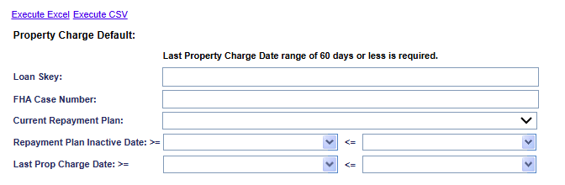
Figure 9-30: Property Charge Default
To generate this report:
- Click on the report link on the left menu and the report search screen will display.
- You must enter a date range for Last Prop Charge Date.
- To narrow the results of your report, you can filter by:
  - Loan Skey
  - FHA Case Number
  - Current Repayment Plan
  - Repayment Plan Inactive Date (Date Range)
  - Last Prop Charge Date (Date Range)
- Click the Execute Excel or Execute CSV link.

The following results are displayed:
Loan Skey, FHA Case No, Case Status, Case Sub-Status, Property Charge Balance, Payment Plan Type, Net Principal Limit (NPL), Credit Line Set Aside (CLSA), Total Funds Available, Property Charge Less Available Funds, Current Repayment Plan (Active/Inactive), Repayment Plan Inactive Date, and Last Property Charge Transaction Date.

Release Activity Steps By User Report
The Release Activity Steps by User Report enables authorized users to view the specifics or list of Release Activity information in the SM.

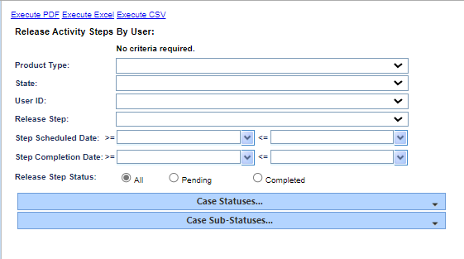
Figure 9-31: Release Activity Steps by User Report
To generate this report:
- Click on the report link on the left menu and the report search screen will display.
- To narrow the results of your report, you can filter by:
  - Product Type
  - State
  - User ID
  - Release Step
  - Step Scheduled Date (Date Range)
  - Step Completed Date (Date Range)
  - Release Step Status
- To limit your report, if necessary, expand the selection boxes for:
  - Case Statuses
  - Case Sub-Statuses
- Click the Execute PDF, Execute Excel or Execute CSV link.
The following results are displayed:
Loan Skey, FHA Case No, Product Type, Loan Status, State, Release Step, Step Schedule Date, Step Completion Date , User ID , and Loan Balance.

SAMS Daily Transaction File Report
The SAMS Daily Transaction File Report enables authorized users to generate a report displaying the data generated in the daily Single Family Acquired Asset Management System (SAMS) interface file in the SM. The report also lists dates of each activity was sent to SAMS.
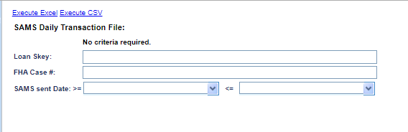
Figure 9-32: SAMS Daily Transaction File Report
To generate this report:
- Click on the report link on the left menu and the report search screen will display.
- To narrow the results of your report, you can filter by:
  - Loan Skey
  - FHA Case #
  - SMSs Sent Date
- Click the Execute Excel or Execute CSV link.
The following results are displayed:
Sams FHA Case No, HERMIT FHA Case No, ADP Code, Fund, Cohort, Endorsement Date, Property Address , Property Address 2, City, State, Zip Code, Principal Balance, Expense Amount, Sams Total Trans, Accounting Period, Closing Code DIL or FC, SOA, Custodial Care Request Date, Custodial Care Placed Date, Acquisition Type, Fee Status, Area for Custodial Property, Deed Recorded Date, Mortgagee No, Mortgagee Name, and SAMS Sent Date.

Subordinations Carried Over Detail Report
The Subordination Carried Over Detail report enables authorized users to view the specific subordination details or a list of Subordination details and status information for cases in the SM.

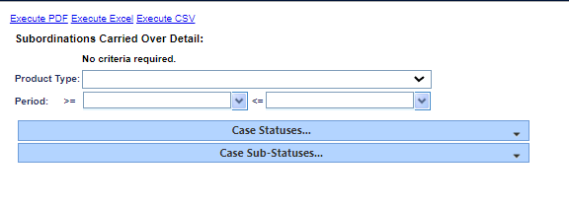
Figure 9-33: Subordinations Carried Over Detail Report
To generate this report:
- Click on the report link on the left menu and the report search screen will display.
- To narrow the results of your report, you can filter by:
  - Product Type (You can also leave this blank to run a report for all product types).
  - Period (Date Range)
- To limit your report, if necessary, expand the selection boxes for:
  - Case Status
  - Case Sub-status
  - Click the Execute PDF, Execute Excel or Execute CSV link.
The following results are displayed:
Product Type, FHA Case No, Loan Skey, Lender Loan Number, Borrower Name, Subordination Status, Timeline Status, Package Received Scheduled Date, Package Received Completed Date, and Step Status.

Tax Amount Report
The Tax Amount Report allows authorized users to view Tax Due Dates for Assigned Loans.
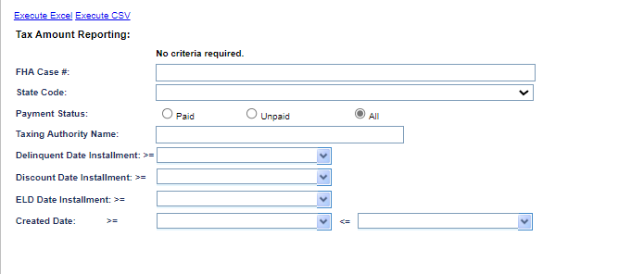
Figure 9-34: Tax Amount Report

To generate this report:
- Click on the report link on the left menu and the report search screen will display.
- To narrow the results of your report, you can filter by:
  - FHA Case #
  - State Code
  - Payment Status
  - Tax Authority Name

- To limit your report, if necessary, expand the selection boxes for:
  - Delinquent Date Installment
  - Discount Date Installment
  - ELD Date Installment
  - Created Date
- Click the Execute Excel or Execute CSV link.
The following results are displayed:
Tax Authority Name, Tax Authority Type, Customer Number, FHA Case No, Contract/Order Number, Contract/Order Suffix, Pending Apportionment/Hit Code, Exemption Code, State Code, County Code, First Installment Payment Status, First Installment Tax Amount, First Installment Delinquent Date, Second Installment Payment Status, Second Installment Tax Amount, Second Installment Delinquent Date, Third Installment Payment Status, Third Installment Tax Amount, Third Installment Delinquent Date, Fourth Installment Payment Status, Fourth Installment Tax Amount, Fourth Installment Delinquent Date, Total Tax Amount, Discounted Total Tax Amount, Tax Identification Number, Reference Number, Prior Year Delinquency Indicator, Service Bureau Customer Number, Number of Installments, Current Installment, and Create Date.

Tax Payment Report
The Tax Payment Report allows authorized users to view Tax Payments for Assigned Loans and Tax Payments associated with the Agency Header File.

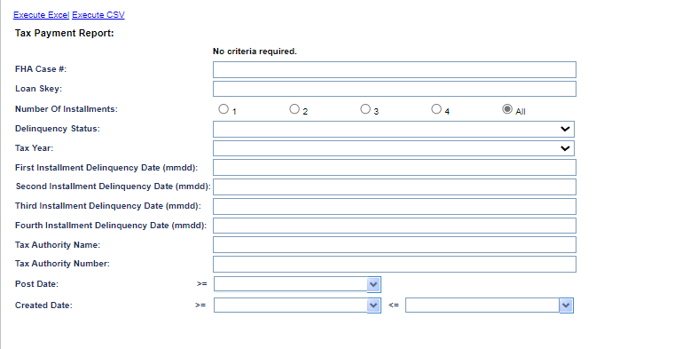
Figure 9-35: Tax Payment Report
To generate this report:
- Click on the report link on the left menu and the report search screen will display.
- To narrow the results of your report, you can filter by:
  - FHA Case #
  - Loan Skey
  - Number of Installments
  - Delinquency Status
  - Tax Year

- To limit your report, if necessary, expand the selection boxes for:
  - First Installment Delinquency Date (mmdd)
  - Second Installment Delinquency Date (mmdd)
  - Third Installment Delinquency Date (mmdd)
  - Fourth Installment Delinquency Date (mmdd)
  - Tax Authority Name
  - Tax Authority Name
  - Post Date
  - Created Date.
- Click the Execute Excel or Execute CSV link.
The following results are displayed:
Status Code Customer Number, FHA Case No, Loan Skey, Area Service Center Code, Taxing Authority Number, Taxing Authority Name, Tax Identification Number, Pending Apportionment/Hit Code, Contract/Order Number, Contract/Order Suffix, Service Type, Borrower Name, Property Street Number/Name, Property City, Property State Abbreviated, Property Zip Code, Legal Description, Lien Status Code, Delinquency, Search Date, Post Date, Taxable Year, 1st Installment Delinquency Date, 2nd Installment Delinquency Date, 3rd Installment Delinquency Date, 4th Installment Delinquency Date, Number of Installments, Delinquent Age, Bill Type, Tax Bill Number, First Installment Amount, Second Installment Amount, Third Installment Amount, Fourth Installment Amount, Total Installment Amount, First Redeem Amount, First Redeem Thru Date, Second Redeem Amount, Second Redeem Thru Date, Third Redeem Amount, Third Redeem Thru Date, Pay Plan, Lien Note Code, Criticality Flag, Agency Tax Type, and Create Date

Timeline Activity Report
The Timeline Activity Report allows authorized users to view Assigned and Endorsed Timelines that have a HUD, HUD Contractor, and certain timelines with a Servicer Step group. Endorsed Timelines that contain only Step group Servicer are excluded from the report results.
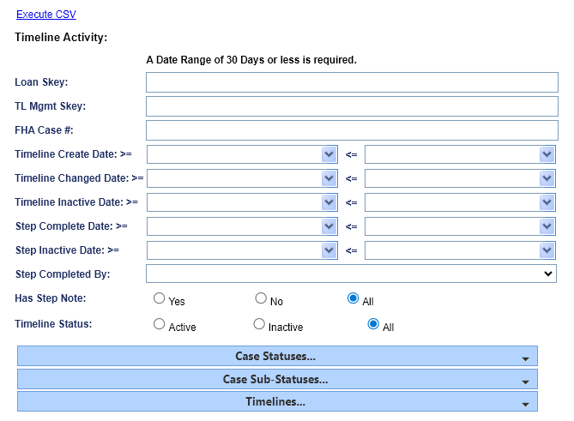

Figure 9-36: Timeline Activity Report
To generate this report:
- Click on the report link on the left menu and the report search screen will display.
- To narrow the results of your report, you can filter by:
  - Loan Skey or FHA Case # (At least one is required)
  - TL Mgmt Skey
  - Timeline Create Date (Required; cannot exceed 30 days)
  - Timeline Changed Date (Required; cannot exceed 30 days)
  - Timeline Inactive Date (Required; cannot exceed 30 days)
  - Step Completed Date (Required; cannot exceed 30 days)
  - Step Inactive Date (Required; cannot exceed 30 days)Step Completed By
  - Has Step Note (Yes, No, All)
  - Timeline Status (Active, Inactive, All)
- To limit your report, if necessary, expand the selection boxes for:
  - Case Statuses
  - Case Sub-Statuses
  - Timelines
- Click the Execute CSV link.
The following results are displayed:
Loan Skey, FHA Case No, Case Status, Case Sub-Status, Servicing Type, Timeline Group, TL Mgmt Skey, Timeline Status, Servicing Status, Step Name, Timeline Servicing Step Skey, Step Group For Timeline Step, Timeline Step Status, Borrower Last Name, Property Address, Property City, Property State, Property ZIP, Property County, Servicer Name, Responsible Party, Created By, Timeline Create Date, Step Complete Date, Step Completed By, Step Completed By Date, Changed By, Changed Date, Timeline Inactive Date, Timeline Inactivated By, Step Inactive Date, Step Inactivated By, Step Note, Unscheduled Advance Amount Assigned, Request From HUD Advance Amount, and Request For Payment Amount.

Transaction Activity Report
The Transaction Activity Report enables authorized users to view the transaction activities on a specific FHA Case # or list of FHA case numbers with a specific activity type. The transaction activity has an option to select only HUD NSC transactions during Search.

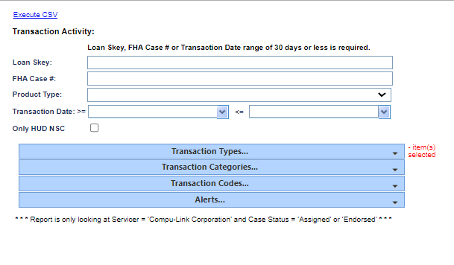
Figure 9-37: Transaction Activity Report
To generate this report:
- Click on the report link on the left menu and the report search screen will display.
- To narrow the results of your report, you can filter by:
  - Loan Skey or FHA Case # (At least one is required)
  - Product Type
  - Transaction Date (Required; cannot exceed 30 days)
- To limit your report, if necessary, expand the selection boxes for:
  - Transaction Types
  - Transaction Categories
  - Transactions Codes
  - Case Statuses
  - Case Sub-Statuses
  - Alerts
- Click the Execute CSV link.
The following results are displayed:
Transaction Type, Transaction Category, Transation Code, Case Status, Case Sub-Status, Loan Skey, FHA Case No, Product Type, Transaction Date Specified, Loan Skey, FHA Case No, Transaction Date, Effective Date, Principal Amount, Interest Amount, MIP Amount, Claim Amount, Service Fee Amount, Taxes and Insurance Withheld, Service Fee Set Aside Amount, First Year Set Aside Amount, Repair Set Aside Amount, Corporate Advance Amount, Other Set Aside Amount, Principal Limit Amount, Credit Line Amount, Unscheduled CL Disbursement, Interest and MIP Amount, Total Transaction Amount, Post Status, Create Date, Create By.

HUD Monthly Count Report
The HUD Monthly Count Report enables authorized users to view the monthly loan count by category.
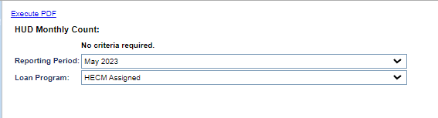
Figure 9-38: HUD Monthly Count Report
To generate this report:
- Click on the report link on the left menu and the report search screen will display.
- To narrow the results of your report, you can filter by:
  - Selecting a month in Reporting Period
  - Selecting a Loan Program as HECM Assigned
- Click the Execute PDF link.
The following results are displayed:
The loan count information by activity, monthly and cumulative (for the fiscal year) and for current month, the following sections: Loan Inventory, Partial Release Summary, Release Summary, Payoff Summary, Due & Payable Summary, Extension Summary, and Preservation & Protection Summary.
The Loan Inventory (Month Counts) is displayed as a pie chart and Release Summary is displayed as a bar graph.

HUD Monthly Director Report – HECM Assigned Detail Report
The HUD Monthly Director Report enables the authorized user to view the detailed report for HECM Assigned loans month by month for a period during the selected fiscal year.
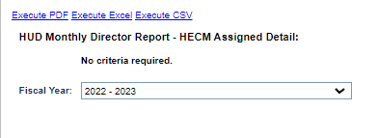
Figure 9-39: HUD Monthly Director Report
To generate this report:
- Click on the report link on the left menu and the report search screen will display.
- Select a year in the Fiscal Year dropdown.
- Click the Execute PDF, Execute Excel or Execute CSV link.
The following results are displayed:
Period No, Period Month, Period Year, Prior Loan Count, New Loan Count, Changed to Open Count, Closed Loan Count, Deleted Loan Count, End Loan Count, Prior Loan Bal, Loan Bal New Amt, Loan Bal Credit Amt, Loan Bal Payment Amt, Loan Bal Other Increase Amt, Loan Bal Payoff Amt, Loan Bal Payoff Compromise Amt, Loan Bal Other Collection Amt, Loan Bal Misc Amt, Loan Bal Write Off Amt, Loan Bal Transfer FCL Amt, Loan Bal Transfer DIL Amt, Loan Bal Transfer Other Amt, Curr Loan Bal, Credit Line Count, Monthly Payment Count, NOI Issued Count, Transfer FCL Count, Transfer DIL Count, Transfer Other Count, Pending Assign Pay Count, Pending Assign Nopay Count, Pending Assign Pay Bal, Pending Assign Nopay Bal, Total End Open Loans, Total Increases, Total Decreases, Total End Loan Bal, Total Increase Decrease, Total Without Credit Or Payment, Average Amount Disbursed, Total Pending Amt, Average Loan Value, Total Payoff Book Value, Average Payoff Collected, and Payoff Recover Ratio.

Additional Report detail:
- For Loan Inventory: Beginning Open Loans, New Loans, Loans Changed to Open, Closed Loans (Inventory Reduction), and Loans Deleted (Other Adjustments).
- For Loan Balance: Beginning Loan Balance, New Loans, Payments – Increases (Credit Line Payment Amount, Monthly Payment Amount and Other Balance Increases), Total Increases, Collections – Decreases (Full Payoff of Debt, Compromised Payoff, Other Collections Amount, and Other Balance Decreases). Total Decreases (Write-offs, FCL Amount, DIL Amount, and Other Adjustments), and Total Increase/ Decreases.
- For Eligible for Disbursements to Borrowers (Counts): Credit Line Payments, Monthly Payments, Without Credit or Monthly Payments, and Average Amount Disbursed.
- For Servicing Activity: Loans NOI Issued, Loans in FCL Process, Loans Conveyed, and Other Loans in Default.
- For Pending Assignments: Pending Assignments Payments, Pending Assignments No Payments, Totals, and Loan Balance of Pending.
- For Ratios: Average Value per Loan, Book Value of Payoffs, and Payoff Recovery Ratio.
- The Ending Open Loans and Ending Open Loans are summarized with graph of column.

HUD Monthly Management Report
The HUD Monthly Management Report enables the authorized user to view the detailed report for HECM Assigned loans month by month for a period during the selected fiscal year.

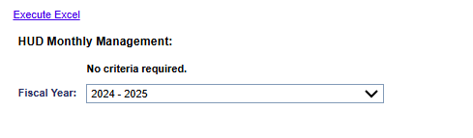
Figure 9-40: HUD Monthly Management Report
To generate this report:
- Click on the report link on the left menu and the report search screen will display.
- Select a year in the Fiscal Year dropdown.
- Click the Execute Excel link.
The following results are displayed for each Reporting Period column:
Endorsed (04), Assigned (05), Total Assign (05), Term (08), Total Pend (02,10), Total Endorsed (04), Total Active Cases (02,04,10), Max Claim Amount (Endorsed), Initial MIP, Monthly MIP, Initial MIP Plus Monthly MIP, Initial MIP Cases, Total Monthly MIP Cases, Late Charge & Penalty Interest Amount, Total Processed Refund Disbursements, In process Refund Disbursements, Refund Cases Processed, Refund Cases In Process, Debit Vouchers Amount (Premiums and Claims), and Debit Vouchers Cases (Premiums and Claims).

Month-End Trial Balance Detail Report
The Month-End Trial Balance Detail Report enables authorized users to view the detailed information on month-end trial loan balance.

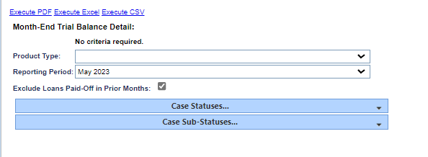
Figure 9-41: Month End Trial Balance Report (Excerpts)
To generate this report:
- Click on the report link on the left menu and the report search screen will display.
- To narrow the results of your report, you can filter by product type or reporting period:
  - Select a month from Reporting Period dropdown.
  - If necessary, select the checkbox for Exclude Loans Paid-Off in Prior Months.
  - If necessary, limit your selection by choosing case statuses and sub-status.
- Click the Execute PDF, Execute Excel or Execute CSV link.
The following results are displayed (please note: PDF results may differ):
Servicer Name, Investor Name, Investor Pool, FHA Case No, Fannie Mae No, Borrower Last Name, Borrower First Name, Loan Skey, Loan No, Prev Int Rate, Margin, Funded Date, Loan Setup Amount, Prior Loan Balance, Current Scheduled Advance, Current Unscheduled Pay, Current Repayment, Current MIP Total, Current Service Fee Total, Current Int Accrued, Payoff Amountt, Writeoff Amount, Current Loan Balance, Next Int Rate, Current Change Of Plan Fee Total, Property State Code, Lender Skey, Lender Name, and Loan Status.
The report displays the following information for the current month:
Loan Setup Amount, Scheduled Disbursements, Unscheduled Disbursements, Partial Repayments, MIP/PMI, Service Fee, COP Fee, Interest, Payoffs, Write-offs, and Ending Loan Balance.

Monthly Activity Detail Report
The Monthly Activity Detail Report enables authorized users to view the detailed information on monthly activities of the loans queried.
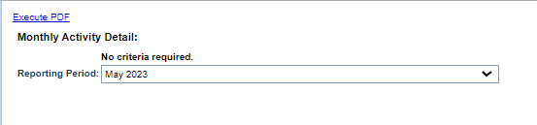
Figure 9-42: Monthly Activity Detail Report
To generate this report:
- Click on the report link on the left menu and the report search screen will display.
- To narrow the results of your report, you can filter by:
  - Select a month as desired from the Reporting Period dropdown list.
- Click the Execute PDF link.
The following results are displayed:
Reporting period as selected, Servicing Type, Servicing Step, Completion Date, Loan Skey, Lender Name, Loan Number, FHA Case No, Borrower Name, Property Address, and Property State.

Monthly Claims Paid Report
The Monthly Claims Paid Report provides authorized users with a list of loans on which the claims were paid in the period of Claim Paid Date defined by the user.
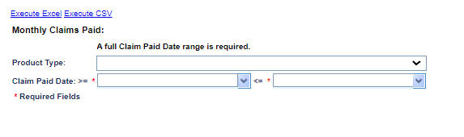
Figure 9-43: Monthly Claims Paid Report
To generate this report:
- Click on the report link on the left menu and the report search screen will display.
- To narrow the results of your report, you can filter by:
  - Claim Paid Date range (required)
  - Product Type (optional) to limit the selection. Without selection, all product types will be included in the report.
- Click the Execute Excel or Execute CSV link.
The following results are displayed:
Loan Skey, FHA Case No, Loan Status, ADP Code, Claims Paid Amount, MIC Date, Claim Paid Date, Product Type, Borrower Name, Create User ID, Create Date, Maintenance User ID, and Maintenance Date.

Monthly Portfolio Activity Report
The Monthly Portfolio Activity Report provides authorized users with monthly portfolio activities on the active loan inventory and the active loan balance in a fiscal year. The same report is also available under a different section of Reports.

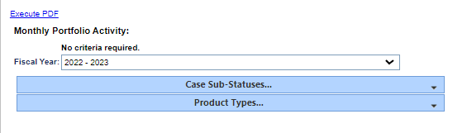
Figure 9-44: Monthly Portfolio Activity Report
To generate this report:
- Click on the report link on the left menu and the report search screen will display.
- To narrow the results of your report, you can filter by:
  - Select a fiscal year
- To limit your report, if necessary, expand the selection boxes for:
  - Case sub-statuses
  - Product types
- Click the Execute PDF link.
The following results are displayed for each Reporting Period column:
Beginning Loan Count:
New Loans, Changed to ACTIVE, Payoffs, Deleted, Ending Loan Count
Active Loan Balance:
Beginning Balance, New Loans, Accrued Interest, MIP/PMI, Service Fees, Scheduled Disbursements, Unscheduled Disbursements, Other Disbursements, Change Of Plan Fees, Partial/Repays, Payoffs, Writeoffs, Ending Balance

Management and Budgetary Reports
The following Management and Budgetary reports, compiled using daily data, are available:
- CT-22 Denial Reason
- HUD Pending Decision
- Indemnification Data
Repayment PlanThe following monthly reports are available:

- Monthly Cohort Summary
- Monthly Portfolio Activity
- Monthly Statistical Summary

CT-22 Denial Reason
The CT-22 Denial Reason Report allows authorized users to view the denial reasons selected on the HECM Assignment Acceptance Checklist from the HUD Decision Denial Letter.

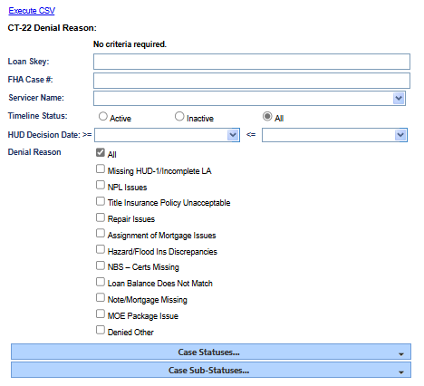
Figure 9-45: CT-22 Denial Reason Report
To generate this report:
- Click on the report link on the left menu and the report search screen will display.
- Enter a value for the report criteria (FHA Case # or Loan Skey).
- To further narrow the results of the users report, you can filter by:
  - Servicer Name
  - Timeline Status (ex. Active, Inactive, All)
  - HUD Decision Date (Date Range)
  - Denial Reason (ex. All, Missing HUD-1/Incomplete LA, etc.)
- To limit the results of the report, if necessary, the user can expand the selection boxes for:
  - Case Statuses
  - Case Sub-Statuses
- Click the Execute CSV link.
The following results are displayed:
Loan Skey, FHA Case No, Case Status, Case Sub-Status, Timeline Status, HUD Decision Date (Step Completion Date), Missing HUD-1/Incomplete LA, NPL Issues, Title Insurance Policy Unacceptable, Repair Issues, Assignment of Mortgage Issues, Hazard/Flood Ins Discrepancies, NBS - Certs Missing, Loan Balance Does Not Match, Note/Mortgage Missing, MOE Package Issue, Denied Other, and Servicer.

HUD Pending Decision Report
The HUD Pending Decision Report enables authorized users to view all loans that need a HUD decision when the following timeline steps are completed.
Assigned:
- Loss Mitigation – Pre-Foreclosure – Request Approval By HUD to Foreclose
- Loss Mitigation – Short Sale – Send Short Sale Approval request to HUD
- Write-Off Review – Write-off – Recommendation sent to HUD
- Substitution of Collateral – Recommendation Sent to HUD
- Partial Release – Recommendation Sent to HUD
- Assignment Repurchase – Recommendation Sent to HUD
Endorsed:
- Partial Release – Recommendation Sent to HUD
- Consent of Lien Holder – Recommendation Sent to HUD
- Substitution of Collateral – Recommendation Sent to HUD
- Request to Call Due & Payable Sent to HUD
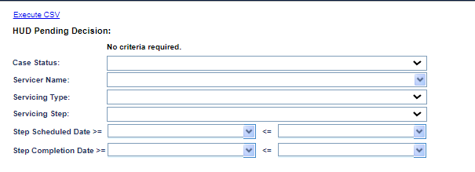
Figure 9-46: HUD Pending Decision Report
To generate this report:
- Click on the report link on the left menu and the report search screen will display.
- To narrow the results of your report, you can filter by:
  - Case Status
  - Servicer Name
  - Servicing Type
  - Servicing Step
  - Step Scheduled Date
  - Step Completion Date
- Click the Execute CSV link.
The following results are displayed:
Loan Skey, FHA Case No, Lender Name, Servicer Name, Investor Name, Case Status, Case Sub-Status, Servicing Type, Servicing Step, Step Scheduled Date, Step Completion Date, Pending Additional Info (Y or N)

Indemnification Data Report
The Indemnification Data Report enables authorized users to view loans with Indemnification records associated with the loan.
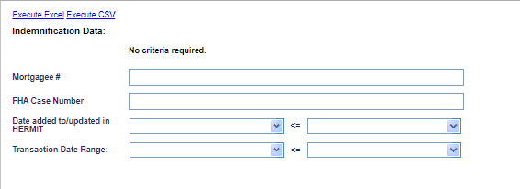
Figure 9-47: Indemnification Data Report
To generate this report:
- Click on the report link on the left menu and the report search screen will display.
- To narrow the results of your report, you can filter by:
  - Mortgagee #: TIP this is the Mortgagee ID provided by CHUMS, not the current servicer for the loan.
  - FHA Case Number
  - Date added to/updated in HERMIT: TIP this is the date HERMIT received the original or updated record from CHUMS.
  - Transaction Date Range
- Click the Execute Excel or Execute CSV link.
The following results are displayed:
Loan Skey, FHA Case No, Case Status, Case Sub-Status, Claim Type, Transaction Date, Transaction Amount, HERMIT Create Maintenance, Create Date, Update Date, Delete Date, Expiration Date, Endorse Date, Indemnification Term, Bill Mortgagee, Mortgagee Name, Servicer Name, Agree Date, QAD File No, Docket No, Status, Current Investor Name, and Current Investor Mortgagee ID

Repayment Plan Report
The Repayment Plan Report enables authorized users to view the repayment plan details on all loans, regardless of case status.
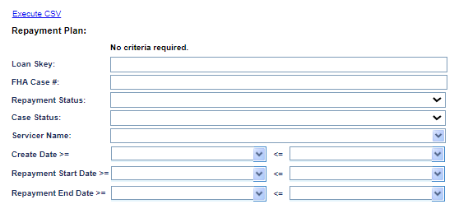
Figure 9-48: Repayment Plan Report
To generate this report:
- Click on the report link on the left menu and the report search screen will display.
- To narrow the results of your report, you can filter by:
  - Loan Skey
  - FHA Case#
- To limit your report, if necessary, expand the selection boxes for the following:
  - Repayment Status
  - Case Statuses
  - Servicer Name
  - Create Date
  - Repayment Start Date
  - Repayment End Date
- Click the Execute CSV link.
The following results are displayed:
FHA Case No, Loan Skey, Case Status, Case Sub-Status, Create date, Product Type, Servicer Name, Servicer Mortgagee Number, Repayment Plan Status Description, Outstanding Total Arrearage, Monthly Surplus Income, Repayment Plan Term, Monthly Payment Amount, Next Payment Due Date, Payments Remaining, Hardship Experienced, Repayment Plan Start Date, Repayment Plan End Date, Hardship Reason, Last Payment Received Date, Total Payment Received.

Monthly Cohort Summary Report
The Monthly Cohort Summary Report enables authorized users to view the detailed loan count, maximum claim amount for all the cohort years, current fiscal year and the current reporting month.
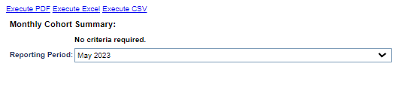
Figure 9-49: Monthly Cohort Summary Report
To generate this report:
- Click on the report link on the left menu and the report search screen will display.
- To narrow the results of your report, you can filter by:
  - Selecting a month and year from the Reporting Period dropdown box (the current month end is defaulted as the reporting period).
- Click the Execute PDF, Execute Excel or Execute CSV link.
The following results are displayed (please note: PDF results may differ):
Cohort Year, Cumulative Month End, Cumulative Loan Count, Cumulative Max Claim, Cumulative Avg Max Claim, Fiscal Start, Fiscal End, Fiscal Loan Count, Fiscal Mac Claim, Fiscal Avg Max Claim, Month End, Month End Loan Count, Month End Max Claim, Month End Avg Max Claim, Month End Loan Bal, MMI Count, and GI Count.

Monthly Portfolio Activity Report
This is the same Monthly Portfolio Activity Report stated above under a different section of Reports. See topic 9.6.33 above for details about this report.

Monthly Statistical Summary Report
The Monthly Statistical Summary Report enables authorized users to view by each pay plan the detailed loan count, maximum claim amount for the current fiscal year, the current reporting month, and the cumulative numbers up to the current fiscal year.
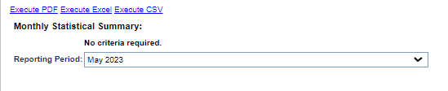
Figure 9-50: Monthly Statistical Summary Report
To generate this report:
- Click on the report link on the left menu and the report search screen will display.
- Select the following criteria:
  - Select a month and year from the Reporting Period dropdown box (the current month end is defaulted as the reporting period)
- Click the Execute PDF, Execute Excel or Execute CSV link.
The following results are displayed (please note: PDF results may differ):
Payment Plan Type, Payment Plan, Cumulative Month End, Cumulative Loan Count, Cumulative Max Claim, Cumulative Avg max Claim, Fiscal Start, Fiscal End, Fiscal Loan Count, Fiscal Max Claim, Fiscal Avg Max Claim, Mont End, Month End Loan Count, Month End Max Claim, Month End Avg Max Claim, and Month End Loan Balance
For each type of pay plan, the number of loans on that pay plan, the maximum claim amount, and the average per loan.
These amounts are shown based on cumulative totals through the end of the month you selected, the current fiscal year, and the month itself (also displays the outstanding loan balance). For each of these time frames, the report totals each of these amounts.

Servicer Reports
The following Servicer reports are available:
- CHUMS-HERMIT Data Mismatch Report
- Claim AOP Amounts
- Claims Detail
- Complete Date Changes
- Default Key Dates
- DMF (Death Master File)
- Document Tracking
- LESA (Life Expectancy Set Aside)
- No Pay Order
- Over Claims
- Prop Pres Detail
- Repurchase Timelines

CHUMS-HERMIT Data Mismatch Report
The CHUMS-HERMIT Data Mismatch Report enables authorized users to generate the errors displayed during the processing of the CHUMS inbound file.

The Search Criteria for the CHUMS-HERMIT Data Report includes the following:
- FHA Case #
- Create Date (To and From)
- Message Type:
- Message Column:
- Servicer Name (Defaulted to the servicer logging in, open to all for HUD Roles)
- Investor Name
- Lender Name

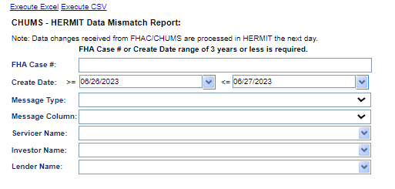
Figure 9-51: CHUMS-HERMIT Data Mismatch Report
To generate this report:
- Click on the report link on the left menu and the report search screen will display.
- The Create Date field is automatically populated with the current date and the previous day’s date but may be updated. The date range cannot exceed 90 days.
- To restrict your report, you may also enter
  - An FHA case #
  - Message type (Critical error or general warning)
  - The text of an error message (the message column)
- Click the Execute Excel or Execute CSV link.

The following results are displayed:
FHA Case No, Create Date, Lender Name, Investor Name, Servicer Name, Error Message and Error Type.

Claim AOP Amounts Report
The Claim AOP Amounts Report enables authorized users to obtain information on Advice of Payments for claims that were Submitted for Payment.
The Search Criteria for the Claim AOP Amounts Report includes the following:
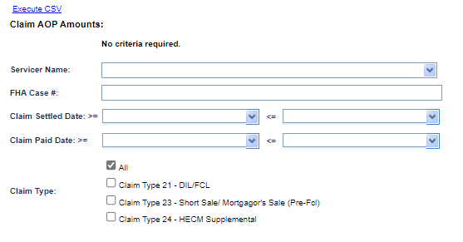
Figure 9-52: Claims AOP Amounts Report
To generate this report:
- Click on the report link on the left menu and the report search screen will display.
- To narrow the results of your report, you can filter by:
  - Servicer Name
  - FHA Case #
  - Claim Settled Date
  - Claim Paid Date
  - Claim Type
- Click the Execute CSV link.

The following results are displayed:
Loan Skey, FHA Case No, Case No Assigned Date, Servicer Name, Max Claim Amount, Claim Type, Settlement Date, Subsequent Claim Type 24, Investor Name, Case Status, Case SubStatus, Debenture Int Rate From Date, Debenture Int Rate To Date, Claim Curtailed, Debenture Int Rate, HUD Comments, AOP Total Expense Amount, UPB Adjustment Amount, Claim Type 24 UPB Adjustment Amount, Borrower Recoverable UPB Adjustment Amount, UPB Amount, UPB Debenture Int Amount, Line Number 110 Additions, Line Number 110 Interest, Line Number 111 Additions, Line Number 111 Interest, Line Number 112 Additions, Line Number 112 Interest, Line Number 113 Additions, Line Number 113 Interest, Line Number 114 Additions, Line Number 114 Interest, Line Number 116 Additions, Line Number 117 Additions, Line Number 117 Interest, Line Number 120 Additions, Line Number 120 Interest, Line Number 122 Additions, Line Number 122 Interest, Line Number 125 Additions, Line Number 125 Interest, Line Number 128 Additions, Line Number 129 Additions, Line Number 130 Additions, Line Number 130 Interest, Line Number 121 Interest, Line Number 132 Additions, Line Number 109 Deductions, Line Number 115 Deductions, Line Number 127 Deductions, Line Number 108 Deductions, Block 27 Estimate Damage, Net Claim Amount.

Claims Detail Report
The Claims Detail Report enables authorized users to analyze claim details and assist in banking reconciliation. If a servicer is selected there are no date range restrictions. If a servicer is not selected (run for all servicers) then date range is restricted to 2 years.

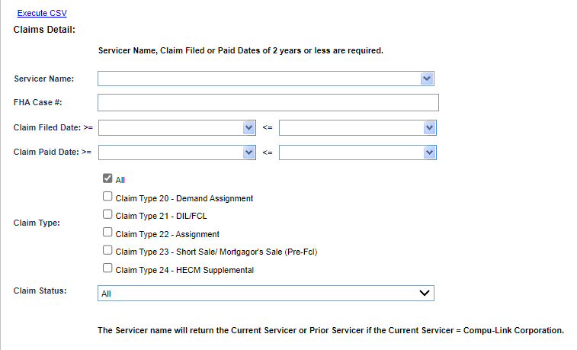
Figure 9-53: Claims Detail Report
To generate this report:
- Click on the report link on the left menu and the report search screen will display.
- For Servicers, Servicer Name will be pre-populated. Enter filters for FHA Case # or Transaction Date range as desired.
- To narrow the results of your report, you can filter by:
  - FHA Case #
  - A Claim Filed Date range
  - A Claim Paid Date range
  - Claim Type
  - Claim Status
- Click the Execute CSV link.
The following results are displayed:
Loan Skey, FHA Case No, Current Servicer, Prior Servicer, Current Investor, Prior Investor, Claim Type, Claim Status, Claim Filed Date, Claim Approved Date, Claim Paid Date, Debenture Interest From Date, Debenture Interest To Date, Curtailed, Self Curtail Date, Debenture Int Rate, UPB Amount, Adjusted UPB Amount, UPB Debenture Int Amount, Net UPB Amount, Debenture Int Amount, Expense Amount, Sales Appraisal Amount, Claim Paid Amount, Max Claim Amount, Claim AOP Comment, Case Status, Case Sub-Status, Approved Style, ADP Code, Claim Pended Date, Damage Escrow, Servicer when Claim Paid, Investor when Claim Paid, Responsible Party, Is Subsequent CT24, Previous UPB Debenture Interest, Previous Expenses Debenture Interest, Previous Block 121C, Block 408 Debenture Interest, Over Claim Debenture Interest, Recalculated UPB Debenture Interest, Recalculated Expenses Debenture Interest, Block 121C, Debenture Interest Date Change Reason, New Debenture Interest End Date Curtailment Date, Third Party Sale, HUD Approved Variance, Extended Curtailment, Claim Default Reason, DIL Agreement Date, Loan Balance, and Endorse Date.

Complete Date Changes Report
The Complete Date Changes Report enables authorized users to obtain two data sets: Steps Audit and Servicing Fields Audit. The Steps Audit includes changes on certain timeline step completion dates. The Servicing Fields Audit includes changes to certain timeline servicing management fields. This report will help the industry and HUD monitor changes to complete dates and servicing management dates.

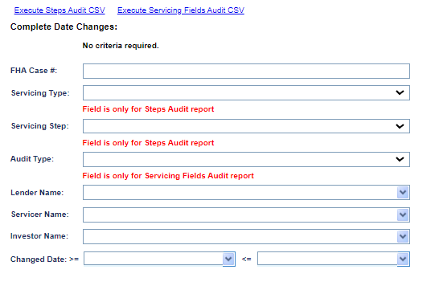
Figure 9-54: Complete Date Changes Report
To generate this report:
- Click on the report link on the left menu and the report search screen will display.
- Enter filters as desired
- To narrow the results of your report, you can filter by:
  - FHA Case #
  - Servicing Type (for Steps Audit only)
  - Servicing Step (for Steps Audit only)
  - Audit Type (for Servicing Fields Audit only)
  - Lender Name
  - Servicer Name
  - Investor Name
  - Changed Date range
- Click the Execute CSV link for the report you wish to retrieve.
The following results are displayed for the Steps Audit:
FHA Case No , Servicing Type, Step, Original Value, New Value, Servicer Name, Investor Name, Lender Name , Changed Date, and Changed By
The following results are displayed for the Servicing Fields Audit:
FHA Case No , Audit Type, Original Value, New Value, Servicer Name, Investor Name, Lender Name , Changed Date, and Changed By

Default Key Dates Report
The Default Key Dates Report enables authorized users to identify failed reporting events and confirm/reconcile reported events. It will assist with timely and accurate servicing activity reporting into HERMIT, resulting in better quality reporting for HUD. If a servicer is selected there are no date range restrictions. If a servicer is not selected (run for all servicers) then date range is restricted to 2 years.
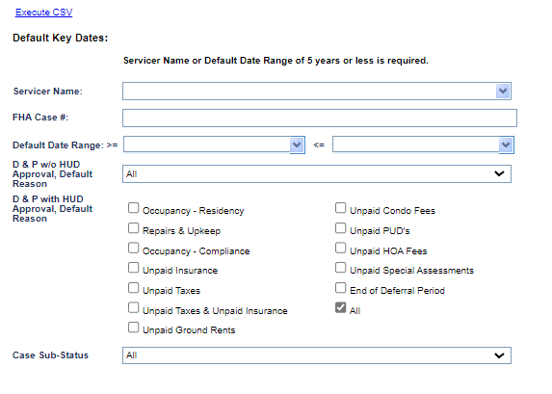
Figure 9-55: Default Key Dates Report
To generate this report:
- Click on the report link on the left menu and the report search screen will display.
- Select a Servicer Name.
- To narrow the results of your report, you can filter by:
  - FHA Case #
  - A Default Date range
  - D&P w/o HUD Approval, Default Reason
  - D&P with HUD Approval, Default Reason
  - Case Sub-Status
- Click the Execute CSV link.
The following results are displayed:
Servicer Mortgagee Number; Servicer Name; Loan Skey; FHA Case No; State Code; Case Status; Case Sub-Status; D&P W/Out HUD Create Date; D&P W/Out HUD Default Date; D&P W/Out HUD Default Reason; D&P W/Out Notification of Default to HUD; Death Date of last Borrower; D&P W/Out HUD Obtain Appraisal Date; D&P with HUD Create Date; D&P with HUD Decision Approved Date; D&P with HUD Disposition Event Notified Date; D&P with HUD Default Date; D&P with HUD Default Reason; D&P with HUD Upload D&P Package Date; D&P with HUD Pend Info Scheduled Date; D&P with HUD Pend Info Step Note; D&P with HUD Pend Info Complete Date; D&P with HUD Notification Sent to Borrower; D&P with HUD Obtain Appraisal Date; Loss Mit Pre Foreclosure Create Date; Loss Mit Pre Foreclosure First Legal Date; Loss Mit Pre Foreclosure Notice Sent to HUD; Foreclosure Create Date; Foreclosure Sale Appraisal Date; Foreclosure Sale Scheduled Date; Foreclosure Sale Completion Date; Foreclosure Final Marketable Title; Loss Mit DIL Record Deed Received Date; Repayment Start Date; Repayment End Date; Monthly Surplus Income; Outstanding Total Arrearage; Repayment Plan Term in months; Number of Remaining Payments; Monthly Payment Amount; Next Monthly Due Date; Hardship Experienced; Hardship Reason; Extension Claim Filing Servicer Initiated Extension; Extension Claim Filing HUD Decision Approved; Extension Claim Filing Expiration Date; Extension Claim Filing Reason for Request; Extension Repairs Servicer Initiated Extension; Extension Repairs HUD Decision Approved; Extension Repairs Expiration Date; Extension Repairs Reason for Request; Extension Request to Delay Foreclosure Servicer Initiated Extension; Extension Request to Delay Foreclosure HUD Decision Approved; Extension Request to Delay Foreclosure Expiration Date; Extension Request to Delay Foreclosure Reason for Request; Extension Deed in Lieu Servicer Initiated Extension; Extension Deed in Lieu HUD Decision Approved; Extension Deed in Lieu Expiration Date; Extension Deed in Lieu Reason for Request; Extension Late Notification of Death Servicer Initiated Extension; Extension Late Notification of Death HUD Decision Approved; Extension Late Notification of Death Expiration Date; Extension Late Notification of Death Reason for Request; Extension Hardest Hit Fund Servicer Initiated Extension; Extension Hardest Hit Fund HUD Decision Approved; Extension Hardest Hit Fund Expiration Date; Extension Hardest Hit Fund Reason for Request; Extension Property Charge Loss Mitigation Servicer Initiated Extension; Extension Property Charge Loss Mitigation HUD Decision Approved; Extension Property Charge Loss Mitigation Expiration Date; Extension Property Charge Loss Mitigation Reason for Request; Extension Appraisal Servicer Initiate Extension; Extension Appraisal HUD Decision Approved; Extension Appraisal Expiration Date; Extension Appraisal Reason for Request; Extension Other Servicer Initiated Extension; Extension Other HUD Decision Approved; Extension Other Expiration Date; Extension Other Reason for Request; D&P with HUD Inactive Rescission Date; Loss Mitigation Short Sale Received Cls Proc Date; Foreclosure Refer To Counsel Date; Bankruptcy Chapter 13 Filed Date; Bankruptcy Chapter 13 Discharge Date; Bankruptcy Chapter 13 Dismissed Date; Bankruptcy Chapter 7 Filed Date; Bankruptcy Chapter 7 Discharge Date; Bankruptcy Chapter 7 Dismissed Date; Claim Type 21 Claim Filed Date; Claim Type 21 Claim Approved Settlement Date; Claim Type 21 Claim Paid Amount; Claim Type 23 Claim Filed Date; Claim Type 23 Claim Approved Settlement Date; Claim Type 23 Claim Paid Amount; Claim Type 24 Claim Filed Date; Claim Type 24 Claim Approved Settlement Date; Claim Type 24 Claim Paid Amount; FHA Case Assignment Date; Loss Mitigation Short Sale Deed Record Date; Foreclosure Eviction Restriction Expired; Foreclosure Eviction Initiation; D&P W/Out HUD Notification Sent to Borrower; Corp Advance Eviction Balance; Claim Type 21 Extension Expiration Date; Claim Type 21 DIL Completion Date; Claim Type 21 Marketable Title Date; Claim Type 21 Block 10 Sales Based Claim Date; Claim Type 21 Block 10 Appraisal Based Claim DIL Date; Claim Type 21 Block 10 Appraisal Based Claim Foreclosure Date; Claim Type 21 Indicator Appraisal Based Claim; Claim Type 21 Indicator Foreclosure or DIL; Loss Mitigation Short Sale Closing Date; Loss Mitigation DIL Deed Record Date; Indicator 3rd Party Sale, and Extension Property Charge Loss Mitigation Default Date.

DMF (Death Master File) Report
The DMF Report enables authorized users analysis of Date of Death details reported by the Social Security Administration (SSA).
Servicers are reminded the DMF file is provided as an additional tool for the industry and is not intended to replace current business processes. It is the responsibility for mortgagees/servicers to obtain documentation of the death of the mortgagor or eligible non-borrowing spouse for foreclosure and claim purposes.
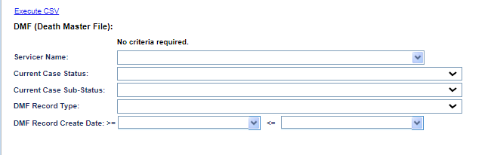
Figure 9-56: Death Master File report
To generate this report:
- Click on the report link on the left menu and the report search screen will display.
- To narrow the results of your report, you can filter by:
  - Servicer Name
  - Current Case Status
  - Current Case Sub-Status
  - DMF Record Type
  - DMF Record Create Date range
- Click the Execute CSV link.
The following results are displayed:
Loan Skey, FHA Case No, HERMIT Contact Type, HERMIT Contact Name, HERMIT DOB, HERMIT Date Of Death, Death Date Changed Date, Death Date Changed By, DMF Record Type, DMF Record Create Date, DMF Name, DMF Status, DMF Date Of Birth, DMF Date Of Death, HERMIT Current Case Status, HERMIT Current Case Sub-Status, HERMIT Result and Organization.

Document Tracking Report
The Document Tracking Report allows authorized users to view the document notes and types in HERMIT for all loans within the Servicer’s portfolio. This report is also available under Assigned Notes Reports.
Figure 9-57: Document Tracking Report
To generate this report:
- Click on the report link on the left menu and the report search screen will display.
- To narrow the results of your report, you can filter by:
  - FHA Case #
  - Loan Skey
  - Servicer Name
  - Investor Name
  - Lender Name
  - Document Type
  - Created By
  - Created Date (From / To)
- Click the Execute Excel or Execute CSV link.
The following results are displayed:
Loan Skey , FHA Case No , Lender Name , Servicer Name , Investor Name , Record Number , Document Note , Document Type , File Name , Created By , and Created Date .

LESA (Life Expectancy Set Aside) Report
The LESA (Life Expectancy Set Aside) Report enables authorized users to obtain information on loans that have a LESA via HERMIT specific to their portfolio.

The Search Criteria for the LESA (Life Expectancy Set Aside) Report includes the following:
- Loan Skey
- FHA Case #
- Product Type
- Case Status
- Case Sub Status
- Life Expectancy Type
- Endorsement Date
- Servicer Name (Defaulted to the servicer logging in, open to all for HUD Roles)
- Investor Name
- Lender Name
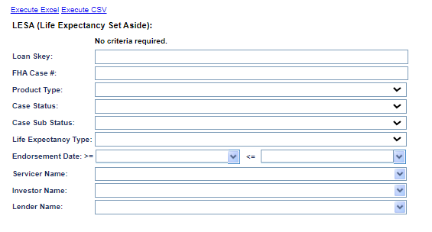
Figure 9-58: LESA (Life Expectancy Set Aside) Report
To generate this report:
- Click on the report link on the left menu and the report search screen will display.
- Click the Execute Excel or Execute CSV link.

The following results are displayed:
Loan Skey, FHA Case No, Endorsement Date, Case Status, Case Sub-Status, Servicer FHA Mortgagee #, Servicer Name, Investor Name, Lender Name, Product Type, Life Expectancy Type (Fully Funded, Partially Funded or Voluntary), Life Expectancy Payment Type (Active Payments or Payment Suspended), LESA Setup Effective Date, LESA Setup Transaction Date, LESA Setup Trans Code (automatic populates for 6610), LESA Setup Amount, Current LESA Balance

No Pay Order Report
The No Pay Order Report enables authorized users to obtain information on No Pay Orders placed on a loan in their portfolio.
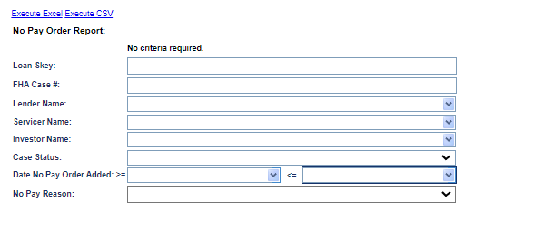
Figure 9-59: No Pay Order Report
To generate this report:
- Click on the report link on the left menu and the report search screen will display.
- To narrow the results of your report, you can filter by:
  - Loan Skey
  - FHA Case #
  - Lender Name
  - Servicer Name
  - Investor Name
  - Case Status
  - Date No Pay Order (Date range)
  - No Pay Reason
- Click the Execute Excel or Execute CSV link.
The following results are displayed:
Loan Skey, FHA Case No, Case Status, Case Sub-Status, Lender Name, Servicer Name, Investor Name, Date No Pay Order Added, No Pay Order Added User ID, No Pay Reason, and No Pay Explanation.

Over Claims Report
The Over Claim Report enables authorized users to obtain information on Over Claims submitted via HERMIT specific to their portfolio.

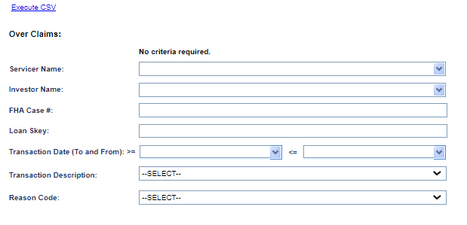
Figure 9-60: Over Claim Report
To generate this report:
- Click on the report link on the left menu and the report search screen will display.
- The Search Criteria for the Over Claim Report includes the following:
  - Servicer Name (Defaulted to the servicer logging in, open to all for HUD Roles)
  - Investor Name (Search for Investors at the time the Over Claims Payment was submitted to HUD)
  - FHA Case #
  - Loan Skey
  - Transaction Date (To and From)
  - Transaction Description (Dropdown to display values to include all)
  - Reason Code (Dropdown to display values to include all)
- Click the Execute CSV link.
The following results are displayed:
Loan Skey, FHA Case No, Servicer Name, Investor when Over Claim Paid, Transaction Date, Effective Date, Transaction Description, Over Claim Amount, Reason Code Description, Note, Created By, Created Date, Changed By, Changed Date, Original Claim Paid Date, Original Claim Paid Amount, Batch Number, and Batch Status.

Prop Pres Detail Report
The Prop Pres Detail Report enables authorized users to obtain information on Property Preservation Over-Allowable requests when the P&P expenses exceed the HUD allowable limits submitted via HERMIT specific to their portfolio.
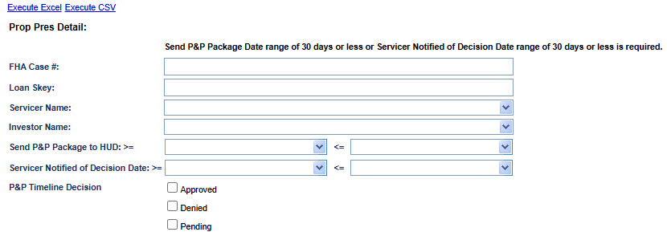
Figure 9-61: Prop Pres Detail Report
To generate this report:
- Click on the report link on the left menu and the report search screen will display.
- The Search Criteria for the Prop Pres Detail Report includes the following:
  - FHA Case #
  - Loan Skey
  - Servicer Name (Defaulted to the servicer logging in, open to all for HUD Roles)
  - Investor Name
  - Send P&P Package to HUD (To and From)
  - Servicer Notified of Decision Date (To and From)
  - P&P Timeline Decision
- Click the Execute Excel or Execute CSV link.
For the Servicer Name and any additional criteria selected, this report shows the following fields:
Loan Skey, FHA Case No, Case Status, Case Sub-Status, Servicer Name, Investor Name, Request ID, Specific Timeline Number, Sequence Number, Transaction Code, Transaction Type, HUD Bid Decision (Approved, Denied, Pending), Bid Requested Amt, Bid Approved Amt, Bid 1 Amt, Bid 2 Amt, Specific Transaction Number, Linked (Y/N), Linked Transaction amount, Linked Transaction - Trans Date, Linked Transaction - Effective Date, Linked Transaction - Incurred Date, Servicer remarks, HUD remarks, Created user id, Created date, HUD Decision User ID, HUD Decision Date, HUD Decision - Approved Step Date (for this timeline), HUD Decision - Denied Step Date (for this timeline), HUD Decision - Pended Step Date (for this timeline), Line-Item User ID, Line-Item Change Date

Repurchase Timelines Report
The Repurchase Timelines Report enables authorized users obtain information on Active Repurchase Timelines when they are the Prior Servicer associated with the Timeline.
HUD Users: When HUD and HUD Contractor users run this Report, the Report will run wide open. No specific criteria are needed for HUD and HUD Contractor users.

Prior Servicer: The Prior Servicer user will only be able to see this Report when the Repurchase Timeline has the Step “HUD Decision – Approved Pre-Repurchase” completed and/or Step “HUD Decision – Approved Repurchase” completed and the Step “Servicer Authorizes Repayment of Claim” is not completed.
The Search Criteria for Repurchase Timeline Report includes the following:
- Prior Servicer Name (Defaulted to the Prior Servicer logging in, open to all HUD Roles)
- FHA Case #
- Timeline Create Date (To and From)
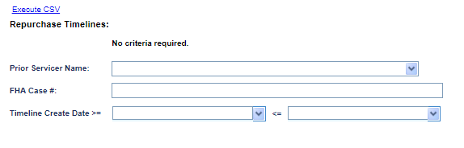
Figure 9-62: Repurchase Timelines Report
To generate this report:
- Click on the report link on the left menu and the report search screen will display.
- Click the Execute CSV link.
The following results are displayed:
Loan Skey, FHA Case No, Current Lender, Current Servicer, Current Investor, Prior Lender, Prior Servicer, Prior Investor, Case Status, Case Sub Status, Status, Repurchase Reason, HUD Comments, Create Date, Created By, Last Completed Step, Step Complete Date, Approved Pre-Repurchase Date, Approved Repurchase Date.

Servicer Alert Details Report
The Servicer Alert Details Report allows Servicers to view all Alerts within their own portfolio unless the Servicer is HUD/HUD Contractor (Servicer = 900000). The user is required to select between 1-10 Alerts from the multi-select options.

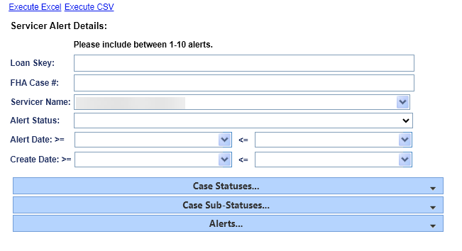
Figure 9-63: Servicer Alert Details Report
To generate this report:
- Click on the report link on the left menu and the report search screen will display.
- The Servicer Name field is automatically populated with the current Servicer unless the Servicer is the HUD/HUD Contractor (Servicer = 900000).
- To restrict your report, you may also enter
  - Loan Skey
  - FHA Case #
  - Servicer Name
  - Alert Status
  - Alert Date
  - Create Date
- To limit the results of the report, if necessary, the user can expand the selection boxes for:
  - Case Statuses
  - Case Sub-Statuses
  - Alerts

- Click the Execute Excel or Execute CSV link.

The following results are displayed:
Loan Skey, FHA Case #, Case Status, Case Sub-Status, Lender Name, Servicer Name , Investor Name, Borrower Last Name, Borrower First Name, Alert Status, Alert Date, Alert Description ,Alert Severity, Alert Type, Alert Amt, Alert Expiration, Alert Note, Alert Created By, Alert Create Date, Alert Changed By, and Alert Changed Date.

HERMIT Support
All HERMIT Support reports are based on daily data. The following reports are available:
- Accounting Exceptions
- Audit Tracking – Non Loan
- B2G Transaction Exception
- File Upload Exception

Accounting Exceptions Report
The Accounting Exception Report enables authorized users to generate the errors generated while processing an inbound interface file from the AM.

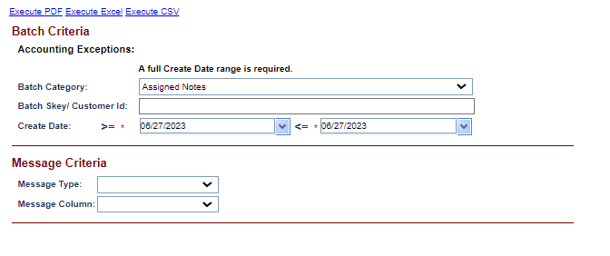
Figure 9-64: Accounting Exceptions Report
To generate this report:
- Click on the report link on the left menu and the report search screen will display.
- Select the following criteria from the Batch Category box:
  - Batch Category
  - Batch Skey/Customer ID
  - Create Date (Date Range)
- Select the following criteria from Message Sub Category box:
  - Message Sub Category
  - Message Type
  - Message Column
- Click the Execute PDF, Execute Excel or Execute CSV link.
The following results are displayed:
Batch Category, the Batch Skey/Customer ID, message type and date range, the date and time the exceptions were created, the date and time they were sent to the GL, the servicer/investor name, and the error type.

Audit Tracking – Non Loan Report
The Audit Tracking – Non Loan Report enables authorized users to generate the report on updates not associated with the loan. The system inclusion covers the updates due to batch jobs.

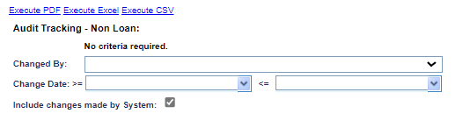
Figure 9-65: Audit Tracking – Non Loan Report
To generate this report:
- Click on the report link on the left menu and the report search screen will display.
- Select the following criteria:
- From the Changed By dropdown box, select a name. (To see activity by all users, leave this field blank).
- In the Change Dates fields, select start and end dates (or to see all activity unconstrained by date, leave these fields blank). The range cannot exceed 30 days.
- For the Include Changes Made by the System checkbox, uncheck the checkbox if you want to exclude system changes from the report.
- Click the Execute PDF, Execute Excel or Execute CSV link.
The following results are displayed:
Changes made by the system and/or users during the dates you selected, the type of audit, the new and old value, the entity making the change, and the date and time the change occurred.

B2G Transaction Exception Report
The B2G Transaction Exception Report enables authorized users to generate the messages displayed during the B2G upload process for transactions imported after 1/1/14:

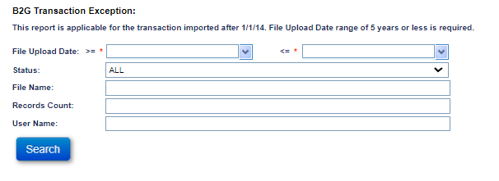
Figure 9-66: B2G Transaction Exception Report
To generate this report:
- Click on the report link on the left menu and the report search screen will display.
- Select the following criteria:
  - The user must enter the File Upload Date. The range cannot exceed 90 days.
- To further narrow the results of your report, you may also select the Status, File Name, Record Count, and User Name.
- Click Search
- Select the file in question from the search results
- Click the Preview Records or Execute PDF links.
The following results are displayed:
Row #, FHA Case No, Status, Error Message, Original Data

File Upload Exception Report
The File Upload Exception Report enables authorized users to generate the errors displayed during the batch upload for the following B2G files:
- Alerts
- Disbursements
- HUD Disbursements
- Investor Transfer
- Loan Details and Loan Transactions
- Loan Setup
- Master Servicer
- Notes
- NSC Transactions
- OPL/CPL
- Release Fee Disbursements
- Servicer Transfer
- Transactions
- Vendor
- State Prohibited Legal Appraisal Disbursements
- State Prohibited Legal Inspection Disbursements

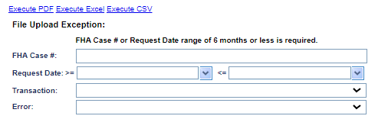
Figure 9-67: File Upload Exception Report
To generate this report:
- Click on the report link on the left menu and the report search screen will display.
- Select the following criteria:
  - At a minimum, enter either FHA Case # or a Request Date range. The range cannot exceed 180 days.
- To further narrow the results of your report, you may also select a transaction and an error code.
- Click the Execute PDF, Execute Excel or Execute CSV link.
The following results are displayed:
FHA Case No, Created Date, Created by User ID, file name, Comments (Error message), File Upload type, Error Type, and the request date and time for each upload exception.

CHAPTER 10: ADMIN FUNCTIONS

ADMIN FUNCTIONS
This chapter discusses the administrative functions available in the Servicing Module:
- Admin Functions Overview
- Common Functionality
The following areas are available under Admin on the Left Menu:
- Alerts
- Announcements
- Authorized Person
- County Clerks
- Editable Timeline Steps
- Helpful Links
- Investor
- Lender
- Lender Links
- Master Servicer Links
- Servicer
- Master Servicer
- Petitioner
- Tax Authority
- Vendors
- Claims Auto Delegation
- Bulk Vendor Upload

Admin Functions Overview
Admin allows authorized users to manage certain functions in the system. These functions will be explained in detail in this section. This tab will be limited to a small number of HUD users.
Admin enables authorized users to manage the functions listed below:
Function | Description
Alerts | Add new manual alerts, edit or inactivate an existing alert. These alerts are displayed on the alerts screen.
Announcements | Add new announcements, edit or inactivate an existing announcement related to HUD and its reverse mortgage program. The announcements are displayed on the Servicing Module home page under the Announcements section.
Helpful links | Add new links, edit or inactivate an existing link related to HUD and its reverse mortgage program. The links are displayed on the Servicing Module home page under Helpful Links section, displayed on the HERMIT home page.
Update Business partners | Add, edit or inactivate HUD Business Partner related to HECM loan processing:  - County Clerks  - Investors  - Lenders  - Servicers  - Master Servicers  - Petitioners  - Tax Authority  - Vendors
Claims | Manage claims auto functionality:  - Claims Auto Approval Rules  - Claims Auto Delegation
Table 10-1: Admin Functions

Common Functionality
Most maintenance tasks are performed in general the same way as described below.
- After logging into the system, click Admin from the Left Menu.
- From the navigation bar on the left, select a task and a table will be displayed with the type of admin task you selected.
You can now:
- Restrict your search by applying various filters. (The criteria vary and are discussed below).
- Export the search results to Excel (except Lender Links)
- Sort the search results by a column
- Create a new record (except Lender Links)

Restricting a Search (General Instructions)
Various search filters are associated with each type of task.
To restrict (filter) your search results:
- Complete one of more of the fields at the top of the screen.
- Click Filter.

Sorting the Search Results by Column (General Instructions)
You can sort the table for any task by clicking on the column header.

Exporting your Search Results to Excel (General Instructions)
You can export the table of results in .xls format. Exporting to a spreadsheet application enables you to work with the data or import it into some external database applications.
To export the table to Excel:
- Filter or sort the table if desired.
- Click the Export to Excel link.
- Follow the prompts to save or open the file.

Create a New Record (General Instructions)
To create a record:
- Click the New button.
- Fill in (at a minimum) the required fields and click OK. The tab information table is displayed, and the record will be added to the table.
Specific instructions for creating a record for each type of admin task are discussed later in this chapter.

Editing an Existing Record
To edit a record:
- Click a record from the table.
- Edit the desired fields and then click OK. The tab information table will display, and the edited record will be displayed in the table.
Specific instructions for editing a record each type of admin task is discussed later in this chapter.

Alerts Screen
This screen enables authorized users to add new alerts manually, or to edit or inactivate an existing alert. Upon the addition of new alert, authorized users can select the new alert from the alerts drop down list and add it on a loan. You cannot delete an alert. An alert that should no longer be used should be changed to inactive.
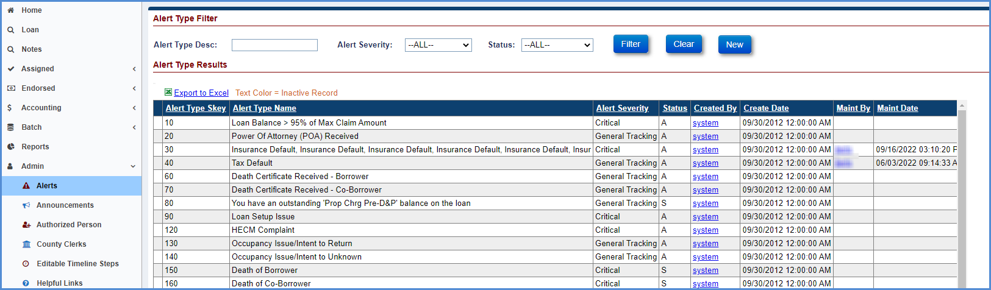
Figure 10-1: Alerts Screen

Filtering Alerts
Alerts can be filtered by:
- Alert type
- Description
- Severity
- Status

Sorting Alerts
Alerts can be sorted by:
- Alert Type Skey
- Alert Type Name
- Alert Severity
- Status
- Created By
- Create Date
- Maintained by
- Maintenance date

Creating an Alert
To create a new alert:
- Click the Alerts tab and click New. The Alert screen is displayed so the user can create a new alert.
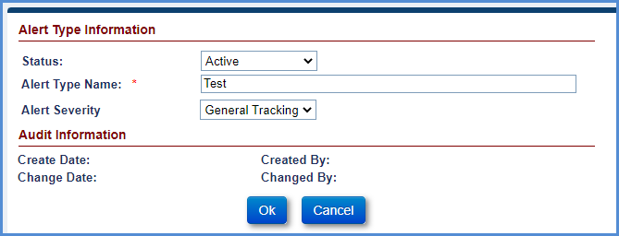
Figure 10-2: Creating an Alert
- On the dialog box, for Alert Type Information, specify:
  - The status of the alert (Active, Inactive, or System Generated)
  - The name of the alert
  - The severity (General Tracking or Critical)
- Click OK.

Editing an Alert
You can edit all fields for alerts except Alert Type Skey and audit information.
- Click on a record in the table and the Edit Alerts screen will be displayed.
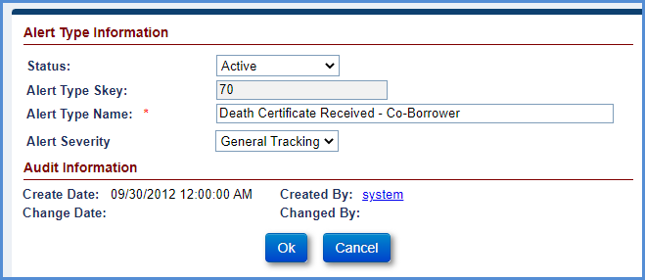
Figure 10-3: Editing an Alert
- Modify the information you need to edit and click the OK button. The Alerts tab record table with the edited record will be displayed in the table.

Announcements Screen
This screen enables authorized users to add new announcements, or to edit or inactivate an existing announcement related to HUD and its reverse mortgage program. The announcements with an active status and an expiration date greater than the current system date are displayed on the Home page under the Announcements section. You cannot delete an announcement. An announcement that should no longer be used should be changed to Inactive.
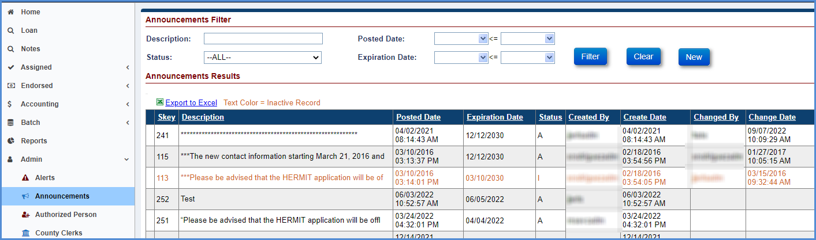
Figure 10-4: Announcements Screen

Filtering Announcements
Announcements can be filtered by:
- Description
- Posted Date
- Status
- Expiration Date

Sorting Announcements
Announcements can be sorted by:
- Skey
- Description
- Posted Date
- Expiration Date
- Status
- Created By
- Create Date

Creating an Announcement
To create an announcement:
- Click New. The Announcements screen will display so the user can create an announcement.
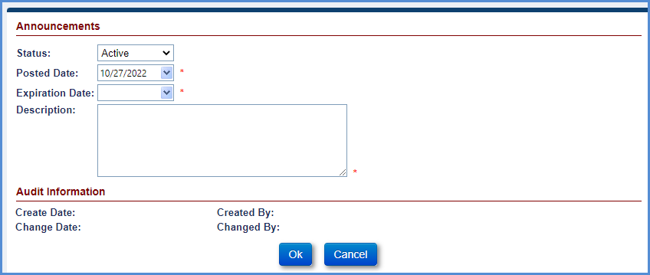
Figure 10-5: Creating an Announcement
- Enter:
  - Status (Select either Active or Inactive)
  - Posted Date (The day the announcement should appear on the site)
  - Expiration Date (The date the announcement should be removed from the site)
  - Description (The text of the announcement)

- Click OK.

Editing an Announcement
You can edit all fields for announcements except audit information.
- Click on a record in the table and the Announcements screen will be displayed.
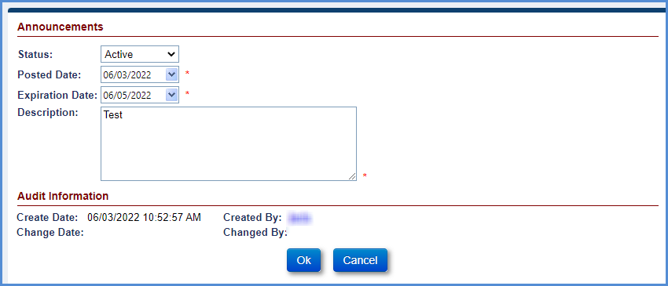
Figure 10-6: Editing an Announcement
- Modify the information you need to edit and click the OK button. The Announcements tab record table with the edited record will be displayed in the table.

County Clerks Screen
This screen enables authorized users to add county clerks, or to edit or inactivate a county clerk.
These are the clerks of court for the county in which the mortgaged property is located. You cannot delete a county clerk. A county clerk that should no longer be used should be changed to Inactive.

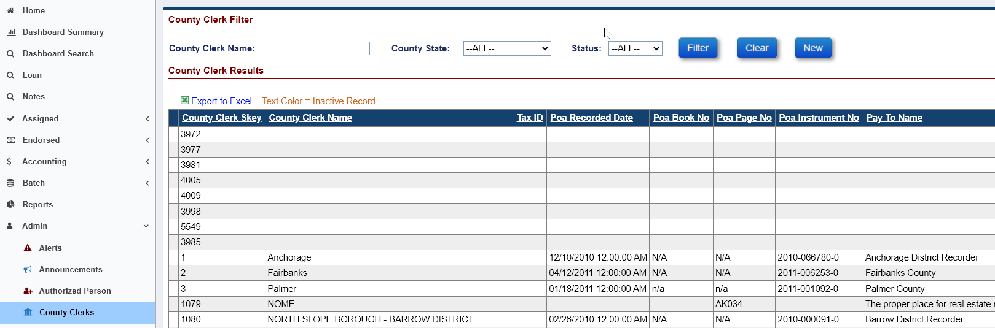
Figure 10-7: County Clerks Screen

Filtering County Clerks
County clerks can be filtered by:
- County Clerk Name
- State
- Status

Sorting County Clerks
County clerks can be sorted by:
- County Clerk Skey
- County Clerk Name
- Tax ID
- POA Recorded Date
- POA Book No
- POA Page No
- POA Instrument No
- Pay To Name
- Attention To
- County Address1
- County Address2
- County State
- County Zip
- POA Sent For Recording Date
- Recording Fee Info
- Status
- Created By
- Create Date
- Maint By
- Maint Date
- First Page Rec Fee Amt
- Additional Page Rec Fee Amt
- Customer ID

Creating a County Clerk
To create a county clerk record:
- Click New. The County Clerks screen will display so the user can add a new county clerk.

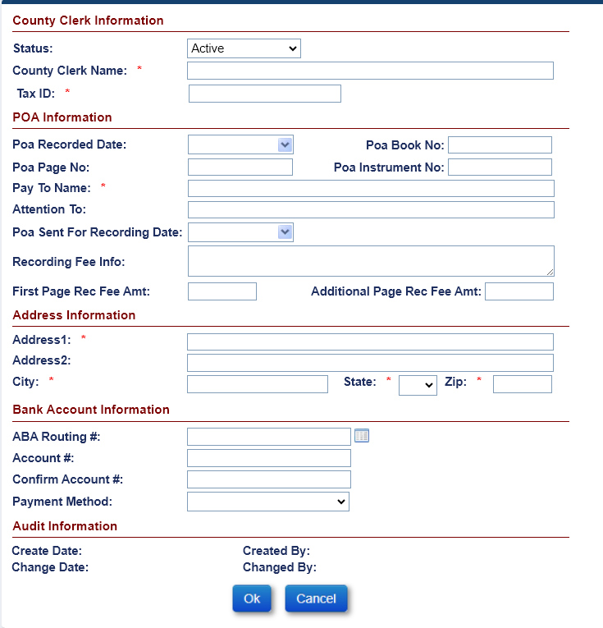
Figure 10-8: Creating a County Clerk
- Enter the following information
  - Status
  - County Clerk Name (required)
  - Tax ID (required)
  - POA Recorded Date
  - POA Book No
  - POA Page No
  - POA Instrument No
  - Pay To Name (required)
  - Attention To
  - POA Sent For Recording Date
  - Recording Fee Info
  - First Page Rec Fee Amt
  - Additional Page Rec Fee Amt
  - Address1 (required)
  - Address2
  - City (required)
  - State (required)
  - Zip (required)
  - Bank Account Information
- Click OK.

Editing a County Clerk
You can edit all fields except county clerk skey, customer ID, and audit information.
- Click on a record in the table and the County Clerk screen will be displayed.

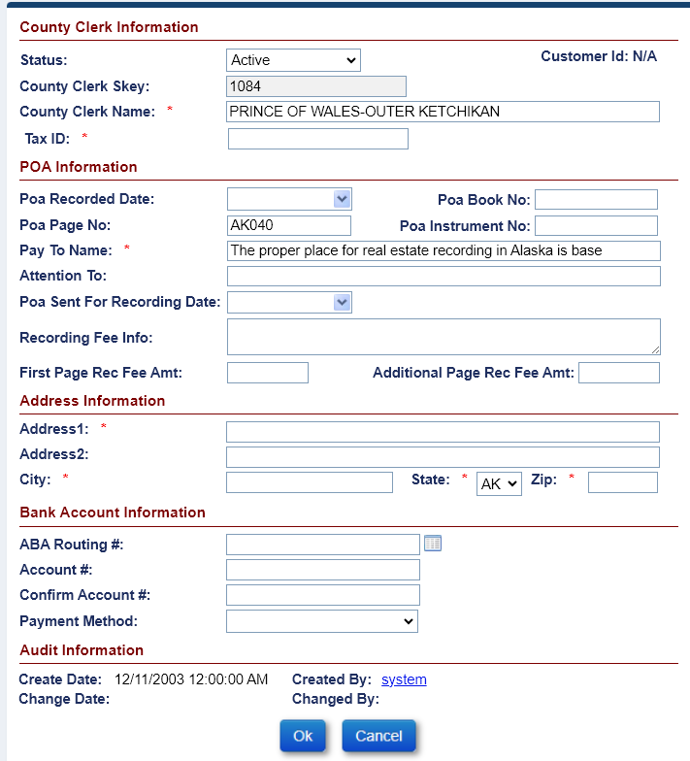
Figure 10-9: Editing a County Clerk
- Modify the information you need to edit and click the OK button. The County Clerk tab record table with the edited record will be displayed in the table.

Editable Timeline Steps
This screen enables authorized users to view which Timeline Steps allow the Step Completion Date to be edited after the date has previously been populated. Clicking on the Servicing Type expands a 2nd column that displays the individual timeline steps that are editable for the selected timeline.

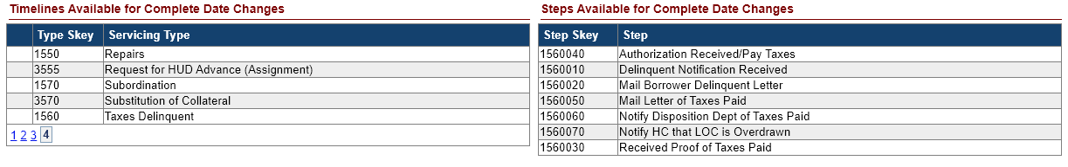

Helpful Links Screen
This screen enables authorized users to add new links, or to edit or inactivate an existing link related to HUD and its reverse mortgage program. The links with active status and expiration date greater than the current system date are displayed on the Home page under the Helpful Links section. You cannot delete a link. A link that should no longer be used should be changed to Inactive.
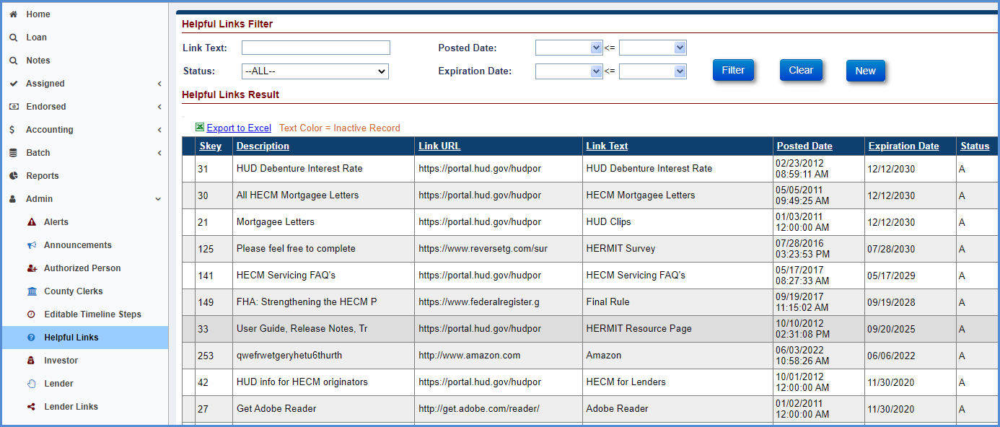
Figure 10-10: Helpful Links Screen

Filtering Helpful Links
You can filter Helpful Links by:
- Link Text
- Posted Date
- Status
- Expiration Date

Sorting Helpful Links
You can sort Helpful Links by:
- Skey
- Description
- Link URL
- Link Text
- Posted Date
- Expiration Date
- Status
- Created By
- Create Date
- Changed By
- Change Date

Creating Helpful Links
- Click New. The Helpful Links screen is displayed so the user can create a link.
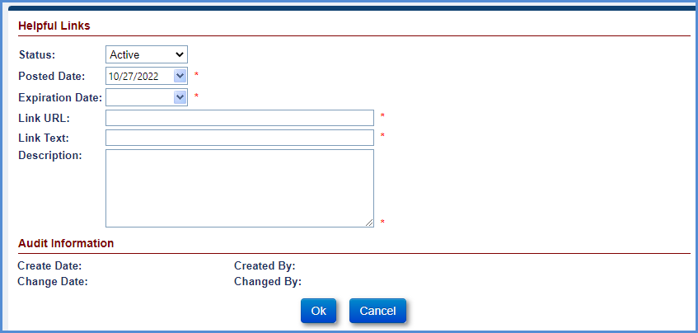
Figure 10-11: Creating a Helpful Link
- Enter the following information:
  - Status
  - Posted Date
  - Expiration Date
  - Link URL (required)
  - Link Text (required)
  - Description
- Click OK.

Editing a Helpful Link
You can edit all fields except for audit information.
- Click on a record in the table and the Helpful Link screen will be displayed.
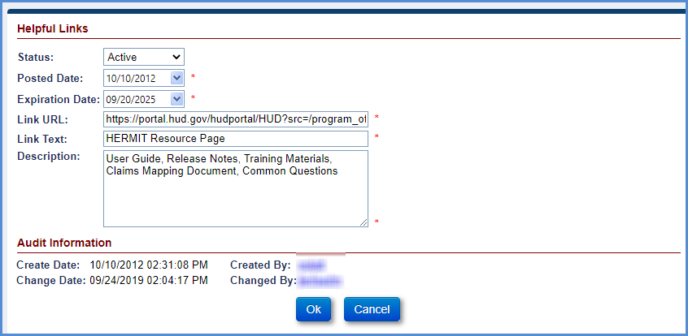
Figure 10-12: Editing a Helpful Link
- Modify the information you need to edit and click the OK button. The Helpful Link tab record table with the edited record will be displayed in the table.

Investor Screen
This screen allows the authorized user to add a new Investor, edit or inactivate an Investor. You cannot delete an investor. An investor that should no longer be used should be changed to Inactive.
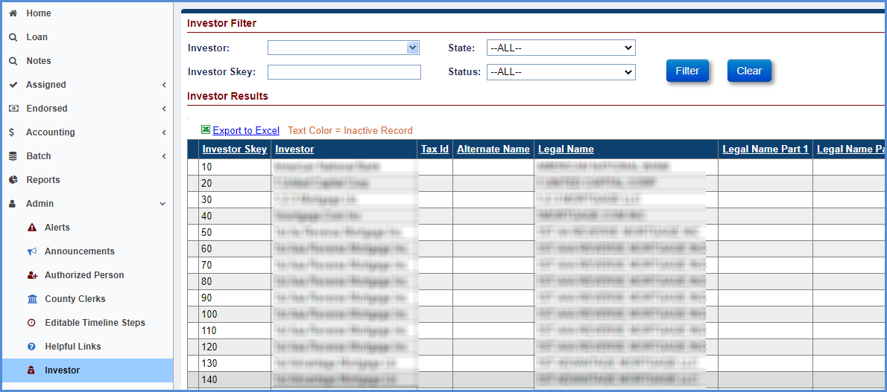
Figure 10-13: Investor Screen

Filtering Investors
You can sort investors by:
- Name (Investor)
- State
- Mortgagee #
- Status

Sorting Investors
You can sort Investors by:
- Investor Skey
- Investor Tax ID
- Alternate Name
- Legal Name
- Legal Name Part 1
- Legal Name Part 2
- Address1
- Address2
- City
- State
- Zip
- Main Phone #
- Alt Phone #
- Fax #
- Email
- Website URL

Editing an Investor
You can edit all fields except Investor Skey, Customer ID and audit information.
- Click on a record in the table and the Investor screen will be displayed.
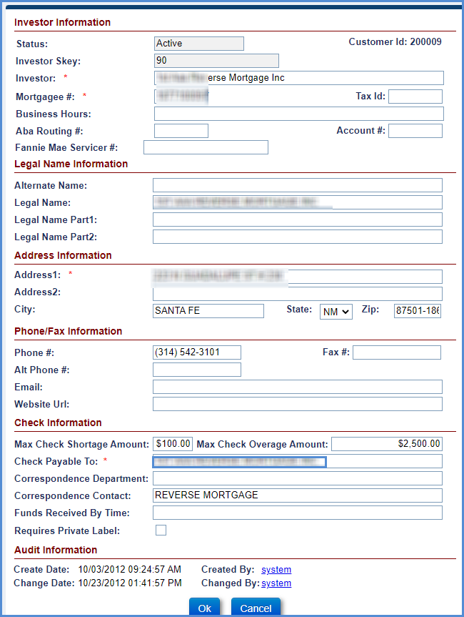
Figure 10-14: Editing an Investor
- Modify the information you need to edit and click the OK button. The Investor tab record table with the edited record will be displayed in the table.

Lender Screen
This screen enables authorized users to add a lender, or to edit or inactivate a Lender. You cannot delete a lender. A lender that should no longer be used should be changed to Inactive.
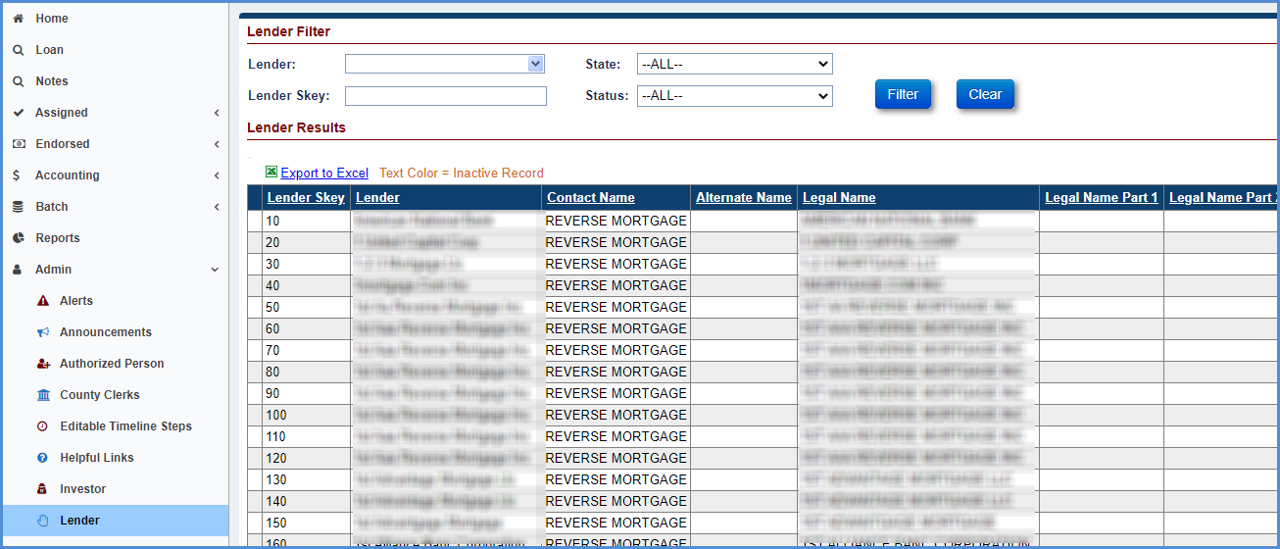
Figure 10-15: Lenders Screen

Filtering Lenders
You can filter lenders by:
- Lender
- State
- Mortgagee #
- Status

Sorting Lenders
You can sort lenders by:
- Lender Skey
- Lender Contact Name
- Alternate Name
- Legal Name
- Legal Name Part 1
- Legal Name Part 2
- Address1
- Address2
- City
- State Zip
- Main Phone #
- Alt Phone #
- Hearing Impaired #
- Fax #
- Email
- Website URL
- Check Payable To
- Correspondence Dept
- Correspondence Contact
- Funds Received By
- Time Status
- ABA Routing #
- Account #
- Mortgagee #
- Business Hours
- Create Date
- Created By
- Change Date
- Changed By

Editing a Lender
You can edit all fields except Lender Skey and audit information.
- Click on a record in the table and the Lender screen will be displayed.
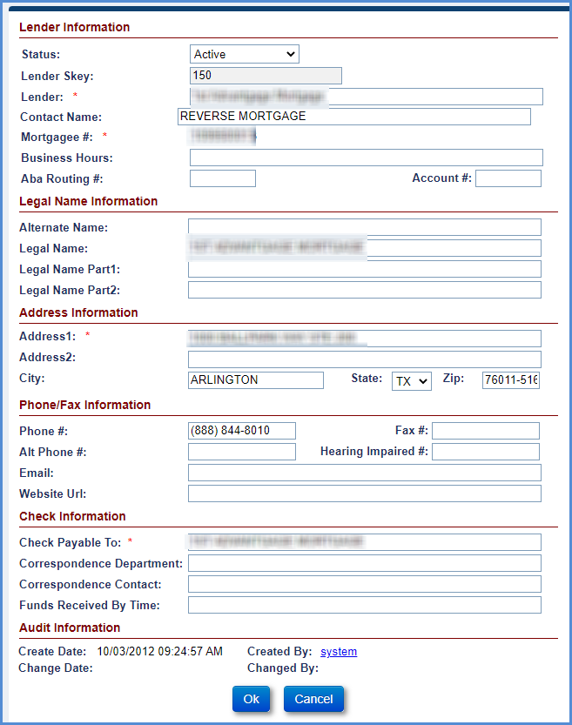
Figure 10-16: Editing a Lender
- Modify the information you need to edit and click the OK button. The Lender tab record table with the edited record will be displayed in the table.

Master Servicer Links
This screen shows links between Servicers and Master Servicer. When you click on a Master Servicer record on the left side, right side of the screens shows list of servicers that are linked to Master Servicer.
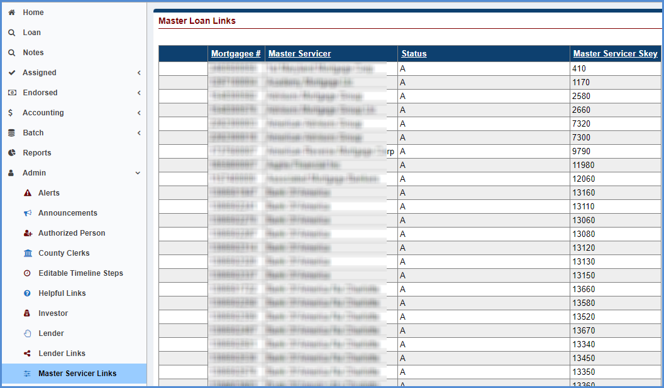
Figure 10-17: Master Loan Links

Servicer Screen
This screen enables authorized users to add Servicers or edit or inactivate a Servicer. This screen also allows authorized user to set “No Pay” on the Servicer. Refer to Claims “No Pay” section for details. You cannot delete a servicer. A servicer that should no longer be used should be changed to Inactive.
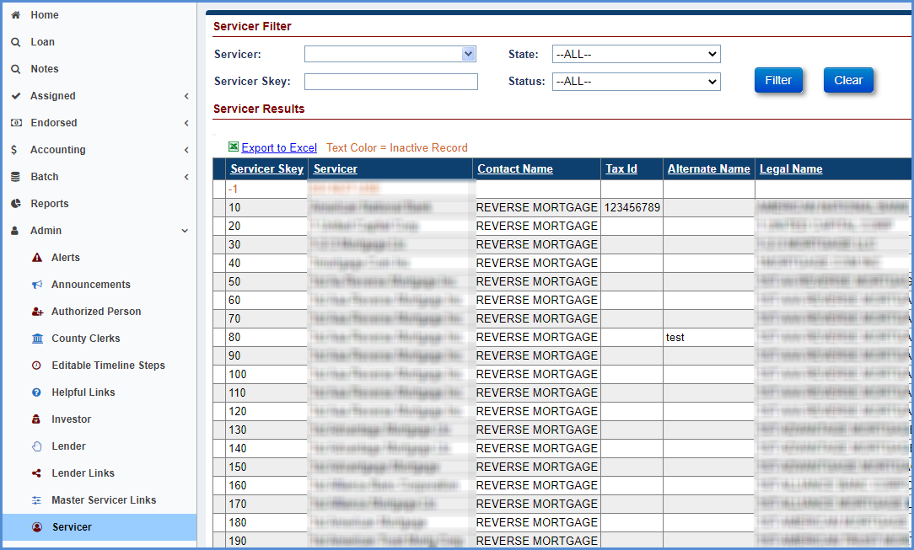
Figure 10-18: Servicer Screen

Filtering Servicers
Servicers can be filtered on one or more of following criteria:
- Name
- Mortgagee Number
- State
- Status

Sorting Servicers
Servicers can be sorted by:
- Servicer Skey
- Servicer Contact Name
- Tax ID
- Alternate Name
- Legal Name
- Legal Name Part 1
- Legal Name Part 2
- Address1
- Legal Name Part 2
- Address1
- Address2
- City
- State
- Zip
- Main Phone #
- Alt Phone #
- Hearing Impaired #
- Fax #
- Email
- Website URL
- Check Payable To
- Correspondence Dept
- Correspondence Contact
- Funds Received By Time
- Status
- ABA Routing #
- Account #
- Mortgagee #
- Business Hours
- Customer ID
- Create Date
- Created By
- Change Date
- Changed By

Editing a Servicer
All fields can be edited except customer ID, servicer skey, and audit information. Only authorized users with the permission to edit No Pay and Display Disbursements Page can edit the checkboxes.
- Click on a record in the table and the Servicer screen will be displayed.
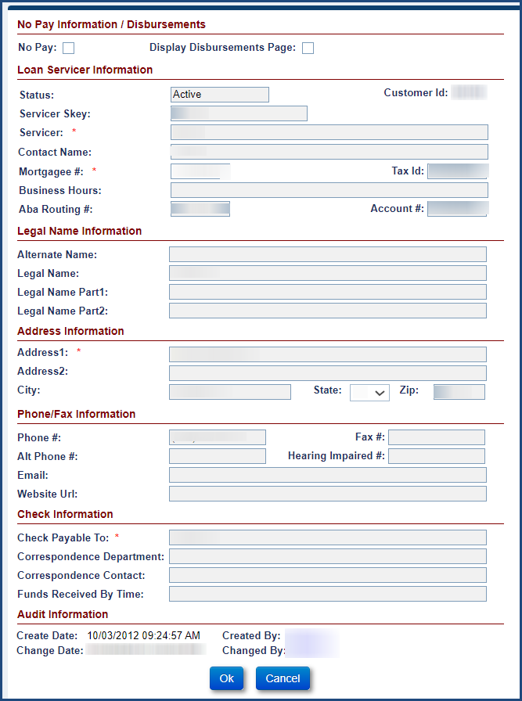
Figure 10-19: Editing a Servicer
- Modify the information you need to edit and click the OK button. The Servicer tab record table with the edited record will be displayed in the table.

Master Servicer
This screen displays all Master Servicers in the system. This screen can be used to change an Active Master Servicer to Inactive.
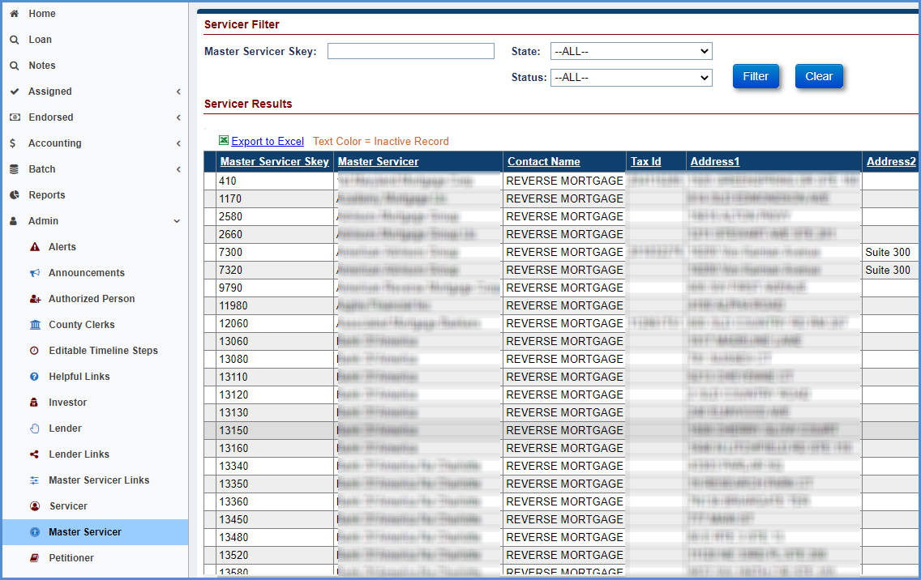
Figure 10-20: Master Servicers

Filtering Master Servicers
Master Servicers can be filtered on one or more of following criteria:
- Master Servicer Skey
- State
- Status

Sorting Master Servicers
Master Servicers can be sorted by:
- Master Servicer Skey
- Master Servicer
- Contact Name
- Tax ID
- Address1
- Address2
- City
- State
- Zip
- Main Phone #
- Alt Phone #
- Email
- Website URL
- Status
- Mortgagee #
- Alternate Name
- Legal Name
- Legal Name Part 1
- Legal Name Part 2
- Address1
- Legal Name Part 2
- Address1
- Address2
- City
- State
- Zip
- Main Phone #
- Create Date
- Created By
- Change Date
- Changed By

Editing a Master Servicer
All fields can be edited except customer ID, Master Servicer Skey, Mortgagee # and audit information.

- Click on a record in the table and the Master Servicer screen will be displayed.
- Modify the information you need to edit and click the OK button. The Master Servicer tab record table with the edited record will be displayed in the table.
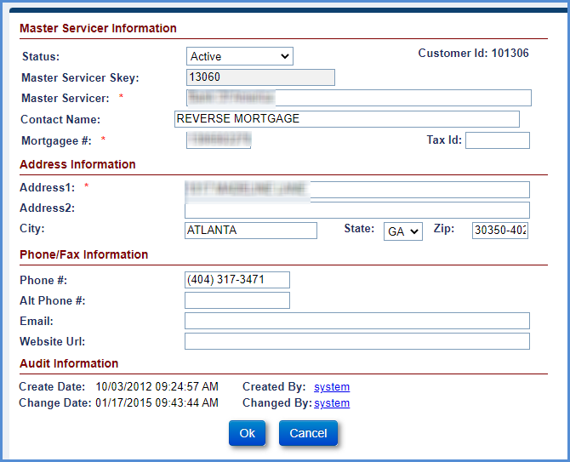
Figure 10-21: Editing a Master Servicer

Petitioner Screen
Petitioners are legal entities such as the Department of Justice. This screen enables authorized users to add a petitioner, or to edit or inactivate a petitioner. You cannot delete a petitioner. A petitioner that should no longer be used should be changed to Inactive.
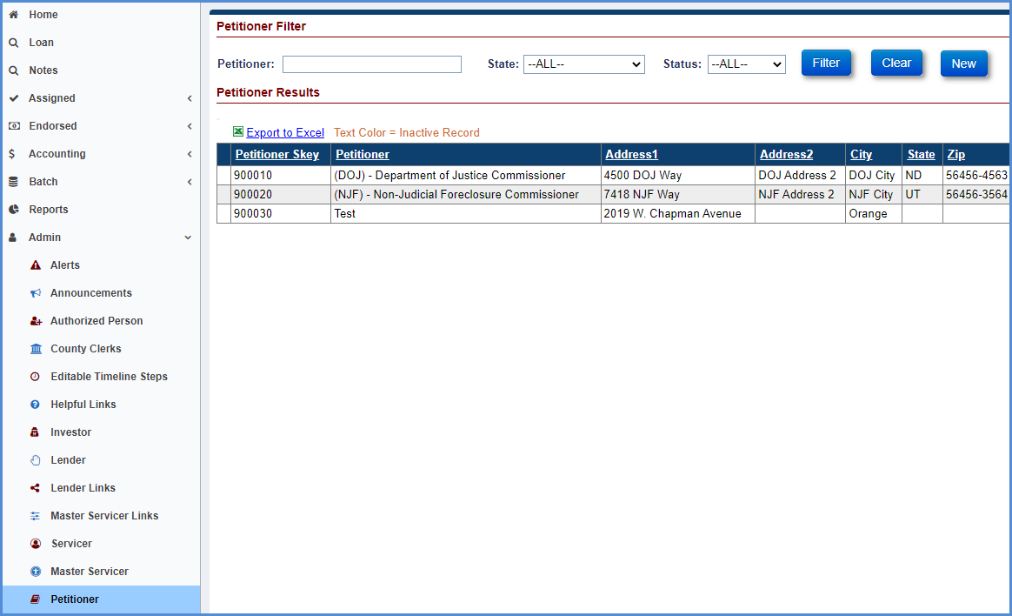
Figure 10-22: Petitioners Screen

Filtering Petitioners
Petitioners can be filtered by one or more of three criteria:
- Name
- State
- Status

Sorting Petitioners
Petitioners can be sorted by:
- Status
- Petitioner
- Address1
- Address2
- City
- State
- Zip
- Phone #
- Fax #
- Create Date
- Created By
- Change Date
- Changed By
- User Information

Creating a Petitioner
To create a petitioner:
- Click New. The Petitioner screen will display so the user can add a new petitioner.
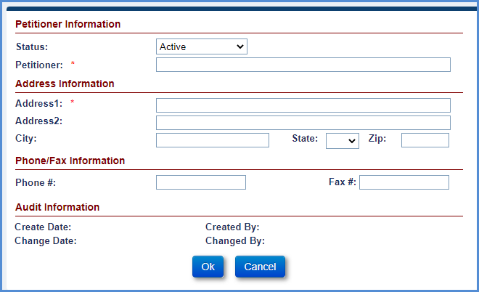
Figure 10-23: Creating a Petitioner
- Enter the following information:
  - Status
  - Petitioner (required)
  - Address1(required)
  - Address2
  - City
  - State
  - Zip
  - Phone #
  - Fax #
- Click OK.

Editing a Petitioner
All fields except audit information and Petitioner Skey can be edited.
- Click on a record in the table and the Petitioner screen will be displayed.
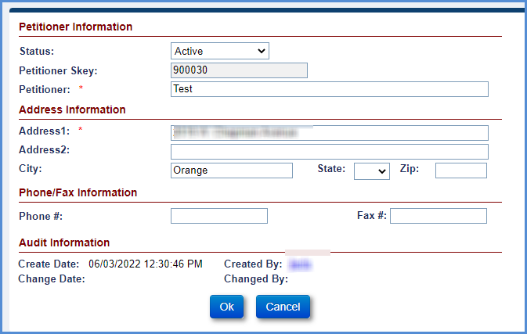
Figure 10-24: Editing a Petitioner
- Modify the information you need to edit and click the OK button. The Petitioner tab record table with the edited record will be displayed in the table.

Tax Authority Screen
Tax Authorities are entities that are in line to collect taxes related to the property. This screen enables authorized users to add a tax authority, or to edit or inactivate a tax authority. You cannot delete a tax authority. A tax authority that should no longer be used should be changed to Inactive. Users can add Tax Authorities with the same name to HERMIT if the State is different.
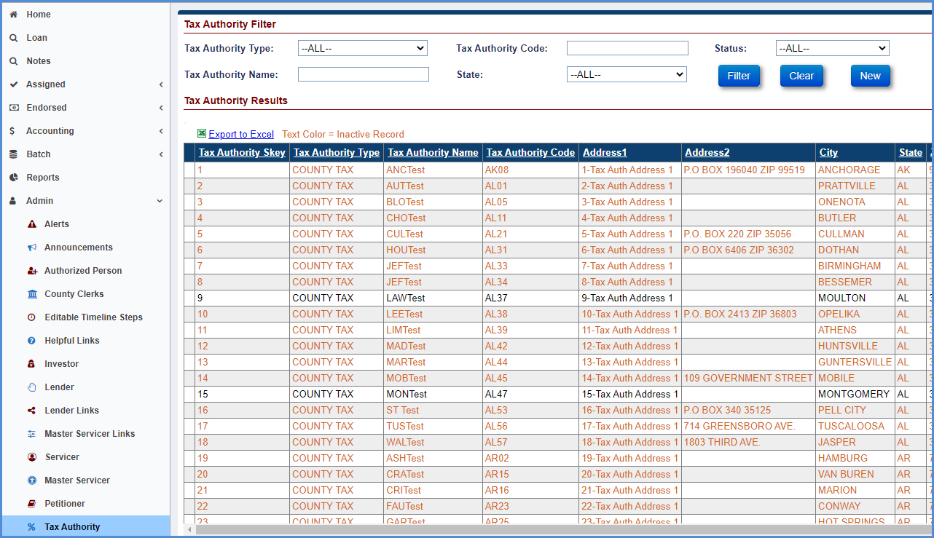
Figure 10-25: Tax Authority Screen

Filtering Tax Authorities
Tax Authorities can be filtered by one or more of five criteria:
- Tax Authority Type
- Tax Authority Name
- Tax Authority Code
- State
- Status

Sorting Tax Authorities
Tax authorities can be sorted by:
- Tax Authority Skey
- Tax Authority Number
- Tax Authority Type
- Tax Authority Name
- Tax Authority Code
- Address1
- Address2
- City
- State
- Zip
- Phone #
- Fax #
- Status
- Created By
- Create Date
- Maint By
- Maint Date
- AuthPayee
- County
- Tax ID

Creating a Tax Authority
- Click New. The Tax Authority screen will display so the user can add a new Tax Authority.

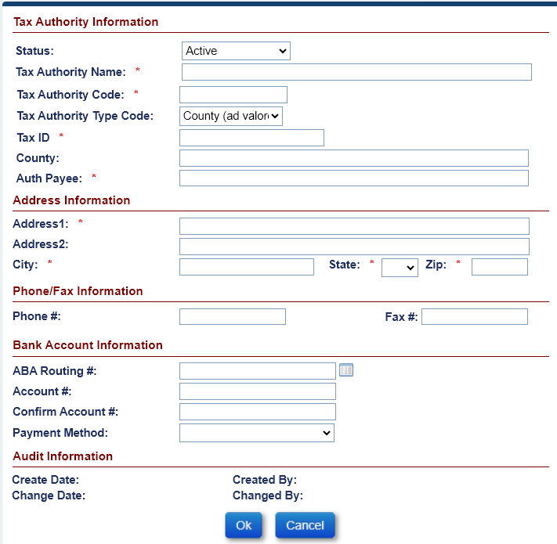
Figure 10-26: Creating a Tax Authority
- Enter the following information:
  - Status
  - Tax Authority Name(required)
  - Tax Authority Code (required)
  - Tax Authority Type Code
  - Tax ID (required)
  - County
  - Auth Payee (required)
  - Address1 (required)
  - Address2
  - City (required)
  - State (required)
  - Zip (required)
  - Phone
  - Fax #
  - Bank Account Information
- Click OK.

Editing a Tax Authority
All fields except for audit information and Tax Authority Skey can be edited.
- Click on a record in the table and the Tax Authority screen will be displayed.

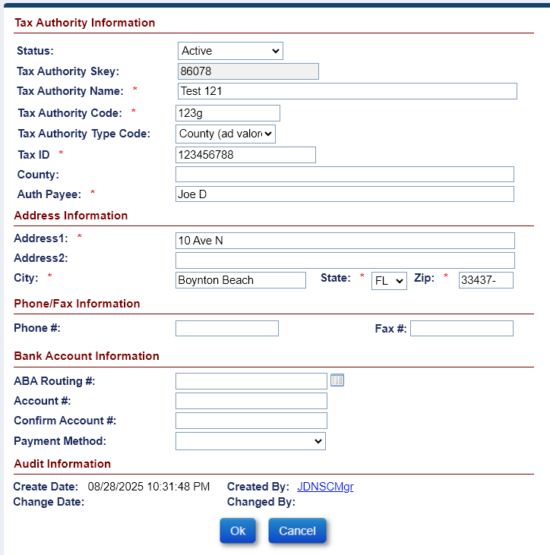
Figure 10-27: Editing a Tax Authority
- Modify the information you need to edit and click the OK button. The Tax Authority tab record table with the edited record will be displayed in the table.

Vendors Screen
This screen allows the authorized user to add new Vendors, edit or inactivate a Vendor. Vendors can be any contractors that provide a service on the mortgaged property (property management companies, appraisers, etc.). You cannot delete a vendor. A vendor that should no longer be used should be changed to Inactive.

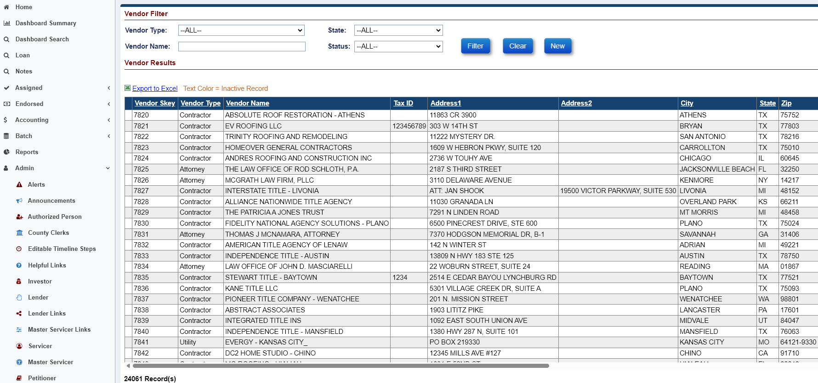
Figure 10-28: Vendors Screen

Filtering Vendors
Vendors can be filtered on one or more of four criteria:
- Vendor Type
- Vendor Name
- State
- Status

Sorting Vendors
Vendors can be sorted by:
- Vendor Skey
- Vendor Type

- Vendor Name

- Tax ID
- Address1
- Address2
- City
- State
- Zip
- Phone #
- Fax #
- Contact Name
- Department
- Email
- License #
- License State
- Status
- Created By
- Create Date
- Maint By
- Mait Date
- Customer ID

Creating a Vendor
To create a vendor:
- Click New. The Vendor screen will display so the user can add a new Vendor.

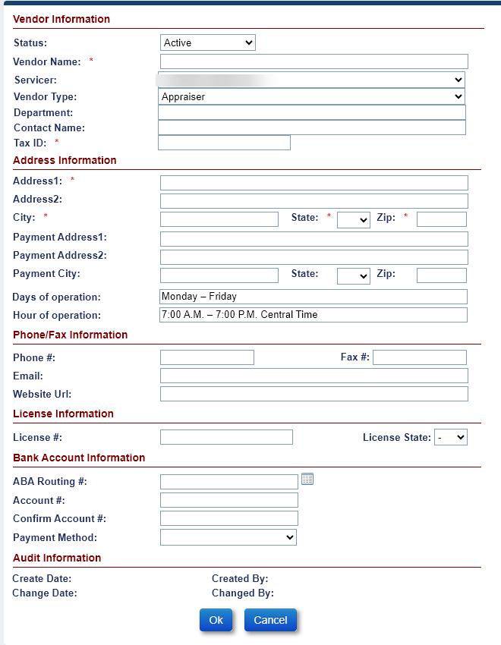
Figure 10-29: Creating a Vendor
- Enter the following:
  - Status
  - Vendor Name (required)
  - Servicer
  - Vendor Type
  - Department
  - Contact Name
  - Tax ID (required)
  - Address1 (required)
  - Address2
  - City (required)
  - State (required)
  - Zip (required)
  - Payment Address1
  - Payment Address2
  - Payment City
  - State
  - Zip
  - Days of operation
  - Hour of operation
  - Phone #
  - Fax #
  - Email
  - Website URL
  - License #
  - License State
  - Bank Account Information
- Click OK.

Editing a Vendor
All fields except for audit information and Customer ID can be edited.
- Click on a record in the table and the edit alerts screen will be displayed.

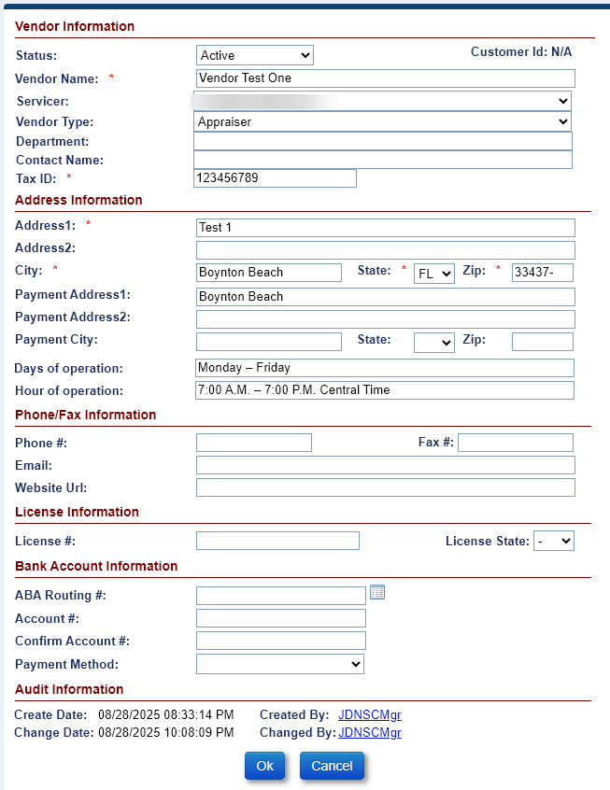
Figure 10-30: Editing an Existing Vendor
- Modify the information you need to edit and click the OK button. The Vendor tab record table with the edited record will be displayed in the table.

Claims Auto Delegation Screen
This screen allows the authorized HUD user to set the order that claims filed by the servicer are delegated to eligible Responsible Parties. When the claim is initially filed by the servicer, the system delegates the claim in order of the Responsible Party designation from the Claims Auto Delegation Screen. Different Responsible Party user list can be defined for each Claim Type 21, Claim Type 23, and Claim Type 24. The auto delegation rules can be inactivated for specific users or Claim Types.

Claims Auto Delegation – Setting Responsible Party delegation

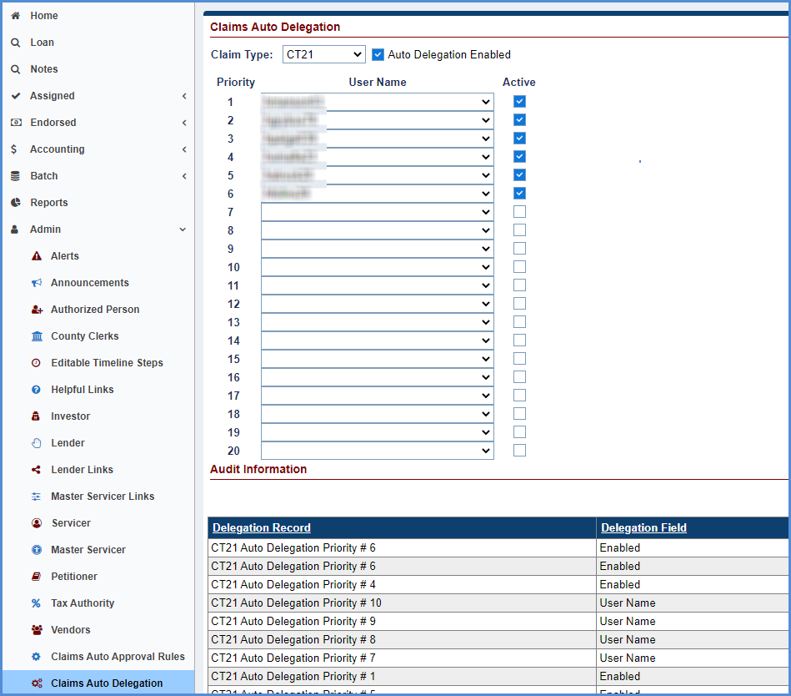
Figure 10-31: Editing Claims Auto Delegation

Claims Auto Delegation - Audit Information
The Audit Information displays changes made to the Claims Auto Delegation settings
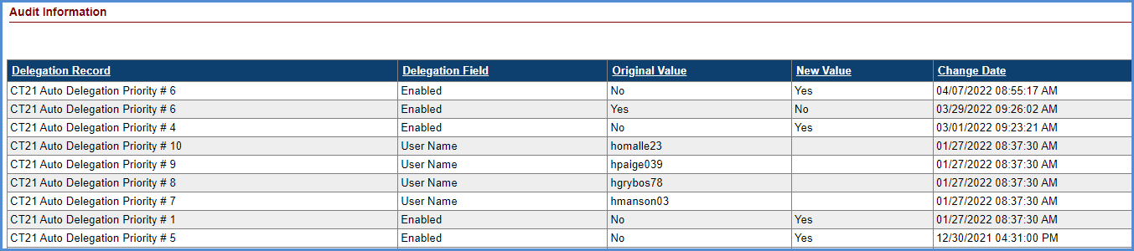
Figure 10-32: Editing Claims Auto Delegation Priority

Bulk Vendor Upload Screen
The Bulk Vendor Upload Screen allows the Authorized user to add multiple vendors to the Servicing Module at the same time. For complete instructions please refer to the HERMIT resources document named “HERMIT Bulk Vendor Upload File Format.”

Creating Bulk Vendors
To create vendors using the Bulk process:
- Click Vendor Link.
- Click Open on the Vendor Import Upload File to add multiple Vendors on the Vendor Template.
- Enter the following data into the Vendor Template:
  - Vendor Name (required)
  - Servicer (required)
  - Vendor Type (required)
  - Department
  - Contact Name
  - Tax ID (required)
  - Address1 (required)
  - Address2
  - City (required)
  - State (required)
  - Zip (required)
  - Phone #
  - Fax #
  - Email
  - Website URL
  - License #
  - License State
  - Bank Account Information (Conditionally Required)

Step 3: Save File as .txt (Tab Delimited)

Step 4: Click Choose File. On the popup window select the File and click open.

Step 5: Click Upload

APPENDICES

APPENDIX A: ACRONYMS

APPENDIX A: ACRONYMS

Acronym | Description
AAR | Applicant Access Request.
ABA | American Bankers Association.
ACH | Automated Clearing House.
ADJ | Adjustment.
ADP | Automatic Data Processing.
ARM | Adjustable Rate Mortgage.
B2G | Business To Government.
BPS | Basis Points.
BSP | Business Service Provider.
CHUMS | Computerized Homes Underwriting Management System.
CMB | Cash Management Branch.
CMMI | Capability Maturity Model Integration.
CMT | Constant Maturity Treasury.
COI | Certificate of Indebtedness.
COP | Change of Plan.
COTS | Commercial-Off-The-Shelf.
CT | Claim Type.
CWCOT | Claims Without Conveyance of Title.
DEO | Data Entry Operator.
DIL | Deed-in-Lieu.
DMF | Death Master File.
DOB | Date of Birth.
DOJ | Department of Justice.
DOT | Deed of Trust.
FCL | Foreclosure.
FHA | Federal Housing Administration.
FHASL | Federal Housing Administration Subsidiary Ledger.
FOCS | Financial Operations and Control Section
FTP | File Transfer Protocol.
GL | General Ledger.
GLD | General Ledger Division.
GTM | Government Technical Monitor.
HECM | Home Equity Conversion Mortgage.
HECM SP | Home Equity Conversion Mortgage Service Provider.
HERMIT | Home Equity Reverse Mortgage Information Technology.
HITS | HUD Information Technology Service.
HOA | Homeowner’s Association.
HOCs | Homeownership Centers.
HUD | U.S. Department of Housing and Urban Development.
IACS | Insurance Accounting Collection System.
IMIP | Initial Mortgage Insurance Premium.
LIBOR | London Interbank Offered Rate.
LOC | Line of Credit.
LTV | Loan To Value.
MCA | Maximum Claim Amount.
M&M contractor | Management and Marketing.
MIC | Mortgage Insurance Certificate.
MIP | Mortgage Insurance Premium.
MMI | Mutual Mortgage Insurance.
MMIP | Monthly Mortgage Insurance Premium.
MTH-SF | Monthly Service Fee.
NACHA | National Automated Clearinghouse Association.
NJF | Non Judicial Foreclosure.
NPL | Net Principal Limit.
NSC | National Servicing Center.
NSF | Non-Sufficient Funds.
OMB | Office of Management and Budget.
PC | Personal Computer.
PCC-OTC | Paper Check Conversion Over The Counter.
P&P | Property and Preservation.
PDF | Portable Document Format.
PMI | Private Mortgage Insurance.
POA | Power of Attorney.
REO | Real Estate Owned.
RFS | Reporting and Feedback System.
SAMS | Single Family Acquired Asset Management System.
SF | Single Family.
SFHEDW | Single Family Housing Enterprise Data Warehouse.
SFTP | Secure File Transfer Protocol.
SMART | Single Family Mortgage Asset Recovery Technology.
SOA | Section of the Act.
SOFR | Secured Overnight Financing Rate
SP | Service Provider.
SPS | Secure Payment System.
SSA | Social Security Administration
SSN | Social Security Number.
T & I | Tax and Insurance.
UPB | Unpaid Principal Balance.
URL | Uniform Resource Locator.

APPENDIX B: SM MENU MAP

APPENDIX B: SM MENU MAP

APPENDIX C: HERMIT User Guide Version 2.8 Updates (Release 4.1)

APPENDIX C: HERMIT USER GUIDE VERSION 2.8 UPDATES (Release 4.1)
Item No. | Description
 | Updated Fig-2-13 –The Life Expectancy Set Aside (LESA) fields are now displayed in the Loan Balance Screen
 | Updated Fig-2-14 –The Life Expectancy Set Aside (LESA) fields are now displayed in the Loan Balance Screen
 | Updated Fig-4-2 - The Life Expectancy Set Aside (LESA) fields are now displayed in the Loan Set Up Screen
 | Updated Section 4.2.2.8 to add Life Expectancy Set Aside
 | Added New Section 4.2.2.9 to list the details of data fields within Life Expectancy Set Aside (LESA)
 | Updated Section 5.5.1.5 to include Disb-Life Expectancy Set Aside
 | Updated table 5-5 Disbursement Transactions to include Disb-Life Expectancy Set Aside
 | Added New Section 5.5.1.10.3 Repayment of Life Expectancy Set Aside (LESA)-(ENDORSED)
 | Added Fig 5-24 -Repays LESA Transaction window
 | Added Table 5-9 LESA Repay Transaction
 | Added New Section 5.5.4 Viewing Life Expectancy Set Aside Growth Transaction
 | Added Fig-5-34 Viewing LESA Growth Transaction
 | Updated Fig-5.40 Deactivate a Non Borrowing Spouse to display the field "Eligible" renamed as "Eligible NBS"
 | Updated 5.6.6 Added the word Eligible preceding NBS
 | Added New Section 5.6.7 Adding a Non Borrowing Spouse
 | Added New Section 5.6.8 Editing a Non Borrowing Spouse Contact
 | Updated Fig 5-66 -View Monthly Statement Screen to display the LESA fields added to the Monthly Statement Details
 | Added New Section 6.3.3 Activating or Suspending Life Expectancy Set Aside (LESA) Payments
 | Added Fig-6-10 LESA Payment Plan Information Section
 | Added Fig-6-11 Edit LESA Payment Plan Window
 | Added New Section 6.5.1.7 Life Expectancy Set Aside (LESA) Repays -(ASSIGNED)
 | Added Fig-6-25 Repays LESA Transaction Window
 | Added Table 6-5 LESA Repays Transaction
 | Updated Fig-6.41 Deactivate a Non Borrowing Spouse to display the field "Eligible" renamed as "Eligible NBS"
 | Updated 6.6.6 Added the word Eligible preceding NBS
 | Added new Section 6.6.7 Adding a Non Borrowing Spouse Contact
 | Added new Section 6.6.8 Editing a Non Borrowing Spouse Contact
 | Updated Fig 6-77 View Monthly Statement Screen to display the LESA fields added to the Monthly Statement Details
 | Added New Section 6.15.8 Performing a Life Expectancy Set Aside Disbursement
 | Added New Section 6.19.2.5 Reprint Void Check
 | Added Fig 6-101 Reprint Check(s) Message
 | Added Fig 6-102 Printer Paper Message
 | Updated Fig 7-36 Timelines Steps-Endorsed Due and Payable w/o HUD Approval to display the sequence of timeline steps.
 | Updated Fig 7-40 Edit Servicing Management-Endorsed Due and Payable w/o HUD Approval to display the new sequence of timeline steps.
 | Updated Fig 7-41 Timeline Steps-Endorsed Due and Payable w/o HUD Approval to display the sequence of timeline steps.
 | Updated Section 7.2.2.5 Loss Mitigation Pre Foreclosure Step 8 and Step 10 to include renamed step "Servicer Prepares Foreclosure Document
 | Updated Fig-7-58 Timeline Steps-Endorsed Pre-Foreclosure to display the sequence of timeline steps
 | Updated Fig-7-59 Edit-Step to Endorsed Pre-Foreclosure to display the step “Servicer Prepares Fcl Checklist/HUD Form renamed as "Servicer Prepares Foreclosure Documents"
 | Updated Fig 7-65 Edit Servicing Management -Endorsed Foreclosure to display renamed step "Sale/Refer to REO to "Foreclosure Sale Date" and display the new sequence of timeline steps.
 | Updated Fig-66 Timeline Steps-Endorsed Foreclosure to display renamed step "Sale/Refer to REO to "Foreclosure Sale Date" and display the new sequence of timeline steps.
 | Updated Fig 7-87 Edit Servicing Management Screen- Endorsed Due and Payable w/HUD Approval to display the new sequence of timeline steps.
 | Updated Fig-7-88 Timeline Steps -Endorsed Due and Payable w/HUD Approval to display the new sequence of timeline steps.
 | Updated Fig- 7-92 Edit Servicing Management Screen -Endorsed Claim Filing -Steps were arranged as per calendar days
 | Updated Fig- 7-93 Timeline Steps -Endorsed Claim Filing -Steps were arranged as per calendar days
 | Added New Section 7.3.1.14 Extension-Late Notification of Death
 | Added Fig-7-146 Setup Search-Endorsed-Late Notification of Death
 | Added Fig-7-147 Edit Servicing Management Screen-Endorsed Late Notification of Death
 | Added Fig-7-148 Timeline Steps-Endorsed Late Notification of Death
 | Added Fig-7-149 Edit Step Window-Endorsed Late Notification of Death
 | Added Fig-7-150 Edit Step- Endorsed Late Notification of Death
 | Added Fig-7-151 New Step-Endorsed Late Notification of Death
 | Added New Section 7.3.1.15 Extension-Hardest Hit Fund
 | Added Fig-7-152 Setup Search-Endorsed-Hardest Hit Fund
 | Added Fig-7-153 Edit Servicing Management Screen-Endorsed Hardest Hit Fund
 | Added Fig-7-154 Timeline Steps-Endorsed Hardest Hit Fund
 | Added Fig-7-155 Edit Step Window-Endorsed Hardest Hit Fund
 | Added Fig-7-156 Edit Step- Endorsed Hardest Hit Fund
 | Added Fig-7-157 New Step-Endorsed Hardest Hit Fund
 | Added New Section 7.3.1.16 Extension-Property Charge Loss Mitigation
 | Added Fig-7-158 Setup Search-Endorsed-Property Charge Loss Mitigation
 | Added Fig-7-159 Edit Servicing Management Screen-Endorsed Property Charge Loss Mitigation
 | Added Fig-7-160 Timeline Steps-Endorsed Property Charge Loss Mitigation
 | Added Fig-7-161 Edit Step Window-Endorsed Property Charge Loss Mitigation
 | Added Fig-7-162 Edit Step- Endorsed Property Charge Loss Mitigation
 | Added Fig-7-163 New Step-Endorsed Property Charge Loss Mitigation
 | Added New Section 7.3.1.17 Extension-Appraisal
 | Added Fig-7-164 Setup Search-Endorsed-Appraisal
 | Added Fig-7-165 Edit Servicing Management Screen-Endorsed Appraisal
 | Added Fig-7-166 Timeline Steps-Endorsed Appraisal
 | Added Fig-7-167 Edit Step Window-Endorsed Appraisal
 | Added Fig-7-168 Edit Step- Endorsed Appraisal
 | Added Fig-7-169 New Step-Endorsed Appraisal
 | Added New Section 7.3.1.18 Extension-Other
 | Added Fig-7-170 Setup Search-Endorsed-Other
 | Added Fig-7-171 Edit Servicing Management Screen-Endorsed Other
 | Added Fig-7-172 Timeline Steps-Endorsed Other
 | Added Fig-7-173 Edit Step Window-Endorsed Other
 | Added Fig-7-174 Edit Step- Endorsed Other
 | Added Fig-7-175 New Step-Endorsed Other
 | Added a Note to section 8.3.7.2
 | Added additional steps for Assignment Denied- No Funds Due HUD Section 8.3.7.2

APPENDIX D: HERMIT User Guide Version 2.9 Updates (Release 4.2)

APPENDIX D: HERMIT User Guide Version 2.9 Updates (Release 4.2)
Item No. | Description
 | Added Pay Plan Type to Table 2-2 - Loan Search Criteria
 | Added Repayment Plan to Table 2-4 - Description of the SM Side Menu Bar
 | Updated Fig-2-13 –The Loan Balance Screen - Example of the Top Menu Bar
 | Updated Fig-2-14 –The Loan Balance Screen - Example of the Side Menu Bar
 | Update Section 3.3 to include user roles for Repayment Plan
 | Update Section 3.7 to include user roles for Repayment Plan
 | Update Section 3.8 to include user roles for Repayment Plan
 | Updated Table 4-2 Credit Type Mandatory - Data Fields - Rates Information Section
 | Updated Fig 4-2 - Loan Setup Screen to display Credit Type field as mandatory
 | Added Lump Sum to Pay Plan Type Section 4.2.2.6
 | Removed Note from Pay Plan Type Section 4.2.2.6
 | Added New Balance Adjustment Section 5.5.1.14
 | Added Fig 5.29 –Adjust Loan Balance Window
 | Added Fig 5.30 –Loan Balance Adjustment Transaction
 | Updated Section 5.12 – Change of Plan with pay
 | Added New Section 5.20 Repayment Plan
 | Added Sub-Section 5.20.1 Viewing a Repayment Plan
 | Added Sub-Section 5.20.2 Creating a New Repayment Plan
 | Added Sub-Section 5.20.3 Editing a Repayment Plan
 | Added Fig 5-97 Repayment Plan Screen
 | Added Fig 5-98 View Repayment Plan Screen
 | Added Fig 5-99 New Repayment Plan Window
 | Added Fig 5-100 New Repayment Plan Displayed on Repayment Plans Section
 | Added Fig 5-101 Edit Repayment Plan Window
 | Added a Note that Lump Sum Pay Plan Type cannot be changed to Section 6.12 – Change Of Plan
 | Added a Note that user cannot change from any existing Pay Plan to Lump Sum to Section 6.12 – Change Of Plan
 | Added New Section 6.21 Repayment Plan
 | Added Sub-Section 6.21.1 Viewing a Repayment Plan
 | Added Sub-Section 6.21.2 Creating a New Repayment Plan
 | Added Sub-Section 6.21.3 Editing a Repayment Plan
 | Added Fig 6-112 Repayment Plan Screen
 | Added Fig 6-113 View Repayment Plan Screen
 | Added Fig 6-114 New Repayment Plan Window
 | Added Fig 6-115 New Repayment Plan Displayed on Repayment Plans Section
 | Added Fig 6-116 Edit Repayment Plan Window
 | Added Note to Section 8.3 - Initiating and Submitting Claim Type 22 to mention about Corp Advance and Pre D&P transaction.
 | Updated Fig 8-7 - Claims Worksheet for CT21
 | Updated Fig 8-28 - Claims Worksheet for CT23
 | Updated Section 9.7 to include Repayment Plan Report
 | Added New Section 9.7.4 for Repayment Plan Report
 | Added Fig 9.35 Repayment Plan Report

APPENDIX E: HERMIT User Guide Version 2.10 Updates (Release 4.3)

APPENDIX E: HERMIT User Guide Version 2.10 Updates (Release 4.3)
Item No. | Description
 | Updated Fig 2-16 on Resetting Password
 | Updated the text below the Fig 2-16
 | Added Step 3 in Section 5.5.1.11 on Termination
 | Added Fig 10-32: Error message on Terminating the loan in Section 5.5.1.11.
 | Added Fig 10-33: Error message on Terminating the loan in Section 5.5.1.11
 | Added Section Servicer Activities 7.3.1.11.3 for HUD Advance Servicer Activities
 | Updated Repayment Claim Payment processing Steps in Section 7.4.7.2
 | Added Fig 7-288 Approve / Cancel Repurchase
 | Added Step 4 in Section 8.2 Initiating and Submitting Claim Type 21
 | Added Fig 8-4 Error message when initiating CT 21 in Section 8.2 (below Step 2)
 | Section 8.2 Step 23. Added information on the negative Claim not being approved
 | Added Step 4 in Section 8.4 Initiating and Submitting Claim Type 23
 | Added Fig 8-27 Error message when initiating CT 23 in Section 8.4 (below Step 3)
 | Section 8.4 Step 23. Added information on the negative Claim not being approved
 | Section 8.5 Step 21. Added information on the negative Claim not being approved
 | Updated Fig 9-21 Placed in Custodial Care Report
 | Updated text in 9.6.8 for the User to have ability to Search by HUD NSC Transactions only

APPENDIX F: HERMIT User Guide Version 2.11 Updates (Release 5.0)

APPENDIX F: HERMIT User Guide Version 2.11 Updates (Release 5.0)
Item No. | Description
 | Updated all Figures Containing the Header
 | Updated the SM Help Desk Information in Section 2.1
 | Updated Figure 2-2 to show the new HERMIT login screen

APPENDIX G: HERMIT User Guide Version 2.12 Updates (Release 5.1)

APPENDIX G: HERMIT User Guide Version 2.12 Updates (Release 5.1)
Item No. | Description
 | Updated section 9.1 Reports Overview – changed references of “Premiums” section to read “Lender/Servicer reports”.
 | Updated section 9.2 Accessing Reports – changed screen shots to show the updated “Lender/Servicer Reports” group.
 | Updated section 9.4 Generating Reports screen shot to reflect “Lender/Servicer Reports”.
 | Updated section 9.5 to read “Lender/Servicer Reports”.
 | Added new section 9.8 Servicer Reports, which includes information on the new Claims Detail and Default Key Dates report.
 | Updated Section 9.6.13 Needs Custodial Care report – added references to new fields section of act (SOA), custodial care request date, custodial care placed date, area for custodial property, and recorded date of deed.
 | Updated Section 9.6.14 Placed In Custodial Care report to add missing and new fields – FHA Case Number, Borrower Name, Property Address, Loan Status, Customer Care Request Date, Section of Act (SOA), Fee Status, Area for Custodial Property, and Recorded Date of Deed.
 | Updated Section 7.4.4 Assigned Foreclosure Timeline: updated screenshot in step 4 to reflect updated timeline steps; added new steps (11 and 12) to generate the Occupied Conveyance Letter; added a reference in Step 20 to the lockdown of the Custodial Care Placed Date field.
 | Updated section 1.2.2 General Servicing Activities for Insurance-in-Force Cases and Assigned Loans – add a reference to adding scheduled payments to the paragraph.
 | Updated section 5.1 General Servicing Overview – added a reference to adding scheduled payments to the paragraph.
 | Updated section 5.5.1.2 – added a reference to manually creating scheduled payment transactions to the transaction category table.
 | Updated section 6.15 Assigned Disbursements to include Disb-Scheduled in the transaction categories available. Added a new sub-section 6.15.9 “Manually Adding a Scheduled Payment Disbursement” detailing the process for creating these disbursement transactions.
 | Updated figure 7-241 in section 7.4.2.5 Loss Mitigation – Pre-foreclosure
 | Updated screenshot in section 9.6.20 for HUD Monthly Director Report – HECM Assigned Detail report so it includes the new Loans NOI Issued records.
 | Updated figure 6-13 in section 6.4.1 Edit Loan Details to reflect lockdown of the “Cust Care Place Date:” field.
 | Updated Figure 7-264: Edit Servicing Management – Assigned Foreclosure, and Figure 7-261: Timeline Steps – Assigned Foreclosure to reflect current timeline steps.
 | Updated section 7.4.2.5.3 HUD NSC Contractor Activities – removed references to Occupied Conveyance Letter from Steps 17 and 18.

APPENDIX H: HERMIT User Guide Version 2.13 Updates (Release 5.2)

APPENDIX H: HERMIT User Guide Version 2.13 Updates (Release 5.2)
Item No. | Description
Updated section 5.6 Contacts {XE “Endorsed Contacts Screen”} –
- Added references to the added capability to add property assessment information for HOAs and CONDOs to the loan contacts page.
- Added new section 5.6.9 Adding Assessment Information
- Added new section 5.6.10 Viewing and Editing Assessment Information

 | Updated section 5.7.1 Property Information – added a reference to the new Assessment Type Flag on the Property Details section of the Property Information Page.
Updated section 6.6 Contacts {XE “Assigned Contacts Screen”} –
- Added references to the added capability to add property assessment information for HOAs and CONDOs to the loan contacts page
- Added new section 6.6.9 Adding Assessment Information
- Added new section 6.6.10 Viewing and Editing Assessment Information
 | Updated section 6.7.1 Property Information – added a reference to the new Assessment Type Flag on the Property Details section of the Property Information Page.
Updated section 9.6 Assigned Notes Reports – added Property City, Property State, Property ZIP and Property Count as fields included in the following reports:
- Updated section 9.6.4 Closed Loan Files {XE “Closed Loan Files Report”}
- Updated section 9.6.9 Foreclosure Activity Listing {XE “Foreclosure Activity Listing Report”}
- Updated section 9.6.10 HECM Foreclosure {XE “HECM Foreclosure Report”}
- Updated section 9.6.12 Missing Loan Document Detail {XE “Missing Loan Document Detail Report”}
- Updated section 9.6.13 Needs Custodial Care {XE “Needs Custodial Care Report”}
- Updated section 9.6.14 Placed in Custodial Care {XE “Placed In Custodial Care Report”}
Updated Section 2.4 Navigating HERMIT –
- Updated section 2.4.2 Constructing a Basic Search – updated print screen for Figure 2-4: to include Property City and Property ZIP code search fields.
- Updated section 2.4.1.3 Loan Search Criteria – Table 2-2: Loan Search Criteria. Added Property City and Property ZIP to the table.
- Updated section 2.4.3.2 – Screen shot for Figure 2-5: Building a Search in Step 2 replaced so it includes all currently available search filters.
 | Replaced Figure 2 4: Loan Search Screen
 | 2.4.2.1 Added new search screen fields
 | 2.4.3.1 Added new search screen fields to Loan Search Criteria list (Property City, Property Zip)
 | Replaced Figure 2 5: Building a Search
 | Updated Table 5 10: Terminate Transactions
 | Updated Table 6 4: Terminate Transactions
 | Replaced Figure 7 177: Setup Search – Endorsed 2nd Release
 | Replaced Figure 7 178: Timeline Steps – Endorsed Release 2nd
 | Replaced Figure 7 179: Edit Step – Endorsed Release 2nd
 | Replaced Figure 7 180: New Step – Endorsed Release 2nd
 | Replaced Figure 7 278: Release Search – Assigned Released 1st
 | Replaced Figure 7 279: Timeline Steps – Assigned Release 1st
 | Replaced Figure 7 280: New Step for Release
 | Replaced Figure 7 281: Release Search – Assigned Release 2nd
 | Replaced Figure 7 282: Assigned – Release 2nd Timeline Steps
 | Replaced Figure 7 283: New Step – Assigned Release
 | Updated Table 2 2: Loan Search Criteria
 | Updated section 7.3.2.1 with changes for Release Timelines
 | Updated 117 additional print screens that were indirectly related to search screen updates (the print screen in a table or figure was no longer current). The full list is available upon request/imbedded below:
 | Updated TOC, page numbers, and figure reference numbers.

APPENDIX I: HERMIT User Guide Version 2.14 Updates (Release 5.3)

APPENDIX I: HERMIT User Guide Version 2.14 Updates (Release 5.3)
Item No. | Description
 | Updated Email Address on Figure 2-1: Process for Requesting Access to HERMIT
 | Updated Table 6-4: Terminate Transactions to include Re-Terminations
 | Modified language for Step 18 in section 8.3.1 - Submission of CT 22 Assignment Package – Servicer Activities
 | Added Figure 8-17 - Warning Message to Enter Mortgagee Reference #
 | Replaced Figure 8-18 - Certify Window – Submit Assignment Request Step
 | Updated Figure #’s for Figures 8-19 through 8-70
 | Added Section 9.9.5 – B2G Transaction Exception Report
Update the following Figures:
- 2-3 - The Home Screen
- 4-2 - Loan Setup Screen
- 5-2 - The Loan Balance Screen
- 5-7 - Loan Details Screen
- 5-39 - View Contact Information Screen
- 5-100 - Repayment Plan Screen
- 6-1 - Loan Search Screen – Print Welcome Letters
- 6-17 - Transactions – Loan Screen
- 6-37 - View Contact Information Screen
- 6-44 - Property Information Screen
- 6-68 - Change of Plan Screen
- 6-119 - Repayment Plan Screen
- 9-1 - Reports Tab

APPENDIX J: HERMIT User Guide Version 2.15 Updates (Release 5.4)

APPENDIX J: HERMIT User Guide Version 2.15 Updates (Release 5.4)
Item No. | Description
 | Updated max on Export to Excel from 10,000 to 150,000 in section 2.4.5
 | Updated max on Loan Setup B2G from 1,500 to 10,000 in section 4.3.1
 | Added new transactions: Cash for Keys and Utilities – Liens in section 5.5.1.3
 | Replaced Figure 5-41 "Edit Contact Information Window" in section 5.6.3
 | Clarified language under default reason Death in section 7.2.2.1
 | Replaced Figure 7-36 "Timeline steps - Endorsed Due and Payable w/o HUD Approval" in section 7.2.2
 | Replaced step "Disposition Event occurred" with "Default Event Occurred" on D&P timelines in section 7.2.2
 | Removed instructions to edit create date on D&P w/o HUD approval timeline in section 7.2.2
 | Replaced Figure 7 40: Edit Servicing Management – Endorsed Due and Payable w/o HUD Approval in section 7.2.2
 | Replaced Figure 7 41: Timeline Steps – Endorsed Due and Payable w/o HUD Approval in section 7.2.2
 | Removed "Obtain Appraisal" from D&P timelines in section 7.2.2
 | Added new Default Reasons and whether it is considered "Missed Property Charges" in section 7.3.1.3.1
 | Replaced Figure 7-87: Edit Servicing Management Screen - Endorsed Due and Payable in section 7.3.1.3.1
 | Replaced Figure 7-88: Timeline Steps – Endorsed Due and Payable w/HUD Approval in section 7.3.1.3.1
 | Added new steps Upload Due & Payable Package, Submitted D&P Request to HUD to "D&P w/ HUD Approval" timeline in section 7.3.1.3.3
 | Removed "Mail Notice of Repayment" step in section 7.3.1.3.3
 | Added sections 7.3.1.3.4, 7.3.1.3.5, and 7.3.1.3.6 for Due and Payable w/ HUD Approval timeline for Default Reasons that are categorized as “Missed Property Charges”
 | Additional text added to section 8.8
 | Added Property Assessments Report in section 9.5
 | Added new Figure 9-8 and updated figure numbering in section 9.5.3
 | Added DMF report information in section 9.8.3
 | Added B2G Transaction Exception to the list of HERMIT Support reports in section 9.9
 | Replaced Deed in Lieu and Short Sale timeline Figures 7-44, 7-45, 7-53 and 7-54 in section 7.2.2 Endorsed Disposition Timelines
 | Replaced Deed in Lieu and Short Sale timeline Figures 7-230 and 7-231, 7-240 and 7-241 in section 7.2.4 Assigned Disposition Timelines
 | Added DMF to section 1.2.5 “Data Exchange with External Systems”

APPENDIX K: HERMIT User Guide Version 2.16 Updates (Release 5.5)

APPENDIX K: HERMIT User Guide Version 2.16 Updates (Release 5.5)
Item No. | Description
1 | Section 4.5.2: Late Charges and Penalty Interest removed from MIP refund topic
2 | Section 5.3.1: Add that payments are suspended when case sub-status changes to Due & Payable
3 | Section 5.5.1.3: Add new Relocation Incentive Corp Advance transaction to table 5-3
4 | Figure 6-5: Replaced with screen displaying LESA fields
5 | Section 6.15.2: Add new Disb - Unscheduled from LOC Release Fee transaction to table 6-9
6 | Section 8.2: Step 4. Added error messages for existing claim timeline and Paper Claim record
7 | Section 8.2: Step 8. Changed pop-up box name from MCA Validation to Warning
8 | Figure 8-7. Replaced with pop-up box named Warning
9 | Figure 8-8. Replaced with Claims Disposition Screen displaying new S407 and 408 text
10 | Section 8.2: Step 12. Added to auto-save the Claim Worksheet, click on Print HECM Worksheet
11 | Section 8.2: Step 18. Changed pop-up box name from MCA Validation to Warning
12 | Figure 8-12. Replaced with pop-up box named Warning
13 | Section 8.2: Step 24. Added clarification: to view auto-saved Claim form
14 | Figure 8-14. Replaced with window that displays "Assign prior to MCA reaching 97.5%" box
15 | Section 8.3.1: Step 4: added reference to "Assign prior to MCA reaching 97.5%"
16 | Section 8.3.4: Step 2. Changed pop-up box name from MCA Validation to Warning
17 | Figure 8-20. Replaced with pop-up box named Warning, updated figure description
18 | Section 8.3.4: Step 11. Changed pop-up box name from MCA Validation to Warning
19 | Figure 8-24. Replaced with pop-up box named Warning, updated Figure description
20 | Section 8.3.5: Step 1. Updated with new Assigned timeline step
21 | Section 8.4: Step 4. Added error messages for existing claim timeline and Paper Claim record
22 | Figure 8-29. Replaced with current screen shot displaying NBS and Deferred fields
23 | Section 8.4: Step 8. Changed pop-up box name from MCA Validation to Warning
24 | Figure 8-30. Replaced with pop-up box named Warning, updated Figure description
25 | Figure 8-31. Replaced with new CT23 Claims Worksheet Disposition Info window
26 | Section 8.4: Step 12. Added to auto-save the Claim Worksheet, click on Print HECM Worksheet
27 | Figure 8-34. Replaced with new Negative Claim validation error message
28 | Section 8.4: Step 18. Changed pop-up box name from MCA Validation to Warning
29 | Figure 8-36. Replaced with pop-up box named Warning, updated Figure description
30 | Section 8.4: Step 24. Added to auto-save the Claim Worksheet, click on Print HECM Worksheet
31 | Section 8.5: Added description of 6-month claim filing deadline for CT24
32 | Section 8.5: Step 6. Added 6-month claim filing deadline for CT24
33 | Figure 8-39. Added figure for 6-month claim filing message
34 | Section 8.5: Step 8. Changed pop-up box name from MCA Validation to Warning
35 | Figure 8-41. Replaced with pop-up box named Warning, updated Figure description
36 | Section 8.5: Step 11. Added to auto-save the Claim Worksheet, click on Print HECM Worksheet
37 | Section 8.5: Step 17. Changed pop-up box name from MCA Validation to Warning
38 | Figure 8-45. Replaced with pop-up box named Warning, updated Figure description
39 | Section 8.6.1: Step 7. Added that HUD Decision notes will be auto-saved on Approval
40 | Section 8.6.1: Step 8. Added 6-month claim filing deadline for CT24
41 | Figure 8-49. Added figure for 6-month claim filing approval
42 | Section 8.6.2: Step 7. Added that HUD Decision notes will be auto-saved on Denial
43 | Section 8.6.3: Step 7. Added that HUD Decision notes will be auto-saved on Pending
44 | Section 8.6.3.1: Step 5. Changed pop-up box name from MCA Validation to Warning
45 | Figure 8-58. Replaced with pop-up box named Warning, updated Figure description
46 | Section 8.6.3.1: Step 14. Changed pop-up box name from MCA Validation to Warning
47 | Section 8.10: Added section for Over Claim remittance
48 | Figure 8-74. Added Over Claim Transaction
49 | Figure 8-75. Added Over Claim Transaction
50 | Section 8.11: Added section for Paper Claim records
51 | Figure 8-76. Added Paper Claim error message
52 | Section 9.8: Added new Over Claims report
53 | Section 9.8.1: Added field to Claims Detail report: damage / escrow amount
54 | Section 9.8.4: Added section for Over Claims report
55 | Figure 9-40. Added Over Claim Report screen

APPENDIX L: HERMIT User Guide Version 2.17 Updates (Release 5.6)

APPENDIX L: HERMIT User Guide Version 2.17 Updates (Release 5.6)
Item No. | Description
1 | Section 1.4.1: Updated link for free Excel Viewer
2 | Section 4.2.2.7: Updated Late Charge and Penalty Interest section
3 | Section 4.5.1.1 : Updated explanation of requesting refund on Late Charge and Penalty Interest
4 | Section 5.5.1.3: Added Corporate Advance Transaction “State Prohibited Legal”
5 | Section 5.5.1.11: Added comment that if there is an Unpaid HUD Advance, the loan cannot be terminated
6 | Figure 5-25: Updated screen shot Error message on Terminating the loan
7 | Figure 5-26: Added New Figure: other screen shot Error message on Terminating the loan and updated subsequent figure numbers
8 | Section 6.5.5: Added this section for Transactions - Miscellaneous
9 | Section 6.15.2: Added this section for Performing a Corp Advance - Section 305 Disbursements
10 | Figure 6-84: Added New Figure
11 | Figure 6-85: Added New Figure and updated subsequent figure numbers
12 | Section 9.8.1: Added new Fields to Claims Detail Report and added information about date restriction for HUD users running this report
13 | Section 9.8.2: Added new fields to Default Key Dates Report and added information about date restriction for HUD users running this report

APPENDIX M: HERMIT User Guide Version 2.18 Updates (Release 5.7)

APPENDIX M: HERMIT User Guide Version 2.18 Updates (Release 5.7)
Item No. | Description
1 | Figure 5-26 – Updated description of screen shot
2 | Figure 5-28 – Replaced screen shot
3 | Figure 7-225 – Replaced screen shot
4 | Figure 7-245 – Replaced screen shot
5 | 7.3.1.11.3 Added text: “ In addition, Servicers will not be able to terminate a loan until all outstanding HUD Advances have been authorized and paid back.” (Page 7-95)
6 | 8.10.3 Updated section to remove CT 24 and add Claim Type 21 – Supplemental Over Claim and Claim Type 23 – Supplemental Over Claim (Page 8-56)
7 | 8.11.1 Added section “ Servicer can Initiate a Claim if there was a Paper Claim Type 22 and a Repurchase on a loan.” (Page 8-57)

APPENDIX N: HERMIT User Guide Version 2.19 Updates (Release 5.8)

APPENDIX N: HERMIT User Guide Version 2.19 Updates (Release 5.8)
Item No. | Description
1 | Section 9.8.1 – Updated field list to include renamed field and new field. Page 9-37
2 | Updated multiple Negative Claim references to “Negative or zero claim”
3 | Figure 8-34. Replaced with new Negative Claim validation error message
4 | Figure 2 4: Loan Search Screen
5 | Table 2 2: Loan Search Criteria
6 | Figure 2 5: Building a Search
7 | Table 2 3: Description of the SM Top Menu Bar
8 | 3.1 Overview of User Groups
9 | 3.1 Add "Master Servicers "
10 | Table 3 2: Servicer User Group Crosswalk
11 | Figure 4 1: Loan Search Screen - Suspense Loans
12 | Table 4 10: B2G Interface Files
13 | Figure 5 40: View Contact Information Screen
14 | Figure 5 41: Add Contact Information Window
15 | Figure 5 44: Deactivate a Non Borrowing Spouse
16 | 5.6.7 Adding a Non Borrowing Spouse Contact
17 | 5.6.8 Editing a Non Borrowing Spouse Contact
18 | 5.15 Servicer Info
19 | Figure 5 74: Servicer Information Screen
20 | 5.15.5 Transferring a case to a Master Servicer
21 | Table 5 23: B2G File Descriptions
22 | 5.19.4.13 Preparing Master Servicer Import File
23 | Figure 6 36: Set Aside - Loss Draft Transaction Window
24 | 6.5.3.6 Hardest Hit Funds Set Aside- Setup
25 | 6.3 Notes Search
26 | Figure 6-37: View Contact Information Screen
27 | Figure 6 38: Add Contact Information Window
28 | Figure 6 39: Edit Contact Information Window
29 | Figure 6 41: Deactivate a Non Borrowing Spouse
30 | 6.6.6 Viewing Eligible and Ineligible Non Borrowing Spouse
31 | 6.6.7 Adding a Non Borrowing Spouse Contact
32 | 6.6.8 Editing a Non Borrowing Spouse Contact
33 | 6.16 Servicer Info
34 | Figure 6 95: Servicer Information Screen
35 | 6.16.3 Transferring a Case to a Master Servicer
36 | 6.16.5 Hardest Hit Funds Disbursement
37 | Table 7 2: Search Criteria on the Setup Screen
38 | Table 7 3: All Loan Information Criteria
39 | Figure 7 7: Compliance Setup Search – Endorsed Occupancy Compliance
40 | Figure 7 8: Timeline Steps – Endorsed Occupancy Compliance Certification
41 | 7.2.2.1 Due and Payable w/o HUD Approval
42 | 7.4.2.1 Asset Sale
43 | 7.4.2.17.4.2.2 Due and Payable
44 | Updated Figure numbers from 7-221 to 7.297 due to inserting Asset Sale topic
45 | 8.2 Initiating and Submitting Claim Type 21
46 | 8.3.1 Submission of CT 22 Assignment Package
47 | 8.4 Initiating and Submitting Claim Type 23
48 | Figure 8 34 : Claims Worksheet for CT 23 with Validation Errors
49 | 8.5 Initiating and Submitting Claim Type 24
50 | Figure 8 68: Admin - Servicer Screen
51 | 9.8.1 Claims Detail Report
52 | 10. ADMIN FUNCTIONS - Various Changes

APPENDIX O: HERMIT User Guide Version 2.20 Updates (Release 5.9)

APPENDIX O: HERMIT User Guide Version 2.20 Updates (Release 5.9)
Item No. | Description
1 | Updated section 5.7.2.2 Added "Note: a PDF document must be attached to save the Property Value record".
2 | Replaced Figure 5-53 new screen shot
3 | Updated section 5.7.2.3 Editing a Property Value
4 | Replaced Figure 5-54 new screen shot
5 | Updated section 6.6, added "Miscellaneous"
6 | Updated section 6.8.2.2 Added "Note: a PDF document must be attached to save the Property Value record".
7 | Replaced Figure 6-58 new screen shot
8 | Updated section 6.8.2.3 Added "Note: a PDF document must be attached to save the Property Value record".
9 | Replaced Figure 6-59 new screen shot
10 | Updated section 6.22.2, updated last bullet to "Hardship Reason"
11 | Added section 7.3.1.19 Substitution of Collateral Timeline
12 | Added new figures 7-182 to 7-186
13 | Added section 7.3.2 Release Timelines
14 | Added new figures 7-187 to 7-190
15 | Replaced Figure 7-218 new screen shot
16 | Replaced Figure 7-266 new screen shot
17 | Replaced Figure 7-267 new screen shot
18 | Replaced Figure 7-268 new screen shot
19 | Replaced Figure 7-269 new screen shot
20 | Updated section 7.4.2.7.1 clarification
21 | Added section 7.4.3.4 Substitution of Collateral Timeline
22 | Added new figures 7-282 to 7-285
23 | Updated remaining figure #'s in section 7
24 | Updated section 8.3.2 for clarification
25 | Updated section 8.3.4 for clarification
26 | Updated section 8.3.5, when HUD Issued Final Title Approval step is completed
27 | Updated section 8.5 with new Claim Type 24 exceptions
28 | Replaced Figure 8-39 new screen shot
29 | Replaced Figure 8-41 new screen shot
30 | Replaced Figure 8-45 new screen shot
31 | Added new figure 8-47
32 | Replaced Figure 8-59 new screen shot
33 | Updated remaining figure #'s in section 8
34 | Added section 8.6.4
35 | Updated section 8.9, Claim Paid Date is date HUD paid the claim
36 | Deleted topic 10.5, re-numbered remaining topics

APPENDIX P: HERMIT User Guide Version 2.21 Updates (Release 6.0)

APPENDIX P: HERMIT User Guide Version 2.21 Updates (Release 6.0)
Item No. | Description
1 | Updated section 6.6.1.3 - Added a new repay transaction to table 6-4: Repay Transactions
2 | Updated Table 5.10 – Removed Terminate – Other – Endorsed Loans
3 | Updated Table 6.5 – Removed Terminate – Other – Assigned Loans
4 | Updated section 8.3 – Added MOE Assignment
5 | Replaced Figure 8-14: Initiating CT22
6 | Updated section 8.3.1 Step 4 to include MOE Assignment
7 | Updated section 8.3.1 to add ensure that the MOE Assignment box under Servicing Mgmt tab is correct for the loan
8 | Updated section 9.8.1 – added new fields to list under Claims Detail report

APPENDIX Q: HERMIT User Guide Version 2.22 Updates (Release 6.1)

APPENDIX Q: HERMIT User Guide Version 2.22 Updates (Release 6.1)
Item No. | Description
1 | Added section 7.3.1.20 Endorsed/Extension – COVID-19 Request to Delay Claims Submission timeline
2 | Added section 7.3.1.21 Endorsed/Extension – COVID-19 Request to Delay Due & Payable timeline
3 | Added section 7.3.1.22 Endorsed/Extension – COVID-19 Request to Delay Foreclosure timeline
4 | Added section 7.4.3.6 Assigned/Extension – COVID-19 Request to Delay Due & Payable timeline
5 | Added section 7.4.3.7 Assigned/Extension – COVID-19 Request to Delay Foreclosure timeline
6 | Updated Table 5 14: Transmittal Screen Search Criteria to add Check/ACH # field
7 | Updated Table 6 15: Transmittal Screen Search Criteria to add Check/ACH # field
8 | Updated Figure 5-86: Transmittals Search Results Screen
9 | Updated Figure 6 135: Transmittals Search Results Screen
10 | Updated Figure 6 138: Disbursements Screen
11 | Updated Table 6 19: Disbursement Information to add Submit. Date field
12 | Updated Figure 6 141: Authorize Disbursements - Checks
13 | Updated Figure 6 142: Authorize Disbursements - ACH
14 | Updated Figure 9 2: Expanded Reports Folder
15 | Added section 9.6.1 Accounting Exception For Notes report
16 | Updated Figure 9 15: Disbursement Detail Selection

APPENDIX R: HERMIT User Guide Version 2.23 Updates (Release 6.2)

APPENDIX R: HERMIT User Guide Version 2.23 Updates (Release 6.2)
Item No. | Description
1 | Figure 5-27: Updated for Termination changes
2 | Figure 6-28: Updated for Termination changes
3 | Page 1-3: Updated for Termination changes
4 | Page 1-7: Updated for Termination changes
5 | Page 1-7: Updated for Termination changes
6 | Page 5-30: Updated for Termination changes
7 | Page 5-32: Updated for Termination changes
8 | Page 6-126: Updated for Termination changes
9 | Page 6-127: Updated for Termination changes
10 | Added section 7.3.1.23 - Endorsed/Extension - At-Risk
11 | Added section 7.4.3.7 – Assigned/Extension - At-Risk
12 | Updated section 6.22 Repayment plan for Assigned loans
13 | Updated section 10.13 - Users can add Tax Authorities with the same name to HERMIT if the State is different

APPENDIX S: HERMIT User Guide Version 2.24 Updates (Release 6.3)

APPENDIX S: HERMIT User Guide Version 2.24 Updates (Release 6.3)
Item No. | Description
1 | Figure 9-42 – Updated for Over Claims Report Changes
2 | Updated section 7.3.1.3.7 for Due & Payable w/HUD approval timeline change
3 | Updated section 8.7.1 for new fields No Pay Reason and No Pay Explanation
4 | Updated section 5.13 to remove Preview Payoff Statement

APPENDIX T: HERMIT User Guide Version 2.25 Updates (Release 6.4)

APPENDIX T: HERMIT User Guide Version 2.25 Updates (Release 6.4)
Item No. | Description
1 | Removed section 6.14.1 to remove Preview Payoff Statement (change from 6.3)
2 | Edit section 6.14 for Add Estimated Expenses to the Payoff Statement
3 | Added 6.14.2 for Adding Estimated Expenses
4 | Added Section 7.4.3.8 new Assigned Extension – Request to Delay Foreclosure timeline
5 | Update 7.4.2.6 - Step 6
6 | Added section 7.4.3.9 new Assigned Extension – Property Charge Loss Mitigation timeline
7 | Added section 7.4.3.10 new Assigned Partial Release timeline
8 | Updated Figure 6-93: View Monthly Statement Screen (6.15.1) – Removed Total Funds Available field
9 | Updated Figure 5-76: View Monthly Statement Screen (6.15.1) – Removed Total Funds Available field
10 | Update section 5.8.2 and 6.9.2 Uploading Loan Documents size to 30 MB
11 | Added section 9.7.5 for HUD Pending Decision report
12 | Update Section 7.3.1.3 D&P with HUD Approval: Default Reason "End of Deferral Period" removed
13 | Update Section 7.2.2 D&P w/o HUD Approval: Default Reason "End of Deferral Period" added
14 | Added Section 7.3.1.4 Extension – Claims Deadlines: Updated timeline name and new dropdown options for "Reason for Extension"
15 | Added Section 7.3.1.24 Extension - Delay Due & Payable: new extension timeline added
16 | Update Section 8.6.4 CT24 new Optional Step "Allow CT24 Resubmit after 45 days". Added new topic in 8.6.4.2 and updated # of former topic to 8.6.4.3

APPENDIX U: HERMIT User Guide Version 2.26 Updates (Release 6.5)

APPENDIX U: HERMIT User Guide Version 2.26 Updates (Release 6.5)
Item No. | Description
1 | Figure 5-7 and 5-8: Updated for Lifetime Cap
2 | Table 5.5.1 - Updated to include new 305 Repay Transactions
3 | Added Section 9.7.10 - CHUMS-HERMIT Data Mismatch report
4 | Removed Section 9.8.3 - CHUMS Exception report
5 | Updated Section 8.10.3 - Added new system generated auto note for Over Claim
6 | Updated section 9.7.5 – to include Assignment Repurchase to HUD Decision Pending report
7 | Updated screenshot 7.353 for Repurchase timeline changes
8 | Updated screenshot7.354 for Repurchase timeline changes
9 | Add section 7.4.7.1 for Repurchase timeline changes
10 | Add section 7.4.7.3 for Repurchase timeline changes
11 | Updated screenshots 7.4.3.5: Figure 7-304. 7.4.3.6: Figure 7-307
12 | Updated screenshots 7.3.1.20: Figure 7-187, 7.3.1.21: Figure 7-190, 7.3.1.22: Figure 7-193
13 | Updated screenshots 7.3.1.4: Figure 7-96, 7-100
14 | Updated screenshot 8.2: Figure 8-8
15 | Added fields to Claims Detail report in section 9.7.6

APPENDIX V: HERMIT User Guide Version 2.27 Updates (Release 6.6)

APPENDIX V: HERMIT User Guide Version 2.27 Updates (Release 6.6)
Item No. | Description
1 | Added section 5.6.4 and 6.7.4 for Borrower in nursing facility checkbox
2 | Figure updated 5-40, 5-42, 6-47, 6-49 for Borrower in nursing facility checkbox
3 | Updated 6.16.8 to add Refund to heir and Vendor Refund info
4 | Figure added 6-118 for Adding Heir info to Payoff timeline
5 | Revised initial Extension Request Date for all 3 COVID timelines to 3/1/20; sections 7.3.1.20, 7.3.1.21, and 7.3.1.22
6 | Added new Reason for Extension option to Extension – COVID-19 Request to Delay Foreclosure “Notification to Borrower/Estate”
7 | Updated Definition of Disb - Unscheduled from LOC Release Fee in Table 6-10 to include County Clerk information
8 | Updated Payee Type in Table 6-133 for the County Clerk Payee Type
9 | Updated Figure 6-142, 6-145, 6-146, to include the new Void Type Dropdown
10 | Added Void Type to the definitions in Table 6-19
11 | Update Figure 10-9 and 10-10 to Include the Bank Account Information for County Clerk
12 | Update Figure 10-29 and 10-30 to Include the Bank Account Information for Tax Authority
13 | Update Figure 10-32 and 10-33 to Include the Bank Account Information for Vendor
14 | Updated section 7.4.2.1 to include new “Goodbye Letter sent to Borrower” step and new “Goodbye Letter”
15 | Replaced Figure 7-248 with newer screenshot of Asset Sale timeline steps
16 | Added new Figure 7-250 and Figure 7-251 into Asset Sale timelines area
17 | Added new section 9.6.13 for the new Occupancy Certifications and Hazard/Flood Ins Detail Report

APPENDIX W: HERMIT User Guide Version 2.28 Updates (Release 6.7)

APPENDIX W: HERMIT User Guide Version 2.28 Updates (Release 6.7)
Item No. | Description
1 | Updated section 5.6.4 and 6.7.4 for Borrower in Health Care Facility Checkbox.
2 | Updated screenshots 6-49; 5-42 for Borrower in Health Care Facility Checkbox
3 | Updated screenshot 2-4 and 2-5 for Borrower in Health Care Facility Checkbox
4 | Updated Table 2-2 for Borrower in Health Care Facility
5 | Section 8.3.8.2 - HUD NSC contractor activities section: CT 22 timeline will be automatically inactivated when Assignment Denied- No Funds Due HUD step is completed.
6 | 2.4 Navigating HERMIT - updates for correction & clarification (starting on page 2-3)
7 | 7.1 - updates for correction & clarification
8 | 7.2.2.1 Due and Payable w/o HUD Approval (starting on page 7-26)
9 | 7.3.1.7 Extension – Request to Delay Foreclosure (starting on page 7-80)
10 | 8.2 - User Alerts on Claim filing (starting on page 8-9)
11 | 8.2 - Curtailment message displayed on Claim filing "warning" popup (pg 8-12, 8-28, 8-31, 8-35, 8-
12 | Updated section 7.4.7.2 for Repurchase timeline changes

APPENDIX X: HERMIT User Guide Version 2.29 Updates (Release 6.8)

APPENDIX X: HERMIT User Guide Version 2.29 Updates (Release 6.8)
Item No. | Description
1 | Updated Table 2-2 - Loan search criteria to include LESA Checkbox
2 | Updated screenshot 2-5 include LESA Checkbox
3 | Added section 9.8.6 LESA (Life Expectancy Set Aside) Report
4 | Added section 9.6.25 SAMS Daily Transaction File Report
5 | Updated Table 5 1: Loan Screen - Transactions to include "Loan Bal on Trans Dt" column
6 | Edited section 7.4.2.7 Write-Off Review to add Write-Off worksheet
7 | Removed section - 5.7.2.3 Editing a Property Value. User will not be able to edit property
8 | Updated section 5.7.2.3 Deleting a Property Value
9 | Updated section 9.8.7 Servicer reports with new report: Claim AOP Amounts
10 | Added the word “Report” to each report name in Chapter 9

APPENDIX Y: HERMIT User Guide Version Release 7.00

APPENDIX Y: HERMIT User Guide Version Release 7.00
Item No. | Description
1 | HERMIT Release 7.00 Modernization updates throughout entire document
2 | Removed index

APPENDIX Z: HERMIT User Guide Version Release 7.10

APPENDIX Z: HERMIT User Guide Version Release 7.10
Item No. | Description
1 | 6.14 Added text stating Loss Draft and Hardest Hit Funds disbursements are not included on the Payoff Statement.
2 | 5.5.1.3 Added “Corp Advance – Misc Claim” to the Transaction categories
3 | Added “Corp Advance – Misc Claim” Transaction to Table 5-3: Corp Advance Transactions
4 | 5.8.2 Added text stating “There is a separate process for uploading bulk documents using SFTP. For details on this process please refer to the HERMIT resources document named “HERMIT Document Upload File Format.”
5 | 7.3.1.16 Removed “At-Risk Mortgagor” and replaced with the new Reason for Extension “Covid – 19 Property Charge Repayment Plan.”
6 | 7.3.1.16.2 Added text stating “In certain situations, the Extension Expiration Date will be updated with the last surviving borrower’s date of death” on Step 15.
7 | - Added “Covid 19 – Property Charge Repayment Plan”
8 | 8.8 Added Step 8 “Once the Claim has been Cancelled the step “Claim Payment Cancelled” is added to the Claims Timeline and the previous step “Approved for Payment” is inactivated. The existing AOP document is renamed to “Claim Type xx – Cancelled/unissued Claim Payment – AOP.””  Added Step 9 “The HUD user needs to re-decision the claim.”
9 | Added Section 10.16 Bulk Vendor Upload Screen
10 | General typographical corrections throughout document
11 | Removed Index section

APPENDIX AA: HERMIT User Guide Version Release 7.20

APPENDIX AA: HERMIT User Guide Version Release 7.20
Item No. | Description
1 | 2.4 Changed Legal Notice to System Use Notification message
2 | 5.5.1.4 Property Preservation section: updates for changes to checkboxes, including renaming Prev. Approved to “Exclude from Max” and adding radio buttons when selected
3 | 6.19.2 Batch Details: new field Batch Note
4 | 6.19.3 Accounting Disbursements Search page: add Change Date
5 | 6.19.3 Accounting Disbursements Search page: add Void Reason
6 | 6.19.3.5 Added Void Reason dropdown to Edit Disbursement window
7 | 7.1 General updates to section: add generic information about timelines
8 | Removed sections 7.1.5.1 – 7.1.5.5; left menu links to common pages such as Notes, Documents, etc. This is stated elsewhere in the User Guide.
9 | 7.3.1.10 Endorsed > Requests “Preservation & Protection” timeline “Servicer Remarks” box
10 | 9.0 Reports: multiple changes to reports to replace screen shots of report output examples with screen shots of the Search screen for each report. Also re-ordered the reports to appear in the same order they are displayed in HERMIT User Interface
11 | 9.7.2 New Report: Indemnification Data
12 | 9.8.3 Update Report Date Range on Claims Detail report from 6 months to 2 years
13 | 9.8.4 Add Details for Report “Complete Date Changes”.
14 | 9.8.9 New Report: Repurchase Timelines

APPENDIX BB: HERMIT User Guide Version Release 7.30

APPENDIX BB: HERMIT User Guide Version Release 7.30
Item No. | Description
1 | 5.8.2 Document Upload page: Added text “Editable PDFs not permitted.”
2 | 6.9.2 Document Upload page: Added text “Editable PDFs not permitted.”
3 | 6.16.3 (Table 6-10) Added text “The Disb – Unscheduled from LOC Release Fee is automatically written off when Disbursed through accounting” for the Transaction Disb – Unscheduled from LOC Release Fee.
4 | 6.16.8 Added text “When Overage funds are available and user attempts to enter a different transaction type, a message is displayed for the user to confirm if they want to use the available overage instead or proceed with selected transaction type” to Performing a Refund/Payment Remittance Overage Disbursement
5 | 6.16.8 Added “Payment” to Refund Remittance Overage Disbursement
6 | Added Section 6.20 – 6.20.1.9 Batch > NSC File Uploads
7 | 8.10.5 Reason Code List: Added Reason Code “Bankruptcy Payments Owed to HUD”

APPENDIX cc: HERMIT User Guide Version Release 7.40

APPENDIX CC: HERMIT User Guide Version Release 7.40
Item No. | Description
1 | 2.5.1 Add Scrolling Alert to the Loan Header
2 | 6.20.1 - 6.20.1.4 Added Alert Uploads section
3 | 6.20.2 - 6.20.2.4 Added NSC Disbursement Upload section
4 | 6.20.3 – 6.20.3.12 Added Loan Details & Transaction PDFs
5 | 7.2.1.11.2 - Removed sentence "Upon completion of the step, a Welcome Letter is generated. This letter is auto-imaged and auto-saved on the Documents screen."
6 | 7.3.3.1 COI Sent to Requestor step is now auto-completed by printing the letter
7 | 7.3.3.2 Payoff Request (Assigned); replaced screen shots with timeline step name, added text about Auto-Note when any step in the timeline is completed.
8 | 8.3.2 Added sentence "If the current Payment Plan Type is Line of Credit, Modified Term, or Modified Tenure, then one Unscheduled Advance Request Form will be printed with the Welcome Letter."
9 | 8.7 Update No Pay Order section to state new claims hard stop validation instead of former method of inactivating claims timeline
10 | 8.12 Added Rejected Claim Payments section for reissue Claim Payment after Investor has rejected
11 | 9.6.8 Added Due & Payable Report section
12 | 9.6.19 Added Timeline Activity Report section
13 | 9.7.1 - Added "Request to Call Due & Payable Sent to HUD under Endorsed area
14 | 9.7.2 Indemnification Data report new fields: Current Investor Name, and Current Investor Mortgagee ID
15 | 9.8.8 Over Claim Report new fields added
16 | 9.8.9 - Updated to say HUD and HUD Contractors

APPENDIX DD: HERMIT User Guide Version Release 7.50

APPENDIX DD: HERMIT User Guide Version Release 7.50
Item No. | Description
1 | Section 5.5.1.1 was updated to show new Batch fields displayed in Transaction Results
2 | Section 5.5.1.5 was updated to rename section “Transactions” instead of “Disbursements”
3 | Section 5.15 Added Disbursements left menu topic for HUD Borrower Disbursements
4 | Section 5.18.4, 5.18.4.17, 5.18.4.18, 5.18.4.19, & 5.18.4.20 was updated to display the new Investor Transfer link
5 | Section 5.18.5 was added to display HUD Disbursements page
6 | Section 7.3.1.3.2 was updated to display the changes to trigger steps
7 | Section 7.3.1.3.3 was updated to display the Decisions Date in the Due & Payable letter
8 | Section 7.3.1.7 was updated to add the timeline will be automatically inactivated when a D&P timeline is inactivated
9 | Section 7.3.1.24 was updated to add the timeline will be automatically inactivated when a D&P timeline is inactivated
10 | Section 7.4.2.6 & 7.4.2.6.1 was updated to display the initiation is based on an Active Assigned D&P and the Default Reason is pulled in from the Assigned D&P
11 | Section 8.3.2 added new step for CT22 Welcome Letter Sent
12 | Section 8.3.4 added new validation
13 | Section 9.6.4 added Claim Type 22 – Assignment (Endorsed) to print the Welcome Letter
14 | Section 9.6.15 was added to display New Overage Report page
15 | Section 9.6.20 was added to display new Tax Amount Reporting page
16 | Section 9.7.3 was updated to display two new search criteria fields
17 | Section 10.10.13 Added new Screen Shot to Admin Servicer “Display Disbursement Page” checkbox

APPENDIX EE: HERMIT User Guide Version Release 7.60

APPENDIX EE: HERMIT User Guide Version Release 7.60
Item No. | Description
1 | Section 5.19.5 added left menu topic under Batch called Note Uploads to display the Notes File Uploads Screen for Servicers/Lenders
2 | Section 5.19.5.1,5.19.5.2,5.19.5.3,5.19.5.4 were added to describe how to Prepare, Save, Upload and Display the Status of the Notes Import File for Servicers/Lenders
3 | Section 6.20.2 was updated to rename the Batch Status Field Vendor Disbursement to Inspection Disbursement and add the Batch Status Field Release Fee Disbursements
4 | Section 6.20.2.1,6.20.2.2,6.20.2.3,6.20.2.4 Updated Vendor Disbursements to Inspection Disbursements
5 | Section 6.20.2.5,6.20.2.6,6.20.2.7,6.20.2.8 was added to describe how to Prepare, Save, Upload and Display the Status of the Release Fee Disbursement Import File for HUD Contractors
6 | Section 6.20.3 added left menu topic under Batch to display the Notes File Uploads Screen for HUD Contractors
7 | Section 6.20.3.1,6.20.3.2,6.20.3.3,6.20.3.4 were added to describe how to Prepare, Save, Upload and Display the Status of the Notes Import File for HUD Contractors
8 | Section 9.6.21 added a new report called Tax Payment Report
9 | Section 7.2.4 updated multiple Pages. Revised Foreclosure Timeline Section
10 | Page 5-13 minor modifications to Transaction Description for Relocation Incentive
11 | Page 5-13 added new Mortgagee Incentive to Transaction List
12 | Page 5-13 added new Probate Cost to Transaction List
13 | Page 5-14 added modifications to Transaction Description for Relocation Incentive
14 | Pages 8-9, 8-28, 8-29: updated explanation of User Alerts and replaced screen shots.
15 | Page 8-2 added summary of Statutory Maximum Claim amount and Claim capping for this and MCA
16 | Multiple Pages: replaced screen shots of “Loan Identifiers” section to show Statutory MCA
17 | Monthly MIP Approvals – inserted section 5.18.1.6

APPENDIX FF: HERMIT User Guide Version Release 7.70

APPENDIX FF: HERMIT User Guide Version Release 7.70
Item No. | Description
1 | Section 5.5.1.4 Corp Advance - Property Preservation. Updated section to include mention of three various ways to report a P&P transaction
2 | Section 5.5.1.14 Balance Adjustments. Updated section to state adjusting MIP using this feature affects MIP Accounting Module collection amounts.
3 | Section 5.15.1 HUD Borrower Disbursement. Clarification
4 | Section 6.8 and 6.8.3: Added a new page called “Property Tax Info” to Loan > Property
5 | Section 6.15: Added “Only certain monthly statements are available in the Reporting Period dropdown.”
6 | Section 7.1.1.3 Servicing Types/ Timeline Name. Added Assigned > Compliance > Request for Payment
7 | Section 7.2 Endorsed timelines: reorganized section to list topics in order they are displayed in the system, and to combine into one main section that includes regardless of whether Servicer and HUD NSC Contractor both need to work the timeline.
8 | Sub Sections under Section 7.2: added screen shot of each timeline available in each section
9 | Section 7.2.3.3 Due and Payable w/ HUD Approval. Added timeline steps list, updated language, and added Release related changes to this section.
10 | Section 7.2.3.21 Preservation and Protection timeline. Added timeline steps list, updated language, and added Release related changes to this section.
11 | Section 7.2.3.22 Request for HUD Advance (Assignment). Updated language for clarity
12 | Section 7.2.6.1 Release 2nd Timeline. Updated setup for Endorsed >2nd Release Timeline. Added upon completion of step “Recorded Release Received from County” the timeline is inactivated. Added a new trigger step and added an auto note will be created upon completion of any step.
13 | Section 7.3.1.1 and Section 7.2.1.4 The Signed Anniversary Date is now pre-populated to reflect the first day of the month after closing.
14 | Section 7.3.1.6 Added Request for Payment Timeline
15 | Section 7.3.1.7 Request for Unscheduled Advance. Updated language for clarity
16 | Section 7.3.4 Active D&P is needed to setup an Assigned Foreclosure Timeline.
17 | Section 7.3.6.1 Added upon completion of step “Recorded Release Received from County” the timeline is inactivated. Added an auto note will be created upon completion of any step.
18 | Section 7.3.7.1.7 Added “If there are any Estimated Expenses on the Loan an Error message will be displayed stating “HUD Decision Approved Repurchase” Step cannot be completed until all Estimated Expenses have been removed from the Payoff”.
19 | Section 8 General improvements to language and layout
20 | Section 8.2 Claim Type 20-Demand Assignment
21 | Section 8.4.1.1.1 Updated Letters
22 | Section 8.3.2 Added Table 8-4
23 | Section 8.5.2 Added Table 8-5
24 | Section 8.6.2 Added Table 8-6
25 | Section 9.6.23 Added Step Completed By Date, Changed By, and Change Date to the report results area on the Timeline Activity Report.
26 | Section 9 General improvements to language
27 | Section 9.6.3: Added FHA Case #, removed and changed columns in the Audit Tracking report
28 | Section 9.6.6: Added a new report called “Contact Information Report”
29 | Section 9.7.2: Added Transaction Date Range to the Indemnification Report
30 | Section 9.8.8 Added new “No Pay Order Report”

APPENDIX GG: HERMIT User Guide Version Release 7.80

APPENDIX GG: HERMIT User Guide Version Release 7.80
Item No. | Description
1 | 5.5.1.1 Transactions – Loan Filter Categories: Added field "Excluded from Max" to column list, removed "Utility Costs", and "Vacant Prop Reg"
2 | 5.5.1.4 Corp Advance – Property Preservation: Updated screen shot and section related to Excluded from Max
3 | 5.15.1 Performing a HUD Borrower Disbursement on Endorsed Loans and Reimbursing HUD: Added Reimbursements to HUD of HUD Borrower Disbursements to this section and added new screen shots
4 | 6.16.3 Added “Disb – Unscheduled from LOC Utilities” and “Disb – Unscheduled from LOC Title Report Fee” to the Unscheduled from LOC Disbursements Table
5 | 6.20.1 New Section NSC Bulk Disbursements
6 | 6.20.2 New Section NSC Bulk Servicing Steps
7 | 7.2.5.1 Updated Assigned Bankruptcy to show required fields
8 | 7.2.5.2 Updated Assigned Bankruptcy to show required fields
9 | 7.3.5.1 Updated Assigned Bankruptcy to show required fields
10 | 7.3.5.2 Updated Assigned Bankruptcy to show required fields
11 | 7.3.2.6 Loss Mitigation - Pre Foreclosure
12 | 7.3.4 Assigned Foreclosure Timeline
13 | 8.2.1 Added Steps “Assignment of Mortgage (AOM) Rejected,” “Corrected Aom has been submitted,” and “Contractor received AOM for Review”
14 | 8.2.7 Removed "Additional Documentation Sent to HUD" from CT20
15 | 8.4.1 Added Steps “Assignment of Mortgage (AOM) Rejected,” “Corrected Aom has been submitted,” and “Contractor received AOM for Review”
16 | 8.4.7 Removed "Additional Documentation Sent to HUD" from CT22
17 | "8.11.4 Reason Codes for Over Claim Transactions: Added new Over Claim Reason Codes: Part D/Block 305 – Cash for Keys, Part D/Block 305 – Probate Cost, and
18 | 8.11.5 Over Claim Transaction Validations: Revised sentence to state Over Claims are considered in MCA check
19 | 9.6.9 Document Tracking Report added to Assigned Notes Reports section
20 | 9.8.7 Document Tracking Report added to Servicer Reports section

APPENDIX HH: HERMIT User Guide Version Release 7.90

APPENDIX HH: HERMIT User Guide Version Release 7.90
Item No. | Description
1 | Figure 4 1: Loan Search Screen - Suspense Loans. Replaced screen shot to show Print Welcome Letters link removed
2 | 4.5.2 Automatic Refund of MIP – Cancellation from CHUMS. Updated to state that Uncollected MIP is not refunded
3 | Figure 4 9: Refund Transaction on Cancelled Loan. Replaced screen shot
4 | 5.5.1.2 Creating a New Loan Transaction. Updated to state only authorized user roles can create Transactions
5 | Table 5 5: Disbursement Transactions. Updated to reflect new Transaction Descriptions on existing codes and add 2 new Transactions.
6 | 5.5.1.11 Termination. Updated to state that error messages will be displayed, if applicable
7 | 5.16.1 Transferring a Case to a Servicer. Corrected the order of the steps and other content
8 | 5.18.1.3 Premiums Batch Statuses. Correction to Batch Status Category for Batch Status Disbursed
9 | Remove former section # 6.2.3.1 Bulk Print Welcome Letters as the Print Welcome Letter link has been removed for all users. Welcome Letters must be printed from the CT20 or CT22 timelines or Bulk Printing on the Reports page
10 | Figure 6 13: The Loan Balance Screen. Replaced screen shot to display field renamed from "Unscheduled Prop Chrg" to "Property Chrg Default Balance"
11 | Figure 6 99: View Disbursements. Corrected label
12 | Table 6 10: Corp Advance – Section 305 Disbursements. New table inserted and remaining Tables renumbered.
13 | 6.16.3 Performing an Unscheduled from LOC Disbursement: Table 6 11: Unscheduled LOC Disbursements. Updated to reflect new Transaction Descriptions on existing codes and add 2 new Transactions.
14 | 6.20.4 NSC Disbursement Uploads – Multiple File Types: Table 6 22: B2G File Descriptions. Updated to add 2 new Transaction codes
15 | Figure 6 150: NSC Disbursement Uploads. Updated to show 2 new File Types for State Prohib Legal
16 | Figure 6 152: Inspection Disbursement Import Results. Replaced screen shot to show 2 new File Types for State Prohib Legal
17 | 6.21 Repayment Plan. Replaced text "Unscheduled Prop Chrg" with “Property Chrg Default Balance”
18 | Figure 7 6: Servicing Management Tab. Replaced Screen shot
19 | Figure 7 7: Servicing Management Screen. Replaced Screen shot
20 | 7.3.7.1.8 Post Repurchase Approval - HUD NSC Contractor Activities. Added text related to how Pre-Repurchase Letter Issued to Servicer Comments are populated
21 | 8.4.4 HUD NSC Contractor Activities - Preliminary Title Approval. Updated to state Unscheduled request form will be included only if funds are available to be drawn
22 | Corrected Report Results list: 9.5.1 Daily IMIP Transaction Report
23 | Corrected Report Results list: 9.5.2 Daily Refund Transaction Report
24 | Corrected Report Results list: 9.5.3 Property Assessments Report
25 | Corrected Report Results list: 9.6.1 Accounting Exceptions for Notes Report
26 | Corrected Report Results list: 9.6.2 Alerts Detail Report
27 | Corrected Report Results list: 9.6.3 Audit Tracking Report
28 | Corrected Report Results list: 9.6.5 Closed Loan Files Report
29 | Corrected Report Results list: 9.6.6 Contact Information Report
30 | Corrected Report Results list: 9.6.7 Disbursement Detail Report
31 | Corrected Report Results list: 9.6.8 Disbursement Summary Report
32 | Corrected Report Results list: 9.6.11 Foreclosure Activity Listing Report
33 | Corrected Report Results list: 9.6.12 HECM Foreclosure Report
34 | Added New Report: 9.6.19 Property Charge Default
35 | Corrected Report Results list: 9.6.21 SAMS Daily Transaction File Report
36 | Updated Report Results list: 9.6.25 Timeline Activity Report
37 | Corrected Report Results list: 9.6.28 HUD Monthly Director Report – HECM Assigned Detail Report
38 | Added New Report: 9.6.29 HUD Monthly Management Report
39 | Corrected Report Results list: 9.6.30 Month-End Trial Balance Detail Report
40 | Corrected Report Results list: 9.6.33 Monthly Portfolio Activity Report
41 | Added New Report: 9.7.1 CT-22 Denial Reason
42 | Corrected Report Results list: 9.7.5 Monthly Cohort Summary Report
43 | Updated to state same report as listed above, available under 2 different Report locations: 9.7.6 Monthly Portfolio Activity Report
44 | Corrected Report Results list: 9.7.7 Monthly Statistical Summary Report
45 | Corrected Report Results list: 9.8.1 CHUMS-HERMIT Data Mismatch Report

APPENDIX II: HERMIT User Guide Version Release 8.00

APPENDIX II: HERMIT User Guide Version Release 8.00
Item No. | Description
1 | Section 2.3 Resetting and Changing HERMIT Password. Updated details and instructions based on system change
2 | Section 4.2.2.7 Late Charge and Penalty Interest. Updated table stating Late Charge and Penalty Interest rules for both IMIP and MMIP, based on system change
3 | Section 5.18.1.1 IMIP/Refunds/MMIP, Table 5-14 and Figure 5-91. Updated table listing fields on Transmittal Screen
4 | Section 5.18.1.2 Viewing Transmittal Details, Table 5-15. Updated table listing fields on Transmittal Search Results grid
5 | Section 6.16 Disbursement. Updated detail and screen shot to display "Export Disbursements" feature, based on system change
6 | Multiple: Updated references from section 6.19.4 to 6.19.3.3 for HUD Disbursement authorizations.
7 | Section 6.16.3 Performing an Unscheduled from LOC Disbursement, Table 6-11. Updated table to list missing Disbursement Types
8 | Multiple: Updated section titles for topics under 6.19 Accounting
9 | Section 6.19 Accounting > Transmittals. Updated Table 6 16: to add new fields
10 | Multiple: Section 6.19.3 minor language updates to clarify this section
11 | Section 6.19.4 minor language updates to clarify the Servicer Authorizations section
12 | Section 7.1.1.3 Servicing Types / Timeline name. Updated Table 7-2: Timelines by Group and Category to add new Cash for Keys timeline
13 | Section 7.1.4. Updated Table 7 6: Standard Timeline Fields, to add missing fields
14 | Section 7.2 Endorsed Timelines. Updated several timelines due to system updates:  7.2.1.1 Insurance Flood Policy  7.2.1.3 Insurance Hazard Policy  7.2.1.4 Occupancy Compliance Certification  7.2.2.2 Loss Mitigation - Cash for Keys  7.2.3.4 Extension - Appraisal  7.2.3.5 Extension - At-Risk  7.2.3.6 Extension - Claims Deadlines  7.2.3.10 Extension - Deed-in-Lieu  7.2.3.11 Extension - Delay Due & Payable  7.2.3.12 Extension - Hardest Hit Fund (HHF)  7.2.3.13 Extension - Late Notification of Death  7.2.3.14 Extension - Other  7.2.3.15 Extension - Property Charge Loss Mitigation  7.2.3.16 Extension - Repairs  7.2.4 Foreclosure  7.2.5.1 Bankruptcy - Chapter 13  7.2.5.2 Bankruptcy - Chapter 7
15 | Section 7.2 Endorsed Timelines. Updated several timeline sections to new section layout: (no system changes)  7.2.1.2 Insurance Force Placed  7.2.2.1 Due & Payable w/o HUD Approval  7.2.2.3 Loss Mitigation - Deed in Lieu  7.2.2.4 Loss Mitigation - Family Sale Pending  7.2.2.5 Loss Mitigation - Pre-Foreclosure  7.2.2.6 Loss Mitigation - Short Sale  7.2.3.7 Extension - COVID-19 Request to Delay Claims Submission  7.2.3.8 Extension - COVID-19 Request to Delay Due & Payable  7.2.3.9 Extension - COVID-19 Request to Delay Foreclosure  7.2.3.17 Extension - Request to Delay Foreclosure
16 | Section 7.3 Assigned Timelines. Updated several timelines due to system updates:  7.3.1.1 Insurance Flood Policy  7.3.1.2 Insurance Hazard Policy  7.3.1.3 Insurance Loss Draft Admin  7.3.1.5 Occupancy Compliance Certification  7.3.3.2 Extension - At-Risk  7.3.3.5 Extension - Property Charge Loss Mitigation  7.3.4 Foreclosure  7.3.5.1 Bankruptcy - Chapter 13  7.3.5.2 Bankruptcy - Chapter 7
17 | Section 7.3 Assigned Timelines. Updated several timeline sections to new section layout: (no system changes)  7.3.1.4 Insurance Hardest Hit Funds  7.3.2.1 Asset Sale  7.3.2.2 Due & Payable  7.3.2.3 Loss Mitigation - Deed in Lieu  7.3.2.4 Loss Mitigation - Family Sale Pending  7.3.2.6 Loss Mitigation - Short Sale  7.3.2.7 Write-Off Review  7.3.3.3 Extension - COVID-19 Request to Delay Due & Payable  7.3.3.4 Extension - COVID-19 Request to Delay Foreclosure  7.3.3.6 Extension - Request to Delay Foreclosure
18 | Section 8.3. Updated details about the yellow User Alerts area on the claim due to new Cash for Keys message.
19 | Section 9.6.19 Property Charge Default Report. Updated details to mention required date range
20 | Section 9.8 Servicer Reports and Section 9.8.11. Added new report "Property Pres Detail"

APPENDIX JJ: HERMIT User Guide Version Release 8.10

APPENDIX JJ: HERMIT User Guide Version Release 8.10
Item No. | Description
1 | Updated Section 1.2.5 Data Exchange with External Systems
2 | Replaced Figure 1 1: Business Process Flow
3 | Updated Figure 2 22: Example of the Left Menu. Updated to display new field Borr Recov Corp Adv Balance
4 | Updated Figure 2 23: Example of the Sub Menu. Updated to display new field Borr Recov Corp Adv Balance
5 | Updated Figure 5 2: Loan Balance. Updated to display new field Borr Recov Corp Adv Balance
6 | Updated Figure 5 13: Transactions to display new fields Corp Adv Borr Recov and Int Rate
7 | Updated Table 5-1: Loan Screen – Transactions to add Borrower Recoverable Corp Advance and Int Rate fields, remove % Recoverable and Recoverable Amt.
8 | Updated Figure 5-14: Loan Transactions Filter and Results Section to display new fields Corp Adv Borr Recov and Int Rate
9 | Updated Table 5 1: Loan Screen – Transactions. Added new fields Corp Adv Borr Recov and Int Rate, removed prior fields % Recoverable and Recoverable Amt
10 | Updated Figure 5 14: Loan Transactions Filter and Results Section. Updated to display new field Corp Adv Borr Recov
11 | Updated 5.5.1.2 Creating a New Loan Transaction Figure 5 15: New Loan Transaction Window to include Borr Recoverable
12 | Updated 5.5.1.3 Corporate Advance Transactions. Updated to include Borrower Recoverable field and screen shots
13 | Updated 5.6.7 Viewing Eligible and Ineligible Non Borrowing Spouse. Updated language for clarification
14 | Updated Figure 5 105: Batch Servicer Transactions. Updated to display Borr Recoverable field
15 | Updated Figure 5 109: Sample Excel Template for B2G Transactions Import. Updated to display Borr Recoverable field
16 | Updated 7.1.3.2 Servicing Management Search Criteria to include TL Mgmt Skey
17 | Updated Figure 7 5: Timeline Search Page to include TL Mgmt Skey
18 | Updated Figure 7 60: Endorsed - Release - Search – Release 2nd to include TL Mgmt Skey
19 | Updated 7.3.2.6 Loss Mitigation – Short Sale (Assigned). Updated timeline steps list according to triggered and automated step changes and removed previous screen shots.
20 | Updated 7.3.3.1 Certificate of Indebtedness (COI) (Assigned). Updated format of section and removed previous screen shots
21 | Updated 7.3.3.7 Partial Release (Assigned). Updated format of section and removed previous screen shots
22 | Updated 7.3.3.8 Payoff Request (Assigned). Updated format of section and removed previous screen shots
23 | Updated 7.3.3.9 Substitution of Collateral timeline (Assigned). Updated format of section and removed previous screen shots
24 | Updated 7.3.3.10 Zero Balance (Assigned). Updated format of section and removed previous screen shots
25 | Updated 7.3.6.1 Release 1st (Release of HUD's First Mortgage) screen shot for Assigned - Release - Search to show screen with TL Mgmt Skey
26 | Updated 7.3.6.2 Release 2nd (Release of HUD's Second Mortgage) screen shot for Assigned - Release - Search to show screen with TL Mgmt Skey
27 | Updated Figure 8 3: Endorsed - Claims - Search to include TL Mgmt Skey
28 | Multiple changes to 9.4 Generating Reports to standardize language and update field lists
29 | Updated 9.6.4 Bulk Printing Letters Report Figure 9 12: Bulk Printing Letters Report to show new screen with previous text removed
30 | Updated Section 10.5 County Clerks Screen to include Tax ID field. Including updates to Figure 10 7: County Clerks Screen, Figure 10 8: Creating a County Clerk, Figure 10 9: Editing a County Clerk
31 | Inserted new topic 10.6 Editable Timeline Steps. Updated subsequent topic numbering
32 | Updated 10.14.1 Filtering Tax Authorities to add "Tax Authority" to multiple field names
33 | Updated 10.14.2 Sorting Tax Authorities to add multiple additional fields
34 | Updated 10.14.3 Creating a Tax Authority to include new required fields and update screen shots for Figure 10 26: Creating a Tax Authority, Figure 10 27: Editing a Tax Authority
35 | Updated 10.14.110.15.1 Filtering Vendors to add multiple additional fields
36 | Updated 10.15.2 Sorting Vendors to add multiple additional fields
37 | Updated 10.15.3 Creating a Vendor to include new required fields and update screen shots for Figure 10 29: Creating a Vendor, Figure 10 30: Editing an Existing Vendor
38 | Updated 10.17.1 Creating Bulk Vendors to indicate which fields are required
39 | Added SOFR to Appendix A: Acronyms

APPENDIX KK: HERMIT User Guide Version Release 8.20

APPENDIX KK: HERMIT User Guide Version Release 8.20
Item No. | Description
1 | 5.5.1.2.7 Creating New Repays Transactions: combine section 5.5.1.2.8 Repayment of Property Charges Pre D&P with this section.
2 | 5.5.1.2.7.2 Repayment of Life Expectancy Set Aside (LESA): Language clarification
3 | 7.2.3.21.2 HUD NSC Contractor Activities: Language clarification in Step 2
4 | Figure 7 43: Preservation and Protection tab. Screen shot updated
5 | 7.3.7.2 Title Approval : Added missing section
6 | 8.4.2 CT22 Assignment Timeline Letters: Added "Bankruptcy" to the list of permitted Welcome Letter Case sub statuses
7 | 9.6.15 Added new Report: NBS Missing SSN Report

APPENDIX LL: HERMIT User Guide Version Release 8.30

APPENDIX LL: HERMIT User Guide Version Release 8.30
Item No. | Description
1 | Updated Figure 5-7: Loan Details
2 | Updated Figure 5-10: Edit Loan Identifiers Window
3 | 5.18.1.2 Viewing Transmittal Details: correction related to partial FHA case #
4 | 5.21 New Section on Preservation & Protection which includes both Transaction entry and Timelines.
5 | 5.5.1.2.2 Corp Advance Preservation & Protection Transactions section was revised to direct readers to the new section 5.21 for P & P
6 | 7.2.3.21 Preservation & Protection under timelines was revised to direct readers to the new section 5.21 on P & P
7 | 6.2 Approval Portal Section Added
8 | 6.6 Loan Details: Updated Figure 6-19: Loan Details Screen
9 | 6.6 Loan Details: Updated Figure 6-21: Edit Loan Identifiers Window
10 | 6.20.4 Accounting > Authorizations: Updated Figure 6 146: Authorize a Repurchase Transaction
11 | 6.21.4.4 Updated Figure 6 153: Inspection Disbursement Import Results
12 | 7.2.1.4 Occupancy Compliance Certification: typo to correct "Requests" with "Compliance"
13 | 7.2.3.4 Extension - Appraisal timeline updates
14 | 7.2.3.10 Extension - Deed-in-Lieu timeline updates
15 | 7.2.3.11 Extension – Delay Due & Payable timeline updates
16 | 7.2.3.12 Extension – Hardest Hit Fund (HHF) timeline updates
17 | 7.2.3.13 Extension – Late Notification of Death timeline updates
18 | 7.2.3.14 Extension – Other timeline updates
19 | 7.2.3.15 Extension – Property Charge Loss Mitigation timeline updates
20 | 7.2.3.16 Extension – Repairs timeline updates
21 | 7.2.3.18 Investor Short Sale timeline updates
22 | 7.2.3.21 Preservation and Protection
23 | 7.2.3.22.1 Updated Template Steps, removed an Optional Step, and added trigger steps
24 | 7.2.3.22.3 Removed Step 4 and added a new bullet to the Import Information section
25 | 7.3.1.5 Occupancy Compliance Certification: typo to correct "Requests" with "Compliance"
26 | 7.3.2.6 Loss Mitigation – Short Sale updated steps from HUD to HUD Contractor and renamed step description (2 steps)
27 | 7.3.7.1.10 Repurchase Claim Payment Processing replaced Figure 7 78: Approve / Cancel Repurchase
28 | 8.4.1 CT22 Timeline Steps Updates
29 | 9.6.1 Accounting Exceptions for Notes Report updates
30 | 9.6.3 Asset Sale Report: Added New Report
31 | 9.6.59.6.6 Closed Loan Files Report: removed Box # and changes to report results
32 | 9.6.14 Insurance Policy Information Report: Added New Report
33 | 9.6.28 Timeline Activity Report: added more fields to search criteria
34 | 9.8.2 Claim AOP Amounts Report: added field Borrower Recoverable UPB Adjustment Amount
35 | 9.8.3 Claims Detail Report: added fields , Loan Balance, and Endorse Date.
36 | 9.8.5 Default Key Dates Report: added field Extension Property Charge Loss Mitigation Default Date.
37 | 9.8.13 Servicer Alert Details Report: added new report
38
39
40
41
42
43
44
45

