Home Equity Reverse Mortgage Information Technology
(HERMIT)

HERMIT System Changes – Release 8.4

Release Date: September 26, 2026
Document Date: September 16, 2026
Version 1.0

September 2026

INTRODUCTION
The Home Equity Reverse Mortgage Information Technology (HERMIT) software release version 8.4 consists of the following system changes:
Table of Contents
Servicer Related Changes 4
1. Loan Setup: New Required field “Responsible for MMIP” and other changes to Loan Setup (#591937) 4
2. Timeline: CT22 Timeline Changes to remove multiple Steps (#598942) 5
Servicer and DHOC / HUD Related Changes: 6
3. Timeline: Updates to all Timelines with the Responsible Party field on the Servicing Mgmt page (#598384) 6
4. Timeline: Endorsed > Requests > Property Preservation Timeline Updates (#599017) 6
5. Timeline: Endorsed > Compliance > Occupancy Compliance Certification Timeline updates to “Mail Annual Occupancy 2nd Request Letter” (#598896) 8
6. Case Sub-Status: Add New Case Sub-Statuses Deferral Period – Standard and Deferral Period – MOE (#597240) 9
7. Loan: Search Filter criteria were added to the Loan > Documents page (#598575) 11
DHOC / HUD Related Changes: 11
8. Approval Portal: New Request Category “Set-Aside Transactions” and new Request Sub-Category “Loss Draft Disbursements” (#596139) 11
9. Approval Portal: New Request Category “Change of Plan” and related updates to the Change of Plan page for Assigned loans (#596138) 12
10. Approval Portal: New Request Category “Loan Transactions” and new Request Sub-Category “Write-Off Transactions” (#596140) 14
11. Timeline: Assigned > Compliance > Insurance – Hazard Policy & Insurance – Flood Policy Timelines Updates (#597127) 16
12. Timeline: Assigned > Compliance > Occupancy Compliance Certification Timeline updates to “Mail Annual Occupancy 2nd Request Letter” (#598896) 16
13. Timeline: Assigned > Request > Payoff Request Timeline Updates to Step “Issue Payoff Letter (#595559) 17
14. Timeline: Tax ID (TIN) not required when Entering Company Name on Insurance-Hazard and Flood timelines (#597678) 17
15. Timeline: Conditional Assignment Decision Steps within CT22 Timelines (#598297) 18
16. Transaction: Loan > Transaction page updates include a new transaction, a new button, and a new column on the Loan Transaction Results grid. (#598140 & 598038) 18
17. Report: New Report Property Preservation Pending Decision (#598006) 21
18. Report: Changes to the Bulk Printing Letters Report (#597624) 22
19. Annual Statements Privacy Policy for the Assigned Portfolio (#577470) 22
20. Loan: Custodial Care Dates updates and new SAMS File Field (#597289) 23

If you have any questions regarding the functionality of the software release, please contact the HERMIT Help Desk at 561-899-2610 or at servicingsupport@hermitsp.com. If you have any policy related questions, please send an email to HUD at answers@hud.gov.

Servicer Related Changes

Loan Setup: New Required field “Responsible for MMIP” and other changes to Loan Setup (#591937)
Modifications were made to the Loan Setup Screen to require the user completing Loan Setup to separately identify the party responsible for paying both the Initial Mortgage Insurance Premium (IMIP) and the Monthly Mortgage Insurance Premium (MMIP) on the loan. Additional modifications were made to the Loan Setup B2G Template to accommodate the ability to separately identify the company responsible for the Initial Mortgage Insurance Premium (IMIP) from the Monthly Mortgage Insurance Premium (MMIP) servicer.

Batch > Initial Transfer
Batch > Initial Transfer was modified to remove the restriction for completing an Initial Transfer when the Case Status is “Pending IMIP Payment.” This permits loans in a “Pending IMIP Payment” Case Status to be transferred to a different servicer using the Initial Transfer screen.
Loan Setup
On the Loan Setup Screen, the section heading “Lender/Servicer/ Investor Information” was renamed to “Lender/Investor Information.” A new section “Payment of MIP” has been added, the field “Servicer/Sub-Servicer” was renamed to “Responsible for IMIP” and was relocated under this new section.
A new required dropdown field named “Responsible for MMIP” was added to display under section heading “Payment of MIP.” The Servicer in this field will be responsible for Paying Monthly MIP Accruals and will become the Current Servicer displayed after the Loan Setup is completed
A new message “Please ensure the loan is transferred to the Servicer responsible for Monthly MIP.” was added to the pop-up box while completing Loan Setup.
- If either the “Responsible for IMIP” or “Responsible for MMIP” fields are not populated an error message will display stating either “Responsible for IMIP” is required” or “Responsible for MMIP” is required.”
- Batches for IMIP and MMIP created by the Servicing Module and sent to Accounting Module for collection are tied to the entity responsible for that payment.
- MMIP Adjustments that are tied to a backdated IMIP payment (a payment made for a Funded Date in a prior month) will continue to be batched and charged to the IMIP Payor.
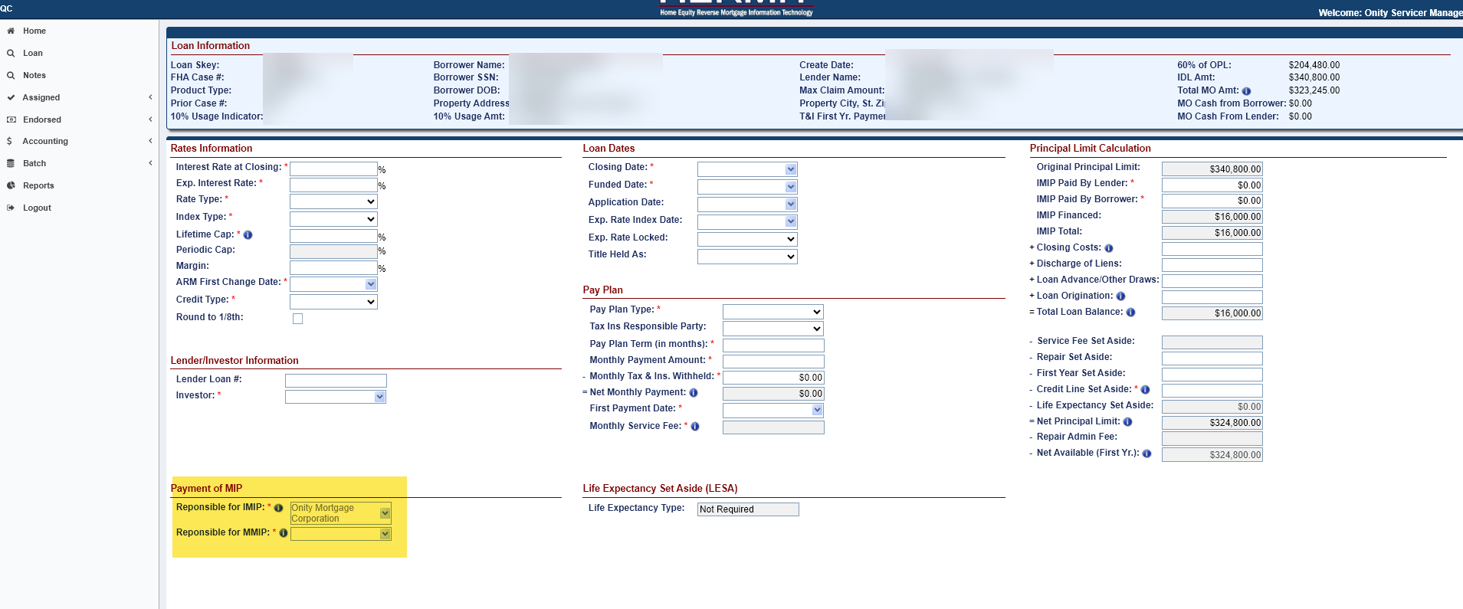

B2G Loan Setup Template
Modifications made to the Loan Setup B2G Template include Column K “Servicer/Sub-Servicer” was renamed to “Responsible for IMIP.” A new column named “Responsible for MMIP” was also added as well as functionality causing an immediate Initial Transfer to the Servicer listed in this field following the Loan Setup process. The Servicer in this field will be responsible for Monthly MIP Accruals and will be the Current Servicer displayed after the Loan Setup is completed.
  - A new alert was created and named “Initial Servicer Transfer occurred at Loan Setup” with a note stating “MMIP will be collected by [MMIP Servicer].” This Alert notifies of the date the loan was transferred and the name of the servicer it was transferred to. The alert is added to the loan during Loan Setup when the Responsible for IMIP company is NOT the same as Responsible for MMIP Servicer.

Timeline: CT22 Timeline Changes to remove multiple Steps (#598942)
Updates have been made to the Endorsed > Claims > Claim Type 22 – Assignment Timeline to remove the following template Steps:
- Confirm Clear Title
- Confirm Occupancy
- Verify Hazard Insurance current
- Verify Property Taxes current
NOTE: There have been no changes to the current Claim Type 22 Assignment process. Servicers should continue to perform these tasks in accordance with the established Assignment to HUD process.
Additional updates have been made to the Submit Assignment Request to HUD Step requiring each of the following Active Steps on the timeline to be completed to complete this step:
- Confirm loan balance is 97.000% or greater than MCA
- Upload Compliance Package
- Upload Collateral Package
- Upload Servicing Package

Servicer and DHOC / HUD Related Changes:

Timeline: Updates to all Timelines with the Responsible Party field on the Servicing Mgmt page (#598384)
The “Responsible Party” field was updated on all timelines with active pending steps to remove any user listed as the Responsible Party if that user has been inactivated or they are no longer considered a responsible party. For timelines where all steps are completed, the username will remain in the Responsible Party field even if the user has been inactivated or no longer considered a responsible party.

Timeline: Endorsed > Requests > Property Preservation Timeline Updates (#599017)
Updates have been made to the Endorsed > Requests > Property Preservation Timeline to include new steps, inactivate existing steps, generate auto notes, and introduce new triggers. This streamlines the process of submitting the P&P Package to HUD, automatically decisioning Over-Allowable Requests within the Preserve & Protect screen, decisioning the Timeline, and automatically generating the Preservation and Protection Decision Letter.
- List of Step changes on Preservation and Protection Timelines:
Update | Step Description | Servicing Step Type | Scheduled Date | Rule
New | HUD Auto Decision -Approved | Trigger | Step Creation Date | Step is automatically added and completed on the timeline when ALL line items in the Request to Exceed Limits for Preservation and Protection section within the Preserve & Protect screen have a HUD Decision of Approved
 |  |  |  | Upon completion of the step, a system generated note is placed in the Notes screen
 |  |  |  | Step is a letter step which is tied to the Preservation and Protection Decision Letter
New | HUD Auto Decision – Denied | Trigger | Step Creation Date | Step is automatically added and completed on the timeline when ALL line items in the Request to Exceed Limits for Preservation and Protection section within the Preserve & Protect screen have a HUD Decision of Denied
 |  |  |  | Upon completion of the step, a system generated note is placed in the Notes screen
 |  |  |  | Step is a letter step which is tied to the Preservation and Protection Decision Letter
Update | Send P&P Package to HUD | Trigger | Step Creation Date | Step will automatically be added to the timeline once the Step Upload P&P Package has been completed AND at least one line item has been added to the Preserve & Protect screen
Update | Request to Exceed Package Reviewed | Trigger | Step Creation Date | Step will be automatically added to the timeline once the Step Send P&P Package to HUD has been completed
Update | Servicer Notified of Decision | Trigger | Step Creation Date | Step will automatically be added and completed on the timeline once the following Steps have been completed: HUD Decision – Approved (Optional), HUD Decision – Denied (Optional), HUD Decision – Pending Additional Info (Optional), HUD Auto Decision – Approved (NEW Trigger), HUD Auto Decision – Denied ( NEW Trigger)
- The following Step is inactivated and no longer used after the date of this release:
  - Request to Exceed Package Received
- The following changes were made to the section Request to Exceed Limits for Preservation and Protection which is located within the Preserve & Protect screen and are applicable to all Property Preservation Transaction Types.
  - When there is an active competed Step Upload P&P Package: once the Send P&P Package to HUD Step gets completed, the system will automatically update the HUD Decision field to Approved for any line item whose Requested Amount is equal to or less than the predetermined threshold established by HUD. Upon auto-approval, the system will automatically update the Approved Amount field to match the value from the Requested Amount field.
  - When there is an active completed Step Upload P&P Package: once the Send P&P Package to HUD Step gets completed, the HUD Decision field will remain unchanged as Pending for any line item whose Requested Amount is greater than the predetermined threshold established by HUD.
  - If any line items remain without a HUD Decision (i.e., still marked as Pending), the new HUD Auto Decision - Approved and HUD Auto Decision - Denied Steps will not be added to the timeline. Authorized users still have the ability to manually add and complete the optional HUD Decision Steps (HUD Decision - Approved, HUD Decision - Denied, and HUD Decision - Pending Additional Info) on the timelines as needed.
  - Once all remaining line items requiring manual decisioning have been decisioned (with any combination of Approved or Denied), the system will automatically add and complete Step HUD Auto Decision - Approved on the Preservation and Protection Timeline.
- New system generated notes are displayed in the Notes section.
  - When the new Step HUD Auto Decision – Approved is added and completed, the system generated note reads:
    - “Preservation and Protection Requests: HUD Auto Decision - Approved was completed on MM/DD/YY H:MM:SS AM/PM. Amount Approved: <AMOUNT APPROVED> Amount Denied: $0
  - When the new Step HUD Auto Decision – Denied is added and completed, the system generated note reads:
    - “Preservation and Protection Requests: HUD Auto Decision - Denied was completed on MM/DD/YY H:MM:SS AM/PM. Amount Approved: $0 Amount Denied: <AMOUNT DENIED>
- The following Letter Steps were changed to automatically generate the Preservation and Protection Decision Letter, the system places a copy in the Documents tab, and the Printer icon is removed once the Steps are added/completed:
  - HUD Decision – Approved (Optional Step)
  - HUD Decision – Denied (Optional Step)
  - HUD Decision – Pending Additional Info (Optional Step)
  - HUD Auto Decision – Approved (NEW Trigger Step)
  - HUD Auto Decision – Denied (NEW Trigger Step)

Timeline: Endorsed > Compliance > Occupancy Compliance Certification Timeline updates to “Mail Annual Occupancy 2nd Request Letter” (#598896)
The Step “Mail Annual Occupancy 2nd Request Letter” automation and scheduled date were updated.
- “Mail Annual Occupancy 2nd Request Letter” step will automatically be added after a nightly job once the following conditions are met:
- Step “Annual Occupancy Certification Letter” is Complete
- Step “Annual Occupancy Cert Letter Received” is Pending Completion
- Step “Annual Occupancy Cert Letter Returned for Non-Delivery” Pending Completion or does not exist
- The Scheduled Date for Step “Mail Annual Occupancy 2nd Request Letter” will now be set to the Complete Date of “Annual Occupancy Certification Letter” plus 25 days.

Case Sub-Status: Add New Case Sub-Statuses Deferral Period – Standard and Deferral Period – MOE (#597240)
Updates have been made to add new Case Sub-statuses Deferral Period – Standard and Deferral Period – MOE for Assigned and Endorsed Loans. Loans will now move in and out of these new Sub-Statuses based on the predetermined Case Sub-Status hierarchy, based on the following:
Case Sub-Status | Business Rules
Deferral Period – Standard (Endorsed & Assigned Case Status) | Non-Borrowing Spouse is indicated as an Eligible NBS located in the Contacts screen
Deferral Period – Standard (Endorsed & Assigned Case Status) | Deferred field located on the Loan Information banner under the section Borrower Information displays “Yes”
Deferral Period – Standard (Endorsed & Assigned Case Status) | MOE field located on the Loan Information banner under the section Borrower Information displays “No”
Deferral Period – MOE (Endorsed & Assigned Case Status) | Non-Borrowing Spouse is indicated as an Eligible NBS located in the Contacts screen
Deferral Period – MOE (Endorsed & Assigned Case Status) | Deferred field located on the Loan Information banner under the section Borrower Information displays “Yes”
Deferral Period – MOE (Endorsed & Assigned Case Status) | MOE field located on the Loan Information banner under the section Borrower Information displays “Yes”
Endorsed Case Sub-Status Location: Deferral Period – Standard is placed in priority after CT 20 – Pending Assignment, and before Deferral Period – MOE. Deferral period – MOE is placed in priority after Deferral Period – Standard and before Payment Suspended.
Assigned Case Sub-Status Location: Deferral Period – Standard is placed in priority after Due & Payable, and before Deferral Period – MOE. Deferral period – MOE is placed in priority after Deferral Period – Standard and before Payment Suspended.

Loan: Search Filter criteria were added to the Loan > Documents page (#598575)
Search filters were added to the Loan > Documents page so users can conveniently search for given document(s) on the page.
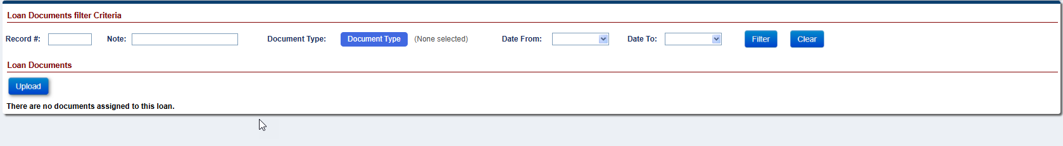

DHOC / HUD Related Changes:

Approval Portal: New Request Category “Set-Aside Transactions” and new Request Sub-Category “Loss Draft Disbursements” (#596139)
A new Request Category “Set-Aside Transactions” was added on the Approval Portal page, with Request Sub-Category “Loss Draft” specifically to include Loss Draft Disbursements and Adjustments. The Portal continues to be visible only to user roles which have access as predetermined by HUD.
- Approval Portal request with a Request Category = “Set-Aside Transactions” and a Request Sub-Category = “Loss Draft” is systemically created with a user notification when a user accesses the Loan > Transactions > Set Aside page and adjusts an existing “Loss Draft - Setup” Transaction. The user creates this new request by clicking the Adjust Set Aside Transaction button on the left side of the transaction grid (Loss Draft – Setup), completing the Adjust Set Aside Transaction and clicks Submit. The message states “Approval is required before this Loss Draft Transaction can processed. A new request has been created in the Approval Portal and the transaction will be processed once the Request Status is set to “HUD Approved – Change Processed.”.”
- If a Set-Aside Transaction - Loss Draft request is pending approval, users will be restricted from creating a Loss Draft Disbursement or adjusting an existing Loss Draft Set-Aside Amount. The error message will display “A Loss Draft Transaction is currently pending approval. The Loss Draft Transaction must be approved, denied, or failed before a new transaction can be initiated.”
- All users will be restricted from adjusting a Loss Draft Set Aside Balance (creating a (6540) “Loss Draft – Setup Adj” Transaction) until all Pending and Authorized Disbursements are disbursed or no longer pending from the Accounting > Disbursements page. The error message will display “The Loss Draft Set Aside Balance cannot be adjusted until all Pending and Authorized Disbursements are disbursed or no longer pending.”.
The following permission changes were made to the Approval Portal “Set-Aside Transactions” page: The following user roles have access to view, add or adjust the Request Category “Set Aside Transactions” on the Approval Portal page:
HERMIT User Role | Create New Loss Draft Set Aside Permission | Adjust Loss Draft Set Aside Permission | Create New Loss Draft Disbursement Permission | Approval Portal User Type
HUD NSC Manager | No | Yes (NEW) | No | HUD Supervisor
Contractor - Cash | Yes | Yes | Yes | HUD Contractor Non-Supervisor
Contractor - Cash Supervisor | Yes | Yes | Yes | HUD Contractor Supervisor

Approval Portal: New Request Category “Change of Plan” and related updates to the Change of Plan page for Assigned loans (#596138)
Updates were made to the Assigned loan Change of Plan page to accommodate the new Request Category “Change of Plan” on the Approval Portal page. The Approval Portal will display a Change of Plan record after the Contractor Supervisor has Approved the new Change of Plan request on the Change of Plan page.
Change of Plan Page changes:
- Detailed information on the updates made to the Change of Plan page for Assigned loans
- The Delete button was removed from the Change of Plan page for loans serviced by HUD.
- A new “Deny” button was added to the Change of Plan page.
- A new Pay Plan Status of Denied was added. The Pay Plan Status “Denied” will appear when a Contractor Supervisor or HUD Manager denies the record with the required Denial Reason either on the Change of Plan page or on the Change of Plan Approval Portal.
Approval Portal - Change of Plan:
- Detailed information for the new Approval Portal Request Category: Change of Plan
- Once a New Change of Plan has been created by a user on the Change of Plan page the Pay Plan Status for the newly created plan will display as “Pending Approval.” The “Pending Approval” request will need to be Approved by an authorized Contractor Supervisor on the Change of Plan page. After the Contractor Supervisor Approves the request, a pop-up message will display stating: “Approval is required before the Change of Plan becomes effective. A new request has been created in the Approval Portal and the Change of Plan will be processed once the Request Status is set to “HUD Approved – Change Processed.”
- The HUD Manager will only have Permission to Approve or Deny the Change of Plan Request within the Approval Portal.
- The Change of Plan record will Fail when any of the following occur:
- The loan is Terminated (occurs following a nightly job)
- The loan is no longer Serviced by HUD
- The request is not Approved by the End of the Month (occurs following a nightly job)
- Error message associated with a “Pending Approval” Change of Plan.
- If a “Pending Approval” Change of Plan request already exists on a loan and a user clicks “New” from the Change of Plan page, then the following error message will display: “A Change of Plan is currently pending approval. The Change of Plan must be approved, denied, or failed before a new Change of Plan can be created” and prevent the user from creating a new Change of Plan.
- If a “Pending Approval” Change of Plan request already exists on a loan and a user attempts to click “Approve” or “Deny” from the Change of Plan page, then the following error message will display: “Change of Plan is currently pending approval and must be decisioned by a HUD Supervisor through the Approval Portal” and prevent the user from Approving or Denying the Change of Plan on the Change of Plan page.
- If a “Pending Approval” Change of Plan request already exists on a loan and a user attempts to create a Transaction that affects the loan balance (excluding Termination Transactions), then the following error message will display: “A Change of Plan request is pending approval for this loan. The selected transaction cannot be created until the pending request has been approved or denied”.
- If a “Pending Approval” Change of Plan request already exists on a loan and a user attempts to adjust off a Transaction that affects the loan balance, then the following error message will display: “ Change of Plan request is pending approval for this loan. The selected transaction cannot be adjusted until the pending request has been approved or denied”.
- If a “Pending Approval” Change of Plan request already exists on a loan and a user attempts to create a Disbursement that affects the loan balance, then the following error message will display: “A Change of Plan request is pending approval for this loan. The selected disbursement cannot be created until the pending request has been approved or denied”.
- If there is a pending disbursement which affects loan balance and a user tries to create a new change of plan, then the following error message will display: “A Change of Plan cannot be created while a disbursement is pending” and prevent the user from creating a new Change of Plan.
- Permission Changes to the Change of Plan page & Approval Portal functionality
- The following permission changes were made to the Loan > Change of Plan page:
HERMIT User Role | Create New Payment Plan Change Permission | Approval Button permission on Change of Plan page | Deny Button Permission on Change of Plan page | Approval Portal User Type
Cont-First Mortgage | Yes | No | No | Contractor Non-Supervisor
HUD NSC-Mgr | Yes | No | No | HUD Supervisor
Cont-Cash Supervisor | Yes | Yes | Yes | Contractor Supervisor
Cont-Supervisor/Management | Yes | Yes | Yes | Contractor Supervisor
- Auto Notes which will display when a Change of Plan request record is Pending, Approved, Denied, or Failed.
- The Auto Note “Request ID: xx - Approval Portal Request Status changed to "Request Status" on a Change of Plan request on MM/DD/YYYY” will display when the Approval Portal Request Status is updated for each type of Request Status.
- The Auto Note “Change of Plan (Create Date: xx/xx/xxxx (added from the Loan > Change of Plan screen) was denied: (Add the text from the Denial Reason pop-up modal)” will display when the Contractor Supervisor Denies a Change of Plan on the Change of Plan page.
- The Auto Note “Request ID: xx Approval Portal Request Status changed to “Denied”: (Text from the Denial Reason field from the Request Details Modal should be copied here)” will display when the Change of Plan request is Denied in the Approval Portal.
- The Auto Note “Request ID: xx – Failed due to the Change of Plan not being approved before the end of the month” will display when the pending Change of Plan request in the Approval Portal Fails because the request was not approved before month end.
- The Auto Note “The Pay Plan Status was updated from Pending Approval to Inactive since an approval was not issued before the end of the month. The terms of the proposed Change of Plan may no longer be accurate and must be resubmitted” will display when the Pending Approval on the Change of Plan page has not been approved before month end.
- The Auto Note “The Pay Plan Status was updated from Pending Approval to Inactive due to an adjustment transaction posted to the loan balance. The terms of the proposed Change of Plan may no longer be accurate and must be resubmitted” will display when there is a Pending Approval Change of Plan on the Change of Plan page that has not been approved to go to Approval Portal and a disbursement is adjusted off.
- The Auto Note “Request ID: xx – Failed due to an adjustment transaction posted to the loan balance. The terms of the proposed Change of Plan may no longer be accurate and must be resubmitted” will display when the Pending Approval Change of Plan request in the Approval Portal Fails due to a Disbursement Adjustment.
- The Auto Note “Request ID: xx – Failed due to Case Status updated to Terminated” will display when a Pending Approval Change of Plan request in the Approval Portal Fails due to the loan being Terminated.
- The Auto Note “Request ID: xx – Failed due to the loan no longer being serviced by the HUD Contractor” when the Pending Approval Change of Plan on the Approval Portal Fails due to the loan no longer being serviced by HUD.
- Update to the “Change of Plan Pending Approval” Alert
- The Alert “Change of Plan Pending Approval” will Inactivate when there is no “Pending Approval” Change of Plan on the loan.

Approval Portal: New Request Category “Loan Transactions” and new Request Sub-Category “Write-Off Transactions” (#596140)
A new Request Category “Loan Transactions” was added on the Approval Portal page, with Request Sub-Category “Write-Off Transactions”, specifically to display a Write-Off record after the user has created a Write-Off Transaction on the Loan > Transaction page.
- Detailed information for the new Request Sub-Category: Write-Off Transactions
- Once a New Manual Write-Off or Terminate – Full Write-Off Transaction has been created by a user on the Loan > Transaction page, the request will be sent to the Approval Portal and set to a “Pending Approval” Request Status.
- The new “Pending Approval” request created by a contractor non-supervisor will require a two-layer approval process from an authorized Contractor Supervisor and a HUD Manager before the Write-Off Transaction will become effective. After the user creates a Write-Off transaction, a pop-up message will display stating: "Approval is required before the Write-Off Transaction can be processed. A new request has been created in the Approval Portal and the transaction will be processed once the Request Status is set to “HUD Approved – Change Processed."
- “Write-Off” Transactions will only require one layer of Approval when a Contractor Supervisor or HUD Manager creates the Write-Off Transaction.
- The “Terminate – Full Write-Off” Transaction that is a Re-Termination will be auto approved through a nightly job if the Effective Date is within 45 days of the Termination Date on the Loan Details page.
- The Write-Off Transaction record will Fail when any of the following occur:
- The loan is no longer Serviced by HUD
- The request is not Approved by the End of the Month (occurs following a nightly job)
- Error message associated with a “Pending Approval” Write-Off Transactions:
- If a “Pending Approval” Write-Off Transaction request already exists on a loan and a user attempts to create or adjust off a Transaction affecting the loan balance, then the following error message will display: “A Write-Off Transaction is currently pending approval. The Write-Off Transaction must be approved, denied, or failed before a new transaction can be initiated”.
- Permission Changes to the Write-Off Manual button
- The role HUD NSC Manager now has permission to create a Manual Write-Off Transaction.
- Auto Notes which will display when a Write-Off Transactions request record is Pending, Approved, Denied, or Failed.
- The Auto Note “Request ID: xx – Failed due to the loan no longer being serviced by the HUD Contractor” will display when the Pending Approval record Fails due to the loan no longer being serviced by HUD.
- The Auto Note “Request ID: xx – Failed due to the Transaction note approved before the end of the month” will display when the Pending Approval record Failes due to record not being Approved before Month End.
- The Auto Note “Request ID: xx Approval Portal Request Status changed to “Denied”: (Text from the Denial Reason field from the Request Details Modal should be copied here)” will display when the Write-Off Transaction request is denied on the Approval Portal.
- The Auto Note “Request ID: xx - Approval Portal Request Status changed to "Request Status" on a Loan Transactions / Write-Off Transactions request on MM/DD/YYYY” will display when the Approval Portal Request Status is updated for each type of Request Status.

Timeline: Assigned > Compliance > Insurance – Hazard Policy & Insurance – Flood Policy Timelines Updates (#597127)
Updates were previously made in Release 8.0 (#590751) to the Assigned > Compliance > Insurance – Hazard Policy and Assigned > Compliance > Insurance – Flood Policy timelines which introduced functionality that automatically created a new Insurance timeline when the Steps Renewal Insurance Declaration Received and Renewal Insurance Declaration Effective are added and completed.
Updates made in this release to the Assigned > Compliance > Insurance – Hazard Policy and Assigned > Compliance > Insurance – Flood Policy timelines upon the completion of the trigger Step Renewal Insurance Declaration Effective on the existing Insurance timeline, the system automatically populates the new timeline’s Servicing Management screen with data from the source (transferring) timeline with the following information:

- Policy #
- Policy Holder
- Company Name
- Agent Name
- Address 1
- Address 2
- City
- Email
- Phone #
- Tax ID
- State, Zip
- Website URL
- Fax #

Additionally, once the new Insurance – Flood Policy and Insurance – Hazard Policy timelines are created, the Complete Date from the Renewal Insurance Declaration Received Step from the existing timeline is automatically transferred as the Complete Date to the newly created timeline for the Step Insurance Declaration Received.

Timeline: Assigned > Compliance > Occupancy Compliance Certification Timeline updates to “Mail Annual Occupancy 2nd Request Letter” (#598896)
The Step “Mail Annual Occupancy 2nd Request Letter” automation and scheduled date were updated.
- “Mail Annual Occupancy 2nd Request Letter” step will automatically be added after a nightly job once the following conditions are met:
- Step “Annual Occupancy Certification Letter Sent” is Complete
- Step “Annual Occupancy Cert Letter Received” is Pending Completion
- Step “Annual Occupancy Cert Letter Returned for Non-Delivery” Pending Completion or does not exist
The Scheduled Date for Step “Mail Annual Occupancy 2nd Request Letter” will now be set to the Complete Date of “Annual Occupancy Certification Letter Sent” plus 25 days.

Timeline: Assigned > Request > Payoff Request Timeline Updates to Step “Issue Payoff Letter (#595559)
On the Assigned > Request > Payoff Request Timeline the Step “Issue Payoff Letter” was updated to only allow the user to complete the step by clicking the printer icon. The printer icon will no longer appear for the Step “Issue Payoff Letter” once letter has been printed and the step has been completed. The field “Payoff Request Date” will no longer be editable once the “Issue Payoff Letter” has been completed.

Timeline: Tax ID (TIN) not required when Entering Company Name on Insurance-Hazard and Flood timelines (#597678)
Updates were made to remove the Tax Identification Number (TIN) Error message “Tax ID of 9 digits is required” on the Assigned > Compliance > Insurance – Flood Policy and Assigned > Compliance > Insurance – Hazard Policy Timelines. The existing message on the Edit Servicing Management Modal was modified to remove the validation for “Tax ID” when the user sets up or edits the timeline. The message will now be displayed as, “Agent Name, Address1, City, State, and ZIP are required when Company Name is entered.” Note: if the user attempts to make a disbursement from the Loan > Disbursements area to an insurance payee that does not have a 9-digit Tax ID they will receive the message “Tax ID of 9 digits is required. Please update in the appropriate area.”
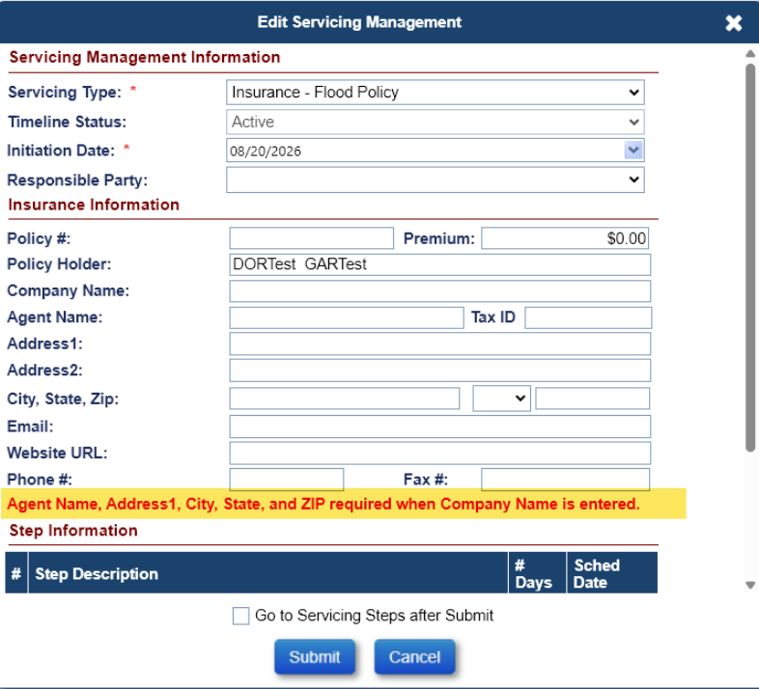

Timeline: Conditional Assignment Decision Steps within CT22 Timelines (#598297)
Updates have been made to the Endorsed > Claims > Claim Type 22 – Assignment Timeline to conditionally display optional Assignment Denied decision steps based on whether funds are due to HUD from an outstanding HUD Advance.
Step Assignment Denied - Funds Due HUD
Is available when an authorized user selects “New” only if:
- An Active Completed Step Funds Due HUD Received does NOT exist AND an Active Endorsed > Requests > Request for HUD Advance (Assignment) Timeline exists AND
  - An Active Completed Step Request for HUD Advance Processed exists OR
  - An Active Completed Step Advance Denied – No Funds Issued does NOT exists.
Step Assignment Denied – No Funds Due HUD
Is available when an authorized user selects “New” only if:
- The Case Sub-Status is NOT Assignment Denied – Funds Due HUD
- An Active Completed Step Funds Due HUD Received exists on the CT22 – Assignment Timeline
- No Active Endorsed > Requests > Request for HUD Advance (Assignment) Timeline exists
- An Active Endorsed > Requests > Request for HUD Advance (Assignment) Timeline exists AND
  - An Active Completed Step Advance Denied – No Funds Issued exists OR
  - An Active Completed Step Request for HUD Advance Processed does NOT exist OR
  - An Active Completed Step HUD Verifies Repayment of HUD Advance exists.
Additional updates have been made to the HECM Assignment Acceptance Checklist Completed Step when the system automatically adds the Step Assignment Denied – Funds Due HUD based on the Endorsed > Requests > Request for HUD Advance (Assignment) Timeline activity.
If upon the automatic/system addition and completion of Step Assignment Denied - Funds Due HUD to the CT22 – Assignment Timeline
- If the Step HECM Assignment Acceptance Checklist Completed
  - Is Active pending, the system automatically inactivates the Step
  - Has been completed, it shall remain Active

Transaction: Loan > Transaction page updates include a new transaction, a new button, and a new column on the Loan Transaction Results grid. (#598140 & 598038)
Updates were made to the Loan > Transaction page to include an “Overage Adj” button, a new column “Overage Amt”, and a new transaction. An overage button called “Overage Adj” was added to allow the users to add or decrease funds from the overage amount. A new column called “Overage Amt” was added to the Loan Transaction results grid. This column will handle overages and remittance to overages instead of combining them with the corporate advances. A new transaction type call “Overage Balance Correction” was created that will be the difference between the current overage from remittance transaction and the corrected amount on loans in HUD’s portfolio (Servicer = 900000).
a. The new column “Overage Amt” on the Loan Transaction grid will populate the Overage amount when an Overage Transaction is created on the Loan > Transactions page. The Overage amount will no longer be calculated within the “Corp Adv Amt” column on the Loan Transaction Results grid.
- The following Transactions amount will be populated in the new “Overage Amt” column:
trans_code | long_trans_desc
2550 | Disb - Refund/Payment Remittance Overage
2590 | Disb - Refund/Payment Remittance Overage Adj
2610 | Overage From Remittance
2690 | Overage From Remittance Adj
2620 | Overage Balance Correction

- The new “Overage Adj” button will only display when the loan is Terminated with an Overage and the Overage is amount < $0.00. Note: The Overage amount is always displayed as a negative value this is existing functionality.
- The user roles “HUD NSC Manager” and “Contractor Cash Supervisor” will only have permission to see the “Overage Adj” button and increase or decrease the overage amount.
- Once the user clicks on the “Overage Adj” button, the modal “Adjust Overage Transaction” will appear. This modal will contain the fields Transaction Type, Effective Date, Correct Amount, Current Amount, and Adjustment Amount.
  - The “Transaction Type” will not be an editable field. This will always display “Refund – Overage Balance Correction”
  - The “Effective Date” will not be an editable field and will always display Today’s date.
  - The “Correct Amount” will be an editable field. This will be the amount the user wants the Overage to display.
  - The “Current Amount” will not be an editable filed. This will display the amount the Overage is currently.
  - The “Adjustment Amount” will not be an editable field. This will be a system calculated field displaying the amount being adjusted between the correct amount and current amount.
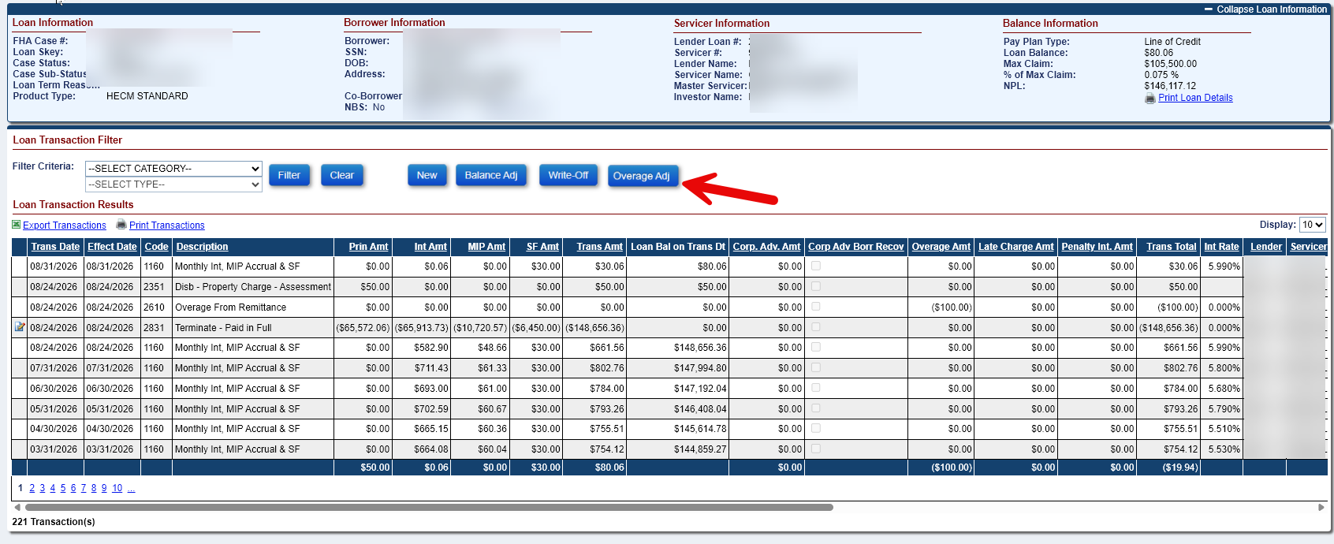

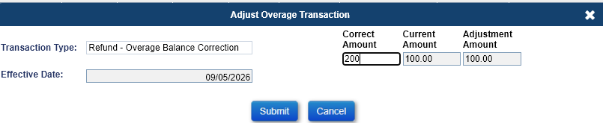

- If there is a pending “Disb – Refund/Payment Remittance Overage” when the user clicks the “Overage Adj” button an Error message will display.
- Error message “This loan has a pending “Disb - Refund/Payment Remittance Overage” disbursement. The Overage cannot be adjusted till all pending overage disbursements have been disbursed.”
- The new “Overage Balance Correction” Transaction (Trans Code 2620) will display on the Loan > Transaction page once the user enters a value in the correct amount field and clicks submit on the “Adjust Overage Transaction” modal. This transaction will display the amount difference between the “Current Overage amount” and the “Correct Overage Amount.”
- Example: The Current Overage amount is $900 and the Correct Overage amount entered on the modal is $500. Then the “Overage Balance Correction” will display an amount of $400.

Report: New Report Property Preservation Pending Decision (#598006)
A new report called “Prop Pres Pending Decision” was added in the Reports module under Assigned Notes Reports > Daily Reports. Servicers initiate the Preservation and Protection timeline for each over-allowable (OA) request when the Preservation and Protection expenses exceed the HUD allowable limits. This report captures the over-allowable requests once submitted for review, which are pending a decision by HUD or the HUD Contractor.
Assigned Notes Reports area:
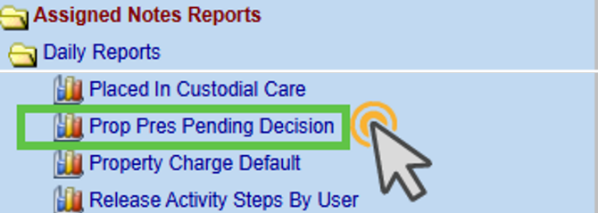
Prop Pres Pending Decision Report Search Criteria:
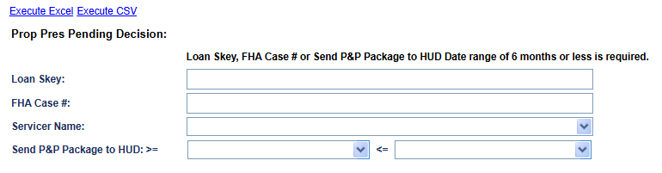
- Search Criteria includes:
- Loan Skey
- FHA Case #
- Servicer Name
- Send P&P Package to HUD (date range of 6 months days or less)
- The output is available in CSV and Excel formats and includes the following fields:
- Loan Skey
- FHA Case Number
- Case Status
- Case Sub Status
- Servicer Name
- Investor Name
- Request ID
- Servicing Default Management Skey
- Sequence Number
- Transaction Code
- Transaction Type
- HUD Bid Decision
- Requested Amount
- Approved Amount
- Bid1 Amount
- Bid2 Amount
- Servicer Remarks
- HUD Remarks
- Create User ID
- Created Date
- HUD Decision User ID
- HUD Decision Date
- Line Item User ID
- Line Item Change Date

Report: Changes to the Bulk Printing Letters Report (#597624)
Updates were made to the Bulk Printing Letters report within the Reports module, located under Assigned Notes Reports > Daily Reports, by adding Case Status and Case Sub-Status as search criteria.
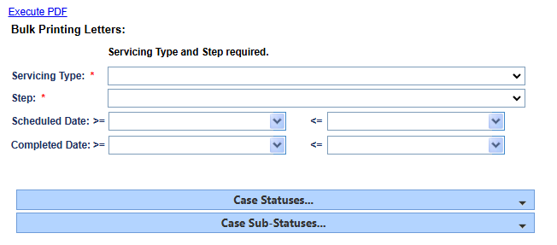

Annual Statements Privacy Policy for the Assigned Portfolio (#577470)
An update was made to the bulk monthly statements and monthly statements in Loan > Statements to include the following Privacy Statement to December’s monthly statements on Assigned loans:
PRIVACY POLICY
We recognize the importance you place on your privacy and the confidentiality of your financial information. We do, however, collect non-public personal information, which may include your social security number and income, payment and transaction history, account balances and other information about you from the following sources:
- Information received from your loan documents.
- Information received from your transactions with us.
- Information received from your transactions with nonaffiliated third parties, such as insurers and state or local tax authorities.
We do not disclose and do not reserve the right to disclose non-public personal information about borrowers or former borrowers, to affiliates or non-affiliated third parties except as permitted by law, or if we obtain your written permission in advance. We restrict access to non-public personal information about you to those employees who need to know that information to provide products and services to you. Compu-Link may disclose non-public personal information, for example, your social security number and income, payment and transaction history, account balances and other information, to nonaffiliated companies for everyday business purposes, such as processing of transactions, maintaining accounts, monitoring of tax and insurance payments, and responding to court orders or legal investigations. We maintain physical, electronic, and procedural safeguards that comply with federal standards to guard your non-public personal information, including computer safeguards and secured files and buildings.

Loan: Custodial Care Dates updates and new SAMS File Field (#597289)
Updates were made to remove the Vacancy Date, Custodial Care Request Date, and Custodial Care Placed Dates from the Loan > Details Screen when a loan is terminated using the following transition codes, 2880 – Terminate – 3rd Party FCL Sale (PIF), 2882 – Terminate – Full Write-Off and Terminate – 3rd Party FCL Sale (PIF w/WOFF). In addition to the 2831 – Terminate – Paid in Full, 2877 – Terminate – Refinance, 2883 – Terminate – Asset Sale, 2885 – Terminate – Short Sale and 3582 – Claim Type 22 – Repurchase codes that already exist in HERMIT.
- When the terminations are executed, the system will automatically add a system note when the Vacancy Date, Custodial Care Request Date, and Custodial Care Place Date are removed when the loan is terminated using any of the termination transactions noted above.
- The removal of the Vacancy Date, Custodial Care Request Date, and Custodial Care Place Date will trigger a remove from SAMS File Code = “RM” for all termination transactions noted above except for 2883 – Terminate – Asset Sale which will trigger an “AS” code.
- A new field called “Settlement Date” was added to the SAMS File to the last column to the right of the “Remove from SAMS Flag” which will be populated with the termination transaction effective date when the loan in the SAMS file is terminated with “2883 – Terminate – Asset Sale” transaction.

------ End of Document -----

