Home Equity Reverse Mortgage Information Technology
(HERMIT)

HERMIT System Changes – Release 8.21 and Release 8.3

Release Date: May 23, 2026
Document Date: May 13, 2026
Version 1.0

May 2026

INTRODUCTION
The Home Equity Reverse Mortgage Information Technology (HERMIT) software release version 8.21 and 8.3 consists of the following system changes:
Table of Contents
Servicer Related Changes 4
1. Claims: CT23 Pre-Final Rule Block 17 Reduced Amount to AOP and AOP Report (#597508) 4
2. Reports: CT23 Pre-Final Rule Block 17 Reduced Amount to AOP Report (#597508) 4
3. Reports: New Servicer Alert Details Report Showing All Loans w/ Alerts for Servicers (#589247) 4
Servicer and DHOC / HUD Related Changes: 6
4. Accounting: Repurchase Amount in Accounting > Authorizations (#597444) – 8.21 Release 6
5. Accounting > Transmittal Search screen and results (N/A) 7
6. Transaction Codes: 3. New Transaction Codes for Existing “Unscheduled from LOC” Disbursements issued by HUD & HUD Contractor (#594626) 7
7. Timeline: Changes to Endorsed > Claims > Claim Type 22 – Assignment Timeline (#595197, #596675) 8
8. Timeline: Auto-Approval of Endorsed > Requests: Extension – Appraisal (#596945) 11
9. Timeline: Auto-Approval of Endorsed > Requests: Extension – At Risk (#596943) 12
10. Timeline: Auto-Approval of Endorsed > Requests: Investor Short Sale (#596946) 15
11. Timeline: Auto-Approval of Endorsed > Requests: Extension – Property Charge Loss Mitigation (#596944) 18
12. Timeline: Auto-Approval of Endorsed > Requests: Extension – Delay Due & Payable (#596942) 21
13. Timeline: Auto-Approval of Endorsed > Requests: Extension – Late Notification of Death (#595351) 22
14. Timeline: Auto-Approval of Endorsed > Requests: Extension – Deed in Lieu (#595351) 23
15. Timeline: Auto-Approval of Endorsed > Requests: Extension – Hardest Hit Fund (HHF) (#595351) 25
16. Timeline: Auto-Approval of Endorsed > Requests: Extension – Other (#595351) 26
17. Timeline: Auto-Approval of Endorsed > Requests: Extension – Repairs (#595351) 27
18. Reports: Default Key Dates Report (596945, 595351, 596944, etc.) 29
19. Timeline: Updates made to the Endorsed > Request > Request for HUD Advance (Assignment) Timeline (#596660) 30
DHOC / HUD Related Changes: 32
20. Loan Balance Screen: Zero out Property Charge Balance with Termination (#596927) 32
21. Loan: Automatically adjust “Write-off Auto” transaction after Disbursement Adjustment for LOC Release Fee (#596547) 33
22. Timeline: Loss Mitigation - Short Sale Timeline: Update Step Descriptions and Step Groups under Assigned – Disposition area (#597466) 33
23. ADMIN: NSC Auto Delegation for Responsible Party (#578647) 34
24. Dashboard: Endorsed > Claims > Claim Type 22 – Assignment Timeline Steps (#595197) 35
25. Reports: New Asset Sale Report for Active Loans with Servicer Skey = 900000 (#596655) 36
26. Reports: 7. Timeline Activity Report - Add Changed Date and Inactive Date to Report Search Criteria (#595329) 38
27. Reports: New Insurance Hazard Policy Servicing Mgmt Info Report for Assigned – Compliance Timelines (#595675) 38
28. Reports: Add Fields to various reports (#539464) 40
29. Accounting: HERMIT will send the Accounting Module the Void Reason “Stale Dated Check” via the Nightly Accounting Job (#594750) 41
30. Loan: Payoff Statement on the Loan > Payoff page was updated to exclude estimated expenses in the per diem amount. (# 50703) 41
31. New Approval Portal Page (#596137) 41

If you have any questions regarding the functionality of the software release, please contact the HERMIT Help Desk at 561-899-2610 or at servicingsupport@hermitsp.com. If you have any policy related questions, please send an email to HUD at answers@hud.gov.

Servicer Related Changes

Claims: CT23 Pre-Final Rule Block 17 Reduced Amount to AOP and AOP Report (#597508)
Updates were made with the implementation of the Borrower Recoverable Corporate Advances (BRCA) in Release 8.10 (September 2025), and a new field was added for Claim Type 23 Pre-Final Rule to reduce the UPB to prevent duplicate interest from being paid on the claim, if applicable.
This update added visibility of this field BRCA CT23 Pre Final Rule Reduction to the Advice Of Payment (AOP) document along with clarifying language as to this field’s purpose, stating “(Info: Amount Already Deducted from Blk 17)”
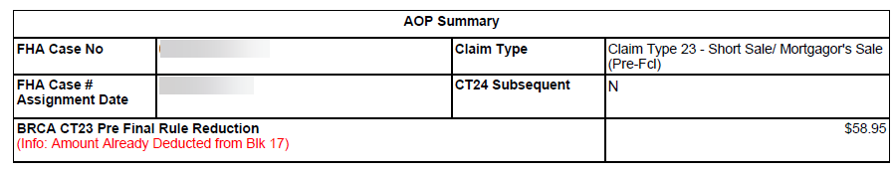

Reports: CT23 Pre-Final Rule Block 17 Reduced Amount to AOP Report (#597508)
Updates were made to add the field BRCA CT23 Pre Final Rule Reduction to the Servicer Reports > Daily Reports > Claim AOP Amount Report between the CT24 UPB Adj Amt and UPB Amt fields.
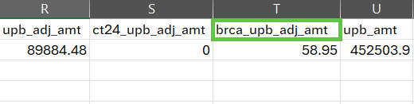

Reports: New Servicer Alert Details Report Showing All Loans w/ Alerts for Servicers (#589247)
A new report called “Servicer Alert Details” was added to the Reports module under Servicer Reports > Daily Reports which includes all Alerts that Servicers will be able to pull within their own portfolio. The new report defaults to the Servicer’s portfolio unless the Servicer is HUD/HUD Contractor (Servicer = 900000). The user is required to select between 1-10 Alerts from the multi-select options, just as it does for the Alert Details Report that already exists for Assigned Alerts.
Report criteria include:
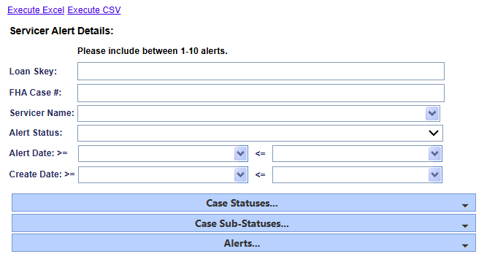
  - Servicer Alert Details Report Search Criteria:
- Loan Skey
- FHA Case #
- Servicer Name
- Alert Status
- Alert Date Range
- Create Date Range
- Case Status
- Case Sub Status
- Alerts
  - The output is available in CSV and Excel formats and includes the following fields:
- Loan Skey
- FHA Case #
- Case Status
- Case Sub-Status
- Lender Name
- Servicer Name
- Investor Name
- Borrower Last Name
- Borrower First Name
- Alert Status
- Alert Date
- Alert Description
- Alert Severity
- Alert Type
- Alert Amt
- Alert Expiration
- Alert Note
- Alert Created By
- Alert Create Date
- Alert Changed By
- Alert Changed Date

Servicer and DHOC / HUD Related Changes:

Accounting: Repurchase Amount in Accounting > Authorizations (#597444) – 8.21 Release
Background: HUD permits an Assignment once the outstanding loan balance reaches 100 percent of the Maximum Claim Amount (MCA). Since the Assignment Claim cannot exceed the MCA, any portion of the outstanding balance which is above the MCA cap is recorded as an Adjustment to Outstanding Balance.
At the time of Repurchase, the required repurchase amount has been updated to the amount received by the servicer on the Assignment Claim plus post-assignment advances and accruals. Additionally, any unpaid HUD Advances which were adjusted when the Assignment Claim was paid have been accounted for.
Updates have been made to the Authorization Information pop-up modal located within the Accounting > Authorizations screen for Repurchase receivable type, to display the adjustment to outstanding balance in a new field named “Reduce for MCA Cap” and calculate the Total Amount to include this adjustment.
Field Name | Description/Field Purpose
UPB | Calculated repurchase payoff amount plus repurchase Interest which has accrued as of the latest month end
Remaining UPB | Prorated repurchase Interest which has accrued for the current month through the date the authorization is being processed (I.e., Today)
Reduce for MCA Cap | Calculated from the Adjustment to Outstanding Balance minus Funds Due HUD for Unpaid HUD Advance and Interest
Total Amount | Calculated Unpaid Principal Balance (UPB) plus Remaining UPB minus Reduce for MCA Cap
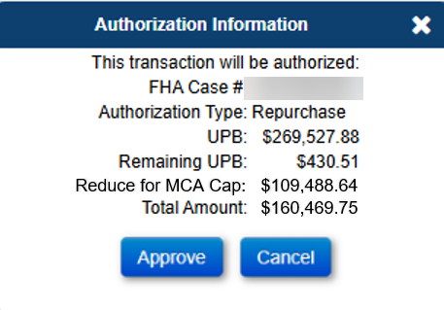

Accounting > Transmittal Search screen and results (N/A)
Updates have been implemented in the Accounting > Transmittal screen when a Batch has a transaction count of one, the results will display the FHA Case# associated with that Batch, without having to view the Batch Results. This update provides the same information when exporting the results to excel.
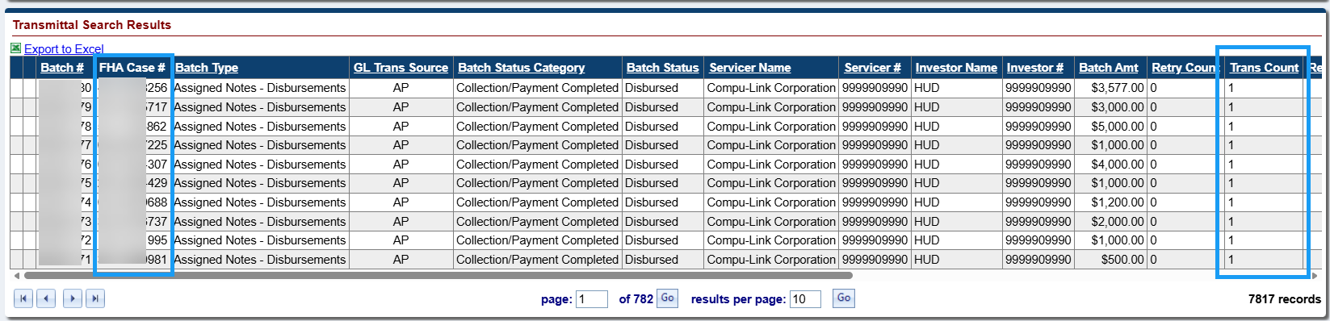

Transaction Codes: 3. New Transaction Codes for Existing “Unscheduled from LOC” Disbursements issued by HUD & HUD Contractor (#594626)
New Transaction codes were implemented along with system logic to automatically distinguish between different types of Disbursements issued by HUD. Going forward the system will automatically assign the appropriate Transaction codes to classify the type of disbursement and improve reporting capabilities. Formerly, the same numerical transaction codes were shared by the following 3 types of Disbursements.
- Unscheduled from LOC: Regular Unscheduled Disbursements on HUD-serviced / Assigned portfolio loans (serviced by Compu-Link)
- HUD Advance: Disbursements made on behalf of an Industry Servicer when the disbursement would cause the loan balance to exceed the MCA threshold
- HUD Borrower Disbursement: Disbursements made related to a Demand Assignment / CT20

List of Transaction Codes and Adjustments:
Trans Code | Transaction Description | Usage
1374 | Disb - HUD Advance | Disbursements made on behalf of an Industry Servicer when the disbursement would cause the loan balance to exceed the MCA threshold
1375 | Disb - HUD Advance Adj
1376 | Disb - HUD Borrower | Disbursements made related to a Demand Assignment / CT20
1377 | Disb - HUD Borrower Adj | Disbursements made related to a Demand Assignment / CT20
1350 | Disb - Unscheduled from LOC | No Changes: Regular Unscheduled Disbursements on HUD-serviced / Assigned portfolio loans (serviced by Compu-Link).
1390 | Disb - Unscheduled from LOC Adj

Timeline: Changes to Endorsed > Claims > Claim Type 22 – Assignment Timeline (#595197, #596675)
Updates have been made to the Endorsed > Claims > Claim Type 22 – Assignment Timeline to improve how the timeline flows from initiation to completion.
Servicer Related Changes
The Servicer step “Original Mortgage/Deed of Trust & Note sent to HUD” is now split into two new steps which are to be completed by the Servicer:
- “Original Mortgage/Deed of Trust sent to HUD”
- “Original Note sent to HUD”
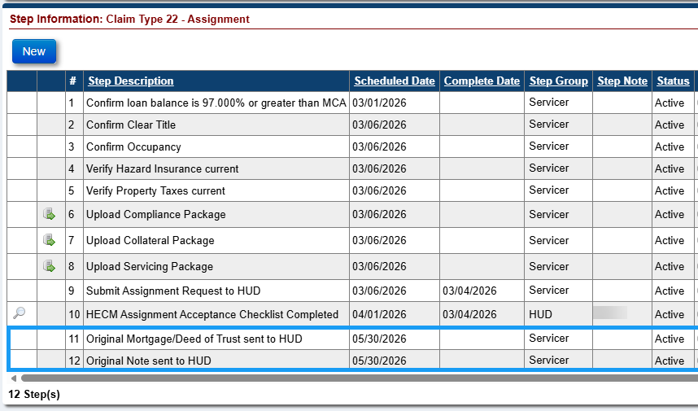
The following steps must be completed for the Servicer to complete the Step Submit Assignment Request to HUD:
- Confirm loan balance is 97.000% or greater than MCA
- Confirm Clear Title
- Confirm Occupancy
- Verify Hazard Insurance current
- Verify Property Taxes current
- Upload Compliance Package
- Upload Collateral Package
- Upload Servicing Package
Error Message is displayed if the steps are not completed:
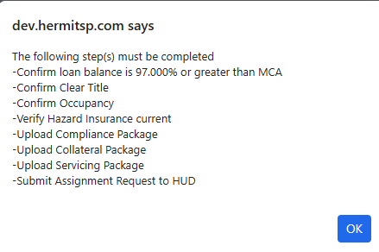
Updates were made to allow the initiation of the Claim Type 22 - Assignment timeline if the loan’s Case Sub-Status is Assignment Denied – Funds Due HUD. Updated error message show the Case Sub-Status is now allowed:
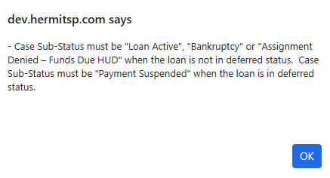
Contractor & HUD Related Changes
The HUD Contractor step “Original Mortgage/Deed of Trust & Note received by HUD” is now split into two new triggered steps once the corresponding sent steps are completed:
- “Original Mortgage/Deed of Trust received by HUD”
- “Original Note received by HUD”
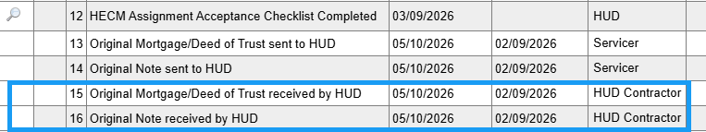
The following Steps are inactivated and no longer used after the date of this release:
- Assignment Package Received
- Assignment Package Reviewed
- HUD Decision – Pending Incomplete Package
- Received HUD Decision – Pending Incomplete Package
- Follow-up on Incomplete Package

Upon completion of the Servicer Step – Submit Assignment Request to HUD, the system automatically adds the HECM Assignment Acceptance Checklist Completed step to the timeline. This checklist must be completed before any of the optional decision steps—HUD Issued Preliminary Title Approval, Assignment Denied – Funds Due HUD, or Assignment Denied – No Funds Due HUD—can be added or completed.
Only one decision outcome is allowed on the same timeline. Therefore, HUD Issued Preliminary Title Approval cannot be added or completed if either Assignment Denied – Funds Due HUD or Assignment Denied – No Funds Due HUD has already been added or completed.
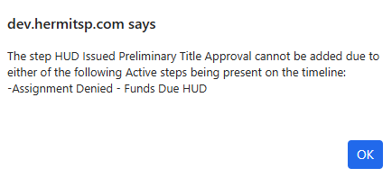
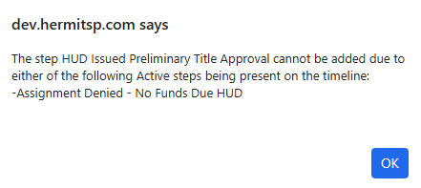
Likewise, if a denial step has been added or completed, HUD Issued Preliminary Title Approval is not permitted.
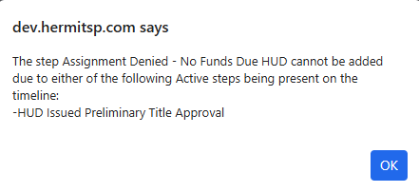
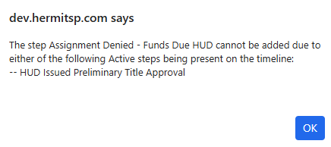
If the step HUD Issued Preliminary Title Approval has been added to the timeline, the step is permitted to be inactivated by the HUD NSC Manager role, except when the step Assignment to HUD sent for recording/Servicer Files Claim Type 22 – Form 27011 has been completed. However, once the HUD Issued Preliminary Title Approval decision step is completed, the timeline cannot be inactivated.

Timeline: Auto-Approval of Endorsed > Requests: Extension – Appraisal (#596945)
Updates have been made to the Endorsed > Requests > Extension – Appraisal Timeline to include new steps, step types for existing steps, existing steps were inactivated, and new triggers introduced.
- List of Step changes on Extension – Appraisal Timelines:
Update | Step Description | Servicing Step Type | Scheduled Date | Rule
Automation logic changed | Initiate Extension | Automated | Timeline Creation Date | Step will be automatically completed when the Timeline is created
New | Appraisal Effective End Date | Trigger | Complete Date of Step “Upload Extension Package” plus 1 Day | Step will be automatically added to the timeline when the step “Upload Extension Package” has been completed.
New | HUD Auto-Approved | Trigger | Step Creation Date | Step will be automatically added to the timeline when the step “Appraisal Effective End Date” has been completed.
 |  |  |  | Upon completion of the step, the timeline will be automatically approved and the Extension Expiration Date in the Servicing Management screen will be automatically populated with the Appraisal Effective End Date complete date plus 180 days.

- The following Steps were inactivated and no longer used after the date of Release 8.3:
  - Submit Extension Request for Time
  - Extension Request Reviewed
  - HUD Decision – Approved
  - HUD Decision – Denied
  - Servicer Notified of Decision
  - Follow Up
  - Request for Extension of Time Recvd
- The “Request” field in the Timeline Setup Modal is no longer editable and defaults to “First” when the timeline is created. Only one active extension is allowed per loan.
- The “Extension Expiration Date” field in the Servicing Management screen is no longer editable.

Timeline: Auto-Approval of Endorsed > Requests: Extension – At Risk (#596943)
Updates have been made to the Endorsed > Requests > Extension – At-Risk Timeline to include new steps, step types for existing steps, new error messages were added, existing steps were inactivated, and new triggers introduced.
- List of Step changes on Extension – At-Risk Timelines:
Update | Step Description | Servicing Step Type | Scheduled Date | Rule
Automation logic changed | Initiate Extension | Automated | Timeline Creation Date | Step will be automatically completed when the Timeline is created
New | HUD Auto-Approved | Trigger | Step Creation Date | Step will be automatically added to the timeline when the step “Upload Extension Package” has been completed.
 |  |  |  | Upon completion of the step, the timeline will be automatically approved and the Extension Expiration Date in the Servicing Management screen will be automatically populated with the Step Complete Date + 12 Months.
*If one or more Extensions exists |  |  |  | If the MAX “Extension Expiration Date” is greater than or equal to the latest Step “HUD Decision – Approved” Complete Date from the Endorsed > Requests > Due & Payable w/ HUD Approval Timeline, then the “Extension Expiration Date” for the new timeline is the MAX “Extension Expiration Date” + 12 Months.
 |  |  |  | If the MAX “Extension Expiration Date” is less than the latest Step “HUD Decision – Approved” Complete Date from the Endorsed > Requests > Due & Payable w/ HUD Approval Timeline, then the “Extension Expiration Date” for the new timeline is the Step “HUD Auto-Approved” Complete Date + 12 Months.
New | Extension Eligibility End Date | Optional | Date the step is added to the Timeline | Step Complete Date is used to track when a Borrower is no longer eligible for an At-Risk Extension.
 |  |  |  | Optional step can only be added if there is either an active completed Step "HUD Decision - Approved" or "HUD Auto-Approved" Step
 |  |  |  | The Complete Date must be on or after Step "HUD Auto-Approved" Complete Date or Step "HUD Decision - Approved" Complete Date and before the "Original Extension Expiration Date"
 |  |  |  | The Complete Date cannot be a future date
 |  |  |  | Upon completion of the step, the Extension Expiration Date is updated to the Complete Date plus 90 days.
 |  |  |  | If completed Step is manually inactivated, the Extension Expiration Date is automatically updated back to the previous value

- The following Steps are inactivated and no longer used after the date of release 8.3:
- Submit Extension Request for Time
- Extension Request Reviewed
- HUD Decision – Approved
- HUD Decision – Denied
- Servicer Notified of Decision
- Follow Up
- Request for Extension of Time Recvd
- New error messages were added to display when complete dates are outside of the parameters, or as notification of missing steps from the timelines.
- Error message will display if the loan does not meet the criteria from the active “Due & Payable w/ HUD Approval” Timeline at the Timeline creation.
- Error message will display if a user attempts to enter a date into the “Extension Eligibility End Date” that do not meet the parameters.
- Error message will display if a user attempts to add a Step "Extension Eligibility End Date" when a HUD Approval Step does not exist.
- Error message will display if the loan does not meet the criteria to reactivate the Timeline.
- A new Extension – At-Risk Timeline cannot be created unless the following criteria is met:
  - An active “Due & Payable w/ HUD Approval” Timeline and an active Completed Step “HUD Decision – Approved” exists.
  - An active “Due & Payable w/ HUD Approval” Timeline and if an active Completed Step “HUD Decision – Denied” exists, then the step completion date must be before the completion date of Step “HUD Decision – Approved”.
  - An active “Due & Payable w/ HUD Approval” Timeline and no active completed Step “HUD Request to Rescind Decision Approved” exists
  - An active “Due & Payable w/ HUD Approval” Timeline and an active completed Step “HUD Request to Rescind Decision Approved” exists and an active completed step “HUD Request to Rescind Decision Denied” exists and the step completion date of Step “HUD Request to Rescind Decision Approved” is before the completion date of Step “HUD Request to Rescind Decision Denied”
- The “Request” field in the Timeline Setup Modal is no longer editable, and defaults to “First.” Only one active extension is allowed per loan.
- The “Extension Expiration Date” field in the Servicing Management screen is no longer editable.
- If the last remaining Borrower’s Death Date is entered into the Loan > Contacts page, then the “Extension Expiration Date” will update to the latest Borrower’s Death Date if the Death Date when the date is less than the current “Extension Expiration Date”.
  - If the last remaining Borrower’s Death Date is removed from the Loan > Contacts page, then the “Extension Expiration Date” will revert to the value prior to the Borrower’s Death Date being entered (as retained in the Audit Tracking Table), unless new Optional Step “Extension Eligibility End Date” was completed after the last remaining Borrower’s Death Date (creating an “Extension Expiration Date” after the Death Date) and before the death date was removed, then the “Extension Expiration Date” will remain unchanged.
- Reactivation is only allowed by user role HUD NSC Manager and if the following are true:
  - An “Extension Expiration Date” is populated in the Servicing Management Information screen of the timeline being reactivated.
  - An active “Due & Payable w/ HUD Approval” Timeline with an active Completed Step “HUD Decision – Approved” exists.
  - An active “Due & Payable w/ HUD Approval” Timeline exists and if one or more active Completed Steps “HUD Decision – Denied” exists, then the latest step complete date must be before the latest step complete date of Step “HUD Decision – Approved”. If the latest Complete Dates are the same, then the Create Date of Step “HUD Decision – Denied” with the latest complete date must be before the Create Date of Step “HUD Decision – Approved” with the latest complete date.
  - An active “Due & Payable w/ HUD Approval” Timeline exists and If no active completed Step “HUD Request to Rescind Decision Approved” exists OR no active completed Step “HUD Request to Rescind Decision Denied” exists OR an active completed Step “HUD Request to Rescind Decision Approved” exists and an active completed Step “HUD Request to Rescind Decision Denied” exists and the latest step complete date of Step “HUD Request to Rescind Decision Approved” is before the latest complete date of Step “HUD Request to Rescind Decision Denied”. If the Complete Dates are the same, then the Create Date of Step “HUD Request to Rescind Decision Approved” with latest complete date must be before the Create Date of Step “HUD Request to Rescind Decision Denied” with the latest complete date.
  - The “Extension Expiration Date” of the timeline being reactivated is greater than or equal to the latest Step “HUD Decision – Approved” Complete Date from the Endorsed > Requests > Due & Payable w/ HUD Approval Timeline.

Timeline: Auto-Approval of Endorsed > Requests: Investor Short Sale (#596946)
Updates have been made to the Endorsed > Requests > Investor Short Sale Timeline to include new steps, step types for existing steps, new error messages were added, existing steps were inactivated, and new triggers introduced.
- List of Step changes on Investor Short Sale Timelines:
Update | Step Description | Servicing Step Type | Scheduled Date | Rule
Automation logic changed | Initiate Investor Short Sale Process | Automated | Timeline Creation Date | Step will be automatically completed when the Timeline is created
New | HUD Auto-Approved | Trigger | Step Creation Date | Step will be automatically added to the timeline when the step “Initiate Investor Short Sale Process” has been completed.
 |  |  |  | Upon completion of the step, the timeline will be automatically approved, and the Servicing Management Information is no longer editable.
New | Servicer Approval Notification | Trigger | Date the step is added to the Timeline + 1 day | Step will be automatically added to the timeline when the step “HUD Auto-Approved” has been added/completed.
 |  |  |  | Letter step with the Short Sale Calculation Worksheet
 |  |  |  | Step Complete Date is when the letter is printed from the Timeline
- The following Steps are inactivated and no longer used after the date of release 8.3:
- Submit Extension Request for Time
- Extension Request Reviewed
- HUD Decision – Approved
- HUD Decision – Denied
- Servicer Notified of Decision
- Follow Up
- Request for Extension of Time Recvd
- List of changes within both the Setup Modal and Servicing Management screens on Investor Short Sale Timelines:
Update | Field Description | Location | Rule
New | Contract Date | Setup & Servicing Management | Represents the Contract Date for the sale contract and is required.
New | Net Sale Proceeds | Setup & Servicing Management | Represents the anticipated net sale proceeds from the sale after Closing Costs have been deducted and is required.
Rename | Contract Sales Price | Setup & Servicing Management | Field was previously “Offered Sales Price” and is required.
New | Payoff Amount/Current Balance | Servicing Management | Field is automatically populated once the Step “HUD Auto-Approved” has been added/completed and the value is not editable by the user.
Update | Appraised Value | Setup & Servicing Management | Field is now required
Remove | Payoff Amount of 1st Mortgage | Setup | Field was removed from the Setup Modal
- New error messages were added to display when complete dates or amounts are outside of the parameters.
- Error messages will display for each required field that is blank at the initiation of the Timeline.
- Error message will display if the calculated field “Percentage of Appraised Value” is < 95% once the required “Contract Sales Price” and “Appraised Value” fields are populated.
- Error message will display if a timeline reactivation is attempted that does not meet the criteria.
- Error message will display in the Claims Worksheet for Claim Type 21, 23 and 24 as a completed Step “Short Sale Approved by HUD” or a completed Step “HUD Auto-Approved” is required to confirm a reported HUD Approved Variance.
- An Investor Short Sale Timeline can be reactivated by a HUD NSC Manager role if one of the following criteria is met:
  - A completed Step “Short Sale Approved by HUD” exists or a completed new Step “HUD Auto-Approved” exists and no completed Step “Short Sale Denied by HUD” exists.
  - At least one completed Step “Short Sale Approved by HUD” and at least one completed Step “Short Sale Denied by HUD” exists and the latest completion date of Step “Short Sale Approved by HUD” is after the latest completion date of Step “Short Sale Denied by HUD”. If the latest completion dates for both steps are the same date, then the Create Date of Step “Short Sale Approved by HUD” must be after the Create Date of Step “Short Sale Denied by HUD”.

Timeline: Auto-Approval of Endorsed > Requests: Extension – Property Charge Loss Mitigation (#596944)
Updates have been made to the Endorsed > Requests > Extension – Property Charge Loss Mitigation Timeline to include new steps, step types for existing steps, new error messages were added, existing steps were inactivated, and new triggers introduced.
- List of Step changes on Extension – Property Charge Loss Mitigation Timelines:
Update | Step Description | Servicing Step Type | Scheduled Date | Rule
Automation logic changed | Initiate Extension | Automated | Timeline Creation Date | Step will be automatically completed when the Timeline is created
New | Repayment Plan Start Date | Trigger | Complete Date of Step “Upload Extension Package” plus 1 Day | Step will be automatically added to the timeline when the step “Upload Extension Package” has been completed.
 |  |  |  | Step Complete Date can be edited after completion until the new step “HUD Auto-Approved” is added and completed.
 |  |  |  | Step complete date must be before the complete date of the new step “Repayment Plan End Date”
New | Repayment Plan End Date | Trigger | Complete Date of Step “Repayment Plan Start Date” | Step will be automatically added to the timeline when the step “Repayment Plan Start Date” has been completed.
 |  |  |  | Step Complete Date can be edited after completion until the new step “HUD Auto-Approved” is added and completed.
 |  |  |  | Step complete date must be after the complete date of the new step “Repayment Plan End Date”
 |  |  |  | The amount of time between Step complete date of “Repayment Plan Start Date” and the complete date of this step must not be greater than 60 months.
New | HUD Auto-Approved | Trigger | Step Creation Date | Step will be automatically added to the timeline when the step “Repayment Plan End Date” has been completed.
 |  |  |  | Upon completion of the step, the timeline will be automatically approved and the Extension Expiration Date in the Servicing Management screen will be automatically populated with the Step “Repayment Plan End Date” Complete Date. (when no active/completed Repayment Plan Default Date step exists)
New | Repayment Plan Default Date | Optional | Date the step is added to the Timeline | Step Complete Date represents the date the Borrower defaulted on the current Repayment Plan
 |  |  |  | Optional step can only be added if there are completed steps “Repayment Plan End Date” and “HUD Auto-Approved”/”HUD Decision Approved” exists.
 |  |  |  | Step Complete Date cannot be prior to the Repayment Plan Start Date Complete Date or after the Repayment Plan End Date.
 |  |  |  | Upon completion of the step, the Extension Expiration Date is updated to the Complete Date plus 90 days.
 |  |  |  | If active completed Step is manually inactivated, the Extension Expiration Date automatically is updated back to the “Repayment Plan End Date” step Complete Date.
- The following Steps are inactivated and no longer used after the date of release 8.3:
- Submit Extension Request for Time
- Extension Request Reviewed
- HUD Decision – Approved
- HUD Decision – Denied
- Servicer Notified of Decision
- Follow Up
- Request for Extension of Time Recvd
- New error messages were added to display when complete dates are outside of the parameters, or as notification of missing steps from the timelines.
- Error message will display if the Repayment Plan Start Date step complete date is greater than 60 days from the current date.
- Error message will display if the time between the complete date of the Repayment Plan Start Date step and the complete date of the Repayment Plan End Date step is greater than 60 months.
- Error message will display if the loan does not meet the criteria from the active “Due & Payable w/ HUD Approval” Timeline at the Timeline creation.
- Error message will display if the optional Step Repayment Plan Default Date cannot be added to the timeline, if it would cause more than one active step, or the Step Complete Date would be prior to the Repayment Plan Start Date Complete Date or after the Repayment Plan End Date.
- A new Extension – Property Charge Loss Mitigation Timeline cannot be created unless the following criteria is met:
  - An active “Due & Payable w/ HUD Approval” Timeline and an active Completed Step “HUD Decision – Approved” exists.
  - An active “Due & Payable w/ HUD Approval” Timeline and if an active Completed Step “HUD Decision – Denied” exists, then the step completion date must be before the completion date of Step “HUD Decision – Approved”.
  - An active “Due & Payable w/ HUD Approval” Timeline and no active completed Step “HUD Request to Rescind Decision Approved” exists
  - An active “Due & Payable w/ HUD Approval” Timeline and an active completed Step “HUD Request to Rescind Decision Approved” exists and an active completed step “HUD Request to Rescind Decision Denied” exists and the step completion date of Step “HUD Request to Rescind Decision Approved” is before the completion date of Step “HUD Request to Rescind Decision Denied”
- The “Request” field in the Timeline Setup Modal is no longer editable, and defaults based on the count of active Timelines. “First” if no other active timelines and “Subsequent” if one other active timeline exists. Only two active extensions are allowed per loan.
- The “Extension Expiration Date” field in the Servicing Management screen is no longer editable.
- If the last remaining Borrower’s Death Date is entered into the Loan > Contacts page, then the “Extension Expiration Date” will update to the latest Borrower’s Death Date if that date is less than the current “Extension Expiration Date”.
  - If the last remaining Borrower’s Death Date is removed from the Loan > Contacts page, then the “Extension Expiration Date” will revert to the value prior to the Borrower’s Death Date being entered (as retained in the Audit Tracking Table), unless Step “Repayment Plan Default Date” was completed after the last remaining Borrower’s Death Date (creating an “Extension Expiration Date” after the Death Date) and before the death date was removed, then the “Extension Expiration Date” will remain unchanged.

Timeline: Auto-Approval of Endorsed > Requests: Extension – Delay Due & Payable (#596942)
Updates have been made to the Endorsed > Requests > Extension – Delay Due & Payable Timeline to include new steps, existing steps were inactivated, and new triggers introduced.
- List of Step changes on Extension – Delay Due & Payable Timelines:
Update | Step Description | Servicing Step Type | Scheduled Date | Rule
Automation logic changed | Initiate Extension | Automated | Timeline Creation Date | Step will be automatically completed when the Timeline is created
New | Extension Start Date | Trigger | Complete Date of Step “Initiate Extension” plus 1 Day | Step will be automatically added to the timeline when the step “Initiate Extension” has been completed.
 |  |  |  | Step Complete Date will represent the start date of the extension
 |  |  |  | Step Complete Date is not editable once the step has been completed.
New | HUD Auto-Approved | Trigger | Step Creation Date | Step will be automatically added to the timeline when the step “Extension Start Date” has been completed.
 |  |  |  | Upon completion of the step, the timeline will be automatically approved and the Extension Expiration Date in the Servicing Management screen will be automatically populated with the Step “Extension Start Date” Complete Date plus 180 days.
- The following Steps are inactivated and no longer used after the date of release 8.3:
- Submit Extension Request for Time
- Extension Request Reviewed
- HUD Decision – Approved
- HUD Decision – Denied
- Servicer Notified of Decision
- Request for Extension of Time Recd
- The “Request” field in the Timeline Setup Modal is no longer editable, and defaults based on the count of active Timelines for each of the “Reason for Extension” selection. Only two active extensions are allowed for each “Reason for Extension” per loan.
- The “Extension Expiration Date” field in the Servicing Management screen is no longer editable.
- The user will not be allowed to Activate an Inactive Extension – Delay Due & Payable Timeline.

Timeline: Auto-Approval of Endorsed > Requests: Extension – Late Notification of Death (#595351)
Updates have been made to the Endorsed > Requests > Extension – Late Notification of Death Timeline to include new steps, new error messages were added, existing steps were inactivated, and new triggers introduced.
- List of Step changes on Extension – Late Notification of Death Timelines:
Update | Step Description | Servicing Step Type | Scheduled Date | Rule
Automation logic changed | Initiate Extension | Automated | Timeline Creation Date | Step will be automatically completed when the Timeline is created
New | HUD Auto-Approved | Trigger | Complete Date of Step “Upload Extension Package” plus 1 Day | Step will be automatically added to the timeline when the step “Upload Extension Package” has been completed.
 |  |  |  | Upon completion of the step, the timeline will be automatically approved and the Extension Expiration Date in the Servicing Management screen will be automatically populated with the Step “Servicer Notified of Death” Complete Date from the active Endorsed > Disposition > Due & Payable w/o HUD Approval Timeline plus 90 Days.
- The following Steps are inactivated and no longer used after the date of release 8.3:
- Submit Extension Request for Time
- Extension Request Reviewed
- HUD Decision – Approved
- HUD Decision – Denied
- Servicer Notified of Decision
- Follow Up
- Request for Extension of Time Recd
- New error messages were added to display if:
- A user selects a “Extension – Late Notification of Death” as the Servicing Type in the new timeline setup modal when an active Completed Step “Servicer Notified of Death” does not exist.
- A user attempts to reactivate an Extension – Late Notification of Death Timeline that does not meet the criteria.
- The “Request” field in the Timeline Setup Modal is no longer editable, and defaults to “First” when the timeline is created. Only one active extension is allowed per loan.
- The “Extension Expiration Date” field in the Servicing Management screen is no longer editable.
- Reactivation is only allowed by user role HUD NSC Manager and if the following are true:
  - An active Completed Step “Servicer Notified of Death” from an Endorsed > Disposition > Due & Payable w/o HUD Approval Timeline exists.
  - The timeline Create Date of the Extension – Late Notification of Death Timeline being reactivated is on or after the timeline Create Date of the active “Due & Payable w/o HUD Approval” Timeline.

Timeline: Auto-Approval of Endorsed > Requests: Extension – Deed in Lieu (#595351)
Updates have been made to the Endorsed > Requests > Extension – Deed in Lieu Timeline to include new steps, new error messages were added, existing steps were inactivated, and new triggers introduced.
- List of Step changes on Extension – Deed in Lieu Timelines:
Update | Step Description | Servicing Step Type | Scheduled Date | Rule
Automation logic changed | Initiate Extension | Automated | Timeline Creation Date | Step will be automatically completed when the Timeline is created
New | HUD Auto-Approved | Trigger | Complete Date of Step “Upload Extension Package” plus 1 Day | Step will be automatically added to the timeline when the step “Upload Extension Package” has been completed.
Upon completion of the step, the timeline will be automatically approved and the Extension Expiration Date in the Servicing Management screen will be automatically populated:

First Extension: If the “Request” field displays “First”, then the Extension Expiration Date equals the Complete Date plus 90 Days.

Second Extension: If the “Request” field displays “Subsequent”, then the Extension Expiration Date equals the Extension Expiration Date from the First Extension (Active) plus 90 Days.
- The following Steps are inactivated and no longer used after the date of release 8.3:
- Submit Extension Request for Time
- Extension Request Reviewed
- HUD Decision – Approved
- HUD Decision – Denied
- Servicer Notified of Decision
- Follow Up
- Request for Extension of Time Recd
- New error messages were added to display if:
- A user attempts to create a new extension timeline if two active timelines exist.
- A user attempts to create a new extension timeline when there is an active Extension – Deed in Lieu Timeline without the new “HUD Auto-Approved” step, or existing “HUD Decision – Approved” or “HUD Decision – Denied” steps.
- A user attempts to inactivate the extension timeline when one or more active timeline exists and the Extension Expiration Date of the timeline being inactivated is not later than the Extension Expiration Date of all existing active timelines.
- The “Request” field in the Timeline Setup Modal is no longer editable, and defaults to “First” or “Subsequent” based on the count of active timelines. Only two active extensions are allowed per loan.
- The “Extension Expiration Date” field in the Servicing Management screen is no longer editable.
- Inactivation is allowed by a user if the following are true:
  - An active Completed Step “HUD Decision – Approved”, Step “HUD Decision – Denied”, or New Step “HUD Auto-Approved” does not exist.
  - An active Completed Step “HUD Decision – Approved”, Step “HUD Decision – Denied”, or New Step “HUD Auto-Approved” exists AND:
    - Only one active Extension – Deed in Lieu Timeline exists; OR
    - More than one active Extension – Deed in Lieu Timeline exists AND the Extension Expiration Date on the timeline to be inactivated is later than the Extension Expiration Date of the other active Extension – Deed in Lieu Timelines.
- Reactivation is only allowed by user role HUD NSC Manager and if the following are true:
  - An active completed Step “HUD Decision – Approved” or new Step “HUD Auto-Approved” exists AND
    - Only one active Extension – Deed in Lieu Timeline exists; OR
    - More than one active Extension – Deed in Lieu Timeline exists AND the Extension Expiration Date on the timeline to be reactivated is later than the Extension Expiration Date of the other active Extension – Deed in Lieu Timelines.

Timeline: Auto-Approval of Endorsed > Requests: Extension – Hardest Hit Fund (HHF) (#595351)
Updates have been made to the Endorsed > Requests > Extension – Hardest Hit Fund (HHF) Timeline to include new steps, existing steps were inactivated, and new triggers introduced.
- List of Step changes on Extension – Hardest Hit Fund (HHF) Timelines:
Update | Step Description | Servicing Step Type | Scheduled Date | Rule
Automation logic changed | Initiate Extension | Automated | Timeline Creation Date | Step will be automatically completed when the Timeline is created
New | HUD Auto-Approved | Trigger | Complete Date of Step “Upload Extension Package” plus 1 Day | Step will be automatically added to the timeline when the step “Upload Extension Package” has been completed.
 |  |  |  | Upon completion of the step, the timeline will be automatically approved and the Extension Expiration Date in the Servicing Management screen will be automatically populated to the Complete Date plus 60 Days.
- The following Steps are inactivated and no longer used after the date of release 8.3:
- Submit Extension Request for Time
- Extension Request Reviewed
- HUD Decision – Approved
- HUD Decision – Denied
- Servicer Notified of Decision
- Follow Up
- Request for Extension of Time Recd
- The “Request” field in the Timeline Setup Modal is no longer editable, and defaults to “First” when the timeline is created. Only one active extension is allowed per loan.
- The “Extension Expiration Date” field in the Servicing Management screen is no longer editable.
- Reactivation is only allowed by user role HUD NSC Manager.

Timeline: Auto-Approval of Endorsed > Requests: Extension – Other (#595351)
Updates have been made to the Endorsed > Requests > Extension – Other Timeline to include new steps, existing steps were inactivated, and new triggers introduced.
- List of Step changes on Extension – Other Timelines:
Update | Step Description | Servicing Step Type | Scheduled Date | Rule
Automation logic changed | Initiate Extension | Automated | Timeline Creation Date | Step will be automatically completed when the Timeline is created
New | HUD Auto-Approved | Trigger | Complete Date of Step “Upload Extension Package” plus 1 Day | Step will be automatically added to the timeline when the step “Upload Extension Package” has been completed.
 |  |  |  | Upon completion of the step, the timeline will be automatically approved and the Extension Expiration Date in the Servicing Management screen will be automatically populated to the Complete Date plus 90 Days.
- The following Steps are inactivated and no longer used after the date of release 8.3:
- Submit Extension Request for Time
- Extension Request Reviewed
- HUD Decision – Approved
- HUD Decision – Denied
- Servicer Notified of Decision
- Follow Up
- Request for Extension of Time Recd
- The “Request” field in the Timeline Setup Modal is no longer editable, and defaults to “First” when the timeline is created. Only one active extension is allowed per loan.
- The “Extension Expiration Date” field in the Servicing Management screen is no longer editable.
- Reactivation is only allowed by user role HUD NSC Manager.

Timeline: Auto-Approval of Endorsed > Requests: Extension – Repairs (#595351)
Updates have been made to the Endorsed > Requests > Extension – Repairs Timeline to include new steps, existing steps were inactivated, error messages were added and removed, and new triggers introduced.
- List of Step changes on Extension – Repairs Timelines:
Update | Step Description | Servicing Step Type | Scheduled Date | Rule
Automation logic changed | Initiate Extension | Automated | Timeline Creation Date | Step will be automatically completed when the Timeline is created
New | HUD Auto-Approved | Trigger | Complete Date of Step “Upload Extension Package” plus 1 Day | Step will be automatically added to the timeline when the step “Upload Extension Package” has been completed.
Upon completion of the step, the timeline will be automatically approved and the Extension Expiration Date in the Servicing Management screen will be automatically populated:

First Extension: If the “Request” field displays “First”, then the Extension Expiration Date is set to the earlier of the Repair Rider Expiration Date plus 90 Days OR the Closing Date plus 12 Months.

Second Extension: If the “Request” field displays “Subsequent”, then the Extension Expiration Date is set to the earlier of the Repair Rider Expiration Date plus 180 Days OR the Closing Date plus 12 months.
- The following Steps are inactivated and no longer used after the date of release 8.3:
- Submit Extension Request for Time
- Extension Request Reviewed
- HUD Decision – Approved
- HUD Decision – Denied
- Servicer Notified of Decision
- Follow Up
- Request for Extension of Time Recd
- Error messages were changed as follows:
- Removal of the existing timeline creation restriction of requiring a subsequent extension within 30 days of the first Extension Expiration Date.
- A new error message in the Timeline Setup Modal if the latest Extension Expiration Date on an active Extension – Repairs Timeline is greater than or equal to the Closing Date + 12 months
- A new error message in the Timeline Setup Modal if two active Extension – Repairs Timelines already exist
- A new error message in the Timeline Setup Modal if a user attempts to create a new extension timeline when there is an active Extension – Repairs Timeline without either the new “HUD Auto-Approved” or the existing “HUD Decision – Approved” or “HUD Decision – Denied” steps.
- A new error message displays if a user attempts to inactivate an Extension – Repairs Timeline when an active timeline exists and the Extension Expiration Date of the timeline being inactivated is not later than the Extension Expiration Date on the existing active timeline.
- Removal of the existing error message when a timeline was being reactivated.
- A new error message displays if a user attempts to reactivate an Extension – Repairs Timeline when multiple active timelines exist and the Extension Expiration Date of the timeline to be reactivated is not greater than the Extension Expiration Date on all other active timelines OR the Extension Expiration Date on the timeline being reactivated is greater than the Closing Date + 12 months.
- The “Request” field in the Timeline Setup Modal is no longer editable, and defaults to “First” and “Subsequent” based on the number of active extensions when the timeline is created. Only two active extensions are allowed per loan.
- The “Repair Rider Expiration Date” field in the Servicing Management screen is no longer editable.
- The “Extension Expiration Date” field in the Servicing Management screen is no longer editable.
- Inactivation is allowed by a user if the following criteria are met:
  - An active Completed Step “HUD Decision – Approved”, Step “HUD Decision – Denied”, or New Step “HUD Auto-Approved” does not exist.
  - An active Completed Step “HUD Decision – Approved”, Step “HUD Decision – Denied”, or New Step “HUD Auto-Approved” exists AND:
  - Only one active Extension – Repairs Timeline exists: OR
  - An active Extension – Repairs Timeline exists AND the Extension Expiration Date on the timeline to be inactivated is later than that of the existing active timeline.
- Reactivation is only allowed by user role HUD NSC Manager if the following criteria is met:
  - An active Completed Step “HUD Decision – Approved” or New Step “HUD Auto-Approved” exists AND
  - The Extension Expiration Date of the timeline being reactivated is less than or equal to the Closing Date + 12 months AND
  - No active Extension – Repairs Timeline Exists; OR
  - No more than one active Extension – Repairs Timeline exists AND the Extension Expiration Date of the timeline being reactivated is greater than the Extension Expiration Date on the existing active Extension – Repairs Timeline.

Reports: Default Key Dates Report (596945, 595351, 596944, etc.)
Updates have been made to the Reports > Servicer Reports > Daily Reports > Default Key Dates Report. The column now displays the later step Completion Date from either the “HUD Decision – Approved” or “HUD Auto-Approved” step completion date from the corresponding timeline.
Report Fields | Field purpose | Changes
Ext Appraisal HUD Decision Appr | Provides the date the Extension was approved | Update to Step "HUD Auto-Approved" Complete Date or Step (3529050) "HUD Decision - Approved" Complete Date (NOTE: The latest complete date between the two steps)
Ext Deed in Lieu HUD Decision Appr | Provides the date the Extension was approved | Update to Step "HUD Auto-Approved" Complete Date or Step (3525060) "HUD Decision - Approved" Complete Date (NOTE: The latest complete date between the two steps)
Ext Late Not of Death HUD Decision Appr | Provides the date the Extension was approved | Update to Step "HUD Auto-Approved" Complete Date or Step (3526050) "HUD Decision - Approved" Complete Date (NOTE: The latest complete date between the two steps)
Ext Hard Hit Fund HUD Decision Appr | Provides the date the Extension was approved | Update to Step "HUD Auto-Approved" Complete Date or Step (3527050) "HUD Decision - Approved" Complete Date (NOTE: The latest complete date between the two steps)
Ext Other HUD Decision Appr | Provides the date the Extension was approved | Update to Step "HUD Auto-Approved" Complete Date or Step (3561050) "HUD Decision - Approved" Complete Date (NOTE: The latest complete date between the two steps)
Ext Repairs HUD Decision Appr | Provides the date the Extension was approved | Update to Step "HUD Auto-Approved" Complete Date or Step (3515050) "HUD Decision - Approved" Complete Date (NOTE: The latest complete date between the two steps)
Ext Prop Chrg Loss Mit HUD Decision Appr | Provides the date the Extension was approved | Update to Step "HUD Auto-Approved" Complete Date or Step (3090060) "HUD Decision - Approved" Complete Date (NOTE: The latest complete date between the two steps)
Ext Prop Chrg Loss Mit Default Date | Provides the new step “Repayment Plan Default Date” complete date | New Field

Timeline: Updates made to the Endorsed > Request > Request for HUD Advance (Assignment) Timeline (#596660)
The Endorsed > Request > Request for HUD Advance (Assignment) Timeline was updated to include a new step, step types were updated on existing steps, a new Error message was added, and the timeframe has been updated to add the Step “Assignment Denied/Payoff Issued” in the nightly job.
- List of Changes to Endorsed > Request > Request for HUD Advance (Assignment) Timeline:
Update | Step Description | Servicing Step Type | Scheduled Date | Rule
Servicing Step Type Change | Request for HUD Advance Received from Servicer | Trigger | Complete Date of Step "Upload Request for HUD Advance Package" plus 1 business day | Servicing Step Type changed from Template Step to Trigger Step  Triggered by completion of the Step "Upload Request for HUD Advance Package"
Servicing Step Type Change | Request for HUD Advance Processed | Trigger | Complete Date of Step "Request for HUD Advance Received from Servicer" plus 3 business day | Servicing Step Type changed from Template Step to Trigger Step  Triggered by completion of the Step "Request for HUD Advance Received from Servicer"
New | Request for HUD Advance Voided | Automated | Date Step is added | Automated Step will be added to the timeline (and auto-completed with Today's Date) if an "Endorsed HUD Advance" disbursement is voided and the create date of the Voided Disbursement is after the Create Date of the active "Request for HUD Advance (Assignment) Timeline.

- The nightly job has been updated from 90 to 30 days from the Complete Date of the Step “Request for HUD Advance Processed” on the Endorsed > Request > Request for HUD Advance (Assignment) Timeline for when the system will add the Denial Steps for both the Endorsed > Claim > Claim Type 22 – Assignment and Endorsed > Request > Request for HUD Advance (Assignment) Timeline. The Step Note has been updated for the automatically added Denial Step on the Claim Type 22 Timeline.
- The Step “Assignment Denied/Payoff Issued” will be added to the Endorsed > Request > Request for HUD Advance (Assignment) Timeline when Today’s date is over 30 days from the Complete Date of the Step “Request for HUD Advance Processed” on the Endorsed > Request > Request for HUD Advance (Assignment).
- The Step “Assignment Denied – Funds Due HUD” will be added to the Endorsed > Claims > Claim Type 22 – Assignment Timeline when Today’s date is over 30 days from the Complete Date of the Step “Request for HUD Advance Processed” on the Endorsed > Request > Request for HUD Advance (Assignment) and No Decision on the Claim Type 22 Timeline exists.
- New Error message was added to prevent duplication of the Step “Assignment Denied/Payoff Issued”
- The Error message “Only one active step may exist on the timeline” will appears if an active “Assignment Denied/Payoff Issued” step already exist.
- After the Step “Request for HUD Advance Processed” is completed the HUD NSC Manager will no longer be able to Inactivate the Request for HUD Advance (Assignment) timeline.
- The Timeline cannot be reactivated once the timeline has been inactivated.

DHOC / HUD Related Changes:

Loan Balance Screen: Zero out Property Charge Balance with Termination (#596927)
Updates have been made to the Loan Balance screen to automatically reduce the Property Charge Default Balance to zero ($0) when a termination transaction is posted and amount restored to its previous value once the termination transaction is subsequently reversed/adjusted. The following termination transactions, along with the Adjustment transaction:
    - 2831 – Terminate – Paid in Full
    - 2841 – Terminate – Paid in Full Adj
    - 2880 – Terminate – 3rd Party FCL Sale (PIF)
    - 2844 – Terminate – 3rd Party FCL Sale (PIF) Adj
    - 2883 – Terminate – Asset Sale
    - 2845 – Terminate – Asset Sale Adj
    - 2887 - Terminate – FCL Conveyed
    - 2897- Terminate – FCL Conveyed Adj
    - 2882 - Terminate – Full Write-Off
    - 2892 - Terminate – Full Write-Off Adj
    - 2877 - Terminate – Refinance
    - 2843 - Terminate – Refinance Adj
    - 2886 - Terminate - 3rd Pty FCL Sale(PIF w/WOff)
    - 2847 - Terminate - 3rd Pty FCL Sale(PIF w/WOff) Adj
    - 2888 - Terminate - DIL Conveyed
    - 2898 - Terminate - DIL Conveyed Adj
    - 2885 - Terminate - Short Sale (PIF W/Write-Off)
    - 2846 - Terminate - Short Sale (PIF W/Write-Off) Adj

Note: In cases where trailing expenses are posted after the termination and the termination transaction is not adjusted, the Property Charge Default Balance will remain zero.

Loan: Automatically adjust “Write-off Auto” transaction after Disbursement Adjustment for LOC Release Fee (#596547)
Updates have been made to the Transactions > Loan screen once a Disbursement from LOC Release Fee has been adjusted, the system automatically generates the corresponding Write-Off – Auto transaction and the Loan Balance return to zero ($0).

Timeline: Loss Mitigation - Short Sale Timeline: Update Step Descriptions and Step Groups under Assigned – Disposition area (#597466)
The following changes have been made to Servicing Step Descriptions and Step Groups on existing HUD Decision Steps in the Assigned > Disposition > Loss Mitigation – Short Sale Timeline.

Previous Step Description | New Step Description | Previous Step Group | New Step Group
Short Sale Approved by HUD | Short Sale Approved by LSC | HUD (10) | HUD Contractor (50)
Short Sale Denied by HUD | Short Sale Denied by LSC | HUD (10) | HUD Contractor (50)
Short Sale Pending Additional Documentation | (No change) Short Sale Pending Additional Documentation | HUD (10) | HUD Contractor (50)

New Permissions have been created for HUD Contractor Users on the Assigned > Disposition > Loss Mitigation – Short Sale Timeline:
- Permission “Approved by LSC” was created so step “Short Sale Approved by LSC” may only be completed by User Roles “HUD NSC Manager” and “Cont-Supervisor/Management”.
- Permission “Denied by LSC Cash Management” was created so step “Short Sale Denied by LSC” may only be completed by User Roles “HUD NSC Manager” and “Cont -Supervisor/Management”.
- Permission “Short Sale Pending Additional Documentation” was created so step “Short Sale Pending Additional Documentation” may only be completed by User Roles “HUD NSC Manager”, “Cont – First Mortgage”, and “Cont-Supervisor/Management.

ADMIN: NSC Auto Delegation for Responsible Party (#578647)
The Admin > NSC Auto Delegation screen allows authorized HUD users (HUD NSC Manager) to configure automatic delegation priorities for timeline activities submitted by Servicers, eliminating the need for manual assignment of the Responsible Party. This functionality can be enabled or disabled by the authorized user. The User Name dropdown displays a list of predetermined responsible party usernames, the dropdowns adjacent to Timeline Group and Category and Servicing Type allows users to select and adjust delegation priorities according to the selected Timeline.
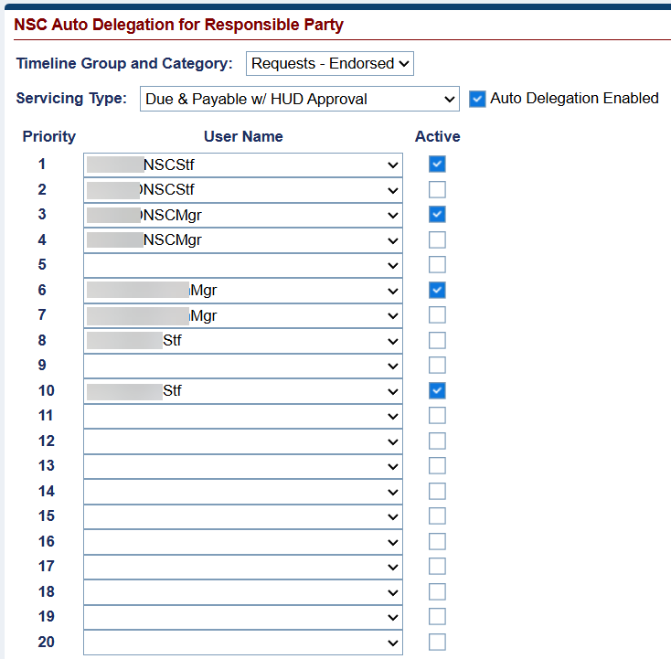
Example – NSC Auto Delegation Screen
Authorized users can modify the usernames and priority of the auto delegation and toggle its status between active and inactive as needed. After making changes—either to the priority value or the active status—the user must click Update in the Audit Information section.
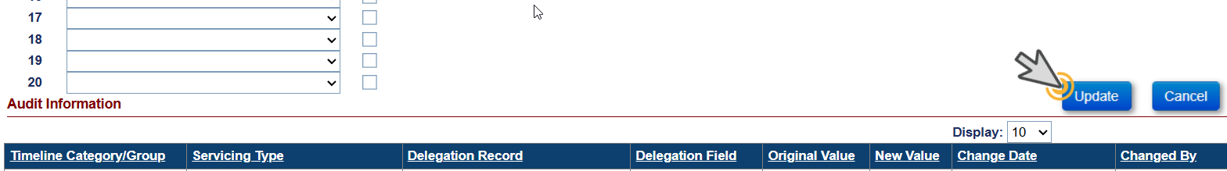
This action triggers a Save Changes window summarizing the modifications, including the rule name, previous and new values, and previous and new statuses. To confirm, the user must click Yes or No.
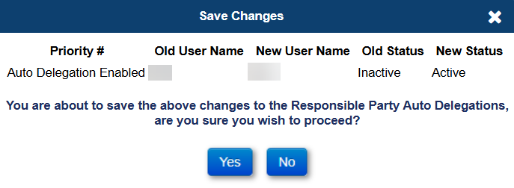
Example – Save Changes Window
Upon confirmation, the Audit Information section is updated to reflect the change details, including the date of modification and the username of the individual who made the update.
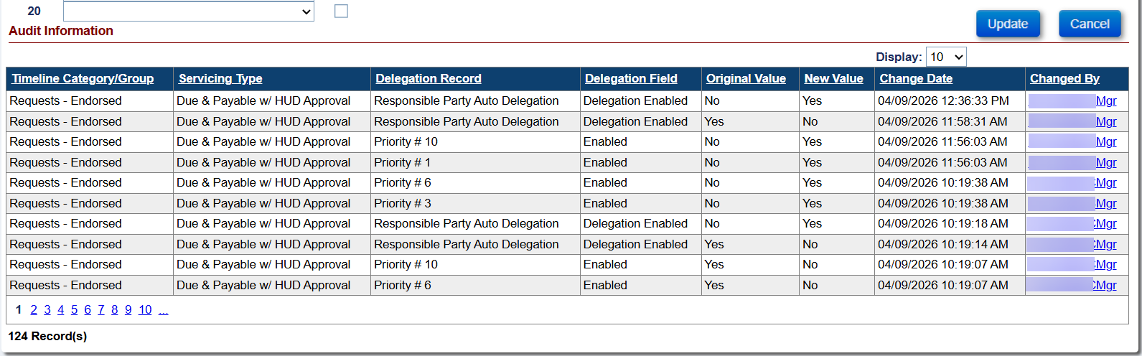
Example – Audit Information Section

Dashboard: Endorsed > Claims > Claim Type 22 – Assignment Timeline Steps (#595197)
Updates have been made to the Dashboard Summary screen, the Export to Excel results, to the dropdown menu items under Step Name within the Dashboard Search screen, and the Export to Excel results to remove the following steps:
- Assignment Denied - Funds Due HUD
- Assignment Denied - No Funds Due HUD
- Assignment of Mortgage (AOM) Rejected
- Assignment Package Received
- Assignment Package Reviewed
- Assignment to HUD sent for recording/Servicer Files Claim Type 22 - Form 27011
- Claims Paid
- Confirm Clear Title
- Confirm loan balance is 97.000% or greater than MCA
- Confirm Occupancy
- Corrected AOM has been submitted
- Follow-up on Incomplete Package
- Funds Due HUD Received
- HUD – Follow Up on Recorded Assignment
- HUD Approves Claim Type 22 for Payment
- HUD Decision - Pending Incomplete Package
- HUD Issued Preliminary Title Approval
- Original Mortgage/Deed of Trust & Note received by HUD
- Original Mortgage/Deed of Trust & Note sent to HUD
- Original Mortgage/Deed of Trust received by HUD
- Original Mortgage/Deed of Trust sent to HUD
- Original Note received by HUD
- Original Note sent to HUD
- Receipt of recorded assignment from county
- Received HUD Decision - Pending Incomplete Package
- Sent recorded assignment to HUD
- Servicer - Follow Up
- Submit Assignment Request to HUD
- Submitted for Payment
- Upload Collateral Package
- Upload Compliance Package
- Upload Servicing Package
- Verify Flood Insurance current
- Verify Hazard Insurance current
- Verify Property Taxes current

Reports: New Asset Sale Report for Active Loans with Servicer Skey = 900000 (#596655)
A new report called “Asset Sale” was added to the Reports module under Assigned Notes Reports > Daily Reports which displays all Endorsed and Assigned Loans for Servicer 900000 (Compu-Link) that have an active Due & Payable Timeline (with any Default Reason) and all borrowers, co-borrowers or eligible NBSs are deceased.
Asset Sale Report Search Criteria:
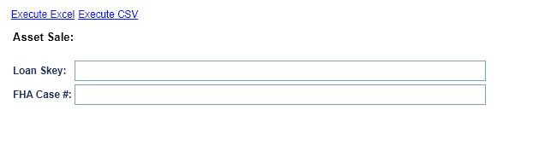
- Search criteria include:
- FHA Case #
- Loan Skey

- The output is available in CSV and Excel formats and includes the following fields:
- FHA Case #
- Case Status
- Case Sub-Status
- Property Address 1
- Property Address 2
- Property City
- Property State
- Property Zip Code
- Property County
- Eligible NBS: Yes/No
- As-Of-Date: TODAY (in MM/DD/YYYY format)
- Loan Balance
- Principal Balance
- Interest Balance
- MIP Balance
- Service Fee Balance
- Default Date (from the Active - Assigned - Disposition - Due & Payable timeline)
- MAX Date of Death for Borrower, Co-Borrower or eligible NBS
- Assignment Date
- Vacancy Date
- Cust Care Place Date
- Product Type
- Pay Plan Type
- Loan Type: IF
- Payment Plan Type Skey: 20 (Term) = "01 - Term"
- Payment Plan Type Skey: 10 (Line of Credit) = "02 - Line of Credit (LOC)"
- Payment Plan Type Skey: 30 (Tenure) = "03 - Tenure (TEN)"
- Payment Plan Type Skey: 40 (Modified Term) = "04 - Term and LOC (TMLC)"
- Payment Plan Type Skey: 50 (Modified Tenure) = "05 - Tenure and LOC (TNLC)"
- Payment Plan Type Skey: 60 (Lump Sum) = "06 - Lump Sum Payment (LSP)"
- Index Type
- Margin
- Rate Type
- Lifetime Cap
- Current Interest Rate
- Monthly Service Fee
- Max Claim Amount
- Lender Name
- Servicer Name
- Investor Name

Reports: Timeline Activity Report - Add Changed Date and Inactive Date to Report Search Criteria (#595329)
New Search Criteria have been added to the Timeline Activity Report under Assigned Notes Reports / Daily Reports search criteria page, that include the following:
- Changed Date (Range)
- Timeline Inactive Date (Range)
- Step Inactive Date (Range)
Additionally, the error messages for all Date Ranges have been changed to “A Date Range of 30 Days or less is required.”

Reports: New Insurance Hazard Policy Servicing Mgmt Info Report for Assigned – Compliance Timelines (#595675)
A new report called “Insurance Policy Information” was added to the Reports module under Assigned Notes Reports > Daily Reports which pulls specific fields from the Servicing Management Information screen on all active Assigned > Compliance > Insurance – Hazard Policy Insurance and Assigned > Compliance > Insurance – Flood Policy Timelines for loans with a Case Status = “Assigned” or loans with a Case Status = “Endorsed” that have a Servicer Skey = “900000”

Insurance Policy Information Report Search Criteria:
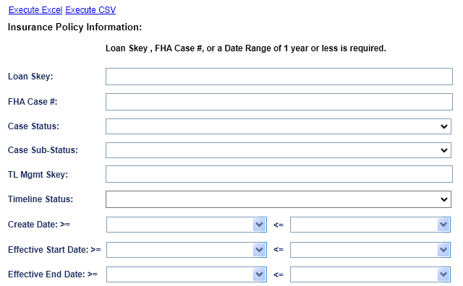

- The output is available in CSV and Excel formats and includes the following fields:
- Search criteria include:
- FHA Case Number
- Loan Skey
- Case Status
- Case Sub-Status
- Timeline Skey
- Timeline Status (Active or Inactive)
- Create Date (Range)
- Effective Start Date (Range)
- Effective End Date (Range)
- The output is available in CSV and Excel formats and includes the following fields:
- FHA Case Number
- Loan Skey
- Case Status
- Case Sub-Status
- Lender Name
- Servicer Name
- Investor Name
- Timeline Skey
- Servicing Type
- Create Date
- Created By
- Servicing Status
- Timeline Status
- Change Date
- Changed By
- Responsible Party
- Policy Effective Start Date
- Policy Effective End Date
- Policy #
- Premium
- Policy Holder
- Company Name
- Agent Name
- Tax ID
- Address 1
- Address 2
- City
- State
- Zip
- Email
- Website URL
- Phone #
- Fax #

Reports: Add Fields to various reports (#539464)
Changes to the “Closed Loan File Report” located under the Assigned Notes Reports > Daily Reports include:
- Removed the fields, “Closed Box “No, “Servicer Skey”, “Investor Skey”, “Investor Loan #” to the “Closed Loan File Report”
- Added the “FHA Case No” and “Loan Balance” fields to the Closed Loan File Report
- The order of columns A-D has been changed to match the order of the columns in the “Loan Principal Limit Detail report”: “Servicer Name”, “Investor Name”, “FHA Case No”, “Loan Skey”
The fields “FHA Case No” and” Check# or ACH #” have been added to the “Accounting Exceptions for Notes Report” located under the Assigned Notes Reports > Daily Reports.
The field “Loan Term Reason” has been added to the “Loan Principal Limit Detail Report” located under the Assigned Notes Reports > Daily Reports.
The fields “Loan Balance” and “Endorsement Date” have been added to the “Claims Detail Report” located under the Servicer Notes Reports > Daily Reports.

Accounting: HERMIT will send the Accounting Module the Void Reason “Stale Dated Check” via the Nightly Accounting Job (#594750)
The Accounting Module Nightly job has been updated to include a Void Reason column which will only display “Stale Dated Check” when the Disbursement is voided with this reason. All other Void Reasons will not be displayed in the accounting module file.

Loan: Payoff Statement on the Loan > Payoff page was updated to exclude estimated expenses in the per diem amount. (# 50703)
The Payoff Statement on the Loan > Payoff page was updated to exclude estimated expenses in the per diem amount.

New Approval Portal Page (#596137)
A New Approval Portal page has been added to HERMIT. The Approval Portal page will have different Request Categories to which only specific users roles will have access to these categories. Once a request has been created it will flow over to the Approval Portal where it will be waiting for HUD Contractor Supervisor Approval and HUD Supervisor Approval. Once the request has been approved the updated change will be effective in the system. This release specifically addresses Request Category “Bank Account” which is changing Borrower Bank Account information on Assigned Loans
- New Approval Portal page Information which applies to all Request Categories

- A new left-menu screen titled Approval Portal will be added to HERMIT, positioned between the Dashboard Search and Loan options. Key features include:
- The Approval Portal will only be visible to user roles that have access to view Assigned Loans.
- The landing page mirrors the Dashboard Search layout, with search filters at the top and results displayed below.
- Search parameters include a Request Status dropdown and a Category selector (required before search).
- Search results are unique to the selected Category.
- An Export to Excel link and an Approve Request(s) link will appear between the search filters and search results.
- The Approve Request(s) link is visible only to authorized roles when the appropriate Request Status is pending. The HUD Contractor Supervisor will only see the checkbox in the Select All column when the record is in a “Pending HUD Contractor Approval” status and the HUD Supervisor will only see the checkbox in the Select All column when the record is in a “Pending HUD Approval” status.
- Authorized users can select individual records or use Select All for bulk approval.
- Denial decisions must be processed individually within the Approval Portal Request Details modal (no bulk denial).
- Users can click any row in the Search Results to open the Approval Portal Request Details modal, where they can also approve or deny the request if authorized.

- The approval workflow is role-based and supports multi-layer approvals. The following process applies:
Initiating Role | Approval Layers | Process
HUD Contractor Non-Supervisor | Two layers | Pending Contractor Approval → Pending HUD Approval → HUD Approved – Change Processed
HUD Contractor Supervisor | One layer | Pending HUD Approval → HUD Approved – Change Processed
HUD Non-Supervisor | One layer | Pending HUD Approval → HUD Approved – Change Processed
HUD Supervisor | Auto-approved (nightly job) | Request created → nightly job auto-approves to HUD Approved – Change Processed

- Additional Approval Portal rules:
  - Only one change of the same nature for the same loan may be in a pending status at a time. A unique error message will display if a second change is attempted while a request is pending.
  - If a request becomes invalid (e.g., the loan is terminated or transferred away from the HUD contractor), the system will update the status to "Failed.”.
  - A Denial Reason is required whenever a request is denied. The error message “A Denial Reason is required to deny the Request” will display if a user attempts to deny without entering a denial reason.
  - All Request Status changes are automatically recorded to the Notes screen under a new Note Type: "Approval Portal", created by the System. The Auto Note “Request ID xx - Approval Portal Request Status changed to "Status Name" on a Category Name data change request on MM/DD/YYYY” will display on the loan for the different record statuses and categories” will display each time the status is updated.

- Detail information for the new Request Category: Bank Account

- Once the user initiates an updated Bank Change (when an authorized user updates any editable field ABA Routing #, Account #, Account Type, or Payment Method) in the Loan > Bank Account page they will receive the warning message “Approval is required before the requested change will be processed. A new request has been created in the Approval Portal and the change will be completed once the Request Status is set to “HUD Approved – Change Processed” thus indicating the request gone to the Approval portal for approval.
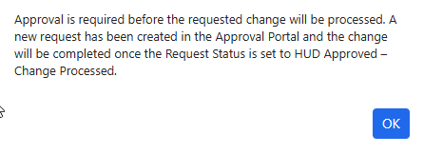
- If a pending Bank Account request already exists on the loan the error message “A requested change to this data is currently pending approval. The pending change must be approved, denied, or failed before a new request can be initiated” will display when a user attempts to click Edit, preventing any new changes until the existing request is resolved.
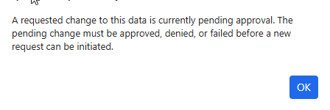
- A new loan-level flag "Suspend Borrower Disbursements" was created for use on Assigned Loans. This Flag will automatically be set to “Yes” once a Bank Account Change has been sent to the Approval Portal.
- When set to "Yes", this flag will:
    - Restrict Scheduled Disbursements from being released to the Accounting Module.
    - Prevent manually created Scheduled and Unscheduled Disbursements payable to the borrower (Payee Type = "Borrower" or "Borrower & Vendor") from being created.
    - This restriction applies to disbursements created through the Loan > Disbursements page, Batch > NSC Bulk Disbursements, and the Batch > HUD Disbursements page.
NOTE: Restrictions do not apply if the Current Servicer Skey <> '900000'.
- The flag will be visible and editable in the Loan Details > Loan Identifiers page (editable by a HUD NSC Mgr) and also visible within the Approval Portal search and results. The flag will be updated from "Yes" to "No" only when one of the following occurs:
    - A HUD Supervisor manually updates the flag in Loan Details.
    - The Approval Portal Request Status is updated to "HUD Approved – Change Processed".
    - The Approval Portal Request Status is updated to "Failed".
- The Suspend Borrower Disbursement Flag will remain “Yes” when the Bank Account record is Denied. This can only be updated from “Yes” to “NO” on a Denial if the HUD NSC Manager unchecks the box before denying the record on the Approval Portal Request Details modal or unchecks the box on the Loan > Loan Details page.
- Scheduled Disbursements created while this flag is set to "Yes" will be placed into a new Batch Status of "Suspended" and held until the flag is set back to "No". Once released, disbursements will move to "Ready to Transmit" at this time the Borrower Banking Information will matches the Bank Information on the Loan > Bank Account page.
- The following permission have access to see the Request Category “Bank Account” on the Approval Portal page:
HERMIT User Role | Bank Acct Change Permission | Requires Approval? | Approval Portal Role
HUD NSC-Mgr | Yes (NEW) | No | HUD Supervisor
Cont-Cash | Yes | Yes | HUD Contractor Non-Supervisor
Cont-Cash Supervisor | Yes | Yes | HUD Contractor Supervisor
Cont-First Mortgage | Yes | Yes | HUD Contractor Non-Supervisor
Cont-Supervisor/Management | Yes | Yes | HUD Contractor Supervisor
  - The following permission changes were made to the Loan > Bank Account page:
  - The Loan > Bank Account page permissions were updated to remove the Edit permissions for HUD SF Premium Mgr – this role will no longer be able to edit Borrower Bank Account information.
  - The Loan > Bank Account page permissions were updated to Add Edit permissions for HUD NSC-Mgr – this role will now be able to edit Borrower Bank Account information (Bank Changes will still be sent to the Approval Portal).
- If there is a pending Bank Account record and/or the Borrower Disbursement flag is checked the user will not be allowed to create Borrower Disbursement (Payee Type = Borrower or Borrower and Vendor). The error message “Borrower Disbursements are restricted on this loan due to a “Suspended Borrower Disbursements” flag in the Loan Detail page or an unresolved Approval Portal Request” will display until the status is Approved, Denied, or Failed and/or if the Suspend Borrower Flag is unchecked.
- The System will update the Pending Bank Account record to either “HUD Approved – Change Processed” or “Failed” via the nightly job. The nightly job will run a series of validation checks on all Pending Bank Account Requests:
- Check 1 – Case Status (Terminated)
- If the Case Status has been updated to Terminated, the Request Status is updated to "Failed" and the auto-note "Request ID xx – Failed due to Case Status updated to 'Terminated'” is recorded.
- Check 2 – Duplicate ABA/Account # Combinations
- The system checks duplicate ABA Routing # and Account # combinations that exist on another FHA Case Number (in the Bank Account page or in pending Approval Portal requests).
- If a duplicate is found, the "Duplicate Record" checkbox in the Approval Portal Request Details modal is checked and the note “Request ID xx - Duplicate Account and ABA Routing # combination were found on the following FHA Case #(s): xxx-xxxxxxx, xxx-xxxxxxx on MM/DD/YYYY” is added to the Notes field on the Pending Bank Account Record. The Note will display all FHA Case #’s that appear as a duplicate to that record.
- Check 3 – HUD Supervisor Auto-Approval
- If the Pending Request was initiated by a HUD Supervisor role, the nightly process will auto-approve the request, updating the Request Status to "HUD Approved – Change Processed".
- Check 4 – "Initial" Change Auto-Approval
- "Initial" changes are defined as the first change to any editable Bank Account field within 90 days of the loan being assigned to HUD.
- Of all Pending Requests meeting the "Initial" change criteria: 90% will be auto-approved via the nightly process; 10% will be held back and follow the standard approval process.
- All other (non-"Initial") changes follow the standard multi-layer approval process and are not eligible for auto-approval.
- The Pending record will update to Failed if the servicer is no longer serviced by the HUD Contractor. The Auto Note “Request ID xx - Failed due to this Loan no longer being serviced by the HUD Contractor” will appear on the Loan > Notes page.
- The Pending record will be updated to Failed via the nightly job if the Loan is Terminated. The error message “The Pending Bank Account record cannot be Approved on a Terminated loan. After the nightly job runs this record will be updated to Failed” will display if an authorized user tries to Approve a Pending record via the Approval Portal Request Details Modal when the Case Status is Terminated. The system will display the Auto Note “Request ID xx – Failed due to Case Status updated to “Terminated”” on the Loan > Notes page after the nightly job has failed the record.

- Two New Alerts have been added to HERMIT when the Flag is on for Suspended Borrower Disbursements.

  - The Critical Alert Description “Scheduled Disbursement Suspended” will appear on the loan when the Suspended Borrower Disbursements Flag is checked during the Month End process and the Alert Amt will reflect the amount of the Suspended “Disb – Scheduled” disbursement. The Alert Note will display "Scheduled Disbursement has been suspended due a pending change to the Borrower's Bank Account information.” The Alert will become Inactive when the Suspend Borrower Disbursements Flag is unchecked.
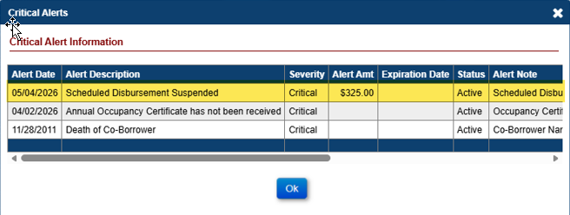
  - The Critical Alert Description “Suspend Borrower Disbursements” will appear on the loan when the Suspended Borrower Disbursements Flag is checked and there is a Pending Bank Account record in the Approval Portal with a Pending Disbursement on the loan. The Alert Note will display "Borrower Disbursements have been suspended due to a pending change to the Borrower's Bank Account information.” The Alert will become Inactive when the Suspend Borrower Disbursements Flag is unchecked.
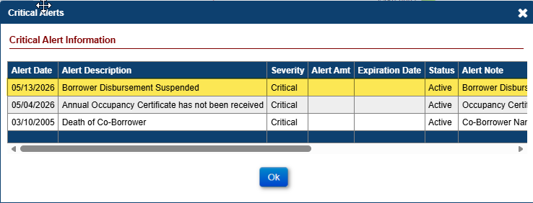

------ End of Document -----

